Define the term professional and explain what it means to be a ‘people professional’. (AC 1.1)

“A professional is a member of a profession. Professionals are governed by codes of ethics, and profess commitment to competence, integrity and morality, altruism and the promotion of the public good within their expert domain. Professionals are accountable to those served and society” (PSA, 2021).
The term professional is often used when referring to jobs such as lawyers or doctors, however, being professional does not simply relate to an individual’s job role, it is also reflected in their behaviours. Mind Tools states that "Professionalism is not the job you do, it's how you do the job” ( Mind Tools, 2022).
The CIPD Profession Map (CIPD, 2022), outlines the core and specialist knowledge required from professional people practitioners in order to provide support for the organisations they are affiliated with. Reward, employee experience, people analytics, resourcing and wellbeing are all examples of specialist knowledge depicted in the Profession Map (CIPD, 2022). Culture and behaviour, business acumen, evidence-based practice and technology and people are examples of core knowledge areas.
The skills and knowledge illustrated in the Profession Map can be acquired, behaviour however is more complex, and is influenced by several factors such as age, personality, life experiences and personal beliefs. Cherry notes that these can have “can have a powerful influence over behaviour and affect how people act in various situations” (Cherry, 2022).
Behaviours in a professional setting can also be impacted by “norms” which can be defined as “informal unspoken set of rules or guidelines outlining acceptable behaviours that all employees are expected to adhere to”.
Armstrong states that “the most important aspect of HR values is the ethical stance HR people take”. (Armstrong, 2020). Being a people professional means behaving ethically, role modelling and championing ethical behaviour and treating others fairly, even when making decisions that do not lead to positive outcomes. It is also crucial for those working in people practice to challenge unethical behaviour, by using both their influencing skills and courage.
In conclusion, being a professional is about more than being a member of a professional body or taking exams, the behaviour and values of a professional are of equal importance.

Explore how the role of a people professional (either a generalist or a particular specialist) is evolving and the priorities this raises for continuing professional development (CPD) (AC 3.1)

The last 30 years have seen a shift from transactional HRM, where HR was largely concerned with managing personnel information, paperwork and policies, to a more transformational, strategic role that supports business results and implements talent strategies. The emergence of technology and automation has facilitated a reduction in bureaucracy and paper-based processes and enabled the people practitioner to increase their focus on strategic planning. HR Consultant argues that “Those who today still see HR as a sector solely of bureaucracy tend to fall behind the competition”. (HR Consultant UK, 2021).
The CIPD states that “professional opinion carries more weight when it's supported by strong evidence from diverse sources” (CIPD, 2022). Rather than relying on “fads” or intuition, people practitioners should instead examine and interpret evidence from critically appraised sources.
Advances in data analysis have allowed large amounts of data to be gathered and this provides the people professional with a wider insight into the organisation, enabling more informed decision making.
Research by the CIPD/Mind argues that “The HR profession has a pivotal role to play in steering the health and wellbeing agenda in organisations” (CIPD , 2018). There has been an increasing recognition in recent years that employee wellbeing is more complex than illness or physical injury, it also extends to metal health. In response to this shift, people practitioners need to influence senior leadership to regard wellbeing as a key priority and work with line managers, providing guidance and support so that policies and procedures are implemented compassionately.
Key priorities for continuing professional development of the people professional therefore should be ensuring that they continue to keep both their tech and digital skills up to date and embracing the digital revolution; utilising and interpreting data, for example, to reach decisions. However, it is important to note that, in addition to “hard” skills, such as qualifications, there is an increasing emphasis on “soft” skills. As organisations continue to recognise the importance of a holistic approach to wellbeing, there is a need for, people practitioners, not only to develop their own soft skills such as compassion, teamwork and empathy, but also champion these in their own organisations. Cheese argues the importance of this stating “now is the time to act” (Cheese, 2023).

Discuss the concept of ‘ethical values’, and how at least three ethical values that you hold personally, impact (or could impact) on your work as a people professional. (AC 1.2)

Ethics is defined by the Compact Oxford Dictionary as being “related to morals, treating of moral questions”. A simpler interpretation could be that ethics is concerned with behaviour, whilst morality is about beliefs. The decisions made by people practitioners can have far reaching implications for people’s lives and the organisation’s reputation, Armstrong states that people professionals have “a special responsibility for guarding and promoting core values in the organisation” (Armstrong, 2020). Making good decisions, that are derived from good values result in improvements to the lives of others and this can have a positive influence on their experience in the workplace.
Three ethical beliefs that I hold personally are kindness, honesty and reliability. Kindness is reflected in my work, through my interactions and communication with others. I believe it is important to treat others with respect and make them always feel included. For example, I take the time to listen to my colleagues when they approach me with any issues, and I always try to empathise with them. I show an interest in their lives outside the workplace and ask questions about the things that matter to them such as family and hobbies. By doing this, I believe it helps people to feel valued and included. Honesty is also important to me, for example, if I make mistakes, I always admit to them and reflect on how I can improve. I try to have a transparent relationship with both my line manager and my peers, as I believe this helps to build trust and facilitate a good relationship with them. Finally, I strive to be reliable. I do my best to complete tasks on time and do whatever is required of me. If I am presented with confidential, sensitive information, I understand the responsibility of this and handle it in a careful way. I believe that by holding these values, I can make a positive impact on the organisation I work for.

Explain why it is essential for people professionals to contribute confidently to discussions, and ways of doing this that are (AC 1.3):
- informed
- clear
- engaging.

The CIPD Profession Map (CIPD, 2022), outlines the core behaviours that people professionals should practice. One of these is “Professional courage and influence.” The map underpins this, stating, people professionals should be “showing courage to speak up and skilfully influencing others to gain buy in” It is crucial, that when contributing to discussions, whether this is at board level or with line managers, that people practitioners confidently challenge unethical behaviour, such as management tolerance for exploitation or harassment for example. To not do so can have far reaching consequences, it damages trust, the organisations reputations and undermines the relationship that people practitioners have with others in the organisation, Grave argues that the “corroding of trust is one of the most poisonous consequences of both poor leadership and poor HR practice.” (Grave, 2018).
Being informed to a confident contribution in discussions, the CIPD states that the people practice should be “evidence based “ (CIPD, 2022), rather than relying on “fads”. For example, when trying to gain leadership buy in for a new strategy, people practitioners should instead make use of data analytics and reliable research, in order to make the business case more credible
Communicating clearly is also necessary in order to present the message effectively, in doing so, this avoids confusion. Communicating clearly often means being concise, Emerson cautions against the use of “unnecessary words and overly flowery language.” (Emerson, 2021) as this can lead to the message being missed. When communicating with others, I try to be aware of how my language, tone and body language are likely to be perceived and I endeavour to adjust this accordingly.
Discussions are likely to be more engaging and valuable if they are not dominated by one person. For example, when I attend the Employee Forum in my organisation, I try to ensure that everyone is given the opportunity to share their views, by asking direct and open-ended questions. Page states that “Communication is a two-way process” (MIchael Page , 2022).To be fully engaged, individuals need to be listened to, in order to feel valued.

Discuss when and how to raise concerns when issues such as organisational policies or Discuss leadership approaches conflict with ethical values or legislation. (AC 1.4)

Knowing when and how to raise concerns is crucial for people practitioners, the CIPD notes “the courage to challenge decisions and actions. (CIPD, 2022) as one of the key behaviours required to be a people professional. However, in a controlling and commanding culture, Armstrong acknowledges that “challenging can be difficult “ (Armstrong, 2020). This should be the case for all individuals within an organisation, who are able to raise concerns, informally, formally or by whistleblowing A whistle blower is usually a worker who raises “a concern about danger or illegality that affects others” (CIPD , 2022), the information is passed to an employer or regulator. Following a number of high-profile scandals, the Public Interest Disclosure Act was passed in 1999. This piece of legislation provides protection to whistle-blowers from unfair treatment or dismissal.

A high-profile case where legislation and ethics conflict, is the decision by P&O to dismiss 800 employees via video link without prior consultation. The Company claimed the decision was legal, as its workers were outside the UK’s jurisdiction. However, this generated a raft of negative publicity for P&O and highlighted the human impact of such decisions, leading Harries to comment “just because it's legal, doesn't mean that it's right.” (Harries, 2022).

Previously, I raised a concern about how employees’ personal information relating to their sickness absence was being handled by line managers. I was concerned that this would constitute a breach of the Data Protection Act of 2018. After careful consideration, I decided to raise my concern formally with the Data Protection Officer in the organisation. I approached this directly and calmly and provided all the information. As a result of this, line managers received refresher training on the handling of personal data and a new process was implemented to minimise the likelihood of any further breaches.

Provide a robust argument for ethical people practice that is supported by academic theory and details both the business and human benefits of people at work feeling included, valued and fairly treated. AC 2,1
Ethical people practice is ensuring that employees feel included, valued and fairly treated and the CIPD states that “people professionals are uniquely placed to support embedding principled decision-making into daily practice.” (CIPD, 2022). An organisation with high ethical standards can increase employee satisfaction, leading to reduced staff turnover and the potential to attract more talent. It can improve workplace culture, when stakeholder holders hold leaders accountable for ethically questionable actions, they begin to scrutinise their own actions. These types of interactions create a more resilient culture where stakeholders feel “feel safe, protected and engaged” (Indeed, 2023). It also has implications for the organisation’s reputation, a failure to act ethically can damage the public perception of the brand. Bersin cautions “If you start looking like a horrible place to work, you're going to suffer serious impacts — on not just morale, but business reputation and recruitment.” (Bersin, 2022)
According to Herzberg’s two factor model (Herzberg, 1957) there are two factors that influenced feelings of satisfaction and dissatisfaction, those factors which are intrinsic to the work itself, such as “ achievement, the interest of the work, responsibility and opportunities for advancement” (Armstrong, 2020) and “extrinsic” factors such as pay and conditions. In isolation, extrinsic factors simply prevent dissatisfaction, however they do not serve to motivate or provide long term satisfaction, the intrinsic motivators which relate to “quality of working life” are more likely to have a longer-term positive effect. People practitioners can apply this theory, by providing opportunities for learning and development and championing a culture of rewarding and valuing employees. Liddle argues that people practitioners should be “ a real advocate for the needs of the people” (Liddle, 2022)

,

Drawing on your own or a hypothetical example of providing a people practice solution to meet a particular need or introducing a new policy or initiative, describe:
- strategies for designing the solution/initiative so that it will be inclusive.
- strategies for checking that, when in practice, the solution/initiative engages and meets the needs of all those it is aimed at. (AC 2.2)

Initially when designing a new hybrid working policy, information from a range of sources needs to be acquired prior to agreeing on the most suitable solution. In the case of a large organisation where employees are based across various locations, an online survey could be used, this would need to be brief to ensure that employees are not deterred from answering them, when designing a survey, the definitions and outcomes must be “ as precise as possible” (Armstrong, 2020). By giving as many people as possible the opportunity to share their views, this will ensure that they feel engaged in the process, and their needs are considered in addition to the those of the organisation. The CIPD cautions that while hybrid working has “has the potential to support inclusion and fairness” (CIPD, 2022) if it is poorly implemented it can “worsen existing inequalities”, (CIPD, 2022) highlighting the importance of working together with employees. Interviews with staff most affected by the changes would also provide insight into how the new policy is likely to be received.
The other implications of a move to hybrid working could be the impact on colleague wellbeing, research by Gallup found that “remote work causes loneliness and isolation” (Gallup, 2019). Therefore, it is necessary to consider methods to mitigate this, such as upskilling managers to notice the signs of a decline in a colleague’s mental wellbeing.
CIPD’s Value Your Talent (CIPD, 2022), framework can be used an initial starting point to understand the impact of people on business performance. It can be used to measure the outcomes of the policy. The use of data analytics to measure quantitative data such as retention and sickness absence can be used in conjunction with staff interviews and further surveys to provide a broader insight into the success of the policy.

Activity 2 AC 2.3 and 3.2

In order to inform my assessment, I have requested 360 feedback from my colleagues, including my line manager and two of my peers who I work with closely in my current role. I have also researched the CIPD Profession Map and assessed how am currently applying the core behaviours in my role. By doing this, I have also identified areas which require further development and formulated appropriate development activities to assist with my continuing professional development. In addition to this, I have also undertaken additional research from academic papers, websites and books to further to gain a deeper insight into the core behaviours. I have also taken the time to reflect on my behaviours and the impact they have, both on other colleagues and the wider organisation.

Appendix 1
Appendix 2

Activity 2 AC 3.3 Appendix 3

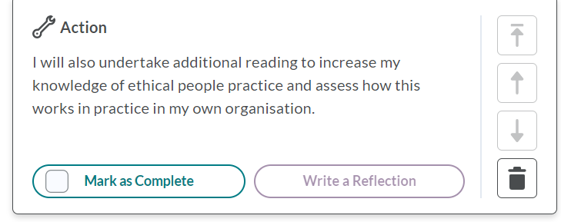

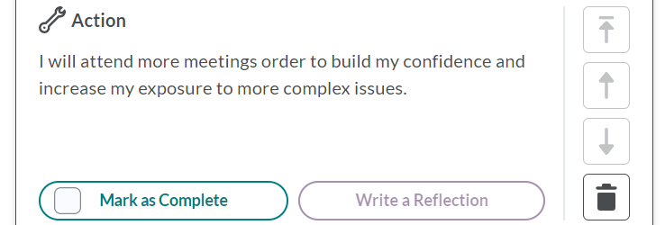

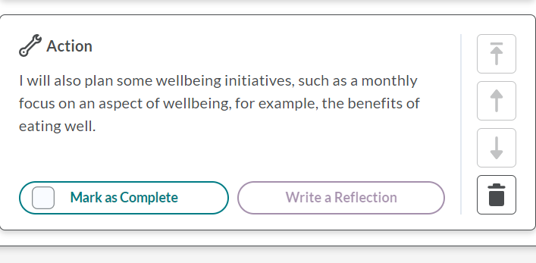

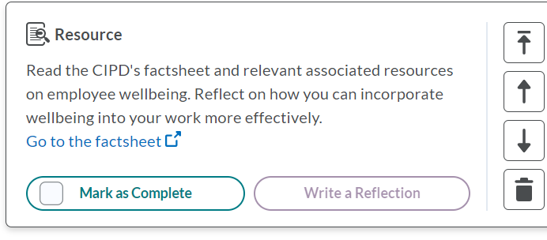

Feedback from my line manager has indicated that I need to increase my confidence when dealing with difficult conversations and raising concerns when ethical matters conflict with their own leadership styles, particularly when they are strong personalities. In order to build my confidence, I have selected to undertake additional reading regarding the ethical treatment of employees. I will also review the policies in my own organisation with a view to establishing if they are ethical in addition to being legal.
To further increase my confidence and increase my exposure to difficult situations, I have created an action plan to attend more meetings, such as grievance hearings and disciplinary meetings. I believe

this will provide more opportunities to raise concerns regarding the ethical and fair treatment of others and allow me to consider ways to raise concerns.

The CIPD assessment tool and feedback from line manager demonstrates that although I work well with others and demonstrate valuing others at the moment, I am keen to explore this and develop further. To do this, I have selected to access additional resources as indicated by the assessment tool and also focus on developing wellbeing initiatives within my organisation. I would like to implement a monthly focus on a particular aspect of wellbeing, such as the benefits of healthy eating for example. I will engage with other stakeholders to establish if this would be well received and following the implementation of this, I will request feedback on my work and reflect on how I can build on this.

AC 3.4
In the previous twelve months, I have undertaken a range of varied development activities to enable my continuing professional development.
Firstly, I attended a workshop on the use of Excel. Previously, I had a limited experience of using Excel and I found this was affecting my ability to complete tasks efficiently, so I was keen to learn more about how this could assist me. One of the core purposes of the CIPD Profession Map is “Evidence Based Practice” and the need to make decisions based on evidence rather than intuition or “fads”. The use of Excel and data therefore is crucial to a people professional as is the ability to produce and interpret data. By using Excel to produce graphs and tables, I believe this will help when making a business case to implement a new initiative for example, by presenting the data in clear way in order to gain “buy in” from senior leadership, rather than relying on anecdotal evidence.
Reflecting on this activity has made me think about the potential for using data and has also made me consider how I can build on this. I have planned to attend further Excel training in the next twelve months, and I will also ask for some guidance from the financial analyst in my organisation, as he has an extensive knowledge of Excel and this will assist me further.
I am currently employed in the agricultural and manufacturing industry. Our workforce is very diverse, and we have colleagues from all over the world, although most originate from Eastern Europe, particularly, Ukraine, Kyrgyzstan, Uzbekistan and Lithuania. Most of these colleagues are Russian speaking and their English is very limited or in some cases they have no English at all. This can cause issues when communicating clearly with them and is of course frustrating for them when trying to raise concerns about their pay. I have recently begun Russian lessons so that I can start to understand the colleagues needs and make it easier for them to communicate their issues. I am also conscious of how difficult it must be to arrive in a new country, with all that entails, with limited language. I am keen to make the transition period less stressful for them, in addition to making them feel welcome and included and by being able to communicate with these colleagues in their own language, I am optimistic that this may be helpful in a small way. I have already undertaken an introductory course in Russian and I have plans to attend the next stage of the learning. I feel that undertaking this learning has made me consider the difficulties faced when moving to a new country and over the next twelve months, I will consider other methods of making people feel more included in the workplace.
Recently I attended an employment law update delivered by a local firm of employment solicitors. The session provided information about the outcomes of recent employment tribunals and upcoming changes to employment legislation. I found the session very interesting and informative, and it gave me an insight into the complexities of employment law and how the law can be interpreted differently, particularly as the some of the cases illustrated had progressed to the Supreme Court. I found the session to be an extremely valuable experience and I was interested to further my knowledge of employment law. I began to research tribunal cases and I also read more widely about employment law to extend my knowledge further. I was particularly interested in cases regarding flexible working, and as a result, I reviewed the policies currently in place in the organisation I am currently employed with a view to introducing more family friendly policies. I also undertook further research into the changes to legislation that were to take effect in the next twelve months and examined our current policies. I diarised the dates of the proposed changes to ensure that the current policies would be amended to remain compliant with the legislation changes. This session is an annual event that I will continue to attend, so I can continue to be up to date with any changes to legislation.

Bibliography

Mind Tools, 2022. Mind Tools. [Online]
Available at: https://www.mindtools.com/av44li2/professionalism
[Accessed 2023 February 2023].
Armstrong, M., 2020. Armstrongs Book of Human Resource Management. 15th ed. London: Kogan Page.
Bersin, J., 2022. HR Magazine. [Online]
Available at: https://www.hrmagazine.co.uk/content/news/pos-pr-disaster-exposes-hrs-critical-role-in-risk-management
[Accessed 12th March 2023].
Boxall, P. a. P. J., 2003. Strategy and Human Resource Management. 4th ed. Basingstoke: Palgrave Macmillan.
Cayenne Consulting , 2022. Cayenne Consulting. [Online]
Available at: https://www.caycon.com/blog/how-the-role-of-hr-professionals-is-evolving
[Accessed 5th March 2023].
Cheese, P., 2023. People Management. [Online]
Available at: https://www.peoplemanagement.co.uk/article/1815592/uk-losing-22bn-year-not-investing-soft-skills-development-research-finds#:~:text=Peter%20Cheese%2C%20chief%20executive%20of%20the%20CIPD%2C%20said,the%20basis%20for%20almost%20every%20job%2C%E2%80%9D%20he
[Accessed 11th March 2023].
Cherry, K., 2022. Very Well Mind. [Online]
Available at: https://www.verywellmind.com/attitudes-how-they-form-change-shape-behavior-2795897
[Accessed 2o23 March 2023].
CIPD , 2018. People Managers' guide to mental health. [Online]
Available at: https://www.cipd.co.uk/about/media/press/260918-manager-mental-health-guide
[Accessed 11th March 2023].
CIPD , 2022. CIPD. [Online]
Available at: https://www.cipd.co.uk/knowledge/fundamentals/emp-law/whistleblowing
[Accessed 12th March 2023].
CIPD, 2022. CIPD. [Online]
Available at: https://www.cipd.co.uk/knowledge/strategy/analytics/workforce-reporting-factsheet
[Accessed 19th March 2023].
CIPD, 2022. CIPD. [Online]
Available at: https://www.cipd.co.uk/knowledge/fundamentals/relations/flexible-working/planning-hybrid-working
[Accessed 18th March 2023].
CIPD, 2022. CIPD. [Online]
Available at: https://peopleprofession.cipd.org/profession-map/core-purpose/evidence-based
[Accessed 11th March 2023].
CIPD, 2022. CIPD. [Online]
Available at: https://peopleprofession.cipd.org/profession-map
[Accessed 26th February 2023].
Emerson, M. S., 2021. Harvard Business Review. [Online]
Available at: https://professional.dce.harvard.edu/blog/eight-things-you-can-do-to-improve-your-communication-skills/
[Accessed 12th March 2023].
Gallup, 2019. Gallup. [Online]
Available at: https://www.gallup.com/workplace/268076/manage-loneliness-isolation-remote-workers.aspx
[Accessed 18th March 2023].
Grave, K., 2018. People Management. [Online]
Available at: https://www.peoplemanagement.co.uk/article/1741719/hr-must-speak-up-about-ethics
[Accessed 12th March 2023].
Harries, T., 2022. LinkedIn. [Online]
Available at: https://www.linkedin.com/in/tilly-harries-16a11360/recent-activity/shares/
[Accessed 12th March 2023].
Herzberg, F., 1957. The Motivation to Work. 1st ed. New York: Wiley.
HR Consultant UK, 2021. HR Consultant UK. [Online]
Available at: https://hrconsultantuk.co.uk/evolution-of-people-management-learn-about-the-main-advances-in-the-area/
[Accessed 11th March 2023].
Indeed, 2023. Indeed. [Online]
Available at: https://www.indeed.com/career-advice/career-development/why-ethics-is-important-in-the-workplace
[Accessed 15th March 2023].
Liddle, D., 2022. HR Magazine. [Online]
Available at: https://www.hrmagazine.co.uk/content/news/pos-pr-disaster-exposes-hrs-critical-role-in-risk-management
[Accessed 15th March 2023].
MIchael Page , 2022. Michael Page. [Online]
Available at: https://www.michaelpage.co.uk/advice/management-advice/development-and-retention/importance-good-communication-workplace
[Accessed 12th March 2023].
Personio, 2022. Personio. [Online]
Available at: https://www.personio.com/blog/hr-trends/?utm_source=cipd&utm_medium=newsletter&utm_campaign=uki_cipd_hrtrends
[Accessed 5th March 2023].
Personnel Today, 2002. How HR has evolved. [Online]
Available at: https://www.personneltoday.com/hr/how-hr-has-evolved/
[Accessed 5th March 2023].
PSA, 2021. Professional Standards COuncil. [Online]
Available at: https://www.psc.gov.au/legislation
[Accessed 26th February 2023].

