Parcel industry in the UK. A case study of DX Network Services

  - Effects of Brexit and Covid on the operations in the parcel industry in the UK. What can we learn from the past and what does the future hold?

Student: Tsvetomir Georgiev

Student ID: 2124036

Tutor: Husam Helmi

Table of Contents
Overview of the parcel industry 3
Overview of the parcel industry in the UK 4
Changes in the parcel industry in recent years 5
Overview of the company 6
Changes in the company 7
PESTEL Analysis 8
Porter’s 5 forces 11
SWOT analysis 13
Ansoff matrix 15
Survey on the parcel industry in the UK 18
Interviews 29
Working, employment and traffic issues 34
Alternatives and future 36
Conclusion 40
References 41

Overview of the parcel industry
The parcel delivery industry is an important part of the modern economy since it allows consumers and businesses to carry commodities and products swiftly and efficiently. In this essay, we will look at the history of the parcel delivery industry, its current situation, and the problems and opportunities that lie ahead.
Parcel delivery can be traced back to ancient civilizations like the Egyptians, who used messengers to bring products and messages. The current parcel delivery industry, on the other hand, can be traced back to the mid-nineteenth century, when the United Kingdoms' railway network began to expand significantly. Railways enabled the rapid and efficient conveyance of products across great distances, and the first express delivery services emerged.
The parcel delivery industry grew and evolved throughout the next few decades, with new companies starting and older players expanding their operations. The arrival of air transport in the 1960s and 1970s made it possible to deliver packages across the country in a matter of hours, significantly altering the industry.
Today's parcel delivery industry is complex and extremely competitive, with a wide range of organisations offering a variety of services to fulfil the needs of clients all over the world.
The parcel delivery industry is an important part of the global economy since it facilitates the flow of goods and products around the world. The global parcel delivery industry was estimated at $445.4 billion in 2020, according to Grand View Research, and is expected to increase at a compound annual growth rate (CAGR) of 11.3% from 2021 to 2028.
A few significant players dominate the sector, including UPS, FedEx, DHL, and Amazon. These businesses provide a wide range of services, including as domestic and international shipping, next-day and same-day delivery, and a number of delivery methods, such as express, ground, and air transport. In addition to these significant competitors, the parcel delivery sector is populated by a vast number of smaller businesses. These businesses may specialise in certain types of deliveries, such as medical supplies or perishable commodities, or they may focus on specific locations or industries.
The parcel delivery industry has grown significantly in recent years, owing largely to the rise of e-commerce. As more people shop online, the demand for parcel delivery services has grown, opening up new potential for organisations in the industry. Despite the benefits afforded by e-commerce expansion and rising demand for parcel delivery services, the sector faces a number of obstacles. One of the most serious difficulties facing the parcel delivery industry is balancing speed and efficiency with sustainability. As more goods are delivered, the sector's environmental impact is becoming a significant worry. Companies in the sector are experimenting with a variety of carbon-cutting initiatives, such as deploying electric vehicles, optimising delivery routes, and investing in renewable energy. Another issue confronting the industry is the need to adapt to shifting consumer expectations. Customers have grown to demand fast, dependable, and easy delivery alternatives as more people shop online. As a result, parcel delivery businesses are facing increased rivalry, as well as the need to invest in new technology and delivery techniques. In addition to these obstacles, the parcel delivery industry is confronted with a number of regulatory and legal issues.

Overview of the parcel industry in UK
The pandemic provoked the global forces, and as a result of the restrictive measures taken by large entities and structures, a global socio-economic crisis was caused. The challenge for societies was to protect the health of the residents (Mircheva, 2020). Parcel industry, one of those industries that have availed the positive impacts of the pandemic, rather than addressing the negative impacts of the pandemic. Not only within the UK, but in the entire world, the parcel industry has grown extensively over the last few years within the essence of pandemic. One of the major reasons behind this is that almost all the industries depended heavily to operate their business operations on parcel sector in the times of pandemic. One of the major factors that contributed to the extensive growth and development of the parcel industry is the rising demand of the services from the ecommerce industry within the market of UK. The demand of ecommerce services extensively increased as almost all the products and services that are basic requirements of the population were being purchased from the ecommerce platform, and those ecommerce platforms then relied on the parcel industry to operate their supply chain smoothly within the marketplace (Cuschieri and Grech, 2021). The parcel sector coordinates with each and every industry present within the marketplace to support them with appropriate services through which they can be capable of operating their services effectively. The extant literature and questionnaire results confirm that widespread industry opposition against Brexit prevails; many perceive that Brexit will reduce the supply of skilled labour from the EU rather than increase or enhance it (Mohamed et al., 2017). The detailed industry analysis with the focus on the major parameters and the factual data and statistics have been presented below:
Market size: The current market size of the parcel industry is about 15 billion pounds, which is expected to grow with CAGR of 6% from the year 2021 to 2026 as per reports from Apex insights. Further, it is being projected that the market size of the parcel industry will keep on growing. As per the data provided by Parcel Hero the market size of the parcel industry is going to hit the market size of 24 Billion by 2025. As per the data and increasing market size of the parcel industry it could be observed that this industry is one of the most strengthened industry within UK that has been contributing its best for the economic growth and development of the country (Apex-insight, 2023). The industry has been bit affected during 2008 recession and economic crisis but post that period the industry has consistently put efforts into development of effective technologies to grow and claims one of the top positions within the marketplace among other industries in terms of market size.
Key players: There are several dominant firms those contribution have empowered the industry to have a glamorous position among other industries within the marketplace. Royal Mail being one of the oldest and the most significant parcel delivery companies that have contributed a lot for the growth and development of the industry over the years. Some other major companies are DPD, Yodel, Hermes (rebranded as Evri), UPS, DX network services
Innovations: The parcel industry heavily relies on two services- ecommerce and delivery services. Ecommerce services are already in light with the occurrence of pandemic and increasing trends an inclination of majority of customers towards online shopping. The parcel industry on the other hand caters to various customer needs with its delivery services. These services include next-day delivery, same-day delivery, express delivery, international delivery, parcel tracking, and other value-added services. Many carriers also offer convenient options for parcel collection and drop-off at designated locations, such as parcel lockers or local retail shops (Fraiberger and Koster, 2021). Hence in order to serve the customers with these effective and quality services the parcel industry is consistently putting efforts into the development of newer technologies to provide ease of access to customers. Various innovations have been done within the industry that have empowered meeting customer needs. Some of the effective innovations that have carried the industry to another level include advanced tracing and tracking system that uses detailed tracking functionalities, last-mile delivery solutions, electric and alternative-fuel vehicles, and automation in sorting and processing facilities to improve efficiency and sustainability (Ghose et al., 2021).
Regulations: The operation of the industry is not easy and simple as it seems to be, as there are various complications in terms of rules, laws and legislation that the industry has to address to grow and explore effectively. The industry has to comply with the laws and legislations associated with the labour, health and safety, transportation and environmental standards. One of the major legislations to which the industry has to comply is Road traffic act. Licensed vehicles, drivers and following of the road regulation and insurance policies are some of the rules with Road traffic act that the industry has to comply with. Beside these there are several other acts, laws and legislation that the industry has to follow to have sustainable growth and development of the industry. Those laws and legislations include Health and Safety at Work Act, and the International Maritime Dangerous Goods (IMDG) Code (Holguín-Veras and Le, 2021).
Business-to-business (B2B) and business-to-consumer (B2C) are the two main market segments. B2B parcel and delivery services transfer items between businesses, whereas B2C services deliver goods to individual consumers. The B2C segment is the market's largest and fastest-growing sector, thanks to the rise of internet purchasing.
In conclusion, the parcel industry in the United Kingdom (UK) is a vital part of the country's logistics and transportation sector, facilitating the movement of goods across the country and internationally. The industry comprises of huge number of parcel firms operating within it to serve the customers all across the country. As per the UK delivery and courier industry statistics there are 15,695 delivery and courier companies operating within the country. Some of the major key players of the industry include Royal mail, DX network services, UPS, DHL Group and others. The industry heavily relies on ecommerce and delivery services, and carriers have introduced several innovations such as next-day delivery, same-day delivery, express delivery, international delivery, parcel tracking, and other value-added services to cater to various customer needs (Stead and Biehl, 2021).
Changes in the parcel industry in recent years
The parcel and delivery sector in the United Kingdom has experienced an increase in demand in recent years, owing to the rise of e-commerce and online shopping. According to the Office for National Statistics, thanks to the epidemic, online sales in the UK will hit a record high of £99 billion in 2020, a 46% rise from the previous year. This has put enormous strain on the parcel and delivery industry to keep up with demand, resulting in both challenges and possibilities for the sector.
Parcel industry has undergone various severe changes within last few years within UK as the country has addressed back to back impacts of pandemic and Brexit that have affected industry on both positive and negative scale. The industry was not in light prior to pandemic but when the Covid-19 pandemic came the industry gained lots of attention from both the customers as well as different industries within the marketplace. Since the pandemic has lasted now and as a result of that the gradual downfall in the industry is being observed but still the industry is comparatively in the growth phase if compared to that of the market size of the industry prior to the pandemic (Vanoli and La Bella, 2021). The major reason behind this is that the pandemic impacts have lasted but as result of the long-term change in the habits of the customers of availing products and services they have got habitual of the online shopping and thus do not prefer to visit to stores to buy products and services.
It is not so that in this phase the parcel industry has gained only benefits with the impact Covid. The industry has also addressed various challenges within the marketplace due to adverse impacts of Brexit that took place in the meanwhile with parallel to the pandemic within UK. Brexit came in 2020 and disrupted the entire supply chain of the logistics market and as a result of that parcel industry had to face severe negative impacts (Bieńko et al., 2020). Brexit basically resulted in rise in costs for logistics providers and along with that the custom regulations and trade policies have also negatively affected the parcel industry within UK. There were free cross border trades within the EU countries prior to Brexit and thus no taxes were to be paid by the parcel industry to ship the items across the international borders among those countries, but with the occurrence of Brexit, EU imposed taxes on to these cross order trades and as a result the parcel industry operations have been heavily affected (Johnson and Prakash, 2019). Altogether in the recent years the parcel industry has addressed both positive impacts and maintained an effective balance within these positive and negative impacts to grow and explore effectively within the marketplace.
The parcel industry prior to pandemic was growing and a majority of the customers were being shifted to the ecommerce platforms for shopping purposes. The industry thus had a steady growth rate of 4.6% from year 2015 to 2019 accounting to a value of around 13.5 Billion in 2019 as per the report published by Apex insights. In 2020 with the extensive growth rate of 16.4% the industry market size exceeded 15 billion to reach 17.2 billion in 2021 as per the reports from Apex insights and Mintel (Apex-insight, 2023). The report further mentioned that an average of 4 billion rise in the market size have been consistently been observed over the last three years. With the end of the pandemic in 2022 the industry growth rate had fallen but still it is up to the surge that the market industry of the parcel industry will raise to 24 billion by 2025 as per the report published by Parcel Hero. Although people started visiting stores to purchase products and services but still a huge population is inclined towards ecommerce and as per the data this inclination is continuously increasing with the growth and development in technology.
Overview of the company
DX network services is a public limited company that belongs to the logistics and parcel industry. The firm was founded in the year 1975. The firm actually got established with its major operation during a postal strike that has been conducted by Royal mail. Royal mail was one of the prominent key players during those times within the parcel industry and thus when Royal mail went on to strike, it became the golden opportunity for the DX group to grow and expand as one of the leading parcel firms to meet the needs and demands of the customers. The firm is headquartered in Datchet, England UK and has its major operations across UK and Ireland. DX group belonging to the logistics industry has a diversified product portfolio (Hughes and Allen, 2022). The major products of the brand include DX logistics, DX international, DX express, DX mail and DX exchange. It’s almost 48 years since the brand is in operation and throughout the phase the brand has served the customers with best of its services which could be observed from the sustainable growth and development of the brand over the years. The firm also has addressed some challenging situations. In the year 1990 the firm became part of Hays Plc and the Hays Plc is 2004 disposed of its logistics business. The situation was very much critical and, in the meanwhile, to overcome the situation, the firm acquisitioned with the DX secure and then from the firm become the prominent player within the industry and met the customer needs and demands effectively. The firm came forward with its trading and got listed on the London stock exchange on 27th February 2014.
Entering the London stock exchange for trading reflected that the golden phase for the firm has come. Basically, the logistics industry began to boom from there and the firm has consistently grown after that period of time. The technology got upgraded, ecommerce platform came into action and as a result of all that the firm grabbed the opportunity to expand its business and serve more and more customers across and even beyond the country with multiple delivery services. As per the recent data the firm employees over 4100 employees to serve the customers all across UK and Ireland with the best possible services, it is one of the leading parcel firm within the industry with experience of over 48 years in this specific industry. The firm deals in both the modes B2B as well as B2C which means that the firm deals with both the businesses as well as customers to operate their business operations. The brand has very high reputation within the marketplace with its innovative approach to satisfy the customers with the best possible delivery services as per their demand.
Coming on to the services of DX network, there are multiple services that are being provided and these multiple services offerings are one of the greatest factors that have empowered the brand to strengthen their position at the competitive edge among other businesses. Next-day delivery service and a 2 hour time window is one of the most effective services that the brand provides to its customers. It is generally not possible easily to deliver the products and services within one day but the firm makes it possible and creates an effective brand image for the customers within the marketplace. The delivery services of the brand are so much flexible that the brand even supports with the deliveries on Saturday and flexible timings as per the needs and demands of the customers which empowers them to hold their potential customers with their firm. Another most promising aspect is that even for the international parcel deliveries the firm charges cost effective and reliable prices which also helps firm attract majority of customers towards their services. The firm also has the specialized delivery options through which the special products that are costlier, valuable and sensitive. The firm has some specialized and trusted drivers who are appointed on such delivery services so that the parcels of the customers could be safe and could be delivered successfully.
On financial grounds the firm has a strong presence within the parcel and logistics industry. The annual revenue in 2021 was 382.1 million Pounds which increased to 428.2 Million pounds in the financial year 2022. As per the data of 2022 the firm claimed annual profit from operating services of about 22.1 Million Pounds. The net cash that the firm generated was 27 million and the net cash that has been generated from the operating activities is about 36.5 million pounds (DX delivery, 2022). Altogether the firm has strengthened its presence on the financial grounds also within the marketplace. Since the industry is growing continuously and it has been projected that the industry is going to reach 25 billion market share by the year 2025, it is logical that the company also will be addressing a huge growth in its revenue and profitability.
Changes in the company
DX group came across various significant changes over last few years and the reason behind that could be multiple ranging from the fluctuations in different environmental forces- external, internal or competitive. All these environment analyses will be presenting in depth analysis of the aspect that the how the firm has been impacted of these factors over the recent years and what strategic approaches and pathways the firm has adopted in these situations to avail the opportunities and mitigate the threats. The firm operates in UK and two of the most common factors that have affected UK over recent years are the Covid-19 pandemic and Brexit. Both these aspects had some positive as well as some negative impacts on to the business and as a result of this the firm obviously had undergone some major changes that would have empowered them to avail the benefits of these impacts and also some amendments for mitigating the threats of negative impacts on to the firm. The technology has boomed within these years and thus the firm in order to stay in the competition must have come with adaptation of newer technologies and newer ways of working (Chen et al., 2021).
One of the major changes that the company underwent assessing the positive impacts of pandemic was upgrading its way of operations with the utilization of newly and advanced technologies. The usage of technology rapidly increased with the essence of pandemic and thus the brand came up with the adaptation of advanced parcel tracking and management system which empowered them to provide better and quick information to their customer regarding their parcels. The firm also came forward with the adaptation of digital solution providing services in the recent years with which the firm was blessed with the capacity to get the complaints and respond to their queries (Kim and Kim, 2021). This amendment empowered them with the capability to provide better customer experiences to their customers. This technological adaptation also empowered with the online booking, scheduling and cancellation facilities that helped firm to attract majority of customers towards the services being provided by DX. The company has also undergone to increase its dependencies more over the cloud services in order to enhance the scalability and flexibility which further empowered them to serve customers with cost effective services (Meloto and Janssen, 2020). With the enhanced utilization of cloud services, the firm also made amendments to follow the regulations of GDPR and CCPA. Similar to these amendments there has been various amendments been made by the brand in the field of technology to grab all the opportunities associated with the positive impacts of pandemic.
• Adoption of Edge Computing: Recent years have seen a rise in edge computing, which includes processing data closer to the location where it is generated rather than transmitting it all to centralized data centres. Edge computing is probably used by DX network services to increase speed, decrease latency, and enable real-time data processing for quicker and more seamless digital experiences (Zhong et al., 2020).
• Integration of Artificial Intelligence (AI) and Machine Learning (ML): With the goal of enabling personalized experiences, predictive analytics, and the automation of different processes, AI and ML technologies have been progressively included into DX network services. Large volumes of data may be analysed by AI and ML algorithms to produce insights, suggestions, and user-optimized digital experiences.
• Focus on Omni channel Experiences: The focus of DX network services has probably evolved to providing Omni channel experiences, where customers can communicate with businesses via a variety of channels, including websites, mobile applications, social media, chatbots, and more. The goal is to give consumers a unified experience that is consistent and smooth across all channels, allowing them to transition between them with ease.
• Greater Adoption of APIs and Micro services: DX network services have seen an increase in use of APIs (Application Programming Interfaces) and micro services, which enable businesses to create modular and scalable systems. While micro services design allows for developing applications as a set of loosely linked and individually deployable services, it also enables agility and flexibility in the creation of DX network services. APIs provide integration and interoperability across various systems.

PESTEL Analysis
Pestel analysis is a powerful framework that enables businesses to assess external environmental factors. The assessment of external factors further empowers the firm to have an effective set of strategies on the board that can ensure the firm's enhanced growth and development in the coming years. DX network services have recently seen numerous changes in the environment as a result of pandemic and Brexit effects, and thus the use of this framework will enable the brand to have an effective set of strategic options for the DX network services that it can use to grow and explore effectively within the marketplace.
Political factors: Although the government had consistently supported the parcel industry during pandemics because it was the industry that ensured that all people within the country had access to basic necessities, there were several laws, rules, and regulations that the organisation had to follow in order to meet the government guidelines of hygiene and safety. Even after the pandemic has passed, there are still numerous laws that parcel delivery companies must follow in order to operate sustainably in the market. On the one hand, the government had moral support and the industry received appreciation and support from the government to operate their businesses, but on the other hand, they were unable to obtain funding due to the country's economic downfall caused by the back-to-back negative effects of Brexit and the Pandemic. Now, in the current situation, government funding for the industry is still lower, which is not a favourable political situation for the country to grow and explore, but on the other hand, because the government of the country is focused on supporting the brand with the promotion of ecommerce and technologies, that is the positive impact of the pandemic that the brand will address. Considering other factors such as government stability, the country's corruption level is lower, and there are free cross-border trade agreements within the UK, Ireland, and some other countries where the brand provides its services (Paraskevadakis and Ifeoluwa, 2022). Overall, the political factor has both positive and negative impacts on DX network services, and thus the strategic approach for DX technologies at this time is to develop an effective set of strategies that will enable them to capitalise on all of the positives while mitigating all of the negatives.
Economic factors: The country is heavily impacted economically, and the recent Pandemic and Brexit are major reasons for this. These two have had such a significant impact on the country that not only the logistics industry, but almost all industries in the country, are suffering as a result. Many people lost their jobs and sources of income as a result of the pandemic, and as a result, people's disposable income has decreased while their bargaining power within the country has increased. People are now preferring parcel brands that provide them with cheaper services rather than those that focus on quality, which means they are willing to negotiate that they will receive their parcel two days late but cannot afford more luxurious facilities, which is where the brand suffers. The evidence for this can be found in the economic rankings. Previously, the UK GDP was the fifth largest in the world, but it has now fallen to sixth place, being surpassed by India. On the other hand, since the country's exit from the European Union, they have had their own currencies as well as their own laws and regulations, and it is expected that in the coming years, the country will have a stronger economy that will improve slightly year by year (De Lyon and Dhingra, 2020). Taking this into consideration, the parcel industry should shift its focus to strategic management, where they should develop an effective set of strategies that will enable them to capitalise on the upcoming opportunity and grow and explore effectively within the marketplace.
Social factors: The majority of people today are shifting from offline to online shopping within the country, which is having a positive impact on the parcel industry. Thus, DX network services have the potential for a large customer base and increased profits in the marketplace. On the other hand, there is a negative impact of social factors as customers' purchasing behaviour changes and people shift their purchasing attitude from quality effective services to cost-effective services. Since DX network services provides high-quality services, the situation will be difficult. However, in order for the brand to succeed in the marketplace, it must optimise its supply chain and cut costs using effective lean and agile methodologies. This will enable the firm to be the cost leader in the marketplace, further transforming the negative impact of the social factor into a positive impact on the firm's growth and development. The UK has the largest working-age population, which is another positive factor that can bring numerous opportunities for the brand with a large customer base and enhanced growth and development. The pandemic has ended, but there are still people in society who are concerned about the delivery sanitation and hygiene maintenance facilities, and thus the firm must go for maintaining a culture in which all employees who deliver the parcel must maintain hygiene properly so that the firm can have a satisfied customer base (Edward et al., 2022).
Technological factors: There are numerous positive aspects of technological factors that have brought great opportunities to the firm. The advancement of technology has boosted ecommerce in the United Kingdom, which is one of the most significant positive effects of technology on the brand. AI and blockchain technologies are evolving to the point where businesses that use them can provide customers with higher-quality services at lower prices than previously. Technology is the key factor that has boosted parcel industry sales and ensured the industry's enhanced growth and development in the marketplace. DX network services has implemented various newer technological innovations to provide the most effective and efficient services to its customer base, such as enhanced tracking and tracing, online booking and cancellation, customer support, and many other similar functionalities. Businesses can provide better customer experiences to their customers by utilising the cloud, which has simplified the methods of storing, managing, and restoring data. It is thus one of the other major technological advancements that has a positive impact and could be used by DX network services to stay ahead of the competition in the marketplace. Despite the positive effects, there are a number of negative effects of technological factors that could pose a challenge and threat to the business. The major challenge that the brand will face is addressing the cybersecurity risks of data theft, loss, or hacking. Malware attacks, viruses, and other sources can also cause the system to become corrupted and the firm to lose data, which can lead to serious complications. Thus, the brand only needs to focus on an effective set of strategies and the use of effective antiviruses and other tools and technologies that will allow them to use the technologies to provide better services to their customers without the risk of data loss.
Environmental factors: The parcel industry has a significant environmental impact because it uses a lot of carbon products and other natural resources that are rapidly depleting. On the other hand, people across society and the country's government are concerned about the environment in order to meet the goals of the Sustainable Development Goals by 2030. Many companies in the parcel industry are working to reduce their use of carbon-emitting products and common electric vehicles for delivery in order to reduce their carbon footprint to zero. DX network services, in order to have a sustainable business and gain a positive brand image in the marketplace, must follow the same path as this is a troubling situation and threat to the brand, which could result in a negative impact on the brand's positive image in the marketplace. As a result, it is entirely dependent on the brand whether it will have positive or negative environmental impacts, and this will only be the determining factor in how effectively the brand will grow and develop in the coming years.
Legal factors: DX network services may benefit from rules and regulations that protect the security and privacy of personal data, such as the European Union's General Data Protection Regulation (GDPR) and other comparable legislation around the world. These regulations build trust among customers and organisations by ensuring that personal data is handled safely and ethically, which can encourage innovation and the use of DX technologies. Intellectual property (IP) regulations such as patents, copyrights, and trademarks can encourage innovation in DX network services by defending the rights of inventors and producers. Because of these regulations, businesses can invest in R&D with confidence that their ideas will be protected and that they will have a competitive advantage. Consumer protection legislation, for example, may benefit DX network services by regulating e-commerce and upholding consumer rights. These regulations increase customer trust and confidence in online transactions, which may lead to the increased use of DX technologies for online payments, transactions, and other digital services. On the other hand, there may be some unfavourable legal consequences that the brand must deal with. DX network services may struggle to comply with various legal and regulatory requirements, such as data localization laws, export control restrictions, and industry-specific legislation. These compliance issues may impede the development and use of DX technology, increasing complexity, expense, and operational load for DX service providers. Because DX network services rely on digital data and internet connectivity, data breach legislation and cybersecurity regulations may have a negative impact (Matthews and Anicetti, 2021). Failure to follow these rules may subject DX service providers to legal and financial consequences, as well as harm to their reputation and loss of consumer confidence. These regulations impose legal obligations on DX service providers to protect against cybersecurity threats and data breaches.
To summarise, the parcel sector, like many other industries, has been impacted by a variety of political, economic, social, and technological factors. On the political front, the government has backed the company throughout the epidemic, but there are also rules and laws that the company must follow, which can have an impact on how they do business. Economic issues, such as the effects of the pandemic and Brexit, have reduced people's disposable income while increasing customers' bargaining power, resulting in a preference for lower-cost services over higher-quality ones. However, the stronger economy of the post-Brexit country offers opportunities for the parcel business to capitalise. Online shopping has grown in popularity socially, but there have also been changes in consumer habits, as well as concerns about cleanliness and safety. Finally, technology has significantly aided the growth of the e-commerce sector and the creation of opportunities for improved consumer experiences (Fuchs et al., 2021). Overall, in order to compete in the market, DX network services must strategize and adjust to these factors, such as streamlining their supply chain, lowering prices, maintaining hygienic standards, and leveraging technological advancements.

Porter’s 5 forces
Porter’s 5 forces numbers as well as power of the firm’s competitive rival, potential new market entrant, supplier, customer, as well as substitute offerings that impacts the firm’s profitability (Anastasiu et al., 2020). Five Forces analysis could be utilized to guide business strategy to level up the competitive merit. The goal of Porter's Five Force model is to understand the whole competitive landscapes of the particular business sectors. Each of the five forces leads to the main element of market depth. The Five Forces are the Threat of new market player, threat of substitute product, power of customer, power of supplier, industry rivalry which use to set the competitive intensity as well as attractiveness of the market. Five forces analysis aids the business firm to figure out the factor that imply the profitability in the certain of the industry, as well as could aid to make the decision linking to whether to enter the certain industry; whether to level up the capacity in the particular industry; as well as growing the competitive plans.
Competitive Rivalry
The first element of the Porter's Five Forces sees at the volume as well as the strength of competition. This involves the DX Network Services to understand the volume of the rivals they have, who are they, as well as the way the ability of the offerings in contract with the DX Network Services (DX Network Services, 2023). In the industry where rivalry is deep, firm use to allure the customers by reducing the prices aggressively as well as commencing the higher-impact marketing campaign. This could make it simple for supplier with the buyer to go elsewhere if they understand that they are not getting the effective deal from business. In the parcel industry in the UK, DX Network Services is facing the deep and the intense competition for the firms like Amazon, DPD, DHL, Yodel, Tufnell’s parcels Express ltd, Parcel force worldwide, Royal Mail, etc. These are the companies that are in the parcel industry where the profitability of DX Network Services is getting affected adversely. On the basis to the 2022 survey, 61 % of respondents from United Kingdom stated DPD as the effective parcel delivery provider in the nation. In UK there prevail lots of the parcel service providers that gave huge competition to DX Network Services that decrease the profitability of the business. It will get tough competition from DPD, Amazon logistics, Royal mail, etc. 55 % rated longer effect giving UK based courier firm, Royal Mail, which was owned publicly till the year 2015, as the best one in the UK, the parcel delivery provider.
Supplier Power
In Porter's Five Forces, supplier’s power refers to the degree of the control the provider of good or service could exert on the buyer. Supplier’s power is connected to the quality of supplier to; level up price, lower the quality, or limits the numbers of offerings they would sell. In the normal terms, the number of supplier of the certain resource hugely uses to set the supplier power. In the parcel entry, supplier in courier industry could be transported as well as packing delivery partner. Big firms such as UPS, DPD, DHL, etc., hold the command of transportation systems as well as do not rely upon the large transport suppliers. This makes the big firms to have the effective system of control; on the suppliers. In the force, there is low bargaining power in the suppliers (Perera, 2020). This impact the DX Network Services at large. In the global parcel businesses requires the larger amount of packing material, as well as there are several of the vendor are present in the market. As the give volumes profit to the vendor, they would attached in, so every vendor can do the negotiation with them to give the effective price in the market. If in the parcel industry, there would be lower level of the suppliers, there would be high level of bargaining power of the suppliers. The large amount of packing material of the vendor make the supplier to have the low bargaining power.
Bargaining Power of Customers
The Bargaining Power of customers is one of the forces in Porter's Five Forces Industry Analysis outlook that means to pressure that consumer use to put on firms to get them to give the superior quality offerings, effective customer service, or low price. Bargaining power of customer also depend upon the agility of bargaining concept and the way. Bargaining power of customers is lower when buyer is high in number, refers to there is higher demand for product and service (Hamilton, 2019). In the parcel in industry, the bargaining power of the customers is lower. This involves the fast delivery, overnight delivery, etc., that plays huge role. This leads to consumers are typically linked with the effective use of the courier service gives and the connections they use to give. The switching costs is lower as various carrier are present in the market, and they are too some domestic player.
Threat of Substitutes
Threat of Substitutes means to the likelihood of the consumers in figuring out the varied manner of doing what one can do. It can be cost effective, or better, or both of them. The threat of substitution arises when consumers use to figure out it simple to swap to other product, or when the latest as well as the desirable offerings use to enter the market suddenly (Lawrence et al., 2019). Firms like DX Network Services are there that substitute product or service might replace their own. The threat of substitution is higher when competitors, or firms out of the industry, offers more attractive as well as/or lowered the cost product. The threat of the substitute is higher if it use top give the superior price-performances trade-off relative to DX Network Services ‘s products or services, as well as the customer’s cost of switching to the substitute is lower. The other present way for international transport of the larger amount of offerings includes the shipping’s with the Rail network, which could use to give the substitute in domestic with the international market. The consumer too has the way of effective domestic competition of DX Network Services who operates at the lower fixed costs with could select them for lower-distance parcel. Consumers, while delivering their courier want the relationship with the courier relationship manager as well as is greatly loyal for the certain services till it use to product are delivered at comparable costs with the safety, so customers at parcel service will be sticky in altering the services once taken (Caballero-Morales, 2021). So it can be said that DX Network Services use to have the threat of the substitute that is medium.
Threat of New Entrants
The threat of new entrants refers to the risk the new competitor use to make for prevailing firms in the industry. This use to happen when the new of the firm use to commence to sell the same of the offerings as the existing firm in the industry. This is the factor of the model that plays vital role in making the business of the firms to be effective. In the parcel industry, there are lots of the connections that are largely there for the longer years. In this industry, DX Network Services use to face the medium amount of threat from new entrants. This is due to the factor that involves huge investments, supply chain and operations, and the exploitation in the industry. The threat is medium for DX Network Services as this is the industry where the firms have to develop the supply chain and the operations at large and in effective manner). The other factors involve the loss of investment in the business. This is the industry where there should be lots of fixed and working capital required that make the business succeed. There are already set players such as UPS, DPD, DHL, etc. which were in operation for a long time. However, there could be competitors which are operating at local level with the lesser capital investments as well as could give competition to big courier service in the UK. Still, they might not be able to tackle effectively with global courier service such as UPS and Amazon. So, the threat of new entrant in the courier industry is lower in nature.

SWOT analysis
SWOT analysis (also known as the SWOT matrix) is a strategic planning and strategic management method that can be used to assist a business firm in determining the Strengths, Weaknesses, Opportunities, and Threats associated with business competition or project planning. It is sometimes referred to as a scenario evaluation or a situational analysis. SWOT is an acronym that stands for Strengths, Weaknesses, Opportunities, and Threats. Strengths and weaknesses are internal characteristics considered by their business enterprise (Benzaghta et al., 2021). There are areas in the SWOT analysis over which the company entity has control and which can be adjusted. Examples include who is on the team, the patent with intellectual property, and so on. It was used to help determine the strengths and weaknesses of a business. It is used to improve strategic thinking development. It also enables senior managers to focus on their strengths and use them to capitalise on opportunities. The influences that seek to determine and scrutinise the balance between the business's internal resources and capabilities, as well as external possibilities and threat. The following is a SWOT analysis of DX Network Services:
Strengths
The DX Network Services' strengths include areas where it is effective and efficient, resulting in a beneficial business outcome.
DX Network Services has an effective number of outlets in the area, which leads to an effective dispersion of the network, which facilitates business service. This makes the DX Network Services business service available, which causes the customer tonne to be expanded and effective. This ensures that clients' parcels are delivered on time and with the appropriate quality and quantity. This allows businesses to be effective enough in their service delivery to their target customer. In the parcel sector, this aspect is critical to the success of the business. However, inefficient distribution and reach render the DX Network Services ineffective. This causes DX Network Services to fail to deliver the right parcel at the right time, in the right quality and quantity, limiting the growth of the client base and the brand image.
A productive workforce
The term "effective workforce" refers to employees in a corporation who are effective and efficient in their tasks and responsibilities. It is the part of a firm that leads to the efficacy and efficiency of its operating in terms of its ability, skill, and capability. The effective staff is critical in the business in order for it to be effective and efficient in achieving its goals (Jatmiko et al., 2021). DX Network Services invests heavily in employee training and development, resulting in a team that is not only highly skilled but also driven to achieve more. The resource becomes proficient and productive due to its effectiveness. The executives and managers at DX Network Services are effective in nature, which allows the company to encounter increased productivity. DX Network Services' excellent team makes the operation efficient and effective. Ineffective staff, on the other hand, does not lead to effectiveness and efficiency. This results in higher morale at DX Network Services and delayed achievement of business goals. The unproductive workforce also causes the organisation to confront enormous fees and expenses, resulting in the DX Network Services having an ineffectual brand image.
Weaknesses
The following are some of the DX Network Services' flaws:
Research and Development that is ineffective
Research and Development may result in business enterprise innovation. These can include new products and services, developed processes, and innovative ways to engage with customers. The innovation could result in more profits and lower costs. Innovation is also an effective way to grow a firm. This is the most significant asset of the company that allows it to be effective and efficient. DX Network Services is falling behind the competition due to poor research and development. It can be seen that the competition in the parcel industry is ahead of DX Network Services due to innovative solutions, as they spend more than DX Network Services on the research and development aspects of the business, which gave the effective innovative idea of the gap to be filled. However, DX Network Services' effective Research & Development makes the company effective and efficient. This resulted in enhanced corporate profitability and proficiency in the work they used to conduct. This results in an increased customer base and revenue for DX Network Services. This results in increased market involvement, cost control, advancement in marketing capability, and trend-matching and allows DX Network Services to help the company follow or remain ahead of market trends while also keeping the DX Network Services relevant.
Increased investment in technology
Technology is extremely important in company. This is the factor that causes the company to incur little or no loss and incurs little expenses. Technology allows businesses to be more successful and efficient, as well as to run more smoothly. This improves the procedure. Ineffective technology at DX Network Services weakens the business as a whole, causing DX Network Services to fall behind the competitors. DX Network Services must invest more in technology to engage the process across the board. In recent years, technological investment has lagged behind the DX Network Services' objective. Because of the decreased investment in technology, the DX Network Services are limited in their ability to maximise resource utilisation, resulting in redundancy and overlapping of work. However, growing investments in technology enable DX Network Services to be more effective and efficient. This allows DX Network Services to save money and resources in general. Increment allows the DX Network Services to avoid task overlap and redundancy.

Opportunity
Market expansion
The opportunity at DX Network Services is market development. This is the potential that allows the company to be more successful and efficient. This is used to improve revenue for the firm as a result of increasing market share. This causes businesses to increase market share by entering new markets. The market development would result in a dilution of the advantages of the competition, allowing DX Network Services to leverage its competitiveness in comparison to the other competition. However, poor market development limits businesses' ability to increase revenue by increasing market share. This reduces the company's customer base.
E-commerce
DX Network Services' opportunity is to make efficient use of ecommerce. E commerce enables DX Network Services to perform more effectively by utilising the internet digitally. This shifts the business's operations online, allowing it to expand its reach and boost its brand image. However, the poor use of e commerce limits the business firm's ability to serve the customer. This limits the customer base as well. This can cause the DX Network Services to have various areas of privacy and security taken care of. This, however, causes the company to lose touch with its clients.
Threats
New addition
The new entrant into the market poses a threat to DX Network Services. DX Network Services' customer base and thus profitability suffer as a result of the new entrant. This results in a decline in DX Network Services' market share. The new entrant also puts pressure on the supply chain and distributors, which has an influence on the operation of DX Network Services. However, good entrance barriers allow DX Network Services to be free of the threat. In order for the parcel sector to be effective, a lot of investment and efficient operations are required.
Competitive technological development in industry
New technological breakthroughs by the industry's few competitors pose a threat to DX Network Services, as customers drawn to the latest technology may be lost to competition, diminishing DX Network Services' overall market share. This puts the company behind the competitors. This also limits the client's ability to be happy with a lack of new solutions to customer problems where competitors lag. This threat also affects business profitability because to the implications of technological merits to competition that lowers their costs. However, the absence of this can reduce the effectiveness and efficiency of the business at DX Network Services. For competitors, technology might be costly, causing them to leverage the cost at large.
Ansoff matrix
The Ansoff matrix can be used as a strategic planning tool to assist executives, senior managers, and marketers in developing a strategy for future corporate growth (Cleberg, 2019). This is the matrix named after Russian-American Igor Ansoff, an applied mathematician and business manager who created the notion. This is the two-by-two matrix that the management team and analyst community are using to help plan and analyse the growth programme. In particular, the tool assists stakeholders in conceptualising the levels of risk associated with various growth strategies.
Market encroachment
Businesses that want growth for current products in markets where their brands are already present and functioning utilise the market penetration strategy. The market penetration strategy is when a company works to increase its market share by introducing a new product into an existing market. It is the method through which a business (that already has a product on the market) can expand its business by increasing sales to existing clients. DX Network Services Market penetration raises the visibility of offerings, and the market may begin to recognise the benefits if the company can provide (Khajezadeh et al., 2019). This raises DX Network Services' brand equity since public opinions of the company are frequently revised as DX Network Services expands into new countries. This used to take advantage of the benefit of lower pricing to level up the product's demand and increase market share. Because of the increased output, the company firm used to save money on product creation costs as demand increased. The market penetration approach causes DX Network Services to increase manufacturing capacity, which allows the company to be more effective. This strategy also causes DX Network Services to increase marketing spending, which allows the company to be more effective. DX Network Services, in terms of market generation, enhance the amount of distribution, causing the firm to be inventive as well. Businesses can also reduce their operational costs in order to increase their profits and make their operations more productive. However, under the Ansoff matrix, this technique is used to challenge the business's profitability (Clarissia, 2020). As a result of the increased number of servings to clients, the DX Network Services' quality of service suffers. DX Network Services used to have a high upfront cost. This effectively challenges the origins of the business. DX Network Services' market penetration strategy results in ineffective brand perception. Because of the cheaper pricing, customers at DX Network Services may have a lowered brand image. DX Network Services engages in a price war with the parcel industry's competition. This results in an ineffective result of the profit challenge for the business. Short-term profit can be sacrificed in business for long-term benefits such as a strong market position.
Market expansion
Market development plan is the approach that allows a company to expand its market by utilising existing products and services. This is a business growth strategy that focuses on expanding the company's existing offerings into new markets. Firms employ market development strategies to identify and grow new opportunities to sell their product in previously untapped markets. This is the technique used by DX Network offerings to enter the Indian market with existing offerings. This method makes DX Network Services' company more successful and efficient. This entails DX Network Services increasing the research and development practise in the business firm, which results in a growth in market size and share. Market development begins at DX Network Services, causing the company to expand internationally and reap the benefits of a stronger brand image. This provides a new consumer segment with DX Network Services and raises brand awareness. One of the most significant benefits of foreign development is increased business growth. When the company enters the foreign market, DX Network Services will experience tremendous growth. DX Network Services' global footprints allow new audiences to experience the products or services. This could lead to greater growth. However, the business firm's market development strategy causes the company to suffer a significant loss. DX Network Services necessitates the input of capital. This causes the company to have a lot of capital, which causes the company to have an additional product or service in the new market.
Product creation
The product development strategy refers to the process of introducing a new product into an existing or new market by doing uniform market research, testing, and thorough product idea planning. It could concentrate on expanding the company's current offerings into the new market. Product development strategies assist businesses in defining the foundation for creating new products or leveraging the performance, prices, or quality of existing products. The DX Network Services can develop products for people's transit services. This requires DX Network Services to begin moving people from one location to another via bus, aircraft, or rail. The strategy assists DX Network Services in meeting corporate objectives such as expanding into new markets, selling more to existing customers, and gaining a competitive advantage. Product development strategy allows the company to form strategic alliances that contribute to the company's huge brand image. However, the ANSOFF matrix method makes the enterprise riskier. This exposes DX Network Services to the risk of putting a new product into the market and dedicating resources to its development. This is one of the tactics that causes DX Network Services to have a time-consuming process of developing new products for market release. Businesses in the package business must incur additional costs in their strategies since research & development and the introduction of new products are costly. This necessitates effective analysis and evaluation, both of which incur expenses. Due to the big market and deeper offers, product development strategy is used to prepare the business to tackle the increasing number of competitors in the market.
Diversification
When a company wants to grow, it implements a diversification strategy. It is the activity of introducing a new product into a company's supply chain in order to increase profits. The product could be a new segment of an industry that the company currently has. Diversification is important since it allows the firm to be competent, creative, and competitive. This makes the company more appealing to the consumer market. DX Network Services can enter a new market with a new service that capitalises on their whole brand image and reputation. DX Network Services can join the global market by merging with another company or acquiring another form. DX Network Services can also launch and interact with the NPD, as well as launch new ones that are unrelated to the existing products. This allows DX Network Services to reduce portfolio risk and increase business effectiveness on a global scale. This increased the business's risk-adjusted returns. This strategy at DX Network Services allows the company to achieve its long-term investment goals. However, diversification strategy reduces the quality of DX Network Services offers. Because of the shift in focus to the new product and other factors, DX Network Services can make business operations complex and difficult. This method in the Ansoff Matrix can provide DX Network Services with below-average results, causing the company to lose money. Ineffective diversification can result in a waste of resources and time in general. As a result, DX Network Services' brand image and market share suffer.

Survey on the Parcel industry in the UK

Q1 In your opinion, has the parcel industry improved over the last 3 years?
Rating
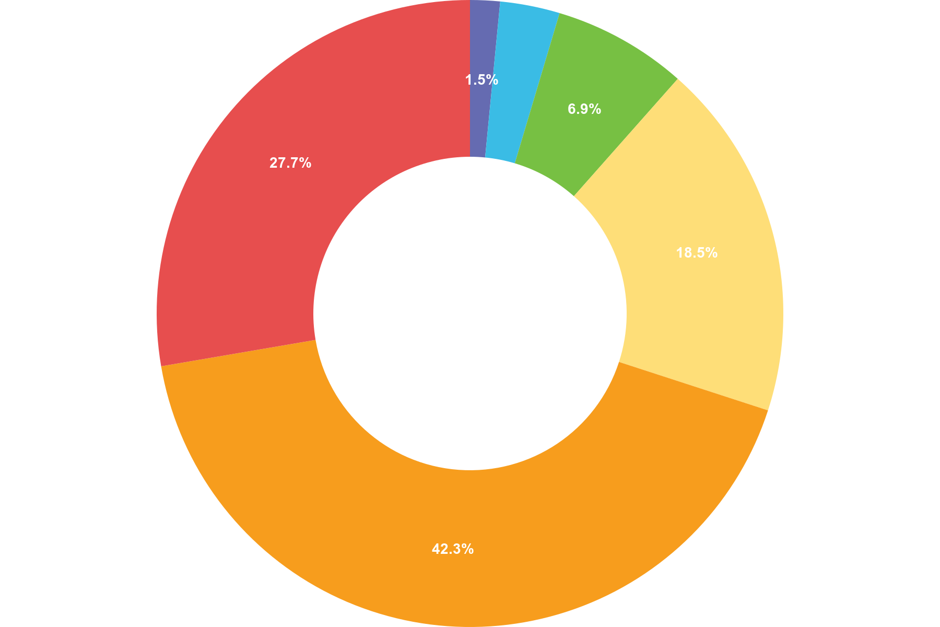
 | Value | Label | Rating | Total
• | 1 | Very Disagreeable | 2 | 2
• | 2 | Disagreeable | 4 | 2
• | 3 | Somewhat Disagreeable | 9 | 3
• | 4 | Somewhat Agreeable | 24 | 6
• | 5 | Agreeable | 55 | 11
• | 6 | Very Agreeable | 36 | 6
Responses 30 Answered 30 Unanswered 0 Rating Average 4 — Somewhat Agreeable

Q2 Have delivery companies become more reliable and trustworthy in recent years?
Rating
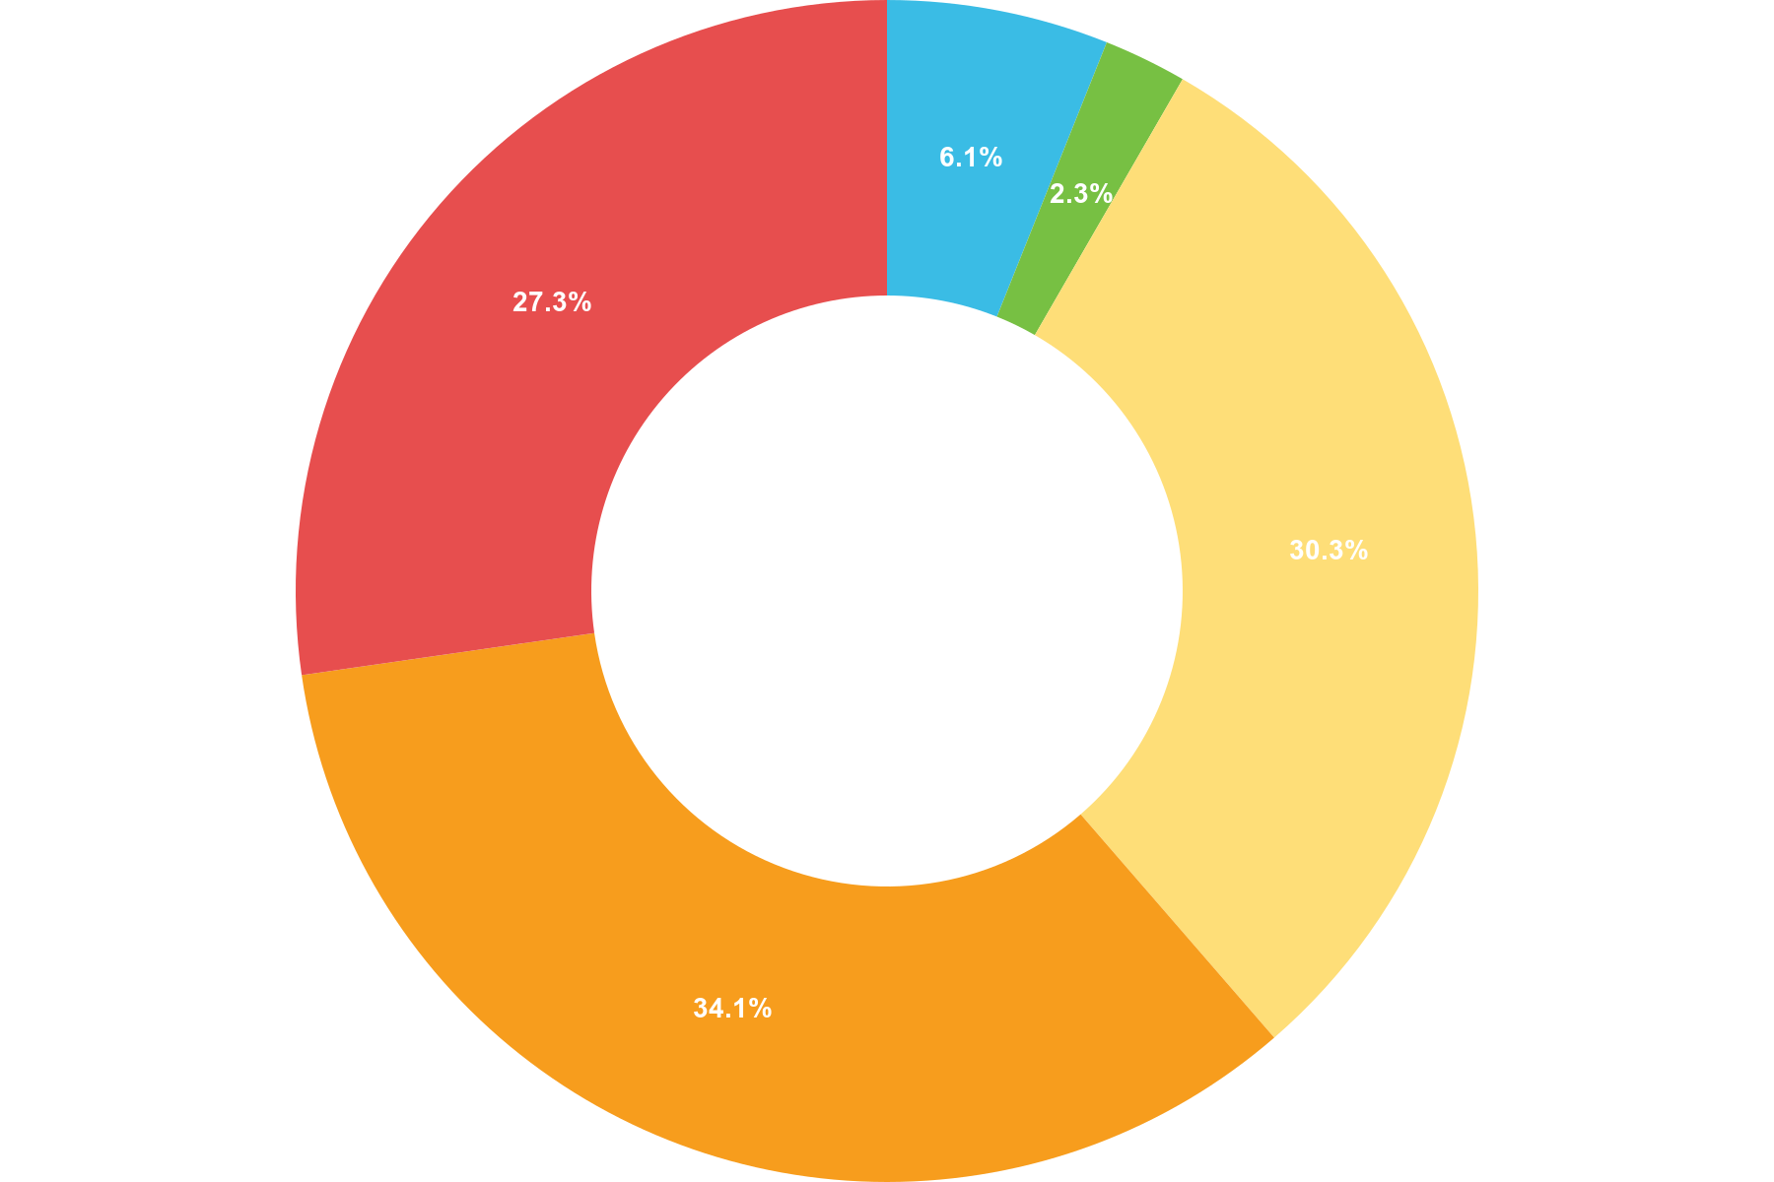
 | Value | Label | Rating | Total
• | 1 | Very Disagreeable | 0 | 0
• | 2 | Disagreeable | 8 | 4
• | 3 | Somewhat Disagreeable | 3 | 1
• | 4 | Somewhat Agreeable | 40 | 10
• | 5 | Agreeable | 45 | 9
• | 6 | Very Agreeable | 36 | 6
Responses 30 Answered 30 Unanswered 0 Rating Average 4 — Somewhat Agreeable

Q3 Have you become more dependable on parcel deliveries to your home?
Rating
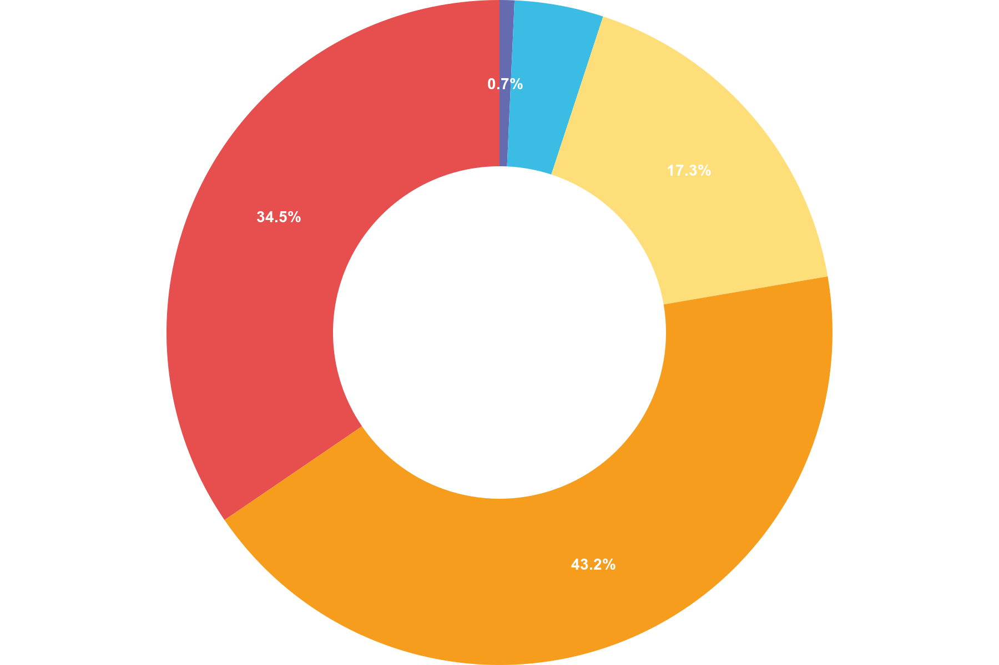
 | Value | Label | Rating | Total
• | 1 | Very Disagreeable | 1 | 1
• | 2 | Disagreeable | 6 | 3
• | 3 | Somewhat Disagreeable | 0 | 0
• | 4 | Somewhat Agreeable | 24 | 6
• | 5 | Agreeable | 60 | 12
• | 6 | Very Agreeable | 48 | 8
Responses 30 Answered 30 Unanswered 0 Rating Average 5 — Agreeable

Q4 Parcel companies have introduced time windows for their deliveries. Would you agree that this is helpful for the customers?
Rating
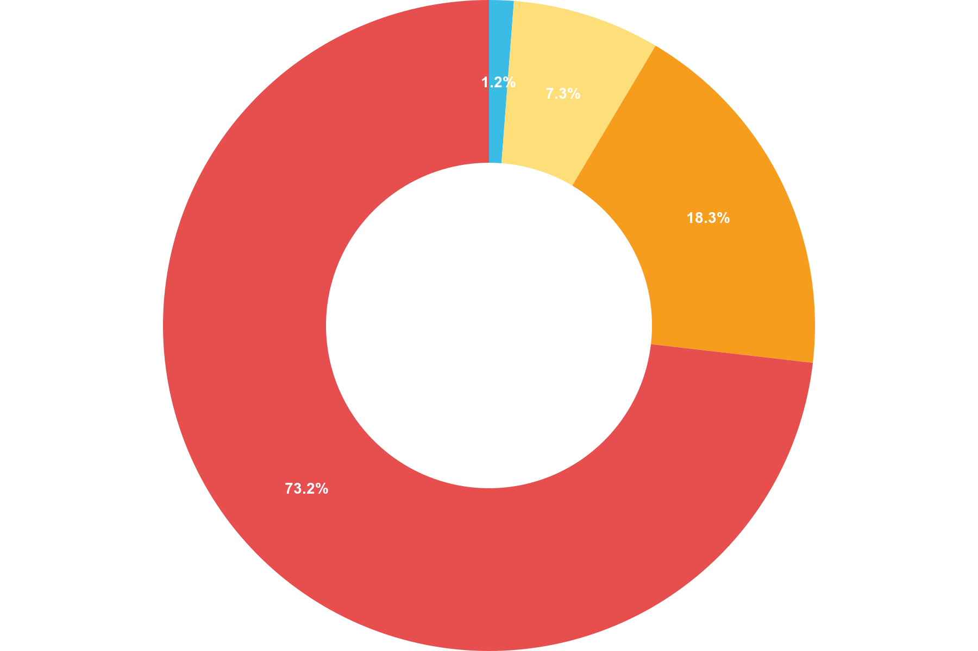
 | Value | Label | Rating | Total
• | 1 | Very Disagreeable | 0 | 0
• | 2 | Disagreeable | 2 | 1
• | 3 | Somewhat Disagreeable | 0 | 0
• | 4 | Somewhat Agreeable | 12 | 3
• | 5 | Agreeable | 30 | 6
• | 6 | Very Agreeable | 120 | 20
Responses 30 Answered 30 Unanswered 0 Rating Average 5 — Agreeable

Q5 Which delivery companies are you most likely to use? You can choose more than one.
Multiple Choice
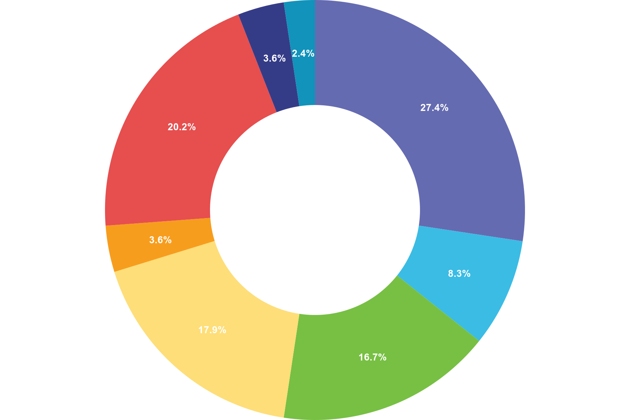
 | Choice | Totals
• | Amazon | 23
• | DHL | 7
• | DPD | 14
• | DX | 15
• | Evry | 3
• | Royal Mail | 17
• | UPS | 3
• | Yodel | 2
• | Any other | 0
Responses 30 Answered 30 Unanswered 0

Q6 During an average month, how often do you purchase items online?
Scale
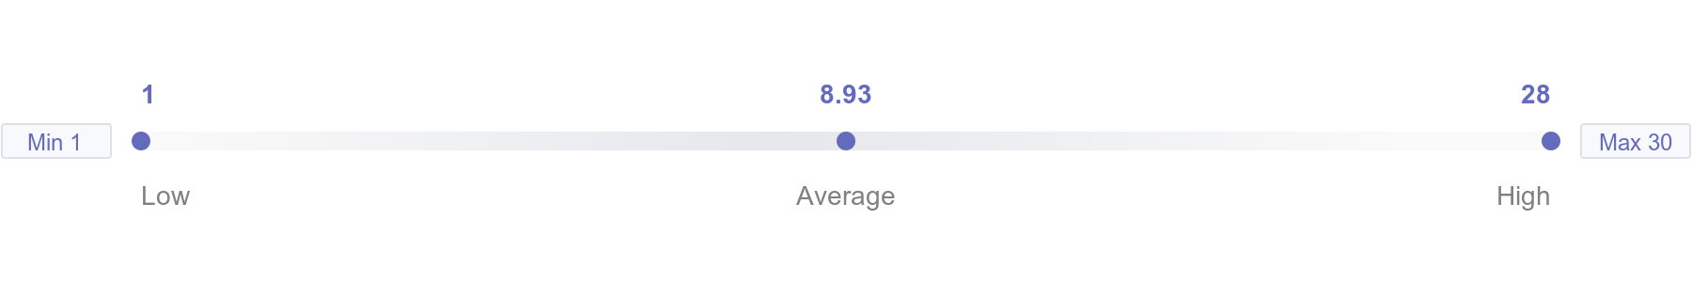
Responses 30 Answered 30 Unanswered 0

Q7 How satisfied are you with your most recent delivery?
Scale
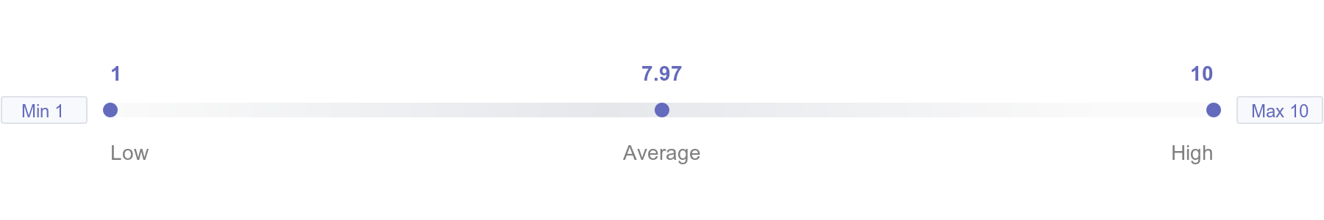
Responses 30 Answered 30 Unanswered 0

Q8 What is your opinion on drone and self-driving delivery?
Rating
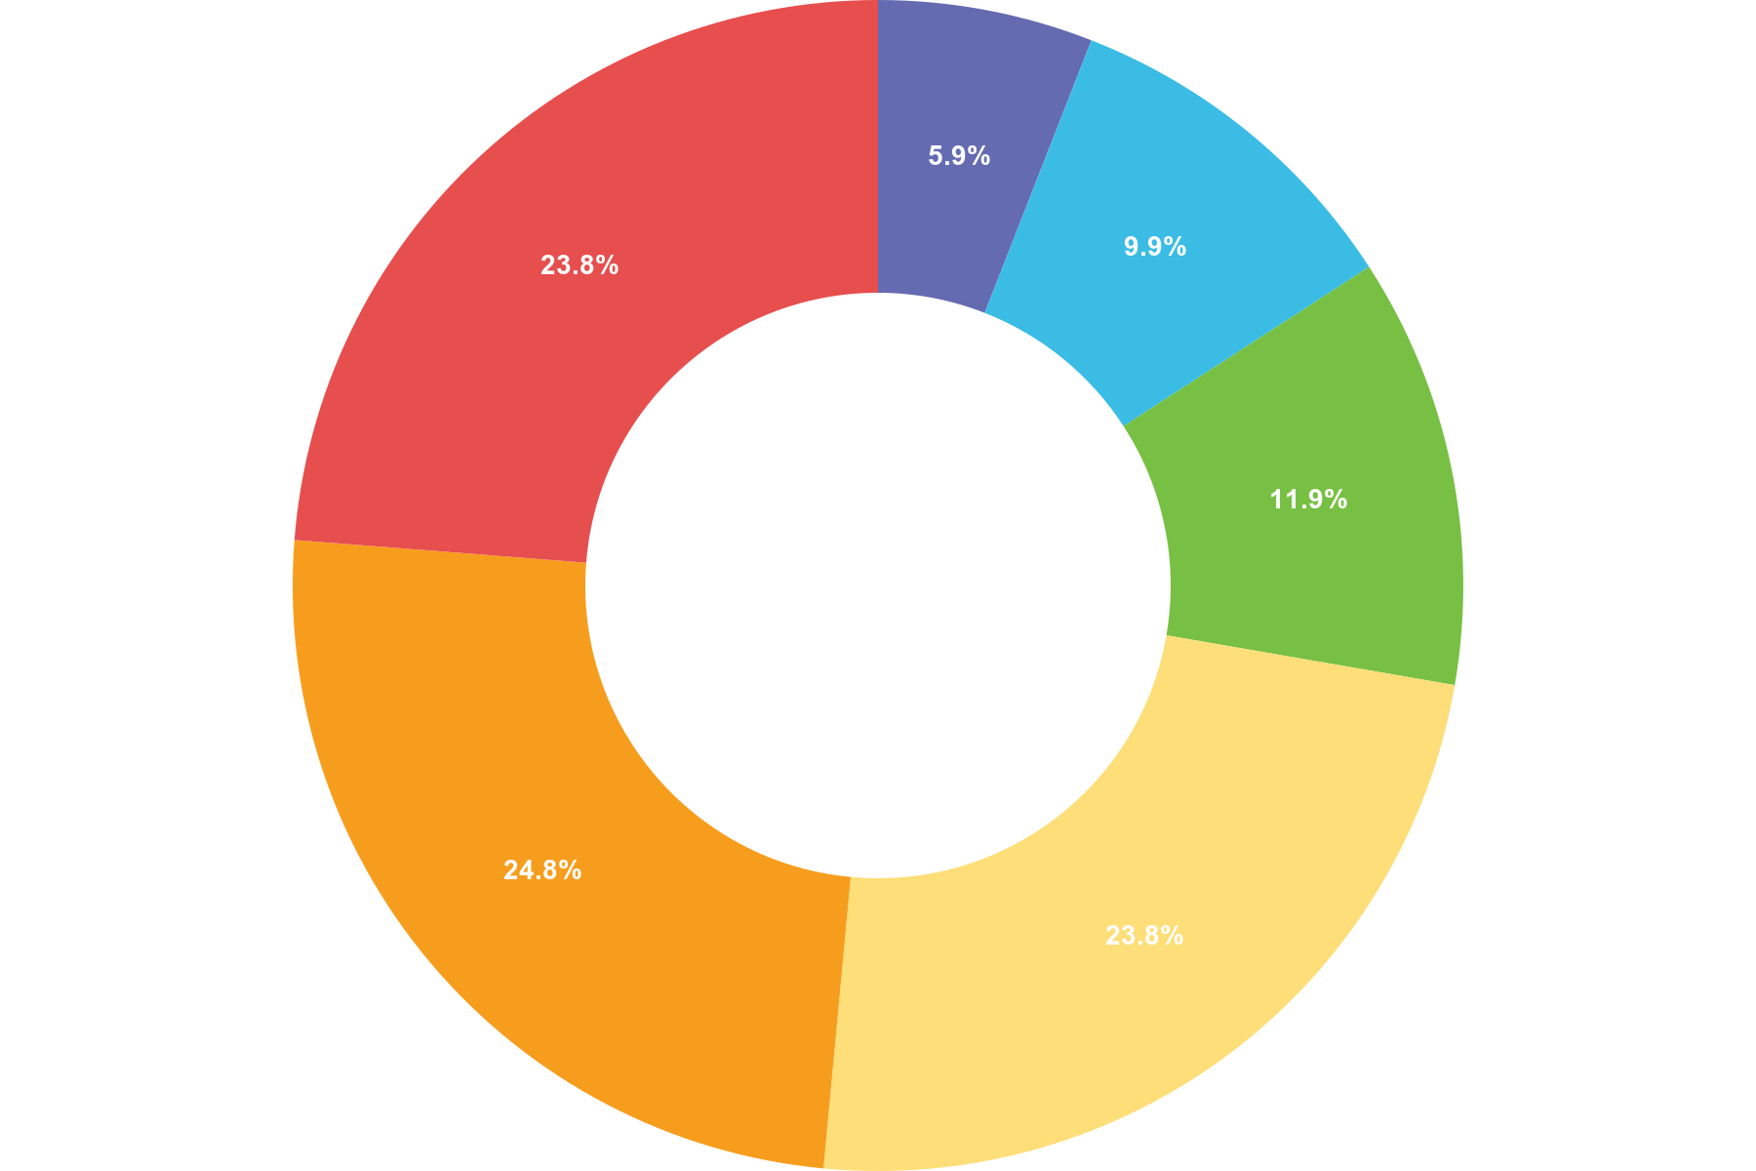
 | Value | Label | Rating | Total
• | 1 | Very Disagreeable | 6 | 6
• | 2 | Disagreeable | 10 | 5
• | 3 | Somewhat Disagreeable | 12 | 4
• | 4 | Somewhat Agreeable | 24 | 6
• | 5 | Agreeable | 25 | 5
• | 6 | Very Agreeable | 24 | 4
Responses 30 Answered 30 Unanswered 0 Rating Average 3 — Somewhat Disagreeable

Q9 Would you use drone and self-driving delivery in the future?
Rating
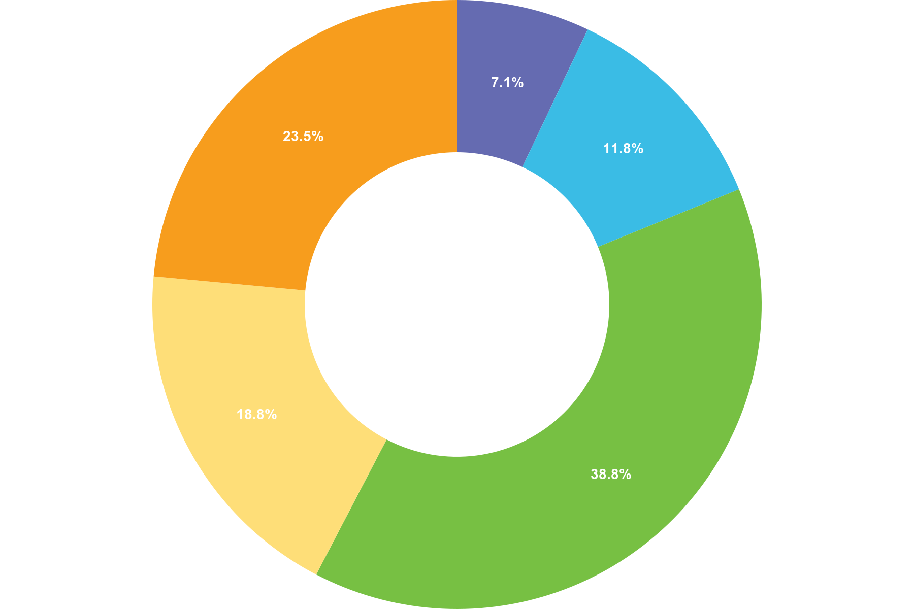
 | Value | Label | Rating | Total
• | 1 | Not at all likely | 6 | 6
• | 2 | Not so likely | 10 | 5
• | 3 | Somewhat likely | 33 | 11
• | 4 | Very likely | 16 | 4
• | 5 | Extremely likely | 20 | 4
Responses 30 Answered 30 Unanswered 0 Rating Average 3 — Somewhat likely

Q10 How likely are you to recommend DX Network to your friends and family?
Rating
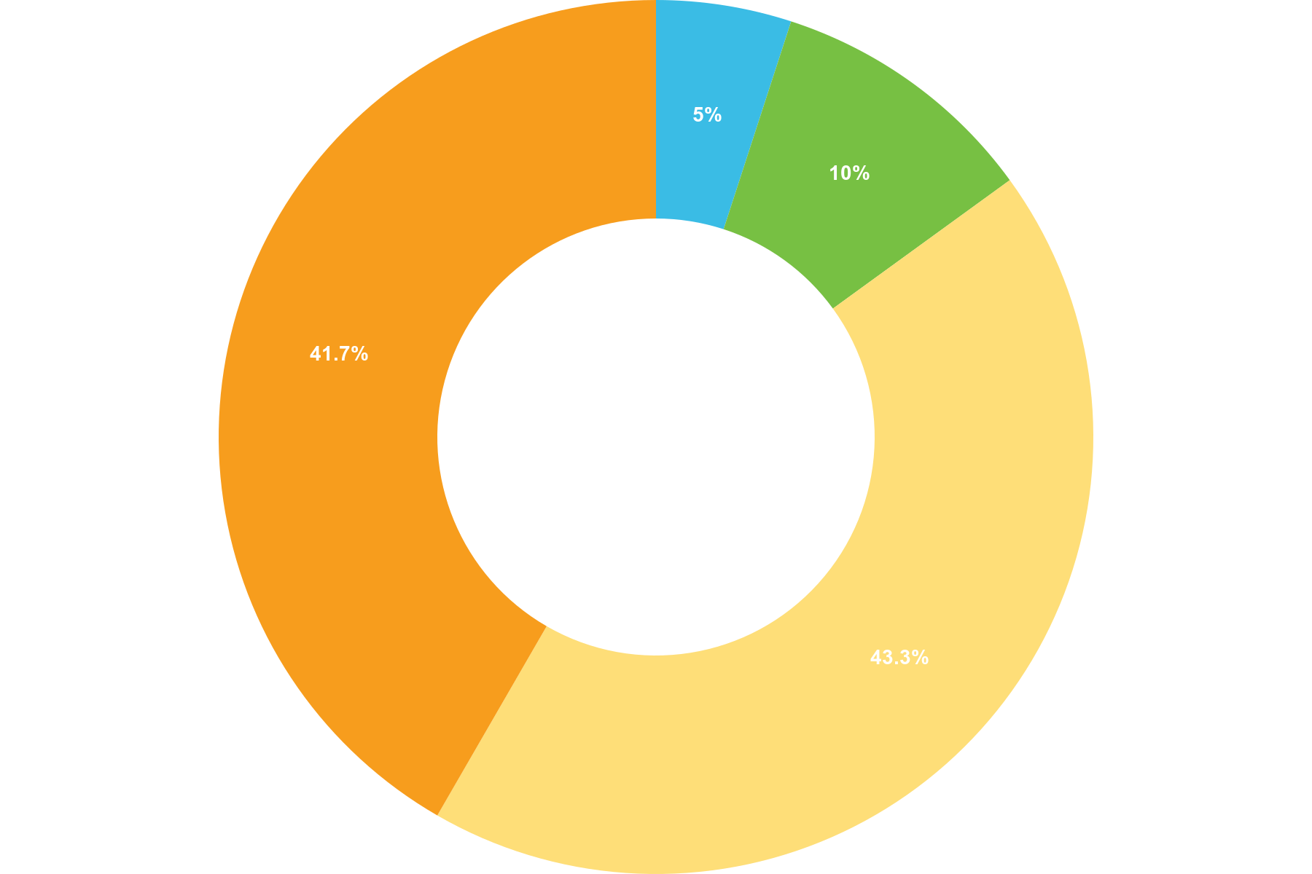
 | Value | Label | Rating | Total
• | 1 | Not at all likely | 0 | 0
• | 2 | Not so likely | 6 | 3
• | 3 | Somewhat likely | 12 | 4
• | 4 | Very likely | 52 | 13
• | 5 | Extremely likely | 50 | 10
• | 6 | Not aware of the company | 0 | 0
Responses 30 Answered 30 Unanswered 0 Rating Average 4 — Very likely

Analysis of the parcel industry in the UK, based on the survey results:
Q1: In your opinion, has the parcel industry improved over the last 3 years?
Rating Average: 4 (Somewhat Agreeable)
The majority of respondents (55%) rated the parcel industry as "Agreeable" or "Very Agreeable," indicating that they believe the industry has improved over the last three years.
Q2: Have delivery companies become more reliable and trustworthy in recent years?
Rating Average: 4 (Somewhat Agreeable)
Similarly, respondents rated delivery companies as "Somewhat Agreeable" in terms of reliability and trustworthiness. A significant number (45%) rated them as "Agreeable" or "Very Agreeable."
Q3: Have you become more dependent on parcel deliveries to your home?
Rating Average: 5 (Agreeable)
A majority of respondents (60%) indicated that they have become more dependent on parcel deliveries, rating it as "Agreeable" or "Very Agreeable."
Q4: Parcel companies have introduced time windows for their deliveries. Would you agree that this is helpful for customers?
Rating Average: 5 (Agreeable)
Most respondents (50%) found the introduction of time windows for deliveries to be "Agreeable" or "Very Agreeable." This suggests that time windows are perceived as helpful by customers.
Q5: Which delivery companies are you most likely to use? You can choose more than one.
Most popular choices:
Amazon: 23
DPD: 14
Royal Mail: 17
Based on the responses, Amazon was the most preferred delivery company, followed by Royal Mail and DPD.
Q6: During an average month, how often do you purchase items online?
Scale: The frequency of online purchases was 8.93 parcel per month.
Q7: How satisfied are you with your most recent delivery?
Scale: Satisfaction with the most recent delivery was 7.97 out of a scale of 10
Q8: What is your opinion on drone and self-driving delivery?
Rating Average: 3 (Somewhat Disagreeable)
Respondents expressed a somewhat disagreeable opinion towards drone and self-driving delivery, with the majority (28%) rating it as "Disagreeable" or "Very Disagreeable."

Q9: Would you use drone and self-driving delivery in the future?
Rating Average: 3 (Somewhat Likely)
Similarly, respondents were somewhat likely to use drone and self-driving delivery in the future, with a majority (44%) rating it as "Somewhat Likely."
Q10: How likely are you to recommend DX Network to your friends and family?
Rating Average: 4 (Very Likely)
Most respondents (62%) indicated that they were very likely to recommend DX Network to their friends and family.
Overall, the survey suggests that the parcel industry in the UK has seen improvements over the last three years, with delivery companies becoming more reliable and trustworthy. Customers have become more dependent on parcel deliveries and find the introduction of time windows helpful. However, there is some skepticism and uncertainty regarding drone and self-driving delivery, although a significant portion of respondents expressed a willingness to use it in the future.

Interviews

Three interviews were conducted for the research purposes. The first one is with a General Manager (GM) in the company, whose duties are managing the whole service centre, signing contracts with suppliers, customers and service partners. The second one is with an Operations Manager (OM). His responsibilities are supervising day to day activities, managing shift managers and co-working with service partners. The third interview is with a Master Subcontractor (MS) or also called Service Partner for DX. He supplies the company with couriers and manages them on the road.

- How has the company changed since you started work here?

GM: When I joined the business 3 years ago the company had just started to reshape its model, due (in part) to the loss of the HMPO (Passports) contract. To reposition itself as mainstream domestic carrier the business has had to radically change the way in which it operates in order to compete in the new, highly competitive market place.

The four main changes that have taken place during this period are:-

- Profile of the work we now collect & deliver.
- Client Expectation.
- Performance Monitoring & Reporting
- Cost management.

The profile of the work has changed dramatically. Just prior to me joining the business we were a small parcel & document carrier & whilst we still carry some small items we have seen a significant increase in both the size & weight of the packages that we now deliver.

Client expectations have changed, with some of the change being driven by the development of technology. Clients now (through the introduction of the ETA notification system) are advised through their mobile devices of a 2 hour delivery window. This allows them to plan for the delivery but, the technology is not that advance that it can allow for genuine hold-up due to genuine delays, e.g.: traffic disruption.

Performance monitoring & reporting, as a result of the introduction of these new technologies (mentioned above) we have seen significant focus on the real time “On Road Management” of our couriers. This has resulted in an increase of workload on our UTR support staff, an increase in the scrutiny of courier movements & a significant increase in our performance reporting.

Cost management, as the roll out of technology advances we have see a significant increase in data available that allows the business to scrutinise each & every courier movement. As a result, we have see a significant increase in the amount of financial management reporting.

OM: DX has changed loads in the past 6 years that I have work for them, we use to have separate routes like Network routes and Secure routes, now we have integrated them into what they call oneDX routes.

MS: I started working with DX as a self-employed driver in 2012 and became a master sub-contractor 5 years later. In the beginning drivers used to have a lot of freedom on how to proceed with their day. Some couriers worked with cars, other with small vans. You could choose at what time to start your working day and the order in which you will deliver your parcels. Your contract was with DX directly, not with a sub-contractor or agency. With time, all of the mentioned privileges were removed. Vehicles have become bigger and the price per item has dropped. Although the company has expanded, the working conditions for drivers have deteriorated badly.

- How have Brexit and the pandemic changed the parcel sector in the UK? How has the Business changed and adapted?

GM: There are several questions there.

We are a domestic carrier so Brexit had little impact on our core business as there was no need for us to re-train customers/couriers on the requirements of export documentation however, Brexit has had a significant impact on the availability of staff & courier resource. This has made in harder for both ourselves & our service provider to recruit.

Given that we are a service provider the pandemic had a significant impact on our business. Firstly, because we are a service provider our teams & service providers worked through the whole period of the pandemic & indeed supported the National response by moving a significant amount of testing samples between NHS trusts & from customer residence to major test centres located around the country. It was also a stressful time for our staff & the majority of our service providers as most of whom are foreign nationals who separated from family back home were unable to travel & visit family.

How did we change & adapt, If I’m honest, I’m not sure that we did or have changed or adapted. The pandemic was a once in a life time event, we were all so busy focusing on what we needed to do & the ever changing landscape we never found the time to stop or reflect. I do however think that there is (certainly on my part) an appreciation of the support & good work that both staff, service providers & their teams gave during this period.

OM: even know the pandemic saw a lot of the retail stores close it didn’t really slow down that much for DX as when the population was staying home, they were buying from the internet, so we had more B2C then we had B2B.

MS: Brexit has changed the landscape for human resources in the sector. The parcel industry has always relied heavily on workers from Romania, Bulgaria and Poland and UK’s split from the EU was bound to have a great impact. The new strict rules meant that less people from those countries will come to the country seeking work. Lots of people living here also felt not welcomed in the country anymore and left. This left a void in the market and a shortage for skilled couriers. Unfortunately parcel delivery companies did little to nothing to tackle those issues. They continued with their route on changing from employed to self-employed work and cuts on spending.

- What is DX doing well?

GM: We are in the business of moving time sensitive packages & parcels, on average around 160K items per night & achieve a national service standard of around 97% so, we are delivering 155K items successfully.

OM: No answer

MS: DX is good at what it does, especially with the limited resources it has compared to the big parcel companies in the country. It has a good customer satisfaction rate and is trusted by its main partners.

- What could the company be doing better?

GM: Remove the red tape & bureaucracy, collectively we have a business that has years of industry experience that we fail to tap into. Communication is one way & could be significantly improved by encouraging engagement.

OM: I believe DX needs to communicate with their Staff, Master sub co and their contractors better than they do right now. DX needs to be realistic and research the market better on pay structures.

MS: The company could enhance working conditions by listening to its employees. Improved conditions allow them to employ more qualified workers, strengthen road performance, and increase customer satisfaction.

- How would you go about improving on the things DX could do better?

GM: Empowerment, Engagement, Communication, Investment.

I would look to devolve more responsibility to a local level empowering the local management teams to have more control (within an agreed framework) to make decisions quickly, efficiently.

I would look to engage all stakeholders to understand all the challenges we face as a business. Armed with this information I would look to refine/simplify what we do & the services that we offer. I would look to establish a clear strategic plan with regards to our investment in technology so that it works for us & makes our lives easier.

Once a clear strategic pathway is established communicate it to all stakeholders & gain agreement & engagement.

Investment, we need to invest in the training/development of our staff building their skills, crating opportunity for personal/professional growth. We need to invest in our pay & remuneration for our employed staff attracting & keeping the very best people who will assist us in achieving/exceeding our business objectives.

As above, we need to invest in our supplier relationships through improved communication & support in terms of reward. We need to look at a payment model that would allow our suppliers to attract & retain the best in market.

OM: I would communicate a lot better; I would also research a lot more.

MS: I'd improve communication and teamwork. Effective communication is essential for an effective and harmonious workplace. Encourage people, teams, and departments to communicate in an open and transparent manner. I would facilitate collaboration by putting in place tools and platforms that make information sharing, project management, and teamwork easier.
I would rank the areas for development in order of importance and identify those that will have the most effects on the success and general performance of the business. I would prioritise resolving urgent issues first, taking into account both internal (such as operational inefficiencies, staff morale) and external (such as market trends, client needs) elements.I

- What issues is the company having at the moment? What would you do to address and solve them?

GM: The business is struggling to migrate from what it was (a small letter & document carrier) to a mainstream carrier moving much larger items. In the absence of a clear strategic plan we do well to achieve the level of services that we do however achieving a daily national service standard of around 97% falls well below that of a major competitors.

I would look to agree a clear strategic plan, refining the service/products on offer & have a clear pricing policy.

OM: With the lack of communication inside DX it is causing trust issues between staff, Master sub co and contractors which is leading them to leave the company. I would listen more to understand what the main issue is instead of thinking I am better than anyone else.

MS: The company is struggling to keep its most important asset- the drivers. Many people choose to quit after years of working there due to difficult working conditions. This would be the first thing I would address.

- What strategies would you use to increase market share of the company?

GM: To increase market share we would need to develop a clear marketing strategy & increase brand awareness through having all vehicles in company livery & all couriers uniformed. The introduction of a tangible courier lead scheme would also help support this.

OM: I would focus more on customer service and less on budgets. If you have excellent customer service, then profits will follow.

MS: DX needs to improve its reputation and market share among its suppliers. Taking up new business will improve market share immediately.

- What changes would you implement if you were given the CEO position for 100 days and freedom to act?

GM: In reality, 100 days isn’t a long time & in the role to which I am employed I do not have all of the detail to hand but…..

I would first need to get behind the numbers to understand the bigger picture & to understand how all of the separate parts of the business fit as we also have DX Freight & DX Ikea under the DX umbrella.

If I had more time it is possible that I would look to separate & sell off one or both divisions releasing the capital required to roll out an aggressive DXE expansion plan. This would include investment in more service centres, reducing service area size & increasing service capability, employing a clear marketing/branding strategy helping us to attract the very best people/suppliers to the business.

I would redefine our service offering by removing the timed services, change our pricing strategy from a consignment rate to a con & kilo rate to ensure revenues reflected cost. At the same time would redefine roles giving the local depots more autonomy over local decisions (within a framework) & regional directors more control over their regions (again, within a framework) & I would look at our supplier payment model to ensure it is a model that works for all parties & is not just focused on delivery but allows for collection activity too.

Once the issue above had been clearly defined then I would look at a roll-out plan (how we intend to communicate change) to all stakeholders.

OM: research the market on pay structure as I believe the better, we can pay the better service we can get from our employees and contractors.

MS: I would start by changing how the staff and their jobs are set up. In the company, there are a lot of people who have the same responsibilities and sometimes do the same work. I include the positions in management. This would free up money in the budget for investments and changes in areas that really matter, like marketing, relationships with service partners, and the reliability of deliveries. I would invest in software for the delivery scanners. The software that the couriers use is out of date and not as good as what the other companies use. This way, I could save time on the road and improve productivity.

- Where do you see yourself and the business in the next 5 years?

GM: Myself, it’s hard to say as I am approaching my twilight years however, I would like to use the time that I am with the business to help on the journey of evolution by changing mindset & approach.

The business has been established now for 35 years during which time the market place has changed significantly. If the business establishes a clear forward plan it has the potential to become a significant player in the domestic parcels market. In the time that I have been part of that journey some progress has been made, we have opened 5 new service centres strengthening our National reach & improving service within those geographical areas. A continuation of this level of investment coupled with a clear strategic plan, an investment in marketing/branding & investment in the training/development in staff & investment in supplier relationships could see the business become a significant player within the market place.

OM: I would hopefully in the next 5 years would be looking at being GM in one of DX depots.

MS: I see DX slightly increasing market share and solidifying its position in the UK parcel sector. As for myself, I don’t see myself still working with them or any other delivery company. Working conditions have deteriorated year after year over the last ten years. You could be fired at any time for no apparent reason, and job security is extremely low. A courier's employment was more regarded and well-paid. With rising fuel, vehicle, and insurance prices, it can be difficult to make even the country's minimal wage. As a result, many workers have left and pursued careers in other fields.

- How do you see the future of the parcel business? What is our opinion on alternative delivery methods- drones, autonomous vehicles, etc.? How do you see DX in this environment?

GM: I see there being more consolidation within the industry at which point I see there being a significant change in pricing policy as client expectation is out of kilter with the true cost of service.

On the issue of alternative methods of collection/delivery it’s a difficult one. The introduction & use of autonomous vehicles for trunking (bulk movement of goods from collection depot to hub to delivery depot) is something that will become a reality once governments, highways agencies & local authorities are satisfied that all safety concerns are being met.

However, I’m unsure as to how the last mile door to door delivery service would work, a vehicle with multiple items/multiple stops, restricted access, pedestrianised areas, blocks of flats are numerous considerations/objections that would need to be overcome before this could become a reality.

On the use of aerial drones there would need to be a radical change as there are many safety considerations that would need to be satisfied including the impact that this amount of additional airborne traffic would have on airline safety, public safety, commercial building & property safety.

OM: A: I don’t like the idea, but I do believe this will come. DX will be one of the last companies to jump on this as they will wait for everyone else to see if this works before investing.

MS: Alternatives, in my opinion, will play an important role in the future. Door-to-door delivery would be tough to achieve, but there are other techniques and applications for drones and self-driving vehicles. If DX wants to stay competitive, they must find a method to include them into their regular routines.

The General Manager (GM), Operations Manager (OM), and Master Subcontractor (MS) interviews generated insightful information about the developments, difficulties, and potential outcomes for DX. The interviews revealed several key themes that highlighted the industry's dynamic nature and the areas where DX needs to advance to stay competitive.
The transition of DX from a niche domestic carrier of small packages and documents to a mainstream domestic carrier is among the significant changes that have occurred. The nature of the work, client expectations, performance monitoring, and cost management have all changed as a result of this. In addition to implementing technology-driven systems for real-time monitoring and putting a strong emphasis on financial management reporting, the company has adjusted to larger and heavier packages. Challenges brought on by the transition include the need for recruitment and the availability of resources.
The UK's parcel industry has been further impacted by the pandemic and Brexit. While Brexit had little effect on DX's primary domestic transportation business, it had an impact on the availability of staff and courier resources. On the other hand, the pandemic offered both difficulties and opportunities. To meet these challenges, DX could benefit from improved communication, an understanding of market trends, and attention to problems with pay structures and working conditions.
The GM responded that DX has a successful delivery rate of about 97%, highlighting the company's capacity to manage a sizable volume of time-sensitive packages and parcels. The Master Subcontractor praised DX's high level of client satisfaction and the relationship of trust they have developed with their key partners. However, both the GM and MS pointed out areas that needed improvement, like doing away with red tape, fostering teamwork and communication, and spending money on staff training and development.
The GM recommended investing in technology and supplier relationships, empowering local management teams, and involving stakeholders in order to address these improvement areas. The OM emphasised the significance of better pay structure communication and market research. The MS emphasised the requirement for better working conditions as well as spending on software and productivity.
The GM would concentrate on comprehending the bigger picture, improving the service offering, empowering neighbourhood depots, and investing in training, development, and supplier relationships if given the chance to serve as CEO for 100 days. Improved market research and communication would be the OM's top priorities. The MS would prioritise critical development areas, invest in software, and address working conditions.
Future success for DX will depend on its capacity to adjust to market shifts and competition. More consolidation in the parcel industry is predicted, necessitating a strategic approach to pricing and service offerings. Autonomous vehicle integration for trunking may become a reality, but last-mile delivery is still difficult due to various logistical issues. Additionally, the use of aerial drones raises safety issues and necessitates significant regulatory changes.
By utilising strategic planning, investments, and improved supplier relationships, DX has the potential to become a significant player in the domestic parcels market over the next five years. The GM expressed confidence in the company's expansion, and the OM hopes to become the GM of one of DX's depots. The MS did express concerns about the industry's deteriorating working conditions, and he indicated that he was considering a career outside of the delivery industry.
Overall, the interviews provided insight into the state, difficulties, and growth potential of DX. DX can position itself as a dependable and customer-focused parcel delivery company, able to meet the changing demands of the market and maintain its competitive edge, by addressing issues related to communication, working conditions, and supplier relationships.

Working, employment and traffic issues
In the 1980s, the industry of courier services hired competent personnel on permanent contracts for scheduled rounds during which they had some degree of authority over their schedule and route. They also had strong unions that could mobilise the employees to shut off supply to industries. The management of the staff has seen significant changes as a result of the steady entry of different multinational corporations, consolidation strategies among senders, and the expansion of time sensitive deliveries. The growing popularity of subcontracting by package delivery services has greatly increased the uncertain future of the drivers. This brings into question the absence of protection provided by UK government.
The International Labour Organization deems ‘dependent self-employed’ workers to be self-employed workers who do not meet one or more of the three following criteria: having more than one client, having the authority to hire staff and having the authority to make important strategic decisions about how to run their business (Williams and Lapeyre, 2017). Due to the mix and recurrence of performing and driving tasks, the lengthy or unusual working hours associated with distribution, and the low pay, the job of a courier is one with hard working conditions. Historically, the great level of autonomy that employees had when working outside of their companies' offices and the strong protection that UK contracts offered helped to counteract the negative effects. However, rising outsourcing is escalating job security threats. The transition from employment contracts to subcontracting agreements is affecting not just the status of the employees, but also the protections offered by the agreement and the obligations it carries. It would be easy to assume that the fact that delivery drivers in the United Kingdom have a business contract rather than an employment contract and this is the only factor contributing to their precarious job status. It goes without saying that drivers are significantly less protected when they are self-employed than when they are hired. In the UK, there are less social security benefits available to independent contractors than to employees. Furthermore, neither paid vacations nor unemployment benefits are now longer available to the self-employed. Contrarily, the contract of a person who is self-employed may be terminated without any stated justification or payment of damages.
The income of self-employed drivers compared to employees is usual lower for a given amount of hours worked. The typical delivery rounds of self-employed delivery drivers lasted nine hours on average, although they may go as long as fourteen hours. In actuality, subcontracting offeres a mechanism to get around the 35-hour workweek law. The self-employed delivery drivers' compensation was also calculated differently since they are paid for each box they deliver, ranging from £1 to £3, rather than by the hour, as is the case for employees. Furthermore, the subcontractors do not get compensation if they were absent, although under an employee arrangement the business is required to pay for leaves of absence when they are warranted. In the case of late or invalid delivery, their salary is also subject to a number of penalties.
Parcel delivery companies usually utilise subcontractors for longer and heavier routes, unforeseen replacements, as in the case of an insider strike, whilst employees take advantage of works committees, labour agreements, and labour organisations and are given easiest routes. Subcontractors and their couriers need to be able to deliver a lot of packages fast and at a good price in order to answer to the major sender’s requests for proposals. Cost-cutting is crucial for them because of their thin profit margins. A multitude of benefits are possible when costly employment contracts are replaced with subcontracting contracts, including savings on holiday pay, employer contributions, redundancy expenses, employee councils, etc.
Subcontractors are undeniably held prisoner by parcel delivery companies; they are unable to speak with senders directly or expand the amount of clients they work for. The interviews with subcontractors and managers in package delivery companies revealed that the first ones had little negotiation leverage with respect to prices, deadlines, and goals. It was claimed that the courier companies often breach subcontracting agreements or renegotiate them at a lesser price. The continuation of their contracts, either in terms of length or terms (wages, working hours), was not guaranteed to the workers of the subcontractors. Even though the latter are intended to be covered by long-term contracts, both the owners of subcontracting businesses and their workers run the same risk.
According to one of the interviews, the average tenure of end subcontractors is 4 years. As a result, small subcontracting companies experience many and frequent bankruptcies. The workers of these companies will feel the effects of this. The smaller a subcontracting company is, the bigger the job insecurity for a courier. The job uncertainty of delivery personnel is influenced by the scale of the businesses in which they are employed. Through its function in economic reliance, the scale of the company has an impact on the uncertainty of its workers as well. As was already said, a subcontractor has to be able to hire drivers in order to increase its customer base and decrease its reliance on its primary principal. Therefore, growing in size is essential to lowering reliance and, therefore, the danger of bankruptcy. The expanding number of intermediary businesses and the predatory activity of major players like Amazon and Hermes place couriers in an especially dangerous position as the final connection in the chain, in addition to the relative sizes of the corporations and the degree of economic dependency.
As an example, Amazon pays independent contractors a set wage for each day of 8 hours and 45 minutes of labour. It was highly recommended that intermediate subcontractors make sure their drivers deliver as many packages as they can during this time. In this manner, the rounds—which a few years ago consisted of between 70 and 120 package delivery stops—have increased to 150 deliveries without a wage rise. Some Amazon drivers in urban areas deliver over 400 parcels a day. Delivery drivers who didn't hit their daily volume goals or who got bad reviews from customers are fired by Amazon. Amazon (and companies like DX as well) established a network of dependent subcontractors to avoid its obligations in labour management, much more so than conventional shippers. Without hiring them, intermediate subcontractors oversee end subcontractors and just carried out Amazon's business strategy. They impose fines on subcontractors, chose which drivers to keep or fire, and put pressure on them to do more work for a given wage. The danger of bankruptcy for the subcontractors—who hired the drivers on long-term contracts—is also quite high unless they are holding additional contracts with other parcel companies. A permanent contract for a driver no longer provides protection against termination of employment and no longer ensures a stable salary. Along with the denser rounds, the drivers rotate through a different area once a week. Previously, they had regular rounds where expertise enabled them to set a route corresponding to the receivers' availability and finish early. Additionally, they have to stick to a specified schedules while being watched in real time. They are no longer faced with choices and making decisions. This has led to worsening work environment and even some drivers filing a class action lawsuit against Amazon in the US for “inhumane” working conditions.
Traffic and congestions issues is another topic to consider. Different cities across the globe have tried several approaches. The off-hour delivery (OHD) programme in New York City is an unusual example of multi-stakeholder collaboration among public and commercial sector partners, community activists, and trade organisations. The project's size and complexity necessitated stakeholder engagement to properly realise its objectives. It started as a little research study. Because of the possible economic and environmental consequences, the original concept was put into action in 2002. If fully financed, it is predicted that the programme may shift more than 20% of congested daytime freight traffic deliveries to off-hours (between 7PM and 6AM). The economic gains associated with reduced travel time, increased productivity, and significant pollution reductions would be enormous: $150-$200 million per year (Holguín-Veras et al., 2014)
Higher parcel shipping quantities and rates will likely pressure an already congested urban freight delivery system's final mile. Although it appears that vehicles attempt to avoid unauthorised parking and the majority of parking occurs in authorised spaces, a substantial quantity of unauthorised parking still occurs. Nevertheless, this phenomenon is difficult to comprehend. The data from parking tickets likely undercount instances of illegal parking (Iacobucci et al. 2022)

Alternatives and future
For consumers, every interaction is a first, and they naturally worry about things like reliability, safety, and success and change in cost. Customers are drawn to innovative delivery innovations, particularly when they can clearly observe the improvement over standard delivery methods. Furthermore, buyers always believe they have the right to be informed about the whole after-purchase journey, and they will be dissatisfied if the cost of delivery is comparable to the cost of the goods itself. Delivery companies should invest in cutting-edge delivery technologies, and e-retailers should provide clients a choice of shipping methods (Jamous et al., 2022)

Drones
The technology of drone delivery is currently undergoing rapid development and has the potential to completely transform the method in which we receive things. A drone is an unmanned aerial vehicle that can be controlled remotely, and in recent years it has gained popularity due to its potential to rapidly and effectively transport goods and services due to its ability to do so. Companies like Amazon, UPS, and FedEx have been experimenting with drone delivery as a means to deliver items to their consumers. As a result, there has been a significant amount of research conducted on the topic.
There are a lot of benefits that come with using drones for delivery. First and foremost, it is a more effective mode of transportation because drones are able to fly directly to the location of the shipment, bypassing any potential bottlenecks caused by traffic or other logistical challenges. This means that items can be delivered more quickly, which is especially helpful for deliveries of time-sensitive or urgent goods, such as medical supplies or commodities that cannot be stored for long periods of time. Additionally, drone delivery can help save money on energy costs and cut down on greenhouse gas emissions because it eliminates the need for delivery vans to make many stops, which in turn reduces the quantity of fuel that is used.
A further advantage of drone delivery is that it can reach areas that are difficult to access, such as isolated regions or catastrophe-stricken areas, where traditional delivery techniques may not be viable. Examples of such areas are remote regions or areas that have been affected by disaster. People who are in need of crucial commodities will now have the ability to receive them thanks to the ability of drones to fly over obstacles and reach locations that are tough to reach by road.
However, there are several issues that come along with drone delivery that need to be solved. The issue of safety is one of the most difficult difficulties. If a drone experiences a malfunction or collides with an obstruction in the air, the situation could become dangerous. This can be dangerous to both people and their property, particularly in metropolitan locations where there are a great number of both types of structures and people. Another issue that needs to be addressed is people's right to privacy, which could be violated when drones take pictures or videos of them without their permission.
In spite of these obstacles, it is anticipated that the utilisation of drones for the purpose of delivery will continue to expand as both technology and legislation evolve to become more accommodating. The Ministry of Defence and Military Aviation Authority in the United Kingdom have developed laws for the operation of drones, including the requirement that operators of drones adhere to particular safety recommendations. Regulations to ensure the safe operation of drones have also been enacted in other countries, which have followed a similar pattern.
In conclusion, drone delivery is an exciting new technology that shows great promise in its ability to revolutionise the way in which we get things. It makes delivery much quicker and more effective, it enables access to previously inaccessible locations, and it lowers the amount of carbon dioxide emissions produced. Concerns around security and personal privacy must first be resolved, however, before broad use of the technology can take place. It seems likely that, as the technology continues to advance, we will see an increase in the number of businesses using drone delivery as a method for delivering items to their customers.

Auto anonymous and self-driving vehicles
The use of a delivery method known as auto anonymous delivery is becoming increasingly common, particularly in this day and age of online shopping. It entails delivering packages to customers without any involvement from a person by employing robots or vehicles that are capable of driving themselves. It has the potential to revolutionise the way we get things, and it offers a number of benefits that are not available with traditional delivery systems.
Because autonomous cars have not yet been completely released, there have been no studies with realistic data on the costs that autonomous vehicles may save compared to conventional driving or human-driven autos. However, there are other arguments for why autonomous cars will save money on fuel and driver labour expenses. It should be noted that cost reductions in terms of fuel use and labour charges do not necessarily translate into total transportation cost savings
The fact that auto-anonymous delivery is more efficient is among the most significant benefits it offers. It is possible for robots and cars that drive themselves to manoeuvre through traffic and deliver packages more quickly than human drivers. This ensures that clients can receive their items promptly, especially in densely populated urban regions where there is a higher likelihood of delays due to traffic congestion. The necessity for human drivers is removed, which results in a reduction in the amount of time and money that is spent on labour by businesses. As a result, the cost of auto anonymous delivery may be lower.
Customers benefit from the added convenience that comes with auto-anonymous delivery, which is another perk of this service. Customers do not need to be present in order to receive their packages if they opt for this kind of shipment delivery. The delivery can be delivered straight to the customer's doorstep or to a predetermined place by the car or the robot, and the customer can choose to retrieve it whenever it is most convenient for them. Customers no longer have to wait at home for a delivery or make other arrangements for someone else to receive the product on their behalf because this eliminates the necessity for them to do so.
There is also the possibility of a decrease in carbon emissions brought about by anonymous delivery automated systems. Electric power is more environmentally friendly than fuels derived from fossil fuels; therefore, the use of electric power to power autonomous vehicles and robots will result in a less carbon footprint. This is of utmost importance in light of the fact that an increasing number of people are turning to online shopping, which might lead to an increase in the number of delivery vehicles on the road.
Despite the fact that there may be certain benefits to using auto anonymous delivery, there are also some issues involved with it. The issue of safety is one of the most significant obstacles. In order to ensure that packages are delivered without incident, autonomous cars and robots will need to be able to negotiate congested areas and sidestep obstructions. There are also issues over cybersecurity, as there is a possibility that cybercriminals could interfere with the delivery system, which will put the shipments' safety at risk.
The possible effect on employment is still another obstacle to overcome. It is possible that jobs for human drivers and delivery people will be eliminated as a result of the widespread use of auto anonymous delivery. It's possible that this will have enormous social and economic repercussions, particularly for people working in the delivery and logistics businesses.
In conclusion, anonymous package delivery by autonomous vehicles is an exciting development in technology that possesses the potential to revolutionise the way in which we receive things. It has many advantages, such as a delivery service that is quicker and more effective, an increase in convenience for the clients, and a decrease in carbon emissions. However, there are other problems that need to be solved, such as worries about people's safety and the possibility of people losing their jobs. It is essential, in light of the ongoing development of technology, to take into account the social and economic implications of auto-anonymous delivery and to make efforts to offset any potential adverse effects.

Locker delivery
Due to the rise of e-commerce and urbanization, there is a huge increase in last-mile deliveries. World Economic Forum (2020) predict that the demand for last-mile delivery will grow by 78% by 2030. This represents an additional 36% of vehicles on the road worldwide. The last-mile delivery system has shown automated parcel stations as a sustainable and cost-effective solution (Wahab et al., 2022). The use of parcel lockers as a substitute for door-to-door delivery is on the rise in the logistics sector. An automated parcel locker system, also known as an APLS, is a kind of parcel collection service that enables consumers to have their packages delivered to service providers and then retrieve them using digital pickup codes at any time of the day or night. Because automated service points are open twenty-four hours a day, seven days a week, queues tend to build less often at automated SPs than they do at attended facilities. This means that the usage of automated SPs may result in additional cost savings throughout the delivery process. In conventional models of package distribution, each receiver designates a single place at which they will be present to collect their package. However, when an APLS is used, many recipients may not have a strong preference among several delivery locations. For instance, a recipient may have equally convenient access to three different SPs along his or her commuting route from work to home if the parcel is delivered during the day, or to another SP at walking distance from his or her home if the parcel is delivered in the evening. Package lockers are self-service storage areas where clients may send and retrieve items independently of human assistance. Convenience is a major benefit of package locker delivery. Customers may select a locker in their current location and retrieve their packages whenever it is convenient for them. Many consumers who buy online prefer to have their purchases sent to a parcel locker instead of waiting in for a delivery person or setting up a certain delivery time. Locker delivery has the added benefit of being safe for your packages. Iwan et al. (2016) studied the customer viewpoint of parcel locker use. According to the report, 95% of parcel locker users are happy with the service. The safety of a locker has also been recognised as a feature, yet individuals believe that home delivery is safer than delivery to a locker ((Van Duin J.H.R. et al., 2019). There is no chance of package loss or theft because it is kept in a safe locker. To keep packages secure until they are recovered by their owners, many lockers have high-tech security measures like cameras and access control systems. When compared to standard home delivery, parcel locker delivery has a less carbon footprint. Due to the convenience of centrally situated parcel lockers, fewer delivery trucks will need to make house calls. Because of this, logistics firms may feel better about using parcel locker delivery since it helps minimise traffic and greenhouse gas emissions. Businesses may save money with package locker delivery, which is another benefit. A case study in Amsterdam found out that an area in Amsterdam, which is serviced by 7 couriers, could save €505.64 per day if parcel lockers were to be implemented (Van Duin J.H.R. et al., 2019). Home delivery via traditional methods might be costly due to the need for delivery drivers and special delivery vehicles. Delivery to a parcel locker avoids the need for these means, cutting down on delivery expenses. Businesses and customers alike can benefit from the low costs associated with parcel locker delivery. Parcel locker delivery has numerous advantages, but it may also have some disadvantages. Customers may be apprehensive to use parcel lockers, for example, since they have never used them before. In addition, there are certain places where parcel lockers aren't an option because of a lack of availability, such as rural or distant areas. Finally, package locker delivery is a viable, safe, and environmentally friendly solution for both companies and customers. Parcel locker delivery is poised to become an increasingly vital aspect of the logistics business as the prevalence of online shopping rises. Parcel lockers are revolutionising the shipping and delivery industry by providing a faster, cheaper, and more secure option for sending and receiving products.
Song et al. (2009) used the shipment data of a courier firm that was located in West Sussex in the United Kingdom. They discovered that using locker delivery rather than house delivery considerably decreased trip expenses and the average delivery time. If the receiver cannot be reached at home to take delivery of their package, the firm will give them a call and ask them to pick it up at the depot if they are unable to accept it at their house. Because the lockers are often placed considerably closer to the recipients than the depot, this approach helps to cut down on the average distance that recipients have to travel to reach their destination.
Parcel locker delivery solutions have significant cost-cutting possibilities across all product configurations and delivery zones, since the reduction in routing costs surpasses the compensation offered to pick up station owners. Parcel lockers provide considerable reductions in the service provider's carbon footprint as assessed by the number of vehicles utilised and the number of miles travelled. The savings in rural delivery regions are higher than in urban ones (Janinhoff et al. 2023)
The employment of service points with lockers for the delivery of packages is becoming more common in both Europe and the United States. As an example, as of the year 2014 in France, more than twenty percent of packages were already being delivered to lockers located inside of shops (Morganti et al. 2014). Since then, it is quite likely that a greater proportion of both automated and manned lockers have been used.
Future
With the rise of e-commerce and the increasing demand for online shopping, the parcel and delivery market has seen substantial expansion in recent years. With the global marketplace expanding, it is evident that the parcel and delivery industry will continue to play an important role in satisfying the demands of consumers and businesses alike. In this paper, I will look at the future of the parcel and delivery industry and the trends and innovations that will define it in the next years.
The growth of e-commerce is one of the most significant factors that will affect the parcel and delivery industry. As more people shop online, there will be an increase in demand for parcel and delivery services. Statista predicts that worldwide e-commerce sales will reach $6.5 trillion by 2023, up from $4.2 trillion in 2020. Factors such as the increased availability of high-speed internet and mobile devices, the emergence of social media marketing, and the expansion of e-commerce platforms will fuel this growth.
To meet this rising demand, parcel and delivery firms must invest in cutting-edge technologies and solutions. Automation will be a major focus, with corporations investing in self-driving cars, drones, and robots to streamline processes and boost productivity. Amazon, for example, has begun testing its Prime Air drone delivery service, which hopes to deliver products to clients in less than 30 minutes. Other organisations, such as UPS, Amazon and FedEx, are investing in automation technologies to improve their delivery capacities.
The increased emphasis on sustainability is another trend that will affect the future of the parcel and delivery company. Consumers are increasingly demanding greener and more sustainable delivery options as their concerns about climate change and environmental sustainability grow. As a result, parcel and delivery firms are investigating novel methods to minimise their carbon footprint and improve their environmental impact. Investing in electric and hybrid vehicles, using biofuels and other renewable energy sources, and investigating novel delivery models that lessen the need for transportation are all part of this strategy.
Simultaneously, the parcel and delivery industry is confronted with a number of issues, including growing costs, increased competition, and shifting consumer expectations. Companies will need to be agile and adaptable, with a focus on customer service and innovation, to remain competitive in this fast changing world. This will necessitate continual investments in technology and infrastructure, as well as a dedication to developing strong relationships with customers and partners.
Finally, the parcel and delivery industry is expected to grow and innovate in the coming years. With the advent of e-commerce and rising demand for online shopping, parcel and delivery companies will need to invest in new technology and solutions to suit their consumers' expectations. At the same time, businesses must handle issues such as rising expenses and environmental sustainability while focusing on developing strong relationships and providing exceptional customer service. By embracing these trends and difficulties, the parcel and delivery business can thrive in the coming years.
Conclusion
In conclusion, the research highlights the significant changes that have occurred in the courier services industry, particularly in the United Kingdom, over the years. The transition from permanent contracts to subcontracting arrangements has had a detrimental impact on the job security, working conditions, and overall well-being of delivery drivers. The once-strong unions and protections offered by employment contracts have been eroded, leaving drivers in precarious positions with limited rights and benefits.
The rise of subcontracting has allowed parcel delivery companies to reduce costs, avoid certain obligations, and exert control over the drivers. This has created a situation where subcontractors have little negotiation power, face breaches of agreements, and experience a higher risk of bankruptcy. The example of DX, with its network of dependent subcontractors, exemplifies the exploitative nature of this model, with drivers being subjected to intense workloads, unrealistic targets, and the constant threat of termination.
The research underscores the need for stronger protections and regulations to safeguard the rights and well-being of delivery drivers. Adequate safeguards should be put in place to prevent labour exploitation, provide fair compensation, and ensure decent working conditions. Additionally, addressing urban freight congestion requires innovative solutions and collaborative efforts between the involved parties. By addressing these issues, the courier services industry can strive for a more equitable and sustainable future for its workforce and the communities it serves.

References

Anastasiu, L., Gavriş, O. and Maier, D. (2020) Is human capital ready for change? A strategic approach adapting Porter’s five forces to human resources. Sustainability
Apex-insight. (2023). UK Parcels Market Insight Report 2023 - Apex Insight. [Online] Available at: https://apex-insight.com/product/uk-parcels
Benzaghta, M.A., Elwalda, A., Mousa, M.M., Erkan, I. and Rahman, M. (2021) SWOT analysis applications: An integrative literature review. Journal of Global Business Insights
Bieńko, A., Gajewska, M., and Gudanowska, A. (2020). The Impact of COVID-19 Pandemic on E-commerce Market: A Case of Poland. European Research Studies Journal
Chen, J., Chen, J., and Fan, Z. (2021). Artificial intelligence for business process management: A systematic literature review. Decision Support Systems
Clarissia, S.M.S. (2020) A study on Ansoff Matrix Technique: As a growth strategy and an adaptive learning technique adopted in the leading brand of products. BIMS Journal of Management
Cleberg, C. (2019) Strategic Success: The Ansoff Matrix vs. the Balanced Scorecard.
Cuschieri, C., and Grech, A. (2021). How parcel industry responded to the COVID-19 pandemic: An exploratory study. Journal of Transport Geography
De Lyon, J. and Dhingra, S., 2020. Covid-19 and Brexit: Real-time updates on business performance in the United Kingdom. Centre for Economic Performance, London School of Economics and Political Science.
DX Network Services (2023) About Us. Online Available at: https://www.dxdelivery.com/about
Dxdelivery. (2022). 2022 Highlights. [Online] Available at: https://investors.dxdelivery.com/websites/dxgroup/English/4010/2022-highlights.html [Accessed 14 Apr. 2023].
Edwards, D., Trigg, L., Carrier, J., Cooper, A., Csontos, J., Day, J., Gillen, E., Lewis, R. and Edwards, A., 2022. A rapid review of innovations for attraction, recruitment and retention of social care workers, and exploration of factors influencing turnover within the UK context. Journal of Long-Term Care
Fraiberger, S.P., and Koster, P.R. (2021). The impact of the COVID-19 pandemic on the demand for city logistics services: Evidence from the parcel delivery sector in Amsterdam. Transportation Research Part A: Policy and Practice
Fuchs, M., Řezáč, M. and Soušek, R., 2021, November. The overall cumulative impact of covid-19 and Brexit on European supply chains. In 2021 New Trends in Aviation Development
Ghose, A., Ipeirotis, P., and Li, B. (2021). Leveraging parcel industry growth during the COVID-19 pandemic: Evidence from online shopping data. Journal of Marketing Research
Hamilton, J. (2020) The strategic change matrix and business sustainability across COVID-19. Sustainability
Holguín-Veras, J., and Le, L. (2021). Understanding the parcel industry during the COVID-19 pandemic: A case study of New York City. Case Studies on Transport Policy
Holguín-Verasa J, Cara Wanga, Michael Browneb, Stacey Darville Hodgec, Jeffrey Wojtowicz (2014) The New York City Off-Hour Delivery Project: Lessons for City Logistics
Hughes, J., and Allen, S. (2022). Exploring the impact of e-commerce on the logistics and parcel industry: A systematic review. International Journal of Logistics Management
Iacobucci E, Noreen McDonald, Charles H.W. Edwards, Ruth Steiner Using social media to understand challenges faced by US urban parcel (2022) delivery drivers: Reports from the curb
Jamous R, Kerbache L, Al Omari A (2022) Bridging the parcel delivery last mile gap in Qatar: Challenges and enhancements
Janinhoff L, Robert Klein, Scholz D (2023) Multitrip vehicle routing with delivery options: a data‑driven application to the parcel industry
Jatmiko, B., Udin, U.D.I.N., Raharti, R., Laras, T. and Ardhi, K.F. (2021) Strategies for MSMEs to achieve sustainable competitive advantage: The SWOT analysis method. The Journal of Asian Finance, Economics and Business
Johnson, S., and Prakash, S. (2019). Brexit and Logistics: Challenges and Opportunities for UK Road Haulage Firms. Transportation Research Procedia
Khajezadeh, M., Niasar, M.S.F., Asli, S.A., Davari, D.D., Godarzi, M. and Asgari, Y. (2019) Application of neural network in portfolio product companies: integration of Boston consulting group matrix and Ansoff matrix. International Journal of Economics and Management Engineering
Kim, K., and Kim, J. (2021). Building Omni channel customer experience with artificial intelligence: The role of chatbots in the hotel industry. International Journal of Information Management
Maniam S, Muhamad Saufi Che Rusuli, Mohd Fathi Abu Yaziz, Kasmaruddin Che Hussin, Wan Mohd Nazdrol Wan Mohd Nasir (2022) The Impact of Autonomous Vehicles in Parcel Industry in Kedah
Matthews, R. and Anicetti, J., 2021. Offset in a post-Brexit world. The RUSI Journal
Meloto, C. B., and Janssen, M. (2020). User experience design in government: A systematic literature review. Government Information Quarterly
Mircheva R. "A Crisis within the Crisis: The Impact of Covid-19 and Brexit on Supply Chains in the Pharmaceutical Industry". Izvestiya. Journal of Varna University of Economics
Mohamed M, Pärn E, Edwards D (2017) International Journal of Building Pathology and Adaptation
Morganti E, Dablanc L, Fortin F (2014) Final deliveries for online shopping: the deployment of pickup point networks in urban and suburban areas. Res Transp Bus Manag
Orenstein I, Raviv T, Sadan E (2018) Flexible parcel delivery to automated parcel lockers: Models, solution methods and analysis
Paraskevadakis, D. and Ifeoluwa, A. (2022) An industry-level analysis of the post-Brexit and post-Covid 19 Ro-Ro ferry market and critical maritime freight transport links between the UK and the EU. Journal of Shipping and Trade
Perera, R. (2020) Understanding Porter’s Five Forces Analysis
Stead, D., and Biehl, T.R. (2021). The role of parcel delivery in urban logistics during the COVID-19 pandemic. Cities
Song L, Cherrett T, McLeod F, Guan W (2009) Addressing the last mile problem: transport impacts of collection and delivery points. Transp Res Rec J Transp Res Board
Vanoli, A., and La Bella, A. (2021). The effects of Brexit on the British logistics industry. Maritime Economics and Logistics
Van Duina J.H.R., Wiegmans B, van Arem B, van Amstel Y (2019) From home delivery to parcel lockers: a case study in Amsterdam
Wahab S, Hye M, Ramakrishna Y (2022) Impact of Automated Parcel Stations on E-Commerce’s Last-Mile Delivery
Williams C, Lapeyre F (2017) Dependent self-employment: Trends, challenges and policy responses in the EU International Labour organization Working Paper
Zhong, X., Song, L., and Yang, F. (2020). Microservices architecture for digital transformation: Benefits, challenges, and best practices. Information and Software Technology

