


Network Management (NM)

WC February 24, 2014

Faculty of Applied Design and Engineering
School of Applied Computing
Mount Pleasant Campus
Swansea
SA1 6ED

- INTRODUCTION AND OBJECTIVES OF THE Exercises
As future Network Administrators who will be require to manage and troubleshoot network problems for any anomalies such as attacks. This case study will require of you to determine analyse a scan data from a system that was compromised. Apply your understanding and knowledge from what you have learnt in the lecture and as well as conduct research using text books, library databases, and/or the Internet to do the following questions:

Task 1:
- Imagine you are working on the computer networking team of a small company and you realize that an unauthoriised system has successfully connected to the wireless access point. All you know at the outset is the IP address of the wireless system. Figure 1 shows the network diagram.
Figure 1: Wireless Intrusion network diagram

You have used the Argus scanning tool to collect session data on all interface of the firewall/gateway. The session Data from the Wireless Segment is given below. The new IP address which appears from the scan result is in bold.
Session Data from the Wireless Segment

  - Examine the Argus data and state if you can track the Attackers movement.
The attacker tries to connect to 172.27.20.3’s SSH port and fails twice. Then the attacker connects to 192.168.60.3’s SSH port successfully for over 5 mins.
  - From what you have learnt in your network Management module, analyze and evaluate the company network diagram and list all the flaws you can identify in the design.

- There should be a main firewall sat in between the router and the internet.
- No redundancy between links
- Vlan1 used for Human resources.
- Wireless access point isn’t in a secure vlan

  - Redesign the company network to make it more secure and advance the company on best practice to avoid a similar occurrence in the future.

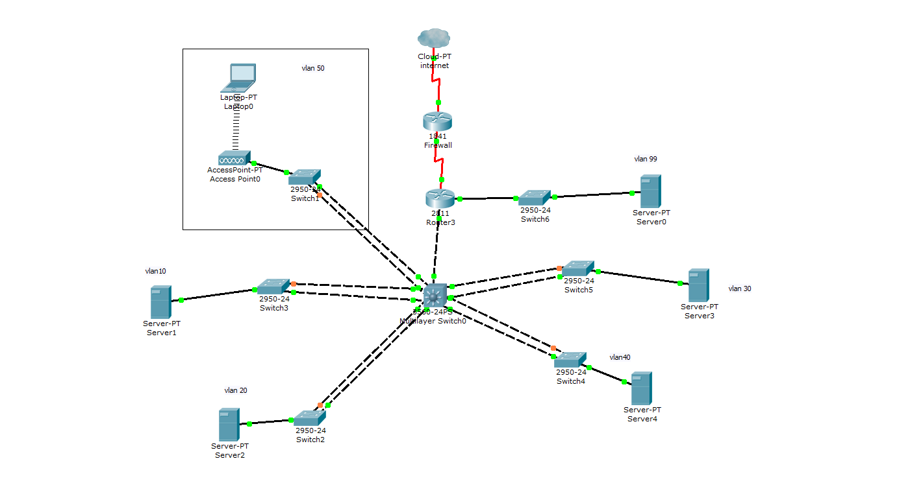

  - Can a network be 100% safe from internal and external threats? Give your reasons
No, there’s always a tradeoff between security and speed/usability. If a network is too secure it can become slow and unusable.

Work in groups of two or three, Present your findings & understanding to the class.

