
Applied Industrial Placement (SPORT)
M5X02295
Placement Portfolio Template

Student Name
Name – Rhys Surringer
P Number – P149723
Report
Title – Applied Industrial Placement
Word Count –
References (Total) –
Job Title –Sports Development Assistant
Organisation
Name – NPT Pass and Celtic Leisure
Address – NPT PASS, Margam Park, Margam
Celtic Leisure, Neath Sports Centre, Roman Way, Neath SA10 7BE
Email – NPT PASS – Mark.Napieralla@uwtsd.ac.uk
Neath Sports Centre – Mike.Bendyk@celticleisure.org
Telephone Number – NPT PASS 07967499965
Neath Sports Centre – 01639 640060
Line Manager
Name – NPT PASS Mark Napieralla , Neath Sports Centre – Mike Bendyk
Position – Manager
Email– Mark.Napieralla@uwtsd.ac.uk, Mike.Bendyk@celticleisure.org
Telephone Number – (As Above)

TASK A– (Reflective Learning Log 1 - 500 words – First Experience of Placement)
Recommend to link the reflective experience to two different key themes.
I decided to use two different placement providers to gain more experience and learn more about two different types of job roles.
My first placement provider at Neath Ports Talbot Physical Activity and Sports Service provides coaching sessions and events for schools and organisations in the Neath Port Talbot area, encouraging and developing a range of different sports projects and initiatives to young children with the aim of getting as many children active as possible. When I was first introduced to the team and got an induction to see how the program worked, I could see how much of an impact the NPT PASS team had on the physical wellbeing of young children in the area. Not only were they looking to get children active, but they made it enjoyable both for the staff and the children participating. One aspect of the job I was assigned to do was online marketing: social media is used to advertise all their programs and post about forthcoming events and the online ticketing system called Eventbrite is used, and this is a cheap and easy way to get information out about what is going on within the organisation. All the staff was very confident and knowledgeable and they all had their set roles and knew the tasks they were assigned to complete. It was a well organised set up, but very friendly and approachable.

‘The importance of social media in sport’ by Andrew Cave and Alex Miller for The Telegraph states:

‘By engaging fans via social media, sports rights holders can open new communication channels with their audience that can be measured and valued as a new commercial opportunity with sponsors. Businesses that get involved through sponsorships and social media promotions, meanwhile, benefit from increased brand affinity and loyalty.’

Eventbrite describes the benefits of using its services:

'Manage and analyse your event from anywhere: Access real-time sales and check-in data, manage and promote your event 24/7, from any device.

Reach new audiences and sell more tickets: Tap into the 50+ million active ticket buyers who use Eventbrite each year — while leveraging targeted event promotion, social sharing and industry-leading SEO.

Sell where your fans are: reach target consumers where they spend the most time online — and convert their interest into sales more easily with an end-to-end checkout on partner sites. Build a loyal attendee base: From a secure, 100% mobile-optimised purchase flow to rapid ticket scanning from any device, we make it easy to delight your attendees and keep them coming back.’
My second placement was with Celtic Leisure at Neath Sports Centre; here during my induction I was shown around the building and was told I was going to be able to shadow the manager and watch closely and see the day to day running of the sports centre and learn more about operational management. I could see how important health and safety was and how it played a major part in day to day activities, during the induction I had to read up on the Normal Operating Procedures and also the Emergency Action Plan in case of the event of an emergency.

In their book, 'Sport and Leisure Operations Management', Una McMahon-Beattie and Ian Yeoman state:
'Sports and Leisure Operations Management focuses on the operations management of games, events, experiences and activities within the world of Sport. All operations provide goods and services by devising processes which transform or change the state or condition to produce output. Sport and related activities are no exception. The operations manager is responsible for the activities, decision-making and duties associated with managing the transformation process.'

TASK A – (Reflective Learning Log 2 - 500 words – Mid Point Experience)
Recommend to link the reflective experience to two different key themes.
At the placement provider with NPT PASS, after being involved in a lot of the advertising and marketing and organising of various smaller events, the placement provider put me in charge of organising the World Cup Beach Football event at Aberavon beach. This was the organisation's biggest event of the summer, under the guidance of the manager, I sent out invitations to all the primary schools in Neath Port Talbot via social media and email; this proved to be a good method of communication as over 30 teams from different primary schools entered the tournament. After getting all the teams in, I then had to organise these teams into groups and set up the fixtures for each team to compete against each other, and sort out the schedule and structure for each game throughout the day. This had to be made simple and straightforward for each school to understand, to ensure the tournament ran smoothly; with over a 1000 children taking part it was extremely important that the event was well organised and well-structured with the correct number of staff members to supervise the children.
A useful book by Guy Masterman, ''Strategic Sports Event Management'' covers the planning and organisation of sporting events: 'The hosting of sports events – whether large international events, or smaller niche events – can have a significant and long-lasting impact on the local environment, economy and society.
Strategic Sports Event Management provides students and event managers with an insight into the strategic management of sports events of all scales and types, from international mega-events to school sports. Combining a unique conceptual framework with a practical, step-by-step guide to planning, organising, managing and evaluating events, the book explains the importance of adopting a strategic approach, showing how to implement strategies that lead to successful outcomes over the short and long-term.'

At my placement provider Celtic Leisure, I learnt a lot about how valuable customer service and standards were. Celtic Leisure aims to follow the customers on a journey from the moment they hear about the services to the first impression of the sports centre and then retaining them as a valued customer, they have guidelines in place as to how they send out their information and how they return customer enquiries, whether it be by telephone, via email or online. They also have set standards in place in how to deal with customers face to face. They want to keep the building clean and tidy, including outside in the carpark, so when the customers enter the site, they are greeted
with a clean and presentable atmosphere; this will create a good impression of the company. There are checklists to do daily, weekly and monthly to ensure the building is kept to the correct standards; the manager's or supervisor's job is to ensure the checklist and the jobs have been completed by the leisure attendants.
Ignacio Cepeda-Carrión, (Department of Business Management, University of Seville, Seville, Spain) concludes in 'How public sport centers can improve the sport consumer experience':
'...a sport center’s absorptive capacity for external knowledge is crucial for enhancing the sport consumer experience and also that this effect requires additional knowledge management, such as the sport center’s knowledge storage and knowledge application.

TASK A – (Reflective Learning Log 3 - 500 words – Mid Point Experience)
Recommend to link the reflective experience to two different key themes.
I was lucky enough to attend meetings at both NPT PASS and also Neath Sports Centre. There was a different approach in the leadership styles of both managers:
the manager of the NPT PASS team had a far more open approach with each member of the team having their say on the current situation, jobs they had coming up and their planning, and what they needed to complete the tasks. It seemed to be a far more relaxed and democratic approach, with everyone sharing their ideas and thoughts.
At Neath Sports Centre meeting it was quite the opposite, with the manager using a more autocratic approach in his leadership style; he was the sole speaker in the meeting, telling his staff what they needed to do and how to do it. This resulted in a totally different atmosphere amongst the staff at the two different placement providers.

'Leadership Styles and Frameworks You Should Know' by Kendra Cherry, discusses the different types of leadership styles and says that research done by psychologist Kurt Lewin 'found that participative leadership, also known as democratic leadership, is typically the most effective leadership style. Democratic leaders offer guidance to group members, but they also participate in the group and allow input from other group members.

TASK A – (Reflective Learning Log 4 - 500 words – Near end of Experience)
Recommend to link the reflective experience to two different key themes.
As my placement was coming to the end at NPT PASS, I felt as if I had settled in well within the company and enjoyed the planning of different events and seeing them unfold in a well-organised and structured way as well as seeing the children keeping fit and enjoying the different activities that were put on for them. We planned a transition day for the children of the new primary school in Briton ferry; this was designed so that the children could meet the pupils from other schools, so we had to organise team building activities. I was in charge on the day making sure the equipment, activities and coaches ran the event to its full potential. This was a chance for me to use my leadership and mentoring skills which I had acquired from the guidance of the manager of the placement provider.
During the end of my placement with Neath Sports Centre I was able to use my coaching qualifications, and run fun sessions during the school holidays. This was a good opportunity for me to work with young children, plan and lead sessions on my own, using the skills I have picked up from planning the events at NPT PASS and combining that knowledge to run a well-structured and enjoyable session.

'Mentoring is a way of developing leadership skills' by Blair Mcpherson, explains the benefits of mentoring for trainee managers:
'Mentoring isn't just one-way but an exchange that can help leaders develop their management skills... Developing as a manager is an ongoing process. One very effective way for a manager to continue their development is to identify a mentor. A management mentor is a guide, someone with greater experience and the wisdom that comes with it and someone who can offer impartial advice and support.'

TASK A – (Add 250 words on link to future Continued Professional Development and Reference list based on total referenced material in Task A)
Continued Professional Development post placement (250 words - Link to pre placement module)
I will be continually aiming to improve my knowledge and understanding of leadership and organisational skills, looking to gain more experience in running sports events and camps. I would like to work more with older children, so that I can work on more advanced coaching and development.
I would also like to gain more qualifications in coaching, and with women’s football improving, it would be good to gain more knowledge and understanding of the women’s game.
I would like to do more mentoring and help younger coaches develop and improve their knowledge and approach to coaching.

References from TASK A (10+ references)
- . https://www.telegraph.co.uk/investing/business-of-sport/social-media-in-sport/

- . https://www.eventbrite.co.uk/organizer/overview/

- . 'Sport and Leisure Operations Management': Una McMahon-Beattie and Ian Yeoman

- . 'Strategic Sports Event Management': Guy Masterman,

- . https://www.emeraldinsight.com/doi/abs/10.1108/IJSMS-02-2017-0008

- . https://www.verywellmind.com/leadership-styles-2795312

- . https://www.theguardian.com/public-leaders-network/2011/apr/29/mentoring-developing-leadership-skills

- .

- .

- .

- .

- .

TASK B – (YouTube Video – 10 x 1 min integrated video)(Experience, Roles, Improvements)
NOTE – Make sure the link works correctly
Website Link –

Link Password –

Video Duration –

Device used to create video –

Software used to create video –

Production contributors
Name | Position | Organisation

TASK B – (Picture Board – 5 pics(40MB upload limit to Turnitin)(Experience, Roles, Improvements)
Picture | Text (Paragraph)
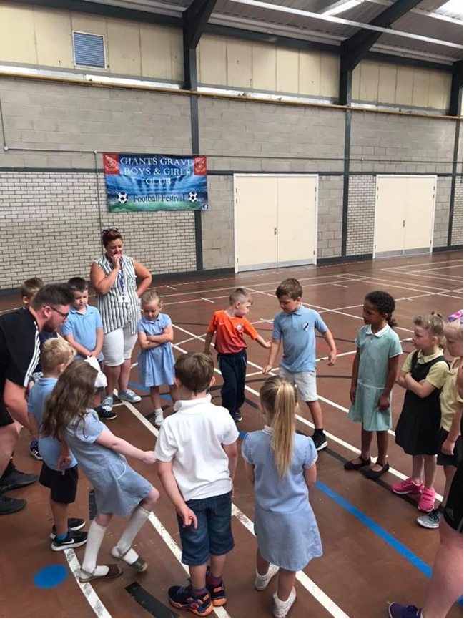 | At the NPT PASS team we organised transition days with different primary schools, that were going to attend the brand new super school in birton ferry, it was designed so we could do team building exercises so all the children could make friends and get to know each other.
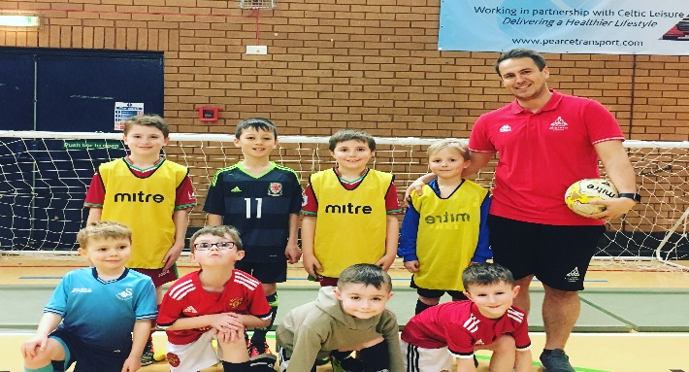 | One of my sports camps at Neath Sports Centre, where I got to coach young players football, it was a fun experience being able to get children out and having fun while developing their football skills.
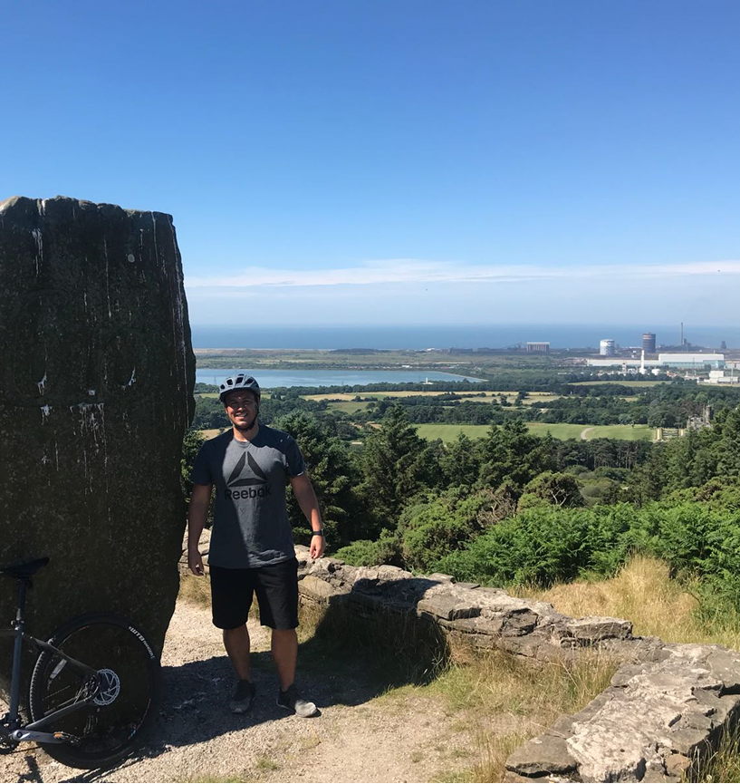 | During my time with NPT PASS, we had to cycle the different routes before taking the children to make sure the routes were safe, we wanted to find routes that were challenging and fun for the children to ride but also safe enough that nobody would get hurt.
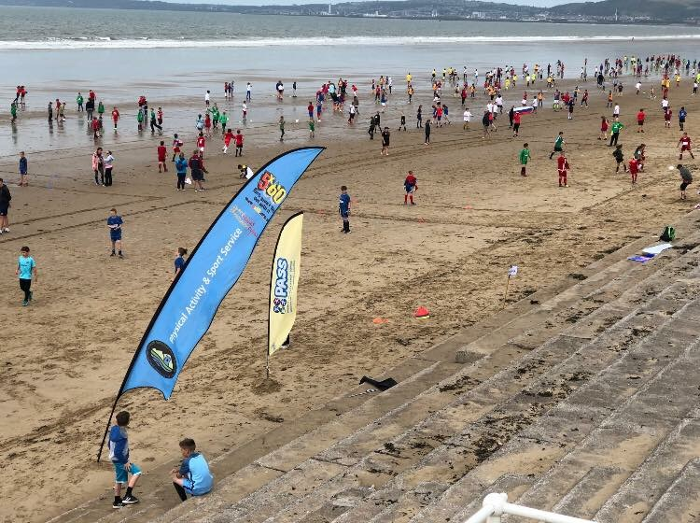 | This was the biggest event, NPT PASS planned this summer, the world cup beach tournament at Aberavon beach, over 1000 children took part from 30 different primary schools in Neath Port Talbot, with that many people taking part, it was important that everything was well organised and run smoothly.
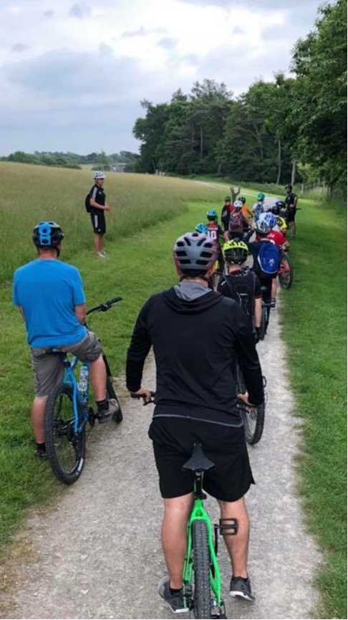 | One of the clubs with NPT PASS was mountain biking, it was important we had the correct number of staff on duty, to ensure all the students were safe while riding around the park.

TASK B – (Picture Board Cont.–5 pics (40MB upload limit to Turnitin)(Experience, Roles, Improvements)
Picture | Text (Paragraph)
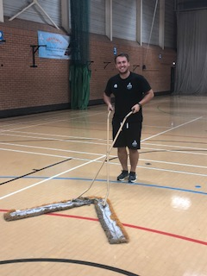 | The Sports Hall is used for multiple things through out the day, from fitness class, to indoor football, badminton and trampolining, it is very important the hall is kept clean and the equipment is set up and changed over in a timely fashion, so the clubs are not waiting around and the different activities can start on time.
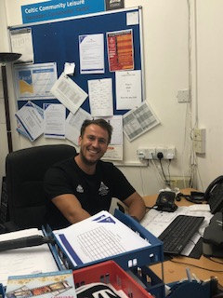 | In the back office, is where the manager works, I was asked to help contact sports clubs and take bookings for astro turf, and to contact other members who had enquiries about the gym or fitness classes.
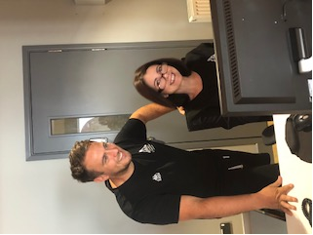 | I was asked to work on reception as part of my work placement, this is the first point of contact with customers, it is important to have good knowledge on all the aspects of the business, so everything will run smoothly, it is also important that you look presentable and have good customer service skills, when dealing with customers face to face and over the telephone.
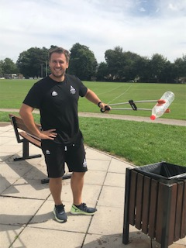 | Litter Picking is a task that was required to do everyday at placement, it is very important to keep the outside areas and car park, clean and tidy to give the customers a good first impression when entering or visiting the facilty.

TASK C Evidence – Employer Report (Signed),
NOTE – This will be compared against the report sent to the University.
NOTE – You will need to complete additional copies if you have more than one provider.

TASK C Continued Evidence – Employer Report (Signed),
NOTE – This will be compared against the report sent to the University.

TASK C Evidence – Ethics Form – Signed by Organisation and Lecturer
NOTE – You will need to complete additional copies if you have more than one provider.
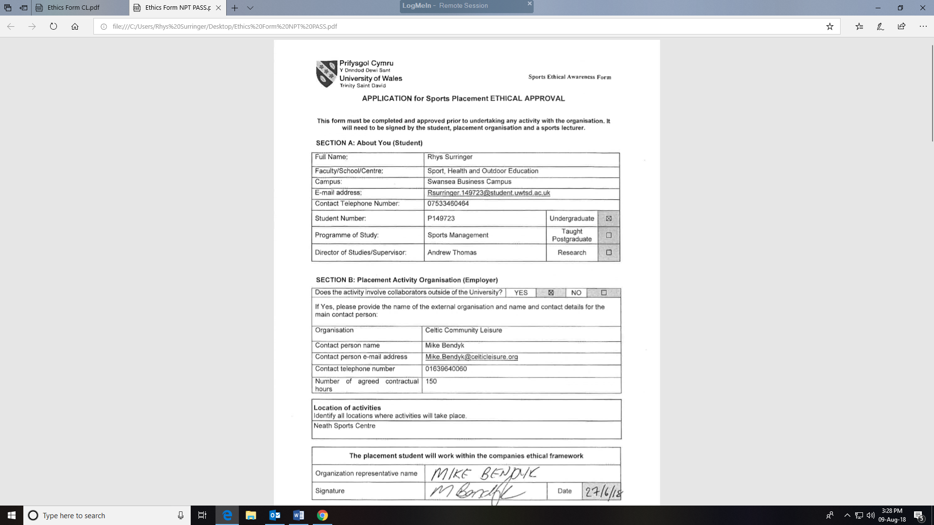

TASK C Evidence – Ethics Form Continued
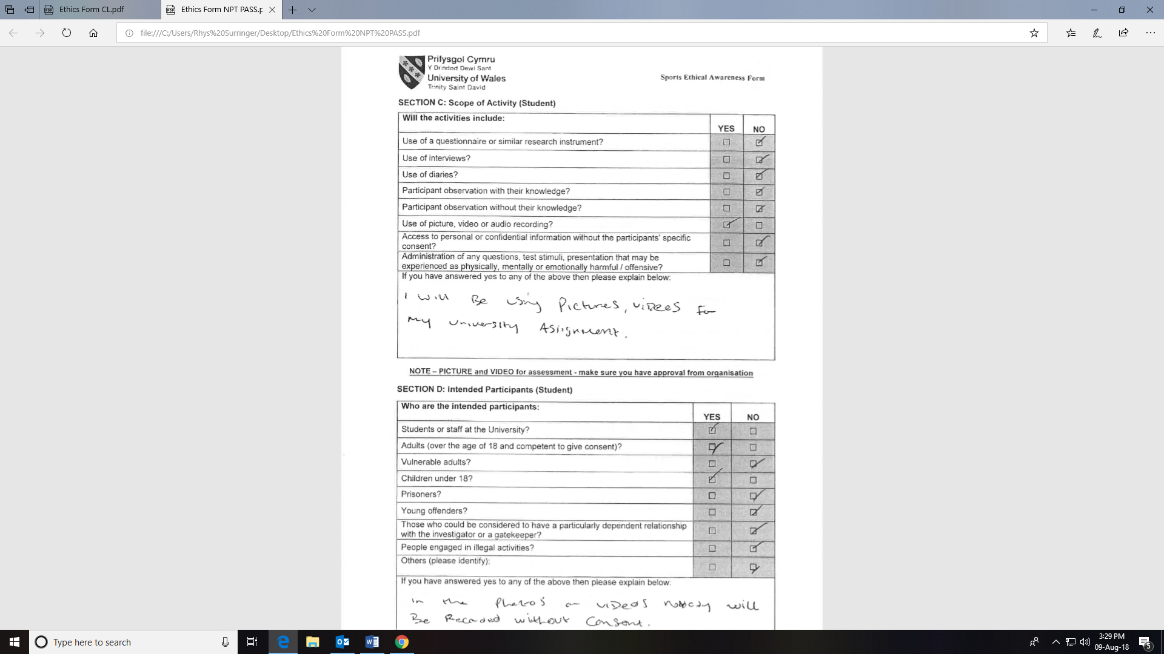

TASK C Evidence – Ethics Form Continued
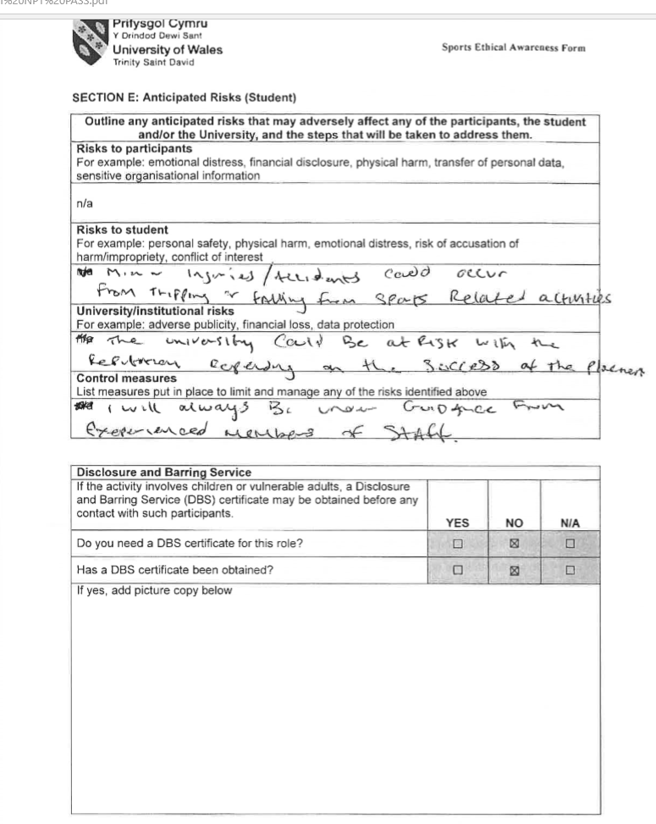

TASK C Evidence – Ethics Form Continued
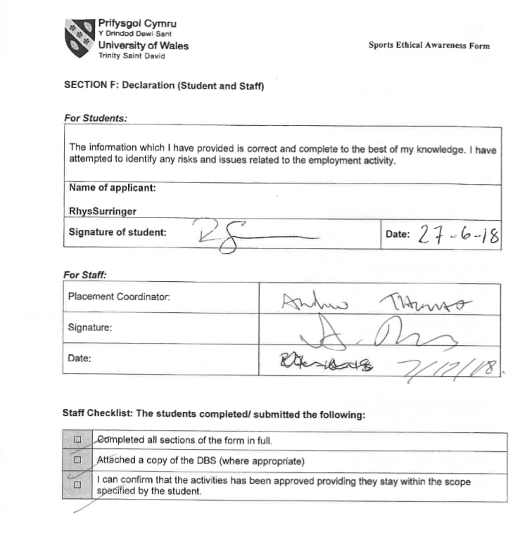

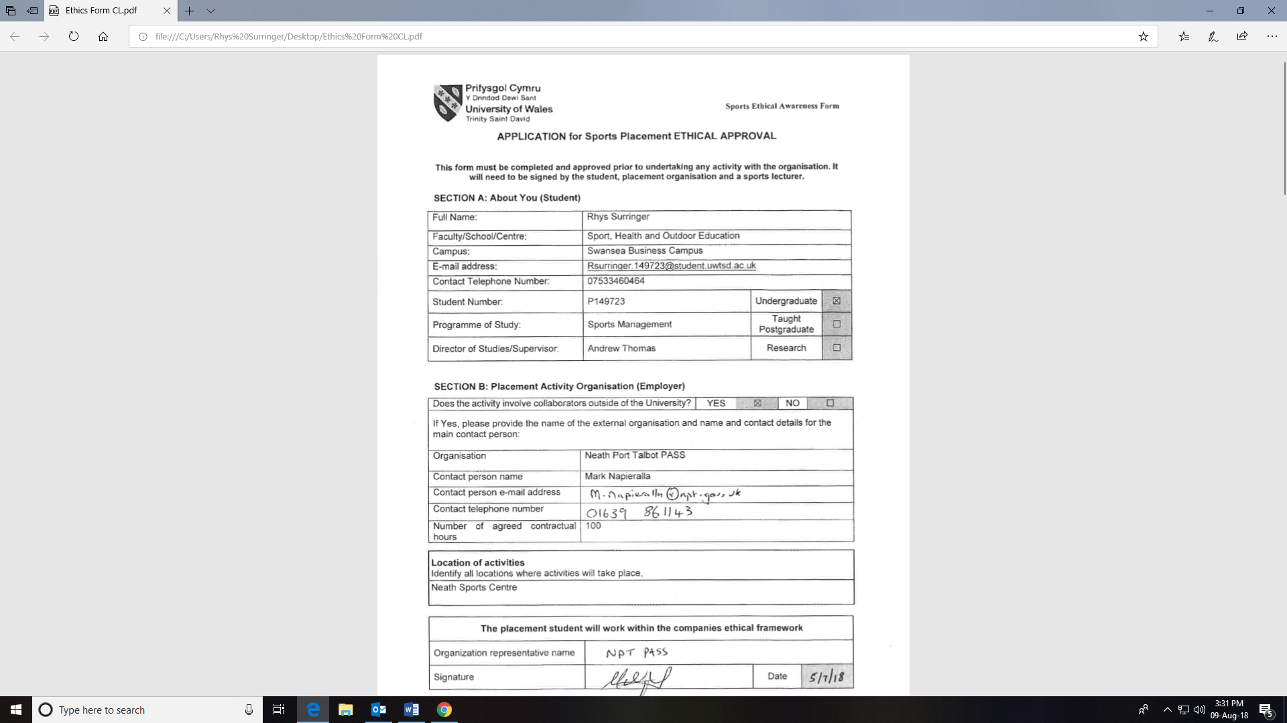

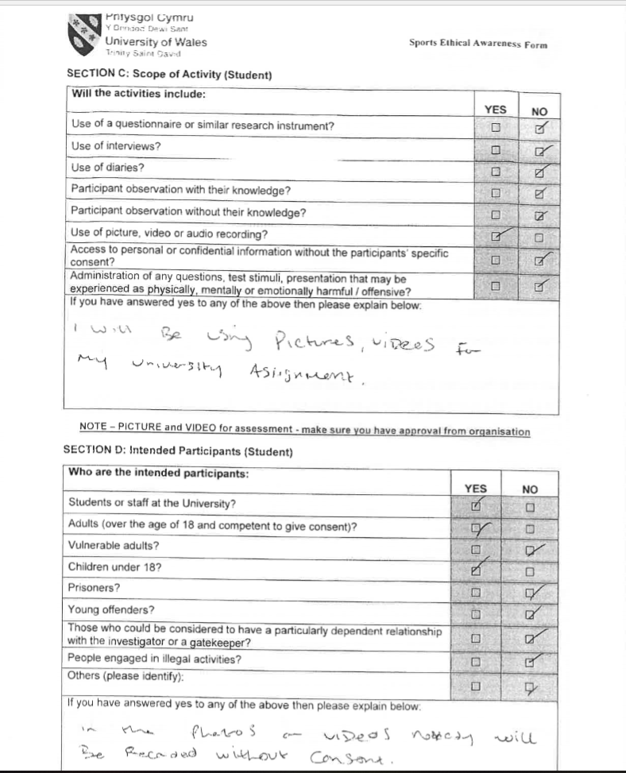

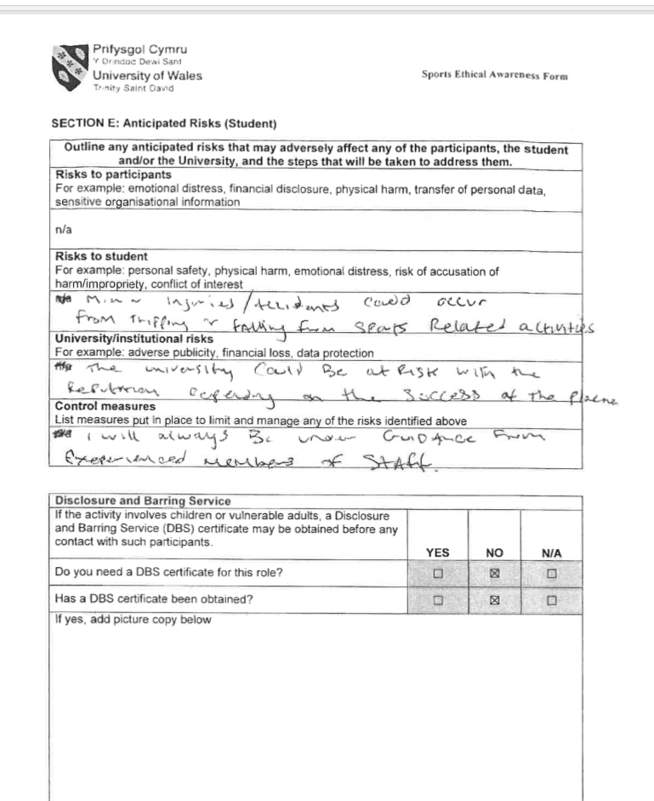

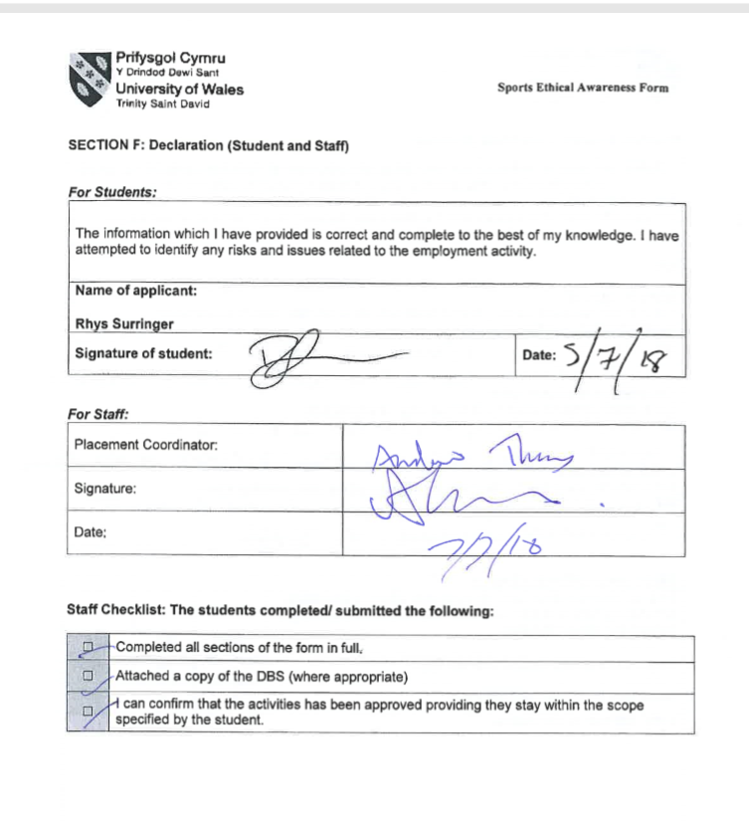

TASK C Evidence – Post Placement Review and Feedback
Dear Participant

Many thanks for your involvement in the work placement. I hope that you had a positive experience. The University of Wales Trinity Saint David reviews the provision annually for enhancement purposes and so we would be pleased to hear your feedback on any aspect of the placement.

Yours sincerely

Andrew Thomas, Placement Coordinator Sports Management Portfolio

Name of provider’sorganisation:
Name of student:
What were the positive aspects?
Were there any problems?
Do you have any recommendations for enhancement for the future?
Signed:
Name in block capitals:
Position (please tick one): | ☐ Placement Provider  ☐ Student  ☐ Placement Tutor |  | Date:

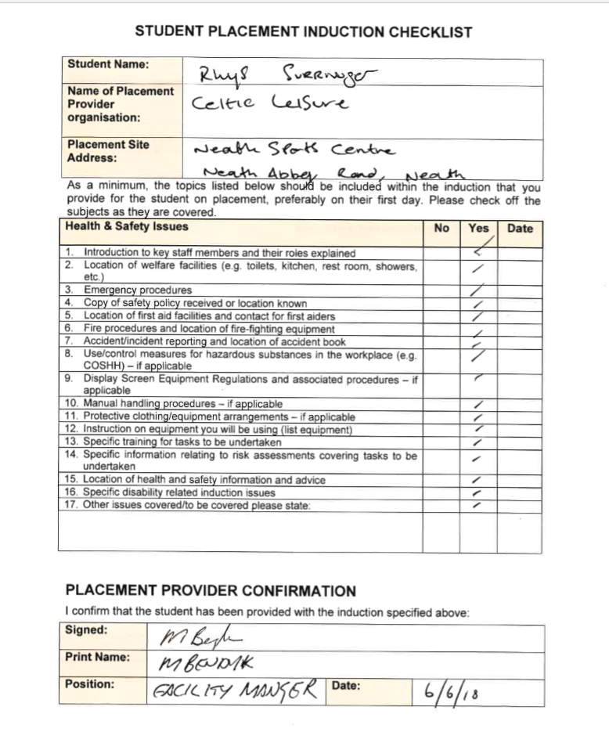

As a minimum, the topics listed above should be included within the induction that you provide for the student on placement, preferably on their first day. Please check off the subjects as they are covered.

PLACEMENT PROVIDER CONFIRMATION

I confirm that the student has been provided with the induction specified above:
Signed:
Print Name:

Position: |  | Date:

STUDENT CONFIRMATION

I confirm that I have been provided with an appropriate induction as specified above:
Signed:
Print Name:

Position: |  | Date:

NOTE – If this is not completed please ask your supervisor on the placement to complete ASAP. However, please inform the placement coordinator at the earliest possible opportunity if this procedure does not take place.


UWTSD SPORT
Placement

