Health and Safety at Work Act & CDM

By Dylan J Pugh

Table of Contents
1.0 What is the Health and Safety at Work Act 1974? 3
2.0 What Is CDM? 4
3.0 Roles 5
4 Responsibilities:- 5
4.1 Commercial Client 6
4.2 Domestic Client 6
4.3 Designers 6
4.4 Principal Designers 6
4.5 Principal Contractors 6
4.6 Contractors 7
4.7 Workers 7
4.0 Working at Height Act 2005 8
5.0 Confined Spaces 9
6.0 COSHH 10
7.0 References 11

What is the Health and Safety at Work Act 1974?

The Health and Safety at Work Act 1974 (HASAWA) is the main source of Legislation for covering occupational health and safety in Wales, England, and Scotland.
It’s general duties it covers are:-
- Is the health and safety employers have towards their employees and the public.
- Health and Safety employees have for themselves and others.
- The Health and Safety certain self-employed workers have for themselves and others.
Quoting the HSE’s meaning and understanding of HASAWA 1974 (HSE, Health and Safety at Work etc Act 1974, n.d.).
The act covers all aspects of health and safety in the workplace from the likes of a cut fingers, sprained ankles, and fatalities.
All regulations and legislations relate back to the HASAWA 1974 because for anything to be build it must be safe to use or build. As you wouldn’t go into a house which has no load bearing walls because it would collapse. The act is the most important and related to act as I said previously is covers all aspects of Health and Safety in construction, film, education and more. Anywhere that has the chance of harm, injury or fatal to a person the HASAWA 1974 will cover it.
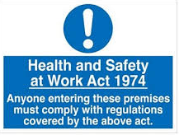
(elliswhittam, 2019)

What Is CDM?
CDM stands for Construction, Design and Management. The most recent CDM regulations is CDM Regulations 2015. CDM is to improve the health and safety in the industry. It aims to help by doing:-
- Sensibly planning the work to safely manage the risks from the start and end of a project.
- Making sure you have the right people for the right jobs at the right time.
- Cooperate and coordinate your work with others.
- Having the right information about risks and how to manage them.
- Effectively communicating information to the people who need to know.
- Consulting and Engaging with the workforce about risks and how to manage them.
Quoting the HSE on what CDM is (HSE, The Construction (Design and Management) Regulations 2015, n.d.).
CDM covers the process and methodology of how you do jobs. Most companies have their own way of doing tasks, but all have to comply with CDM as that’s the approved regulations. Within CDM there are many roles and responsibilities each person must follow and comply with CDM.
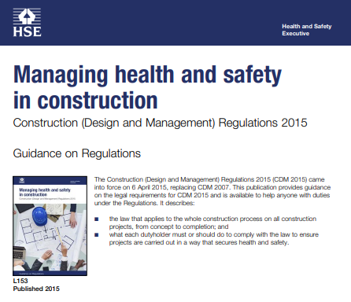
(HSE, Managing health and safety, n.d.)

Roles
All information is referenced to the HSE on the CDM 2015 Roles and Responsibilities (HSE, Summary of duties under Construction (Design and Management) Regulations 2015 (CDM 2015), n.d.)

There are 2 types of client:-
- Commercial Client;
Are organisations or individuals such as Local Authorities, Governments or businesses like Tesco and Morrison’s as a construction project is carried out as a part of business.

- Domestic Client;
Are people who have construction carried out in their own property like building extensions, renovations, and house repairs. As these are not done as a part of a business.

Designers are organisations or independent businesses who prepare or modify designs for a building, product or system relating to construction work.
Principal Designers are appointed by the client in projects that involve one or more contractors. They can be an independent person or a person working for an organisation which has sufficient knowledge and experience in the role they carry out.
Principal Contractors are the appointed contractors by the client to carry out the construction phase of the project where it involves more than one contractor.
Contractors are those who carry out the actual work and they can be either independent/self employed contractors or an organisation like Alun Griffiths, TRJ and Scotts.
Workers are those working for or under the control of a contractor on a construction site.

Responsibilities:-
All information is referenced to the HSE on the CDM 2015 Roles and Responsibilities (HSE, Summary of duties under Construction (Design and Management) Regulations 2015 (CDM 2015), n.d.)

Commercial Client
The responsibilities of the Commercial Client are to make sure that all relevant information is ready and prepared to give to other duty holders, that the principal designers and contractors carry out their own duties and that all welfare facilities are provided and up to the relevant legislations and regulations.
Also, they have to make appropriate arrangements which are suitable for managing a project which are that other duty holders are appointed for the appropriate positions and that all resources are allocated, and that sufficient time is allocated too.

Domestic Client
The responsibilities of the Domestic Client are similar to that of the Commercial Client but due to the scope of CDM 2015 their duties are usually transferred to the Contractor for single contractor projects or the Principal Contractor for projects with more than one contractor.
Although, the Domestic Client can choose to have a written agreement with the Principal Designer to carry out the client’s duties, if they wish to.

Designers
Designers duties are to prepare, modify or eliminate, reduce, or control foreseeable risks that possible could arise in the construction of the project or the maintenance and use of a building once constructed.
Furthermore, they also provide more information to other members of the project team to help them fulfil their responsibilities.

Principal Designers
Principal Designers are there to plan, manage monitor and coordinate health and safety in the pre-construction phase of a project which includes that the Designers carry out their responsibilities and that any foreseeable risks have been identified, eliminated, and controlled.
They provide and prepare the duty holders with the relevant information. Also, they liaise with the Principal Contractor to discuss planning, management monitoring and coordination of the construction phase.

Principal Contractors
The Principal Contractor liaises with the Client and Principal Designers. As they are responsible for the planning, management, monitoring and coordination of health and safety in the construction phase of the project. As they prepare the Construction Phase Plan (CPP). They organise the cooperation between different contractors and coordinating their work.
They have to make sure that all health and safety is maintained with suitable site inductions carried out and proper welfare facilities are carried out. A Principal Contractor also has to make sure all workers are consulted and engaged in securing their health and safety and that all steps are taken to prevent unauthorised success As Far As Reasonably Possible (AFARP).

Contractors
The Contractors responsibilities are similar to that of the Principal Contractor with the projects Health and Safety and Management.
With project that have more than one contractor they must coordinate their activities with others on the project team. In particular with complying with directions given by the Principal Designer and Principal Contractor.
As in a single contractor project they must prepare a CPP.

Workers
Workers must cooperate with their employer, fellow workforce, contractors, and duty holders. They are responsible for their own health and safety and those around them too and the public. As their actions could affect others too.
They’re have a duty to report anything that they see that could be dangerous to them or others health and safety. As well as consulting any matters which affect their welfare and health and safety.

CDM applies to all forms of construction small or big. As everyone is responsible for their own health and safety and of others to. As one small thing like a loose screw or bolt could mean the difference in keeping someone safe or having someone get hurt.
Within CDM they responsibilities could change as organisations or individuals could carry out other roles if they have the necessary skills, knowledge, and experience.

Working at Height Act 2005
All information is referenced to the HSE on the Working at Heights Act 2005 (HSE, The Law, n.d.)
The Working at Heights Act 2005 is to prevent death and injury cause by a fall from height. The act applies to those who control work at height or employers.
The employer and those in control of any works at height must properly plan, supervise, and have competent persons carrying out the tasks. Using the right equipment like harnesses, right methods of work and access and egress to the works.
Employers and those who control work at heights must carry out risk assessments to assess the possible risks and hazards. They have general legal duties to take care of themselves and those who may be affected by their actions. Those who carry out the tasks must cooperate with the those in control or the employer to make sure all health and safety duties and responsibilities are complied with and all requirements are met.
The employer and those in control must make sure all operatives that carry out the task at heights is trained, inducted, and meets all the health and safety requirements and is competent on doing the task.
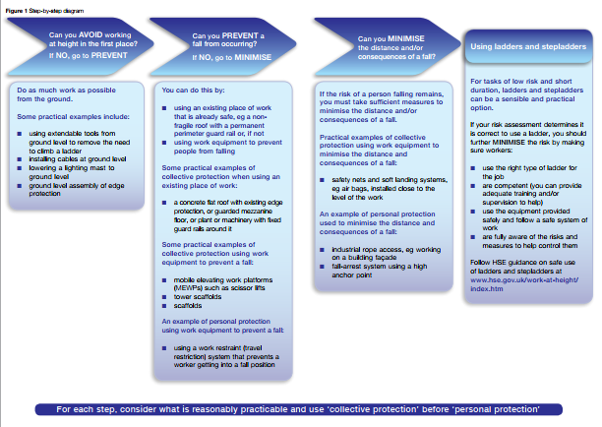 (HSE, Working at height A brief guide)

Confined Spaces

“A confined space is a place which is substantially enclosed (though not always entirely) and where serious injury can occur from hazardous substances or conditions within the space or nearby (e.g. lack of oxygen)” this is the HSE’s definition of a confined space.
Confined spaces can be any thing from going into a trench, down an inspection chamber or into a BT box which is only 700mm deep. As it’s a space with only one entry in or out or a lack of something like oxygen. Some cases it’s the lack of mobility.
Going into any confined space you have to be trained and briefed on the activity and space. As all operatives who go into a confined space have to be trained in confined spaces, competent as sending someone who isn’t can threaten anyone else in the confined space as if they pass out or have a panic attack then you have to get them safely out and yourself. Also, you are not allowed to send anyone under the age of 18 into a confined space as they don’t have any experience with them.
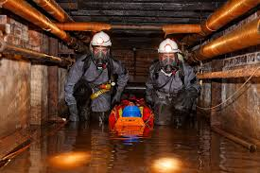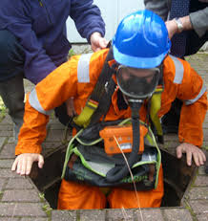
(SHP, n.d.) (Training, n.d.)
In confined spaces you will need equipment like oxygen tanks and masks and tripod with a fall arrestor and full body harness. As you could be going down 5 or 10 metres deep and theses spaces could have gases in their which could knock out the operatives if they have got the right equipment.

COSHH

COSHH standards for the Control of Substances Hazardous to Health.
Substances like Oil, petrol, adhesive and concrete all come under COSHH as they are hazardous to people as they can cause harm or irritation. Furthermore, are substance that can cause harm to the environment like water courses or ground are put under COSHH.
All Construction sites must have a COSHH folder where all COSHH reports go into, specifications of the substances and records. Sites must have Spill Kits as they are used to clean up the hazardous substance. As they are kept by areas where its likely to occur such as Fuel Bowsers or by COSHH bins which are steel cages with a lock on that contain hazardous substances to prevent anyone from just taking them.
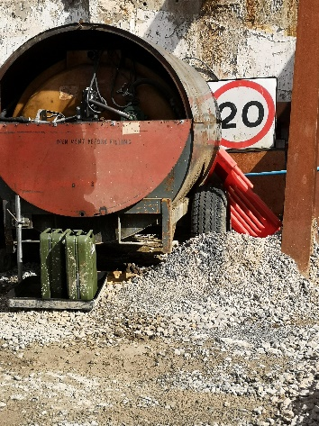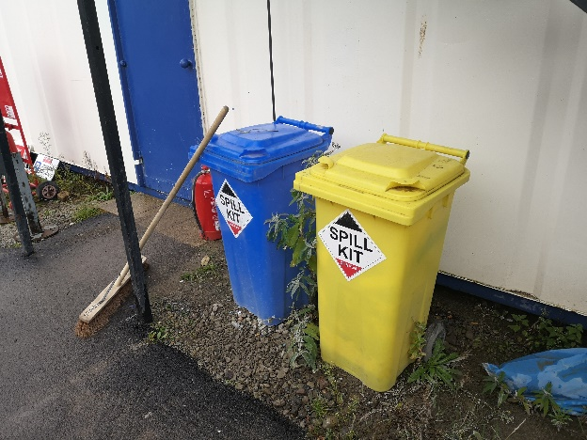
These are pictures I’ve taken from site of our spill kits and bunds around the fuel bowsers. As we put bunds around them so no fuel would leak or spill to side and pound as under the bowser is a nappy which soaks up the fuel or hazardous substances and theirs a spill kit in between the bowsers on site. As we had one at the bowsers and by our site offices.

7.0 References
elliswhittam. (2019). What does ‘reasonably practicable’ mean? | 2019 Guide. Retrieved from https://elliswhittam.com: https://elliswhittam.com/blog/reasonably-practicable-mean/
HSE. (n.d.). Health and Safety at Work etc Act 1974. Retrieved from https://www.hse.gov.uk: https://www.hse.gov.uk/legislation/hswa.htm
HSE. (n.d.). Managing health and safety. Retrieved from https://www.hse.gov.uk: https://www.hse.gov.uk/pubns/priced/l153.pdf
HSE. (n.d.). Summary of duties under Construction (Design and Management) Regulations 2015 (CDM 2015). Retrieved from https://www.hse.gov.uk: https://www.hse.gov.uk/construction/cdm/2015/summary.htm
HSE. (n.d.). The Construction (Design and Management) Regulations 2015. Retrieved from https://www.hse.gov.uk: https://www.hse.gov.uk/construction/cdm/2015/index.htm
HSE. (n.d.). The Law. Retrieved from https://www.hse.gov.uk: https://www.hse.gov.uk/work-at-height/the-law.htm
HSE. (n.d.). Working at height A brief guide. In HSE, Working at height A brief guide (p. 4). HSE.
SHP. (n.d.). Q&A: everything you need to know about confined spaces. Retrieved from SHP: https://www.shponline.co.uk/construction/qa-everything-you-need-to-know-about-confined-spaces/
Training, S. T. (n.d.). CONFINED SPACES - WORKING IN A MEDIUM RISK CONFINED SPACE. Retrieved from Confined Spaces Training: http://www.confinedspacestraining.com/c-confined-spaces-safe-entry-and-escape.php

