

Reflection on Personal Career Development

Student Name | Bianca Ioana Terza
Student Number | 2009067
Module Number | BMSW4005_LON
Module Title | Professional Career Development
Lecturer Name | Gulnar Ali
Date on submission | 3rd of September 2021

Table of Contents:

- Introduction page 3
- Reflection on the role-play (Assignment 1) page 3
- Self-evaluation, Self-motivation, and learning style page 5
- SWOT analysis, Johari Window, SMART analysis, and PDP page 8
- Understanding the world of employment page 10
- Conclusion page 11
- References page 11
- Appendix page 14

1. Introduction

Planning a future path has never been easy, as selecting a role among never-ending choices requires a long reflective process that helps understanding how life experiences can influence a career. Reflection is considered by Jasper, in 2003, as a fundamental tool that transforms knowledge into practical skills for a professional, she also considers the individual's background as an excellent starting point to learn from.
In this report I will analyze my performance throughout the “Personal Career Development” module, and, using the different self-awareness tools learned, deliver a self-reflection on my readiness to enter the world of work.

2. Reflection on the role-play (Assignment 1)

The previous assignment consisted of a role-play, wherein pair, the students were experiencing both sides of a job interview, described by Morgan, in 2017, as a nerve-racking and challenging event that everyone will face in life.
In 1997 Berman acknowledges the importance of structured interviews defining them as more reliable, yet he also added, supported by Lee & Gura in 1997, the importance of a first impression, as the interviewee is more likely to be considered suitable for the position if they present themselves appropriately. (Dabbs, 1969)
Nowadays other aspects impact the interviewer’s opinion such as punctuality, positivity and politeness, as professionalism is expected, and adequate body language like smiling and maintaining and appropriate eye contact which helps to improve the performance. (Prospects.ac.uk, 2019)
In the next paragraphs I will reflect on my performance as interviewer and interviewee applying Kolb’s reflective cycle (1984) where the concrete experience is analyzed, learning outcomes are conceptualized, and future actions are planned. (Mcleod, 2017)

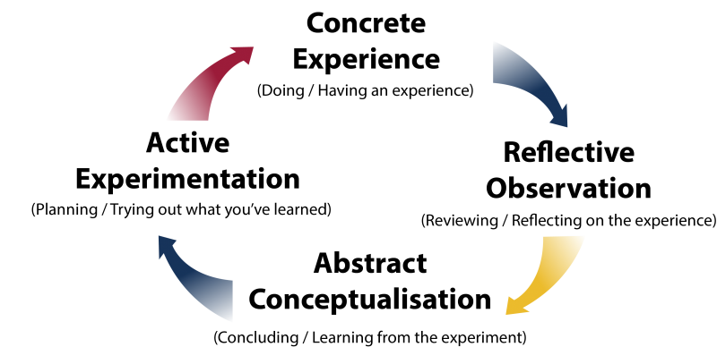
(Queensu.ca, 2019)

Interviewer prospective

In 2017, Morgan, describes the role of the interviewer as someone able to select a candidate capable to carry out the requested task with excellence but also adept to fit the company’s standards and beliefs.

While interviewing my colleague, I had to understand with a couple of questions, if they would be trustworthy and honest. I had to evaluate their ability to listen and comprehend the inquiries and analyze their responses according to the company’s ideals. I also had to consider if my partner would ably integrate within the existing team and have a positive impact on the group’s final performance.
In this simulation, I had the possibility to sense the complexity of the interviewer role as an inappropriate choice can impact the employee’s conduct in the workplace.
I also understood the expectations an employer has on the candidate and for this reason, I realize the importance that planning and researching in advance have on delivering an outstanding interview.

Interviewee prospective

During the interview, the tension is high as we feel that the interviewer is over-judging our performance and not only assessing our suitability for the position applied. (Morgan, 2017) This is also caused due to the variety of questions the employer may ask. Open questions are encouraging the candidate to present as much information about a defined topic, for example, a self-description, and are usually asked at the beginning of the interview. Behavioral questions require personal examples while case interview questions are presenting the interviewee with a hypothetical scenario to deal with. (Careers, Search and Doyle, n.d.)

During the preparation for the interview, I had to reflect on my applicability for the role and research about the organization’s goals and ideals, and take into consideration the job description, before preparing a set of possible answers to give the interviewer. Knowing that the first impression matters, I had to maintain composed conduct and a clear speech without appearing arrogant or disinterest.
After performing, I realized how important is to reflect on the responses as I feel that some of mine were rushed and imprecise.
For future interviews, I will have to practice my ideas and ensure clarity and simplicity while maintaining my enthusiasm and maturity.

3. Self-evaluation, Self-motivation, and learning style

Self-evaluation

In 2010 Cottrell defines self-evaluation as the process throughout which an individual is assessing their own professional performance and identifying new ways to implement improvement.

As a student is important to acknowledge and weigh the achievement as this process can improve the person’s self-confidence and encourage them to set more ambitious goals where additional effort is required. (www.healthguidance.org, n.d.)
For a more complete self-evaluation process, I think that the opinion of instructors or supervisors is required as an external opinion may bring a new perspective and help to discover new areas where progress is possible.

Self-motivation

Self-motivation describes the ability to motivate yourself by understanding the cause that encourages you to do something. Self-motivation heartens individuals to move forward and reach the goals settled. (skillsyouneed.com 2011)
In 2003, Benabou and Tirole individualized two types of motivation: Extrinsic and Intrinsic. They defined Extrinsic motivation as the act of rewarding someone for their achievements, and Intrinsic motivation as the individual’s ambition to act for their personal interest.

I consider this skill as a personal drive to accomplish aspirations and goals. I think that, even if self-motivation is fundamental for the professional development where the person is the center of the process, external support helps to improve the performance and discover new perspectives and interests that impact the final work.

Learning style

The ability to retain information differs from person to person, for this reason in 1987 Neil Fleming individualized different learning styles, developing the VARK model, where learners’ preferences are divided into four groups. Visual learning where pictures, diagrams, and graphs help the student to memorize concepts easier, auditory learning, where discussions and lectures are preferred. The reading/writing learning style, where study is faster via textbooks and notes while kinesthetic learners are prone to hands-on activities, and they have to be physically involved in the learning process. (Cherry, 2012)

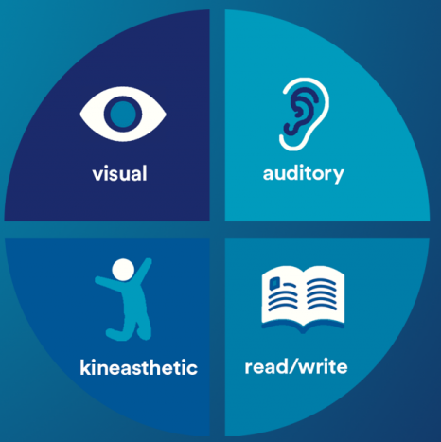
(Careers blog, n.d.)

One year earlier, in 1986 Peter Honey and Alan Mumford create the Honey and Mumford learning style chart, where they also individualize four types of styles people use when studying. They define the activists as people who learn by doing, the theorists as someone how focuses on the theories behind the facts, the pragmatists as those who prefer to understand how to apply ideas to practice, and reflectors as individuals who learn via observation.

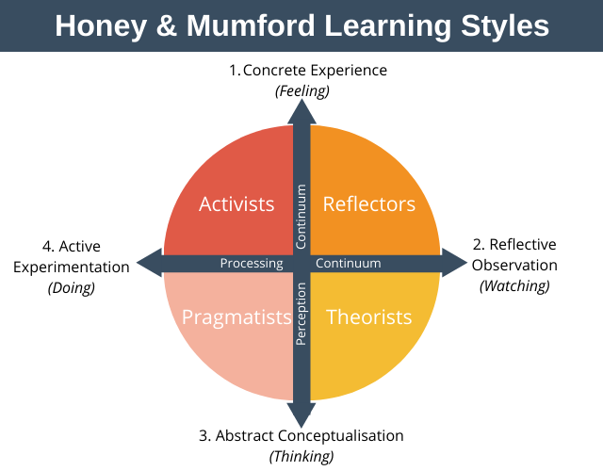(Expert Program Management, 2020)

After researching the different learning styles, I decided to respond to different questionnaires to understand which category represents me better.
In the VARK model, the visual style is predominant, as I find diagrams and pictures easy to understand and I often use color-coded notes to remember facts and data. Making lists and outlining conceptual maps also help to improve myself.

The Honey and Mumford test defined my answers as typical of a pragmatist learning style. I do, in fact, prefer studying the theory before applying it to a real case scenario, I also appreciate receiving feedback and practical examples that guide my conduct.
In conclusion, I think these tests may help a student to improve their performance by suggesting new strategies and different approaches to their studies.

4. SWOT analysis, Johari Window, SMART analysis, and PDP

During the term, the class has been introduced to different self-assessment tools I will use in the following paragraphs to reflect on my persona.

SWOT Analysis

In 1960, Albert Humphrey created a table where was possible to evaluate external and internal factors that may impact a business, in the present, his method is also a self-assessment tool where the individual analyses personal strengths, weaknesses, opportunities, and threats. (www.professionalacademy.com, n.d.)

In my SWOT analysis [1] I identified different strengths that may have a positive impact on my future career. I am a quick learner and that makes me flexible and facilitates my adaptability to new environments and policies. Even if I am committed to my professional development, I tend to lose interest easily and this may have an impact on the final performance. My disorganization and impulsivity bring me to procrastinate on important work. Although the company I am working with offers multiple online resources for career changes, I have difficulty growing in my department due to my lack of experience. Having said that, my interest in improving myself with self-study sessions and the passion I have for statistical and analytical work will support my future progress.

Johari window

In 1955, Joseph Luft and Harry Ingham, developed a psychological model that helps self-awareness, emphasizing the “soft skills”. (self-awareness, 2013)

In the first quadrant of my Johari model [2], I analyze the “open self”. I am a positive person, committed to the role received. I am a hard worker and personal feelings don’t affect my performance, making me able to focus on the work and complete the tasks efficiently.
In the second part, I discuss the “blind self”. After considering my colleagues’ opinions, I realized that they see me as a leader able to set the path for others to follow. I am confident that this skill, once developed further, will come handful for a future career.
In the “hidden self” quadrant I include behaviors I tend to hide from others, for example, even if I may appear confident, I have to work on my self-esteem, as this insecurity brings me to remain in a “safe spot” where I avoid taking risks and struggle to progress. I believe that, by setting more ambitious goals, my curiosity would be triggered, leading to self-improvement.
In the last section, I cover the “unknown self”. I believe that the fear of failure and the feeling of discouragement caused by my inexperience may impact my performance and confidence in a work setting and a life approach.

SMART objective

George T. Doran publishes in 1981 a paper where he introduces the SMART objective model, which helps to set clear goals in a simple framework.
In the following paragraph, I will discuss how the SMART objective plan [3] will help me reach the Psychologist’s career.

Specific: My aspiration is to become a Psychologist and in order to do so, I need to work on my sensitive listening and communication skills, as they are a fundamental part of a Psychologist’s life.
Measurable: The path that leads to the Psychologist’s career is arduous and filled with theoretical knowledge that I can start gaining by reading related publications or participating in activities and lessons before attending a specialized university.
Attainable: I’m planning to work on my set of skills and gradually integrate the ones expected for the role.
Relevant: I want to know how to implement my current abilities in the Psychologist’s role.
Time-bound: In the next 5 years, I want to progress and gain experience in different work environments until I manage to reach the position of a fully certified Psychologist.

PDP

The personal development plan, in short PDP, is a reflective piece that presents the main goals an individual sets for their career development.

As presented in the SMART objective and PDP [4] I aspire to become a fully certified Psychologist and to do so, I need to work on different sets of skills and attend courses to gain the necessary knowledge.

In the following six months I’m planning to strengthen my communication skills by practicing active listening and focusing on body language as gestures, facial expressions, and intonation may reveal different aspects of the speaker. I also intend to work on my planning skills by using lists and deadlines to improve my capacity to prioritize tasks by importance.

In a year’s time, I am evaluating the idea of changing career and offer voluntary work in order to experience new situations and get closer to my final goal.
I understand how important teamwork is in each work environment and for this reason, I want to improve my listening skills and learn how better integrate other’s strengths and weaknesses to create a united team.

After one year I consider attending a psychology-related courses to commence my academic studies. I also intend to work on my leadership skills by taking more initiative at work and practice critical thinking and active listening.

5. Understanding the world of employment

To become a Psychologist in the UK is necessary to complete a university course accredited by the British Psychological Society, proceed with a Graduate Basis for Chartered Membership, followed by a certified post-graduate course where the individual decides a specialization. Once finalized the Master’s course, the student needs to enlist the Directory of Chartered Membership in order to enter the world of work. (www.bps.org.uk, n.d.)

I aspire to become someone able to support those overwhelmed by the challenges life is presenting; from stress, anxieties, depression, unhealthy habits, to family problems, loss, or mental disorders.

6. Conclusion

This report presents different self-assessment tools that can support the professional development of an individual.
It introduces the reader to the concepts of self-evaluation, self-motivation, and the difference in learning styles.
A self-analysis follows, with the support of a SWOT analysis and a Johari window model.
Proceeding with a SMART objective and concluding with a PDP where the steps to become a Psychologist are presented.

7. References

- Benabou, R. and Tirole, J. (2003). Intrinsic and Extrinsic Motivation. Review of Economic Studies, [online] 70(3), pp.489–520. Available at: https://academic.oup.com/restud/article-abstract/70/3/489/1571401 [Accessed on 31st of August 2021].
- Careers, F.B.F.L.F.T.A.D. is the job search expert for T.B., Search, O. of the I.M.H.-R.J. and Doyle, career experts R.T.B. editorial policies A. (n.d.). Types of Job Interview Questions You May Be Asked. [online] The Balance Careers. Available at: https://www.thebalancecareers.com/types-of-interview-questions-2061365 [Accessed on 30th of August 2021]
- Cherry, K. (2012). Overview of VARK Learning Styles. [online] Verywell Mind. Available at: https://www.verywellmind.com/vark-learning-styles-2795156 [Accessed on 31st of August 2021]
- Cottrell, S. (2015). Skills for success : personal development and employability. 3rd ed. London: Palgrave Macmillan.
- Dobson, J.L. (2009). Learning style preferences and course performance in an undergraduate physiology class. Advances in Physiology Education, 33(4), pp.308–314.
- Expert Program Management (2020). Honey and Mumford Learning Styles. [online] Expert Program Management. Available at: https://expertprogrammanagement.com/2020/10/honey-and-mumford/ [Accessed on 31st of August 2021]
- GOV.UK. (2020). Career Development Plan. [online] Available at: https://www.gov.uk/government/publications/hr-career-frameworks/career-development-plan [Accessed on 31st of August 2021]
- Haughey, D. (2014). A Brief History of SMART Goals. [online] Project Smart. Available at: https://www.projectsmart.co.uk/brief-history-of-smart-goals.php [Accessed on 1st of September 2021]
- Jasper, M. (2003). Beginning reflective practice. Cheltenham: Nelson Thornes.
- Jonas (2021). 6 Top Reasons Why Self-Motivation is Important? - 2021. [online] Available at: https://jonasmuthoni.com/blog/importance-of-self-motivation/ [Accessed on 30th of August 2021]
- Mcleod, S. (2017). Kolb’s Learning Styles and Experiential Learning Cycle. [online] simplypsychology.org. Available at: https://www.simplypsychology.org/learning-kolb.html [Accessed on 30th of August 2021]
- Morgan, P. (2017). Business Student’s Guide To Study And Employability. S.L.: Sage Publications.
- nationalcareers.service.gov.uk. (n.d.). Psychologist | Explore careers | National Careers Service. [online] Available at: https://nationalcareers.service.gov.uk/job-profiles/psychologist [Accessed on 1st of September 2021]
- Prickett, T.J. (2000). First impressions in job interviews. [online] Available at: https://www.researchgate.net/profile/Frank-Bernieri/publication/313878823_The_importance_of_first_impressions_in_a_job_interview/links/58acde3caca272af06662de3/The-importance-of-first-impressions-in-a-job-interview.pdf [Accessed on 30th of August 2021].
- Prospects.ac.uk. (2019). How to prepare for an interview | Prospects.ac.uk. [online] Available at: https://www.prospects.ac.uk/careers-advice/interview-tips/how-to-prepare-for-an-interview [Accessed on 30th of August 2021]
- Queensu.ca. (2019). What is Experiential Learning? | Queen’s Experiential Learning Hub. [online] Available at: https://www.queensu.ca/experientiallearninghub/about/what-experiential-learning [Accessed on 30th of August 2021]
- self awareness (2013). Self Awareness. [online] Self Awareness. Available at: https://www.selfawareness.org.uk/news/understanding-the-johari-window-model [Accessed on 1st of September 2021]
- skillsyouneed.com 2011-2019 (2011). Self-Motivation | SkillsYouNeed. [online] Skillsyouneed.com. Available at: https://www.skillsyouneed.com/ps/self-motivation.html [Accessed on 30th of August 2021]
- TDTC. (2021). Honey and Mumford Learning styles. [online] Available at: https://tdtc.co.uk/honey-and-mumford-learning-styles/ [Accessed on 31st of August 2021].
- www.bps.org.uk. (n.d.). Chartered Membership (CPsychol) | BPS. [online] Available at: https://www.bps.org.uk/join-us/membership/chartered-membership [Accessed on 1st of September 2021]
- www.healthguidance.org. (n.d.). The Importance of Self Evaluation | HealthGuidance. [online] Available at: https://www.healthguidance.org/entry/15764/1/the-importance-of-self-evaluation.html [Accessed on 30th of August 2021]
- www.professionalacademy.com. (n.d.). Marketing Theories – Swot Analysis. [online] Available at: https://www.professionalacademy.com/blogs/marketing-theories-swot-analysis/ [Accessed on 1st of September 2021]

8. Appendix

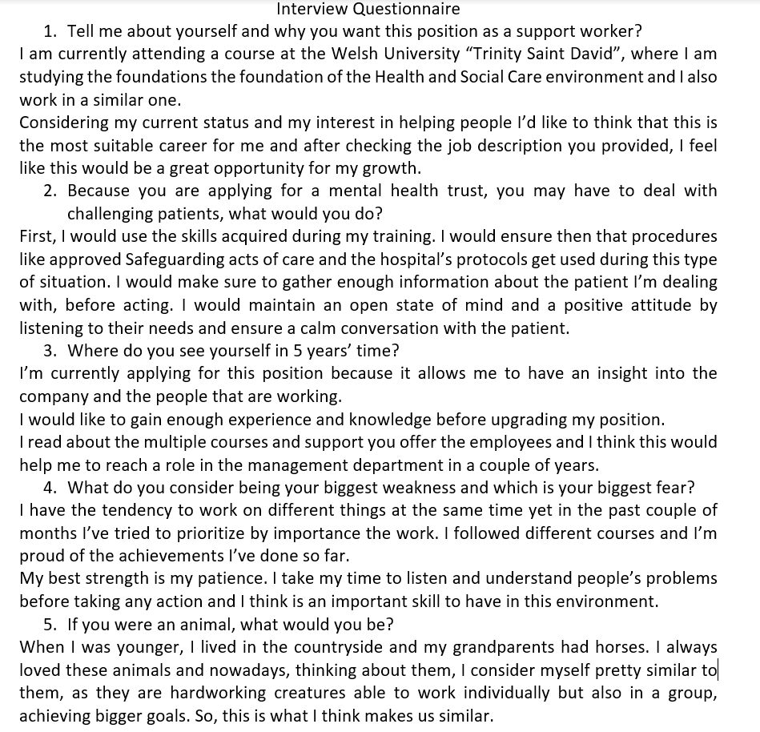

SWOT Analysis [1]
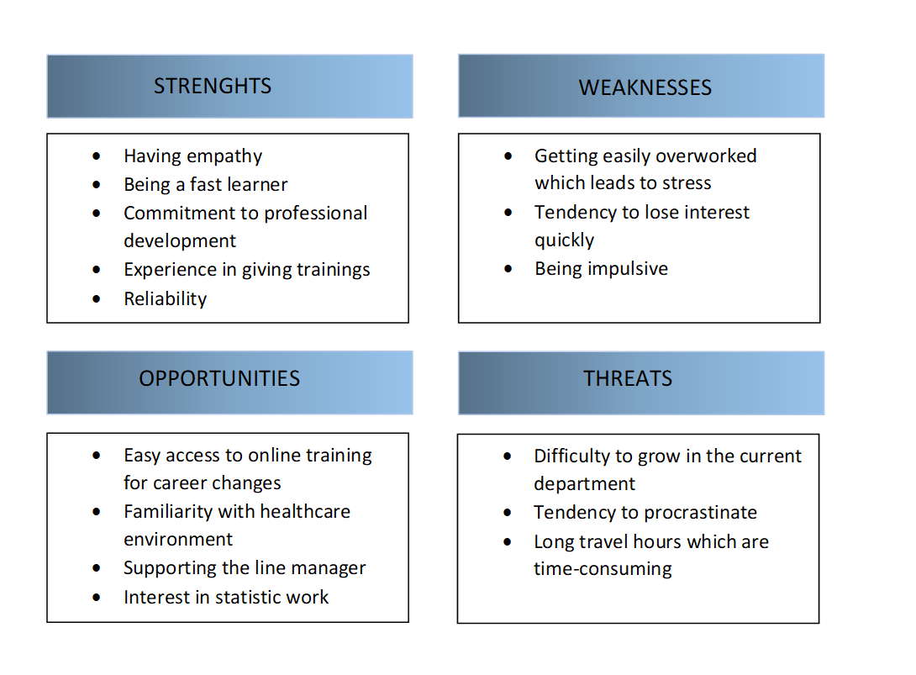

Johari window [2]
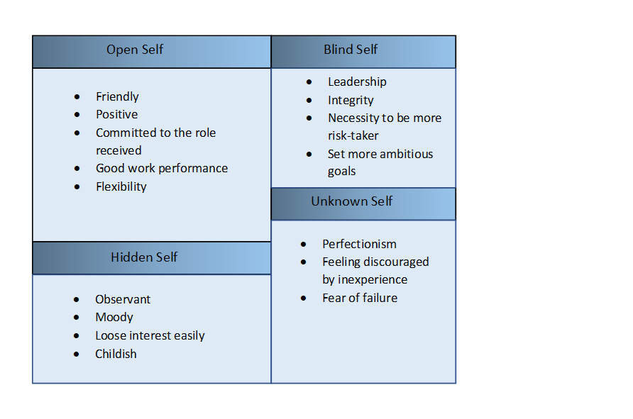

SMART objective [3]
Specific skills | - Sensitive listening skills  - Communication skills  - Knowledge of psychological theories
Measurable | - Publications  - Activities  - Lessons  - University courses
Attainable | Integrating the needed skills to the existing ones
Relevant | Implement current abilities into psychologist’s role
Time-bound | 5 years in the future

PDP [4]
Final Goal
I aspire to become a fully certified Psychologist

Skill gap | Actions needed | Time set
- Communication skills  - Planification skills  - Prioritizing | - Practice active listening  - Focus on body language  - Work with lists and deadlines | 0 – 6 moths
- Teamwork skills  - Career change  - Voluntary work | - Listening skills  - Practice integration  - Appreciate contribution | 6 – 12 months
- Leadership skills  - Enrolling university courses | - Take initiative  - Practice critical thinking  - Practice active listening | After 1 year

