A Report Focused on the Bases of Surveying Classifications

and

How Digital Surveying Technologies are Applied in Surveying Listed Buildings.

Prepared for:
J. Dauda

Prepared By:
T. M. Williams

Table of Contents
1.0 Introduction 2
2.0 Definition of Surveying 3
3.0 Surveying Classification Bases 3
3.1 Primarily Based Classification 3
3.1.1 Plane surveying 3
3.1.2 Geodetic surveying 3
3.2 Method Based Classification 4
3.3 Equipment Based Classification 4
3.3.1 Chain surveying 4
3.3.2 Theodolite surveying 4
3.3.3 Compass surveying 4
3.3.4 Total Station 5
3.4.1 Cadastral Survey 5
3.4.2 City Survey 6
3.4.3 Construction Survey 6
3.4.4 Hydrographic Survey 6
4.0 The Application of Digital Technologies for Surveying Listed Buildings. 7
5.0 Tools Used for a Listed Building Survey 8
5.1 Thermal Camera 8
5.2.1 Surface Readings - Two-pin Method 9
5.2.2 Sub-Surface Readings - Deep wall probe method 9
5.2.3 Sub-Surface Readings - Search Mode 9
5.3 Laser Scanner 10
6.0 Information Collated from a Listed Building Survey 10
7.0 Conclusion 10

1.0 Introduction
The aim of this report is to explore the subject of surveying as a general and look at the different types of surveying. Surveying is classified based on different factors and this report will seek to outline these factors and further analyse in depth the different types of surveying under one of these factors.
It will also look at the process of surveying listed buildings and the application and use of digital surveying technologies within this. The report will seek to identify the range of appropriate tools to be used and what information can be gained and collated from the survey.

2.0 Definition of Surveying
Surveying is the way of making relatively large-scale, accurate measurements of the Earth’s surfaces. Surveying involves 5 main areas.
Research, analysis and decision making. Firstly, looking at the location and making decisions on which survey is best suited and analysing associated risks. Then look at logistics required with regards to equipment and people.
A field visit made to site in order to acquire data with field notes through taking measurements, observing and sketches.
The information collected would be processed and transferred to the computer. The speed of this is determined by the equipment used, with digital equipment and tools being quicker to process than manual equipment data.
Next collating the data into a report, in terms that the client can interpret.
Lastly is staking out on site.

3.0 Surveying Classification Bases

3.1 Primarily Based Classification
This can be categorised into two types and are as follows.

3.1.1 Plane surveying
This type of surveying is suited to smaller areas; less than 200 sq. Mi. This type of surveying will yield precise results, but the accuracy and precision of such results will decrease as the area surveyed increases in size. To make computations in plane surveying, you will use formulas of plane trigonometry, algebra, and analytical geometry.
The plane surveying type is widely used. Surveys for the location and construction of highways and roads, canals, landing fields, and railroads are classified under plane surveying (Anon., 2021)

3.1.2 Geodetic surveying
In Geodetic surveying, the earth’s surface is considered as a curve. So, the line which connects these points are curves and the triangles made joining these lines are Spherical triangles. The method of Geodetic surveying is usually used for larger areas of more than 200 sq. Mi. This type of survey is suited for long lines and the stations are normally far apart. Compared to plane surveying, more precise instruments and surveying methods are required to ensure an accurate survey (Anon., 2021).

3.2 Method Based Classification
There are 3 types of methods used in surveying.
- Triangulation-Triangles to calculate angles in order to work out the length
- Trilateration-Triangles but only to measure distance
- Traversing-The use of a number of survey lines connected to form a framework, the directions and lengths of the survey lines are measured with an angle measuring instrument and a tape or chain respectively.
(Anon, 2022)

3.3 Equipment Based Classification

3.3.1 Chain surveying
Chain Surveying is the simplest form of surveying. The areas are divided into triangles and the sides of the triangles are measured.
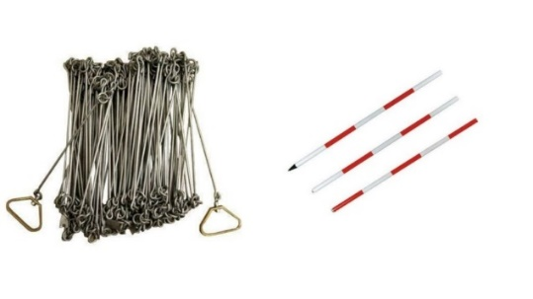 (Vincivilworld.com)

3.3.2 Theodolite surveying
This is an instrument that measures horizontal and vertical angles. 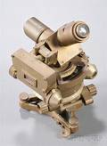 (Skinnerinc.com)

3.3.3 Compass surveying
This is the branch of surveying in which the position of an object is located using angular measurements determined by a compass and linear measurements using a chain or tape.
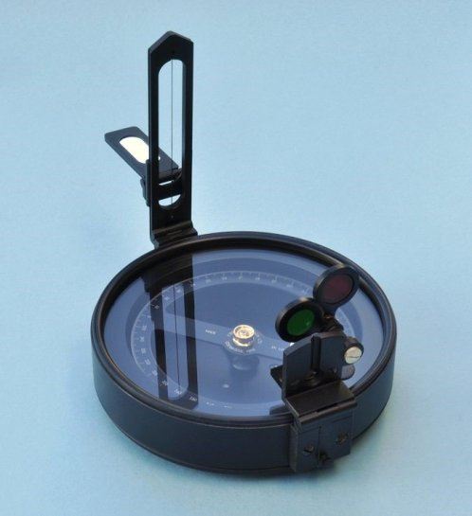 (Engineeringcivil.org)

3.3.4 Total Station
This can be used to measure distances and angles using infrared/laser and has built in recording ability where angles and measurements can be downloaded through software.
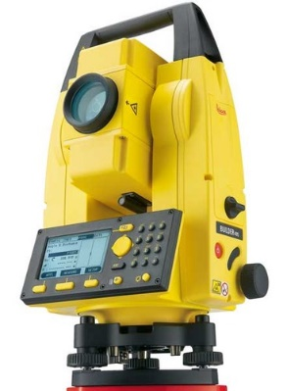 (Indiamart.com)
3.4 Purpose Based Classification
A survey type can be determined depending on the purpose of the survey. There are many different types within the purpose-based classification. Some of these include:

3.4.1 Cadastral Survey
This survey is used to define ownership of property boundaries. It is integral in establishing the legal creation of a property. It is the main method of defining the rights, any restrictions or interests in a property.
There are many different methods which can be used for a cadastral survey. Most common are:
- Terrestrial Imaging – Angles and distances are measured and used to calculate the height and co-ordinates of the object which is to be surveyed. This can be done with a tacheometer. It’s a faster method when surveying rough terrain, where chaining or other methods would be more difficult, slower and less accurate. Digital models used in modern day also yield results quicker due to the technology being able to store the data collected in the device, allowing ease of transfer on to an office computer ready for representation.
- Laser Scanning – Laser scanning is usually done from the air, using perhaps a drone or an aircraft fitted with a scanning device to fly above the terrain to be surveyed. This method can be used to gather data with regards to the topography and structure of the land. This works by measuring the distance from the ground – calculated using the position of the flying source and the laser signal duration.
(Anon, 2021)

3.4.2 City Survey
This survey is used to aid in the growth and evolution of cities. It is used to develop areas in terms of utilities such as water supply and telecommunication lines. City surveys can by prone to increased risk due to the environment in which they take place, for example inner cities where there are increased distractions. Methods used in city surveying are:
- Geospatial – use of 3D laser scanning and topography
- Structures – Concrete scanning using laser, ferroscan and pulse radar technology to determine sub surface conditions.
(Anon, 2021)

3.4.3 Construction Survey
This survey will be used when determining the positioning of new infrastructures such buildings and roads. It will begin with analysis of the proposed site/ land using geodesic co-ordinates. It will look at existing infrastructure and underground infrastructure. Reference points will be staked out to determine location of planned structure. Measurements can be obtained using several different equipment methods including:
- Levels
- Theodolite
- GPS
- Total Stations
(Anon, 2021)

3.4.4 Hydrographic Survey
This survey is used as a scientific measure of bodies of water such as the sea, a river or lakes. It can be used to define the shoreline and identify any features or obstructions below the water surface, to aid safety. It is used to aid in the construction of harbours and sea defence works and obtain tidal data. Some examples of methods used in this survey are:
- Scanning Sonar – to detect items of debris/obstruction for maritime safety
- Sounding – sounding boats, sounding pole/rod and echosounder to determine depth of water
- Electronic sensor systems – to check flow of water.
(Anon, 2021)

4.0 The Application of Digital Technologies for Surveying Listed Buildings.
The use of digital technologies for surveying listed buildings is becoming increasingly common, as modern technology is altering the way we live, work, communicate, and we are on the brink of a new industrial revolution. All though RICS has been active for over a century and the basis of building surveying are ingrained, new technological breakthroughs are beginning to alter the shape of the industry. The first technological development to begin a change in the profession was the laser scanner, which was revealed more than 2 decades ago. However, in the last couple of years new technology is being used to vastly improve quality, efficiency, and predictability has gathered speed, with the latest digital innovations (Gissane, 2021)

5.0 Tools Used for a Listed Building Survey

5.1 Thermal Camera
The use of thermal imaging in surveying buildings is mainly used to checking how well insulated the building is and where possible heat loss is occurring, making sure your home or workplace is as energy efficient as possible.
Thermal imaging can also help with:
- Construction Faults - By using thermal Imaging to identify construction faults, you can get this problem fixed before they result in causing possible harm to you or the property.
- Drying of Buildings - Thermography can help identify moisture problems on the interior or exterior of the property.
- Air Leaks - Finding an air leak during your building survey can help you keep your home warmer and more insulated, possibly resulting in a decrease in energy costs.
- Leaks in Flat Roofs - Thermal Surveys can help reduce the chance of possible leakage in flat roofing before it becomes a wider issue.
- Building Renovations - Thermal Imaging can help show what parts of the property need improving, saving money on unnecessary restoration works.
- Damp and Mildew - Using thermal cameras, you are able to pinpoint areas of damp, allowing you to rectify the issue from its root.
Occasionally thermal surveys play a big part in locating the issue causing the problem with a building, thermography can do this not only quickly and efficiently, but it can also conduct this without wasting time for everyone involved within the process (Anon., 2021).
5.2 Moisture Meter/Protimeter
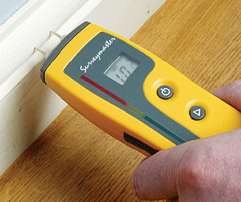

5.2.1 Surface Readings - Two-pin Method
The two-pin mode is used to measure the surface moisture level at gradual depth, it can also be used with auxiliary wall probes to measure to a deeper depth. The readings in measure mode are accurate to the immediate point of the electrodes contact. Hold the protimeter with the pins touching the surface of the material and use the LED scale to read the moisture level (Anon, 2021).

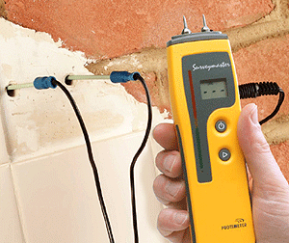

5.2.2 Sub-Surface Readings - Deep wall probe method
To determine the moisture reading of the sub-surface, the surveyor utilises the deep wall probes which connect to the Protimeter auxiliary port. Two clearance holes must be drilled, which are 1/4 in. (6 mm) in diameter and approximately 1 1/2 in. (40 mm) apart to the depth required (Anon, 2021).

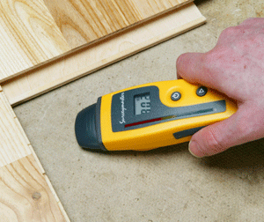

5.2.3 Sub-Surface Readings - Search Mode
The main issue with taking moisture readings, is locating the areas affected, even when the surface has a covering. The search mode supplies a non-intrusive method of scanning walls and floors for moisture while not damaging the surface. Holding the meter against a surface, as pictured, the meter sends a signal into the material. This then gives the moisture content from the strength of the signal that returns (Anon, 2021)

5.3 Laser Scanner
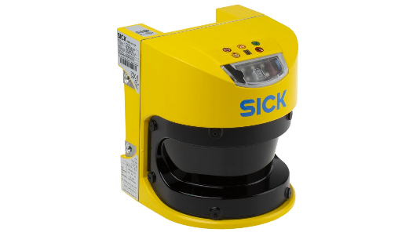 (uk.rsonline.com)
A laser scanning is very different from previous techniques, laser scanning is a major development because of the freedom it offers in detail capture. Surveyors are likely to use just a tripod-mounted scanner, which spins at very high speed while a low-energy laser fires a reflecting beam with great precision, collating over a million points per second. The density is adjusted according to the surveys purpose, usually with lateral spacing of 1-3mm. The scan collates large amounts of data which are downloaded and processed to create what’s known as the ‘point cloud’, using specialist software (anon, 2021).

6.0 Information Collated from a Listed Building Survey
A listed building survey briefly comprises of:
- Current state of repair (structure, subsidence, damp, rot, drains, woodworm, roofs, etc as covered in a normal Building Survey) and what may be required in future.
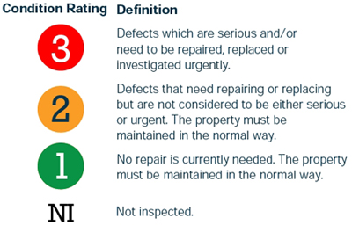 (www.cwhsurveyors.co.uk)
- Materials and building techniques used in the original construction.
- Specialist works required to keep the building in good condition and retain original features.
- Compliance with listed building consent – currently and moving forward, should you wish to make any changes to the property.
- Discussions with you before and after the survey to answer your questions and help you make informed decisions and choices. (anon, 2021)

7.0 Conclusion
There is an extremely large market for older buildings, some of which are classed to be of such historical or architectural importance that they are listed and maintain a level of protection. These properties need a more in-depth property survey for the prospective purchaser to ascertain if and what repairs are required, what they will cost and if the investment would be viable. Buildings may be listed for numerous reasons. Historic England state that any building constructed before 1700 which has been kept in a satisfactory state of repair will be listed, as most buildings constructed between 1700 and 1840 that are in a satisfactory condition. Some newer buildings can also be listed if they have significant importance. These tend to be over 30 years of age. Listed buildings are graded which determines how they should be treated and maintained. Grade I is the most protected, then Grade II*. 91.7% of buildings are Grade II.

References
Anon., 2021. [Online]
Available at: www.thermascan.co.uk
Anon., 2021. brainkart.com. [Online]
Available at: https://www.brainkart.com/
Anon, 2017. [Online]
Available at: https://engineeringcivil.org/
anon, 2021. [Online]
Available at: www.architectsdatafile.co.uk
anon, 2021. [Online]
Available at: www.devonsurvey.co.uk
Anon, 2021. [Online]
Available at: www.damp-meter-direct.co.uk
Anon, 2021. [Online]
Available at: www.theconstructer.org
Anon, 2021. [Online]
Available at: www.Landform-surveys.co.uk
Anon, 2021. [Online]
Available at: www.citysurveysgroup.co.uk
Anon, 2021. [Online]
Available at: www.cadastre.ch
Anon, 2022. [Online]
Available at: www.civilprojectsonline.com
Gissane, R., 2021. [Online]
Available at: www.pbctoday.co.uk

