Elizabeth Kokori (1910041)
- Lecturer Adesewa Ajayi
PROBLEM-SOLVING AND DECISION MAKING-BMSW4004

Table of content

Introduction

What is complex problem

Identified problems

Alternative solutions to problem

Decision-Making techniques

Plan for implementing the solutions

Communicate the plan

Monitoring and review techniques

Introduction
This report will be focusing on the identified complex problem in the workplace and how the use of problem-solving, and techniques is essential to generating lasting solutions that will improve workplace productivity. Research and articles will be used to explain expert knowledge impact problem-solving in complex affairs. This report will also be focused on how complex situations are represented in the minds of people. According to Funke {2001} suggested that to solve a complex problem, and people usually would need to gain and provide understanding about complex systems concerning the system structure.

What is a Complex Problem?
Sometimes in life, everyone experiences a problem from time to time. Most of these problems can be enormous and, most times, complicated, while some issues can be easily solved. Workplace challenges, for example, can aggravate problems; whether these problems are big or small, they need to be resolved as quickly as possible.
According to Frensch and Funke, 1995}, they believe that problem-solving produces a lot of Characterizations of complex problems, and there has not been a definition of complex issues accepted in the scientific community.
There is an ongoing debate about what should be considered as complex in complex problem solving and how complexity might be measured in detail. {Quesada et al. 2005}.
Workplace problems can be challenging, and the impact on the organization and employee can be devastating if not resolved as soon as possible. Most times, when the issue is delayed being resolved, it can affect the productivity of the workplace and, impact the mental and quality of life of the employee in numerous ways. For example, when there is no work culture where the employee can communicate freely to give their opinions and ideas, when their voice is not being heard can affect the ability of the employee to progress, and it can lead to a shutdown. According, it is believed that the more serious the workplace problem the lower the wellbeing of employee and Some of workplace complex problems includes
- Long working hours
- Attitude at work
- Effective communication
- Heavy workload
- A decline in the quality of work

Analyzing the information on the identified problem
The information from long working hours is that it engages employees and puts them under pressure, which can negatively impact the health and well-being of e worker. Research literature has shown that long working hours with disruption can cause deterioration of work performance.

Workers are to portray the right attitude to their customers within and outside of the work environment. When there is a poor attitude of workers towards clients and co-workers, this can significantly impact the organization, and this has always been a concern to managers, customers—mostly working in a professional setting like the care sector.
The heavy workload was also identified as one of the workplace problems. This can cause emotional stress, especially working with a patient who requires intensive care workload operating conditions that can increase the rate of making mistakes at work. {Demir Zencirci, 2010}.
Effective communication is essential amongst management and employee, whereby there is ineffective communication in the workplace can lead to disconnect and detrimental. A manager who cannot communicate effectively cannot direct employees to success; poor communication makes it difficult for co-workers to cohabit at work.
A decline in work quality is one of the many factors why customers would stop to patronize an organization, which can lead to financial loss and death, especially in healthcare settings.

Alternative Solutions to The Problem Identified

To provide solutions to the identified workplace problem, it is essential first to identify the root cause of the problem and how it has affected individuals. By this, a long-lasting solution can be created to eradicate the problem. Often it is difficult to make the right decisions without critical thinking and planning. Before an excellent decision to solving a problem, the following steps are to be followed.
Define what the problem is about
- Know the cause and effect
- Solution planning
- Evaluation of effect
- Evaluation of the process

Many researchers are of the view that stress is linked to long working hours on an employee. To solve this problem, employees would be advised to create time to unwind with breaks in between tasks, and there will be options of narrowing down to part-time work contract and talk about your struggles openly with the tour manager as soon as possible.
Research has shown that pad attitude at work could be that employees want to be heard, and no one is listening. The solution to this problem is for the employer to listen to the complains of staff, advise employees to come straight to management first instead of backstabbing others or the organization. Another solution to negative attitude at work is that employees should be motivated because a positive mood stimulates people to be creative and put reinforcement as a motivating factor for all employees.
Communication is very important in the workplace, without effective communication there is no functionality. The solution is to set communication standard high, there should be frequent face to face interactions with feedback.
Work overload can be detrimental to an employee, according to researchers. Providing solution as a manager is to advise employees to be effective in time management, try to complete one task at a time, always ask for help when overwhelm by workload, and the administration to employ more employee to reduce administrative workload.
Decline in the quality of work can cause costumer loss and dissatisfaction and reduce the quality of care to costumers. This can be solved by actively setting out goals and objectives, employing a competent and qualified individual, and training staff and investing in technology.

Decision – Making Technique to Evaluate Solutions

What is Decision Making?
Decision making is the act of making options by identifying a decision, gathering of information, and assessing alternative resolutions. Employing one step at a time in the decision-making process can enable you to create other intentional, thoughtful decisions by organizing relevant information and defining alternatives. This approach increases the chances for you to choose the most satisfying possible solutions. {Umassd. Edu}
The decision techniques steps are
- Identifying the problem
- Gather information
- Identify Alternative
- Weigh the Evidence
- Choose Among Alternatives
- Take action
- Review your decision.

Fishbone and Swot analysis are the technique that will be used to establish the cause and effect of the identified problem to allow the correct evaluation of solutions. Fishbone is a mind tool used to analyze the cause and effect of a problem as it helps a manager to think of the various factors that can lead to a problem. This assists in separating the symptoms of a problem from its primary cause. Using a fishbone diagram, you are likely to find the root cause of the problem rather than jump into an immediate solution, which may later turn incorrect.
The fishbone has a skeleton shaped bone, which has the head as the problem that you want to investigate. The backbone represents the spine, which connects the range of various causes of the pain. The most common way to create a fishbone is through brainstorming with your team.

As researchers have described fishbone, I will use this idea to evaluate various solutions to problems.

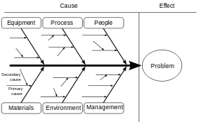
This Photo by Unknown Author is licensed under CC BY-SA

Causes and effect of problems
Management / poor communication/ no face to face interaction with employee
People / Long working hours / low wages/
Work overload / stress, unfocused
Negative attitude at work / financial difficulties/ lack of feedback/ feeling unheard
Declined in quality of work / too many tasks/time management / no training

Using the fishbone techniques to identify the possible cause and effect of the workplace problem

Pestle Analysis

P -Political, policies and political stability
E-Economic, globalization, and cost of living
S-Social, lifestyle, and social norms
T- Technology, how a business responds to new technology
L -Legal, protecting working practices-
E Environmental factor, social responsibility.

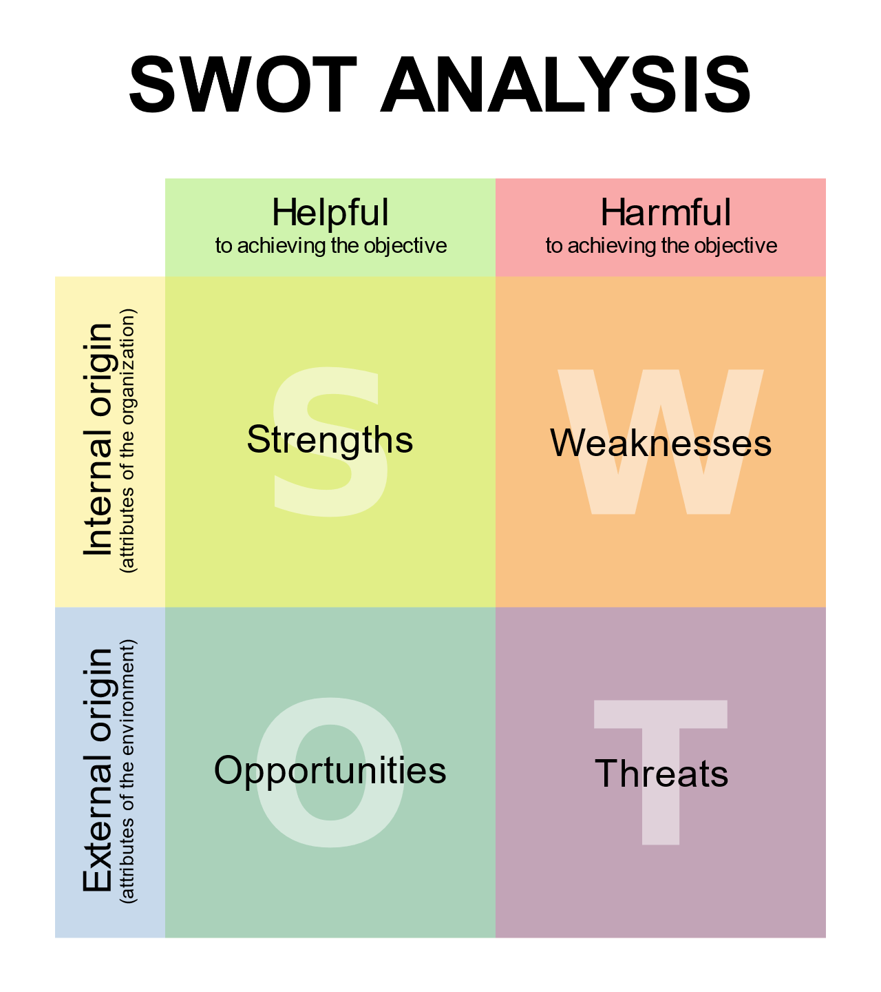
This Photo by Unknown Author is licensed under CC BY-SA.
Swot analysis is a problem-solving tool not only for personal development but also for the business organization. A swot analysis can help improve the input and output of a business.
Fishbone and swot analysis are problem-solving tools that have been used to identify that poor communication is the major problem and need management to improve relationships with employees by listening and giving them a sense of belongingness. Staff training technological updates will enhance the quality of work performance.

Develop a plan for implementation

To implement a solution to a problem, one must follow the brainstorming process to make a lasting solution in the interest of the organization, which is the process of analyzing each of the alternative solutions carefully before putting it into effect. Steps to develop a plan are listed below.
Define goals and objectives- the reasons why you want to accomplish success. This should be made clear from the beginning.
Schedule achievement- set task deadlines and project timeline that is achievable to execute the plan. It an important to outline your schedule in the implementation phase
Allocate Resources- One of the most vital purposes of an implementation plan is to make sure that you have adequate resources, for example, Time, Money, and Personnel. It is essential to gather data to know if you have sufficient resources or not.
Allocation-This is where team responsibility comes in. assign a specified role by creating a general team plan with overall roles that each team member will play.
Define standards for success, this will help to determine whether you are successful with your plan, what data are you going to use to measure your result {qualitative or quantitative}
Make a plan of how to adapt if the need arises to make changes in your list, be sure to consider factors outside your control that could seriously alter the schedule success of the project and create emergent strategies ahead of time.
Evaluate success- in defining your metrics for success, you are to decide how often you will carry out an evaluation of progress within the organization, for example, {quarterly review} Kate Eby. Dec 14, 2017

Communicate the plan to stakeholders
- Communicate the identified problem to the stakeholders
- Explain how the problem has affected employee, how the situation has impacted their mental wellbeing, and costumers are dissatisfied because of the decline in quality of work
- Communicate the decision-making techniques and tools that have been used to conclude.
Based on critical thinking, we found that the solution to a long working hour is to create more breaks in between work,
We found out that the answer to improving the quality of work is to maximize good time management and invest in staff training in technology upgrades’; fun will be required to facilitate costumers’ fun activities. I believe the situation will be better if these changes are put into place.

Techniques for Reviewing the Implementation of the solution

Evaluation. This allows management to as if they are on the right part and how to look at the outcomes for intended beneficiaries, and this also will enable you to rethink if there are other better ways of achieving results.
Understanding the aim and objective of the process is essential to defining why you need to do an evaluation, how it will be used, and by whom. Monitoring reports should include substantive content and full information to measure outcomes.
Involve participant-This creating a work culture where evaluation and review are vital steps in implementation to gather decision making about policy and procedures.
evidence for informed
Apply the result, make the best use of your findings and recommendation. {implementation@pmc.gov.au}

Conclusion
This report has described how tools and problem-solving techniques help facilitate critical thinking ability to provide solutions to complex problems in the workplace.

References
Wustenberg, S., Greiff, S.& Funke, J. {in press}. Complex Problem-Solving. More than reasoning? Intelligence. Forthcoming 2012
Paul J. H. Schoemaker, J Edward Russo, D01; 10, 1057/ 9781137294678,0160 {Palgrave Macmillan}
Dr. Radhika Kapur on Mar 16, 2018
Kelliher, C., Richardson, J., and Boiarintseva, G., 2019. All of the work? All of Life?
Reconceptualizing work-life balance for the 21st century, Human Resource Management Journal, 29 {2}, pp.97-112.

