Module Name: Independent Project
Module Code: BMSW6009
Topic: Role of Transformational Leadership in Managing Growing Labour Shortages and Staff Retention Crisis in UK Hospitality: A Case Study of Whitbread Plc

Table of Contents
1. Introduction to the topic 3
2. Aim & Objectives 4
Aim 4
Objectives 4
3. Literature Review 4
Theme 1: Underlying Causes of Labour Shortages and High Employee Turnover in the UK Hospitality. 4
Theme 2: Employee Retention and Transformational Leadership 5
Theme 3: Constraints to the Effectiveness of Transformational Leadership 6
Theme 4: The Relationship between Organisational Barriers, Transformational Leadership and Labour Shortages 7
Conceptual Framework 9
Literature Gap 9
4. Proposed Methodology and Sampling Technique 9
Research Philosophy 9
Research Approach 10
Research Choice 10
Data Collection Method 10
Data Analysis Method 11
Ethical Consideration 11
Sampling Method 11
5. Conclusion 11
References 12
Appendices 15
Appendix: Gantt Chart 15

1. Introduction to the topic
Labour shortage is a vital issue that many organisations are facing in the current situation. Within the hospitality sector, labour shortage creates several challenges, including low operational growth, issues in wider expansion and increasing overall productivity in the competitive environment. The study has selected labour shortage issues of Whitebread Plc, one of the most popular UK-based companies that operate different market areas. Based on the perspective of Riadil (2020), it has been observed that due to COVID-19 and the Brexit incident, the UK hospitality sector faces issues related to high employee turnover, recruitment challenges and others. Currently, Whitbread Plc has nearly thirty-five thousand employees across its global locations (Whitbread, 2025). Based on the report of Statista, it has been observed that by comparison to 2015-2016, the total employee number of the company has decreased significantly in 2024-2025 (Statista, 2025). The study aims to understand the role of transformational leadership in managing labour shortage issues in the workplace of Whitebread Plc. According to the research work of Greimel et al. (2023), it has been observed that transformational leadership helps to enhance the standard of the workplace environment by integrating training programs, healthy competition between different groups, motivating employees to enhance their productivity levels and securing employee well-being accordingly. As a result, organisations become efficient in tackling their people management and overcoming employee shortages.
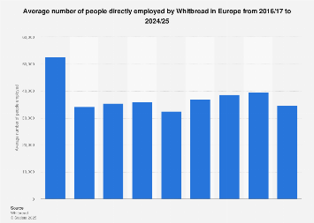
Employee Strengths and Whitebread Plc
(Source: Statista, 2025)

2. Aim & Objectives

Aim
To critically analyse how transformational leadership can be used to solve the labour shortages and increase retention of staff in the UK hospitality industry.

Objectives
- To examine the major reasons for labour deficit and high labour turnover in hospitality organisations of the UK.
- To critically assess the concept of Transformational Leadership and its applicability in employee retention.
- To determine the obstacles that restrain the performance of transformational leadership in the management of workforce challenges.
- To suggest leadership practices that could be implemented to increase employee engagement and boost long-term staff retention within the UK hospitality industry.

3. Literature Review

Theme 1: Underlying Causes of Labour Shortages and High Employee Turnover in the UK Hospitality.
The issue of labour shortage and high staff turnover are still ongoing problems of the UK hospitality industry. Baum et al. (2023) contend that such attributes as anti-social working schedules, low wages, lack of career development, and the restriction on migration post-Brexit have exacerbated the hospitality industry workforce instability. It is an industry that has inherent high mobility because of its seasonal and flexible character (Cottrell, 2015). Conversely, Schmidt et al. (2018) argue that structural management flaws and ineffective employment practices are the main reasons behind retention issues as opposed to external labour market factors.
The dissatisfaction associated with motivation is significant in this argument. According to Herzberg's Two-Factor Theory, as explained by Holston-Okae and Mushi (2018), hygiene factors, including pay and working conditions, do not preclude dissatisfaction but do not automatically produce long-term commitment. Nonetheless, to the contrary, Chiat and Panatik (2019) state that in the hospitality industry, insufficient hygiene factors alone may have a direct influence on turnover intentions. Thus, labour shortage cannot be explained only by macroeconomic factors; poor managerial practices and low motivation strategies have a great impact on labour turnover decision-making.
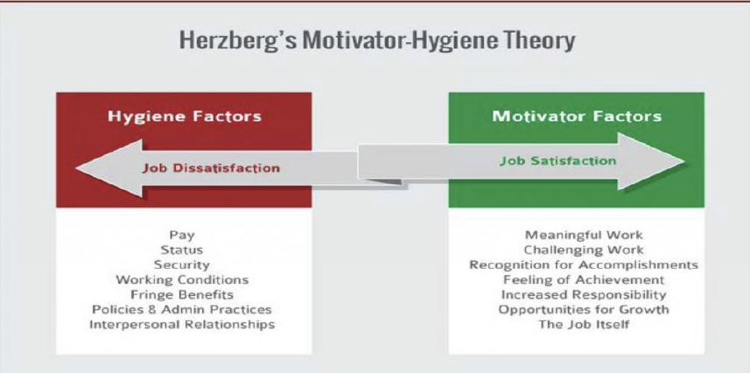
Figure: Herzberg's Two-Factor Theory
(Source: Mansfield and Kuhn, 2024)

Theme 2: Employee Retention and Transformational Leadership
Dlamini et al. (2017) suggest that transformational leadership has been largely marketed as a remedy to the retention issues in service-based businesses. Employees might be more emotionally committed to their jobs by their leaders who inspire, intellectually stimulate, and consider people individually. They claim that this leadership style boosts both interaction and organisational commitment (ASET, 2013). Conversely, Baig and Zaid (2020) state that the transformational leadership approach cannot solve the structural workforce shortages based on pay differentials and job insecurity.
As indicated by the statement of Gupta (2025) the principles of the Transformational Leadership Theory are inspirational motivation and idealised influence as the motivators and motivators of performance and commitment. However, in opposition to this, Mahran et al. (2025) write that as an operational pressure and cost-cutting are natural characteristics of hospitality settings, they can often limit the efficiency of practice by leaders who seek to exercise transformational behaviours. Therefore, organisational culture and structural support are vital in determining the success of transformational leadership, even though positive impacts are possible on the morale of the employees. Leadership cannot work outside the context of the wider human resource strategies.
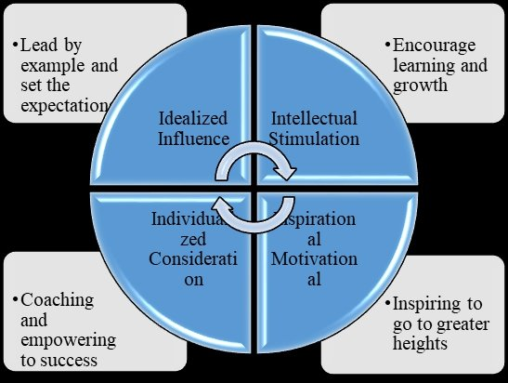
Figure: Transformational Leadership Theory
(Source: Alzoraiki et al., 2018)

Theme 3: Constraints to the Effectiveness of Transformational Leadership
Despite the possible advantages of transformational leadership, there are a number of organisational obstacles which can limit its success. According to Oktaviani and Kusmayadi (2025) high workload requirements, inadequate training of managers, and financial limitations may make leaders unable to spend time and efforts in developing employees. Whitebread Plc and other hospitality organisations focus on efficiency and cost management in order to stay competitive (Gray, 2018). Antes et al. (2019) on the other hand suggest that over operational emphasis can destroy the practice of building relationships and support leadership.
Portoghese et al. (2020) believed that the Job Demand-Control Model can be used to understand this tension because it argues that high job demands with low decision autonomy contribute to stress and burnout among employees. Nevertheless, despite the efforts by leaders to empower employees, organisational hierarchies can hinder effective involvement. Moreover, the immediate short-term needs of the staffing will usually leave managers with no choice but to focus on short-term operational survival as opposed to the long-term engagement strategies. Accordingly, Gui et al. (2020) refuted that the intentions of leadership could be inapplicable in real life, but the obstacles of structure and culture that undermine the implementation of transformational leadership in the hospitality industry.
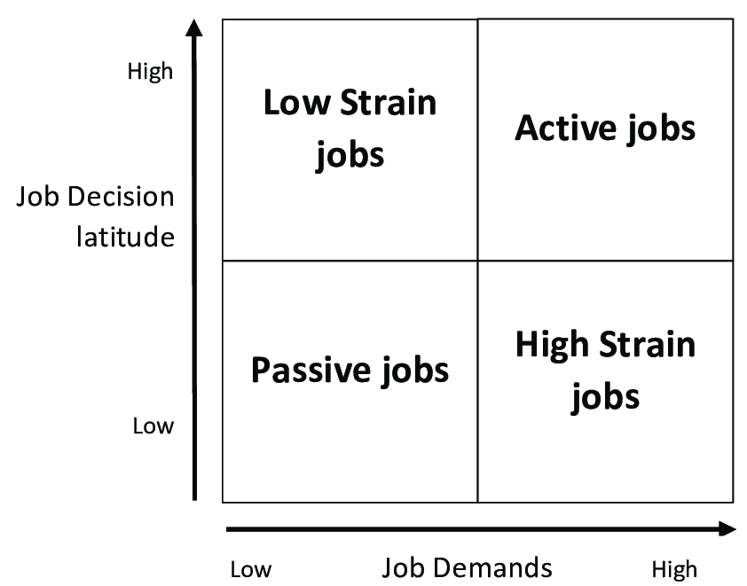
Figure: Job Demand-Control Model
(Source: Larsson et al., 2019)

Theme 4: The Relationship between Organisational Barriers, Transformational Leadership and Labour Shortages
The research by McGinley et al. (2017) indicates that the study of labour shortages in the UK hospitality sector requires the consideration of the interplay between structural factors, leadership, and organisational limitations. Transformational leadership has been placed as a strategic reaction to high turnover and low engagement. Conversely, Green et al. (2020) state that such macroeconomic pressures as decreased migrant labour and increasing living costs also contribute to labour shortages, which cannot be addressed solely by the leadership. This brings conflict between leadership possibility and situational constraints.
According to the viewpoint of Bordia et al. (2017) the Psychological Contract Theory is one of the constructs that can be used to interpret this process by arguing that when employees feel that their expectations of fairness, development, and support are being met, they tend to be committed. But, conversely, Clarinval (2026) believe that even transformational leaders cannot hold up trust and loyalty when organisations do not fulfil these expectations because of operational pressures or cost-cutting measures. Moreover, the application of the leadership behaviours is undermined by the barriers that include limited managerial autonomy and high job demands. Thus, labour shortages and retention issues cannot be resolved only by the leadership style; they are a multifaceted connection of organisational systems with employee expectations and economic realities in the context.
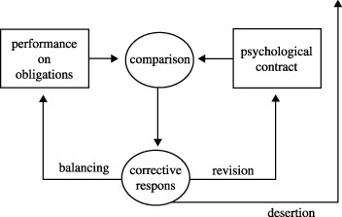
Figure: Psychological Contract Theory
(Source: Schalk and Roe, 2007)

Conceptual Framework
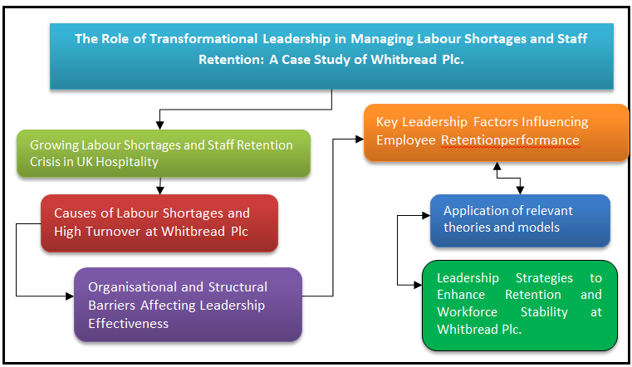
(Source: Learner)

Literature Gap
Even though there has been previous research conducted on transformational leadership and employee retention in isolation, little has been conducted on the direct relationship between the two in the current labour shortages within the UK hospitality industry. What is more, the existing literature does not pay much attention to the structural and operational limitations that can limit leadership performance in practice. Lack of empirical evidence that puts attention on the views of frontline employees in the hospitality sector is also lacking. Thus, there is a research gap regarding the mechanism of operation of transformational leadership in the context of sector-relevant workforce challenges.

4. Proposed Methodology and Sampling Technique

Research Philosophy
Research philosophy refers to the process of involving theoretical concepts and perspectives that underpin the overall investigation (Sreekumar, 2023). This study will involve the interpretivism research philosophy to understand the role of transformative leadership in managing the detrimental impact of labour shortage in the UK Tourism sector. The interpretivism research philosophy will help to interpret a specific topic by utilising different scholarly opinions, industrial reports, and philosophy related to the transformational leadership in the context of overcoming labour shortage.

Research Approach
The process of detecting suitable Pathways for conducting the overall research is known as the research approach (Furidha, 2023). Among Inductive and Deductive research approaches, the study will select the deductive research approach in this investigation to understand organisational activities, in the context of a broader industrial background. The deductive research approach helps to identify a wider aspect as per research objectives and then goes to the core area of the study. The study will identify the role of transformational leadership in a wider industrial area, which is the tourism sector. After that, the study will identify its impact on the leadership activities of Whitebread Plc. Though the study will go to a specific area from a wider perspective, the utilisation of a deductive research approach is justified and appropriate.

Research Choice
The process of compiling data from different resources as per research objectives is known as the research choice. Among quantitative and qualitative research choices, the study will select the qualitative research method to identify the influence of transformational leadership to manage employee shortage in the workplace of Whitebread PLC. According to the perspective of Susilawati et al. (2025), the process of involving non-statistical and logical identification-based data is considered in qualitative research choice. Instead of using quantitative or statistical data, the implementation of qualitative data is good for the study, because it will help to understand the latest industrial trends, employee management policies of tourism companies and strategic recommendations from scholarly perspectives. As a result, the interpretation of relevant and useful datasets becomes productive. Thus, the utilisation of qualitative data is relevant and useful for the study.

Data Collection Method
Data Collection Method is the process of gathering pertinent and helpful information sets from different reliable sources (Khoa et al. 2023). To understand the influence of transformational leadership in the context of the tourism industry to overcome labour shortage issues, the study will utilise a secondary data collection method. It has been found that the approach of the secondary data collection method refers to the process of using information from different journals, articles, industrial datasets, scholarly opinions, former research works and others. The benefit of utilising the secondary data collection method is the easy availability of reliable data and getting opportunities to use verified information from different trustworthy sources.

Data Analysis Method
After getting different types of information related to the topic, the study will analyse them by involving different viewpoints and comparison to make the understanding more effective and realistic (Susilawati et al. 2025). The study will employ thematic analysis in this research to understand the topic from different angles. As a result, the chance of conducting in-depth research and developing critical discussion accordingly.

Ethical Consideration
To make the study widely accepted, it will maintain ethical standards by following the University regulations along with academic integrity. The study will follow the Data Protection Act and the regulations of GDPR to protect all datasets from external users and hackers. The study will also acknowledge former scholars by listing their works and names in the reference list.

Sampling Method
The study will employ the systematic research sampling method to understand the influence of transformational leadership on overcoming labour shortage issues in the UK tourism sector. The systematic research sampling is the process of selecting research samples systematically by using specific intervals to gather information. Though the study will follow the secondary research, the systematic sampling will help the study to utilise such resources, which are specifically connected with the research topic.

5. Conclusion
After completing the entire research proposal, it can be concluded that conducting an initial literature review and identifying the best research methodology helps in-depth analyses to make a proper evaluation and investigation. The topic of the study is associated with the labour shortage issue of Whitebread Plc in the UK tourism sector. The study has selected the secondary research method for the final study. Due to the utilisation of the secondary method, the study will not consider any type of primary information throughout the study. Thus, it can be said that the utilisation of primary data along with secondary data, the overall study might be developed as per research objectives and will help to identify the actual scenario more efficiently.

Reference List
Alzoraiki, M., Rahman, O.B.A. and Mutalib, M.A. (2018). The effect of the dimensions of transformational leadership on the teachers’ performance in the Yemeni public schools. European Scientific Journal, 14(25), pp.322-334.
Antes, A.L., Kuykendall, A. and DuBois, J.M. (2019). Leading for research excellence and integrity: A qualitative investigation of the relationship-building practices of exemplary principal investigators. Accountability in research, 26(3), pp.198-226.
ASET (2013). Good Practice Guide for Work Based Learning and Placement Learning in Higher Education.
Baig, J. and Zaid, A.A. (2020). Behavioral incivility and leadership styles: Assessing the mediation of job strain, employment insecurity and relational injustice: A conceptual model. International Journal of Scientific & Technology Research, 9(3), pp.687-693.
Baum, T., Rubio, J.C. and Congreve, E. (2023). ReWAGE Evidence Paper: Work, Wages and Employment in the UK's Hospitality Sector, pp.1-42.
Bordia, P., Restubog, S.L.D., Bordia, S. and Tang, R.L. (2017). Effects of resource availability on social exchange relationships: The case of employee psychological contract obligations. Journal of Management, 43(5), pp.1447-1471.
Chiat, L.C. and Panatik, S.A. (2019). Perceptions of employee turnover intention by Herzberg’s motivation-hygiene theory: A systematic literature review. Journal of Research in Psychology, 1(2), pp.10-15.
Clarinval, P. (2026). Strategic Alignment in the Luxury Hotel Industry Through the Mastery of the Full Range Leadership Model, pp.1-22.
Cottrell S, (2015). Skills for Success Personal Development and Employability, 3rd edition, Palgrave. London.
Dlamini, N.N.N., Garg, A.K. and Muchie, M. (2017). The impact of transformational leadership style on organisational commitment in the hospitality industry. African Journal of Hospitality, Tourism and Leisure, 6(3), pp.1-21.
Furidha, B.W., (2023). Comprehension of the descriptive qualitative research method: A critical assessment of the literature. Acitya Wisesa: Journal Of Multidisciplinary Research, pp.1-8.
Gray, D.E. (2018). Doing Real World Research, London: SAGE.
Green, A.E., Owen, D., Atfield, G., Baldauf, B., Bramley, G. and Kispeter, E. (2020). Employer decision-making around skill shortages, employee shortages and migration: Literature review, pp.1-12.
Greimel, N.S., Kanbach, D.K. and Chelaru, M., (2023). Virtual teams and transformational leadership: An integrative literature review and avenues for further research. Journal of Innovation & Knowledge, 8(2), p.100351.
Gui, C., Luo, A., Zhang, P. and Deng, A. (2020). A meta-analysis of transformational leadership in hospitality research. International Journal of Contemporary Hospitality Management, 32(6), pp.2137-2154.
Gupta, P. (2025). Transformational leadership: inspiring change and innovation. International Journal of Science and Research (IJSR), 14(2), pp.504-509.
Holston-Okae, B.L. and Mushi, R.J. (2018). Employee turnover in the hospitality industry using Herzberg’s two-factor motivation-hygiene theory. International Journal of Academic Research in Business and Social Sciences, 8(1), pp.218-248.
Khoa, B.T., Hung, B.P. and Hejsalem-Brahmi, M., (2023). Qualitative research in social sciences: data collection, data analysis and report writing. International Journal of Public Sector Performance Management, 12(1-2), pp.187-209.
Larsson, K., Ekblom, Ö., Kallings, L.V., Ekblom, M. and Blom, V. (2019). Job demand-control-support model as related to objectively measured physical activity and sedentary time in working women and men. International journal of environmental research and public health, 16(18), p.3370.
Mahran, K., Albarrak, H., Ibrahim, B.A. and Elamer, A.A. (2025). Leadership and sustainability in tourism and hospitality: a systematic review and future research agenda. International Journal of Contemporary Hospitality Management, 37(7), pp.2219-2242.
Mansfield, S. and Kuhn, J.R. (2024). Education and job satisfaction in uS Contact centers. International Journal of Professional Business Review: Int. J. Prof. Bus. Rev., 9(9), p.2.
McGinley, S.P., Hanks, L. and Line, N.D. (2017). Constraints to attracting new hotel workers: A study on industrial recruitment. International Journal of Hospitality Management, 60, pp.114-122.
Oktaviani, A. and Kusmayadi, O. (2025). The Influence of Training, Leadership Style, and Workload on Employee Work Productivity. Primanomics: Jurnal Ekonomi & Bisnis, 23(3), pp.11-20.
Portoghese, I., Galletta, M., Leiter, M.P., Finco, G., d’Aloja, E. and Campagna, M. (2020). Job demand-control-support latent profiles and their relationships with interpersonal stressors, job burnout, and intrinsic work motivation. International Journal of Environmental Research and Public Health, 17(24), p.9430.
Riadil, I.G., (2020). Tourism industry crisis and its impacts: investigating the Indonesian tourism employees perspectives’ in the pandemic of COVID-19. Jurnal Kepariwisataan: Destinasi, Hospitalitas Dan Perjalanan, 4(2), pp.98-108.
Schalk, R. and Roe, R.E. (2007). Towards a dynamic model of the psychological contract. Journal for the theory of social behaviour, 37(2), pp.167-182.
Schmidt, J.A., Willness, C.R., Jones, D.A. and Bourdage, J.S. (2018). Human resource management practices and voluntary turnover: a study of internal workforce and external labor market contingencies. The International Journal of Human Resource Management, 29(3), pp.571-594.
Sreekumar, D., (2023). What is research methodology? Definition, types, and examples. Paperpal Blog-Academic Writing Guides.
Statista, (2025), ‘Average number of people directly employed by Whitbread in Europe from 2016/17 to 2024/25’, available at: https://www.statista.com/statistics/755720/whitbread-employment/?srsltid=AfmBOoqlHKrHsIR0hi1LrIjHB3toyeyRlV490rkI-lUNSNEo4Ns32RYd accessed on: 26-02-2026
Susilawati, A., Al-Obaidi, A.S.M., Abduh, A., Irwansyah, F.S. and Nandiyanto, A.B.D., (2025). How to do research methodology: From literature review, bibliometric, step-by-step research stages, to practical examples in science and engineering education. Indonesian Journal of Science and Technology, 10(1), pp.1-40.
Whitbread, (2025), ‘Whitebread Plc, Investing Growth’, availableat: https://cdn.whitbread.co.uk/media/2025/05/Whitbread-PLC-Annual-Report-and-Accounts-2024-25.pdf accessed on: 26-02-2026

Appendices

Appendix: Gantt Chart
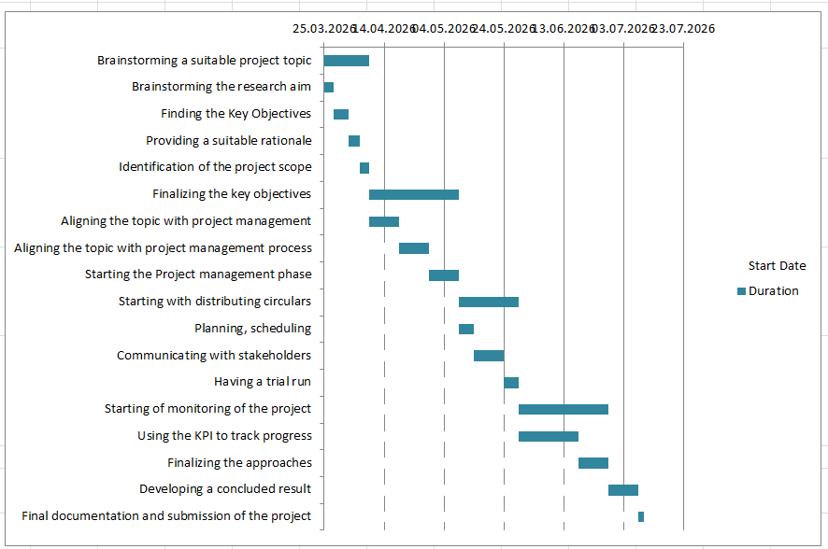
(Source: Learner)

