Assessment 1
Economics of Sustainability
Pheobe Twigg

Externality – something damaging the market
Provide evidence of externality and how trade block costed the damage done to the society
Hypothetically utilise supply and demand diagram for externality
Look at solution put in place by group of government/ country

Introduction
The automotive industry is a vital part of the UK economy with it being worth more than £78.9 billion in turnover and adding to the UK economy £15.3 billion in value. In the UK in 2019 over 1.3 million cars, 78,270 commercial vehicles and 2.5 engines were built (SMMT 2020). The European automobile industry generates a £74 billion trade surplus for the EU, powering economic growth. As the automobile industry has great effects throughout the economy, supporting a vast supply chain and generating an array of services (ACEA 2020). In 2015, around 947 million passenger cars and 335 million commercial vehicles were in operation worldwide. The passenger vehicles are becoming more of a normality within today’s society as it continues to increase (Key 2021). There are more than 30 manufacturers of vehicles in the UK supported by 2,500 component providers along with the world’s most skilled engineers.
This essay will address how regulations have been put in place to reduce the CO2 emissions within the automobile industry and to revolutionise the industry into being more environmentally sustainable and to reduce the negative effects. These regulations also supports lowering the detrimental risks posed to society associated with the output emissions that are produced within the industry.
The failure of externality within the industry to the environment will be address prior to the regulations being implemented through figures along with evident diagrams to develop and understanding of why the industry was failing within the economy.
This essay will also analysis the industry post the regulations being implemented and how this has improved the industry and how it has influenced the environment and society through tables of evidence.
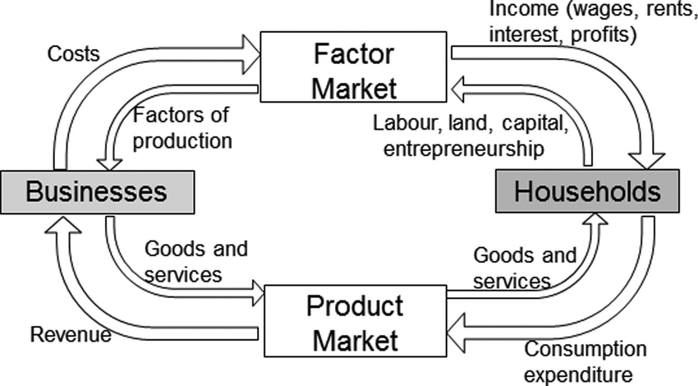
The circular flow model indicates the relationship between manufacturers and households and how demand influences the production and supply of goods and services.

Failure and externalities of the automobile industry
Road transport is a major source of air pollution that harms human health and the environment. An externality is a spillover effect associated with production or consumption that extends to a third party outside the market (Pettinger 2021). The externality within the automobile industry is the level of CO2 emissions transmitted from vehicle which is causing harm to the earth as well as human health. The cars within the automobile industry account for over 18% of the UK emissions, according to the figures provided by the government. As a whole transport emissions account for a third of the UK’s total emissions (European Commissions 2021). Carbon dioxide is the primary greenhouse gas emitted through human activities. With the main for of greenhouse gas globally being C02 its impact combined with other greenhouse gases has a large impact on earth and has the potential of speeding up global warming to an irreversible extent (SEPA 2020). Personal vehicles are a major cause of global warming along with passenger vehicles.
Prior to 2009 within the EU there were no generated regulations as to what percentage of CO2 emissions that could be generated from vehicles. The manufactures producing vehicles in the way they saw fit and profitable were solely responsible for the CO2 emissions a vehicle would produce. As well as influencing the earth it also influences human’s health as CO2 emissions impact human health by displacing oxygen in the atmosphere.
Prior to the CO2 emissions regulations being implemented there was an increase of man-made emissions within the atmosphere which upset the natural balance to the point of causing possible irreversible damage to the earth and atmosphere (Craddock 2020). In 2012nthe average emissions were 132.2 gCO2/km. The transport industry is responsible for around 33% of CO2 emissions in the UK being the highest contributor in the last decade before the regulations were implemented (European Environment Agency 2021). In 2018, UK emissions stood at 57% of their 1990 levels.

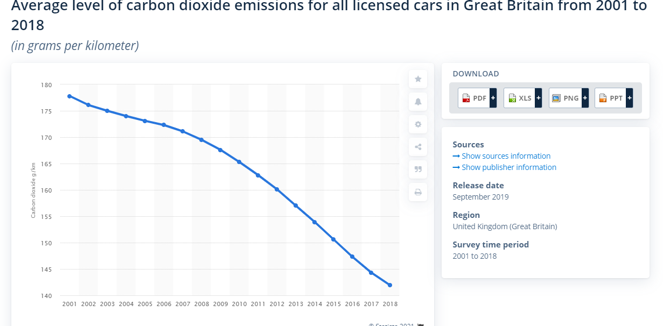
(European Environment Agency 2021)
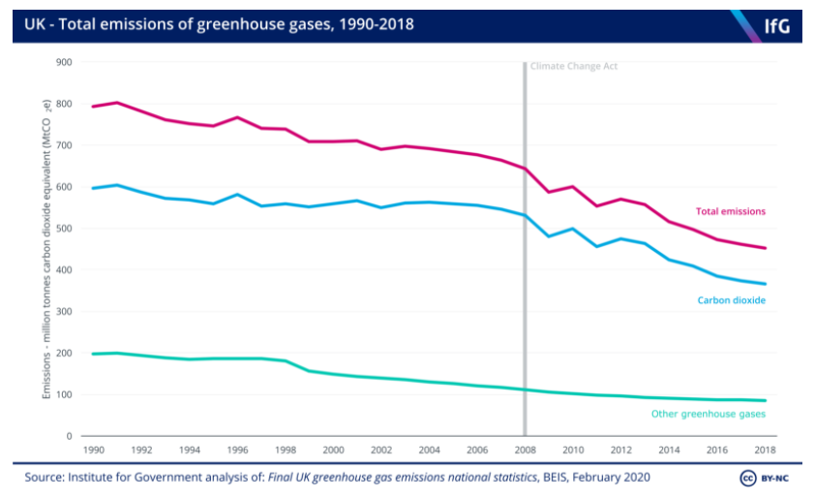

Institute for Government (2020)

Prior to the CO2 emissions regulations regarding the issue of global warming being at its highest along with the health risks of excessive CO2 emissions increasing, manufacturers weren’t considering CO2 as an important element of the vehicles and had full authority over the amount of CO2 emissions a vehicle would transmit. Although there was the ability to adjust and change materials and methods to decrease the CO2 emissions a vehicle released this would lead to a profit decrease for the manufacturer and the product would appear the same as previously. With the industry failing prior to the regulations being implemented as they weren’t considering the marginal external costs such as marginal social costs.
Therefore, when the manufacturers fails to pay marginal social costs arising from their activities, the social costs remain with society. When manufacturers produce vehicles that transmit a large amount of CO2 this is polluting the air and environment and society must pay the cost of the polluted environment along with it having a negative effect on individuals health. A marginal social cost would be the pollution to the air as the excessive CO2 emissions being released is affecting individual’s health as well as progressing global warming. A public good is non-rivalry and therefore when it’s consumed it doesn’t reduce the amount available for others (Pettinger 2021). Air is a public good and the pollution of the industry prior to the regulations. Anthropogenic Pollutants are human induced and include all residuals associated with consumption and production (Webster 2020).
Marginal external costs is defined as the additional cost imposed on third parties, who may not necessarily consume the product by producing an extra unit of good (EZY Education 2021). The impact on third parties are different within different situations, in this case the producer is the car manufacturer and the consumers are the vehicle users. Environmental economists are interested in things that damage the environment. The third party in this case are wider society as they incur the additional costs from the vehicles as they are exposed to the CO2 emissions that are polluting the environment, consequently from the car fumes creating the negative externality of pollution.
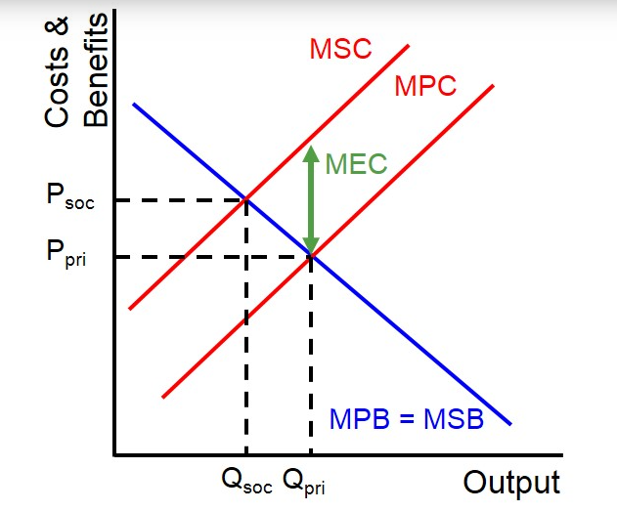
Below is a visual diagram of the marginal external costs:

(EZY Education 2021)

Organisations within the automobile industry could implement this diagram into their organisation as it allows them to measure the size of the external costs and to then allow them to adapt to be in line with the government and social factors. As the existence of external costs can lead to market failure (Pettinger 2021). Marginal external costs can be identified at the point where the marginal private costs and the marginal social cost curve diverge. Prior to the regulations relating to CO2 emissions being implemented if the automobile industry would have utilised this model, the marginal cost prior to the regulations it would have shown that the producer wasn’t including externality cost of damaging the environment with the CO2 emissions produced by the vehicles and therefore were pricing the vehicles at a too low price but producing too many vehicles.
The automobile industry was understood to be failing prior to the regulations due to them having no incentives to adjust and change the way they were producing the vehicles to reduce the environmental damage outside the market transaction. As there is a large competition within the automotive industry with 14 companies control a combined 62 brands producing vehicles there is large competition and focus on profit within their operations with it being a major industrial and economic force worldwide (Gould 2018). The producers within the automobile industry were collectively failing prior to the governments regulations set out in 2010 due to them not considering their external costs to the environment and solely concentrating on the number of vehicles produced and units sold.

Market performance in the automobile industry after the solutions of the regulations
The government have set out regulations within the automobile industry as they have noticed that the market was failing, there are a variety of methods of improvement within different industry’s as the products vary within different industries. These possible solutions can vary from regulations, taxes, and subsidies (CFI Education Inc 2021). With the issue of externality in this industry the solutions are regulations and taxes as property rights and Coase theorem attribute ownership of the marginal external cost and therefore wouldn’t be applicable. The Coase theorem states, "if trade in an externality is possible and there are no transaction costs, bargaining will lead to an efficient outcome regardless of the initial allocation of property rights.” (Valdes 2019). This applies as air cannot be owned by any individual as it is a public good therefore within this industry the solution of processing property rights wouldn’t be relevant in this situation. The market approach is justifiable as it is based on incentive-based policies that encourages conservation or pollution reduction.
Regulations were put in place to support the automobile industry out of the failing economy, these regulations were set out to reduce the amount of impact of CO2 emissions on the environment. To improve the quality of the air the EU set out regulation setting limits for the maximum amount of pollution that can be emitted from vehicles, this is to be followed by the UK until are fully independent and will likely become a regulation in the UK (European Environment Agency 2021). These regulations were drafted in 2010, to support the automobile industry out of the failing market as it imposed them to deal with the negative externalities of their production and to reduce the amount of CO2 emissions polluting the air. The regulation set out a target for new vehicles that between 2015-2019 that their emissions would be reduced to a level of 130g CO2/km (European Commission 2020). The goal for 2021 is for the CO2 emissions of new vehicles to be reduced to 95g CO2/km. The purpose of the regulations set out by the EU was to reduce the CO2 emissions released from cars into the air which would lower the level of marginal external cost within the industry of the air pollution.

The previous model is used to identify market failure within an industry, but the same model can also be used to identify the improvement within the industry since the regulations and methods of improvement have been applied. As seen below:

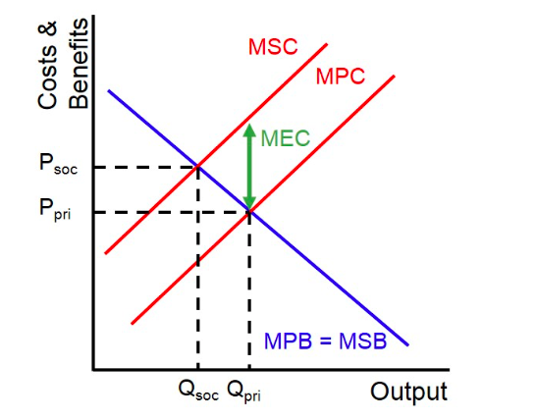

(EZY Education 2020)

Since the regulations were implemented, the amount of C02 emissions per g/km has significantly dropped in comparison to before the implementation of the regulations, an average drop of 27.6g C02/km (European Commission 2020). With the CO2 emissions reaching 122.4g CO2/km in 2019, being below target of 130g CO2/km that applied as the goal for 2019 but above the EU target of 95g CO2/km that was set for this year (European Environment Agency 2021). The decrease in emissions between 2010 and 2019 will increase the marginal external cost of the businesses within the automobile industry which will increase the equilibrium price and lower production costs of products. Equilibrium in an economy is the state of balance, the market equilibrium price is the price that equates demand and supply within the market (Pettinger 2019).

As the protection of air quality and reduction of greenhouse gas emissions is a priority for the European Commission, the regulations set out by the EU as environmental policies are of high standard with the quality of the air and environment, to help reduce the impact of the emissions on individuals health while also making the economy more efficient (Sarao 2020). Standards can cause implications they can cause legislative constraints as standards are benefit based, they are set out to improve society’s well-being with no consideration for the associated costs, where the marginal social benefit (MSB) abatement equals to the marginal social cost (MSC) abatement. The market equilibrium is the point at which value for society has been maximized. It is at this point that allocative efficiency has been achieved (Pettinger 2021). In this case this would be the price society are willing to pay for the emissions of the vehicles but must be equal to the opportunity cost of manufacturing the product, this would balance the benefits of the manufacturer to meet the consumer demand to maintain production (Argarwal 2020). Within the automotive industry the MSB abatement is measured by the reduction in damage of CO2 emissions to the environment and the MSC abatement is calculated by combing the total pollution marginal abatement (MAC) and the marginal cost of enforcement of regulation (MCE).
MSC- Within the automobile industry if the manufacturers marginal social costs are higher than the marginal private costs, the marginal external cost is positive and results in a negative externality, meaning it produces a negative effect on the environment.


The level of allocative efficiency can be identified at the point where the MSB and MSC curve intersect. The value society places on the good is equivalent to the value of the resources given to produce it.

(Seldis 2012)

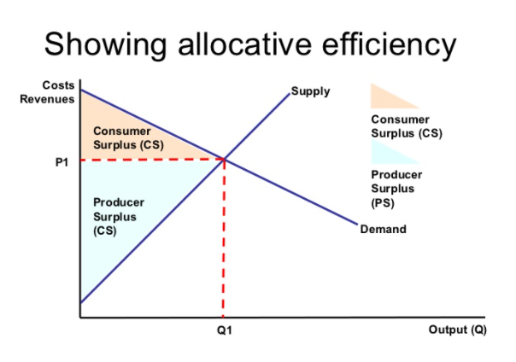
Manufacturers can be affected by regulations as they come with legislative constraints which makes it difficult for them to reach their allocative efficiency. As with regulations such as the CO2 emissions regulations this can affect manufacturers bottom line due to the devices that reduce car emissions cost money to develop and mass produce which means there’s an increase in cost for manufacturers (Investopedia 2019). Regulations are seen sometimes to consider more of the benefit that the regulation will have on the environment rather than considering the issues and changes that arise for manufacturers during the change. With the regulations being updated in 2019 for the target to get emissions of new vehicles within the automobile industry to 95g CO2/km this could create additional costs which will have a negative effect on manufacturers. If the manufacturers don’t comply with the regulations and guidelines set out by the EU and their emissions aren’t in line with it, they could be faced with a penalty (European Commission 2015). For every 1g/km of CO2 that a manufacturer exceeds its average emissions target by, it will be fined €95 multiplied by its volume of new-car registrations in the preceding year. Research has stated that car manufacturers in the EU are not expected to meet the new 95g CO2/km target and could face fines amounting to more than €20 billion in both 2021 and 2022 (Roberts 2020).
Implementing new standards within the vehicles the manufacturers produce can require a large amount of resources to adapt their products to meet the standards and this could put many manufacturers within a rut as to how they are going to proceed to follow the standards. Volkswagen has been one of the leading offenders, with their CO2/km slated to average 109.3g in 2021. Global automakers face the risk of 17.2 billion in fines from the European Union for failing to meet the new tough emissions standards (Lemerle 2019). Allocative efficiency may not be a sustainable action of standard for many car manufacturers. As the supply increases with allocative efficiency, the demand for the product decreases since society as it becomes more ready want less. Therefore, allocative efficiency is a more convenient method of standard but doesn’t always consider the impact regulations have on manufacturers when the regulations are enforced within a specific industry, they just focus on society (Corporate Finance Institute 2021).
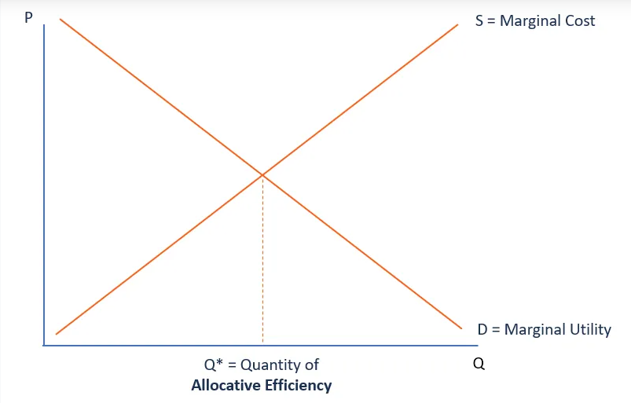

(Corporate Finance Institute 2021)

The future of the industry
Rather than the current allocative efficiency approach that is currently being imposed upon the automobile industry, it could be argued that in the future a market approach would be greater long-term and more effective. The market approach refers to an incentive-based policy that encourages a pollution reduction strategy (Portney 2020). The market incentive approach that would be most relevant within the automobile industry is that of pollution charge, these are fees that vary depending on the amount of pollutants released, as these fees vary the most suitable one for this industry would be emission fees. Due to the regulations causing many manufacturers to not be able to meet the proposed regulations and causing them to fall within the market and continuing on with these regulations there won’t be any market left to regulate, the market incentive approach is a better method of regulating the automobile industry. This market approach incentive proposes a pollution reduction strategy which encourages pollution charges and pollution trading systems as an alternative to proposing legislative regulations. With this approach there would be an imposed product charge as per unit tax on product, with this each individual firm would be a charge which would be reflective of their individual pollution percentage of their CO2 emissions, therefore the less the pollution, the lighter the vehicle the less the charge. There would be a product fee imposed per vehicle on the discharge of pollution, which is typically implemented through a tax. This method is more effective as it encourages manufacturers to adapt their products to pay a lower charge (Zhang 2012). It also offers incentives to manufacturers to reach the goals in a cost-effective way.
A Pigouvian tax is a government cost on any activity that creates socially harmful externalities. Pigouvian taxes can also create more efficiency in an economy, especially when the tax covers the cost of the external damage (Amadeo 2020). If the charge imposed on a vehicle is equal to that of the marginal external cost of the vehicle it is deemed as Pigouvian tax.


This model illustrates how a Pigouvian tax achieves efficiency in the market for some pollution-

With the tax been set at the point between the private marginal cost and private marginal cost it allows the manufacturers within the automobile industry to operate more effectively rather than having a substantial fine if their emissions are excessively high. The Pigouvian tax is a more effective way of discouraging the activities that lead to negative externalities (Corporate Finance Institute 2021). There can be implications to the market approach of applying the Pigouvian tax of an economy of large scale as it can be difficult to manage, as the Pigouvian taxes must be equal to the negative externality costs and it’s not always possible to get the precise measurement (Corporate Finance Institute 2021). As the marginal costs vary amongst all the manufacturers within the automobile industry it may be difficult to analyse everyone’s exact tax. Although this is an effective market approach method and its effectively trying to reduce the emissions that are produced within the automobile industry, it’s not directly enforcing lower emissions, as firms are still able to operate in the same way it just means they’ll have a higher amount of tax to pay. Although this method is seen as more beneficial for organisations it may not reduce the amount of CO2 emissions that are affecting the environment which is the main issue.
Pollution reduction subsidy could be a solution to reducing the amount of CO2 emissions produced within the automobile industry. Subsidies are forms of financial government support for activities that are believed to be environmentally friendly. In contrast to charging the polluter for emissions, this method rewards polluters for reducing emissions (Environmental Protection Agency). Environmental subsidies typically are implemented as grants, low-interest loans, tax credits or exemptions, and rebates.

(Pettinger 2019)

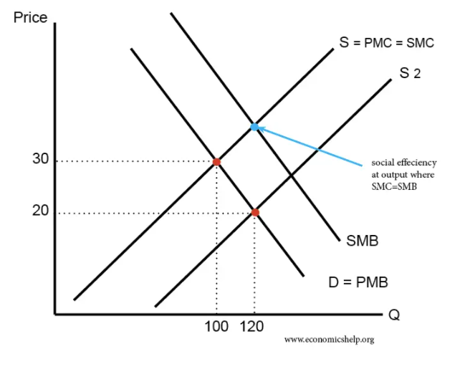

Pollution reduction subsidies can be an advantage as within this scheme the government can raise substantial revenue, which could be used to finance other pollution schemes (Pettinger 2019). It also provides organisations such as the manufacturers within the automobile industry to offer more efficient engines, which then reduces the amount of CO2 emissions that are being released and reduces pollution. It can be seen as negative as firms may take advantage and keep the subsidy money for extra profit within their organisation rather than for developing alternative energy source. This may lead to public money being wasted, with little reduction in pollution (Pettinger 2019).

Conclusion
The automobile industry market was failing greatly prior to the regulations implemented on the industry by the EU, due to social costs and the amount of CO2 emissions the vehicles were releasing into the environment causing it damage as well as health issues for individuals. With a reduction in CO2 emissions, the air quality will improve, and this will result in an increase amongst the health of the entire planet. In conjunction to improvement of public health the global economy will also benefit from a cleaner environment through a reduction emissions (Enright 2019). The regulations set out by the EU have made a effective change within the amount of CO2 emissions transmitted by vehicles and it has decreased effectively over the last decade, although there is far more advanced actions that need to be taken in order to ensure that the CO2 emissions can be reduced further to avoid further danger to the environment and individuals health.
Although the automobile industry aren’t failing since the implementation of the regulations relating to CO2 emissions, the automobile industry are completely successful as they transmitted other emissions from the vehicles produced. Some manufacturers within the automobile industry are offering alternatives but these aren’t recognised on such a scale, they offer electric cars, and research has shown that electric cars are better for the environment as they emit less CO2 and air pollutants over their lifetime than a petrol or diesel car (EDF Energy 2020).
The models used have allowed an understanding of how the changes within the industry have helped to identify potential benefits within the industry as well as the reduction in social costs from the changes in manufacturers decisions. Although the regulations have made a difference over the last decade manufacturers within the automobile industry are failing to reach the regulations over the last few years, they have managed to independently low CO2 emission rates but have hit a point where the regulations alone aren’t sufficient enough to lower the emission rates to the desired amount of pollution in the atmosphere. For the CO2 emissions to be at the desired level the regulations must be collaborated with another method such as the market incentive approach of taxation to allow a large difference amongst the emissions in the environment.

References

ACEA. (2020). Facts about the automobile industry. Available: https://www.acea.be/automobile-industry/facts-about-the-industry. Last accessed 4th May 2021.
Agarwal, P. (March 2020). Allocative Efficiency. Available: https://www.intelligenteconomist.com/allocative-efficiency/. Last accessed 6th May 2021.
Amadeo K. (November 2020). Pigouvian Taxes, Their Pros and Cons, and Examples. Available: https://www.thebalance.com/pigouvian-tax-definition-and-examples-4157479. Last accessed 7th May 2021.
CFI Education Inc. (2021). Externality. Available: https://corporatefinanceinstitute.com/resources/knowledge/economics/externality/. Last accessed 6th May 2021.
Corporate Finance Institute. (2021). Allocative Efficiency. Available: https://corporatefinanceinstitute.com/resources/knowledge/accounting/allocative-efficiency/. Last accessed 7th May 2021.
Corporate Finance Institute. (2021). Pigouvian Tax. Available: https://corporatefinanceinstitute.com/resources/knowledge/other/pigouvian-tax/. Last accessed 7th May 2021.
EDF Energy. (2020). Benefits of electric cars on the environment electric car green environment By Marta Moses | February 15, 2020 | Electric cars (EVs) Electric cars are ever more appealing in a world where reducing car. Available: https://www.edfenergy.com/for-home/energywise/electric-cars-and-environment#:~:text=Research%20has%20shown%20that%20electric,to%20fuel%20them%20is%20considered. Last accessed 7th May 2021.
Enright Z. (2019). 7 Key Benefits of Greenhouse Gas Emission Reduction. Available: https://www.gensuite.com/7-key-benefits-of-greenhouse-gas-emission-reduction/. Last accessed 7th May 2021.
Environmental Protection Agency. (2021). Economic Incentives. Available: https://www.epa.gov/environmental-economics/economic-incentives. Last accessed 10th May 2021.
European Commission. (2015). EU ETS Handbook. Available: https://ec.europa.eu/clima/sites/default/files/docs/ets_handbook_en.pdf. Last accessed 6th May 2021.
European Commission. (2020). Road transport: Reducing CO2 emissions from vehicles. Available: https://ec.europa.eu/clima/policies/transport/vehicles_en. Last accessed 6th May 2021.
European Commission. (2021). Progress Made in Cutting Emissions. Available: https://ec.europa.eu/clima/policies/strategies/progress_en#:~:text=2020%20target,%2C%20emissions%20declined%20by%203.7%25. Last accessed 4th May 2021.
European Environment Agency. (2021). Average CO2 emissions from new cars and new vans increased again in 2019. Available: https://www.eea.europa.eu/highlights/average-co2-emissions-from-new-cars-vans-2019. Last accessed 6th May 2021.
European Environment Agency. (2021). Consumers buying more efficient cars in Europe. Available: https://www.eea.europa.eu/highlights/consumers-buying-more-efficient-cars#:~:text=New%20vehicle%20technology%20is%20becoming,which%20is%20an%20encouraging%20sign.&text=The%20latest%20edition%20of%20Mo. Last accessed 4th May 2021.
EZY Education. (2021). Marginal External Cost. Available: https://www.ezyeducation.co.uk/ezyeconomicsdetails/ezylexicon-economic-glossary/741-marginal-external-cost.html. Last accessed 5th May 2021.
Gould S. (February 2018). These 14 companies dominate the world's auto industry. Available: https://www.businessinsider.com/biggest-car-companies-in-the-world-details-2018-2?r=US&IR=T. Last accessed 5th May 2021.
Institute for Government. (2020). UK net zero target. Available: https://www.instituteforgovernment.org.uk/explainers/net-zero-target. Last accessed 4th May 2021.
Investopedia. (June 2019). What Regulations Affect the Automotive Sector? Available: https://www.investopedia.com/ask/answers/042015/how-much-impact-does-government-regulation-have-automotive-sector.asp. Last accessed 6th May 2021.
Key, B. (2021). Vehicles and road traffic. Available: https://www.statista.com/statistics/281134/number-of-vehicles-in-use-worldwide/. Last accessed 4th May 2021.
Lemerle M. (May 2019). New CO2 emission regulations in Europe: A perfect storm for car manufacturers? Available: https://www.eulerhermes.com/en_global/news-insights/economic-insights/New-CO2-emission-regulations-in-Europe-A-perfect-storm-for-car-manufacturers.html. Last accessed 7th May 2021.
Pettinger T. (2019). Equilibrium. Available: https://www.economicshelp.org/microessays/equilibrium/market-equilibrium/. Last accessed 6th May 2021.
Pettinger T. (2019). Policies to reduce pollution. Available: https://www.economicshelp.org/blog/11077/environment/policies-to-reduce-pollution/. Last accessed 10th May 2021.
Pettinger T. (2021). Allocative Efficiency. Available: https://www.economicshelp.org/blog/glossary/allocative-efficiency/. Last accessed 6th May 2021.
Pettinger T. (2021). Definition of Public Good. Available: https://www.economicshelp.org/micro-economic-essays/marketfailure/public-goods/. Last accessed 5th May 2021.
Portney P. (June 2020). Market-Based Approaches to Environmental Policy: A “Refresher” Course. Available: https://www.resources.org/archives/market-based-approaches-to-environmental-policy-a-refresher-course/. Last accessed 7th May 2021.
Roberts L. (February 2020). Carmakers face €20 billion in fines for exceeding CO2 targets – Part 2. Available: https://autovistagroup.com/news-and-insights/carmakers-face-eu20-billion-fines-exceeding-co2-targets-part-2. Last accessed 6th May 2021.
Sarao J. (22nd May 2020). Reducing Carbon Emissions Will Benefit the Global Economy- Here’s How. Available: https://earth.org/carbon-emissions-economy/#:~:text=Reducing%20carbon%20emissions%20would%20decrease,between%20the%20two%20is%20needed. Last accessed 6th May 2021.
Seldis A. (2012). Economic Efficiency. Available: https://www.slideshare.net/aseldis/economic-ef fiency. Last accessed 6th May 2021.
SEPA. (2020). EU Emissions Trading System. Available: https://www.sepa.org.uk/regulations/climate-change/eu-emissions-trading-system/. Last accessed 4th May 2021.
SMMT. (2020). UK Automotive. Available: https://www.smmt.co.uk/industry-topics/uk-automotive/#:~:text=The%20UK%20automotive%20industry%20is,value%20to%20the%20UK%20economy.&text=Over%201.3%20million%20cars%20%2C%2078%2C270,in%20the%20UK%20i. Last accessed 4th May 2021.
Valdes O. (2019). The US Economy. Available: https://www.thoughtco.com/introduction-to-the-coase-theorem-1147386. Last accessed 6th May 2021.
Webster M. (2020). anthropogenic. Available: https://www.merriam-webster.com/dictionary/anthropogenic. Last accessed 5th May 2021.
Zhang B. (2012). Market-based solutions: An appropriate approach to resolve environmental problems. Available: https://www.tandfonline.com/doi/full/10.1080/10042857.2013.777526. Last accessed 7th May 2021.

