

BA International Hotel Management
Student name: Maria Costinela Hurmuzache
Student ID:2125468
Lecturer name: Helen Lee
Personal resourcing and development.

Executive Summary
This guidebook, which emphasizes cultural knowledge and sensitivity, attempts to provide Ritz London employees with ideas to improve the guest experience for foreign guests. The hotel may improve service by understanding its customers' cultural customs and making appropriate accommodations. The research highlights the significance of cultural sensitivity across many hotel divisions and offers an extensive inventory of 'Do's and Don'ts' to facilitate staff communication.
Table of Contents
Executive Summary 2
Introduction 4
Cultural Intelligence And Sensitivity In Hospitality 4
Implications For Guest Services From London’s International Visitor’s 5
Front Desk And Reception 5
Housekeeping 5
Food And Beverages Services 5
Concierge Services 6
Security And Safety 6
Do’s And Don’ts For Hotel Ritz London 6
Conclusion 6
Recommendations For Hotel Ritz London Staff 6
Attend Frequent Training Classes On Cultural Sensitivity. 6
Create A Resource Guide That Includes References To Cultural Subtleties. 7
References 8

Introduction
Given the diversity of foreign visitors to London, a thorough knowledge of other cultures is necessary. Therefore, the importance of cultural intelligence for Ritz London hotel staff is explored in this research. However, globalization transformed hospitality and simplified interaction with people from different backgrounds and places, revolutionizing the tourist industry. In order to address the needs of global travellers, this transition necessitates heightened cultural understanding (Cooper, 2007). At the same time, the industry's most common kind of mass tourism along the shore presents potential and problems for coastal hospitality.
Moreover, comprehending the varied origins of visitors is essential for providing customized services (Bramwell, 2004). In order to facilitate inclusive guest experiences, the Journal of Intercultural Communication delivers insights necessary for managing cultural difficulties in hospitality and tourism (Journal of Intercultural Communication, 2018). Fortunately, this guidebook offers practical insights to modify service delivery to suit the varied cultural norms and preferences of visitors from different countries by examining the cultural implications on guest services. By encouraging inclusion and great client experiences, this hotel guidebook is a thorough manual for Ritz London employees as they traverse the varied cultural terrain of foreign tourists in the hospitality sector.

Cultural Intelligence And Sensitivity In Hospitality
Cultural intelligence is becoming an essential resource for hotels such as the Ritz London, located in the tourist hotspot of London, in the ever-changing hospitality business. Jandt (2016) emphasizes the critical role that cultural intelligence plays in the hospitality industry, particularly for facilities that host a wide range of foreign guests. This significance strikes a deep chord in the selected nation since London continues to be a global melting pot of cultures that attracts visitors worldwide.
As espoused by Moran (2018), accepting and comprehending people from different cultural origins goes beyond simple improvements in communication. It serves as the foundation for reducing the possibility of misunderstandings and raising visitor pleasure. This knowledge is essential for creating experiences specifically customized to the expectations and cultural preferences of the hotel's global customers, such as the Ritz London.
Furthermore, Timm's (2011) claim on how cultural awareness affects the whole tourism experience is especially relevant to the seaside area of the hotel. London requires a subtle approach because of its diversified visitor population and coastline attractions. In this environment, cultural sensitivity becomes a strategy for maintaining competitiveness in the dynamic tourism sector and improving visitor experiences. As a result, promoting a warm and inclusive atmosphere is consistent with the Ritz London's mission to deliver outstanding and culturally sensitive guest experiences.

Implications For Guest Services From London’s International Visitor’s

Front Desk And Reception
Effective communication may require translators or language help (Abingdon, 2009). Consequently, Ritz London has to improve its front desk and reception. Their employees should treat visitors decently and consider local customs while extending pleasantries.

Housekeeping
Another area that Ritz London has to prioritize is housekeeping. It is meant by Understanding guests' preferences about amenities, food requirements, and room arrangement is essential to their satisfaction.

Food And Beverages Services
The Ritz London's food and beverage services are intended to provide a variety of culinary alternatives and consider dietary limitations. Dining experiences are improved when one is aware of the customs and manners of different cultures.

Concierge Services
In addition to other implications, concierge services may greatly improve the visitor experience by informing guests about activities and places relevant to their culture (Lewis, 2008).

Security And Safety
Ritz London may prosper by honouring private requests and maintaining security; these actions also conform to many cultural norms.

Do’s And Don’ts For Hotel Ritz London
Do’s | Don’ts
  - Please give guests a warm, polite greeting.  Source: (Fluentu.com, 2016) |   - Avoid assuming anything about cultural preferences.  Source: (Preply.com, 2023)
  - Do offer linguistic support wherever required.  Source: (Surveyvista.com, 2023) |   - Never disregard dietary requirements or preferences  . Source: (Wp.com, 2018)
- To provide a variety of food alternatives.  Source: (Chp.gov.hk, 2014)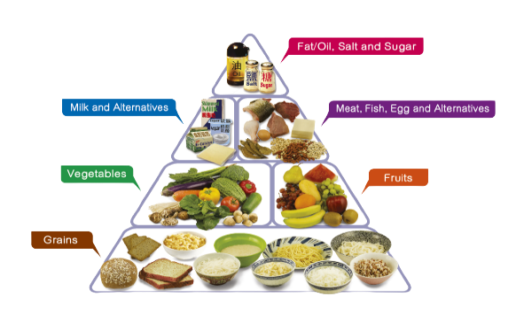 | - Never disregard requests for a specific room layout.  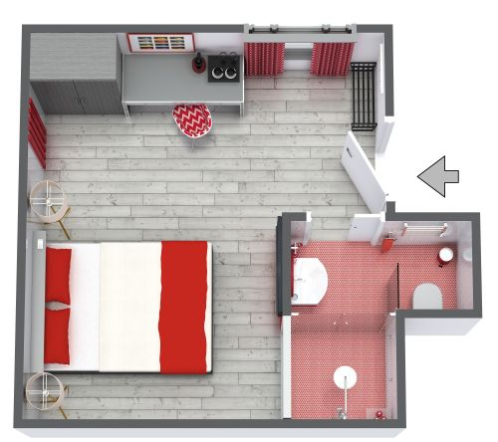  Source: (Roomsketcher.com, 2023)
- Honour people's choices for privacy.   | - Pay attention to how communication techniques vary throughout cultures.    Source: (Pinimg.com, 2023)

Conclusion
Conclusively, for the Ritz London to be successful, guest services must be modified to meet the cultural demands of foreign guests. Fortunately, the hotel may enhance the guest experience and create a warm and inviting atmosphere for all guests by putting the mentioned "Do's and Don'ts" into practice and encouraging cultural awareness.

Recommendations For Hotel Ritz London Staff

Attend Frequent Training Classes On Cultural Sensitivity.

Source: (Slidesharecdn.com, 2023)
Regular training courses on cultural sensitivity allow Ritz London staff members to continually improve their comprehension of various cultural conventions and behaviours. Interactive workshops, case studies, and conversations showcasing diverse cultural manners, communication styles, and customs should all be included in these sessions. Moreover, employees who work in a learning atmosphere can become more aware, empathetic, and adaptive, which will help them interact with visitors from different backgrounds courteously and confidently. Ultimately, this continuous training fosters a more welcoming environment and a closer bond and understanding between employees and foreign guests.

Source: (Cloudfront.net, 2023)

Create A Resource Guide That Includes References To Cultural Intricacies

Source: (Medium.com, 2023)
Producing an all-inclusive resource book is an invaluable aid for Ritz London employees, offering conveniently available details about cultural subtleties, traditions, and inclinations of visitors from a wide range of foreign backgrounds. Moreover, comprehensive information about greeting customs, dining etiquette, communication methods, and other cultural nuances should also be considered by the hotel.

Source: (Epicpxls.com, 2023)
It should be readily available to all departments and updated regularly so employees can promptly obtain the information they need to customize their services properly. Moreover, an employee may comfortably handle encounters with visitors while displaying cultural tolerance and understanding with the help of such a practical guide.

References
Abingdon. Samovar, L.(2009) Communication Between Cultures, Wadsworth,
Bramwell, B. (2004) Coastal Mass Tourism, Clevedon: Channel View.
Chp.gov.hk. (2014). Available at: https://www.chp.gov.hk/files/jpg/adult_eng.jpg
Cloudfront.net. (2023). Available at: https://d230yvp9l0f4m2.cloudfront.net/zquthdhyzpi5dynk2hru1yyziba0_72624025be.jfif
Cooper, C. and Wahab, S., (eds.) (2007) Tourism in the Age of Globalisation. London: Routledge.
Epicpxls.com. (2023). Available at: https://imgproxy.epicpxls.com/4Ei2Gp4iG3YTpsmcAZbw6TsDTk3dXgWgIwd5_Te8Ju0/rs:fill:800:600:0/g:no/aHR0cHM6Ly9pdGVt/cy5lcGljcHhscy5j/b20vdXBsb2Fkcy9w/aG90by83MjgzNjUy/YWI2ZGI0Y2NiZTVk/YTU3MDY2ZThiYjE0/MA.jpg
Fluentu.com. (2016). Available at: https://www.fluentu.com/blog/english/wp-content/uploads/sites/4/2023/06/hotel-receptionist-giving-key-to-guest.jpg
Jandt, F (2016) An Introduction to Intercultural Communication, 8th edition, Sage: San Bernadino.
Journal of Intercultural Communication (2018). Journal of Intercultural Communication. [online] Immi.se. Available at: https://immi.se/intercultural
Lewis, R.D. (2008) Cross-Cultural Communication: A Visual Approach, London, Nicholas Brealey Publishing.
Medium.com. (2023). Available at: https://miro.medium.com/v2/resize:fit:1400/1*1kr4zDD9NXVNST2OUWqJpw.jpeg
Moran, R. (2018) Managing Cultural Differences, 10th edition, Routledge: Abingdon.
Pinimg.com. (2023). Available at: https://i.pinimg.com/474x/c6/83/ca/c683ca97d202cbf9857342bcb75a4996.jpg
Preply.com. (2023). Available at: https://preply.com/wp-content/uploads/2021/01/Formal-greetings.jpg
Roomsketcher.com. (2023). Available at: https://fpg.roomsketcher.com/image/project/3d/15/-hotel-room.jpg?w=500&h=500
Slidesharecdn.com. (2023). Available at: https://image.slidesharecdn.com/culturalsensitivityanddiversitytraining-190326203533/85/cultural-sensitivity-and-diversity-training-1-320.jpg?cb=1671625265
Surveyvista.com. (2023). Available at: https://surveyvista.com/wp-content/uploads/2020/06/multi-lang.png
Timm, A. (2011) Intercultural Problems in the Tourism Industry, GRIN Verlag.
Wp.com. (2018). Available at: https://i0.wp.com/chefbraakman.com/wp-content/uploads/2018/08/special-diets.jpg?fit=1173%2C692&ssl=1

