

LOCATION: Swansea | LLEOLIAD: abertawe
LEVEL 4 | LEFEL 4
EXAMINATION PERIOD | CYFNOD ARHOLIADAU
July 2019 | Gorffennaf 2019

MODULE CODE: ACDA4004
Micros Peripherals and Interfaces
TIME: 2 HOURS
answer all questions

Equipment or materials required – Calculator
Adnoddau neu ddefnyddiau sydd eu hangen - Cyfrifiannell

ANSWER ALL QUESTIONS

- The following comprise a number of mnemonics from the PIC16F887 microprocessor instruction set. Give the meaning of what each mnemonic stands for and explain what the instruction actually does:
  - BSF
[2 Marks]
  - BTFSC
[2 Marks]
  - ADDLW
[2 Marks]
  - ANDLW
[2 Marks]
  - DECF
[2 Marks]

- What is the resolution of an 8 bit DAC with a maximum output voltage of 10V? Give your answer in mV.
[4 Marks]

- For the binary weighted DAC shown in Fig Q3, calculate the output voltage, Vout, assuming the reference voltage is 5V.

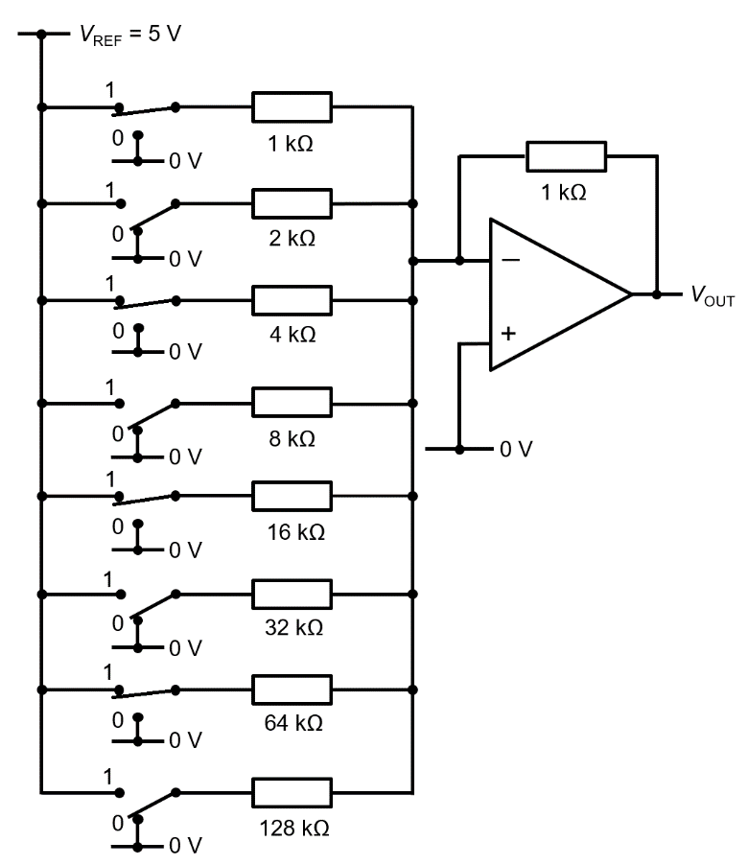
Fig Q3
[6 Marks]

- Draw the logic symbol for an XOR gate and provide the truth table for it.
[4 marks]

- The following circuit comprises two inputs, A and B. Construct a truth table, showing the output states of all the intermediate logic gates as well as the final, overall output.

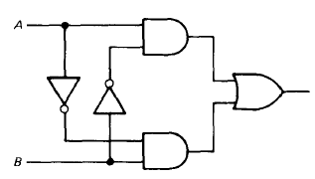

Fig Q5
[8 Marks]

- Using De Morgan’s Theorem, show how you can implement a NAND function using NOR only logic
[8 Marks]

- Compare and contrast the Harvard and Von Neumann processor architectures and state common applications for each. You may wish to use diagrams to support your answer.
[10 Marks]

Diwedd/End

