Problem Solving and Decision Making


Name : Vasuruban Nadarajah
Student Number : 2133550
Module Code : BMSW4004
Lecturer Name : Balendran Kandasamy

Contents
Introduction ............................................................................................ 3
The workplace problem.......................................................................... 3

Analysing Information ............................................................................. 5
Root cause analysis (RCA) .................................................................... 5
Applying Situation Analysis Models ..................................................... 7

Range of Alternative Solutions ............................................................. 8

Evaluation of Alternative Solutions....................................................... 8

Implementing Solutions ........................................................................ 9
Communication Plan with Stakeholders.............................................. 10

Conclusion ............................................................................................... 12

References .............................................................................................. 13

Appendix ................................................................................................. 14

Introduction
Problem-solving is the ability to identify and understand a problem, find a solution and take action. It is a skill that is used in every aspect of our lives, from personal relationships to professional careers. Problem-solving is a key skill. Problem-solving skills are the ability to identify problems and analyze solutions for the problem and implement the best solutions. Those with good problem solving ability will move the business forward more effectively. Those lacking problem solving ability will be ineffective in making solutions to key business issues, solutions which will fail to resolve the issues.

Tesco plc is a British groceries and general merchandise retailer headquartered in Welwyn Garden City, England In 2011 it was the third-largest retailer in the world measured by gross revenues. and the ninth-largest in the world measured by revenues. It has shops in Ireland, the United Kingdom, the Czech Republic, Hungary, and Slovakia.
Tesco has expanded globally since the early 1990s, with operations in 11 other countries in the world. The company pulled out of the US in 2013, but as of 2018 continues to see growth elsewhere. Since the 1960s, Tesco has diversified into areas such as the retailing of books, clothing, electronics, furniture, toys, petrol, software, financial services, telecoms and internet services. In the 1990s, Tesco re-positioned itself from being a downmarket high-volume low-cost retailer, attempting to attract a range of social groups with its low-cost "Tesco Value" range (launched 1993[) and premium "Tesco Finest" range.

The Workplace Problem

People can feel stressed very easily especially at work. There are many reasons for cause for stress at work. Long work hours, heavy workload, changes within the organisation, tight deadlines, changes to duties. job insecurity, boring work, experiencing discrimination, hate or abuse are some of the reasons and causes for work related stress.

Work related stress can affect workers through job performance, productivity, work engagement and communication, physical capability, and daily functioning. Also, it can affect the mental health, physical health, wealth, family and future. Even excessive stress can cost death.

Organizations can permanently shut if the workers unable to perform well effectively and efficiently due to above mentioned causes.

ROOT CAUSE ANALYSIS – FISH BONE DIAGRAM
Work related Stress

Poor communication
Unavailability for work
Workload

Tiredness / injury
Wrong Information
Heavy tasks
Absence
Tight deadlines
Illness
Not able to understanding details
Limited hours

Dissatisfaction
Discrimination
Less wages

Unhappy
Unfair job roles
No bonus or increments
Uninterested in work
No encouragement
No rewards
Poor Management
Under paid
Lack of Support
The fish bone diagram was clearly explained by the Lecturer on how to identify the possible causes of identified issue and how to identify the possible root causes of identified problem causes. Here it is clear that the work related stress has many possible causes. Listed above on the diagram are few identified root causes and possible causes for work related stress.

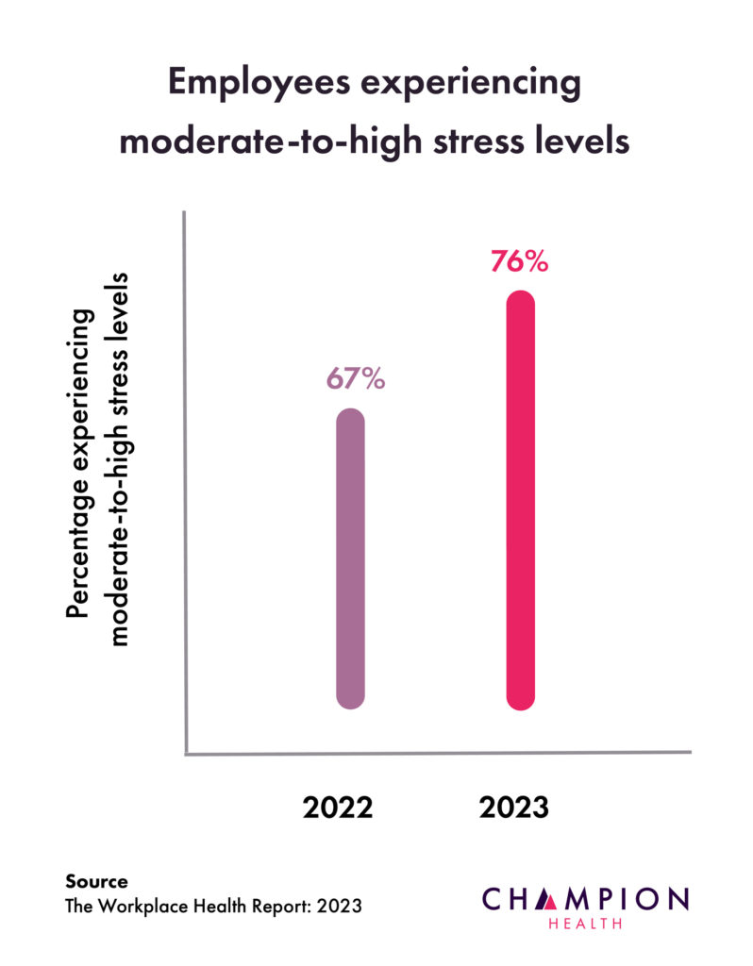

Considering the reasons for work related stress, Poor Management, Under pay, Lack of support, Workload, poor communication and unavailability for work ( mental health or physical health reasons) are been identified as possible root causes for the complex problem.

In the latest report of Champion Health has stated employees experiencing moderate-to-high stress levels from 67% in the year 2022 to 76% in the year 2023 which is a hike of 9% already by April 2023.

Applying Situational Analysis
Tracking stressors, keeping a journal for a week or two to identify which situations create the most stress and how you respond them, developing healthy responses, communicating with each other, establishing boundaries, taking time to recharge, learning how to relax, talking to management, getting some support are few steps that can help to do job role in an efficient and effective way without stress at work place.

Decision Making Techniques

SWOT

Strength  - Honesty  - Training and Skills  - Enthusiastic  - Positive attitude | Weakness  - Poor Communication  - Concentration Problem
Opportunities  - Facilities to upgrade Skills  - Adopt Technologies  - Create Good Team | Threats  - Insecurity in work  - Injuries  - Competition  - Data Security

RANGE OF ALTERNATIVE SOLUTIONS

Given below are the solutions for the possible root causes explained in the fishbone diagram. These solutions are supportive to lessen the stress or reduce the stress or work without stress and work place.

Solution 1: Providing support

Solution 2: Consider Flexible Work Schedules

Solution 3: Encourage Open Communication

EVALUATION OF ALTERNATIVE SOLUTIONS

Weighted Decision Matrix

Decision Making Factors | Weight | Solution 1  (Providing Support) |  | Solution 2  (Considering Flexible Work Schedules) |  | Solution 3  (Encouraging Open Communication)
Workload | 5 | 5x5 | 25 | 3x5 | 15 | 3x5 | 15
Poor Communication | 5 | 4x5 | 20 | 2x5 | 10 | 5x5 | 25
Unavailability for Work | 5 | 2x5 | 10 | 4x5 | 20 | 3x5 | 15
Poor Management | 5 | 4x5 | 20 | 2x5 | 10 | 5x5 | 25
Underpaid | 5 | 4x5 | 20 | 3x5 | 15 | 2x5 | 10
Lack of Support | 5 | 5x5 | 25 | 4x5 | 20 | 2x5 | 10
 |  |  | 130 |  | 90 |  | 100

As per the scores for Solutions 1, 2 and 3. It is clear that the solution 1 is highest with 130 and is the best alternative solution which is providing support at work.

Providing support is workload, high tasks and uninterested work will help with work in satisfactory and will pay a high role in staff stress free work.

IMPLEMENTING THE SOLUTION

ADKAR

Awareness:

Why the change is necessary?
It is important to understand that the work related stress needs to be taken into consideration. Change can produce effective results.

Desire:

Unsatisfied with the work?
Yes. Due to the complex problem identified, it is clear that the unsatisfaction at work place will cause stress.

Knowledge:

How to Change?
Preparing a plan with solutions and implanting the plan.

Ability:

Skills to make the change happen?

Implementing the plans through practical exercises and introducing plans with consistency.

Reinforced:

Practising.

COMMUNICATION PLAN WITH STAKEHOLDERS

The major stakeholders in a corporation usually include its customers, employees, investors, suppliers, and the local community.

List of Stake Holders :

- Full-Time Employees
- Part-Time Employees
- Seasonal Employees
- Temporary Employees

High
Part-Time Employees  Encouragement / Praise  Active Listening  Be transparent  Ask for suggestions  Treating Equally | Full- Time Employees  Open communication  Providing resources  Offering opportunities  Be flexible  Creating policies in favour
Seasonal Employees  Fair Play  Providing appropriate support | Temporary Employees  Training  Reach out

Influence of Power of Stakeholders

Low High

Interest of Stakeholders

STAKEHOLDERS ENGAGEMENT PLAN

An employee engagement plan is a mechanism that organizations develop to define and prioritize their actions for improving employee engagement. It enables recognizing the key factors that influence employee engagement, identifying the employees’ pain points, and creating customized initiatives to address them. These can be fast and easy employee engagement improvements, as well as long-term programs.
Employee engagement plan helps convey to employees that the company is committed to responding to any sort of employee engagement feedback.
Thus, an employee engagement plan is an ideal tool to get started with if your company is willing to make a significant difference in how your organization approaches employee engagement.
Even though employee engagement is receiving increased attention in many companies, most workers are disengaged at work. Just 36% of employees said they were engaged at work, according to a Gallup survey A lot of causes trigger low employee engagement, including a lack of respect from superiors, poor company communication, and a lack of alignment with the company’s mission. Since engaged employees contribute to long-term employee retention, higher productivity levels, and increased job efficiency, it’s clear that company leaders need to start seeing employee engagement as a strategic business goal.

Considering the above factors, it is important to identify and provide a solution or a change to the employees to make them satisfies in their job roles and to do the work without stress.

Support from the workplace can help increase an employee's feelings of competence and therefore their level of interest in their work. Employees who feel valued and supported perform better at work, and go beyond their required duties.

In work support includes but is not limited to: Job coaching – learning the job or specific tasks with the person and helping them practice how to do it in line with employer requirements. Supporting individuals to complete induction and other training is essential.

The support which is mentioned above includes: Learn to listen, Motivate and inspire, Communicate, Provide feedback, Be available, Focus on employee development, Reward achievements, Recognize strengths and weaknesses.

CONCLUSION

Providing support to employees will result the company/business’ make employees feel rewarded and appreciated for their work, also provide support to an employee's family, health, and financial future which can help attract and retain top talent.

Support from the workplace can help increase an employee's feelings of competence and therefore their level of interest in their work. Employees who feel valued and supported perform better at work, and go beyond their required duties.

REFERENCES

https://championhealth.co.uk/insights/stress-statistics/#:~:text=76%25%20of%20employees%20report%20moderate,stress%20is%20workload%20(73%25)

https://www.google.com/search?q=10+ways+to+reduce+stress+at+work&bih=746&biw=1536&rlz=1C1ONGR_enGB1018GB1018&hl=en-GB&sxsrf=APwXEdc7ebOXm-WRosfTU41-IHrgRBrdZw%3A1682203469421&ei=TWNEZJuwGc-gptQPxpmhqAI&oq=alternative+solutions+for+work+related+stress&gs_lcp=Cgxnd3Mtd2l6LXNlcnAQARgAMgQIABBHMgQIABBHMgQIABBHMgQIABBHMgQIABBHMgQIABBHMgQIABBHMgQIABBHSgQIQRgAUABYAGCBGWgAcAJ4AIABAIgBAJIBAJgBAMgBCMABAQ&sclient=gws-wiz-serp

https://youtu.be/4Ok2BKSuAew

https://www.google.com/search?q=communication+plan+with+stakeholders+examples&rlz=1C1ONGR_enGB1018GB1018&oq=communication+plan+with+&aqs=chrome.5.0i512l2j69i57j0i512l3j0i22i30l4.10623j0j7&sourceid=chrome&ie=UTF-8

https://www.google.com/search?q=how+to+satisfy+full+time+employees&rlz=1C1ONGR_enGB1018GB1018&sxsrf=APwXEdckC3sKcfR9RHM6KjfYxJLpH3y6OA%3A1682375663265&ei=7wNHZO_TD8CxptQP36W7oAs&ved=0ahUKEwivh6beycP-AhXAmIkEHd_SDrQQ4dUDCBA&uact=5&oq=how+to+satisfy+full+time+employees&gs_lcp=Cgxnd3Mtd2l6LXNlcnAQAzIFCCEQqwI6CggAEEcQ1gQQsAM6BwgAEA0QgAQ6CAgAEIoFEIYDOgcIIxCwAhAnOgoIIRCgARDDBBAKOggIIRCgARDDBEoECEEYAFDtA1jDFmDyHmgBcAF4AIAB4AGIAZYNkgEFMC45LjGYAQCgAQHIAQjAAQE&sclient=gws-wiz-serp#ip=1

U.S. Employee Engagement Reverts Back to Pre-COVID-19 Levels (gallup.com)

APPENDIX

ASSESSMENT 1 – In class

Role Play

Ruban: Good Afternoon Mate. Everything Okay?

Diego: Good Afternoon, No. Not okay. Not happy and I am so tired.

Ruban: Everyone is saying not happy and they are so tired.

Diego: Yes. No staff. most of them are sick. All of them stressed with work. They gossip and there are some miscommunication going on.

Ruban: Yes. I need to try and recruit few staff from the agency to cover.

I will have to put a rota system to duty.
Spread the work to everyone.
I need to schedule a meeting with staff. Explain what they need to do.

Some they forgetting what they need to do and they are doing something else.

Don’t worry Diago. We will sort this out. Take care.

Diago: Thanks. Take care.

Role Play Presentation

Root Causes for Dissatisfied Employee:
- Being Under paid
- Unsupportive Management
- Limited Career Growth
- Work Stress

