Network Operating Systems and Services

(NOSS) Assignment 1

Worksheet: Building a virtual LAN utilising type 2 Hypervisor Management Software

By Kristen Buller 2005063

Task 1

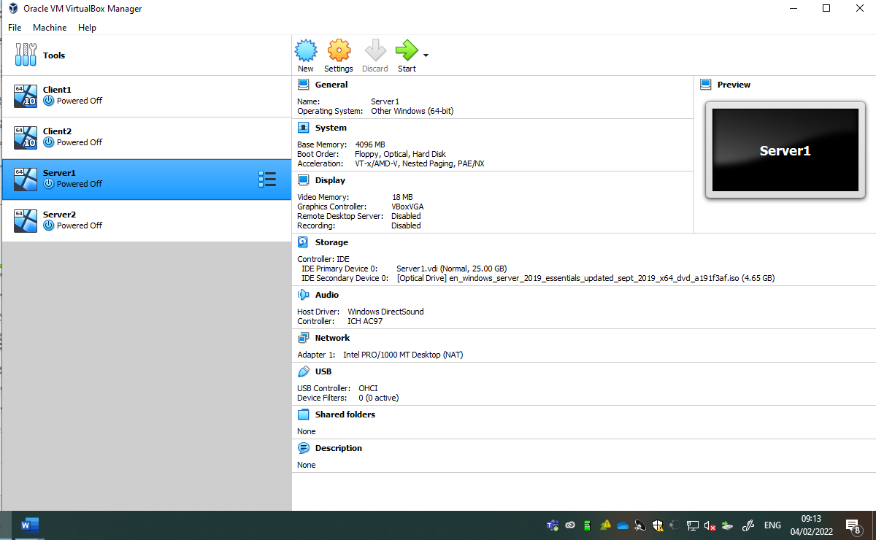
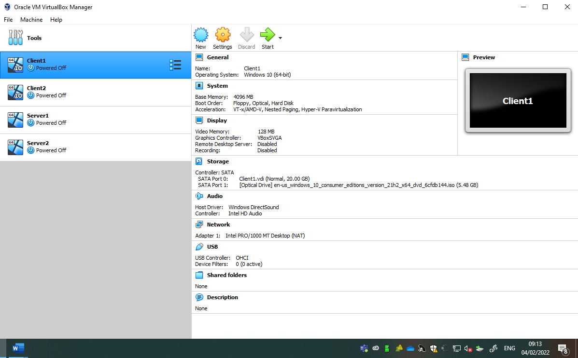
The user has taken Windows Server 2019 and Windows 10 from Azure. They have created two Virtual Box machines, setting the memory size for both VM’s at 4096MB (REFERENCE IF WANT).
The user then selected the VDI Virtual Disk Image this is a type of file which is used for the Virtual Hard Disk. They selected 25GB for the Virtual Hard Disk size, 20GB for the Client VM, and 25GB for the Server VM. The client VM does not need to be more than 20GB this will save physical hard drive space.
Once these steps are completed, the ISO Windows Server 2019 and Windows 10 are installed onto the VM’s.

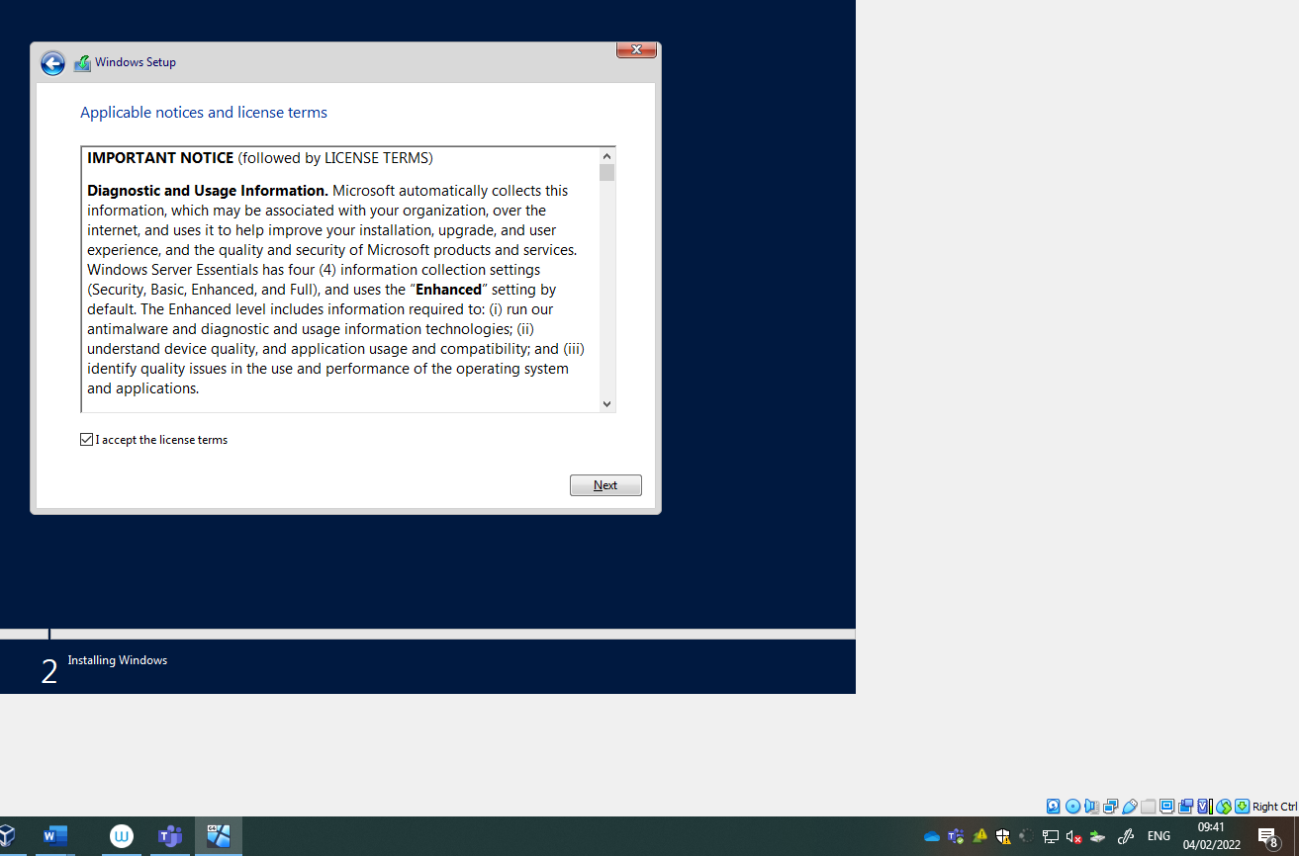
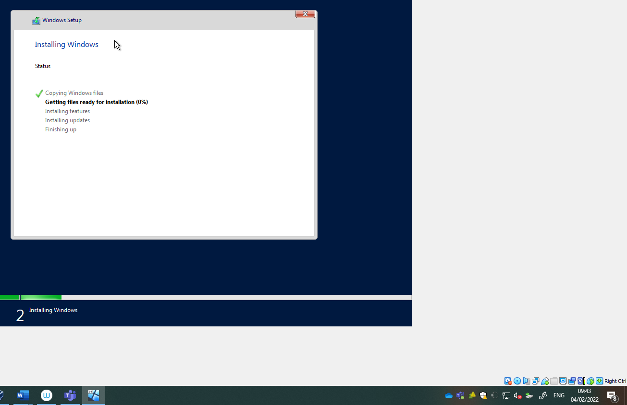
Server 1 is booted up through the virtual machine, this begins to download Windows Server 2019.

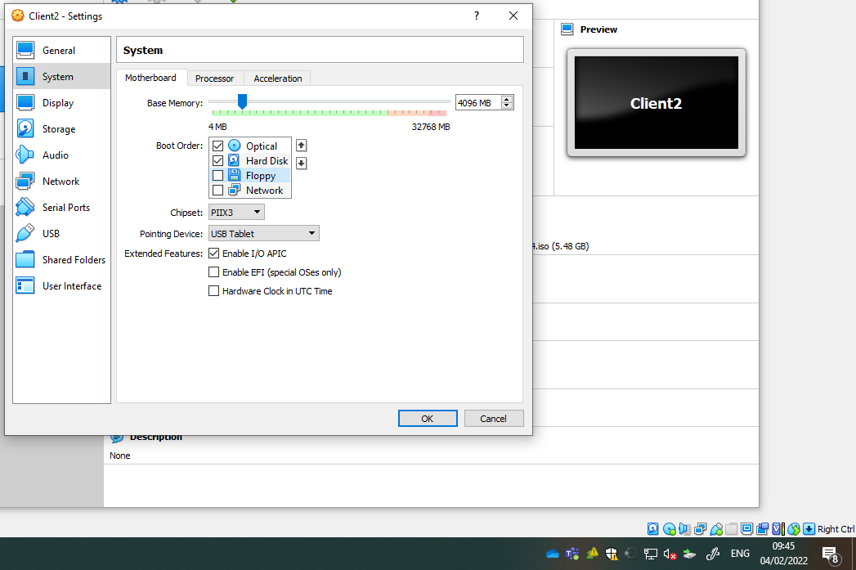
Through the systems Virtual Machine on Client2 the user unselected Floppy Disk as it’s no longer used in modern day computing. And only selected Optical Disc and Hard Disk, they moved them both to the top so booting the PC is much faster and no unnecessary memory is used to boot up the floppy disk, meaning much faster loading.

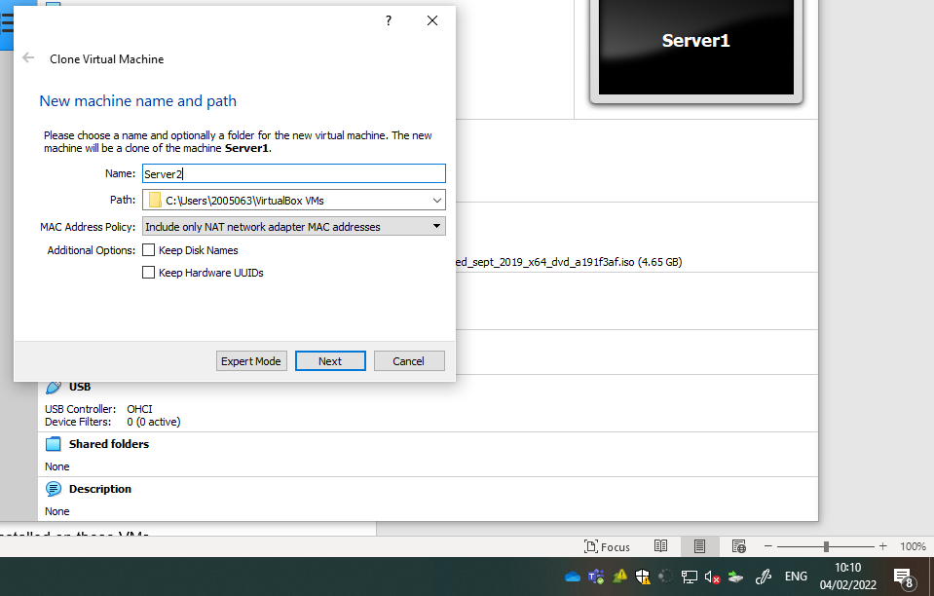
When Server2 is generated. It’s important to be mindful of MAC address policy setting. Generating a new mac address for all adapters is important because LAN protocols such as Ethernet cabling allow for fast transfer of data, ensuring that each Server has its own unique mac address allows the transfer of data between each Virtual Machine.

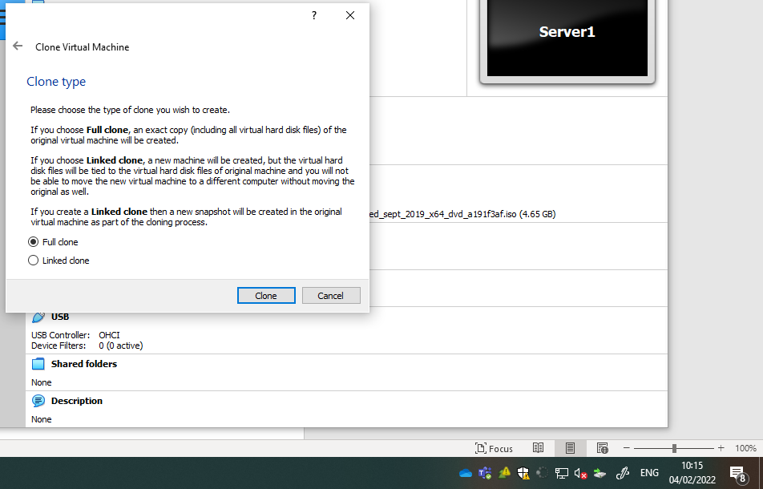
Cloning the Server1 allows for the user to create an identical SRV2

2. Virtual Network Configurations

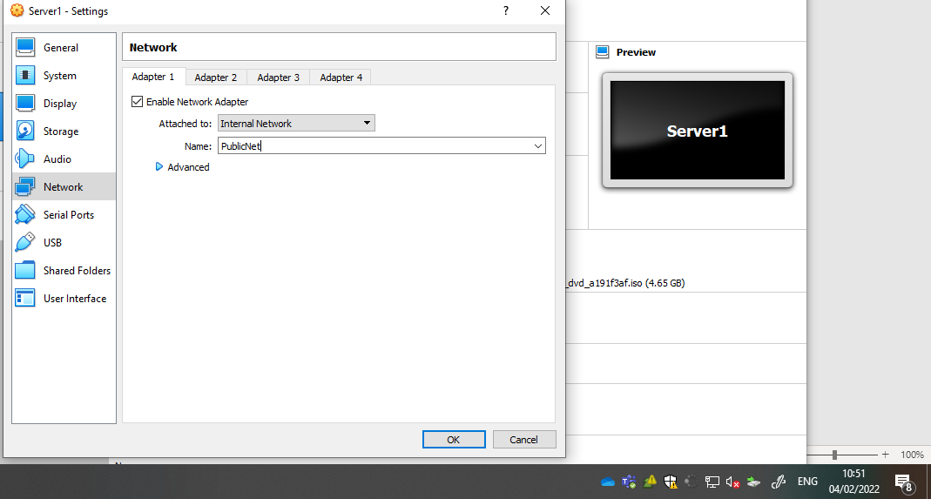

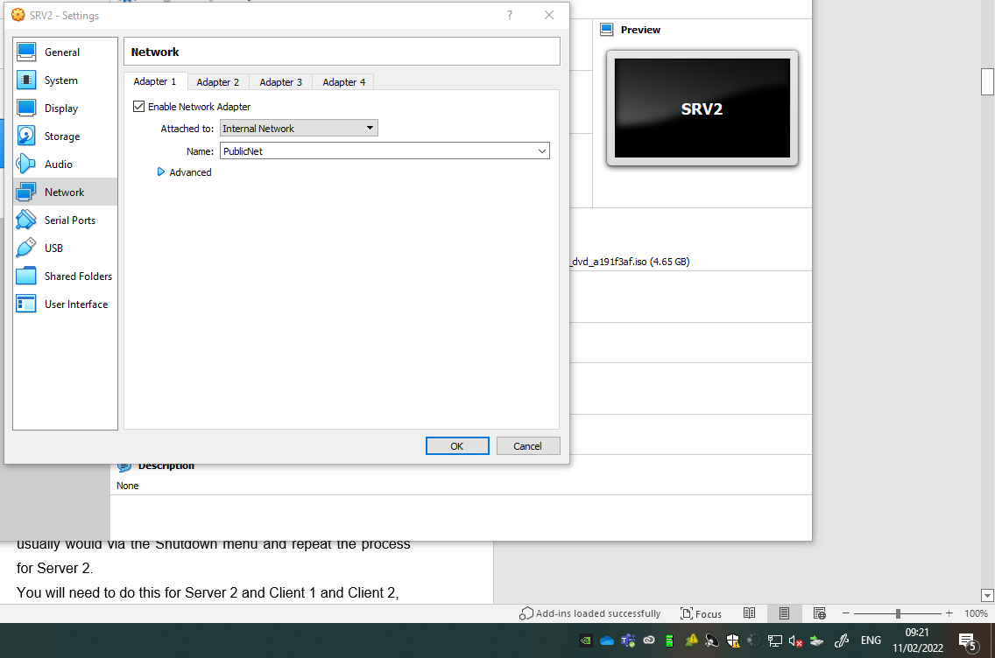
As per the topology given, SRV2 Adapter 1 is attached to the Internal Network, Renaming the name of the network Adapter is important so an individual can identify what network adapter it is. Given appropriate names is important as the network adapter is used to communicate through the network, so ensuring someone knows which adapter to connect to it allows for smooth and easy LAN connection.

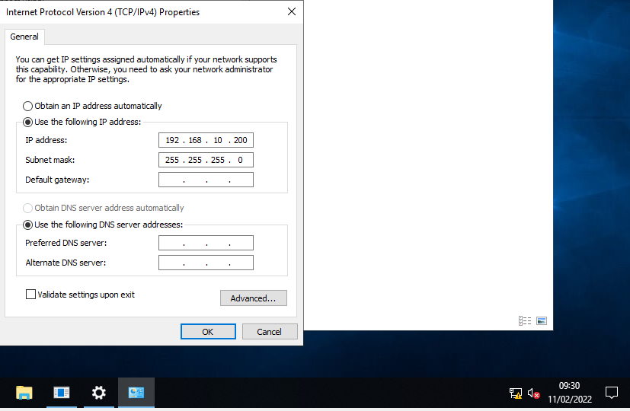
Once the configurations are done through the Virtual Box and the adapters have been renamed and setup too allow for a communication between the different servers, IP address must be set up to allow this to happen. Following the topology, assigning IPV4 address allow for this communication through the LAN.

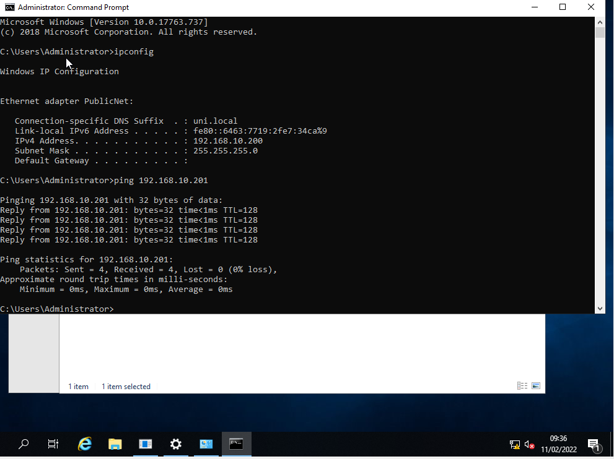
By entering the command prompt typing in “ipconfig” allows the ability to see the ethernet adaptar settings, it shows the name which is what was set earlier. The IPV6 address, and the IPV4 address which was set manually by the user.
Typing the “ping” command and the IP address in which someone attends to communicate with, can determine if both of the servers are connected together through the LAN, as seen in this example above the ping was successful.

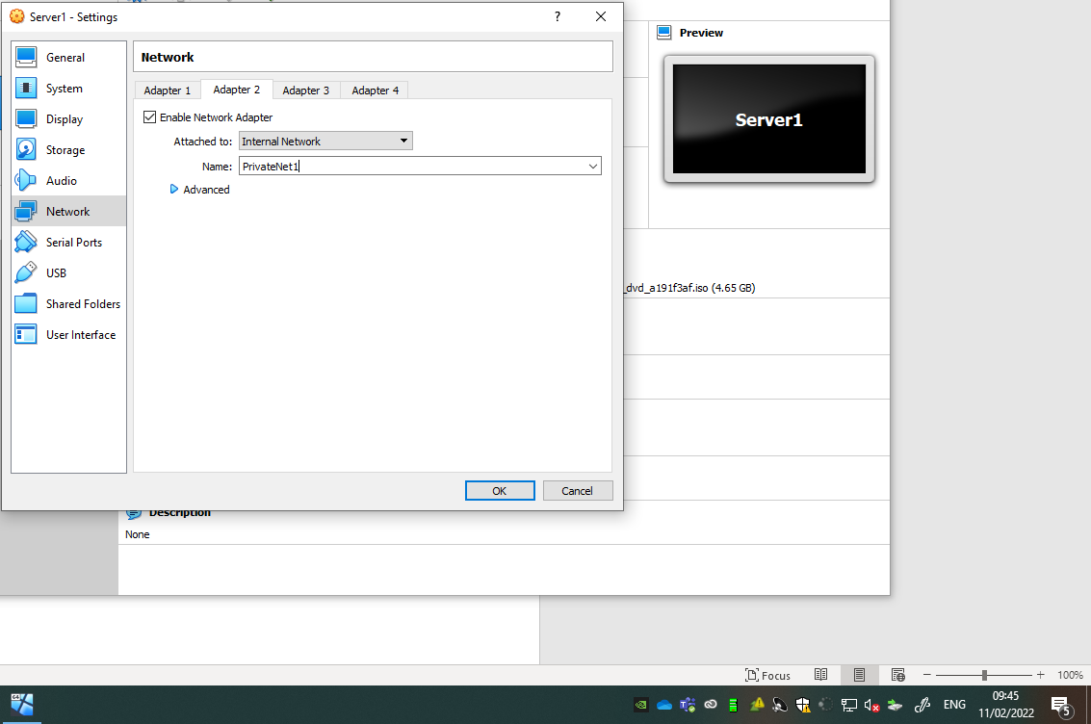
Adapter 2 Internal Network for the PrivateNet1 is set. [Referenced 7.]

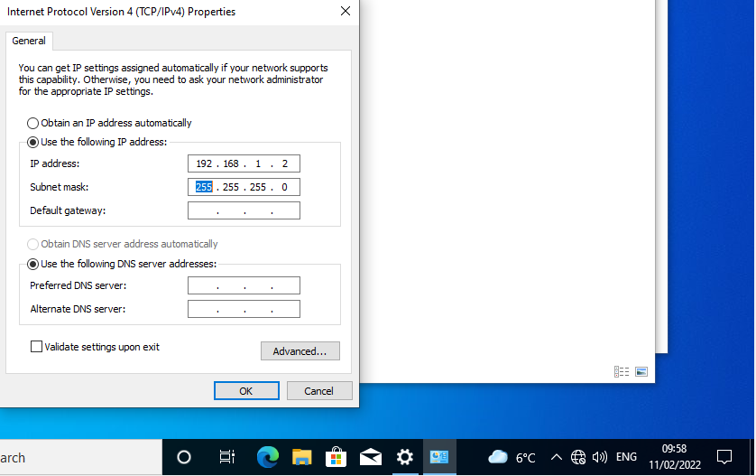
The IP address is set in IPV4 for Client1 as per topology. [Referenced 8.]

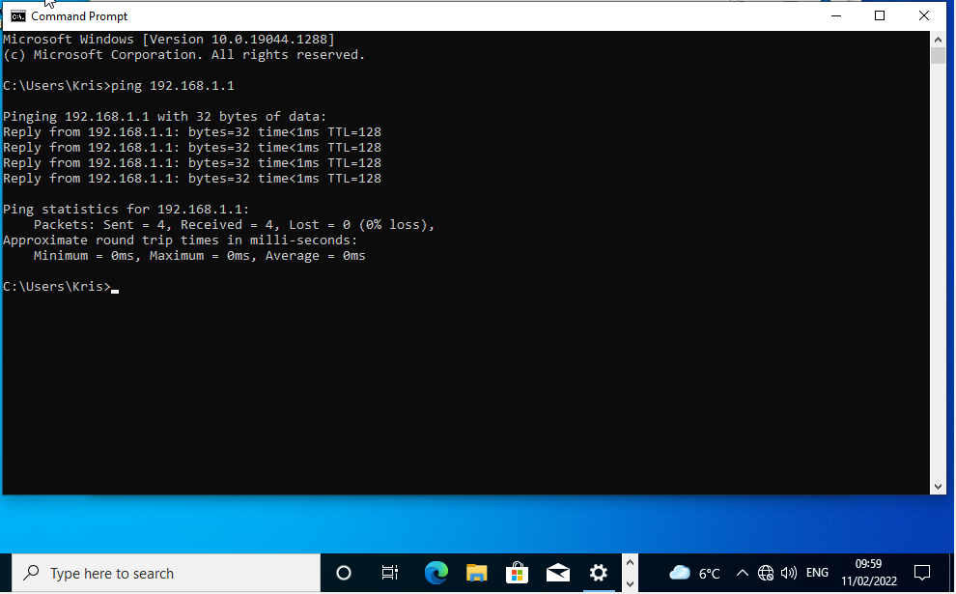
Successful ping request from Client1 to Server1. [Referenced 9.]

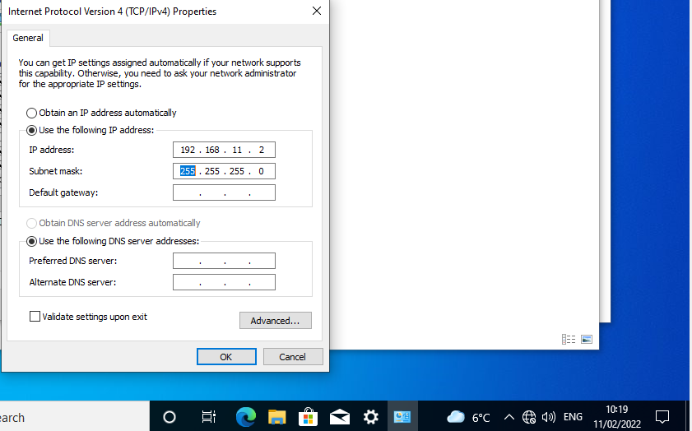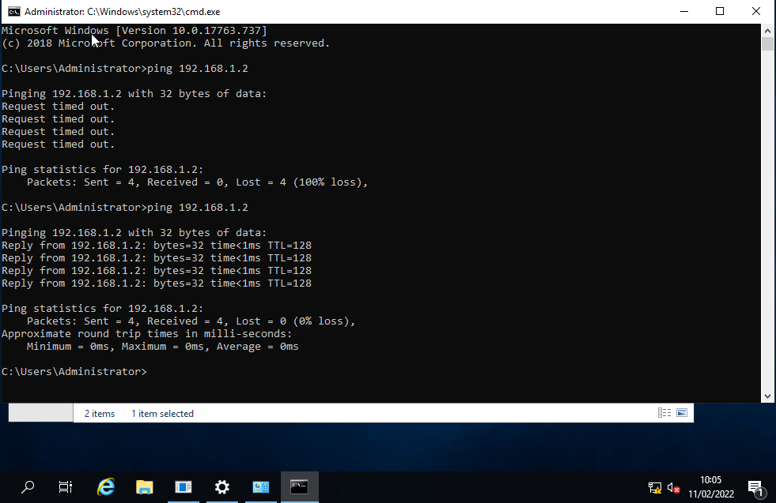
Attempting to ping 192.168.1.2 from 192.168.11.2 resulted in a Request Timed Out.

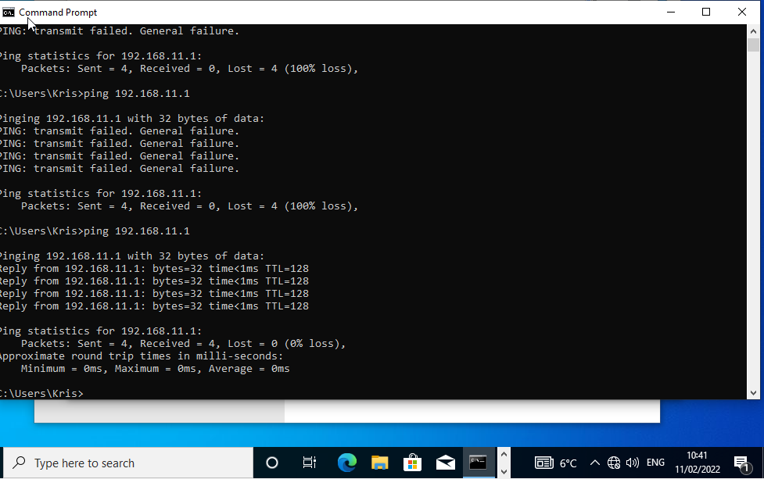
As shown in the above image the same outcome has happened.
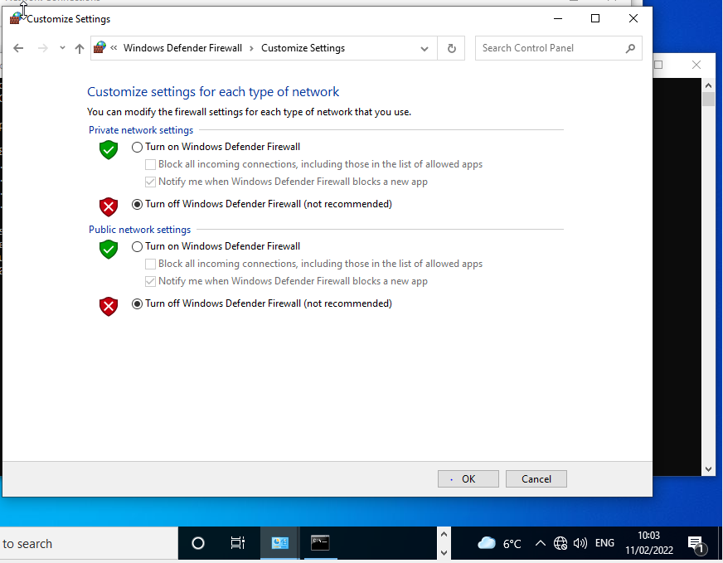
To allow communication between the public net, the Windows Defender Firewall must be turned off for both virtual machines. Turning off the Firewall is strongly advised against, as a hacker could easily gain access to your network, resulting in theft and loss of information. However, while troubleshooting a network, to ensure that the clients can communicate with each other, this is advised to see that it’s successful and all the IP configurations are correct.

Task 2

Deploying a Network Directory Service and Creating and Understanding Active Directory Network Objects

No DNS is set up. Firewall is turned off [Reference 14]

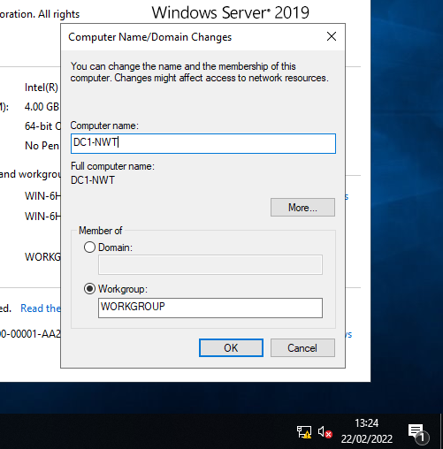
In Windows entering This PC and choosing properties, gives the user access to the Advanced System Settings, from here the user can change the Computer Name. As specified in the lab, the user will name the computer DC1-NWT. By doing this the user can easily manage and identify network resources. Having an appropriate name is important so the user can see what service is being deployed for their network.

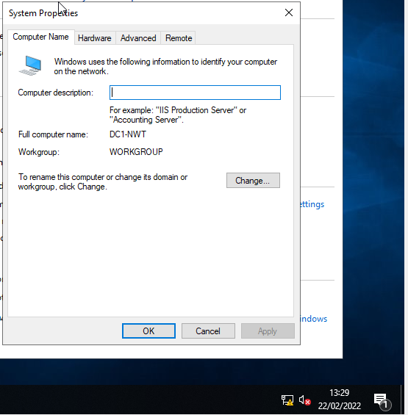
Proof that the computers name has been changed to DC1-NWT creating a new service for Server 1.

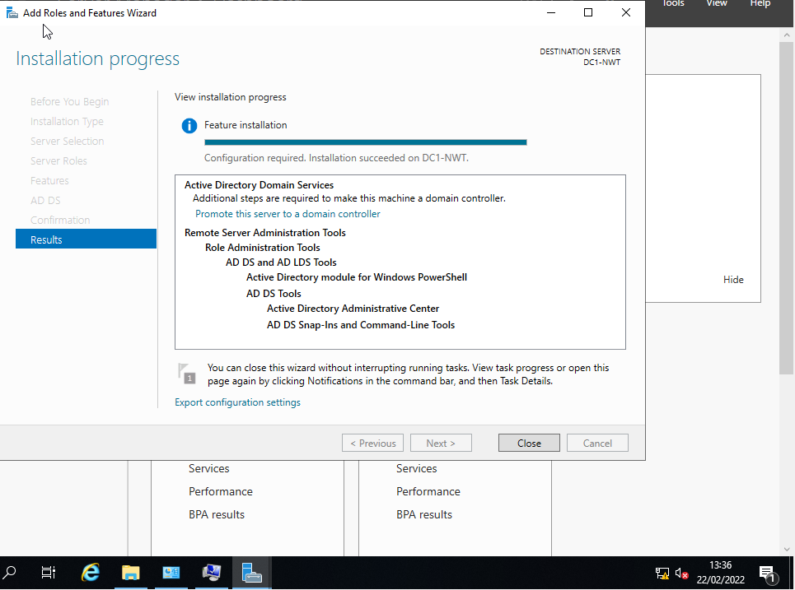
Proof of tools which have been specified in the brief being installed.

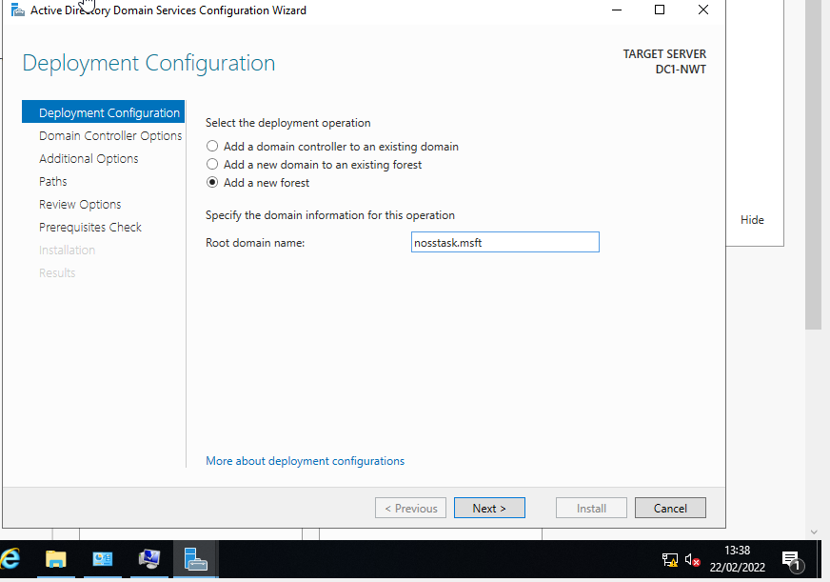
Through the Deployment Configuration, select Add a new forest and give the Root domain name: nosstask.msft.

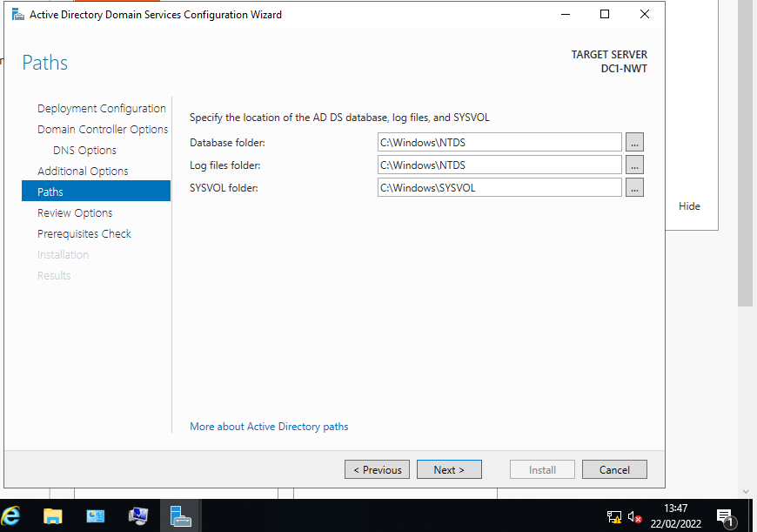
The network domain is now installed for server DC1-NWT.

3. Creating user account objects using Active Directory Users and Computers snap-in console.

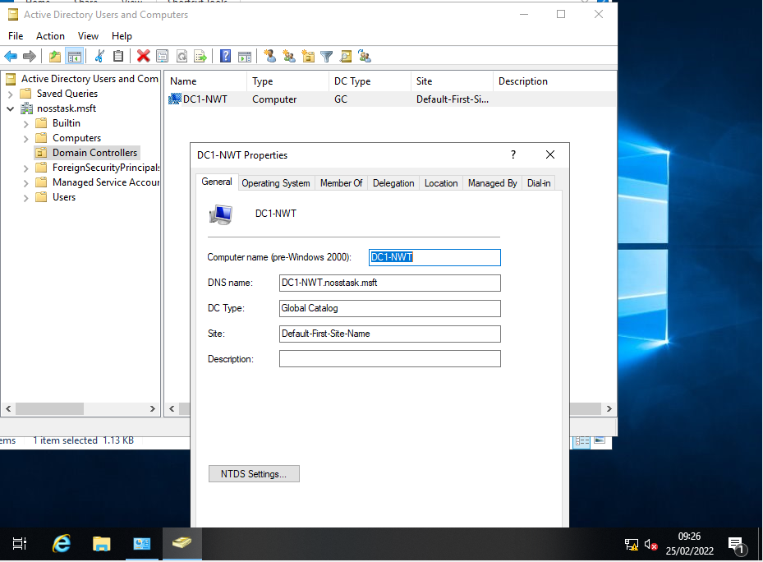
Nosstask.msft domain has been created and now appears in Active Directory Users and computers. Proof that server DC1-NWT is listed as the nosstask.msft domain controller.

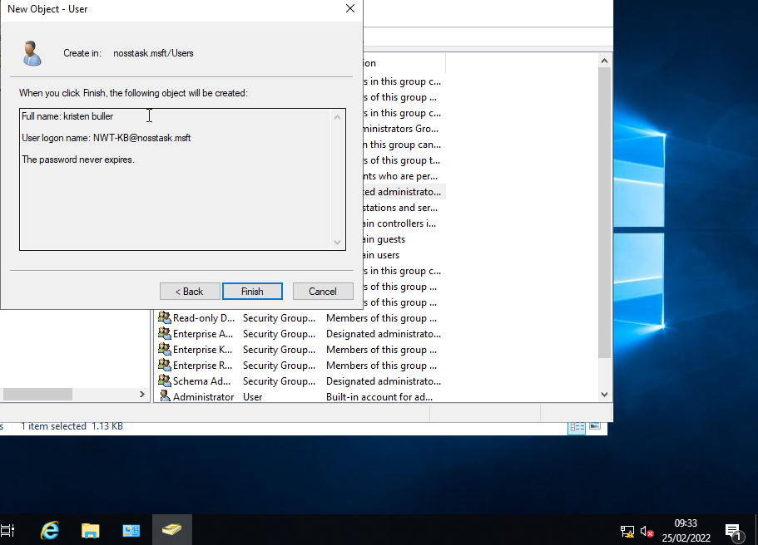
Creating more than one administrator account is important, as the main account could get hacked or lost.

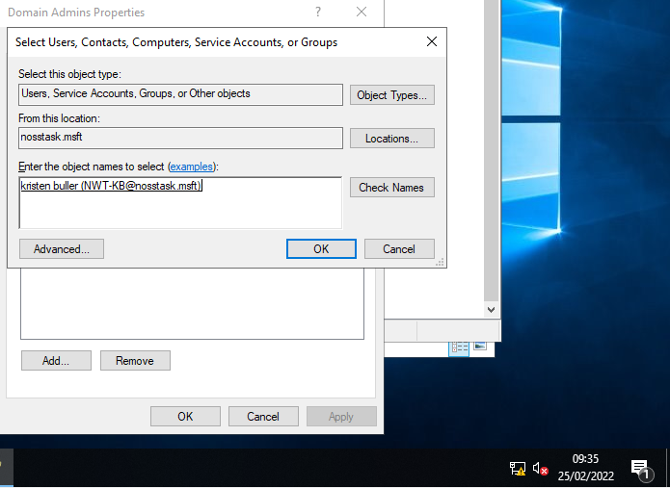
The account which the user created, has been added to the Domain Admins Group. Once it has been added, the account has been added to the nosstask.msft meaning the user account can be logged in through Domain Admin group nosstask.mft.

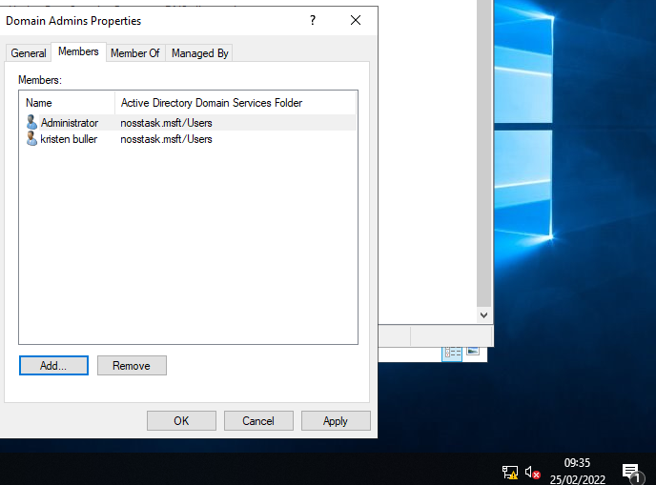
List of members in the nosstask.msft Active Directory Domain services folder.

4.Object attributes of interest.

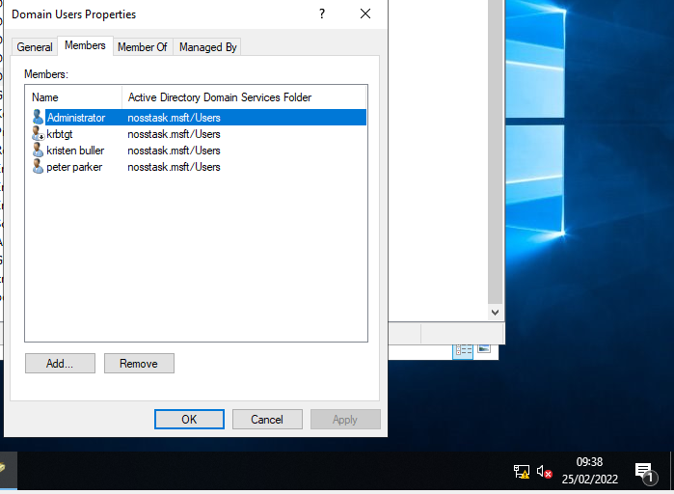
Proof list of the members the user Peter Parker has been created.

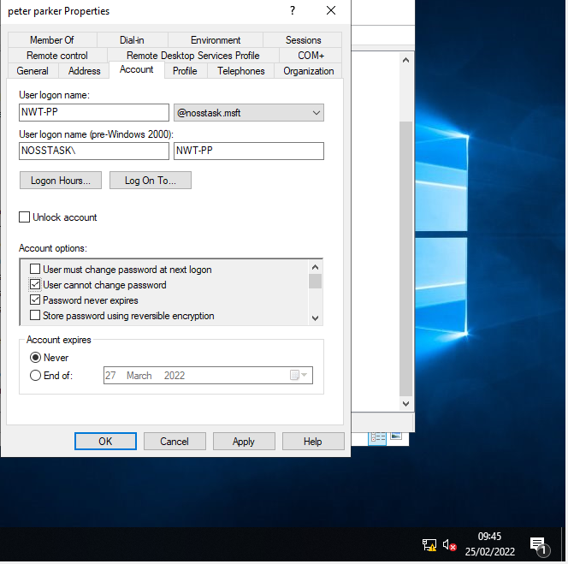
Setting the account options gives the administrator several options to set for the user. This example prevents the user from changing their password. Also, the password never expires.

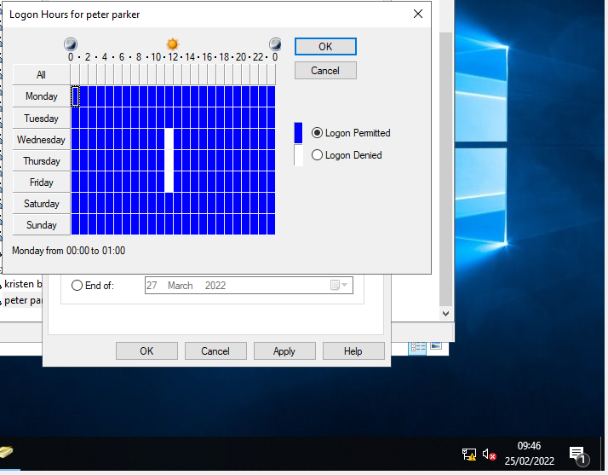
In the members properties folder, the administrator can set the times, and dates in which the user can and cannot access their computer.

5.Adjoining the domain and testing user logins.

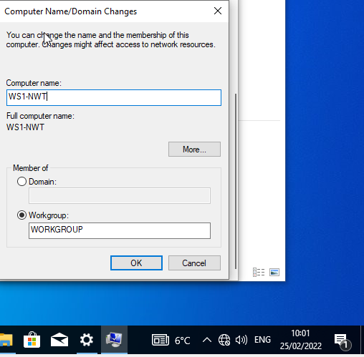
The computer domain name is WS1-NWT.
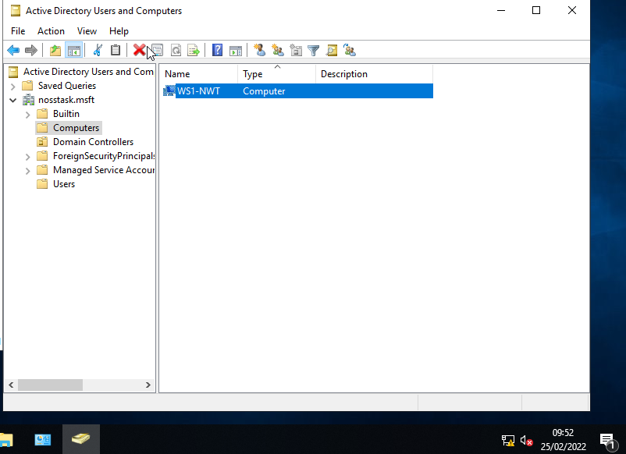
Proof WS1-NWT

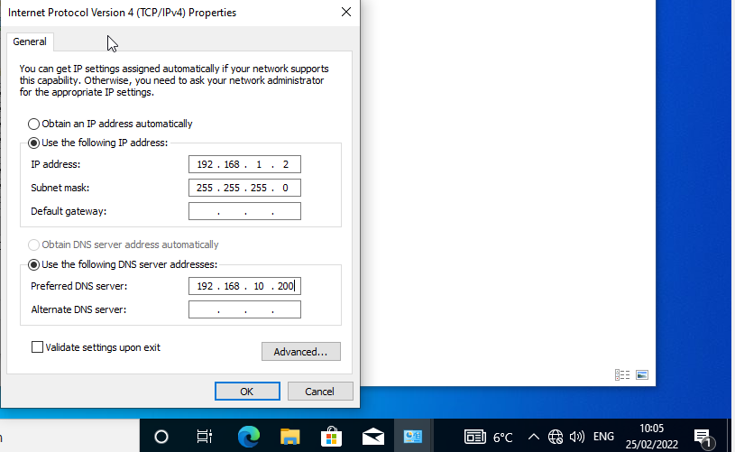
The IP address and the Preferred DNS server need to be the same etc 192.168.1.2 not 192.168.10.200 so they can communicate.
So, the Preferred DNS server IP address should be changed to 192.168.1.200, this is because the .10 in the DNS server won’t ping because when connecting a host of computers together on a LAN, setting the correct and appropriate IP addresses for each PC, ensures they are all on the same network allowing for quick and easy communication. Two computers that belong to different IP networks cannot communicate directly to each other.

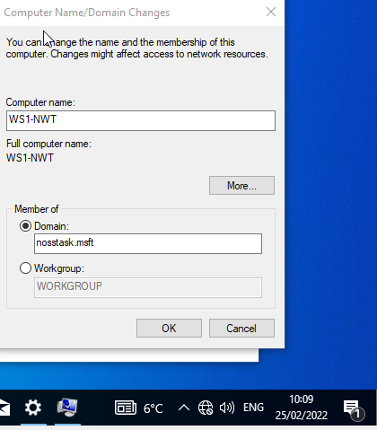
To connect to the domain, the user typed in nosstask, if a login window appears then the user must log into one of the user accounts in which they linked the nosstask.msft too.

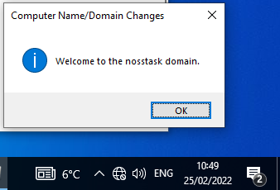
This message will appear if successful. The user account is now connected to the nosstask domain, meaning it can be accessed via the client using the correct login credentials.
Accessed was granted through the nosstask domain via the user.

Report

Main differences between Type1 and Type2 Hypervisors.

Type-1 and Type2 Hypervisors are designed to run virtual workspace. Software, hardware or firmware virtual machines allow for a sand boxed environment to create and visualise a computer workspace. Services can be run from the virtual box, meaning customers can purchase subscriptions to access virtual machines over the server. Hypervisors play key part in this as they give access to different vendors like Oracle Virtual Box, VMware, Microsoft Hyper-V and many more.
Both Type-1 and Type-2 Hypervisors are different in terms of the way they run and what kind of virtual machine can use them. For example, Type-1 Hypervisor has direct control of the virtual box’s resources through the physical computer. The VMM runs on a bare machine, unlike Type-2 Hypervisor it will take an existing operating system and operate on top of it. Under the host operating system the VMM runs on an extended host. Both types create a virtual machine, however the main differences come in terms of how much resources are needed to create each one. Type-1 comes bare, system scheduling and resource allocation must be performed on the hypervisor. Some code may not be needed for Type-1 virtualization. However, on Type-2 the system resource allocation and environment creation functions are more clearly split. Due to there already being an OS installed, it provides a standard extended machine and the normal system resource allocation.
VMware, Microsoft Hyper-V are all Type-1 Hypervisors. The hypervisor makes resource allocation and scheduling decisions despite Hyper-V depending on a host environment called dom().
Oracle VirtualBox and VMware are Type-2 Hypervisors, cooperating with the host operating system it will schedule all system resources. [1]
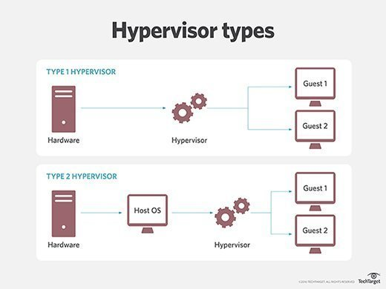
As seen in the above illustration a Type-1 Hypervisor runs directly into the host physical hardware, compare that to Type 2 where it runs straight to the host operating system. One advantage of Hyper-1 is that it’s considered much more secure as its Hypervisors are connected directly to the physical hardware. The virtualization process cuts the risk of a hacker gaining access to other VM’s on the hardware because each user has its own OS. This isolates the attack to one user VM preventing it from spreading throughout. Software-defined storage and networking is given, this adds an extra layer of security, the consequence of this and one disadvantage is that it will cost an organisation more than Type-2 to run and maintain.
Type-2 Relies on the existing OS so it can manage the memory, CPU, storage and network resources. Despite both type-1 and 2 hypervisors being identical, having an underlying OS within type-2 leads to latency. Every process of the hypervisors and the work of each VM must pass through the host OS. As type 1 doesn’t need to go through a host OS, it considered much safer as type 2 must have a host OS to process different activities through the hypervisor. This means other VMS that are being processed through the host OS are now compromised. Due to safety concerns, it’s only recommended that people should use type-2 when designing a software product to test it before its release. [2]

Cloud Computing
One of the biggest reasons why cloud computing is so popular and why so many businesses use it is because it’s incredibly flexible and easy to use. Resources such as storage, databases, networks, operating systems, computer hardware and software applications are available instantly through the cloud. Savings are a plus of cloud computing, for example some business may require to bring in IT professionals to install software, hardware and maintain the systems network. However, through cloud computing organisations can pay for a service which gives them everything they need right from the cloud. Users can rent out OS’s, CPU, memory, large amount of storage and network resources, this means that users can get some of the best specs for their PC, without having to purchase the parts, or maintain the system themselves. Also, many users who use Cloud computing may not be the most experienced when it comes to managing their systems. So, services are offered like backups and recovery the cloud computing service will have a team who will protect and recover data. Also Cloud computing can be very easy to deploy and set up. Also cloud computing offers almost unlimited storage, so companies could pay for the cloud storage, use thousands of TB of data, but won’t need to purchase expensive storage devices, as their data could be stored all over the world. [3]
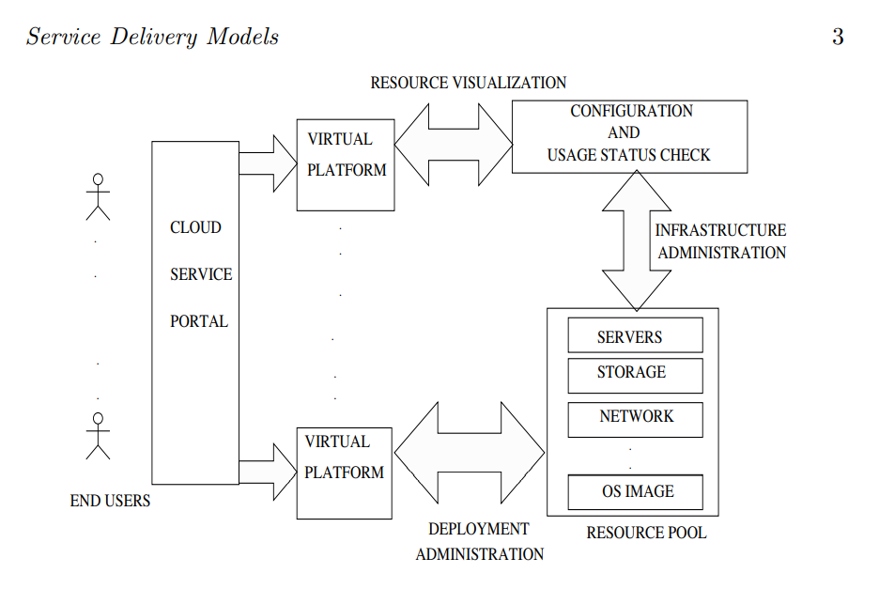
[3]
A vendor will lease out different IT resources one of those is Communication-as-a-Service, this service is outsourced. It’s a communication solution that offers voice over IP (VoIp). Ability for instant messaging great for people who prioritise communication over their cloud. Other sorts of communication are included like videoconferencing applications mobile devices etc.
There are many different cloud architectures to decide from, choosing the right one for a specific business is vital. IBM Computing or blue cloud, Microsoft Azure cloud, Sun cloud, Google’s AppEngine, Amazons Elastic Compute cloud. These are some of the most popular ones. There are open-source cloud computing tools to be chosen from like VMware. Choosing the right one depends on the virtualization environment, the scope that the company has given, certain business requirements the budget etc. For example, Microsoft Hyper-V has a built-in set of technologies, tools and processes. Along with the system centre and windows azure, they provide a technological platform for infrastructure, applications and data. [3]

DNS

Think of DNS like a phonebook, the book contains the numbers and names of individual people. DNS uses the same contact when it comes to web IP addresses and the names of those websites. A typical person when on the internet would type in what they want access to for example google.com these are called domain names. Using the Internet Protocol (IP) web browsers will interact with this protocol to send the user to their website of choice. Domain names are translated into IP addresses so the browser can load up a specific internet resource, for example in the command prompt if you ping 8.8 or ping google.com you get the same result. Except if you ping 8.8 first it will not translate the domain name as there isn’t any domain name.
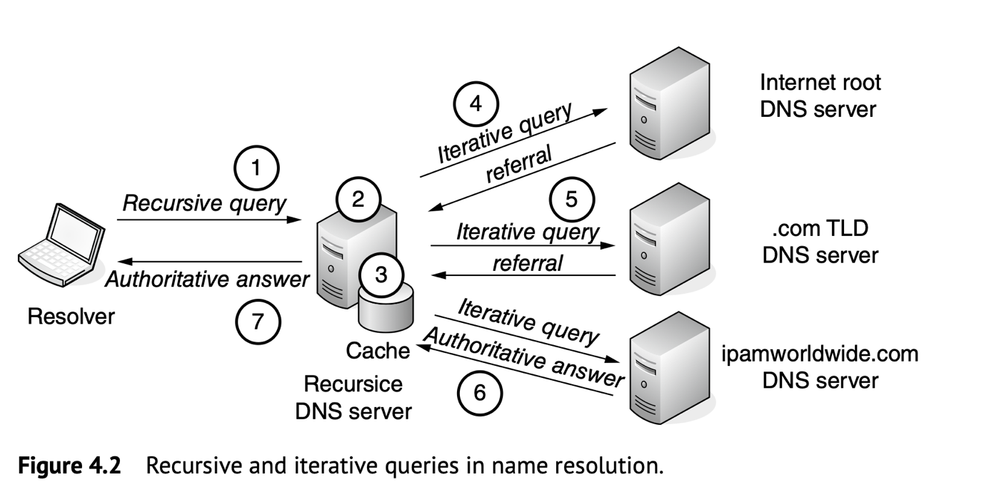
Example of how the resolver com query to the DNS server, the DNS server will query the Internet Root DNS server, if its resolver cannot communicate after checking the IP address the root will send it to the .com TLD server and if that cannot communicate together it will send it to the ipamworldwide.com DNS server.
Active directory uses DNS underneath active directory. It follows the same principles. For example noss.task is the domain name. [5]

Role or feature based installation
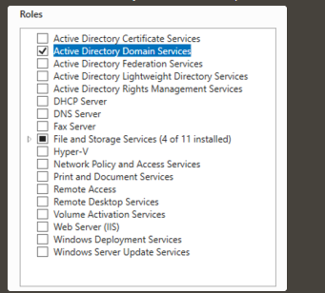
Hyper-V is a built in Microsoft software, which provides hardware virtualization. Each virtual machine must run on a virtual hardware for example hypervisor type 2. Hyper-V allows the ability to create virtual hard drives over the virtual box. Virtual switches and many virtual devices can be added via Hyper-V. [6]
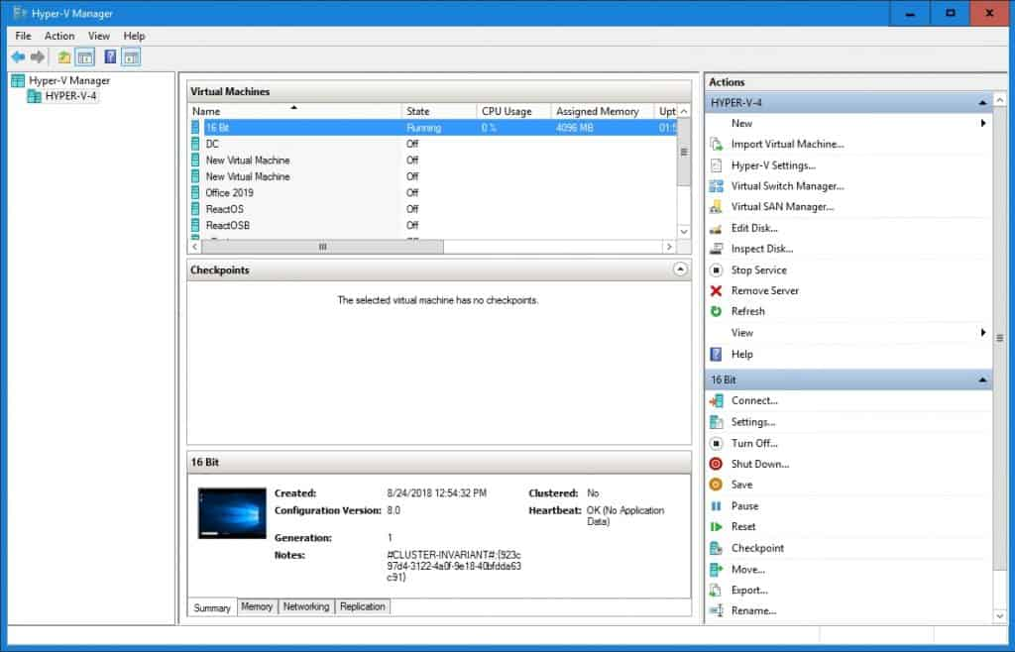
The DHCP server will automatically provide and assign IP addresses default gateways to the client’s devices. Known as Dynamic Host Configuration Protocol it will respond to broadcast queries by clients. The benefit of A DHCP server is that it automatically assigns an IP address to the client computers so they can communicate through the network. Without DHCP IP addressing need to be added manually which is prone to mistakes resulting in network connection issues.[7]
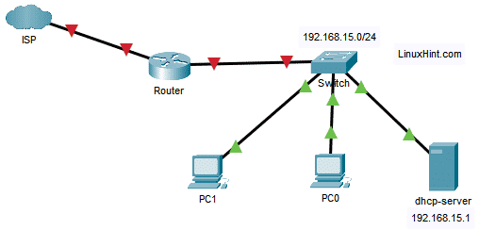

Terminologies
The whole point of ping is to attempt a communication across the network. ICMP internet control message protocol is used, it’s a network layer protocol which is used by the network devices to communicate across the network. ICMP is used to see if the data is reaching its intended target, and in a timely manner. [8]
Server Management main aims is to monitor and maintain the servers that operate at peak performance. Eliminate or at least minimize server downtimes, downtimes can have a very negative affect on an organization. Adds roles/features to out server.[9]
Firewall job is to monitor and filter the incoming and outgoing network traffic. A firewall is a network security device. Think of a firewall as a door, the door opens and closes, between the private internal network and the public internet, the door well open for good non-threating traffic but close for dangerous traffic.[10]
PAE/NX will give priority to other VM’s on the machine. If PAE/NX is enabled, it will determine the capabilities of the host CPU. If supported by the OS then a 32-bit CPU can access more than 4 GB of RAM> Another 4 bits can be added through the memory addresses. Unless you’re in a 32bit environment you would keep this turned off.
OOBE is a vanilla installation of the Windows OS. Files profiles, settings are all removed. When a customer turns on their Windows PC for the first time, they will see the OOBE. This is a setup, the screen will consist of a license agreement, connecting to the internet, log in, or sign up. [11]

Reflection
To reflect I Built a virtual LAN on the Oracle Virtual Box. Setting up the specs so choosing the memory, the operating the storage. Setting up a network so each VM pc can ping each other, so selecting the correct and relevant IP addresses and ensuring that each PC can ping to each other. Creating a list of users, setting the privileges each user can have for example some users are added to a certain domain, meaning they can only access a domain which they have been assigned to. Users who have not been set to that domain aren’t recognise meaning they aren’t permitted to enter. times and dates there allowed on the system, what they and can’t do on their PC. I learnt about the different tools in Microsoft’s active directory network directory service.

References
[1]E. Bugnion, D. Tsafrir, and J. Nieh, Hardware and software support for virtualization. San Rafael, California: Morgan & Claypool Publishers, 2017. doi: 10.2200/S00754ED1V01Y201701CAC038.
[2]Stephen J. Bigelow and Brian Kirsch, Difference between type 1 and type 2 hypervisor, What's the difference between Type 1 vs. Type 2 hypervisor? (techtarget.com), 2021
[3]Dr.Sunilkumar Manvi and Dr.Gopal K. ShyamCloud Computing. CRC Press, 9781003093671_webpdf.pdf, 2021.
[4]M. E. Dooley and T. Rooney, IP address management, Second edition. Hoboken, New Jersey: Wiley, 2021. doi: 10.1002/9781119692263.
[5]?, https://www.cloudflare.com/en-gb/learning/dns/what-is-dns/, 2021
[6]?, Microsoft, https://docs.microsoft.com/en-us/virtualization/hyper-v-on-windows/about/, 2021
[7]?, Microsoft, Dynamic Host Configuration Protocol (DHCP) | Microsoft Docs, 2021
[8]?, CloudFlare, What is the internet control message protocol, What is ICMP? | Internet Control Message Protocol | Cloudflare, 2021
[9]?, DNSstuff, What is server management?, What Is Server Management? Definition, Best Practices, and Best Software - DNSstuff,2019
[10]? , Checkpoint, What is a firewall, What is a Firewall? The Different Types of Firewalls - Check Point Software, 2021
[11]?, Microsoft, OOBE, Customize OOBE | Microsoft Docs, 2021

