

Christopher Budden
P148323
Dr. Stephen Mosey

LEVEL/ LEfEL 6

SEMESTER 2

MODULE CODE/ Cod Y modIwl:
m6x00942_qinetiq
Advanced Instrumentation Systems

aSSESSMENT TYPE/ mATH O ASESU: aSSIGNMENT

Assessment/Component/ AsESIAD/CYDRAN: 1

This page is left blank intentionally

Contents

Introduction 1
Radar Site 1 1
Radar Site 2 2
Literature Review 3
Radar Fundamentals 3
Radar Horizon 4
Radar Cross-Section (R.C.S.) 5
Frequency Bands 5
Types of Radar 6
Site 1 – Surveillance 10
Chosen Technology – Primary Surveillance Radar (P.S.R.) 10
Pros/ Cons of Chosen Technology 10
Range Calculations 10
Radar Detection Range Calculation 10
Surveillance Radar Horizon Calculations 13
Site 2 – Tracking 15
Chosen Technology 15
Pros/ Cons of X-Band CW Radar 15
Range Calculations 15
Tracking Radar Detection Range Calculation 15
16
Tracking Radar Horizon Calculations 17
Other Technologies 17
Conclusion 20
References 21
Bibliography 22
Figures 23

Introduction
A requirement has been made to upgrade two Radar sites; Site 1 required for long range surveillance, site 2 used for tracking fast moving objects, travelling away from land. The objective is to produce two Radar system specifications based on the requirements below. The derived Radar’s operating frequency bands will coincide with the Institute of Electrical & Electronics Engineers (IEEE) radio frequency bands, from 3MHz High-Frequency (HF) up to 300GHz (mm Wave) [1].
Both Radar systems are to detect a target reflector with a Radar Cross-section (R.C.S.) of 10m² & a minimum received detectable signal level of -150dBW. The requirements that are given are as follows;

Radar Site 1
Site 1 Radar system used primarily for surveillance;
- To cover an area extending to 350km
- 270° azimuth sweep coverage
- Located on a peninsula
- Radar antenna situated 80m above mean sea level
- 1km from the shore line
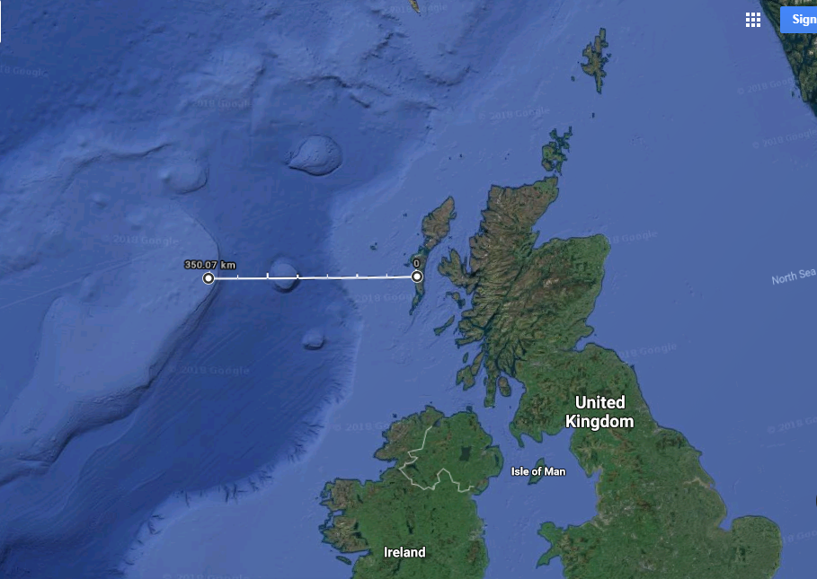
Figure 1
1km from shore

Radar Site 2
The 2nd Radar site is used to track fast moving objects heading away from the tracking Radar set. The specification it must fulfil is thus;
- Cover an area extending to 50km
- 45° azimuth coverage
- Antenna height 10m above mean sea level
- 150m from the shoreline
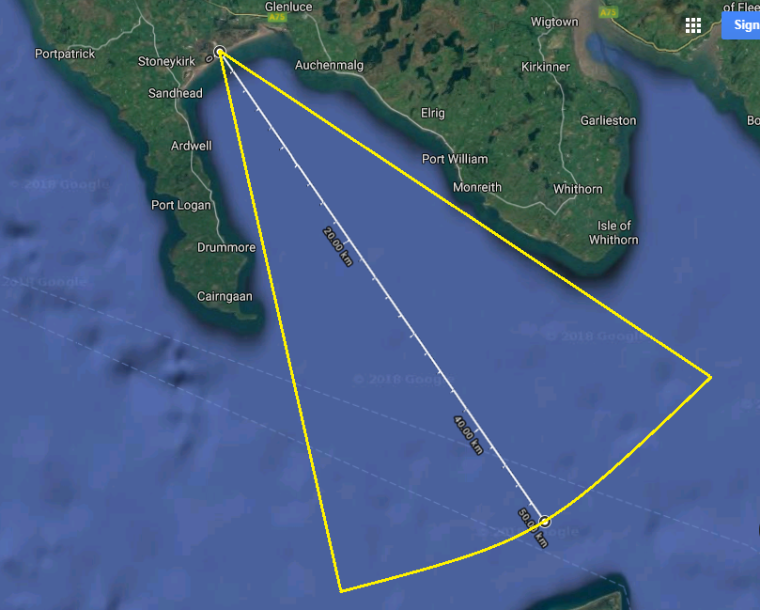
150m from shore
Figure 2

Literature Review

Radar Fundamentals
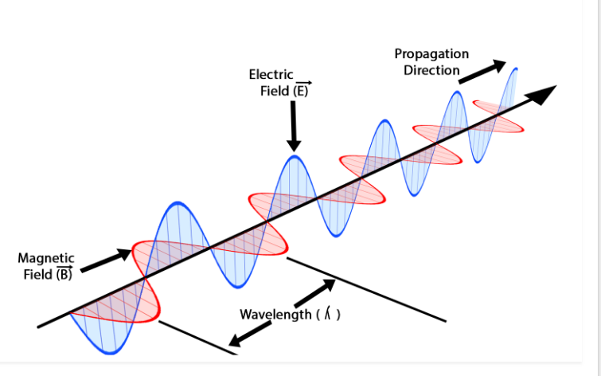
The basic principle on how Radar works, Radar short for; RAdio Detection And Ranging, is an EM (Electro-Magnetic) wave that is transmitted into the Radar’s reflector panel, thus instantly increasing the antenna gain by: 2. The Radar transmits a non-ionizing EM radio wave. The radio wave itself contains both electric and magnetic components; the electric wave (E) is orthogonal to the plane of the magnetic wave (B) and 90° out of phase. [2]
Electro-Magnetic Radio Wave
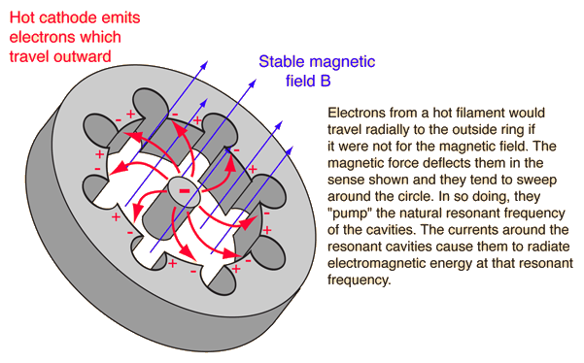
Figure 3
The EM wave is generated either through a di-pole antenna, or with the much more powerful transmitters, a waveguide, called a magnetron [3].
Figure 4

The fundamental of Radar detection, is that the EM wave is transmitted outward from the antenna & the propagating wave front is spread spherically & proportionally to the distance it covers. The propagating EM wave is then reflected off the targets surface & a portion of the reflected energy travels back towards the transmitting antenna, this is known as Radar Cross-section (RCS).

Radar Horizon
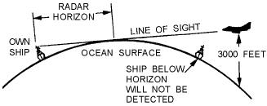
The Radar horizon is the slope distance from the Radar to the point on the Earth’s horizon, to which that point is where the tangent line, i.e. the slope distance, that intercepts the circumference of the Earths topography, Shown here in Figure 5.
Figure 5

The target appears to the radar at sea level, but actually the target, is some distance above the sea level. The curvature of Earth restricts direct Line of sight (L.O.S.) from an observer’s point of view to the target. The Radar horizon distance extends further than this, due to refraction of the Electro-magnetic (EM) wave. Depending on the time of day, if the surface of Earth is cooler than the atmosphere above it, the EM wave refracts downwards, following the Earth’s curvature, extending the range further. If the surface of the Earth is hotter than the atmosphere above it, the EM wave refracts upwards, decreasing the Radar’s horizon range [4].
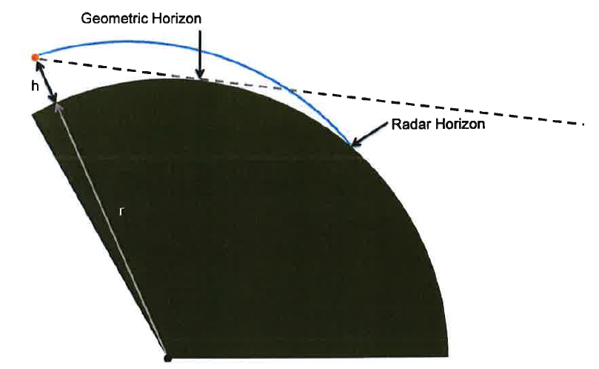
Illustration of Radar horizon

Figure 6

Radar Cross-Section (R.C.S.)
Radar Cross-Section or RCS, is defined as the reflective area of an object or target that the Radar receives its reflected transmission from [5]. To put this into perspective, a Boeing 747 has a R.C.S. of 158.3m² [6] & a cruise missile has a R.C.S. of 15.3m² [7]. There are advances in Radar stealth technology that decreases the objects R.C.S. with the use of ‘steep’ angle profiles of the object & Radar absorbing material. Radar absorbing material was first developed by a German scientist; Rudolf Kühnhold in 1956, that consisted of ‘grid elements’, to which pose electrical conductivity to which disperse the EM energy as heat throughout the substrate, in turn, opposing the reflected EM RF wave [8].

Frequency Bands
The adoption of the IEEE standard letter frequency bands originated back to the development & first uses of Radar technology during WW2. The IEEE designation letters sub-categorized each Radar operating frequency bands into letters, i.e. ‘L-band’ 1-2GHz. This was introduced to ensure secrecy to the various types of Radars & their operating frequencies that the Allies were implementing during WW2 [9]. Today, the IEEE standard letter Radar frequency band designation is still in use, with the exception that post WW2, the International Telecommunication Union (ITU) & United Nations (UN) in 1959 declared that this standardisation is to be shared & implemented globally to avoid interferences [10].

Types of Radar

Primary Surveillance Radar (P.S.R.)
Primary Surveillance Radar or P.S.R. typically uses a rotating antenna dish that transmits a pulsed frequency, known as Pulse Repetition Frequency (PRF). Typical P.S.R.’s are mono-static, i.e. transmitter & receiver located in the same position. P.S.R.’s are primarily used for long range surveillance, that covers a wide area, thus the rotating antenna has a sweep azimuth of >270°. P.S.R.’s operate independent to the target for the ability to detect it at a long range. This is because it relies on the reflected energy off the target back to the receiver [11].

Secondary Surveillance Radar (S.S.R.)
Secondary Surveillance Radar is primarily used for the aviation industry for Air Traffic Control (ATC), to where critical flight information is sent to the ground station from the aircraft.
The basic principle on how S.S.R. works; the aircraft is required to be equipped with a transponder, the ground station Radar transmits a frequency of 1030MHz as the ‘Interrogator’ transmission, & the transponder aboard the aircraft receives the interrogation transmission from ATC and then transmits its flight data on a separate frequency of 1090MHz [12]. This system came about during WW2 as the Identification of Friend or Foe (IFF) system, as a means of distinguishing between allied & axis aircraft & the outcome of various allied friendly fire incidents [13].
S.S.R, although uses a rotating directional antenna, typically <20 revolutions per minute. It features an omni-directional transmitting antenna, positioned above the main S.S.R. This omni-directional antenna transmits a 3rd interrogator pulse on the same frequency as the S.S.R. system. Due to side-lobing, if the aircraft receives the S.S.R. ($P_{1}$ & $P_{2}$) interrogator pulses followed by the 3rd transmitted pulse from the omni-directional antenna ($P_{3}$), the gain from $P_{1}$ & $P_{2}$ would be lower in amplitude as that of $P_{3}$, therefore the interrogation from the ground S.S.R. is rejected by the aircraft, overcoming side-lobe tracking [14].

Mode A & C
Mode A is the transmission of the interrogated aircrafts unique identity code, to which is manually set on the cockpit’s transponder unit. Mode C, (normally included in the same transponder that of Mode A), transmits the aircrafts altitude. The altitude is measured via a pressure transducer external to the aircraft. The altitude readings are measured in 100ft increments [15]. Both Mode A & C transmit a 4-digit Octal data transmission, modulated by a carrier On-Off Keying (OOK) frequency (1090MHz). The 4-digit Octal transmission data comprises of 8⁴ (4096) codes [16]. To distinguish between the two data modes of transmission from the aircrafts transponder, the coded pulsed of Mode A & C each have a unique ‘dead pulse’ on a particular ‘bit’. $F_{1}$ & $F_{2}$ bits are used as ‘framing pairs’ to contain the message string.
$$F_{1}$$

$$C_{1}$$

$$A_{1}$$

$$C_{2}$$

$$A_{2}$$

$$C_{4}$$

$$A_{4}$$

$$B_{1}$$

$$D_{1}$$

$$B_{2}$$

$$D_{2}$$

$$B_{4}$$

$$D_{4}$$

$$F_{2}$$

$$x$$

20.3μS
Mode A Pulse Train
Figure 7
A | B | C | D
$$A_{1}$$ | $$B_{1}$$ | $$C_{1}$$ | $$D_{1}$$
$$A_{2}$$ | $$B_{2}$$ | $$C_{2}$$ | $$D_{2}$$
$$A_{4}$$ | $$B_{4}$$ | $$C_{4}$$ | $$D_{4}$$
Mode A 4-digit Octal Table

Figure 8

Mode S
Mode S comprises of both Modes A & C, which makes Mode S backwards compatible, but further increases its coded pulses to a 24-bit address, generating $2^{24}$ (16,777,216) codes. Mode S is a requirement to the Civil Aviation Authority (CAA) & International Civil Aviation Authority (ICAO). This mode is compulsory as it insures the Traffic Collision Avoidance System/ Automatic Collision Avoidance System (TCAS/ ACAS), to which the aircrafts equipped transponder also transmits its altitude & heading to other aircraft in the area. This system automatically diverts the aircraft if both planes converge on the same flight path [17].

False Replies Unsynchronised with Interrogator Transmissions (F.R.U.I.T.)
False Replies Unsynchronised with Interrogator Transmissions, or F.R.U.I.T., is a phenomenon that occurs when ground SSR’s transmitting fields converges with each other, creating an overlap of interrogation coverage. The interrogated aircraft is positioned within both converging SSR’s fields, thus the aircraft transmits its interrogated message to both SSR’s.

SSR 1

X
SSR 2

X

Asynchronous F.R.U.I.T.

Figure 9

Doppler Radar, Continuous Wave (C.W.)
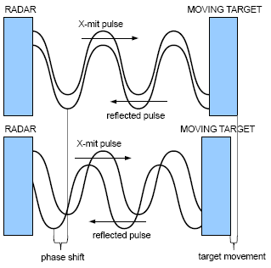
Doppler Radar, for the purpose of velocity & position acquisition, transmits a fixed, continuous EM wave of amplitude and frequency. The CW Doppler radar is based on the Doppler Effect principle. To that, as the target travels further away from the Radar, the time between phase’s increases, (the time from the transmitted to the received peaks of the waveform) Figure 10. This is known as Doppler frequency shift, and is expressed mathematically as; $f_{d}=2. \frac{V_{r}}{λ} = 2v.\frac{Cosθ}{λ}$

Figure 10
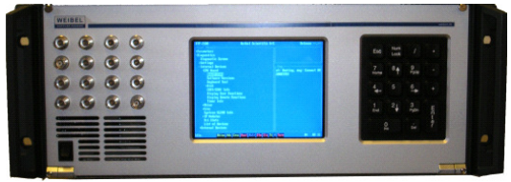
Doppler Radar is primarily used for tracking sub-sonic objects, i.e. clouds, for weather forecast or artillery shells, for trajectory data. However, the digital signal processing (DSP) required to produce a time-velocity profile requires sophisticated Fast Fourier Transformation (FFT) algorithms, therefore powerful real-time processors, such as the Weibel Scientific 2100 Real-Time Processor (RTP) is needed [18].
Weibel Scientific 2100 Real-Time FFT Processor With 4x4 IQ Channels

Figure 11

Continuous Wave (CW) Doppler Radar tracks objects by measuring the received power in its multiple element receivers. If the received power is lower in one of its receiver elements, it will physically move the antenna panel on its pedestal via servo motors in to the direction of the stronger power elements to equalize the average power in say 4 of its receiver elements. The tracking Radar constantly makes these adjustments in both X & Y planes.
Weak Rx power
Tracked Object
Receiver Elements
Direction of antenna movement for correction
X
Y

Figure 12

Site 1 – Surveillance

Chosen Technology – Primary Surveillance Radar (P.S.R.)
The chosen Radar technology, specifically, the type of radio frequency (RF) type will be L-Band Radar. This is chosen due to the ranges that this frequency at the lower end of the Radar RF band spectrum can detect objects at. L-Band is chosen over High Frequency (HF) & Ultra High Frequency (UHF) due to its increased resolution due to its shorter wavelength, giving it the slight advantage of detecting smaller Radar Cross-Sectional (RCS) targets.

Pros/ Cons of Chosen Technology

Pros | Cons
Long Range coverage | Large antenna size
Wide azimuth sweep | Unable to measure target height
Doesn’t require target to transmit in order to detect it | Slow antenna rotation, 6-20 RPM
Can detect multiple targets in 1x 360° sweep | Low resolution, unable to track small objects
Figure 13

Range Calculations

Radar Detection Range Calculation
The Radar detection range is a theoretical calculation that represents the maximum distance that the Radar can detect an object in a perfect environment. This distance does not take into account; atmospheric attenuation; such as hot & cold conditions, humidity & rainfall. It also does not take into account any obstructions by; terrain, man-made & natural obstacles, i.e. buildings & trees. The equation that follows is determined by;
- Transmit power (Watts)
- Transmit & Receive Gain (dB)
- Transmit frequency wavelength (λ)(m)
- Radar Cross-Section (δ)(m²)
- Minimum Received Detection Power ($P_{Rmin }$) (dBW)
- System Losses ($L_{ges}$)

The transmitting frequencies wavelength, lambda λ, in metres, is calculated as;
$$λ= \frac{c}{f}$$
Where;
$c$ = Speed of transmitting wave $3×{10}^{8}$ m/s
$f$ = transmitting frequency (Hz)
Maximum Radar Detection Range Formula;
$$Rmax= \sqrt[4]{\frac{P_{T }G_{T}G_{R}δλ²}{\left(4π\right)³P_{Rmin }L_{ges}}}$$
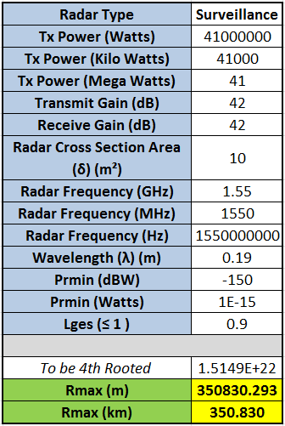
The requirements for site 1, being surveillance Radar is to detect a target extending for 350km, with a minimum detectable signal power of -150dBW. The Radar specification is calculated using the site requirements given & using the maximum Radar detection range formula. For ease of adjusting & automating the Radar maximum range formula, Microsoft Excel is implemented, so that the parameter cells can be changed, i.e. operating frequency increased/ decreased, to give the desired range of 350km.

The Surveillance Radar’s system parameters are calculated based on combined worst case system & atmospheric losses of 0.9, using the $R_{max}$ formula are;
Figure 14
Transmit power = 41 MW
Transmit & Receive Gain = 42 dB
Transmit frequency = 1.55 GHz
System Loss = 0.9
The derived parameters for the specified Radar above are unrealistic to that that is currently produced & in use. Although the operating frequency adheres within L-band Radar types (1-2GHz), the transmitting power is so large that the power needed to generate the 41MW (Mega Watts) of power would need some considerable power transformers that would take up a considerable amount of space, not to mention the size of the antenna needed to transmit the 41MW of power.
If the system noise level was reduced, from worst case: 0.9 to best case, 0.1, & the transmit frequency was reduced to 1.2GHz & the Gain from 42dB to 37dB, this would also decrease the transmit power to a more reasonable 3.5MW, giving a maximum Radar detection range of 350.4km
Other comparable Radar sets are as follows;
 | Site 1 Surveillance Specification | Raytheon AN/SPS-49(V)5
Transmit Power | 3.5 MW | 360 kW
Frequency | 1.2 GHz | 850-942 MHz
Gain | 37 | 28.5 dB
Range | 350.4 km | 463 km
Figure 15
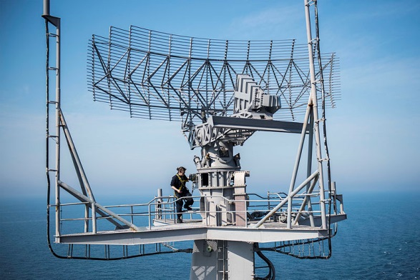
The Raytheon AN/SPS-49(V) 5 primary surveillance Radar can detect sea & airborne targets in excess of 463km. the P.S.R. also makes low altitude detection possible; ‘The antenna is stabilized relative to the horizon, making low-altitude detection possible in most sea states’ [19].
Raytheon AN/SPS-49 Surveillance Radar
It can also ‘acquire fast targets at altitudes up to 150,000 feet in clutter, bad weather, and active or passive countermeasures environments’ [19].
Figure 16

Surveillance Radar Horizon Calculations
Considerations must be made when detecting an object with a CSA of 10m² at a distance of 350km. As mentioned in the ‘Literature Review’ section above, the Radar horizon determines the minimum altitude for detection of the target at the maximum Radar detection range of 350km.
Below in Figure 17, Is the mathematical representation of the Radar horizon calculation.
$$R_{a}$$
$$R_{t}$$
$$h_{t}$$
$$h_{a} (80m)$$
$$350km$$
$$R_{t}=350km- R_{a}$$
$$R_{a}= \sqrt{2×80m×\left(\frac{4 ×6371km}{3}\right)}$$
Horizon

Figure 17

Radar horizon distance is calculated${(R}_{a})$;
$$d =\sqrt{2×h×\left(\frac{4r}{3}\right)}$$
Where;
$h$ = Height of Radar (80m)
$r$ = Radius of Earth (6371km)
So, as we know that the radius of Earth is 6371km, & the Radar’s height is 80m, we can calculate the distance from the Radar to the horizon;
$$d =\sqrt{2×80m×\left(\frac{4 ×6371km}{3}\right)} = 36866.6m or 36.9km=R_{a}$$
The next step is to calculate the remaining distance; the distance from the Radar’s horizon to the maximum detectable range of the target of 350km.
Distance from Radar’s horizon to the target detection distance${(R}_{t})$;
$$R_{t}=350km - R_{a} ∴ R_{t}=350km-36.9km=313.1km$$
From this, we can use the same equation used to find $R_{a}$, the Radar horizon distance. But as we now know $R_{t}$, the distance from the horizon to the target, we can transpose the formula to find the minimum detectable height of the target at 350km;
$$d =\sqrt{2×h×\left(\frac{4r}{3}\right)}$$
Transpose to find $h$;

$$d^{2} =\frac{2×h×\left(\frac{4r}{3}\right)}{2 × \left(\frac{4r}{3}\right)} ∴ \frac{d^{2} }{2 × \left(\frac{4r}{3}\right)}=h ∴ h= \frac{d^{2} }{2 × \left(\frac{4r}{3}\right)}$$
Now the target height can be calculated;

$$h_{t}= \frac{{313.1km}^{2} }{2 × \left(\frac{4 ×6371km}{3}\right)} =5770.2m or 5.77km$$

Site 2 – Tracking

Chosen Technology
The chosen technology for site 2 will be Continuous Wave (CW) X-Band. This is chosen as the preferred method for tracking fast moving objects due to its high resolution, the smaller range to transmit over (50km), sweep azimuth of 45° (±22.5°), accuracy & positional data. X-Band Continuous Wave offers an instant Real-time position & velocity profile of the target its tracking based on the Doppler frequency shift principle.

Pros/ Cons of X-Band CW Radar
Pros | Cons
High resolution | Easily ‘lock on’ to other targets
X, Y, Z positional Data | Easily attenuated by atmospheric conditions
Live tracking data/ display | Tracking in Side-Lobe common phenomenon
Smaller antenna size than P.S.R. | Shorter maximum detection range than P.S.R.
Figure 18

Range Calculations

Tracking Radar Detection Range Calculation
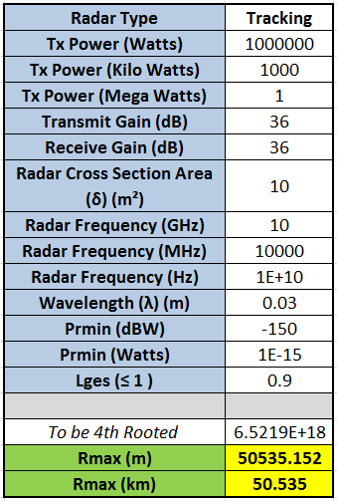
Using the same mono-static Radar maximum range calculation, the Radar’s parameters are defined for the required tracking range of 50km;
$$Rmax= \sqrt[4]{\frac{P_{T }G_{T}G_{R}δλ²}{\left(4π\right)³P_{Rmin }L_{ges}}}$$
The Tracking Radar’s system parameters are calculated based on combined worst case system & atmospheric losses of 0.9, using the $R_{max}$ formula are;
Transmit power = 1 MW
Transmit & Receive Gain = 36 dB
Transmit frequency = 10 GHz
System Loss = 0.9
Figure 19

The parameters given for the specified Radar, from the Radar equation above, are unrealistic to current X-Band CW Radars. The transmitting power of 1MW is fairly ‘overkill’ to track a 10m² target at the medium range of 50km, Thus the Radar safety distance forward of the transmitting elements would also need to be a considerable distance, due to it transmitting 1MW of Non-ionizing radiation.
If the system noise level was reduced, from worst case: 0.9 to best case, 0.1, & the transmit frequency was reduced to 8GHz & the Gain increased from 36dB to 43dB, this would also decrease the transmit power to 50kW, giving a maximum Radar detection range of 50.6km
Other comparable Radar sets are as follows;
 | Site 2 Tracking Specification | Weibel MFDR-2100/40
Transmit Power | 50 kW | 400 W
Frequency | 8 GHz | 10.3-10.58 GHz
Gain | 43 dB | 40 dB
Range | 50.6 km | 60 km
Figure 20

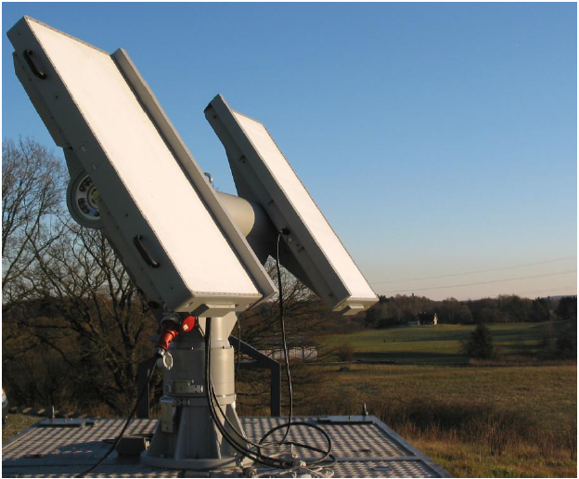
Weibel Scientific X-Band Continuous Wave (CW) Multi-Frequency Tracking Radar (MFTR 2100/40)
The Weibel MFTR features ‘visual and/or IR camera - are mounted on the ASM-2100 Additional Sensor Mount’ [20], this offers visual confirmation of the acquired target, even in low level light conditions.
With the tracking range in excess of 60km, the Weibel MFTR is mounted on a mobile trailer making the Weibel MFTR a ‘Compact system’ & ‘High mobility’ [20]

Figure 21

Tracking Radar Horizon Calculations
Using the same Radar horizon calculation as that used in ‘Site 1: Surveillance Radar Horizon Calculations’, the distance from the tracking Radar, located 10m above mean sea level is used to calculate its distance;
$$d =\sqrt{2×10m×\left(\frac{4 ×6371km}{3}\right)} = 13034.3m or 13.034km=R_{a}$$

The maximum distance for the tracking Radars detectable range is 50km, calculating the remaining distance from the Radar’s horizon to the target at 50km;
$$R_{t}=50km-13.034km = 36.966km= R_{t}$$
Calculating the minimum height of the target from mean sea level for the tracking Radar to detect at 50km;
$$h_{t}= \frac{{36.966km}^{2} }{2 × \left(\frac{4 ×6371km}{3}\right)} =80.432m$$

Other Technologies
There are other Radar technologies that overcome the issues with that of the P.S.R. & CW tracking Radar. Because the combination of the horizon & the power density that’s spread proportionally to the distance it’s covering, reflected Radar energy is very limited when situated as a static ground system. Here, other technologies are assessed in their over comings of this;

Over the Horizon Backscatter (OTH-B) Radar
Over the horizon backscatter Radar overcomes the problem with Earth’s horizon that limits both detectable range and minimum height. The basic principle of OTH-B Radar, is that it transmits a series of High Frequency (HF) pulses into the earths ionosphere [21](F-Layer), at a mean height of 200km [22]. OTH-B still relies on the reflection from the ground & mid-air targets, and uses a single-hop propagation of the transmitted HF EM pulses back to its receiver.
In the 1970’s the US Naval Research Laboratory required a ground station transmitting site, located in Europe that could detect ground launched missiles & aircraft within the USSR at a distance of 2,000 nautical miles from Orford Ness, Suffolk [23]. The Over the Horizon Backscatter Radar system, designated AN/FPS-95 ‘Cobra Mist’, consisted of 18 log-periodic 2,200ft radiating strings [24]. AN/FPS-95 had coverage of 119° arc & transmitted an impressive 3.5MW peak power, pulse-Doppler method on a frequency range of 6 to 40MHz. Because of the backscatter effect, the minimum range was limited to 500 nautical miles at the lowest frequency band. [25]. This early warning detection system devised during the cold war was part of the US & UK’s national defence. The AN/FPS-95 OTH-B system sited at Orford Ness was plagued with interference noise that resulted in its closure.
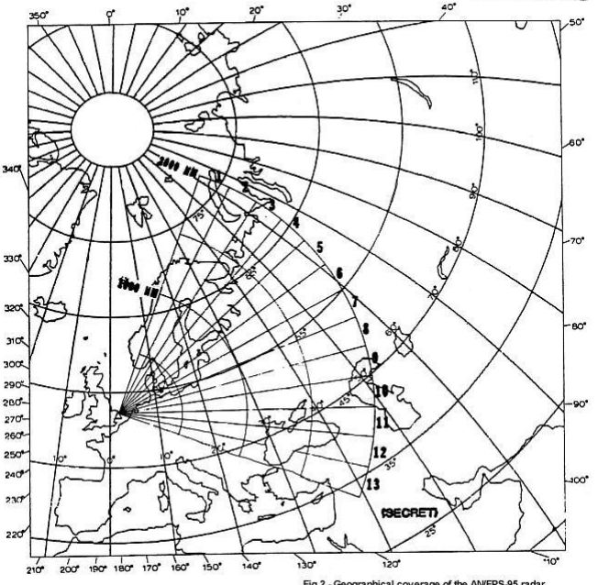
Orford Ness AN/FPS-95 OTH-B Coverage

Figure 22

Airborne Warning and Control System (AWACS)
To overcome the problems that such systems as ‘Cobra Mist’ inherently had, airborne Radar was devised as a way to further improve long range detection by Radar. By equipping a long range aircraft with surveillance Radar, the Jet aeroplane can scan the vast area beneath its Radome, providing early warning threats on the ground.
The AWACS E-3 Sentry, based on the Boeing 707-320B is a militarized airframe with the dorsal mounted Northrop Grumman AN/APY-1/2 AWACS Radar [26]. AWACS was devised by the United States Air Force (USAF) in the late 1970’s, shortly after ‘Cobra Mist’ was de-commissioned, to provide an early warning system & air combat command to the ground forces in combat. Although this overcomes the issue such as over the horizon detection, AWACS area of detection from its AN/APY-1/2 Radar covers an area of 250 miles [27], but still inherits a ‘dead spot’ beneath its fuselage. On the other hand, the E-3 Sentry can be airborne for 8 hours with mid-air refuelling capability. As this Radar system is constantly in flight, it poses better chance of survival when compared to a fixed ground based Radar system that’s liable for attack.
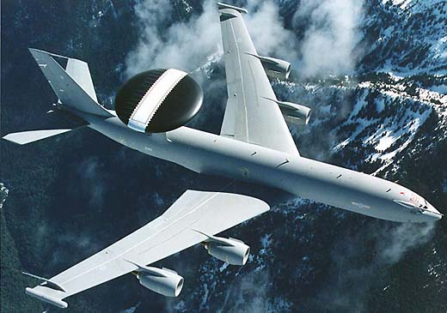
E-3 Sentry Boeing 707-320B with the AN/APY-1/2 AWACS Radar

Figure 23

Conclusion
There are many forms of Radar, although these many forms still transmits a EM RF wave, the way in which these varying technologies deliver these each have their limitations, be it the Earths horizon, the reflected area of the target, or the medium in which the EM wave propagates through.
As we can see in the requirements for site 1 & 2, altering the Radar’s parameters, such as the wavelength, transmitting power & gain directly affects the limiting range in which the Radar system can detect its reflected energy from. If we look at the types of Radar bands used for specific applications, long range surveillance Radars typically have a characteristic of operating within the lower sector of the IEEE RF bands i.e. HF to L band (3MHz to 2GHz), this is because generally, longer wavelengths travel further with lower power than higher frequency bands, such as X-Band, due to the smaller amount of electrical energy needed to sustain the lower cycle oscillations.
There are however, alternative technologies to ground-based Radar systems that are more economical on transmitted Vs returned energy. OTH-B & AWACS Airborne Radar systems are more direct in which the way they transmit their EM RF energy, but there is a catch to obtaining better target acquisition technologies such as this, and its cost, $270 million for just one E-3 Sentry AWACS [28] & $100-$150 million (1973) for the AN/FPS-95 Orford Ness OTH-B Radar [29].

References
[1] IEEE Radar Frequency Band Specifications 1
http://www.radartutorial.eu/07.waves/Waves%20and%20Frequency%20Ranges.en.html - Accessed: 04/06/18
[6] Boeing 747 Cross-Sectional Area 5
https://sites.google.com/site/crosssectionalareaofaboeing747/- Accessed: 06/06/18
[7] MBDA Stormshadow Cross-Sectional Area 5
https://web.archive.org/web/20150103054239/http://www.raf.mod.uk/equipment/stormshadow.cfm - Accessed: 06/06/18
[12] SSR Frequency 6
http://www.radartutorial.eu/13.ssr/sr14.en.html - Accessed: 08/06/18
[15] Mode C Altitude Resolution 7
http://dgca.gov.in/intradgca/intra/icaodocs/Doc%209684%20-%20Manual%20on%20the%20Secondary%20Surveillance%20Radar%20(SSR)%20Systems%20Ed%203%20Amd%201%20(En).pdf - Accessed: 10/06/18
[16] Mode A&C Data Bit Length 7
https://www.eurocontrol.int/sites/default/files/publication/files/surveillance-modes-principles-of-modes-operation-and-interrogator-codes-20030318.pdf - Accessed: 10/06/18
[18] Weibel RTP 2100 9
http://www.tech-bel.com/wp-content/uploads/2017/03/MFTR-2100_Medium-Range.pdf - Accessed: 12/06/18
[19] Raytheon AN/SPS-49(V)5 12
https://www.forecastinternational.com/archive/disp_old_pdf.cfm?ARC_ID=881 - Accessed: 12/06/18
[20] Weibel MFTR 2100/40 16
http://www.tech-bel.com/wp-content/uploads/2017/03/MFTR-2100_Medium-Range.pdf - Accessed: 12/06/18
[22] Ionosphere F-Layer 17
https://www.electronics-notes.com/articles/antennas-propagation/ionospheric/ionospheric-layers-regions-d-e-f1-f2.php - Accessed: 14/06/18
[27] AWACS Detection Distance 19
http://www.af.mil/About-Us/Fact-Sheets/Display/Article/104504/e-3-sentry-awacs/ - Accessed: 15/06/18
[28] AWACS/ E-3 Sentry Unit Cost 20
http://www.af.mil/About-Us/Fact-Sheets/Display/Article/104504/e-3-sentry-awacs/ - Accessed: 16/06/18
[29] AN/FPS-95 Cost (1973) 20
http://www.cufon.org/cufon/cobramst.htm - Accessed: 16/06/18

Bibliography
[2] Electro-Magnetic Wave Principle 3
https://byjus.com/physics/characteristics-of-em-waves/ - Accessed: 04/06/18
[3] Magnetron 3
http://hyperphysics.phy-astr.gsu.edu/hbase/Waves/imgwav/magnetronop.gif - Accessed: 05/06/18
[4] Radar Horizon 4
http://www.ebah.com.br/content/ABAAAg6SUAD/principios-radar-marinha-dos-estados-unidos-ingles?part=3 - Accessed: 05/06/18
[5] Radar Cross-Section Definition 5
http://www.radartutorial.eu/01.basics/Radar%20Cross%20Section.en.html - Accessed: 05/06/18
[8] Absorbtion Device For Electro-Magnetic Waves by R.Kühnold 1954 5
- Accessed: 07/06/18
[9] IEEE Frequency WW2 Secrecy 5
www.nap.edu/read/21774/chapter/10#235 - Accessed: 07/06/18
[10] IEEE Standard Letter Designation for Radar Frequency Bands 5
https://standards.ieee.org/findstds/standard/521-2002.html - Accessed: 07/06/18
[11] Primary Surveillance Radar Fundamentals 6
http://www.airwaysmuseum.com/Surveillance.htm - Accessed: 08/06/18
[13] Identification of Friend or Foe 6
http://www.rfcafe.com/references/electrical/ew-radar-handbook/iff-identification-friend-or- foe.htm - Accessed: 09/06/18
[14] Secondary Surveillance Radar Side Lobe Suppression 6
http://www.radartutorial.eu/13.ssr/sr10.en.html - Accessed: 09/06/18
[17] TCAS/ ACAS 7
https://www.faa.gov/documentLibrary/media/Advisory_Circular/TCAS%20II%20V7.1%20Intro%20booklet.pdf - Accessed: 11/06/18
[21] OTH-B Fundamental 17
https://fas.org/nuke/guide/usa/airdef/an-fps-118.htm - Accessed: 13/06/18
[23] Orford Ness 'Cobra Mist' 18
http://www.spyflight.co.uk/cobramist.htm - Accessed: 14/06/18
[24] Cobra Mist Antennas 18
https://www.globalsecurity.org/space/systems/an-fps-95.htm - Accessed: 14/06/18
[25] AN/FPS-95 Minimum Range 18
http://www.hpcc.ecs.soton.ac.uk/~dan/talks/DarkSideOfTheMoon/FPS-95_enigma_complete3.pdf - Accessed: 14/06/18
[26] E-3 Sentry AWACS AN/APY-1/2 Radar 19
https://www.airforce-technology.com/projects/e3awacs/ - Accessed: 15/06/18

Figures
Figure 1 - Site 1 Surveillance Map Overview 1
Figure 2 - Site 2 Tracking Map Overview 2
Figure 3 - Electro-Magnetic Radio Wave 3
Figure 4 - Magnetron Diagram 3
Figure 5 - Radar Horizon Example 1 4
Figure 6 - Radar Horizon Example 2 5
Figure 7 - Mode A Pulse Train 7
Figure 8 - Mode A 4-digit Octal Table 7
Figure 9 - Asynchronous F.R.U.I.T. 8
Figure 10 - Doppler Frequency Shift Example 8
Figure 11 - Weibel RTP 2100 9
Figure 12 - Doppler Object Tracking Example 9
Figure 13 - Surveillance Radar Pros/ Cons Table 10
Figure 14 - Site 1 Radar Equation Excel Table 11
Figure 15 - Site 1 Radar Comparison Table 12
Figure 16 - Raytheon AN/SPS-49 Surveillance Radar 12
Figure 17 - Radar Horizon Mathematical diagram 13
Figure 18 - Tracking Radar Pros/ Cons Table 15
Figure 19 - Site 2 Radar Equation Excel Table 15
Figure 20 - Site 2 Radar Comparison Table 16
Figure 21 - Weibel MFTR 2100/40 CW X-Band Tracking Radar 16
Figure 22 - Orford Ness AN/FPS-95 OTH-B Coverage 18
Figure 23 - E-3 Sentry Boeing 707-320B with the AN/APY-1/2 AWACS Radar 19

