Cheng Chen (2305261)
University of Wales Trinity Saint David
BSc Applied Computing
Developing an MS Access Database for Coastal Tourism Management Report
L4 - Introduction to Web and Database Concepts (ACCA4023)
Contents
Section A 2
1. DBMS user types and their roles and responsibilities 2
2. The specific needs and responsibilities of each department that may require access to the CTMS 3
Database Design and Implementation 4
ERD (Entity Relationship Diagram): 5
Explain the importance of entities and their associated properties in database design: 5
Relational database architecture design: 6
Application of Database Management System 7
Using a DBMS (Microsoft Access), create a database 7
Reports Design 9
Forms Design, User Interface and Menus 13
Section B 14
References 17

Section A Below are the various departments that play different roles and responsibilities in coastal tourism management and require varying degrees of access to the CTMS to achieve their tasks and responsibilities. The system should provide different levels of access and functionality to different departments to suit their needs.

1. DBMS user types and their roles and responsibilities
a. Visitors/Customers
Roles & Responsibilities: Browse available coastal vacation packages, make reservations, pay and provide feedback. They use systems to plan and complete their vacation experiences.
b. Corporate/Resort Management
Roles & Responsibilities: Manage resort information including adding, editing and deleting vacation packages, pricing, availability, etc. They manage corporate information through the system to provide it to visitors.
c. Customer Support Team
Roles and Responsibilities: Handle visitor inquiries, provide assistance and resolve issues. They need access to the system to view order information, customer information and provide personalized support.
d. Database administrator
Roles and Responsibilities: Responsible for managing the entire database system, including maintenance, backup, data recovery, monitoring performance, ensuring data security, etc. They are responsible for the security and operation of the system.

2. The specific needs and responsibilities of each department that may require access to the CTMS
a. Sales and Marketing Department
Requirements and Responsibilities: Use CTMS to promote and showcase vacation packages, monitor sales data, customer feedback, and market trends. They need access to the system to update and adjust promotional strategies.
b. Customer Service Department
Requirements and Responsibilities: Handle customer reservations, questions and complaints. They need access to the CTMS to view orders, customer information and provide support.
c. Product development and management department
Needs and Responsibilities: Adjust vacation package content and features based on user feedback and market demand. They need access to the system to analyse user feedback and industry trends.
d. Finance Department
Requirements and Responsibilities: Monitor revenue, costs, profits and financial data. They need access to the system for order payment information, profit analysis and financial reporting.
e. Operations Management Department
Requirements and Responsibilities: Manage daily operations, including staffing, resource allocation, etc. They may need access to the system to view bookings, schedule resources and staff.
f. IT/Technical Support Team
Requirements and Responsibilities: Responsible for system maintenance, upgrades and resolving technical issues. They need access to the system to monitor and maintain system health.

Database Design and Implementation
Creating an entity-relationship diagram (ERD) for a coastal tourism management system requires first identifying the main entities in the system and the relationships between them. In this scenario, the following entities may exist:

entity:
User/Customer

Attributes: User ID (primary key), name, contact information, etc.
Coastal Packages

Attributes: package ID (primary key), name, description, price, availability, etc.
Order

Attributes: order ID (primary key), user ID (foreign key), package ID (foreign key), date, total cost, etc.
Comments and Feedback (Feedback)

Attributes: feedback ID (primary key), user ID (foreign key), package ID (foreign key), review content, rating, etc.

Relationships and multiplicity:
One user can have multiple bookings (one-to-many relationship: one user can book multiple vacation packages).
A coastal vacation package can have multiple bookings (one-to-many relationship: a vacation package can be booked by multiple users).
One order can only correspond to one user and one coastal vacation package (one-to-one relationship).
One user can submit multiple reviews and feedback (one-to-many relationship: one user can review multiple vacation packages).
A coastal vacation package can receive multiple reviews and feedback (one-to-many relationship: a vacation package can receive reviews from multiple users).

ERD (Entity Relationship Diagram):
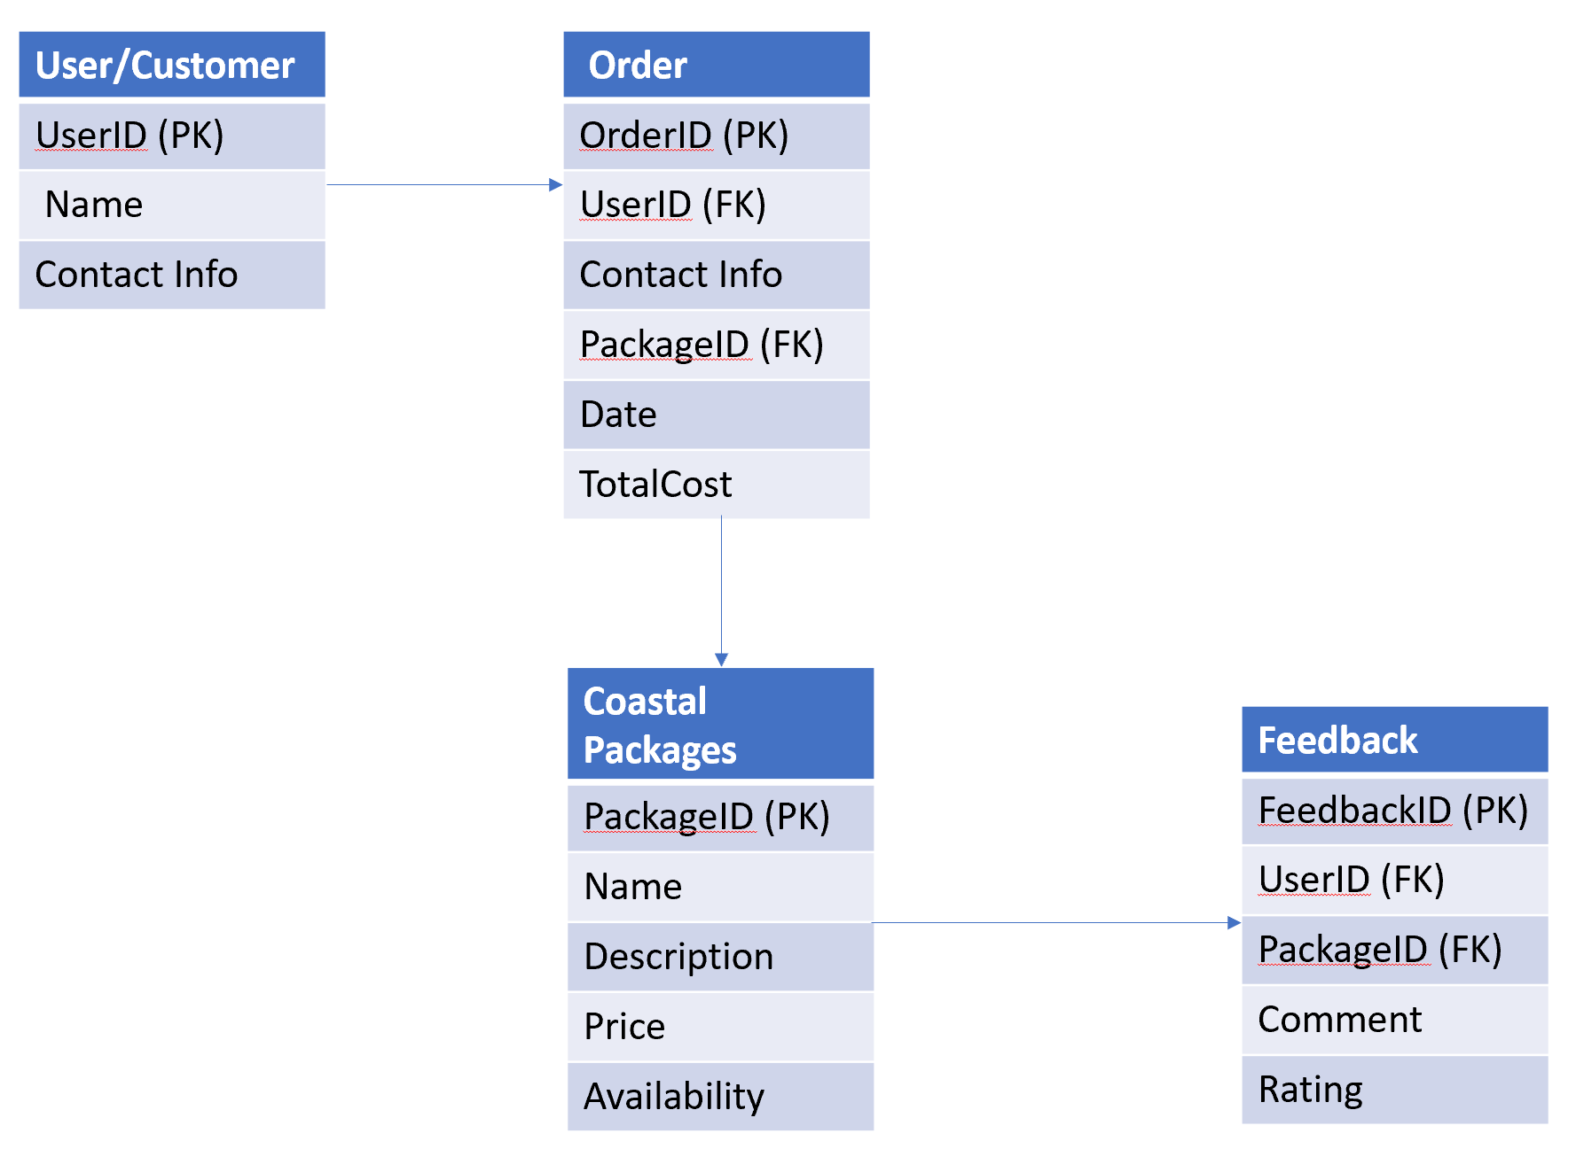

Explain the importance of entities and their associated properties in database design:
Users/customers, orders, vacation packages, and feedback are core elements in the system, and each entity contains important information that enables the system to operate and manage effectively.
Relationships (e.g., between a user and an order, between an order and a vacation package) help understand the interactions and dependencies between different entities, making the system completer and more useful.
By representing these entities and the associated attributes between them in the database, data consistency, accuracy, and completeness can be achieved, as well as effective data management and query operations.

Relational database architecture design:
Based on the above ERD, here is an example relational database schema design:
User/Customer table (Users)
UserID (primary key)
Name
Contact Info

Orders
OrderID (primary key)
UserID (foreign key)
PackageID (foreign key)
Date
TotalCost

Coastal Vacation Packages (CoastalPackages)
PackageID (primary key)
Name
Description
Price
Availability

Comment and feedback form (Feedback)
FeedbackID (primary key)
UserID (foreign key)
PackageID (foreign key)
Comment
Rating

Application of Database Management System

Using a DBMS (Microsoft Access), create a database
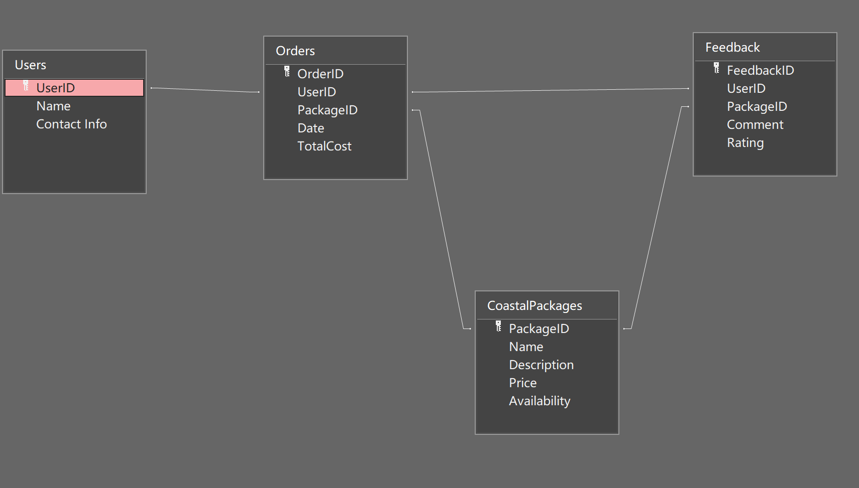
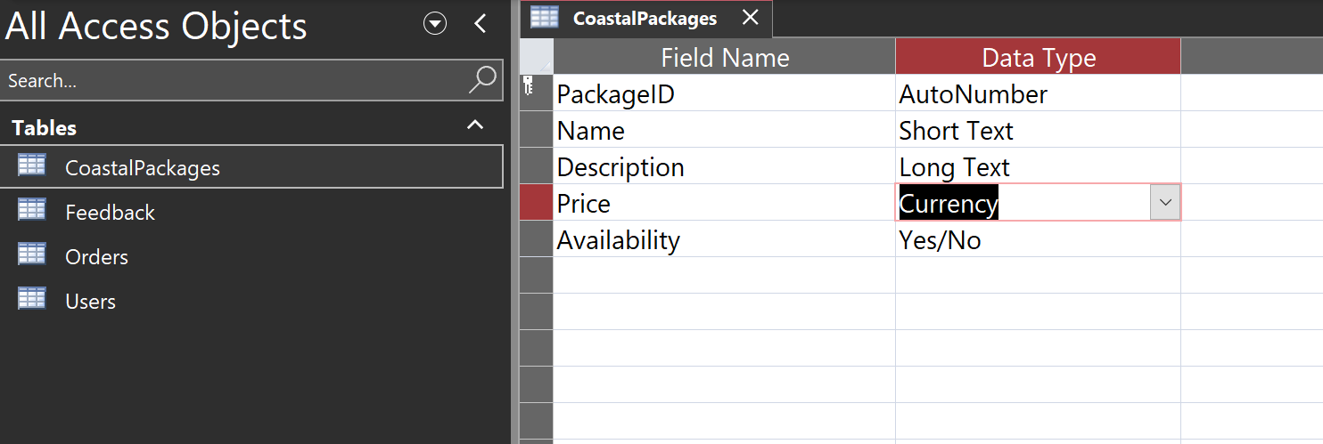
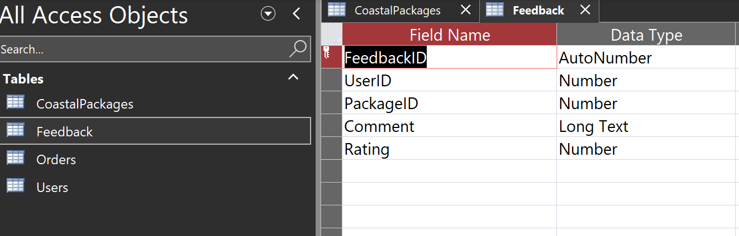
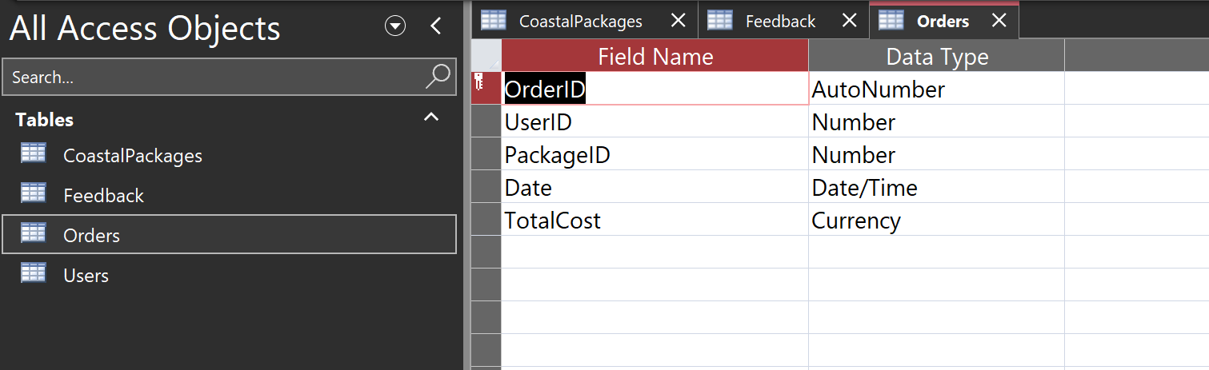
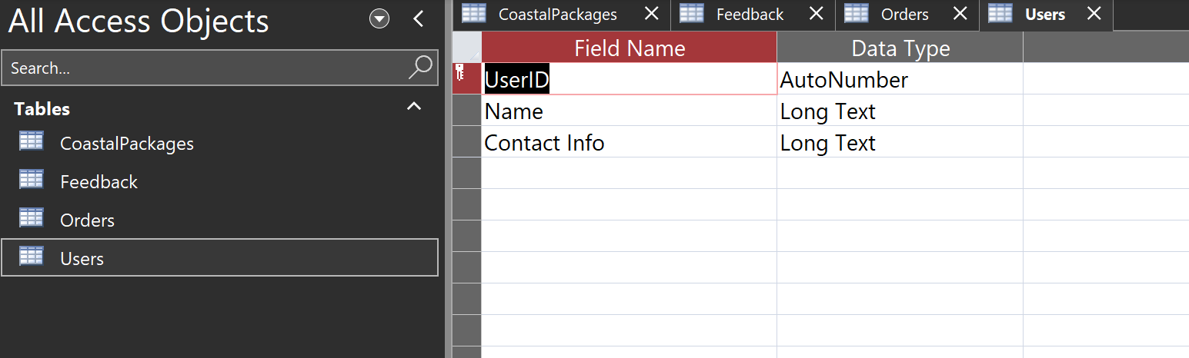

Reports Design
Design and create user-friendly reports
a. Calculate the total revenue report for Coastal Getaways for a specific time period
Create Query:
Create a query to calculate the total revenue for orders over a specific time period. You will need to consider fields that contain the date and total cost of the order. Use the Query Designer tool to create a suitable query based on selecting the date of the order and calculating the total cost of the order.
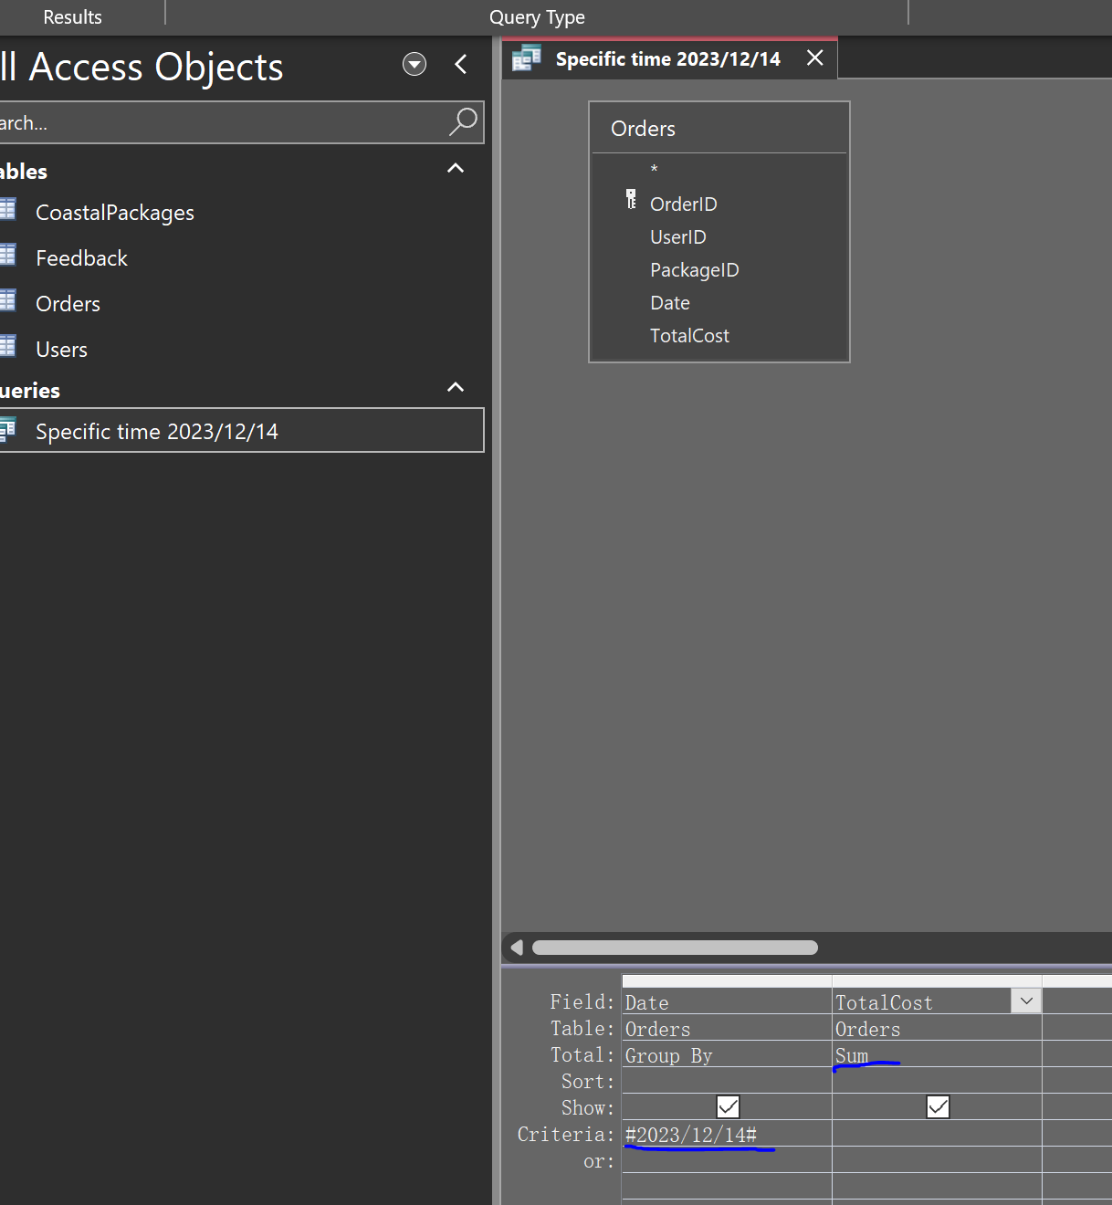
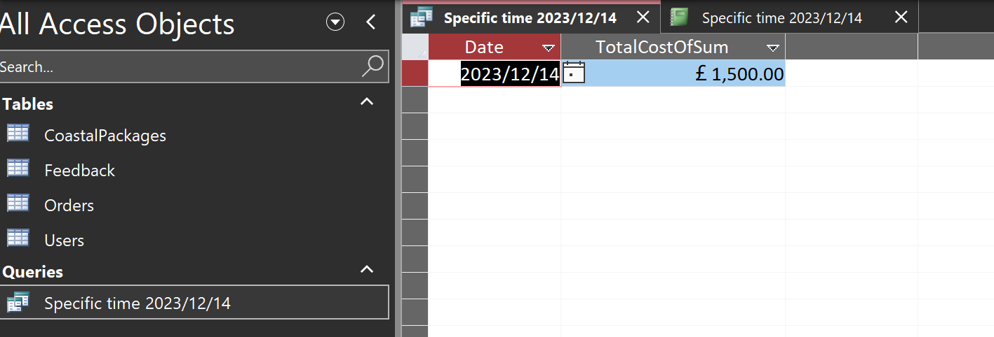
Create the report:
In the Query Design view, use the Report tool on the Create tab to create a report. Use the query as the data source for the report. Add headers, data fields, and any summary information and formatting you may need to the report.
Design the report view:
In the Report Designer, place the Order Date and Total Cost fields from the query in the Detail section of the report. Add a report title, a field that displays the total revenue.
Adjust the layout and style:
Ensure that the layout of the report is clear and concise, including headings, data fields, summary information, and so on. Adjust fonts, colours and styles to make the report more readable and user-friendly.
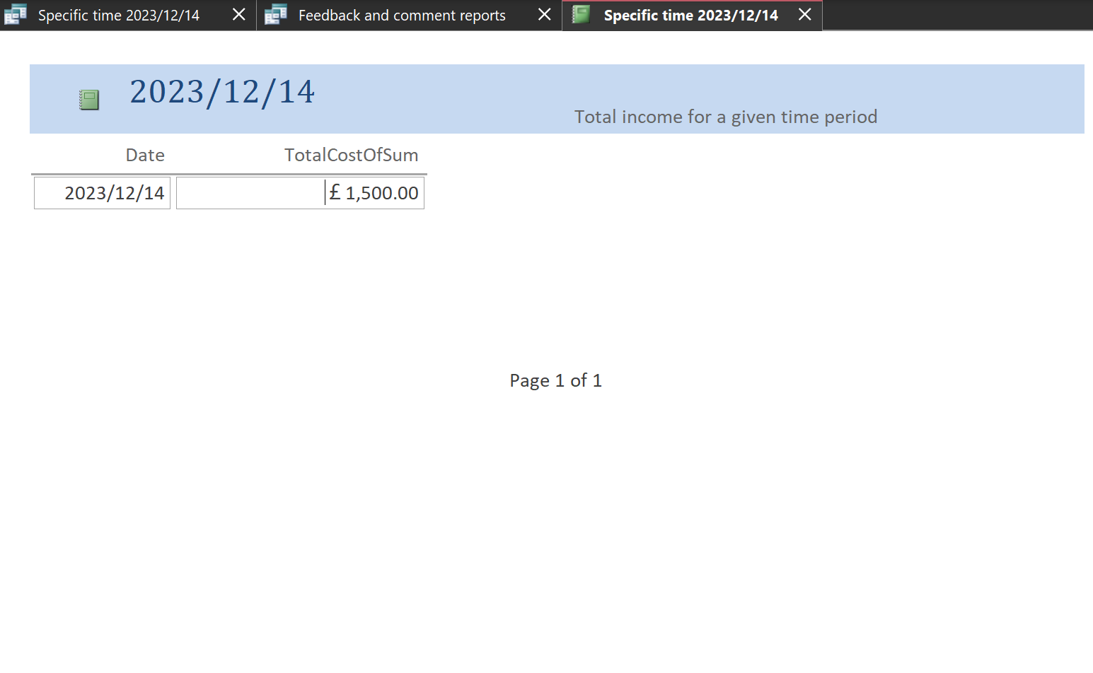

b. Compile a report of guest feedback and comments on Coastal Getaways
Create Query:
Create a query that pulls customer feedback and comments from the feedback form. This needs to include information such as the customer's name, the content of the review, and the rating. Use the Query Designer tool to create the appropriate query based on the information you need.
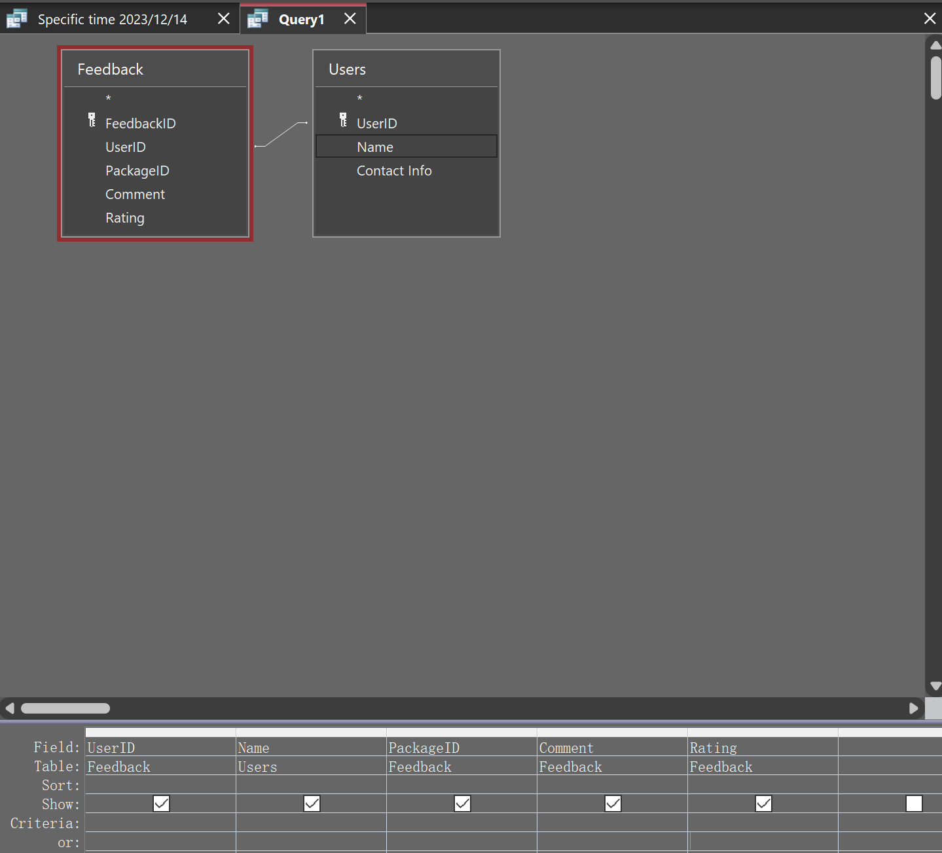
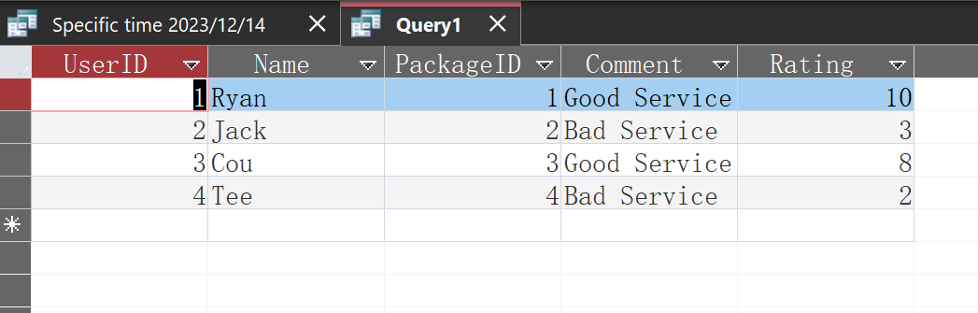
Create the report:
Using the above query as a data source, create a new report in the Report Designer. Add fields such as customer name, review content, rating, etc. to the report and consider grouping or arranging them for better readability.
Design the report view:
Place fields such as customer name, review content, rating, etc. from the query in the detail section of the report so that users can view the feedback and reviews on demand.
Adjust layout and style:
Ensure that the layout of the report is clear and that comments and feedback are easy to read and understand. Adjust the style of the report to match the brand style or user preferences.
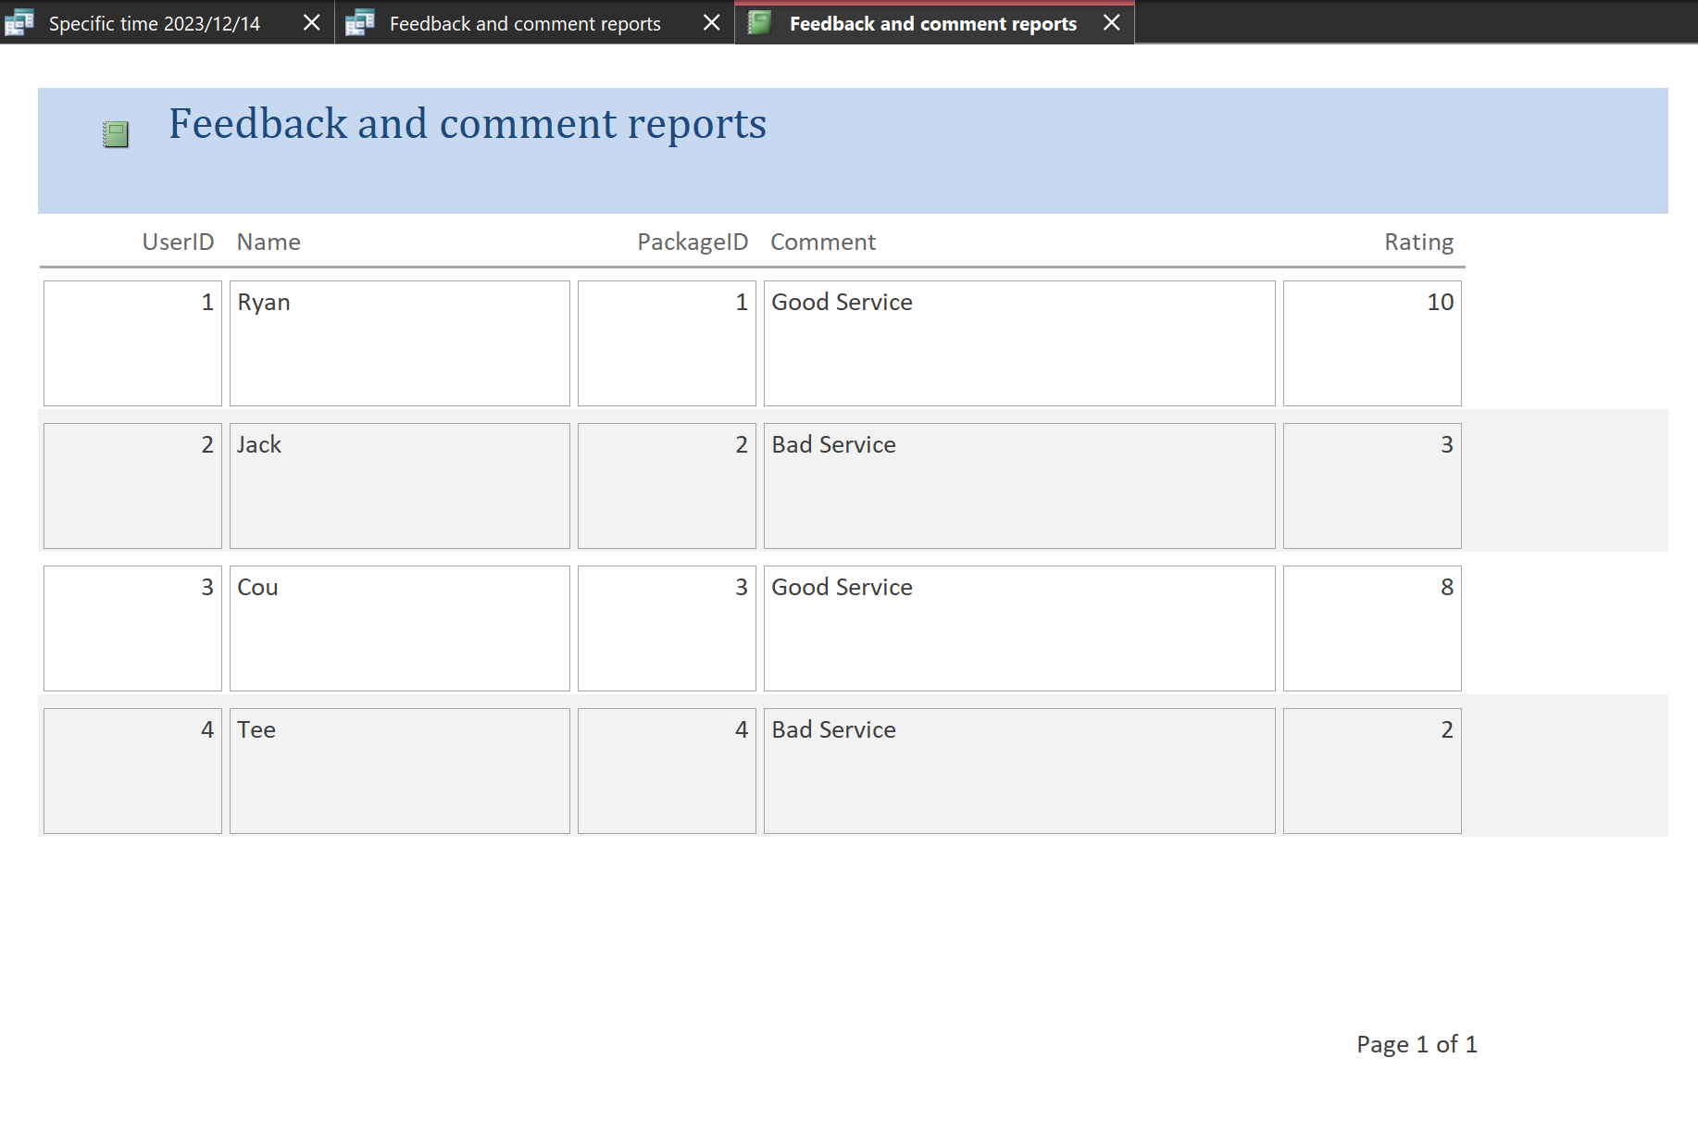

Forms Design, User Interface and Menus
Design
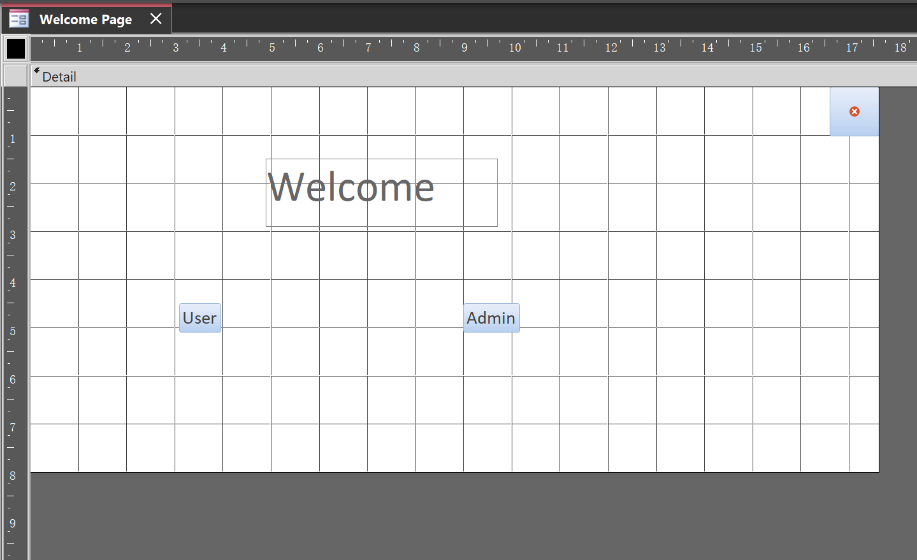
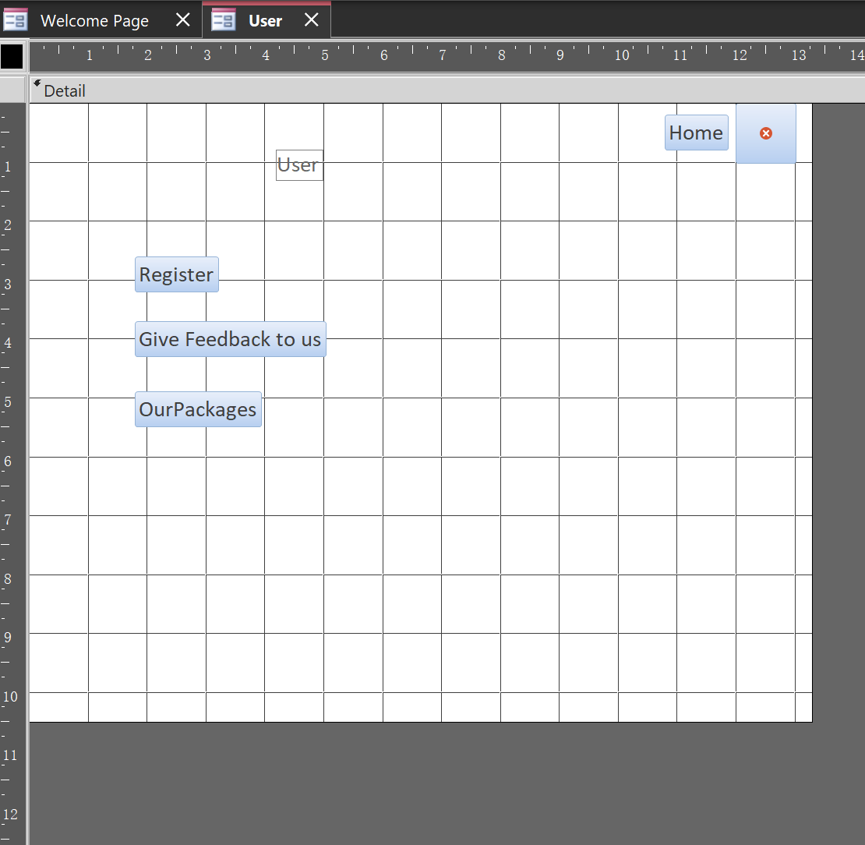
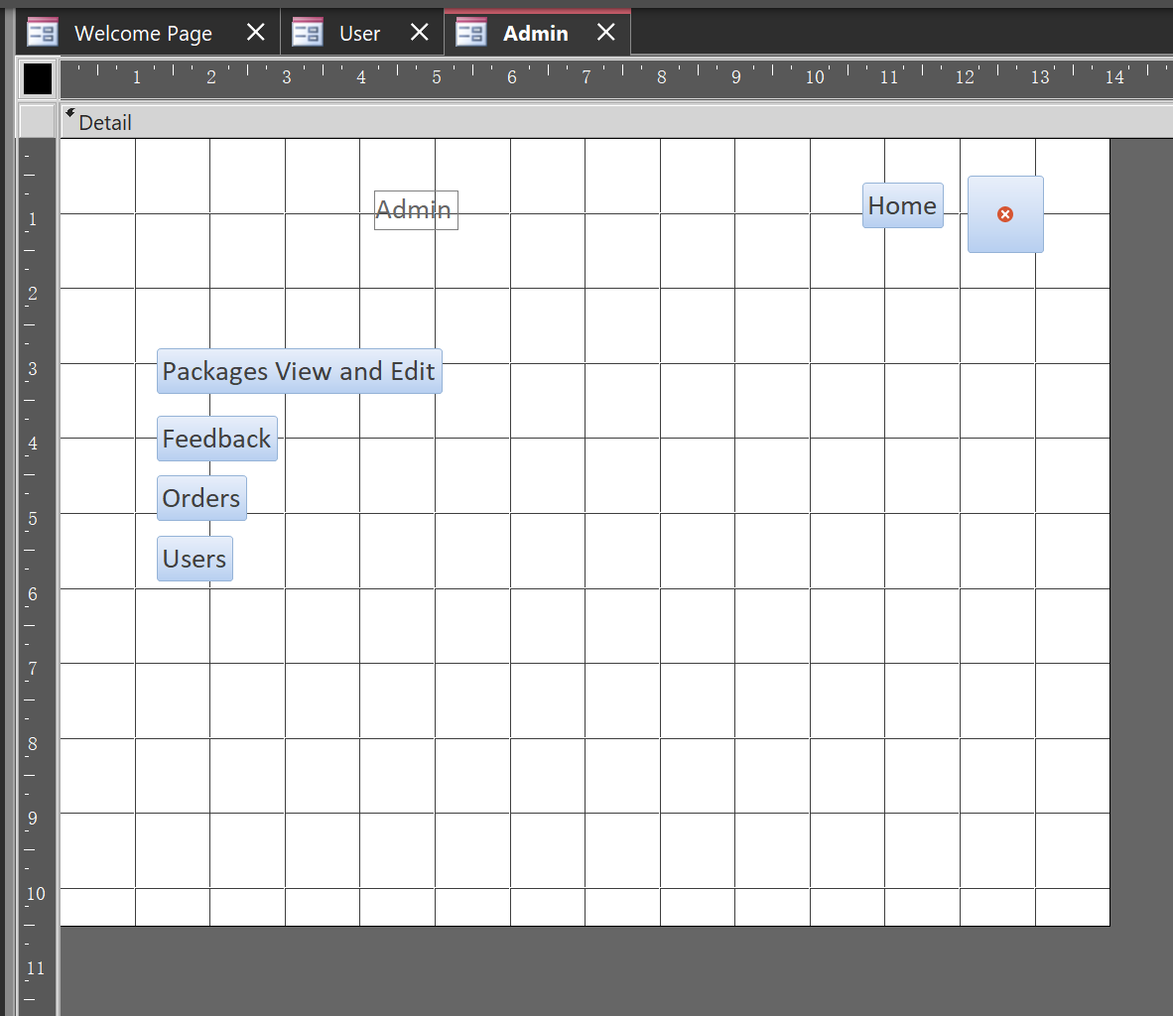
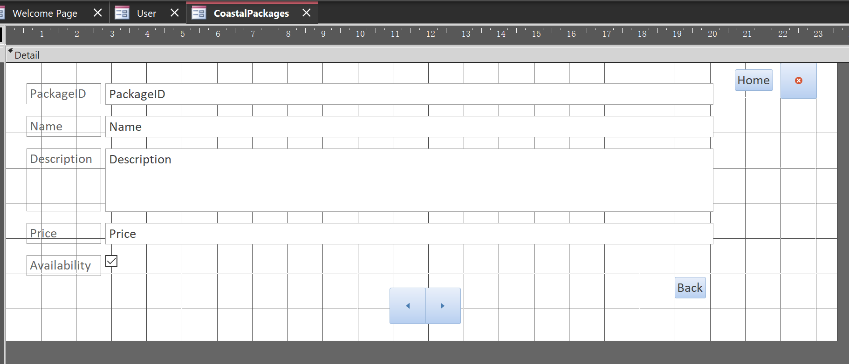
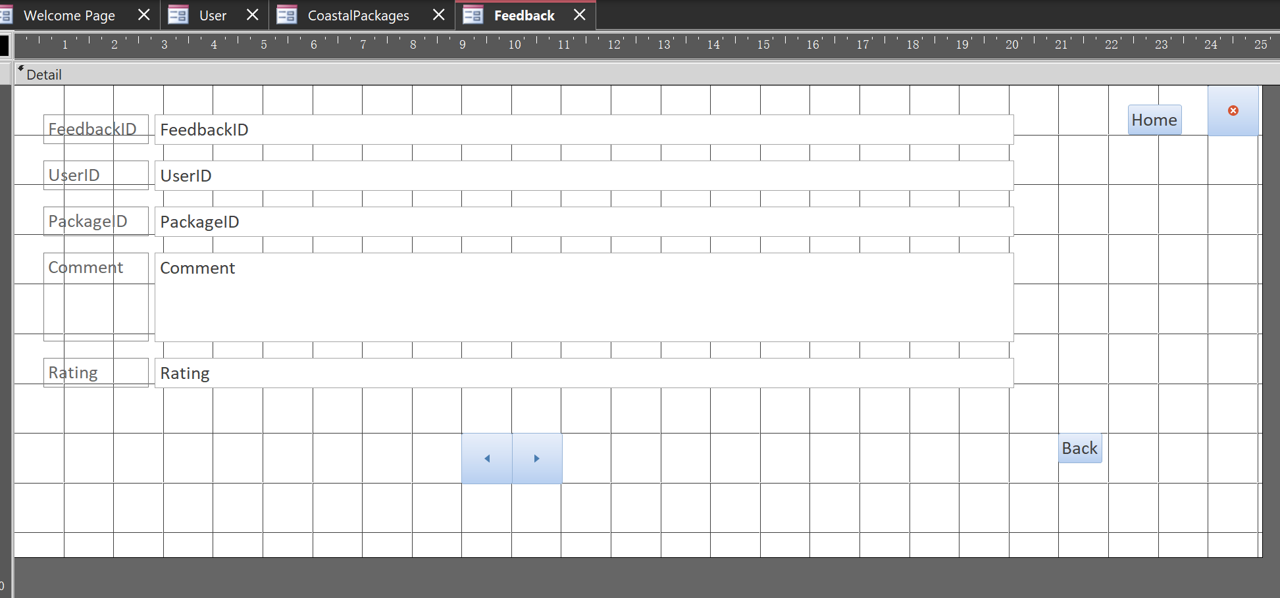
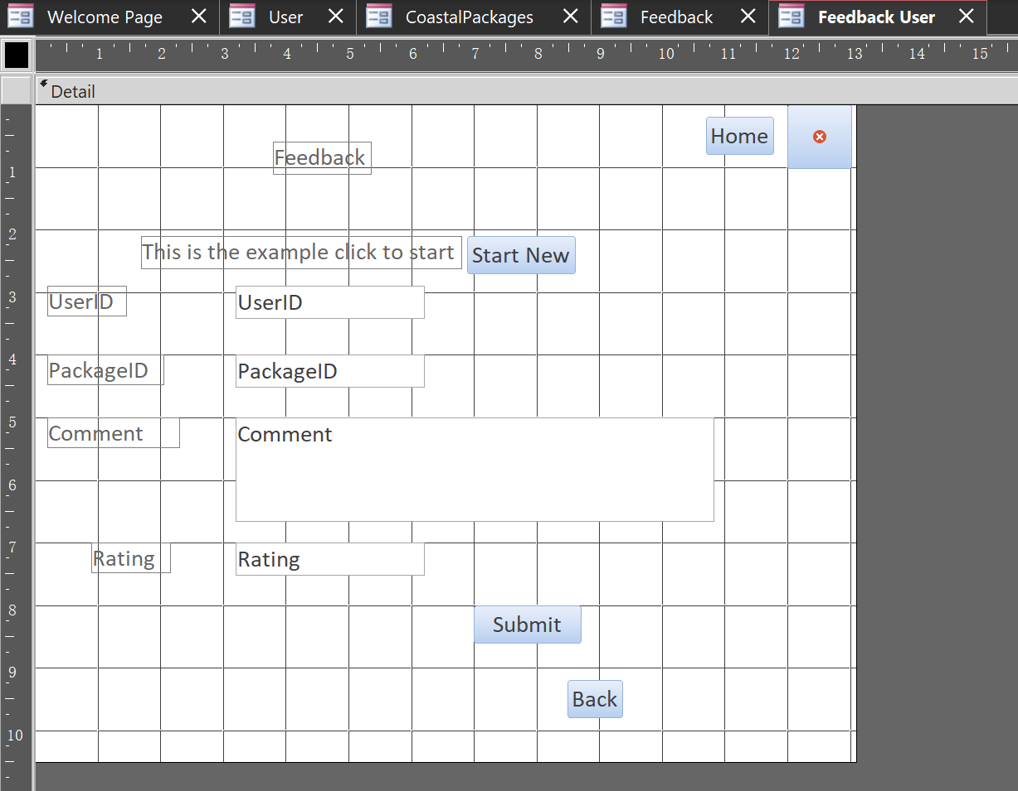
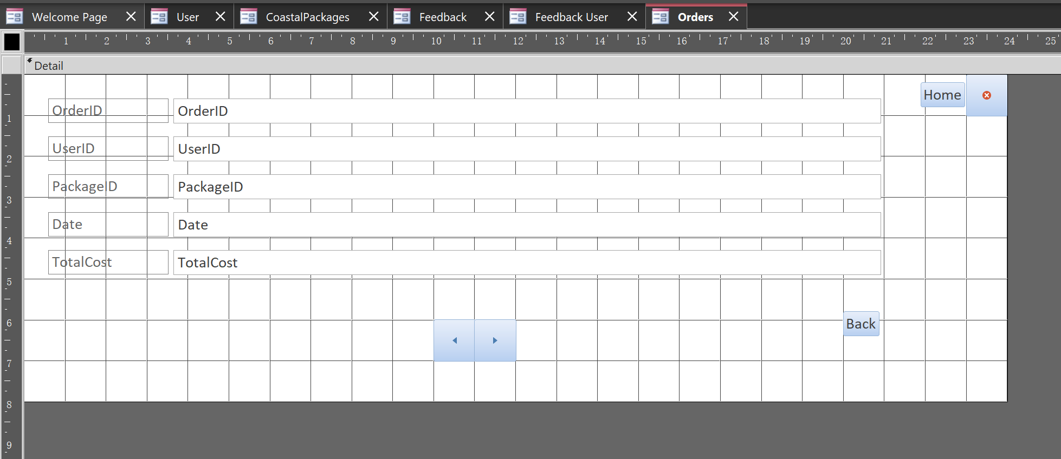
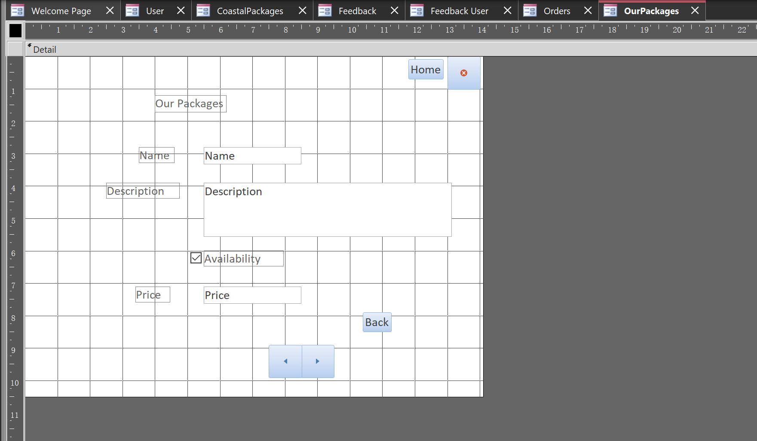
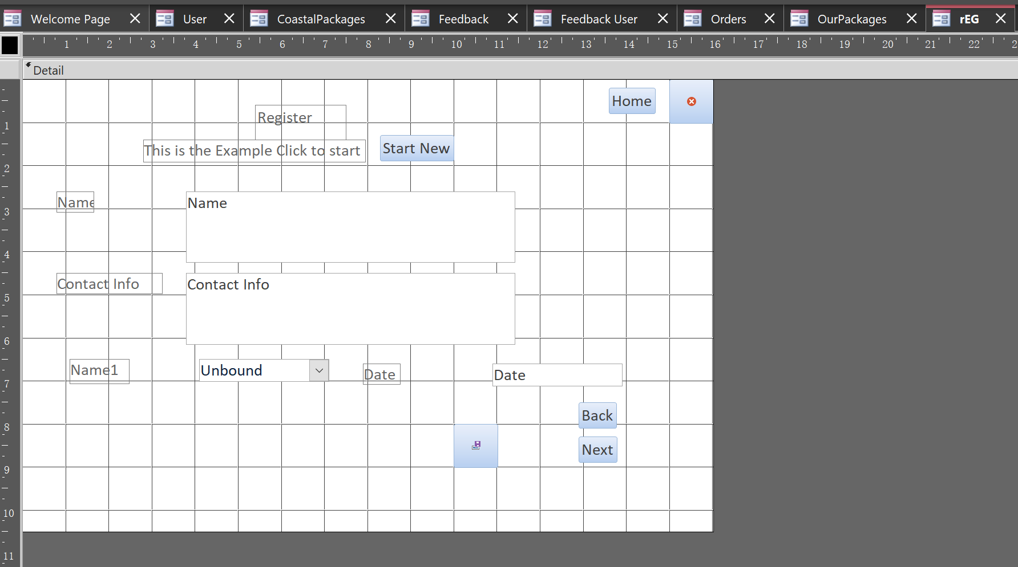
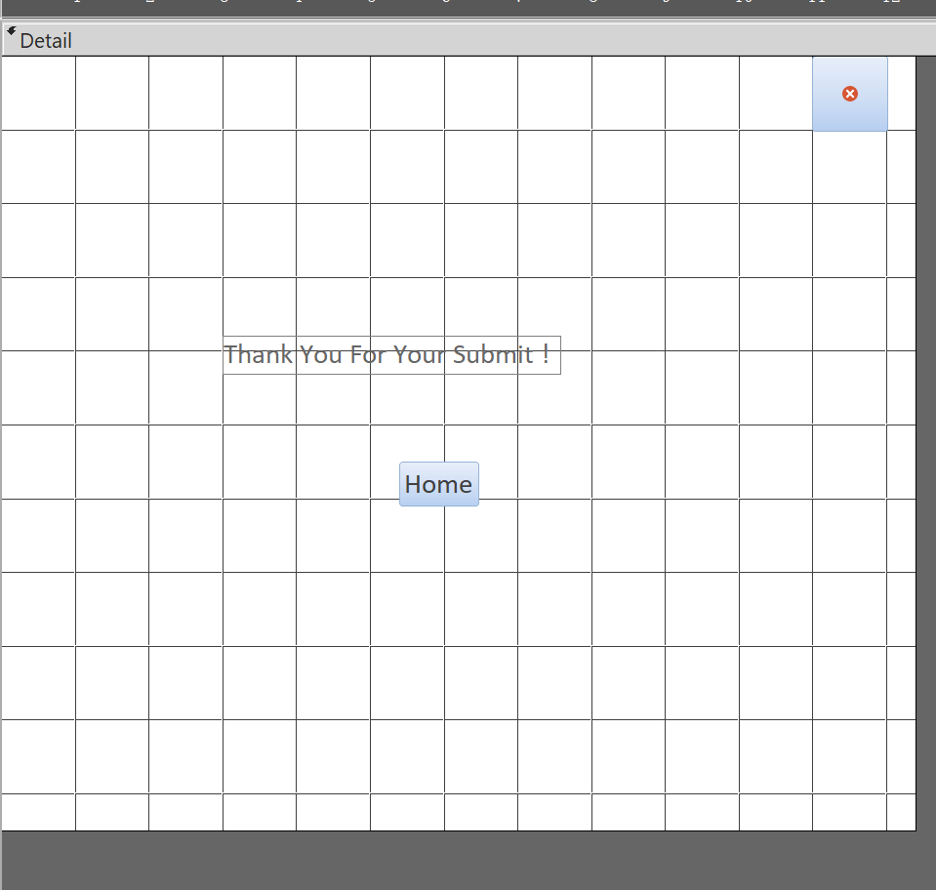
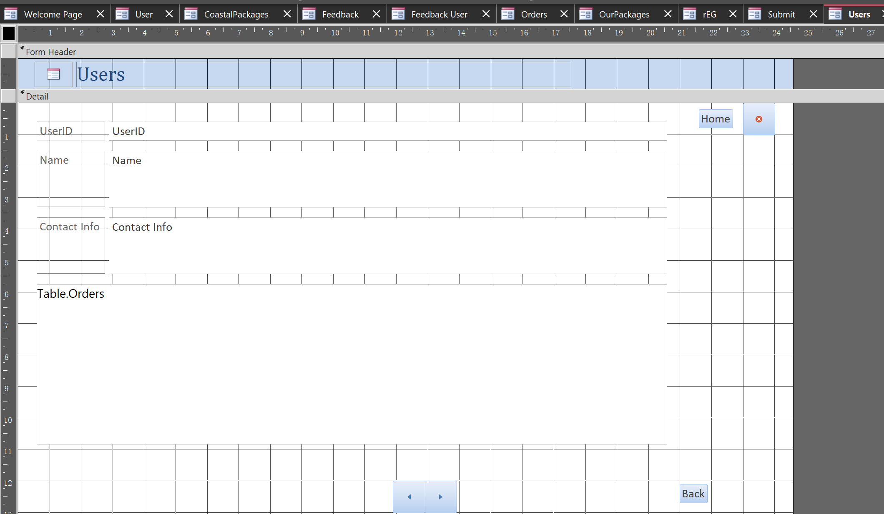

Set Display Form
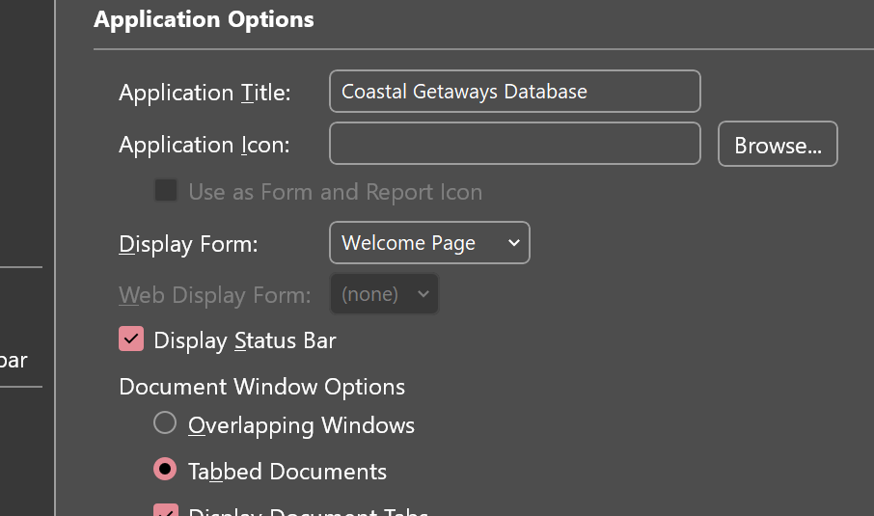
Pages
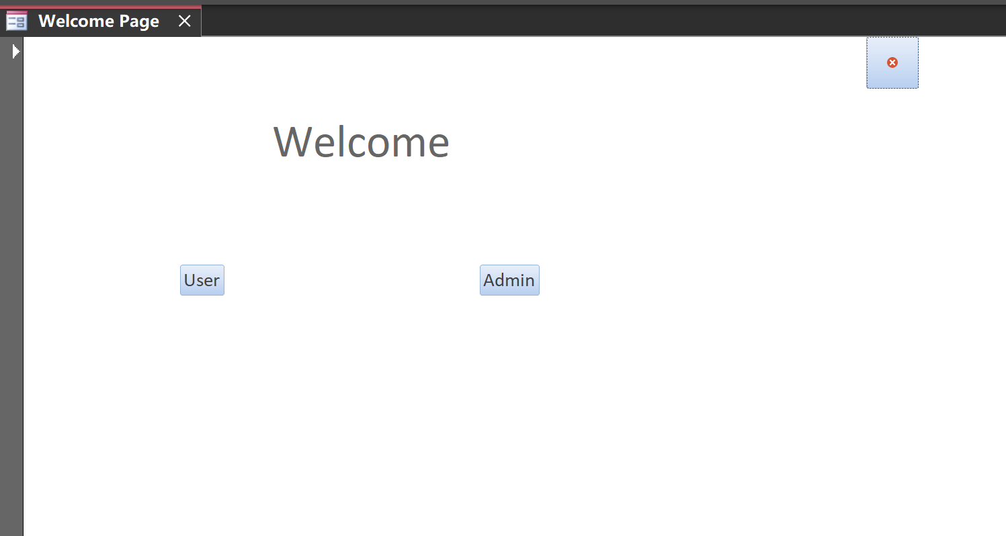
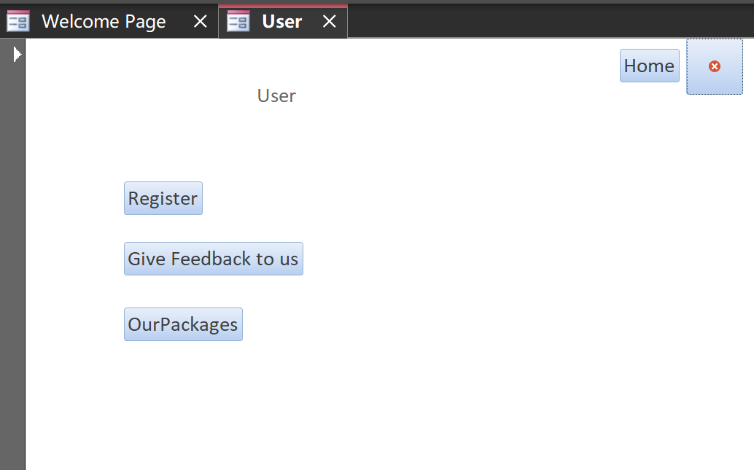
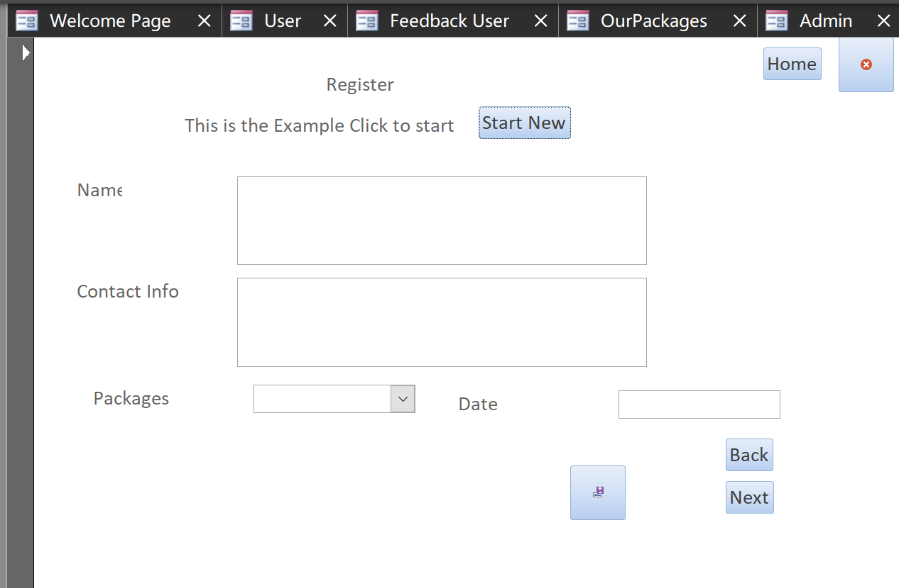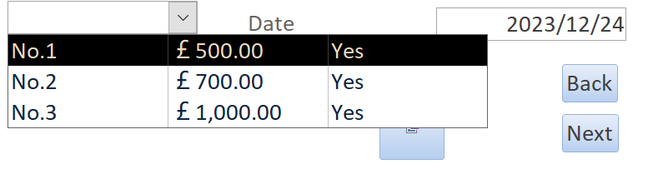

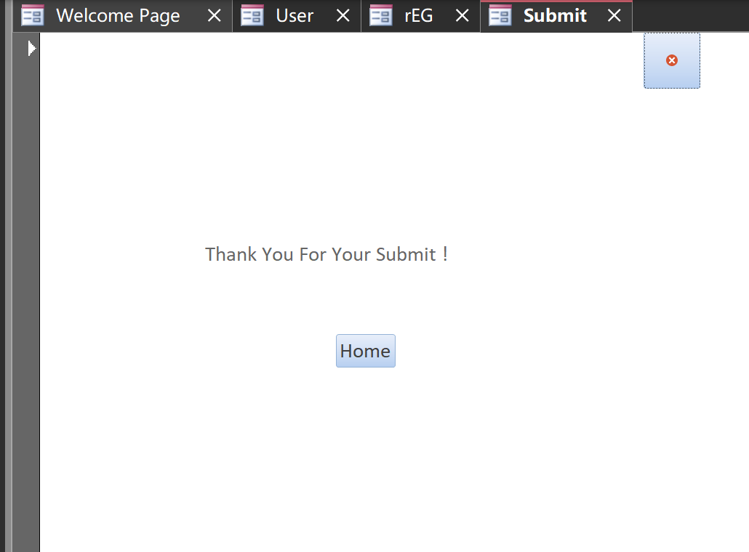
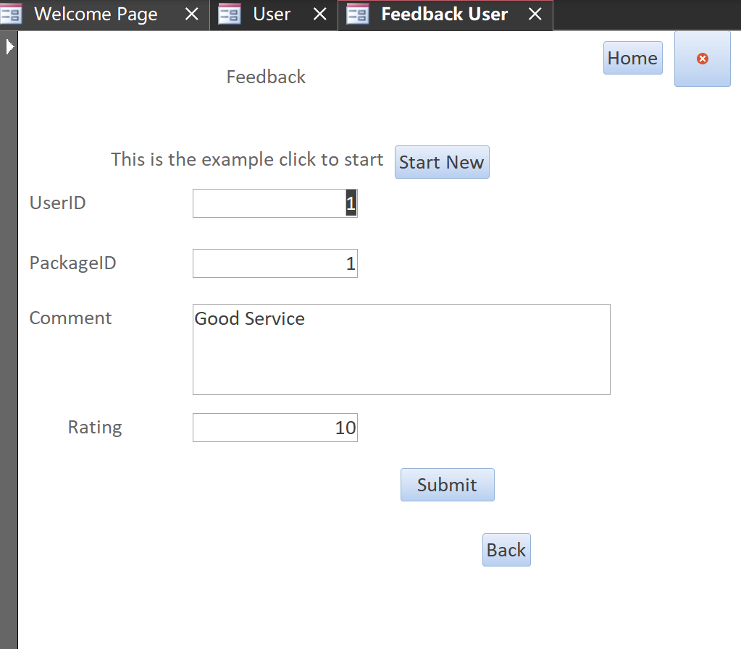
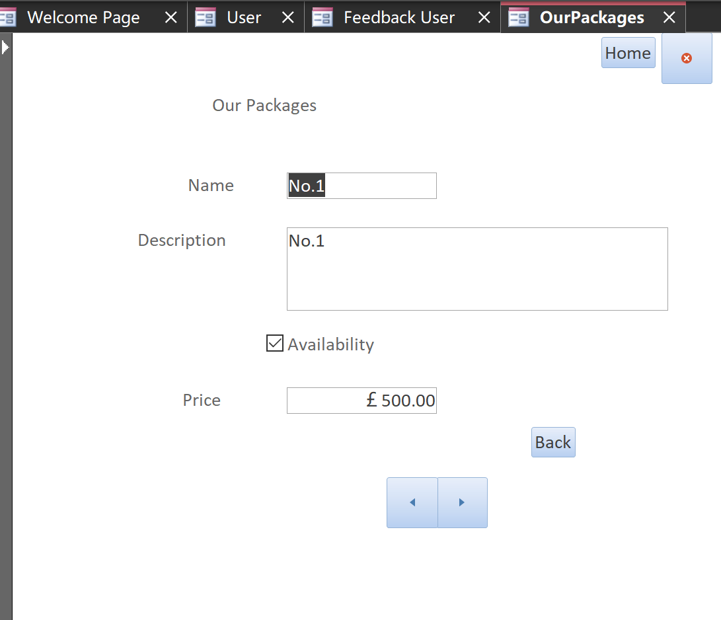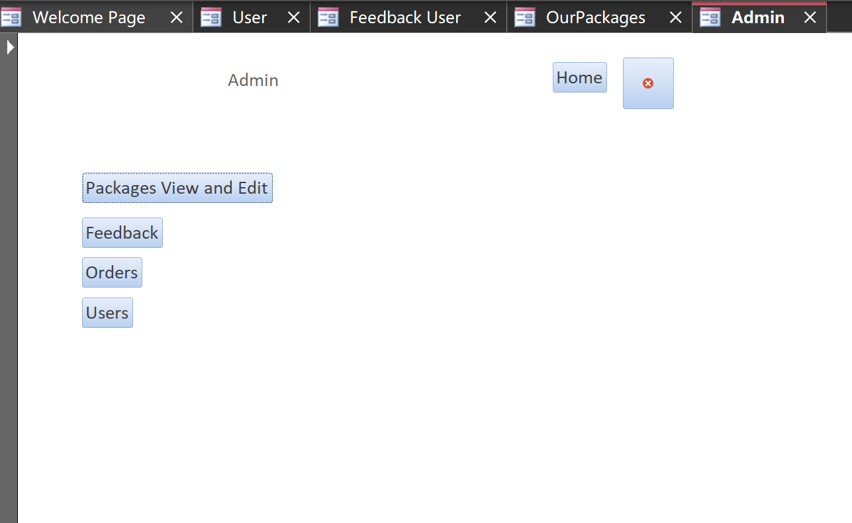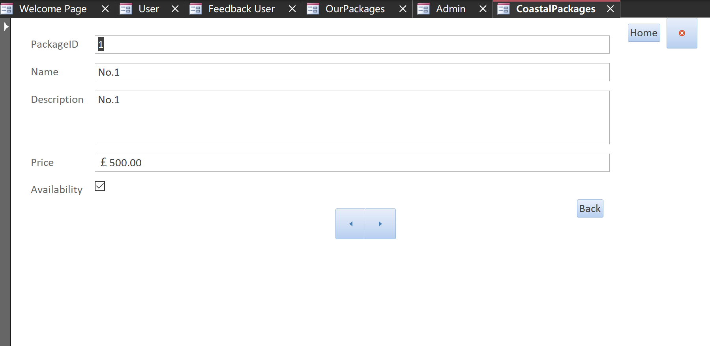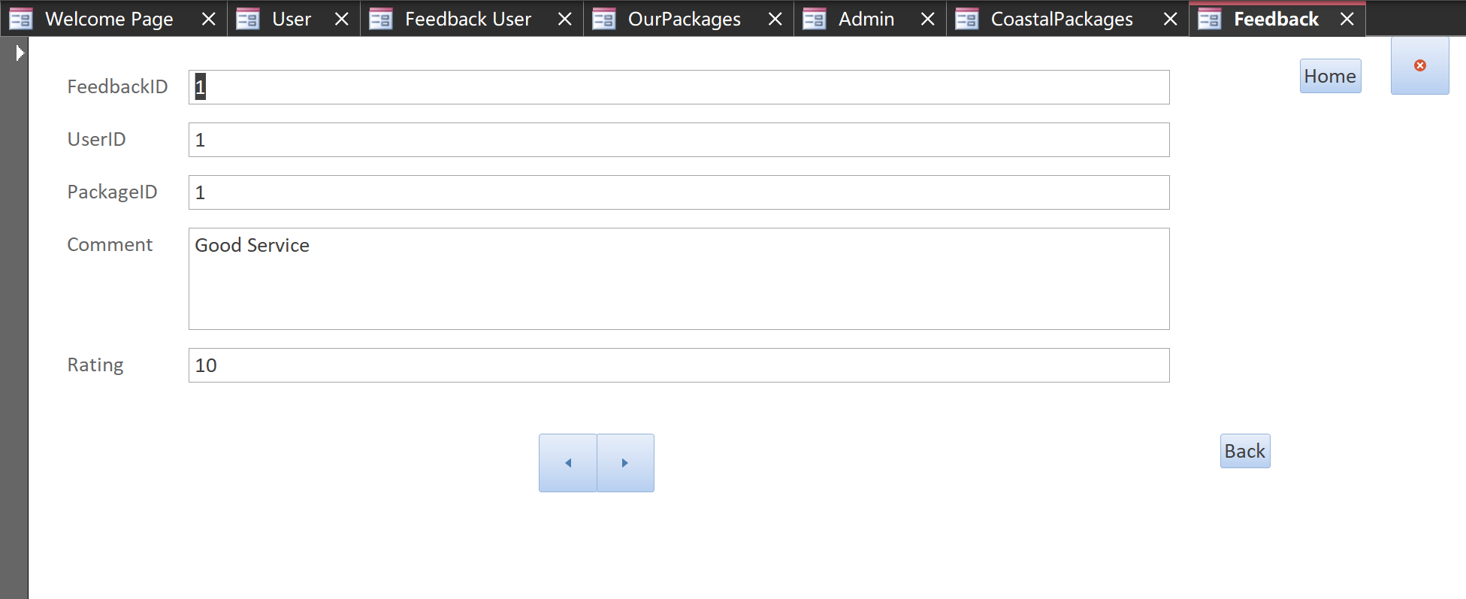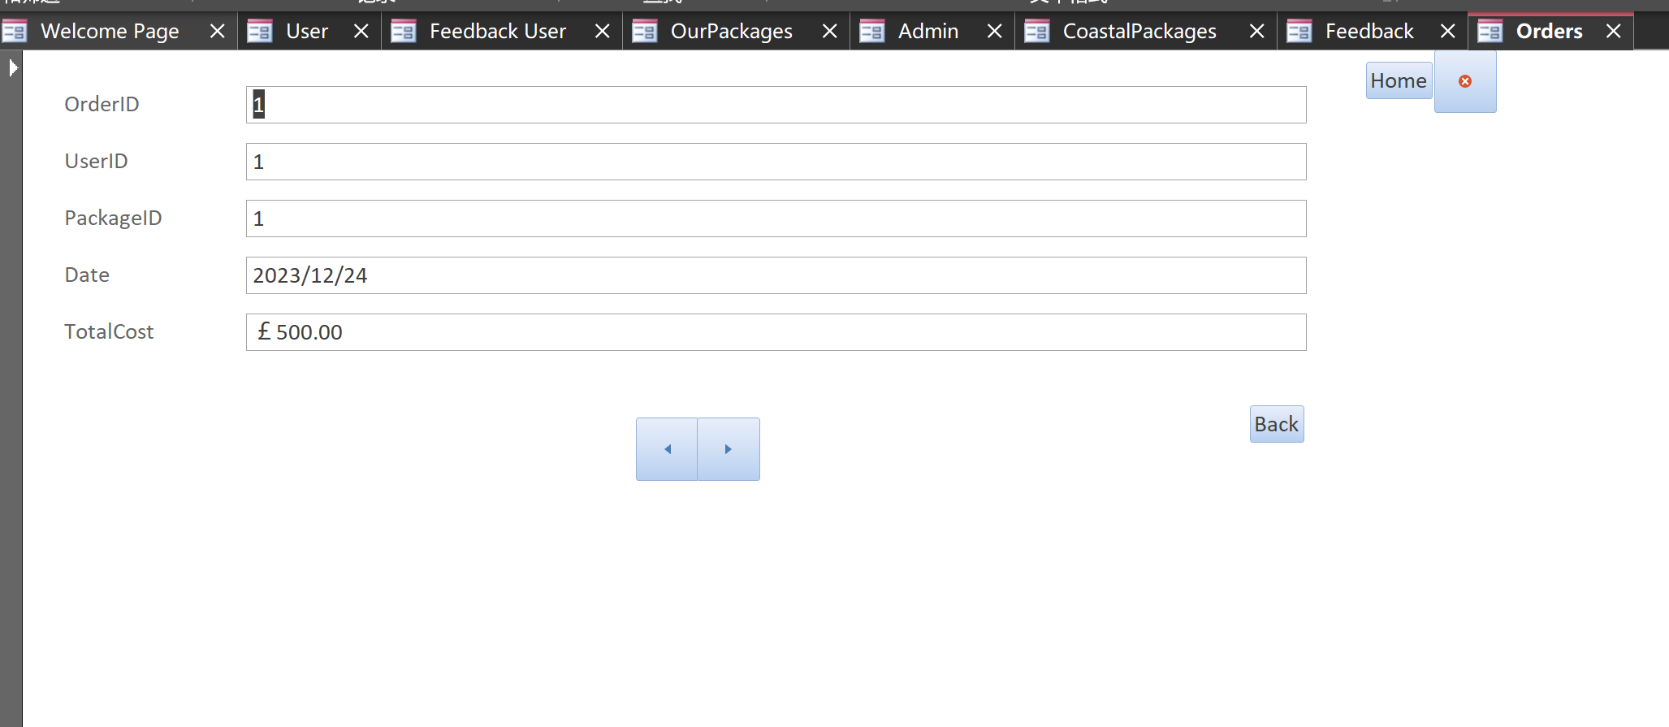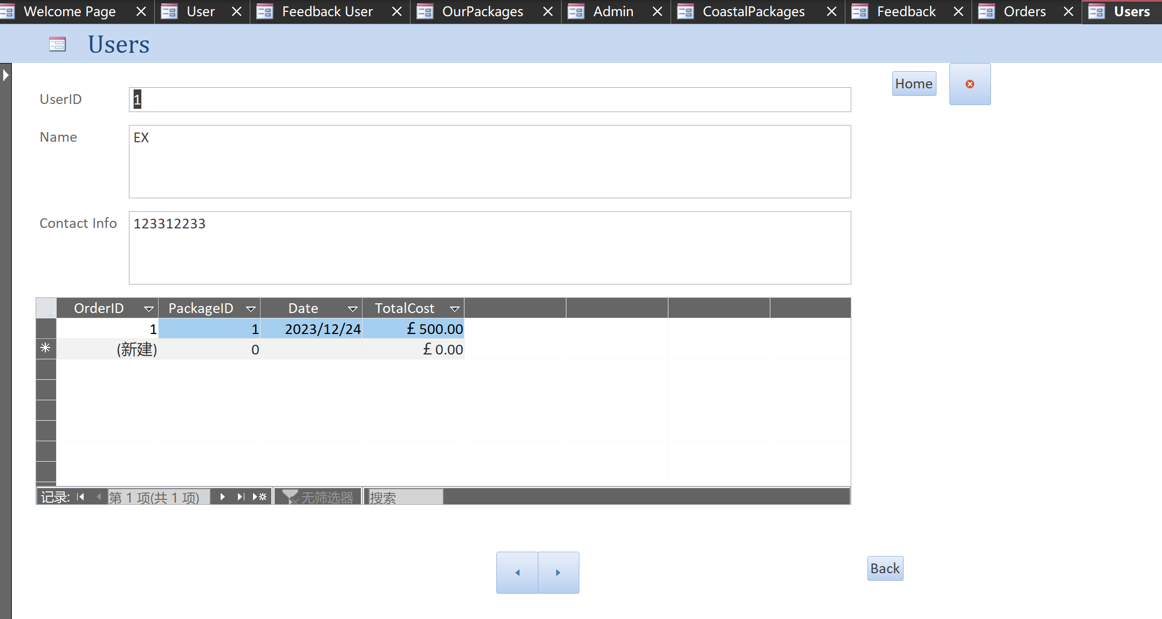

Section B
Through the development and use of a Microsoft Access database, information and business processes relating to coastal tourism in Wales can be effectively managed to improve efficiency, data accuracy and decision support. The database is able to optimise data management processes and provide a more efficient and accurate means of managing data and operations for coastal tourism management.
Incorporated information the board:
Unified Data: Brought together capacity of every applicable datum (for example orders, client data, occasion bundle subtleties, criticism, and so on.) through a data set, empowering simple administration and recovery of data in a single spot.
Information Consistency: Information consistency and respectability confirmation through the data set guarantees the exactness and consistency of all data.
Gives fast question and detailing capacities:
Employers value people with strong attention to detail because they’re both efficient and productive. [1]
Information Recovery: The information base can be questioned to effectively and immediately recover information under unambiguous circumstances, for example, orders inside a particular date range, criticism on unambiguous bundles, and so on.
Making reports: The data set permits you to make reports to sum up and investigate information, for example, gross income reports, client input reports, and so on., which assist the executives with deciding.
Enhance accuracy and efficiency:
Every warehouse mistake is a chance to lose a customer, while every improvement is a way to earn repeat business while reducing operational expenses.[2]
Computerized Cycles: The database is capable of supporting automated procedures like automatically calculating total costs, providing booking confirmations, and automatically generating feedback reminders, among other things. decreasing how much manual handling.
Eliminate Errors: The information base can lessen mistakes through approval rules and field requirements, guaranteeing that information entered meets anticipated organizations and details, and further developing information quality.
Enhance decision-making and customer service:
Good customer service always helps retain your customers. It is what keeps your customers coming back for more purchases. [3]
Client support: Fast admittance to client data and request history empowers better consumer loyalty, customized administration and backing.
Choice help: The database's capabilities for data analysis and reporting can help management make decisions based on more accurate information and data visualization.

Backup and security for data:
The goal of the backup is to deposit your data to a separate, secure location away from your devices where it can be retrieved when necessary. [4]
Security: To protect sensitive data, the database can restrict user access to specific data by setting permissions.
Reinforcement and Recuperation: To guarantee the safety and recoverability of data, the database can be backed up frequently.
Database management systems can address many of the challenges and provide multiple benefits when transitioning from manual data management to computerised systems in coastal tourism management. By overcoming challenges and making effective use of the functionality of database management systems, efficiency, data quality and customer service can be improved.

Possible difficulties:
Information relocation and change: The conversion of data format, structure, and integrity during the migration from a manual data management system to a computerized system may necessitate the transfer of large amounts of existing data into a database, which may result in data loss or errors.
Preparing and transformation: Staff should learn and adjust to the new information base administration framework. For those new to PC frameworks, extra preparation and time might be expected to adjust to the new innovation.
Compatibility and integration of the systems: Joining of existing business processes and different frameworks might make similarity and consistency issues. Information cooperations between various frameworks need to guarantee honesty and exactness.
Security and protection: Moving information from manual administration to data sets can present security dangers, and data set frameworks should be gotten to stay away from information spillage and unapproved access.
Likely Advantages:
Brought together information the executives and availability: Data set frameworks can bring together information the executives and give quick and simple information access and recovery, further developing information openness and exactness.
Further developed Effectiveness: Robotized cycles and fast inquiry capabilities diminish manual work and further develop effectiveness, like consequently computing complete expense of a request and rapidly recovering client data.
Enhanced Quality of Decisions: The data set framework gives information investigation and detailing capacities to help more exact information examination and navigation, assisting the executives with pursuing more educated choices.
Enhance client service: Providing personalized, high-quality customer service is made easier with faster and more accurate access to customer information and history.

How could data set administration frameworks address these difficulties?
Information Relocation and Transformation Instruments:
Data migration is required to combine data from diverse sources into a single, accessible repository for use by the organization's many divisions. [5]
Give apparatuses and strategies to assist with smoothing information relocation and transformation, guaranteeing information honesty and exactness during the movement interaction.
Software Can be used: https://www.fivetran.com/learn/data-migration-tools
Client Preparing and Backing:
Meeting a new client can be both exciting and nerve-wracking. You want to make a good first impression, establish rapport, and demonstrate your value. [6]
Give thorough client preparing projects to help clients in the utilization of the data set framework. Specialized help and FAQs are likewise accessible to assist clients with settling issues.
Upgraded Safety efforts:
The safety and well-being of your employees are important enough reasons to establish a safety program in the workplace. [7]
The data set administration framework ought to give solid security highlights, including encryption innovation and information reinforcement to safeguard information security and protection.

References
[1] Z. Kaplan, “Attention to Detail: Definition and Examples,” 2022. https://www.theforage.com/blog/skills/attention-to-detail (accessed Jan. 04, 2024).
[2] ECI Software Solutions, Inc., “6 Ways to improve, efficiency, speed, and accuracy in your warehouse,” ECI Software Solutions, Sep. 30, 2021. https://www.ecisolutions.com/blog/6-ways-to-improve-efficiency-speed-and-accuracy-in-your-warehouse/
[3] “Importance of customer service explained: 8 benefits | Mailchimp,” Mailchimp. https://mailchimp.com/resources/importance-of-customer-service/#:~:text=Good%20customer%20service%20always%20helps,to%20gain%20a%20new%20one.
[4] Morgan Stanley, “Data Backups: Its Importance for Cybersecurity | Morgan Stanley,” Morgan Stanley. https://www.morganstanley.com/articles/data-backup-importance-cybersecurity#:~:text=The%20goal%20of%20the%20backup,and%20will%20be%20easily%20recoverable.
[5] Fivetran, “Best 12 data migration tools of 2023,” Best 12 data migration tools of 2023, Dec. 28, 2023. https://www.fivetran.com/learn/data-migration-tools
[6] C. Relations, “How do you prepare for a client meeting?,” www.linkedin.com, Oct. 20, 2023. https://www.linkedin.com/advice/3/how-do-you-prepare-client-meeting-skills-client-relations
[7] V. T. Security, “12 simple steps to improve workplace safety,” Vigilant Tiger Security, Sep. 20, 2023. https://vigilanttiger.com/blog/12-easy-ways-to-improve-safety-in-the-workplace/

