Marius-Catalin Bobitiu
Cloud Computing
Web Development
ACCC5004

Table of Contents
Introduction 3
What is a Student Management Website? 3
What should it be used for? 3
1. Login module 3
2. Registration module 4
3. Classes and modules 4
4. Grades 4

Introduction

What is a Student Management Website?

A Student Management System (SMS) Website is a system that manages the record of a student regarding the attendance, grades, courses, modules. It is designed to save the time of the student and administrator. All the processes are managed through automated computerized methods. It also reduces cost and workforce required for this.
By being online helps everyone see the information anywhere and anytime, because the information is globally presented to everyone. Making the system user-friendly, means everyone will be able to use it, so they can obtain the information they need in no time.

What should it be used for?

The Student Management System (SMS) is used to store all the information in a database and help the administrator sort the information. The administrator uses the information to display it according to the needs. It Is also easier to update the information.
The system has different segments to process a specific task, which help it to develop and it also makes it user-friendly.
The system is made over 4 modules:

Login module

Registration module

Classes and modules

Grades

Login module

This module is designed to help users login into the system. The user needs to
enter their name and the password, which originally is “1234” but can be changed anytime. We suggest they should change their password once they log in.
This module provides a layer of security over the system, because only authorized personnel will be able to login into the system. It prevents anonymous persons to enter the system and modify the records.
This software has 3 types of login, which are student, teacher and administrator. The student can see and edit his profile, and he can see his grades. The teacher is able to see his handled class, the students, he can register students into the database, add, edit and delete grades. He can also see the grades. The administrator is the most important one, he can add classes, modules, teachers, set and view exams, and he can also see the students.
All the users can change their password anytime.

Registration module

For a better protection, only teachers can introduce students into the system.
This module is designed to introduce new users into the database, either students or teachers. Teachers can login and add new students, by completing the form, which includes fields regarding personal information like date of birth, address, phone number. The administrator can add teachers.

Classes and modules

Each student can apply from various courses present in the system. Based on their qualifications the teacher will decide if they are suitable or not for the specific course they chose.
Classes have different modules, depending on the year. Everyone is able to see the courses overview, modules, Key features, Assessments, Entry criteria and the career opportunities, just by clicking on the Courses Info. They do not need to login since we want everyone to know everything about the courses that they might join.

Grades

Grading in education is the process of applying various levels of achievement in a course. Grades are used to see the progress of a student. They are obtained by taking an exam, or by making an assessment.
The administrator can set and edit the exams. The teachers will mark the exams or assessments, and the grades will be uploaded by the teachers in the database. The students and teachers can see the grades, but the teachers can also edit and delete the grades.

Conclusion

The website is created to store all the information provided by the administrators and teachers. It is a great tool to use, since it is all computerized, it is very easy to use and also to update the information.

It comes with a very good login and registration system, which helps by adding a new layer of protection. It has classes and modules, which are visible to everyone to study and join. It also has a grade system to make you improve yourself.

Research

What is a framework?

A framework defined as a structure that supports the development of dynamic websites, web applications, and services. Framework code and design are often reusable to assist customization, resource service, and API-related tasks. This study discussed current practice to help a developer understand PHP framework adoption for web application development. (Norhaidah A.Haris, 2019)

Like a comparison, a framework in php is like a std library in C++. We do not need it for the program to work, but it will make our life easier, since without frameworks you will have to write more to do the same thing.

Why should we use a PHP framework?

Frameworks are very popular, and they are widely used for web app development.

Here are 5 main advantages of frameworks: (Korkishko, 2017)

- Most of the popular frameworks are open-source.
- In most cases, they have a good documentation and support.
- They eliminate the need of writing a lot of repetitive code.
- They can gain a strong level of security.
- Integration.

Open-Source

Open-source means that they are available to use for free. They regularly come with licensing that is not prohibitive and permits to build a commercial item.

Good Documentation and support

It merits mentioning that “great support” is an abstract issue now and then. Commonly, paid help will quite often be quicker and more concise, however this likewise relies upon the level of activity inside the framework. As a framework, like Ruby on Rails demonstrates with a huge community, which is famous for its welcoming nature and great support as well.

Repetitive code

Frameworks take out the need of writing a lot of repetitive code that you will discover being utilized in a wide area of uses. The upside of productivity will never be underestimated. You can expect to build a project in significantly less time than would be accomplished by writing without a framework.

Security

It is extremely likely that numerous security dangers are addressed and tested when the framework is being built.

Integration

For building almost any kind of application (counting a website) where you need to store some information, you will typically utilize a database. There likewise exist numerous different tools that link to web development. Many frameworks will accordingly make it simpler to link these tools and furthermore communicate with them.

In conclusion, frameworks are a good method for your website to be more secure, also it will help you with the writing.

What should you look for when searching for Frameworks?

When you are looking for a PHP Framework it can get a bit confusing with what you need your framework to do, and with what your framework it is packed with. Not every PHP Framework offers the same support for databases, network, and an easy to follow user guide. That might be fine in case you are searching for something amazingly straightforward. However, if you find a PHP Framework that you are comfortable with, there should be a variety of options and advantages that come along with it.

Database Support

Database support is significant. For instance, CodeIgniter supports MySQL, Oracle, and SQLite, while the Kohana framework does not support Oracle or SQLite. Depending on which database you want to utilize for your project at hand, you will also need to consider whether your database server supports this database type.

Community Support

Your framework should have a solid community, as far as size as well as in action and supportiveness. Regardless of whether it is a little network, as long as you are able to find support, that is perfect.

Documentation Support

You should also be tired of frameworks that do not have any documentation and definitely no user guide. Ensure that your PHP Framework has good documentation that is kept up-to-date, and that the user guide is generally simple to follow.

Model View Controller Architecture

Your framework should also utilize the MVCA. The vast majority of the good frameworks offers libraries, plug-ins, helpers and extensions. It is good to find a framework that has at least two of these alternatives.

When should we use PHP Framework?

There is a large number of potential outcomes with PHP Frameworks that it truly relies upon the developer. In case you are an advanced PHP programmer, you are more likely to utilize a framework not quite the same as one who is a beginner. PHP Frameworks help eliminate the monotonous repetitive coding and systemizes our building process. When you are working on an application that can benefit from this building process, then a PHP Framework can be utilized. PHP Frameworks are a powerful tool for a powerful programming language which helps you change your code in a sorted out and clean way. On the off chance that this is not something you were looking for, at that point working with a framework is more than likely not for you.
Everybody has various inclinations and necessities. What may appear as implementing a framework for speeding up the coding procedure to one developer, may seem like a waste of time for another. In conclusion PHP Framework have been established to save time and diminish the workload. In conclusion, there is not a specific time when you should use a framework, it is all in your hands as a developer. Whether you think that it will help you with your building process or not.

Conclusion

By utilizing a PHP Framework, you will end up saving loads of time, stopping the need to create repetitive monotonous code, and you will be able to build applications rapidly. When choosing a PHP Framework, you should look for Database, Community and Documentation Support, as well as Model View Controller Architecture. Do not forget that it is not compulsory to use a Framework, it is all in your hands. Whether you want to use them or not.

Testing

I have tested the application so many times, it is working properly.

Index page:
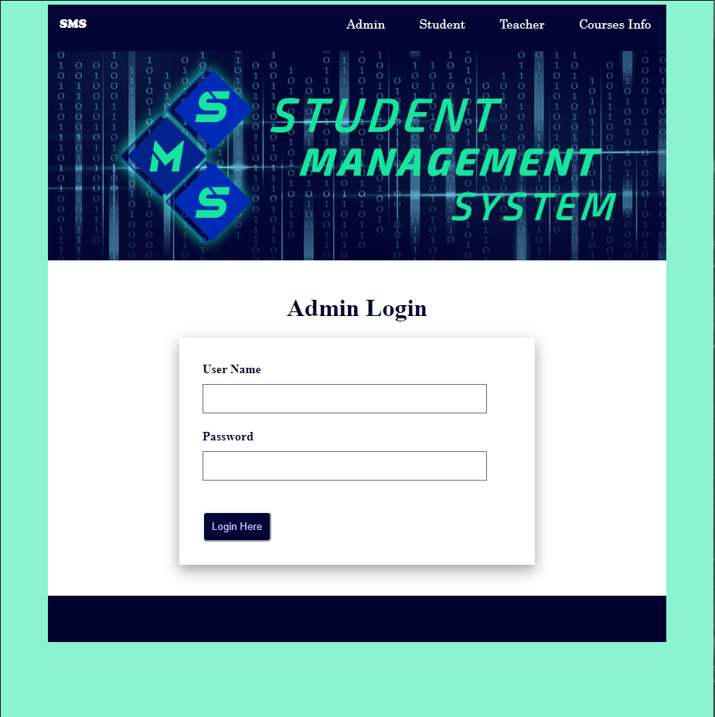

All the buttons are working properly, the validation is there, checking if the user introduced the right username and password.
Here is the code for this including the validation:

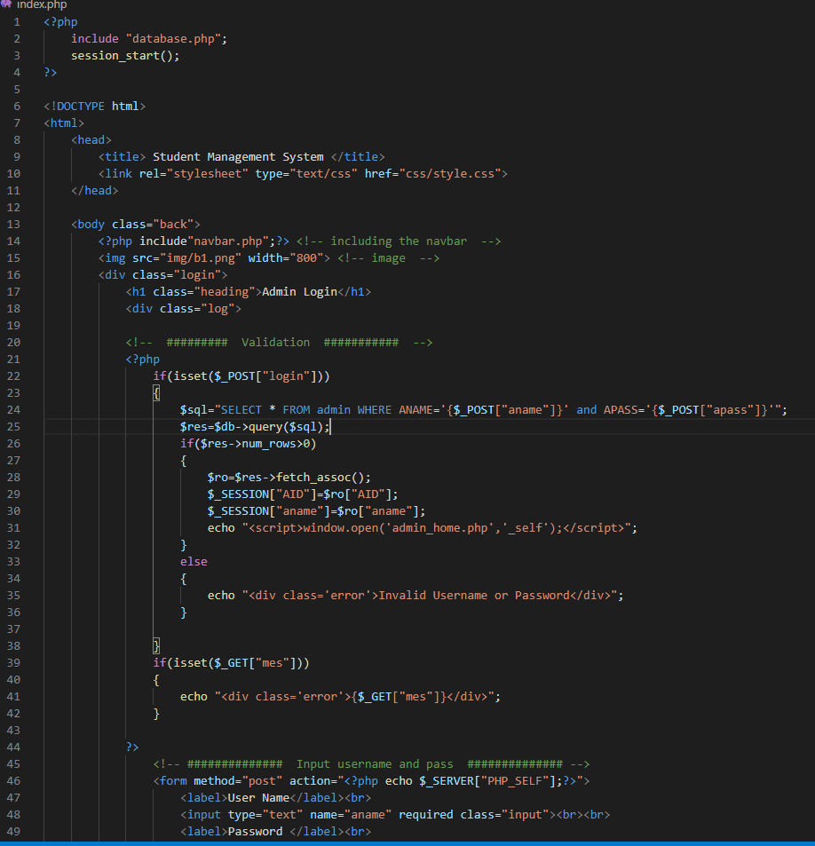

Student login:

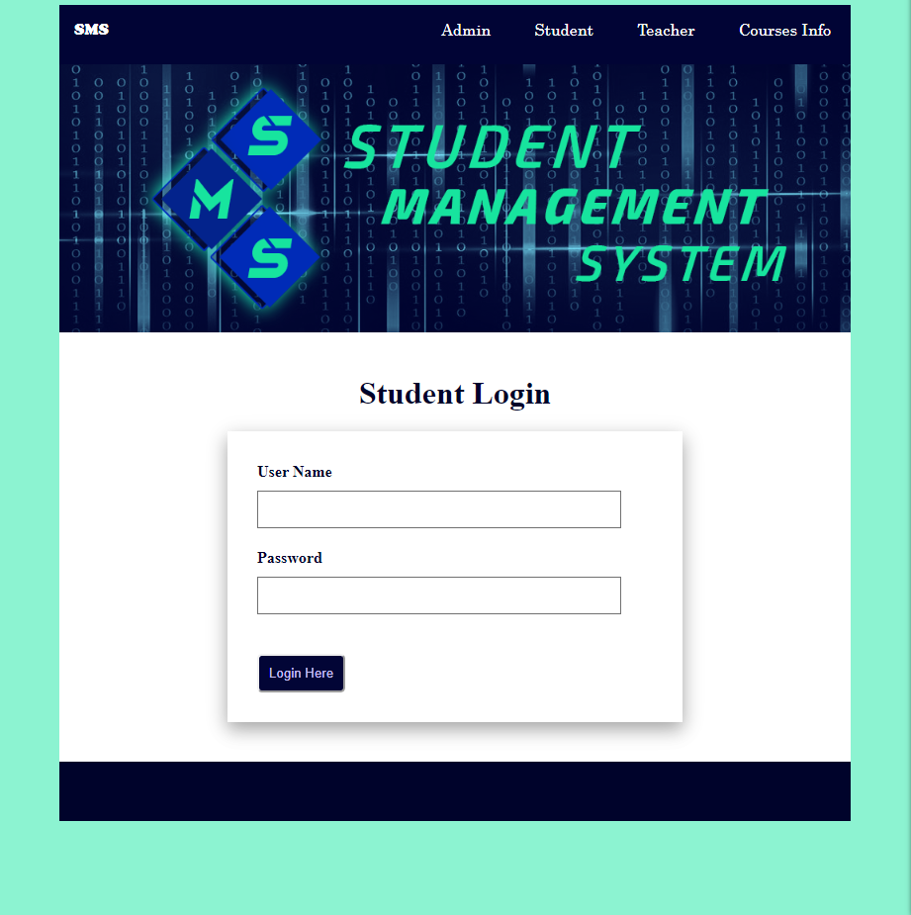

Code:

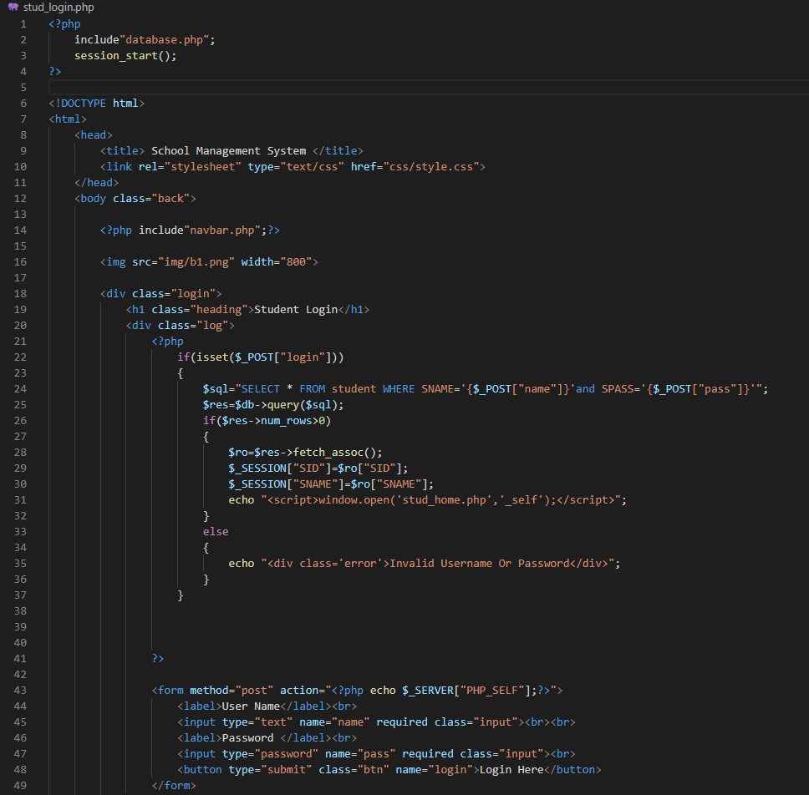

Teacher login:

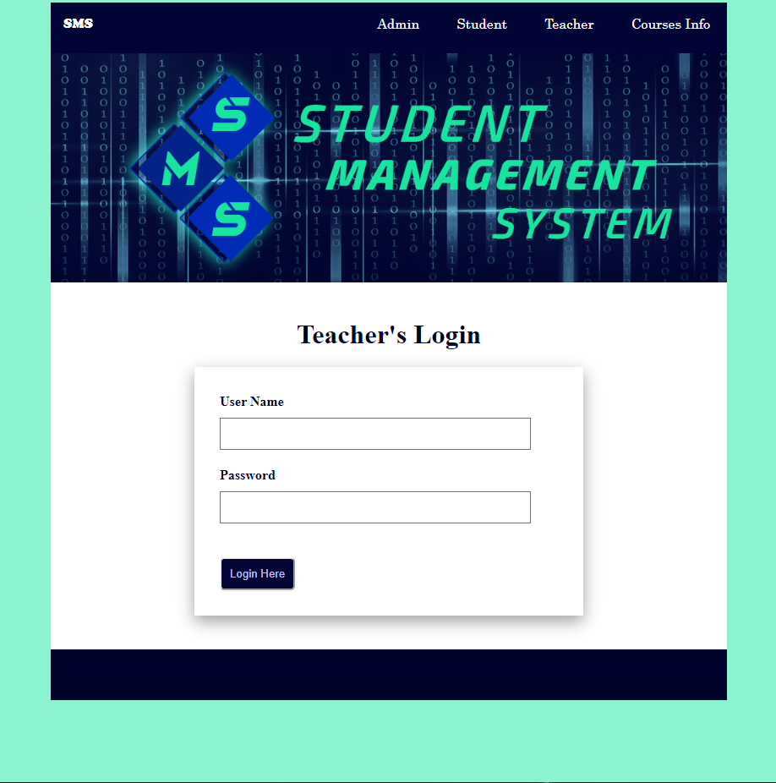

Code:

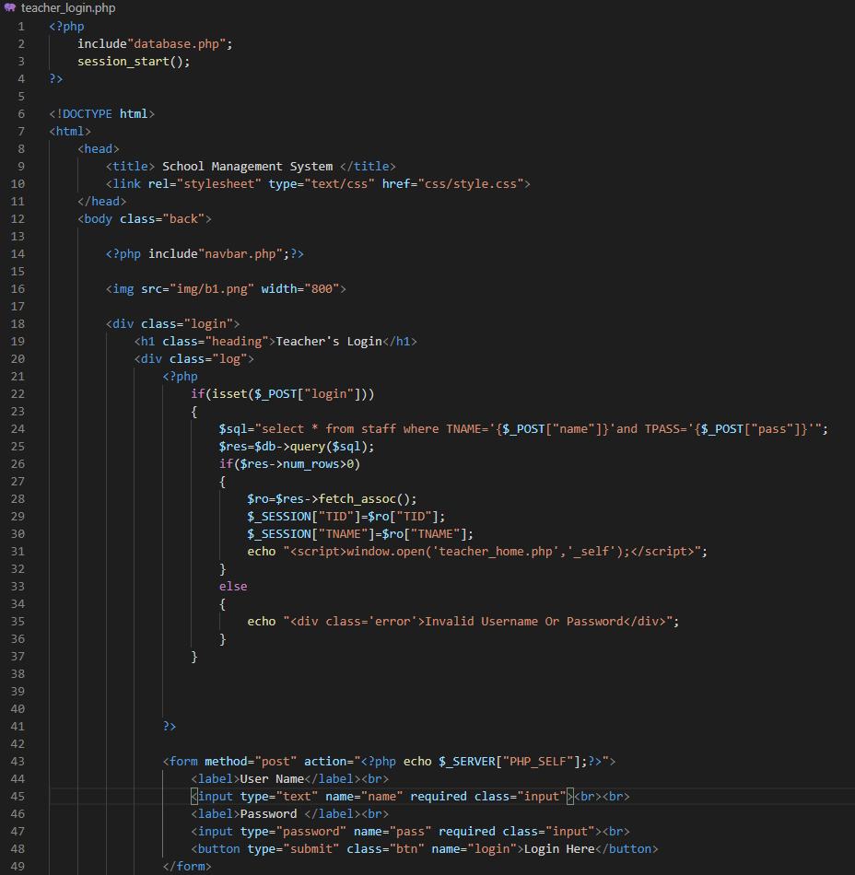

Database:

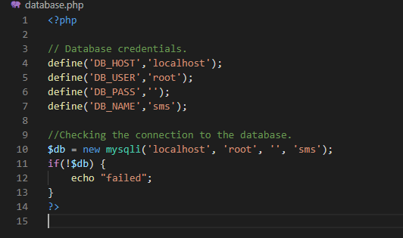

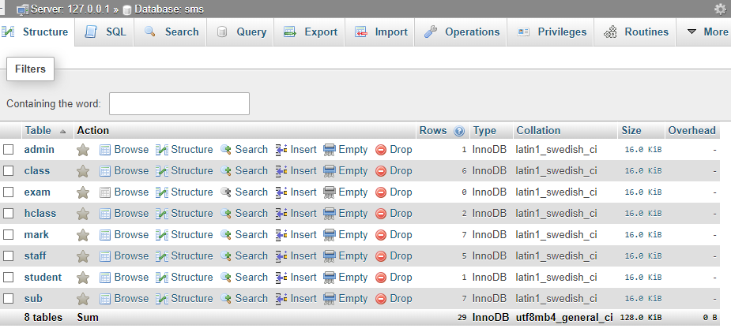

Footer:

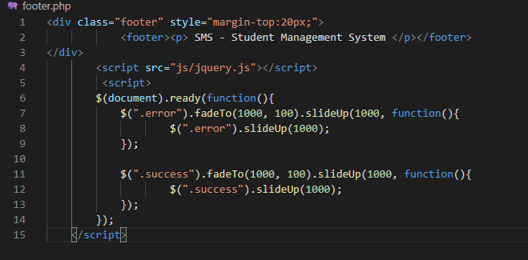

Sidebar:

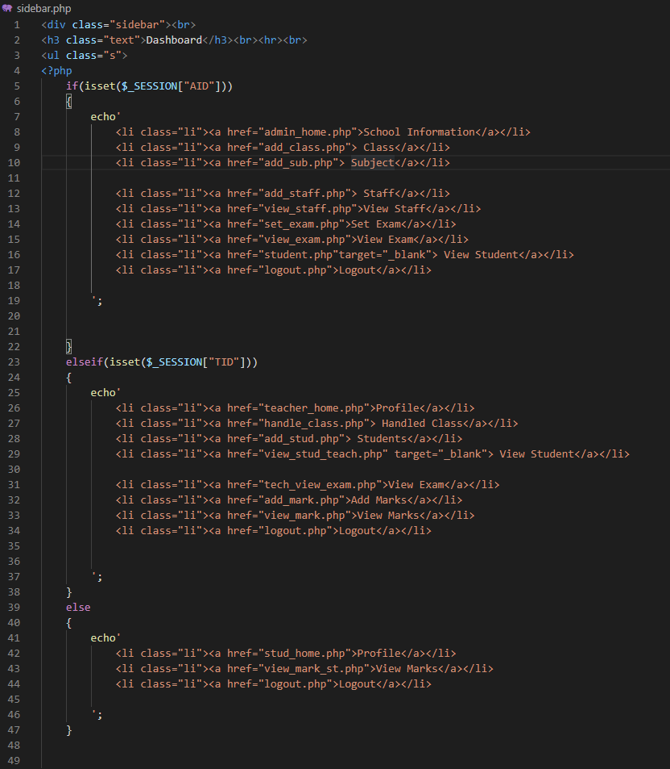

css:

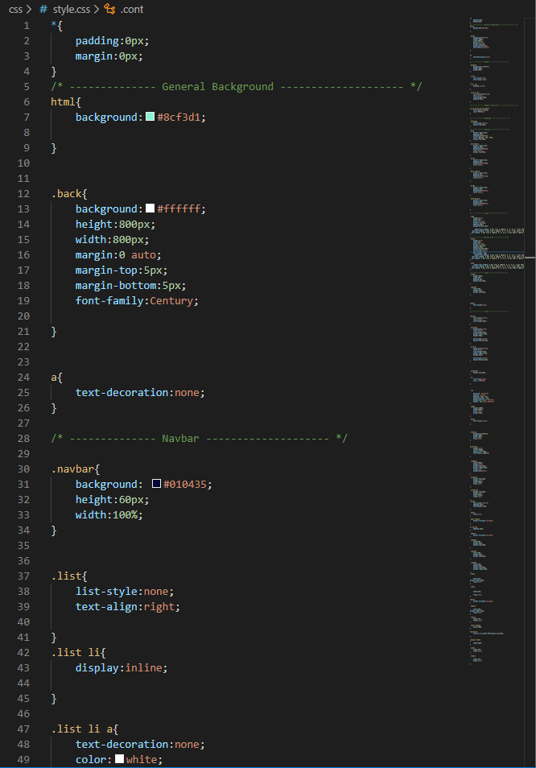

On the right you can see the whole css, it is a long css, but it covers all the pages.

Admin Panel:

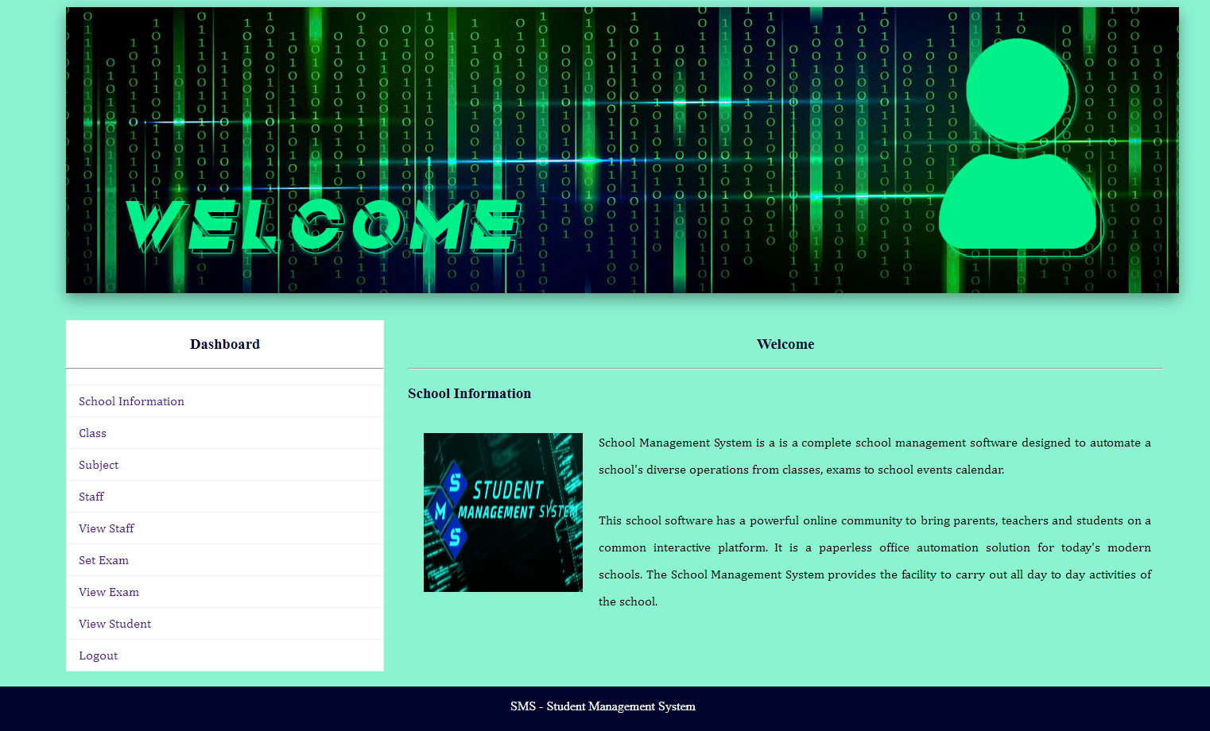

Teacher Panel:

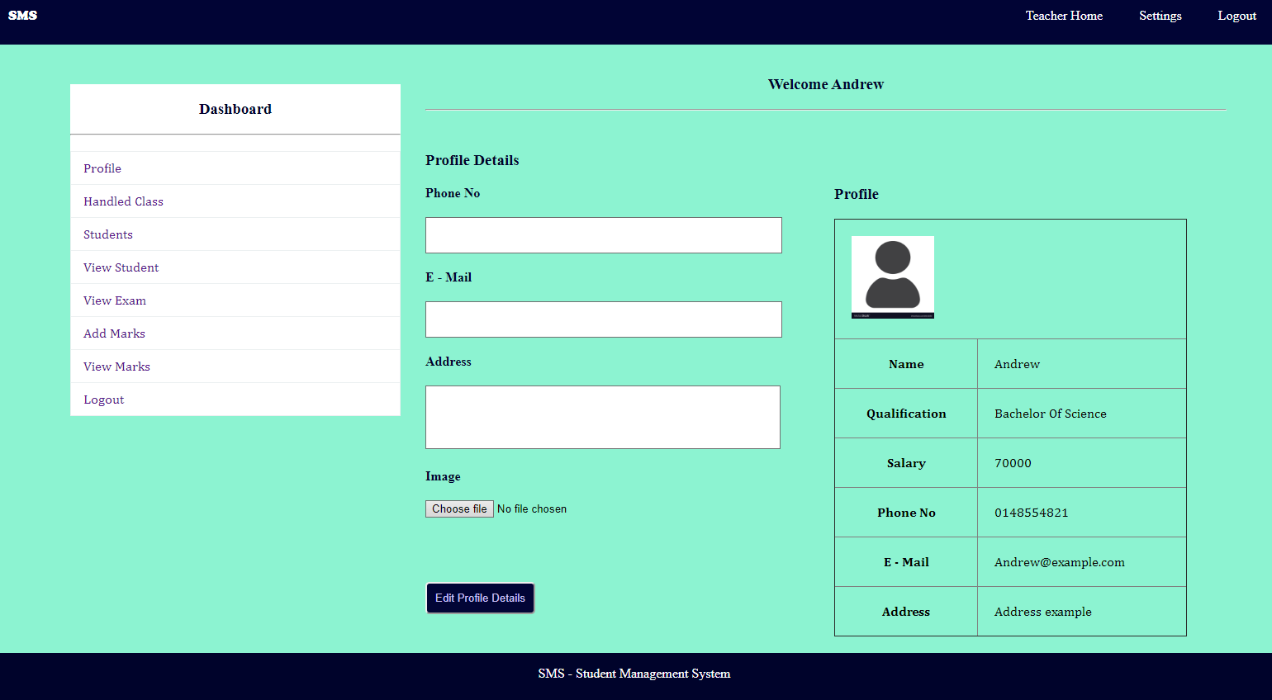

Courses info:

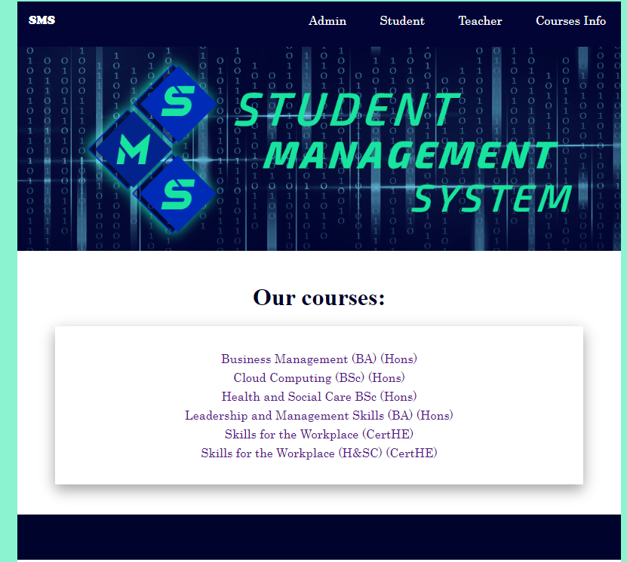

The buttons will take you to this page which gives you information about the page:
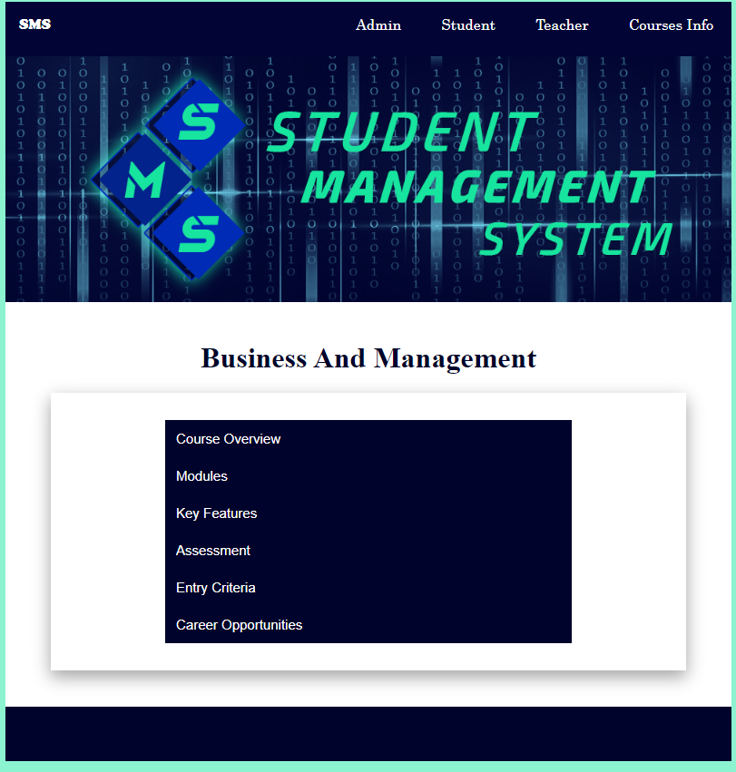

The buttons are working as a toggle button which collapses and expand when they are clicked.
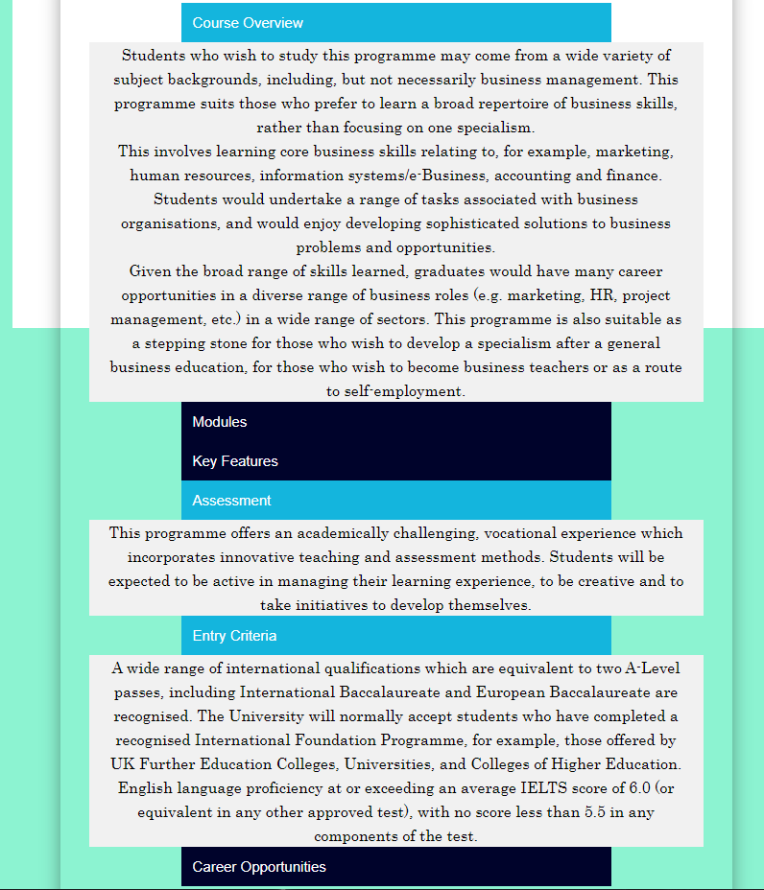

Courses info code:

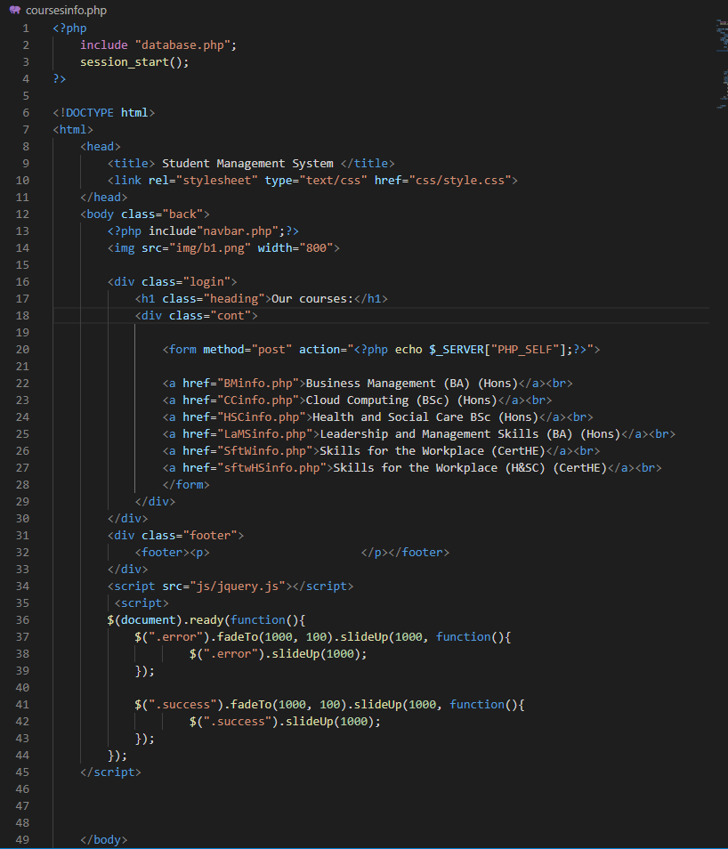

And the buttons code:

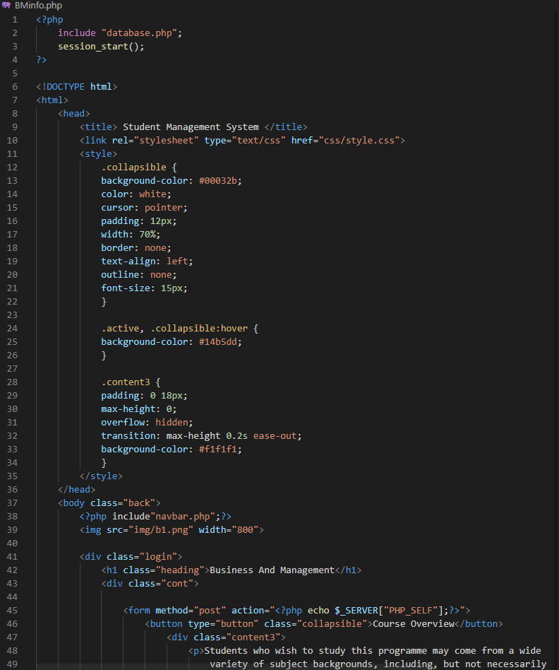

With the script:

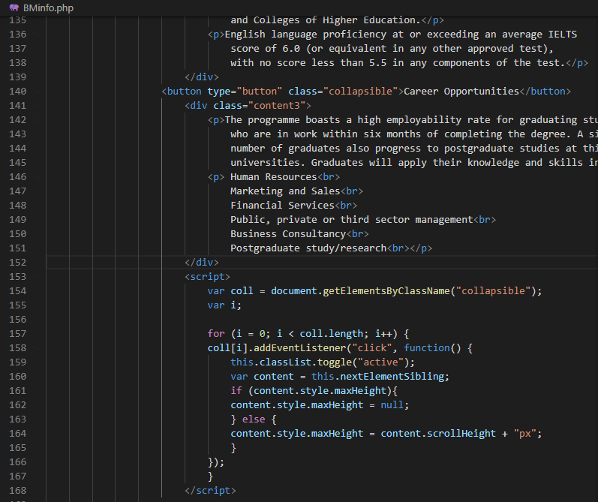

Evaluation

Real world application?

It has the potential of being a real-world application, but I seem to have some problems with some database connection. With a better database, I am sure that it can be used as a real-world application. The database problem is not a big one so, I think that a person with some better than me in databases will solve it in no time.
Beside that, I like the application, it is user-friendly, it requires a little bit of modifications since by mistake I put the teachers select their own handled classes, so that should be the first thing to change. Also, the view mark should be in the admin page as well, so the administrator can modify or delete the marks as well.

Future improvements?

The handled classes, as well as the admin marks that I said before needs to be modified. I think some of the future improvements that will improve the website are:

Better database

I am not the best in the databases, so in my opinion the database needs an upgrade.

Student page

The student page seems to be glitchy, I don’t really know why, It is almost the same code as the teachers page but without the buttons that are not necessarily for the students.

Front page

The index page is taking you to the admin login form, I think a front page would be better.

Conclusion?

The application has a great potential of being a real-world application with some modifications and future improvements.

Bibliography
Korkishko, I. (2017, 08 21). 5 software frameworks advantages for web app development. Retrieved from syndicode: https://syndicode.com/2017/08/21/5-open-frameworks-advantages-for-web-app-development/
Norhaidah A.Haris, N. H. (2019). PHP Frameworks Usability in Web Application Development. International Journal of Recent Technology And Engineering(IJRTE), 109.

Tutorials I watched:

This one gave me the idea of the SMS: https://www.youtube.com/watch?v=z4UwlWNX1R8
I had an error and watched this to “fix” it: https://www.youtube.com/watch?v=BtQhmDvUl7Q
Login system: https://www.youtube.com/watch?v=LC9GaXkdxF8
The steps required to make a website: https://www.youtube.com/watch?v=d-DeCu1ioJA
Incorporating php code in html file: https://www.youtube.com/watch?v=ka5m_kvQUFo
Login system with mysql database:https://www.youtube.com/watch?v=arqv2YVp_3E&t=32s

I am sure they were more but I could not find them.

Appendix

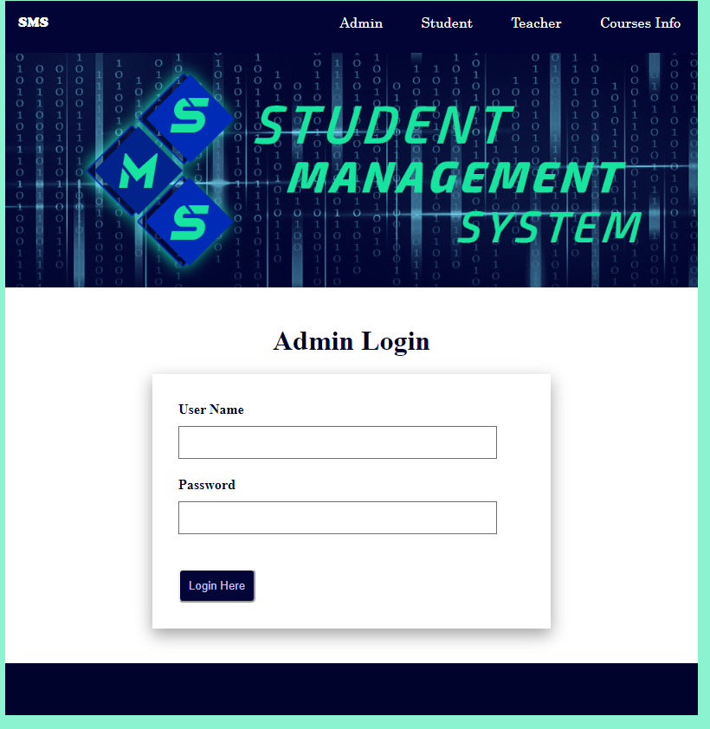

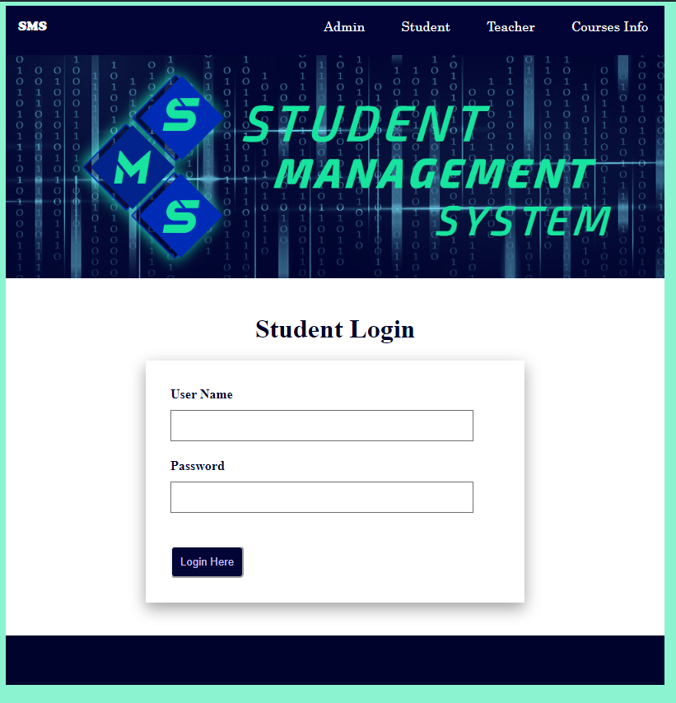

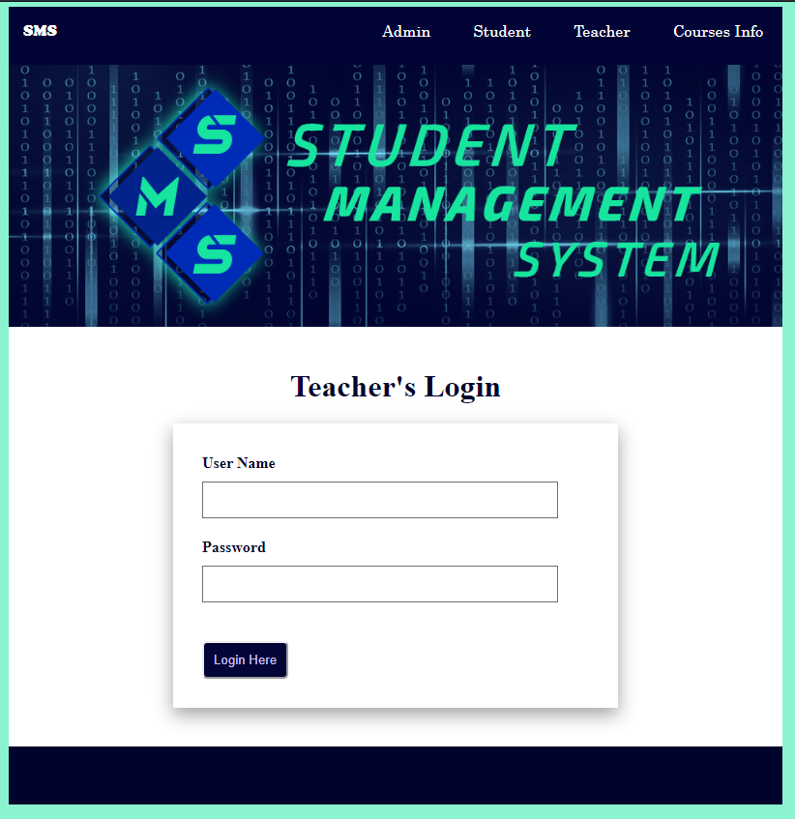

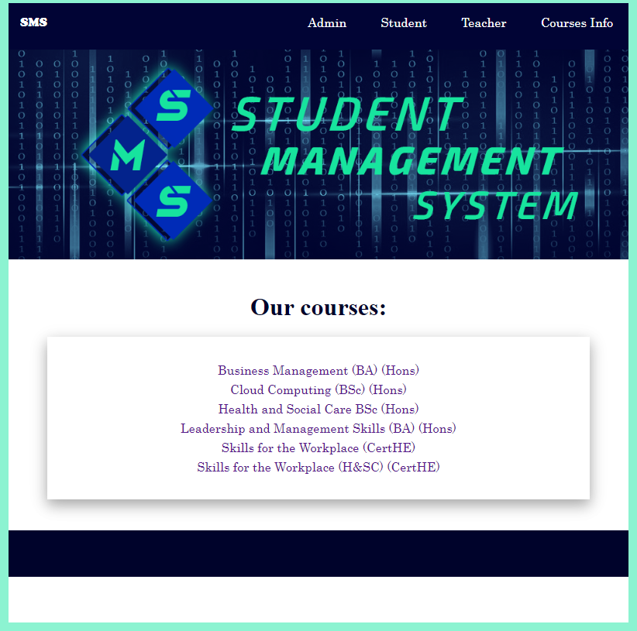

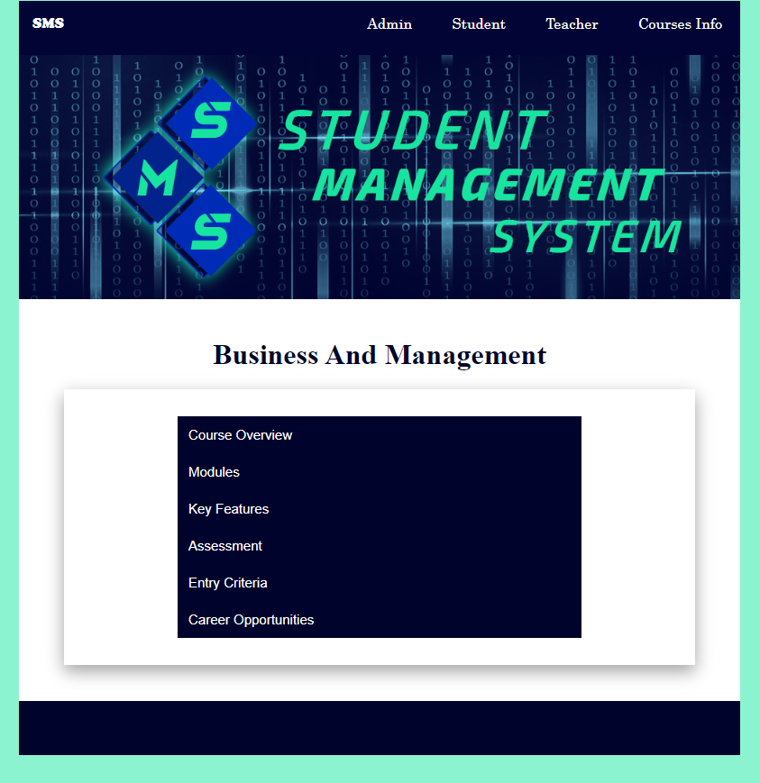

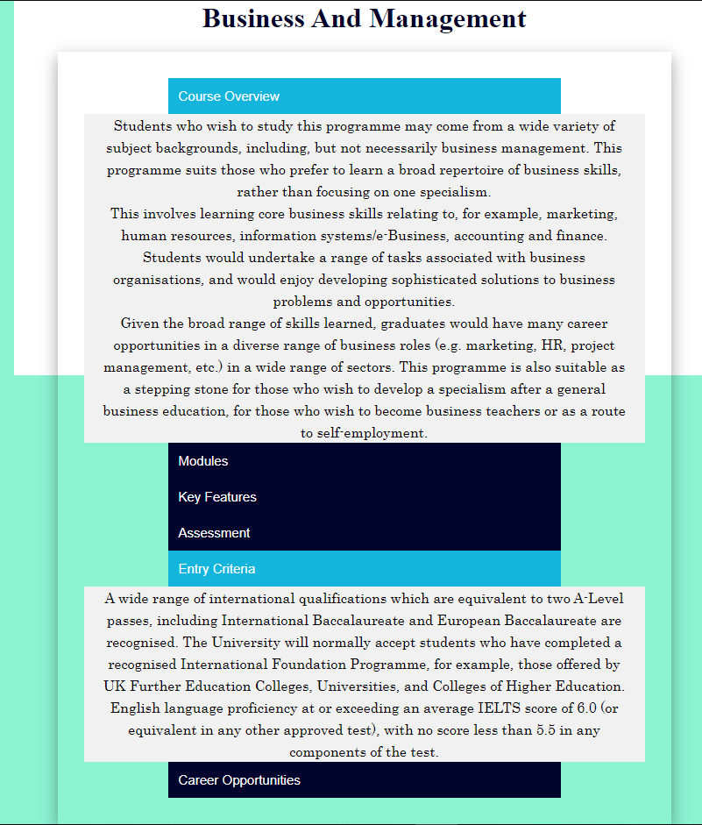

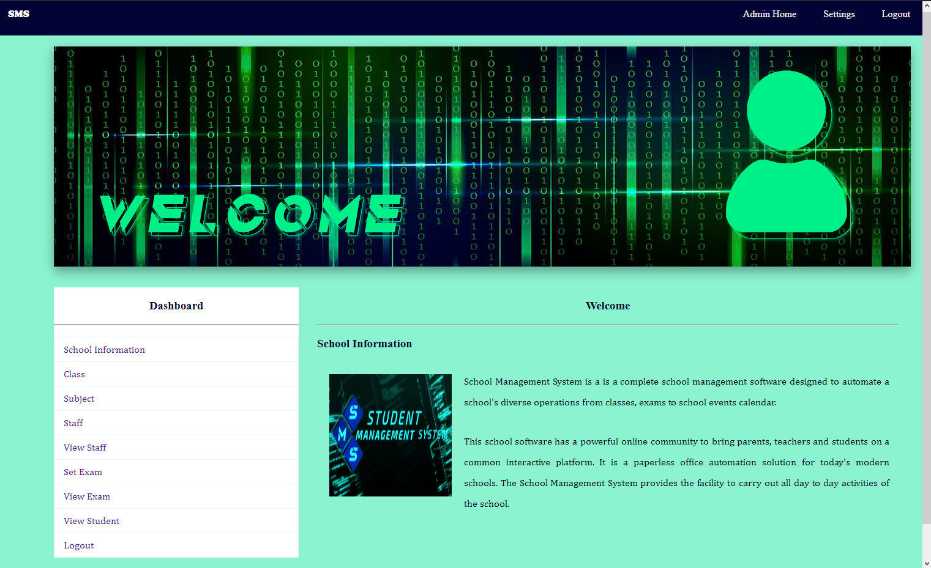

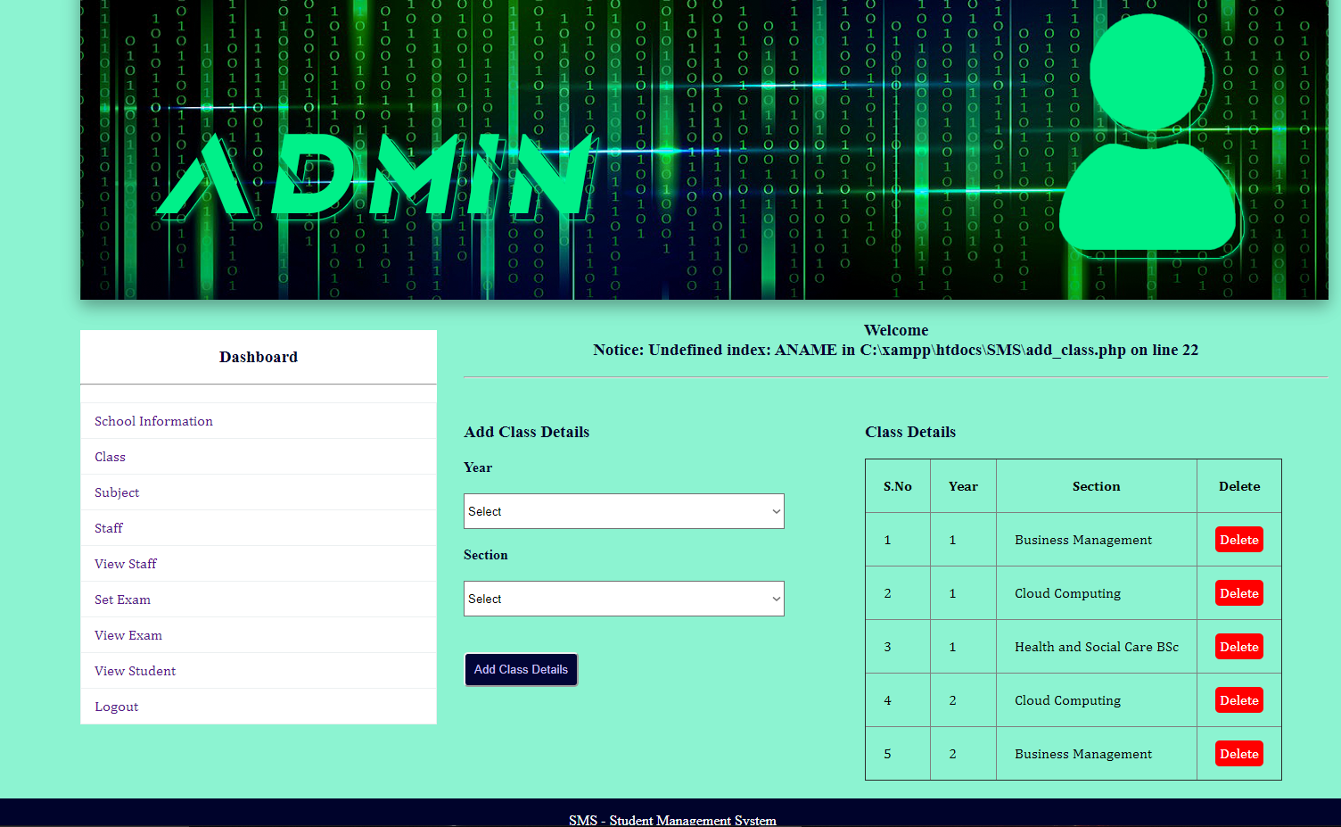

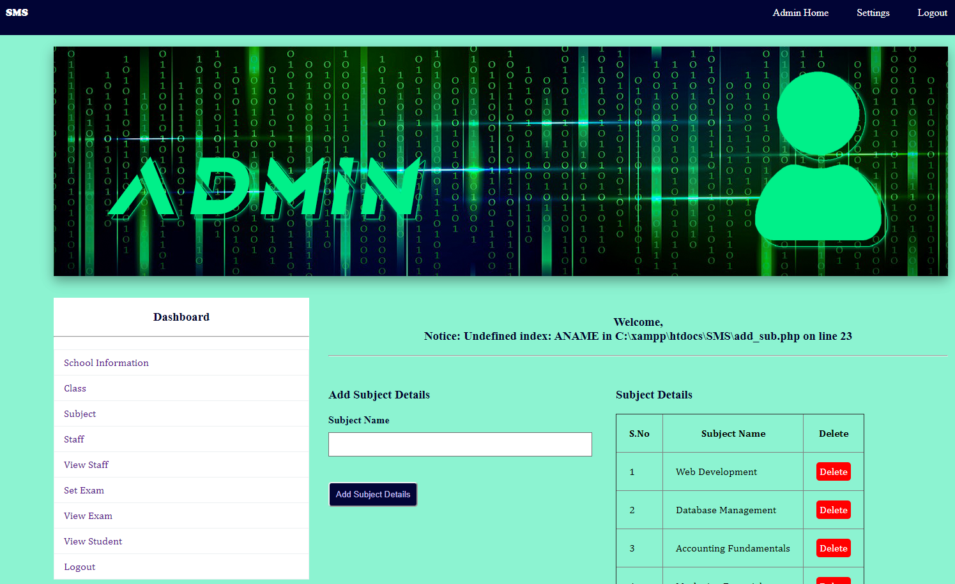

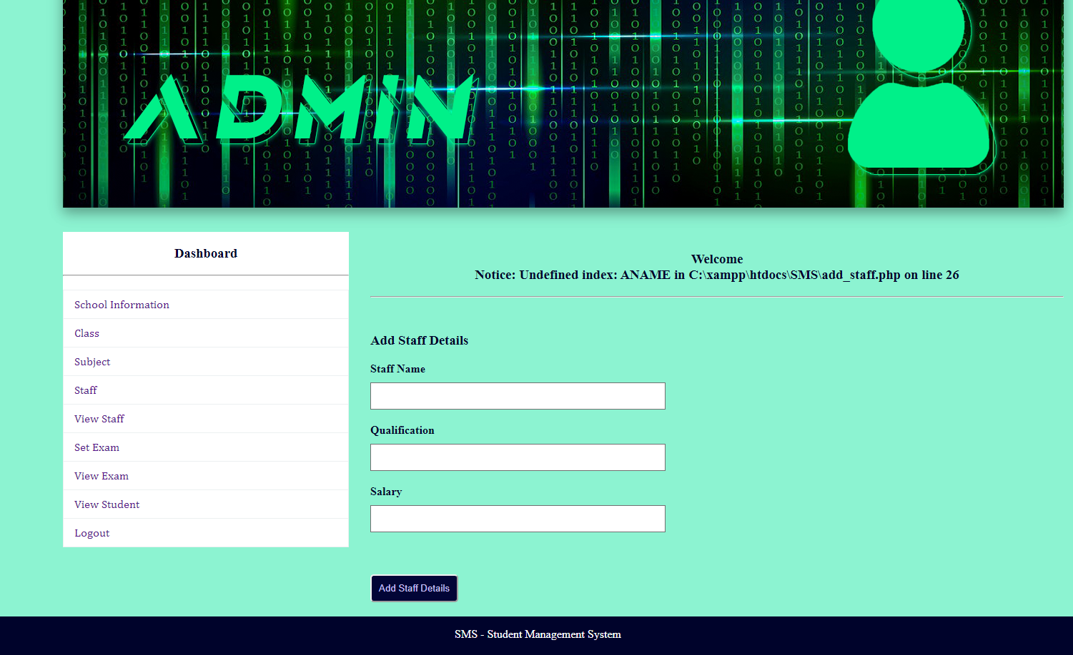

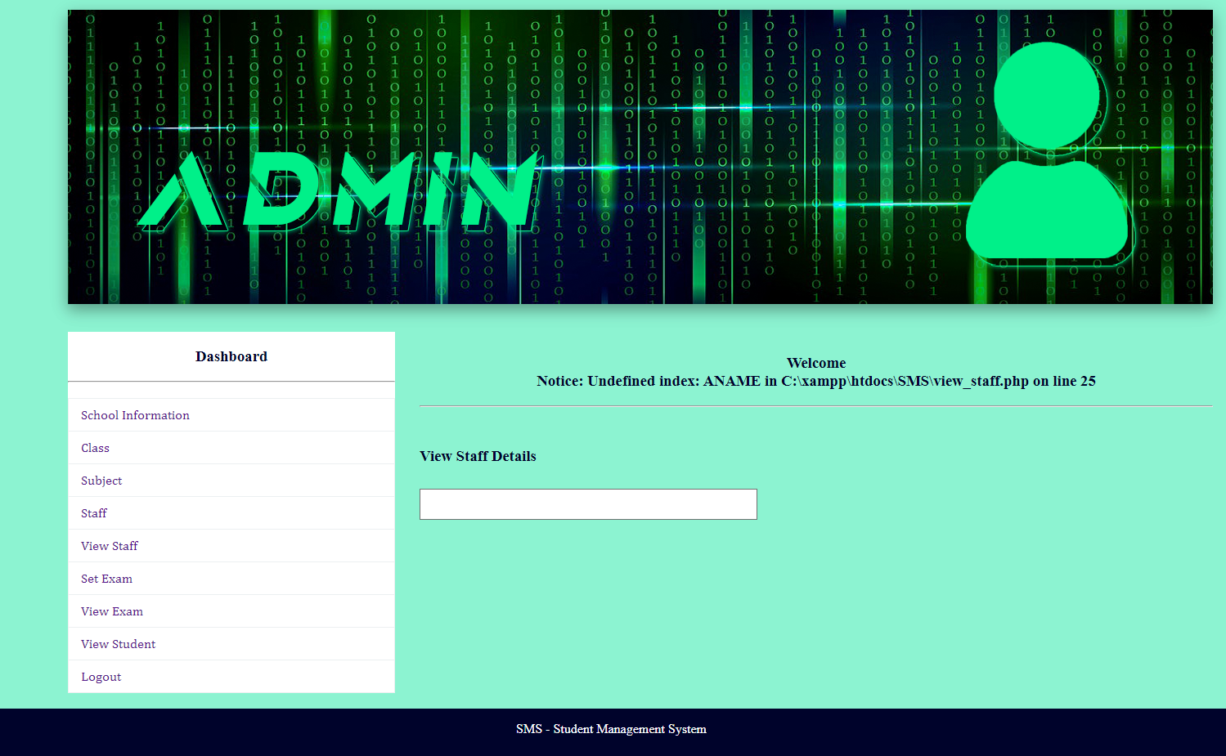

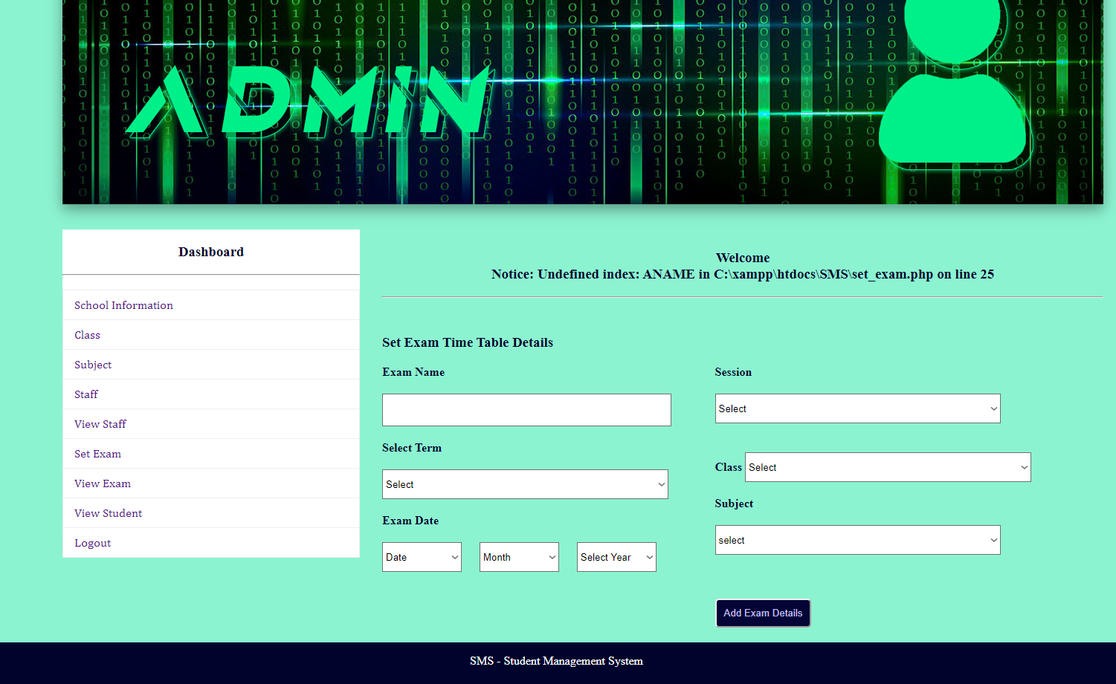

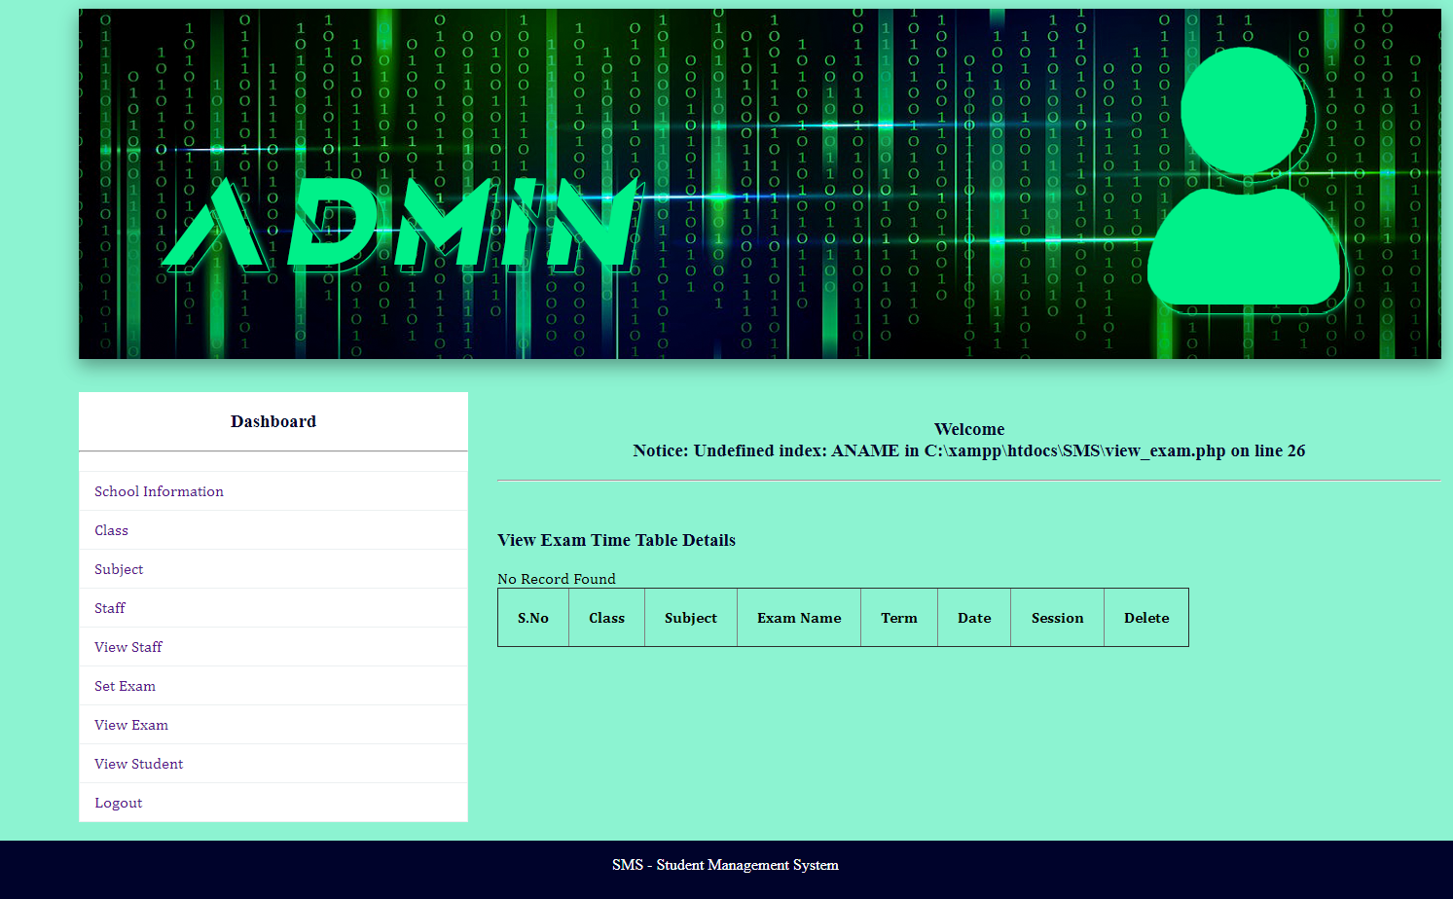

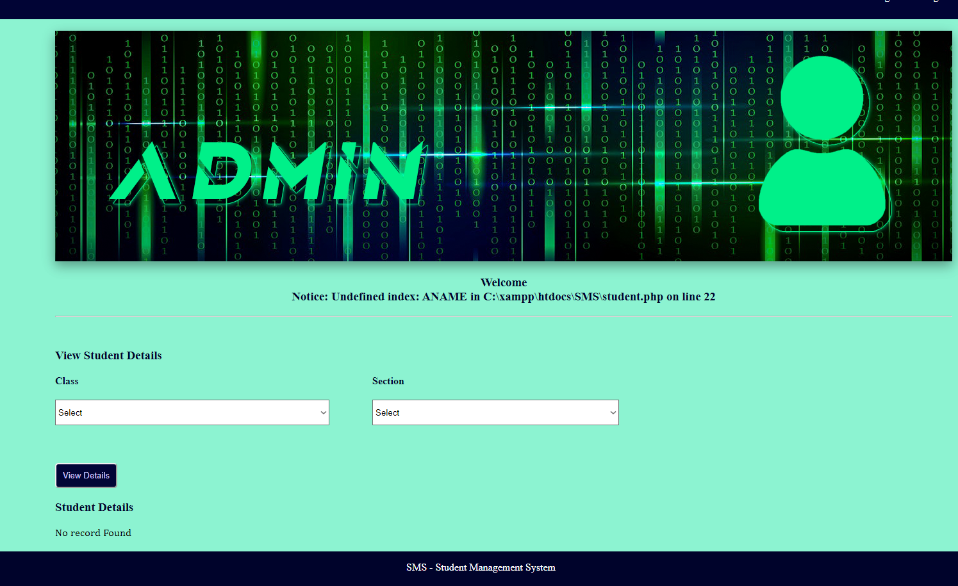

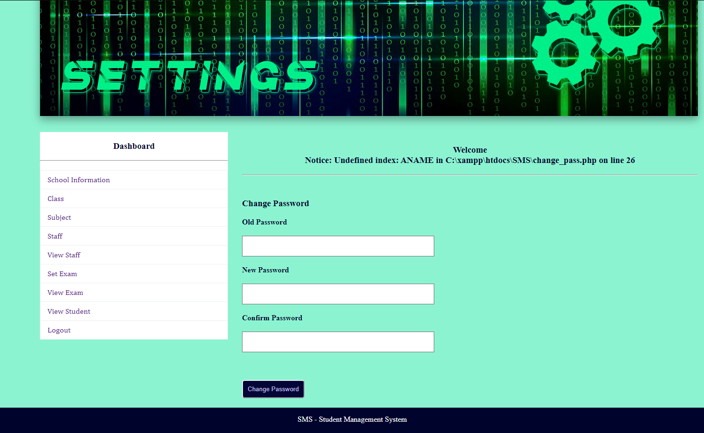

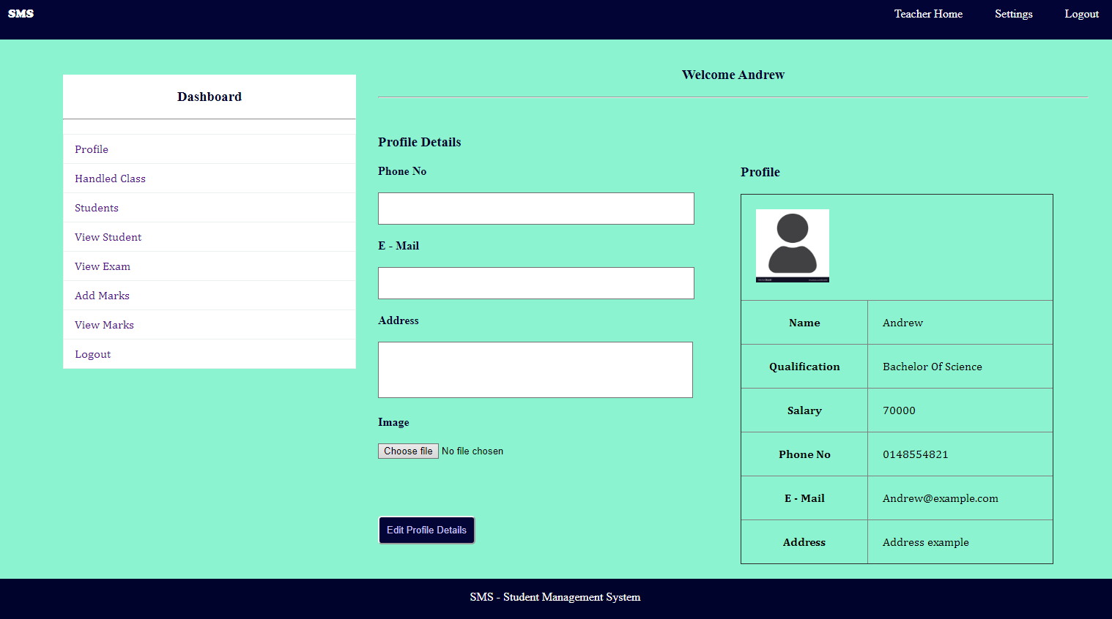

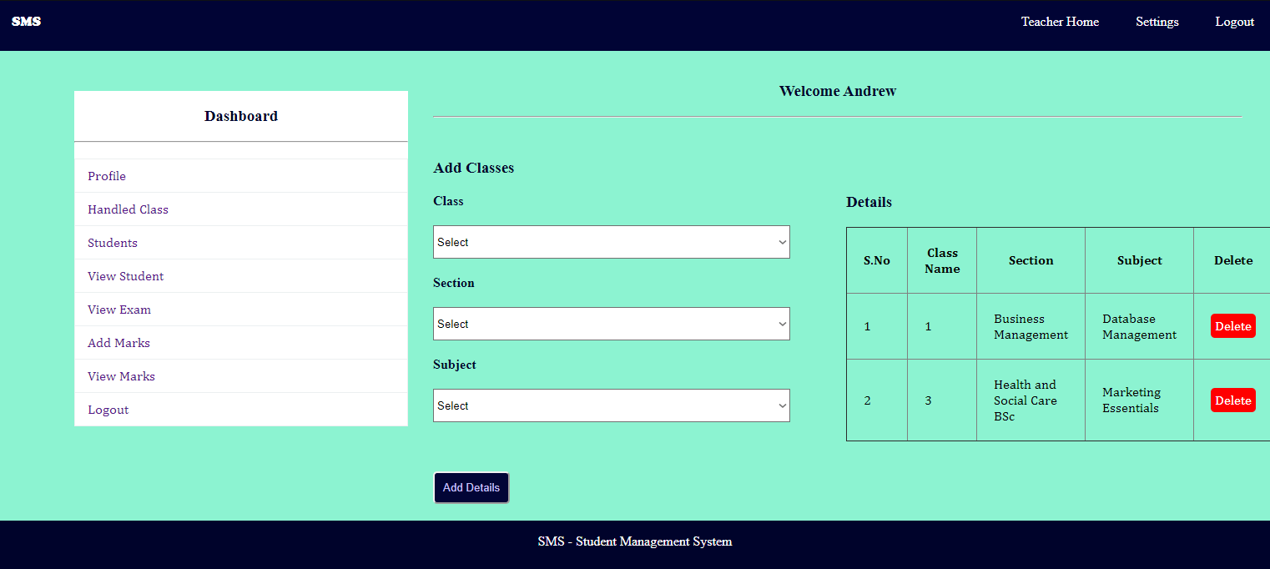

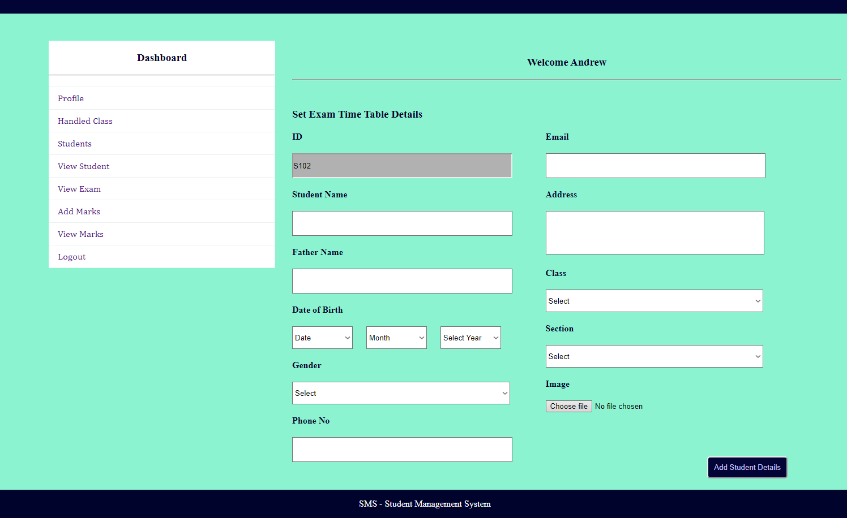

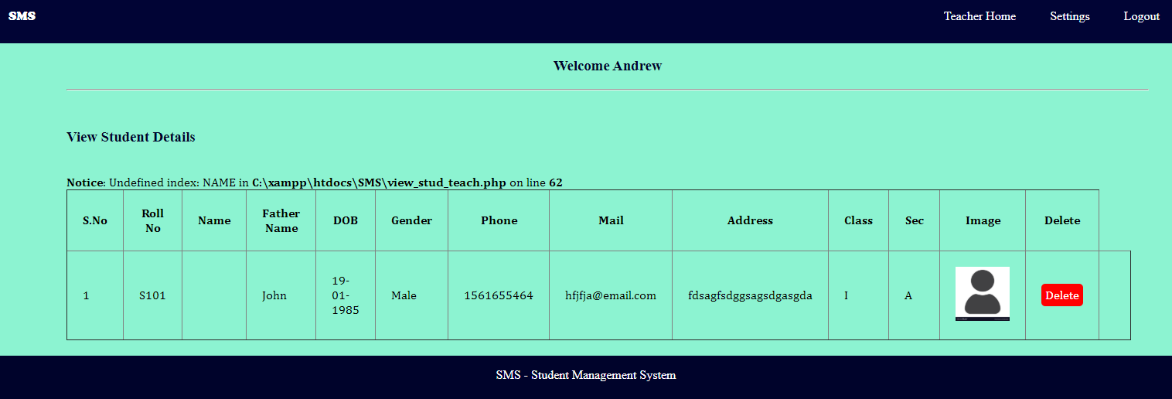

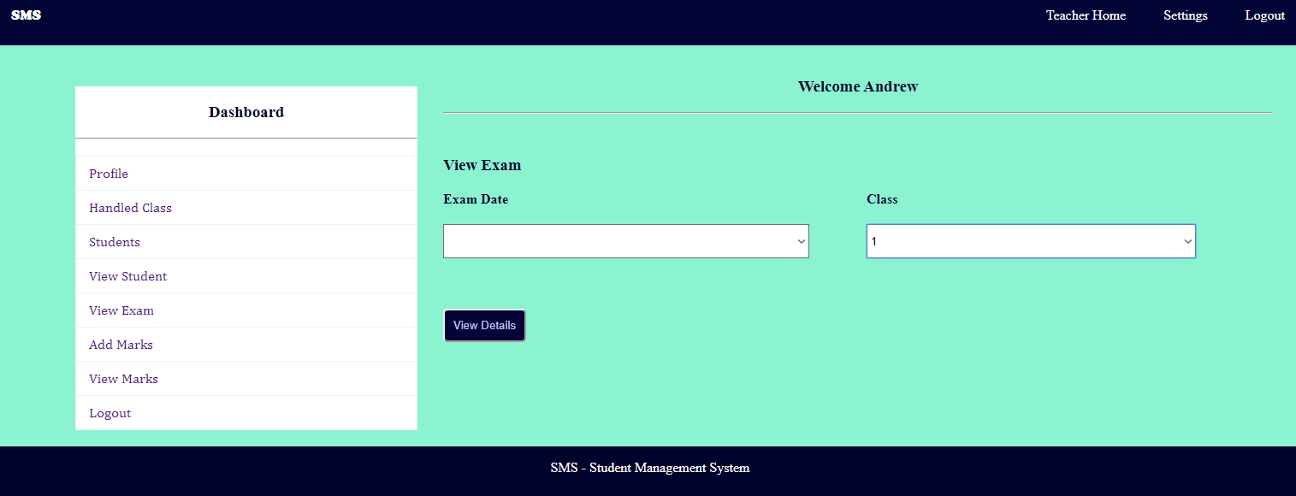

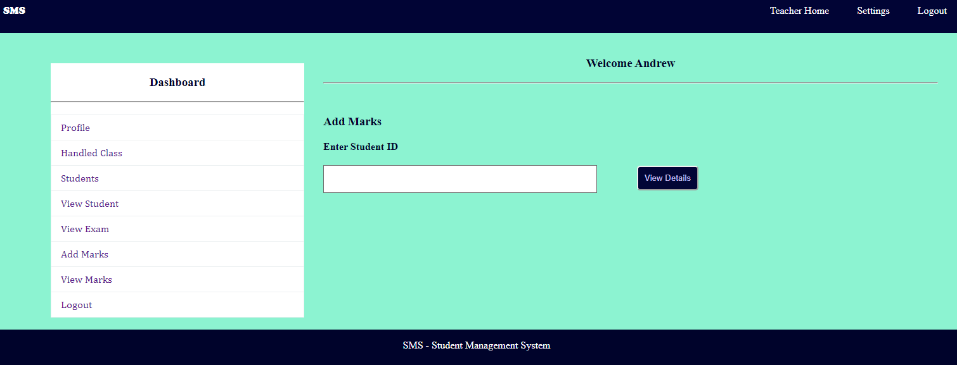

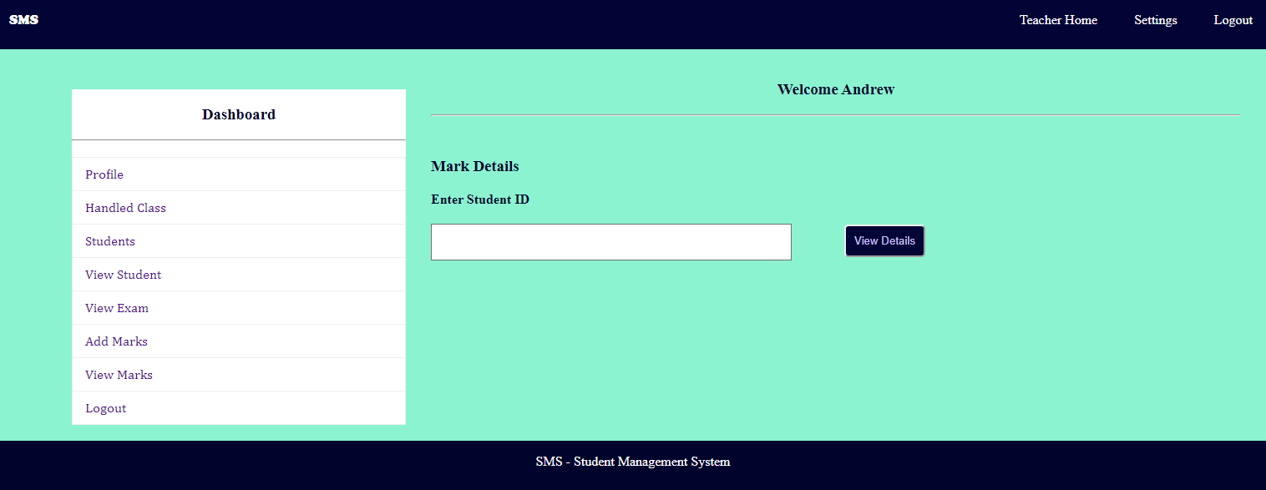

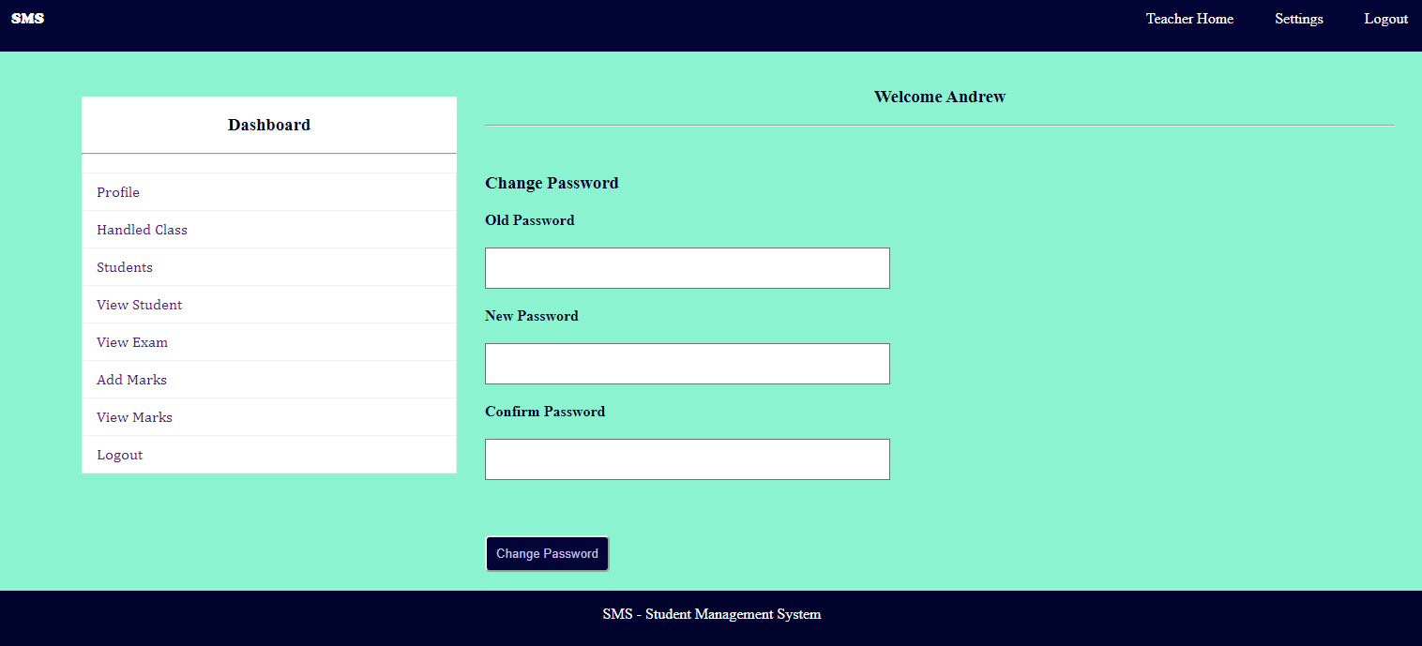

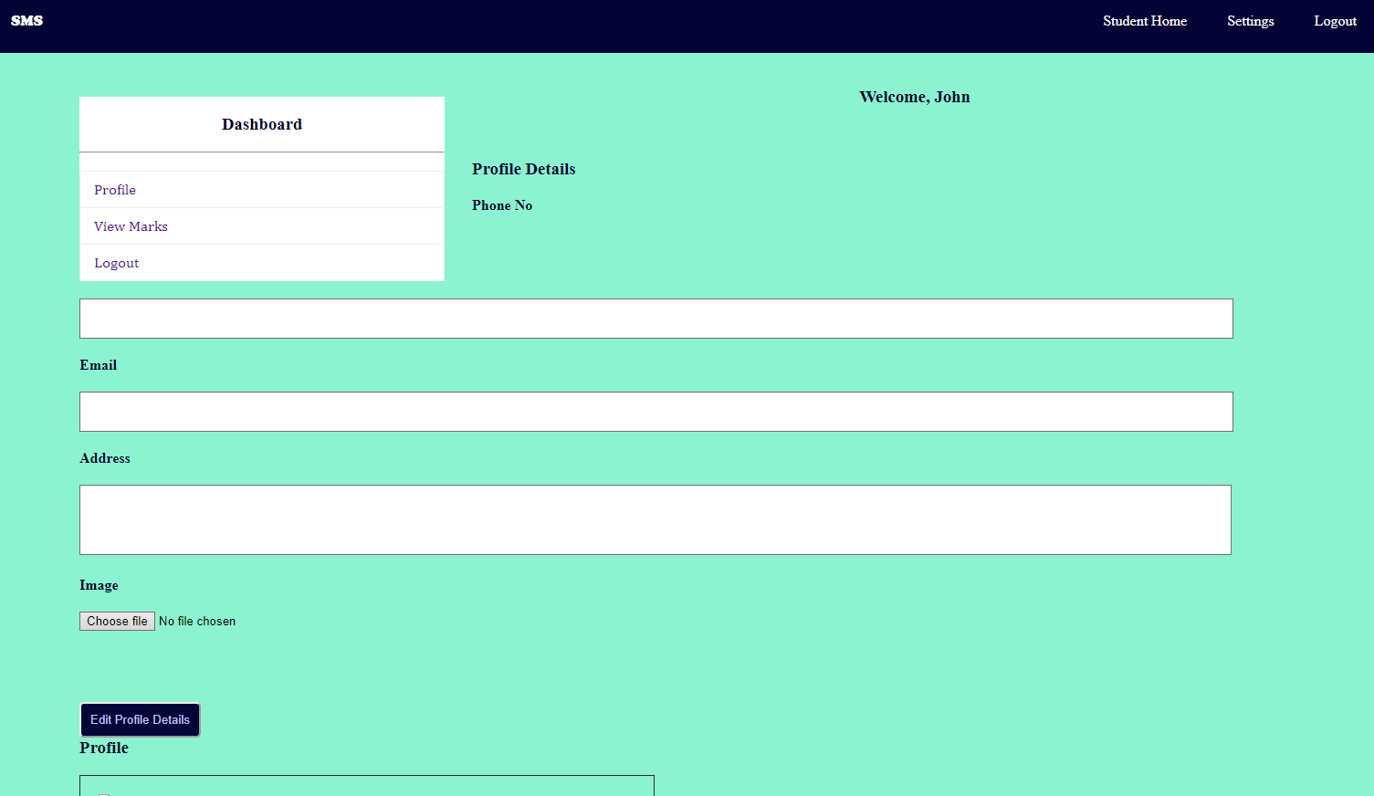

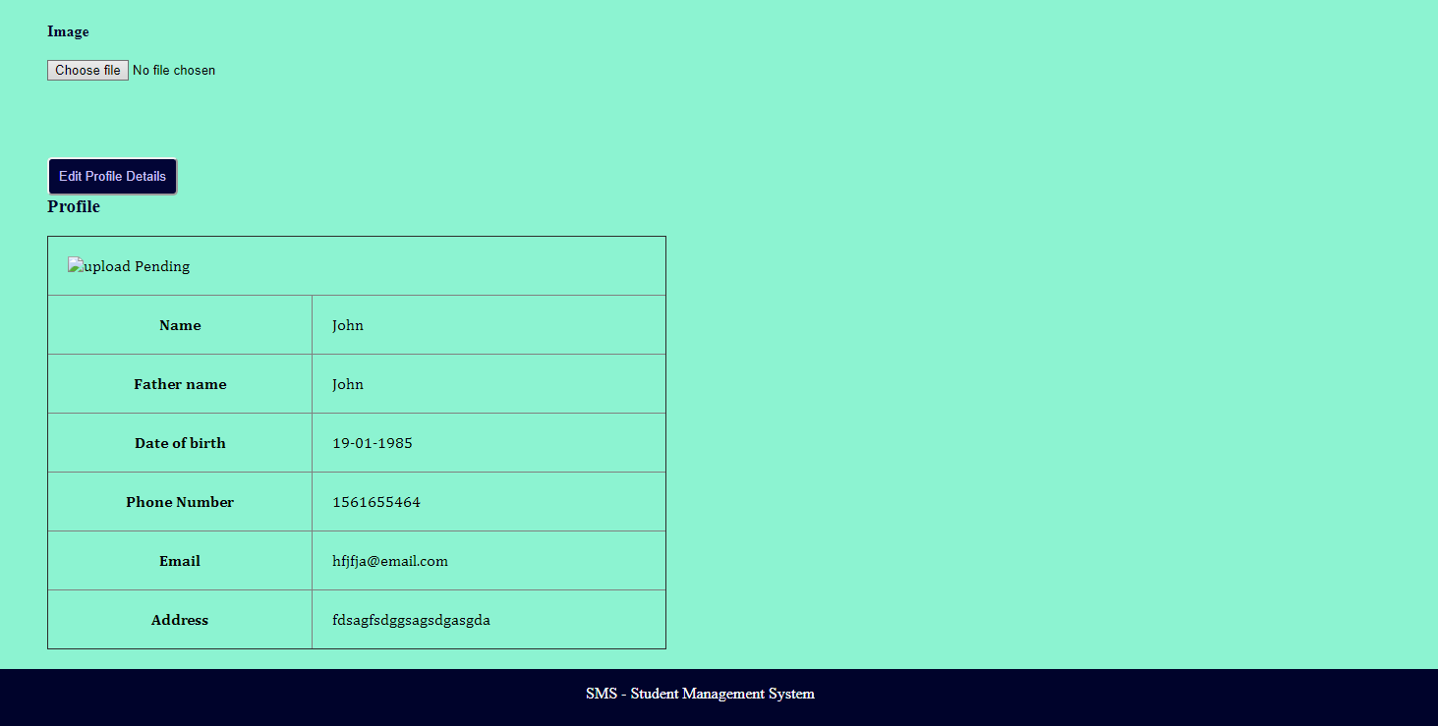

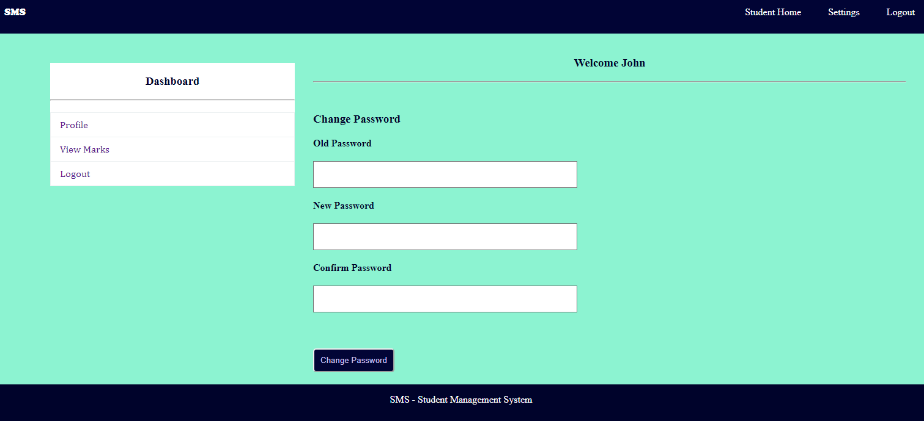

Thank You!

