

ADAA7000 Coexistent Perspectives Module

Name: Gareth Lewis

Student number: 1550799

Word Count: 3476

- Please keep all drafts of your essay. You may be asked to produce these as evidence of your writing process.

- Please ensure you follow the AI guidance on the assessment brief and note when and how you are able to use AI.

- Please also note the guidance regarding plagerism on your assessment brief also refers to referencing the source of your material and that includes the use of AI.

For this assessment,
I confirm that I have not used Generative AI to support me in structuring my submission, including creating a draft argument structure, identifying parts and headings.
I confirm that I have not used Generative AI to create text for my submission.
I confirm that I have not used Generative AI for creative materials, such as images.

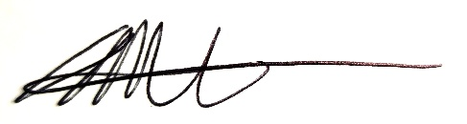
Student Signature:

MA Contemporary Dialogues: Moving Image
Coexistent Perspectives (ADAA7000)

Gareth Lewis (1550799)

7th January 2026

Abstract
Research question: How does Krzysztof Wodiczko's parrhesiastic instinct reclaim authorship through the subversion of smooth surfaces in a palliative society?

This essay examines Krzysztof Wodiczko’s parrhesiastic processes through selected public projection works: El Centro Cultural Projection (2001), Hiroshima (1999) and The Homeless Projection: A Proposal for the City of New York (1986). The works are examined against the theories of Byung-Chul Han’s palliative society and Chantal Mouffe’s agonistic struggle against dominant hegemony. The anaesthetised, post-political state provides a ground for Wodiczko’s exposure of painful truths. The artist seeks parrhesiastic collaboration which disrupts the smoothness of contemporary societies. In this practice, Wodiczko questions the roles of both author and reader in the construction of meaning. Barthes seeks to emancipate the reader, wresting meaning from authorial control. Han’s anaesthetised state and Mouffe’s hegemonic structures deny this role in the audience. Instead, the algophobic audience is comforted by the frictionless, painless condition of established thought. The effect of this narrative dominance is to neutralise dissent but also to stall the ongoing process of agonistic struggle. In conclusion the essay finds that Wodiczko acts as a facilitator of parrhesia. The act of truth-telling is required to expose the audience to alternatives and possibilities beyond the dominant hegemony. It is this authorial incitement that ultimately leads to the emancipation of the reader.

Question

This essay is based on question 3 from the assignment specification:
Space and Place: How do contemporary creative practices engage with the politics and poetics of space, including questions of displacement, postcolonial geography, affective architectures, or the uncanny? What critical frameworks can be used to analyse these spatial imaginaries?
The following question was formulated in response:
How does Krzysztof Wodiczko's parrhesiastic instinct reclaim authorship through the subversion of smooth surfaces in a palliative society?

Introduction

This essay focusses on three works by Krzysztof Wodiczko: El Centro Cultural Projection (2001), Hiroshima (1999) and The Homeless Projection: A Proposal for the City of New York (1986). It provides examinations on how these works challenge the smoothness of the palliative society (Han, 2021). In analyses of the projected interventions on the featureless surface of the OMNIMAX sphere and the preserved, skeletal ruin of the Atomic Bomb Dome, it proposes that Wodiczko facilitates parrhesiastic exposure for his subjects. The earliest work provides a contrasting background, where Wodiczko exerted more authorial control. Finally, it argues that these works utilise public space to reintroduce the viewer to the process of agonistic struggle (Mouffe, 2013) while questioning the role of the author in structuring meaning (Barthes, 1977).
Wodiczko has explicitly stated that his work is influenced by Foucault’s lectures on parrhesia (Wodiczko, 2011, p. 297). This approach to the act of truth-telling is juxtaposed with the exposure of the audience to Chantal Mouffe’s dominant hegemonic structures (2013, p. 132) and Byung-Chul Han’s palliative society (2022). Further discussions look at the role of these theories in challenging the smooth, frictionless state in contemporary social frameworks and examine the role and extent of authorial responsibility in reaction to those frameworks.

A discussion on theory

Only truth hurts. Everything that is true is painful. The palliative society is a society without truth, a hell of the same. (Han, 2021, p. 30)
In the ‘palliative society’ a ‘universal algophobia rules’ (Han, 2021, p. 1). This shared fear of pain is self-perpetuating. As pain is sub-optimal, a weakness, it is masked, mitigated or avoided entirely. Within this smoothed construct, conflict becomes neutralised and unable to provoke questioning (Han, 2021, pp. 2-3). Without a rough, painful truth there can be no change. In this sense, the palliative society has become one of survival where the sole concern is the prolonging of life only as existence in opposition to the act of living (Han, 2021, pp. 14, 17).
… I attempt to detect and trace conditions of life under the illusion or delusion of freedom – the hypocritical life we lead when we take refuge in the machine of a political or cultural system while closing one eye to the implications of our own passivity or, frankly speaking, complicity. (Wodiczko, 1999, xii)
Krzysztof Wodiczko displays a parrhesiastic approach to his work (Wodiczko, 2011, p. 297). Foucault describes the classic form of parrhesia as frank, truthful, critical, moral and risk-laden (Foucault, 1983). This approach challenges the anaesthetised state by using public spaces to confront the palliative society with the ignored roughness of painful truths.
Where Barthes emancipated the reader (1977, p. 145), the freedom that comes from removing the author, to reconstruct meaning, in Han’s palliative society, it is also the freedom to choose not to. The anaesthetised audience is one that avoids pain and confrontation and chooses the smooth over roughness.
This essay must ask if Wodiczko is the author reborn. Where Barthes expects an active reader, Han’s algophobic reader will avoid pain. In a palliative society, the reader cannot and will not engage in the act of reading and is, perhaps, unaware of the text. It is here that Wodiczko’s work becomes a necessary intervention.
Han states that ‘Palliative politics is incapable of implementing radical reforms that might be painful.’ (2021, p. 2). Anaesthetisation has reduced pain to a ‘dead end street’ (2021, p. 37). The palliative society functions as what Chantalle Mouffe terms a ‘dominant hegemony’ producing a smooth lack of resistance and pain that denies adversarial or agonistic struggle. She states that it is in this struggle that lies ‘the very condition of a vibrant democracy’ (Mouffe, 2013, p. 7). Mouffe also considers the struggle to be an unending process (2013, p. 132) not one stifled by a frictionless, painless condition.
Mouffe would recognise that Wodiczko’s work is inherently political, art and politics each bearing elements of the other (2013, p. 91). Wodiczko then, is not only producing aesthetic statements but also political interventions that seek to expose the viewer to painful, rough, truth in otherwise smooth public spaces.
These theoretical investigations provide a foundation for analysing how Wodiczko’s interventions transform specific physical sites from frictionless spaces of consensus to encounters with truth.
Byung-Chul Han describes a palliative society, overwritten by algophobia, a fear of pain (2021, p. 1). This describes a sociopolitical environment that is incapable of, or resistant to the painful introspection, exposure and communicative forms required to challenge the established order. For Han, art “must be able to alienate, irritate, disturb, and, yes, even to be painful” (2021, p. 3). It is with these painful attributes that art can reawaken the ability to identify and narrate pain (Han, 2021, p. 36).
Chantal Mouffe promotes the principle of agonism, a struggle where adversaries recognise the right of the other to fight for their position. This ‘agonistic struggle [is] the very condition of a vibrant democracy’ (Mouffe, 2013, p. 7). Artistic practices are a means of agonistic intervention within a wider struggle against a dominant hegemony (Mouffe, 2013, p. 88). Although ‘dominant hegemony’ appears to be a tautology, Mouffe is deliberate in labelling an existing socioeconomic construct, a stifling dominance of one hegemony that excludes alternatives (2013, p. 132). In challenging this hegemonic structure, Mouffe looks to public space not as the terrain of consensus but as a space for continuing, endless struggle, one that cannot be reconciled.
In this sense, Han’s smooth, anaesthetised society describes the same conditions present in Mouffe’s dominant hegemony. In a society without conflict, lacking dissent, parrhesia can provide a necessary friction.
Examinations of Wodiczko’s interventions

El Centro Cultural Projection (2001)
Tijuana, Mexico, 23-24 February 2001
The Mexican city of Tijuana lies against the border with the USA and became a magnet for multi-national companies looking for cheap labour, and Mexican families seeking employment. Wodiczko’s chosen projection surface was the spherical façade of the OMNIMAX cinema located in the Tijuana cultural centre. Founded in 1982, the cultural zone was designed as a focus for national identity and tourism (San Diego Museum Council, 2024).

Although the OMNIMAX is part of a cultural complex and, itself, delivers educational content and documentary screenings, the exterior is featureless. The usual night lighting scheme accentuates this passive smoothness (Figure 1). As a static, golden pearl, it has no life or active voice. Reading through Han, this could be interpreted as reflecting a state of painless survival (2021, p. 31). The lighting presents a smooth surface. Free of friction and negativity the dome becomes a monument to consensus in a post-political order (Mouffe, 2013, pp. 92-93).
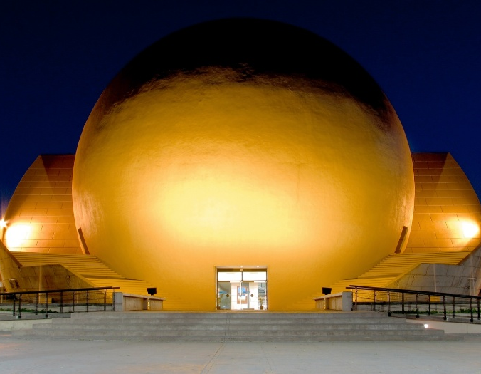 | 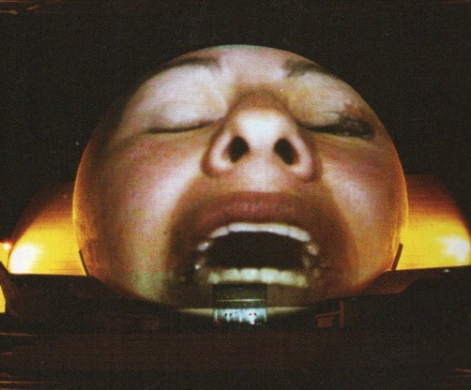
Figure 1: OMNIMAX Cinema, Centro Cultural Tijuana – Night lighting | Figure 2: El Centro Cultural Projection (Apel et al., 2011, p. 294)
The projection presented prerecorded and live responses from Mexican women revealing their experiences of trauma including ‘sexual harassment at the workplace, domestic violence, family disintegration, police brutality’ (Wodiczko, n.d.). The faces of Wodiczko’s collaborators were captured in extreme closeup and projected on to the 30m diameter, smooth rendered, spherical exterior of the OMNIMAX movie theatre (Figure 2). To facilitate the live feedback, Wodiczko devised a headset that provided the wearer with lighting, audio, camera and transmitter (Wodiczko, n.d.) (Figures 3 and 4). The choice of camera angle is not only a practical recreation of the audience’s viewing angle. When projected, the low camera angle provides a more sympathetic view for the audience and a more dominant position for the orator. Secondly the choice of shot size, by the proximity of an extreme close up, brings the audience into the intimate space of the projected face (Mackendrick, 2015, p. 223,225). The combined effect of scale and proximity is of a physically imposing and uncomfortably intimate encounter. This provides exposure, voice and power to the once-hidden, personal, testimonies.
Within this projection there are layers of what Scott McQuire would recognise as the ‘technological uncanny’. Firstly, noting that ‘[uncanniness] belongs to a complex scene of veiling and unveiling, of secrecy, revelation and improper exposure.’ (McQuire, 2011, p. 8) he moves to describe this technological uncanny as a ‘blurring of boundaries’ between corporeal experience and the incongruity of media technologies in terms of sites, boundaries and systems of access and enclosure’ (McQuire, 2011, pp. 10-11). The image of the face is transposed to the dome, spatially removed from the speaker. The testimonies break boundaries of smooth denial with painful truths and transforming a public space from a terrain of consensus to one of agonistic discourse (Mouffe, 2013, p. 92). The familiar presence of the OMNIMAX dome becomes the site of an unveiling and ‘bringing to light of that which ought to have remained hidden’ (McQuire, 2011, p. 8).

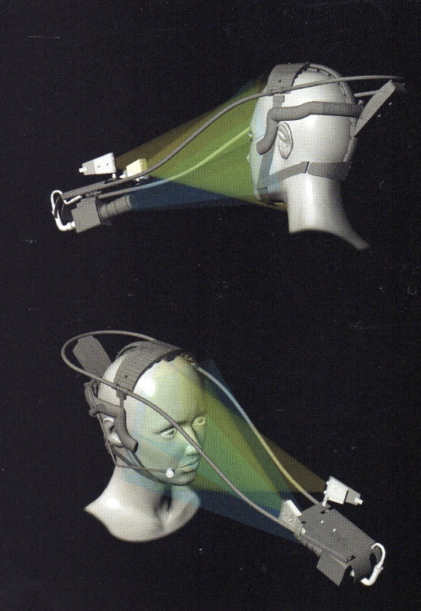 | 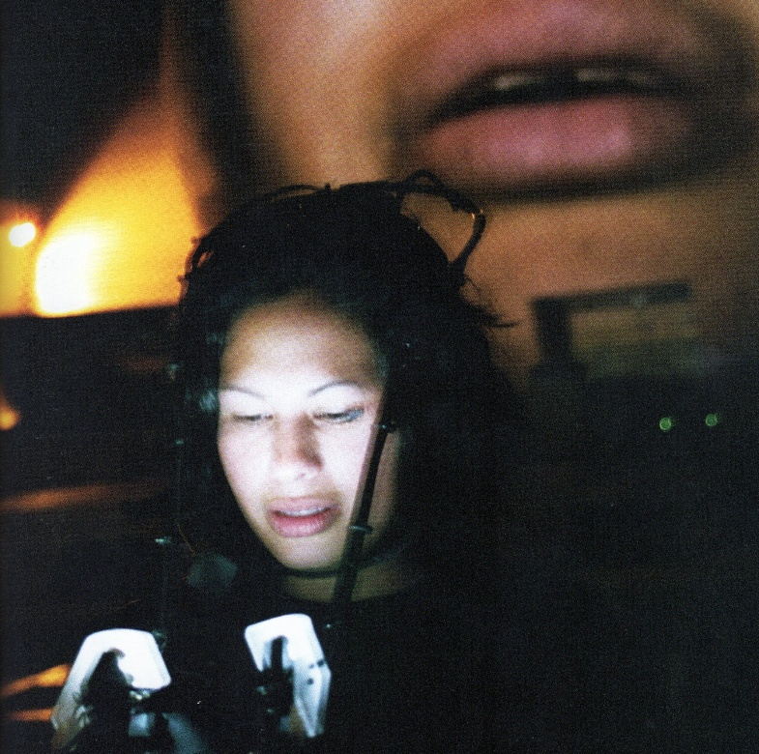
Figure 3: Headset design - El Centro Cultural Projection (Apel, D. et al, 2011, p. 297) | Figure 4: Headset in live use - El Centro Cultural Projection

Wodiczko states that ‘Visibility and public testimony are closely linked to recovery from traumatic experiences.’ (2011, p. 293) He further explains that, based on clinical experience and theory, public speech, the telling of truth on behalf of, and to others has a restorative power (2011, p. 294).
In this respect, Wodiczko’s work becomes a conduit between the truth teller and the audience. The artist becomes a facilitator, the creator of the mechanisms by which the traumatised find their voices and the audience that will hear them. (Wodiczko, 2011, p. 294). As Wodiczko finds influence in Mouffe’s agonistic democracy (Wodiczko, 2011, p. 297). In line with Mouffe’s observations on Alfredo Jaar’s counter-hegemonic interventions, Wodiczko is ‘setting in motion a process that will make [the audience] question their unexamined beliefs’ (Mouffe, 2013, p. 95). It is the means by which the viewer can be made aware of structures that deny dissent and prevent the act of questioning.
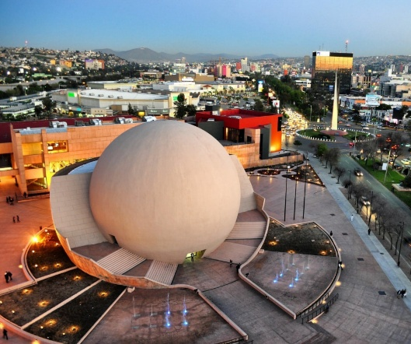 | 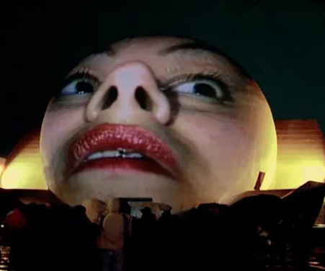
Figure 5: OMNIMAX Cinema, Centro Cultural Tijuana | Figure 6: El Centro Cultural Projection (Wodiczko, n.d.)

The silenced victims have turned their experiences into the most conspicuous, compelling encounter. This is not only a projection of light onto a surface, but also a projection of voices and physical action from the surface as public testimony (Wodiczko, 2011, p. 296).
Society and media had amputated the voices of these women, the subjects deemed taboo (Wodiczko, n.d.). In response, through the relationship between artist and the users of his ‘psycho-cultural prosthetics’ (Wodiczko, 2011, p. 296), Wodiczko provides the means for these collaborators to enact a Socratic parrhesia, harmonising logos (truth) and bios (life) (Foucault, 2001, pp. 102-106).

Hiroshima (1999)
Atomic Bomb Dome, Hiroshima, 7-8 August 1999
On the 6th of August 1945, the bombing of the Japanese city of Hiroshima killed between 70,000 and 140,000 inhabitants (Wellerstein, 2020). The city’s Korean population was estimated at 53,000 with 30,000 dead or missing (Apel et al., 2011, p. 304).
The contributors to this work comprised survivors of this attack and their descendants. The testimonies included accounts of Korean slave workers (Wodiczko, n.d.).
The Atomic Bomb Dome (Genbaku Dome) is a surviving building standing near the hypocentre of the atomic bomb blast. Built in 1914 as a commercial exhibition space (Hiroshima Prefectural Industrial Promotion Hall) on the banks of the Motoyasu River, it now stands as a peace memorial in a preserved state of ruin (UNESCO, n.d.) (Figures 7 and 8).
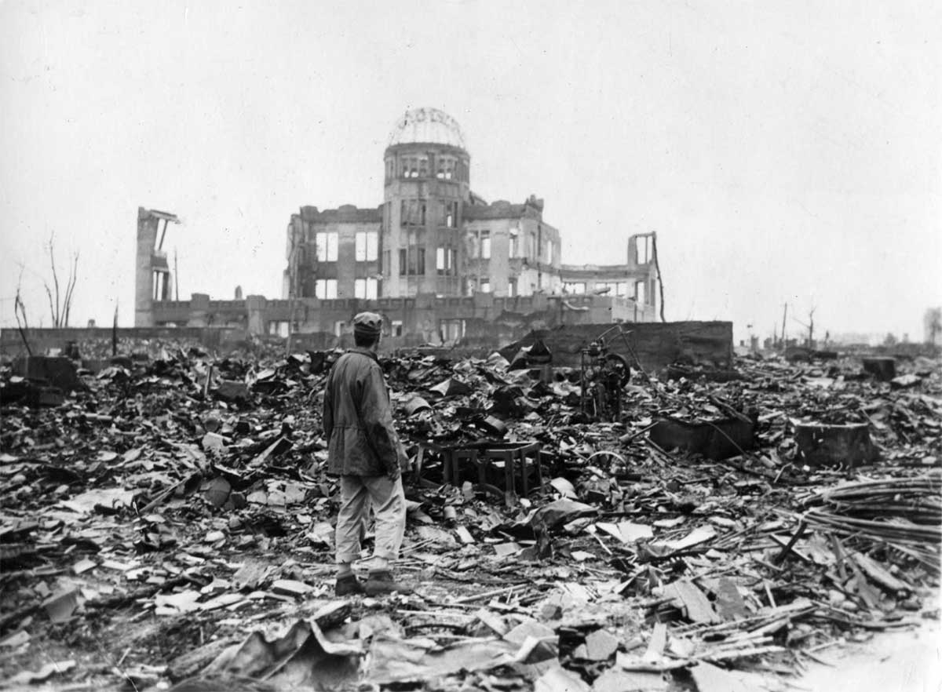 | 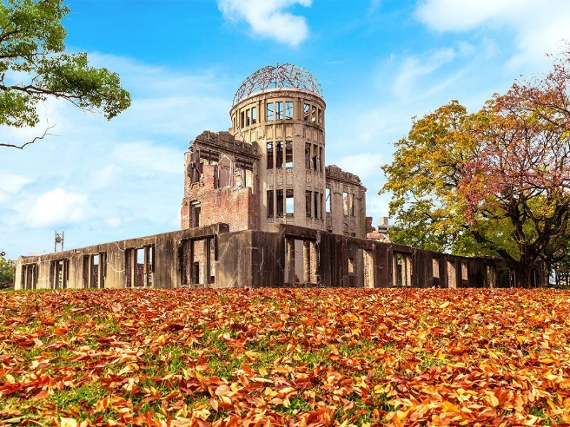
Figure 7: Hiroshima Prefectural Industrial Promotion Hall, Hiroshima, September 7th, 1945 | Figure 8: The Atomic Bomb Dome (Genbaku Dome), Hiroshima, 2019

The projected images of Wodiczko’s installation (Figures 9 and 10) portray the orators' hands against the river embankment, The projections are reflected in the waters of the river where many perished as they sought to escape the pain of their injuries (Wodiczko, n.d.). In this reflection, the water holds the memory of the dead, reanimated under the testimony of the living.
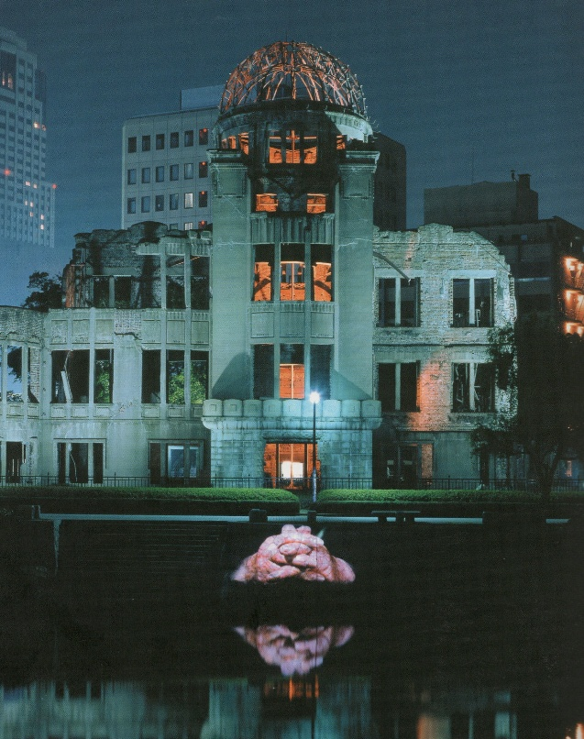 | 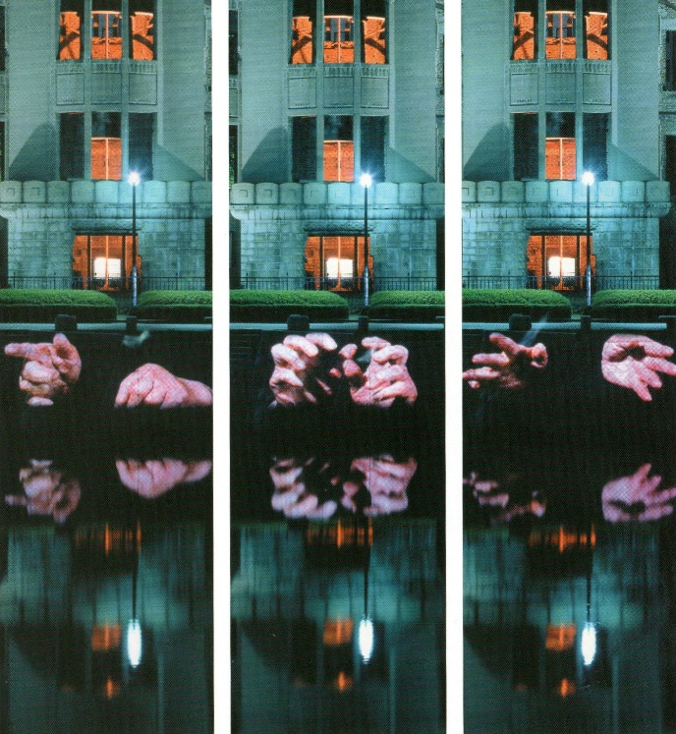
Figure 9: Hiroshima (1999), Atomic Bomb Dome, Hiroshima (Apel et al., 2011, p.300) | Figure 10: Hiroshima (1999), Atomic Bomb Dome, Hiroshima (Apel et al., 2011, p.301)

The ruined, domed structure sitting above the disembodied hands, as if the body and head of the orators, is an architecturalisation of the orator rather than just an anthropomorphism of the structure. The surface contains the voices as testament to the moment that destroyed all around. It remains, damaged and skeletal, a monument to survival but not, in itself, living.
Wodiczko had identified the oppression and later exclusion of the Korean atomic bomb victims (Apel et al., 2011, p. 304). A dedicated memorial was erected in 1979 but only moved within the boundaries of the Peace Park in 1999. The location of the monument was seen as discriminatory though it was also claimed to be a purely bureaucratic decision (Kuroda, 2023). Accounts from those involved in Wodiczko’s project suggest that the culture was heavily discriminatory. Even as late as 1978, Japanese officials would resist calls to survey Korean casualties and survivors (Apel et al., 2011, p. 304).
While the dome stands in memoriam, a material witness to history, it risks becoming a consensual space ‘dedicated to the maintenance and reproduction of the existing hegemony’ (Mouffe, 2013, p. 100). Wodiczko’s intervention can, then, provoke painful, truthful questions that the memorial’s familiar façade has lost. This artistic collaboration transforms the institute into an “agonistic public [space] where this hegemony is openly contested.” (Mouffe, 2013, p. 100). Wodiczko had deliberately chosen to include Korean voices not to maintain consensus but to ask questions around the oppression of minority groups and the suppression of their testimonies.
Wodiczko has provided an authorial vehicle that reintroduces narratives missing from official accounts. The memorial receives and reflects these testimonies, challenging the biases of an accepted history.

The Homeless Projection: A Proposal for the City of New York (1986)
49th Parallel, Centre for Contemporary Canadian Art, New York (Winter 1986)
Wodiczko’s Homeless Projection was never realised in the intended location of Union Square Park, New York City. Due to previous experiences with official bureaucracy (Washington Square, New York) and attempts at restriction of expression (Grand Army Plaza, Brooklyn. New York), Wodiczko assumed similar resistance at Union Square (Wodiczko et al., 1986). The original work was only exhibited as a series of photomontage images (Figures 11-14) and a proposal for temporary use of the public space (Deutsche, 1996, p. 7). The projected slide images comprised the figurative sculptures of the park in the role of the homeless of the city. While official proposals presented a permanent, physical gentrification of Union Square, Wodiczko’s intervention would be transient, revealing and painful.
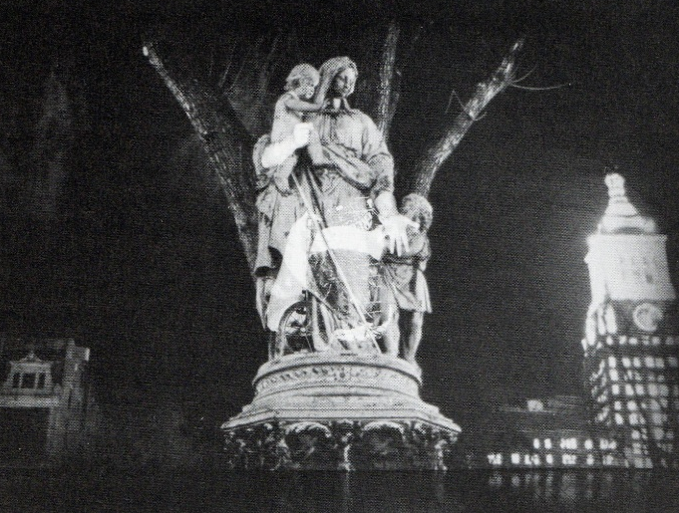 |  | 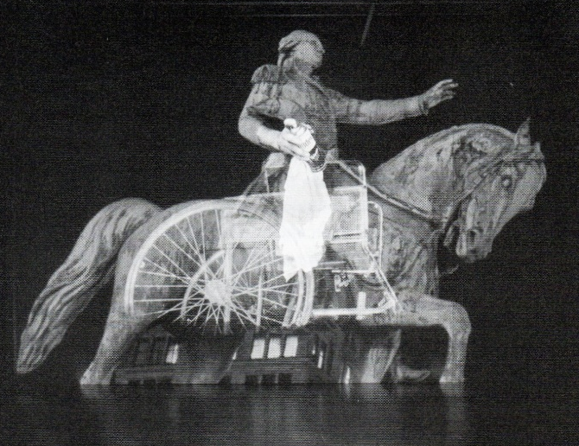
Figure 11: Krzysztof Wodiczko, The Homeless Projection: A Proposal for the City of New York, 1986. Mother and Child Fountain, Union Square Park. |  | Figure 12: Krzysztof Wodiczko, The Homeless Projection: A Proposal for the City of New York, 1986. George Washington Monument, Union Square Park.
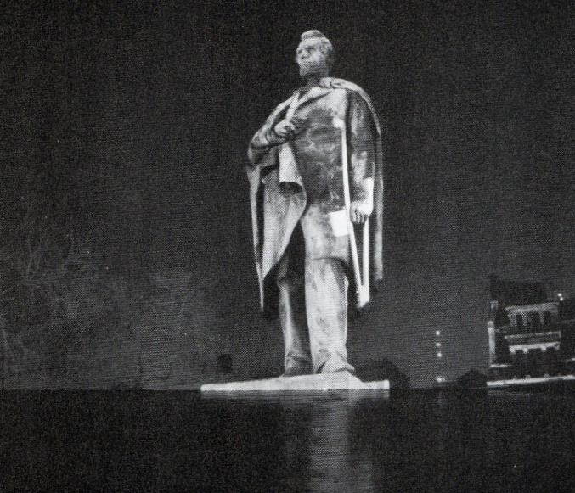 | 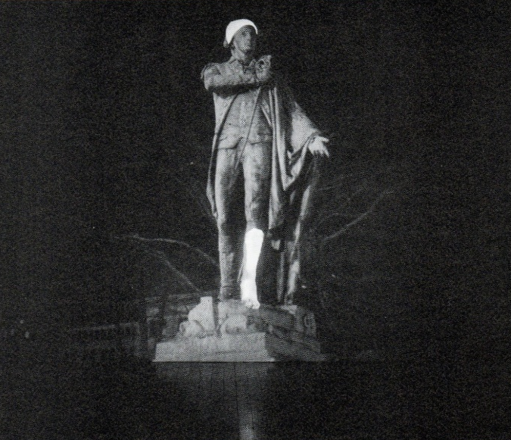
Figure 13: Krzysztof Wodiczko, The Homeless Projection: A Proposal for the City of New York, 1986. Abraham Licoln Monument, Union Square Park. | Figure 14: Krzysztof Wodiczko, The Homeless Projection: A Proposal for the City of New York, 1986. Lafayette Monument, Union Square Park.
It is noteworthy that the name of the work appears to have changed since inception. An earlier labelling uses the subtitle ‘A proposal for Union Square’ (Boswell et al., 1992, p. 76). Later it is consistently subtitled ‘A proposal for the City of New York’ (Wodiczko, 1999, P. 55). The renaming works to move from a site-specific focus to one that points to wider social issues. Here, the City of New York is not only a location but also the population and system of governance within.
New York’s Mayor Ed Koch articulated his thoughts on the city’s homeless in 1988.
These homeless people, you can tell who they are. They're sitting on the floor, occasionally defecating, urinating, talking to themselves many, not all, but many-or panhandling. We thought it would be reasonable for the authorities to say, "You can't stay here unless you're here for transportation." Reasonable, rational people would come to that conclusion, right? Not the Court of Appeals. (Koch, 1988, quoted in Deutsche, 1996, p. 51)
This quote relates to proposed anti-loitering laws but displays a willingness to argue from anecdote. It targets a population for the actions of an unspecified ‘many’. It continues with an appeal to flattery aimed at an audience who may wish to live up to the labels of ‘reasonable’ and ‘rational’. The homeless population is painted as a problem, not to be acknowledged or resolved, but to be moved on without having a defined destination. This is a display of algophobia in the palliative society (Han, 2021, p. 1). Where there could be a painful recognition of the problems within society, they exist only as ‘others’, apart from the ‘reasonable, rational people’.
The Square’s monuments were a disparate assembly that was only provided with an umbrella of meaning by the installation of a flagpole, in the centre of the park, commemorating the Declaration of Independence (Deutsche, 1996, pp. 34-35). It was this constructed history that developers held up as ‘representative of eternal values’ (Deutsche, 1996, p. 34). The individual monuments are removed from their original intentions and redesignated as an unquestionable, symbol of the dominant hegemony. By appealing to a culturally ingrained, monolithic truth, the monuments become a surface that denies dissent, resistant to agonistic struggle.
It is against this political and constructed, smooth hegemony that Wodiczko proposed his intervention. The projections additively adorn the statues with symbols of displacement, homelessness and exclusion. The representations of injury, disablement, improvised labour and an itinerant lifestyle overlay the monuments but do not disguise their original form. This serves to challenge the viewer to question the purpose and permanence of established, hegemonic structures while considering the effect of those structures on an excluded section of society.
In this project, Wodiczko has approached the act of truth-telling but avoided parrhesiastic risk. The meaning neither comes directly from the voice of his subjects nor is delivered directly for the audience to reconstruct. While Wodiczko has not handed the role of the parrhesiastes to the homeless, he does promote their plight through imagery that a New York audience would understand. He also draws attention to the smooth, hegemonic control of the surface. In this respect, Wodiczko is displaying more authorial control than he would in later works.
Conclusion

Barthes declared the “Death of the Author” as an emancipation of the reader that moved the responsibility of constructing meaning away from the creator. For Barthes, meaning would be derived from the text and reconstituted by the viewer without recourse to the intention of the author (Barthes, 1977, pp. 142-148). However, in a contemporary, palliative society, Han suggests that this shift negatively impacts the process of communication. In an anesthetised audience, there is no instinct to search for a truth that might cause pain. The comfort of the smooth, established thought is preferred over the rough friction of critical reading. Indeed, in Mouffe’s dominant hegemony, the viewer will find no preference at all as there is no apparent alternative.
It is in this environment that Wodiczko’s intervention finds necessity. This is not an authoritarian intervention but one of the parrhesiastic facilitator. He provides the means for the voiceless to tell their truth and reintroduces the reader, the audience, to the processes by which they might challenge the conditioned smoothness of the palliative state. It is an intervention that aims to ‘induce emotional response’, shift perception and expose new possibilities (Mouffe, 2013, pp. 96-97).
While Wodiczko uses his creative practice to facilitate authorship, his intention is not to define meaning through this act. The meaning is defined through the process of parrhesia and the interaction with public surfaces to expose the reader to a counter hegemonic process. Though Wodiczko enables and assembles as an author might, the reconstruction of meaning is ultimately in a process that seeks transformations from a state of a palliative survival to a place of active, agonistic living.
In this respect, Wodiczko becomes the facilitator of parrhesia. Moving from the representation of signifiers of poverty, the later works engage collaborators directly. In providing the necessary psycho-cultural prosthetics and securing the public space, Wodiczko enables his collaborators in active, authorial exposure of their own stories. So, while the interventions require the audience to engage with the authors, they also have the effect of challenging the reader to question authorial control. Wodiczko reclaims authorship through the conduit of his collaborators’ parrhesiastic action. In doing so, he incites the process of questioning dominant hegemonies and narratives. It is this process that emancipates the reader.
Bibliography

Apel, D., Deutsche, R., Hebdige, D., Hollier, D., Kwinter, S., Lajer-Burcharth. E., Saltzman, L., Turowski, A. (2011) Krzysztof Wodiczko. London, UK: Black Dog Publishing Ltd.
Barthes, R. (1977) Image, Music, Text. London, UK: Fontana Press
Boswell, P., Hebdige, D., Philips, P. C., Turowski, A. (1992) Public Address: Krzysztof Wodiczko. Minneapolis, MN: Walker Art Center
Deutsche, R. (1996) Evictions. Cambridge, MA: The MIT Press
Foucault, M. (1983) Discourse and truth: The problematization of Parrhesia: 6 lectures given by Michel Foucault at the University of California at Berkeley, Oct-Nov. 1983. Foucault.info. Available at: https://foucault.info/parrhesia/ (Accessed: 16 December 2025).
Foucault, M. (2001) Fearless Speech. Los Angeles: Semiotext(e)
Han, B-C. (2021) The palliative society. Cambridge: Polity Press
Han, B-C. (2022) Non-things. Cambridge: Polity Press
Kuroda, K. (2023) In Hiroshima, Memorial for Korean Hibakusha has a tale to tell, JAPAN Forward. Available at: https://japan-forward.com/in-hiroshima-memorial-for-korean-hibakusha-has-a-tale-to-tell/#:~:text=An%20estimated%2020%2C000%20Koreans%20lived,them%20inside%20Peace%20Memorial%20Park.&text=During%20the%20G7%20Hiroshima%20Summit,being%20evaluated%20in%20South%20Korea. (Accessed: 31 December 2025).
Mackendrick, A. (2015) On Filmmaking. New York: Faber and Faber
McQuire, S. (2011) The Media City. London, UK: Sage Publications Ltd.
Mouffe, C. (2013) Agonistics. London, UK: Verso
San Diego Museum Council (2024) CECUT - Tijuana Cultural Center, San Diego Museum Council. Available at: https://sandiegomuseumcouncil.org/museums/tijuana-cultural-center-cecut/ (Accessed: 29 December 2025).
UNESCO (n.d.) Hiroshima Peace Memorial (Genbaku Dome) - UNESCO world heritage centre, UNESCO. Available at: https://whc.unesco.org/en/list/775/ (Accessed: 30 December 2025).

Wellerstein, A. (2020) Counting the dead at Hiroshima and Nagasaki, Bulletin of the Atomic Scientists. Available at: https://thebulletin.org/2020/08/counting-the-dead-at-hiroshima-and-nagasaki/ (Accessed: 30 December 2025).

Wodiczko, K., Crimp, D., Deutsche, R. and Lajer-Burcharth, E. (1986) ‘A Conversation with Krzysztof Wodiczko’, October, 37, pp. 23–51.
Wodiczko, K. (1999) Critical Vehicles. Cambridge, MA: The MIT Press
Wodiczko, K. (2011) ‘Art, Trauma and Parrhesia’, Art & the public sphere, 1(3), pp. 293–302. Available at: https://doi.org/10.1386/aps.1.3.293_7.

Wodiczko, K. (n.d.) Projections, Krzysztof Wodiczko. Available at: https://www.krzysztofwodiczko.com/public-projections (Accessed: 26 December 2025).

List of figures

Figure 1: OMNIMAX Cinema, Centro Cultural Tijuana – Night lighting
Available at: https://www.tripbucket.com/dreams/dream/visit-tijuana-cultural-center-tijuana-mexico/

Figure 2: El Centro Cultural Projection (Apel et al., 2011, p.294)

Figure 3: Headset design - El Centro Cultural Projection (Apel, D. et al, 2011, p.297)

Figure 4: 2011, p.297)

Figure 5: OMNIMAX Cinema, Centro Cultural Tijuana
Available at: https://sandiegomuseumcouncil.org/museums/domo-imax-centro-cultural-tijuana/

Figure 6: Hiroshima Prefectural Industrial Promotion Hall, September 7th, 1945
Available at: https://www.atomicarchive.com/media/photographs/hiroshima/image-7.html
Figure 7: The Atomic Bomb Dome (Genbaku Dome), Hiroshima, 2019
Available at: https://www.wtravelmagazine.com/exploring-a-resurrected-city-blissful-travels-in-hiroshima/

Figure 8: OMNIMAX Cinema, Centro Cultural Tijuana
Available at: https://imax-history.ca/sites/tijuana-domo-centro-cultural/

Figure 9: Hiroshima (1999), Atomic Bomb Dome, Hiroshima (Apel et al., 2011, p.300)

Figure 10: Hiroshima (1999), Atomic Bomb Dome, Hiroshima (Apel et al., 2011, p.301)

Figure 11: Mother and Child Fountain, Union Square Park. (Deutsche, 1996, p.10)

Figure 12: Krzysztof Wodiczko, The Homeless Projection: A Proposal for the City of New York, 1986. George Washington Monument, Union Square Park. (Deutsche, 1996, p.11)

Figure 13: Krzysztof Wodiczko, The Homeless Projection: A Proposal for the City of New York, 1986. Abraham Licoln Monument, Union Square Park. (Deutsche, 1996, p.8)
Figure 14: Krzysztof Wodiczko, The Homeless Projection: A Proposal for the City of New York, 1986. Lafayette Monument, Union Square Park. (Deutsche, 1996, p.9)

