

Leveraging Power Bi

for

Competitive Advantage

A Case Study of FedEx

Bachelor of Arts, Business Management (BABMGSH-LI)

Dissertation

Supervisor: Dr. Xavier Matieni
Student: Ana Diana Rosca

Student ID: 2020311

Date: 02.01.2024


University Of Wales Trinity Saint David

Abstract

This research project focuses on the implementation of Business Intelligence (BI) solutions using Power BI at FedEx, a multinational logistics company. The key objectives of the study are to address data silos, improve decision-making processes, and effectively implement Power BI.
FedEx operates globally and faces the challenge of data silos, where data is isolated in different departments or systems. The research explores strategies to integrate data from various sources into a unified BI platform, enabling a holistic view of operations and informed decision-making.
The impact of BI on decision-making processes at FedEx is examined, with an emphasis on how Power BI facilitates data-driven decision-making across different organizational levels.
The suitability of Power BI as a tool for implementing BI at FedEx is evaluated, considering its features, functionalities, and capabilities. The study also discusses challenges and best practices for effective implementation.
The findings highlight the importance of breaking data silos, improving decision-making, and implementing BI effectively. By leveraging Power BI, FedEx can overcome data silos, enhance decision-making, and gain competitive advantages through data-driven insights. The study emphasizes the value of BI and demonstrates the potential of Power BI in implementing BI solutions.

Keywords: Business Intelligence, Power BI, Data Silos, Decision-making Processes, Implementation, Competitive Advantages.

Table of Contents
- Introduction ………………...…...5
1.1 Context and motivation 5
1.2 Research Description 6
1.3 Research Contributions....…………………………………………………………...……….7
1.4 Dissertation structure…………………………...……………………….…………………….8
2. Literature Review 8
2.1 History of Business Intelligence 8
2.2 Power BI… 9
2.3 Power BI Limitations….….…………….……………………………………...……………...10
2.4 Concept and Importance……….…………………………………………………………….11
2.5 Benefits…....……. ….……………………………………………………………………….10
3. Methodology 13
3.1 Research Questions and Objectives 13
3.2 Research Design 14
3.3 Research Participants….…………………………………………………………………...14
3.4 Data Collection Methods…...…………………………………………………………….…15
3.5 Data Analysis…………………………………………………………………………. ….…15
3.6 Limitations of Research…….………………………………………………………….…… 16
4. Discussion & Research Findings……………………………………………………………16
4.1 Power BI Implementation…………………………………………………………………16
4.1.1 Rationale for Power BI Implementation at FedEx…….….…………………………17
4.1.2 Integration of Power BI into FedEx IT Infrastructure….….……………………….18
4.1.3 Deployment and Adoption of Power BI within FedEx....……………………….19
4.2 Decision Making Processes...…………………………….……………….…………….20
4.2.1 Quantitative Data Findings…………………….…………………………………….20
4.2.2 Qualitative Data Findings……….………………….…………………………….25
4.3 Case Study-Addressing Data Silo using Power BI...……...……………………… 28
5. Conclusion and Recommendations. …….…………………………………………………36
Glossary……………………………………………………………………………………………..38
Bibliography.……………………………………………………………………………………….39

Table of Tables and Figures

Figure 1- Survey Questions 21

Figure 2-Results of ANOVA Analysis on all participants 22

Figure 3-Results of ANOVA Analysis on Managers 24

Figure 4- Average and Variance - ANOVA results comparison between type of users 25

Figure 5- Word cloud (Qualitative data gathered from 5 interviews) 27

Figure 6- Data and Locations of Data gathered into Power BI for the Performance Overview Report 28

Figure 7-Dimensional Model of Dashboard Report ‘’Performance Overview Chelmsford’’ 29

Figure 8-Description of Data imported in Power BI 31

Figure 9-Performance Overview Chelmsford- Report Cover Page 32

Figure 10-Performance Overview Chelmsford- In depth Report Page 32

Figure 11-Returns by Driver- Rolling In Report page from ‘’Performance Overview Chelmsford’’ 33

Figure 12- Scatter analysis on out for Delivery and Returns by Contractor- In depth Report Page 33

Figure 13 In-depth report Selection on DEX2 KPI Indicator 34

Figure 14-Stops and Packages by Driver/Contractor-In Depth Report 34

Chapter 1. Introduction
  - Context and motivation
In the ever-changing business environment of today, organizations are increasingly realising the significance of utilizing advanced analytics tools to gain a competitive advantage. One such tool that has gained considerable popularity is Power Bl, a powerful business intelligence software developed by Microsoft. This dissertation aims to explore the potential benefits and impact of Power Bl implementation on FedEx, a global logistics and transportation company, and shed light on its strategic utilization for achieving a sustainable competitive advantage in the industry.
The rapid expansion of the internet, technological advancements, and the widespread of digital devices, Internet of Things (IoT) devices, social media, and e-commerce have led to an exponential increase in data generation. The volume of data generated daily has reached unprecedented levels, with Forbes reporting that 2.5 quintillion bytes of data were created each day in 2018, and 90% of the world's data was generated in the previous two years alone (Marr, 2018). This trend has continued, with an estimated 3.5 quintillion bytes of data being created daily in 2023 and a projected 181 zettabytes of data in 2025 (Duarte, 2023); (Wise, 2023) (IBM, 2022)).
The explosion of data, commonly referred to as big data, encompasses the rapid increase in the volume, variety, and velocity of data from diverse sources. Organizations have been collecting and storing vast amounts of data, including sales data, financial records, customer information, and market conditions (Antunes, et al., 2022). However, along with the growth of data, business environments have become more dynamic and competitive, particularly in the online realm where competition is just a click away. Additionally, customer expectations have become increasingly complex, and the focus on providing exceptional customer experiences has become a critical differentiator in many industries (Schmidt-Subramanian, 2014).
To thrive in this fast-paced, competitive landscape, organizations need to access, analyse, and respond to large volumes of data in real-time or near real-time. This data can deliver significant insights into customer behaviour, market trends, competitor activity, and other external factors influencing organizational success (Romero, et al., 2021). Internally, leveraging data can enhance visibility into business performance by tracking Key Performance Indicators (KPIs) and other metrics, enabling organizations to make informed decisions and improve internal operations (Apraksin, et al., 2018)
However, the challenges of integrating and consolidating data from multiple sources and analysing vast amounts of data present obstacles for organizations. Data integration is crucial to obtaining a holistic view of operations, while data analysis is necessary to transform data into actionable insights and inform decision-making (Simon, 2013). Despite the abundance of data, only a small fraction is processed and analysed, making effective data management increasingly challenging( (Abai, et al., 2019); (Apraksin, et al., 2018); (Romero, et al., 2021)).
In response to these challenges, Business Intelligence (BI) has emerged as a solution to effectively manage and analyse large quantities of data, enabling organizations to transition from intuition-based decision-making to data-driven decision-making ( (Abai, et al., 2019); (Apraksin, et al., 2018); (Romero, et al., 2021) BI empowers decision-makers by extracting meaningful insights from data, providing information about the past, present, and future, and aiding in compliance with regulatory requirements ( (Apraksin, et al., 2018); (Baruti, 2023); (Sujitparapitaya, et al., 2012)). The availability of user-friendly BI tools, such as Microsoft Power BI, has contributed to the widespread adoption of BI across organizations of all sizes (Microsoft Power BI, 2023).
1.2 Research Description
FedEx UK operates as a part of the global logistics and transportation company FedEx Corporation. As an integral part of FedEx's operations, FedEx UK plays a fundamental role in facilitating the movement of goods and packages within the United Kingdom and connecting businesses and customers to global markets. (FedEx, 2023)
FedEx UK follows a structured organizational structure that allows for efficient coordination and decision-making across its warehouses and operations. While specific details of the hierarchy may vary, the structure typically consists of the following levels:
Executive Leadership: At the top of the hierarchy, the executive leadership team sets the overall strategic direction and policies for FedEx UK. This includes key decision-makers such as the President, Vice Presidents, and other top-level executives responsible for overseeing the operations and profitability of the company.
Regional Management: Under the executive leadership, regional managers are responsible for overseeing multiple warehouses and operations within a specific geographic region. They are responsible for ensuring operational efficiency, managing resources, and implementing corporate strategies at the regional level.
Warehouse Managers: Warehouse managers are accountable for the daily operations of individual warehouses. They oversee activities such as package handling, inventory management, staffing, and facility maintenance. Warehouse managers play a critical role in ensuring smooth operations and meeting customer service standards.
Operations Team: The operations team, reporting to warehouse managers, consists of supervisors and coordinators who manage various aspects of warehouse operations. They are responsible for coordinating package sorting, ensuring timely deliveries, managing staffing schedules, and resolving any operational issues that may arise.
Frontline Staff: The frontline staff within FedEx UK's warehouses includes package handlers, drivers, and other operational personnel. They play a crucial role in executing the day-to-day tasks required for efficient package handling, sorting, and transportation.
Decision-making within FedEx UK is typically a collaborative process, involving input from various levels of the hierarchy. Strategic decisions related to market expansion, service offerings, and technology adoption are primarily made at the executive leadership level. Regional managers provide input on regional strategies and operational efficiencies, while warehouse managers and operations teams make decisions related to daily operations and process improvements.
The context of this research is the logistics and transportation industry, specifically focusing on FedEx’s regional management. The industry is characterized by its dynamic and complex nature, where timely access to accurate data is crucial for optimizing operations, enhancing customer experience, and gaining a competitive advantage.
The motivation behind this research is to explore how FedEx, on a regional level, leverages Power BI, a data visualization and analysis tool, to drive competitive advantage. With a vast network of operations and handling millions of shipments daily, FedEx generates a massive amount of data. Extracting meaningful insights from this data is essential for making informed decisions and improving operational efficiency.
The research questions are centred around Power BI implementation at FedEx and its impact on decision-making and data silos. The study aims to investigate the specific use cases and implementation strategies employed by FedEx to maximize the potential of Power BI. It seeks to understand how Power BI enables real-time monitoring of key performance indicators, identifies operational bottlenecks, and facilitates data-driven decision-making at various levels of the organization.
Additionally, the research will explore the impact of Power BI implementation on data silos. In an organization as large and complex as FedEx, data silos can hinder effective decision-making and prevent the sharing of valuable insights across departments. By examining how FedEx utilizes Power BI, the study aims to assess its impact on breaking down data silos and promoting cross-functional collaboration and knowledge sharing.
Overall, the context of this research lies in the logistics and transportation industry, with FedEx as the focal organization. The motivation is to understand how Power BI implementation can drive competitive advantage for FedEx. The research questions revolve around Power BI implementation, its impact on decision-making, and its potential to break down data silos within the organization.
1.3 Research Contributions
The research contributes valuable insights to the field of business intelligence (BI), particularly in relation to the implementation of Power BI within FedEx. This research serves as a real-world study of Power BI implementation, providing practical insights and lessons learned that can be applicable to other organizations.
One of the key contributions of this dissertation for FedEx, is the consolidation of information through Power BI dashboards. By ensuring that all stakeholders have access to the same standardized data, fragmentation is reduced, and data silo is being overcome. This contributes to improved decision-making by providing precise and reliable insights based on thoroughly validated data.
The dashboards implemented in the FedEx research enable real-time performance monitoring, allowing proactive interventions to optimize performance and respond swiftly to challenges and opportunities. This enhanced visibility into operational data aids in resource allocation and cost management, identifying inefficiencies and focusing resources for maximum returns.
Furthermore, the dashboards transform strategic planning at FedEx by providing data-backed insights, improving strategic decision-making, and reducing uncertainty. With daily data updates, automation, and reduced manual efforts, the research findings can lead to cost savings, higher productivity, and lower error rates within the organization.
The well-structured and user-friendly dashboards implemented provide extensive and high-quality information, enhancing data comprehension for users. The enhanced interactivity and flexibility in data exploration offer drill-down, roll-up, and filtering options, allowing users to analyse data in a more detailed and customized manner.
Sharing the dashboards on the Power BI service facilitates cross-functional collaboration within FedEx, aligning efforts with organizational goals. This improved access to critical business data empowers data-driven decision-making, positively impacting organizational performance.
In summary, the research contributions encompass various aspects such as decision-making, efficiency, performance monitoring, strategy formulation, cost management, collaboration, and adaptability. These findings can enhance FedEx's competitiveness and position it for sustained success in the data-driven business landscape. Additionally, the research findings can potentially guide other businesses, including FedEx, undertaking similar Power BI implementations, making the dissertation an asset applicable to various companies in the transportation and logistics industry.
Given the importance of data in informing business decisions and improving operational efficiencies, this dissertation is exploring the efficiency of Power BI in data management, breaking down data silos and decision-making in organizations. By addressing the challenges of data integration and analysis, Power BI unlocks valuable insights that can enhance both internal operations and external competitiveness. The findings of this research will contribute to the existing body of knowledge and provide recommendations for leveraging BI to gain a competitive advantage in the data-driven digital age.
1.4 Dissertation structure
This dissertation begins with the present chapter that sets the context for the research by providing background information, stating the problem statement, and outlining the objectives and significance of the study.
To clarify the concepts and deeply understand and frame the main theme of this dissertation Chapter 2 section provides a comprehensive review of existing literature and research, relevant to the topic of the dissertation. It demonstrates the author's understanding of the current knowledge and identifies gaps in the literature that the research aims to address.
Chapter 3 comprises the methodology used to conduct the research. The methodology section describes the research design, data collection methods, and analysis techniques employed in the study. It explains how the research was conducted and justifies the chosen approach.
The following chapter (Chapter 4) presents a discussion on the findings of the research in a clear and organized manner. It includes data, tables, graphs, or any other visual representations of the results, along with explanations and interpretations.
Chapter 5 addresses the conclusions taken during the project, ending with the main limitations encountered and suggestions for future work. Finally, the Bibliography comprises a complete list of all the bibliographic references used throughout the paper.
Chapter 2. Literature Review
2.1 History of Business Intelligence
The origins of Business Intelligence (BI) can be traced back to the late 1950s and early 1960s when companies began using computers to store and analyse large volumes of data. The term "Business Intelligence" was pioneered by Hans Peter Luhn in 1958 in his seminal paper titled "A Business Intelligence System" (Luhn, 1958). This article, published in an IBM journal, provided a framework for identifying the role of data in organizations and laid the foundation for modern BI systems and practices. (Olszak, 2016).
Luhn advocated for the use of BIS to provide organizations with a comprehensive view of their activities and facilitate data-informed decision-making, emphasizing its importance for remaining competitive in a rapidly changing business environment (Apraksin, et al., 2018). He also introduced several key concepts that are still relevant in the field of BI today. It proposed the manipulation of data to obtain information that supports organizational decisions, highlighting the use of analytical tools and methods to extract insights and knowledge from data. Additionally, it emphasized the involvement of various stakeholders, including managers, analysts, and end-users, in the BI process, aligning with the modern notion of BI ( (Abai, et al., 2019); (Luhn, 1958)).
In the early 2000s, the adoption of Business Intelligence (BI) became crucial for companies to remain competitive. Large and medium-sized enterprises believed BI solutions essential, leading to intense competition among industry giants. BI tool development focused on speed and user-friendliness, making data accessible to non-technical individuals. The progress of the internet, social media, and e-commerce expanded data sharing and analysis opportunities. Real-time data integration and self-service features became important, reducing reliance on IT departments. The launch of Google Analytics in 2005 marked a significant step, leading to the term "big data" for vast data volumes beyond traditional management capabilities. BI has evolved into the era of BI 3.0, with increased adoption across industries and enhanced efficiency through user-friendly tools. Cloud computing and quantum computers offer solutions for handling large data volumes. Data governance and management practices have gained traction to address challenges in integrating data from diverse sources and ensure data quality, security, and privacy. The future of BI is predicted to involve enhancements in Natural Language Processing (NLP), conversational BI, and augmented analytics, leveraging Machine Learning (ML) to automate data analysis and empower non-expert users to make data-driven decisions ( (Heinze, 2014); (Lago, 2018)).
2.2 Power BI
Power BI is a powerful and accessible self-service BI tool established by Microsoft. It aims to link the gap between data and decision-making by allowing users to connect to and import data from various sources, transform and clean the data, and create interactive reports and dashboards with visual elements. Power BI consists of software services, apps, and connectors, including Power BI Desktop for creating BI solutions, Power BI Service for publishing and sharing solutions, and Power BI mobile app for viewing reports on mobile devices (Canvas Intelligence, 2023).
Power BI offers features such as data connectivity, integration, preparation, modelling, interactivity, advanced analytics, scalability, collaboration, mobile support, security, ease of use, automation, and alerts. Data connectivity allows users to connect to various data sources, including Excel, SQL Server, and cloud-based services. Data integration combines and visualizes data from multiple sources, providing a comprehensive view (Microsoft Power BI, 2023). Data preparation features in Power BI include data cleansing, transformation, and shaping for accurate and formatted data. Data modelling involves designing the data structure, defining tables, columns, relationships, and calculations. Power Query is used for data preparation, while the Data Analysis Expressions (DAX) language is used for calculations and aggregations. (DAX Patterns, 2023)
Power BI provides a range of built-in visualizations such as charts, tables, maps, and custom visualizations. It also offers advanced analytics features, including AI, ML, and NLP integration for trend identification and pattern recognition. Power BI allows personalized dashboards and interactive reports, catering to specific business needs. The platform is scalable, capable of storing and analysing millions of records, and can adapt to changing organizational requirements. It is available in free and paid versions, allowing organizations to scale their usage. Collaboration features enable teams to work together on reports and dashboards. (Microsoft Power BI, 2023)
Personalized dashboards and interactive reports are another key feature of Power BI, allowing organizations to tailor their BI solutions to their specific needs. The platform is scalable and can handle millions of records, making it suitable for businesses of all sizes. Power BI is available in both free and paid versions, with the paid version offering additional features such as collaboration and data refresh. (Microsoft Power BI, 2023)
Collaboration is facilitated through Power BI Service, a cloud-based service that allows users to create, share, and collaborate on dashboards and reports in real time. Power BI also has a mobile app that enables users to access their dashboards and reports on the go, providing flexibility for remote working and fieldwork. (Microsoft Power BI, 2023)
Security is a priority in Power BI, with dashboards and data access controlled by authorized stakeholders. The platform offers robust security features, including access permissions, row-level security, and secure data transfer between on-premises data sources and the Power BI service. (Microsoft Power BI, 2023)
Power BI is known for its ease of use, with an intuitive user interface and a wide range of built-in templates and sample reports. The platform also offers automation features, such as scheduled data refresh and data-driven alerts, to ensure that reports and dashboards always reflect the latest data. (Microsoft Power BI, 2023)
Overall, Power BI is a game-changer in the realm of BI and data visualization. Its capabilities in data connectivity, transformation, modelling, visualization, and advanced analytics empower organizations to unlock the value of their data. With its user-friendly interface, collaboration features, scalability, security, and automation capabilities, Power BI is an indispensable tool for businesses seeking to make data-driven decisions and gain a competitive advantage in today's data-driven world.
It is a versatile and comprehensive BI tool that empowers users to make informed decisions and gain a competitive edge. Its user-friendly interface, data connectivity, integration, preparation, modelling, interactivity, and advanced analytics features make it an asset for organizations of all sizes.
2.3 Power BI Limitations
While Power BI offers numerous benefits, it also has some limitations that researchers and decision-makers should be aware of:
Learning Curve: Power BI has a relatively steep learning curve, especially for users who are not familiar with data analysis or business intelligence tools. It requires time and effort to master the various features, functions, and data modelling concepts. Training or assistance may be necessary to fully leverage the tool's capabilities.
Data Source Limitations: Power BI supports a wide range of data sources, but there may be limitations in terms of compatibility or connectivity with certain databases or platforms. Some data sources may require additional configurations or custom connectors, which can be time-consuming and require technical expertise.
Cost Considerations: Power BI offers different pricing plans, including a free version with limited features and paid plans with additional functionalities. The cost of licensing, maintaining, and scaling Power BI can be a consideration, particularly for smaller research teams or organizations with budget constraints.

2.4 Concept and Importance
The increasing utilization of advanced analytic tools is closely connected to the surge in data usage. Companies that possess a larger volume of data can leverage analytical tools positive impacts, such as gaining a competitive edge (Mikalef & Gupta, 2021). Data is widely recognized as a valuable resource, making it an attractive asset in the fiercely competitive markets of today (Ciuriak, 2019). By accessing and analysing data, businesses can make more informed decisions, employ predictive analytics (Shmueli & Koppius, 2011), and personalize their products and services to cater to individual consumer needs. However, data alone is insufficient to provide the necessary insights for businesses. (Mikalef, et al., 2018). It requires advanced techniques to unlock its full potential. (Janiesch, et al., 2021). These techniques must possess the ability to efficiently process, analyse, and interpret large datasets to reveal meaningful patterns and insights.
2.5 Benefits
Data Silo
An immense problem that organisations these days face and that Power BI can tackle is Data Silo. Data silos refer to isolated data repositories within an organization that impede efficient data sharing and collaboration (Stedman Craig, 2021). Edd Wilder-James in 2016 delves into the issue of breaking down data silos and how businesses can maximize the value of data analysis.
Data analysis is a powerful tool for businesses to gain a competitive advantage; however, accessing the necessary data can be a barrier. Despite the emergence of data science, 80% of the work still involves acquiring and preparing data (Wilder-James, 2016). Power BI offers a solution by providing a unified platform for data integration, enabling organizations to break down data silos.
Existing literature suggests that Power BI's data connectivity capabilities, such as its ability to integrate data from multiple sources, can assist organizations in consolidating their data and obtaining a comprehensive view of their operations. This consolidation of data promotes better decision-making by providing accurate and real-time insights (Aspin, 2014). Several research articles have addressed the challenges posed by data silos and proposed strategies for breaking them down. Here are some key findings:
The book "Building the Snowflake Data Cloud" by Andrew Carruthers identifies common challenges in breaking down data silos, such as incompatible data formats, lack of data governance, and organizational culture. Carruthers emphasizes the need for a holistic approach that encompasses technology, organizational structures, and cultural changes (Carruthers, 2022).
Merendino and Dibb, (2017) studied the impact of data silos on decision-making processes. Their research highlighted the negative consequences of data silos on decision quality, timeliness, and accuracy. They suggested the use of data integration technologies and collaborative platforms to enable data sharing and enhance decision-making. (Merendino, et al., 2018)
In the context of business intelligence and analytics, Wang, et al (2018) discussed the challenges of data silos and proposed a framework for integrating data from various sources. Their research highlighted the significance of data quality, metadata management, and data integration techniques for effective data integration and analytics. (Wang, et al., 2018)

Decision Making
Several studies have highlighted the positive impact of Power BI on decision-making processes (Ihsanul & Widsyasari, 2022).Their research on the implementation of Power BI in an organization revealed that it resulted in improved data accuracy and reduced time spent on data processing tasks. The study also observed that Power BI's interactive dashboards and visualizations enhanced decision-makers' ability to analyse data and make informed decisions.
Effective decision-making necessitates access to timely and relevant information, which Power BI provides through its interactive dashboards and visualizations. These visualizations have been found to enable users to quickly identify patterns, trends, and outliers, thereby enhancing decision-making outcomes (Bosman, et al., 2022). Additionally, Power BI's self-service analytics capabilities empower users to create their own reports and dashboards, reducing reliance on IT departments and expediting decision-making processes (Microsoft Power BI, 2023).
Other studies have emphasized the significance of interactive dashboards and visualizations in improving decision-making processes. For instance, Ihsanul and Widsyasari (2022) discovered that the use of interactive dashboards in Power BI facilitated a better understanding of data patterns and trends, resulting in improved decision-making outcomes. Furthermore, Power BI's visualizations, such as line charts and scatter plots, enable decision-makers to swiftly identify patterns, trends, and outliers, which is crucial for identifying potential opportunities or issues that may impact decision-making (Palma-Ruiz, et al., 2022)
Implementation Impact:
The implementation of Power BI can significantly impact an organization's decision-making processes. Literature suggests that organizations that have successfully implemented BIS have experienced increased productivity, improved data accuracy, and enhanced decision-making capabilities. However, challenges related to data governance, user adoption, and change management have been identified. It is essential for organizations to address these challenges effectively to ensure a successful implementation and maximize the benefits of using Power BI.
In addition to the positive impact, it is important to consider the challenges associated with implementing Power BI. A study by Edgar (2018) highlighted the importance of addressing data governance issues during the implementation process. It emphasized the need for clear data ownership, data quality controls, and data privacy measures to ensure the accuracy and reliability of the information presented in Power BI.
User adoption and change management are critical factors in the successful implementation of Power BI. Dytha & Taufik, (2023) emphasized the importance of supplying adequate training and support to users to ensure their understanding and acceptance of Power BI. This, in turn, contributes to the effective utilization of the tool in decision-making processes. The study emphasized the importance of defining clear objectives and goals for implementing Power BI, conducting a thorough assessment of data sources and infrastructure, and ensuring the availability of skilled resources for implementation and ongoing support. (Dytha & Taufik, 2023)
It is imperial to highlight the significance of engaging key stakeholders throughout the implementation journey. By involving department heads, data analysts, and end-users in the decision-making process, the organization was able to align Power BI with their specific needs and requirements, leading to a successful implementation.
Furthermore, a study Fauzan, (2019) focused on the role of change management in the implementation of Power BI. The research highlighted the need for organizations to develop a change management plan that includes communication strategies, training programs, and continuous monitoring of user feedback. By effectively managing the change associated with implementing Power BI, organizations can overcome resistance and ensure smooth user adoption. (Rafif, 2019)
The implementation processes of Power BI can vary depending on the organization's size, industry, and existing IT infrastructure. Therefore, it is essential for organizations to conduct a comprehensive needs assessment and tailor the implementation plan accordingly.
This literature review has explored the implementation of Power BI and its impact on organizations. Overall, it has provided valuable insights into the critical aspects of successful Power BI implementation. It underscores the importance of data governance, user adoption, and customization in maximizing the benefits of Power BI for organizations.
The process allowed me to delve into the existing research on the topic and gain a deeper understanding of the key concepts and insights surrounding Power BI implementation and the leverage it can bring to any business.
One key takeaway is the importance of data governance in the context of Power BI. It became evident that organizations need to prioritize data ownership, quality controls, and privacy measures to ensure the accuracy and reliability of the information presented in Power BI dashboards. This reinforced the significance of establishing robust data management practices and frameworks.
Another key point is the emphasis on user adoption and change management. The literature highlighted the importance of providing adequate training and support to users to facilitate their understanding and acceptance of Power BI. This resonated with my own experiences in implementing new technologies, as effective change management strategies are crucial for successful adoption.
Furthermore, the literature emphasized the need for tailoring Power BI implementation plans to the specific needs of an organization. Conducting a thorough needs assessment and customization process ensures that the implementation aligns with the organization's size, industry, and existing IT infrastructure. This highlighted the importance of considering the unique context of each organization to maximize the benefits of Power BI.
Overall, this literature review provided valuable insights and reinforced the importance of data governance, user adoption, and customization in successful Power BI implementation. It highlighted the significance of critically analysing and synthesizing information from various sources to gain a holistic understanding of a topic.
Chapter 3. Methodology
3.1 Research Questions and Objectives
This study focuses on three key research questions regarding the implementation of Power BI at FedEx and its impact on the organization.
Q1. How does Power BI Implementation impact FedEx?

Q2. How can Power Bi affect the Decision-Making Process?
Q3. How can Power BI improve Data Management and eliminate Data Silos?

The main objective is to assess the value and relevance of Power BI, specifically examining whether it fulfils its intended purpose and generates the anticipated benefits outlined in the existing literature.
The central research question is whether Power BI can go beyond data transformation and actively influence decision-making processes within a company. The study aims to determine if Power BI can provide substantial information and knowledge that positively shapes an organization's decision-making, leading to improved performance and a competitive advantage in the business landscape. In essence, the research investigates if Power BI, can guide organizations towards smarter decisions, enhanced performance, and a stronger market position.
Additionally, the research evaluates the effectiveness of Power BI in reducing data silos within the organization. The third research question focuses on assessing the efficacy of Power BI in providing valuable and powerful BI solutions and its potential suitability for breaking down data silos. The objective is to determine if Power BI is an asset as a BI tool and if its capabilities can be extensively and intensively utilized across various analytical needs within companies. By examining these interconnected aspects, the research sheds light on the transformative impact of cutting-edge BI capabilities on organizational decision-making dynamics.
Furthermore, the study evaluates the compatibility and effectiveness of Power BI, aiming to uncover practical pathways through which it could revolutionize the landscape of data-driven decision-making in corporate environments. Through meticulous investigation, the research aims to contribute to a deeper understanding of how Power BI, can reshape the business landscape by empowering enterprises to harness data-driven insights for strategic advantage.
3.2 Research Design
To gain a comprehensive understanding of the impact of Power BI on decision-making processes, a mixed-method research design was adopted. This approach allowed for the exploration of both qualitative and quantitative data, providing a more holistic view of the research topic. The qualitative data gathered through interviews provided in-depth insights into participants' experiences, perceptions, and challenges related to the use of Power BI. The quantitative data collected through questionnaires allowed for statistical analysis and the identification of patterns and trends within the organization.
3.3 Research Participants
The research participants consisted of individuals from various areas within the organization who were involved with Power BI. This included regional managers, IT personnel responsible for implementing and maintaining Power BI systems, key decision-makers who relied on Power BI insights for strategic planning, and operations teams who used Power BI daily for monitoring and reporting purposes. The diverse range of participants ensured a comprehensive understanding of the impact of Power BI across different organizational levels and functions.

3.4 Data Collection Methods
Interviews
Semi-structured interviews were conducted with selected participants to gather qualitative data. The interviews were designed to explore participants' experiences and perceptions of using Power BI, as well as their views on its impact on decision-making processes and how it tackles the data silo. The interviews allowed for open-ended discussions, enabling participants to share their insights, challenges, and suggestions related to Power BI. The interviews were audio-recorded with participants' consent and later transcribed for analysis.

Questionnaires
Questionnaires were distributed to a larger sample of participants (12 managers and supervisors and 38 end users) to collect quantitative data. The questionnaires were designed to measure participants' perceptions of the impact of Power BI on decision-making processes. The questionnaires included closed-ended questions with Likert-scale responses, allowing for quantitative analysis and statistical comparisons (Likert, 1932). The questionnaires were administered electronically, ensuring confidentiality of responses.

Case Study Exploration
In parallel with the research framework, a case study approach is employed to gain in-depth insights into specific organizational contexts. The case study focuses on a specific operational department within FedEx, providing qualitative data on the impact and efficacy of the Power BI solution on the organization. By delving into the specific organizational context, complex issues can be captured and analysed.
3.5 Data Analysis
Qualitative Data Analysis
The qualitative data gathered from interviews were analysed using NLP (Natural Language Processing) analysis. The transcribed interviews were processed using computational techniques to extract key information and insights. NLP algorithms were used to identify patterns in the language, such as word frequency, sentiment analysis, named entity recognition, and topic modelling. The data were coded and categorized based on these quantitative aspects, allowing for the identification of common themes and sub-themes. The NLP analysis process involved iterative readings of the data to ensure accuracy and reliability. The findings were then organized and presented in a coherent manner, highlighting the computational insights derived from the NLP analysis.

Quantitative Data Analysis
The quantitative data collected through questionnaires were analysed using statistical analysis techniques. Descriptive statistics, such as frequencies, means, and standard deviations, were calculated to summarize participants' responses. ANOVA was used to identify significant differences in participants' perceptions based on their roles within the organization. The quantitative analysis allowed for a systematic examination of the data, providing statistical evidence to support the research findings.

Ethical Considerations
In conducting this comprehensive research, utmost importance was given to upholding data protection and ethical principles, especially regarding the privacy and confidentiality of individuals and entities involved. Measures have been implemented to ensure the accuracy and authenticity of the analysed information while safeguarding privacy. Names and specific identifiers of individuals, clients, and companies will be hidden to protect their privacy.
It is important to note that the values and statistics utilized in the study are completely real and unaltered. The modifications made solely pertain to identification, ensuring that specific individuals, or companies cannot be identified while maintaining the factual essence of the data. Thus, the authentic names and identifiers of individuals and entities within FedEx, remain undisclosed throughout the research.

The study is committed to safeguarding participant privacy, upholding ethical research standards, and ensuring reliable and accurate results. By hiding names and specific identifiers, the study prevents any direct or indirect identification, reducing the potential for unintended consequences and maintaining unbiased and fair research.

It is crucial to highlight that FedEx has consented to the utilization of its data with hidden names and specific identifiers. Therefore, as the insights from the study are unveiled, a strong commitment to data protection and ethical research is maintained. This approach reinforces the credibility of the findings and demonstrates a dedication to responsible and conscientious research practices.

3.6 Limitations of Research
It is important to acknowledge the limitations of this research. The sample size and selection of participants may limit the generalizability of the findings to other organizations. The reliance on self-report measures through questionnaires may introduce response biases. Despite these limitations, the research methodology employed aimed to mitigate these potential biases and provide valuable insights into the impact of Power BI on decision-making processes.
The mixed-method approach, including interviews and questionnaires and ensured a comprehensive understanding of participants' experiences and perceptions. The qualitative and quantitative data analysis techniques utilized provided a robust analysis of the research findings. The subsequent chapters will present and discuss the research findings in detail, contributing to the existing literature on Power BI implementation and its impact on organizational decision-making processes.

Chapter 4. Discussion & Research Findings

4.1 Power BI Implementation

This chapter discusses the implementation of Power BI at FedEx and the rationale behind this decision. It highlights the importance of enhanced data visualization, real-time reporting capabilities, and data-driven decision-making in driving the implementation of Power BI. The findings are based on a survey conducted among FedEx employees, as well as qualitative data analysis and NLP analysis of interviews with managers and service assurance administrators. The chapter provides insights into how Power BI was implemented to address the organization's needs and empower employees with data-driven decision-making capabilities.

4.1.1 Rationale for Power BI Implementation at FedEx

Enhanced Data Visualization

The decision to implement Power BI at FedEx was driven by the organization's need for enhanced data visualization capabilities. Prior to adopting Power BI, FedEx relied on traditional reporting tools that presented data in static formats, making it difficult for users to gain meaningful insights. The organization recognized that effective data visualization is crucial for understanding complex data sets and making informed decisions.
FedEx aimed to empower its employees with visually appealing and interactive dashboards that could effectively communicate data trends, patterns, and anomalies. Power BI's intuitive interface and wide range of visualization options were aligned with this objective. By implementing Power BI, FedEx aimed to transform its data into visually compelling and easy-to-understand representations, enabling users to quickly grasp key insights and make data-driven decisions.

Real-time Reporting Capabilities

Another key driver for implementing Power BI at FedEx was the organization's need for real-time reporting capabilities. Traditional reporting tools often provided outdated or delayed information, hindering timely decision-making. FedEx recognized the importance of having access to up-to-date data to respond quickly to changing market dynamics, customer demands, and operational challenges.

Power BI's ability to connect to multiple data sources in real-time and provide real-time updates was a perfect fit for FedEx's needs. The organization aimed to leverage this capability to monitor key performance indicators (KPIs), track operational metrics, and identify emerging trends in real-time. By implementing Power BI, FedEx sought to ensure that decision-makers had access to the most current and relevant data, empowering them to make agile and proactive decisions.

Data-driven Decision-making

FedEx, like any other organization, recognized the importance of making data-driven decisions to stay competitive and drive business growth. However, the complexity and volume of data available posed challenges in extracting actionable insights. FedEx needed a solution that could streamline data analysis, facilitate data discovery, and enable decision-makers to derive meaningful insights from their data.

Power BI's advanced analytics and data modelling capabilities addressed these challenges. The implementation of Power BI at FedEx aimed to empower users to conduct ad-hoc analysis, perform data mining, and generate predictive models to inform decision-making. FedEx intended to create a data-driven culture where decisions were based on evidence and insights derived from comprehensive data analysis.

Challenges and Solutions

During the implementation of Power BI at FedEx, several challenges were encountered. Some of the key challenges included:

Data Integration: FedEx had a diverse IT landscape with multiple data sources, making data integration complex. The solution involved identifying and integrating various data sources, ensuring data consistency, and establishing a robust data governance framework.
User Adoption: Introducing a new business intelligence tool required overcoming resistance and ensuring user adoption. FedEx addressed this challenge by providing comprehensive training programs, conducting workshops, and appointing Power BI champions to promote its usage and benefits among employees.

Data Security: Ensuring data security and privacy was a critical concern for FedEx. The organization implemented stringent security measures, including role-based access controls, data encryption, and compliance with industry standards and regulations.

Scalability: As FedEx is a global organization with a vast amount of data, scalability was a significant consideration. The solution involved architecting a scalable infrastructure capable of handling large volumes of data and supporting the growing demands of users.

FedEx successfully addressed these challenges by collaborating with internal stakeholders, engaging external consultants, and leveraging the expertise of Power BI implementation partners. The organization invested in thorough planning, robust change management strategies, and continuous monitoring to ensure a smooth implementation process.

By overcoming these challenges, FedEx was able to align the implementation of Power BI with its strategic goals of enhanced data visualization, real-time reporting capabilities, and data-driven decision-making.

4.1.2 Integration of Power BI into FedEx's IT Infrastructure
Data Source Integration
Integrating Power BI into FedEx's IT infrastructure involved addressing the challenge of data source integration. FedEx had a diverse IT landscape with various data sources, including internal databases, cloud-based applications, and external data feeds. The integration process required identifying these data sources, establishing connections, and ensuring data consistency and accuracy.
To achieve this, FedEx conducted a thorough analysis of its existing data sources and determined the most valuable and relevant ones for Power BI integration like Shipment Tracking System, Customer Relationship Management (CRM) or Supply Chain Management and Financial Systems. The organization collaborated with internal stakeholders, including IT teams and data owners, to understand the data structure, formats, and availability. This analysis helped in identifying the required data transformations, cleaning processes, and mapping requirements.
Power BI's connectivity options, including connectors for popular databases, cloud services, and APIs, facilitated the integration process. FedEx leveraged these connectors to establish connections with various data sources, ensuring that the required data was accessible for visualization and analysis within Power BI. The organization also implemented data refresh schedules to keep the data up to date.

System Compatibility
Another critical aspect of integrating Power BI into FedEx's IT infrastructure was ensuring system compatibility. FedEx had existing systems and applications that needed to seamlessly integrate with Power BI to enable data flow and sharing.
To address this, FedEx conducted a compatibility assessment to identify any potential conflicts or limitations. The organization collaborated with its IT teams and Power BI implementation partners to ensure that the necessary system configurations, software updates, and compatibility checks were performed.
Power BI's compatibility with multiple platforms and technologies allowed FedEx to integrate it with its existing systems. The organization leveraged Power BI's APIs and SDKs to customize and extend its functionality to align with its specific requirements. This integration ensured that data could flow seamlessly between various systems and applications, providing a comprehensive view of the organization's data landscape.

Security Measures
Ensuring data security and privacy was a critical concern for FedEx during the integration of Power BI. As a global organization, FedEx dealt with sensitive customer information, financial data, and operational metrics that required robust security measures.
To address these concerns, FedEx implemented a comprehensive security framework for Power BI integration. The organization adopted role-based access controls (RBAC) to restrict access to sensitive data and ensure that only authorized users could view and interact with specific datasets and reports.
FedEx also implemented data encryption measures to protect data at rest and in transit. This involved encrypting data stored in Power BI's cloud services and using secure communication protocols for data transmission.
Additionally, FedEx adhered to industry standards and compliance regulations to ensure data privacy and protection. The organization conducted regular security audits, vulnerability assessments, and penetration testing to identify and address any potential security vulnerabilities.
The integration of Power BI into FedEx's IT infrastructure was successful due to the organization's commitment to data source integration, system compatibility, and security measures. The collaboration between internal stakeholders, IT teams, and Power BI implementation partners played a crucial role in ensuring a seamless integration process.
4.1.3 Deployment and Adoption of Power BI within FedEx

Training Programs
To ensure successful deployment and adoption of Power BI within FedEx, the organization implemented ongoing comprehensive training programs. These programs aimed to equip employees with the necessary skills and knowledge to effectively utilize Power BI for data analysis and reporting.
FedEx is conducting training sessions and ongoing workshops for different user groups, including executives, managers, and data analysts. These sessions covered various aspects of Power BI, such as data visualization techniques, report creation, data exploration, and dashboard design. The organization also provided hands-on training, allowing users to practice their skills and gain confidence in using Power BI.
Additionally, FedEx offers online learning resources, including video tutorials, documentation, and community forums, to support continuous learning and skill development. This self-paced learning approach allowed employees to access training materials at their convenience and further enhance their Power BI proficiency.

User Engagement Strategies
To drive user adoption and engagement, FedEx implemented various strategies to promote the use of Power BI across the organization. These strategies aimed to create awareness, encourage participation, and foster a data-driven culture.
FedEx organized internal campaigns and communication initiatives to highlight the benefits of Power BI and its potential impact on decision-making processes. The organization emphasized the importance of data-driven insights and how Power BI could empower employees to make better-informed decisions.
To encourage user participation, FedEx established user communities and forums where employees could share their experiences, best practices, and challenges related to Power BI. These communities fostered collaboration and knowledge sharing, enabling users to learn from each other and find solutions to common issues.

4.2 Decision Making processes.

4.2.1. Quantitative Data- findings

The decision-making processes within FedEx play a crucial role in determining the success and effectiveness of various initiatives. In this chapter, we delve into the discussion of the quantitative data collected through the survey below among 50 employees, consisting of 12 managers and supervisors, as well as 38 end users of Power BI. This survey aimed to gain insights into the decision-making practices and preferences of these individuals, with a specific focus on the utilization and perceptions of Power BI as a decision support tool. By analysing the survey responses, we aim to uncover valuable information that can inform decision-making strategies and enhance the overall decision-making processes within the organization.
- To what extent do you agree that the implementation of Power BI has positively impacted decision-making processes at FedEx?
Strongly disagree | Disagree | Neither agree nor disagree | Agree | Strongly agree
1 | 2 | 3 | 4 | 5
- How effectively has Power BI improved the availability and accessibility of data for decision-making in your department?
Not effective at all | Slightly effective | Moderately effective | Highly effective | Extremely effective
1 | 2 | 3 | 4 | 5
- To what extent do you agree that Power BI has enhanced the speed and efficiency of decision-making at FedEx?
Strongly disagree | Disagree | Neither agree nor disagree | Agree | Strongly agree
1 | 2 | 3 | 4 | 5
- How well does Power BI support data visualization and reporting capabilities for decision-making purposes?
Not well at all | Slightly well | Moderately well | Very well | Extremely well
1 | 2 | 3 | 4 | 5
- To what extent has Power BI facilitated collaboration and information sharing among different departments in the logistics area at FedEx?
Not at all | Slightly | Moderately | Significantly | Completely
1 | 2 | 3 | 4 | 5
- How effectively has Power BI addressed data silos within your department or organization?
Not effective at all | Slightly effective | Moderately effective | Highly effective | Extremely effective
1 | 2 | 3 | 4 | 5
- To what extent do you agree that Power BI has improved data accuracy and reliability for decision-making purposes?
Strongly disagree | Disagree | Neither agree nor disagree | Agree | Strongly agree
1 | 2 | 3 | 4 | 5
- How well does Power BI integrate with existing data management systems and processes at FedEx?
Not well at all | Slightly well | Moderately well | Very well | Extremely well
1 | 2 | 3 | 4 | 5
- To what extent has Power BI improved your ability to make data-driven decisions in your daily work?
Not at all | Slightly | Moderately | Significantly | Completely
1 | 2 | 3 | 4 | 5
- To what extent has the implementation of Power BI positively imp acted the operational efficiency of FedEx?
Strongly disagree | Disagree | Neither agree nor disagree | Agree | Strongly agree
1 | 2 | 3 | 4 | 5
11. Overall, how satisfied are you with the impact of Power BI on decision-making and data silo management at FedEx?
Very dissatisfied | Dissatisfied | Neither satisfied nor dissatisfied | Satisfied | Very satisfied
1 | 2 | 3 | 4 | 5
Figure 1- Survey Questions
The results of the survey on the impact of Power BI implementation at FedEx provide valuable insights into various aspects of decision-making processes, data availability and accessibility, data visualization and reporting capabilities, collaboration and information sharing, data accuracy and reliability, integration with existing data management systems, and overall satisfaction with the impact of Power BI.
The One-Way ANOVA test was used to analyse the quantitative data collected through Likert-scale questions. The test revealed significant differences in the mean responses across the different survey questions, indicating variations in the extent to which respondents agree or disagree with the statements related to the impact of Power BI implementation.

Anova: Single Factor Full survey
SUMMARY
Groups | Count | Sum | Average | Variance
To what extent do you agree that the implementation of Power BI has positively impacted decision-making processes at FedEx? | 50.00 | 214.00 | 4.28 | 0.41
How effectively has Power BI improved the availability and accessibility of data for decision-making in your department? | 50.00 | 213.00 | 4.26 | 0.28
To what extent do you agree that Power BI has enhanced the speed and efficiency of decision-making at FedEx? | 50.00 | 211.00 | 4.22 | 0.26
How well does Power BI support data visualization and reporting capabilities for decision-making purposes? | 50.00 | 237.00 | 4.74 | 0.20
To what extent has Power BI facilitated collaboration and information sharing among different departments in the logistics area at FedEx? | 50.00 | 209.00 | 4.18 | 0.15
How effectively has Power BI addressed data silos within your department or organization? | 50.00 | 215.00 | 4.30 | 0.21
To what extent do you agree that Power BI has improved data accuracy and reliability for decision-making purposes? | 50.00 | 217.00 | 4.34 | 0.23
How well does Power BI integrate with existing data management systems and processes at FedEx? | 50.00 | 200.00 | 4.00 | 0.41
To what extent has Power BI improved your ability to make data-driven decisions in your daily work? | 50.00 | 210.00 | 4.20 | 0.41
To what extent has the implementation of Power BI positively imp acted the operational efficiency of FedEx? | 50.00 | 211.00 | 4.22 | 0.18
Overall, how satisfied are you with the impact of Power BI on decision-making and data silo management at FedEx? | 50.00 | 216.00 | 4.32 | 0.22

ANOVA
Source of Variation | SS | df | MS | F | P-value | F crit
Between Groups | 15.97818 | 10 | 1.597818 | 5.961678 | 1.36E-08 | 1.848263
Within Groups | 144.46 | 539 | 0.268015
Total | 160.4382 | 549
Figure 2-Results of ANOVA Analysis on all participants
Overall Significance: The p-value associated with the F-statistic is very small, indicating that there is a significant difference between the groups in terms of their responses to the questions related to the impact of Power BI on decision-making processes at FedEx.
Between Groups Variation: The variation between the groups (sum of squares between groups = 15.97818) is significantly different from the variation within the groups (sum of squares within groups = 144.46), suggesting that there are meaningful differences in the responses to the survey questions among different groups.
One of the key findings of the analysis is that the implementation of Power BI has positively impacted decision-making processes at FedEx. This is evident from the high mean score of 4.28, indicating a general agreement among respondents. Power BI has improved the availability and accessibility of data for decision-making in various departments, as indicated by the mean score of 4.26. Moreover, Power BI has enhanced the speed and efficiency of decision-making, with a mean score of 4.22.
The survey also revealed that Power BI supports data visualization and reporting capabilities for decision-making purposes, with a mean score of 4.74. This suggests that Power BI has been effective in presenting data in a visually appealing and understandable manner. Additionally, Power BI has facilitated collaboration and information sharing among different departments in the logistics area at FedEx, as indicated by the mean score of 4.18.
The implementation of Power BI has addressed data silos within departments, with a mean score of 4.3. This indicates that Power BI has been successful in breaking down barriers between different departments and promoting cross-functional data sharing and collaboration. The improvement in data accuracy and reliability for decision-making purposes is also evident, with a mean score of 4.34.
In terms of integration with existing data management systems and processes, Power BI received a mean score of 4.0, indicating an optimal level of integration. This suggests that Power BI has integrated with the existing infrastructure at FedEx, allowing for efficient data management and analysis.
Moreover, Power BI has significantly improved the ability to make data-driven decisions in daily work, as indicated by the mean score of 4.22. This highlights the transformative impact of Power BI in enabling data-driven decision-making at all levels of the organization.
Lastly, the implementation of Power BI has positively impacted the operational efficiency of FedEx, as indicated by the mean score of 4.32. This suggests that Power BI has streamlined processes and improved overall efficiency in various operational aspects.
The survey results highlight the value of Power BI in enabling data-driven decision-making and fostering collaboration across departments.
Separating the responses of managers and end users is crucial for gaining a comprehensive understanding of the perspectives and experiences of different groups within an organization.
This separation allows for a nuanced analysis of the impact of Power BI on decision making and data silo management from various organizational levels. By analysing the responses of managers, we can examine how the implementation of Power BI has influenced decision-making processes and overall strategy. On the other hand, analysing the responses of end users provides insights into the impact on daily work, task execution, and the usability of Power BI. This differentiation helps identify areas where Power BI is meeting or falling short of expectations for each group, enabling the development of tailored strategies and recommendations for improvement. Ultimately, this approach enhances the validity and reliability of the findings, providing a more comprehensive understanding of the specific challenges, benefits, and areas for improvement relevant to both managers and end users.

Anova: Single Factor Managers
SUMMARY
Groups | Count | Sum | Average | Variance
To what extent do you agree that the implementation of Power BI has positively impacted decision-making processes at FedEx? | 12.00 | 60.00 | 5.00 | 0.00
How effectively has Power BI improved the availability and accessibility of data for decision-making in your department? | 12.00 | 58.00 | 4.83 | 0.15
To what extent do you agree that Power BI has enhanced the speed and efficiency of decision-making at FedEx? | 12.00 | 58.00 | 4.83 | 0.15
How well does Power BI support data visualization and reporting capabilities for decision-making purposes? | 12.00 | 60.00 | 5.00 | 0.00
To what extent has Power BI facilitated collaboration and information sharing among different departments in the logistics area at FedEx? | 12.00 | 57.00 | 4.75 | 0.20
How effectively has Power BI addressed data silos within your department or organization? | 12.00 | 60.00 | 5.00 | 0.00
To what extent do you agree that Power BI has improved data accuracy and reliability for decision-making purposes? | 12.00 | 60.00 | 5.00 | 0.00
How well does Power BI integrate with existing data management systems and processes at FedEx? | 12.00 | 57.00 | 4.75 | 0.20
To what extent has Power BI improved your ability to make data-driven decisions in your daily work? | 12.00 | 59.00 | 4.92 | 0.08
To what extent has the implementation of Power BI positively imp acted the operational efficiency of FedEx? | 12.00 | 59.00 | 4.92 | 0.08
Overall, how satisfied are you with the impact of Power BI on decision-making and data silo management at FedEx? | 12.00 | 60.00 | 5.00 | 0.00

ANOVA
Source of Variation | SS | df | MS | F | P-value | F crit
Between Groups | 1.24 | 10.00 | 0.12 | 1.56 | 0.13 | 1.91
Within Groups | 9.67 | 121.00 | 0.08
Total | 10.91 | 131.00
Figure 3-Results of ANOVA Analysis on Managers
A comparison of the summary statistics between the full study and the managers' ANOVA analysis results reveals several differences. In terms of averages, the managers' responses exhibit higher average ratings compared to the full study. This suggests that managers tend to agree more strongly with the positive impact of Power BI on decision-making processes at FedEx.
Respondents | Average | Variance
Full Survey | 4.00 to 4.74 | 0.15 to 0.41
Managers | 4.75 to 5.00 | 0.00 to 0.20
End Users | 3.76 to 4.66 | 0.00 to 0.32
Figure 4- Average and Variance - ANOVA results comparison between type of users
Regarding variances, the managers' responses show lower variability compared to the full study. This indicates that there is less variation in the managers' opinions regarding the impact of Power BI.
Comparing of the end users' averages and variances with the managers', the following deductions can be made:
The average ratings of the end users (ranging from 3.76 to 4.66) are lower than those of the managers (ranging from 4.75 to 5.00). This suggests that the end users have a slightly less positive perception of the impact of Power BI on decision-making processes at FedEx compared to the managers.
The variance of the end users' responses (ranging from 0.00 to 0.32) is generally higher than that of the managers (ranging from 0.00 to 0.20). This indicates that there is more variability in the end users' opinions regarding the impact of Power BI compared to the managers.
The results show that the end users have a slightly lower agreement and more varied views on the positive impact of Power BI on decision-making processes at FedEx compared to the managers. This difference could be attributed to the end users having less direct involvement and a potentially lesser understanding of the benefits of Power BI compared to the managers.
Based on these observations, it can be inferred that the managers have a more positive perception of the impact of Power BI on decision-making processes at FedEx compared to the overall population surveyed in the full study. This may be attributed to the managers' better understanding of the benefits and their direct involvement in utilizing Power BI for decision-making.
4.2.2. Qualitative data-Findings
An in-depth analysis of qualitative data collected from interviews conducted with four managers and one assurance manager at various levels within FedEx was performed. The objective of this analysis was to gain insights into the influence of data-driven decision-making and the role of Power BI in supporting decision-making processes within the organization. Additionally, Natural Language Processing (NLP) techniques were employed to analyse the interview transcripts and extract significant themes and patterns. This chapter provides a comprehensive overview of the qualitative data analysis process, NLP analysis, and frequency word results analysis.
Qualitative Data Analysis
Thematic analysis was utilized to analyse the transcribed interviews. The transcripts were carefully examined to identify recurring themes and patterns related to decision-making processes. The analysis focused on capturing insights that have a substantial impact on decision-making within the organization.
Theme 1: Significance of Data-Driven Decision-Making
The qualitative data analysis revealed that all participants emphasized the importance of data-driven decision-making in their respective roles at FedEx. They highlighted how data-driven insights enable informed decision-making, enhance efficiency, and support strategic planning.
Theme 2: Role of Power BI in Decision-Making
The analysis indicated that Power BI played a crucial role in facilitating data exploration and analysis among the participants. They expressed how Power BI empowered them to visualize data, create interactive dashboards, and gain actionable insights. The ease of use, flexibility, and integration capabilities of Power BI were highlighted as key factors contributing to its effectiveness in decision-making processes.
NLP Analysis
NLP techniques were employed to further analyse the qualitative data from the interviews. This enabled the extraction of additional insights and identification of common patterns and themes within the interview transcripts.
NLP Theme 1: Challenges in Implementing Data-Driven Decision-Making
The NLP analysis uncovered common challenges faced by the participants when implementing data-driven decision-making practices at FedEx. These challenges included issues related to data quality, lack of data literacy, and resistance to organizational change.
NLP Theme 2: Collaborative Decision-Making
Another significant theme identified through NLP analysis was the importance of collaborative decision-making. The participants emphasized the involvement of multiple stakeholders in the decision-making process and the utilization of collective knowledge and expertise to make more effective decisions.

Frequency Word Results Analysis
In addition to the qualitative analysis, a frequency word analysis was conducted to identify the most mentioned words and phrases related to decision-making within FedEx.
Most Frequent Words: "Insights"; "Actionable"; ‘’Decision’; ’Competitive’’; ’’Data’’; ‘’Efficiency’’; ‘’Data Architecture’’

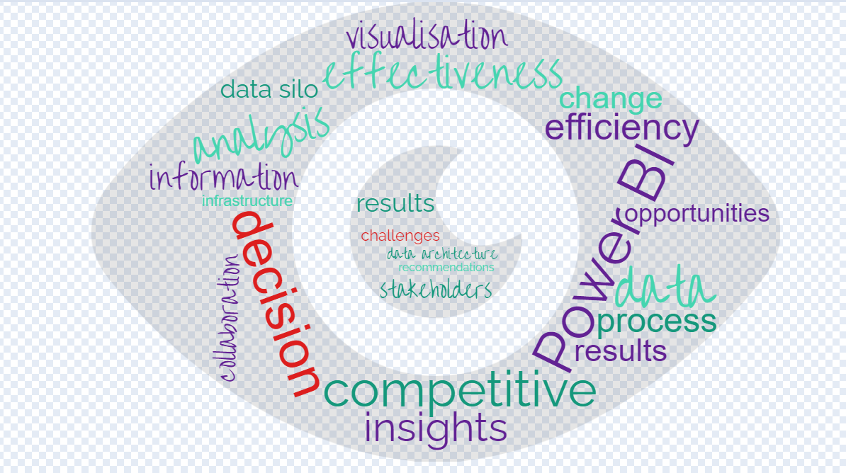
Figure 5- Word cloud (Qualitative data gathered from 5 interviews)
Based on the word frequency analysis of the qualitative data, several key themes and patterns emerge. We can note the following observations:
Decision-making and competitiveness: The high frequency of terms like "decision," "competitive," and "analysis" suggests that the participants are focused on making informed decisions and understanding the competitive landscape. This indicates that they were likely engaged in strategic planning or problem-solving activities.
Data-driven insights: The frequent occurrence of terms like "data," "effectiveness," and "insights" indicates that the participants value the use of data to drive their decision-making processes. They are interested in leveraging data to gain insights and improve the effectiveness of their strategies or actions.
Efficiency and process visualization: The term "efficiency" appearing multiple times suggests that the participants are concerned with optimizing processes and streamlining operations. The presence of "process visualization" indicates that they may be interested in visualizing and mapping out their workflows for better understanding and improvement.
Information and results: The occurrence of terms like "information" and "results" suggests that the participants are interested in obtaining and analysing relevant information and measuring the outcomes of their actions. This indicates a focus on evidence-based decision-making and a desire to track and evaluate the effectiveness of their strategies.
Data architecture and collaboration: The mention of "data architecture" and "collaboration" suggests that the participants recognized the importance of well-designed data systems and the need for collaboration among team members. This indicates an awareness of the challenges posed by data silos and a desire to promote better data sharing and integration within the organization.
Overall, the word frequency analysis suggests that the participants in the qualitative data are focused on data-driven decision-making, competitiveness, efficiency, and collaboration. They value the use of data to gain insights, improve processes, and measure results, indicating a strategic and goal-oriented mindset.

4.3 Case Study

Objective
The objective of this case study is to create a Performance Overview Report for the Chelmsford Branch of FedEx. The report aims to monitor key performance indicators (KPIs) related to scanning activities, pickup volumes, returns, and other relevant metrics. Currently, the data is stored in nine different locations, presenting a challenge of data silos. The goal is to explore how Power BI can effectively handle this data integration issue.
In the context of FedEx's Chelmsford Branch, it is crucial to have a comprehensive understanding of performance metrics to identify areas of improvement and make informed decisions. However, the data required to analyse these metrics is scattered across nine different locations, resulting in data silos. This case study aims to address this challenge using Power BI.
Methodology
Data Collection: Gather data from the nine different locations where it is currently stored. This involves extracting data from various systems, databases, spreadsheets, and other sources, cleaning the date ad mapping it (see Figure 6).

Table | Type of Table | Data Source | Dashboard Report
Contractor Data | Dimension | Excel Spreadsheets from SharePoint | Performance Overview
Returns by DEX Code | Fact | Excel Spreadsheets from SharePoint | Performance Overview
Scanning Information | Fact | eShipment_FedEx SQL Server | Performance Overview
Request To Clear | Fact | DWS SQL Server | Performance Overview
Pickup Volumes | Fact | Tibco Spotfire | Performance Overview
Scan Type | Fact | Tibco Spotfire | Performance Overview
Early Late Pickup | Fact | Tibco Spotfire | Performance Overview
Case Files | Fact | FedEx IIB Server | Performance Overview
No Van Scans | Fact | FedEx IIB32 Server | Performance Overview
Figure 6- Data and Locations of Data gathered into Power BI for the Performance Overview Report

Data Integration and modelling
The collected data is imported into Power BI using the appropriate connectors and integration methods. Ensure that the data is structured and organized in a manner that allows an easy analysis and visualization.
The data is then modelled by establishing relationships between the different datasets within Power BI. This involves identifying common fields or keys that can be used to link the data together. Proper data modelling is essential for accurate analysis and reporting (see Figure7).

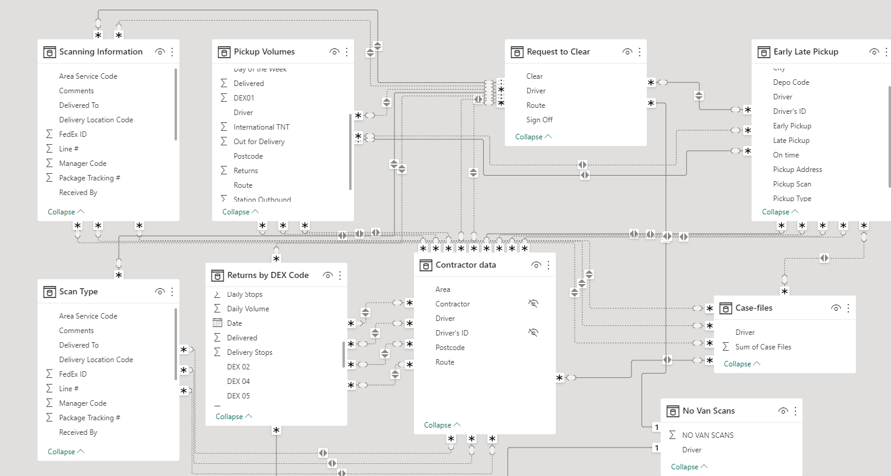
Figure 7-Dimensional Model of Dashboard Report ‘’Performance Overview Chelmsford’’

In the model above we have two types of tables: Fact Tables and Dimension tables.
Fact tables play a crucial role in organizing and storing the quantitative, measurable data that forms the foundation for analysis and reporting. Fact tables are an essential component of a star schema or snowflake schema, which are common data modelling techniques used in Power BI and other data warehouse systems.
Overall, fact tables are essential in Power BI as they provide the foundation for data analysis, enable the creation of interactive reports and visualizations, and support decision-making processes by providing insights into the quantitative aspects of a business.
The next step is to Identify the KPIs that are relevant to the Chelmsford Branch's performance. These may include metrics such as scanning accuracy, on-time delivery, pickup volumes, returns rate, and customer satisfaction. Define measures and calculations within Power BI to accurately calculate and track these KPIs.

Description of Used data:
Dimension Table: Contractor data
Fields: Area, Contractor, Driver, Driver's ID, Postcode, Route, City, County
This table contains data related to contractors, their assigned areas, drivers, driver IDs, postcodes, and routes. This is the central piece linked to each other table and will allows us to also map a territory for each route.

Fact Table: Returns by DEX Code
Fields: Daily Stops, Daily Volume, Date 2, Delivered 2, Delivery Stops, DEX 02, DEX 04, DEX 05
Provides information about returns categorized by DEX code, including the number of daily stops, volume, delivery status, and specific DEX codes associated with the returns

Fact Table: Scanning Information
Fields: Area Service Code, Comments, Delivered To, Delivery Location Code, FedEx ID, Line #, Manager Code, Package Tracking; Received By.
Captures information related to scanning activities, including details such as service codes, comments, delivery information, and tracking details.

Fact Table: Request to Clear
Fields: Clear, Driver Route, Sign Off, Log in Time; Break Time
This table captures information about requests to clear and certain activities or conditions, such as driver routes, and related sign-off details.

Fact Table: Pickup Volumes
Fields: Delivered; Collected; Driver; TNT parcels; Out for delivery; Returns; Route; Station Outbound; Postcode
Captures information about pickup and delivery volumes, and delivery performance, including related metrics and details.

Fact Table: Scan Type
Fields: Area Service Code, Comments, Delivered To, Delivery Location Code, FedEx ID, Line #, Manager Code, Package Tracking.
Provides additional information about different types of scans, including related details such as service codes, comments, delivery information, and tracking numbers.

Fact Table: Early Late Pickup
Fields: Pickup Depo Code, Driver, Driver ID, Early Pickup, On-time Pickup, Address, Pickup Scan, Pickup Type, Postcode, City, Area
Contains data related to pick up activities, including depot codes, driver information, pickup times (early, late, on-time), pickup addresses, city, and associated scans.

Fact Table: Casefiles
Fields: Driver, Case Files, Tracking Number, Issues
Provides aggregated information about casefiles, related to specific drivers and their respective case file and information on complains.

Fact Table: No Van Scans
Fields: NO VAN SCANS, Driver, Tracking Number
Captures data about scanning activities that do not involve van-scans, specifically tracking the number of scans performed by different drivers and missing scans.
Figure 8-Description of Data imported in Power BI

Visualization and Reporting
Power BI's visualization tools were utilised to create informative and visually appealing reports. Design dashboards that present the KPIs in a clear and concise manner, allowing stakeholders to easily understand the branch's performance. Interactive elements, such as filters and drill-through functionality are incorporated to enhance data exploration and analysis.
One key aspect of the report is that it consolidates data from all the databases mentioned above, eliminating data silos. The data can be imported automatically on a daily basis on a schedule or on a refresh basis whenever you want updated information. Previously the information displayed below was stored in nine different databases, in various locations making it difficult to access and analyse the data effectively. The Power BI report brings all thbis data together in a single centralised location making it easier for stakeholdersd to gain insights and to make data-driven decisions.
In the created report, ‘’Performance Overview Chelmsford’’ the main page of the report provides an overviewof key performance indicators(KPI’s) and metrics related to daily performance, returns and drivers. These indicators include metrics such as average performance, total returns, out for delivery and returns (see Figure 9).
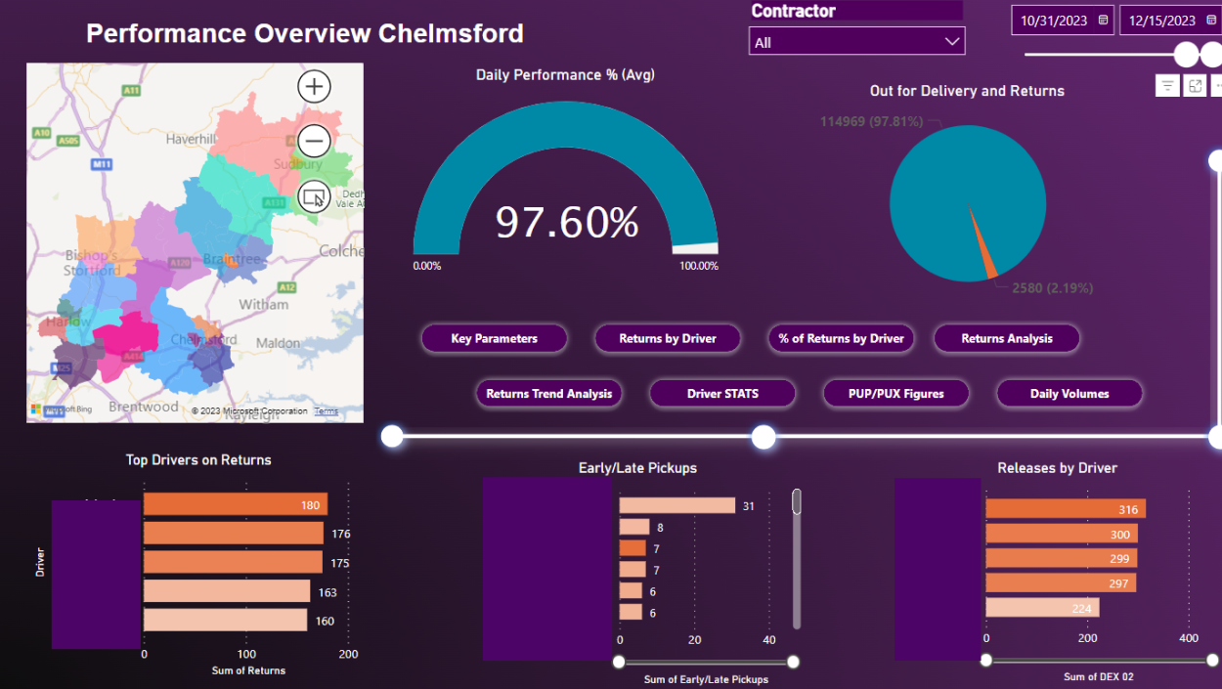
Figure 9-Performance Overview Chelmsford- Report Cover Page

The Power BI Report showcases various indicators and data related to daily performance, returns, drivers and contractors. It provides a comprehensive overview of the performance metrics and allows users to drill down into specific details for further analysis. All report pages also include a map that is linked to the indicators based on the postcode, driver and contractor.
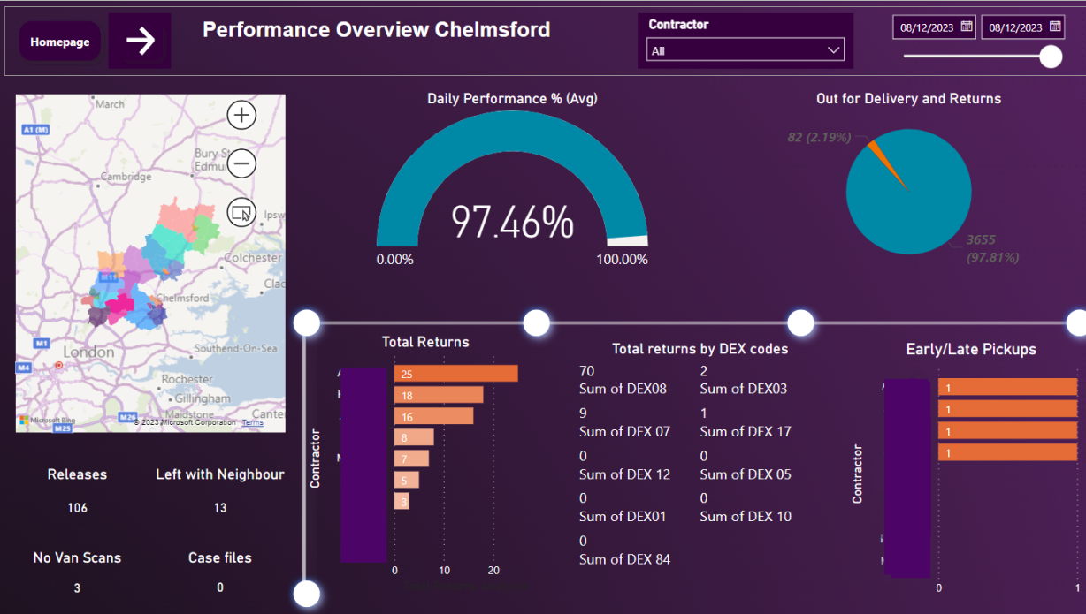
Figure 10-Performance Overview Chelmsford- In depth Report Page

Data Silo Mitigation: it is easy to observe that Power BI can tackle the data silo problem by integrating data from multiple sources into a single platform. It showcases the benefits of having a centralized and unified view of data, enabling holistic analysis and reporting.
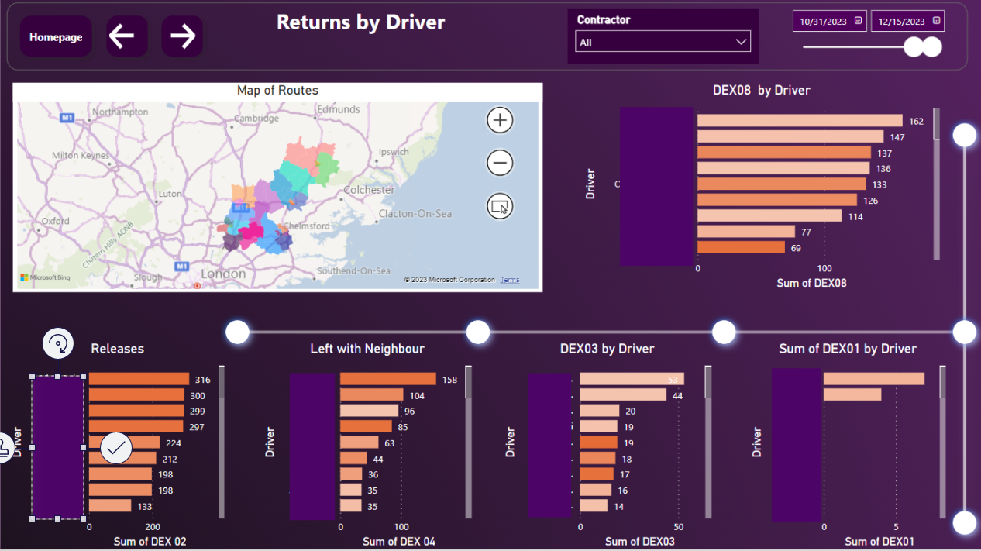Figure 11-Returns by Driver- Rolling in Report page from ‘’Performance Overview Chelmsford’’
With the Drill Functionality users can explore the data in more detail. They can click on specific indicators or data points to drill down and view more granular information. For example, clicking on a specific driver or contractor will display detailed performance metrics and returns associated with them and will also visually pinpoint on the map the exact location on which those metrics were achieved.
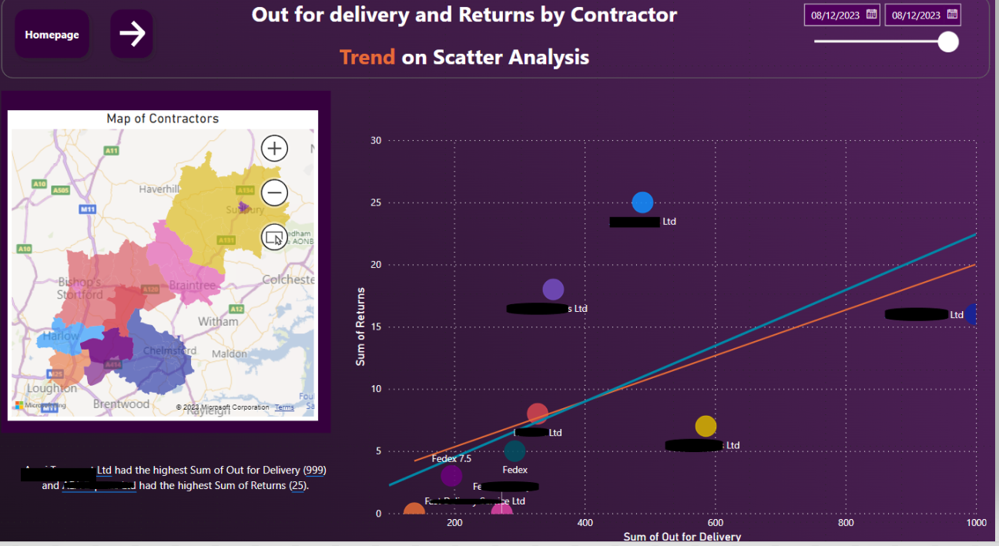
Figure 12- Scatter analysis on out for Delivery and Returns by Contractor- In depth Report Page
Also users can utilise the Select Function to see information on a specific driver, contractor or a specific parameter they want to analyse. This functionality enables users to focus on specific subsets of data and analyse their performance on eny given parameter in more depth ( see Figure 13).
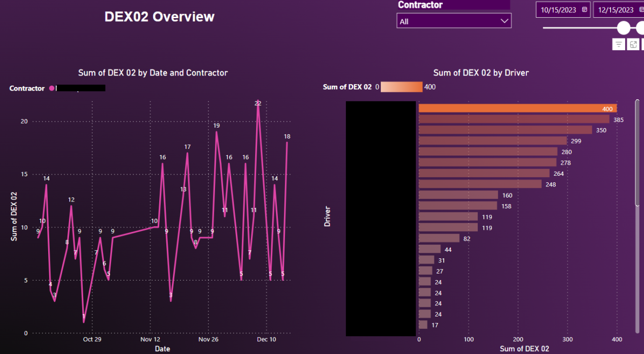
Figure 13 In-depth report Selection on DEX2 KPI Indicator
The map visualisation in the report is linked to the indicators based on driver, covered area, contractor and postcode for each tracking number. Users can interact with the map to view performance, or any other metrics based on the geographical location. This feature provides a visual representation of the data and helps to identify any regional patterns or trends (see Figure 14)
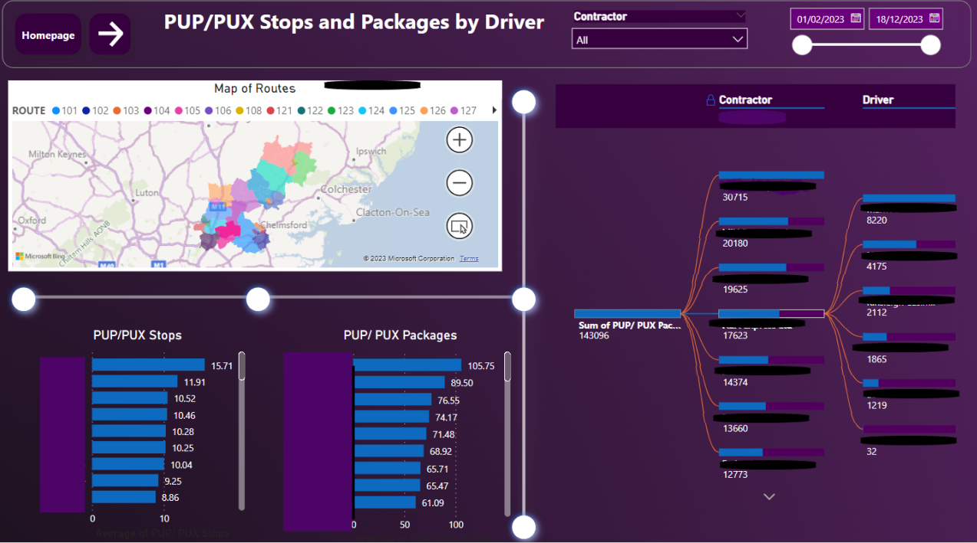
Figure 14-Stops and Packages by Driver/Contractor-In Depth Report
Validation and publication Process
Throughout the case study of the Power BI report at FedEx, a validation and publication process was implemented to ensure that stakeholders were actively involved and provided feedback throughout the creation process.
The validation phase involved regular communication and engagement with stakeholders. Throughout the development process, stakeholders were kept informed of the progress and updates regarding the report. They were also regularly enquired to offer feedback on the report. This feedback could include suggestions for improvements, requests for additional data or visualizations, or any other input that would enhance the report's effectiveness and usefulness. By actively seeking feedback, the project team at FedEx ensured that the report was aligned with the needs and expectations of the stakeholders.
The feedback received from stakeholders played a crucial role in refining the report over time. The project team carefully considered the feedback and incorporated relevant changes and enhancements into subsequent iterations of the report. This iterative process allowed for continuous improvement and ensured that the final version of the report was both accurate and impactful.
The publication phase involved finalizing the report based on the feedback and validation received. Once the report was finalized, it was published and made accessible to the stakeholders. The publication process involved determining the appropriate distribution channels and ensuring that the report was easily accessible to the intended audience. This could involve sharing the report through a secure online platform, distributing it via email, or presenting it in meetings or presentations.
The validation and publication process in the Power BI report at FedEx was a collaborative and iterative approach. It allowed for stakeholders to be actively involved throughout the creation process, ensuring that their feedback was incorporated, and the report was refined over time. This approach resulted in a final report that effectively presented the necessary data and met the requirements and expectations of the stakeholders.
Conclusion
Overall, the Performance Overview Report created for the Chelmsford Branch in Power BI demonstrates the effectiveness of the tool in addressing the challenge of data silos. By integrating data from multiple sources into a single platform, Power BI provides a comprehensive view of key performance indicators related to scanning activities, pickup volumes, returns, and other relevant metrics. This enables stakeholders to make informed decisions and drive improvements in performance.
The case study highlights the importance of data integration and the role of Power BI in overcoming data silos for enhanced business intelligence and decision-making.

Chapter 5. Conclusion and Recommendations

In conclusion, this thesis has explored the implementation and impact of leveraging Power BI at FedEx, focusing on its role in enhancing data management and decision-making processes within the company. The findings of this research highlight the significant benefits and potential of Power BI in improving operational efficiency, optimizing resource allocation, and driving strategic decision-making at FedEx.
Through an extensive review of literature and an in-depth analysis of FedEx's implementation of Power BI, it has been established that the integration of this powerful business intelligence tool has enabled the company to transform its data into actionable insights. Power BI's intuitive interface and robust analytical capabilities have allowed FedEx to gather, visualize, and analyse vast amounts of data from various sources in real-time. This has facilitated a more efficient and accurate decision-making process, enabling FedEx to respond swiftly to changing market demands and make informed strategic choices.
Firstly, the research findings indicate that the implementation of Power BI has had a positive impact on FedEx by enhancing its overall operational efficiency. By automating data collection, processing, and reporting, Power BI has streamlined routine tasks and reduced manual errors, resulting in time and resource savings. This has allowed FedEx to allocate its resources more effectively and efficiently, ultimately improving its operational performance.
Secondly, the research has highlighted the role of Power BI in transforming FedEx's decision-making processes. The intuitive interface and robust analytical capabilities of Power BI have enabled FedEx to gather, visualize, and analyse vast amounts of data from various sources in real-time. This has facilitated a more informed and data-driven decision-making process, empowering FedEx to respond swiftly to changing market demands and make strategic choices based on accurate insights.
Furthermore, the research has shed light on how Power BI can improve data management and eliminate data silos at FedEx. By providing interactive dashboards and visualizations, Power BI has enabled employees at all levels of the organization to access and interpret data easily. This has fostered a data-driven culture within FedEx, where individuals are empowered to make data-informed decisions and collaborate more effectively across departments. Additionally, Power BI has facilitated the integration of data from different sources, breaking down data silos and enabling a more comprehensive and holistic view of the business.
In conclusion, the findings of this dissertation thesis demonstrate the significant impact of Power BI on FedEx. The implementation of Power BI has improved operational efficiency, enhanced decision-making processes, and promoted effective data management within the company. This research has highlighted the broader implications of leveraging Power BI in the logistics and transportation industry and not only. The findings indicate that the use of Power BI can enable companies to identify patterns, trends, and anomalies in data, leading to more accurate demand forecasting, optimized route planning, and improved customer service. This demonstrates the significant potential of Power BI in driving innovation and competitiveness within the industry.
However, it is essential to acknowledge the limitations of this research. The study focused solely on the implementation of Power BI at FedEx and did not explore the challenges or limitations associated with its adoption. Further research is needed to investigate potential barriers and best practices for implementing Power BI in similar organizations.
Looking ahead, there are several avenues for future research in this field. Firstly, exploring the long-term impact of Power BI on key performance indicators and financial metrics at FedEx would provide valuable insights into its overall effectiveness and return on investment. Additionally, investigating the potential integration of Power BI with other emerging technologies, such as artificial intelligence and machine learning, could unlock new opportunities for data analysis and decision-making in the logistics industry.
In conclusion, this thesis has demonstrated the significance of leveraging Power BI at FedEx in enhancing data analysis and decision-making processes and its significant impact on the data silo. The findings emphasize the transformative impact of Power BI in optimizing operational efficiency, improving resource allocation, and driving strategic choices within the company. By harnessing the power of data through Power BI, FedEx has positioned itself at the forefront of innovation in the logistics industry, setting a benchmark for other organizations to follow.

Glossary

BI-Business Intelligence
BIS - Business Intelligence System
DAX - Data Analysis Expressions
DSS - Decision Support Systems
DW - Data Warehouse
IoT - Internet of Things
KPIs - Key Performance Indicators
RBAC -role-based access controls

Bibliography
Abai, N. et al., 2019. Integrating Business Intelligence and Analytics in Managing Public Sector Performance: An Empirical Study. International Journal on Advanced Science, Engineering and Information Technology, 9(1), pp. 172-180.
Antunes, A., Cardoso, L. & Barateiro, J., 2022. Incorporation of Ontologies in Data Warehouse/Business Intelligence Systems - A Systematic Literature Review. International Journal of Information Management Data Insight, 2(2), pp. 1-16.
Apraksin, D., Stylianou, E. & Shcherbinin, N., 2018. Business Intelligence and Learning Analytics as Contributors to a Data Driven Education Industry. International Conference on Engineering Technologies and Computer Science (EnT), pp. 11-13.
Aspin, A., 2014. High Impact Data Visualization with Power View, Power Map, and Power BI. s.l.:Apress.
Baruti, R., 2023. Analysis and Implementation of a Business Intelligence Application for Logistic and Procurement Management, Torino: Politecnico di Torino.
Bosman, L., Magana, A. & Kotla, B., 2022. Promoting Evidence-Based Decision Making Practices to Develop the Entrepreneurial Mindset Enabled by Microsoft Power BI Desktop. IEEE Frontiers in Education Conference (FIE), 29 November.
Canvas Intelligence, 2023. Major benefits of Microsoft Power BI. [Online]
Available at: https://www.canvasintelligence.com/major-benefits-of-microsoft-power-business-intelligence-bi/
[Accessed 12 October 2023].
Carruthers, A., 2022. Breaking Data Silos. In: Building the Snowflake Data Cloud-Monetizing and Democratizing Your Data. s.l.:Apress, Berkeley, CA, pp. 29-50.
Ciuriak, D., 2019. “Unpacking the Valuation of Data in the Data-Driven Economy, s.l.: SSRN.
DAX Patterns, 2023. DAX Patterns. [Online]
Available at: https://www.daxpatterns.com/
[Accessed 11 October 2023].
Duarte, F., 2023. Amount of Data Created Daily. [Online]
Available at: https://explodingtopics.com/blog/data-generated-per-day
[Accessed 10 October 2023].
Dytha, B. & Taufik, T., 2023. Risk Analysis using Risk Failure Mode and Effect in Implementation of Integrated Digital Reporting with Power BI Dashboard. s.l., International Conference on Management of Technology, Innovation, and Project, 2023.
Edgar, K., 2018. Inproving company performance through implementation of Business Intelligence Tools. [Online]
Available at: https://www.theseus.fi/handle/10024/149082
[Accessed 15 October 2023].
Eliacik, E., 2021. Business Intelligence trends for the ''New Normal''. [Online]
Available at: https://dataconomy.com/2022/04/12-business-intelligence-trends-2022/
[Accessed 01 September 2022].
FedEx Corporation, 2023. FedEx, 2023 Annual Report. [Online]
Available at: https://s21.q4cdn.com/665674268/files/doc_financials/2023/ar/419404-1-_10_FedEx_AR_WR.pdf
[Accessed 21 August 2023].
FedEx Corporation, 2023. Innovation & technology policy perspectives. [Online]
Available at: https://www.fedex.com/en-us/about/policy/technology-innovation.html
[Accessed 28 August 2023].
FedEx, 2023. FedEx, Company structure and Facts. [Online]
Available at: https://www.fedex.com/en-us/about/company-structure.html
[Accessed 01 August 2023].
Forbes, 2016. Leading The Future Of Customer Experience With FedEx Express. [Online]
Available at: https://www.forbes.com/sites/blakemorgan/2016/11/09/leading-the-future-of-customer-experience-with-fedex-express/?sh=6c1cb55f468b
[Accessed 28 August 2023].
Heinze, J., 2014. History of Business Intelligence. [Online]
Available at: http://www.bisoftwareinsight.com/history_of_business_intelligence/
[Accessed 12 October 2023].
IBM, 2022. IBM statystics. [Online]
Available at: https://myibm.ibm.com/products-services/manage/508859189/downloads
[Accessed 02 September 2022].
Ihsanul , W. & Widsyasari, Y., 2022. Improving Company Performance by The Correctness of Management Decision through Implementation Dashboard using Power BI Tools (Case Study at Company Y), Malang, Indonesia: International Conference on Education and Technology (ICET).
Janiesch, C., Zschech, P. & Heinrich, K., 2021. “Machine learning and deep learning. Electronic Markets, pp. 1-11.
Lago, C., 2018. 150 years of business intelligence: A brief history. [Online]
Available at: https://www.cio.com/article/221963/history-of-business-intelligence.html
[Accessed 12 October 2023].
Likert, R., 1932. A technique for the measurement of attitudes. Archives of Psychology, 22(140), p. 55.
Luhn, H., 1958. A Business Intelligence System. IBM Journal of research and development, 2(4), pp. 314-318.
Marr, B., 2018. How Much Data Do We Create Every Day? The Mind-Blowing Stats Everyone Should Read. [Online]
Available at: https://www.forbes.com/sites/bernardmarr/2018/05/21/how-much-data-do-we-create-every-day-the-mind-blowing-stats-everyone-should-read/?sh=6760090460ba
[Accessed 10 October 2023].
Merendino, A. et al., 2018. Big data, big decisions: The impact of big data on board level decision-making. Journal of Business Research, pp. 67-78.
Merendino, A. et al., 2018. Big data, big decisions: The impact of big data on board level decision-making. Journal of Business Research, Volume 93, pp. 67-78.
Microsoft Power BI, 2023. Data Connectivity with Power BI. [Online]
Available at: https://powerbi.microsoft.com/en-us/connectors/
[Accessed 12 October 2023].
Microsoft Power BI, 2023. Interactive Reports in Power BI. [Online]
Available at: https://learn.microsoft.com/en-us/power-bi/consumer/end-user-reports
[Accessed 12 October 2023].
Microsoft Power BI, 2023. Microsoft Power BI-Turn your data into immediate impact. [Online]
Available at: https://powerbi.microsoft.com/en-us/
[Accessed 11 October 2023].
Microsoft Power BI, 2023. MicrosoftAssessments. [Online]
Available at: https://learn.microsoft.com/en-us/assessments/browse/?page=1&pagesize=30
[Accessed 12 October 2023].
Microsoft Power BI, 2023. Natural Language Query (Q&A) in Power BI. [Online]
Available at: https://learn.microsoft.com/en-us/power-bi/collaborate-share/service-transform-data
[Accessed 12 October 2023].
Microsoft Power BI, 2023. Power BI implementation planning: Security. [Online]
Available at: https://learn.microsoft.com/en-us/power-bi/guidance/powerbi-implementation-planning-security-overview
[Accessed 12 October 2023].
Microsoft Power BI, 2023. What is the Power BI Service. [Online]
Available at: https://learn.microsoft.com/en-us/power-bi/fundamentals/power-bi-service-overview
[Accessed 12 October 2023].
Mikalef, P. & Gupta, M., 2021. Artificial intelligence capability: Conceptualization,measurement calibration, and empirical study on its impact on organizational creativity and firm performance. Information & Management, p. 103434.
Mikalef, P., Pappas, I. O., Krogstie, J. & Giannakos, M., 2018. “Big data analytics capabilities: a systematic literature review and research agenda. Information Systems and e-Business Management, pp. 547-578.
Olszak, C., 2016. Toward Better Understanding and Use of Business Intelligence in Organizations. Information systems management, 33(2), pp. 105-123.
Palma-Ruiz, J., Torres-Toukoumidis, A. & Gonzalez-Moreno, S., 2022. An overview of the gaming industry across nations: using analytics with power BI to forecast and identify key influencers. Heliyon, Volume 8, pp. 1-10.
Rafif, M. F., 2019. Comparison Study of the Development of Serf-Service Business Intelligence between Power BI and Tableau Desktop( Case Study: Microsoft Adventure Works ), Yogyakarta: Industrial Engineering.
Romero, C., Ortiz, J., Khalaf, O. & Prado, A., 2021. Business Intelligence Business Evolution after Industry 4.0.. Sustainability, 13(18), pp. 1-12.
Schmidt-Subramanian, M., 2014. The Business Impact Of Customer Experience. [Online]
Available at: https://www.medallia.com/wp-content/uploads/pdf/resources/Forrester-Business-Impact-of-CX-2014.pdf
[Accessed 10 October 2023].
Shmueli, G. & Koppius, O. R., 2011. Predictive analytics in information systems research. MIS quarterly, pp. 553-580.
Stedman Craig, 2021. Data Management -What is data architecture?. [Online]
Available at: https://www.techtarget.com/searchdatamanagement/definition/data-silo
[Accessed 11 October 2023].
Sujitparapitaya, S., Shirani, A. & Roldan, M., 2012. Issues in Information Systems. 13(2), pp. 110-120.
Wang, J., Zhang, W., Shi, Y. & Liu, J., 2018. Industrial Big Data Analytics: Challenges, Methodologies, and Applications. Cornell University, 13 October.
Wilder-James, E., 2016. Breaking Down Data Silos-Analytics And Data Science. Harvard Business Review , 05 December, pp. 1-5.
Wise, J., 2023. How much data is created every day in 2023. [Online]
Available at: https://earthweb.com/how-much-data-is-created-every-day/
[Accessed 10 October 2023].

Appendix 1. Transcribed Interview with Regional Manager
- How has the implementation of Power BI affected decision-making processes within your department/organization?
The implementation of Power BI has had a significant impact on decision-making processes within our organization. It has provided us with real-time access to relevant data and insights, allowing us to make more informed and timely decisions. Power BI has streamlined the data analysis process, enabling us to quickly identify trends, patterns, and outliers that influence our decision-making. This has resulted in faster and more accurate decision-making, leading to improved operational efficiency.
- Can you provide examples of specific decisions that have been influenced or improved by using Power BI?
One specific example of a decision influenced by Power BI is our route optimization strategy. With Power BI, we can analyse historical data on package volumes, delivery times, and traffic patterns to identify the most efficient routes for our drivers. This has helped us reduce delivery times, minimize fuel consumption, and improve overall customer satisfaction.
- How has the availability and accessibility of data changed since the implementation of Power BI?
The availability and accessibility of data have greatly improved since the implementation of Power BI. Previously, accessing and analysing data involved manual processes and multiple data sources. With Power BI, we have centralized our data into a single dashboard, making it easily accessible to all relevant stakeholders. We had to work to create our data architecture to manage to sync all the gathered data within our organisation into a single mainframe. This has saved us valuable time and improved data visibility across the organization. Now, anyone in the organization can access and analyse the data they need without relying on IT or data analysts.
- In what ways has Power BI enhanced data visualization and reporting capabilities for decision-making purposes?
Power BI has enhanced our data visualization and reporting capabilities in several ways. The interactive dashboards and visualizations allow us to present complex data in a clear and concise manner. We can create customized reports and share them with stakeholders, enabling them to gain a deeper understanding of the data and take appropriate actions. Especially when it comes to regional management where we deal directly with our contractors. We can now present our KPIs to them, explain how and where they are failing to meet them. Where they need to improve specifically. The ability to drill down into specific data points on a specific contractor or a specific driver and visualize data trends has improved our ability to identify insights and make data-driven decisions.
- How has Power BI facilitated collaboration and information sharing among different departments/teams?
Power BI has facilitated collaboration and information sharing among different departments and teams. The ability to share dashboards and reports with specific individuals or groups has improved cross-functional communication and alignment. For example, with the implementation of the maps that are linked with our deliveries based on each contractor and driver we can now communicate better with our sales teams. We can provide better insights into what areas we need to cover better locally. We can pinpoint exactly how saturated a specific area or postcode is. We can collaborate on data analysis, share insights, and work together to drive meaningful actions based on the data. Our operations team is now able to collaborate with our sales team to analyse customer demand data and optimize our delivery and pick up processes accordingly.
- Have you observed any improvements in data accuracy and reliability since the implementation of Power BI? Can you provide examples?
Yes, we have observed significant improvements in data accuracy and reliability since the implementation of Power BI. By automating data collection and integrating different data sources, we have reduced the chances of human error and data discrepancies. For example, our inventory management data is now automatically synced with Power BI, ensuring accurate and up-to-date inventory levels. This has helped us avoid stockouts and minimize inventory holding costs.
- How well has Power BI integrated with existing data management systems and processes? Have there been any challenges or difficulties in this integration?
Power BI has integrated well with our existing data management systems and processes. However, there were initial challenges in integrating some legacy systems and data sources. We had to work closely with our IT team to ensure proper data integration and resolve compatibility issues. Overall, the integration process was successful, and Power BI now almost seamlessly integrates with our data management systems. This has allowed us to leverage our existing data infrastructure and maximize the value of Power BI.
- In what ways has Power BI improved the ability to make data-driven decisions in your daily work?
Power BI has improved our ability to make data-driven decisions in our daily work by providing real-time insights and visualizations. We can now monitor key performance indicators (KPIs) in real-time and quickly identify areas for improvement. For example, we can track our on-time delivery performance and identify any bottlenecks in our operations. This empowers us to take proactive actions and make data-driven decisions to improve operational efficiency.
- Can you share any specific examples of how Power BI has positively impacted operational efficiency within your department/organization?
Of course. Power BI has positively impacted operational efficiency within our organization in several ways. For instance, it has streamlined our package tracking process by providing real-time visibility into the status and location of packages. This has helped us proactively address any issues, such as delays or misplacements, and improve overall customer satisfaction. Additionally, Power BI has enabled us to analyse data on driver performance, route optimization, and fuel consumption, leading to more efficient operations and cost savings. Where data was scattered across several locations depending on each specific indicator and encoded in term of driver only, we can now manage that data all these indicators at once, on contractor, area, postcode or driver by simply selecting what information we want to see. Where in at first, I was only able to hold meeting with our contractors once per quarter.
- Overall, how satisfied are you with the impact of Power BI on decision-making processes and data management?
Overall, we are highly satisfied with the impact of Power BI on decision-making processes and data management. It has transformed the way we analyse and utilize data, leading to more informed and effective decision-making. The availability of real-time insights, improved data visualization, and enhanced collaboration capabilities have significantly contributed to our operational efficiency. Power BI has become an integral part of our data architecture and decision-making processes.

Appendix 2: Transcribed Interview with Data Assurance manager involved in Power BI implementation

- Can you provide an overview of the rationale behind implementing Power BI at FedEx? What were the main drivers and goals?
The rationale behind implementing Power BI at FedEx was to improve data analysis capabilities, enhance decision-making processes, and enable data-driven insights across the organization. The main drivers were the need for real-time reporting, improved data visualization, and the ability to consolidate data from various sources into a single platform. The goals included increasing operational efficiency, identifying cost-saving opportunities, and enhancing overall business performance.
- How has the implementation of Power BI helped address the issue of data silos within FedEx? Can you share any specific examples or success stories?
The implementation of Power BI has significantly addressed the issue of data silos within FedEx. Previously, different departments had their own data sources and reporting tools, which made it challenging to gain a holistic view of the organization's data. With Power BI, we were able to integrate and consolidate data from various sources into one centralized platform. This has enabled cross-functional analysis, improved data sharing, and facilitated collaborative decision-making. For example, the finance and operations teams can now easily access and analyse sales data in real-time, leading to more accurate forecasting and inventory management.
- What were the major challenges faced during the implementation of Power BI? How were these challenges overcome?
One of the major challenges faced during the implementation of Power BI was data integration from legacy systems and different data formats. We had to ensure that the data from various sources could be seamlessly merged and transformed into a compatible format for Power BI. Additionally, ensuring data accuracy and quality was a significant challenge. To overcome these challenges, we conducted a thorough data analysis and cleansing process, worked closely with the IT team to develop data connectors and transformations, and implemented data governance practices to maintain data integrity.
Follow up Q: Can you tell me more about the challenges you faced during the implementation?
Of course, we encountered several major challenges.
Data Integration from various sources was one of the primary ones. FedEx has multiple systems and databases, each with its own data structure and format. Ensuring that the data could be seamlessly merged and transformed into a compatible format for Power BI was a complex task. We had to work closely with the IT team to develop data connectors and transformations to overcome this challenge.
Data Quality and Accuracy: Another significant challenge was ensuring the quality and accuracy of the data in Power BI. Data from different sources often contained inconsistencies, duplicates, or missing values, which could impact the reliability of the reports and analysis. We had to conduct a thorough data analysis and cleansing process to address these issues and establish data governance practices to maintain data integrity.
Compatibility with Existing Systems: Assessing the compatibility of Power BI with existing systems and technologies was a challenge. We had to evaluate the technical requirements and capabilities of Power BI and compare them with our existing systems. Compatibility testing was conducted to identify and address any compatibility issues. Close collaboration with the IT team and software vendors helped ensure a smooth integration.
Scalability and Performance: As the usage of Power BI grew across different departments and teams, ensuring scalability and optimal performance became a challenge. Power BI relies on data processing and rendering capabilities, and larger datasets or complex reports could impact performance. We had to optimize data models, implement data caching strategies, and work closely with the IT team to allocate sufficient resources to support the growing usage of Power BI.
And as always there was the human factor. We are all resistant to change. Getting employees to adopt and effectively use Power BI was a challenge. Some employees were accustomed to using different reporting tools or manual processes, and there was resistance to change. We had to invest in effective communication and change management strategies to educate employees about the benefits of Power BI and address any concerns or resistance. Regular training sessions and workshops were conducted to enhance employees' understanding and proficiency in using Power BI.
- How was the compatibility of Power BI with existing systems and technologies at FedEx assessed and ensured?
The compatibility of Power BI with existing systems and technologies at FedEx was assessed through a comprehensive evaluation process. We analysed the technical requirements and capabilities of Power BI, compared it with our existing systems, and conducted compatibility testing. We also worked closely with the IT team and software vendors to address any compatibility issues and ensure a smooth integration.
- What security measures were put in place to protect sensitive data and ensure data privacy when using Power BI?
To protect sensitive data and ensure data privacy when using Power BI, several security measures were implemented. Access to Power BI was restricted based on role-based permissions, ensuring that only authorized individuals could access specific data and reports. Data encryption techniques were employed to secure data in transit and at rest. Regular security audits and monitoring were conducted to identify and mitigate any potential vulnerabilities. Additionally, data masking and anonymization techniques were implemented to ensure compliance with data privacy regulations.
- How was the deployment process of Power BI carried out within FedEx? Were there any specific strategies or best practices followed?
The deployment process of Power BI at FedEx followed a phased approach. We started with a pilot project in a specific department to test the functionality and gather feedback. Based on the pilot's success, we gradually expanded the deployment to other departments and teams. Best practices such as conducting user training sessions, providing documentation and support materials, and establishing a dedicated support team were followed to ensure a smooth deployment and adoption process
- What were the key factors that contributed to the successful adoption of Power BI among the employees at FedEx?
Several key factors contributed to the successful adoption of Power BI among employees at FedEx. First, senior leadership support and sponsorship played a crucial role in driving adoption and creating a data-driven culture. Second, effective communication and change management strategies were employed to educate employees about the benefits of Power BI and address any concerns or resistance. Third, regular training sessions and workshops were conducted to enhance employees' understanding and proficiency in using Power BI. Lastly, the availability of a dedicated support team and continuous improvement efforts helped address any technical issues promptly and ensure a positive user experience.
- How was the training and support provided to employees to enhance their understanding and usage of Power BI?
Training and support were provided through a combination of in-person training sessions, online tutorials, and documentation. We conducted hands-on workshops to familiarize employees with the Power BI interface, data visualization techniques, and report creation. We also created a knowledge base and support portal where employees could access tutorials, FAQs, and troubleshooting guides. Additionally, a helpdesk was established to provide personalized support and address any specific queries or challenges faced by users.
- Can you share any insights or lessons learned from the deployment and adoption of Power BI at FedEx?
Through the deployment and adoption of Power BI at FedEx, we gained several insights and lessons learned. It is crucial to involve key stakeholders from different departments early in the process to gather requirements and ensure alignment with business needs. Proper data governance practices, including data quality management and metadata management, are essential for maintaining data integrity and accuracy. Regular communication and training are necessary to drive user adoption and maximize the benefits of Power BI. Lastly, continuous monitoring and evaluation of the Power BI implementation help identify areas for improvement and optimize the platform's usage.
- Looking ahead, what are the future plans and strategies for further leveraging Power BI at FedEx?
Looking ahead, the future plans and strategies for further leveraging Power BI at FedEx include expanding the usage of advanced analytics features, such as predictive modelling and machine learning, to gain deeper insights and enable proactive decision-making. We also aim to integrate Power BI with other business intelligence tools and technologies to create a comprehensive analytics ecosystem. Additionally, there are plans to further enhance data governance practices and establish data driven KPIs to measure the impact of Power BI on business performance.

Appendix 3- Survey Results
To what extent do you agree that the implementation of Power BI has positively impacted decision-making processes at FedEx? | How effectively has Power BI improved the availability and accessibility of data for decision-making in your department? | To what extent do you agree that Power BI has enhanced the speed and efficiency of decision-making at FedEx? | How well does Power BI support data visualization and reporting capabilities for decision-making purposes? | To what extent has Power BI facilitated collaboration and information sharing among different departments in the logistics area at FedEx? | How effectively has Power BI addressed data silos within your department or organization? | To what extent do you agree that Power BI has improved data accuracy and reliability for decision-making purposes? | How well does Power BI integrate with existing data management systems and processes at FedEx? | To what extent has Power BI improved your ability to make data-driven decisions in your daily work? | To what extent has the implementation of Power BI positively imp acted the operational efficiency of FedEx? | Overall, how satisfied are you with the impact of Power BI on decision-making and data silo management at FedEx?
3 | 3 | 3 | 4 | 4 | 4 | 4 | 3 | 3 | 4 | 4
4 | 4 | 4 | 4 | 4 | 4 | 4 | 3 | 3 | 4 | 4
4 | 4 | 4 | 4 | 4 | 4 | 4 | 4 | 4 | 4 | 4
4 | 4 | 4 | 4 | 4 | 4 | 4 | 4 | 4 | 4 | 4
4 | 4 | 4 | 4 | 4 | 4 | 4 | 4 | 4 | 4 | 4
4 | 4 | 4 | 4 | 4 | 4 | 4 | 4 | 4 | 4 | 4
4 | 4 | 4 | 4 | 4 | 4 | 4 | 4 | 4 | 4 | 4
4 | 4 | 4 | 4 | 4 | 4 | 4 | 4 | 4 | 4 | 4
4 | 4 | 4 | 4 | 4 | 4 | 4 | 4 | 4 | 4 | 4
4 | 4 | 4 | 4 | 4 | 4 | 4 | 4 | 4 | 4 | 4
3 | 3 | 3 | 4 | 4 | 4 | 4 | 3 | 3 | 4 | 4
4 | 4 | 4 | 4 | 4 | 4 | 4 | 3 | 3 | 4 | 4
4 | 4 | 4 | 4 | 4 | 4 | 4 | 3 | 3 | 4 | 4
4 | 4 | 4 | 5 | 4 | 4 | 4 | 4 | 4 | 4 | 4
4 | 4 | 4 | 5 | 4 | 4 | 4 | 4 | 4 | 4 | 4
4 | 4 | 4 | 5 | 4 | 4 | 4 | 4 | 4 | 4 | 4
4 | 4 | 4 | 5 | 4 | 4 | 4 | 4 | 4 | 4 | 4
4 | 4 | 4 | 5 | 4 | 4 | 4 | 4 | 4 | 4 | 4
3 | 4 | 4 | 5 | 4 | 5 | 4 | 3 | 3 | 4 | 4
5 | 4 | 4 | 5 | 4 | 5 | 4 | 4 | 4 | 4 | 4
5 | 5 | 5 | 5 | 4 | 5 | 5 | 5 | 4 | 4 | 4
5 | 5 | 5 | 5 | 5 | 5 | 5 | 5 | 4 | 5 | 5
5 | 5 | 5 | 5 | 5 | 5 | 5 | 5 | 5 | 5 | 5
5 | 5 | 5 | 5 | 5 | 5 | 5 | 5 | 5 | 5 | 5
3 | 4 | 4 | 5 | 5 | 5 | 5 | 5 | 5 | 5 | 5
5 | 5 | 5 | 5 | 5 | 5 | 5 | 5 | 5 | 5 | 5
5 | 5 | 5 | 5 | 5 | 5 | 5 | 5 | 5 | 5 | 5
5 | 5 | 5 | 5 | 5 | 5 | 5 | 5 | 5 | 5 | 5
5 | 5 | 5 | 5 | 5 | 5 | 5 | 5 | 5 | 5 | 5
5 | 5 | 5 | 5 | 5 | 5 | 5 | 5 | 5 | 5 | 5
3 | 4 | 4 | 5 | 4 | 5 | 5 | 4 | 5 | 5 | 5
5 | 5 | 5 | 5 | 4 | 5 | 5 | 4 | 5 | 5 | 5
5 | 5 | 5 | 5 | 4 | 5 | 5 | 4 | 5 | 4 | 5
5 | 5 | 5 | 5 | 4 | 4 | 5 | 4 | 5 | 4 | 5
5 | 5 | 5 | 5 | 4 | 4 | 5 | 4 | 5 | 4 | 5
5 | 5 | 4 | 5 | 4 | 4 | 5 | 4 | 5 | 4 | 5
5 | 5 | 4 | 5 | 4 | 4 | 5 | 4 | 4 | 4 | 4
4 | 4 | 4 | 5 | 4 | 4 | 4 | 4 | 4 | 4 | 4
5 | 4 | 4 | 5 | 4 | 4 | 4 | 3 | 4 | 4 | 4
4 | 4 | 4 | 5 | 4 | 4 | 4 | 3 | 4 | 4 | 4
4 | 4 | 4 | 5 | 4 | 4 | 4 | 3 | 4 | 4 | 4
4 | 4 | 4 | 5 | 4 | 4 | 4 | 3 | 4 | 4 | 4
4 | 4 | 4 | 5 | 4 | 4 | 4 | 4 | 4 | 4 | 4
4 | 4 | 4 | 5 | 4 | 4 | 4 | 4 | 4 | 4 | 4
4 | 4 | 4 | 5 | 4 | 4 | 4 | 4 | 4 | 4 | 4
4 | 4 | 4 | 5 | 4 | 4 | 4 | 4 | 4 | 4 | 4
4 | 4 | 4 | 5 | 4 | 4 | 4 | 4 | 4 | 4 | 4
4 | 4 | 4 | 5 | 4 | 4 | 4 | 4 | 5 | 4 | 4
4 | 4 | 4 | 5 | 4 | 4 | 4 | 4 | 4 | 4 | 4
4 | 4 | 4 | 5 | 4 | 4 | 4 | 4 | 5 | 4 | 5

Appendix 4. Permission to Conduct Research

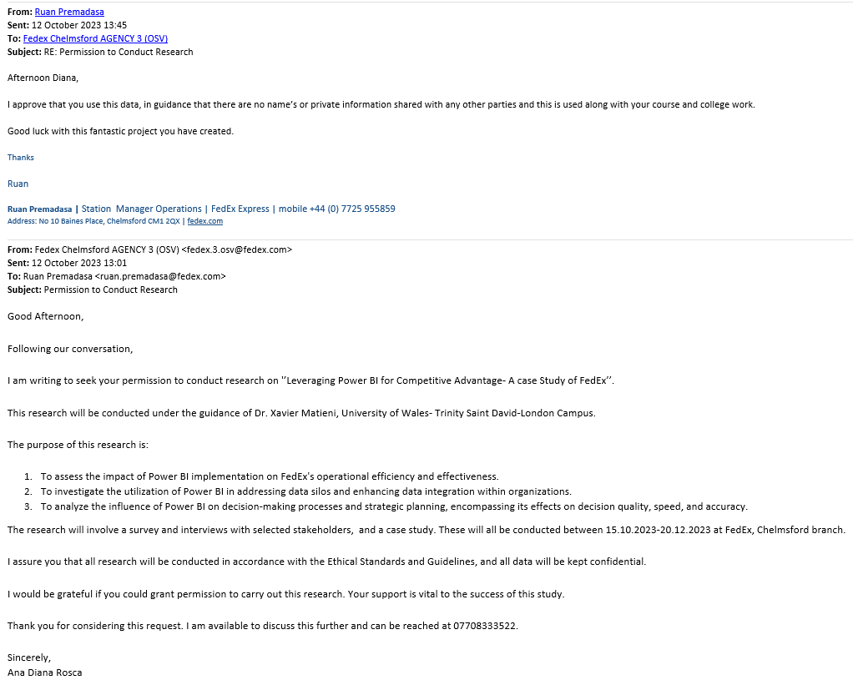

Appendix 5. PG2 / E1 Form


PG2 / E1 FORM

APPLICATION FOR ETHICAL APPROVAL

In order for research to result in benefit and minimise risk of harm, it must be conducted ethically. A researcher may not be covered by the University’s insurance if ethical approval has not been obtained prior to commencement.

The University follows the OECD Frascati manual definition of research activity: “creative work undertaken on a systematic basis in order to increase the stock of knowledge, including knowledge of man, culture and society, and the use of this stock of knowledge to devise new applications”. As such this covers activities undertaken by members of staff, postgraduate research students, and both taught postgraduate and undergraduate students working on dissertations/projects.

The individual undertaking the research activity is known as the “principal researcher”.

Ethical approval is not required for routine audits, performance reviews, quality assurance studies, testing within normal educational requirements, and literary or artistic criticism.

Please read the notes for guidance before completing ALL sections of the form.

This form must be completed and approved prior to undertaking any research activity. Please see Checklist for details of process for different categories of application.

SECTION A: About You (Principal Researcher)
1 | Full Name: Ana Dian Rosca
2 | Tick all boxes that apply: |  | Member of staff: | ☐ | Honorary research fellow: | ☐
 | Undergraduate Student | ☒ | Taught Postgraduate Student | ☐ | Postgraduate Research Student | ☒

3 | Institute/Academic Discipline/Centre: | University Of Wales Trinity Sain David
4 | Campus: | London
5 | E-mail address: | Dianarosca11@gmail.com
6 | Contact Telephone Number: | 07408333522
 | For students:
7 | Student Number: | 2020311
8 | Programme of Study: | Bachelor of Arts, Business Management (BABMGSH-LI)
9 | Director of Studies/Supervisor: | Xavier Matieni

SECTION B: Approval for Research Activity
1 | Has the research activity received approval in principle?  (please check the Guidance Notes as to the appropriate approval process for different levels of research by different categories of individual) |  | YES | ☒ | NO | ☐
 |  |  |  |  | Date
2 | If Yes, please indicate source of approval (and date where known): Approval in principle must be obtained from the relevant source prior to seeking ethical approval | Research Degrees Committee |  | ☒
2 |  | Institute Research Committee |  | ☐
2 |  | Other (write in) |  | ☐

SECTION C: Internal and External Ethical Guidance Materials
 | Please list the core ethical guidance documents that have been referred to during the completion of this form (including any discipline-specific codes of research ethics, location-specific codes of research ethics, and also any specific ethical guidance relating to the proposed methodology). Please tick to confirm that your research proposal adheres to these codes and guidelines. You may add rows to this table if needed.
1 | UWTSD Research Ethics & Integrity Code of Practice | ☒
2 | UWTSD Research Data Management Policy | ☒
3 | [List any other relevant documents here] | ☐

SECTION D: External Collaborative Research Activity
If there are external collaborators then you should gain consent from the contact persons to share their personal data with the university. If there are no external collaborators then leave this section blank and continue to section E.
1 | Institution | FedEx UK
2 | Contact person name | Ruan Premadasa
3 | Contact person e-mail address | ruanpremadasa@fedex.co.uk
4 | Is your research externally funded? |  | YES | ☐ | NO |  | ☒
5 | Are you in receipt of a KESS scholarship? |  | YES | ☐ | NO |  | ☒
6 | Are you specifically employed to undertake this research in either a paid or voluntary capacity? | Voluntary | YES | ☐ | NO | ☒
7 |  | Employed | YES | ☐ | NO | ☒
8 | Is the research being undertaken within an existing UWTSD Athrofa Professional Learning Partnership (APLP)? | If YES then the permission question below does not need to be answered. | YES | ☐ | NO |  | ☒
9 | Has permission to undertake the research has been provided by the partner organisation? | (If YES attach copy)  If NO the application cannot continue | YES | ☒ | NO |  | ☒

Where research activity is carried out in collaboration with an external organisation
10 | Does this organisation have its own ethics approval system? | YES | ☒ | NO | ☐
 | If Yes, please attach a copy of any final approval (or interim approval) from the organisation (this may be a copy of an email if appropriate).

SECTION E: Details of Research Activity
1 | Indicative title: | Leveraging Power BI for Competitive Advantage
2 | Proposed start date: | 15.09.2023 | Proposed end date: | 02.02.2024
Introduction to the Research (maximum 300 words per section)
Ensure that you write for a Non-Specialist Audience when outlining your response to the points below:
- Purpose of Research Activity
- Proposed Research Question
- Aims of Research Activity
- Objectives of Research Activity
Demonstrate, briefly, how Existing Research has informed the proposed activity and explain
- What the research activity will add to the body of knowledge
- How it addresses an area of importance.
3 | Purpose of Research Activity  This research project focuses on the implementation of Business Intelligence (BI) solutions using Power BI at FedEx, a multinational logistics company. The key objectives of the study are to address data silos, improve decision-making processes, and effectively implement Power BI.  (this box should expand as you type)
4 | Research Question  Q1. How does Power BI Implementation impact FedEx?  Q2. How can Power Bi affect the Decision-Making Process?  Q3. How can Power BI improve Data Management and eliminate Data Silos?  (this box should expand as you type)
5 | Aims of Research Activity  The aim of this research is to examine the impact of implementing Power BI on operational efficiency, decision-making processes, and data management in the context of FedEx. The research seeks to explore how the adoption of Power BI has affected the company's operations and decision-making practices, as well as how it has improved data management within the organization.
6 | Objectives of Research Activity  The main objective is to assess the value and relevance of Power BI, specifically examining whether it fulfils its intended purpose and generates the anticipated benefits outlined in the existing literature.  (this box should expand as you type)
Proposed methods (maximum 600 words)
The research for this dissertation thesis utilized a mixed methods approach, combining both qualitative and quantitative methods to gather and analyse data.
Qualitative Research:
- Interviews: In-depth interviews were conducted with employees at FedEx who were involved in the implementation and use of Power BI. These interviews aimed to capture their perspectives, experiences, and insights regarding the impact of Power BI on the company's operations, decision-making processes, and data management.
Case Study: The researcher observed the use of Power BI in real-time within the organization by creating a report that aims to challenge the data silo aspect by gathering data from 9 different locations and offering an overview of key metrics for a regional office of FedEx.
Quantitative Research:
- Surveys: Surveys were distributed to a sample of employees at FedEx to gather quantitative data on their perceptions of the impact of Power BI. The surveys included questions related to operational efficiency, decision-making processes, and data management.
- Data Analysis: analyse existing data and reports from FedEx to quantify the changes and improvements resulting from the implementation of Power BI. This involved comparing data before and after the implementation and conducting statistical analysis to identify any significant differences.
Data Analysis:
- The qualitative data gathered from interviews and observations were analyzed using thematic analysis. The researcher identified common themes and patterns in the data to draw conclusions and insights.
- The quantitative data from surveys and existing data were analyzed using statistical techniques, such as descriptive statistics and inferential analysis. This allowed the researcher to quantify the impact of Power BI and identify any statistically significant relationships or changes.
7 | (this box should expand as you type)
Location of research activity
Identify all locations where research activity will take place.
8 | FedEx UK, Essex- Chelmsford, Basildon, Huntington  (this box should expand as you type)
Research activity outside of the UK
If research activity will take place overseas, you are responsible for ensuring that local ethical considerations are complied with and that the relevant permissions are sought. Specify any local guidelines (e.g. from local professional associations/learned societies/universities) that exist and whether these involve any ethical stipulations beyond those usual in the UK (provide details of any licenses or permissions required). Also specify whether there are any specific ethical issues raised by the local context in which the research activity is taking place, for example, particular cultural and/or legal sensitivities or vulnerabilities of participants. If you live in the country where you will do the research then please state this.
9 | -  (this box should expand as you type)

10 | Use of documentation not in the public domain: Are any documents NOT publicly available? | NO | ☒
10 |  | YES | ☐
11 | If Yes, please provide details here of how you will gain access to specific documentation that is not in the public domain and that this is in accordance with the current data protection law of the country in question and that of England and Wales.  (this box should expand as you type)

 | Does your research relate to one or more of the seven aims of the Well-being of Future Generations (Wales) Act 2015? | YES | NO
12 | A prosperous Wales | ☐ | ☒
13 | A resilient Wales | ☐ | ☒
14 | A healthier Wales | ☐ | ☒
15 | A more equal Wales | ☐ | ☒
16 | A Wales of cohesive communities | ☐ | ☒
17 | A Wales of vibrant culture and thriving Welsh language | ☐ | ☒
18 | A globally responsible Wales | ☐ | ☒
19 | If YES to any of the above, please give details:
 | (this box should expand as you type)

SECTION F: Scope of Research Activity
 | Will the research activity include: | YES | NO
1 | Use of a questionnaire or similar research instrument? | ☒ | ☐
2 | Use of interviews? | ☒ | ☐
3 | Use of focus groups? | ☐ | ☒
4 | Use of participant diaries? | ☐ | ☒
5 | Use of video or audio recording? | ☐ | ☒
6 | Use of computer-generated log files? | ☐ | ☒
7 | Participant observation with their knowledge? | ☐ | ☒
8 | Participant observation without their knowledge? | ☐ | ☒
9 | Access to personal or confidential information without the participants’ specific consent? | ☐ | ☒
10 | Administration of any questions, test stimuli, presentation that may be experienced as physically, mentally or emotionally harmful / offensive? | ☐ | ☒
11 | Performance of any acts which may cause embarrassment or affect self-esteem? | ☐ | ☒
12 | Investigation of participants involved in illegal activities? | ☐ | ☒
13 | Use of procedures that involve deception? | ☐ | ☒
14 | Administration of any substance, agent or placebo? | ☐ | ☒
15 | Working with live vertebrate animals? | ☐ | ☒
16 | Procedures that may have a negative impact on the environment? | ☐ | ☒
17 | Other primary data collection methods. Please indicate the type of data collection method(s) below. | ☐ | ☒
 | Details of any other primary data collection method:  (this box should expand as you type) | ☐ | ☒
If NO to every question, then the research activity is (ethically) low risk and may be exempt from some of the following sections (please refer to Guidance Notes).

If YES to any question, then no research activity should be undertaken until full ethical approval has been obtained.

SECTION G: Intended Participants
If there are no participants then do not complete this section, but go directly to section H.

 | Who are the intended participants: | YES | NO
1 | Students or staff at the University? | ☐ | ☒
2 | Adults (over the age of 18 and competent to give consent)? | ☒ | ☐
3 | Vulnerable adults? | ☐ | ☒
4 | Children and Young People under the age of 18? (Consent from Parent, Carer or Guardian will be required) | ☐ | ☒
5 | Prisoners? | ☐ | ☒
6 | Young offenders? | ☐ | ☒
7 | Those who could be considered to have a particularly dependent relationship with the investigator or a gatekeeper? | ☐ | ☒
8 | People engaged in illegal activities? | ☐ | ☒
9 | Others. Please indicate the participants below, and specifically any group who may be unable to give consent. | ☐ | ☒
 | Details of any other participant groups:  (this box should expand as you type) | ☐ | ☒

Participant numbers and source
Provide an estimate of the expected number of participants. How will you identify participants and how will they be recruited?
10 | How many participants are expected? | 50  (this box should expand as you type)
11 | Who will the participants be? | Employees of FedEx  (this box should expand as you type)
12 | How will you identify the participants? | The questionaries were distributed via email within the FedEx network. They were identified by their decision capability- with or without executive decision making.  (this box should expand as you type)

 | Information for participants: | YES | NO | N/A
13 | Will you describe the main research procedures to participants in advance, so that they are informed about what to expect? | ☒ | ☐ | ☐
14 | Will you tell participants that their participation is voluntary? | ☒ | ☐ | ☐
15 | Will you obtain written consent for participation? | ☒ | ☐ | ☐
16 | Will you explain to participants that refusal to participate in the research will not affect their treatment or education (if relevant)? | ☒ | ☐ | ☐
17 | If the research is observational, will you ask participants for their consent to being observed? | ☒ | ☐ | ☐
18 | Will you tell participants that they may withdraw from the research at any time and for any reason? | ☒ | ☐ | ☐
19 | With questionnaires, will you give participants the option of omitting questions they do not want to answer? | ☒ | ☐ | ☐
20 | Will you tell participants that their data will be treated with full confidentiality and that, if published, it will not be identifiable as theirs? | ☒ | ☐ | ☐
21 | Will you debrief participants at the end of their participation, in a way appropriate to the type of research undertaken? | ☐ | ☒ | ☐
22 | If NO to any of above questions, please give an explanation
 | (this box should expand as you type)

 | Information for participants: | YES | NO | N/A
24 | Will participants be paid? | ☐ | ☒ | ☐
25 | Is specialist electrical or other equipment to be used with participants? | ☐ | ☒ | ☐
26 | Are there any financial or other interests to the investigator or University arising from this study? | ☐ | ☒ | ☐
27 | Will the research activity involve deliberately misleading participants in any way, or the partial or full concealment of the specific study aims? | ☐ | ☒ | ☐
28 | If YES to any question, please provide full details
 | (this box should expand as you type)

SECTION H: Anticipated Risks

Outline any anticipated risks that may adversely affect any of the participants, the researchers and/or the University, and the steps that will be taken to address them.

If you have completed a full risk assessment (for example as required by a laboratory, or external research collaborator) you may append that to this form.
1 | Full risk assessment completed and appended? |  | Yes | ☐
1 |  |  | No | ☒
2 | Risks to participants  For example: sector-specific health & safety, emotional distress, financial disclosure, physical harm, transfer of personal data, sensitive organisational information
 | Risk to participants:  Risk of personal information being revealed by printing their email responses.  (this box should expand as you type) | How you will mitigate the risk to participants:  That risk has been avoided by coding the information according to their level of decision within the company  (this box should expand as you type)
3 | If research activity may include sensitive, embarrassing or upsetting topics (e.g. sexual activity, drug use) or issues likely to disclose information requiring further action (e.g. criminal activity), give details of the procedures to deal with these issues, including any support/advice (e.g. helpline numbers) to be offered to participants. Note that where applicable, consent procedures should make it clear that if something potentially or actually illegal is discovered in the course of a project, it may need to be disclosed to the proper authorities
-

(this box should expand as you type)
4 | Risks to the investigator  For example: personal health & safety, physical harm, emotional distress, risk of accusation of harm/impropriety, conflict of interest
 | Risk to the investigator:  -  (this box should expand as you type) | How you will mitigate the risk to the investigator:  (this box should expand as you type)
5 | University/institutional risks  For example: adverse publicity, financial loss, data protection
 | Risk to the University:  -  (this box should expand as you type) | How you will mitigate the risk to the University:  (this box should expand as you type)
6 | Environmental risks  For example: accidental spillage of pollutants, damage to local ecosystems
 | Risk to the environment:  -  (this box should expand as you type) | How you will mitigate the risk to environment:  (this box should expand as you type)

 | Disclosure and Barring Service
 | If the research activity involves children or vulnerable adults, a Disclosure and Barring Service (DBS) certificate must be obtained before any contact with such participants. | YES | NO | N/A
7 | Does your research require you to hold a current DBS Certificate? | ☐ | ☒ | ☐
8 | If YES, please give the certificate number. If the certificate number is not available please write “Pending”; in this case any ethical approval will be subject to providing the appropriate certificate number.

SECTION I: Feedback, Consent and Confidentiality

1 | Feedback  What de-briefing and feedback will be provided to participants, how will this be done and when?
Feedback on the research results will be provided to FedEx management as agreed with the regional manager- he will receive a copy of my dissertation after submission.

(this box should expand as you type)
2 | Informed consent  Describe the arrangements to inform potential participants, before providing consent, of what is involved in participating. Describe the arrangements for participants to provide full consent before data collection begins. If gaining consent in this way is inappropriate, explain how consent will be obtained and recorded in accordance with prevailing data protection legislation.
A participation consent form( provided by the university) has been sent to all participants via email.

(this box should expand as you type)
3 | Confidentiality / Anonymity  Set out how anonymity of participants and confidentiality will be ensured in any outputs. If anonymity is not being offered, explain why this is the case.
Anonymity is being provided. The participants have been coded into two groups by their level of decision making within the organisation

(this box should expand as you type)

SECTION J: Data Protection and Storage

 | Does the research activity involve personal data (as defined by the General Data Protection Regulation 2016 “GDPR” and the Data Protection Act 2018 “DPA”)? | YES | NO
1 | “Personal data” means any information relating to an identified or identifiable natural person (‘data subject’). An identifiable natural person is one who can be identified, directly or indirectly, in particular by reference to an identifier such as a name, an identification number, location data, an online identifier or to one or more factors specific to the physical, physiological, genetic, mental, economic, cultural or social identity of that natural person. Any video or audio recordings of participants is considered to be personal data. | ☐ | ☐no
 | If YES, provide a description of the data and explain why this data needs to be collected:
2 | (this box should expand as you type)
 | Does it involve special category data (as defined by the GDPR)? | YES | NO
3 | “Special category data” means sensitive personal data consisting of information as to the data subjects’ –  (a) racial or ethnic origin,  (b) political opinions,  (c ) religious beliefs or other beliefs of a similar nature,  (d) membership of a trade union (within the meaning of the Trade Union and Labour Relations (Consolidation) Act 1992),  (e) physical or mental health or condition,  (f) sexual life,  (g) genetics,  (h) biometric data (as used for ID purposes), | ☐ | no☐
 | If YES, provide a description of the special category data and explain why this data needs to be collected:
4 | (this box should expand as you type)

 | Will data from the research activity (collected data, drafts of the thesis, or materials for publication) be stored in any of the following ways? | YES | NO
5 | Manual files (i.e. in paper form)? | ☐ | ☒
6 | University computers? | ☐ | ☐
7 | Private company computers? | ☐ | ☒
8 | Home or other personal computers? | ☒ | ☐
9 | Laptop computers/ CDs/ Portable disk-drives/ memory sticks? | ☐ | ☒
10 | “Cloud” storage or websites? | ☐ | ☒
11 | Other – specify: | ☐ | ☒
12 | For all stored data, explain the measures in place to ensure the security of the data collected, data confidentiality, including details of backup procedures, password protection, encryption, anonymisation and pseudonymisation:
Password protection with double check verification

(this box should expand as you type)

 | Data Protection
 | Will the research activity involve any of the following activities: | YES | NO
13 | Electronic transfer of data in any form? | ☒ | ☐
14 | Sharing of data with others at the University outside of the immediate research team? | ☐ | ☒
15 | Sharing of data with other organisations? | ☐ | ☒
16 | Export of data outside the UK or importing of data from outside the UK? | ☐ | ☒
17 | Use of personal addresses, postcodes, faxes, emails or telephone numbers? | ☐ | ☒
18 | Publication of data that might allow identification of individuals? | ☐ | ☒
19 | Use of data management system? | ☐ | ☒
20 | Data archiving? | ☐ | ☒
21 | If YES to any question, please provide full details, explaining how this will be conducted in accordance with the GDPR and Data Protection Act (2018) (and any international equivalents, where appropriate):
All personal data will be removed, participants info will be coded based on their decision making level

(this box should expand as you type)
22 | List all who will have access to the data generated by the research activity:
Dr Xavier Matieni
FedEx Manager Ruan Premadasa

(this box should expand as you type)
23 | List who will have control of, and act as custodian(s) for, data generated by the research activity:
Ana Diana Rosca

(this box should expand as you type)
24 | Give details of data storage arrangements, including security measures in place to protect the data, where data will be stored, how long for, and in what form. Will data be archived – if so how and if not why not.
Data will be archived in it’s final, the dissertation thesis and the research for it on a personal cloud. Password protected.

(this box should expand as you type)
25 | Please indicate if your data will be stored in the UWTSD Research Data Repository (see https://researchdata.uwtsd.ac.uk/ ). If so please explain. (Most relevant to academic staff)
no
(this box should expand as you type)
26 | Confirm that you have read the UWTSD guidance on data management (see https://www.uwtsd.ac.uk/library/research-data-management/) | YES | ☒
27 | Confirm that you are aware that you need to keep all data until after your research has completed or the end of your funding | YES | ☒

SECTION K: Declaration
The information which I have provided is correct and complete to the best of my knowledge. I have attempted to identify any risks and issues related to the research activity and acknowledge my obligations and the rights of the participants.

In submitting this application I hereby confirm that I undertake to ensure that the above named research activity will meet the University’s Research Ethics and Integrity Code of Practice which is published on the website: https://www.uwtsd.ac.uk/research/research-ethics/
1 | Signature of applicant: | Ana Diana Rosca | Date:01.09.2023

For STUDENT Submissions:
2 | Director of Studies/Supervisor: | Xavier Matieni | Date:01.09.2023
3 | Signature: |  | Date:01.09.2023

For STAFF Submissions:
4 | Academic Director/ Assistant Dean: |  | Date:
5 | Signature: |  | Date:

Checklist: Please complete the checklist below to ensure that you have completed the form according to the guidelines and attached any required documentation:
☒ | I have read the guidance notes supplied before completing the form.
☒ | I have completed ALL RELEVANT sections of the form in full.
☒ | I confirm that the research activity has received approval in principle
☒ | I have attached a copy of final/interim approval from external organisation (where appropriate)
☐ | I have attached a full risk assessment (where appropriate) ONLY TICK IF YOU HAVE ATTACHED A FULL RISK ASSESSMENT
☒ | I understand that it is my responsibility to ensure that the above named research activity will meet the University’s Research Ethics and Integrity Code of Practice.
☒ | I understand that before commencing data collection all documents aimed at respondents (including information sheets, consent forms, questionnaires, interview schedules etc.) must be confirmed by the DoS/Supervisor, module tutor or Academic Director.

RESEARCH STUDENTS AND STAFF ONLY
All communications relating to this application during its processing must be in writing and emailed to pgresearch@uwtsd.ac.uk , with the title ‘Ethical Approval’ followed by your name.
You will be informed of the outcome of your claim by email; therefore it is important that you check your University and personal email accounts regularly.
STUDENTS ON UNDERGRADUATE OR TAUGHT MASTERS PROGRAMMES should submit this form (and receive the outcome) via systems explained to you by the supervisor/module leader.

This form is available electronically from the Academic Office web pages: https://www.uwtsd.ac.uk/academic-office/appendices-and-forms/

