

Module code: LCBB 6015

Module: Strategic Management and Sustainability

Assignment Title: Component 2: Coursework: Written

Report

Module Lead/Lecturer: Mr. Nadeem Mirza
Student name: Roxana Zegheru
Student ID: 2218047
Executive Summary
The report has shed light on the current position of BMW in the automobile industry to formulate suitable strategic options for the growth of the company. The report has focused on the strategic management and sustainability of one of the major automobile firms in the global market, BMW. The strategic intent of the company has been discussed, along with the organisational mission, vision and objectives, which are related to enhancing innovation and organisational growth. A strong business performance of the company has also been recognised, and it is also expanding its organisational practices in the EV market. For the external audit of the external business environment of the company, a PESTLE framework has been adopted. The internal analysis highlighted that despite the strong sales network and product portfolio, the company is facing customer dissatisfaction and has halted its EV production. Additionally, intense competition, supply chain disruption due to geopolitical tension, and more are affecting the company. Its strong value chain and growing sales of EVs can help it maintain its market position. Moreover, based on the results generated from the discussion, it has been defined that BMW needs to focus on enhancing innovation in its EV segment.
Table of Contents
Introduction to Strategy 4
Overview of BMW 5
Strategic Intent 6
BMW’s Current performance 7
Strategy Analysis 8
External Environmental Audit 8
Internal Environmental Audit 10
Strategy Formulation 14
Conclusion and Recommendations 15
Reference List 16

Introduction to Strategy
According to Caprino (2024), a strategy refers to the process of anticipating and planning actions and reactions that can occur from other actors within the system. From a business context, this can refer to a plan of action that can be put together to provide clear guidance. This is an important part of business and its strategic management. As per the definition of Rêgo et al. (2022), strategic management is the dynamic process that includes framing, appraising, and controlling strategies to achieve the strategic intention of the company. This is important to help companies achieve their long-term goals amidst the volatile and changing environment.
The purpose of the report is to assess the current strategic management of BMW to formulate a strategic plan for the growth of the company. In order to do so, the current strategic intent of the company, along with its performance, will be evaluated. Following this, a comprehensive assessment of the external environment through PESTLE analysis, and internal analysis, using SWOT, VRIO, Value chain, and BCG framework. Based on this, strategic choices for the company will be presented, along with some suitable recommendations.

Overview of BMW
Back in 1916, Karl Rapp and Gustav Otto founded BMW with the merger of Bayerische Flugzeug-Werke AG (BFW) and the Flugmaschinenfabrik Gustav Otto company (BMW Group, 2026e). The organisation is well-known for its diversified product portfolio, which includes electric vehicles (EVs), SUVs, hybrid vehicles, automobiles, and more, all of which are synonymous with luxury vehicles. It has four distinct brands under its portfolio, which include Rolls-Royce, Mini, BMW, and BMW Motorrad (BMW Group, 2026g). Additionally, it also offers financial services, such as insurance, lease offers, tailored finance, and more (BMW, 2026). Headquartered in Munich, the company operates in the Motor Vehicle Manufacturing industry (LinkedIn, 2026).
The management and leadership of the automaker is managed by Milan Nedeljković, chairman of the board of management, Jochen Goller, customer, brands, and sales, Ilka Horsrmeier, people and real estate, labour relations director, Walter Mertl, finance, and more (BMW Group, 2026f). To date, the company has expanded its operations across the globe and has 30 production sites worldwide. Its global distribution or sales network is founded in more than 140 countries (BMW Group, 2026h). Its global workforce comprises 159,000 skilled employees, who serve as the foundation for its success due to their technical expertise and commitment (BMW Group, 2026j). The annual revenue of the company in 2025 was around 133,453 million pounds, which was a 6.3% decline from the previous year (BMW Group, 2025).

Strategic Intent
BMW has been recognised as one of the most relevant and strategic business organisations within the global market, which is effectively addressing customer needs and enhancing their experiences. The iFACTORY, or the production unit of the firm, has been recognised as the organisational vision for the transformation of car production (BMW Group, 2026a). The firm has effectively aligned with efficiency, sustainability, and digitalisation for the production of its cars. However, every process of manufacturing is shaped by humans in terms of addressing customers' emotional intelligence.
On the other hand, the mission of the business has been defined as shaping the future of sustainable premium mobility with the help of passion and innovation (BMW Group, 2026b). BMW is also focused on making the business highly profitable by unlocking global growth opportunities for the business. These aspects have been considered strategic for the company in enhancing its organisational performance, along with business effectiveness. The objectives of the business are associated with the organisational culture for better competitiveness of the company, by addressing the expectations of its employees, along with the stakeholders. As a global company, BMW puts its associates first, along with ongoing training and development in terms of ensuring a culture of trust, fairness and respect (BMW Group, 2026c).

BMW’s Current performance
As of 2025, the group revenue of the company has been recognised as €133.5 billion, which has been considered effective for the growth of the organisation. On the other hand, it has also been recognised that the company has sold 2.46 million cars this year, and it shows the strategic relevance of the company in the automotive industry (BMW Group, 2026a). Despite the strategic challenges in the global market, including tariffs, intense competition, and currency fluctuations, the business has strategically focused on growth. The strategic consistency has been recognised as relevant for the company in enhancing the trust of customers, along with shareholders. It has also been identified that, globally, almost 2.5 million customers have chosen a vehicle from the group. As of 2024, the company has delivered 2,463,681 automotive vehicles, which has increased by 0.5%. On the other hand, it has delivered 202,563 in the motorcycle segment this year, which is a 3.7% decrease (BMW Group, 2026d).
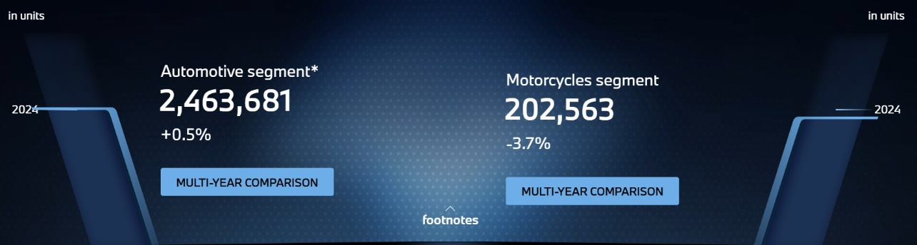
Figure 1: Number of delivered vehicles
(Source: BMW Group, 2026d)
The strong focus of the business on electrified vehicles has also been considered efficient for the growth of the business. More than 1 in 4 vehicles of BMW delivered to customers is either all-electric or a plug-in hybrid. Financial stability has also been recognised within the company, with a stable EBT margin of 7.7% year-on-year, along with over €10 billion in profit before tax (BMW Group, 2026d). Now the firm has participated in the race to catch the Chinese Electric Vehicle (EV) market. In this market, 46% of vehicle sales are accounted for by EVs. However, the company's sales in this market have been recorded as only 5% (Reuters, 2026). Moreover, it has been defined as essential for the company to focus on more strategic expansion in the EV segment, along with promoting its motorcycles to gain a significant increase in sales.

Strategy Analysis

External Environmental Audit
Political
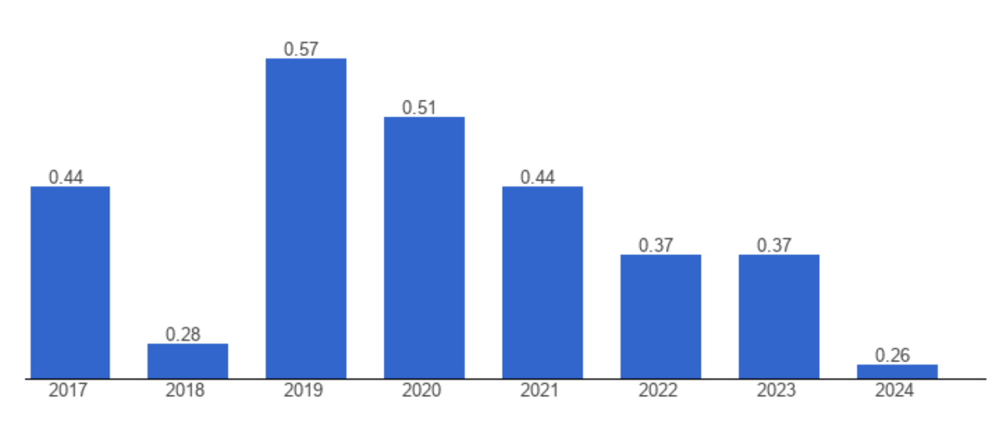
Figure 2: UK Political Stability
(Source: The Global Economy, 2026)
As of 2024, the political stability of the UK is defined as 0.26 whereas in 2023 it was 0.37 (The Global Economy, 2026). The political stability of the country is decreasing, which has been recognised as responsible for the increasing trade barriers for BMW.
Economic
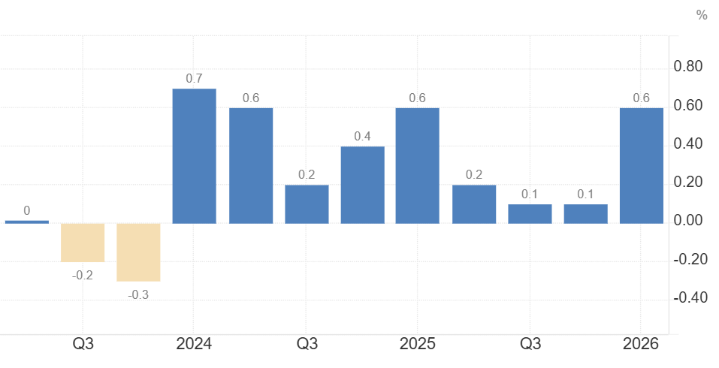
Figure 3: UK GDP growth rate
(Source: Trading Economics, 2026)
The GDP of the UK has expanded by 0.6% quarter-on-quarter as of Q1 2026 in compare to previous year as seen in the graph (Trading Economics, 2026). This is reliable for the company in enhancing its investment with prominent trust.
Social
EV sales in the UK grew 34%, while petrol car sales decreased by 14% (Carbon Brief, 2026). The shift towards EVs can be a key opportunity for BMW's growth.
Technological
The car production number decreased to 859,575 cars in 2021, due to chip shortages (Gilpin, Cooney and Northall, 2022). It is also responsible for affecting the production of cars in BMW, which leads to decreased sales.
Legal
The Factories Act 1961 is in the UK relating to guiding health and safety measures for people working in the manufacturing sector (Legislation, 2026). BMW has to be responsible for ensuring safety of the workers.
Environmental
More than 18% of the total emissions of the UK have been defined as related to the automotive sector (Businesswise Solutions, 2024). In this aspect, BMW needs to manage its emissions and reduce them for a better organisational reputation.

Internal Environmental Audit
SWOT Analysis
Strengths | Weaknesses
- BMW is positioned as a leading premium manufacturer, which has resulted in gaining additional market share (BMW Group, 2025).  - BMW has a diverse product portfolio, along with four unique brands, namely BMW, BMW Motorrad, Rolls-Royce, and Mini (BMW Group, 2026g). | - BMW has halted the US$733 million upgrade of its Cowley facility, which led to delays in EV production (Ahmed, 2025).  - Customers have rated BMW poorly, relating to their dissatisfaction with customer service, systemic failure, and more (Trustpilot, 2026).
Opportunities | Threats
- The automotive industry is integrating AI and Machine Learning (ML) for enhancing productivity and minimising costs (Madhavaram et al., 2024). Hence, BMW can also leverage these tools for supply chain management, manufacturing, passenger experience and more.  - BMW has a global sales network in 140 countries; hence, expanding further can be an opportunity for it (BMW Group, 2026h). | - Geopolitical tension arising from the US-China Trade war has disrupted the global supply chain (Bednarski et al., 2026). This can cause significant delays in BMW’s production and distribution.  - BMW faces intense competition from Toyota Motor, Ford, General Motors, Hyundai Motor, and more (ZoomInfo, 2026).
Table 1: SWOT Analysis
(Source: Created by the learner)
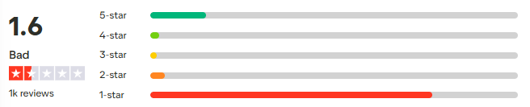
Figure 4: Customer Review
(Source: Trustpilot, 2026)
VRIO
Resource | Valuable | Rare | Inimitable | Organised | Competitive advantage
Strong brand reputation | Yes | Yes | Yes | Yes | Sustained advantage
Advanced engineering & innovation | Yes | Yes | Moderate | Yes | Strong advantage
Global manufacturing network | Yes | Moderate | Moderate | Yes | Temporary advantage
Premium customer loyalty | Yes | Yes | Yes | Yes | Sustained competitive advantage
Table 1: VRIO
(Source: Created by the learner)

BCG
Categories | Explanations
Star | Luxury cars are the main products with growing demand for the BMW 7 series and the BMW i7  Continued momentum for EVs with 47,845 sales in the segment, representing 28.1% of total volume (BMW Group, 2026m).
Cash Cow | BMW's financial services, including tailored finance, insurance, lease offers, and more, can help generate revenue (BMW, 2026).
Question Marks | Motorcycle sales in the UK are up by 16%, and BMW is leading the segment (Jones, 2026).
Dog | Declining demand for old combustion fuel vehicles
Table 2: BCG Matrix
(Source: Created by the learner)
Value Chain Analysis
Primary Activities
Inbound Logistics | - A global supplier network, compliant with environmental and social standards  - Focus on sustainable and ethical sourcing (BMW Group, 2026i)
Operations | - Automated surface processing  - End-to-end digitalised and automated inspection and AI-controlled robots (BMW Group, 2024)
Outbound Logistics | - Global dealership network in 140 countries (BMW Group, 2026h)
Marketing & Sales | - Premium branding  - Online and physical sales
Service | - Connected services  - after-sales support  - However, customer complaints about poor customer service (Trustpilot, 2026)
Support Activities
Firm Infrastructure | - Strong corporate governance for ensuring responsible management and creation of value on a sustainable basis (BMW Group, 2026k)
Human Resource Management | - A skilled and global workforce of 159,000 employees (BMW Group, 2026j)
Technology Development | - Strong focus on innovation  - Use of AI, automated driving, ML, connected cars (BMW Group, 2026l)
Procurement | - Strategic supplier partnerships  - Sustainable procurement (BMW Group, 2026i)
Table 3: Value Chain Analysis
(Source: Created by the learner)

Strategy Formulation
A significant focus on sustainable production by promoting EV manufacturing can be significant for the companies operating in the automotive industry. As per the views of Li and Zhou (2022), energy efficiency in the manufacturing segment has been recognised as essential. This can be relevant for the companies to attract customers with an eco-friendly mindset and enhance the overall organisational sales. Investing in Software-Defined Vehicles (SDVs) can also be considered as a relevant strategy for the business, as tech-driven growth and practices can be observed in the sector. On the other hand, personalisation services for vehicles, along with the development of an efficient supply chain, are also essential for the growth of the business.
Among the key strategic choices, it has been recognised that BMW needs to focus on enhancing innovations in its EV manufacturing segment. A strong EV trend in the UK market can be recognised, as in the 12 months to May 2026, UK customers have bought 516,490 new BEVs (Carbon Brief, 2026). Through this strategic approach, the company can provide high-quality services and prominent experiences to customers. Enhancing innovativeness, BMW can try to increase the mileage of EVs to make them more sustainable and convenient for companies, along with the incorporation of sustainability.

Conclusion and Recommendations
Conclusion
In conclusion, BMW has established a strong presence in the automobile industry, with its diversified product portfolio, global supply chain network, and strong workforce. However, it is currently facing challenges in maintaining strong financial performance and customer satisfaction. The external market also presents some challenges like declining political stability, chip shortage, supply chain disruption and more. However, concerning the growing demand for EVs, the strategic options for BMW can include strengthening EV production, personalisation of services, and increasing innovations.
Recommendations
- For the enhancement of the innovation capabilities of employees, providing them with the necessary training can be of great benefit. According to Blanchard and Thacker (2023), effective training is crucial for the enhancement of employee competencies by equipping them with relevant skills and knowledge. Thus, offering the same can be highly effective for BMW to keep a skilled workforce.
- Personalisation of services can also be recommended to BMW, considering customer complaints about poor service. According to Potwora et al. (2023), using data analytics to personalise their services and recommendations can be useful for the company to offer efficient services to customers. This can help the company minimise customer dissatisfaction and drive sales for its EVs and other vehicle segments.

Reference List
Ahmed, A. (2025) BMW pauses £600m upgrade to Oxford Mini plant. Available at: https://www.theguardian.com/business/2025/feb/22/bmw-pauses-600m-upgrade-oxford-mini-plant-electric-vehicle-demand (Accessed: 16 July 2026).
Bednarski, L., Subramanian, N., Roscoe, S. and Blome, C. (2026) ‘Geopolitical rivalry over strategically important industries: understanding the effects on global supply chain design’, Production Planning & Control, 37(6), pp. 596-618.
Blanchard, P.N. and Thacker, J.W. (2023) Effective training: Systems, strategies, and practices. Sage Publications.
BMW (2026) All in. Simply Smart. BMW Financial Services. Available at: https://www.bmw.co.uk/en/bmw-financial-services.html (Accessed: 16 July 2026).
BMW Group (2024) Automated Surface Processing. Available at: https://www.bmwgroup.com/en/news/general/2024/automated-surface-processing.html (Accessed: 16 July 2026).
BMW Group (2025) ALREADY AHEAD. Available at: https://www.bmwgroup.com/en/report/2025/downloads/BMW-Group-Report-2025-en.pdf (Accessed: 16 July 2026).
BMW Group (2026a) Introducing the BMW Group. Available at: https://www.bmwgroup.com/en/company.html (Accessed: 16 July 2026).
BMW Group (2026b) BMW Group strategy. Available at: https://www.bmwgroup.com/en/company/strategy.html#:~:text=What%20drives%20the%20BMW%20Group%3F,and%20unlocking%20global%20growth%20opportunities. (Accessed: 16 July 2026).
BMW Group (2026c) Our unique Corporate Culture. Available at: https://www.bmwgroup.jobs/es_pt/en/culture.html#:~:text=As%20a%20global%20company%2C%20we,of%20respect%2C%20trust%20and%20fairness. (Accessed: 16 July 2026).
BMW Group (2026d) Home. Available at: https://www.bmwgroup.com/en/report/2025/index.html#delivery_vehicles (Accessed: 16 July 2026).
BMW Group (2026e) BMW Group history. Available at: https://www.bmwgroup.com/en/company/history.html (Accessed: 16 July 2026).
BMW Group (2026f) BMW Group profile. Available at: https://www.bmwgroup.com/en/company/leadership-and-governance.html (Accessed: 16 July 2026).
BMW Group (2026g) Brands and Business Segments of BMW Group. Available at: https://www.bmwgroup.com/en/company/brands-products.html (Accessed: 16 July 2026).
BMW Group (2026h) BMW Group locations – our global network. Available at: http://bmwgroup.com/en/company/locations.html (Accessed: 16 July 2026).
BMW Group (2026i) Supplier Network & Raw Material Management. Available at: https://www.bmwgroup.com/en/sustainability/supply-chain.html (Accessed: 16 July 2026).
BMW Group (2026j) BMW Group employees. Available at: https://www.bmwgroup.com/en/sustainability/employees.html (Accessed: 16 July 2026).
BMW Group (2026k) STATEMENT ON CORPORATE GOVERNANCE 2025. Available at: https://www.bmwgroup.com/content/dam/grpw/websites/bmwgroup_com/ir/downloads/en/2026/bericht/BMW_Group_Statement_on_Corporate_Governance_2025.pdf (Accessed: 16 July 2026).
BMW Group (2026l) Innovations by the BMW Group. Available at: https://www.bmwgroup.com/en/innovation.html (Accessed: 16 July 2026).
BMW Group (2026m) BMW Group UK leads the premium segment in 2025. Available at: https://www.press.bmwgroup.com/united-kingdom/article/detail/T0454784EN_GB/bmw-group-uk-leads-the-premium-segment-in-2025?language=en_GB (Accessed: 16 July 2026).
Businesswise Solutions (2024) How the Automotive Industry is Accelerating to Net Zero. Available at: https://www.businesswisesolutions.co.uk/2024/07/04/net-zero-automotive-industry/ (Accessed: 16 July 2026).
Caprino, K. (2024) Seth Godin: What Is Strategy And Why We So Often Get It Wrong. Available at: https://www.forbes.com/sites/kathycaprino/2024/10/16/seth-godin-strategy-why-most-get-it-wrong/ (Accessed: 16 July 2026).
Carbon Brief (2026) Analysis: UK sales of electric vehicles just overtook petrol cars for the first time. Available at: https://www.carbonbrief.org/analysis-uk-sales-of-electric-vehicles-just-overtook-petrol-cars-for-the-first-time/ (Accessed: 16 July 2026).
Gilpin, J., Cooney, S. and Northall, R. (2022) How the chip shortage is hitting the UK Automotive Sector. Available at: https://www.bdo.co.uk/en-gb/insights/industries/manufacturing/how-the-chip-shortage-is-hitting-the-uk-automotive-sector (Accessed: 16 July 2026).
Jones, R. (2026) BMW leads ‘big-bike’ UK sales in April as adventure and naked segments boom. Available at: https://www.visordown.com/news/bmw-leads-big-bike-uk-sales-april-adventure-and-naked-segments-boom (Accessed: 16 July 2026).
Legislation (2026) Factories Act 1961. Available at: https://www.legislation.gov.uk/ukpga/Eliz2/9-10/34/contents (Accessed: 16 July 2026).
Li, L. and Zhou, M. (2022) Sustainable Manufacturing Systems: An Energy Perspective. John Wiley & Sons.
LinkedIn (2026) BMW Group. Available at: https://www.linkedin.com/company/bmw-group/ (Accessed: 16 July 2026).
Madhavaram, C.R., Sunkara, J.R., Kuraku, C., Galla, E.P. and Gollangi, H.K. (2024) ‘The future of automotive manufacturing: Integrating AI, ML, and Generative AI for next-Gen Automatic Cars’, International Multidisciplinary Research Journal Reviews-IMRJR, 1, p. 010103.
Potwora, M., Zakryzhevska, I., Mostova, A., Kyrkovskyi, V. and Saienko, V. (2023) ‘Marketing strategies in ecommerce: personalised content, recommendations, and increased customer trust’, Financial and credit activity: problems of theory and practice, 5(52), pp. 562-573.
Rêgo, B.S., Jayantilal, S., Ferreira, J.J. and Carayannis, E.G. (2022) ‘Digital transformation and strategic management: A systematic review of the literature’, Journal of the Knowledge Economy, 13(4), pp. 3195-3222.
Reuters (2026) BMW races to catch up in a Chinese EV market that won't slow down. Available at: https://www.reuters.com/business/finance/bmw-races-catch-up-chinese-ev-market-that-wont-slow-down-2026-07-14/ (Accessed: 16 July 2026).
The Global Economy (2026) United Kingdom: Political stability. Available at: https://www.theglobaleconomy.com/United-Kingdom/wb_political_stability/ (Accessed: 16 July 2026).
Trading Economics (2026) United Kingdom GDP Growth Rate. Available at: https://tradingeconomics.com/united-kingdom/gdp-growth (Accessed: 16 July 2026).
Trustpilot (2026) BMW. Available at: https://uk.trustpilot.com/review/bmw.co.uk (Accessed: 16 July 2026).
ZoomInfo (2026) BMW Group. Available at: https://www.zoominfo.com/c/bayerische-motoren-werke-aktiengesellschaft/4128842 (Accessed: 16 July 2026).

