

Student name: Roqia haji haidar
Programme: BA (Hons) Leadership and Management Skills in the Workplace
Module: Understanding & Engaging in the Customer Experience
Module code: BMSK5012
Lecturer: Paul Tinkler
Assignment Title: Understanding & Engaging in the Customer Experience
Submission deadline: 26th of July 2026
Wordcount: 4033
AI Acknowledgement
I confirm that I have not presented any AI generated materials as my own work.
I confirm that I have copies of my drafts, notes, and other resources I used, which I may be asked to provide in evidence.

Table of Contents
- Introduction .......................................................... 4
- Organisation Overview ............................................. 5
- Customer Centrality and Customer Focused Strategy .......... 6–7
3.1 Understanding Customer Needs and Personalisation
3.2 Improving Customer Experience and Engagement
- Customer Segmentation Strategy ................................. 8–9
4.1 Customer Demographic and Lifestyle Segmentation
4.2 Customer Behaviour and Value Segmentation
- Customer Lifecycle Analysis ...................................... 10–12
5.1 Customer Acquisition
5.2 Customer Onboarding
5.3 Customer Retention
5.4 Customer Development
5.5 Customer Loyalty and Advocacy
5.6 Critical Evaluation
- Quality Processes, Customer Value and Managing Customer Expectations ........ 13–18
6.1 Quality Management Processes
6.2 Service Quality Using the SERVQUAL Model
6.3 Customer Value
6.4 Direct and Indirect Customer Value Metrics
6.5 Managing Customer Expectations
6.6 Critical Evaluation

- Recommendations ..................................................... 19–20
7.1 Improve Personalised Customer Services
7.2 Improve Service Consistency Across Stores
7.3 Enhance Digital Customer Experience
7.4 Focus on Customer Trust and Loyalty
- Conclusion .............................................................. 21–22
8.1 Evaluation of CRM Strategy
8.2 Future Improvements and Business Success
- References ............................................................. 23–26
- Appendices ……………………………………………………… 27-32
10.1 Undervalued or Overvalued Customers: Capturing Total Customer Engagement Value
10.2 Customer Retention Importance, Metrics & Strategies
(Caldwell, 2020)
10.3 Understanding the Difference Between Customer Satisfaction and Customer Loyalty
10.4 How to predict customer behaviour
10.5 Types of Customer Segmentation

1. Introduction
Customer Relationship Management (CRM) is an important strategy that helps organisations build strong customer relationships by understanding customer needs, improving communication, and increasing satisfaction and loyalty. Businesses now focus not only on attracting new customers but also on retaining existing customers, as loyal customers can support long term success through repeat purchases and recommendations (Navarro et al., 2021; Gazi et al., 2024).
The optical retail industry is highly competitive, with customers expecting professional eye care, personalised services, and convenient experiences across both online and in-store channels. Businesses must provide efficient and consistent services to meet changing customer expectations and remain competitive (Roggeveen & Sethuraman, 2020).
Vision Express is a leading UK optical retailer providing eye examinations, glasses, contact lenses, and other eye care services. The company focuses on customer satisfaction through professional expertise, quality products, and personalised support.
This report analyses Vision Express’s CRM strategy and evaluates how it manages customer relationships throughout the customer lifecycle. It examines customer acquisition, retention, segmentation, service quality, and customer value. The report also provides recommendations to help improve customer relationships, increase loyalty, and support long term business growth (Navarro et al., 2021; Gazi et al., 2024).

2. Organisation Overview
Vision Express is a well known UK optical retailer providing eye tests, prescription glasses, contact lenses, sunglasses, and hearing care services through its stores and online platforms. The company has built a strong reputation by focusing on professional eye care, quality products, and customer service.
The optical retail market is highly competitive, with growth driven by increasing demand for vision care, an ageing population, and technological developments (D, 2025). Customers now expect convenient booking, personalised services, professional advice, and smooth experiences across both online and in store channels. To meet these expectations, Vision Express uses digital services such as online appointments and customer communication tools.
Customer relationship management is an important part of Vision Express’s strategy. The company collects customer information from appointments, eye examinations, purchases, and aftercare services to provide personalised support and improve customer satisfaction.
Maintaining consistent quality is essential because Vision Express provides both healthcare and retail services. Staff training, professional standards, customer feedback, and quality checks help ensure customers receive reliable service.
However, Vision Express faces challenges from online competitors, changing customer expectations, and increasing competition within the optical retail market (6Wresearch, 2025). By improving technology, service quality, and customer relationships, the company can continue strengthening customer loyalty and maintaining its competitive position.

3. Customer Centrality and Customer Focused Strategy
Customer centrality means placing customers at the centre of business decisions by understanding their needs, expectations, and experiences. A customer focused business aims to create positive experiences and build long term relationships rather than only focusing on sales (Fader, 2020). This is important for Vision Express because it provides eye care services as well as optical products, meaning customers need to trust the company with their eye health.
3.1 Understanding Customer Needs and Personalisation
Vision Express uses customer information collected through eye tests, appointments, purchases, and aftercare services to better understand customer needs. This allows employees to provide more suitable advice and recommend products based on individual requirements. For example, customers who spend long hours using computers may need different lenses compared with customers who mainly use glasses for driving or reading.
Personalised services help customers feel valued and improve their overall experience. By understanding customer preferences and previous interactions, Vision Express can create stronger relationships and increase customer satisfaction.
3.2 Improving Customer Experience and Engagement
Vision Express focuses on making the customer journey easier through online appointment booking, reminders, and digital services. These tools allow customers to access information and manage appointments more conveniently. The use of technologies such as AI chatbots and automated support can further improve communication and service efficiency (Wagobera Edgar Kedi et al., 2024).
Customer feedback through reviews, surveys, and complaints also helps Vision Express identify areas for improvement. However, the company must balance customer needs with business objectives. If customers feel employees are focused mainly on selling expensive products, trust may decrease. Therefore, recommendations should always be based on customer needs.
Overall, customer centrality helps Vision Express strengthen relationships by providing personalised services, listening to feedback, and improving customer experiences. By maintaining a customer focused approach, the company can increase loyalty and remain competitive in the optical retail market.

4. Customer Segmentation Strategy
Customer segmentation means dividing customers into groups based on their needs, behaviours, and characteristics. This helps businesses understand customers better and provide more suitable services (Naim, 2023). For Vision Express, segmentation is important because customers have different eye care needs and buying behaviours.
4.1 Customer Demographic and Lifestyle Segmentation
Vision Express can use demographic segmentation by considering factors such as age and customer needs. Younger customers may prefer affordable glasses, contact lenses, fashionable frames, and online services, while older customers may require regular eye tests, specialist lenses, and additional support for changing vision needs.
Lifestyle segmentation is also important because customers’ daily activities influence the products they require. For example, office workers may need lenses suitable for computer use, while active customers may prefer comfortable and durable eyewear. Customers interested in fashion may choose designer frames and premium products. Understanding these differences helps Vision Express provide more personalised recommendations.
4.2 Customer Behaviour and Value Segmentation
Vision Express can also segment customers based on buying behaviour and service needs. Some customers may only visit when they need new glasses, while others regularly purchase contact lenses, attend eye tests, and use additional services. Regular customers are valuable because they are more likely to continue using the company’s services. Customer profiling and data analysis can help businesses identify customer patterns and create more personalised services (Kasem et al., 2023).
The company can also identify customers who prefer premium products, such as advanced lenses or designer eyewear. However, recommendations should always focus on customer needs rather than only increasing sales. Customer information must also be managed responsibly to maintain trust and protect privacy. Using customer data effectively can help businesses understand preferences and improve decision making (Theodorakopoulos & Theodoropoulou, 2024).
Overall, customer segmentation allows Vision Express to understand different customer groups and provide better services. By using demographic, lifestyle, and behavioural information, the company can improve customer satisfaction, strengthen relationships, and increase long term loyalty.

5. Customer Lifecycle Analysis
The customer lifecycle explains the different stages customers go through when developing a relationship with a business, starting from their first interaction and continuing until they become loyal customers. Effective management of each stage helps organisations improve customer satisfaction, increase retention, and build long term relationships (Mar & Armaly, 2024).
5.1 Customer Acquisition
Customer acquisition is the first stage, where businesses attract new customers and encourage them to use their services. Vision Express attracts customers through online advertising, social media, NHS eye tests, promotions, and online appointment booking. These methods make it easier for customers to access services and create an initial positive experience. However, relying too much on discounts may attract customers who are only interested in low prices. Therefore, Vision Express should focus on attracting customers who value professional eye care and quality service, as these customers are more likely to develop long term relationships (Mar & Armaly, 2024).
5.2 Customer Onboarding
Customer onboarding begins when a customer first visits Vision Express for an eye test or purchases eyewear. This stage is important because the first experience can influence future customer decisions. Vision Express supports onboarding through professional eye examinations, trained staff, and personalised advice. Customers need to feel confident that their eye health is being managed properly and that they are receiving suitable recommendations. Maintaining consistent service standards across all stores is important because differences in staff support, waiting times, or communication can affect customer satisfaction (Mar & Armaly, 2024).
5.3 Customer Retention
Customer retention focuses on keeping existing customers and encouraging them to continue using the company’s services. Vision Express supports retention by maintaining customer records, sending appointment reminders, providing aftercare services, and keeping communication with customers. These activities help customers feel valued and encourage repeat visits for eye tests, glasses, and contact lenses. Retaining existing customers is important because loyal customers often provide more long term value than customers who only make a single purchase. Strong retention strategies can reduce customer turnover and improve loyalty (Cudby, 2020).
5.4 Customer Development
Customer development involves increasing the value of existing customer relationships by understanding customer needs and offering suitable products and services. Vision Express can develop customer relationships by recommending products such as premium lenses, designer frames, contact lenses, and hearing care services. Using customer information, such as previous purchases and lifestyle needs, allows employees to provide more personalised recommendations. However, recommendations should always be based on customer requirements rather than only increasing sales, as trust is essential in healthcare related services (Mar & Armaly, 2024).
5.5 Customer Loyalty and Advocacy
Customer loyalty occurs when customers continue choosing Vision Express and recommend the company to others. Loyal customers are valuable because they are more likely to make repeat purchases and share positive experiences with family and friends. Vision Express can strengthen loyalty by providing reliable eye care, professional advice, good customer service, and effective aftercare support. Positive customer experiences can increase trust and encourage customers to become advocates for the brand through reviews and recommendations (Chauhan, 2023).
5.6 Critical Evaluation
Overall, Vision Express manages the customer lifecycle effectively by combining professional services, customer information, personalised support, and digital communication. The company’s main strength is its ability to build trust through face-to-face interactions with trained optical professionals. However, challenges remain, including competition from online eyewear retailers, changing customer expectations, and maintaining consistent service quality across all locations. To remain competitive, Vision Express should continue improving digital services, customer communication, and personalised experiences. Effective customer lifecycle management will help the company increase satisfaction, strengthen loyalty, and maintain long term customer relationships (Mar & Armaly, 2024; Cudby, 2020; Chauhan, 2023).

6. Quality Processes, Customer Value and Managing Customer Expectations
6.1 Quality Management Processes
Vision Express provides both healthcare services and retail products, making quality management essential. Customers expect accurate eye examinations, professional advice, quality products, and reliable customer service. Service quality affects customer satisfaction, trust, and loyalty (Shi & Shang, 2020).
The company maintains quality through staff training, professional standards, clear procedures, and regular checks. Well trained employees help customers make suitable choices, while customer feedback through reviews and surveys helps identify areas for improvement. Effective quality management supports consistent service delivery and continuous improvement (Permana et al., 2021).
A key strength of Vision Express is its focus on professional care and personalised customer service. However, maintaining the same quality across all stores can be challenging due to differences in staff availability, waiting times, and customer demand. The company must also balance business goals with customer needs to maintain trust.
By continuing to invest in staff development, monitor feedback, and improve service standards, Vision Express can provide better customer experiences. High quality service helps increase customer satisfaction, loyalty, and long term business success (Ali & Shabn, 2024; Singh et al., 2023).
6.2 Service Quality Using the SERVQUAL Model
Service quality is important for Vision Express because customers expect both professional eye care and excellent customer service. The SERVQUAL model measures service quality by comparing customer expectations with their actual experience. It focuses on reliability, assurance, tangibles, empathy, and responsiveness, which help businesses evaluate and improve customer satisfaction (Shi & Shang, 2020).
Reliability means providing accurate and dependable services. Vision Express demonstrates reliability by offering professional eye examinations, accurate prescriptions, and quality optical products. Customers expect consistent service every time they visit. However, mistakes with prescriptions, delays in receiving glasses, or incorrect orders can reduce customer confidence.
Assurance refers to the knowledge and professionalism of employees. Vision Express benefits from trained optometrists and experienced staff who provide advice and support throughout the customer journey. This helps customers trust the company and feel confident about the care they receive. Continuous staff training is important to maintain high service standards and support quality improvement (Permana et al., 2021).
Tangibles include the physical appearance of stores, equipment, and products. Vision Express provides modern stores, professional eye testing equipment, and a wide range of eyewear. A clean and welcoming environment creates a positive impression. However, differences between stores may result in inconsistent customer experiences.
Empathy means understanding individual customer needs and providing personalised care. Vision Express offers one to one consultation and recommends products based on each customer's lifestyle and eye care requirements. This personalised approach increases customer value and supports long term relationships (Ali & Shabn, 2024). During busy periods, however, staff may have less time to provide individual attention.
Responsiveness refers to how quickly and effectively the company responds to customer needs. Vision Express offers online appointment booking, appointment reminders, customer support, and aftercare services to improve convenience. Although these services enhance the customer experience, long waiting times or delays with appointments and orders may reduce customer satisfaction.
Overall, the SERVQUAL model shows that Vision Express performs well by providing reliable eye care, knowledgeable staff, modern facilities, and personalised support. However, the company should continue improving service consistency, reducing waiting times, and responding quickly to customer needs. Delivering high quality service across all five SERVQUAL dimensions can increase customer satisfaction, strengthen loyalty, and improve the company's long term success (Singh et al., 2023).

6.3 Customer Value
Customer value is not only about the price customers pay but also the overall benefits they receive from a product or service. It includes quality, convenience, trust, and the overall customer experience. For Vision Express, creating customer value means providing professional eye care, quality products, and personalised services that encourage long term relationships. High quality service and customer satisfaction play an important role in increasing customer loyalty (Singh et al., 2023).
Vision Express creates practical value by offering eye examinations, prescription glasses, contact lenses, and hearing care services that meet customers' needs. Professional staff, modern equipment, and accurate eye care help customers feel confident in the services they receive. The company also improves convenience through online appointment booking, reminders, and aftercare support, making the customer journey easier.
The company also creates emotional value by building trust with customers. Friendly staff, clear communication, and personalised recommendations help customers feel comfortable when making decisions about their eye health. Since Vision Express provides healthcare services, customers expect advice to be based on their individual needs rather than sales targets.
Relationship value is another important part of the company's strategy. By keeping customer records, sending appointment reminders, and providing aftercare support, Vision Express builds stronger relationships with customers. These activities encourage repeat visits and improve customer loyalty. Loyal customers are more likely to continue using the company's services and increase customer lifetime value, which contributes to long term business success (Ali & Shabn, 2024).
However, maintaining customer value can be challenging. Long waiting times, inconsistent service between stores, or pressure to purchase expensive products may reduce customer trust. To avoid this, Vision Express should continue investing in staff training, monitoring customer feedback, and maintaining consistent service quality across all locations. Continuous improvement helps businesses provide better customer experiences and remain competitive (Permana et al., 2021).
Overall, Vision Express creates customer value by combining professional eye care, quality products, and personalised customer service. By focusing on customer needs and building long term relationships, the company can improve customer satisfaction, strengthen loyalty, and achieve sustainable business success.
6.4 Direct and Indirect Customer Value Metrics
Customer value helps Vision Express measure the strength of its customer relationships. It is not only based on customer spending but also on satisfaction, loyalty, and the likelihood of customers returning.
Direct customer value metrics focus on financial performance, such as revenue from eye tests, glasses, contact lenses, and hearing care. Repeat purchases and Customer Lifetime Value (CLV) are important because they show the long term value of customer relationships (Ali & Shabn, 2024). However, the company should focus on meeting customer needs rather than only increasing sales.
Indirect customer value metrics measure customer opinions and behaviours through surveys, reviews, feedback, and recommendations. These help Vision Express understand customer experiences and improve service quality. Strong service quality can increase customer satisfaction and loyalty (Singh et al., 2023).
By monitoring both financial and customer based measures, Vision Express can improve its services, strengthen customer trust, and build long term relationships. Staff training, quality improvement, and customer feedback are important for maintaining high service standards (Permana et al., 2021; Shi & Shang, 2020).
6.5 Managing Customer Expectations
Managing customer expectations is important because it directly affects customer satisfaction, trust, and loyalty. Customers compare the service they expect with the service they receive. When a business meets or exceeds expectations, customers are more likely to return and recommend the company to others. High service quality plays an important role in meeting customer expectations and improving customer satisfaction (Singh et al., 2023).
Customers visiting Vision Express expect professional eye care, accurate eye examinations, quality eyewear, friendly staff, and convenient services such as online appointment booking and aftercare support. As both a healthcare and retail provider, Vision Express must ensure that customers receive honest advice and personalised recommendations based on their individual needs. Providing reliable and consistent service helps build trust and improves the overall customer experience (Shi & Shang, 2020).
Vision Express manages customer expectations by employing trained optometrists, using modern eye testing equipment, and providing personalised customer support. Clear communication throughout the customer journey, including appointment reminders and updates on orders, also helps customers feel informed and valued. However, long waiting times, appointment delays, or poor communication can reduce customer satisfaction, even when the quality of eye care is high.
Customer expectations continue to increase as technology improves. Many customers now expect quick responses, digital services, personalised communication, and convenient online booking. To meet these expectations, Vision Express should continue investing in technology, staff training, and quality improvement programmes (Permana et al., 2021).
Meeting customer expectations also creates long term value for the business. Satisfied customers are more likely to remain loyal, make repeat purchases, and increase customer lifetime value, contributing to sustainable business growth (Ali & Shabn, 2024).
Overall, Vision Express can successfully manage customer expectations by delivering consistent service quality, professional care, effective communication, and personalised support. Focusing on the complete customer journey helps improve customer satisfaction, strengthen loyalty, and maintain a competitive position in the optical retail market.
6.6 Critical Evaluation
The analysis shows that Vision Express has developed an effective CRM strategy by combining professional eye care, customer information management, personalised services, and digital support. A key strength is its ability to build long term relationships through regular customer interactions. Face to face consultations with trained optometrists give the company an advantage over many online competitors by creating trust and confidence.
However, the success of the CRM strategy depends on delivering consistent service across all stores. Differences in staff availability, waiting times, and communication can affect customer satisfaction and reduce service quality. Maintaining consistent standards through staff training and continuous quality improvement is therefore essential (Permana et al., 2021).
Vision Express also has a competitive advantage because it combines healthcare services with retail products. However, online competitors often offer lower prices, faster purchasing, and greater convenience. To remain competitive, Vision Express should continue improving its digital services while maintaining high quality customer care and reliable service (Shi & Shang, 2020).
Another challenge is balancing customer value with business objectives. Increasing customer lifetime value through repeat purchases and additional services can improve long term business performance (Ali & Shabn, 2024). However, recommendations should always be based on customer needs rather than sales targets, as customer trust is essential in healthcare services.
The company can further improve its CRM strategy by using customer data, purchase history, and feedback to provide more personalised services. At the same time, customer information must be managed responsibly to protect privacy and maintain customer confidence.
Overall, Vision Express has a strong customer focused CRM strategy, but continuous improvement is needed to maintain its competitive advantage. By improving service consistency, investing in digital services, and focusing on customer satisfaction, the company can strengthen customer loyalty, build long term relationships, and achieve sustainable business success (Singh et al., 2023).
7. Recommendations
Based on the analysis, Vision Express can improve its CRM strategy by focusing on personalisation, service quality, digital improvement, and long term customer relationships.
7.1 Improve Personalised Customer Services
Vision Express should use customer information more effectively to provide personalised services. Customer history, preferences, and purchase records can help the company send suitable appointment reminders, relevant offers, and product recommendations. Personalised communication can make customers feel valued and improve satisfaction, leading to stronger long term relationships (Anshari et al., 2019).
7.2 Improve Service Consistency Across Stores
Maintaining consistent service quality across all stores is important for customer trust. Vision Express should continue investing in staff training, employee development, and clear service standards. Well trained employees are more able to provide professional advice, understand customer needs, and deliver a positive customer experience. This can help ensure customers receive the same quality of service regardless of location (Nisifa Prila Anisa et al., 2024).
7.3 Enhance Digital Customer Experience
Customers increasingly expect quick and convenient digital services. Vision Express should continue improving online appointment booking, customer communication, and digital support services. Technologies such as automated reminders and online assistance can make interactions easier and improve the overall customer journey. Using new technologies can help businesses provide more efficient and personalised customer experiences (Hoyer et al., 2020).
7.4 Focus on Customer Trust and Loyalty
Vision Express should focus on developing long term relationships rather than only increasing sales. Employees should recommend products and services based on customer needs, ensuring customers feel supported and valued. Since eye care is a healthcare service, maintaining trust and providing honest advice are essential for building loyalty.
Overall, Vision Express can strengthen its CRM strategy by improving personalisation, maintaining consistent service standards, developing digital services, and focusing on customer satisfaction. These improvements can help the company increase loyalty, improve customer experiences, and achieve sustainable long term success.

8. Conclusion
8.1 Evaluation of CRM Strategy
This report analysed the Customer Relationship Management (CRM) strategy of Vision Express and examined how the company manages customer relationships to improve satisfaction and business performance. The findings show that Vision Express focuses on customer needs by providing professional eye care, personalised services, effective use of customer information, and digital support. These activities help the company understand customer expectations, improve communication, and develop stronger relationships with customers over time (Ang & Buttle, 2006).
The report discussed the importance of customer centrality, customer segmentation, service quality, customer value, and managing customer expectations. By placing customers at the centre of its strategy, Vision Express can identify different customer needs and provide more suitable services. Customer segmentation allows the company to understand differences in customer behaviour, while quality management helps ensure reliable eye care and consistent service standards. Creating customer value through professional advice, quality products, convenience, and personalised support can improve customer satisfaction and encourage long term loyalty.
Vision Express also benefits from building relationships through regular customer interactions. Services such as eye examinations, appointment reminders, aftercare support, and personalised recommendations help customers feel valued. These activities support customer retention and increase the likelihood of repeat purchases and positive recommendations.
8.2 Future Improvements and Business Success
Although Vision Express has developed a strong CRM approach, the company faces challenges including competition from online eyewear retailers, changing customer expectations, and maintaining consistent service quality across all stores. Online competitors often provide lower prices and convenient shopping experiences, meaning Vision Express must continue improving its digital services while maintaining its advantage through professional face to face customer care.
To remain competitive, Vision Express should continue investing in employee training, digital technology, personalised communication, and customer-focused services. Improving customer data analysis can help the company provide more relevant recommendations and create better customer experiences. At the same time, employees should continue focusing on customer needs to maintain trust and loyalty.
Overall, Vision Express has an effective CRM strategy that combines professional expertise, customer knowledge, and technology. By continuously improving service quality and focusing on customer relationships, the company can strengthen loyalty, increase satisfaction, and achieve long term success in the competitive optical retail market (Lyu et al., 2026).

9.References
- Navarro, V. G., Gomez, H. G., Badenes, R. O., & García, J. S. (2021). Customer relationship management and its impact on innovation: A literature review. Journal of Business Research, 129(1), 83–87. https://doi.org/10.1016/j.jbusres.2021.02.050
- Gazi, Md. A. I., Mamun, A. Al, Masud, A. Al, Senathirajah, A. R. S., & Rahman, T. (2024). The Relationship between CRM, Knowledge Management, Organization Commitment, Customer Profitability and Customer Loyalty in Telecommunication Industry: The Mediating Role of Customer Satisfaction and the Moderating Role of Brand Image. Journal of Open Innovation: Technology, Market, and Complexity, 10(1), 100227. https://doi.org/10.1016/j.joitmc.2024.100227
- Roggeveen, A. L., & Sethuraman, R. (2020). Customer-Interfacing Retail Technologies in 2020 & Beyond: An Integrative Framework and Research Directions. Journal of Retailing, 96(3), 299–309. https://www.sciencedirect.com/science/article/pii/S0022435920300439
- D, P. (2025). Optical Retail Market: Analysis and Growth Trends. In BusinessDojo. https://dojobusiness.com/blogs/news/optical-retail-market-analysis
- 6Wresearch. (2025). United Kingdom (UK) Optical Retail Chain Market (2025-2031) | Trends & Outlook. 6Wresearch.Com. https://www.6wresearch.com/industry-report/united-kingdom-uk-optical-retail-chain-market
- Fader, P. (2020). Customer centricity : focus on the right customers for strategic advantage. Pennsylvania Wharton Digital Press.
- Wagobera Edgar Kedi, Chibundom Ejimuda, Courage Idemudia, & Tochukwu Ignatius Ijomah. (2024). AI Chatbot integration in SME marketing platforms: Improving customer interaction and service efficiency. International Journal of Management & Entrepreneurship Research, 6(7), 2332–2341. https://doi.org/10.51594/ijmer.v6i7.1327
- Naim, A. (2023). Consumer Behavior in Marketing Patterns, Types, Segmentation. https://cognitioncommerce.ca/wp-content/uploads/2023/11/consumer-behavior-in-marketing-patterns-types.pdf
- Kasem, M. S., Hamada, M., & Taj-Eddin, I. (2023). Customer profiling, segmentation, and sales prediction using AI in direct marketing. Neural Computing and Applications, 36(9). https://doi.org/10.1007/s00521-023-09339-6
- Theodorakopoulos, L., & Theodoropoulou, A. (2024). Leveraging Big Data Analytics for Understanding Consumer Behavior in Digital Marketing: a Systematic Review. Human Behavior and Emerging Technologies, 2024(1), 1–21.
- Mar, J., & Armaly, P. (2024). Mastering Customer Success. Packt Publishing Ltd. https://www.perlego.com/book/4439147/mastering-customer-success-discover-tactics-to-decrease-churn-and-expand-revenue-pdf
- Cudby, A. (2020). Keep Your Customers. In Perlego.com. Morgan James Publishing. https://www.perlego.com/book/1324433/keep-your-customers-how-to-stop-customer-turnover-improve-retention-and-get-lucrative-longterm-loyalty-pdf
- Chauhan, J. S. (2023). Brand Loyalty and Its Impact on Repeat Purchase Behaviour of Customers: a Cross-Sectional Study in the FMCG Context. Psychology and Education Journal, 55(1). https://doi.org/10.48047/pne.2018.55.1.83
- Shi, Z., & Shang, H. (2020). A Review on Quality of Service and SERVQUAL Model. HCI in Business, Government and Organizations, 12204(1), 188–204. https://doi.org/10.1007/978-3-030-50341-3_15
- Permana, A., Purba, H. H., & Rizkiyah, N. D. (2021). A systematic literature review of Total Quality Management (TQM) implementation in the organization. International Journal of Production Management and Engineering, 9(1), 25. Researchgate.
- Ali, N., & Shabn, O. S. (2024). Customer lifetime value (CLV) insights for strategic marketing success and its impact on organizational financial performance. Cogent Business & Management, 11(1). https://doi.org/https://doi.org/10.1080/23311975.2024.2361321
- Singh, V., Sharma, M., Jayapriya, K., Kiran Kumar, B., Raj, M., Chander, N., & Kumar, B. (2023). Service Quality, Customer Satisfaction And Customer Loyalty: A Comprehensive Literature Review. Journal of Survey in Fisheries Sciences, 10(4S), 3457–3464. https://www.researchgate.net/profile/Vikas-Singh-49/publication/371809524_Service_Quality_Customer_Satisfaction_And_Customer_Loyalty_A_Comprehensive_Literature_Review/links/64965cd18de7ed28ba5231c4/Service-Quality-Customer-Satisfaction-And-Customer-Loyalty-A-Comprehensive-Literature-Review.pdf
- Anshari, M., Almunawar, M. N., Lim, S. A., & Al-Mudimigh, A. (2019). Customer Relationship Management and Big Data enabled: Personalization & Customization of Services. Applied Computing and Informatics, 15(2), 94–101. sciencedirect. https://doi.org/https://doi.org/10.1016/j.aci.2018.05.004
- Hoyer, W. D., Kroschke, M., Schmitt, B., Kraume, K., & Shankar, V. (2020). Transforming the Customer Experience through New Technologies. Journal of Interactive Marketing, 51(1), 57–71. https://doi.org/https://doi.org/10.1016/j.intmar.2020.04.001
- Nisifa Prila Anisa, Rizqi Angelika Sumardi, Nabilla Kusuma Dewi, & Mohamad Zein Saleh. (2024). Enhancing Service Quality Through Employee Training and Development: A Literature Review. Jurnal Riset Manajemen, 2(4), 19–31. https://doi.org/10.54066/jurma.v2i4.2549
- Ang, L., & Buttle, F. (2006). CRM software applications and business performance. Journal of Database Marketing & Customer Strategy Management, 14(1), 4–16. https://doi.org/10.1057/palgrave.dbm.3250034
- Lyu, W., Ashraf, M., Win, N., & Li, Y. (2026). CUSTOMER EXPERIENCE AS A COMPETITIVE ADVANTAGE IN RETAIL: AN INTERNATIONAL PERSPECTIVE. Scientific Culture, 12(1, Part 1), 3476. https://doi.org/10.5281/zenodo.121126254
- Caldwell, A. (2020). The Key to Keeping Customers Around. In Oracle NetSuite. https://www.netsuite.com/portal/resource/articles/crm/customer-retention.shtml
- Growave. (2025). Growave.Io. https://www.growave.io/blog/difference-between-customer-satisfaction-and-customer-loyalty
- Marketing YourCX. (2025). How to predict customer behavior - YourCX. In YourCX. https://yourcx.io/en/blog/2025/01/how-to-predict-customer-behavior/
- Customer Segmentation: Analysis, How-To Guide, and Use Cases. (2024). In Pipeline CRM. https://pipelinecrm.com/crm-guides/customer-segmentation-guide/

10. Appendixes
  - Undervalued or Overvalued Customers: Capturing Total Customer Engagement Value (kumar et al.,2010)

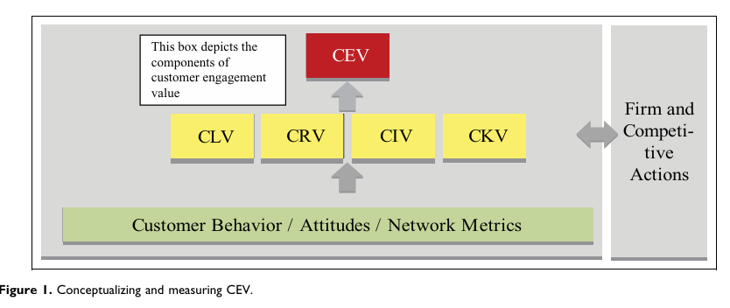

10.2 Customer Retention Importance, Metrics & Strategies
(Caldwell, 2020)

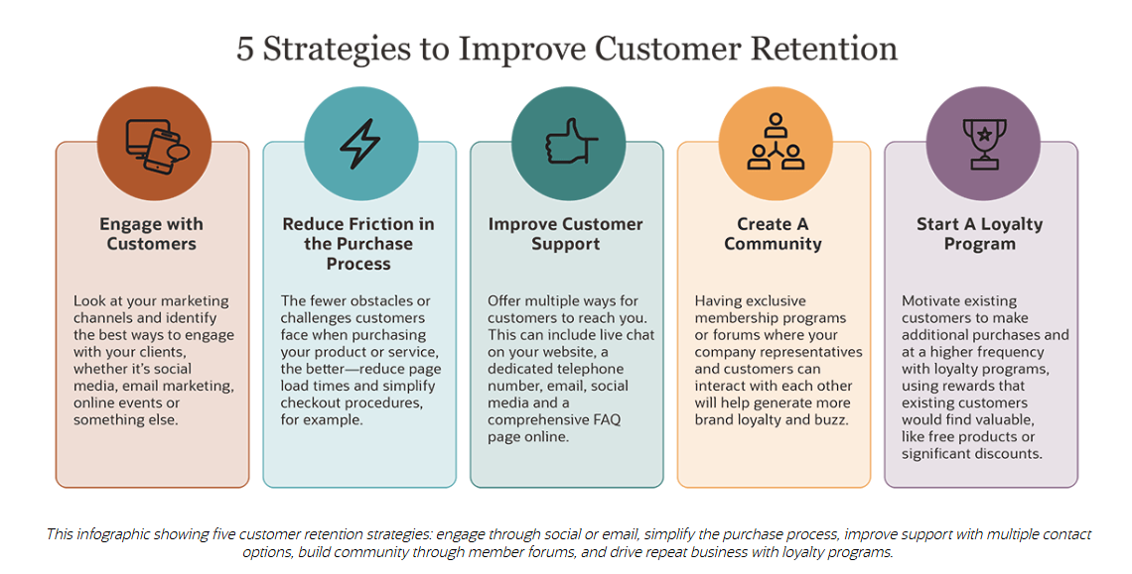

  - Understanding the Difference Between Customer Satisfaction and Customer Loyalty (Growave, 2025)

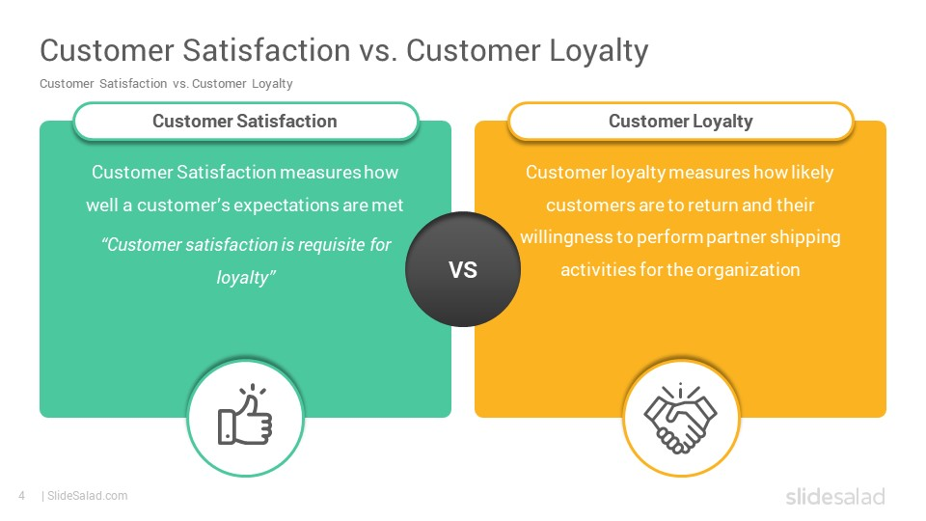

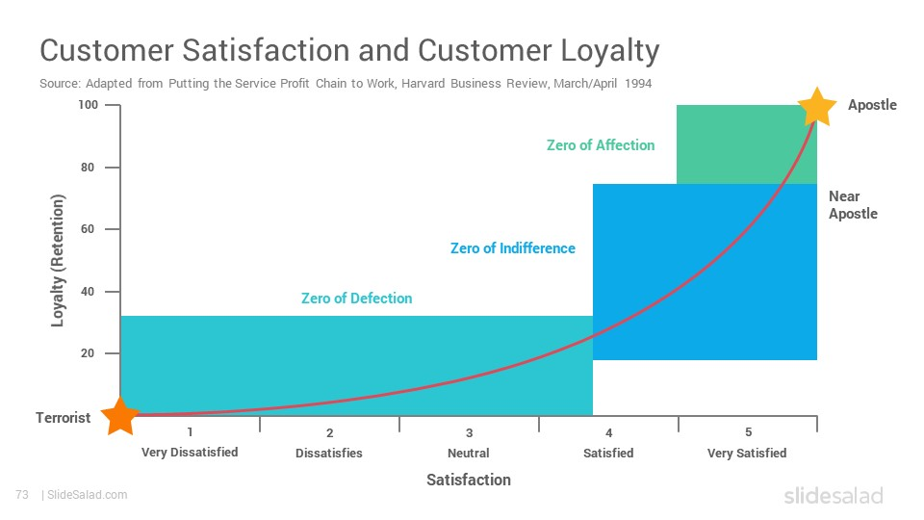

  - How to predict customer behavior (Marketing YourCX, 2025)

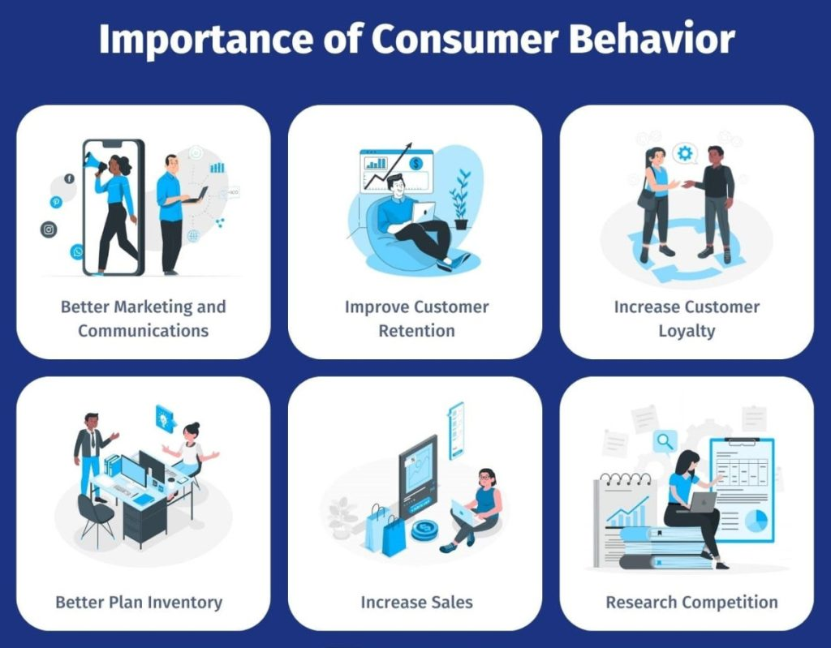

  - Types of Customer Segmentation
(“Customer Segmentation: Analysis, How-To Guide, and Use Cases,” 2024)



