INDIVIDUAL WRITTEN BUSINESS PLAN BASED ON SUSTAINABLE PACKAGING PROCESS

Student name: Belinda cardos

Student ID:2412046
Module code: LCLM 4006
Lecturer name: shengfeng mei

Executive Summary
The study focuses on determining the business plan based on the sustainable packaging process at a glance. Moreover, it also focuses on determining the environmental analysis of the market through PESTLE analysis and information regarding competition. In addition, it also focuses on explaining the marketing strategies of the company which will be adopted for reaching the customers. The financial amount by determining the funding sources and also outline the startup expenses expected at the time of the first month of the operations.

Table of Contents
Introduction 4
Overview of the business idea 4
Offering products 4
Management structure 4
Legal format 4
Market Research 5
Environment analysis through PESTLE framework 5
Key information about the competition 8
Marketing Communications 8
Effective marketing strategies for attracting customers 8
Financials 10
Reference List 13

Introduction
This study creates a business plan for a sustainable packaging business and presents this idea to a group of investors. During this business plan, the main and detailed overview about this new business with environmental analysis was also evaluated. Theoretical frameworks help to analyse the environment of business and provide some information about key competitors. Marketing strategies of business analysed through this study which helps to communicate with potential customers. Financial overview of new business helps to address funding sources and evaluates start-up expenses with including cash flow, budgets as well as breakeven calculation.

Overview of the business idea

Offering products
Sustainable packaging business offers different types of packaging materials such as Compostable Packaging materials, recycled paper, Biodegradable Alternatives, refillable containers, bubble wrap and many others (Petrenko et al., 2024). All of these products make packaging more sustainable in nature and enhance the overall durability of products.

Management structure
Key components of management structure of this new business include board members, Cross-Disciplinary Teams, Sustainability & Compliance Management team, Lifecycle Assessment Specialist and Supplier Engagement Manager (Fragapane et al., 2022). Each of the team has significant responsibility for designing sustainable materials of packaging.

Legal format
New start-up business of sustainable packaging has followed some legal format for establish their business in market which includes:
- Business registration
- Environmental clearances
- EPR Compliance
- Understand Plastic Waste Management Rules
- Certifications for Sustainability
- Labeling and Transparency

Market Research

Environment analysis through PESTLE framework
A new start-up business of sustainable packaging set up in the UK and with the help of PESTLE framework this business easily understands the macro-environmental condition of this country and relies on 6 factors including Political, economical, social, technological, legal and environmental.
Factors | Description
Political | The political stability index of the UK shows the political environment of this country which impacted different other components.  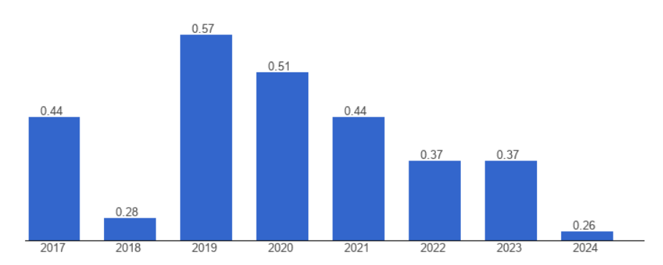  Figure 1: Political stability index of the UK  (Source: The global economy, 2024)  The above graph shows that the political stability index of the UK was 0.26 which decreased from the previous year (The global economy, 2024). Decreasing political index impacts on government regulations and due to unstable political environment government spending rate also decreases. Due to minimising spending, new businesses face difficulty to expand in this country. Existing businesses within this country also get less support from the government and investors also rethink about investment.
Economical | The GDP Rate, inflation rate and many other components significantly influence the economic condition of the UK.  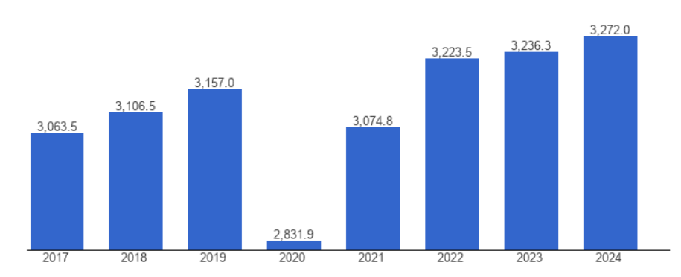  Figure 2: GDP growth of the UK  (Source: The global economy, 2024)  The GDP growth of this country was 3272 billion U.S. dollars in the year 2024 which increased more than the previous year. Increasing GDP shows that this country has stable economic conditions (The global economy, 2024). Good economic conditions directly showcase purchasing capability of consumers and increase market demand. Due to high market demand and consumer purchasing ability new business offers innovative products in this market. New products easily attracted consumers within this market.
Social | 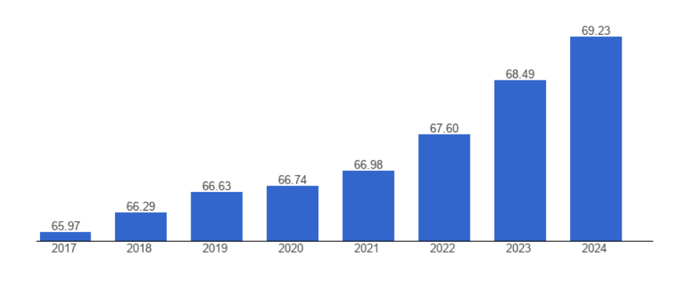  Figure 3: Population growth of the UK  (Source: The global economy, 2024)  The population of the UK was 69.23 million in the year 2024 which increased compared to the previous year (The global economy, 2024). The increasing population consists of different cultural people with various demands. Coping up with rapidly changing demand has become difficult for new startups in the UK.
Technological | 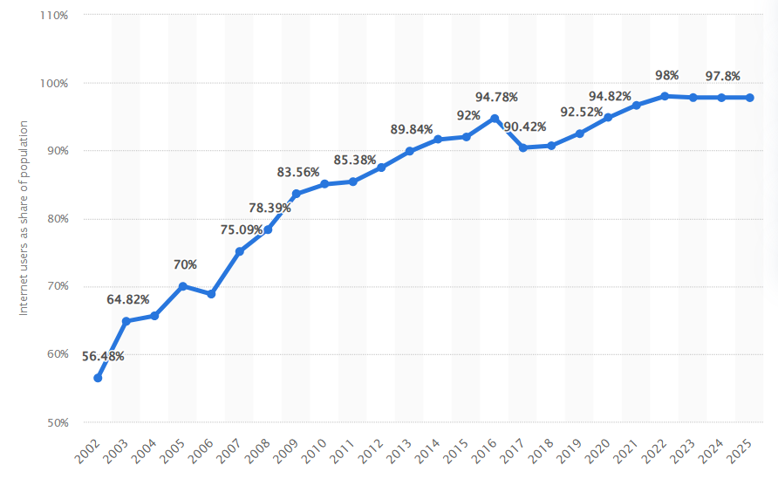  Figure 4: Internet penetration rate of the UK  (Source: D, 2025)  The above graph shows that Internet penetration rate was nearly 98 % in the year 2025 (D, 2025). High Internet penetration rate shows high awareness about digital technologies and most of the businesses in the UK use different digital aids in their operations. New businesses also use technologies to understand market demand and offer suitable products as per consumer demand.
Legal | Legal factors of the UK depend on different regulations as well as policies which help to improve the business environment.  Employment regulation of the UK reformed and focuses on employee rights Unfair dismissal, third-party harassment, sexual harassment, right to request flexible work and many other areas are covered that helps to improve overall workplace condition in this country (Global Legal insights, 2025). New start-up businesses also follow this regulation for smoothly operating their business in the UK.
Environment | Environment regulation of the UK focuses on sustainable measures that help to protect the environment of the UK. The greening government commitment of this country reduces the use of greenhouse gases and minimises the impact of the environment (Gov. UK, 2022). Hence, most of the business in the UK adopts sustainability measures for attracting more consumers.

Table 1: PESTLE analysis of the UK

Key information about the competition
The new sustainable packaging business in the UK has different competitors such as Eco Flexibles, Mondi PLC, DS Smith PLC, Allpack, Huhtamaki UK, Cullen and many others. Their effective manufacturing strategies attract consumers and increase their loyalty towards eco-friendly packaging (Zulfikar, 2024). This new business adopts unique initiatives for offering their products in the market and meet rising demand for eco-friendly products.

Marketing Communications

Effective marketing strategies for attracting customers
The sustainable packaging start-up can focus on operating the B2B contexts that need the marketing strategy that prioritises the overall authenticity, education and transparency for building trust (Civera and Morelli, 2025). Moreover, the effective marketing strategies within the enterprise mainly focus on positioning the packaging as the high performance alternative to traditional single-use plastics that improves brand image and ensures regulatory compliance.
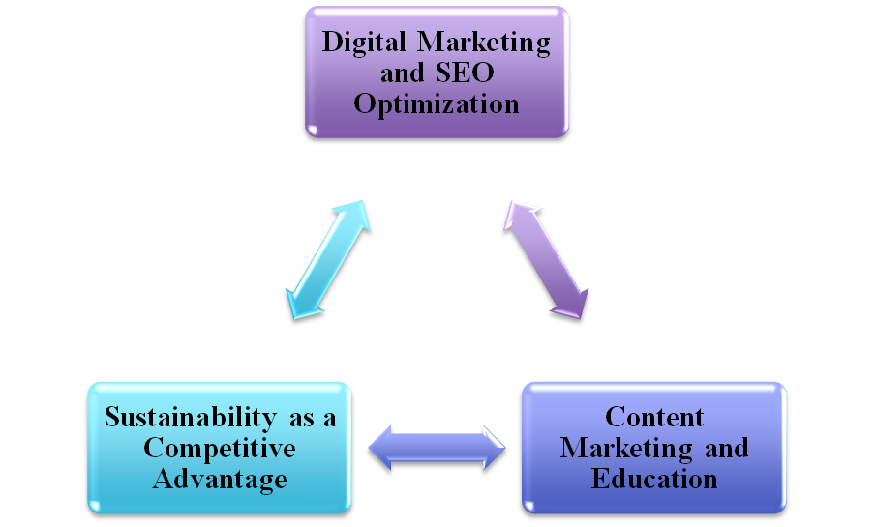
Figure 5: Key marketing strategies Integrated in sustainable packaging start-up
(Source: Self-developed)
The key marketing strategies that is important for the start-up for reaching different customers are,
Digital Marketing and SEO Optimization: Through this, the company will be optimising the website with the industry-relevant keywords such as eco-friendly packaging, sustainable shipping solution and other materials. Moreover, this sustainable packaging start-up includes in using the use of PPC ads on the platforms such as Google search for targeting the specific industries (Sharma et al., 2025). Moreover, they can also focus on utilising the LinkedIn for the B2B networking that showcases the product’s durability and also share the insights regarding the sustainability trends.
Content Marketing and Education: Through this, the company focuses on determining the leadership content which includes in creating the documents. It also addresses the specific challenges based on business facing the ways of sustainable packaging for meeting environmental regulations (Daramola et al., 2025). The content marketing process focuses on switching the start-up packaging by focusing on the cost-effectiveness and positive customer feedback.
Sustainability as a Competitive Advantage: The Company focuses on highlighting the certifications and overall transparency that prominently displays the third-party certification and highlights the marketing and packaging materials for building credibility (Marschlich and Hurtado, 2025). Moreover, the lifecycle assessment transparency focuses on providing the data on the full lifecycle of the packaging from the sourcing and manufacturing for better disposal.

Financials
Amount of funding required for sustainable packaging business and its importance
The funding that is required for the transition to or establishes the sustainable packaging process varies significantly based on the scale that might range from $50,000 for the small scale distribution model to over $5 million for the full scale manufacturing.
The estimated funding requirements includes,
- Manufacturing: $500,000 – $5 million
- Small-scale distribution: $50,000 – $150,000
- R&D for New Materials: $50,000 – $1 million
- Equipment for Manufacturing: $300,000 – $4 million
- Regulatory Compliance: $15,000 – $80,000
The primary funding sources that are applicable for business startups are the Government Grants & Loans and Venture Capitalists (VCs) & Impact Investors. The Government Grants & Loans are important for this business process as it specialises the program to manage the Smart Sustainable Plastic Packaging Challenge. Moreover, Venture Capitalists (VCs) & Impact Investors funding source is also important for the start-up as it determines the dedicated funds like packaging innovation fund that focus on determining the circular economy technologies (Lin, 2022).
These funding resources are required for the business as it has the high upfront capital expenditure for the specialised manufacturing machinery. Moreover, it also focuses on developing the proprietary materials that require certifications that are critical for the market access and the consumer trust but much more expensive.
Outlining the start-up expenses expected during the first month of operations
Launching the sustainable packaging business mainly involves the significant upfront capital with the first month expenses primarily dominated by the manufacturing machinery and facility setup.
First-Month Start-up Budget Estimate
Expense Category | Estimated Costs
Manufacturing Equipment | $250,000
Raw Material Inventory | $75,000
R&D and Certification | $60,000
IT & Infrastructure | $35,000
Facility Setup | $75,000
Contingency Buffer | $733,000

First Month Cash Flow Analysis
The cash flow of the first month focuses on determining the high upfront Capital Expenditure for the inventory and equipment before the sales revenue stabilises.
Cash Inflows: Typically lower in month 1 that relies on the founder capital and pre-orders.
Cash Outflow:
- High (Fixed): Manufacturing Equipment ($250) and facility setup ($75).
- High (Variables): Initial Raw materials purchase ($75).
- Moderate (Operating): Personnel ($39k) and Marketing ($4k–$10k).
Breakeven Analysis Factors
The sustainable packaging business actually faces the higher production costs with higher margins.
- Fixed Costs: Salaries ($39k) and Warehouse rent ($6,500)
- Variable costs: Material costs, inbound freights and logistics.
Conclusion
The study includes in determining the business plan of a sustainable packaging start-up for the group of investors. Moreover, it also focuses on determining environmental analysis through PESTLE analysis. The study also focuses on explaining the marketing strategies that the enterprise uses for adopting the process to reach the customers.

Reference List
Civera, C. and Morelli, B., (2025). Multi-stakeholder marketing in practice: actionable advice for responsible marketers. Management Decision, pp.1-29. https://www.emerald.com/md/article/doi/10.1108/MD-02-2025-0316/1304589
D.T, (2025). Internet penetration in the United Kingdom (UK) 2002-2025. [Online]. Available at: https://www.statista.com/statistics/1124328/internet-penetration-uk/?srsltid=AfmBOoosmt1azHEVNe4yyjZV_dVQwGASOHj6vu93Bm18cT-R6k8xydDr. [Accessed on: 31st March, 2026]
Daramola, O.M., Apeh, C.E., Basiru, J.O., Onukwulu, E.C. and Paul, P.O., (2025). Sustainable packaging operations: Balancing cost, functionality, and environmental concerns. International Journal of Social Science Exceptional Research, 4(1), pp.79-97. https://www.allsocialsciencejournal.com/uploads/archives/20250125142303_SER-2025-1-014.1.pdf
Fragapane, G., Schulte, K.Ø., Eleftheriadis, R., Reke, E. and Ringen, G., (2022). A cross-disciplinary, cross-organizational approach to sustainable design and product innovation in the aluminum industry. Procedia CIRP, 107, pp.59-64. https://www.sciencedirect.com/science/article/pii/S2212827122002268/pdf?md5=6e08e79cbd3ab4e696f9554512c418e8&pid=1-s2.0-S2212827122002268-main.pdf
Global Legal insights, (2025). Employment & Labour Laws and Regulations 2025 – United Kingdom. [Online]. Available at: https://www.globallegalinsights.com/practice-areas/employment-and-labour-laws-and-regulations/united-kingdom/. [Accessed on: 31st March, 2026]
Gov. UK, (2022). Environmental policy. [Online]. Available at: https://www.gov.uk/government/publications/sustainability-in-ukhsa/environmental-policy. [Accessed on: 31st March, 2026]
Lin, L., (2022). Venture capital in the rise of sustainable investment. European Business Organization Law Review, 23(1), pp.187-216. https://pmc.ncbi.nlm.nih.gov/articles/PMC8853163/pdf/40804_2021_Article_238.pdf
Marschlich, S. and Hurtado, E., (2025). The effect of third-party certifications on corporate social responsibility communication authenticity and credibility. Corporate Communications: An International Journal, 30(7), pp.1-20. https://www.emerald.com/ccij/article-pdf/30/7/1/10190857/ccij-01-2024-0015en.pdf
Petrenko, L., Puzko, S., Lavrenenko, V. and Gernego, I., (2024). Fostering sustainable packaging industry: Global trends and challenges. European Journal of Sustainable Development, 13(2), pp.63-63. https://ecsdev.org/ojs/index.php/ejsd/article/download/1526/1498
Sharma, G., Sahai, V., Das, U.C., Pandey, K.A., Mishra, S.K. and Sharma, S., (2025). Digital advertising strategies for sustainable brands: a comparative analysis of social media and e-commerce platforms. Lex Localis, 23(S6), pp.2205-2224. https://www.academia.edu/download/125091229/Gunjan_JLSG.pdf
The global economy, (2024). United Kingdom: GDP, constant dollars. [Online]. Available at: https://www.theglobaleconomy.com/United-Kingdom/GDP_constant_dollars/. [Accessed on: 31st March, 2026]
The global economy, (2024). United Kingdom: Political stability. [Online]. Available at: https://www.theglobaleconomy.com/United-Kingdom/wb_political_stability/. [Accessed on: 31st March, 2026]
The global economy, (2024). United Kingdom: Population size. [Online]. Available at: https://www.theglobaleconomy.com/United-Kingdom/Population_size/. [Accessed on: 31st March, 2026]
Zulfikar, I., (2024). Sustainable marketing strategy: Building brand image and customer loyalty in the eco-friendly era. Jurnal Ekonomi, 13(03), pp.1737-1750. https://www.ejournal.seaninstitute.or.id/index.php/Ekonomi/article/download/5410/4294.

