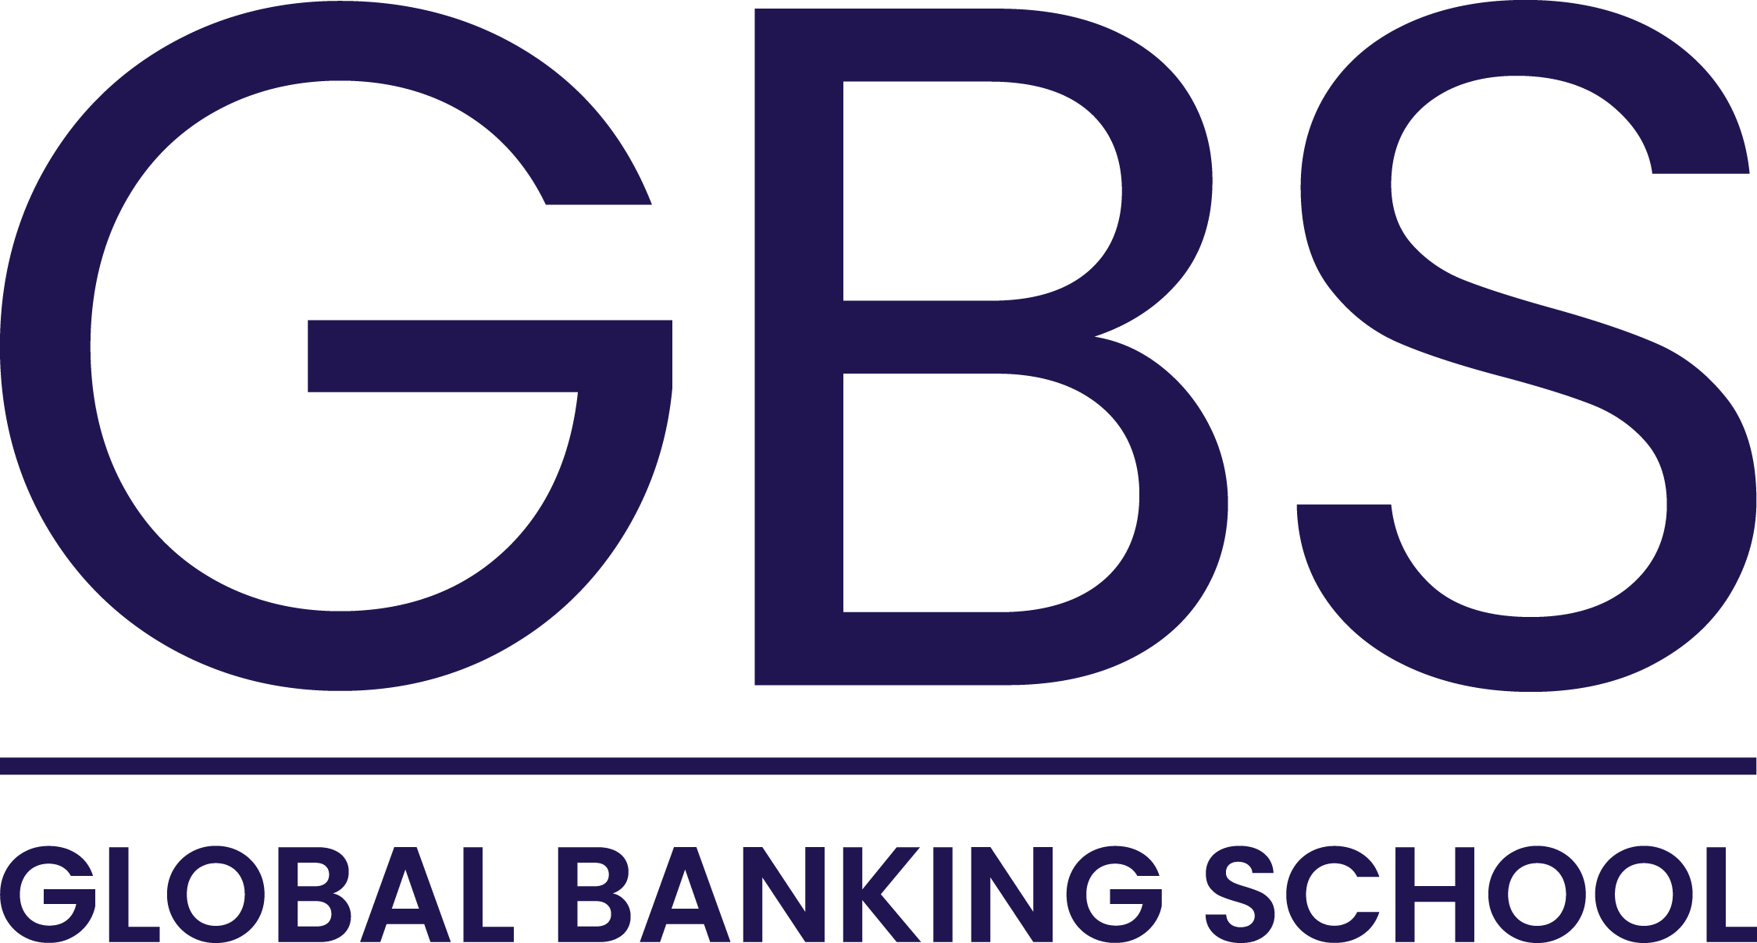




Module 6
Fundamentals of Business Finance
Individual Written Report

Financial Performance Analysis of Echo Journeys (2022–2024)

Prepared By: Business Planning Assistant

Date:

Table of Contents
1. Introduction 3
2. Importance and Quality of Financial Information Error! Bookmark not defined.
2.1. Role of Financial Information in Decision-Making Error! Bookmark not defined.
2.2. Five Qualitative Characteristics of Good Financial Information Error! Bookmark not defined.
2.3. Relevance to Stakeholders 5
3. Key Accounting Concepts 5
3.1. Key Elements of the Statement of Comprehensive Income 5
3.2. Key Elements of the Statement of Financial Position 5
4. Financial Ratio Analysis 5
4.1. Profitability Ratios 6
4.2. Liquidity Ratio 6
4.3. Default Risk Ratio Error! Bookmark not defined.
5. Limitations of Ratio Analysis 7
6. Conclusion and Recommendations 7
References 8
Appendix 9
Appendix A: Ratio Calculations 9

1. Introduction
- Financial stuff really matters for any business, especially when it comes to planning and figuring out what decisions to make(Atrill & McLaney, 2018). As the Business Planning Assistant at Echo Journeys, I put this report together for the Operations Manager. It looks at why financial information is so important and how good it needs to be, plus some basic accounting ideas that fit the tourism world. Then there’s the part where we check the business performance from 2022 to 2024 with ratios, and yeah, it also talks about why ratios are not perfect for everything.

Managers need that financial picture to see how the company is doing right now and where it might go(Atrill, 2020). It helps with planning budgets, keeping spending in check, and seeing if profits are coming in okay. Investors look at it to decide if they want to put money in, checking risks and what they might get back(Watson & Head, 2019). Creditors too, they want to know if the business can pay back loans without troubleBrealey,( Myers & Allen, 2012). And regulators make sure everything lines up with the rules, so accurate reports keep things legal.

I think relevance is one big quality for financial info(IASB, 2018). It should help people make choices by showing what happened before, now, or what could come. Like, Echo Journeys revenue went up from 8.63 million pounds in 2022 to 11.24 million in 2024, and that seems useful for managers thinking about growing the business or something.

Then there’s reliability, which means the info is straight up accurate and complete, no tricks or missing bits. For Echo Journeys, the statements feel trustworthy because they show the real financial side without bias, I guess stakeholders can count on that.

Comparability is another one, where you can look at numbers over years or compare to other investments. Echo Journeys data from 2022 through 2024 is presented the same way each time, so its easier to spot if things got better or not. That part might get a bit messy when you try to line it up with competitors though.

Understandability
Financial info needs to be easy to get, right. Like, if it’s laid out clearly and in some kind of order, people can actually figure out what it means without too much trouble. That helps everyone, whether they know a lot about money stuff or not, to see where the company stands overall.
I am not totally sure, but timeliness seems important too. You have to have the information ready when decisions are being made, otherwise it’s no good. For instance, if managers get the latest on cash flows, they can check if there’s enough money around to cover those short-term things they need to handle. It feels like that part could get messy if its delayed. Some might think it’s obvious, but yeah, it keeps things running.

2.3. Relevance to Stakeholders

This qualitative characteristic makes sure that financial information is used to satisfy the requirements of all the various parties concerned. The management can plan and control its operations, investors can gauge profitability and growth prospects, and creditors measure their financial strength and security. Thus, good financial information will be helpful for decision-making (Atrill & McLaney, 2018)

3. Key Accounting Concepts

3.1. Important Features of the Statement of Comprehensive Income

The revenue is the income earned from the operations performed by the company (Weetman, 2019). In the case of Echo Journeys, revenue comes from its tourism operations.

The cost of services includes direct expenses incurred during the performance of the services offered by the business. This includes the cost of accommodation and transportation.

Gross profit is computed as revenue less cost of services. It can be seen that there has been an improvement in gross profit since it increased from £3.63 million to £5.85 million from 2022 to 2024.

Operating profit is computed as revenue less operating expenses like administrative and marketing expenses as well as depreciation.

3.2. Elements of the Statement of Financial Position

The assets of a business entity refer to the resources that generate economic benefits in the future and are controlled by the entity. The assets of Echo Journeys include fixed assets, tangible assets, intangible assets, and cash assets.

Liabilities are defined as claims that an entity owes to other parties, whether long-term or short-term.

Owner’s Equity refers to the residual amount left in the business after deducting the liabilities from assets. The growth in retained earnings indicates improvement in financial status.

4. Financial Ratio Analysis

4.1. The company’s profitability has strengthened consistently over the three-year period. The gross profit margin rose from 42.0% in 2022 to 44.0% in 2023 and then increased significantly to 52.0% in 2024, indicating improved cost control and more effective pricing strategies. Similarly, the operating profit margin increased from 12.0% in 2022 to 16.0% in 2023 and reached 22.0% in 2024, showing that the business has become more efficient in managing its operating expenses and enhancing overall performance. The Return on Capital Employed (ROCE) also showed gradual improvement(Arnold, 2013), rising from 3.5% in 2022 to 3.7% in 2023 and 4.0% in 2024; however, despite this upward trend, the returns remain relatively low compared with the scale of investment in assets. In contrast, the Return on Ordinary Shareholders’ Funds (ROSF) demonstrated stronger progress(Watson & Head, 2019), increasing from 5.0% in 2022 to 6.2% in 2023 and reaching 9.0% in 2024, suggesting that shareholders are receiving increasingly favourable returns on their investment.

4.2. The company’s current ratio improved from 0.88:1 in 2022 to 1.02:1 in 2023 and then to 1.30:1 in 2024, showing that it has become increasingly able to meet its short-term liabilities and is moving toward a stronger liquidity position.

4.3 Default Risk Ratio

The company’s current ratio rose from 0.88:1 in 2022 to 1.30:1 in 2024(Brealey, Myers & Allen, 2012), indicating reduced default risk as the business has become better able to meet short-term liabilities.

4.3 Default Risk Ratio

The gearing ratio rose from 48% in 2022 to 66% in 2024, showing that the organisation is relying more heavily on debt to support its operations. This upward shift means the organisation is becoming more financially exposed, even though profitability has been improving.

5. Limitations of Ratio Analysis

Ratio analysis will help one learn many numerical aspects but still provides limited information. Since the data used for ratios come from historical books of accounts, future developments might not necessarily come out in their findings. These results could even be manipulated by any factors such as accounting practices, changes in prices, and other anomalies affecting business activities. Aside from the numerical information, there are other essential aspects outside finance that could help provide a more balanced perspective (Gibson, 2013), such as public image and competitive environment of the firm.

6.Conclusion and Recommendations
Echo Journeys has shown strong growth in revenue, profitability, and liquidity between 2022 and 2024. However, the rising gearing ratio suggests an increasing level of financial risk due to higher borrowing. It is recommended that the company carefully manage its debt levels while continuing to grow, ensuring that future expansion is supported by sustainable financial strategies.

References
Atrill, P. and McLaney, E. (2018) Accounting and Finance for Non-Specialists. 11th edn. Harlow: Pearson Education.
Atrill, P. and McLaney, E. (2018) Financial Accounting for Decision Makers. 9th edn. Harlow: Pearson Education.
Weetman, P. (2019) Financial Accounting. 8th edn. Harlow: Pearson Education.
McLaney, E. (2009) Business Finance: Theory and Practice. 8th edn. Harlow: Pearson Education.
Watson, D. and Head, A. (2019) Corporate Finance: Principles and Practice. Harlow: Pearson Education.
Brealey, R.A., Myers, S.C. and Allen, F. (2012) Principles of Corporate Finance. New York: McGraw-Hill Education.
International Accounting Standards Board (IASB) (2018) Conceptual Framework for Financial Reporting. London: IFRS Foundation.
Atrill, P. (2020) Financial Management for Decision Makers. Harlow: Pearson Education.
Gibson, C.H. (2013) Financial Reporting and Analysis. 13th edn. Boston: Cengage Learning.
Arnold, G. (2013) Corporate Financial Management. 5th edn. Harlow: Pearson Education.

Appendix

Appendix A: Ratio Calculations
Gross Profit Margin = Gross Profit / Revenue x 100%
2022 = 3,625 / 8,630 x 100% = 42%
2023 = 4,177 / 9,493 x 100 = 44.0%
2024 = 5,845 / 11,240 x 100 = 52.0%

Operating Profit Margin = Operating Profit / Revenue x 100%

2022 = 1,036 / 8,630 x 100 = 12.0%
2023 = 1,519 / 9,493 x 100 = 16.0%
2024 = 2,473 / 11,240 x 100 = 22.0%

Return on Capital Employed (ROCE) = Operating Profit / Capital Employed x 100%

Capital Employed = Total Assets / Current Liabilities x 100%
2022 = 32,887 / 3,114 = 29,773
ROCE = 1,036 ÷ 29,773 × 100 = 3.5%

2023 = 43,752 − 3,167 = 40,585
ROCE = 1,519 / 40,585 x 100 = 3.7%

2024 = 64,947 / 3,123 = 61,824
ROCE = 2,473 / 61,824 x 100 = 4.0%

⸻

Return on Ordinary Shareholders’ Funds (ROSF)=Profit for the Year / Total Equity × 100%

2022 = 774 / 15,482 x 100 = 5.0%
2023 = 1,158 / 18,669 x 100 = 6.2%
2024 = 1,892 / 21,020 x 100 = 9.0%

Current Ratio = Current Assets / Current Liabilities 100%
2022 = 2,740 / 3,114 = 0.88 : 1
2023 = 3,230 / 3,167 = 1.02 : 1
2024 = 4,060 / 3,123 = 1.30 : 1

Gearing Ratio = Long-term Debt / (Long-term Debt + Total Equity) × 100
2022 = 14,291 / (14,291 + 15,482) x 100 = 48%
2023 = 21,916 / (21,916 + 18,669) x 100 = 54%

2024 = 40,804 / (40,804 + 21,020) x 100 = 66%

