Leadership management theory and practise
Assignment 2
Leadership development programme for
GAME digital PLC

Student number: 1301060

GAME Digital PLC



GAME Digital PLC background
GAME Digital PLC are a British video game and technology company that was founded in 1990 by Terry Norris and Bev Ripley which was originally named Rhino Group but eventually became GAME. There have been many strains put on the company of GAME over the last 15 years with the emergence of e-commerce and many more rival companies setting up in the still a young industry that is gaming. Despite the challenges faced by GAME; as a company, they have relished many of them to ensure the company stays ahead of the competition with improvements to physical aspects of stores to unique selling points that others cannot offer, such as a TRADE-IN scheme which is hugely popular “From high street retail to digital services, events and esports – how we’ve changed and developed over the last 25 years” (GAME, 2018). Despite these unique selling points, what stands out for GAME is the fact that the employees themselves are gamers. This is a key value of the company and what will generate a lot more sales and profit.
The vision and aims of GAME Digital is to ensure that customers gain the best experience when it comes to video gaming and by GAME employing people who are also themselves gamers and share the same enthusiasm as the customer for the product it will generate more sales from the core, the employees “We put the gamer first because gaming’s in our blood. Most of our people are gamers – it’s what they do and love and this relevance to the customer is what sets us apart.” (GAME Digital, 2018) GAME believes the connection between the customer and the employees who engage in aiding their customers experiences face-to-face or even digitally is a key value. “Engaged employees are the employees who provide great customer service. Your customers want a positive, unique experience, and your employees are the people who can provide that experience. Experiences have progressively become the predominant economic offering.” (West, 2018)


Vision
The vision of GAME digital PLC stems from its core values, gaming. Promoting a wider audience to participate in the already growing community of gaming throughout the world. GAME are unique to their own industry of gaming as there are not any competitors who can offer the exclusive gaming experience that they do, due to others not specialising in this industry whereas GAME is built up from gamers to sell to fellow gamers. The employees understand the values of the community and come across with a much more enthusiastic attitude full of knowledge on any video game topic. Built up from nothing to a valuable community which they want to keep on adding to and bringing more new customers in to. GAME promote the vision of its companies values to not feel like just a job, instead gaming is a lifestyle choice “We’re building the most valuable community for gamers” (GAME, 2018). The fellow employees are buying into the vision of the company, to create the world’s best gaming community in supplying the best service and products to its customers.

OMEGA INC.

We at OMEGA INC. are a business consultancy who run leadership development programmes that will enhance your overall performance as an organisation from sales figures, productivity, encouraged team leaders and team members who are much more satisfied increasing employee engagement which ultimately is the core values of any organisation and decreasing turnover rates. OMEGA INC. have been successful in many leadership development programmes.

Leadership theories
The theory behind the leadership and development of an individual involves the process of assessing the different leadership methods that can be brought into an organisations structure. To ensure that leaders within the company are identified for future roles, there must be a leadership and development programme. To build on this leadership and development programme to be successful you must incorporate models of leadership styles to it. There are many modern styles that are used within companies now such as transformational and team leadership. Also, older styles that have been around much longer in organisations such as situational leadership are still valuable to organisations when producing a better workplace and results.
Transformational Leadership can be seen as the deeper understanding into the emotions of an individual. Assessing their feelings and treating them as human beings. The individual’s values are also considered, how they see your company and whether there needs to be a refresh on their views of the company to them through a development programme. The ethics are examined in this approach and the long-term goals that they are setting, whether they suit the organisation. With this approach, other employees will feel much more valued thus making them want to have a better work ethic and create a much more productive organisation. The employee engagement is increased as a result of this approach being instilled in an individual.
Team leadership is present in much of today’s organisations due to its relatively new introduction compared to some of the more traditional styles. The competitive advantage of your organisation will be enhanced due to the organisation becoming flatter, increasing communication from technological advances resulting in faster response time from team members. The productivity also benefits from this structure as the employees see it as a task that can be achieved by working together including the involvement of the leader doing similar tasks. From introducing this approach it increases decision making and problem solving, improving emotional intelligence to keep calm in pressure situations. It is not just the staff who benefit from team leadership being incorporated to your organisation but the stakeholders, it increases a much more positive work environment from the understanding of others in the organisation, providing them with clear communication on tasks asked of them to deliver to customers.
Situational leadership is concerned where directive and supportive is composed and applied to a situation. Situational leadership is the ability to adapt, adaptability ensures that a leader can be ready for almost any circumstance. Northouse describes situational leadership as “effective leaders are those who can recognize what followers need and then adapt their own style to meet those needs.” (Northouse 2016) Northouse is expressing that in order to be effective as a leader you must possess situational approach as it gives you the ability to meet the needs of fellow employees who can only work in a certain situation. Breaking down the situational approach the leader must examine their followers and see how driven they are to reaching their goals. If they are not motivated to, then a good leader will adapt to this situation to ensure they reach the goals set.

LEADERSHIP

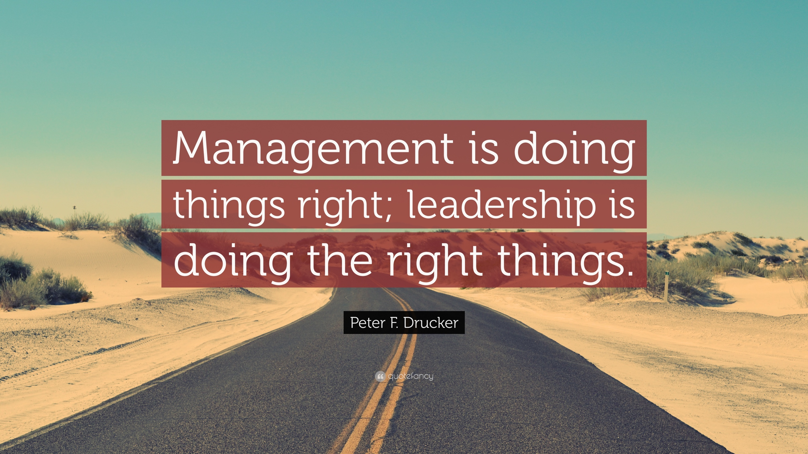
Leadership has many theories to coincide with it, such as the different approaches that a leader will choose to adopt to fit their style. Peter F. Drucker stated “Management is doing things right; leadership is doing the right things” (Drucker,). Drucker here emphasises on how leadership differentiates from management and is the ability for you to make a difference and decide exactly how the outcome of a given situation will be determined from your actions, where management is not down to your leadership skills set but is just accepting what is in front of you and not getting the choice to impact the situation effectively. Leadership that is developed correctly in an individual will ensure that others are able to learn and enhance their skills to one day become a future leader, giving you the power to impact a followers future by leading correctly.
Below figure 1 demonstrates how 195 companies who were asked to rate 74 skills and competencies to rate the most important into 5 themes. From this data conducted we can see that ethical standards are highest when considering what skills are valuable to an organisation when it comes to leading a team. Followed by self-organisation which is broken down to explaining goals and objectives to fellow team members clearly and giving correct guidance. Efficient learning is next very much required according to these companies by having the ability to adapt and change through flexibility, adapting to situations and followers needs. Fourth most valuable is the nurture and growth of an individual, how much they are willing to further their skillset and enhance through training e.g. Leadership development programme. And finally connecting to others is seen as an asset to have within a someone who is looking to lead a company, by keeping everyone engaged and communicating regularly with fellow staff. Making them feel valued and that they succeed together and fail together, creating a safe working environment.
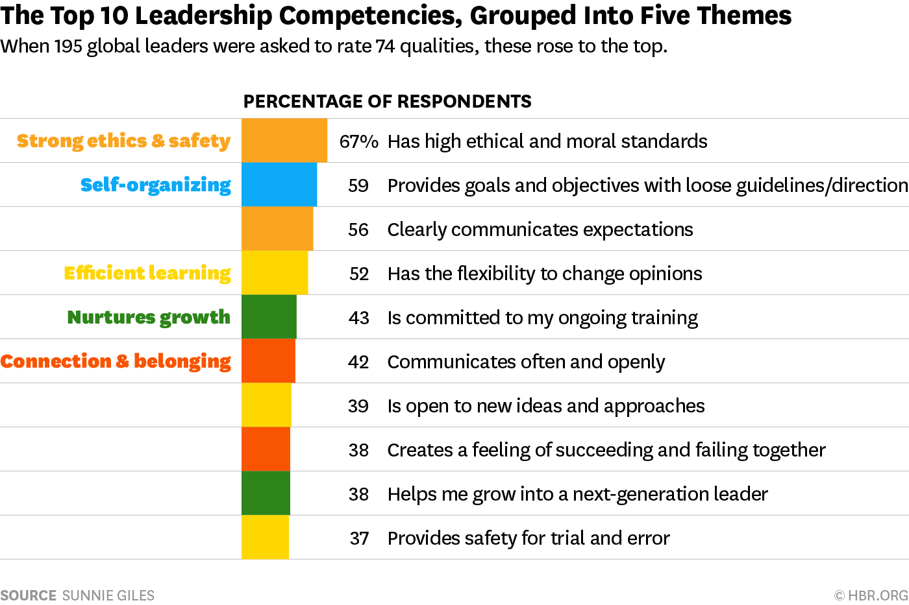

Figure 1

Why identify and inspire future leaders?
Identifying and aspiring future leaders is vital for your organisation, it will save your company money in the long run as you do not have to go through a hiring process when you have developed talent under your noses who already understand the core values and goals that are set out to be achieved by you. “Thus, by developing the right qualities in potential candidates, companies can ensure that they have a continuance of leaders fit to cope with the increasing pressures at the top.” (Londoncoachinggroup.com, 2016) By identifying the future leaders of your company there are plans in progress from the offset of the leadership development programme, they will be gaining the tailored training to develop their skills and leadership style from the programme and working around current leaders who are performing effectively due to the programme which ensures bad leadership habits will not be learned by future leaders.

Overview of leadership development programme
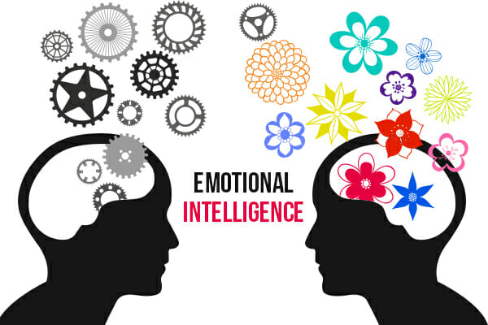
Transforming multiple organisation through tailored coaching, ensuring the client’s needs and values are met through identifying and evaluating their suited programme experience. We believe that leadership theories integrate styles of an organisation to but we know that sometimes these are not being run effectively and that is where we step in and enhance leadership skill sets through a programme that suits your organisation’s values. OMEGA INC. will use a self-assessment tool (360-degree assessment) first analysing an individual’s control of emotions in pressure situations, improving emotional intelligence to enhance decision making, coach the individual to prepare for any changes in future situations of the organisation. Also, OMEGA INC. believe that employee engagement is a key factor to ensuring production is running smoothly and ensuring results are being produced due to a satisfied working environment.
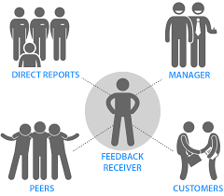

OMEGA INC.
Leadership development
programme

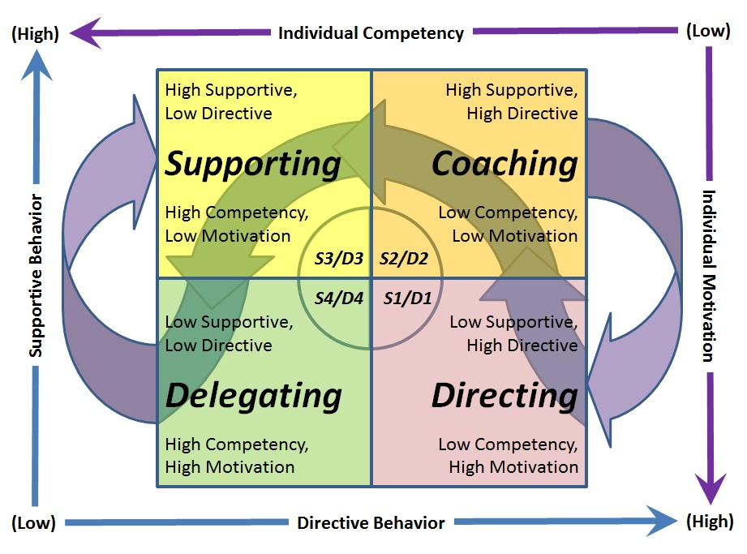
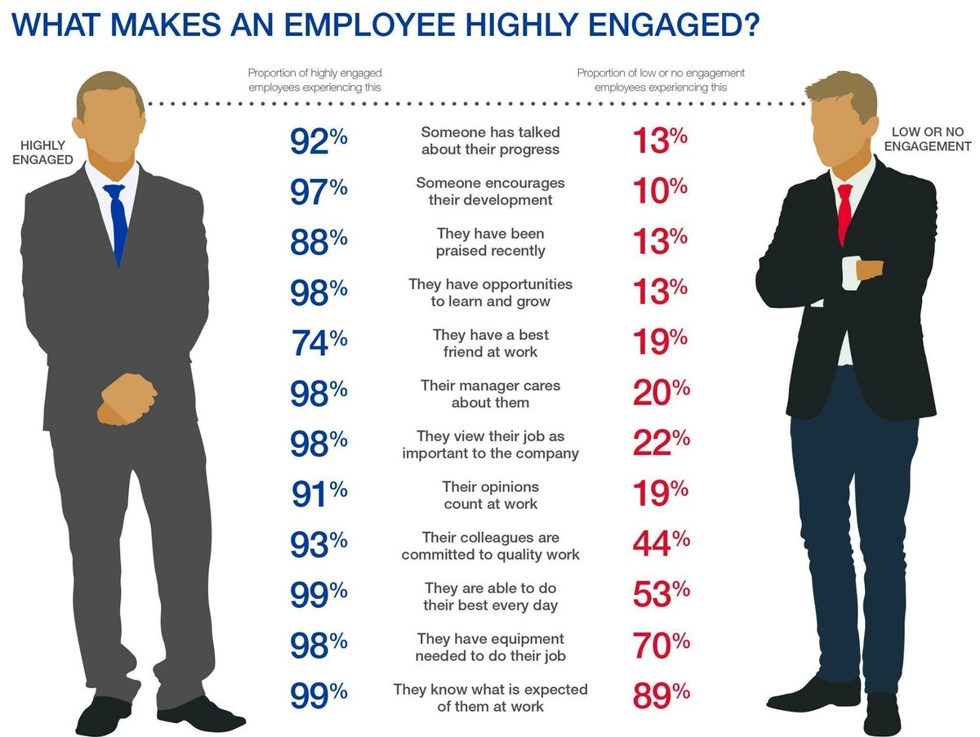

How can OMEGA INC. help you?
OMEGA INC. will bring your organisation better performance results, much more satisfied staff, higher sales of products due to a better employee engagement with a flatter organisation improving communication and response time becoming much quicker to any situation. We will prepare your employees for change, prepare them for future leadership roles within the organisation thus helping you develop staff that is already buying into the vision of your company ensuring quicker results than if you had to hire an external leader and saving money by using a development programme to retain employees. Personal growth will become enhanced due to coaching, as will decision making in pressure situations ensuring you can trust your team leaders to carry out an efficient job. Self-awareness of the leadership qualities will be reviewed and create room for improvement among employees, visualising where they need to strengthen to help improve your company’s productivity. Also, leaders of the company will have enhanced their skills effectively with the programme ensuring that employees of that leader will be training and learning correctly from their colleague, giving them the advantage being ahead of competitors lower rank employees and saving time and money later in their career when they have been identified as a new leader of a role in the organisation. OMEGA INC. will bring many new aspects to your organisation, allowing to aspire to future leaders not just current leaders of your company, guiding them a vison of the right path to take which will decrease turnover rate as a result.
The cycle that a leadership development programme will always start with a self-assessment to know what areas need improvement, followed by using the skill set you have at hand to develop into an even better leader and knowledge of how to use them to get the best of your followers to get used to your leadership theory method. This method will then be applied to your skills set through executive coaching to ensure you are gaining the tailored experience that suits you and your company, assuring your leaders are getting the appropriate path a review of progress and results is viewed to give the individual motivation to see their own progression.
Self-Awareness
(360-degree feedback)

Skills & leadership methods
Acquired skills applied through training

Progression review
(results analysed by employee engagement)

Follow up coaching
Apply skills and leadership method from followed up coaching sessions

Advantages of Leadership development programme
There are multiple benefits to a leadership development programme, they further your leadership skills set and develop your style to suit the organisation thus improving results and performance of the whole organisation from yourself to your work team members. Many studies have shown the enhancement that a leadership development programme has had on their organisation with one study showing that 86% of organisations who took part with a leadership development programme rapidly have responded to changing market conditions, resulting in better profitability. These are some of the main benefits your organisation will see as a result of agreeing to a leadership development programme:
- Financially more economical to train existing employees to higher levels of leadership rather than examine and hire a recruitment for external candidates.
- It saves time to have an employee who has been working within the company for many years to work their way up, understanding core values of the company.
- Aspire future leaders learning from current leaders who know the correct development they need due to the programme.
- Return for your investment, will generate much more profit for the amount spent on the programme in the long-term.
- Surrounding employee members will benefit from this programme, not just current leaders due to a better working environment being created following the programmes development of current leader.
- Creates a path and direction for future leaders or even current leaders which is lacking in organisations environment and the leader of high employee turnover rates.
- Cross-training is a beneficial method of a leadership development programme due to a current leader gaining the opportunity to learn fellow employee’s tasks giving them an understanding of their emotions of the task for their followers.
- Productivity is further enhanced due to a better understand of the current leader to bring the best out of their team.
- Employee engagement is high when managers know how to effectively lead their people. Creating a more nurtured environment and corporate culture increases employees embrace engagement.
- Emotional intelligence increases thus resulting in better strategic plans to cope with pressure situations or times of conflict.
Implications to a leadership development programme
As expected with any programme there can be some implications that are seen when examining a leadership development programme such as:
- This isn’t always seen as a downside but its not an instant pay off that you’ll be expecting to see with a leadership development programme.
- Some programmes can be too brief and not related to the individual, taking into account their needs and values to enhance their skills as a leader.
- A third disadvantage of a leadership development programme that can be seen is the fact core management skills are being overlooked such as planning and organising your organisation, skills must still be kept up to a high standard not just concerned about surrounding employee’s feelings to complete tasks.

Despite these implications, we at OMEGA INC. aim to combat these issues with a tailored experience for your employees, considering everyone is different and requires careful examination to suit their leadership style with a 360-degree assessment. Also, we look to still implement leadership values with management skills as we understand that to be a great leader and see great results these two go hand in hand.

Recommendations
I’m sure that you are wondering how we will get this leadership development programme to fit the needs of your employees, determining who it will benefit?
Well the leadership development programme that OMEGA INC. provide is tailored to a variety of leadership styles and individuals. The leadership programme is aimed at the following:
- Current leaders within your organisation. We see current leaders as the core of our programme, retaining current leaders who understand the values of the company is key to enhancing performance for your business.
- Senior management will also benefit from the development programme as we look to implement the leadership values from our programme throughout the whole organisation, from the very top to the entry employee role. This creates for an effective and understanding for everyone in the organisation of what is expected to achieve the goals set.
- Future high potential leaders are also part of who we aim this leadership development programme at. At OMEGA INC., we aim to identify early potential leaders not just current leaders. Helping you put in place a plan without having to look any further than your own employees. Saving time from having to examine and interview external candidates who are unknown to the company.

‘When will the leadership and development programme begin?’
- The leadership development programme will begin within the next 2-3 weeks, getting started as soon as possible is key to us, as we want to work with your current and future leaders right away to learn how their styles work.
- The programme will be tailored to fit each individual, with one-to-one coaching, 360-degree self-assessment and increasing their skills set.
- Following the first session there will be follow up coaching sessions planned 7 days in advance from the last session. Ensuring continual progress is tracked and reviewed.
- Smart objectives will be set to achieve the goals set, ensuring the individual remains motivated throughout.

Why choose OMEGA INC.?
OMEGA INC. are the right consultancy for you to choose for your business to implement a leadership development programme. We have effected many organisations in a positive way, getting results for their employees increasing employee engagement, productivity and generating better sales. Inspiring current employees to drive to be leaders one day within the organisation, learning the core values of what is expected to become a leader and identifying early through our programme. Retaining staff thus, helping planning for future replacements for leadership roles, saving money and time of hiring external candidates to buy into the values of your company GAME.
Based on the information we have shared about our company on our strategy to enhance your current and future employees into great leaders to improve your organisation I hope you feel well informed to make the correct decision in hiring us to implement a leadership development programme. You will see many positive results outweighing any of the implications in the long-term. We aim to combat any issues you see with the development programme by tailoring the needs of your employee’s leadership needs and values.

References
Donnelly. (2010). How to create a leadership development programme.Available: https://www.inc.com/guides/2010/07/how-to-create-a-leadership-development-program.html . Last accessed 22nd April 2018.

GAME digital . (2018). Our vision. Available: http://www.gamedigitalplc.com/about-game-digital/our-vision. Last accessed 20th April 2018.

GAME digital . (2018). Our vision. Available: http://www.gamedigitalplc.com/about-game-digital Last accessed 20th April 2018.

Goleman, D. (1998). Emotional intelligence in leadership. Available: https://www.mindtools.com/pages/article/newLDR_45.htm. Last accessed 22nd April 2018.

londoncoachinggroup. (2016). The importance of developing future leaders and how to identify them. Available: https://londoncoachinggroup.com/guest-article/the-importance-of-developing-future-leaders-and-how-to-identify-them/ . Last accessed 22nd April 2018.

Northouse, G, P (2016). Leadership theory and practise . London: SAGE. p33-33.

Rufferty, I. (2010). What is Really Needed to Succeed: Emotional Quotient vs. Intelligence Quotient. Available: https://medium.com/bsg-sms/what-is-really-needed-to-succeed-emotional-quotient-vs-intelligence-quotient-7514cd086df2. Last accessed 21st April 2018.

West, K. (2018). The connection between your employees and your customers. Available: https://www.nbrii.com/blog/the-connection-between-your-employees-and-your-customers/. Last accessed 21st April 2018.

Zenger. (2016). How effective are your 360 degree feedback assessments. Available: https://www.forbes.com/sites/jackzenger/2016/03/10/how-effective-are-your-360-degree-feedback-assessments/#2602f438a690 . Last accessed 21st April 2018.

Appendix
Figure 1 - http://thechurning.net/wp-content/uploads/2016/03/Screen-Shot-2016-03-16-at-12.23.43.jpeg

GAME LOGO - https://i.pinimg.com/originals/8b/ea/59/8bea59d2f498cf80cd7b56069aafaa6f.jpg

http://www.timeretailpartners.com/wp-content/uploads/2017/03/GAME-Milton-Keynes.jpg
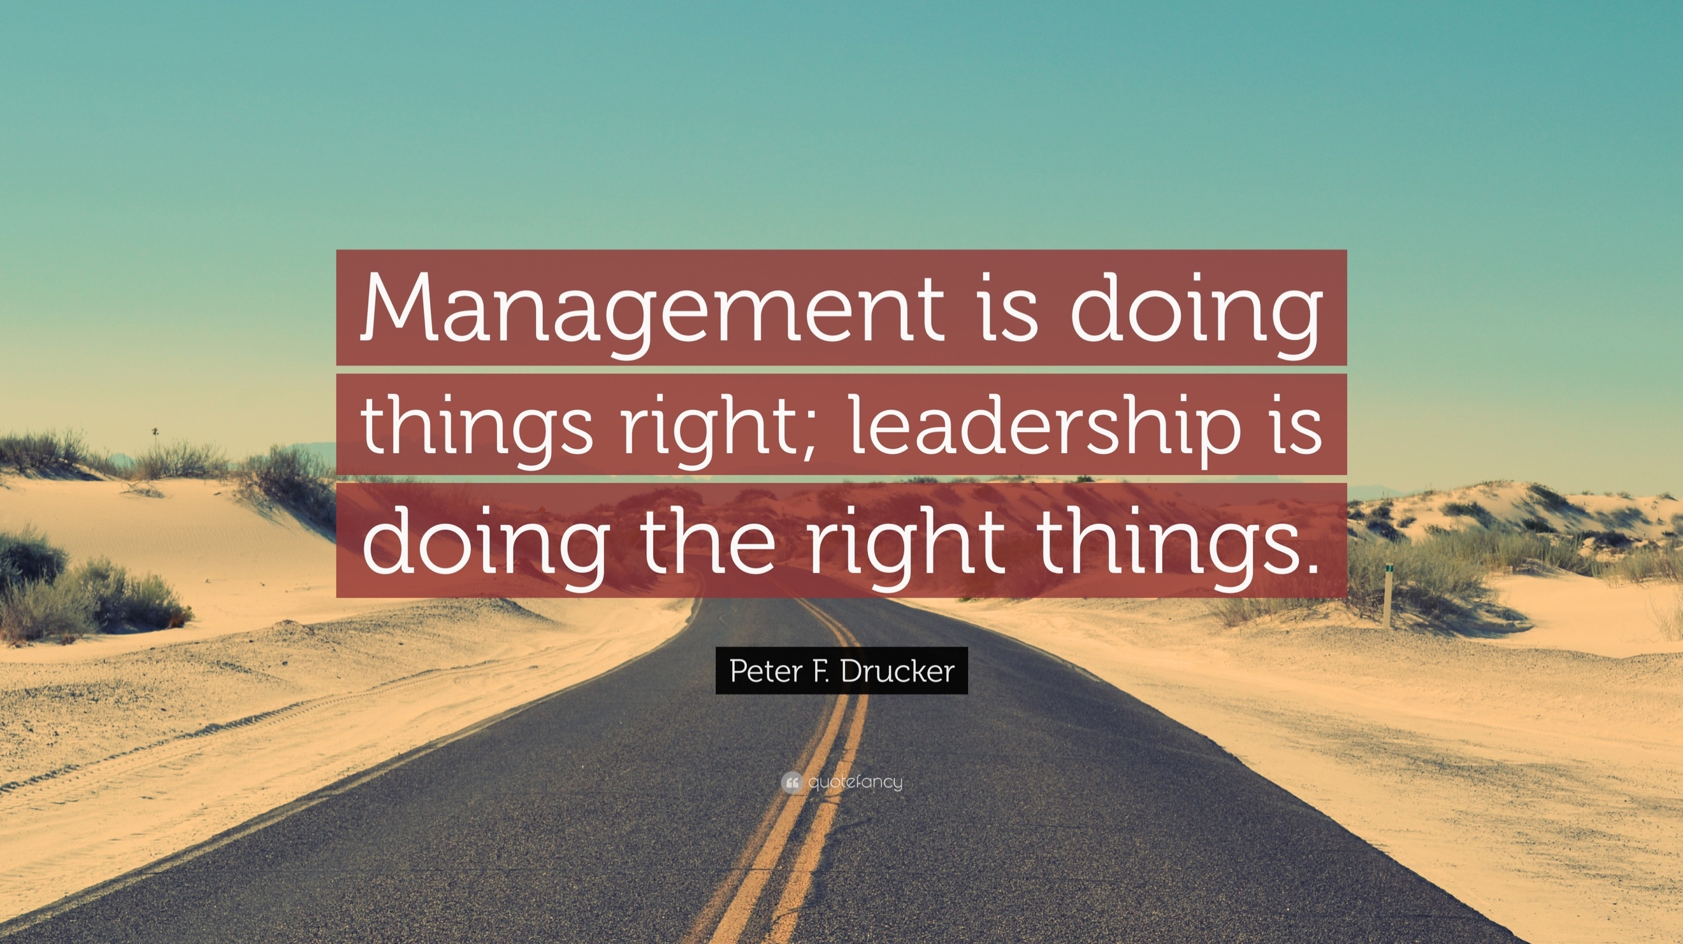

Peter F. Drucker https://quotefancy.com/media/wallpaper/3840x2160/15541-Peter-F-Drucker-Quote-Management-is-doing-things-right-leadership.jpg

360 degree assessment - https://www.cognology.com.au/wp-content/uploads/2014/09/360-Degree-Feedback-Infographic.gif

https://corporatefinanceinstitute.com/resources/careers/soft-skills/emotional-intelligence-quotient-eq/

https://probings.files.wordpress.com/2013/10/blanchard.jpg

https://pbs.twimg.com/media/CnKRGFaWYAApxie.jpg

