
Research, Design and Production of a Home Security System for Private Home Use

by
Samuel Jay Lloyd (2110666)

Supervisor: Steve Mosley

Project submitted as part of the requirements for the award of
BEng (Hons) Embedded Electronic Systems Degree`

April 2025

DECLARATION
I, Samuel Jay Lloyd declare that I am the sole author of this Project; that all references cited have been consulted; that I have conducted all work of which this is a record, and that the finished work lies within the prescribed word limits.
This work has not previously been accepted as part of any other degree submission.
Date : 28/04/2025

FORM OF CONSENT
I, Samuel Jay Lloyd hereby consent that my Project, submitted in candidature for the BEng (Hons) Embedded Electronic Systems Degree, if successful, may be made available for inter-library loan or photocopying (subject to the law of copyright), and that the title and abstract may be made available to outside organisations.
Date : 28/04/2025

Abstract
The Key aims covered over this Project are the research, planning, design and implementation of a modular home security system. The objectives will be to research the current market and possible techniques used, then carrying out a customer survey to complete this understanding. Then use this knowledge the plan and design and then implement this to create a working system.
Within this project a range of methods have been used. As a part of the Literature review and other research, the use of investigation and customer surveys were used. This was to allow the collection of all information required within for development. Then, within the development of the project, the use of simulation and prototyping have been used to allow the improvement of the product to produce the best final product.
The key parts of the final product are the bases of a POE system, proving the concept of the system. The connection between the PI and ESP32-S3-ETH was created and tested and proven valid using a ping which showed that data could be passed back and forth between the devices when a valid ethernet connection is made. Upon completion of the connection the next stage will show how a connection can then become the passing of video data, showing the livestream on a webpage with the IP as the URL. The Final step shown on this project so far is the capture of the video date using a python executable, this shows that it is possible to complete these steps and should be simple to add the future steps.
In conclusion, the work that has been completed to date, shows that theoretically all other steps should be compatible and can be connected and completed. For further work and recommendations, firstly the completion of the prototype is required, completing all the desired steps and finalising the project. Upon finalization of the project, the next stage will be testing the full system, calculating the required hard drive size for 2 weeks’ worth of recordings, running the system for an extended period ensuring no faults occur when the system is being used long term. Finally, the design of an emergency power supply, this will provide the ability to supply the whole system if a power out was to occur for a set period. In summary, good progress has been made but with additional features and further work greater enhancements on the system can be made.

Contents
Abstract 3
Introduction 7
Literature Review 8
Aims 8
Current Market 8
Possible methods of communication 10
Video Compression Techniques 11
Data Storage Techniques 12
Ethical concerns 12
Research and Development Methodology 14
What Research and Development Methodologies Were Used 14
Measures of success 15
Customer survey 15
Questionnaire 16
Analysis of Research and Customer Survey 18
Results 18
Final Module Selection 18
Final Communication method 19
Design and Implementation 20
Module Design 20
Window/door monitor 20
Motion sensor 23
Base module 26
Indoor Camera Module 30
Final Parts List for Prototype 32
Prototyping 32
Evaluation 46
Conclusion 48
Possible Future work 49
Reflection 50
Bibliography 58
Appendix 59

Figure 1: Ring Doorbell [12] 10
Figure 2: Ring Indoor Camera [13] 10
Figure 3: Ring Outdoor Flood light Camera [14] 10
Figure 4: SimpliSafe “The Starter” [15] 10
Figure 5: SimpliSafe "The Bamburgh" [16] 10
Figure 6: Sansco 8 Channel Camera System [17] 10
Figure 7: Yale Smart Alarm Starter Kit [18] 10
Figure 8: Yale Smart Video Doorbell [19] 10
Figure 9: Reolink 4K PoE CCTV Camera Systems 8CH [20] 10
Figure 10: Prototyping Methodology 14
Figure 11: Questionnaire Page 1&2 16
Figure 12: Questionnaire page 3 17
Figure 13: Questionnaire Results 18
Figure 14: Window/Door monitor circuit, Switch Closed 21
Figure 15: Window/Door monitor circuit, Switch Open 21
Figure 16: Window/Door monitor circuit Code 22
Figure 17: RUNCCI-YUN 4X Magnetic Reed Switch [51] 23
Figure 18: Bernstein AG MA-42 Series Magnetic Non-Contact Safety Switch [52] 23
Figure 19: SICK RE21 Series Magnetic Non-Contact Safety Switch [53] 23
Figure 20: Gebildet 3 sets Black Magnetic Switch Wiring NO/NC Recessed Door Sensor Hidden Window Contact [54] 23
Figure 21: IR Sensor High 24
Figure 22: IR Sensor Low 24
Figure 23: Motion Sensor Code 25
Figure 24: Panasonic 10m PIR Motion Detector [55] 26
Figure 25: Panasonic PIR Motion Detector PIR Sensor, 5m Sensor Range [56] 26
Figure 26: Sensor, PIR, Compact, 2m, Black [57] 26
Figure 27: EKMC2610113K Panasonic, EKMC (VZ) PIR Sensor, 5m 3-Pin [58] 26
Figure 28: POE setup options [59] 27
Figure 29: Exsys 2 Port POE Injector [60] 28
Figure 30: Exsys Single Port POE Injector [61] 28
Figure 31: POE INJECTOR, RJ45, DIN RAIL/PANEL [62] 28
Figure 32: Raspberry Pi PoE+ Injector [63] 28
Figure 33: RS PRO Unmanaged 5 Port Ethernet Switch [64] 29
Figure 34: Netgear GS108GE, Unmanaged 8 Port Ethernet Switch [65] 29
Figure 35: TP-Link 8-Port Gigabit Network Switch [66] 29
Figure 36: Ethernet Switch, Unmanaged Fast, 16 x RJ45 Copper Port [67] 29
Figure 37: TP-Link TL-SG1005LP 5 Port Gigabit PoE Switch, 4× Gigabit PoE+ Ports [68] 30
Figure 38: Switch, Embedded, 5 Ports, Industrial, Unmanaged PoE Gigabit Ethernet [69] 30
Figure 39: Switch, Polyamide casing, 5 Ports, Industrial, Unmanaged PoE Fast Ethernet, DIN Rail, RJ45 x 5 [70] 30
Figure 40: 16-Port Gigabit Ethernet Unmanaged PoE+ Switch with FlexPoE (76W) [71] 30
Figure 41: ESP32-POE-ISO-16MB [72] 31
Figure 42: RJ45 Ethernet Development Board (ESP32-S3) [73] 31
Figure 43: Latch Connection 35
Figure 44: Latch No Connection 35
Figure 45: PICKit 4 and outputs [78] 35
Figure 46: PIC12LF1840 Pinout [79] 36
Figure 47: Window/door Monitor Prototype 36
Figure 48: Motion Sensor Circuit, Sensor Not Triggered 36
Figure 49: Motion Sensor Circuit, Sensor Triggered 36
Figure 50: Test Setup 38
Figure 51: ESP Code Define pins and WiFiEvent 39
Figure 52: ESP Code Setup and Serial Output 40
Figure 53: PI terminal output 41
Figure 54: Test Setup & Results 41
Figure 55: ESP32 setupCameraServer Function 42
Figure 56: ESP32 Handle_mjpeg_stream Function 43
Figure 57: ESP32 Camera Webpage Including Setup 44
Figure 58: Saving MJPEG Code & File 45
Figure 59: Gantt Chart During Proposal 46
Figure 60: Gantt Chart from January 47
Figure 61: Gantt Chart April 47

Table 1: Market Research Comparison 8
Table 2: Magnetic Switch Comparison 22
Table 3: PIR Sensor Comparison 25
Table 4: POE Injectors 27
Table 5: Non-POE switches 28
Table 6: POE Switch 29
Table 7: Final Parts List 32
Table 8: Risk Assessment 33
Table 9: Risk matrix 34

Introduction
This project will conduct research into the large market of home Security, then use this information to design and create a modular home security system. Within the project the following objectives will be carried out. Research, there will be investigations into how current systems operate, look at the reviews of existing products and the costs, including upfront costs and monthly fees. A customer research survey will be completed and evaluated, looking into requirements of potential customers desires and needs. Once all this information is collated and evaluated begin a design process, using simulation skills and knowledge of electrical components. Upon completion of the design process, prototyping will be carried out building the designs and then carrying out testing, investigating the performance of the modules individually and then as an all-round system. This will aim to end with a completed product which could be used and sold on the market.

Literature Review

Aims
Within the Literature Review there will be the following aims:
- Carry out market research into the current market’s products, investigating how the systems operate, examining customer reviews of the products by looking at the strengths and weaknesses, the costs, both upfront and monthly, and any other details that are available or any other information that can be collected.
- Investigate methods for the following parts of the final build
  - Communication – looking into how the information will be shared around the system, whether wirelessly or wired, and what methods are commonly used.
  - Video compression – investigating what techniques are commonly used in this area, then assessing which of these would be the best fit for the project, looking into the required processing power, the amount of compression, the cost of the licence if relevant and more.
  - Data storage – should data be stored locally or on the cloud? How long should data be stored for? Should all video data be saved or should this only happen when an alarm is set, or a sensor is triggered? Does this differ for indoor and outdoor sensors?

Current Market
In this case there is a large, growing market [1] to investigate. Table 1 shows some of the major companies in this area and the products they offer and some of the key pros and cons.
Table 1: Market Research Comparison
Brand name | Example Products  *[value]* is a description listed bellow | Price | Advantage | Disadvantage | Recurring fee
Ring [2] | Doorbell camera  Seen in Figure 1 | £69.99 - £159.99 | Easy install, large cloud storage, accessible via mobile app, professional monitoring, range of battery and solar panelled power supplies [3]. | high upfront cost, monthly fees, not as wide of a range of available sensors as others [3]. | Monthly  Basic – £4.99  Standard – £7.99  Premium – £15.99
Ring [2] | Indoor camera  Seen in Figure 2 | £24.99 - £49.99 |  |  | Monthly  Basic – £4.99  Standard – £7.99  Premium – £15.99
Ring [2] | Outdoor camera  Seen in Figure 3 | £59.99 - £109.99 |  |  | Monthly  Basic – £4.99  Standard – £7.99  Premium – £15.99
Ring [2] | Alarm pack *1* | £179.99 |  |  | Monthly  Basic – £4.99  Standard – £7.99  Premium – £15.99
SimpliSafe [4] | The Starter *2*  Seen in Figure 4 | £159.95 | easy install, large cloud storage, accessible via mobile app, professional monitoring, range of battery and solar panelled [5]. | high upfront cost, monthly fees, mid-range video quality [5]. | Daily  Pro plan – 53p  Pro premium – 93p
SimpliSafe [4] | The Edinburgh *3* | £337.37 |  |  | Daily  Pro plan – 53p  Pro premium – 93p
SimpliSafe [4] | The Bamburgh *4*  Seen in Figure 5 | £227.37 |  |  | Daily  Pro plan – 53p  Pro premium – 93p
Sansco [6] | 8 channel camera system  Seen in Figure 6 | £169.99 | Good value, App supported, Night vision cameras, Smart motion detection [7]. | Feels cheap, bad UI, limited storage unless upgraded [7]. | N/a
Yale [8] | Starter kit *5*  Seen in Figure 7 | £399.98 | 1Km range, 100 accessories with a large range of sensors, DIY friendly, compatible with smart homes. [9] | Some very expensive packages, base package is not pet friendly but do more expensive packages that do have it. [9] | Daily  Camera – 12p  Alarm – 16p  Secure – 29p  Secure pro – £1.16
Yale [8] | Premium kit *6* | £499.99
Yale [8] | Smart video doorbell  Seen in Figure 8 | £130.00
Reolink [10] | 4K PoE CCTV Camera Systems 8CH with 2TB HDD NVR and 4 X 8MP Home Security IP Cameras  Seen in Figure 9 | £499.99 | High image quality, night vision, motion detection, easy installation [11] | Expensive | N/a

*[value]* Package information listed below:
*1* - Base station, alarm keypad, contact sensor, motion detector and an alarm.
*2* - Base station, keypad, entry sensor, motion sensor, wired indoor camera, bell box.
*3* - Base station, keypad, 3 entry sensors, 2 motion sensor, temperature sensor, water sensor, 2 key fobs, outdoor camera, wired indoor camera, bell box.
*4* - Base station, keypad, 105dB siren, panic button, 2 key fobs, 3 entry sensors, 2 motion sensors, glass break sensor, wired indoor camera.
*5* - Alarm hub, live siren, motion detector, keypad, 2 door/window contacts.
*6* - Alarm hub, live siren, decoy siren, 2 motion detectors, keypad, keyfob, 2 door/window contacts.

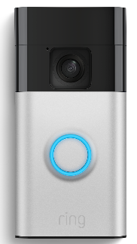  Figure 1: Ring Doorbell [12] | 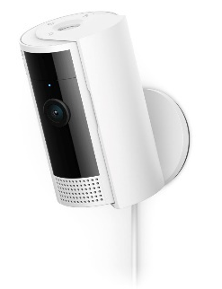  Figure 2: Ring Indoor Camera [13] | 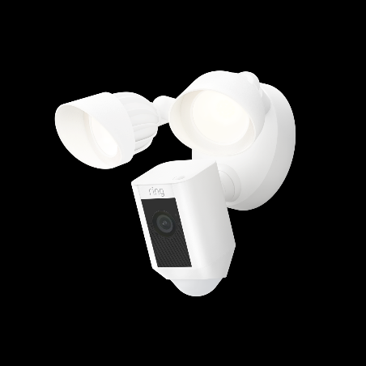  Figure 3: Ring Outdoor Flood light Camera [14]
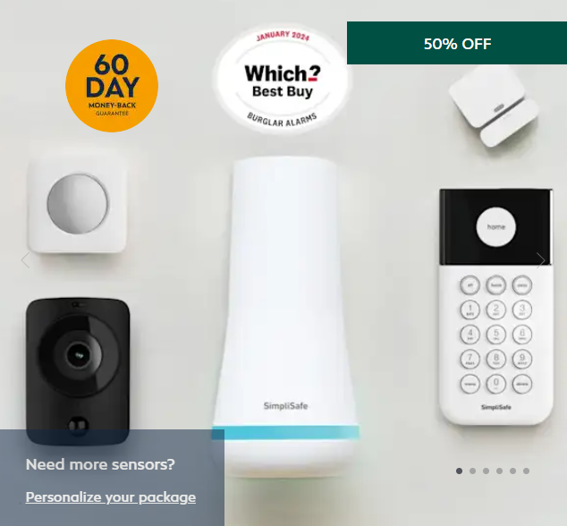  Figure 4: SimpliSafe “The Starter” [15] | 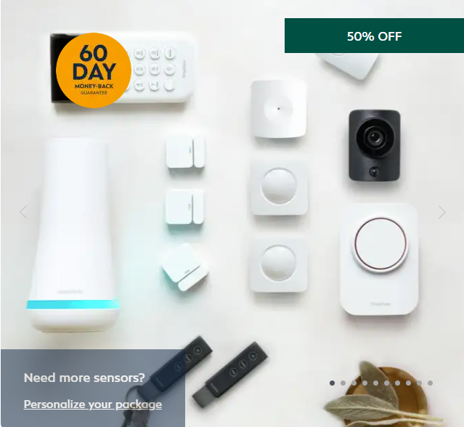  Figure 5: SimpliSafe "The Bamburgh" [16] | 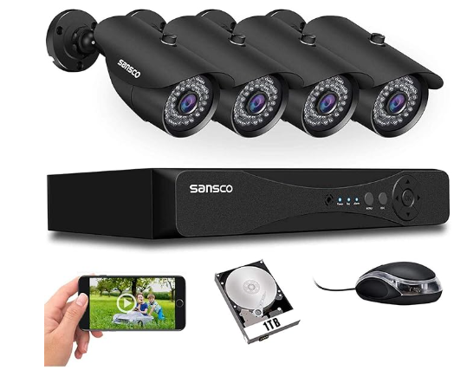  Figure 6: Sansco 8 Channel Camera System [17]
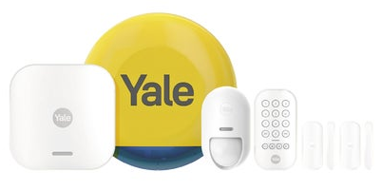  Figure 7: Yale Smart Alarm Starter Kit [18] | 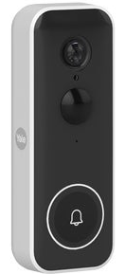  Figure 8: Yale Smart Video Doorbell [19] | 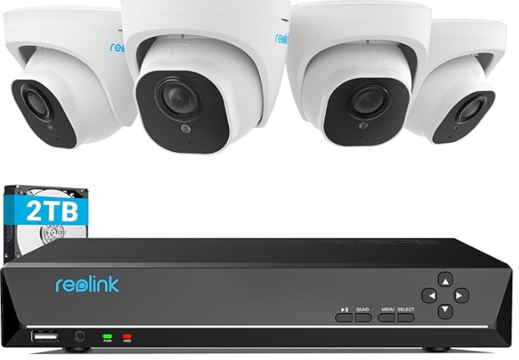  Figure 9: Reolink 4K PoE CCTV Camera Systems 8CH [20]
Looking at all these products there is a large range of concepts and methodologies in how these products work. The information above shows a mix of wired and wireless products, indicating that both aspects of the products are considered valuable. A wide range of additional sensors within the systems, common ones such as motion sensors and cameras, as well as less common such as leak and smoke detectors. Storage methods range from 2TB hard drives with options to upgrade, to recurring fees for access to cloud storage. These products show that all options are possible solutions for the final project.

Possible methods of communication
When investigating what method of communication would best fit this product, the first thing to consider is whether the system should be wired or wireless or a combination of the two [21] [22]. Initially the conclusion was to create a wireless system, this would allow the user to have a much simpler setup and be able to add and remove sensors from the system simply, as there would be no requirement to run cabling around the home to connect the sensors and cameras. However, upon further consideration, the negatives of this method remain significant, for example:
- There are security concerns, such as, could someone hack the system and view the cameras without consent, this can be seen in the “The Tech Flaw That Lets Hackers Control Surveillance Cameras” story by the BBC [23].
- If someone was attempting to break in these systems could be interrupted using a “Jamming system”, this can be seen in “Security Flaw In Amazon’s Ring Doorbells Exposed” by Katie Saatchi and David Quinn from BBC Rip Off Britain [24].
After evaluating this information, greater emphasis was placed on a wired system, this comes with the positives that it is more secure, it will not be affected by any RF noise in the area and if the system has no internet connection it cannot be infiltrated. However, this has the downside of requiring cabling that the customer would have to set up and run back to wherever the central module is housed. Additionally, cameras could not be live viewed and will require a hard drive for data storage.
Another possibility could be to run the system as a combination, meaning that some sensors, for example cameras, are wired to reduce the effect of an infiltration, while other sensors could be wireless if they are less relevant, and any data storage options are still available.
In conclusion, this decision will not be made now, as the best approach will be decided once the Customer Survey results have been assessed, evaluating what is desired for the market.

Video Compression Techniques
For Video Compression Techniques there are a range of methods to consider [25, 26]:
- H.264 and H.265 [27] –
  - This is now an international standard for Video compression, H.265 is the new version of the already good H.264.
  - Of all the forms of Video compression this is the most effective version, but this also comes with requiring the most processing power of the options.
  - This operates by only transferring the data of pixels that have changed.
- Motion JPEG (MJPEG) [28] –
  - Video compression format based on the popular JPEG compression used for still images.
  - It forms a video sequence and gives the impression of motion by combining several still JPEG images.
  - This has the advantage of being robust as if it misses an image is lost in the transfer this will not be noticeable.
  - This is the worst compression of the bunch but requires the least processing and no licence fee.
- MPEG-4 [29] –
  - This is an improvement on the MJPEG system but not as good as the H.26x compression
  - This has the negative of requiring a Licence meaning surveillance products must pay a license fee for each channel of video that uses MPEG4 technology.
Of these options H.264 or H.265 are clearly superior but would require the camera units to have a greater processing power which would make the units much more expensive. With the aim to keep these costs low and have no monthly fees this means Mpeg-4 is not a desired option as this would require a licence fee. This results in the most appropriate option for this project, at this point in time, is MJPEG.

Data Storage Techniques
When considering Data Storage technique, the main considerations are to use Cloud or Local storage. The key parts here are as seen bellow [30, 31]:
- Local
Advantages:
no maintenance or subscription costs.
Does not reply on internet connection.
Greater Privacy and local accessibility to video footage.
Disadvantages:
Limited by the physical capacity of the device.
Risk of theft/damage from the system.
- Cloud
Advantages:
Storage capacity is highly flexible and can scale with user needs.
Could be used as an additional back up.
Can be integrated with AI to add additional features.
Disadvantages:
Requires a stable internet access else data cannot be saved.
Involves variable monthly fee depending on usage.
In this case, the choice of storage method will depend heavily on the system’s communication method. If the system is wireless, then Cloud storage is a good option as the system is already vulnerable, so adding cloud storage does not significantly increase risks.
But if this is a wired system, cloud integration may introduce vulnerabilities that a wired-only setup would otherwise avoid. Additionally, with the aim of making a low costing product for users, adding cloud storage would create a monthly fee for customers, so this should also be considered.

Ethical concerns
When producing a home security system there are several concerns for the product, some of these can be seen below:
- Privacy invasion [32]
When home security is setup there is a concern around privacy of others. For example, if a camera is on the outside of the house/premises this could inadvertently record people, for example neighbours or passersby, who may not have given their consent for the recording, as they are not on your premises this is not legal. This is an issue for the user but it is important that this issue is fully disclosed when selling the product.
- Data security & Hacking [33]
Many home cameras are internet-connected meaning they may be vulnerable to hacking, which can lead to strangers viewing or even speaking through two-way cameras. Additionally, cloud-based storage can be subject to data breaches which could lead to data theft or loss.
Outside of the ethical concerns of the product there are additional concerns surrounding the ethics of the components in production, some of these are:
- Labour conditions & worker exploitation [34] [35]
Many electrical components are manufactured in regions with weak labour protections leading to:
  - low wages
  - Unsafe working conditions
  - Excessive hours
  - Use of child or forced labour

- Environmental impact [36] [37]
In the production of semiconductors there is often the involvement of toxic chemicals and heavy metals that can create a large environmental impact contaminating soil if not disposed of correctly. Additionally, when considering the environmental impact of the component, the location where they are manufactured should be considered due to the transportation. Ordering something form China rather that the UK would create a more damaging carbon footprint.
- Intellectual properties and counterfeit good [38]
This can occur when attempting to purchase cheap components which may seem adequate but could raise legal and ethical concerns around the IP theft of the components.
- Geopolitical considerations [39]
Purchasing from certain companies or countries may indirectly support bad activities, such as authoritarian regimes, surveillance practices or trade politics with questionable ethics.
With all these points the key takeaway, in purchasing of the components for production needs to be careful consideration of the companies, looking into their history in these areas, where production is done and anything else which may have previously been found about the company.

Research and Development Methodology

What Research and Development Methodologies Were Used
The first technique used is investigation [40]. At the beginning of this project, an investigation was conducted, as detailed in the literature review, into the existing market of products, examining the techniques used and the products available. The advantage to this is the large collection of data can be used to make informed decisions, the disadvantage of this is during an investigation false information can be found and you need to be sure if you are making decisions using correct information.
After carrying out the investigation the next step was to implement a survey. Customer surveys [41] are important tools for gathering information from possible customers, gaining knowledge on what they would value most from a product and how they would want this to operate. In this case the advantage of using a survey was to collect ideas from a group of potential buyers of the product, looking at what they would expect from the product and anything additional that may have not been considered initially. The disadvantage of this could be false information, if the people surveyed are either not interested in the product or intentionally provide false information.
The first technique used for the development was simulation [42]. This is a technique used within circuit design to help reduce costs and waste of materials. If testing without simulation, either a great knowledge of electronics, or the finances to waste are required. One negative of simulations is sometimes there are errors or bugs which lead to believing a circuit will or won’t work when the opposite may be the case.
The other techniques used within the development methodology was Prototyping [43], prototyping works by first collecting information, then designing, testing and evaluating the system and then improving this and repeating or using this as the final product. This can be seen illustrated in Figure 10. The positives of using this methodology, you can easily build up a programming project showing how each step will work and be developed. The negative of this is with regular changes the design can slow down the workflows. To prevent this from occurring the use of methods under ISO9001 and creating a QMS (Quality Management system) to gather the code and create a backlog of this meaning nothing is lost.
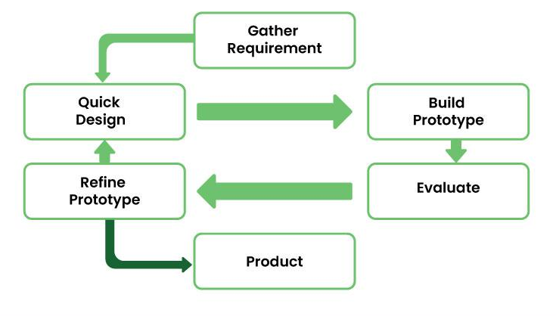
Figure 10: Prototyping Methodology
For carrying out this work, the following software, hardware and tools were required for the job and why:
- Software:
  - Arduino IDE – This will be used to Program the planned board for the camera modules, this will
  - Raspberry Pi Imager – Used to set the OS (Operating System) on the Raspberry Pi
  - Libraries for Code – there will be a requirement for Libraries
  - Appropriate Board Libraries – this will be required to be able to program the board using the Arduino library
  - Python – required for programming the Raspberry PI, this is used as it’s the native language for the Pi making it the simplest option
  - Proteus – used in simulation of the smaller modules
  - CCS – the required compiler for producing the code, this is the best option currently as access is already available and experience using it Prior
  - MPLab – required for Programming the selected PIC’s
- Hardware:
  - MPLab PIC programmer – required for Programming the selected PIC’s
  - Peripherals for PI - required for use of the Raspberry Pi
- Tools:
  - Soldering Iron – needed to produce the physical circuits
  - Fume extraction – required for Safety

Measures of success
For measuring success of this product this will be looking into the key working aspects of this product. A list of goals that need to be achieved towards success are:
- Designing of:
  - Central module.
  - Camara module.
  - 2x smaller models/sensors.
- Successful connection between central module and camera module using the method decided from Questionnaire and further research.
- Passing Livestream of camera data from camera to central module.
- Saving the video appropriately.
- Incorporate the smaller modules into the system.
- Add multiple cameras to the system.
- Save video as determined by the customer survey.
- Create a power supply unit which can power the system if a power cut occurs.
- Implement a Tamper loop

Customer survey
The key objectives of the survey were to gather information on key parts of the product and collate this information for evaluation. To ensure that the goals were measurable a key goal is to make the survey option based, meaning that multiple choices will be offered making the output simple to measure.
To make this achievable the survey was reviewed and trialled on a few people before sending it out ensuring that it was clear and simple. To ensure relevance questions were carefully worded to avoid misinterpretation. Additionally, the survey was distributed to an appropriate target group which are people interested in the product, meaning that their opinion was relevant to the final product.
To complete this within a one-week timeline, the questions were simple and concise, with most answers being in multiple choice format, ensuring a fast but precise response.
For this Customer Survey the subject areas that will be investigated are the following:
- Have they had a home security system before? – This is relevant to understanding the customer and what they have previously experienced or to understand why they haven’t had one before.
- What types of Sensors would they be looking for? – investigating what potential customers want from a product and what modules they would desire the most.
- How would they want the system to operate? – understanding if the customers concern was more on convenience or security when looking at a product.
- How long would data be kept for? – for video data how long are customers expecting the data to be stored for.
- Any other details that they may be looking for?
These subjects relate to the research carried out in the literature review and using this information, conclusions can be made on the final parts of the research.

Questionnaire
The final version of the Questionnaire can be seen in Figure 11 and Figure 12.

Figure 11: Questionnaire Page 1&2

Figure 12: Questionnaire page 3

Analysis of Research and Customer Survey

Results
The Results gathered from 9 completed questionnaires can be seen in Figure 13.
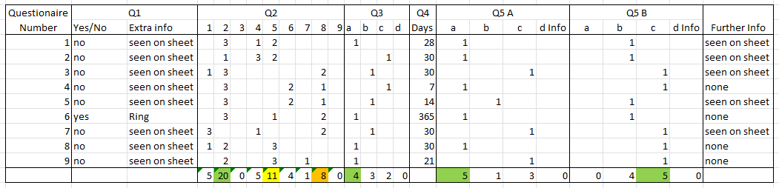
Figure 13: Questionnaire Results
From the Results the Key takeaways are:
- The most desired modules are an indoor camera, a window/door monitor and a motion sensor.
- A wired system for communication is desired - this shows participants valued security over simplicity of setup.
- The average time to hold data is approximately 28-30 days.
- If the system included an external camera, this would be desired to be on 24/7.
- If the system included an internal camera, this would be desired to be recording only if a sensor has been triggered.
Other takeaways include the fact results show that the people surveyed generally did not have existing systems currently apart from one. Some of the reasons collected for not currently having a system included:
- The monthly fees
- The upfront costs
- Do not like that most systems are Wi-Fi based
- Do not want a system currently due to being in a rental and has minimal valuables.
Some of the additional comments about the system included:
- If the system were to be Wi-Fi enabled to:
  - Be able to access the cameras live
  - Use a speaker for speech
After collating and evaluating the data of the survey as presented above the next step is to finalise the research and then begin module design.

Final Module Selection
On completion of the survey the decision was made to create the following modules as a priority:
- Base module – this will aim to control all data. Based on the surveyed data, this will be a wired system for the data collection and possibly have an ability to enable a Wi-Fi connectivity to allow for viewing of the cameras live.
- Indoor camera module – this module will generate video data based on the user's setup location and transmit it to the base station via the chosen wired communication method.
- A window/door monitor – this module will be designed to connect to a window or door and be able to monitor the state of this, alerting the base station if this is opened while the alarm is set.
- A motion sensor – this will be a module based on the output of a PIR sensor, if this sensor detects anything it will send a high pulse to the base station which can then trigger the cameras to record or set a marker on an important point of the footage.
These will be the priority modules to build, if there is more time more modules will be later designed and implemented.

Final Communication method
After the conclusion of using wired communication further research is required into the possible methods that could be used, taking into consideration that power and data need to be transmitted simultaneously. The options are:
- PoE (Power over Ethernet) [44]
  - PoE+ [44]
  - PoE++ [44]
  - UPoE [44]
- Passive PoE [45]
- HDMI [46]
- USB-C [47]
Upon further research HDMI is ruled out as this is only able to pass 5V at 250mA [46]. Looking into the versions of POE and UPOE available, the key differences are the power in the system so any of these option could be used if no excessive power is required in the system.
Passive POE is like other versions of POE but unlike other versions Passive POE is always outputting power no matter the input device, this means it could create a hazard if the wrong device was connected or is misused by the customer.
USB power is another option, being simple and easily accessible and commonly works on most devices, but this only works for short cable length and is not suitable for networking.
With this information the best option is to use active POE. POE is perfect for this job due to all the requirements such as:
- A central hub
- Long cable distances
- High bandwidth
- Standardized – this follows IEEE standards and works across many brands.

Design and Implementation

Module Design
For Designing the modules, a range of approaches were used. To start the smaller modules were developed first. This began with identifying an appropriate microcontroller. For this selection the qualities desired were considered, the requirements are:
- 2 analogue pins
- 1 digital pin
- 3.3-5V supply
With these requirements this meant the project would only need a very basic PIC unit. It was concluded to use a PIC12(L)F1840 [48], a simple and cost-effective PIC that meets all requirements and is familiar from previous projects, this additionally comes in a 5V (PIC12F1840) and 3.3V (PIC12LF184) version meaning when the camera board option is selected the appropriate PIC can be chosen.
Once selected the next phase was the design of the window/door monitor and the motion detector. This was done by creating a design in “Proteus Design Suit” [49], this is a CAD design tool which can be used to design and simulate circuits meaning it is perfect for this situation.
Upon completion, the next step was to purchase the components and then carry out testing on a breadboard ensuring that the parts all work as expected. This would be the plan for completing the smaller modules, for the larger modules this would be slightly different. The larger modules would require more of a research-based approach, carrying out research into how the components will be connected and pass the information ensuring they are suitable for the job beforehand then prototyping this until a final product is reached.

Window/door monitor
For the Window/door monitor the requirements for this would be to monitor a magnetic switch which when opened an output will be made to the system alerting it to the intrusion. This will be done by creating a simple circuit as seen in Figure 14. This image shows the simple circuit where the chip is connected to the output of the switch and then the LED is used in place of the output, this means when running, as seen in Figure 15, when the switch is open the LED turns on. The code for this can be seen in Figure 16, it is coded like this to avoid switch bouncing [50] ensuring that after a period of time the switch position is still the same, removing the effect of possibly creating misinformation.
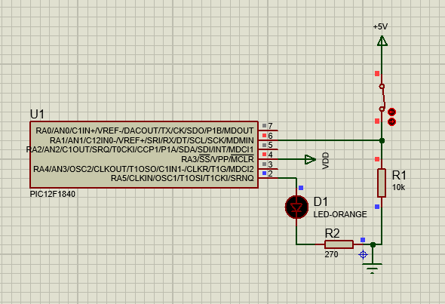
Figure 14: Window/Door monitor circuit, Switch Closed
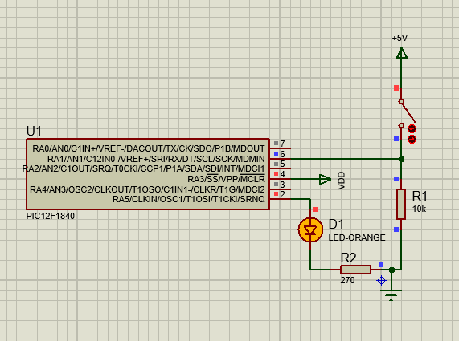
Figure 15: Window/Door monitor circuit, Switch Open
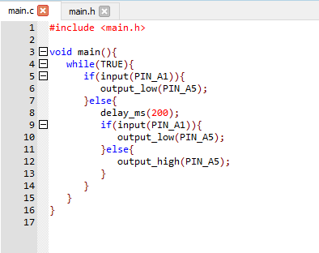
Figure 16: Window/Door monitor circuit Code
Once all parts required were decided upon a conclusion was needed to decide what components would be used in these places. For this circuit research was required into the magnetic switch. The components investigated can be seen in Table 2.
Table 2: Magnetic Switch Comparison

Product name | RUNCCI-YUN 4X Magnetic Reed Switch | Bernstein AG MA-42 Series Magnetic Non-Contact Safety Switch | SICK RE21 Series Magnetic Non-Contact Safety Switch, | Gebildet 3 sets Black Magnetic Switch Wiring NO/NC Recessed Door Sensor Hidden Window Contact
Figure | Figure 17 | Figure 18 | Figure 19 | Figure 20
Manufacturers number | N/A | 6490642319 | RE21-SAC | N/A
Link | Link | Link | Link | Link
Supplier | Amazon | RS | RS | Amazon
Current rating (mA) | 500 | 400 | 400 | 500
Operating voltage (V) | 5-12 | >170 | >30 | 3-100
Price (£) | 10.29 | 54.46 | 57.90 | 8.99

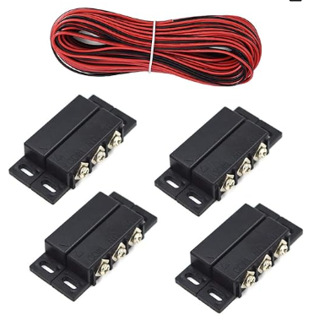  Figure 17: RUNCCI-YUN 4X Magnetic Reed Switch [51] | 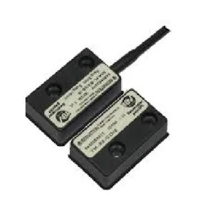  Figure 18: Bernstein AG MA-42 Series Magnetic Non-Contact Safety Switch [52]
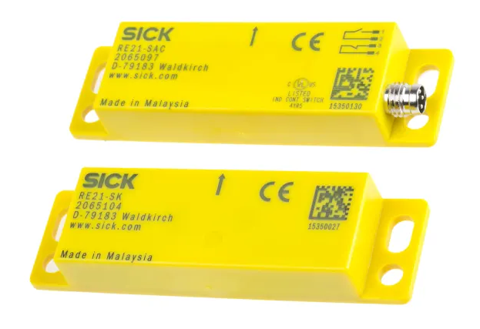  Figure 19: SICK RE21 Series Magnetic Non-Contact Safety Switch [53] | 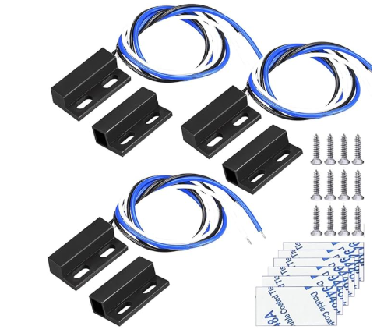  Figure 20: Gebildet 3 sets Black Magnetic Switch Wiring NO/NC Recessed Door Sensor Hidden Window Contact [54]

After completing the research, it was concluded that the best choice would be to use the “Gebildet 3 sets Black Magnetic Switch Wiring NO/NC Recessed Door Sensor Hidden Window Contact” [54]. This was decided due to the low cost and the wide range of voltage meaning this will be simple to power off the PIC and will carry out the job as required. With this conclusion all the key parts are decided and will be displayed in the product list seen in Table 7.

Motion sensor
The motion sensor circuit is a very similar process, a PIC controller connected to a PIR sensor which will be used to see if anything is passing by. The PIC controller will again be the PIC12(L)F1840 [48] keeping this as simple as possible, using the controller as a method of ensuring any data received is passed on to the ESP32. The planned circuit can be seen in Figure 21 and Figure 22 with the test code seen in Figure 23.
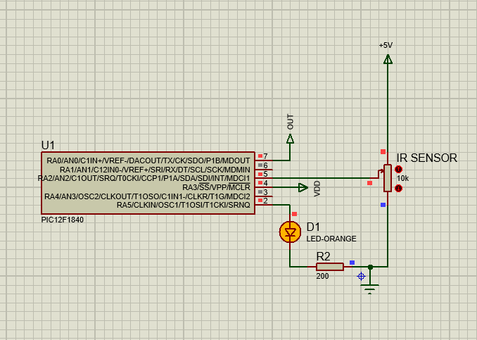
Figure 21: IR Sensor High
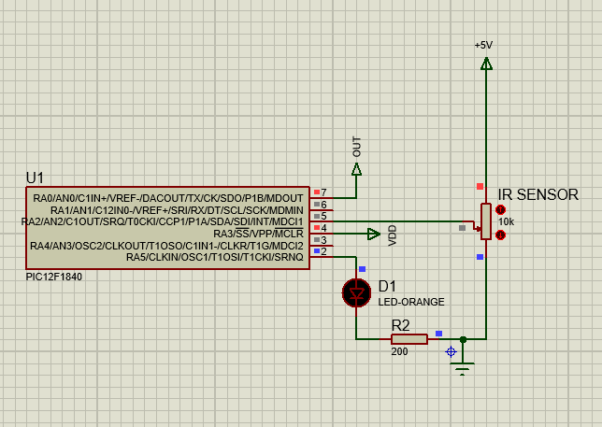
Figure 22: IR Sensor Low
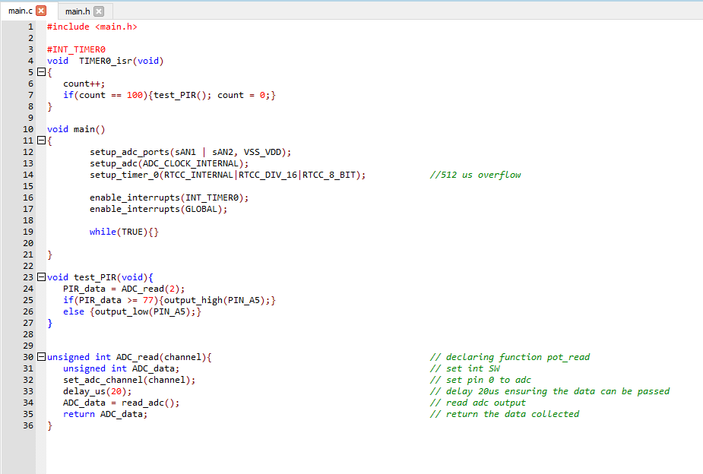
Figure 23: Motion Sensor Code
After completing this the component selection was required so an investigation into PIR sensors was required this can be seen in Table 3: PIR Sensor Comparison
Table 3: PIR Sensor Comparison
Product name | Panasonic 10m PIR Motion Detector | Panasonic PIR Motion Detector PIR Sensor, 5m | Sensor, PIR, Compact, 2m, Black | EKMC2610113K Panasonic, EKMC (VZ) PIR Sensor, 5m 3-Pin
Figure | Figure 24 | Figure 25 | Figure 26 | Figure 27
Manufacturers number | AMN14112 | AMN11111 | AMN12111 | EKMC2610113K
Link | Link | Link | Link | Link
Supplier | RS | RS | Farnell | RS
operating voltage (V) | 4.5-5.5 | 4.5-5.5 | 4.5-5.5 | 3-5.5
Price (£) | 26.30 | 26.51 | 22.99 | 10.45

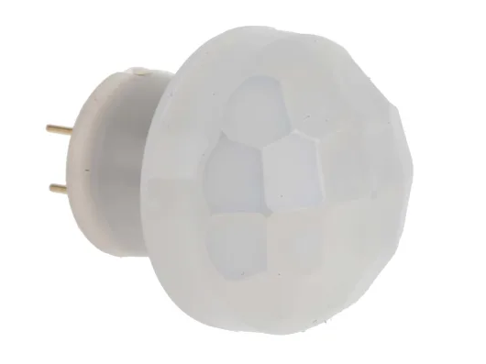  Figure 24: Panasonic 10m PIR Motion Detector [55] | 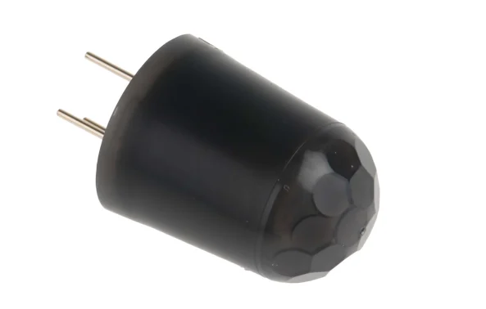  Figure 25: Panasonic PIR Motion Detector PIR Sensor, 5m Sensor Range [56]
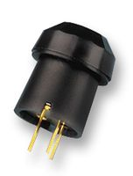  Figure 26: Sensor, PIR, Compact, 2m, Black [57] | 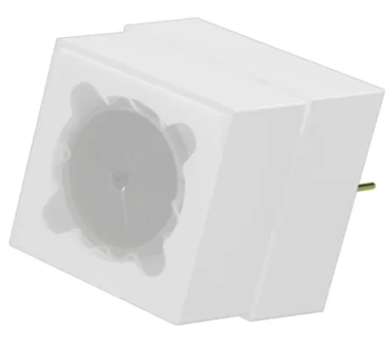  Figure 27: EKMC2610113K Panasonic, EKMC (VZ) PIR Sensor, 5m 3-Pin [58]
After this comparison due to cost the sensor which will be used moving forward will the “EKMC2610113K Panasonic, EKMC (VZ) PIR Sensor, 5m 3-Pin” [58] from RS.

Base module
For this project design the main base module has the following requirements:
- PI 4B central control system
- External Hard drive storage
- Conversion from Lan output to POE
- Multiple POE output
- Can be run from battery if power out occurs
For the Design Phase the external hard drive capacity will not be selected at this time. This is due to the uncertainty of how much data the system will generate. This will be decided later after the testing phase of the prototype.
For the POE output there are multiple ways to complete this, these can be seen in Figure 28. This shows the possible options for component requirements:
- option 1, buying a network switch with POE output
- option 2, purchasing a non-POE network switch and using POE injectors used to add the power into the network.
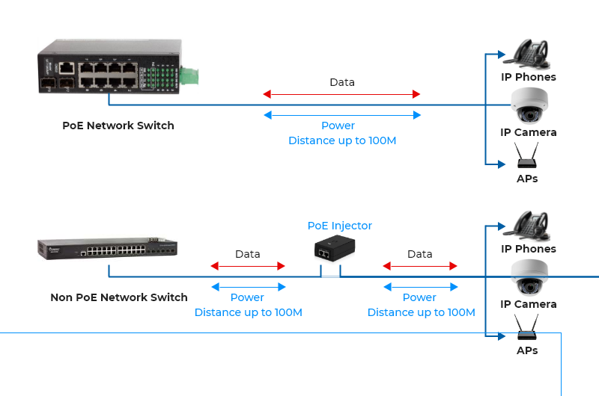
Figure 28: POE setup options [59]
After carrying out an investigation into components for a non-POE switch and Injector, seen in Table 4 & Table 5 this seemed it would cost a lot more than the POE Switch setup, components seen in Table 6.
Table 4: POE Injectors
Product name | Exsys 2 Port POE Injector | Exsys Single Port POE Injector | POE INJECTOR, RJ45, DIN RAIL/PANEL | Raspberry Pi PoE+ Injector
Figure | Figure 29 | Figure 30 | Figure 31 | Figure 32
Manufacturers number | EX-6007PoE-WT | EX-60315 | EB-PSE-24V-1B | SC1677
Link | Link | Link | Link | Link
Supplier | RS | RS | Farnell | PIHut
Watts | 25.5 | 90 | 20 | 30
Price (£) | 142.81 | 339.56 | 283.04 | 23.20

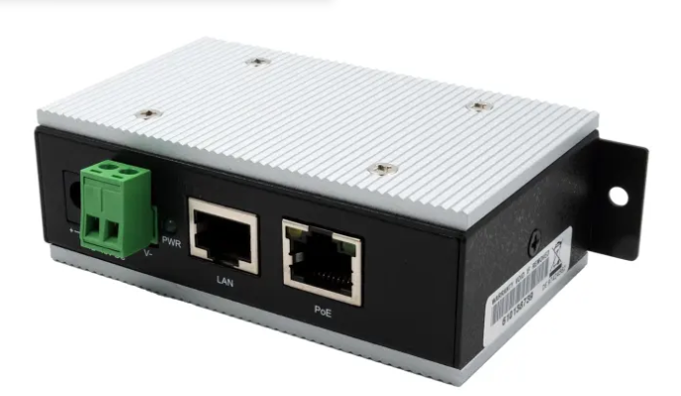  Figure 29: Exsys 2 Port POE Injector [60] | 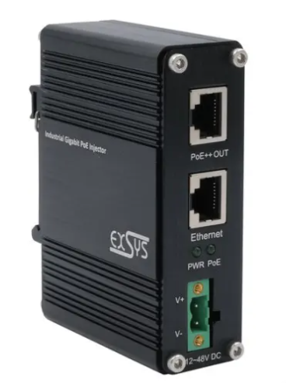  Figure 30: Exsys Single Port POE Injector [61]
  Figure 31: POE INJECTOR, RJ45, DIN RAIL/PANEL [62] | 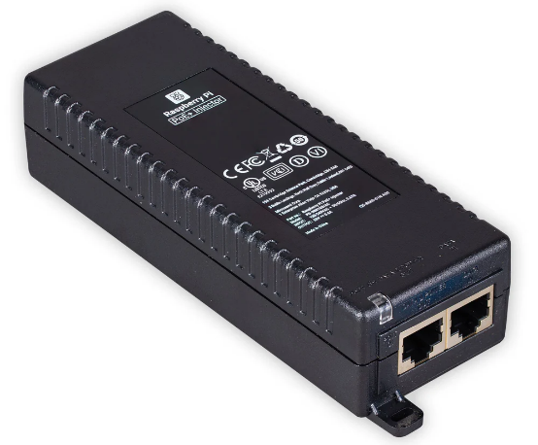  Figure 32: Raspberry Pi PoE+ Injector [63]

Table 5: Non-POE switches
Product name | RS PRO Unmanaged 5 Port Ethernet Switch | Netgear GS108GE, Unmanaged 8 Port Ethernet Switch | TP-Link 8-Port Gigabit Network Switch | Ethernet Switch, Unmanaged Fast, 16 x RJ45 Copper Port
Figure | Figure 33 | Figure 34 | Figure 35 | Figure 36
Manufacturers number | 144-8673 | GS108GE | 103831 | 1241000000
Link | Link | Link | Link | Link
Supplier | RS | RS | PIHut | Farnell
Port number | 5 | 8 | 8 | 16
Price (£) | 88.36 | 36.11 | 18.30 | 479.71

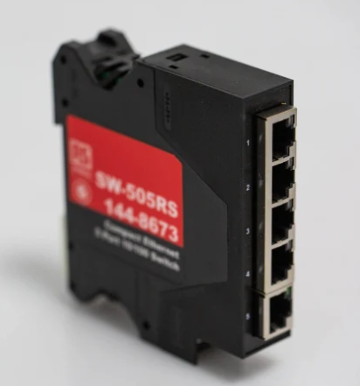  Figure 33: RS PRO Unmanaged 5 Port Ethernet Switch [64] | 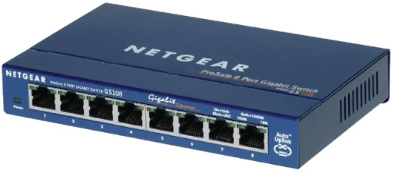  Figure 34: Netgear GS108GE, Unmanaged 8 Port Ethernet Switch [65]
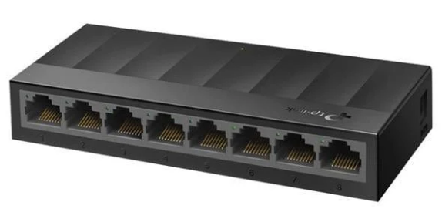  Figure 35: TP-Link 8-Port Gigabit Network Switch [66] | 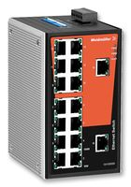  Figure 36: Ethernet Switch, Unmanaged Fast, 16 x RJ45 Copper Port [67]

Table 6: POE Switch
Product name | 5-Port Gigabit Desktop PoE Switch with 4-Port PoE+ | Switch, Embedded, 5 Ports, Industrial, Unmanaged PoE Gigabit Ethernet | Switch, Polyamide casing, 5 Ports, Industrial, Unmanaged PoE Fast Ethernet, DIN Rail, RJ45 x 5 | 16-Port Gigabit Ethernet Unmanaged PoE+ Switch with FlexPoE (76W)
Figure | Figure 37 | Figure 38 | Figure 39 | Figure 40
Manufacturers number | TL-SG1005LP | SW-135 | MP-625 | GS116LP
Link | Link | Link | Link | Link
Supplier | Amazon | Farnell | Farnell | NETGEAR
Ports | 5 | 5 | 5 | 16
Price (£) | 32.99 | 99.99 | 199.67 | 169.99

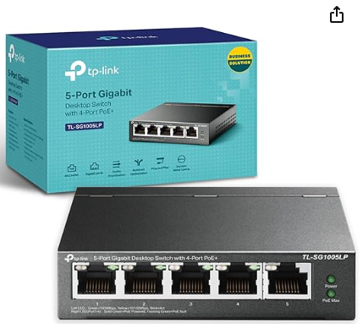  Figure 37: TP-Link TL-SG1005LP 5 Port Gigabit PoE Switch, 4× Gigabit PoE+ Ports [68] | 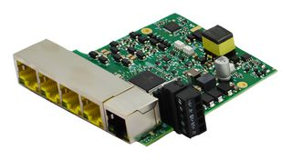  Figure 38: Switch, Embedded, 5 Ports, Industrial, Unmanaged PoE Gigabit Ethernet [69]
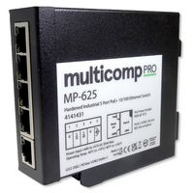  Figure 39: Switch, Polyamide casing, 5 Ports, Industrial, Unmanaged PoE Fast Ethernet, DIN Rail, RJ45 x 5 [70] | 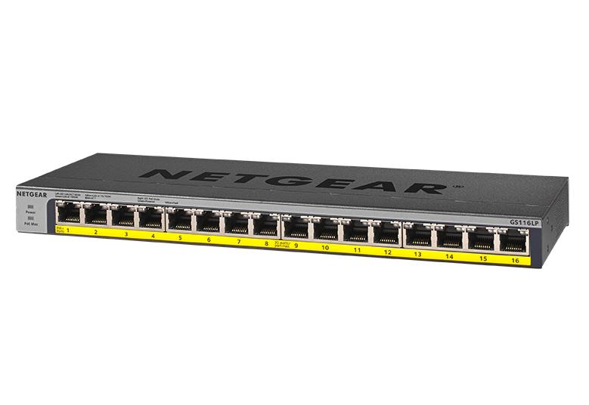  Figure 40: 16-Port Gigabit Ethernet Unmanaged PoE+ Switch with FlexPoE (76W) [71]

For reasons of simplicity and lower cost the decision was to use the POE Switch setup, it was then concluded to use “5-Port Gigabit Desktop PoE Switch with 4-Port PoE+” [68] seen in Figure 37. This product was at low cost, simple to acquire and appropriate for this build.
If more power and ports were required in the future, looking at a product similar to “16-Port Gigabit Ethernet Unmanaged PoE+ Switch with FlexPoE (76W)” [71], seen in Figure 40, would be required but at this point that is over kill.

Indoor Camera Module
For this project design the main base module has the following requirements:
- ESP-32
- Camera
- SD card
The first step was to investigate types of ESP-32’s and which would work best for this project. After carrying out an investigation into ESP-32s, initially it was thought that the most appropriate board was “ESP32-POE-ISO-16MB” [72] seen in Figure 41. This was selected for a range of reasons, it was readily available, it came with a POE connection meaning no POE splitter was needed to separate the power and data connections and it came with excess input pins which could be used to control the other boards connected.
Initially, it was thought this had a slot for an OV2640 which after further investigation was not the case. If this board was used it would require the use of an SPI/UART camera which would use up the majority of the boards pins making this not an ideal approach.
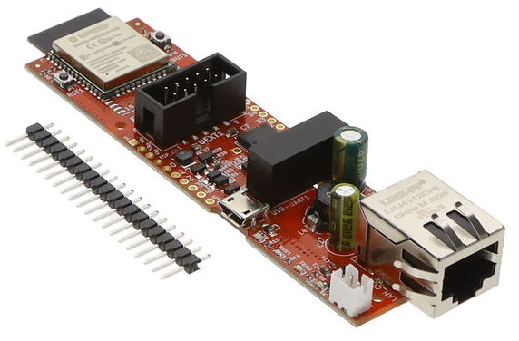
Figure 41: ESP32-POE-ISO-16MB [72]
Upon further investigation the “RJ45 Ethernet Development Board (ESP32-S3)” [73] was found. This product came with the additional options of coming with a POE board attachment and an OV2640, this can be seen in Figure 42. With these additional modules the board comes with all the desired features, having spare connection for the additional modules and a camera attached and POE connection.
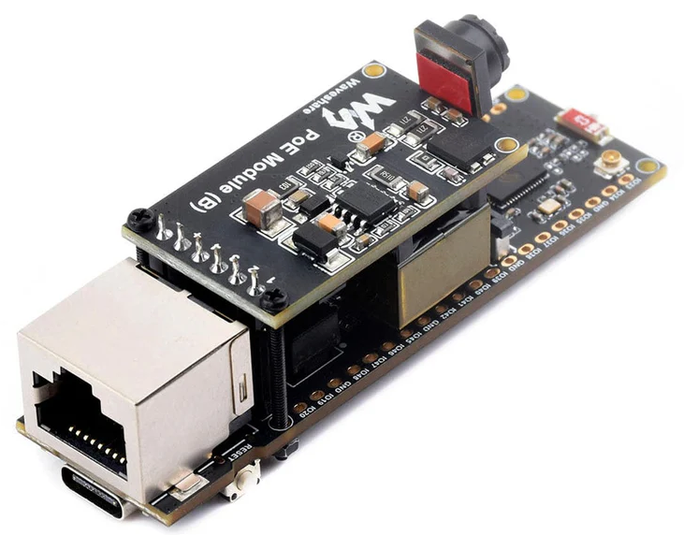
Figure 42: RJ45 Ethernet Development Board (ESP32-S3) [73]
In the end the “RJ45 Ethernet Development Board (ESP32-S3)” was the option moved forward with. As this comes with a camera attached, the only additional requirement is a micro-SD card for this unit. When it comes to the programming of this board, the pins can be found on the Waveshare Wiki page [74].
Upon this conclusion, the PIC12LF1840 was determined as required, this is due to the ESP32-S3 board only having a 3.3V output meaning that the PIC12LF1840 is required.

Final Parts List for Prototype
After deciding upon all components in the prior section the final parts list was created and can be seen in Table 7.
Table 7: Final Parts List
Module | Job | Part name | Link | Manufactures no. | Supplier | Quantity | Price per pack (£) | Price (£)
Main | Main controller | Raspberry PI 4B | LINK | n/a | Already owned | 1 | Already owned | 0
Main | POE switch | TP-Link TL-SG1005LP 5 Port Gigabit PoE Switch | LINK | n/a | Amazon | 1 | 32.99 | 32.99
Main | Hard drive | This will be determined at a later date |  |  |  |  |  | 0
Camera | Controller | RJ45 Ethernet Development Board (ESP32-S3) | LINK | WAV-28772 | PIHut | 1 | 24.60 | 24.60
Camera | Connector | This will be determined at a later date
Window monitor | Controller | Microchip PIC12LF1840-E/P pack of 4 | LINK | PIC12LF1840-E/P | RS | 1 | 6.44 | 7.15
Window monitor | Magnetic switch | Gebildet 3 sets Black Magnetic Switch Wiring NO/NC Recessed Door Sensor Hidden Window Contact | LINK | n/a | Amazon | 1 | 8.99 | 8.99
Window monitor | Resistor | 250 ohms | Found in the lab
Window monitor | LED | Green LED | Found in the lab
Window monitor | Connector | This will be determined at a later date
Motion sensor | Controller | Microchip PIC12LF1840-E/P pack of 4 | LINK | PIC12LF1840-E/P | RS | Enough from above |  | 0
Motion sensor | PIR sensor | EKMC2610113K Panasonic, EKMC (VZ) PIR Sensor, 5m 3-Pin | LINK | EKMC2610113K | RS | 1 | 10.45 | 10.45
Motion sensor | Resistor | 250 ohms | Found in the lab
Motion sensor | LED | Green LED | Found in the lab
Motion sensor | Connector | This will be determined at a later date.
Cables | Ethernet | RS PRO, 1m Cat5e, Yellow RJ45 to Male RJ45 Male, F/UTP Shielded, Terminated PVC Sheath | LINK | 556-247 | RS | 2 | 4.78 | 4.78
 |  |  |  |  |  |  | Total (£) | 93.74

With the total cost of parts for the Prototyping stage coming to £93.03 as seen in Table 7 the next step was to start the process. During the completing of this task, it is important to keep Manufactures number to keep a log on the exact components being used in the project.

Prototyping
Before carrying out prototyping a risk assessment was carried out on for the safety of the work that was to be carried out and the surrounding environment that the task would be completed within. Assessing and evaluating any risks that would be involved in this process of Prototyping. This can be seen in Table 8, the Risk matrix for this can be seen in Table 9.
Table 8: Risk Assessment
Hazard | How might people be harmed | Who would be harmed | L | S | Inherent Risk | Control measures | L | S | Residual Risk
Electrical – working on Low voltage equipment | Electric shocks from discharge of static build up, cables, fixed electrical infrastructure and portable equipment causing serious burns, respiratory failure, and cardiac arrest, potentially leading to death. | Lab users | 4 | D | High | The lab electrical infrastructure is fitted with an Emergency Power Off (EPO) button by the lab door that can be triggered in the event of an emergency.  Before any new equipment is brought into the lab, the equipment must have an up-to-date PAT certificate.  Where applicable and appropriate anti-static mats and ground straps should be used to prevent the build of static energy | 2 | C | Low
Fire Low Voltage Electrical Work | Fire ignition through discharge of built-up static, leading to burns and/or smoke inhalation. Which can cause serious lung defects and potentially death. | Lab users and visitors | 4 | D | High | Low Voltage electrical work is to be conducted in accordance with company ELV Electrical safety work SOP.  Any deviation from the working practices outlined within is to be conducted under a task-based risk assessment authorised by an appropriate member of staff. | 1 | B | Very Low
Use of tools (Soldering) | Soldering iron, molten solder or hot work piece may cause injury through contact with user, leading to blindness and/or serious burns. Fumes from burning solder caused by poor ventilation leading to serious respiratory issues such as asthma, lead poisoning and cancer. | Lab users | 3 | C | Medium | Soldering activity is to be conducted in accordance with the supporting documentation and Standard Operating Procedures (SOPs).  Soldering is only to be undertaken after TL and Occupational Health approval and under initial observation by a SQEP individual. The yellow book is to be signed by each individual carrying out soldering in the lab | 2 | C | Low
Slip trips and falls | Trips over trailing cables, uneven flooring, or equipment poorly stored or left on the lab floor. Slips on spillages and/or rubbish dropped on floor. Leading to falls resulting in bruising, lacerations, broken bones and/or head injuries. | Lab users | 3 | C | Medium | Walkways must be kept clear and free from obstacles such as equipment, chairs, and packaging.  Wherever possible cables are to be run overhead to benches and securely fixed and must not be suspended in mid-air (e.g. across walkways).  Where cables need to be laid on the floor, a suitable and clearly visible cable cover must be used, and the cable removed as soon as work has finished.  Personal belongings are to be minimised within the lab; large lockers are available on the landing outside the lab area. Any bags kept in the lab are to be | 1 | C | Low
Use of tools (Basic Hand and power tools. | Poor use of hand and power tools leading to injuries such as, abrasions, muscles sprains, bruising, friction burns, puncture wounds and eye injuries. | Lab users | 3 | B | Low | Hand and power tools must be inspected for defects before and after use, if defects are found this must be reported to the WPM and the tool taken out of use and clearly labelled to warn other users.  Users must read Using work equipment safely (hse.gov.uk) prior to using a hand tool for the first time and discuss with the WPM should any additional equipment be required to allow safe tool operation.  Tools should be used for their intended purpose only.  When tools are not in use, they should be returned to their proper storage location along with any manuals or accessories. | 2 | B | Low
Display Screen Equipment (laptops and monitors) | Poor set up of display screen equipment leading to Musculoskeletal disorders and visual fatigue and eye strain. | Lab users | 2 | C | Low | Users are to follow the Working with Display Screen Equipment (DSE) - computers and visual displays guidance  A work provided DSE Risk Assessment is to be carried out when working with DSE in the lab. | 1 | C | Low

Table 9: Risk matrix
Risk Matrix |  | Likelihood
 |  | 1 Very Unlikely | 2 Unlikely | 3 Possible | 4 Likely | 5 Very Likely
Severity | (E) Critical | High | High | High | High | Very High
Severity | (D) Severe | Medium | Medium | Medium | High | High
Severity | (C) Major | Low | Low | Medium | Medium | High
Severity | (B) Moderate | Very Low | Low | Low | Medium | Medium
Severity | (A) Minor | Very Low | Very Low | Low | Low | Low
This shows that if all control measures are put in place while working in the lab appropriately then nothing has a high likelihood of causing harm to anyone in the lab. So having read all the appropriate risk assessments and SOP’s (Standard Operating Procedures) and being a registered as a SQEP (Suitably Qualified and Experienced Person) individual for soldering, then the next step is to begin producing the prototype.
While prototyping it was important to keep copies of the code and designs even if newer designs have been made, this is so that there is a log of changes that have been made that will aid future work. Creating a QMS (Quality Management system) following the ISO standards [75] will help aid future work, some of the advantages are [76]:
- Higher customer satisfaction – this is a key component of ISO9001 due to tracking any customer comments and improving from these.
- Continuous improvement – helps find issues in the product making it possible to improve
- Reduced cost – aids in streamlining processes
- Reduced lost time – helps to prevent making the same errors as information is kept on mistakes.
Following this advice there will be copies of all plans and programs recorded through the process to aid in future work.
For starting the Prototyping, the first step carried out was to build the smaller modules and test the outputs of the PICs, ensuring the programs designed work as expected. The method used here was to create the modules in a breadboard, then program the chip and power this testing the output with an LED as done before in Proteus.
Before building the circuit for the window/ door monitor a test was carried out on the latch to determine how it operated, this was done by supplying power and testing the 2 outputs, this can be seen in Figure 43 and Figure 44.
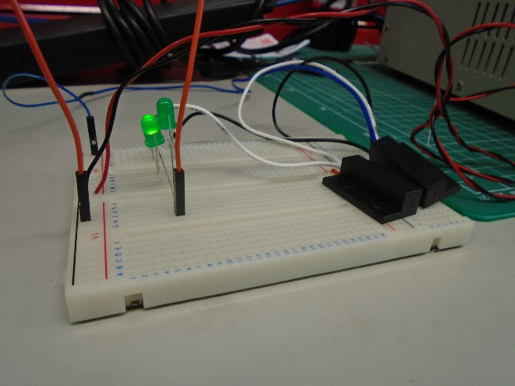  Figure 43: Latch Connection | 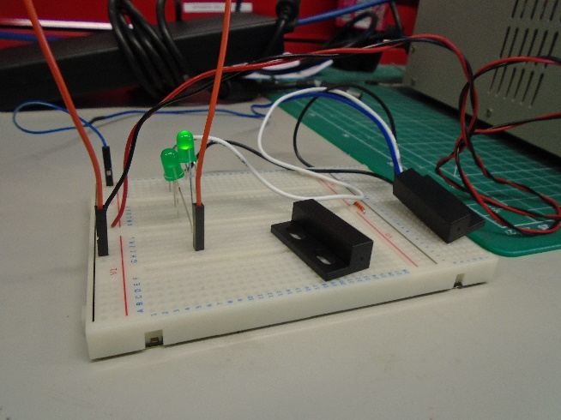  Figure 44: Latch No Connection
As seen in Figure 43 when the connection is made on the switch the output is: White = High, Black = Low. Then when the switch is not connected, seen in Figure 44, the output is: White = Low, Black = High. This means the desired connection that will be utilised is the white wire, connecting this to the PIC.
It is required to move the programs created onto MPLab as this is the software that will be using alongside the PICKit to program the PIC’s. This is done by creating a folder alongside the previously made simulations which uses the same main files as that of Proteus to build the relevant program.
To complete the final prototype board the circuit diagram seen in Figure 14 and Figure 15 was followed to create the circuit on a breadboard for prototyping. Once created the next requirement was to program the PIC, this is done using a programming PICKit [77], the PICKit and outputs can be seen in Figure 45.
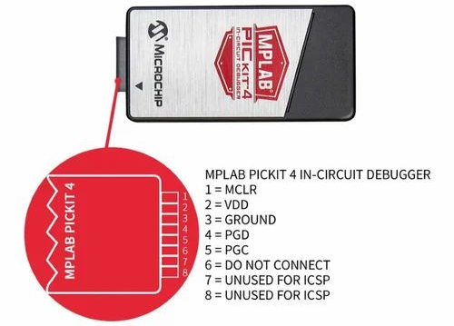
Figure 45: PICKit 4 and outputs [78]
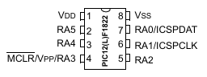
Figure 46: PIC12LF1840 Pinout [79]
Using this knowledge of the PICKit output, seen in Figure 45, and the PIC pinout, seen in Figure 46, the connections to program the PIC can be made and the running the MPLAB program, described earlier this can be used to program the chip. The final prototype can be seen in Figure 47, this shows the simple connections required.
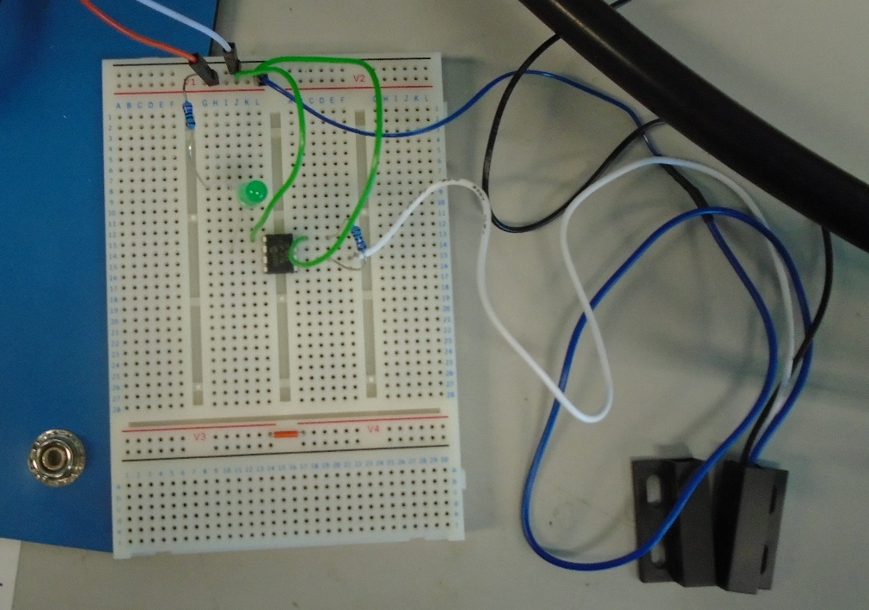
Figure 47: Window/door Monitor Prototype
Next for the prototype stage was the creation of the Motion sensor. This was created using the same technique as the door/window monitor, following the circuit diagram in Figure 21 and Figure 22, then using MPLab and the PICKit to program the PIC. This can be seen in Figure 48, where the sensor is not triggered as seen by the LED being off, and Figure 49, identified by the LED being on.
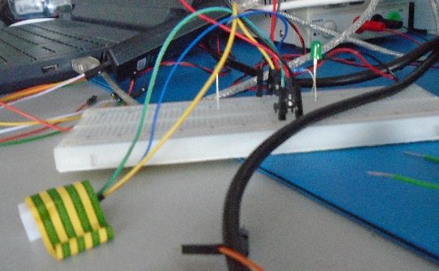  Figure 48: Motion Sensor Circuit, Sensor Not Triggered | 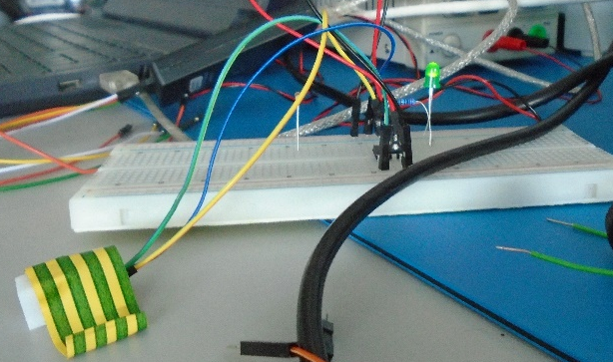  Figure 49: Motion Sensor Circuit, Sensor Triggered
With the creation of the Motion sensor prototype this meant both modules were working as desired. After this the next step was to start creating the main module and camera module communication.
The first step towards creating the main and camera modules was to download the requirements on a laptop for programming the ESP32 and setting up the Raspberry Pi:
- Arduino IDE
- ESPressif board library
- Raspberry PI imager
Once the Pi is set up the following are additionally required:
- Update and upgrade apt
- Installing Python and Python3
To start, a plan was setup for how the code would develop, the steps would be tracked keeping records of each step, the steps would be:
- Creating a server on the ESP32 side which the PI would be able to access/ ping.
- Creating the ability to have the camera footage passed from the ESP32 to the PI and shown live.
- Adding the ability to Save this footage and creating an appropriate save system.
- adding a variable which the PI will check, if this is high then the footage is saved, else the footage is not saved.
- Adding the ability for this to operate over multiple cameras.
Each step here would produce more code and take a step towards the final goal.
Starting the first step, the initial setup involved the PI connected to the POE Switch, connected to the ESP32. After some initial testing and variations of code the conclusion was this was not a viable set up and required a router to be included. This was not the ideal for reducing costing but with the conclusion of the testing nothing else could be done.
This time the testing will be carried out using a router which is still connected to Wi-Fi due to being the only one accessible at short notice and the requirement for access to the internet for downloading any required packages. The router was used to enable LAN (Local Access Network) communication between the data recording device (raspberry pi) and the security cameras (ESP32s). In the Final Product this will operate with a dedicated router that will be isolated from the internet [80]. The setup can be seen in Figure 50, the blue ethernet cable is connecting to a router that cannot be seen in this image.

]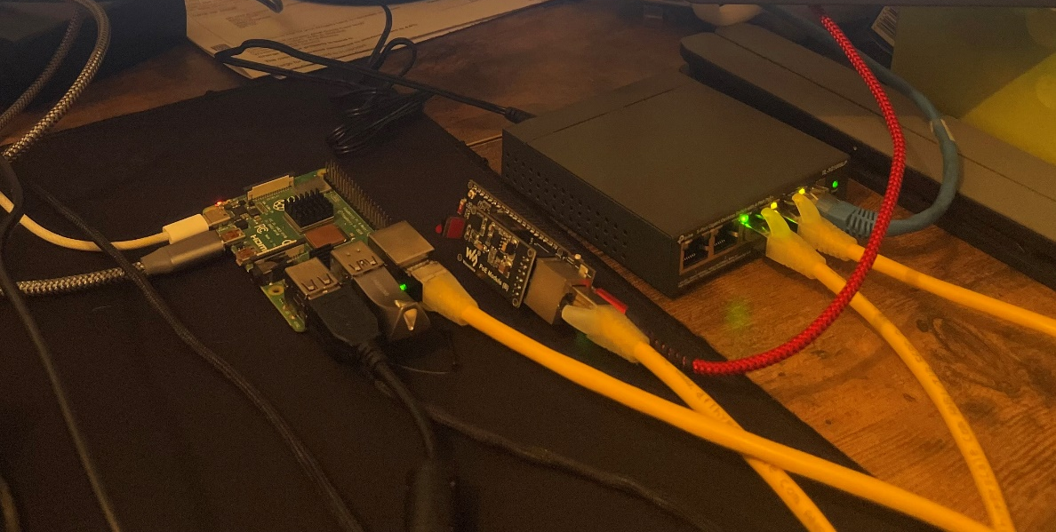
Figure 50: Test Setup
Once this change was made and the code was completed the final parts of the code can be seen in Figure 51 and Figure 52, the Pi then is able to Ping the IP printed from the ESP32, this is seen in Figure 53, the IP has been blurred/removed from this for security reasons. In Figure 52, at the bottom of the image, the set IP, mac address and more details can be seen of the ESP32 upon completion of the boot, as these are not set values currently. These details are also blurred/removed for security. But from what can be seen in Figure 53 the connection between the ESP32 and the Pi is valid, this means that work on the next step can start.
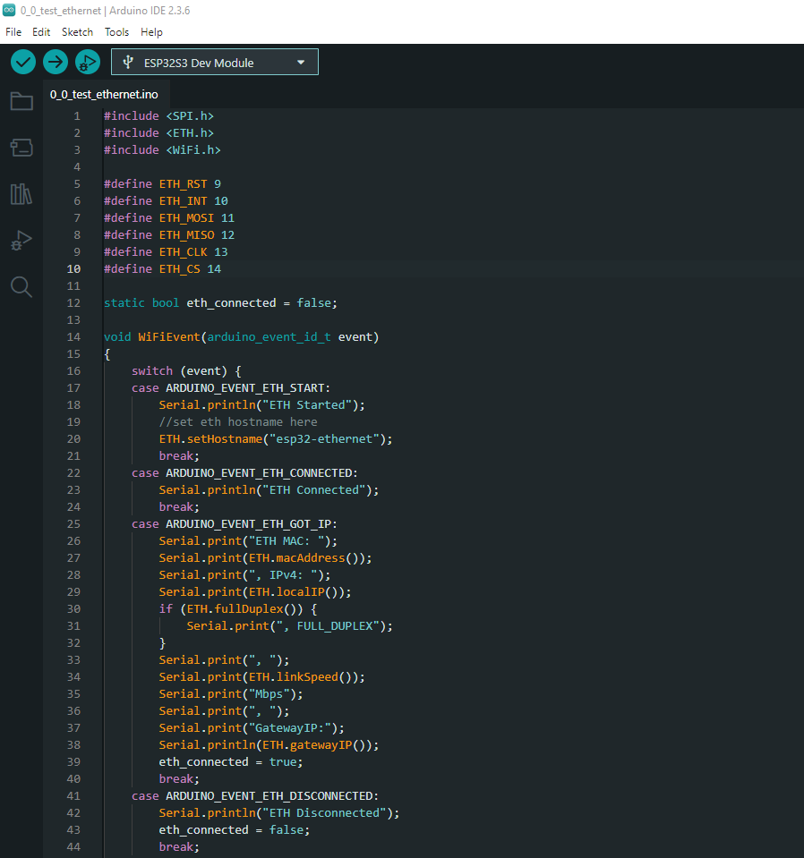
Figure 51: ESP Code Define pins and WiFiEvent

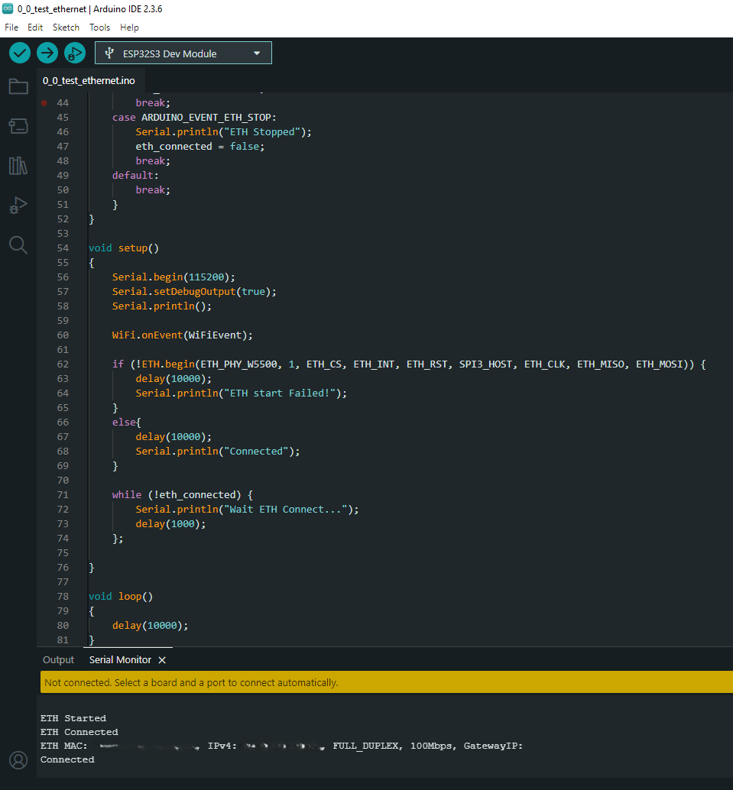
Figure 52: ESP Code Setup and Serial Output

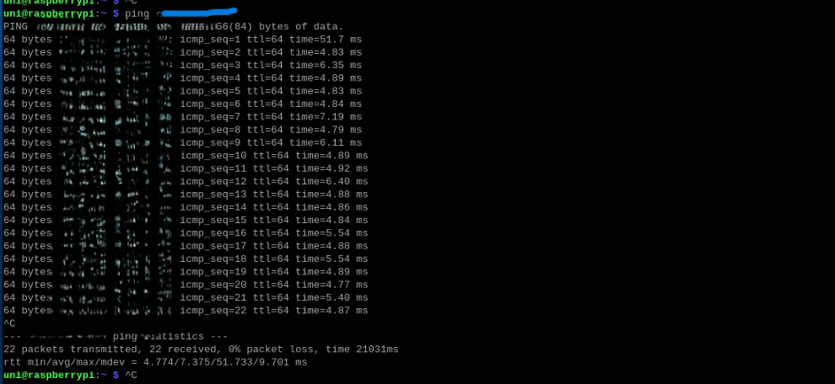
Figure 53: PI terminal output
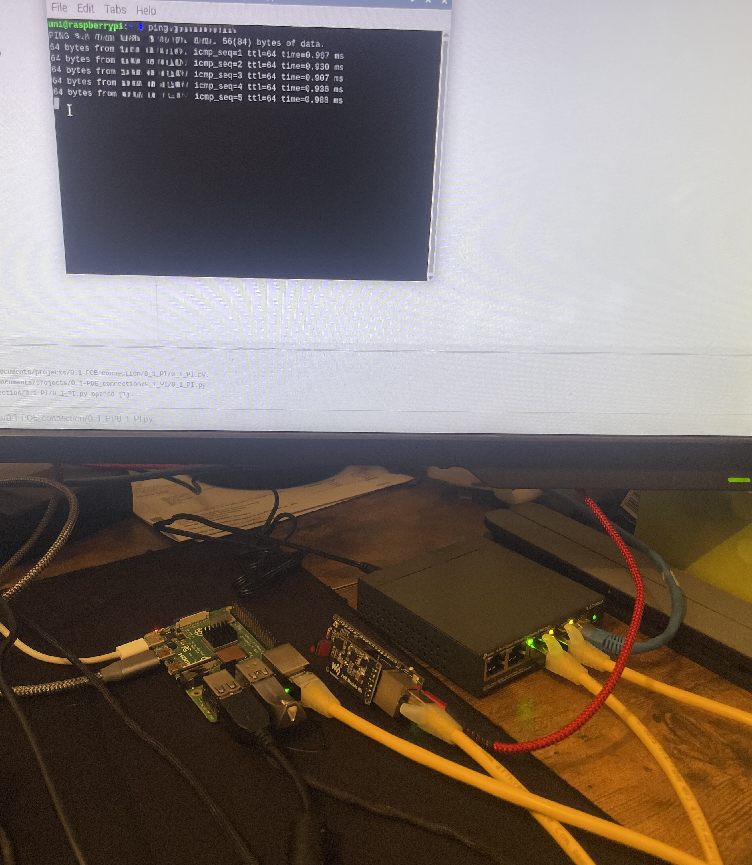
Figure 54: Test Setup & Results
The next step was to begin a live stream for video to be passed for the camera. Some of the code for this can be seen in Figure 55 and Figure 56. An image from the stream can be seen in Figure 57 which is accessed by putting the IP into the search bar on the internet explorer.
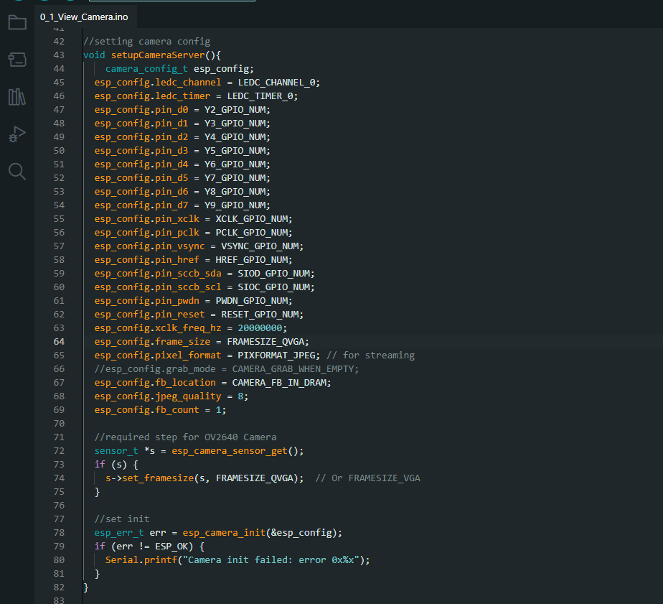
Figure 55: ESP32 setupCameraServer Function
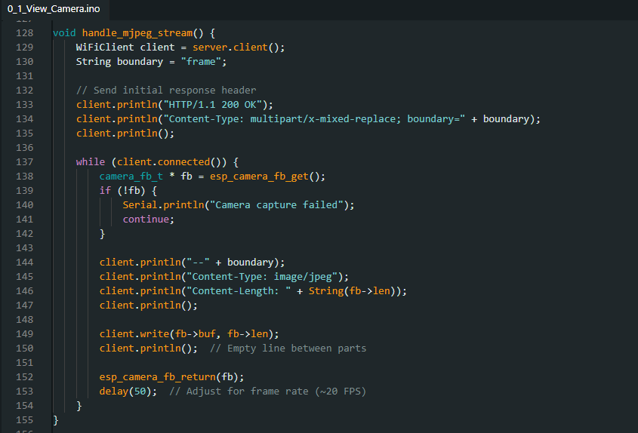
Figure 56: ESP32 Handle_mjpeg_stream Function
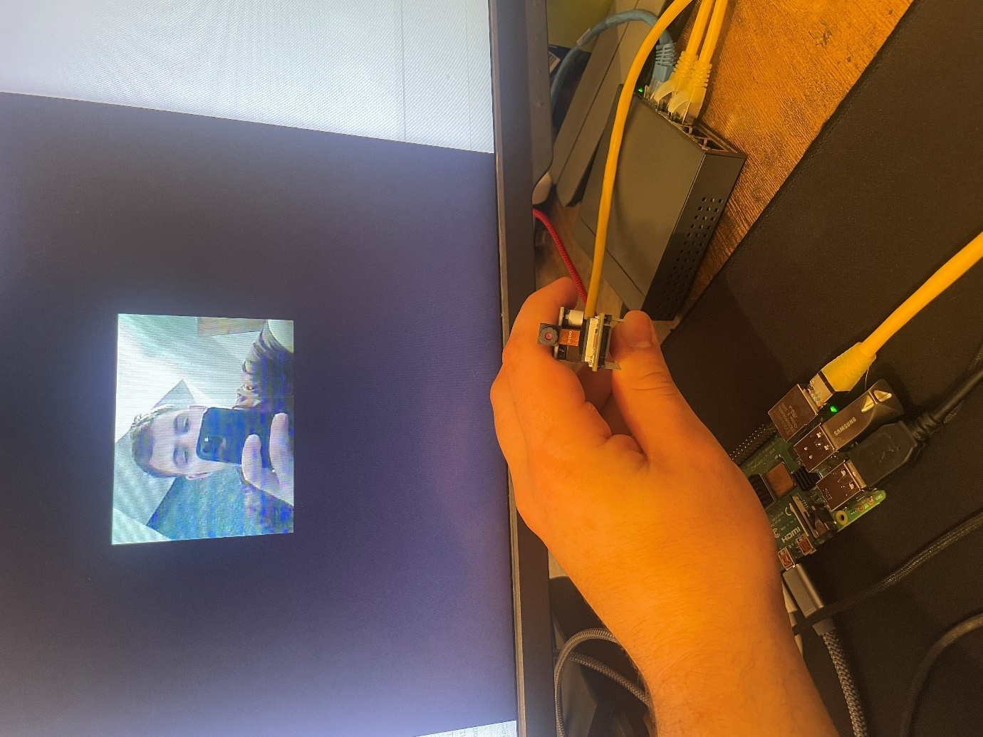
Figure 57: ESP32 Camera Webpage Including Setup
The changes put in place to the code allow the camera server to be setup meaning that the camera data is put on the server and can be accessed from the webpage. The first things that are added are the new includes where “esp.camera.h” and “WebServer.h” are added, these are libraries that are required for the access to all new functions.
The next thing that is required are the camera declares, these are used to declare the Pins required to access the camera and the data it uses. Then the function “setupCameraServer()”, seen in Figure 55, this is used to set the camera config, setting the pins and other details such as the camera quality and frame size, then after setting this config an additional step is required to confirm the camera type, this being the OV2640, then finally the “esp_camera_init” which is used to pass back any errors if any of the steps above have been carried out incorrectly.
The next key part is the “mjpeg_stream_handler()” function designed, seen in Figure 56. This uses the “WebServer.h” library to allow the footage to be available via the handler. This uses the ESP32 camera footage, making it available on the webpage to be viewed by the Pi.
Finally, within the setup it is required to enable the output of the ”CAM_ENABLE” pin that controls the camera but then set this low to ensure that there is no power spike that could damage the camera. Then running the other required functions, “setupCameraServer” function to begin running the camera then “server.on” and “server.begin” enabling the server to be run.
Upon completion of this step the next part is have the PI access the video via an executable instead, then save the footage with an appropriate title, the completed version can be seen in Figure 58. The first step for this was to determine the libraries required to do this, after researching this the answer found was “OpenCV”, using the features of “VideoCapture” and “VideoWrite” these can then be used to view and then save the footage. For improved use after completing a basic save, the “datetime” library was added, using this seen on line 6 and 7 of the code, seen in Figure 58, the save files can then have altered names providing a date and time stamp making it simpler for the user.
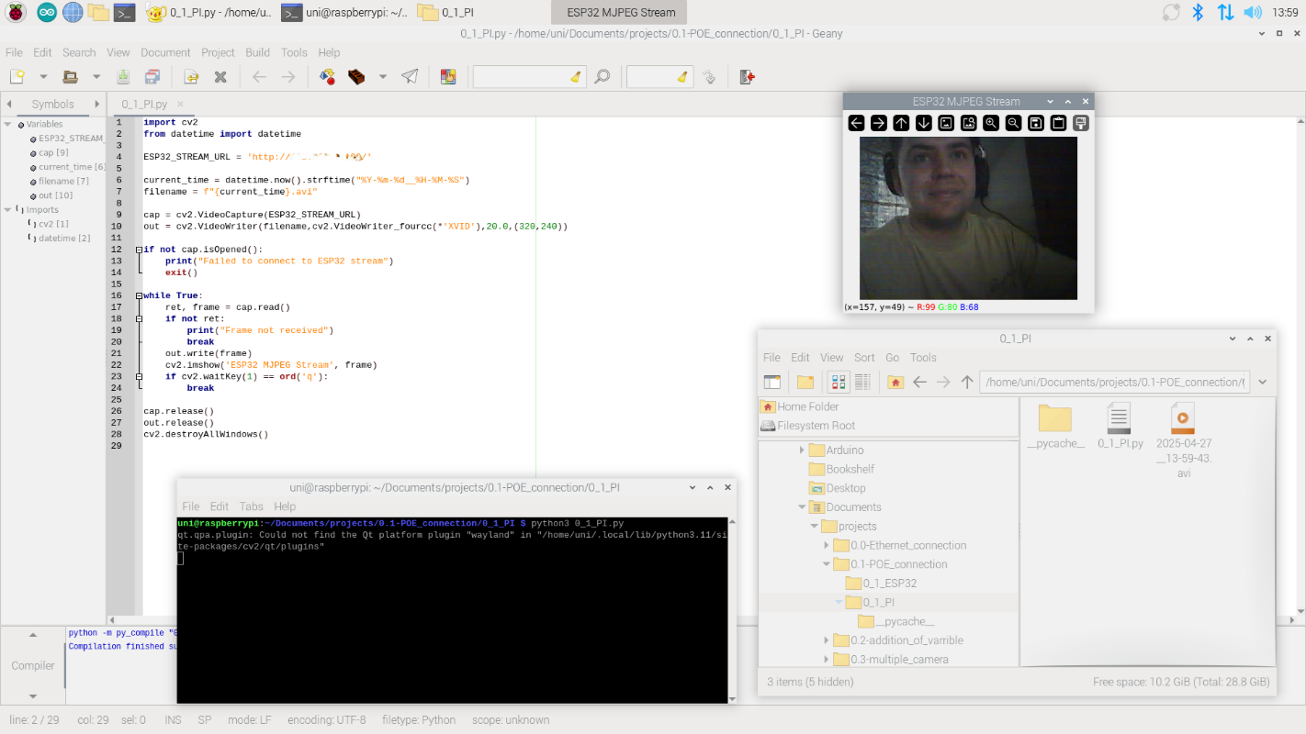
Figure 58: Saving MJPEG Code & File
At this time this is the furthest stage reached during the Prototyping, but this methodology will continue to be implemented for the rest of the project.

Evaluation
At this point in time not all the goals have been achieved, the planned goals that have been accomplished so far are:
- Designing of:
  - Central module.
  - Camara module.
  - 2x smaller models/sensors.
- Successful connection between central module and camera module using the method decided from Questionnaire and further research.
- Passing Livestream of camera data from camera to central module.
- Saving the video appropriately.
Which leaves:
- Incorporate the smaller modules into the system.
- Add multiple cameras to the system.
- Create a power supply unit which can power the system if a power cut occurs.
- Implement a tamper loop
Unfortunately, due to the tasks being more challenging than expected, this increased the time spent on some tasks meaning not all goals were achieved. This can be seen in my Gantt chart, Figure 59 shows my original plan, Figure 60 shows my plan adjusted in January, Figure 61 shows how my time has gone up to this date. This is partly due to inexperienced project management and delays due to work requirements and unexpected time off work.
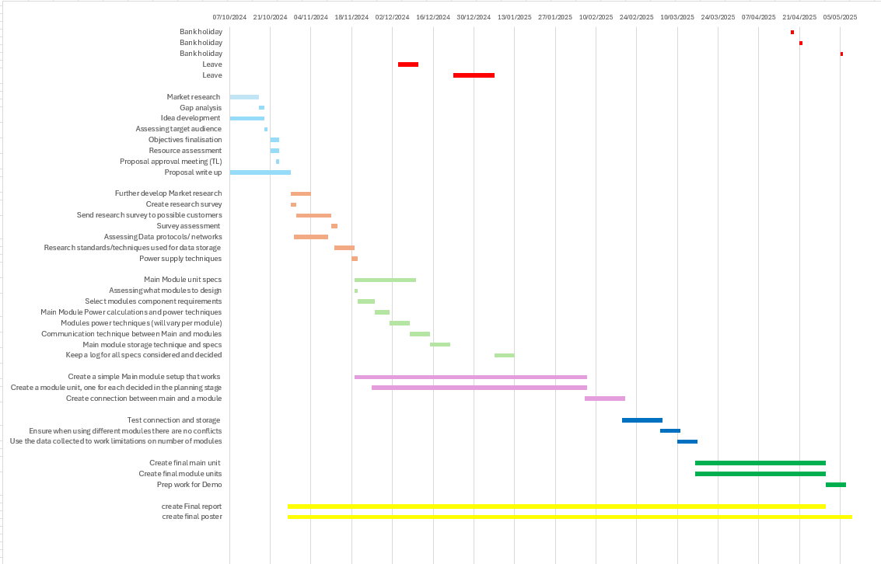
Figure 59: Gantt Chart During Proposal
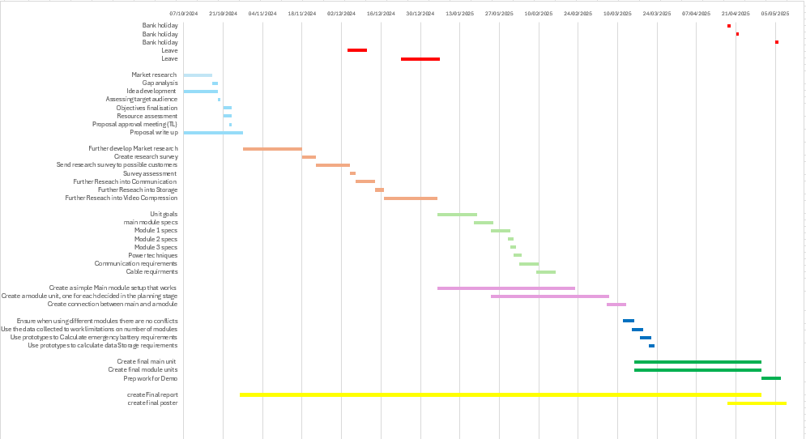
Figure 60: Gantt Chart from January
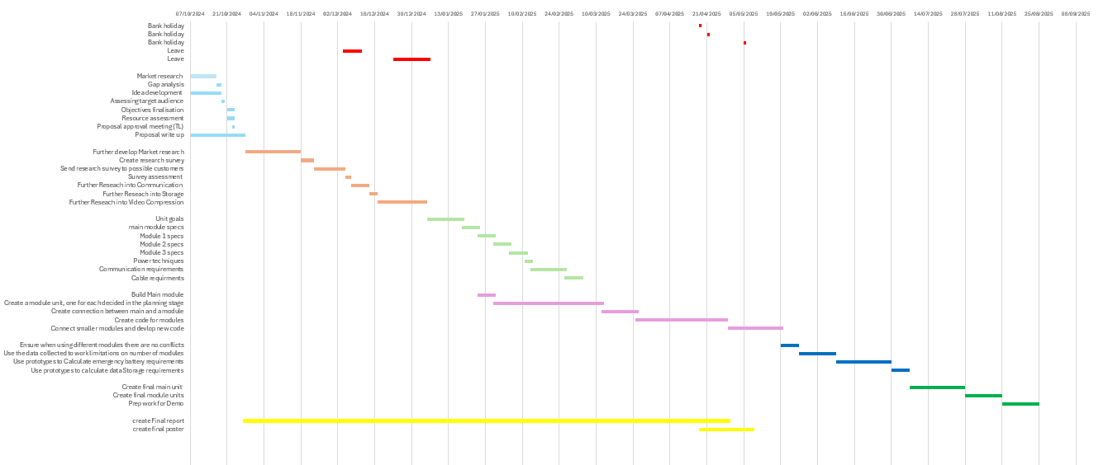
Figure 61: Gantt Chart April
This is the main reason not all tasks have been completed, with more time these other targets could be reached, then further progress can be made.
The steps completed show a clear progress on the task and that, most likely, all the other components could be achieved, the only possible error that could occur under further testing would be if the POE module connected to the ESP32-S3-ETH can power all parts of the system. Additionally further tests need to be run on an Isolated router ensuring that there are no ways to access this via a security flaw.
If this task was to be done again, I believe I would try to dedicate more time to the project and research more onto the networking.

Conclusion
In conclusion for this project the development of the product is moving in the correct path but not at the rate originally planned. To achieve all the goals set out, more time will be required but now it would seem all the goals are achievable. The goals achieved so far are:
- Designing the systems
Within the research phase the Goals of the system were decided, then upon beginning of “Design and Implementation” each part was designed and ready to be implemented.
- Successful connection between central module and camera module using the method decided from Questionnaire and further research.
Upon completion of the design phase, the first step into prototyping was to create a working connection between the central modules. These connections could be proven by pinging the IP assigned to the ESP32 by the router from the Raspberry Pi. During this part it was attempted to use just the Pi and the ESP32, but it was discovered that the Pi does not have the capability to assign IPs to other devices which is why the router was required. At a later date this will have its internet connection removed in further testing ensuring that this has no effect.
- Passing Livestream of camera data from camera to central module.
Once a connection was securely made, the next step was to create a server on the ESP32 which streamed the live video to a place in which the Pi could view it live. This was done by adjusting the code on the ESP32 to allow for the camara to operate and then pass the video, once done this would then be accessible on a webpage, entering the IP in the URL.
- Saving the video appropriately.
The final part of this completed at this point is the ability for the Pi to save the footage, this will later be developed into the ability to only save the footage when the Pi receives a variable from the ESP32 which is from the motion sensor or window/ door monitor.
All of this shows a clear development within the task but due to the challenges within the job this has not gone as far as desired.
Finally using the commercial context gathered at the start of this project there is a clear gap in the market currently for a system like this and form the small amount of customer surveys completed showing a customer desire for this. With more time to gather information and more money to carry out work and produce a final product this could be a product that could be taken to market.

Possible Future work
For future work this task will be carried forward completing the next goals, these will consist of the following:
- Implementing the Motion sensor and window/door monitor into the circuit. this will consist of adding the circuits to the ESP32 and adding additional code into the server which will have a variable which can be passed onto the Pi. This variable will then be monitored by the Pi and when true the video will be saved to an appropriate file format and with and appropriate name which the owner of the product can view.
- When one ESP32 is fully working the next step will be to attempt to integrate multiple, adding these to the system so that the user will be able to have access to multiple cameras within one system.
- Then finally creating a power supply that would operate while a power outage occurs, this will consist of selecting an appropriate battery depending on how much current the whole system requires. Then implementing this battery into the system, this could be achieved using Schottky diodes or something else similar but the best approach to this can be considered at the time depending on the supply required.
Additionally, before finalising this product consideration will be needed to ensure that it is working appropriately and safely. First thing to do is ensure that all code has been written to the appropriate standards. Looking at C++23 [81], the ISO standard surrounding C++, and PEP8 [82] which talks about the standards around python code. Then for safety reasons the following standards should be investigated ensuring the product follows these. Firstly, looking at BS EN 62368-1 [83] which is the standard surrounding “Audio/video, information and communication technology equipment. Safety requirements” [83] which covers: Electrical shock protection, Fire hazards, Mechanical Hazards, and battery safety. BS 7671 [84] is important for requirements for installation, as the aim for this product is to have people setup their own systems, this isn’t completely relevant but would be important knowledge to ensure the users knows before setting up their system.
One consideration when carrying out future work on this project would to create a diverse team to aid advance future work. This would allow greater idea generation form people with different thought and experiences adding in opinions that may have not been previously considered. This would allow for a better product to be created, and a greater understanding of what a wider market would like within the product.

Reflection
During this Project I have learnt a lot of skills I did not previously have, some of these are:
- POE Knowledge
Before carrying out this project I had a limited knowledge of this area and over this time I have improved my understanding of the concept during the research and design phase. Then during the prototyping and building phase of this project I have had practice of the implementation of this.
- Video Compression knowledge
In the same way as with the POE knowledge, I had little to no knowledge coming into this task of video compression techniques. During this task I gained knowledge on this subject during the research section, learning the difference between different techniques used over industry. I then gained knowledge of the implementation of MJPEG while producing the product.
- PI Setup & Programming Skills
This was my first time setting up a PI from nothing, so understanding how to setup the Pi imager, then program the Pi installing all the basics and setting up the executable files. Additionally, programming a custom board on the Arduino IDE, with the Waveshare ESP32-S3-ETH not being standard this meant the there was no board knowledge on the Arduino IDE board library, so for this a lot of the pins needed to be declared before beginning.
- Wired Networking
While producing this project I learned a lot about wired networking, for example, I was unaware about the reason a router was required in this system to allocate IPs for the devises allowing them to communicate.
- Project management
This is my first time solo managing a whole project, I have gained a lot of experience form this task showing that I oversimplified the task at the start, miss judging how much time each part would require. But over the time of this project, I have realised research and development takes more time than I thought.

References
[1] | M. Intelligence, “Home Security System Market Size - Industry Report on Share, Growth Trends & Forecasts Analysis (2024 - 2029),” https://www.mordorintelligence.com/industry-reports/home-security-system-market.
[2] | Ring, “Ring homepage,” https://en-uk.ring.com/.
[3] | K. Allison, “Ring home security review: Smart systems compared with competitors,” independent, https://www.independent.co.uk/advisor/home-security-systems/ring-home-security-review, September 2024.
[4] | SimpliSafe, “SimpliSafe Homepage,” https://simplisafe.co.uk/, SimpliSafe.
[5] | R. Sadler, “SimpliSafe home security review: Systems compared and ranked,” independent, https://www.independent.co.uk/advisor/home-security-systems/simplisafe-home-security-review, September 2024.
[6] | Sansco, “ANSCO 5MP 8 Channel DVR Outdoor CCTV Camera System with 1TB Hard Drive, 4x 1080P Home Security Camera,” Amazon, https://www.amazon.co.uk/dp/B00BPMGUEC?tag=georiot-trd-21&th=1&ascsubtag=trdpro-gb-1261462622019420693-21&geniuslink=true.
[7] | D. Athow, “Best DVR for security cameras of 2024: digital video recorders for CCTV,” techradar, https://www.techradar.com/best/best-dvr-for-cctv, June 2021.
[8] | Yale, “Yale homepage,” https://yalehome.co.uk/.
[9] | H. Holway, “Yale home security review: Which smart home packages are the best?,” Independent, https://www.independent.co.uk/advisor/home-security-systems/yale-home-security-review#:~:text=Yale%20offers%20a%20range%20of%20comprehensive%20packages%20with,rank%20well%20against%20other%20home%20security%20system%20brands., July 2024.
[10] | Amazon, “Reolink 4K PoE CCTV Camera Systems 8CH,” https://www.amazon.co.uk/Reolink-Detection-Recording-Waterproof-RLK8-820D4-Poe-Camera-System/dp/B08KG1SXCZ/ref=sr_1_3_sspa?crid=OC39IORDIGJF&dib=eyJ2IjoiMSJ9.p7DvwdjtZ9v6yLE0tsxfX_fREM3sAHlMJx8C2udW6WduLrXJgG_fEtiZxK4Y0fvQbEZvs8djDflsdadzh64RVs_jr6EeD4VKI.
[11] | topchoice, “Reolink 4k Poe Security Camera System Review Comparison,” topchoice, https://www.topchoice.co.uk/reolink-4k-poe-security-camera-system-review?targetid=dat-2336462209655271:loc-188&matchtype=b&device=c&campaignid=530764814&creative=&adgroupid=1354600826380198&feeditemid=&loc_physical_ms=41793&loc_interest_ms=&network=o&devi, January 2025.
[12] | Ring, “Battery Video Doorbell,” https://en-uk.ring.com/products/battery-doorbell.
[13] | Ring, “Indoor Camera,” https://en-uk.ring.com/products/mini-indoor-security-camera-plug-in.
[14] | Ring, “Floodlight Cam Wired Plus,” https://en-uk.ring.com/products/floodlight-cam-wired-plus.
[15] | SimpliSafe, “The Starter,” https://simplisafe.co.uk/home-security-system-starter.
[16] | SimpliSafe, “The Bamburgh,” https://simplisafe.co.uk/home-security-system-bamburgh.
[17] | Sansco, “SANSCO 5MP 8 Channel DVR Outdoor CCTV Camera System with 1TB Hard Drive, 4x 1080P Home Security Camera,” Amazon, https://www.amazon.co.uk/dp/B00BPMGUEC?tag=georiot-trd-21&th=1&ascsubtag=trdpro-gb-1261462622019420693-21&geniuslink=true.
[18] | Yale, “Yale Smart Alarm Starter Kit,” https://yalehome.co.uk/smart-alarm-starter-kit-1-group/.
[19] | Yale, “Yale Smart Video Doorbell,” https://yalehome.co.uk/smart-video-doorbell-grouped/.
[20] | Reolink, “Reolink 4K PoE CCTV Camera Systems 8CH,” Amazon, https://www.amazon.co.uk/Reolink-Detection-Recording-Waterproof-RLK8-820D4-Poe-Camera-System/dp/B08KG1SXCZ/ref=sr_1_3_sspa?crid=OC39IORDIGJF&dib=eyJ2IjoiMSJ9.p7DvwdjtZ9v6yLE0tsxfX_fREM3sAHlMJx8C2udW6WduLrXJgG_fEtiZxK4Y0fvQbEZvs8djDflsdadzh64RVs_jr6EeD4VKI.
[21] | S. S. Homes, “Wireless VS Wired Home Security Systems: Pros & Cons,” https://www.safesecurehomes.co.uk/wireless-vs-wired-home-security-systems-pros-cons/, August 2023.
[22] | C. Habas, “Are Wired or Wireless Home Security Systems Better?,” SafeWise, https://www.safewise.com/home-security-faq/wired-vs-wireless-security/#:~:text=Wired%20security%20systems%20aren%27t%20susceptible%20to%20electromagnetic%20or,an%20unexpected%20power%20failure%20from%20poor%20battery%20life., May 2023.
[23] | B. Panorama, “The tech flaw that lets hackers control surveillance cameras,” BBC, https://www.bbc.co.uk/news/technology-65975446, June 2023.
[24] | B. R. O. B. Katie Saatchi and David Quinn, “Security flaw in Amazon’s Ring doorbells exposed,” BBC , https://www.bbc.co.uk/programmes/articles/4qdyGR9Gbd2dlPqL4JqPXTc/security-flaw-in-amazon-s-ring-doorbells-exposed.
[25] | ANNKE, “What Is Video Compression Type on Security Cameras?,” https://help.annke.com/hc/en-us/articles/4403987103257-What-Is-Video-Compression-Type-on-Security-Cameras#:~:text=There%20are%20three%20most%20common%20types%20of%20compression,%26%20H.265%202%20Motion%20JPEG%20%28MJPEG%29%203%20MPEG-4, 2021.
[26] | philsecurity, “Video Compression: MJPEG vs MPEG4 vs H264,” philsecurity, https://philsecurity.com/guides/dvr/compression/.
[27] | S. Harding, “What Are HEVC and AVC? H.265 and H.264 Video Codecs Explained,” Tom's HARDWARE, https://www.tomshardware.com/reference/h264-h265-hevc-codec-definition, December 2020.
[28] | VGX, “H.264 vs MJPEG: Which is better?,” https://www.videoexpertsgroup.com/glossary/h264-vs-mjpeg, May 2024.
[29] | D. Kumar, “How Does MPEG-4 Compression Work?,” Baeldung, https://www.baeldung.com/cs/mpeg-4-explanation, March 2024.
[30] | J. Carlsen, “Should I Choose Local or Cloud Storage for My Security Camera?,” safewise, https://www.safewise.com/home-security-faq/cloud-or-local-storage-security-camera/, December 2024.
[31] | M. Wollerton, “Home security 101: Local vs. cloud camera storage,” CNET, https://www.cnet.com/home/smart-home/home-security-101-local-vs-cloud-camera-storage/, March 2016.
[32] | GOV.UK, Guidance on the use of domestic CCTV, https://www.gov.uk/government/publications/domestic-cctv-using-cctv-systems-on-your-property/domestic-cctv-using-cctv-systems-on-your-property: GOV.UK, August 2019.
[33] | P. Labs, Ensuring User Privacy in Home Security: A Necessity in the Digital Age, https://psynclabs.com/blogs/psync-pulse/ensuring-user-privacy-in-home-security#:~:text=Common%20Privacy%20Concerns%20in%20Home%20Security%20Systems%201,Storage%20Opens%20the%20Door%20to%20Major%20Leaks%20: psynclabs, May 2024.
[34] | M. Dummett, The Dark Side of Electric Cars: Exploitative Labor Practices, https://time.com/4939738/electric-cars-human-rights-congo/?utm_source=chatgpt.comTI: TIME, September 2017.
[35] | C. Dr. Robert Gordon, Ethical Issues in Supply Chain Management and Procurement, https://www.apu.apus.edu/area-of-study/business-and-management/resources/ethical-issues-in-supply-chain-management-and-procurement/?utm_source=chatgpt.com: apu, July 2023.
[36] | T. Perkins, Industry acts to head off regulation on PFAS pollution from semiconductors, https://www.theguardian.com/environment/article/2024/aug/24/pfas-toxic-waste-pollution-regulation-lobbying?utm_source=chatgpt.com: The Guardian, August 2024.
[37] | J. C. Hess, Chip Production’s Ecological Footprint: Mapping Climate and Environmental Impact, https://www.interface-eu.org/publications/chip-productions-ecological-footprint?utm_source=chatgpt.com: Interface, June 2024.
[38] | M. Simpson, Consequences of Intellectual Property Theft: Understanding and Prevention, https://www.upcounsel.com/intellectual-theft#:~:text=Ethical%20Concerns%3A%20Intellectual%20property%20theft%20undermines%20the%20value,harm%20consumers%20through%20exposure%20to%20substandard%20counterfeit%20goods.: upcounsel, March 2025.
[39] | C. Correll, Geopolitical Risks: What They Are and How They Impact Electronic Supply Chains, https://www.z2data.com/insights/geopolitical-risk-impact-supply-chains?utm_source=chatgpt.com: z2data, Febuary 2021.
[40] | C. Foglia, “Investigative research: Definition & Process,” sinequa, https://www.sinequa.com/resources/blog/what-is-investigative-research/?utm_source=chatgpt.com.
[41] | LinkedIn, “How can customer surveys help you validate product ideas?,” https://www.linkedin.com/advice/3/how-can-customer-surveys-help-you-validate-product-w7mbc#:~:text=Customer%20surveys%20are%20a%20form%20of%20qualitative%20research,test%20your%20assumptions%2C%20identify%20gaps%2C%20and%20discover%20opportunities..
[42] | L. Prasad, What is Circuit Simulation? Its Advantages and Types, https://www.electronicshub.org/circuit-simulation/: electronicshub, May 2024.
[43] | geeksforgeeks, What are Software Development Methodologies | 15 Key Methodologies, https://www.geeksforgeeks.org/what-is-software-development-methodology-15-key-methodologies/: geeksforgeeks, January 24.
[44] | Alicia, “PoE vs. PoE+ vs. PoE++ Standards: What is the Difference?,” Reolink, https://reolink.com/blog/poe-vs-poe-plus-vs-poe-plus-plus/, September 2024.
[45] | D. Henderson, “Understanding Passive PoE: Essential Guide for Network Enthusiasts in 2024,” Smarthome perfected , https://www.smarthomeperfected.com/passive-poe/, October 2024.
[46] | S. Sweet, “Can you put power through HDMI?,” https://blog.solidsignal.com/tutorials/can-you-put-power-through-hdmi/, March 2020.
[47] | T. Brant, What Is USB-C? Everything You Need to Know About the One Port to Rule Them All, https://uk.pcmag.com/laptop-how-to/40348/what-is-usb-c-an-explainer: pcmag, Febuary 2025.
[48] | M. T. Inc, “PIC12(L)F1840,” Microchip Technology Inc, https://ww1.microchip.com/downloads/en/DeviceDoc/41441B.pdf, 2011.
[49] | “PROTEUS DESIGN SUITE, Getting Started Guide,” Labcenter, https://labcenter.s3.amazonaws.com/downloads/Tutorials.pdf.
[50] | J. Christoffersen, “Switch Bounce and How to Deal with It,” allaboutcircuits, https://www.allaboutcircuits.com/technical-articles/switch-bounce-how-to-deal-with-it/, September 2015.
[51] | Amazon, “RUNCCI-YUN 4X Magnetic Reed Switch,” Amazon, https://www.amazon.co.uk/RUNCCI-YUN-Magnetic-Normally-Security-Contact/dp/B09TP5BSXN/ref=sr_1_10?dib=eyJ2IjoiMSJ9.3q-h7a_yWV0SiRjm-kVaCWjxSvZJdMatd5CdI8dTrau5Wu5Zq8ZEjlZJqwiPCKgLDEPPiOAfKE7jVOHzu099t8NbSRsBn88YoSaV6WHwWcrdEVb0EKI2-i225i1kS5B8Kvyrl58AOaznJ.
[52] | “Bernstein AG MA-42 Series Magnetic Non-Contact Safety Switch,” RS, https://uk.rs-online.com/web/p/non-contact-safety-switches/2101936?gb=s.
[53] | “SICK RE21 Series Magnetic Non-Contact Safety Switch,” RS, https://uk.rs-online.com/web/p/non-contact-safety-switches/7974866?gb=s.
[54] | Amazon, “Gebildet 3 sets Black Magnetic Switch Wiring NO/NC Recessed Door Sensor Hidden Window Contact,” Amazon, https://www.amazon.co.uk/Gebildet-Recessed-Security-Magnetic-Normally/dp/B085XQLQ3N/ref=sr_1_17_sspa?dib=eyJ2IjoiMSJ9.3q-h7a_yWV0SiRjm-kVaCWjxSvZJdMatd5CdI8dTrau5Wu5Zq8ZEjlZJqwiPCKgLDEPPiOAfKE7jVOHzu099t8NbSRsBn88YoSaV6WHwWcrdEVb0EKI2-i225i1kS5B8Kvyrl58AO.
[55] | RS, “Panasonic 10m PIR Motion Detector,” RS, https://uk.rs-online.com/web/p/proximity-sensor-ics/3525007?gb=s.
[56] | RS, “Panasonic PIR Motion Detector PIR Sensor, 5m Sensor Range,” RS, https://uk.rs-online.com/web/p/pir-sensors/3277310?gb=s.
[57] | Farnell, “Sensor, PIR, Compact, 2m, Black,” Farnell, https://cpc.farnell.com/panasonic-electric-works/amn12111/sensor-pir-compact-2m-black/dp/SN36644?st=pir.
[58] | RS, “EKMC2610113K Panasonic, EKMC (VZ) PIR Sensor, 5m 3-Pin,” RS, https://uk.rs-online.com/web/p/proximity-sensor-ics/2309518?gb=a.
[59] | versitron, What is Power Over Ethernet?, versitron: https://www.versitron.com/pages/the-power-over-ethernet-poe-and-its-benefits.
[60] | RS, Exsys 2 Port POE Injector, https://uk.rs-online.com/web/p/poe-injectors/0217905?gb=s: RS.
[61] | RS, Exsys Single Port POE Injector, https://uk.rs-online.com/web/p/poe-injectors/2844438?gb=s: RS.
[62] | Farnell, POE INJECTOR, RJ45, DIN RAIL/PANEL, https://uk.farnell.com/red-lion-controls/eb-pse-24v-1b/poe-injector-rj45-din-rail-panel/dp/3218975: Farnell.
[63] | PIHut, Raspberry Pi PoE+ Injector, https://thepihut.com/products/raspberry-pi-poe-injector?variant=54153851634049&country=GB&currency=GBP&utm_medium=product_sync&utm_source=google&utm_content=sag_organic&utm_campaign=sag_organic&gad_source=1&gbraid=0AAAAADfQ4GFisNKFL4iOTNvV7nSY857O7&gclid=: PIHut.
[64] | RS, RS PRO Unmanaged 5 Port Ethernet Switch, https://uk.rs-online.com/web/p/network-switches/1448673?gb=s: RS.
[65] | RS, Netgear GS108GE, Unmanaged 8 Port Ethernet Switch, https://uk.rs-online.com/web/p/network-switches/2837421?gb=s: RS.
[66] | PIHut, TP-Link 8-Port Gigabit Network Switch, https://thepihut.com/products/tp-link-8-port-gigabit-network-switch?srsltid=AfmBOorTT5Mhc6H2C8Gszyt3oog6m_bVlM7XwW-mBfsM5hTWAR7jFEGg: PIHut.
[67] | Farnell, Ethernet Switch, Unmanaged Fast, 16 x RJ45 Copper Port, https://uk.farnell.com/weidmuller/1241000000/ethernet-switch-16xrj45-copper/dp/1866703: Farnell.
[68] | tp-link, TP-Link TL-SG1005LP 5 Port Gigabit PoE Switch, 4× Gigabit PoE+ Ports, https://www.tp-link.com/uk/business-networking/poe-switch/tl-sg1005lp/: tp-link.
[69] | Farnell, Switch, Embedded, 5 Ports, Industrial, Unmanaged PoE Gigabit Ethernet, PCB Mount, RJ45 x 5, https://uk.farnell.com/brainboxes/sw-135/enet-sw-rj45x5-10mbps-100mbps/dp/4382278: Farnell.
[70] | Farnell, Switch, Polyamide casing, 5 Ports, Industrial, Unmanaged PoE Fast Ethernet, DIN Rail, RJ45 x 5, https://uk.farnell.com/multicomp-pro/mp-625/ethernet-switch-poe-fast-ethernet/dp/4141431: Farnell.
[71] | NETGEAR, 16-Port Gigabit Ethernet Unmanaged PoE+ Switch with FlexPoE (76W), https://www.netgear.com/uk/business/wired/switches/unmanaged/gs116lp/?gQT=1: NETGEAR.
[72] | DigiKey, “ESP32-POE-ISO-16MB,” DigiKey, https://www.digikey.com/en/products/detail/olimex-ltd/ESP32-POE-ISO-16MB/22258039?msockid=05f1e2da66c767f304f9f26367e066c7.
[73] | PIHut, “RJ45 Ethernet Development Board (ESP32-S3),” PIHut, https://thepihut.com/products/esp32-s3-ethernet-development-board-rj45?variant=53678358462849.
[74] | waveshare, ESP32-S3-ETH, https://www.waveshare.com/wiki/ESP32-S3-ETH: waveshare.
[75] | ISO, ISO 9001:2015, https://www.iso.org/standard/62085.html#:~:text=What%20is%20ISO%209001%3F,demonstrate%20their%20commitment%20to%20quality: ISO, 2015.
[76] | B. A. Bureau, What is a Quality Management System (QMS)?, https://www.british-assessment.co.uk/insights/what-is-a-quality-management-system/?utm_campaign=ISO+9001&utm_term=what%20is%20iso9001%20certificate&utm_source=adwords&utm_medium=ppc&hsa_ver=3&hsa_acc=6188181041&hsa_mt=e&hsa_src=g&hsa_cam=19913055275&hsa_g: British Assessment Bureau, October 2024.
[77] | DigiKey, “PICKit 4 Datasheet,” DigiKey, https://www.digikey.sg/en/htmldatasheets/production/3025229/0/0/1/mplab-pickit-4-sell-sheet#:~:text=View%20MPLAB%C2%AE%20PICkit%E2%84%A2%204%20Sell%20Sheet%20by%20Microchip,for%20technical%20specifications%2C%20dimensions%20and%20more%20at%20DigiKey..
[78] | MicroChip, “MPLAB® PICkit™ 4 (PG164140) In-Circuit Debugger/Programmer,” MicroChip, https://developerhelp.microchip.com/xwiki/bin/view/software-tools/programmers-and-debuggers/archive/pickit4/.
[79] | Microchip, “PIC12(L)F1840 Datasheet,” Microchip, https://ww1.microchip.com/downloads/aemDocuments/documents/OTH/ProductDocuments/DataSheets/40001441F.pdf.
[80] | N. Interfaze, How to setup a home network without internet, https://medium.com/@sachinduke/how-to-setup-a-home-network-without-internet-48364ce178ba: medium, April 2024.
[81] | isocpp, The Standard, https://isocpp.org/std/the-standard: isocpp.
[82] | peps.python, PEP 8 – Style Guide for Python Code, https://cs-people.bu.edu/azs/fe459/coding_standards.html: peps.python, July 2001.
[83] | bsigroup, British Standards Document BS EN IEC 62368-1, https://www.element.com/nucleus/2020/en-62368-standard-update-information: bsigroup.
[84] | bsigroup, BS 7671 - Requirements for Electrical Installations, https://www.bsigroup.com/en-GB/products-and-services/standards/bs-7671-requirements-for-electrical-installations/: bsigroup.

Bibliography
Geeksforgeeks, What is Power Over Ethernet (POE)?, What is Power Over Ethernet (POE)? | GeeksforGeeks, February 2022

Steve, Stevessmarthomeguide, Power Over Ethernet (POE)- (Beginners Guide), Power Over Ethernet (POE) ( Beginners Guide), May 2024

Steve, Stevessmarthomeguide, Introduction to IP Cameras and Webcams. https://stevessmarthomeguide.com/introduction-ip-cameras-webcams/, December 2024

Duncan Amos, Randomnerdtutorials, ESP32-CAM Video Streaming Web Server (works with Home Assistant), ESP32-CAM Video Streaming Web Server (works with Home Assistant) | Random Nerd Tutorials, March 2019

Appendix

ESP32 - 0_0_Test_Ethernet.ino
/*
This code was used to test the etherenet/POE
capability of the ESP32-S3-ETH to ensure a connection
could be made to the PI

SamuelJLloyd 2110666
*/

#include <SPI.h> //Required for setting up W5500 chip for ethernet
#include <ETH.h> //Required for setting up ethernet
#include <WiFi.h> //Used within WiFiEvent command

//Defining the pins required for Ethernet
#define ETH_RST 9
#define ETH_INT 10
#define ETH_MOSI 11
#define ETH_MISO 12
#define ETH_CLK 13
#define ETH_CS 14

//Bool for ethernet status
static bool eth_connected = false;

/*
Name - WiFiEvent
Description - This is an event tracker put in place
that will monitor give varying outputs to the
serial monitor depending on the state of the ESP32
Output - The current connection state of the ESP32
*/
void WiFiEvent(arduino_event_id_t event)
{
switch (event) {
case ARDUINO_EVENT_ETH_START:
Serial.println("ETH Started");
//set eth hostname here
ETH.setHostname("esp32-ethernet");
break;
case ARDUINO_EVENT_ETH_CONNECTED:
Serial.println("ETH Connected");
break;
case ARDUINO_EVENT_ETH_GOT_IP:
Serial.print("ETH MAC: ");
Serial.print(ETH.macAddress());
Serial.print(", IPv4: ");
Serial.print(ETH.localIP());
if (ETH.fullDuplex()) {
Serial.print(", FULL_DUPLEX");
}
Serial.print(", ");
Serial.print(ETH.linkSpeed());
Serial.print("Mbps");
Serial.print(", ");
Serial.print("GatewayIP:");
Serial.println(ETH.gatewayIP());
eth_connected = true;
break;
case ARDUINO_EVENT_ETH_DISCONNECTED:
Serial.println("ETH Disconnected");
eth_connected = false;
break;
case ARDUINO_EVENT_ETH_STOP:
Serial.println("ETH Stopped");
eth_connected = false;
break;
default:
break;
}
}

void setup() {
Serial.begin(115200);
Serial.setDebugOutput(true);
Serial.println();

//Start WiFi event
WiFi.onEvent(WiFiEvent);

//Using ETH libray to and supplying the relevent Ethernet Pins
if (!ETH.begin(ETH_PHY_W5500, 1, ETH_CS, ETH_INT, ETH_RST, SPI3_HOST, ETH_CLK, ETH_MISO, ETH_MOSI)) {
delay(10000);
Serial.println("ETH start Failed!");
}
else {
delay(10000);
Serial.println("Connected");
}

while (!eth_connected) {
Serial.println("Wait ETH Connect...");
delay(1000);
};

}

//no actions required.
void loop() {
delay(10000);
}

ESP32 - 0_1_View_Camera
/*
This code was used to test the capability to handle
a server on the ESP32-S3-ETH to the Raseberry PI to
then have access to this a view the footage live or
save it

SamuelJLloyd 2110666
*/

#include <SPI.h> //Required for setting up W5500 chip for ethernet
#include <ETH.h> //Required for setting up ethernet
#include <WiFi.h> //Used within WiFiEvent command
#include "esp_camera.h"
#include <WebServer.h>

//Defining the pins required for Ethernet
#define ETH_RST 9
#define ETH_INT 10
#define ETH_MOSI 11
#define ETH_MISO 12
#define ETH_CLK 13
#define ETH_CS 14

//Camera Shield pinmap
#define PWDN_GPIO_NUM -1
#define RESET_GPIO_NUM -1
#define XCLK_GPIO_NUM 3
#define SIOD_GPIO_NUM 48
#define SIOC_GPIO_NUM 47

//Defining the pins required for the camera
#define Y9_GPIO_NUM 18
#define Y8_GPIO_NUM 15
#define Y7_GPIO_NUM 38
#define Y6_GPIO_NUM 40
#define Y5_GPIO_NUM 42
#define Y4_GPIO_NUM 46
#define Y3_GPIO_NUM 45
#define Y2_GPIO_NUM 41
#define VSYNC_GPIO_NUM 1
#define HREF_GPIO_NUM 2
#define PCLK_GPIO_NUM 39

#define CAM_ENABLE 8

//Bool for ethernet status
static bool eth_connected = false;

// HTTP server on port 80
WebServer server(80);

/*
Name - setupCameraServer
Description - this function sets up the camera
configuration and then checks for any errors that
may occur
Output - No output mean sucessfully connected
Output means errors have occured
*/
void setupCameraServer(){
camera_config_t esp_config;
esp_config.ledc_channel = LEDC_CHANNEL_0;
esp_config.ledc_timer = LEDC_TIMER_0;
esp_config.pin_d0 = Y2_GPIO_NUM;
esp_config.pin_d1 = Y3_GPIO_NUM;
esp_config.pin_d2 = Y4_GPIO_NUM;
esp_config.pin_d3 = Y5_GPIO_NUM;
esp_config.pin_d4 = Y6_GPIO_NUM;
esp_config.pin_d5 = Y7_GPIO_NUM;
esp_config.pin_d6 = Y8_GPIO_NUM;
esp_config.pin_d7 = Y9_GPIO_NUM;
esp_config.pin_xclk = XCLK_GPIO_NUM;
esp_config.pin_pclk = PCLK_GPIO_NUM;
esp_config.pin_vsync = VSYNC_GPIO_NUM;
esp_config.pin_href = HREF_GPIO_NUM;
esp_config.pin_sccb_sda = SIOD_GPIO_NUM;
esp_config.pin_sccb_scl = SIOC_GPIO_NUM;
esp_config.pin_pwdn = PWDN_GPIO_NUM;
esp_config.pin_reset = RESET_GPIO_NUM;
esp_config.xclk_freq_hz = 20000000;
esp_config.frame_size = FRAMESIZE_QVGA;
esp_config.pixel_format = PIXFORMAT_JPEG; // for streaming
esp_config.fb_location = CAMERA_FB_IN_DRAM;
esp_config.jpeg_quality = 8;
esp_config.fb_count = 1;

//required step for OV2640 Camera
sensor_t *s = esp_camera_sensor_get();
if (s) {
s->set_framesize(s, FRAMESIZE_QVGA); // Or FRAMESIZE_VGA
}

//set init, this is used to check for any errors in the setup phase
esp_err_t err = esp_camera_init(&esp_config);
if (err != ESP_OK) {
Serial.printf("Camera init failed: error 0x%x");
}
}

/*
Name - WiFiEvent
Description - This is an event tracker put in place
that will monitor give varying outputs to the
serial monitor depending on the state of the ESP32
Output - The current connection state of the ESP32
*/
void WiFiEvent(arduino_event_id_t event) {
switch (event) {
case ARDUINO_EVENT_ETH_START:
Serial.println("ETH Started");
ETH.setHostname("esp32-ethernet");//set eth hostname here
break;
case ARDUINO_EVENT_ETH_CONNECTED:
Serial.println("ETH Connected");
break;
case ARDUINO_EVENT_ETH_GOT_IP:
Serial.print("ETH MAC: ");
Serial.print(ETH.macAddress());
Serial.print(", IPv4: ");
Serial.print(ETH.localIP());
if (ETH.fullDuplex()) {
Serial.print(", FULL_DUPLEX");
}
Serial.print(", ");
Serial.print(ETH.linkSpeed());
Serial.print("Mbps");
Serial.print(", ");
Serial.print("GatewayIP:");
Serial.println(ETH.gatewayIP());
eth_connected = true;
break;
case ARDUINO_EVENT_ETH_DISCONNECTED:
Serial.println("ETH Disconnected");
eth_connected = false;
break;
case ARDUINO_EVENT_ETH_STOP:
Serial.println("ETH Stopped");
eth_connected = false;
break;
default:
break;
}
}

/*
Name - handle_mjpeg_stream
Description - used to setup a server and the handle
the video stream making it accessable to the PI
Output - Server with video stream
*/
void handle_mjpeg_stream() {
WiFiClient client = server.client();
String boundary = "frame";

// Send initial response header
client.println("HTTP/1.1 200 OK");
client.println("Content-Type: multipart/x-mixed-replace; boundary=" + boundary);
client.println();

while (client.connected()) {
camera_fb_t * fb = esp_camera_fb_get();
if (!fb) {
Serial.println("Camera capture failed");
continue;
}

client.println("--" + boundary);
client.println("Content-Type: image/jpeg");
client.println("Content-Length: " + String(fb->len));
client.println();

client.write(fb->buf, fb->len);
client.println(); // Empty line between parts

esp_camera_fb_return(fb);
delay(50); // Adjust for frame rate (~20 FPS)
}
}

void setup() {
Serial.begin(115200);
Serial.setDebugOutput(true);
Serial.println();

// Configure CAM_ENABLE pin as output, then ensure it is low for startup
pinMode(CAM_ENABLE, OUTPUT);
digitalWrite(CAM_ENABLE, LOW);

//Start WiFi event
WiFi.onEvent(WiFiEvent);

//Using ETH libray to and supplying the relevent Ethernet Pins
if (!ETH.begin(ETH_PHY_W5500, 1, ETH_CS, ETH_INT, ETH_RST,
SPI3_HOST, ETH_CLK, ETH_MISO, ETH_MOSI)) {
Serial.println("ETH start Failed!");
}
else{
Serial.println("ETH.begin Sucessful");
}

while (!eth_connected) {
Serial.println("Wait ETH Connect...");
delay(1000);
};

setupCameraServer();

// setting up server for mjpeg footage
server.on("/", HTTP_GET, handle_mjpeg_stream);
server.begin();
Serial.println("MJPEG stream ready! Visit ESP32_IP/ in browser.");
}

// runs the server handle on loop
void loop(){
server.handleClient();
}

Pi - 0_1_Pi.py
"""
This is an exacutabel that is used on the Raseberry Pi that connects
to the ESP32 server and can view and save the footage
SamuelJLloyd 2110666
"""
import cv2
from datetime import datetime

#set IP
ESP32_STREAM_URL = 'http://ESP32_IP/' #change value to equal IP

#using the datetime libray to set the file name to the time of starting
current_time = datetime.now().strftime("%Y-%m-%d__%H-%M-%S")
filename = f"{current_time}.avi"

#used cv2 for live video viewing and saving
cap = cv2.VideoCapture(ESP32_STREAM_URL)
out = cv2.VideoWriter(filename,cv2.VideoWriter_fourcc(*'XVID'),20.0,(320,240))

#connect to the ESP32
if not cap.isOpened():
print("Failed to connect to ESP32 stream")
exit()

"""
Description - used to test frames are being recived and then save them
output - saved video fottage
"""
while True:
ret, frame = cap.read()
if not ret:
print("Frame not received")
break
out.write(frame)
cv2.imshow('ESP32 MJPEG Stream', frame)
if cv2.waitKey(1) == ord('q'):
break

cap.release()
out.release()
cv2.destroyAllWindows()

Questionnaire 2
- Do you currently have a home security system?

Yes No

If “Yes”, please, if willing, provide the brand and specs you have and any advantages and disadvantages as a user of this system:
________________________________________________________________________________________________________________________________If “No”, please, if willing, explain the reasoning:
Don’t want a system which has Wi-Fi access/ cloud storage___________________________________________________

- In a modular home security system rank the 3 most important modules for your requirements from the list bellow (write 1,2,3 next to the items you want)
- Indoor camera
- Outdoor camera 3
- Fire alarm
- Smoke alarm 1
- Window/door latch 2
- Glass breaking
- Leak detection
- Motion sensor
- Others ________________________________________________________________
- Would you prefer (basic pros and cons below):
  - A Wired system – all modules would be hard wired into the control module
  - A partly wire system – all modules would require mains access
  - A wireless system – no requirements for cables, excluding some for powering certain modules
  - No strong opinion
Wired systems would be more complicated in terms of setup but would create a more secure system as no parts would require Internet communication or and could still be run with external power.
Working on a partly wired system would mean no long cables are required, if all modules are on the same power system they could pass information using “Power Over Ethernet”, but this would fail during a power out.
The key advantage of a wireless system would be simplicity to install but would be less secure due to the hazards of being more susceptible to hacks.

- If using a video system how long would you expect the data to be stored for? (provide a value below in days)
__30___________days

- How would you choose for a camera system to work?
For outdoor cameras
  - Record 24/7
  - Record when user sets the alarm
  - Record when a sensor is triggered
  - Others _______________________________________________
For indoor cameras
- Record 24/7
- Record when user sets the alarm
- Record when a sensor is triggered
- Others _______________________________________________

- Write below if there are any additional features you would find important
_If using a wireless system with remote access, consideration into a failover connection, e.g. 4G, in the case of network outage at the residence.___________________________________________________________________________________________________________________________________________________________________________________________________________________________________________________________________________

Questionnaire 7
- Do you currently have a home security system?

Yes No

If “Yes”, please, if willing, provide the brand and specs you have and any advantages and disadvantages as a user of this system:
________________________________________________________________________________________________________________________________
If “No”, please, if willing, explain the reasoning:
I don’t want to pay monthly fees for the use and storage of the data___________________________________________________________

- In a modular home security system rank the 3 most important modules for your requirements from the list bellow (write 1,2,3 next to the items you want)
- Outdoor camera 1
- Indoor camera
- Fire alarm
- Smoke alarm 3
- Window/door latch
- Glass breaking
- Leak detection
- Motion sensor 2
- Others ________________________________________________________________

- Would you prefer (basic pros and cons below):
  - A Wired system – all modules would be hard wired into the control module
  - A partly wire system – all modules would require mains access
  - A wireless system – no requirements for cables, excluding some for powering certain modules
  - No strong opinion
Wired systems would be more complicated in terms of setup but would create a more secure system as no parts would require Internet communication or and could still be run with external power.
Working on a partly wired system would mean no long cables are required, if all modules are on the same power system they could pass information using “Power Over Ethernet”, but this would fail during a power out.
The key advantage of a wireless system would be simplicity to install but would be less secure due to the hazards of being more susceptible to hacks.

- If using a video system how long would you expect the data to be stored for? (provide a value below in days)
_______30______days

- How would you choose for a camera system to work?
For outdoor cameras
  - Record 24/7
  - Record when user sets the alarm
  - Record when a sensor is triggered
  - Others _______________________________________________
For indoor cameras
- Record 24/7
- Record when user sets the alarm
- Record when a sensor is triggered
- Others _______________________________________________

- Write below if there are any additional features you would find important
The ability to view camera outputs from online ________________________________________________________________________________________________________________________________________________________________________________________________________

Questionnaire 8
- Do you currently have a home security system?

Yes No

If “Yes”, please, if willing, provide the brand and specs you have and any advantages and disadvantages as a user of this system:
________________________________________________________________________________________________________________________________If “No”, please, if willing, explain the reasoning:
Cost of the system ___________________________________________________________________________________________________________

- In a modular home security system rank the 3 most important modules for your requirements from the list bellow (write 1,2,3 next to the items you want)
- Outdoor camera 3
- Indoor camera 2
- Fire alarm
- Smoke alarm
- Window/door latch 1
- Glass breaking
- Leak detection
- Motion sensor
- Others ________________________________________________________________

- Would you prefer (basic pros and cons below):
  - A Wired system – all modules would be hard wired into the control module
  - A partly wire system – all modules would require mains access
  - A wireless system – no requirements for cables, excluding some for powering certain modules
  - No strong opinion
Wired systems would be more complicated in terms of setup but would create a more secure system as no parts would require Internet communication or and could still be run with external power.
Working on a partly wired system would mean no long cables are required, if all modules are on the same power system they could pass information using “Power Over Ethernet”, but this would fail during a power out.
The key advantage of a wireless system would be simplicity to install but would be less secure due to the hazards of being more susceptible to hacks.

- If using a video system how long would you expect the data to be stored for? (provide a value below in days)
30 days

- How would you choose for a camera system to work?
For outdoor cameras
  - Record 24/7
  - Record when user sets the alarm
  - Record when a sensor is triggered
  - Others _______________________________________________
For indoor cameras
- Record 24/7
- Record when user sets the alarm
- Record when a sensor is triggered
- Others _______________________________________________

- Write below if there are any additional features you would find important
____________________________________________________________________________________________________________________________________________________________________________________________________________________________________________________________________________

