
Professional career development
Personal reflection report
Andreea Esanu (1713835) | 3/9/20 | Lecturer name: Husam Helmi

Table of Contents
1. Introduction 2
2. Reflection on role play 2
3. Self-evaluation review 3
4. Swot analysis and Smart objectives 4
5. Career ambitions and expectations 6
6. Personal development plan 6
7. Conclusion 7
8. References 8
References 8

Introduction

A successful career requires an understanding of the skills and knowledge which contribute toward working effectively, also an understanding of a personal strengths and areas for further development, establishing employment goals and develop a personal action plan. To establish employment goals, it is crucial to understand what employment means.
Employment is a process where the responsibilities and benefits of a job are agreed by an employer and employee at the time of hiring., including work hours, dress code, and starting salary. However, the employment is an important part of the economic, social and environmental process and procedure of any country. After this process your stating as an employee where you focus on your job, developing a professional image.
Professionalism is the behaviour and attitude of someone in a work business environment. That being said, professionalism leads to workplace success, a strong professional reputation and a high level of work ethic and excellence.
This report is written based on a personal reflection on the role play (acting as both interviewer and as interviewee) and career development plans, including SWOT analysis and personal development plan. I can say that role play was a creative experience through which I experienced the role of interviewer and made me feel exciting, pushing me to reach the highest standard for my career. And there will be more detailed key learnings and challenges in doing the role play, in the next point of the report.

Reflection on role play

The most challenging part of doing this role play was to link the role play with my personal goals. Not every time is easy to put on the table your achievements, your experiences or your career goals. Others says that publicly announcing your goals increases the chances of success. German professor of psychology, Peter Gollwitzer, explain in his research how goals and plans affect cognition, emotion and behaviour. Holding a strong goal intention does not guarantee goal achievement, because people may fail to deal effectively with self-regulatory problems during goal striving (Gollwitzer and Sheeran, 2006).
However, each person decides when it is the best time to share their ideas and personal achievements.
In the pyramid below are illustrated the steps you need to follow in order to achieve your goals. As we can see, planning a course of action allows us to review our progress and make adjustments that will bring us to our goal.

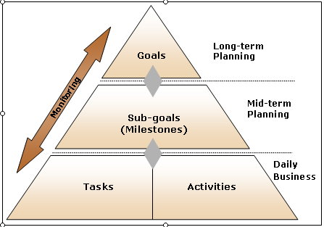
Source: https://encouragingandenlightening.wordpress.com/2011/04/27/you-must-act-to-achieve-your-goals/

The role play as interviewee was about to get the customer service manager position in clothes shop. Although, if I have experience with this kind of job, it`s not enough to meet the company standards. I need to develop many skills that makes me a good candidate for the position I want. Even if was just a role play, I got nervous thinking that I may not have all skills and experience to achieve my goal. But with small steps and hard work, everything is possible.
The role play as interviewer was played with more excitement, even if I had to figure out if the person who applied is the right candidate for the position. You have to be in possession of a variety of questions in order to choose the person who can make your company a success and reach their fool potential.
In conclusion, on both sides (interviewer or interviewee) I experienced a very realistic vision about my future, identifying areas for further development.

Self-evaluation review

In order to take control of your life`s direction you need to set goals. From my experience, I have learned that it is important to take the small steps first, and after you have accumulated enough experience you can go to the biggest steps. I want to take the position of customer service manager and to be the right candidate for that I must have few important skills, such as good communication skills, decision-making skills, interpersonal skills, conceptual skills and technical skills. Communication and interpersonal skill for a manager is a must, because a manager`s job is to control the subordinates and gives high-level managers or administrators information about what`s going on. I never worked before as a manager, but I can say that I have already some of those skills, because being a team leader for my shift is almost same. Most of the time I interact with people inside and outside of the organization. I can lead and communicate with individuals and groups, controlling and motivating them and I think this are what interpersonal and communication skills are. As a team leader I always make decision for my team, even if is not always the best decision.
For example, one day an angry customer was arguing with one of my colleagues regarding the size of one particular product. My colleague tried to remain calm but, the customer became already rude with the person and they create a scene. I had to intervene because the situation was getting worse and we can`t afford to lose customers who are so important to the company`s success. The most important thing to do when dealing with rude customers is to remain calm. I know it is hard because they are taking their frustration out on you personally, but you need to be able to manage the situation with calm, professional and responsible manner. After I listened both my colleague and the customer, I knew the problem was with the client, but I chose to blame my colleague even though he was not the one to blame. I apologized to the customer and to make him happy I offered the same size for the product but a different colour with 10% discount. As for my colleague, I sent him home, losing a few hours of work. I have to say it wasn’t the best decision that I made, but a good manager most often makes a good decision and learns from the bad ones.
According to Maund et al, (2017) there are three key reasons for the emphasis on workplace learning:
- First is to align your values with those of your work organization and to enable you to perform effectively in that first role
- Second, to enable you to develop professionally, in the short to medium term
- Third, for your longer-term career development and your employability, maximising your longer-term potential to align with your dream and ambitions.
This time you have the personal responsibility for what you do, and this is the difference between these aims and your earlier learning.

Swot analysis and Smart objectives

I have often thought about what I will do in the next five years, what do I want to achieve or which are my main objective at this time. Based on my swot analysis and Smart objectives I can now set the goal related with the highest priority in my life. The biggest goal is to open my own clothes shop.
In the scheme below, I have the SWOT analysis, and based on that I can see what is missing or what I need to achieve in order to accomplish my goal.
S- strengths: experience with customers, in sales, in marketing, good communication skills, decision making skills, certificate in higher education skills for the workplace, level 4.
W-weaknesses: English not my first language, lack of knowledge about location, finance, low knowledge about how to open a business, lack of courage, not good connection with partnership.
O-opportunities: to study about how to open a business, to finish the level 5&6 BA (Hons) Leadership and Management, meet people with experience, create connection with knowledge about retail
T-threats: competition, profit margins, experienced people, market needs.

In the next image, it is explained how to set a SMART goal:

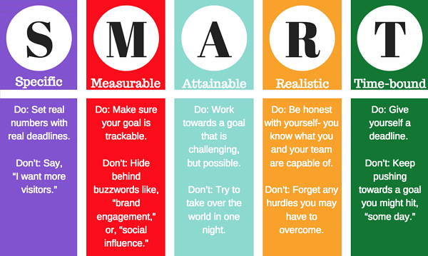
Source: https://www.hydratemarketing.com/blog/the-importance-of-setting-smart-goals
The diagram shows us the few steps needed to be followed to make sure that your goal is motivating and not to end-up in a very destructive “I can't do anything or be successful at anything” frame of mind.

Career ambitions and expectations

In the begging of my job, I wasn’t even thinking that I will love what I am doing. And now I have already plans and ideas to open my own shop. It is a good thing to have ambition and expectations. For now for the next few years I expect to finish level 5&6 in BA (Hons) Leadership and Management, to pass the exam and to get the position of customer service manager, and to learn what it takes to get a specific position and begin building the skills and gaining the experience to obtain the job I want.
At this point I am still learning, but for the next five years I have already everything structured in my personal development plan.

Personal development plan

The primary purpose of a personal development plan is to help you reach short- and long-term career goals, as well as strengthen current job performance by providing a structured approach. It is especially useful when discussing the year's development goals during the performance management process.
In the short-term time frame it is included the things that I want to accomplish in the next three to six months. In this time period, I want to study an English course to perform my grammar, to submit the assessments and pass them, to improve my communication and presentation skills, to read more books, to interact more with people.
The mid-term frame includes the small goals that I want to accomplish in the next six months to two years. During this period, I will graduate, I will improve and learn new skills, work more in a team, take more responsibilities, and become a manager. All these staring after I accomplish my short-term period goals.
For the long-term period time frame I have big goals to achieve. At that time I am expected from myself to be already confident that I will get where I want to go by defining precisely where I want to end up. When the results of my work are coming up successfully and what I wanted to accomplish it is already there, I will go to the next step. At this point I will have the necessary studies to open my own business, I will interact more with people that are in the same position or the upper one, a well-developed leadership ability, and partnership knowledge.
In the image below we can see a personal career plan example and what action we need to take in order to accomplish your goals and have a successfully career.
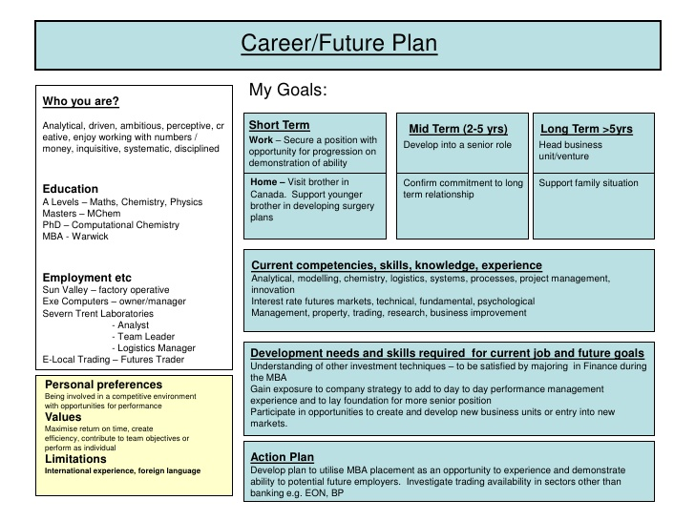
Source: https://www.slideshare.net/uolssds/career-plan-example
As the image shows, first you have to know yourself, who you are and what is your experience. After that you establish the short term, mid-term and long-term goals, because you must know your current competencies, skills, knowledge and experience. After this point, you will develop need and skills required for current job and for future goal and in the end is the action plan. How will you start? When do you expect to finish? By writing out the individual steps, and then crossing each one off as you complete it, you'll realize that you are making progress towards your ultimate goal. Make sure that it's possible to achieve the goals you set. If you set a goal that you have no hope of achieving, you will only demoralize yourself and losing your confidence.

Conclusion
Everyone aspires to a successful career, but not all of them can manage to carry their dreams till the end. That is why is very important to set goals making sure that they are important to you, and that there is value in achieving them.

References

References
Encouraging and enlightening. (2011, April 27). Retrieved September 1, 2020, from You must act to achieve your goals: https://encouragingandenlightening.wordpress.com/2011/04/27/you-must-act-to-achieve-your-goals/
Gollwitzer, P. M., & Sheeran, P. (2006, May 7). ScienceDirect. doi:https://doi.org/10.1016/S0065-2601(06)38002-1
Maund, A., Schriek, M., & Tinkler, P. K. (2017). Certificate in Higher Education: Skills for the Workplace Student Yearbook. London: SAGE.
Merrihew, M. (n.d.). Hydrate Marketing. Retrieved September 1, 2020, from The importance of setting SMART goals: https://www.hydratemarketing.com/blog/the-importance-of-setting-smart-goals
Mindtools. (n.d.). Retrieved September 2, 2020, from Golden rules of goal setting: https://www.mindtools.com/pages/article/newHTE_90.htm
Slideshare. (2010, June 15). Retrieved September 2, 2020, from Career plan example: https://www.slideshare.net/uolssds/career-plan-example

