Research Project Proposal

Topic- What are the current challenges that the hospitality industry is facing that are affecting business performance: a case study of Hotel Mariott

Student name: Alice Catalina Gheorghe
Module title: Personnel Resourcing and Development
Module code: BMIH5005
Lecturer’s Names: Emma Roberts
Abstract
The current challenges faced by the hospital industry affect business performance and create uncertainty in development. After the pandemic and Brexit, most of the hospital industry faces certain challenges regarding staff retention, shortage of staff, and management issues. These challenging circumstances developed obstacles to effective performances. Hotel Marriott faces such problems which creates unnecessary obstacles in business performance. This research is a discussion about the factors and views related to the challenges in the hospital industry. The discussion of issues in Hotel Marriott explains the relevancy of the current issues. The current challenges developed as a negative impact of Brexit and pandemic issues. The obstacle to developing their performances Hotel Marriott loses the performance efficiency of staff.

Table of Contents
1. Introduction 4
1.1 Topic Background 4
1.2 Hotel Overview 4
1.3 Aims 4
1.5 Research questions 5
1.6 Rationale 5
2. Literature Review 6
2.1 Introduction 6
2.2 Theoretical Overview of business management in Terms of facing challenges 6
2.3 Factors Affecting hospitality business 7
2.4 Advantages of risk management in the hospitality business 8
2.5 The industrial competition that triggers business fluctuation in the hospitality sector 9
2.6 Issues that are generally assessed as hospitality challenges 9
2.7 Measures to mitigate those issues 10
2.8 Literature summary 10
2.9 Literature gap 11
2.10 Conceptual framework 11
3. Research Methodology 12
3.1 Research Philosophy 12
3.2 Research Approach 12
3.3 Research Strategy 12
3.4 Research design 12
3.5 Data collection method 13
3.6 Data analysis method 13
4. Ethical Consideration 13
5. Timeline 13
6. Conclusion 14
7. References 15

1. Introduction

1.1 Topic Background
Hotel Marriott is one of the most reputable hotel industries in the United Kingdom. Most of the hospitality industry in the UK faces a certain loss after the emerging issues of the pandemic and Brexit. The challenges regarding the shortage of staff, and poor performance of the employees affected the business performance. Marriott International faces challenges regarding the factors based on the prevailing circumstances related to staff shortage, lack of training and management issues. The overall circumstances of the hotel depend on the working facilities of the working staff and promote the management’s performance (Marriott.com, 2023).

1.2 Hotel Overview
The Marriott Corporation was founded in 1927 by John Willard Marriott. It expands to over 8,484 locations (Marriott.com, 2023). Anthony Capuano is the current CEO of this hotel industry. Marriott International expand its services globally and maintain efficiency through service. Over 50 hotels of the Marriott family are located across the UK. This brand grow as an effective hospitality industry all over the UK while it is one of the largest hotel chains worldwide. Marriott International faces some difficulties in the sector of hospitality after the pandemic breakdown and Brexit.

1.3 Aims
This research proposal aims to find out the current challenges that the hospitality industry is facing from the example of Hotel Marriott.
1.4 Objective
- To identify the current challenges that the hospitality industry is facing after the pandemic and Brexit incident.
- To evaluate theoretical overviews of business management in terms of current challenges.
- To analyse key factors affecting the hospitality business.
- To recommend measures to mitigate the issues related to the hospitality business.

1.5 Research questions
RQ1. How to identify the current challenges that the hospitality industry is facing after the pandemic and Brexit incident?
RQ 2. How to evaluate the theoretical overviews of business management in terms of current challenges?
RQ 3. What are the key factors affecting the hospitality business?
RQ 4. What are the recommendations to mitigate the issues related to the hospitality business?

1.6 Rationale
The challenges that affect the hospitality industry faces depend on the key elements of management problems and staff retention issues. The factors that are developing are relevant from the perspective of nowadays as those disadvantages create a certain negative impact on the effectiveness of the business performance.

2. Literature Review

2.1 Introduction
After Brexit came into effect, the hospitality industry suffered greatly in terms of reservations as well as services. As opined by Davahli et al., (2020, p.7366), the constraints of COVID-19 have also been a part of the losses and hurdles suffered by the industry in aggregate. Some hazards that the industry kept in mind while operating were property damages, food contaminations, special events, traffic accidents, liquor liability, chemicals and much more. However, after the United Kingdom made its exit from the European Union, it has been difficult for hotels and restaurants to take reservations in bulk and offer export services. The challenges faced include changes in marketing trends and dynamics, operational issues, the rising cost of daily consumables, changes in guest expectations and irregular cash inflows.

2.2 Theoretical Overview of business management in Terms of facing challenges
The theories being applied in the current situation to help organisations in the hospitality industry face operational challenges are scientific management theory and neo-classical theory.
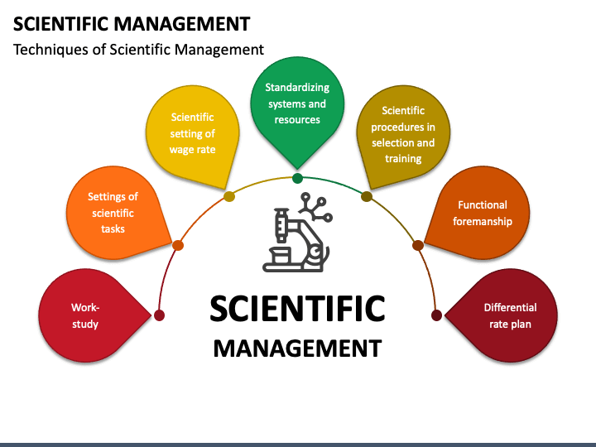
Figure 1: Scientific management theory
(Source: cdn.sketchbubble.com, 2023)
The scientific management theory suggests methods of improving efficiency in the workforce. This method could be used in hotels to increase efficiency in the conduct of staff and operations management. As stated by Segovia-Pérez et al., (2019, p.184)This theory has certain principles which encircle procedures that result in the enhancement of effectiveness. Those principles are science, not the rule of thumb, harmony, not discord, cooperation, not individualism. For instance, Hotel Marriot is using the harmony, not discord principle to establish the same.

Figure 2: Neoclassical theory
(Source: assignmentpoint.com, 2023)
Neoclassical theory of management focuses on individual or group behaviour and human relations to analyse productivity. It enables individuals to work in groups and establish participatory management. The hotels in the hospitality industry could apply this theory as a progressive measure.

2.3 Factors Affecting hospitality business
Several factors affect the hospitality business which is divided into external and internal factors. Those are political, social and economic which are the most influential ones. Some of the factors are described below.
Experience and Personalisation: This factor has a great influence on the workers who tend to work in the hospitality industry. Their work experience along with their approach to the business has affected the industry to a great extent.
Sustainability: As described by Carnevale and Hatak, (2020, p.183) sustainability is regarded as an economical method used by businesses in conducting operations. Since COVID-19 led to many negative effects on the aggregate business. The methods are related to environmental standards and related measures in complying with SDGs in business.
Increase in Hospitality Tech: The current technology trends mention that there must be technology implications in every industry to grow their operations. The hospitality industry has also undergone changes using artificial intelligence, chatbots and mobile ordering to improve relied services.
Changing Consumer Demands and Markets: With the changes in the environment, customer demands have been changing drastically. The market forces also act in favour of such changes relating to supply and demand chains imposed after Brexit.
Rising Operational Costs: the operational costs are related to the set-up costs and daily working costs which are required to run the business smoothly. Nowadays due to inflation, costs of everything have been rising and hence, operational costs have risen as well in the hospitality industry.

2.4 Advantages of risk management in the hospitality business
The advantages of risk management in the hospitality business are as follows:
Mitigation of potential risks: There are uncertainties in the business and these are very difficult to be identified. However, proper risk management in the team helps in preparing the management against such risks. After identification, those could be mitigated and reliable steps could be taken against them.
Helps in ensuring safety for customers: The customers are majorly prone to such risks and they are not even aware of such factors. In that case, the business shall ensure that its customers are safe and secure.
Minimising losses at critical times: As stated by Litvinenko, (2020, p.1521) every business faces critical times and they are affected in ways all through. Those times are the crucial points where risks are required to be managed evidently. Risk management has entailed an extended benefit in this regard to hospitality businesses.
Treatment and monitoring of risks: The existing risks are to be treated and monitored to deal with them. A critical analysis of such risks helps in monitoring and controlling the effects.

2.5 The industrial competition that triggers business fluctuation in the hospitality sector
There exists intense competition among the hotels in the hospitality industry which is critical for the consumers and operators of business. As depicted by Cooke, (2018, p.12) although organisations have to face cut-throat competition, the business also ensures that the guests get the best value for their money and render quality customer service. This imparts fair share value and maximum profitability to the firm. The competition factors that affect the business are:
Barriers to entry: The hotels generally don’t face any barriers to entry as the service industry is open. With proper compliance policies, they are set to establish their business. The competition persists when similar service providers are there in the same industry.
Information availability: Many hotels do not engage in providing information to their customers. It is the obligation that every organisation shall follow. The hospitality industry faces acute competition in this regard.
Location: Location is the prime factor in business fluctuation which has triggered the effect of competition in the industry. The location factor is the aspect every hotel looks at before starting its business.

2.6 Issues that are generally assessed as hospitality challenges
The issues that the hospitality industry has to go through in its daily business are as follows:
Hiring and retaining staff: The hospitality industry majorly faces the issue of staff shortage. There are increased turnarounds and staff leaving their positions vacant. Therefore, the hotels need to hire staff and take the necessary steps in retaining them. The process of retention proves to be cumbersome overall.
Taxation: The taxation policies and recent changes like the inclusion of GST have impacted the industry. The changes have led to a dormant increase in negative responses which has created the issue of image identification.
Globalisation: Entire work culture has been affected by globalisation and so has the hospitality industry. It created ways for affordable travel but along with it came the bulk of cultural issues which took over the range of destinations. The diversity has been enhanced.
Security: As written by Beijer et al., (2021, p.12) the security measures increased with an increase in the number of visitors. The enlarged number of visitors requires a more secure environment which hotels sometimes fail to provide. The hospitality industry has an underlying issue of security in its approaches.
Lodging and recreation: Lodging and recreation facility needs cleanliness. Along with it, the services rendered to the customers require top-notch quality which is not possible in an enlarged number of reservations.

2.7 Measures to mitigate those issues
Prioritising training: Providing training to staff and polishing their practical skills shall help in mitigating those issues identified above. The training also provides knowledge to the personnel on the conduct of the activities.
Personalising guest's stay: The guests in hotels want privacy during their stay and hence hotels must ensure that the guests are provided with such facility. Moreover, there should not be any disturbances in the felicitation and services provided.
Investing in hotel technology: Issues can easily be resolved by investing in the technology. A more technological approach means more automation and saving time.
Maintaining the building’s physical facilities: Buildings physical facilities decide the lookout which shall be impressive. This could be a relying measure in handling the issues.

2.8 Literature summary
The literature review contains an engrossing discussion on the issues faced by the hospitality industry. Several points are mentioned that describe distinct aspects being faced by the business. The factors affecting the business, competitive structure, the underlying issues and measures to deal with such issues are specified clearly. In addition to this, the trigger points are also stated which decide the competitiveness in the industry.

2.9 Literature gap
In this research process, the literature review is based on theoretical overviews of the challenging factors. It concludes the discussion on risk management, industrial competition, issues and measures to mitigate them. Those points help to maintain the factors related to the Hotel Marriotts. There are more factors which can be discussed in future research processes. There are scopes which can be discussed in further studies related to the fault of the management system in Hotel Marriott.

2.10 Conceptual framework
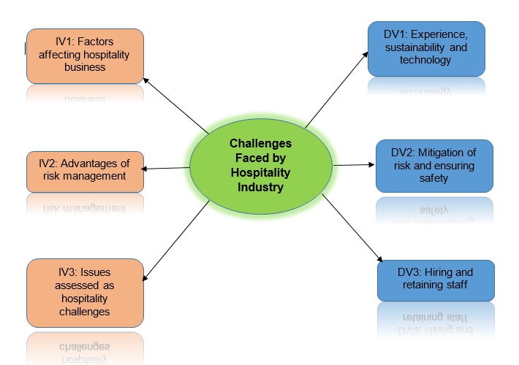
Figure 3: Conceptual Framework
(Source: Developed by the learner)

3. Research Methodology

3.1 Research Philosophy
The research philosophy formulated the overall structure of the research process. There are four types of research philosophies including positivism, interpretivism, realism and pragmatism. In this research, the interpretivism philosophy would be applicable. The interpretivism philosophy helps to gain the current knowledge of analysing the issues in the hospitality business (Zulkifli and Hshim, 2020,p.40).

3.2 Research Approach
The research approach formulated the constructive pattern of the research process. There are three types of research approaches including inductive, abductive and deductive. In this research, the inductive approach would be applicable. The inductive approach helps to collect all the data related to the issues in the hospitality business (Baye et al., 2019,p.160).

3.3 Research Method
The research strategy is formulated as the blueprint of the research process. There are two types of research strategies qualitative and quantitative. In this research, the qualitative strategy would be applicable. The qualitative strategy helps to gain the current conditions and issues related to the hospitality business (Nappi et al., 2021,p.20).

3.4 Research design
The research design navigates the formulation of further research progress. There are two types of research design including explanatory and exploratory designs. In this research, the explanatory design would be applicable. The explanatory design helps to construct the current affecting issues the hospitality business (Bondaryk et al., 2021,p.230).

3.5 Data collection method
The data collection method is formulated as the background of the whole research process. There are two types of data collection methods including primary and secondary. In this research, a secondary method of data collection would be applicable. The secondary method helps to collect the data from various sources of journals, articles and case studies related to the issues of Hotel Marriott in the hospitality business (Mazzotti et al., 2021,p.60).

3.6 Data analysis method
The data analysis method gives a clear perspective for further progress in research. There are two types of data analysis methods including descriptive method and thematic analysis. In this research, thematic analysis helps to narrate the factors of disadvantages in the hospitality business related to Hotel Marriott (Marriott.com, 2023).

4. Ethical Consideration
The ethical consideration of the research process helps to generate the authentication of data collection and data analysation. In this research process, all the collected data are verified and maintained by the Data Protection Act 2018 (Legislation.gov.uk, 2023). The method of collecting all data collected from various secondary sources is free from unwanted interference.

5. Timeline
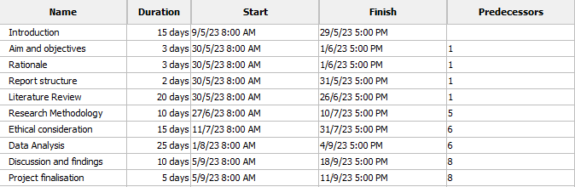

Figure 4: Gantt Chart
(Source: Developed by the learner)

6. Conclusion
This research is based on the current challenges that the hospitality industry is facing in terms of the current situation. The negative impact of Brexit and the pandemic breakdown is affecting the hospitality industry which provides a challenging situation for many hotel industries. Hotel Marriott is one of the reputable hotel industries in the UK which faces certain challenges due to the challenging factors. The keen analysis of those factors helps to gain the mitigation way to resolve those issues.

7. References
Websites
assignmentpoint.com, 2023 Available at: https://assignmentpoint.com/wp-content/uploads/2022/10/Critics-of-Neoclassical-Economics.webp (Accessed on May 9th 2023)
cdn.sketchbubble.com, 2023 Available at: https://cdn.sketchbubble.com/pub/media/catalog/product/optimized1/9/0/90581b8793046a88d1607fb07f32ad0f1a2a5c27859e8c2ec8a8906b3cb1a0d6/scientific-management-mc-slide1.png (Accessed on May 9th 2023)
Legislation.gov.uk, 2023 Available at: https://www.legislation.gov.uk/ukpga/2018/12/contents/enacted (Accessed on 9th May 2023)
Marriott.com, 2023 Available at: https://www.marriott.com/search/findHotels (Accessed on 9th May 2023)
Journals/Books

Baye, A., Inns, A., Lake, C. and Slavin, R.E., 2019. A synthesis of quantitative research on reading programs for secondary students. Reading Research Quarterly, 54(2), pp.133-166. https://ila.onlinelibrary.wiley.com/doi/abs/10.1002/rrq.229
Beijer, S., Peccei, R., Van Veldhoven, M. and Paauwe, J., 2021. The turn to employees in the measurement of human resource practices: A critical review and proposed way forward. Human Resource Management Journal, 31(1), pp.1-17. https://doi.org/10.1111/1748-8583.12229
Bondaryk, L.G., Hsi, S. and Van Doren, S., 2021. Probeware for the modern era: IoT dataflow system design for secondary classrooms. IEEE Transactions on Learning Technologies, 14(2), pp.226-237. https://ieeexplore.ieee.org/abstract/document/9360508
Carnevale, J.B. and Hatak, I., 2020. Employee adjustment and well-being in the era of COVID-19: Implications for human resource management. Journal of business research, 116, pp.183-187. https://doi.org/10.1016/j.jbusres.2020.05.037
Cooke, F.L., 2018. Concepts, contexts, and mindsets: Putting human resource management research in perspectives. Human Resource Management Journal, 28(1), pp.1-13. https://doi.org/10.1111/1748-8583.12163
Davahli, M.R., Karwowski, W., Sonmez, S. and Apostolopoulos, Y., 2020. The hospitality industry in the face of the COVID-19 pandemic: Current topics and research methods. International journal of environmental research and public health, 17(20), p.7366. https://doi.org/10.3390/ijerph17207366
Litvinenko, V.S., 2020. Digital economy as a factor in the technological development of the mineral sector. Natural Resources Research, 29(3), pp.1521-1541. https://doi.org/10.1007/s11053-019-09568-4
Mazzotti, V.L., Rowe, D.A., Kwiatek, S., Voggt, A., Chang, W.H., Fowler, C.H., Poppen, M., Sinclair, J. and Test, D.W., 2021. Secondary transition predictors of postschool success: An update to the research base. Career Development and Transition for Exceptional Individuals, 44(1), pp.47-64. https://journals.sagepub.com/doi/pdf/10.1177/2165143420959793
Nappi, F., Singh, S.S.A., Bellomo, F., Nappi, P., Chello, C., Iervolino, A. and Chello, M., 2021. Exploring the operative strategy for secondary mitral regurgitation: a systematic review. BioMed Research International, 2021, pp.1-22. https://www.hindawi.com/journals/bmri/2021/3466813/
Segovia-Pérez, M., Figueroa-Domecq, C., Fuentes-Moraleda, L. and Muñoz-Mazón, A., 2019. Incorporating a gender approach in the hospitality industry: Female executives’ perceptions. International Journal of Hospitality Management, 76, pp.184-193. https://doi.org/10.1016/j.ijhm.2018.05.008
Zulkifli, H. and Hashim, R., 2020. Philosophy for children (P4C) in improving critical thinking in a secondary moral education class. International Journal of Learning, Teaching and Educational Research, 19(2), pp.29-45. http://ijlter.net/index.php/ijlter/article/view/431

