Module Assignment Submission
Cover Page

Student Name: | Margaret Thomas
Student Number: | 1811544
Module No: | BMSK 4005
Module Title: | Professional Career Development

Date submitted: | 9th December 2018
Time submitted: | 15.30hrs
Statement of Confirmation of Authenticity
By the act of making this submission, the student declares that this is the work of the student named above. Where materials have been used from other sources it has been properly acknowledged. If this statement is untrue, the student acknowledges that an assessment offence has been committed. Proven incidents of plagiarism, collusion or cheating can result in a learner being withdrawn from a
qualification.
Attention is drawn to the Plagiarism, Collusion and Cheating Policy and Unfair Practice policies of the University and ILM.
Permission for ILM to use this script
ILM uses learners’ submissions – on an anonymous basis – for assessment standardisation. By submitting, both the centre and the learner agree that ILM may use this script on condition that identifying information is removed. However, if you are unwilling to allow ILM use this script, please refuse by ticking the box: □

Table of Contents
1.0 Introduction 3

1.1 Learning styles identified for myself and another team colleague 3
1.2 Barriers to learning identified and overcoming them 4
1.3 Control of possible barriers to learning using SWOT analyses ……………..…………………………………..…… 4
  - Support mechanisms …………………..……………………………………………………………………………………………… 6
  - Preparing A Personal Development Plan 7
1.6 Monitoring development 7
2.0 Recruitment processes 9
2.1 Identify and apply for a suitable job vacancy 9
2.2 Creation of a CV focused on the applied job vacancy………………………………………………..………………………9
2.3 Evaluation of previous interview experiences ..…………………………………………………………..………..……….10
References 12
Bibliography ………………………………………….………………………………………………………………………………….. 14
Appendix 1 ……………………………………………………………………………………………………………………………….. 15
Appendix 2 ……………………………………………………………………………………………………………………………….. 17
Appendix 3 ……………………………………………………………………………………………………………………………….. 18

1.0 Introduction
As part of my duties as a departmental manager I am required to report on the learning needs for staff I’m responsible for, in order to achieve the organisational objectives and to ensure the company values and behaviours are maintained. In working towards these aims this report provides a useful professional career development pathway to achieve these objectives. The evaluation reveals the preferred learning styles for myself and for another colleague of my team, by researching and using suitable recognised learning style analysis tools I gathered the results and evaluated the outcomes to provide a guide to develop a plan and programme for current learning needs and future development requirements to provide an opportunity for career progression. Following the use of learning style questionnaires I prepared a personal development plan for myself and my colleague, to identify any possible barriers to learning and how to overcome them and to provide options to address the learning needs required to improve the efficiency and effectiveness of myself and the staff working in the department and in that process enhancing our current skills, to provide a platform for transferrable skills to provide opportunities for obtain career goals.

Learning styles identified for myself and another team colleague
Before embarking on looking at what learning needs were required for myself and my colleague I sought to find out what was our preferred learning style(s)? From previous learning experiences, some good some not so good, I felt it was a good time to try to identify what type of training or courses are best for me as well as another team member to apply on, whether we had similar learning styles or opposites and whether we complement each other with the way we behave or relate to each other, to try to ensure a successful learning outcome. an individual to attend. Whilst analysing my learning styles and for a member of the team I used the VARK Learning Style Self-Assessment Questionnaire – Fleming (1987) to evaluate what is my preferred style of learning the results revealed that my preferred learning style was Auditory which means that I prefer to listen how to undertake the task myself, preferably with the opportunity to query and interact to ensure that I’m doing the task correctly, before attempting the do the task. I also looked at the Learning Style tool by Dantec (accessed 2018) the results from this questionnaire, revealed that I was Learner type 1 which in Dantec’s analysis states is the reflective learner. This reinforces my learning style identified from VARK’s Self Assessment Questionnaire which states that I learn through listening and sharing of ideas, which means I prefer to have the opportunity to ask questions as I go along. Dantec’s evaluation for the Reflector or feeling learner states that they prefer to know or understand rather than apply ideas that are already written down. Another evaluation tool which I found useful was Characteristics of the Four Learning Styles (Honey & Mumford 1986) these results showed that I was a Pragmatist, preferring practical application of ideas, and a more hands on approach when dealing with tasks. Overall from past learning experiences I agree with the findings of these questionnaires, from previous learning experiences. I prefer classroom based tutorials, where I can listen to the explanation of the subject being taught and there is an option to interact by posing questions, which help me to understand what I’m being taught.
I gave the same tools to another member of my team so she could look at what her results showed and how we could then use the results to tailor a study plan based on her preferred way of learning. Her outcomes using the VARK self-assessment were Visual, with Honey & Mumford - Reflector and Dantec her result was also reflective observation. This interprets that her preferences are being able to observe things, or being shown how to do something which can include for example diagrams, pictures, films, handouts etc. Her characteristic strengths as a Reflector are the ability to collect data from a variety of sources, and able to look at situations from various perspectives. It also revealed that both our learning styles are quite similar and we therefore, would prefer the same style of training.
1.2 Barriers to learning identified and overcoming them
From the results of the learning style questionnaires and understanding what our preferred learning styles were, the first priority was to identify what learning needs are required by us, which are a priority for our effective personal development to fill our skills gap and essentially required by the department and company. I used the Johari Window technique by psychologists Luft & Ingham (1955) a self-awareness tool they created to help people understanding and be aware of themselves and how they behave or develop relationships with others predominantly in the workplace,
to help gain the necessary skills for your employer and for future employment opportunities.

From this I identified that my current qualifications did not reflect my knowledge and experience that I’ve gathered in my current and previous job roles.
This has made me reluctant to apply for other available positions internal in the organisation and external and acted as a barrier to my career progression opportunities and to evidence what I can provide a prospective employer or how I believed I lacked to compete against other applicants.
My colleague’s analysis showed that she lacks confidence in her abilities and wants to undertake further training to upskill her knowledge and qualifications. The barrier to this is her ability to have time to undertake training as she has carer responsibilities, and little support. Higher Education Academy (HEA) 2018;

What | How | When | Resources | Success
ILM Level 4 | Enrol on a course | 1 year starting Jan 19 | Employer to pay for the course | Obtain certificate

1.3 Control of possible barriers to learning using SWOT analyses
From using the various tests above I then created a SWOT analysis to identify the strengths, weaknesses, opportunities and threats for myself as well as the other member of my team. This was to find out what development needs were required to enhance our skills and to identify gaps, weaknesses and any barriers that need to be addressed to ensure there was a plan so that we can progress as individuals as well as improve our ability to bring a more efficient and effective workforce for the company.

My personal SWOT Analysis
Strengths (internal) | Weaknesses (internal)
Attention to detail  Good Listener  Empathic  Creative  Keeping to deadlines  Good general knowledge  Confidentiality  Approachable  Calm  Determined  Analysis of fine details  Focused  Depth of knowledge and experience in field of expertise | Dislike personal confrontation  Emotional  Get bored easily  Untidy (disorganised)  Time management (appointments)  Shy and introvert  Keeps feelings to myself  Lack of confidence  Conflict management  Short temper  Impatient  Skill level to apply for appropriate vacancies  Lack of formal qualifications
Improved career prospects  Career progression  Self employment  Inhouse training  External university studies | Change of industry trends  Legislation  Restructure  Funding and budget reductions  Brexit
Opportunities (external) | Threats (external)

From completing the SWOT analysis on myself I identified that some internal weaknesses could be a barrier and may have been a barrier to my learning in the past, which are hidden disabilities, on my mental health and learning needs for dyslexia. Whilst these have been potential barriers in the past there are various opportunities for help and support available these days through the employer as well as with GP services and education centres, where they can provide counselling and an assessment for dyslexia to find out what level of dyslexia and what learning aids can be provided. There are various training courses offered for free within the organisation, although it is still necessary to get permission to attend from your line manager, as there is obvious staff resource cost to consider and whether there is enough cover for your role when you attend any course, internal or external. From the review and personal appraisal and development review with my line management, it was agreed that I should contact the Education and Development Department to find out what courses are available online or classroom based to develop my skills and support my learning needs.
My line manager also agreed that I could research what external courses were available through Open University, Union Learning or from an Academic University, to find out whether I was eligible to apply for these courses or if I needed to undertake a foundation learning course in the first instance. I would then send a report to my line manager on my findings together with a report of the costs, length of course and times required for attendance although they may not be able to fund this training due to budget constraints, when I have gathered this information, we will reconvene to discuss the various options. Find out whether there is any funding available through grants, loans or bursaries and whether I’m eligible to obtain these. Whether I need to undertake further training (foundation learning) to develop my knowledge requirements to apply or whether my previous prior learning, knowledge and experience is sufficient.
SWOT Analysis for the other member of my team
Strength (internal) | Weaknesses (internal)
Enthusiastic  Team player  Time management | IT Skills  Confidence issues  Formal qualifications
Learning and Development  Childcare vouchers funding  Flexible working  Work from Home | Issues with Lack of sufficient childcare support
Opportunities (external) | Threats (external)

Team member’s barriers to learning:
From the completion of the SWOT analysis by my team member it was clear that the main weaknesses that needed addressing and to turn into strengths and/or opportunities were her Skills gap in computer literacy and issues with childcare support hampering ability to attend training.
- Skills levels – identify suitable IT training, in-house and/or online for example ECDL (European Computer Drivers Licence).

- Childcare responsibilities – enquire whether the company were still running the childcare voucher scheme and whether she was eligible for the scheme. Apply for flexible working arrangements and a works laptop so that she can work from home when necessary.
- Confidence issues – Enrol onto a confidence and assertiveness course

Support Mechanisms
Following the results from the SWOT analyses I asked for a meeting with my line manager to discuss my learning needs and possible training opportunities as well as to find out what support was available. I also arranged a one to one meeting with my colleague to discuss the results of her SWOT analysis, I thought the best way to conduct this meeting was to use the Go MAD Framework (Gilbert A. & Chackravarty I (2002) this was an informal discussion using the Framework more as a diagnostic tool as shown by Think Leicestershire YouTube presentation (2014) – Using the Go MAD Framework as a Diagnostic Tool (YouTube 29 Jan 2014)
Going forward from both discussions it was agreed that the best way to ensure a success outcome for my training needs and my colleague’s training needs was to source suitable courses for both of us to attend which suits our learning styles, needs and times available and was prioritised as essential with our job requirements. It was also suggested that finding a mentor would be helpful.

  - Preparing A Personal Development Plan
I then prepared a PDP (personal development plan) for myself and my colleague using the SMART objective framework as shown in the table below.
OBJECTIVES | MYSELF | COLLEAGUE
S pecific | ILM 4 | ECDL
M easurable (measure success, monitor progress) | Start February 2019 | Start next cohort in Spring
A chievable (competency)agreed | Obtain ILM 4 certificate | Obtain ECDL Passport
R ealistic (relevant) | Request study leave | Provide protected time to undertake and flexible working arrangements to attend course
T ime Bound | 1 year course review in next appraisal | 6 week in house course. Assess in 3 monthly personal development review

  - Monitoring Development
In conclusion, after researching suitable training courses available, both online and classroom based and from identifying my learning style, essential requirement needs to develop from my PDP and resources available and after discussion with my line manager, it was agreed that applying for the ILM Level 4 (Institute Leadership & Management) course would be most suitable to enhance my current personal development as well as provide a platform to go on to support my further development needs and opportunities for career progression. It will provide formal recognised qualification within the organisation as well as an opportunity to apply for jobs externally and the ability to compete on a level footing with other job applicants.

Further to the informal meeting with my colleague a personal development plan (see below) was discussed and drawn up which was agreed together would support my colleague in achieving her current essential needs to development in her role within the department as well as provide her with the skills to continue to progress. I applied to procure a laptop and encryption key from the department budget, so that my colleague could work from home when required as well as be able to use to undertake online training which she could connect with the in-house training, whilst at home through the encryption key to support her childcare cover needs. My colleague was keen to apply for the online ECDL (European Computer Drivers Licence) course, this was available within the organisation, as an online course it was available continuously although time limited when starting the course, she could complete the course whilst in work under the protected time policy. The course covers Microsoft software applications used, for example: Word, Excel and PowerPoint and is run at 3 different levels, basic, intermediate and advanced.

Personal Development Plan - PDP (colleagues)
Title | When | Where | Resource | Review | Complete
IT mandatory & statutory training | Continuous compliance | Internal | No cost, an organisation requirement | Monitor through ESR for compliance level | N/A
ECDL qualifications (in house) | Current availability | Internal ESR learning | No cost, an organisation development opportunity | Via Personal Appraisal Review | ECDL Passport Basic acquired
Confidence Building (in house class) | In house classroom 1 day course | Education & Development Department | No cost, an organisation development opportunity |  | Certificate acquired
Assertiveness Training (book in house class) | In houses  Classroom  1 day course | Education & Development Department | No cost, an organisation development opportunity | Via Personal Appraisal Review | Certificate acquired
Other M & S training (online via ESR) for compliance | Online via ESR | Internal ESR learning | No cost, an organisation requirement | ESR Compliance | 100% compliance achieved
NVQ Essential Skills Maths & English (in house) | 1 year course | Education & Development  Department | No cost, an organisation development opportunity | Via Personal Appraisal Review | Certificate acquired
Flexible working arrangements | 6 months temporary arrangement. | N/A | N/A | Review after 3 months
Work from home (work’s laptop and encryption key) | N/A | N/A | Procured from non-staff department budget | Review after 3 months | N/A

- Recruitment processes
From researching my learning styles and discovering what skills I have and where I could enhance these skills, from further training identified from my appraisal with my line manager finding out what courses and training were available and these courses applied for and/or undertaken. I looked into what job roles would be good for my future career progression. It’s important when looking for a suitable job that you consider options available to you and what position, and organisation best fits you. Things to take into consideration are:-
Whether you willing to travel, if you need to have transport, or whether staying local is a necessity. What type of organisation and job role would be most beneficial? Research websites and read their annual reports to discover if they have a quick turnover of staff. If they have development opportunities available, what does their mission statement say.

2.1 Identify and apply for a suitable job vacancy

I considered what suitable vacancies were available locally in the job market that suited my skills, knowledge and experience and gained my interest in submitting an application. There were several avenues that I could go down and after deciding which direction I wanted to go I identified an Area Manager position in a local security company which the job description and person specification essential criteria attracted my interest and I then completed an application form. I felt it suited my selection criteria suited my current skills, knowledge and qualifications and previous experience. The position was advertised as a permanent position, although there was opportunity for secondment and/or job share and flexible working. The company information showed that they were an equal opportunities employer, they had the ‘Investors in People’ Award (IIP) and staff turnover was low. (See Appendix 1).

2.2 Creation of a CV focused on the applied job vacancy

Further to completing the job application form, I studied the job description and person specification in detail and tailored my CV to highlight the skills knowledge, experience and qualifications I currently have that are listed as essential criteria for the position. I also gave further information on skills, knowledge or qualifications I’m currently undertaking or keen to obtain in the future from the desirable criteria. To ensure I would be successful in obtaining an interview for the position I applied for, I needed to update and modify my CV to be succinct, have an attractive and appropriate layout and provide a high chance for selection, short listing and interview invitation. It also needs to reflect how I would be an asset to their company and that I would fit in with the company are looking for. (See Appendix 2).

2.3 Evaluation of previous interview experiences
From my previous interview experiences, I’ve identified what I see as good practices to enable a better experience for candidates and for interview outcomes for panels to gain good information to make a suitable person for the role and company. These are:
    - Give contact details on the day where to speak to someone in the event of an emergency (as most panel members will not be at their normal locations).
    - Have an accessible venue
    - Well signposted
    - Provide good directions of the location
    - When possible provide information on who will be on the panel, and many will be on the panel and what their role is.
    - Explain what the format of the interview will be.
    - Put people at ease (relaxed candidates will perform better)
    - Be kind, courteous and respectful.
A theory developed by David Kolb ‘The Learning Cycle’ (1984) was a simple and quick way to understand what you have experienced, and how to learn from that experience by making reflective observations, what happened, what went well, or not to prevent repeating a bad experience happening again and look at how to improve opportunity for a better experience in similar circumstances going forward. From previous interview experiences, I realised I wasn’t confident doing presentations, to overcome my fears and reluctance to apply for jobs that required a presentation style interview I attended a presentation workshop, from this I learnt some top tips such as:
- Be acquainted with the subject asked to present
- Hone presentation on the topic and the question asked.
- Be prepared for every eventuality such as technology failure. Print handouts, prepare cue cards.
- Rehearse presentation timings, if states provide a 10 minute presentation, need to ensure that it doesn’t overrun.
- Be punctual, and suitably attired.
- Prior to interview, contact the company to ask what is available, don’t assume that they will have facilities to present PowerPoint slides.
- Research the company background statistics, for example, awards won, who are their competitors, their mission statement and what that means, future development plans, how well the business is doing.
These tips have improved my confidence and I’ve learnt, you need to research and know the subject well to develop understanding and this has resulted in an improved experience.
Other tips I’ve identified is to be honest, if you’re not sure what the question is, ask for clarification. There’s no such thing as a stupid question.
Try to provide good answers using the STAR model. For example, at a previous interview I was asked what the term co-morbidity meant. I said I wasn’t certain, but attempted to give my understanding of what it meant. After the interview, it was explained to me that another candidate had brought the word up in her interview and when asked to explain what she meant, she demonstrated that she didn’t know. From this I’ve learnt don’t try to impress a panel on something they know well and you don’t!
Considering Gibbs Cycle of Reflection (1988) at another interview that didn’t go so well, I asked for feedback to understand what I could do better for future interviews and find out why I was unsuccessful.
Conclusion
In conclusion from my previous experiences I believe the best way to find the right organisation, and the right job for you is to look at key essentials and create a tick box looking at these points:-
    - Research the company, what is happening currently?
    - What are they doing or what they have achieved?
    - What is their staff turnover?
    - What are their figures on staff development and career progression?
    - Look at how the company is growing and what they are doing to develop their staff.

At presentation you need to ensure you have covered these points:-

Look at the question being asked for the presentation. Know the subject fully.

Make it visually attractive, with graphs and pictures, some quotes and opinions from scholars on the subject you are trying to demonstrate. Some humour like an appropriate cartoon, fitting the subject matter.

Finish with a question or ask if they would like to ask further questions. Also research their threats and/or competitors and your ideas how you could resolve or overcome these.

References
Brett & Kate McKay | October 23, 2013,
Last updated: November 29, 2018 Decision Making, Dwight D. Eisenhower, Money & Career

“The Eisenhower Decision Matrix”: Available at: <https://www.artofmanliness.com/articles/eisenhower-decision-matrix/>
Cottrell, S. (1999). The Study Skills Handbook. London: Macmillan Press Ltd.

Covey, Stephen R. (2013). The 7 Habits of Highly Effective People: Powerful Lessons in Personal Change. London: Simon & Schuster UK Ltd.
Fleming, N. (1987). The VARK Inventory: The VARK Questionnaire Available at: <http://www.vark-learn.com> [accessed November 2018]
Fleming, N. D. and Mills, C. E, (1992) 'Not Another Inventory, Rather a Catalyst for Reflection', To Improve the Academy, Vol. 11, p. 137-155.
Gibbs Cycle of Reflection (1988)
Gilbert, A. & Chackravarty, I. (2002) Go MAD about Coaching, Woodhouse Eaves: Go MAD
Honey, P. and Mumford, A. (1995) Using your learning styles. Maidenhead: Peter Honey
Kolb, D.A. (1976). Learning Styles Inventory: Technical Manual. Boston, MA: McBer & Co.
Kolb, D.A. (1984). Theory of Experiential learning: experience as the source of learning and development. Upper Saddle River, NJ.: Prentice-Hall.
Luft, J.; Ingham, H. (1955). "The Johari window, a graphic model of interpersonal awareness". Proceedings of the western training laboratory in group development. Los Angeles: University of California, Los Angeles.
Mourad, D. Letica Goodchild, L. and Dantec, C. (2018) What is your learning style? Available at: http://loc.llas.ac.uk/lob/5/view [accessed: 23 November 2018]
Mumford, A. (1986) Developing Skills for Matrix Management. Industrial and Commercial Training Issue 5 Volume 18, Pages 2-7
Think Leicestershire YouTube presentation (2014) –“ Using the Go MAD Framework as a Diagnostic Tool” (YouTube 29 Jan 2014)
Tjan, A.K., February 2015, 5 Ways to Become More Self-Aware. [online] Available at: <https://hbr.org/2015/02/5-ways-to-become-more-self-aware> [Accessed 15 July 2017]

Bibliography
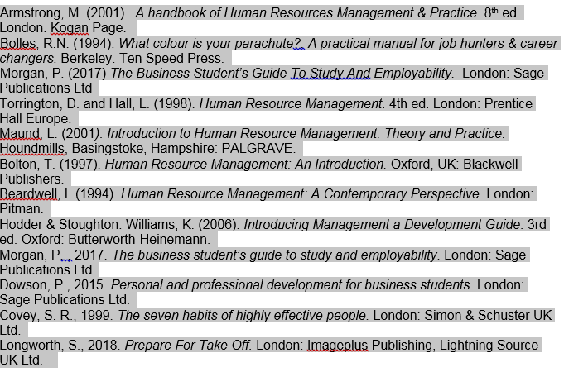

Appendix 1
Job Application
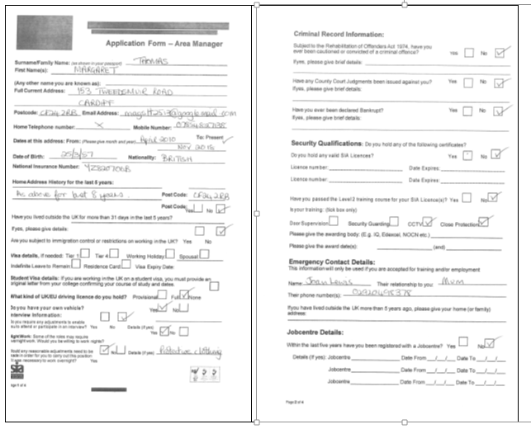
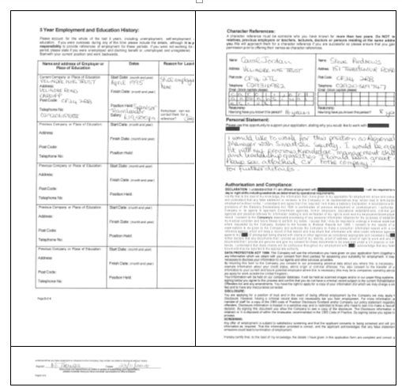

Appendix 2
Covering letter (email)
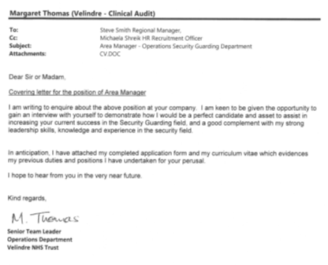

Appendix 3
Curriculum Vitae
Margaret Thomas
153 Tweedsmuir Road , CARDIFFCF24 2RB 02920498378 magstt2513@googlemail.com
LinkedIn | Twitter | Instagram
Professional Summary | High-performing Manager with 12 years of healthcare experience in hospital and medical office environments. An Audit Manager with broad background in operations, project and risk management. Enthusiastic team player dedicated to process improvements and staff development. Seasoned management professional who excels in establishing excellent working relationships with customers, employees, vendors and contractors.

Skills
  Industrial Relations  Job Evaluation and Analysis  Health & Safety Officer  Team player  Strong Leadership skills | Work on own initiative  Change Management expert  Project Lead  Attention to detail

Work History | April 1998-Current  Clinical Audit Manager | Velindre NHS Trust | CARDIFF, South Glamorgan  - Conducted several security audits per month to identify potential problems related to physical security, staff safety and asset protection.  - Supervised a team of security personnel organised rosters and take decisions to meet clients and organisational needs .  - Communicates effectively with staff, clients and contractors at all levels and liaise regarding identified needs and next steps.  - Travel to all sites within the area to attend meetings with clients and To visit all assigned sites, clients and Security Officers at designated times.  - Undertake risk assessments and on the Health & Safety Committee on behalf of Audit Department.  - An expericenced Train the Trainer having delivered regular mandatory and statutory training on audit security.  - To complete Assignment Instructions and issue as per directions and Company requirements. To address additional Health and Safety Issues with relevant Line Manager.  - To train officers at their place of work, to coach and guide to a high level of service delivery; to assess officers performance and complete training records as per Company requirements.  - To complete site visit sheets for each store visited or where relief cover has been provided and communicate these with designated departments.  - To deal with Company misconduct and disciplinary procedures and issue misconduct forms and store/site removal requests in line with Company policy.  - Recruit, select employees when vacancies are needed to be filled.  - Appraise staff for personal development plans.  - Undertake sickness and disciplinary meetings with staff when necessary, in line with HR policies.  - Experienced in dealing with staff conflict and sensitive situations within the workplace.  - Ensure that the dress code policy is complied with by auditing uniforms issued and returned by staff.  - Partake on the on call rota, to respond in the event of an emergency.  - Trained Investigator to undertake investigations within the organisation when required.

Education | 2002  NEBS Management  Pontypridd College, Pontypridd  - Coursework in Business, Management and Communications

Accomplishments | - London Marathon 2016

Affiliations | Race Council Cymru Management Committee  BHM Steering Committee  Welsh Clinical Audit & Effectiveness Assocation  WRVS

Additional information | Hospital Volunteer

