
Developing Relationship and Workplace Achievement
Shahida Miah 1710331


Executive Summary
The purpose of this report is to analyse different developmental vehicles and how effective or ineffective these methods may be for an individual and the organisation. Looking at how the certain theorist support each vehicle and how the studies undertaken explain the best way to meet objectives and reach goals. Case studies also giving an insight of how organisations run through using different elements of performance management to increase motivation and productivity. A Personal Developmental Plan will highlight areas the researcher is need of developing to achieve career aim, this framework will set out a plan backed with credible sources to make realistic strategies.
The report concluded each chosen vehicle has a vital part in the success of an individual as well as the organisation. Each theorist has different ideas of motivation and success of a company and employees but still work within most organisation. The PDP reveals few vital abilities in need of attention but in the research, it has been found courses and coaching along with framework available to improve these elements.

Table of Contents
Executive Summary……………………………………………………………………………………1
Introduction…………………………………………………………………………………………….2
Main Findings………………………………………………………………………………………….3
Task 1: What is Motivational Developmental Vehicle? ………………………………………………………….……….3-4
What is Performance Management Vehicle?......................................................................................4-5
What is Training Developmental Vehicle?...........................................................................................6-7
What Sort of Developmental Vehicles do Companies use?...................................................................7
Task 2: Assessing Potential Benefits to the Individual of Personally Developing Individual in the Workplace…………………………………………………………………………………………………………………………………….7-8
Assessing Potential Benefits to the Organisation of Developing Individual to the Workplace……....9-10
Task 3: Personal Development Plan….……………………………………………………………………………………10-11-12
Conclusion……………………………………………………………………….……………………13
Bibliography……………………………………………………………………………………………….………………14-15-16-17-18
Reference List……………………………………………………………………………………………….…………………19-20-21-22
Appendices……………………………………………………………………………………………………………………………23-24-25

Introduction
Looking into the three different developmental vehicle which are, Motivation, Performance Management and Training. CIPD (2018) stated to keep up to the rapid changes of the environment it is vital for organisation to apply critical practices such as organisation development methods, this increases value, focuses on strategies and goals. Various theorist that use different vehicles were analysed to view the implementation of models. According to Badubi (2017), a mix of theories can be applied to follow performance management and appraisals as well as reward and promotions.
Developmental benefit for individuals and organisations is critically analysed using the Pearson’s RED model. As Geeson (2019) explained there may be many potential benefits such as enhancing new skills and increased confidence and efficiency. However, an insight in organisations case studies will draw conclusion to whether it is a fact or assumption.
The researcher will look at the Personal Performance Plan to determine what skill need to be improved to reach goals. The Board Developer (2019) stated, a PDP encourages self-awareness, utilises strengths and identify areas to develop.

Main Findings

Task 1
What is a Motivational Development Vehicle?
Motivational development vehicle prompts and encourages human behaviour positively to achieve goals. According to Management Study Guide (2019), motivation helps to expand skills and abilities within the employees making the workers feel significant to the organisation, along with encouraging employees to perform well. This can be acquired by participating in training, seminars, conferences, setting goals, responsibilities, creating positive work environment, incentives and recognition (Management Study Guide 2019).
Compare and Contrast Theories and Models:
Elton Mayo, an Australian psychologist and a professor at the Harvard Graduate School explained Cole and Kelly (2011) Mayo was approached by the western electric company to perform a study on two groups with improved and minimal lighting to observe performances. The result of the study indicated that the social factor was key to achievement and reaching goals effectively, despite the lighting conditions, the importance of groups effected behaviour (Cole and Kelly 2011).
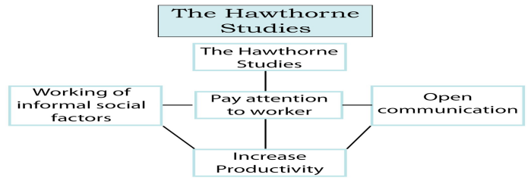

However, Frederick Taylor who was an advocate for scientific management stated by Mind Tool (2019), Taylor published a book “The Principles of Scientific Management” proposing managers need to interact with workers. Taylor believed in time, and motion studies leading to efficient work. According to British Library (2019), Taylor believed a suitable person should do specific roles and it was managements responsibility to know who was suitable for what role rather than develop and motivate other employees.
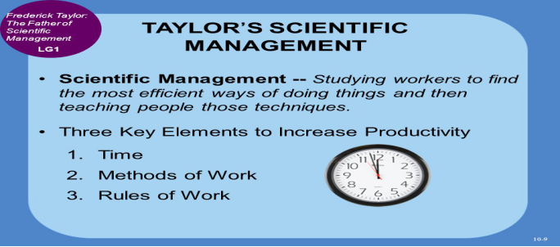

Similarities/Differences in approaches:
Frederick Taylor and Elton Mayo do have similar goals as both concentrate on how to motivate employees to increase productivity explained Stenly (2010), both try to discover the needs of the workers allowing managers to find a mechanism to aid staff and improve performance. However, Stenly (2010) also stated that the differences between Mayo and Taylor is that Mayo was inspired by the hawthorn studies which was discovered if management have a better working relation this can motivate and improve performance. On the other hand, Tool Hero, (2019) stated that Taylor’s method was more allocating task accordingly to ability, leaving workers to continue everyday with appointed roles. Taylor believed this method-maintained time, routine and increased productivity and was a believer of salary being the main motivation factor.
What is Performance Management Vehicle?
Performance management is an on-going process consisting of managers expressing expectations of employees reaching goals, doing well at the job, measuring performances, looking at barriers and how to overcome them also, how both can work together to improve performances (Bacal, 2004).
Compare and Contrast Theories and Models.
Looking at the Goal Setting Theory of Motivation, introduced by Edwin Locke which helps employees to establish the goals by examining performance explained Salaman et al (2005) cited by Agarwal (2011). According to Cole and Kelly (2011), the feedback on motivation directs employees on how much effort needed to reach goals. Goals should be a clear concept, realistic, challenging, self-efficiency and committed.
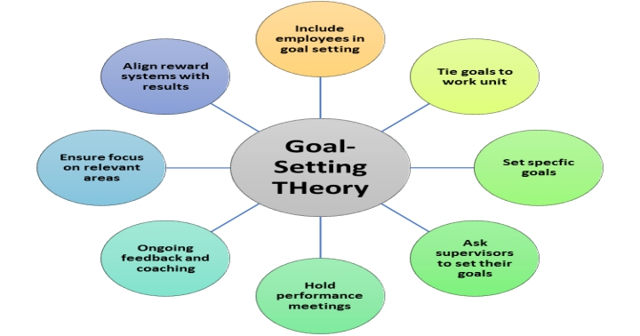
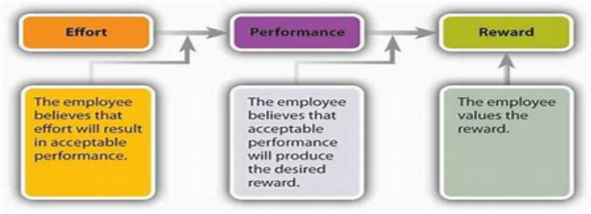
However, Victor Vroom developed the Expectancy theory in the 1960s as according to Cole and Kelly (2011), this theory is based on three perceptions of, effort, performance and reward. An employee gets stimulated by goals set which the behaviour of individual is adjusted accordingly. This is a more psychological mechanism.

Similarities/Differences in approaches:
In comparing both theorist, the similarities explained by Study Mode (2019) is both motivate through incentives and objective setting, as expectancy theory believes setting hard goals can de-motivate staff however, Study Mode (2019), also stated that the Goal theory believes the tougher the goal the greater the effort leads to enhances performance.

What is a Training Vehicle?
Training is an opportunity for employees to develop knowledge stated Frost (2019), as this vehicle addresses employees’ weaknesses and strengthens skills. It improves employee’s performance and aid staff to become aware of procedures and task. Frost (2019) also explained that a structured training programme helps employees to keep up with organisations policies, most importantly leaves employees with job satisfaction which highlights how employees are valued.
Compare and Contrast Theories and Models.
Taking Kirkpatrick four level training evaluation model, according to Mind Tool (2019), this method analysis how effective training has been. This was developed by Donald Kirkpatrick in 1959 and was updated three times. Mind Tool (2019) also stated the four levels are, Level one: Reaction, measuring how employees were engaged by asking questions. Level two: Learning, this focuses on what knowledge, determination and understanding employees gained. Level three: Behaviour, this is to understand how employees apply training. Finally, level four: Results, this is seeing the outcome of training which can lead to good or bad productivity.
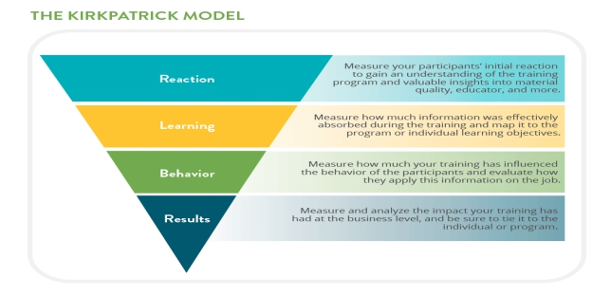
However, the CIRO model as according to CIPD (2018), this is an evaluation of management training developed by Warr, Bird and Racham in the 1970s, which stands for, Context: evaluating information. Input: examine effectiveness of training. Reaction: examining the reaction of employees. Outcome: evaluating the result.
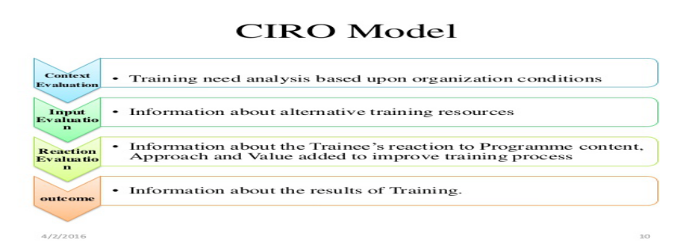
Similarities/Differences in approaches:
In looking at the similarities both CIRO and Kirkpatrick are very similar as these methods looks at identifying objectives and training needs stated Pembstrainer (2013). However, according to Spearhead Training (2019) CIRO mainly looks at the actions before and after the training and has been criticised for not looking into the behaviour aspects, which is believed this model is best suited for bigger organisations.
What sorts of development vehicles do companies use?
Tesco believe a workplace that is motivated well will achieve great productivity and reduce labour cost, explained The Times 100 (2019) in a business case study. Tesco follow the Taylors theory, which is financial awards such as, promotions, pay rise, free shares, save as you earn, pension schemes discounts, private health care, gym membership, phone contracts and holiday discounts. Tesco’s invites employees to take part in a staff satisfaction survey to ensure motivation or offer, lifestyle or career breaks.
However, The Times 100 (2019) also states that Elton’s Mayo theory is applied as Tesco’s believe communication is a vital factor, this done through one-to-one discussions, newsletters, appraisals and daily meetings. This aids managers to understand what is happening and offer appropriate value awards. Tesco also have a personal development plan using the 360-degree feedback to help offer staff opportunities. The Times 100 (2019) highlights how Tesco implement the Frederick Herzberg theory by paying attention to hygiene factors, this is done by communication, delegation, making decisions together, helping managers and employees take interest in employment. This case study highlights the implementation of motivational, training and performance management vehicles.
Task 2
Assessing Potential Benefits to the Individual of Personally Developing Individual in the Workplace:
Individual:
Personal development can keep individuals motivated explained Rabid Office Monkey (2019), this can define potential work promotions in the future along with helping to be more decisive and confident. Personal development can improve many skills such as communication and problem solving, which can be utilised during work. This can also be applied on daily life and improve chances on other jobs when highlighted on a CV. According to Ross (2019), some of the core benefits are, discovering individual’s life purpose as this is connected to self-actualisation, directing a person towards empowerment and inspiration. An individual can set realistic goals leading to a positive attitude and belief ultimately leading to happiness.
Is Personal Development True or Exaggerated:
In applying the Pearson’s RED model which lays down the path of separating facts from assumptions, evaluating information and drawing an conclusion (Course Hero 2019). looking at the benefit of personal development in a workplace to be true or an assumption, Resume Perk, (2019) stated, to gain professionally success, constant development is necessary, this aids the individual to reach career heights and productivity. According to Daphnegans Blog (2011), personal development is the foundation of prosperity, happiness, better relationships and maturity. Many individuals go through emotional struggle as importance is given to professional and academic achievements rather than developing personal skills.
The theorist state that personal development is a vital element to have as according to Mark (2014), the Frederick Herzberg two-factor theory explained, this theory influences satisfaction and motivation. The motivational factor that lead to progression is implemented by supporting workers, appreciating employees, feedback and helping individuals to grow with the company which is a form of personal development.
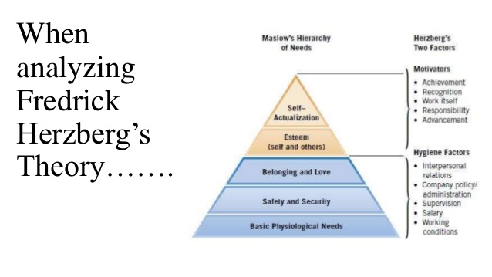
Abraham Maslow’s Hierarchy of needs that has five levels states an individual must achieve one level before going onto another. These levels are: physiological, safety, belonging, esteem and self-actualisation. These can be achieved through development training and supporting all aspects of the employee’s lives (Mark 2014).
What are the Potential Benefits?
However, in evaluating further, employee appraisal is an objective of performance, this method helps receive feedback and give guidance to aid an individual need and corrects training component (Lloyd 2019). According to CIPD (2018) to achieve strategic goals, its vital for managers to monitor performance, which is done by feedback, reviewing performance and appraisals. Performance management is a way to keep the individual in line with the company’s objectives which is done through HR and managers. CIPD (2018) recognises that the benefit of personal development is achieved through managing performance, which reinforces the link between the organisation and employee.
How did the Individual Benefit? Case Study:
In drawing the conclusion, Tesco that ranges from different products from groceries to banking, Study Moose (2019) explained in a case study how Tesco need to have the right staff in the right place. Tesco offer personal development by offering on-the-job training which can be done by shadowing, mentoring, coaching and job rotation, Tesco also offer external courses. Although individuals are responsible for identifying the development needs, managers do help plan developments, the organisation then benefit by having the rightly trained staff and develop other potential workers, offering customers the correct knowledge of product.
Assessing Potential Benefits to the Organisation of Developing Individuals to the Workplace:
Recognising the skill gap and developing individuals within the existing workforce can have various benefits stated Monster (2019), these are; reduced turnover, increased productivity and efficiency, increased risk management, engaged motivated employees and customers and a positive view of recruits as being able to demonstrate how the organisation is prepared to invest in new staff. According to Explorance (2013), other benefits are; increased communication and profits, enhancing service making organisations more competitive, organisation can also influence employee development.
Is Organisational Development True or Exaggerated?
In separating assumptions from what may be true, Quain (2018) explained the importance of having organisational development can boost employee morale, a business aspect of decision making is affected and aid problem solving. Organisations may have to invest time and money as this aids companies to identify areas that needs changing. Quain (2018) also states how managing and planning can enhance corporate growth. Development help to analyse process within the organisation acting towards product innovations, empowering the value of the company.
The Hawthorn Elton Mayo’s theory found after undertaking an experiment explained Magloff (2019), that organisations have great influence on productivity by providing security and commitment along with recognition, de-motivation comes from not being valued. To gain productivity and value, organisations must develop through management styles (Magloff 2019).
According to the Contingency and Expectation Theory of organisation motivation, developed by Fred Luthons, Magloff (2019) stated, individuals are motivated through different aspects however, leadership styles should therefore be adapted according to the workers, involving the appropriate development methods for the organisation and individuals. 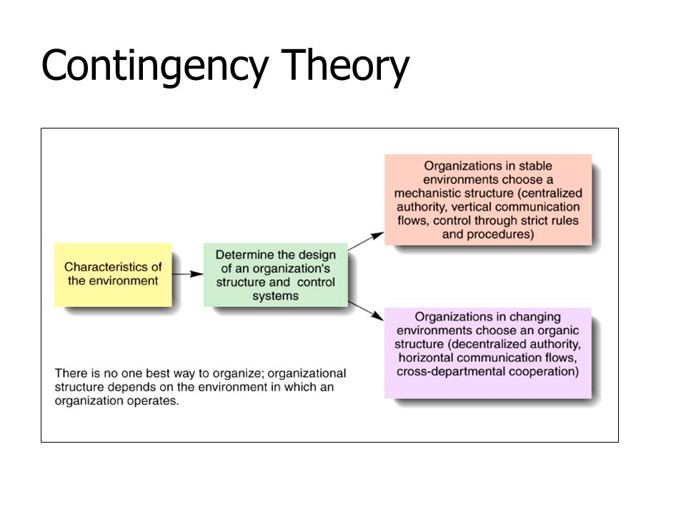

What is the Potential Benefit?
In evaluating further, Rasel (2014) stated, the benefits are; positive changes throughout the organisation increasing the quality of work, better resolution to conflicts, lower turnover rate, improved teamwork along with motivation, productivity and job satisfaction. However, Rasel (2014) also highlighted the limitations of organisational development which are; requiring major time, high cost, delayed pay-off period, failure of outcome, privacy of company being leaked, difficulty in evaluating, psychological harm and incompatibility on culture.
How did the Organisation Benefit? Case Study:
In drawing the conclusion, a case study by Anne Maley Consulting (2019), on an organisation that faced lawsuit, couldn’t pay bills, high debts. There was no trust amongst managers and employees and the company seem to have lost sight of the core missions. The action then taken was that board meetings were increased which helped build communication and trust. New members were brought in and trained as old trustees had resigned. General regular meetings were also increased, clarified job description to have clear sense of responsibility. Expenses were cut and resourced in mission driven programmes. The outcome was that all debts were recovered and produced huge productivity within three years. It has been found that an organisation can benefit from using development methods.
Task 3
Introducing a Personal Development Plan:
The researcher’s dream job is to own and run a Dental Hygiene Practice, a PDP framework will help identify skills possessed and any in need of development. This shows, what needs to be achieved and how. Focuses on career objectives and goals and develops CV, job opportunities and appraisals (Open University 2019).
Objectives  What do I want to be able to do or do better? | Success criteria  How will I recognise success?  How will I review and measure my improvement? | Actions  What methods will I use to achieve my learning objectives? | Implementation  How will I practise and  apply what I learn?
Time management (Transferable). According to Andrews (2014) this improves efficiency, productivity and meet deadlines. This skill is needed by the researcher to improve on to meet objectives effectively. | Looking at the CIPD (2018), performance management, when Goals achieved using necessary skill. | Attending time management Courses (Reed Jobs 2018). | By planning, prioritising and staying  organised (Appointment  Plus 2013).
Performance management and Appraisal skills (Specific). According to Revolution (2019), the researcher will need to keep team members engaged, drive performances and help value staff. | Will be evident when there’s Increased profit, quality, growth and employee satisfaction. (Hearn, 2017). | Taking short coaching sessions available, (Institute of Engineer 2018). According to Skill for You (2019) use SMART objective to aid overall vision and goals. | Tracking process to see  objectives are being  met using management tools,  techniques and monitor  performances (Skills You  Need 2019).
The researcher needs Improvement on leadership skills (Adaptable) to add to interpersonal skills, co-ordinate, motivate and form a team (Elevation Network 2016). | The researcher can watch a video and take a quiz by Mind Tool (2019), to analyse performance in leadership. | Undertaking a leadership assessment to work on the blind spot (OfficeVibe 2018). | Take further training available  by Linkedin 2019). According  to May (2019), researcher  could take the systematic approach,  building alignments, growing  employee’s capabilities and use  core competency mapping.
Education (Specific) the researcher needs right education to inform patients of hygiene information with latest regulation and engage with patient. | Receive certification by the National Examining Board for Dental (2019). | Researcher already is registered with the general dental council but taking further courses in relation to dental hygiene knowledge. | Providing correct oral hygiene  education to prevent bad oral  hygiene (Colgate 2019).
The researcher needs to achieve further decision-making skills (Transferable). According to Akrani (2011), this help utilise resources within a business. | Researcher can recognise success when confidently making decisions along with use records Of Important decisions to make better judgement. | Use the decision-making framework, according to Skills You Need (2019), the seven stages can aid the researcher to implement effective decision-making skills by, listing Possible solutions, setting time-scale gathering information, weighing the risk, deciding on values, weighing pros and cons and making decisions. | Continue with improvement  framework to measure progress,  confidence, consideration,  prioritising and determine if  objectives are being met  (Decision Innovation 2019)
For the researcher to reach the target goals, having Team Management skills (Transferable) is vital. According to Bridges (2017), this aids with leadership, communication, problem solving, business strategy, appraisals, performance management and define goals. | When the researcher receives certification (Linkedin 2019). | Take leadership and management Courses (Linkedin 2019). | By holding regular review meeting  and appraisals (Wily Manager 2019).

Conclusion
In Conclusion of task one, Management Study (2019) explained, motivational vehicle helps to increase skills and performance. Cole and Kelly (2011) stated, Elton Mayo a motivational theorist found social factor is the main element to work efficiently. However, Mind Tool (2019) also stated Frederick Taylor belief was money to be the main drive. In comparison, Stenly (2010), both theorists increase productivity with some limitation of Frederick Taylor not believing developing employees in other fields.
In further conclusion, Bacal (2014) stated performance management to be a process for management to express expectations. Cole and Kelly (2011) explained the Goal setting theory showing employees clear and realistic goals. However, The Expectancy theory shows how behaviour is adjusted more to the type of goal. In comparison Study Mode (2019) states, both theories motivate through incentives and tough goals.
Concluding further, Frost (2019) explained the training vehicle is a way for employees to acknowledge weakness and work on skills. Mind Tool (2011) reveals the Kirkpatrick’s model to examine how effective training has been. The CIRO model which is a smaller version of Kirkpatrick also evaluates the training outcome (CIPD). It has been found both models may be similar in identifying training needs but CIRO does not inspect behavioural aspects.
In conclusion of task two, Rabid Monkey (2019) explained individual personal development can aid in various positive outcome. Daphenagan (2011) stated, personal development being the foundation to future productivity. Mark (2011) cited, Abraham Maslow and Frederick Herzberg theory support the benefit of personal development for an individual.
In concluding further Monster (2014) stated, organisations developing individuals benefit from reduced turnover and increased efficiency. Magloff (2019) explained the Elton Mayo and the Contingency and Expectation theory believe organisations can develop through management therefor, appropriate developmental methods must be applied.
Finally, to conclude the PDP, the researcher found few skills in need of improvement. It has been highlighted of courses that are available by Reed Jobs (2018) to attend courses for time-management and coaching session by Institute of Engineer (2018). Plan has also been set in how to implement these by, providing oral hygiene education (Colgate 2014). Using framework to measure progress (Decision Innovation 2019).

Bibliography

Agarwal, A. (2011), Models and Theories of Performance Management System, [Online]. Available: https://www.projectguru.in/publications/models-and-theories-of-performance-management-system/. [Accessed 27th March 2019].
Akrani, G. (2011), Importance of Decision Making in Management, [Online]. Available: http://kalyan-city.blogspot.com/2011/08/importance-of-decision-making-in.html. [Accessed 3rd April 2019].
Andrews, A. (2014), Why is Time Management Important at Work, [Online].Available: https://www.activia.co.uk/blog/why-is-time-management-important-at-work. [Accessed 2nd April 2019].
Anne Maley Consulting. (2019), Case Study Organisational Development, [Online]. Available: http://annemaley.com/organizational-development/case-study-organizational-development/. [Accessed 1st April 2019].
Appointment Plus. (2013), Learn How to Implement Time Management Tips, [Online]. Available: https://www.appointmentplus.com/blog/how-to-implement-time-management-tips/. [Accessed 2nd April 2018].
Bacal, R. (2004), How to Manage Performance, New York: R.R, Donnelley.
Badubi, R.M. (2017), Theories of Motivation and Their Application in Organizations: A Risk Analysis, [Online]. Available: https://researchleap.com/theories-motivation-application-organizations-risk-analysis/. [Accessed 4th April 2019].
Blog Career Development. (2019), How to Prepare for a Work Appraisal, [Online]. Available: https://www.jobsite.co.uk/worklife/appraisal-19050/. [Accessed 1st April 2019].
Board Developer. (2019), Benefits of Personal Development Planning, [Online]. Available: http://boarddeveloper.com/benefits-of-personal-development-planning/. [Accessed 4th April 2019].
Bridges, J. (2017), Top 5 Team Management Skills Every Manager Needs, [Online]. Available: https://www.projectmanager.com/training/top-5-team-management-skills-every-manager-needs. [Accessed 3rd April 2019].
British Library. (2019), Frederick Windsor Taylor, [Online]. Available: https://www.bl.uk/people/frederick-winslow-taylor. [Accessed 22nd March 2019].
Cambridge University. (2016), Vroom’s Expectancy Theory, [Online]. Available: www.ifm.eng.ac.uk. [Accessed 15th February].
CIPD. (2018), Evaluating Learning and Development, [Online]. Available: https://www.cipd.co.uk/knowledge/fundamentals/people/development/evaluating-learning-factsheet. [Accessed 28th March 2018].
CIPD. (2018), Organisational Development, [Online]. Available: https://www.cipd.co.uk/knowledge/strategy/organisational-development/factsheet. [Accessed 4th April 2019].
CIPD. (2018), Performance Management, [Online]. Available: https://www.cipd.co.uk/knowledge/fundamentals/people/performance. [Accessed 28th March 2019].
Cole, G.A and Kelly, P. (2011), Management Theory and Practice, (7th Ed). China: R.R, Donnelley.
Colgate. (2019), What is a Good Oral Hygiene, [Online]. Available: https://www.colgate.com/en-us/oral-health/life-stages/adult-oral-care/what-is-good-oral-hygiene. [Accessed 3rd April 2019].
Course Hero. (2019), Pearson’s RED Thinking Model, [Online]. Available: https://www.coursehero.com/file/18081036/the-red-model/. [Accessed 7th April 2019].
Daphnegans Blog. (2011), Importance of Personal Development, [Online]. Available: https://daphnegan.wordpress.com/2011/12/20/importance-of-personal-development/. [Accessed 31st March 2019].
Decision Innovation. (2019), Building Key Decision Making Skills, [Online]. Available: https://www.decision-making-solutions.com/decision-making-skills.html. [Accessed 3rd April 2019].
De-Palma, A and Faadh, F. (2019), Patient education technologies for dental hygienists, [Online]. Available: https://www.dentistryiq.com/articles/2019/02/patient-education-technologies-for-dental-hygienists.html. [Accessed 3rd April 2019].
Elevation Networks. (2016), Why Leadership Skills are Important in the Workplace, [Online]. Available: http://www.elevationnetworks.org/why-leadership-skills-are-important/. [Accessed 3rd April 2019].
Explorance. (2014), 5 Key Benefits of Organizational Development, [Online]. Available: https://explorance.com/blog/5-key-benefits-organizational-development/. [Accessed 1st April 2019].
Frost, S. (2019), The Importance of Training & Development in the Workplace, [Online]. Available: https://smallbusiness.chron.com/importance-training-development-workplace-10321.html. [Accessed 28th March 2019].
Green,A, Hauser, J. (2012), Managing to Change the World, America: John Wiley and Sons.
Hammond, K. (2018), Pros and Cons of Motivation Theories, [Online]. Available: https://bizfluent.com/info-846718?-pros-cons-motivational-theorist.html. [Accessed 15th February 2019].
Hearn, S. (2017), How to measure the effectiveness of performance management, [Online]. Available: https://www.clearreview.com/resources/guides/how-to-measure-performance-management/. [Accessed 3rd April 2019].
Heathfield, S.M. (2018), Performance Management, [Online]. Available: https://www.thebalancecareers.com/performance-management-1918226. [Accessed 27th March 2019].
Institute of Mechanical Engineer. (2019), Performance Management and Appraisal Skills, [Online]. Available: http://www.imeche.org/training-qualifications/training-details/performance-management-and-appraisal-skills. [Accessed 3rd April 2019].
Linkedin. (2019), Courses on Leadership and Management, [Online]. Available: https://learning.linkedin.com/en-us/cx/2017/may/. [Accessed 3rd April 2019].
Lloyd, K. (2019), Employee Appraisal Phrases: Growth and Development, [Online]. Available: https://www.dummies.com/business/human-resources/employee-relations/employee-appraisal-phrases-growth-and-development/. [Accessed 31st March 2019].
Magloff, L. (2019), Organizational Motivation Theories, [Online]. Available: https://smallbusiness.chron.com/organizational-motivation-theories-4961.html. [Accessed 1st April 2019].
Management Study Guide. (2019), Management and Development Development, [Online]. Available: https://www.managementstudyguide.com/motivation-and-employee-development.htm. [Accessed 22nd March 2019].
Mark. (2014), 5 Psychological Theories of Motivation to Increase Productivity, [Online]. Available: https://contactzilla.com/blog/5-psychological-theories-motivation-increase-productivity/. [Accessed 31st March 2019].
Mind Tool. (2019), Frederick Taylor and Scientific Management, [Online]. Available: https://www.mindtools.com/pages/article/newTMM_Taylor.htm. [Accessed 22nd March 2019].
Mind Tool. (2019), Kirkpatrick's Four-Level Training Evaluation Model, [Online]. Available: https://www.mindtools.com/pages/article/kirkpatrick.htm. [Accessed 28th March 2019].
Mind Tools. (2019), How Good Are Your Leadership Skills? [Online]. Available: https://www.mindtools.com/pages/article/newLDR_50.htm. [Accessed 3rd April 2019].
Monster. (2019), What are the benefits of developing the skills of your existing workforce? [Online]. Available: https://hiring.monster.co.uk/hr/hr-best-practices/workforce-management/hr-management-skills/what-are-the-benefits-of-developing-skills.aspx. [Accessed 1st April 2019].
National Examining Board for Dental Nurses. (2019), Where Can I Study, How Can I Apply? [Online]. Available: https://www.nebdn.org/oral-health-education-0. [Accessed 3rd April 2019].
Natural Hr. (2018), Dealing with an Employee Who is Always Late, [Online]. Available: https://www.naturalhr.com/2016/12/20/dealing-employees-always-late/. [Accessed 15th February 2019].
Nawaz, S. (2019), How to Talk to an Employee Who isn’t Meeting their Goals, [Online]. Available: https://hbr.org/2019/02/how-to-talk-to-an-employee-who-isnt-meeting-their-goals. [Accessed 15th February 2019].
OfficeVibe. (2018), What Makes a Great Leader? [Online]. Available: https://www.officevibe.com/employee-engagement-solution/leadership? [Accessed 3rd April 2019].
Oscar, T. (2014), How to Respond to your Boss about Being Late, [Online]. Available: https://www.careeradict.com/respond-to-your-boss-about-being-late. [Accessed 15th February 2019].
Pembstrainer. (2013), Models of Evaluation, [Online]. Available: https://trainerstimes.wordpress.com/2013/12/14/models-of-evaluation/. [Accessed 28th March 2019].
Quain, S. (2018), The Importance of Organizational Development, [Online]. Available: https://smallbusiness.chron.com/importance-organizational-development-11904.html. [Accessed 1st April 2019].
Rabid Office Monkey. (2014), Personal Development in your Workplace, [Online]. Available: https://rabidofficemonkey.com/personal-development-in-your-workplace/. [Accessed 29th March 2019].
Rasel. (2014), Advantages and Disadvantages of Organization Development, [Online]. Available: http://bankofinfo.com/advantages-and-disadvantages-of-organization-development/. [Accessed 1st April 2019].
Reed Jobs. (2018), Time Management Courses, [Online]. Available: https://www.reed.co.uk/courses/time-management?gclid=Cj0KCQjwkIzlBRDzARIsABgXqV8mi_XWtX5HDz9qjeJxPW9hLeMyBzLDv3gBZ8vj-6KGp6VM3NlSZo8aAhO5EALw_wcB&gclsrc=aw.ds. [Accessed 2nd April 2019].
Resume Perk. (2019), Importance of Personal Development in the Workplace, [Online]. Available: http://resumeperk.com/blog/importance-of-personal-development-in-the-workplace. [Accessed 31st March 2019].
Revolution. (2019), Performance Management and Appraisal Skills Training Course, [Online]. Available: https://www.revolutionlearning.co.uk/appraisal-skills-training/. [Accessed 3rd April 2019].
Ross, G. (2019), The 7 Core Benefits of Personal Development, [Online]. Available: https://www.wisdomtimes.com/blog/core-benefits-of-personal-development/. [Accessed 29th March 2019].
Salaman, Graeme; Storey, John; Billsberry, Jon. (2005) 2nd Edition. Strategic Human Resource Management: Theory and Practice. Sage Publications Ltd.
Skills You Need. (2019), 5 Skills All Managers Need for Implementing Successful Performance Management, [Online]. Available: https://www.skillsyouneed.com/rhubarb/performance-management.html. [Accessed 3rd April 2019].
Skills You Need. (2019), Effective Decision Making – A Framework, [Online]. Available: https://www.skillsyouneed.com/ips/decision-making2.html. [Accessed 3rd April 2019].
Spearhead Training. (2019), Evaluating Training, [Online]. Available: https://www.spearhead-training.co.uk/blog/evaluating-training. [Accessed 28th March 2019].
Stenly. (2010), Compare and Contrast Management Theories, [Online]. Available: https://www.essaysforstudent.com/term-paper/Compare-and-Contrast-the-Management-Theories-of-Frederick/72052.html. [Accessed 23rd March 2019].
Study Mode. (2019), Compare and Contrast Expectancy and Goal Setting Theories of Work Motivation. Which Do You Find the More Useful and Why? [Online]. Available: https://www.studymode.com/essays/Compare-And-Contrast-Expectancy-And-Goal-1450359.html. [Accessed 28th March 2019].
Study Moose. (2019), Tesco Case Study, [Online]. Available: https://studymoose.com/tesco-case-study-essay. [Accessed 1st April 2019].
The Open University. (2019), Develop your Career: Personal Development Plan (PDP), [Online]. Available: https://help.open.ac.uk/pdp. [Accessed 2nd April 2019].
The Times 100. (2019), Motivational Theory in Practice at Tesco, [Online]. Available: https://is.muni.cz/el/1451/podzim2013/np2330/tesco_15_full.pdf. [Accessed 28th March 2019].
Tools Hero. (2019), Scientific Management and Taylorism, [Online]. Available: https://www.toolshero.com/quality-management/scientific-management/. [Accessed 24th March 2019].
Wellington, P. (2017), Effective People Management, (2nd Ed), London: Kogan Page Limited.
Whitmore, J. (2015), 7 Steps for Getting the chronically Late Employee to be Punctual, [Online]. Available: https://www.entrepreneur.com/amphtm/247065. [Accessed 15th February 2019].
Wily Manager. (2019), The Business Review Meeting, [Online]. Available: http://www.wilymanager.com/business-review-meeting/. [Accessed 3rd April 2019].

Reference List
Agarwal, A. (2011), Models and Theories of Performance Management System, [Online]. Available: https://www.projectguru.in/publications/models-and-theories-of-performance-management-system/. [Accessed 27th March 2019].
Akrani, G. (2011), Importance of Decision Making in Management, [Online]. Available: http://kalyan-city.blogspot.com/2011/08/importance-of-decision-making-in.html. [Accessed 3rd April 2019].
Andrews, A. (2014), Why is Time Management Important at Work, [Online].Available: https://www.activia.co.uk/blog/why-is-time-management-important-at-work. [Accessed 2nd April 2019].

Anne Maley Consulting. (2019), Case Study Organisational Development, [Online]. Available: http://annemaley.com/organizational-development/case-study-organizational-development/. [Accessed 1st April 2019].
Appointment Plus. (2013), Learn How to Implement Time Management Tips, [Online]. Available: https://www.appointmentplus.com/blog/how-to-implement-time-management-tips/. [Accessed 2nd April 2018].
Bacal, R. (2004), How to Manage Performance, New York: R.R, Donnelley.
Badubi, R.M. (2017), Theories of Motivation and Their Application in Organizations: A Risk Analysis, [Online]. Available: https://researchleap.com/theories-motivation-application-organizations-risk-analysis/. [Accessed 4th April 2019].
Board Developer. (2019), Benefits of Personal Development Planning, [Online]. Available: http://boarddeveloper.com/benefits-of-personal-development-planning/. [Accessed 4th April 2019].
Bridges, J. (2017), Top 5 Team Management Skills Every Manager Needs, [Online]. Available: https://www.projectmanager.com/training/top-5-team-management-skills-every-manager-needs. [Accessed 3rd April 2019].
British Library. (2019), Frederick Windsor Taylor, [Online]. Available: https://www.bl.uk/people/frederick-winslow-taylor. [Accessed 22nd March 2019].
CIPD. (2018), Evaluating Learning and Development, [Online]. Available: https://www.cipd.co.uk/knowledge/fundamentals/people/development/evaluating-learning-factsheet. [Accessed 28th March 2018].
CIPD. (2018), Organisational Development, [Online]. Available: https://www.cipd.co.uk/knowledge/strategy/organisational-development/factsheet. [Accessed 4th April 2019].
Cole, G.A and Kelly, P. (2011), Management Theory and Practice, (7th Ed). China: R.R, Donnelley.
Colgate. (2019), What is a Good Oral Hygiene, [Online]. Available: https://www.colgate.com/en-us/oral-health/life-stages/adult-oral-care/what-is-good-oral-hygiene. [Accessed 3rd April 2019].
Course Hero. (2019), Pearson’s RED Thinking Model, [Online]. Available: https://www.coursehero.com/file/18081036/the-red-model/. [Accessed 7th April 2019].
Daphnegans Blog. (2011), Importance of Personal Development, [Online]. Available: https://daphnegan.wordpress.com/2011/12/20/importance-of-personal-development/. [Accessed 31st March 2019].
Decision Innovation. (2019), Building Key Decision Making Skills, [Online]. Available: https://www.decision-making-solutions.com/decision-making-skills.html. [Accessed 3rd April 2019].
De-Palma, A and Faadh, F. (2019), Patient education technologies for dental hygienists, [Online]. Available: https://www.dentistryiq.com/articles/2019/02/patient-education-technologies-for-dental-hygienists.html. [Accessed 3rd April 2019].
Elevation Networks. (2016), Why Leadership Skills are Important in the Workplace, [Online]. Available: http://www.elevationnetworks.org/why-leadership-skills-are-important/. [Accessed 3rd April 2019].
Explorance. (2014), 5 Key Benefits of Organizational Development, [Online]. Available: https://explorance.com/blog/5-key-benefits-organizational-development/. [Accessed 1st April 2019].
Frost, S. (2019), The Importance of Training & Development in the Workplace, [Online]. Available: https://smallbusiness.chron.com/importance-training-development-workplace-10321.html. [Accessed 28th March 2019].
Hearn, S. (2017), How to measure the effectiveness of performance management, [Online]. Available: https://www.clearreview.com/resources/guides/how-to-measure-performance-management/. [Accessed 3rd April 2019].
Institute of Mechanical Engineer. (2019), Performance Management and Appraisal Skills, [Online]. Available: http://www.imeche.org/training-qualifications/training-details/performance-management-and-appraisal-skills. [Accessed 3rd April 2019].
Linkedin. (2019), Courses on Leadership and Management, [Online]. Available: https://learning.linkedin.com/en-us/cx/2017/may/. [Accessed 3rd April 2019].
Lloyd, K. (2019), Employee Appraisal Phrases: Growth and Development, [Online]. Available: https://www.dummies.com/business/human-resources/employee-relations/employee-appraisal-phrases-growth-and-development/. [Accessed 31st March 2019].
Magloff, L. (2019), Organizational Motivation Theories, [Online]. Available: https://smallbusiness.chron.com/organizational-motivation-theories-4961.html. [Accessed 1st April 2019].
Management Study Guide. (2019), Management and Development Development, [Online]. Available: https://www.managementstudyguide.com/motivation-and-employee-development.htm. [Accessed 22nd March 2019].
Mark. (2014), 5 Psychological Theories of Motivation to Increase Productivity, [Online]. Available: https://contactzilla.com/blog/5-psychological-theories-motivation-increase-productivity/. [Accessed 31st March 2019].
Mind Tool. (2019), Frederick Taylor and Scientific Management, [Online]. Available: https://www.mindtools.com/pages/article/newTMM_Taylor.htm. [Accessed 22nd March 2019].
Mind Tool. (2019), Kirkpatrick's Four-Level Training Evaluation Model, [Online]. Available: https://www.mindtools.com/pages/article/kirkpatrick.htm. [Accessed 28th March 2019].
Mind Tools. (2019), How Good Are Your Leadership Skills? [Online]. Available: https://www.mindtools.com/pages/article/newLDR_50.htm. [Accessed 3rd April 2019].
Monster. (2019), What are the benefits of developing the skills of your existing workforce? [Online]. Available: https://hiring.monster.co.uk/hr/hr-best-practices/workforce-management/hr-management-skills/what-are-the-benefits-of-developing-skills.aspx. [Accessed 1st April 2019].
National Examining Board for Dental Nurses. (2019), Where Can I Study, How Can I Apply? [Online]. Available: https://www.nebdn.org/oral-health-education-0. [Accessed 3rd April 2019].
OfficeVibe. (2018), What Makes a Great Leader? [Online]. Available: https://www.officevibe.com/employee-engagement-solution/leadership? [Accessed 3rd April 2019].
Pembstrainer. (2013), Models of Evaluation, [Online]. Available: https://trainerstimes.wordpress.com/2013/12/14/models-of-evaluation/. [Accessed 28th March 2019].
Quain, S. (2018), The Importance of Organizational Development, [Online]. Available: https://smallbusiness.chron.com/importance-organizational-development-11904.html. [Accessed 1st April 2019].
Rabid Office Monkey. (2014), Personal Development in your Workplace, [Online]. Available: https://rabidofficemonkey.com/personal-development-in-your-workplace/. [Accessed 29th March 2019].
Rasel. (2014), Advantages and Disadvantages of Organization Development, [Online]. Available: http://bankofinfo.com/advantages-and-disadvantages-of-organization-development/. [Accessed 1st April 2019].
Reed Jobs. (2018), Time Management Courses, [Online]. Available: https://www.reed.co.uk/courses/time-management?gclid=Cj0KCQjwkIzlBRDzARIsABgXqV8mi_XWtX5HDz9qjeJxPW9hLeMyBzLDv3gBZ8vj-6KGp6VM3NlSZo8aAhO5EALw_wcB&gclsrc=aw.ds. [Accessed 2nd April 2019].
Resume Perk. (2019), Importance of Personal Development in the Workplace, [Online]. Available: http://resumeperk.com/blog/importance-of-personal-development-in-the-workplace. [Accessed 31st March 2019].
Revolution. (2019), Performance Management and Appraisal Skills Training Course, [Online]. Available: https://www.revolutionlearning.co.uk/appraisal-skills-training/. [Accessed 3rd April 2019].
Ross, G. (2019), The 7 Core Benefits of Personal Development, [Online]. Available: https://www.wisdomtimes.com/blog/core-benefits-of-personal-development/. [Accessed 29th March 2019].
Salaman, Graeme; Storey, John; Billsberry, Jon. (2005) 2nd Edition. Strategic Human Resource Management: Theory and Practice. Sage Publications Ltd.
Skills You Need. (2019), 5 Skills All Managers Need for Implementing Successful Performance Management, [Online]. Available: https://www.skillsyouneed.com/rhubarb/performance-management.html. [Accessed 3rd April 2019].
Skills You Need. (2019), Effective Decision Making – A Framework, [Online]. Available: https://www.skillsyouneed.com/ips/decision-making2.html. [Accessed 3rd April 2019].
Spearhead Training. (2019), Evaluating Training, [Online]. Available: https://www.spearhead-training.co.uk/blog/evaluating-training. [Accessed 28th March 2019].
Stenly. (2010), Compare and Contrast Management Theories, [Online]. Available: https://www.essaysforstudent.com/term-paper/Compare-and-Contrast-the-Management-Theories-of-Frederick/72052.html. [Accessed 23rd March 2019].
Study Mode. (2019), Compare and Contrast Expectancy and Goal Setting Theories of Work Motivation. Which Do You Find the More Useful and Why? [Online]. Available: https://www.studymode.com/essays/Compare-And-Contrast-Expectancy-And-Goal-1450359.html. [Accessed 28th March 2019].
Study Moose. (2019), Tesco Case Study, [Online]. Available: https://studymoose.com/tesco-case-study-essay. [Accessed 1st April 2019].
The Open University. (2019), Develop your Career: Personal Development Plan (PDP), [Online]. Available: https://help.open.ac.uk/pdp. [Accessed 2nd April 2019].
The Times 100. (2019), Motivational Theory in Practice at Tesco, [Online]. Available: https://is.muni.cz/el/1451/podzim2013/np2330/tesco_15_full.pdf. [Accessed 28th March 2019].
Tools Hero. (2019), Scientific Management and Taylorism, [Online]. Available: https://www.toolshero.com/quality-management/scientific-management/. [Accessed 24th March 2019].
Wily Manager. (2019), The Business Review Meeting, [Online]. Available: http://www.wilymanager.com/business-review-meeting/. [Accessed 3rd April 2019].

Appendices

The Forestry Commission Presentation:

Q: Why is training important to an employee of the Forestry Commission?
Training is vital within the organisation of the Forestry Commission as this is a way for employees to work their way up in their positions, explained Business Case Studies (2019). They also state that the organisation like to invest in training to allow the growth and development of the Forestry Commission. Regular
- Health and Safety Training
Is given to abide by the law and to ensure staff can use equipment safely. Along with training to improve skills such as
- Technical Skills
So, staff can handle powerful machines safely. Also
- Communication and Leadership Skills and
- Customer Care Skills
Are highlighted through training to help work efficiently with the
- Public, Internal Customer and Other Organisations.
The Forestry Commission also has a system of regular appraisals to allow employees to review their performances and take training plans in areas needed along with setting
- SMART Objectives.
Training does not only help employees develop their skills but also broadens their knowledge. Once the individual skill gap has been identified, Forestry Commission can offer appropriate training, this can be
- On-the-job
Training which involves coaching and mentoring or
- Of-the-job
Which involves attending courses and event training. So, having training within the organisation of the Forestry Commission allows workers to be equipped, confident, achieve objectives, allowing people, animals, plant life and our planet to be better managed.

The NDA Presentation:

Q: How does the NDA apply Theory to Practice in the management of staff management?
The Nuclear Decommissioning is an organisation with a process of keeping nuclear sites safe and cost-effective manner, which came into practice in 2005. The NDA employ around 300 staff and have many objectives to ensure high standards and safety procedures. This organisation does apply theories to practice ensuring high productivity (Times 2019)
Taking the Maslows theory in account, it has been recognised that people are motivated by different things, that is why NDA implemented pension schemes and introduced training such as, development programmes and promotions to achieve self-actualisation.
NDA also embraces the theory of Douglas McGregor, who in 1960 explained there are two theories, theory X is people who need to be disciplined. Theory Y is allowing staff take responsibility as they want to work with great efficiency. NDA likes to follow theory Y and let the workers be self-disciplined, also allowing high level of responsibility (Times 2019).
NDA display the value followed such as building talent and teams and confronting problems. Allowing Maslow’s high and low order to meet leading to a safe, secure and developing environment (Times 2019).
NDA uses the motivational hygiene theory of Frederick Herzberg by setting targets for employees are being rewarded after meeting them. Some staff are given targets for additional reward. For the highly skilled staff, this is an opportunity to reach higher position by taking on more responsibilities. Employees are offered motivational hygiene factors such as holidays, health insurances, incentives, employee support and leave. This theory is not motivational but also reduces staff turnover (Times 2019).
According to Cambridge University (2016), Vroom realised that workers performance was based on behaviour, if a person was positive, favourable and satisfied this can lead to results. NDA looks for workers that are committed and innovated leading to be motivated and able to handle complex task. However, according to Hammond (2018) using motivational theories in practice may not always be successful as motivational need may change according to a person, for example: a older staff is motivated by relying on the job whereas, a younger staff sees security of a job a hygiene factor with incentives also may be desirable to few employees.
.

Performance Management Seminar:
Case 1- The Late Footballer Player:
Manager: The case of the lateness has come to a situation that it has to be addressed but, as Nawas (2019) explained on Linkedin the first and best way to approach the matter is by asking the footballer to assess his own performance. Coming in on time and starting training is part of performance.
If the footballer does not point out the issue of lateness and feels they are doing fine then as a manager, I would agree on the hard work undertaken in the past three years, but then mention where performance is lacking in punctuality. A list of expectations will be discussed where it is expected all employees to accept.
As the goal of the manager and employee is the same, to train, perform well, so it is important to build relationships with them, remind them of the goal of winning matches with efficiency. As organising the time is an issue, an agreement can avoid lateness and if the employee feels there will be occasions of lateness, then this time will have to be made up.
According to Whitmore (2015), I will explain to the employee that together we have to run our club efficiently, to avoid other employees noticing leading to frustration and friction. Lateness can sometimes be unavoidable, as this is becoming consistence it is becoming a serious problem. I will have to ensure my employee understands that management is tired of this behaviour and not the person.
Documents will be brought in that display the amount and lengths of lateness. I will give recognition of achievement and hard work as I don’t want the employee to fell un-appreciated. I will listen to the employee’s reasons and feedback and see where I can make an exception of possibly starting 10 minutes later but making the time up. Although this disturbs training time, however as first warming up session starts this will be missed. Other solution would be to see means of childcare as this seems to be the issue, so future lateness can be dismissed. Main thing is for the employee to understand that it is a problem that cannot be ignored.
Explain that if agreement is breached, a written warning would have to be taken and possible wage deduction. The meeting would take place in private to avoid embarrassment. Concerns would be voice along with giving opportunity for their feedback to be given. As Natural HR (2018) explained, at the end of the meeting, the main objective would be to get a solution of the problem, to stop the quality and ethics of work from decreasing, to stop staff falling behind, just simply avoid overall effectiveness from deuterating.
The management would document our conversation and send a copy to HR along with send an email copy to the employee of agreed action, using the SMART objectives. The employee will finally be explained that if the action plan is not followed then a disciplinary counselling would be offered where the employee can also bring a third person.
Employee: the employee may be surprised and very unhappy to be called in but has been late, so it is best to accept responsibility. Oscar (2014) explained, it is best to go in the meeting hold themselves accountable to defuse potential fallout and future awkwardness, better to apologise to honest and tell the truth. The employee should highlight the hard work over the past three years and re-assure the manager of sharing the same objective as the manager.
As Cornerstone (2019) stated, the employee should have a positive attitude and take criticism, to try to take information to make improvement. Any evidence of hard work in the past three years will be taken such as certification or awards, as CIPD (2018) explained, as an employee it must be understood what is expected to achieve goals.
The employee should take any questions prepared in with them, along with discussing lateness an alternative solution should be offered to make a mutual understanding. Maybe offer making up time when late and give clarity to the employer that performance will not be affected.

