Lists as Databases Week 2

Skills Outline

- Understanding concept of lists, fields and records

- Sort on single field

- Sort on multiple fields

The Microsoft Excel Help Facility

Look at the sections under - Managing Lists

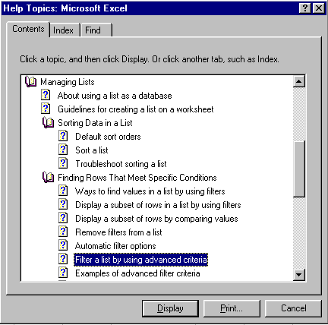

Lists as Databases

A list is a labelled series of rows that contain similar data. See Figure 1 - A List in Excel

Field

Field Name

Figure 1 - A List in Excel

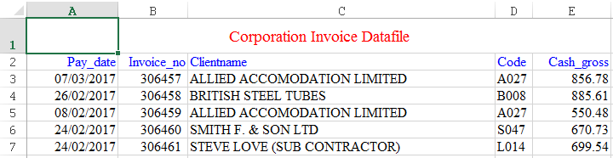
A Record/Row

A List can be Used as a Database

In Excel a list can also be used as a database. Excel will recognise a list as a database when database tasks such as sorting and filtering are performed.

See Figure 1 - A List in Excel

The columns in the list are the fields of the database.
The column labels in the list are the field names in the database.
Each row in the list is a record in the database.

Example
Column D in the Corporation Invoice List is the field holding the type of car a customer has purchased.
The label for column D (Code) is the field name.
Row 3 is the first record in the database.

A finance officer of a large corporation has devised a simple method of keeping track of invoices. This involves using Excel to store the information in a list format.
The spreadsheet file named Corporation Invoice List is located on Moodle
A list is a labelled series of rows that contain similar data.

Sorting Data

The Corporation Invoice List holds 300 records, the ability to sort the records quickly and easily is essential. Microsoft Excel rearranges rows (records) according to the contents of the Sort By column (field) you choose.

You can sort data by one field in ascending or descending order.
You can also sort by up to three fields in ascending or descending order.

Ascending order Descending order
Text is sorted A to Z Text is sorted Z to A
Numbers are sorted from 1 to 10 Numbers are sorted 10 - 1

Exercise 1 - Sorting records by one field

Open the file Corporation Invoice List located in Semester 2|Week 2 on Moodle .
Sort by Clientname in ascending order.

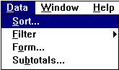
1. Select a single cell anywhere in the list (see Figure 1 - A List in Excel) and choose Sort from the Data menu.

2. Click the down arrow next to the Sort By box and choose Clientname.
See Figure 2 - Sorting by one Field

3. Choose Ascending

4. Click on OK

Figure 2 - Sorting by one Field

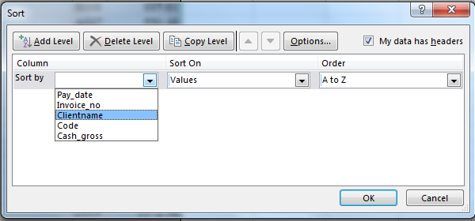

Click on the drop down arrow and choose the field (column) you wish to sort by
If you have sorted correctly the first record reads
14-Mar-17, 306493, A Bentley ESQ., BO41, £337.60
Exercise 2 - Sorting Records by more than one field

Sort by Clientname in descending order within Pay-date by ascending order.

1. Select a single cell anywhere in the list (see Figure 1 - A List in Excel on page 1) and choose Sort from the Data menu.

2. Click the down arrow next to the Sort By box and choose Pay-date.
See Figure 3 - Sorting by two fields

3. Choose Ascending

4. Click the down arrow next to the Then By box and choose Clientname.
See Figure 3 - Sorting by two fields

5 Choose Descending
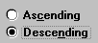

6. Click on OK

Figure 3 - Sorting by two fields
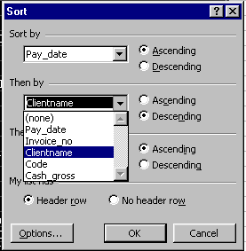

If you have sorted correctly the first record reads
01-Jan-17, 306716, SALVESEN TUBULAR SERVICES, S002, 908.36

Exercise 3
- Sort the database by Clientname in ascending order.

What is the Code of the first record in the database? | Answer:

- Sort by the amount owed (Cash_gross) in descending order.

What is the value of Cash_gross for the last record in the database? | Answer:

- Sort by pay-date in ascending order within Clientname in ascending order (hint, sort ny Clientname first).

How many records are there for the first client in the database and how much do they owe? | Answer | How many:  Amount:

Do not use a calculator

Use the AutoSum button to calculate the amount owed, making sure you select the correct cells that are needed for the calculation.
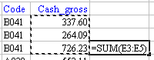

- Sort by Pay_date in ascending order (hint change the Then by box back to (delete level)).

What is the date of the oldest invoice and how much is owed? | Answer | Date:  Amount:

- Sort by Invoice_no in ascending order.

What is the first invoice number displayed? | Answer

- Sort by Code in descending order within Pay_date in ascending (hint sort by Pay_date first)

- How many records are there for the 27-Feb-18? | Answer

- How many records are there for the 27-March-18? | Answer

