Digital Sureveying and highway design
Digital Building Survey

Alexander Ford 2501109

Contents
Introduction 2
Planning the Survey 3
Practical 5
Measurement and Analysis 7
Conclusion 8
Reference List 9
Appendix A- Manual Survey Sketches 10
Appendix B- Laser Scan Sketch 14

Introduction
Developments in surveying technology in recent years alongside the increasing use of digital technologies within the industry has transformed the way building surveys are planned, undertaken and analysed. One development is 3D laser scanning, which uses lasers to capture precise spatial data, producing a point cloud that accurately represents the geometry of buildings and environments. (Artec 3D 2025) This assignment is based on a digital survey carried out at the Dylan Thomas Centre, it is a complex building, and the survey is focused on the first floor of the building, where a laser scanner was used to capture detailed internal measurements. This assignment will demonstrate how to plan a professional building survey, carry out a laser scan and analyse the data. It will also evaluate the effectiveness of laser scanning compared to traditional measurement methods.

Planning the Survey
Purpose of the Survey
The purpose of the survey was to capture internal data on the first floor of the Dylan Thomas Centre using laser scanning technology. The survey aimed to record the internal measurements of the buildings, this included room layouts and door openings to gather accurate and reliable dimensions of the Dylan Thomas Centre. Laser scanning was selected as the preferred method, as it has a high level of accuracy typically with an accuracy of around 2mm, it is also efficient as it has the ability to capture large amounts of data in a short period of time. (MB Survey Solutions, 2024) As well as this, it also reduces the risk of human error that comes with manual measurement techniques. The intended output of the survey was to create a processed point cloud from which accurate measurements could be extracted. This type of data survey is often used within professional practices to map an existing site, validate designs for quality assurance, evaluate progress and architects often use this type of data to communicate complicated design ideas to project stakeholders. (Designing Buildings, 2023)
Survey Area Definition
The area which would be surveyed was the first-floor corridors of the Dylan Thomas Centre which forms a loop around the internal spaces of the building. The survey was limited to the corridors only; this decision was influenced by time constraints, public access considerations and trying to minimise disruptions to lectures ongoing in the building. As well as this, the looped corridor layout provided suitable conditions for a good scan overlap, which helped the accuracy of the data. The area that was going to be scanned included corridor walls, door openings, ceiling heights, corridor width and corridor dimensions, which are essential to produce accurate measured drawings of the first floor. The level of detail required for the survey was minimal as it only needed to capture the internal dimensions of the floor. The survey also needed to capture wall protrusions caused by concealed pipework, this allowed for an accurate length measurement of the corridor. Decorations such as wallpaper were not required to be captured in detail in this survey as the purpose of the survey was focused on measurements and the floor plan of the Dylan Thomas Centre. Keeping the level of detail to this minimum level was more effective as it only provided the information needed and saved time.
Site Assessment
To begin the site assessment, it was important to consider access points and fire exits of the building, the Dylan Thomas Centre is a public building that has staff present during the day so access could be granted through the main entrance of the building during working hours. Prior to the survey being undertaken, access permission was required to ensure that the survey could be carried out safely and without disruptions. Permission was granted as the Dylan Thomas Centre is part of UWTSD University, so access was granted through the university and staff responsible for the building. Considerations were also given to maintain clear access routes along the corridor; this reduced disruptions to people using the building.
As well as assessing access points and obstructions to fire exits it was also important to consider the positions where the laser scanner would be placed to complete the scans. It was decided that the scanner would be positioned at one point in each corridor of the first floor, this would allow for full coverage of the area. Scanner positions were chosen to minimise shadows from doors and glare from the windows, as according to (TechnoStruct 2025) “Direct sunlight can make the scans challenging as they can affect the performance of the laser”. Although laser scanning is not dependent on good lighting conditions, it is beneficial as it can provide better scan quality.
Health and Safety was also a key part in the site assessment due to the survey taking place in a public area and big surveying equipment was being used. The first thing that was considered was the potential trip hazard from the scanners tripod; this issue was mitigated by carefully positioning and supervising the scanner at all times. As well as this, it was made sure people could access fire exits if needed. This meant we were compliant with the (Fire Safety Order 2005) that states “in the event of danger, it must be possible for persons to evacuate the premises as quickly and as safely as possible”. Finally, equipment security was another consideration due to laser scanners costing upwards of £50,000 (G2 Survey Equipment Specialists), to mitigate the risk of damage or theft the equipment was never left unattended.
Overall, the site assessment ensured that access, scanner positions, lighting conditions and health and safety requirements were fully considered before conducting the survey. By taking the precautions outlined it ensured that there were minimum disruptions to the public, safe access routes were maintained and high quality data could be captured efficiently and safely in the Dylan Thomas Centre.

Practical

The laser scanning survey was carried out at the Dylan Thomas Centre in line with the original survey plan that was made during the planning stage of the assignment. Access to the building was gained through the main entrance, prior permission had been granted through the university as the building is part of the UWTSD University, the survey started around 11am on the 3^{rd of} November.
Upon arrival to the site an initial walk through of the first floor was done to identify any potential hazards and where the survey could be obstructed by people using the building. Before starting anything, a brief was given by the supervisor Matt to remind everyone what needed doing and how the laser scanner worked. Emergency exits were also noted to ensure that the survey did not obstruct any fire escape routes.
The laser scanner was then set up securely on a tripod and positioned in the corridor. One scan was used in each of the corridors in a space which would provide a full scan of the area without compromising on quality. Attempts were made to ensure the scanner was placed where originally planned but this wasn’t possible on every occasion due to poor lighting and movement of other people. The scanner was positioned close to corridor walls where possible to not obstruct people and it also minimised the risk of someone tripping on the tripod and either hurting themselves or damaging the equipment. The scanner was always supervised and was never left unattended.
During the survey several small issues were encountered. Due to the Dylan Thomas Centre being a public building and in constant use by the University there was a constant movement of people through the corridor when we were trying to obtain data. This meant that we sometimes had to pause the scanning to wait for clear periods before re-doing the scans as people blocking the scanner would affect the data. Another way in which we managed this issue was communicating with people nearby and doing the scans when lectures were taking place as these were the calmest periods. Another issue that was encountered was time constraints due to only having two hours to complete the scans. This added more pressure to get the survey completed and made obstructions more detrimental to the task. The time issue was managed in two ways, firstly it was made sure that no time was wasted, and no data was captured that didn’t need to be, this was accomplished by lowering the scan quality to the medium setting opposed to the higher setting, this saved a lot of time while also providing sufficient data.
Another issue was obstructions from objects such as wall protrusions caused by concealed pipework, and the main problem was objects such as bins and chairs in the corridor. Although this added more complexity to the scanning it was avoidable by removing the objects post scanning and taking the measurements above the objects. The issue with the wall protrusions was overcome as the laser scanner effectively captured the wall protrusions which made the scans more accurate.
In addition to data being gathered from the laser scanner, manual measurement sketches were also produced using laser measurers. These sketches recorded only the internal dimensions of the building, this included features such as wall protrusions. These sketches provide physical evidence of my attendance and involvement in the survey. (see Appendix A, Figures A1-A4)
Overall, the survey was completed successfully and mostly followed the original plan. Minor adjustments were made to respond to issues that were encountered during the survey, this demonstrated the need for flexibility during surveying.

Measurement and Analysis
Following the scanning of the Dylan Thomas Centre, the processed scan data was provided in paper format and showed a 1:100 scale representation of the first-floor corridors. (see Appendix B Figure B1) Accurate internal measurements could then be obtained by using a scale ruler. To assess the reliability and accuracy of the laser scanner, the dimensions obtained were compared against the measurements that were taken manually using a laser measurer and ruler. By using corridor 1 as a comparison, it revealed that the scanner recorded the one corridor width at approximately 1.8 metres and the manual measurement had a recording of approximately 1.859 metres. Also, the laser scanner recorded the other width of the corridor at 1.100 metres, and the manual measurement recorded it at 1.173 metres. This reveals a small difference of no more than 0.08m. This small difference shows that the manual measurements were carried out accurately, but the laser scanner provides a higher level of reliability. The laser scanner also allows for measurements to be rechecked without having to do another site visit.
Another benefit of the laser scanner is the scan data was very clear and effortlessly showed all protrusions caused by concealed pipework which were more difficult to measure accurately using manual methods. The laser scanner measured these offsets with a good accuracy which improved the reliability of the data. Compared to the manual survey which required multiple individual measurements to be taken frequently along the corridor. This was very time consuming and increased the potential for human error. However, the data from the laser scanner required a significant amount of time to process, especially in this case as multiple scans had to be connected correctly and there were also objects in the corridor, so the scans had to be altered post processing to gather accurate corridor dimensions. Although this is a significant disadvantage of using laser scanners it is offset by the quality and quantity of data obtained. Unlike the manual measurements which only provide measurements the laser scanner creates a point cloud that can be useful for many other things not just for dimensions.
Overall, the comparison between modern technology and manual techniques demonstrates that laser scanning offers clear advantages over traditional measurement techniques due to better accuracy, efficiency and the large amount of data that can be gathered. Although manual surveying remains useful for small scale tasks, laser scanning is more beneficial to more complex and bigger surveys.

Conclusion
To conclude, this assignment has demonstrated the planning, execution and analysis of a digital building survey using a laser scanner at the Dylan Thomas Centre. Through a thorough survey plan and site assessment the first-floor corridor layout of the Dylan Thomas Centre was successfully scanned and measured while maintaining a good safety standard, it was completed within the time constraints and caused minimal disruptions to people within the building. The practical survey highlighted the advantages of laser scanning which include high accuracy and efficiency. Analysis of the laser scans data revealed how detailed and reliable measurements could be extracted from a point cloud. Although the processing of the data can sometimes be time consuming it provides more accurate data than manual measurements and requires less time on site. It also gives long term benefits as it provides a digital representation of the building. Overall the project showed how 3D laser scanning is an effective and important tool within building surveys.

Reference List
Artec 3D (2025) Laser 3D Scanning. Available at https://www.artec3d.com/learning-center/laser-3d-scanning (Accessed: 10th November 2025)
Designing Buildings (2023) 6 Uses of 3D Laser Scanning in Construction Project. Available at https://www.designingbuildings.co.uk/wiki/6_Uses_of_3D_Laser_Scanning_in_Construction_Project (Accessed: 13th November 2025)
G2 Survey (2025) Leica RTC360 3D Laser Scanner. Available at: https://g2survey.com/leica-rtc360-3d-laser-scanner/ (Accessed: 20th November 2025)
Legislation.gov.uk (2005) Regulatory Reform (Fire Safety) Order 2007, Article 14- Emergency routes and exits. Available at: https://www.legislation.gov.uk/uksi/2005/1541/article/14 (Accessed: 20th November 2025)
MB Survey Solutions (2024) What is the accuracy if 3D Laser Scanning? Available at: https://www.mbsurveysolutions.co.uk/news/what-is-the-accuracy-of-3d-laser-scanning (Accessed: 12th November 2025)
TechnoStruct (2025) 3D Laser Scanning in Construction. Available at: https://www.technostruct.com/blog/2025/01/22/3d-laser-scanning-in-construction/ (Accessed: 15th November)

Appendix A- Manual Survey Sketches
Figure A1: Manual Sketch of Corridor 1
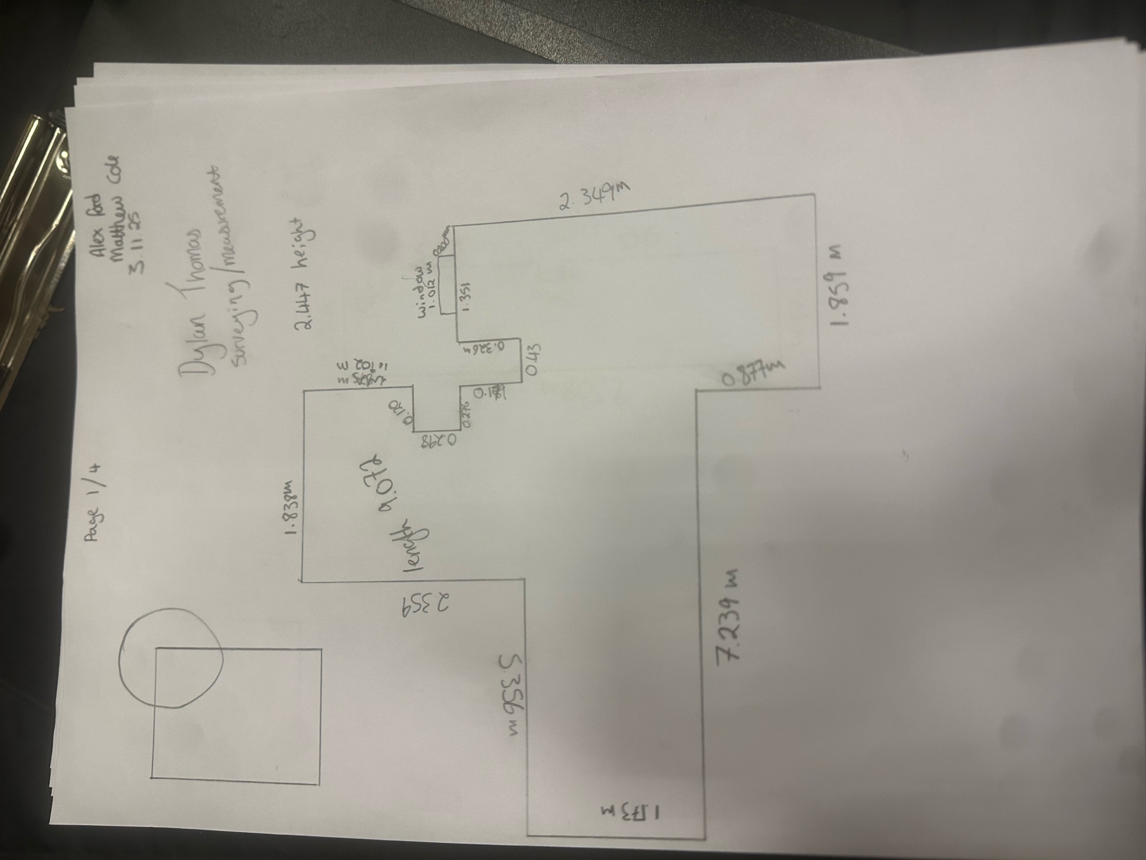

Figure A2: Manual Sketch of Corridor 2
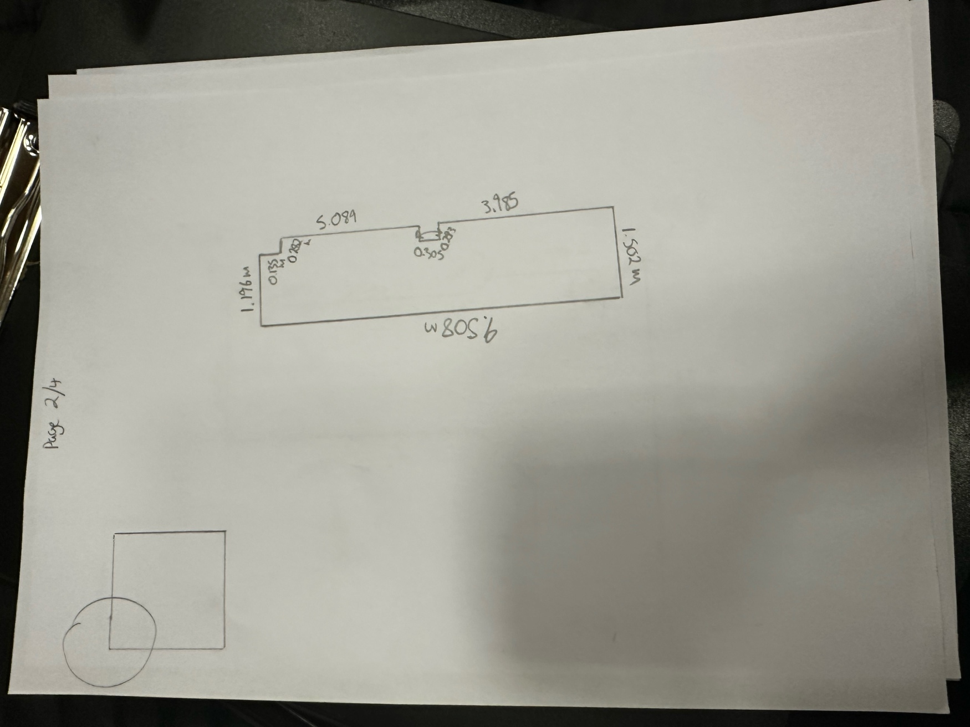

Figure A3: Manual Sketch of Corridor 3
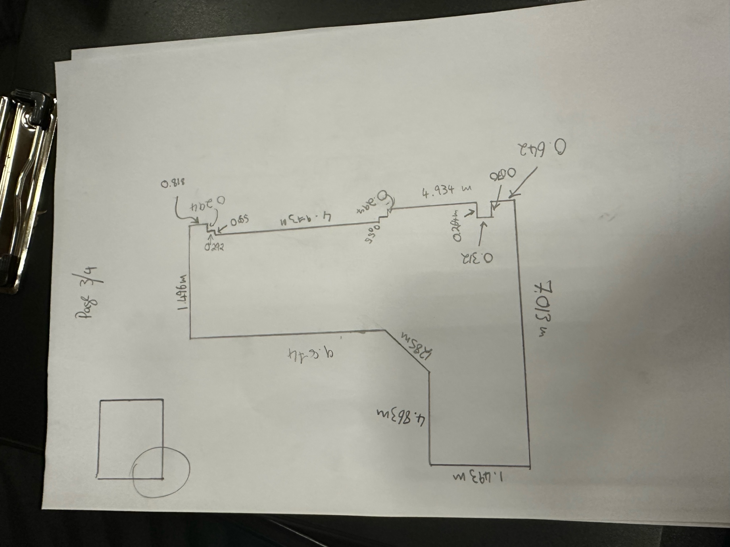

Figure A4: Manual Sketch of Corridor 4
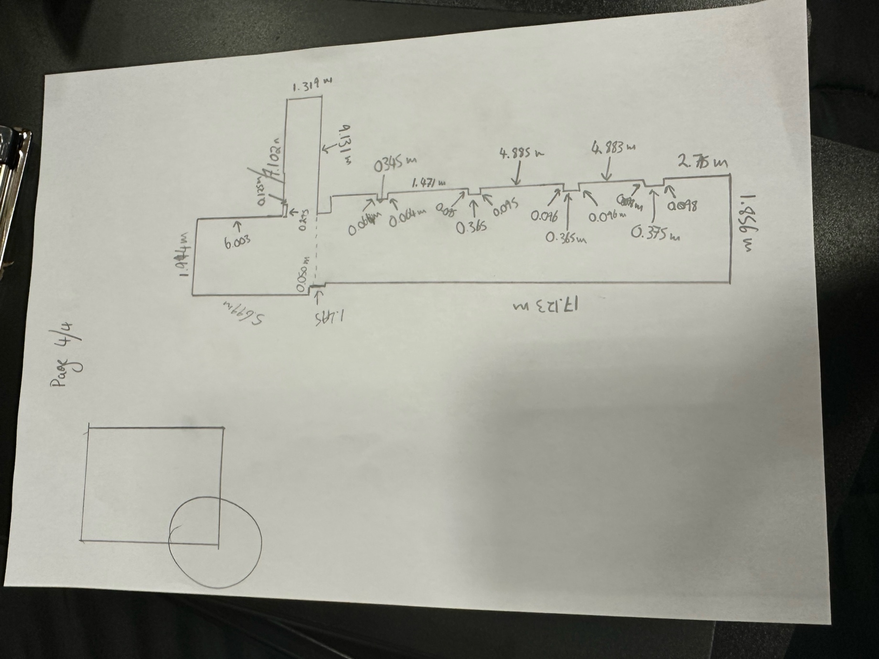

Appendix B- Laser Scan Sketch
Figure B1: 1:00 Digital Representation Laser Scan of Dylan Thomas Centre


