Student Name: Ansar Ali
Student Number: 2433274
Module Name: Introduction to Public Health
Module Code: LCHS4008
Lecturer: Vivian Osuchukwu
Title: Heart Disease Report

Table of Contents
Introduction 3
Definition of the disease 4
Signs and symptoms 4
Incidence and severity 5
Worldwide 5
United Kingdom 5
Main body 6
Disease Control 7
Population-level prevention and policy 7
Primary-care risk identification and management 8
Acute care and secondary prevention 8
System and service interventions 8
Factors influencing health and well-being of people affected and those around them 8
Modifiable behavioural and clinical risk factors 8
Social determinants and inequalities 9
Health-system factors and service access 9
Psychological, family and economic influences 9
Commercial and environmental drivers 9
Conclusion 10
References 11

Introduction
This report defines heart disease, summarises key signs and symptoms, outlines global and UK incidence and burden, examines impacts on communities and the NHS, explains control measures, and discusses factors influencing health and wellbeing. Heart disease, commonly referred to as cardiovascular disease (CVD), encompasses conditions affecting the heart and blood vessels, including congenital and rheumatic heart disease, heart failure, coronary heart disease, and stroke (Mayo Clinic, 2024). CVD is the leading global cause of death and disability, responsible for significant early mortality, long-term morbidity, and demand for health services (WHO, 2025). An estimated 17.9–18 million deaths occur worldwide each year, with millions more living with chronic heart conditions due to ageing populations and increasing risk factors (WHO, 2025; BHF, 2025). In the UK, CVD remains a major cause of death and disability. Around seven million people are affected, and large numbers require hospital or specialist care annually, placing sustained pressure on the NHS (BHF, 2025; NHS England, 2025).

Definition of the disease

Conditions affecting the heart and blood arteries are referred to as "heart disease" (also known as CVD) (Lakatta and Levy, 2023). Heart failure, peripheral arterial disease, rheumatic heart disease, cerebrovascular disease, ischaemic heart disease and congenital heart disease are the main categories (Lopez et al., 2023). The majority of CVD is brought on by atherosclerosis, or plaque in the arteries, and problems with the rhythm of the heart; some types, such rheumatic heart disease, are linked to past illnesses or congenital defects (WHO, 2025; BHF, 2025a). Below the Figure 1 illustrates the chamber and valves of the heart.

Figure 1

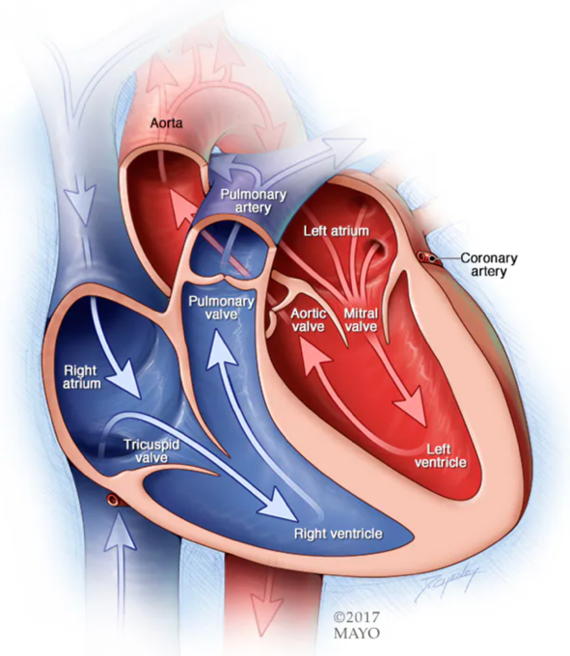
(Mayo Clinic, 2024)

Signs and symptoms
Symptoms depend on the specific condition and severity but commonly include:
- Chest pain (angina) and pressure spreading to the jaw, neck, shoulder or arm.
- Shortness of breath, especially when lying flat (common in heart failure).
- Palpitations, light-headedness or fainting (arrhythmias).
- Sudden intense symptoms such as severve chest pain, collapse or sudden weakness/numbness.
- Fatigue and reduced exercise tolerance; ankle swelling in advanced heart failure.
Many CVD presentations can be unusual or silent, delaying diagnosis and therapy (especially in women, older adults, and those with diabetes). (WHO, 2025; BHF, 2025a).

Incidence and severity
Worldwide: The most common cause of death worldwide is CVD, according to the most recent WHO data, CVD causes approximately 17.9 million deaths annually, with myocardial infarction and stroke accounting for four out of five CVD deaths. The prevalence of CVD is likewise high and continues to rise (WHO, 2025). According to a global factsheet from the BHF, 640 million people globally suffer from CVD (BHF, 2025).
United Kingdom: More than seven million people in the UK suffer from heart and circulation conditions (NHS England, 2025). A significant percentage of deaths and premature mortality (deaths under 75) are caused by CVD, which exhibits distinct socioeconomic gradients with significantly higher rates in underprivileged areas (Office of National Statistic, 2025). As illustrated in figure 2 below:
Figure 2: Deaths in England and Wales in 2024 and 2023
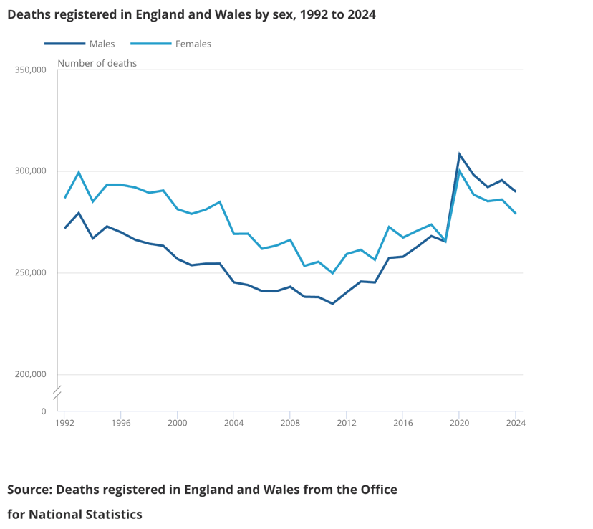
(Office for National Statistic, 2025)
According to recent BHF databases, heart and circulatory disorders, as well as CHD, continue to cause a substantial number of deaths. They also show that certain negative trends have increased since 2019 (BHF, 2025; GOV.UK, 2024). Research has revealed a significant incidence of deaths among patients awaiting valve surgery or transcatheter aortic valve implantation (TAVI) while on NHS waiting lists (Jahangiri et al., 2021). Press and national data have also indicated rising waiting lists and treatment delays for cardiac operations in England (BHF, 2025; The Guardian, 2025; NHS England, 2025).

Main body

Consequences of heart disease in the community and for the NHS
Heart disease causes significant personal suffering and reduced quality of life (Hecker et al., 2022). Myocardial infarction and stroke are acute occurrences that can result in mortality or leave survivors with long-term functional impairment, cognitive problems, chronic pain or exhaustion, and limits in daily functioning. Survivors often require ongoing medication, follow-up consultations, and rehabilitation services (Chohan et al., 2019). Anxiety, despair, and a lack of confidence are common psychological effects that can hinder rehabilitation and secondary-prevention efforts. When patients cannot work, families and unpaid carers often handle practical care needs, transportation to appointments, and financial burden. Communities with high CVD prevalence experience greater social-care demands and reduced labour-force participation (BHF, 2025a; WHO, 2025).

High rates of primary care visits, emergency attendances for heart attacks, unstable angina, and stroke, inpatient stays, cardiology consultations, diagnostic tests, and costly interventional or surgical procedures are all driven by CVD (Kobo et al., 2022). An estimated 1 million hospital bed days (about 2% of all NHS inpatient days) and significant emergency admissions, when hospital care, long-term care, and rehabilitation are considered, the annual financial cost to the NHS and social care sectors amounts to billions of pounds, are attributed to heart failure alone (BHF, 2025).
Recent reports shown in figure 3 illustrate there are record-high wait times for routine cardiac care in England, increases in wait times longer than 18 weeks, and alarming wait-related mortality for certain procedures (The Guardian, 2024).

Figure 3: Patients waiting for cardiac care
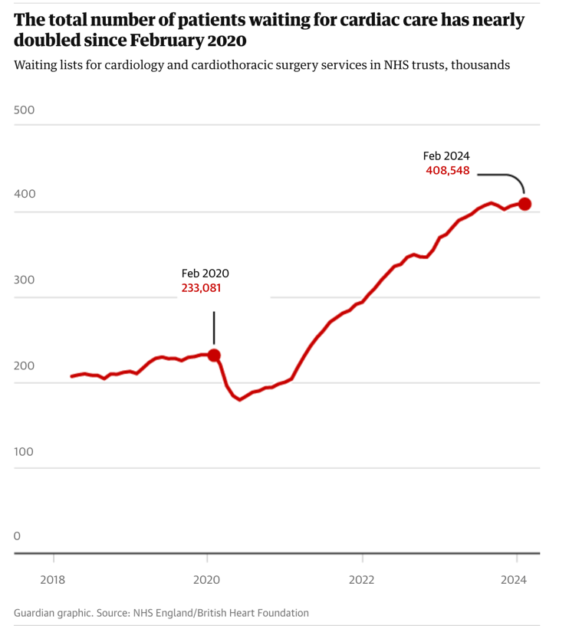
(The Guardian, 2024).
These findings highlight service capacity pressures and potential preventable harm from postponed treatment (NHS England, 2025; The Guardian, 2025). These challenges are made worse by a lack of cardiology and cardiac surgery personnel, diagnostic bottlenecks, and limited interventional capacity. These factors also contribute to socioeconomic inequalities results and access (NHS England, 2025; BHF, 2025).
Economic and Societal burden
Beyond direct NHS expenses, CVD raises welfare expenditures and unpaid care while decreasing productivity through early retirement and sick leave. Programs for early intervention and prevention are therefore financially appealing: Effective primary prevention lowers long-term disability and future, costly acute treatment (Alsaidan, 2025).

Disease Control

Population-level prevention and policy
It is fundamental to implement policy actions to lower population exposure to significant risk factors. Tobacco control, food reformulation, trans fat limitations, policies to reduce dangerous alcohol consumption, encouraging physical exercise and active transport through urban design, and improving air quality are also effective strategies (Di Cesare et al., 2024). Tobacco taxes, salt reduction, alcohol laws, and public awareness are among the "best buys" that the WHO has determined offer significant public health benefits for the prevention of CVD (WHO, 2025; BHF, 2025).

Primary-care risk identification and management
Smoking, diabetes, dyslipidaemia, and hypertension are the main modifiable factors for CVD that are identified and managed in primary care (Kucia and Hartley, 2022). In the UK, preventive counselling and the prescription of statins and antihypertensive medications are guided by cardiovascular risk calculators, such as QRISK. Reducing first occurrences requires comprehensive and opportunistic screening, smoking cessation programs, and diabetes and obesity treatment (Merwass et al., 2024; NHS England, 2025).

Acute care and secondary prevention
Mortality and disability are decreased by prompt, evidence-based treatment of acute coronary syndromes (timely reperfusion via primary percutaneous coronary intervention or thrombolysis), stroke thrombolysis or thrombectomy where needed, and expert heart-failure management (Bergmark et al., 2022). Recurrence is decreased and functional recovery is enhanced by secondary prevention (antiplatelets, statins, ACE inhibitors/ARBs, beta-blockers where needed) and cardiac rehabilitation. Ensuring timely and equal access to these services is a top responsibility for the health system (Sulashvili and Nimangre, 2025).

System and service interventions
To fulfil demand and minimise preventable injury, it is essential to address waiting lists, increase interventional capacity, make investments in staff development and diagnostics, and provide integrated pathways across primary, secondary, and community care (Csontos et al., 2025). Inequalities in the use of preventative and treatment services can be decreased by focused outreach to underprivileged populations and culturally appropriate interventions (Aidoo, 2024).

Factors influencing health and well-being of people affected and those around them

Modifiable behavioural and clinical risk factors
The primary modifiable causes of CVD are smoking, unhealthy diets heavy in salt, saturated fat, and ultra-processed foods, physical inactivity, hazardous alcohol consumption, obesity, uncontrolled hypertension, high cholesterol, and diabetes (Mendis, 2024). The risk of first and subsequent occurrences is significantly reduced when these hazards are effectively modified (WHO, 2025).

Social determinants and inequalities
Exposure to risk and access to care are significantly influenced by socioeconomic level, education, work, housing circumstances, and neighbourhood surroundings (Troost et al., 2023). The most impoverished areas of the UK have significantly higher rates of premature CVD mortality; ethnic disparities (such as a higher risk of CHD in some South Asian populations) reflect intricate relationships between biology, culture, risk-factor patterns, and access to care (Anand et al., 2025).

Health-system factors and service access
Results are influenced by prompt availability to diagnosis, treatments, and rehabilitation. Measurable variations in survival and disability following cardiac events are caused by waiting durations, regional variances in service delivery, and a lack of workers (NHS England, 2025; The Guardian, 2025).

Psychological, family and economic influences
Following cardiac events, mental-health comorbidity (anxiety, depression) is prevalent and hinders adherence and self-care. Financial and emotional strain are experienced by carers and their families; rehabilitation and long-term wellbeing are enhanced by social support and the integration of mental and physical care (BHF, 2025).

Commercial and environmental drivers
Environmental exposures (air pollution) and commercial determinants (selling of unhealthy foods, alcohol, and tobacco) increase population risk and require regulatory actions to lessen upstream causes of disease (Lee and Freudenberg, 2022; WHO, 2025).

Conclusion
In conclusion, CVD remains the leading global cause of death and a major source of morbidity and system strain in the United Kingdom (WHO, 2025). Beyond short-term clinical suffering, its effects include long-term incapacity, mental health consequences, financial and familial hardship, and substantial ongoing costs for social services and healthcare. Population-level policies (tobacco control, food reformulation, salt reduction, physical activity promotion), effective primary-care risk detection, timely acute treatment, and equitable access to specialised interventions and rehabilitation can significantly reduce death and disability (Di Cesare et al., 2024). Reducing inequalities requires addressing social determinants that concentrate risk in disadvantaged groups, expanding NHS capacity, and providing integrated, person-centred care (Anand et al., 2025). To lessen the future burden of heart disease on people, communities, and the NHS, sustained investment in prevention and service resilience is essential (WHO, 2025; BHF, 2025a; NHS England, 2025).

References
Aidoo, E.M. (2024) ‘Community based healthcare interventions and their role in reducing maternal and infant mortality among minorities’, International Journal of Research Publication and Reviews, 5(8), pp.4620-36.
Alsaidan, A.A. (2025) ‘Cardiovascular disease management and prevention in Saudi Arabia: strategies, risk factors, and targeted interventions’, International Journal of Clinical Practice, 2025(1), p.7233591.
Anand, S.S., Kandasamy, S., Marchand, M., Kavousi, M., Gulati, M., Deanfield, J. and Quyyumi, A.A. (2025) ‘Reducing inequalities in cardiovascular disease: focus on marginalized populations considering ethnicity and race’, The Lancet Regional Health–Europe, 56. pp. 1-17.
Bergmark, B.A., Mathenge, N., Merlini, P.A., Lawrence-Wright, M.B. and Giugliano, R.P. (2022) ‘Acute coronary syndromes’, The Lancet, 399(10332), pp.1347-1358.
British Heart Foundation (2025) Heart and Circulatory Disease Statistics 2025. British Heart Foundation. Available at: https://www.bhf.org.uk/what-we-do/our-research/heart-statistics/heart-statistics-publications/cardiovascular-disease-statistics-2025 (Accessed: 12 November 2025).
British Heart Foundation (2025a) Global cardiovascular disease factsheet. British Heart Foundation. Available at: https://www.bhf.org.uk/-/media/files/for-professionals/research/heart-statistics/bhf-cvd-statistics-global-factsheet.pdf (Accessed: 12 November 2025).
Chohan, S.A., Venkatesh, P.K. and How, C.H. (2019) ‘Long-term complications of stroke and secondary prevention: an overview for primary care physicians’, Singapore medical journal, 60(12), p.616.
Csontos, J., Gillen, E., Edwards, D., Islam, A., Davies, J., Edwards, R.T., Edwards, A., Cooper, A. and Lewis, R. (2025) ‘Integrated care for older people or people living with frailty and waiting times/lists–a mixed methods rapid review’, medRxiv, pp.2025-06.
Di Cesare, M., Perel, P., Taylor, S., Kabudula, C., Bixby, H., Gaziano, T.A., McGhie, D.V., Mwangi, J., Pervan, B., Narula, J. and Pineiro, D. (2024) ‘The heart of the world’, Global heart, 19(1), p.11.
GOV.UK (2024) Cardiovascular Disease Profiles: Short Statistical Commentary (December 2024 update). Available at: https://www.gov.uk/government/statistics/cardiovascular-disease-profiles-december-2024-update/cardiovascular-disease-profiles-short-statistical-commentary (Accessed: 12 November 2025).
Hecker, J., Freijer, K., Hiligsmann, M. and Evers, S.M.A.A. (2022) ‘Burden of disease study of overweight and obesity; the societal impact in terms of cost-of-illness and health-related quality of life’, BMC Public Health, 22(1), p.46.
Jahangiri, M., Bilkhu, R., Embleton-Thirsk, A., Dehbi, H.M., Mani, K., Anderson, J., Avlonitis, V., Baghai, M., Birdi, I., Booth, K. and Bose, A. (2021) ‘Surgical aortic valve replacement in the era of transcatheter aortic valve implantation: a review of the UK national database’, BMJ open, 11(10), p.e046491.
Kobo, O., Moledina, S.M., Raisi-Estabragh, Z., Shanmuganathan, J.W.D., Chieffo, A., Al Ayoubi, F., Alraies, M.C., Biondi-Zoccai, G., Elgendy, I.Y., Mohamed, M.O. and Roguin, A. (2022) ‘Emergency department cardiovascular disease encounters and associated mortality in patients with cancer: a study of 20.6 million records from the USA’, International Journal of Cardiology, 363, pp.210-217.
Kucia, A.M. and Hartley, A. (2022) ‘Risk factors for cardiovascular disease’, Cardiac Care: A Practical Guide for Nurses, pp.35-51.
Lakatta, E.G. and Levy, D. (2003) ‘Arterial and cardiac aging: major shareholders in cardiovascular disease enterprises: Part II: the aging heart in health: links to heart disease’, Circulation, 107(2), pp.346-354.
Lee, K. and Freudenberg, N. (2022) ‘Public health roles in addressing commercial determinants of health’, Annual review of public health, 43(1), pp.375-395.
Lopez, E.O., Ballard, B.D. and Jan, A. (2023) Cardiovascular disease. In StatPearls [Internet]. StatPearls Publishing.

Mayo Clinic (2024) Heart-Disease. Available at: https://www.mayoclinic.org/diseases-conditions/heart-disease/symptoms-causes/syc-20353118 (Accessed: 16 November 2025).
Mendis, S. (2024) ‘Diet and Prevention of Cardiovascular Disease’, Recent Progress in Nutrition, 4(3), pp.1-19.
Merwass, N.A., Alkhader, Y.K., Alharthi, S.A., Al Fardan, R.M., Alqahtani, A.M., Mahnashi, F.A., Salam, N.M., Al Najim, M.M., Alenezi, A.A., Binobaid, A.O. and Alkhader, Y. (2024) ‘The role of screening, risk factors, and early intervention in preventing diabetes in the obese population: A systematic review’, Cureus, 16(7).
NHS England (2025) Monthly Operational Statistics — January 2025 and NHS England publications on cardiovascular high-impact interventions. NHS England. Available at: https://www.england.nhs.uk/long-read/monthly-operational-statistics-january-2025/ (Accessed: 12 November 2025).
Office for National Statistics (ONS) (2025) Deaths registered in England and Wales: 2024. ONS. Available at: https://www.ons.gov.uk/peoplepopulationandcommunity/birthsdeathsandmarriages/deaths/bulletins/deathsregistrationsummarytables/2024 (Accessed: 12 November 2025).
Sulashvili, N. and Nimangre, R.R. (2025) ‘Manifestation of some aspects of cardiovascular diseases, implications, pharmacotherapeutic strategies, effects, impacts and potential hazards in general’, Junior Researchers, 3(1), pp.1-27.
The Guardian (2024) Number waiting over 18 weeks for NHS heart treatment in England rises fivefold. Available at: https://www.theguardian.com/society/2024/apr/11/number-waiting-for-nhs-care-for-serious-heart-problems-in-england-rises-fivefold (Accessed: 15 November 2025).
The Guardian (2025) More than 400 with heart valve condition dying each year on NHS waiting list, research finds, 18 May 2025. Available at: https://www.theguardian.com/society/2025/may/18/heart-valve-condition-aortic-stenosis-deaths-nhs-waiting-list (Accessed: 12 November 2025).
Troost, A.A., Van Ham, M. and Manley, D.J. (2023) ‘Neighbourhood effects on educational attainment. What matters more: Exposure to poverty or exposure to affluence?’, Plos one, 18(3), p.e0281928.
World Health Organization (WHO) (2025) Cardiovascular diseases (CVDs) — fact sheet (updated 31 July 2025). WHO. Available at: https://www.who.int/news-room/fact-sheets/detail/cardiovascular-diseases-(cvds) (Accessed: 12 November 2025).

