Module: Research Methods II

Module Code: ECPS5002

Title: Qualitative Report: Thematic Analysis:
‘Individual and Environmental Wellbeing’.

Abstract
A thematic analysis was applied through a transcribed pre-recorded interview which involved a single female participant. The interviewer wanted to “explore the concept of “wellbeing” at both an individual and environmental level” and what the participant understands about wellbeing through her own experiences. Barton (2016), emphasises, "Affluent countries and social groups across the world are facing relatively new health and wellbeing challenges". However, overall, the study results emphasised the complexity between cognitive processes and mindfulness. The participant stated, "I do practice the mindfulness meditation," and participated in a six-week course which not only enlightened her on her wellbeing but of others too (Thwaites et al., 2015). Obtaining the skill to be mindfully present has links with positive effects such as reduced stress. This was found through single-session mindfulness exercises such as 'green care' which increased levels of essential mindfulness (Watier & Dubois, 2016).

Method

Participants: A transcribed pre-recorded interview was used involving a single female participant. However, the recruitment method is unknown due to the module lead providing the transcript.

Design: The method of data analysis was thematic analysis, and a report was collated using a qualitative interview design to collect data. The questions were specified around the subject of wellbeing and the environment. Due to the interview being held prior to student involvement, the interview location is unknown.

Materials: If the student conducted the interview, the participant would have been presented with a debrief form, consent form, and an information sheet. The interviewer researcher and supervisor's contact details are provided for further clarification. They would also provide an interview schedule and a voice recorder. On this occasion, the transcription of the interview was provided for the student.

Procedure: If the student had conducted the study, they would have used the following procedures to ensure BACP guidelines were followed. An introduction would be made to establish a rapport and ensure the participant was comfortable with the researcher. Secondly, the participant's anonymity would have been ensured following data protection guidelines (Service, 2015). Thirdly, the consent form would ensure the participant understood what the interview would entail, understanding that they could leave the interview and retract their data at any point. Fourthly, the schedule would have questions that would be ethically researched and remain relevant to the interview. Finally, the debrief would thank them for their time and include the research question and their supervisor's contact details for further clarification or aftercare. However, the process of gathering data was completed prior to this assessment.

Results:

Themes:

Theme 1 - Difficulties and feelings of neglect, stress and time.

Subordinate theme 1.1 - Neglect
"When I was younger I would have just thought of the physical side of it and neglected the actual, y'know, psychological part as well."
The participant reflects on how she misunderstood wellbeing and assumed it only related to physical elements and not psychological elements. She understands in hindsight how this was neglectful but is now working on improving and gaining a complete sense of wellbeing.

Subordinate theme 1.2 - Stress
The participant was asked how she finds it difficult to look after her wellbeing and stated, "I’ll try and go have a walk." Thus, showing awareness and using a healthy habit to tackle her stress.

Subordinate theme 1.3 - Time
The participant explains how "when I'm nice and organised, and have plenty of time and everything", she feels she can accomplish the tasks she sets herself. However, it comes across that she does not have enough time to do this usually.

Theme 2 - Environmental wellbeing

Subordinate theme 2.1 - Recycling
Following uncompleted tasks, one is being recycling "-so it goes straight in the bin without recycling– sorry!" Throughout the interview, she fixates on recycling and how it brings both self-satisfaction when she achieves it and annoyance in others who do not.

Subordinate theme 2.2 - Community
The participant feels a part of the community when recycling and cleaning the beach. Which can give her purpose, and her effort has not gone unnoticed; as she states, "you can see that the community has made an effort."

Subordinate theme 2.3 - Litter picking
A prime example of practising environmental wellbeing is when the participant says, "just pick up up one bit of litter and chuck it in the bin." This is to help keep the beach clean and "looking nice."

Theme 3: Emotional responses, both negative and positive

Subordinate theme 3.1 - Stigma
The participant portrays stigma when stating, "going to sound a bit hippiesh now" when explaining how if people were more considerate towards others and the environment and how it could help others.

Subordinate theme 3.2 - Frustration
The participant explains how she can be left "feeling quite angry and annoyed" when there is dog excrement left "everywhere" and then feels "there's nothing I can do about it", so she feels she must dispose of it.

Subordinate theme 3.3 - Hopeful
The participant then presents positive feelings towards herself when she claims she feels "Quite self-satisfied" when clearing the beach of litter.

Theme 4: Practicing and understanding self-care

Subordinate theme 4.1 - Exercise
The participant explained how when she is stressed she will "walk around some woods or somewhere green I find that really soothing – its very relaxing". This is a practice of both physical and mental wellbeing by going "somewhere green".

Subordinate theme 4.2 - Meditating
The participant found that "looking after yourself, a bit like self-care" was necessary for mental wellbeing. She also stated that "I do practice the mindfulness meditation" to help her mental health.

Theme 5 - The importance of mindfulness and routines

Subordinate theme 5.1 - Mindfulness
The participant states, "I also practice mindfulness, I've done a course, a six-week course, and that helps to put things into a lot better context of what wellbeing is as an individual but also other people's wellbeing around you kind of thing." This is especially important as she is a carer for both her parents.

Subordinate theme 5.2 - Routine
The participant also shows how adhering to her routine helps manage her depression and anxiety. "I have to keep an established routine, and that's when I feel the best."

Introduction:
In 1943, Abraham Maslow put forward his framework of the hierarchy of needs (see table 1). If followed throughout, would lead an individual to self-actualisation, then finally onto self-transcendence. Maslow believed that belongingness was crucial for building the foundation of this concept, enabling a person to transform and therefore lead to self-actualisation (Taormina & Gao, 2013).
However, belongingness can only be achieved through affiliation within a group impacted by cultural values and beliefs that determine what is acceptable to the group. This results in individuals conforming to those values and social norms to accomplish social wellbeing (Baumeister & Bushman, 2017).
Furthermore, social wellbeing can result in the individual gaining better self-esteem. This is branched under the deficiency needs within the framework as there is recognition and achievement, especially if they are doing a group project. For example, the individual might participate in a task knowing a hedonic reward would be achieved (Diener et al., 2003; Houwer, 2012).
Studies have shown that having a routine can alleviate some stress by instilling a sense of control over the individual's life (Watier & Dubois, 2016).
However, Carl Rogers believed it was unreasonable to perceive mental wellbeing as a specified state and that it is not something that can be achieved through an order of steps, disagreeing with other psychoanalysts who believed it would be achieved by reducing biological motives or drives. Alternatively, Rogers favoured seeing the human mind, the environment and human behaviours as alive and continuously changing organisms (Hemmings & Collin, 2018).

Discussion:
The difficulties the participant describes have changed over time. The participant explained how she had "neglected" the importance of obtaining and maintaining her mental health and wellbeing, as when she was younger, she did not believe mental health had the same importance as physical health. Practising self-care would give her the skills and tools to maintain healthy mental, physical, and psychological wellbeing.
However, completing cognitive therapy will have equipped her with Cognitive Behavioural Therapy (CBT) skills. These skills can help her wellbeing and enlighten her on the importance of psychological wellbeing (Wilkins, 2000).
CBT is different compared to other traditional therapy methods as it delves into the issues the client is dealing with currently, as opposed to the past. This has become prominent in her routine, which she admits she sometimes struggles to uphold (Tudor & Worrall, 1994).
One of the foremost core beliefs of CBT is that the client is more than capable to self-heal. However, according to the National Health Service (NHS), CBT can also help daily by continuously looking into finding practical and rational ways to improve the state of mind and not focusing on medication but on retraining the brain to think differently, especially when it comes to triggering situations. This is then used in the future for similar situations to reach a different, more positive outcome rather than repeating the same cycle (Ponomarjova, 2015; NHS, 2019).
Being a carer for both her parents, the participant reiterates how she needs to come first several times throughout the interview. An example of this is when she says, "once the carer falls, who is going to look after the other people? So, I finally realised that the carer has to come first". The participant could have learned to practice Albert Ellis's ABC approach alongside the Gibbs reflective cycle. a standard method used alongside CBT (Hemmings & Collin, 2018; Williams et al., 2012).
The Activating events, Belief system and Consequences (ABC) approach explains how a person can experience an activity; the response to the event can be interpreted through their belief system, and then the person would feel powerful emotions or consequences. Suggesting the practise of the Gibbs reflective cycle, the participant demonstrated the final stage, which was the action plan that advocates a new way of thinking and how they can change the outcome. For example, her view on littering "So instead of moaning about it I'll do something about it and pick up a can." (Collin et al., 2012; Bond, 2004).
If the participant applied these skills to other aspects of her life, such as when she feels stressed, stating "when I'm nice and organised, and have plenty of time and everything", she feels she can uphold her routine and complete the things she wants to do. This is an example of having a hedonic reward from picking up the litter, again tying to the community and keeping the areas clean (Ryan et al., 2010).
Andrea Abele (2014) found that through her study which involved both Russian and German participants, communal traits were held at a higher importance against agentic traits. Finding that the difference between agentic traits needed for goal-attainment which usually belongs to relevant qualities such as decisiveness and communal content denotes to qualities relevant for establishing and maintain social relationships such as being helpful (Hogan, 1982). The participant here was presenting more of a communal trait and held that as a higher priority than agentic traits. Creating a bond with the community could foster a relationship and sense of belonging. This is presented when the participant states, "you can see that the community has made an effort." and follows with "we all go tidy it up", which can show pride in being a part of the community, which may be why she is fixated on recycling alongside the beach but not so much within her own home to obtain societal wellbeing (Flett et al., 2009).
This leads to when the participant picks up litter, and she feels "Quite self-satisfied." This can be a part of goal-oriented emotional regulation, defining the offset of an emotional response. In this case, it can give her a hedonic reward which could be a reason as to why she feels so strongly about it within the community but again not towards her own home. When she follows her routines and recycles, this can be seen as her good deed, especially within the community, giving her a sense of belonging and purpose (Baumeister & Bushman, 2017).
However, the participant displays negative feelings such as hopelessness when she affirms, "nothing I can do about it". The participant then feels she must pick up the recycling when, if she applied the CBT skills she learned, she could retrain her emotions and instead of "feeling quite angry and annoyed", she could use the Gibbs reflective cycle and have a different, more positive outlook on herself as well (Taylor, 2020).
This again can be seen through how she feels like she has achieved something when she does as opposed to when she tries to recycle at home but tends to forget, this could happen for several reasons, but lack of time stands out (Joshi & Phadke, 2018).
This leads to improving her wellbeing, specifically how she uses 'Green care', which is when she will "walk around some woods or somewhere green I find that really soothing – its very relaxing" when she feels stressed. Barton (2016), emphasises, "Affluent countries and social groups across the world are facing relatively new health and wellbeing challenges". Burton further explains how nature is multisensory and can aid in developing a sense of place that can further attachments to both people and places, leading to societal and environmental wellbeing (Goodenough & Waite, 2017; Casamassima, 2020).
Obtaining the skill to be mindfully present has links with positive effects such as reduced stress. This was found through single-session mindfulness exercises such as 'green care' which increased levels of essential mindfulness (Watier & Dubois, 2016).
However, overall, the study results emphasised the complexity between cognitive processes and mindfulness. The participant stated, "I do practice the mindfulness meditation," and participated in a six-week course which not only enlightened her on her wellbeing but of others too (Thwaites et al., 2015).
This could also be how she has demonstrated polorisation throughout the interview. This is through the participant's reaffirmations regarding looking after herself and the importance of self-care. Primarily through upholding her routine, as she states, "I have to keep an established routine, and that is when I feel the best." displaying an understanding of what works for her mental health (Atthowe, 1975).
She also shows awareness as she says, "I'm more aware of when I'm starting to go on a bit of downward spiral and with all this kind of training and a bit of therapy I can – not so much avert it – but try and go another way, so it has to be routine.". The participant relies heavily on having this routine and understands that following green care and meditating is a part of practising self-care and wellbeing (Milton, 2010).
A study conducted by Koome et al. (2012), found that everyday routines assisted a multitude of purposes ranging from creating a supportive framework for wellbeing as well as eliciting a sense of control and coping mechanisms, which heightened belonging and was found to be not only productive but also elicit positive wellbeing.
Conclusion:
In conclusion implementing Maslow's framework as a guide to obtain a comprehensive grasp on wellbeing would be beneficial for the client. Promoting fullness across the trifecta - psychologically, physically, and mentally, results in having a healthier life (Gormon, 2010; Bishop, 2015).
Using CBT as a way of thinking will also aid a stronger sense of overall wellbeing as it can take a negative situation and change the narrative to become a positive outcome (Pearson & Podeschi, 1999). This is especially true if being mindfully present would become the norm, as it is proven to reduce stress (Watier & Dubois, 2016). The client would benefit as she already practices green care, so this would be a more manageable, more advantageous transition she could soon achieve. Finding that throughout the interview the client understood the importance of Greencare and how wellbeing can affect mood and motivation was a positive indication that this will be employed throughout their life.

References
Abele, A. E. (2014). Pursuit of communal values in an agentic manner: A way to happiness? Frontiers in Psychology, 5. https://doi.org/10.3389/fpsyg.2014.01320
Atthowe, J. M. (1975). Behavior Modification, Behavior Therapy, and Environmental Design. American Behavioral Scientist, 18(5), 637–655. https://doi.org/10.1177/000276427501800504
Badrī Mālik, Abdul-Wahid, L., & Henzell-Thomas, J. (2018). Contemplation (2nd ed., pp. 7, 15–24). IIIT.
Barton, J. (2016). Green exercise (pp. 1–11). Routledge.
Barton, J., & Pretty, J. (2010). What is the best dose of nature and green exercise for improving mental health? A multi-study analysis. Environmental Science & Technology, 44(10), 3947–3955. https://doi.org/10.1021/es903183r
Baumeister, R. F., & Bushman, B. J. (2017). Social Psychology and human nature. Cengage Learning.
Biles, D. (2016). Reapproaching Rogers: looking to the source to show us where we are going wrong. Person-Centered & Experiential Psychotherapies, 15(4), 318–338. https://doi.org/10.1080/14779757.2016.1228539
Bishop, M. (2015). The Good Life: Unifying the Philosophy and Psychology of Well-Being. https://doi.org/10.1093/acprof:oso/9780199923113.001.0001
Bond, T. (2004). Ethical guidelines for researching counselling and psychotherapy. Counselling and Psychotherapy Research, 4(2), 10–19. https://doi.org/10.1080/14733140412331383893
Brownell, P. (2010). Gestalt therapy. Springer.
Casamassima, B. (2020). Retrieved from https://blog.interface.com/can-biophilic-design-improve-emotional-wellbeing/.
Collin, C., Grand, V., Benson, N., Lazyan, M., Ginsburg, J., & Weeks, M. (2012). The psychology book (pp. 130–135, 138). Dorling Kindersley.
Diamond, S. A. (2018). Existential Therapy and Jungian Analysis: Toward an Existential Depth Psychology. Journal of Humanistic Psychology, 002216781880991. https://doi.org/10.1177/0022167818809915
Diener, E., Kahneman, D., & Schwarz, N. (2003). Well-being: The foundations of hedonic psychology (2nd ed.). Russell Sage Foundation.
Elkatawneh, H. H. (2012). Moral and Ethical Framework Appraisal: A Counsellors Ethical Responsibilities in Reporting Clients/Tarasoff Case. SSRN Electronic Journal. https://doi.org/10.2139/ssrn.2139717
Flett, G. L., Krames, L., & Vredenburg, K. (2009). Personality traits in clinical depression and remitted depression: An analysis of instrumental-agentic and expressive-communal traits. Current Psychology, 28(4), 240–248. https://doi.org/10.1007/s12144-009-9063-0
Gallagher, J. (2017). The Core Conditions and Diversity in Counselling and Psychotherapy. Academia.edu. Retrieved 2021, from https://www.academia.edu/30928192/The_Core_Conditions_and_Diversity_in_Counselling_and_Psychotherapy
Gillon, E. (2007). Person-centred counselling psychology. SAGE.
Goodenough, A., & Waite, S. (2017). Wellbeing from woodland (pp. 15–46). Springer International Publishing AG.
Gormon, D. (2010). (PDF) Maslow's hierarchy and social and emotional wellbeing. ResearchGate. Retrieved October 15, 2021, from https://www.researchgate.net/publication/279505175_Maslow's_hierarchy_and_social_and_emotional_wellbeing
Hemmings, J., & Collin, C. (2018). How psychology works (pp. 128–135). DK.
Houwer, J. D. (2012). Cognition & Emotion: Reviews of current research and theories. Psychology.
Joshi, A., & Phadke, K. M. (2018). Rational Emotive Behaviour Therapy Integrated (pp. 33, 35, 48, 49). Sage Publications India.
Koome, F., Hocking, C., & Sutton, D. (2012). Why routines matter: The nature and meaning of family routines in the context of adolescent mental illness. Journal of Occupational Science, 19(4), 312–325. https://doi.org/10.1080/14427591.2012.718245
Lees-Oakes, R., & Kelly, K. (2017). The Core Condtions. S3.amazonaws.com. Retrieved 2021, from https://s3.amazonaws.com/CounsellingTutor/CT+Opt+Ins/CT+Core+Conditions.pdf
Mearns, D. (2003). Developing person-centred counselling (pp. 3–5). Sage Publications.
Milton, M. (2010). Therapy and beyond. Wiley-Blackwell.
NHS. (2019, July 16). Overview - Cognitive behavioural therapy (CBT). NHS choices. Retrieved October 7, 2021, from https://www.nhs.uk/mental-health/talking-therapies-medicine-treatments/talking-therapies-and-counselling/cognitive-behavioural-therapy-cbt/overview/
Pearson, E. M., & Podeschi, R. L. (1999). Humanism and Individualism: Maslow and his Critics. Adult Education Quarterly, 50(1), 41–55. https://doi.org/10.1177/07417139922086902
Ponomarjova, K. (2015, June). (PDF) understanding the link between ... - researchgate.net. Understanding the link between theories of recognition and subjective well-being. Retrieved November 15, 2021, from https://www.researchgate.net/publication/280037246_Understanding_the_link_between_theories_of_recognition_and_subjective_well-being
Ryan, R. M., Lynch, M. F., Vansteenkiste, M., & Deci, E. L. (2010). Motivation and Autonomy in Counseling, Psychotherapy, and Behavior Change: A Look at Theory and Practice 1ψ7. The Counseling Psychologist, 39(2), 193–260. https://doi.org/10.1177/0011000009359313
Service, G. D. (2015, September 16). Data protection. GOV.UK. Retrieved February 1, 2022, from https://www.gov.uk/data-protection
Taormina, & Gao. (2013). Maslow and the motivation hierarchy: Measuring satisfaction of the needs. The American Journal of Psychology, 126(2), 155. https://doi.org/10.5406/amerjpsyc.126.2.0155
Taylor, K. (2020). How the brain works (pp. 48–49,108). DK.
Thwaites, R., Cairns, L., Bennett‐levy, J., Johnston, L., Lowrie, R., Robinson, A., Turner, M., Haarhoff, B., & Perry, H. (2015). Developing Metacompetence in Low Intensity Cognitive‐Behavioural Therapy (CBT) Interventions: Evaluating a Self‐Practice/Self‐Reflection Programme for Experienced Low Intensity CBT Practitioners. Australian Psychologist, 50(5), 311–321. https://doi.org/10.1111/ap.12151
Tudor, K. (2011). Rogers' therapeutic conditions: A relational conceptualization. Person-Centered & Experiential Psychotherapies, 10(3), 165–180. https://doi.org/10.1080/14779757.2011.599513
Tudor, K., & Worrall, M. (1994). Congruence reconsidered. British Journal of Guidance & Counselling, 22(2), 197–206. https://doi.org/10.1080/03069889408260314
Watier, N., & Dubois, M. (2016). The Effects of a Brief Mindfulness Exercise on Executive Attention and Recognition Memory. Mindfulness, 7(3), 745–753. https://doi.org/10.1007/s12671-016-0514-z
Wilkins, P. (2000). Unconditional positive regard reconsidered. British Journal of Guidance & Counselling, 28(1), 23–36. https://doi.org/10.1080/030698800109592
Williams, K., Woolliams, M., & Spiro, J. (2012). Using a framework for Reflection: Gibbs’ reflective cycle. Reflective Writing, 90–102. https://doi.org/10.1007/978-0-230-37724-0_16

Appendices
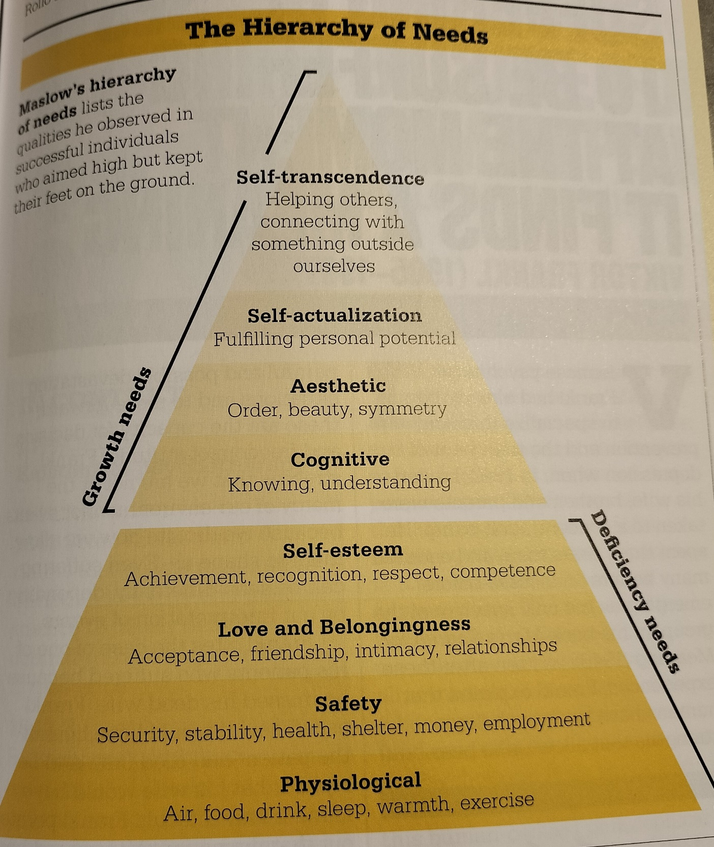
Table 1
(Collin et al., 2012)

Table 2
Table 3
Table 4
Table 5

Table 6

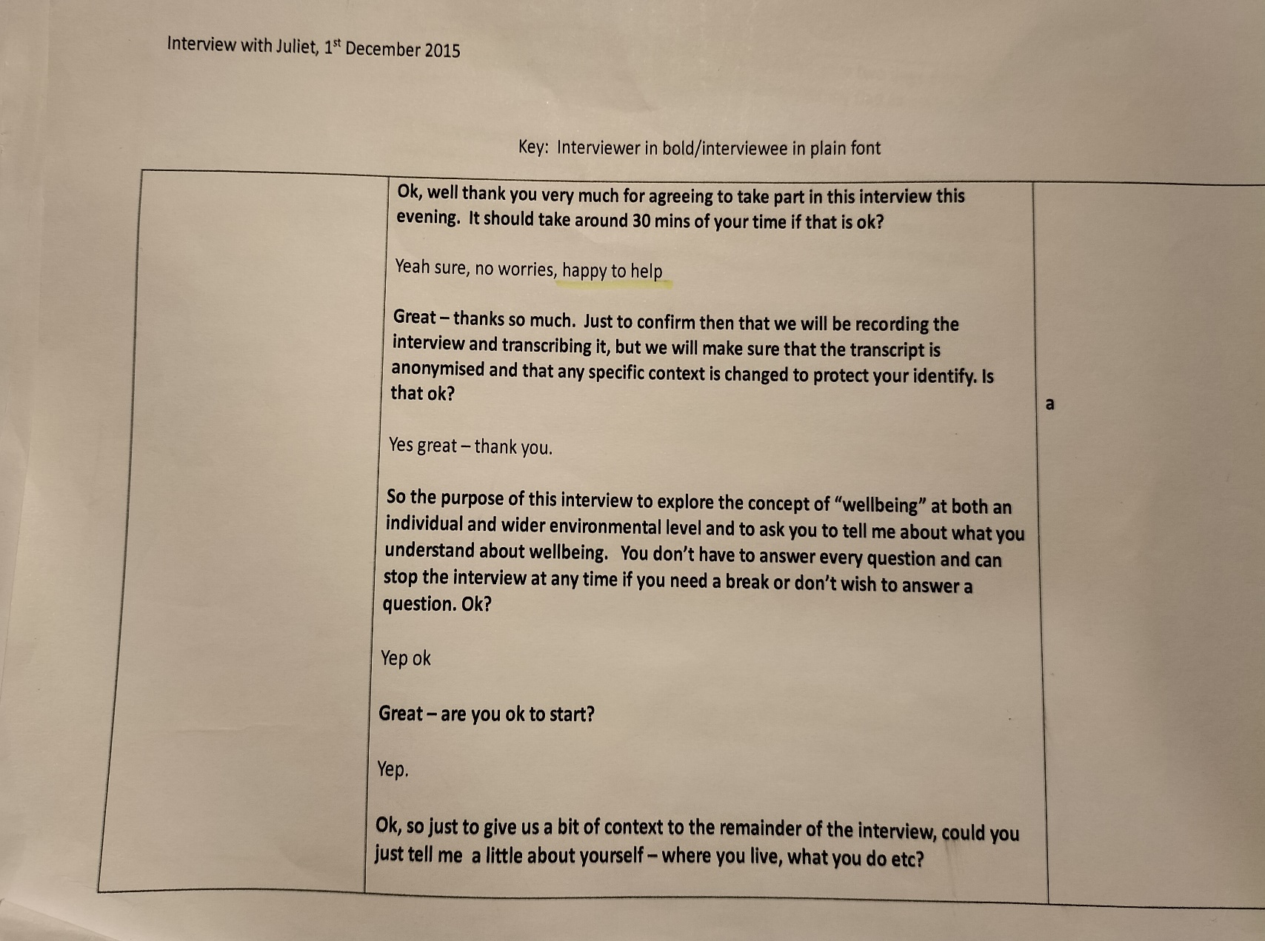
Appendix A

Appendix B
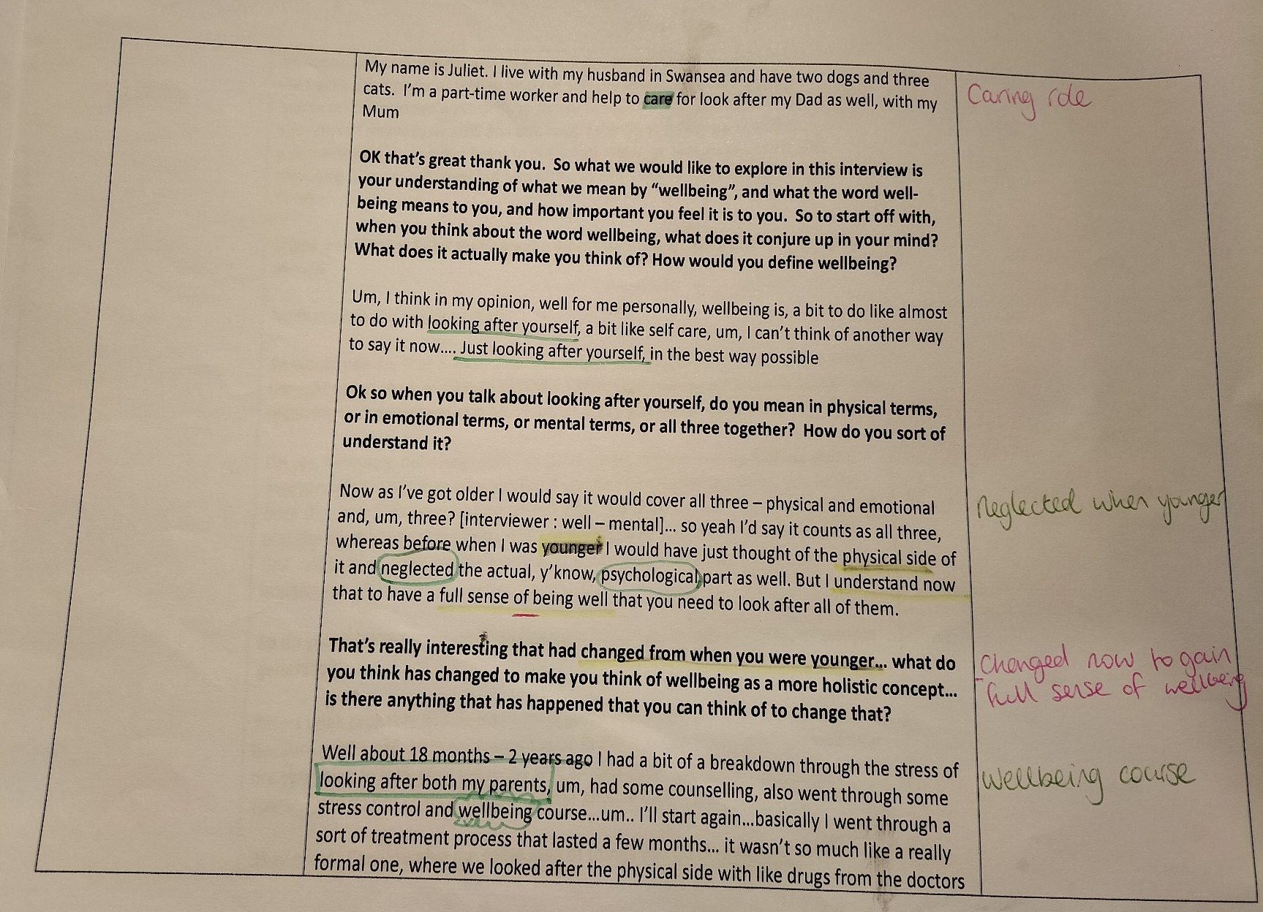

Appendix C
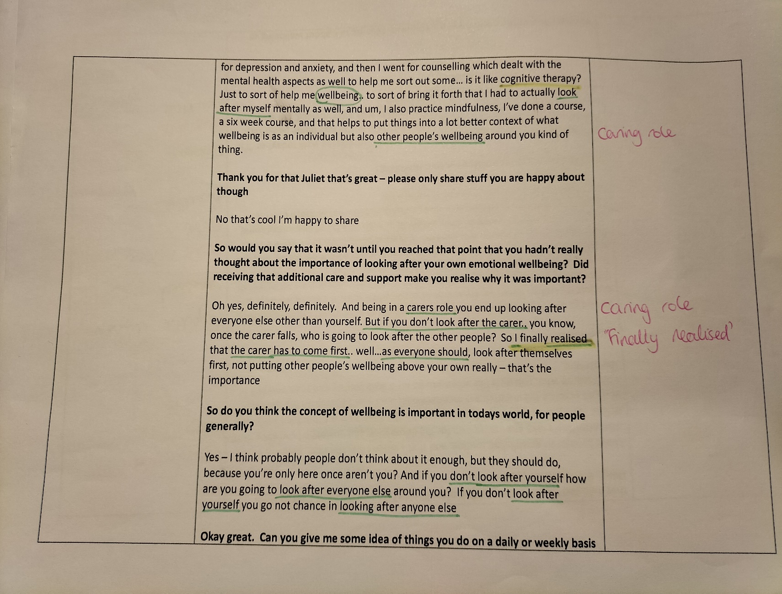

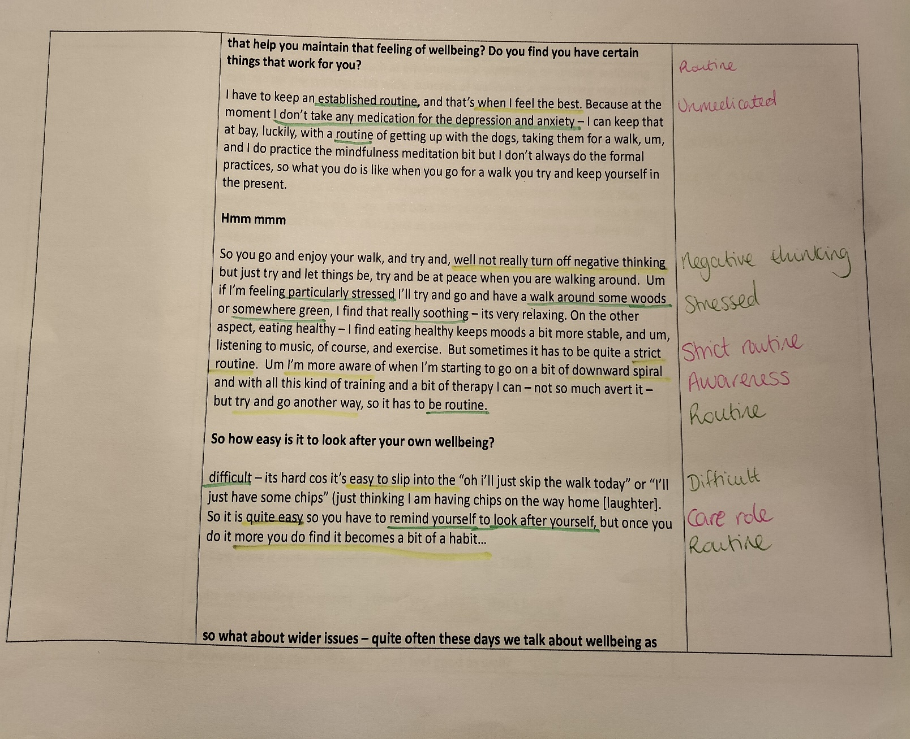
Appendix D

Appendix E
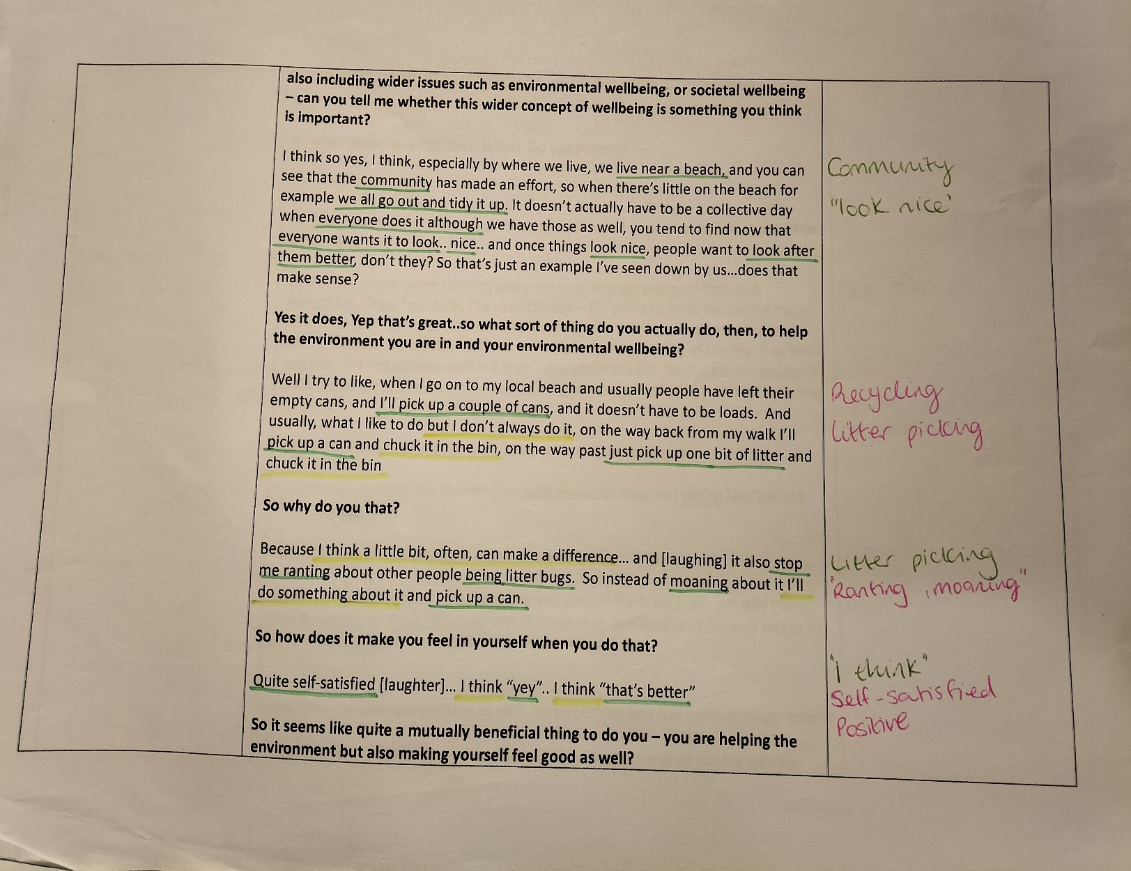

Appendix F
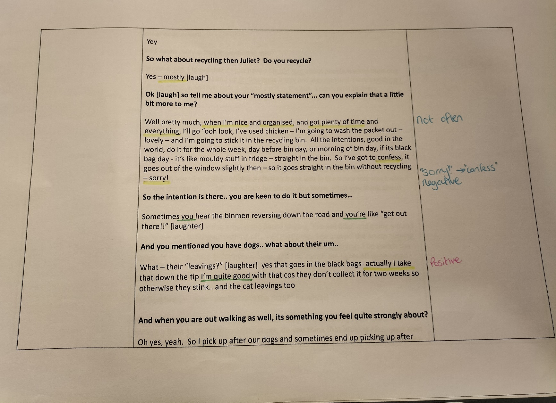

Appendix G
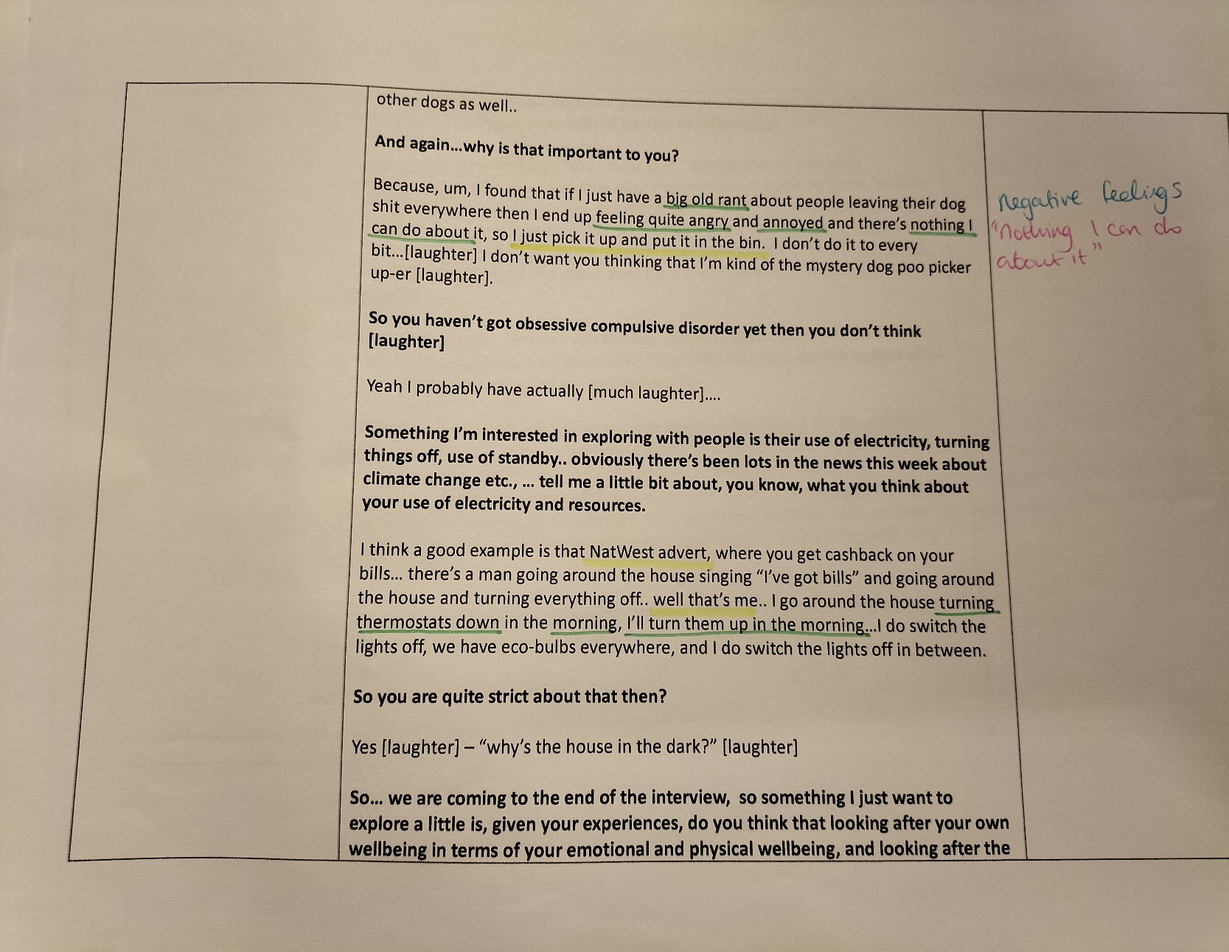

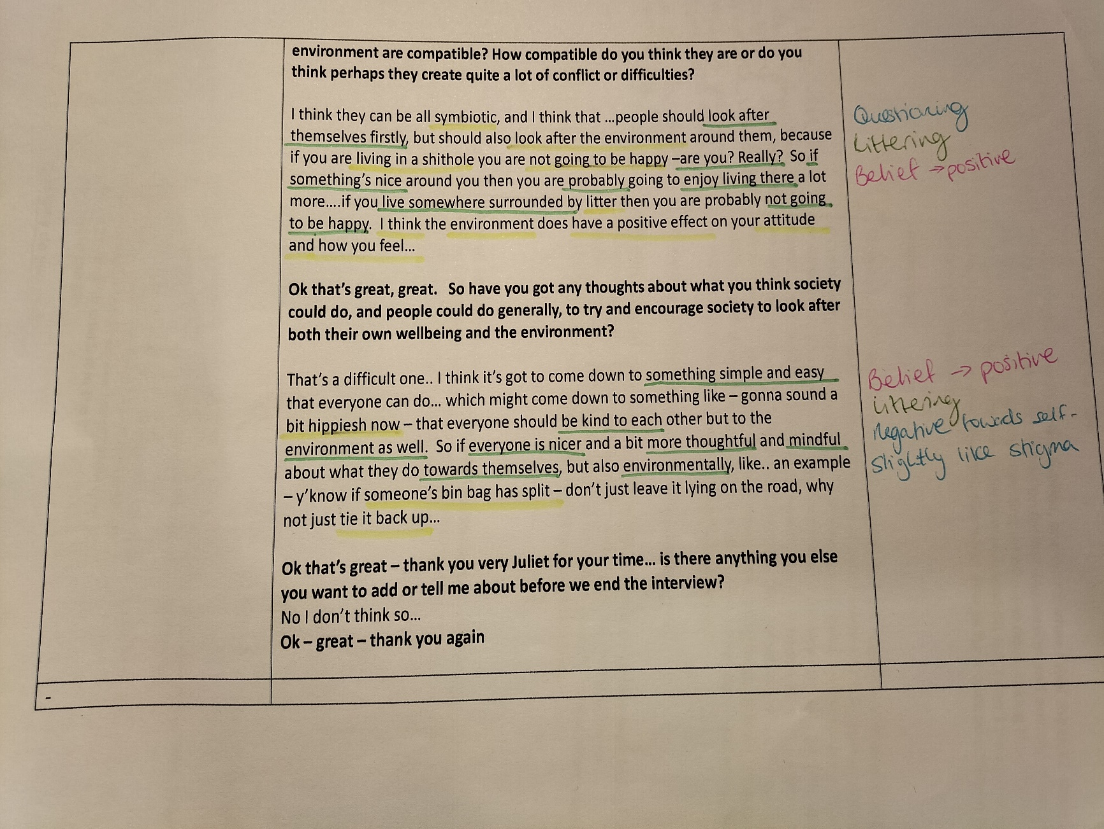
Appendix H

