CLOUD COMPUTING ARCHITECTURE
Assignment Two
ACCA5025

Crina Iordache
Suneth Fernando
University of Wales Trinity Saint David

Table of Contents

Introduction 3

azure virtual machine description 3

virtual machines resources 5

virtual networks 7

network security groups 9

additional exercise 10

conclusion 30

references 30

Introduction

This report is comprised of two main tasks which are as follows, the first task is to describe theoretical aspects and specific views of virtualisation in azure, definition of its characteristics, components, security, graphics, and subnets. The second task is the given exercise of creating two virtual machines, the first with webserver and the second with a database and focus on network security by adding them to a network security group.

azure virtual machine description

Microsoft Azure, a cloud platform developed by Microsoft Corporation, serves as a platform for individuals to access and utilize cloud-based services. The utilization of Microsoft Azure by companies for the storage and management of their information is feasible. Corporations can enhance their operational efficacy by relocating their critical tasks onto the Azure cloud platform. Microsoft has implemented a usage-based pricing strategy for its cloud services. To gain a deeper understanding of the Azure services, further exploration may be pursued.[1][2][3]
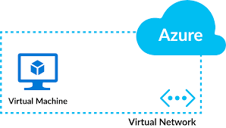
The expeditious creation of virtual machines tailored for both Linux and Windows operating systems can be achieved through the utilization of Microsoft Azure. Azure Virtual Machines could seamlessly operate a diverse range of software, among which are SQL Server, Linux, Windows Server, SAP, Ubuntu Server, Redhat, Oracle software, and applications that are engineered for high-performance computing purposes. The Azure Virtual Machines offer a streamlined approach to the creation of virtual renditions of a diversity of information technology solutions. Certain computer programs provide cost-free assistance in the aspects of collaboration and automated resizing. [1][2][3]
Figure 1 Azure Virtual Machine
Organizations could leverage Microsoft Azure's virtual machines as a means of hosting their web applications in the cloud. The data generated by these applications has the potential to be archived in Microsoft's computerized storage hub. The Azure Virtual Machines offer a plethora of functionalities and capabilities for users to explore and deploy. Azure provides diverse virtual machine (VM) variations that can meet all your application necessities. [1][2][3]
The utilization of VM scale sets facilitates prompt escalation of the quantity of virtual machines within a range of one to thousands and it is possible to safeguard personal information, mitigate the potential risks posed by malicious software on virtual machines, ensure the security of online communication, and adhering to regulations and policies pertaining to data protection. [1][2][3]
There is an option to select between the utilization of Linux or Windows. The individual undertaking the task may elect to employ a pre-existing digital illustration procured from another source, or alternatively, generate an original visual representation utilizing personal creative aptitude. The images can be located within the Azure Marketplace. [1][2][3]
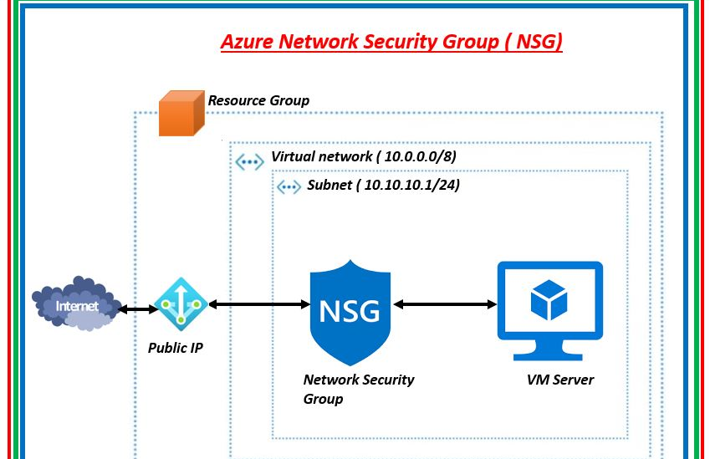
Figure 2 Azure NSG

The implementation of Azure Virtual Machines (VMs) is a cost-effective strategy for minimizing organizational expenses. Through the process of integrating managed instances with Azure Hybrid Benefit, it is possible to achieve a significant cost reduction of up to 80%. The utilization of spot pricing for virtual machines has the potential to result in cost savings for extended usage periods, as opposed to the alternative of hourly rate payment. The implementation of Azure Cost Management facilitates the optimization of budget utilization for cloud services. By migrating to Azure, the continuity of receiving security updates for Windows Server can be ensured for an additional three years, without incurring supplementary charges. [1][2][3]

The present study pertains to the safeguarding, supervision, and preservation of virtual machines through the implementation of Azure toolsets. Ensuring that applications are compatible with Azure facilitates their rapid deployment and implementation organization wide. Azure Advisor provides recommendations for enhancing the dependability, security, swiftness, and cost-effectiveness of all virtual machines. The utilization of Azure Backup can effectively safeguard and fortify the security of pertinent data against probable threats of ransomware. The Azure Monitor solution strategically identifies and pre-emptively mitigates potential issues before they escalate, while simultaneously furnishing valuable insights. The improvement of security measures and adherence to regulations can be effectively facilitated through the utilization of Azure tools. The confidential computing service provided by Azure ensures the perpetual security of data stored in virtual machines, even when in active use. The Azure Security Centre assists in task monitoring as well as identifying and rectifying vulnerabilities. This measure aids in the preservation and safeguarding of data and its confidentiality. The deployment of an Azure virtual machine is limited to allocation on a distinct physical server that is solely designated for organizational use. Azure offers the flexibility of selecting varying levels of assurances to determine the dependability of your virtual machines. The degree of assurance provided by Azure varies depending on the specific virtual machine arrangement. [1][2][3]

virtual machines resources

The process of virtualization segregates hardware and the OS, while software requires four essential components for optimal performance. These components are crucial to a virtual machine system: CPU, network interface, memory and hard drive for storage. Guest operating systems and applications treat them as physical objects. The program has initial resources, which can be changed as needed. Unresponsiveness may stem from a malfunction in one of four components. [1][2][3][4]
Virtual hard disks store substantial amounts of data and were originally used to safeguard simulated computing systems. Currently, they have multiple uses such as testing computer apps, storing important data, using various operating systems, and fixing software bugs. The VHD format can store distinct types of data, making it more flexible compared to other formats. Virtual disks are portable and can be easily moved. Virtual disks are like files that can move easily within a computer and store data efficiently, they vary and require newer Windows versions to start. Fixed size means a set format that works well, taking up all its space and staying the same size. It is viable to enlarge, but space allocation is irrevocable, making recuperation impossible even if no longer needed and this often happens when too much space is given. [4][5][6]
In the context of virtual machine infrastructure, a virtual hard disk (VHD) is a disk drive that shares comparable functionality with a conventional hard drive, although it is accessed, managed, and installed in a virtualized environment. [4][5][6]
The Virtual Hard Disk (VHD) is acknowledged as an application and file format primarily designed to cater to the needs of virtual machines. Commonly, it comprises the identical hard drive sectors that are present on a tangible hard drive, encompassing disk partitions and the file system. [4][5][6]

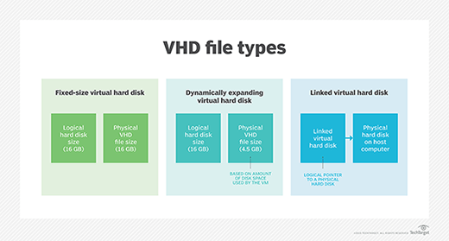
A virtual hard disk operates in a manner similar to that of a conventional physical hard disk, possessing the capacity to generate disk sectors, files, and folders. Additionally, it is capable of supporting an operating system and loading and executing various applications. A logical distribution is assigned to a virtual hard drive, which is situated on a physical hard drive. [4][5][6]
Figure 3 VHD file
As a result, the system has the capacity to accommodate multiple virtual hard drives simultaneously, contingent upon its dimensions. Each virtual hard disk that has been generated operates as a tightly bound drive that does not overwrite or disrupt any of the other virtual hard disks. [4][5][6]
The sizing of virtual hard disks can be either fixed or elastic and is subject to management and control by the virtualization administrator or the parent operating system. The origins of virtual hard disks can be traced back to Connectix Inc., a company subsequently acquired by Microsoft Co. The present software has been designed to serve as a virtual machine application that can be deployed on virtual computers running the Windows operating system. [4][5][6]

virtual networks

Windows Azure is a prominent technology that facilitates the creation, deployment, and administration of software applications across a vast network of Microsoft-controlled data centres, distributed throughout various locations around the world. The technological framework of Windows Azure encompasses various aspects such as cloud facilities, virtual machines, mobile facilities, web sites, data storage, and media. Windows Azure provides its users with the flexibility to choose between existing Windows Server or Linux operating systems and enables them to prepare their own virtual machines as per their requirements.[7][8][9]
The Azure virtual network is a service that enables centralized management and global scalability of subscription-level network resources. The proposition entails the capability to efficiently regulate all network resources via a singular platform.[7][8][9]
Azure Virtual Network is a fundamental instrument that empowers individuals to create, tailor, and administer virtual networks in the Azure cloud computing platform. The creation and management of virtual networks can be facilitated through the utilization of VNet Manager. The present study investigates Virtual Networks as a reliable solution to interconnect organizational resources in the Azure Cloud while concurrently extending On-Premises networks to Azure Cloud. [7][8][9]
The Azure Virtual Network Manager is a service that facilitates the creation and administration of virtual networks within the Azure platform. The Azure virtual networks are self-contained and confidential networks that facilitate the establishment of a secure connection between the Azure resources and the extension of the physical network onto the cloud. The Azure Virtual Network Manager can be regarded as an effective mechanism for the establishment and administration of a personalized virtual private network (VPN) within the Azure platform. The Azure Virtual Network Manager affords the ability to construct virtual networks, subnets, and network security groups (NSGs). Azure Resource known as Virtual Networks enables interconnecting of different Azure resources. Subnetting is a technique that enables the division of a virtual network into smaller, segmented subnetworks. Network security groups (NSGs) provide the means to manage incoming and outgoing traffic within a virtual network. By utilizing a series of user-friendly prompts, one may effortlessly generate a virtual network and tailor it to suit their specific requirements. It is possible to include subnets, tailor IP addresses, and establish connectivity between an On-Premises network and a virtual network. It is possible to configure subnets to have Ip addresses, followed by the implementation of further modifications to permit or restrict traffic based on the utilization of network security groups. Network Security Groups (NSGs) can be configured with precise rules that enable or disable the flow of data relying on the underlying protocols, ports, and the source or destination Internet Protocol (IP) addresses. The utilization of a Virtual Private Network (VPN) gateway facilitates a secure connection between a physical network and a virtual network in Azure, thereby imparting the ability to access Azure resources in a similar manner as if they were locally present. [7][8][9]

network security groups
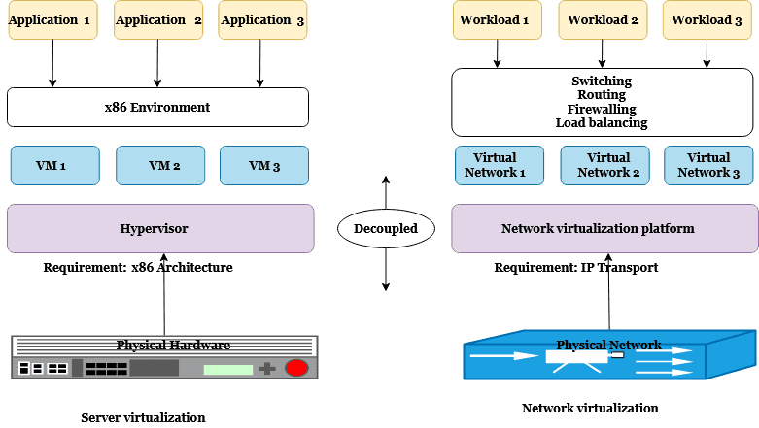
Figure 4 Virtual network
Network security groups serve to enhance the security of virtual networks within the Azure environment by partitioning them into smaller, more secure segments as they facilitate the generation of security regulations for applications based on centralized data rather than individual IP addresses. The process effectively segregates internet traffic originating from secure components of a computer network, thereby enabling the conglomeration of virtual machines whilst simultaneously safeguarding software programs.[9][10][11]
This system is able to categorize internet traffic based on the specific functionalities of various applications. To establish an effective organizational structure for applications, it is recommended to create distinctive groups and assign them appropriate nomenclature that reflects their interdependence and collective functionality. The said resource may be used for diverse purposes, such as programming, task management, computer components, degrees of complexity, environment, and any profession. [9][10][11]
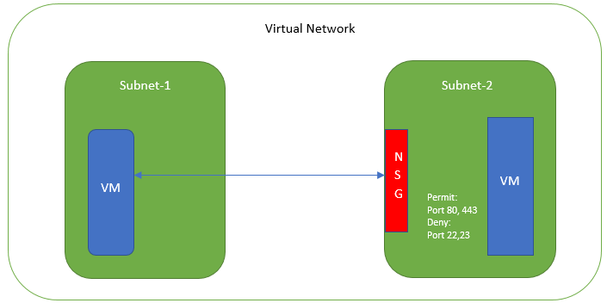
NSGs can be employed to establish a singular set of regulations for the virtual network. By utilizing a singular N.S.G. it is possible to uniformly enforce the regulations across various segments of a network. Using a single network security group affords the ability to effectively view and regulate all traffic regulations in a centralized location. [9][10][11]
Figure 5 Virtual network

It is imperative to ensure that virtual machines are appropriately assigned to relevant groups to optimize their functionality and effectiveness. To enable the execution of distinct operations on a virtual machine, one may utilize multiple network security groups. One's access to resources is contingent upon the specific tasks and requirements they must fulfil. The concern pertaining to security has been assuaged, eliminating the need for any further apprehension. It is possible to establish a working arrangement wherein individuals are exclusively permitted to utilize particular programs that have been approved by the authorities in charge. [9][10][11]
utilization of Azure Security Groups facilitates a reduction in the number of network security groups present in each subscription. At times, it suffices to employ a single network security group for governing multiple subnets within a virtual network. Automated setting adjustments allow individuals to effectively manage their surroundings while in motion, offering a plethora of beneficial advantages. The underlying concept of the N.S.G. is to centralize all traffic regulations in a singular, cohesive location. The process of effecting modifications and regulating them is uncomplicated. To grant authorization to a cluster of virtual machines or incorporate an additional port to these clusters, one could modify a targeted protocol. [9][10][11]
Centralized logging refers to the process of gathering all log data into a singular location. The comprehension and examination of traffic can be facilitated by this aspect. It is comparatively simpler to manage homogeneous logs with identical formatting. To impede the ingress of specific categories of data, one may establish a pivotal safety regulation and adhere to directives set forth by authoritative personnel. [9][10][11]
Furthermore, autoscaling groups aid in the separation of various tasks and contribute to enhanced safety within your virtual network. In the depicted image, a diverse array of programs is employed across a computer network. According to the security policies, tasks are maintained in separate entities to ensure their distinctiveness. Should an unauthorized individual gain access to a single program within a virtual machine environment, the potential for harm would be significantly reduced. Within this scenario, let us consider the scenario where an individual or a group has infiltrated one of the computer systems responsible for operating a particular website. Nevertheless, the remaining sections of the website shall remain secure, and access to vital resources such as the database shall be precluded. This application ensures the safety and security of your network by providing protection against unauthorized access and facilitating prompt response in case of any security breach. [9][10][11]

additional exercise

In this section I will describe and provide examples and illustrations for the successful creation and configuration process of the virtual machines and their creation process, virtual network, virtual security group, its subnets and MySQL database.

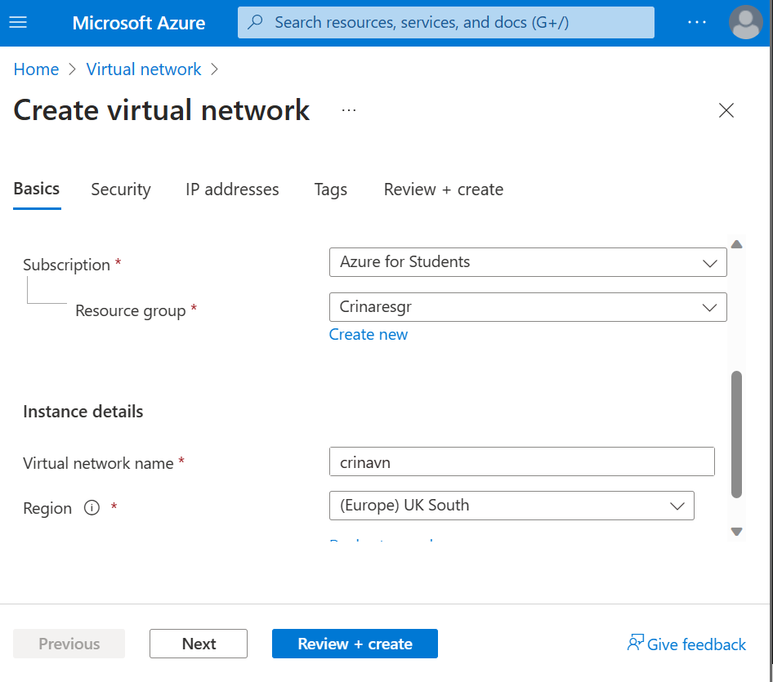
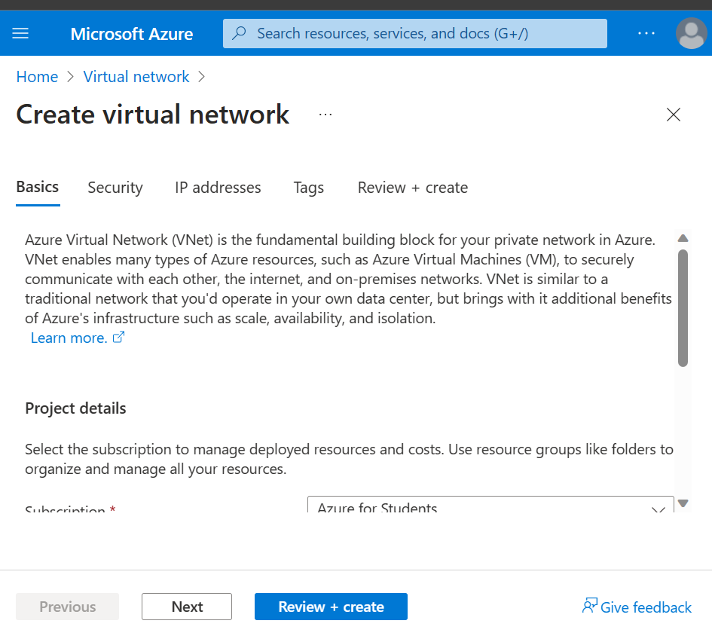
Figure 6 Virtual network creation two
Figure 7 Virtual network creation
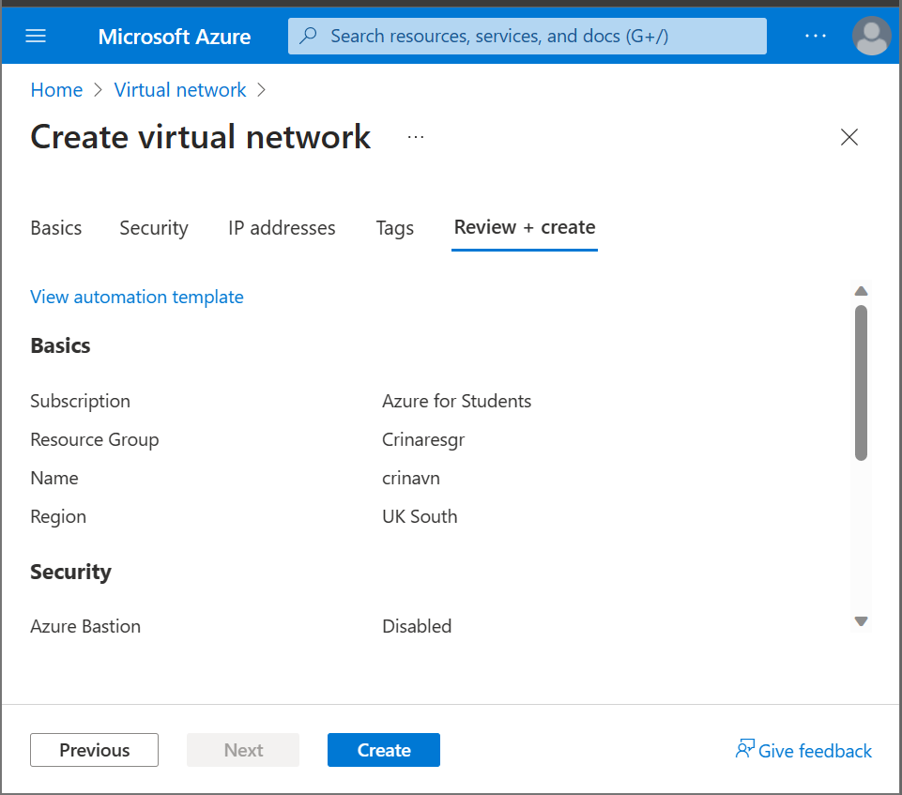
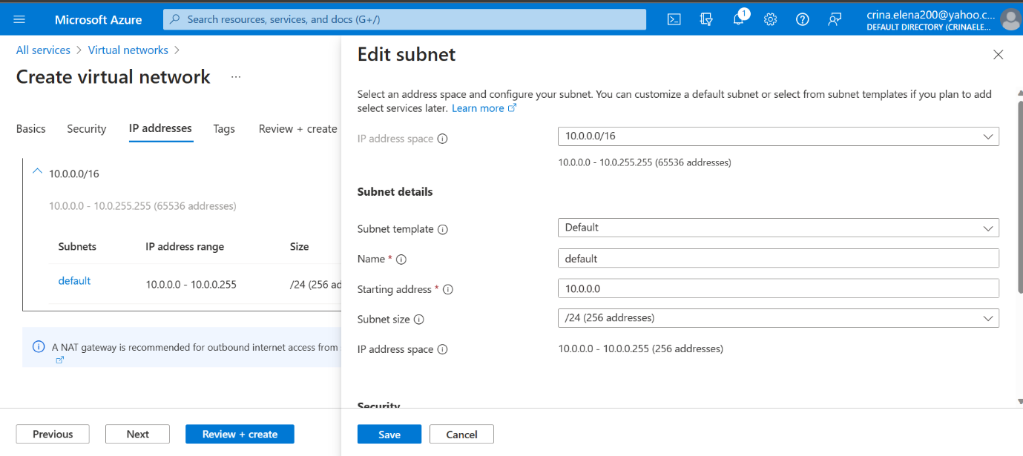
Figure 8 Virtual network creation three
Figure 9 Virtual network creation four

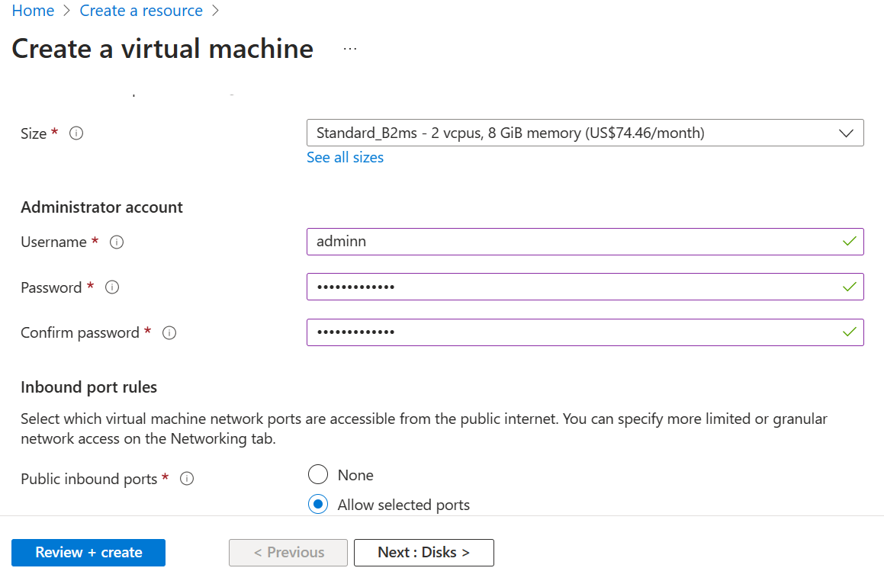
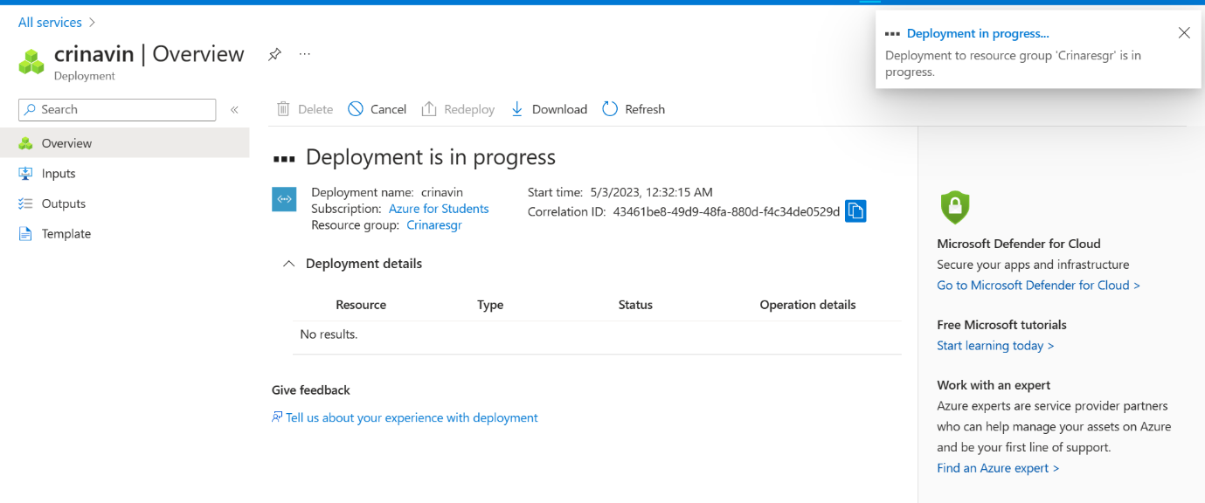
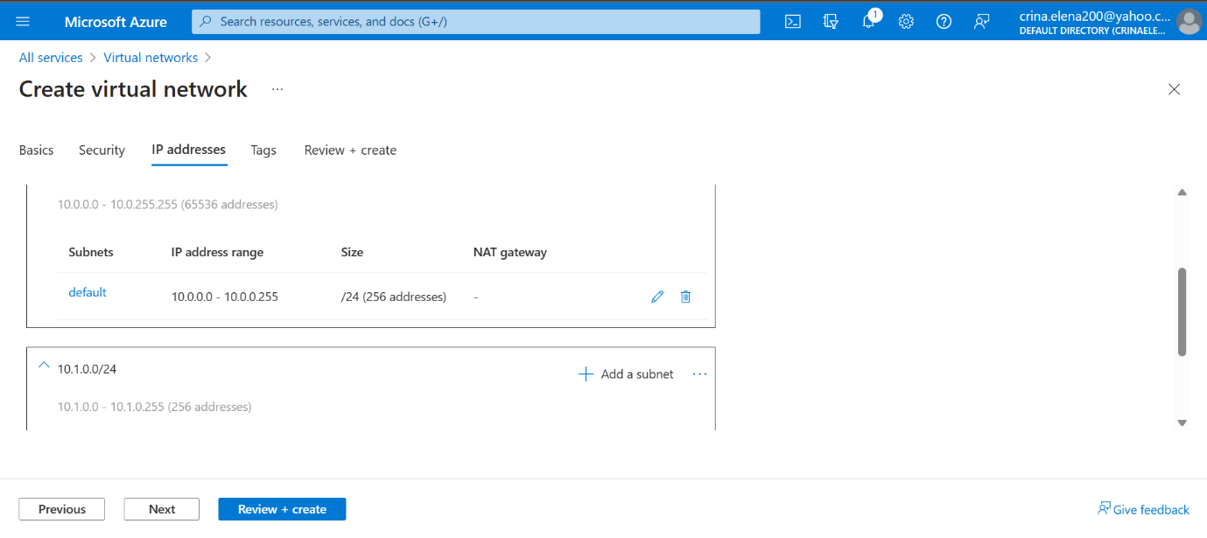
Figure 12 Virtual machine
Figure 10 Virtual network five
Figure 11 Virtual network creation six
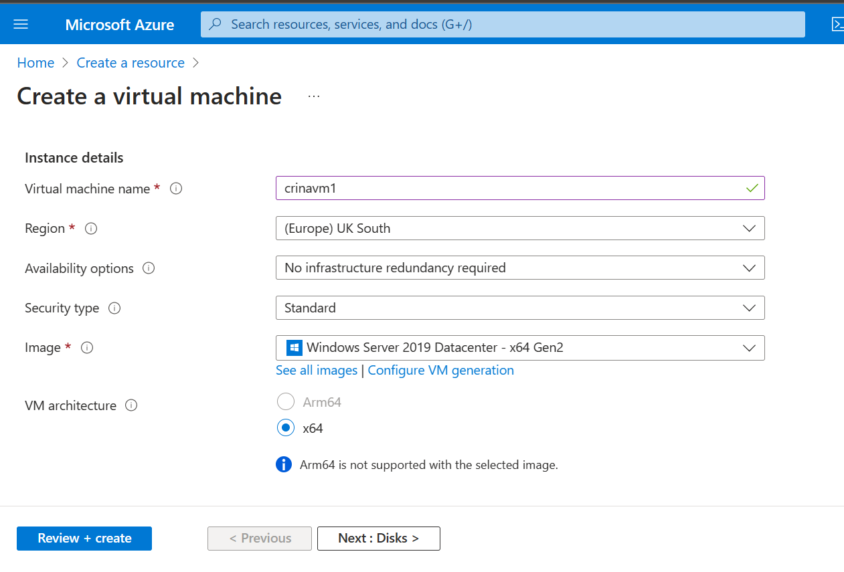
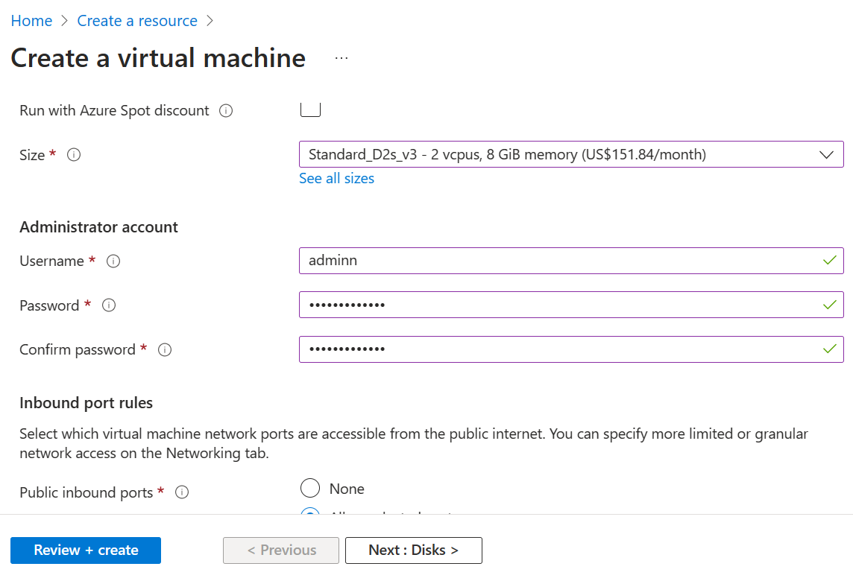
Figure 13 Virtual machine
Figure 14 Virtual machine
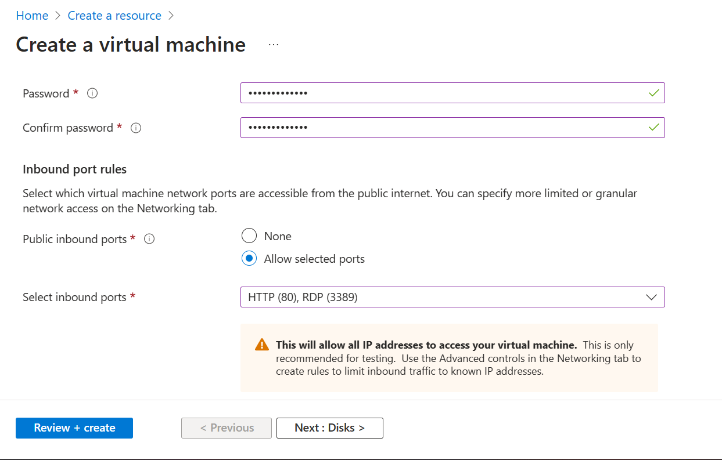
Figure 15 Virtual machine
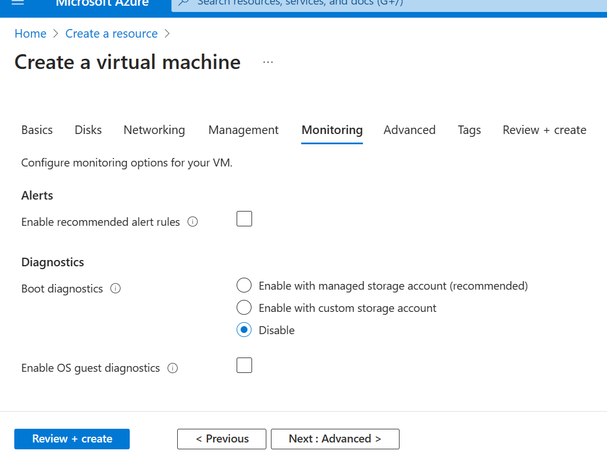
Figure 16 Virtual machine
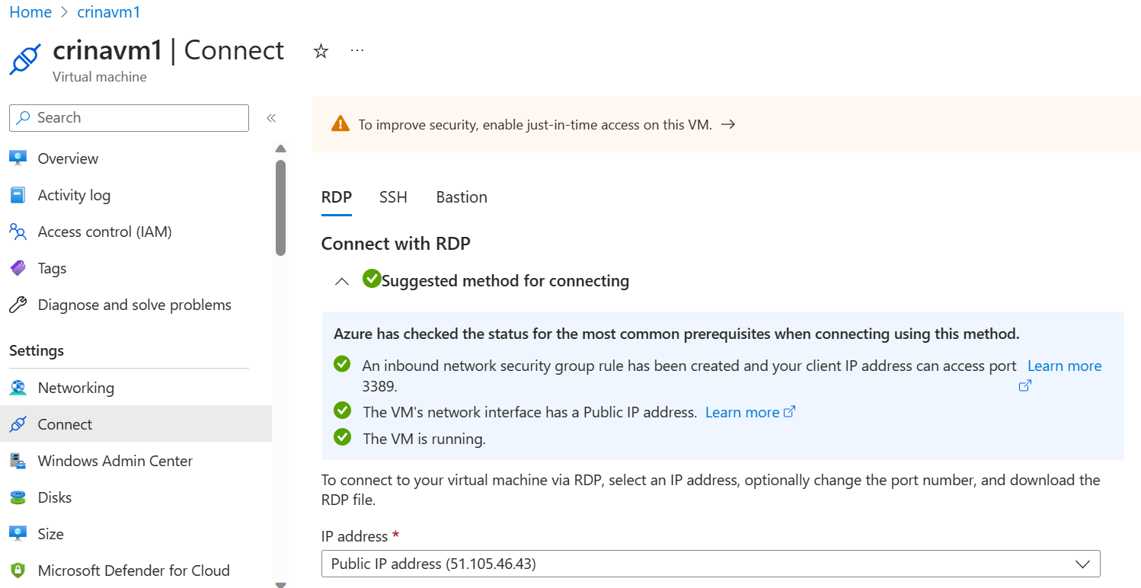
Figure 17 Virtual machine RDP connection
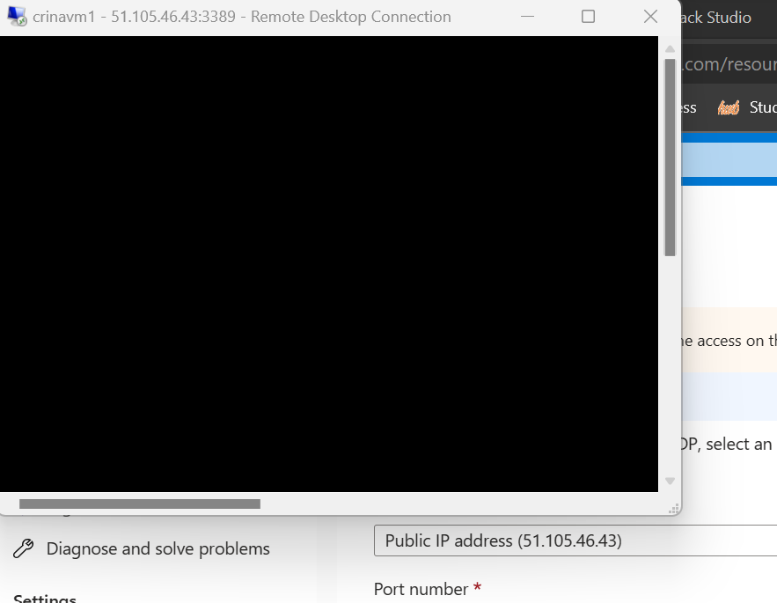
Figure 18 Virtual machine RDP
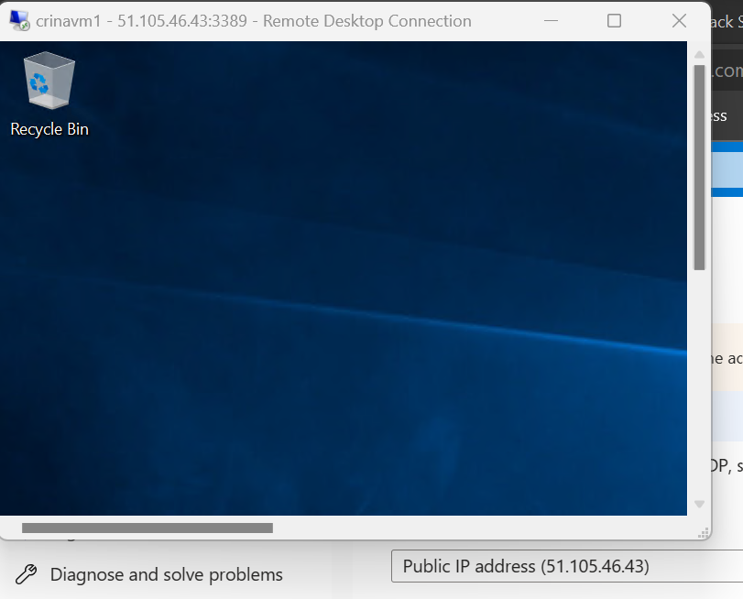
Figure 19 Virtual machine RDP
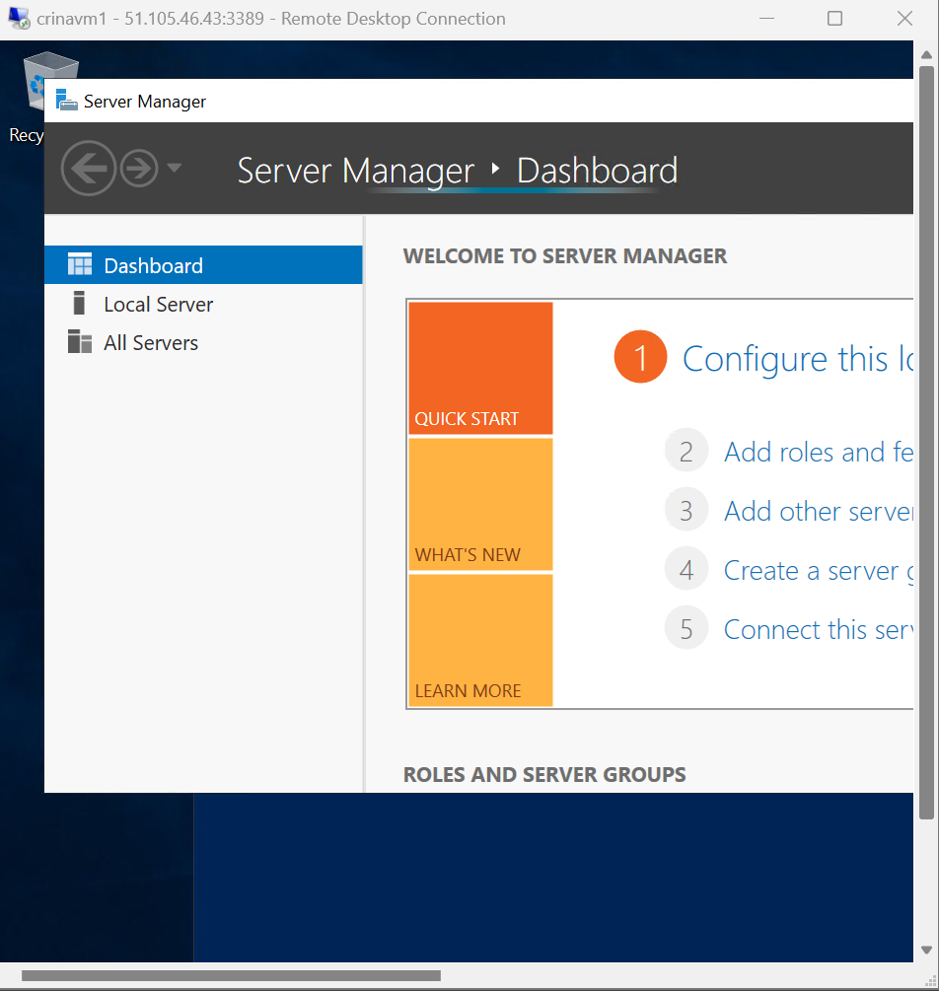
Figure 20 Virtual machine RDP
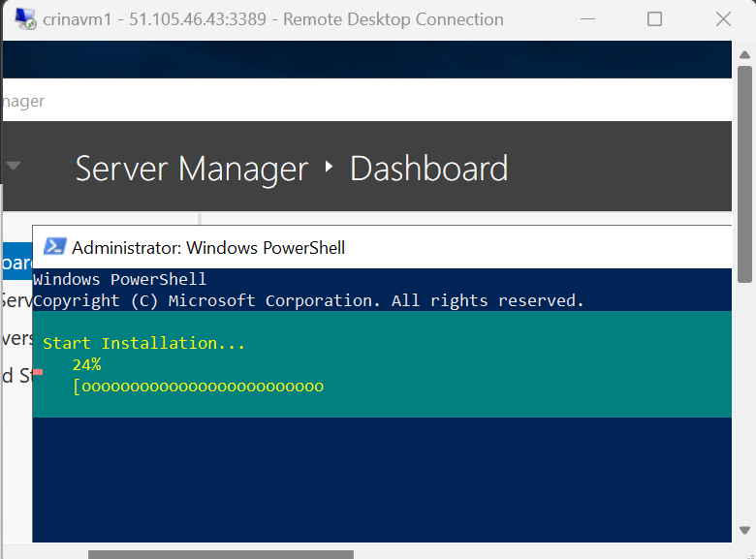
Figure 21 Virtual machine RDP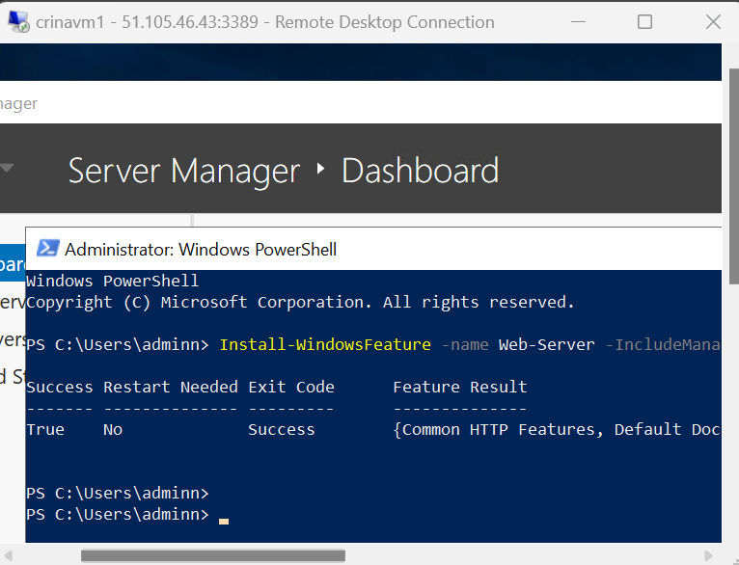
Figure 22 Virtual machine RDP

Figure 23 Virtual machine RDP
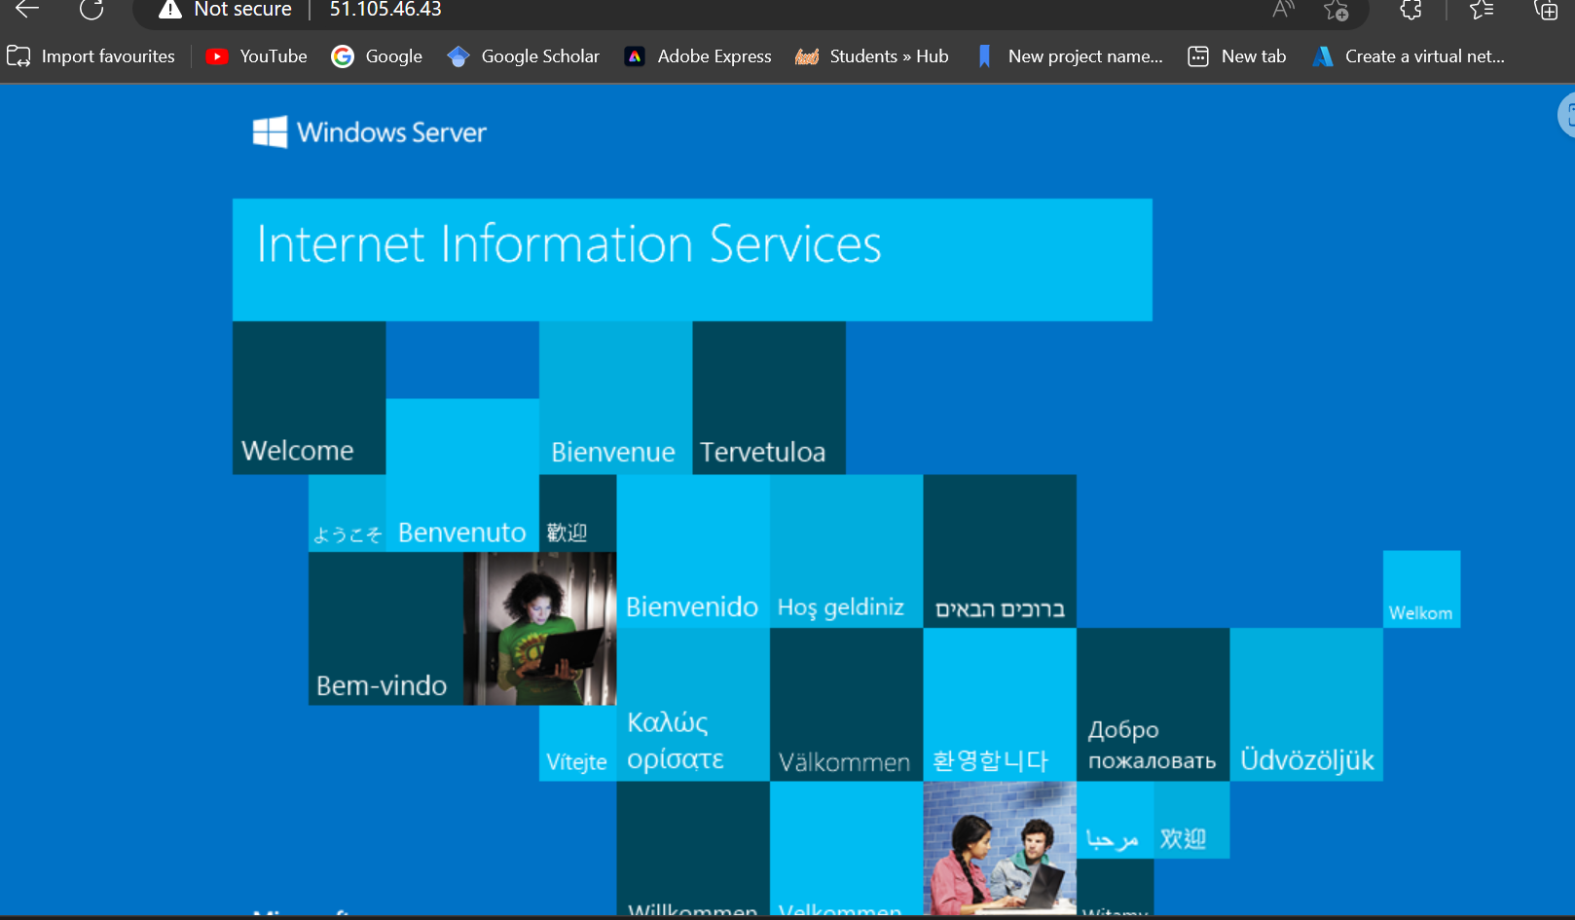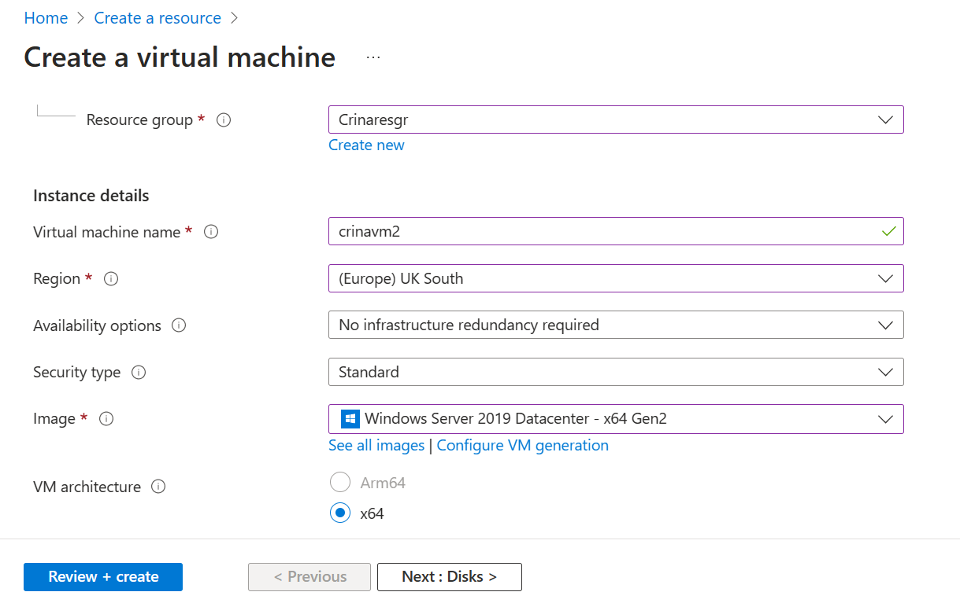
Figure 24 Virtual machine
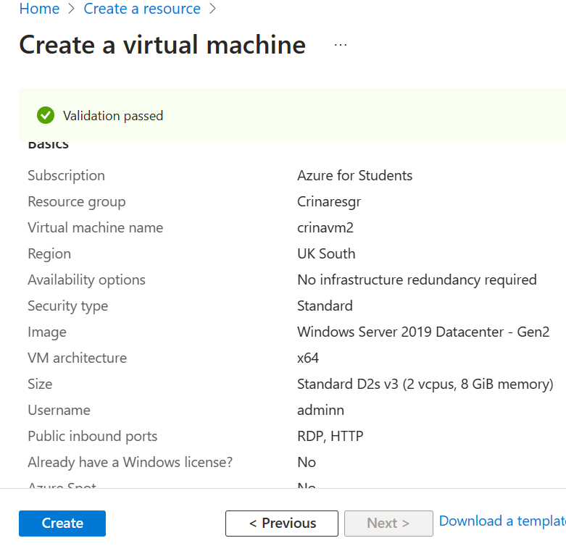
Figure 25 Virtual machine creation
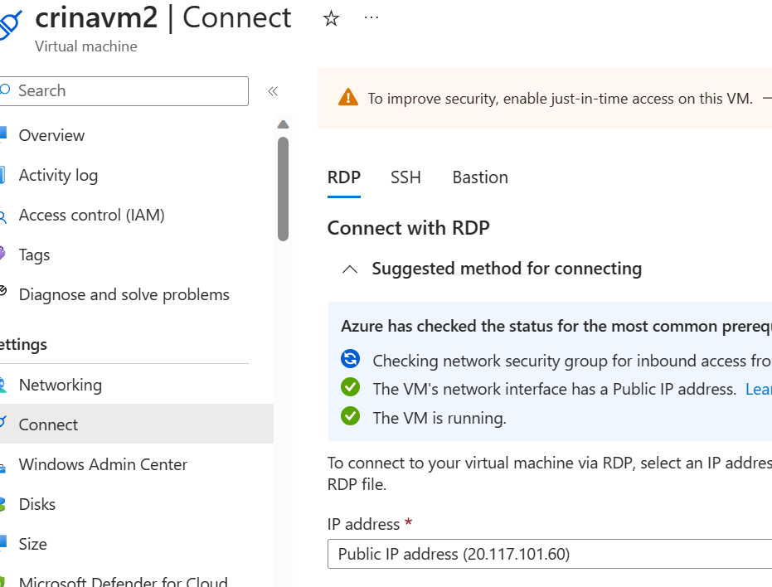
Figure 26Virtual machine RDP 2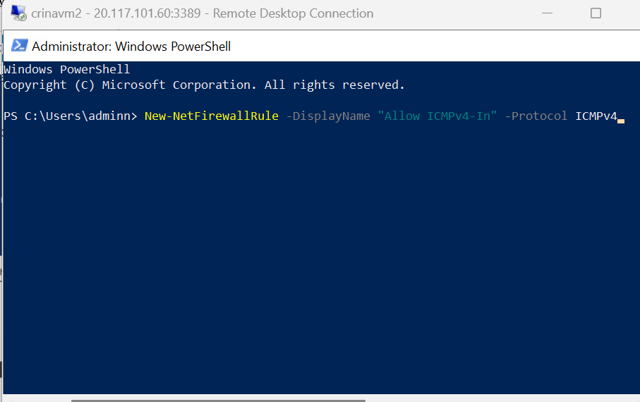
Figure 27 Virtual machine RDP
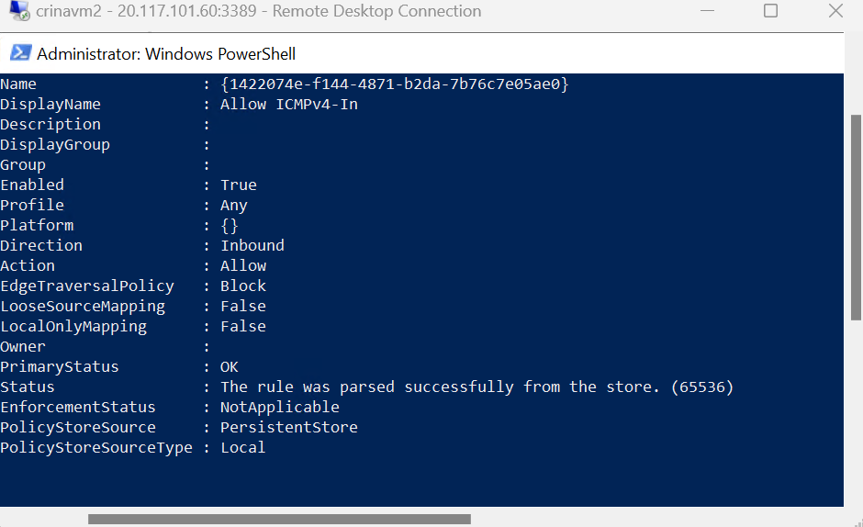
Figure 28 Virtual machine RDP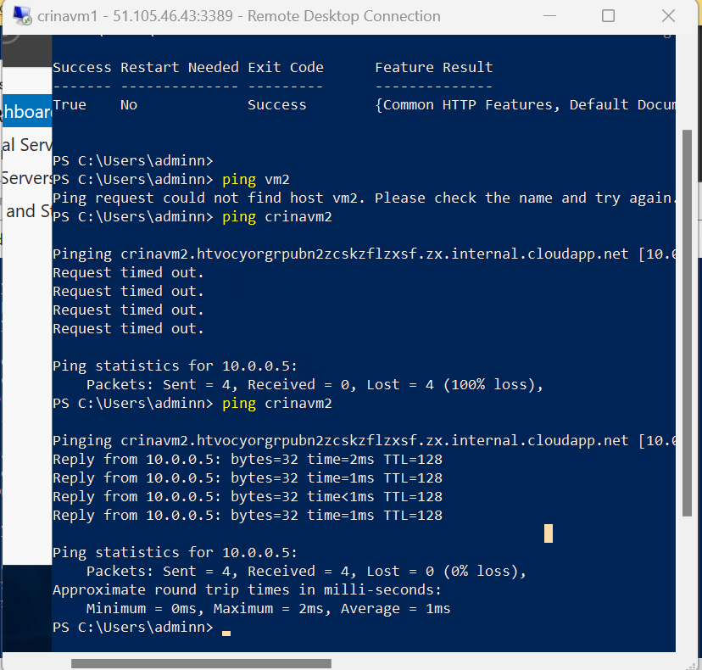
Figure 29 Virtual machine RDP
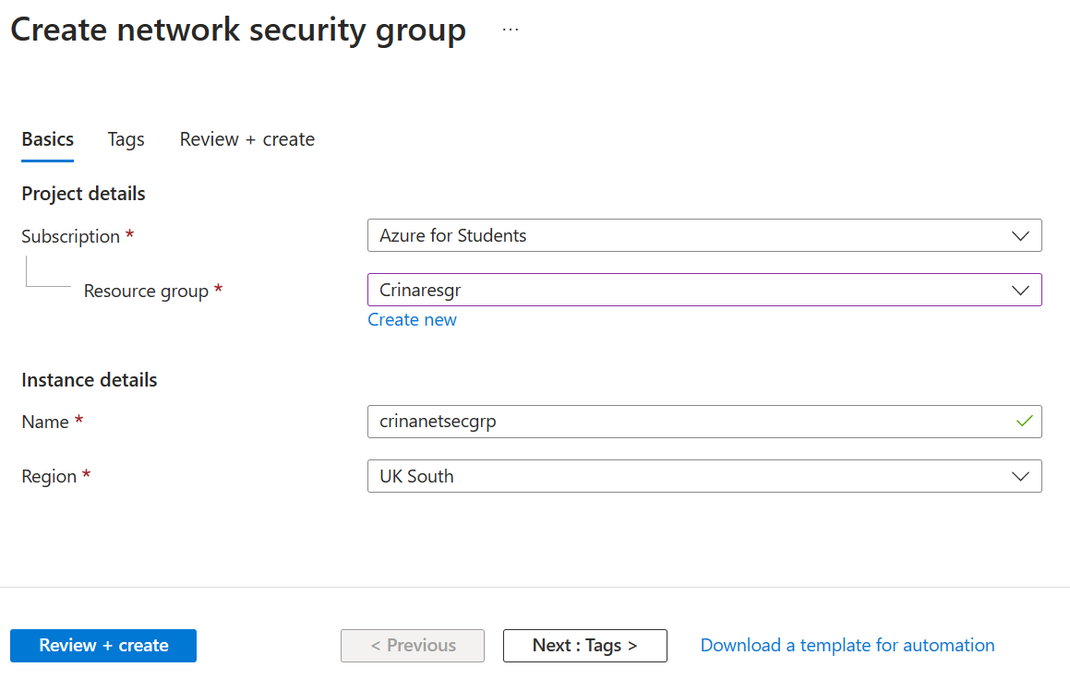
Figure 30 Network security group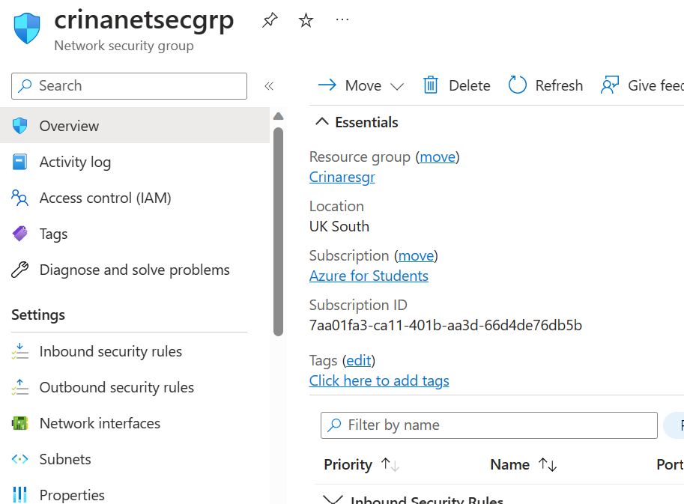
Figure 31 Network security group
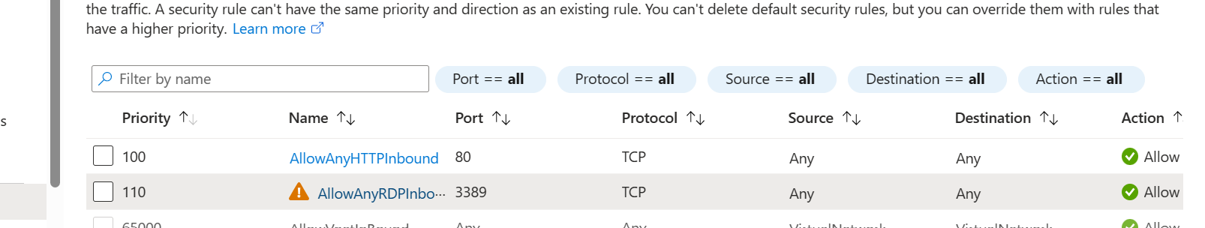
Figure 32 Network security group
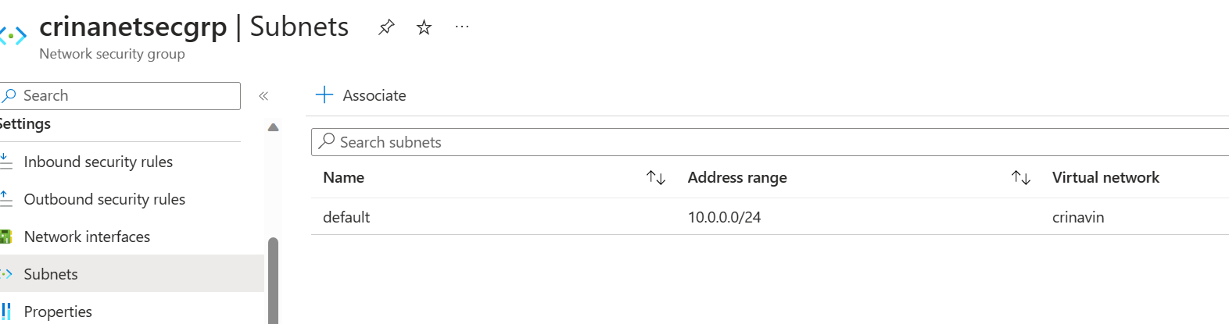
Figure 33 Network security group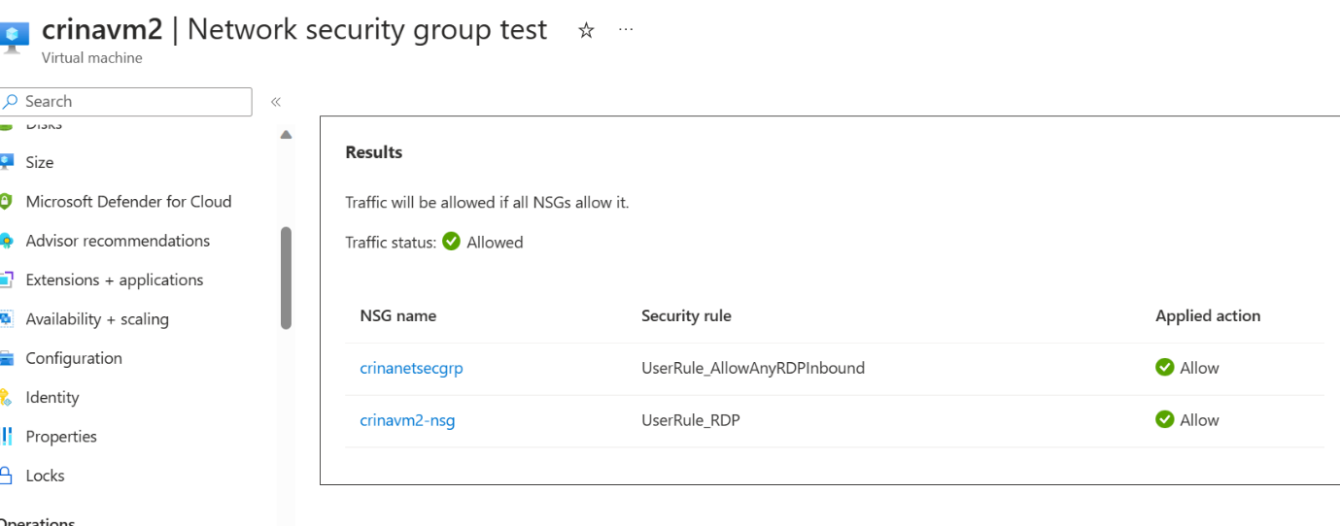
Figure 34 Network security group
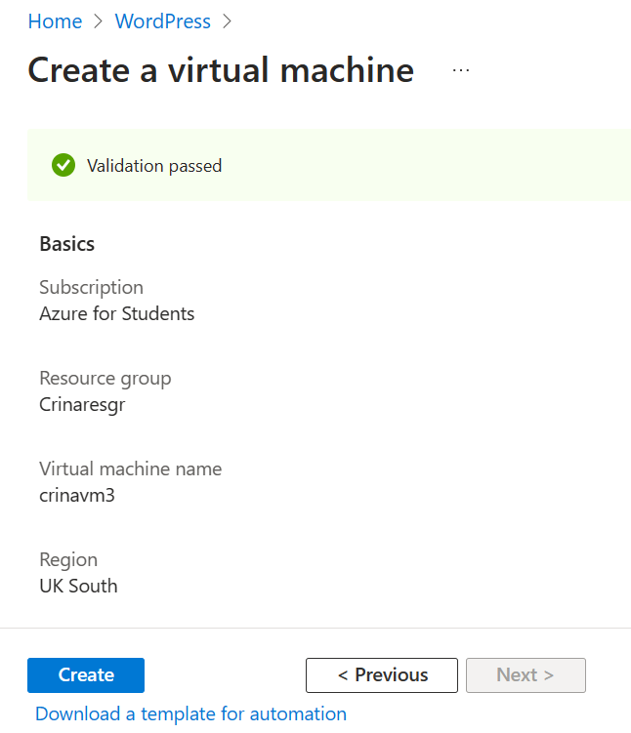
Figure 35 WordPress
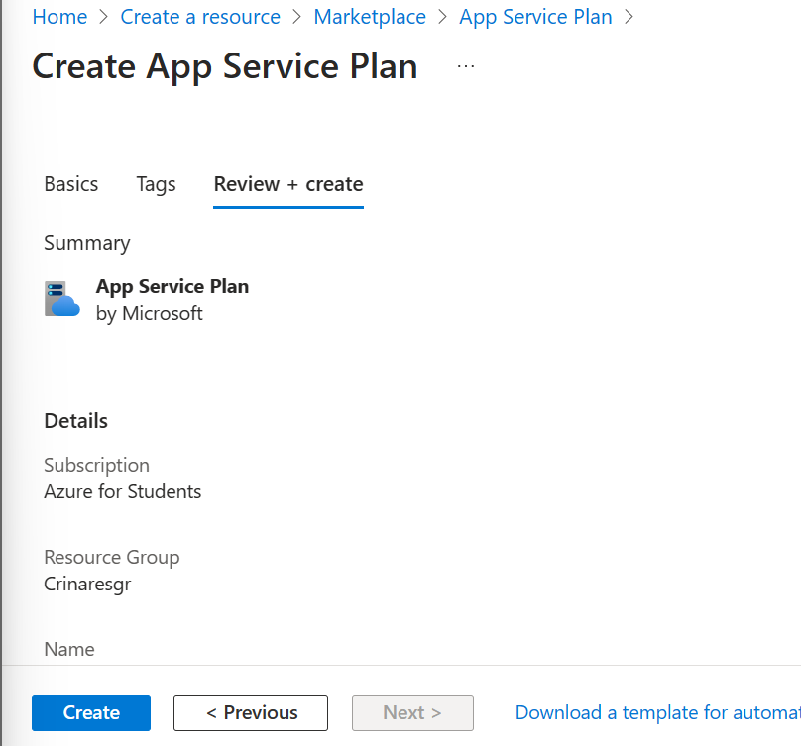
Figure 36 WordPress
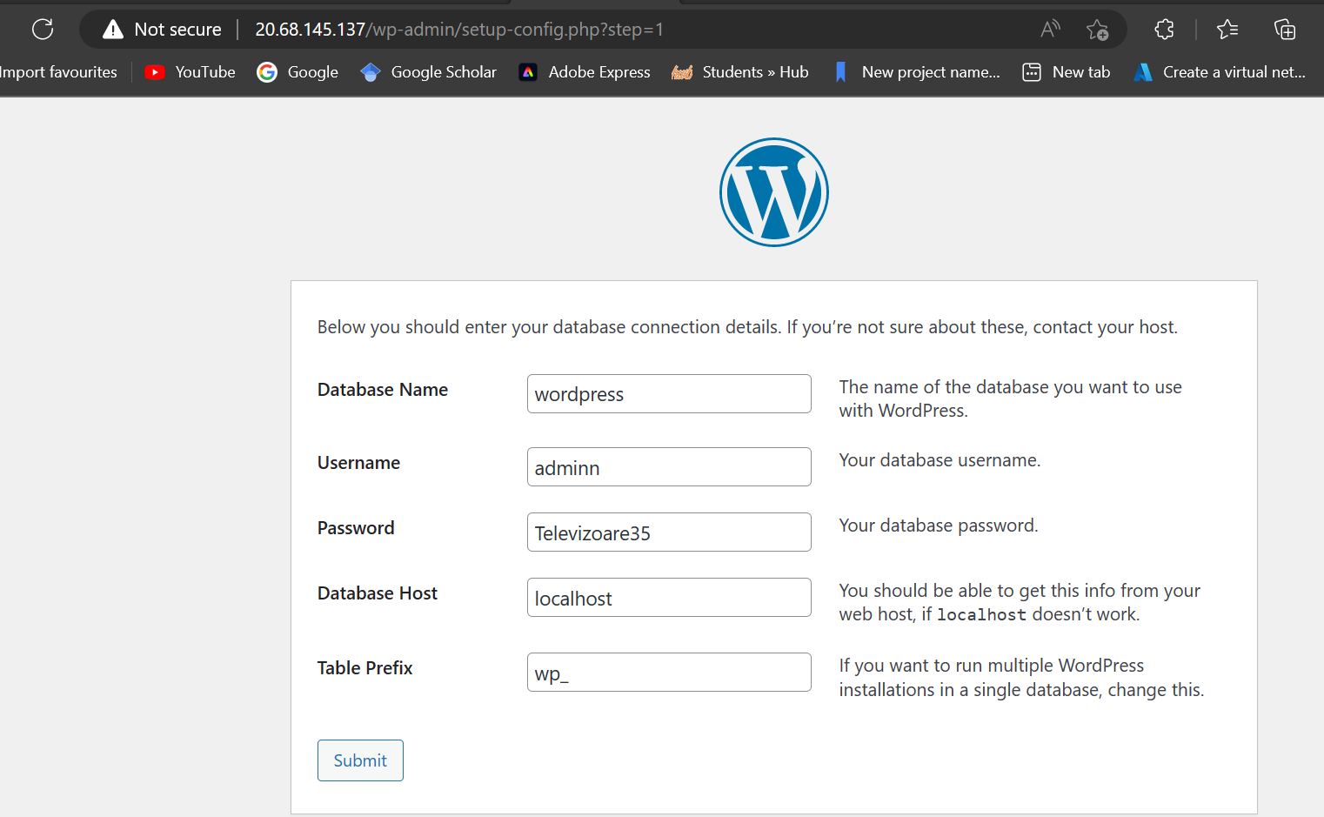
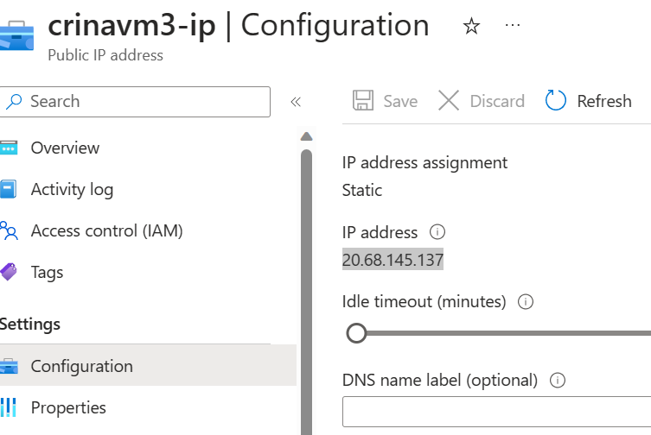
Figure 37 WordPress
Figure 38 WordPress
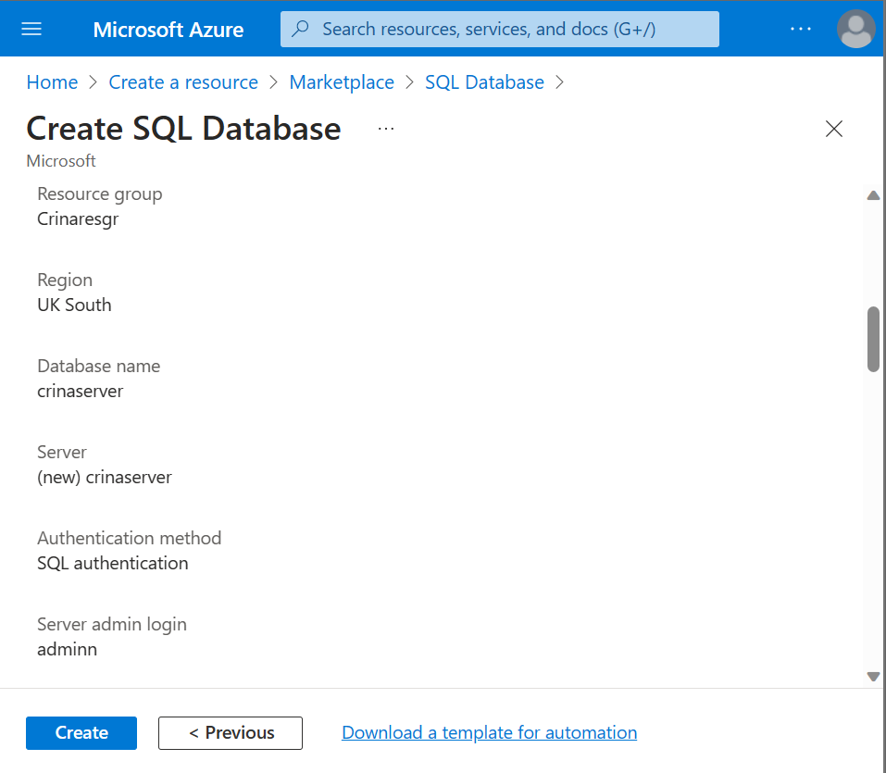
Figure 39 SQL Database
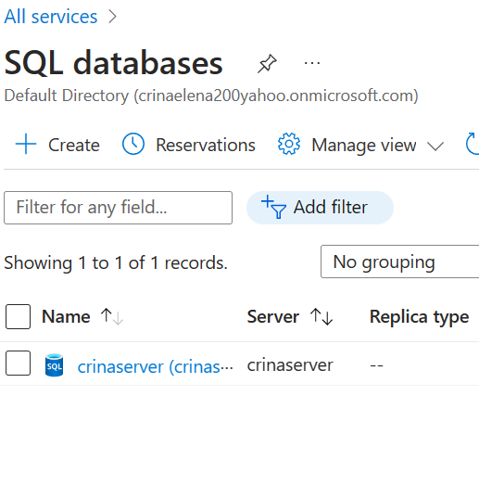
Figure 40 SQL Database
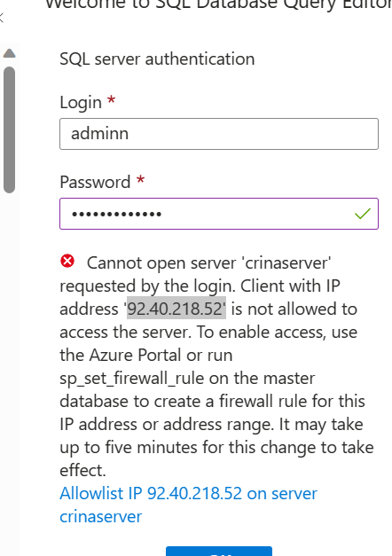
Figure 41 SQL Database
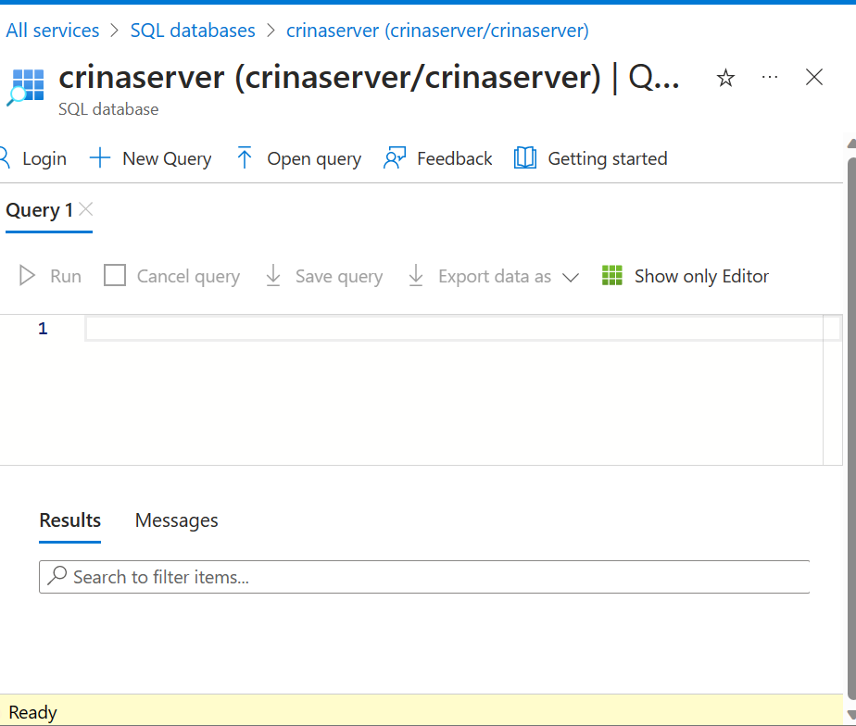
Figure 42 SQL Database
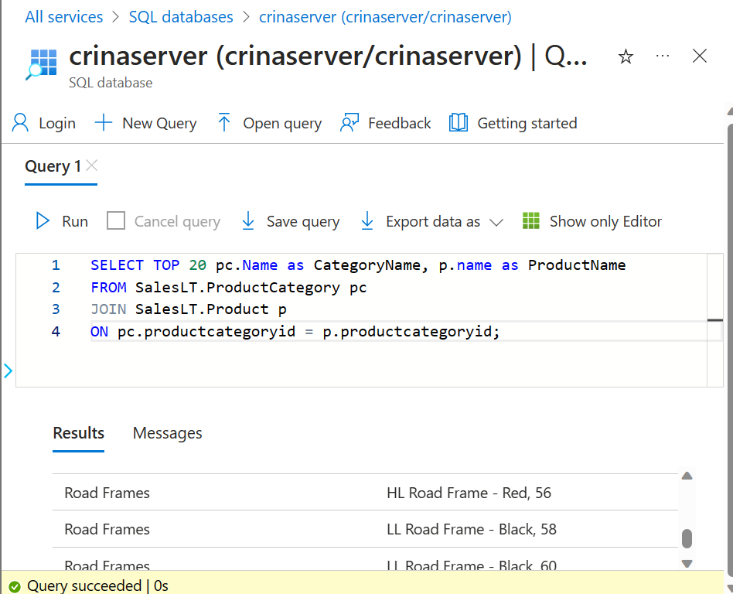
Figure 43 SQL Database

conclusion

In conclusion based on the given research, information, illustration, and proof of exercise successful completion the topics have been presented in a straightforwardly, comprehensible, yet complex and in-depth manner and all the key areas have been thoroughly discussed.
Video link: Virtual machine creation process. - YouTube

references

[1]T. L. Warner, Microsoft Azure for Dummies. John Wiley & Sons, 2020. Accessed: Mar. 07, 2023. [Online]. Available: https://books.google.co.uk/books?hl=ro&lr=&id=hQbQDwAAQBAJ&oi=fnd&pg=PA3&dq=azure+regions+availability+zones+and+resource+groups&ots=s8hyu4N-I9&sig=Rh8RFrM0ujK5ZsGa-FEbNRzCexg&redir_esc=y#v=onepage&q=azure%20regions%20availability%20zones%20and%20resource%20groups&f=false
[2]P. Herath, “Securing Resources with Azure Firewall,” Azure Cloud Security for Absolute Beginners, pp. 189–205, Dec. 2021, doi: https://doi.org/10.1007/978-1-4842-7860-4_9.
[3]J. Soh, M. Copeland, A. Puca, and M. Harris, “Overview of Azure Infrastructure as a Service (IaaS) Services,” in Microsoft Azure, Berkeley, CA: Apress, 2020, pp. 21–41. doi: https://doi.org/10.1007/978-1-4842-5958-0_2.
[4]M. Galloway, G. Loewen, J. Robinson, and S. Vrbsky, “Performance of Virtual Machines Using Diskfull and Diskless Compute Nodes,” IEEE Xplore, Jul. 01, 2018. https://ieeexplore.ieee.org/abstract/document/8457870?casa_token=7kVQfdyN2VUAAAAA:yYZ0vY9ZFn0IOAMNQBroNiawMsRQgXhNPvlCxuOUWY4-PgDWr_QUoj-WBjW1-BeGcIP6PQdjuQTAZw (accessed May 02, 2023).
[5] Q. Zhang et al., “Open access to the Proceedings of the 15th USENIX Symposium on Networked Systems Design and Implementation is sponsored by USENIX. Deepview: Virtual Disk Failure Diagnosis and Pattern Detection for Azure This paper is included in the Proceedings of the 15th USENIX Symposium on Networked Systems Design and Implementation (NSDI ’18). Deepview: Virtual Disk Failure Diagnosis and Pattern Detection for Azure,” 2018.

[6]C.-J. Su and S.-F. Huang, “Real-time big data analytics for hard disk drive predictive maintenance,” Computers & Electrical Engineering, vol. 71, pp. 93–101, Oct. 2018, doi: https://doi.org/10.1016/j.compeleceng.2018.07.025.
[7]M. Wali, Learn Microsoft Azure: Build, manage, and scale cloud applications using the Azure ecosystem. Packt Publishing Ltd, 2018.

[8]M. Noshy, A. Ibrahim, and H. A. Ali, “Optimization of live virtual machine migration in cloud computing: A survey and future directions,” Journal of Network and Computer Applications, vol. 110, pp. 1–10, May 2018, doi: https://doi.org/10.1016/j.jnca.2018.03.002.
[9]D. Firestone et al., “This paper is included in the Proceedings of the 15th USENIX Symposium on Networked Systems Design and Implementation (NSDI ’18). Azure Accelerated Networking: SmartNICs in the Public Cloud Azure Accelerated Networking: SmartNICs in the Public Cloud,” 2018. Accessed: May 02, 2023. [Online]. Available: https://www.usenix.org/system/files/conference/nsdi18/nsdi18-firestone.pdf
[10]J. Backes et al., “Reachability Analysis for AWS-Based Networks,” Computer Aided Verification, pp. 231–241, 2019, doi: https://doi.org/10.1007/978-3-030-25543-5_14.
[11]
D. Huang, A. Chowdhary, and S. Pisharody, Software-Defined Networking and Security: From Theory to Practice. CRC Press, 2018.

