ECIE4012
The Principles of Learning and Teaching

Portfolio

Student Number:2223470

Blog 1
Demonstrate your understanding of a theory of learning from the following list: Bruner, Dewey, Skinner, Piaget, Vygotsky, Froebel
Theory of Cognitive Development


(monstersinc.fandom.com)
Have you ever felt like you’re speaking in a different language when explaining things to children? Most of you are thinking I can resonate with this. Either this or they look at you as if you have just grown another head. The struggle is real. Did you know that according to Swiss psychologist Jean Piaget, children's cognitive development limits their ability to understand certain concepts? (Mcleod, 2023) Join me as I explore the fascinating theory of Jean Piaget (1896-1980). You won't want to pass up on this golden opportunity to enhance your understanding of this revolutionary approach to education.

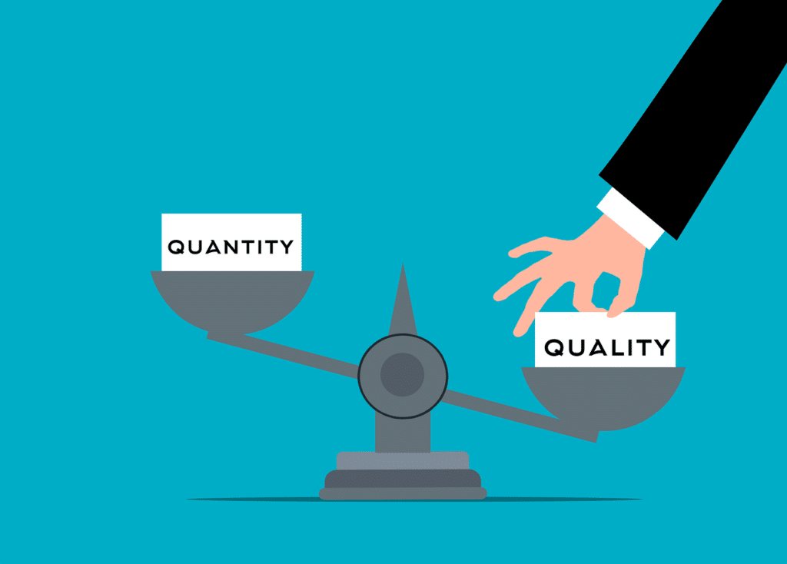  (globalsocialmediamarketing.com) (shutterstock.com)

P
iaget did not look at this as a quantitative (bit of a mouthful) process No, Piaget's theory suggests that as children progress through the four stages of development, their way of thinking changes, rather than accumulating more knowledge or information.. This is referred to as the qualitative process (Mcleod, 2023).

So simple only a genius could have thought of it (Albert Einstein).

(Iconfinder.com)
Several factors affect how children learn and grow
- Schemas
- Assimilation
- Accommodation
- Equilibration

(Cherry, 2023)
If you would like to dig deeper into the factors affecting children’s learning please visit –
https://www.verywellmind.com/piagets-stages-of-cognitive-development-2795457
Schema – A cognitive framework that helps to organise, clarify, and retain information about the environment. Schemas which already exist allow us to interpret new experiences in the world (Nickerson, 2021b).

Assimilation – works in conjunction with another key concept in Piaget's theory called accommodation. It is the process of assimilating new information into your existing knowledge. Whenever you experience something new, you relate it to things that you already know and process it accordingly (Kendra Cherry, 2018).

For example, consider a child who has a schema for a cat. If the child discovers a new four-legged animal, like a dog, they may initially assimilate it into their existing schema for a cat. The child may refer to the dog as a cat since it fits the familiar category of a furry, four-legged animal (Nickerson, 2021a).
Accommodation – When you come across new information or experiences that require you to adjust or update your existing cognitive frameworks or schemas. You change the schema to accommodate the new information rather than trying to fit it into an existing one (Nickerson, 2021a).

Equilibration – An ongoing process when further information is balanced with existing knowledge (Mcleod, 2023).
Piaget said that it is only through new experiences that children learn because each child has had a varied set of experiences. This is why each child’s knowledge and understanding are different. Although they are all the same age, their stages are different.
Stages not Ages

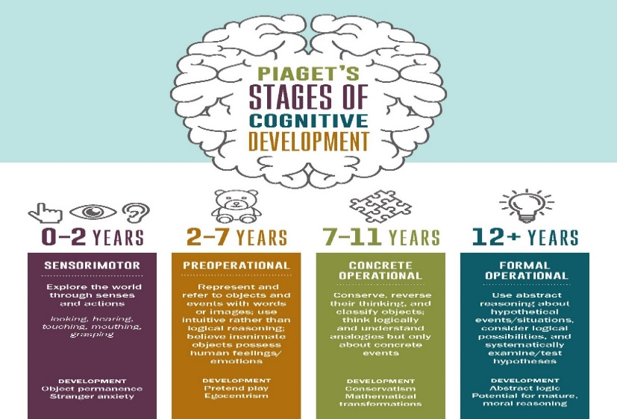
Piaget proposed that there are four stages of learning, the sensorimotor, preoperational, concrete operational, and formal operational stages. According to Piaget, children are active learners who gain knowledge by experimenting and observing the world around them. This approach enables them to develop new ideas and adapt existing ones to incorporate new information (Cherry, 2023).

(Pinterest.com)

Piaget’s Playground
Piaget's theory of cognitive development emphasises the importance of play in the development of children's intelligence. According to his theory, children's play and environment should encourage cognitive and language development as they grow older (Hamid, 2018).
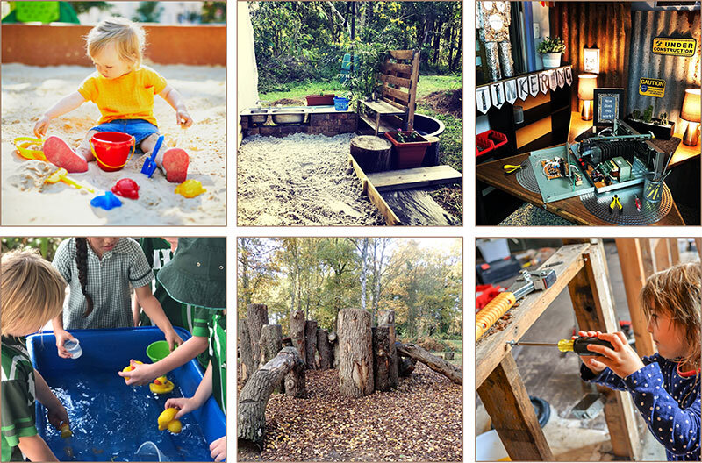
Did you know that different theories intersect, providing unique perspectives to understand a child's growth? Les Vygotsky, a Russian psychologist, shared Piaget's view that active participation is crucial in the learning process. Erik Erikson, another theorist, shares Piaget's ideas in his stage-based approach (Main, 2021).
(Myteachingcupboard.com)
Were you aware that Piaget's theory continues to be highly influential in both popular and academic circles in shaping our understanding of how developmental forces influence our knowledge of the world?
In the Classroom
Did you know that applying Piaget's theory in the classroom benefits teachers and students in many ways? Teachers can understand their students' thinking and adjust their teaching strategies based on their cognitive level. The following principles are used in classrooms today –
- DISCOVERY LEARNING
- PROBLEM-SOLVING
- STAGE-BASED LEARNING (Cherry, 2022).
The Foundation Phase refers to a stage-based learning approach (Early Years Wales, 2020).
Piaget, Interplay, Adaption, Growth, Equilibration, Theory
Comment below to share your thoughts on this blog, any questions? Just ask.

Reference list
Cherry, K. (2022). Jean Piaget Biography (1896-1980). [online] Verywell Mind. Available at: https://www.verywellmind.com/jean-piaget-biography-1896-1980-2795549 [Accessed 4 Jan. 2024].
Cherry, K. (2023). Piaget’s 4 Stages of Cognitive Development Explained. [online] Verywell Mind. Available at: https://www.verywellmind.com/piagets-stages-of-cognitive-development-2795457 [Accessed 3 Jan. 2024].
Early Years Wales (2020). Foundation Learning. [online] Early Years Wales. Available at: https://www.earlyyears.wales/en/foundation-learning [Accessed 6 Jan. 2024].
Hamid, K. (2018). The Psychological Theories Behind Learning Through Play. [online] Pentagon Play. Available at: https://www.pentagonplay.co.uk/news-and-info/psychology-learning-through-play [Accessed 4 Jan. 2024].
Kendra Cherry (2018). Assimilation and Jean Piaget’s Adaptation Process. [online] Verywell Mind. Available at: https://www.verywellmind.com/what-is-assimilation-2794821 [Accessed 4 Jan. 2024].
Main, P. (2021). Jean Piagets theory of Cognitive Development. [online] www.structural-learning.com. Available at: https://www.structural-learning.com/post/jean-piagets-theory-of-cognitive-development-and-active-classrooms#:~:text=Piaget%20believes%20that%20children%20must [Accessed 4 Jan. 2024].
Mcleod, S. (2023). Jean piaget’s theory of cognitive development. [online] Simply Psychology. Available at: https://www.simplypsychology.org/piaget.html [Accessed 3 Jan. 2024].
Nickerson, C. (2021a). Accommodation and assimilation in psychology - simply psychology. [online] www.simplypsychology.org. Available at: https://www.simplypsychology.org/what-is-accommodation-and-assimilation.html [Accessed 4 Jan. 2024].
Nickerson, C. (2021b). The Role of a Schema in Psychology - Simply Psychology. [online] www.simplypsychology.org. Available at: https://www.simplypsychology.org/what-is-a-schema.html [Accessed 4 Jan. 2024].

Blog 2
Demonstrate your understanding of a theory of learning from the following list:
Bruner, Dewey, Skinner, Piaget, Vygotsky, Froebel. The theory must be different to Blog 1.
The Power of Play - Is Play Important?
When I was a child, one of my favourite memories was playing with my dolls. Being an only child, I would spend hours talking to them, feeding them, putting them to bed, taking them for walks in their prams, and more. Little did I know that by playing with my dolls, I was unknowingly developing my social, empathy, and fine motor skills (Devlin, 2022).


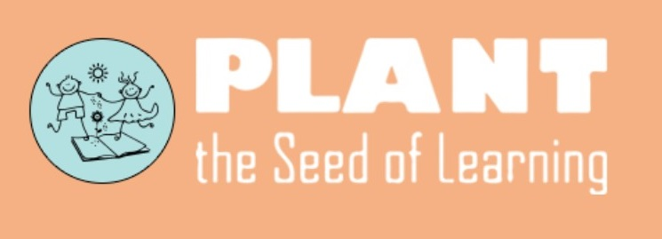 (Quarryvillelibrary.org)
Garden of Children
Join me as I delve into the fascinating theory of learning through play proposed by Friedrich Froebel. This concept has stood the test of time and has been embraced by educators worldwide as an effective and engaging way for children to learn (Early Education, 2021 Don't miss this chance to gain a deeper understanding of this innovative educational approach. It is worth acknowledging that the theory in question holds a key place in our educational practice even today. It's no secret that playing is an integral part of childhood, and research has shown time and again that children benefit from it (Mader, 2022). Froebel (1782-1852) a German educator, is known for creating kindergarten and believed in the importance of play (Tovey, 2017). Many theorists also agree with this such as Montessori, and Reggio Emilia. By prioritising an understanding of child development, these individuals all share a common approach to early learning. Their commitment to a developmental perspective has proven to be effective in fostering young minds and providing a solid foundation for future growth (Spielgaben, 2015). It's possible that you may not even be aware that you're using the theory developed by Froebel. To clarify he believed that children should be able to build on their creativity, critical thinking skills, and social interactions. Child-initiated activities are at the heart of the curriculum and a powerful context for creative thinking thanks to Froebel. His principles underpin most of the provision and practice we use today (Early Education, 2021).
Wild Wisdom
Were you aware that Froebel believed in using nature to help children develop their senses and curiosity? (Froebel Trust, 2022)
Gifts and Occupations
Did you know that Froebel initiated the notion of gifts and occupations to reinforce children’s learning and development? Gifts were in the form of wooden blocks, balls, and sticks. This was to encourage exploration, manipulation, and construction. Occupations were more firsthand experiences like woodwork, lacing, weaving, drawing, and cutting. This allowed children to construct their meaning of how things work and let them use their imagination, fine motor skills, and spatial awareness (Early Education, 2021).
What are the Main Principles?

Creativity and the power of symbols | Supportive environments allow children to express their unique thoughts and concepts.
Importance of Play | Assists children in expressing their emotions, thoughts, and experiences through play, allowing them to take ownership of their playtime.
Unity and Connectedness | When children are aware of unity, they develop a deeper understanding of themselves, others, nature, and the wider world.
Autonomous Learners | Children learn best through firsthand experiences, which include reflection.
The value of childhood | The process of acquiring knowledge and skills starts as soon as a person is born.
Importance of relationships | Relationships play a crucial role in a child's life.
Engaging with Nature | Having an experience and understanding of nature and our place in it is crucial.  (Froebel Trust, 2022).

Play is an important activity for children to explore and enhance their creativity. It allows them to interact with others, express themselves, and manipulate various materials (Zapata, 2020). Friedrich Froebel, a renowned educator, believed that play was a critical part of children’s development. However, as parents, we often struggle to find time to play with our children due to work commitments. It's okay to feel this way. You're not alone in this struggle. I, too, have had my fair share of challenges. Let's work together to overcome them.
In a nutshell… Play is our brain's favourite way of learning (Diane Ackerman)

Reference list
Devlin, H. (2022). Playing with dolls helps children talk about how others feel, says study. [online] the Guardian. Available at: https://www.theguardian.com/society/2022/feb/06/playing-dolls-helps-children-talk-about-how-others-feel-study [Accessed 3 Jan. 2024].
Early Education (2021). Friedrich Froebel – Early Education. [online] Early Education. Available at: https://early-education.org.uk/friedrich-froebel/ [Accessed 2 Jan. 2024].
FROEBEL TRUST (2022). Froebelian principles. [online] Froebel Trust. Available at: https://www.froebel.org.uk/about-us/froebelian-principles [Accessed 2 Jan. 2024].
Mader, J. (2022). The benefits of play are immense across all ages, research shows. [online] The Hechinger Report. Available at: https://hechingerreport.org/want-resilient-and-well-adjusted-kids-let-them-play/ [Accessed 3 Jan. 2024]. (Mcleod, 2023)
Mcleod, S. (2023). Jean piaget’s theory of cognitive development. [online] Simply Psychology. Available at: https://www.simplypsychology.org/piaget.html.
Spielgaben (2015). Comparison among Froebel, Montessori, Reggio Emilia and Waldorf-Steiner Methods-Part 1. [online] Spielgaben. Available at: https://spielgaben.com/comparison-froebel-montessori-reggio-waldorf-part-1/ [Accessed 3 Jan. 2024].
Tovey, H. (2017). A FROEBELIAN APPROACH: Froebel’s principles and practice today. [online] Froebel Trust, pp.1–24. Available at: https://www.froebel.org.uk/uploads/documents/FT-Froebels-principles-and-practice-today.pdf [Accessed 2 Jan. 2024].
Zapata, K. (2020). The Importance of Play: How Kids Learn By Having Fun. [online] Healthline. Available at: https://www.healthline.com/health/the-importance-of-play [Accessed 3 Jan. 2024].

Blog 3
Identify, discuss, and evaluate the theoretical approaches to learning linked to your theories from Blogs 1 and 2.
Piaget
Let's delve deeper into Piaget's theory. He was a constructivist which means that his theory was based on the notion that children develop their thoughts and understanding of the world based upon their experiences. He saw learning as a continual process where children utilised their schema to develop their learning. As I explained in my previous blog, there are four stages to the process: assimilation, equilibrium, disequilibrium, and accommodation. There are also four developmental stages from birth to adulthood. These are the sensorimotor stage (birth - 18/24 months), pre-operational stage (18/24 months -7 years), concrete-operational stage (7-11 years) and the formal operational stage (11-adult) (Mcleod, 2023).
 (simplypyschology.org)
Children enjoy actively exploring their surroundings, right? Piaget believed that this is how children learn best.
You could say that Piaget’s theory has been very influential in the field of psychology (Hopkins, 2011).
It is a well-known fact that children require a certain level of psychological maturity to handle certain tasks. Pushing them to take on tasks beyond their capabilities may lead to undesired outcomes. Hence, it is vital to comprehend and acknowledge the individual abilities of children before expecting them to undertake challenging tasks (Mcleod, 2023).  (Prosperityeconomics.org)

Let's look at the pros and cons of Piaget’s theory.
Cons | Pros
Overestimating the ability of adolescence | Emphasis on active learning
His theory lacks scientific control | Recognition of individual differences
He used children in his studies who were solely European from families of high socioeconomic status | Integrated approach
The subjects were not studied across the entire lifespan – age limitations | Practical applications – firsthand
He may have underestimated a child’s capabilities due to tests being difficult to understand | Collaborative learning
It doesn’t consider the child’s upbringing | Scaffolding techniques
Based on a small number of children | Better understanding of child development
Progress to the formal operational stage isn’t guaranteed | Enormous impact on the future of education and developmental psychology
Not biologically based | Pioneered the development of the clinical method
Data collected is based on his own subjective interpretation of events | Helped change the way that researchers thought about children
Didn’t consider social setting and culture | Influenced concepts of individual and student-centred learning, formative assessment, active learning, discovery learning, and peer interaction
A child's emotional development is overlooked | A clear framework for how children at different ages and stages are capable of learning
(Cherry, 2019) Your opinion matters! I would love to hear your thoughts on this.
There has been criticism that Piaget's theory is too rigid and doesn't account for individual differences in children (Marcin, 2018). What are your thoughts on this? This suggests that social and cultural influences and individual differences impact cognitive development (Mcleod, 2023). The timing of when individuals reach different stages varies depending on their culture and personal circumstances.
HOWEVER,
To achieve optimal cognitive growth, it is crucial to support active learning and exploration. There's no doubt that these key components significantly contribute towards cognitive growth, so make sure to encourage and promote them (Main, 2021).
 (yourdictionary.com).
Froebel
Moving on to Froebel who established that play is the most important form of human development during childhood. It is the free expression of what is in the child’s ego (Early Education, 2021). As stated by Froebel, play allows children to develop their understanding of the world through firsthand experience.
I agree that Piaget and Froebel were both inspirational names in the education sector, especially in the realm of child development. Their work has contributed significantly to the understanding of child development and education (Pancare, 2017).
Both parties shared similarities in that they both agreed on the following points:

- Children are the driving force for success, not parents or teachers. Encouraging children to explore their interests and take charge of their education helps them reach their full potential.
- A teacher should act as a guide rather than an instructor, encouraging children to learn and grow by making mistakes and asking questions.
- Both individuals promoted a child-centred approach.
- both constructivists.
- both agreed on the importance of play.
- Although the stages were not the same, they both believed in stages of development.
- both took a holistic approach to education.
Ok so let's look at the pros and cons of Froebel’s theory.
Cons | Pros
Less applicable or practical for older students | Child-centred approach
Lack of extensive academic structure | Play-based learning
Gaps in foundation skills | Holistic development
Limited attention to cultural diversity | Gifts and occupations – enhance hands-on learning experiences
 | Emphasis on early childhood
(FROEBEL TRUST, 2022)
In summary, I am sure you can agree that both theorists have their strengths and weaknesses. Various factors, such as the age of children, educator skills, and institutional goals, impact implementation and success (Cherry, 2021).
Do you have learners who could benefit from these approaches or use them already?
If you want to learn more about these theories and how they apply to modern practices, visit the Fact Sheet titled (pacey.org.uk).

Reference List
Cherry, K. (2019). Support and Criticism of Piaget’s Stage Theory. [online] Verywell Mind. Available at: https://www.verywellmind.com/support-and-criticism-of-piagets-stage-theory-2795460 [Accessed 5 Jan. 2024].
Cherry, K. (2021). Important Milestones of Cognitive Development in Children. [online] Verywell Mind. Available at: https://www.verywellmind.com/cognitive-developmental-milestones-2795109 [Accessed 6 Jan. 2024].
Early Education (2021). Friedrich Froebel – Early Education. [online] Early Education. Available at: https://early-education.org.uk/friedrich-froebel/ [Accessed 5 Jan. 2024].
FROEBEL TRUST (2022). Froebelian principles. [online] Froebel Trust. Available at: https://www.froebel.org.uk/about-us/froebelian-principles [Accessed 7 Jan. 2024].
Hopkins, J.R. (2011). The enduring influence of Jean Piaget. APS Observer, [online] 24(10). Available at: https://www.psychologicalscience.org/observer/jean-piaget [Accessed 5 Jan. 2024].
Main, P. (2021). Jean Piagets theory of Cognitive Development. [online] www.structural-learning.com. Available at: https://www.structural-learning.com/post/jean-piagets-theory-of-cognitive-development-and-active-classrooms [Accessed 5 Jan. 2024].
Marcin, A. (2018). What Are Piaget’s Stages of Development and How Are They Used? [online] Healthline. Available at: https://www.healthline.com/health/piaget-stages-of-development#cons [Accessed 7 Jan. 2024].
Mcleod, S. (2023). Jean piaget’s theory of cognitive development. [online] Simply Psychology. Available at: https://www.simplypsychology.org/piaget.html [Accessed 5 Jan. 2024].
Pancare, R. (2017). How To Adult. [online] How To Adult. Available at: https://howtoadult.com/comparison-early-childhood-development-theorists-6320.html [Accessed 5 Jan. 2024].

Blog 4
Draw on experiences from your own setting to identify resources and strategies used to support effective teaching and learning, linking back to your chosen theories in Blogs 1 & 2
My personal experience with using Piaget's approach to support constructivism and Froebel's approach to support play.
I am currently employed as a primary school support assistant, and I would like to share the strategies that we use to implement these theories into our teaching practice.
Firstly Piaget,
In our learning environment, we promote discovery-based learning through an inclusive pedagogy. We motivate children to develop their own understanding by engaging in an inquiry-based learning process. The new curriculum follows a constructivist approach to education. This approach encourages children to take an active part in their education and fosters self-directed learning. Planning is differentiated to suit children’s individual needs. We implement Reciprocal reading which involves the children summarising, questioning, clarifying and predicting. This enables children to teach each other by actively engaging in reading. We build upon their interests and prior knowledge. During the learning process, individuals can enhance their comprehension of different views and ideas by developing critical thinking and problem-solving skills. Our educational approach emphasises inquiry-based learning, where children are encouraged to ask their own questions and analyse answers through research and direct observation (Mcleod, 2023).
Our approach to promoting children's learning and development is based on building and expanding their existing schemas. To accomplish this, we provide children with opportunities to explore the world around them. Through a variety of experiences, we encourage children to experiment and interact with their environment, which helps them gain a hands-on understanding of different concepts (Nickerson, 2021).

(inventionlandinstitute.com)

In our learning environment, we promote problem-solving which is an essential skill in everyday life. We provide children with opportunities to make choices, clarify, formulate, model, and investigate problems, select and use technological functions, and communicate solutions successfully. We adopt a learner-centred approach where children brainstorm ideas by creating lists. In our educational setting, we prioritise the development of problem-solving skills, we also have role-play areas that encourage reflection. Problem-solving helps children to gain confidence and express themselves better. Additionally, problem-solving nurtures creativity which can be applied in writing. In lessons, children engage in debates and are presented with tasks or challenges (Cherry, 2010).
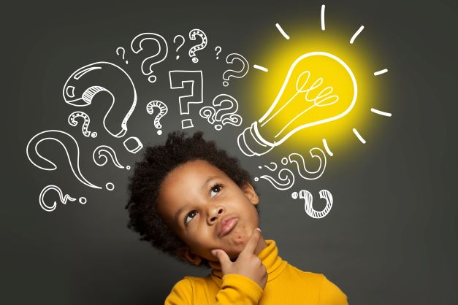
(Zeeko.ie)

Secondly Froebel,
Our commitment to fostering imagination and creativity is reflected in our setting's value of play. We believe in fostering a sense of joy in discovery and exploration. Our relationships are warm, responsive, and built on trust, and we encourage both adults and children to take risks and be adventurous (Gov, 2019). We make a conscious effort to involve parents in our activities, which includes organising family engagement days (Woolf, 2023).

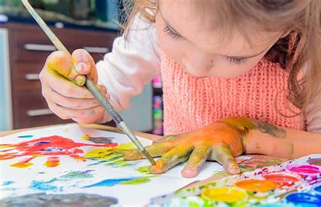
(raisingchildren.net.au)
Children in our setting play with a variety of natural materials, including small world, blocks, sand, water, and more. Through these activities, children develop a sense of wonder about nature and learn about cause and effect. We hope that by engaging with the environment in this way, children will be more likely to become invested in shaping a sustainable future (Barry and Boyd, 2022).
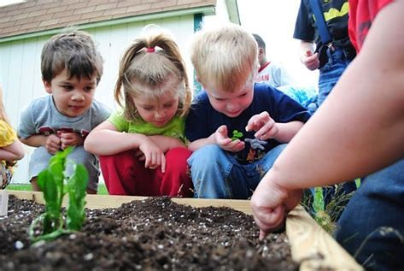
(wastetoenergysystems.com)
We encourage children to engage in outdoor activities and participate in Forest Schools programs. Our outdoor learning complements indoor learning and is of equal importance. Play and learning flow seamlessly between indoors and outdoors. This allows children to take full advantage of the resources available to them and develop their ideas without disruption (sites.google.com, 2023).
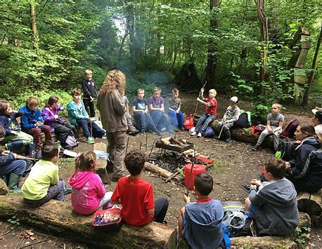
(woodlandclassroom.com)

Both theories have been implemented based on advice from the Welsh Assembly Government Learning and Teaching Pedagogy (2008).

As a final word, I'd like to share a quote with you,
Most of what children need to learn during their early childhood years cannot be taught: it’s discovered through play (Ruth Wilson).

So do you have any children that you think Piaget or Froebel’s theory may assist? Why not expand your teaching strategies to include more learning theories to meet the varied needs of your children and establish a more inclusive and personalised classroom experience?

Reference list
Barry, R. and Boyd, N. (2022). Sustainability Matters in Early Childhood. [online] Available at: https://www.ncfe.org.uk/media/p1socs4v/sustainability-matters-in-early-childhood-resource.pdf [Accessed 7 Jan. 2024].
Cherry, K. (2010). Problem-Solving Strategies and Obstacles. [online] Verywell Mind. Available at: https://www.verywellmind.com/problem-solving-2795008 [Accessed 7 Jan. 2024].
Gov (2019). Play Matters | Department of Education. [online] Education. Available at: https://www.education-ni.gov.uk/articles/play-matters [Accessed 7 Jan. 2024].
Mcleod, S. (2023). Jean piaget’s theory of cognitive development. [online] Simply Psychology. Available at: https://www.simplypsychology.org/piaget.html [Accessed 7 Jan. 2024].
Nickerson, C. (2021). The Role of a Schema in Psychology - Simply Psychology. [online] www.simplypsychology.org. Available at: https://www.simplypsychology.org/what-is-a-schema.html [Accessed 7 Jan. 2024].
sites.google.com. (2023). Pembroke Dock Community School. [online] Available at: https://sites.google.com/hwbcymru.net/pdcsprimary/home [Accessed 7 Jan. 2024].
Woolf, N. (2023). Family Engagement in Schools: A Comprehensive Guide. [online] www.panoramaed.com. Available at: https://www.panoramaed.com/blog/family-engagement-comprehensive-guide [Accessed 7 Jan. 2024].

