Recap IPV4 Addressing
- For the following IP addresses deduce the network ID and Broadacast address

- 192.168.10.253 /24
- 192.168.10.253 /25
- 192.168.10.253 /26
- 192.168.10.253 /27
- 192.168.10.253 /30

NETWORK TOPOLOGY
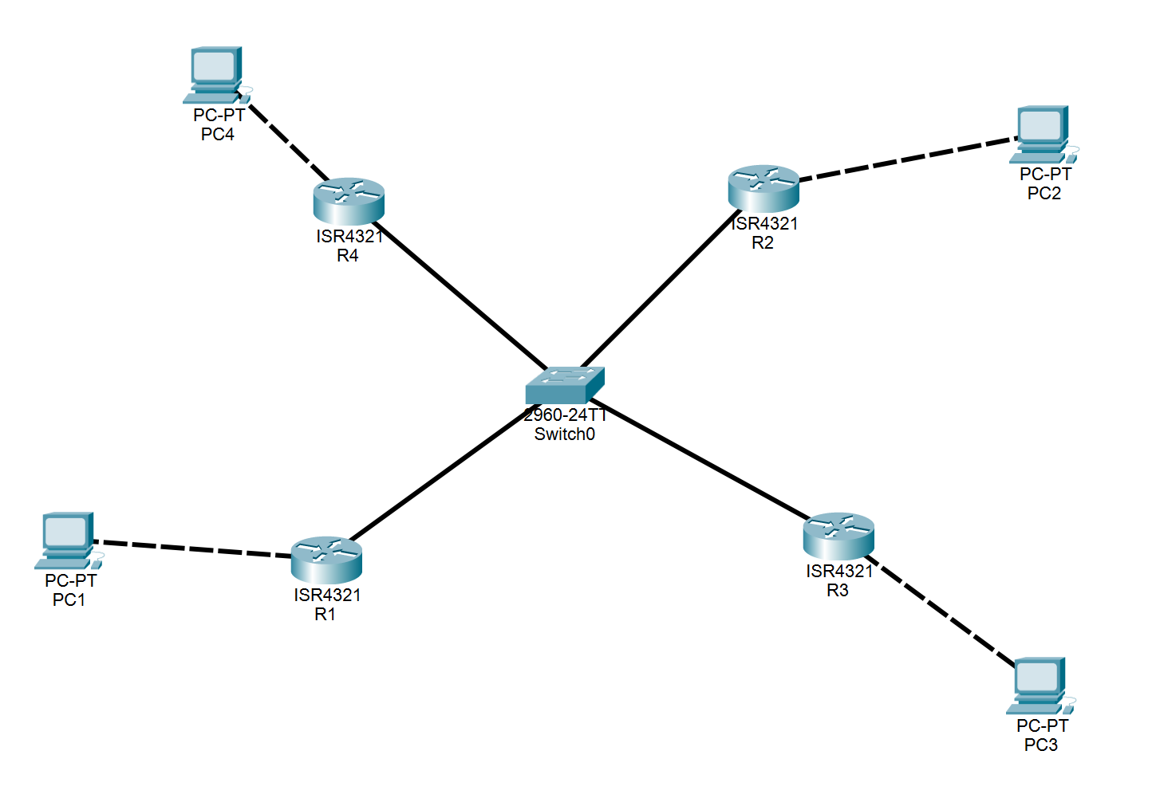

Recap -OSPF
Work in groups of 3

- Use Cisco Real Devices to implement the given Topology
- Design and assign IPV4 Addresses to topology devices and links
- Configure Single Area OSPF
RID for R1 is 1.1.1.1
RID for R2 is 2.2.2.2
RID for R3 is 3.3.3.3
RID for R4 is 4.4.4.4.
- Make sure PCs can ping each other
- Identify DR, BDR and Drothers

