Secure the network from common threats and attacks
Networks and Cyber Security Essentials
ACCA4024
2104032 Charlie Wilkins

Table of Contents

Task 1. Security Analysis Report: Batman Textiles.

Task 2. Review of different types of threats, vulnerabilities and attacks.

Task 3. Demonstration of how security could be implemented in Batman Textiles network infrastructure.

Task 4. Guidelines for “Batman Textiles” staff members, and customers to responsibly use their digital space.

List of Figures/ Tables/Linked assessments

- Introduction to Packet Tracer” course from Cisco networking academy. https://www.credly.com/badges/b23a8a75-2e98-4c1b-a15b-29a7fd97c643

- Physical and Logical Topology based on the scenario.

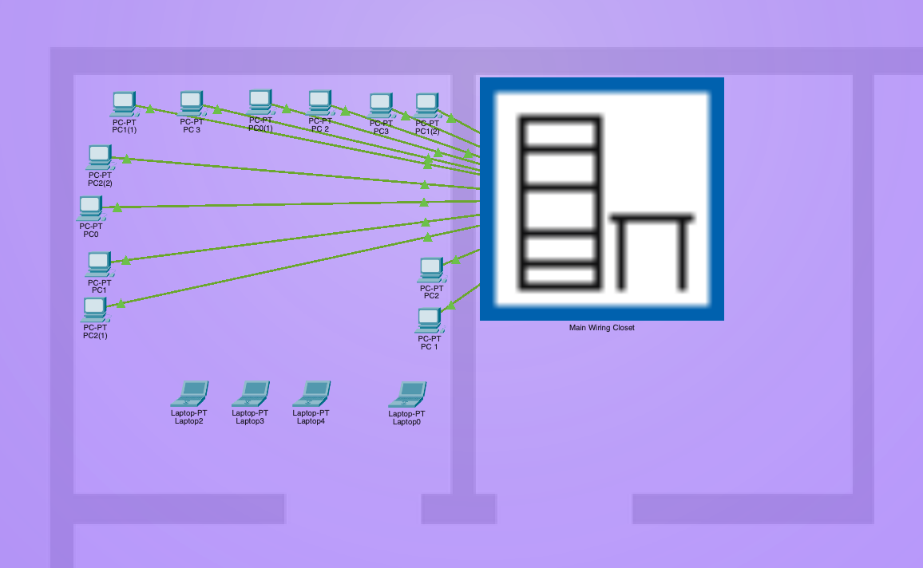
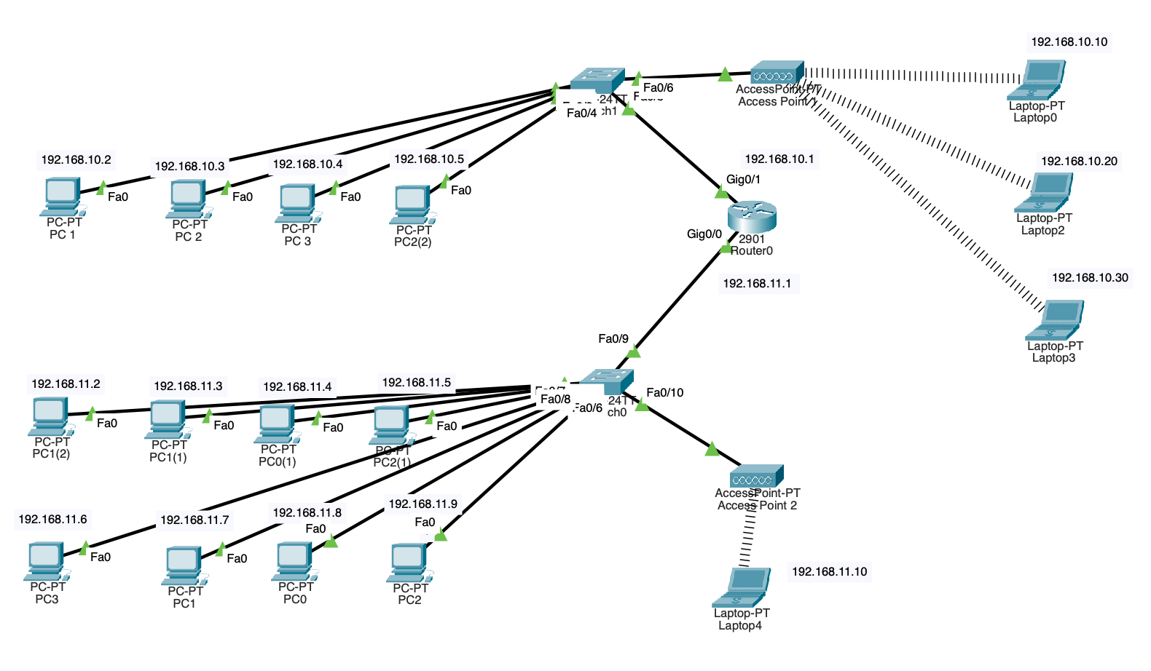

Abstract
The Networks and Cyber Security Essentials course is one of the first three modules in the HND Computing (Computer Networks and Cybersecurity) course. During the course I have learnt about the essentials of cybersecurity and this submission has focused on threat and vulnerabilities, using a case example of a company with poor cybersecurity.
The submission is in 4 parts and consists of an initial Security Analysis Report for the company (Batman Textiles). The second part is a review of different types of threats, vulnerabilities and attacks, followed by a demonstration of how security could be implemented in Batman Textiles network infrastructure. The final section is an example of guidelines for “Batman Textiles” staff members, and customers to responsibly use their digital space.

Introduction
The submission was to look at cybersecurity, building on the work done during the module in the term and complete an assignment using a case scenario.

Task 1

Security Analysis Report
Charlie Wilkins
HND Cybersecurity and Networks
Swansea, UK
Charlie.Wilkins@icloud.com

To Bruce, the Owner of “Batman Textiles”.

Analysis:

Possible Security Breach 1: Change in Internet security permissions for the employees.
To start with there were 12 Sales Executives with limited access, 2 Sales Heads with privilege access and Bruce and the Accounts Officer with full access.
Alfred (who was previously presumably a Sales Executive?) was given full access so then Bruce the Accounts Officer and Alfred all had full access. This increased the risk to the company of inadvertent or malicious misuse of this full access.
The next step was to give all the Sales Executives full access, increasing the number of people to 3 already full access +11 more (or 12 more if Alfred was not a SE to start with).
So, this company went from just Bruce and the Accounts Officer with full access to a total of 16 people with full access, two of whom, the Sales Heads were sacked. That is far too many people to control carefully without rigid processes and policy. There is no indication that Batman Textiles has any security measures in place.

Secondary factor: Disgruntled Employees. The owner decided to make budget changes and try to streamline cost so ended up firing some of the employees. This might have been a difficult decision to make, and they might not have taken the news well even if Bruce tried to be kind about it as they had been part of a company which had good salaries. There were therefore two people who were unhappy with the management of the company. There may have been others who were still employed and also unhappy with the company; maybe because the sacked Sales Heads were their friends or because they felt they were being given more work than the pay they were receiving as Sales Executives, without any change in their salaries. Therefore, any of these employees could have caused harm if cybersecurity steps were not in place.

Possible Security Breach 2: Complimentary WiFi in the café. Alfred made this change in order to attract more custom but there were no additional safeguards put in place to separate the business internet use from the customer internet use. If there is only one network for the company and restaurant which the public have access to, then anyone with IT understanding could reconfigure the switch or router, adding passwords and then insert viruses or malware including ransomware. In addition to malicious attacks, simply having customers on the system would add to the number of users and slow down the internet for the employees and the customers which could be frustrating because of the limited bandwidth.

This dual use of the internet provides a portal through which data breeches could be made and everyone might have been able to access all Company files on the public Wi-Fi.

The combination of full access rights and disgruntled employees who had previously been working for the company would have been a bad combination, but the café WiFi access meant that the former employees could come back as customers the café and would be able to ‘get back in’ to the company files and cause harm. One of the disgruntled former employees did come back and was able to take and encrypt files. This then meant that the company was unable to function without breaking this encryption.

Recommendations:
Proper cyber security policy and processes to include:
- Train all employees to understand their roles and responsibilities.
- Install and monitor firewall performance.
- Update passwords at least every quarter.
- Advanced Endpoint Detection.
- Create a virtual private network (VPN)
- Filter and delete spam emails.
- Shut down computers when not in use.
- Encrypt all sensitive files.

Task 2

Threats:
A Threat is “Any circumstance or event with the potential to harm an information system through unauthorized access, destruction, disclosure, modification of data, and/or denial of service”. Threats arise from human actions and natural events, Verizon’s 2021 data breach investigation report stated “85% of breaches involved human element, 36% breaches involved phishing which is 11% more than the previous year, 10% of breaches involved ransomware which is almost double the last year.”

Types of Threats.
The rate of cybercrime is increasing despite efforts by organisations, cybersecurity professionals and individuals to secure network. The types of threat include,:
- Ransomware and as-a-service attacks
- Enterprise security tool sprawl
- Misconfigured security applications at scale
- Sophisticated spear phishing strategies
- Increased frequency of credential theft
- Mobile device and OS vulnerabilities left unchecked
- Data governance and management errors
- Distributed growth of insider threats post-COVID
- Poorly secured cloud environments
- Incomplete post-attack investigations

Significance of threats in a Network.
Today's most significant threats to network security are,:

- Ransomware. Ransomware isn't a new network security threat, but blockchain technology is making it more popular.
- Botnets.
- Distributed Denial of Service (DDoS).
- Cryptojacking.
- Phishing.
- Unprepared Network Security Staff.

The 8 most common types of malware are:
- Adware. This can be both annoying and allow viruses and spyware to be installed.
- Fileless Malware.
- Viruses which can stop systems from working, lock you out of Apps, stop you from accessing crucial website and mess with operating systems such as screen colour change or freeze.
- Worms which when activated spread over the whole network and can be used to slow the Internet down, or a company’s service on which they rely.
- Trojans can appear innocent but once they're in a system they can do damage to the system at will.
- Bots are able be programmed to two different functions such as requested information DDoS which can be crippling for a company.
- Ransomware, can be used to encrypt the targeted information and request money for the return on information
- Spyware can be used to collect private information such as password employee records. They may be undetected for a time while gathering information which is then used for Ransomware.

Vulnerabilities:
In computer security, a vulnerability is “a weakness which can be exploited by a threat actor, such as an attacker, to cross privilege boundaries within a computer system. To exploit a vulnerability, an attacker must have at least one applicable tool or technique that can connect to a system weakness” .

The two main causes of vulnerability are:
Complexity: Large, complex systems increase the probability of flaws and unintended access points.
Familiarity: Using common, well-known code, software, operating systems, and/or hardware increases the probability an attacker has or can find the knowledge and tools to exploit the flaw.

How Vulnerabilities affect a system.
A vulnerability is a weakness in an IT system “that can be exploited by an attacker to deliver a successful attack. They can occur through flaws, features or user error, and attackers will look to exploit any of them, often combining one or more, to achieve their end goal” .

Attacks:
The definition of Attacks is: “to take aggressive military action against (a place or enemy forces) with weapons or armed force.” A cyberattack is “any offensive manoeuvre that targets computer information systems, computer networks, infrastructures, or personal computer devices” .
Cyber attacks are usually either criminally or politically motivated. Adversaries can be either a private person, state actor or a criminal organisation who attempt to damage or destroy a computer network or system.

A cyber attack is any attempt to gain unauthorised access to a computer, computing system or computer network with the intent to cause damage. Cyber attacks aim “to disable, disrupt, destroy or control computer systems or to alter, block, delete, manipulate or steal the data held within these systems”

Ransomware is a type of malware hack in which the attacker holds the victim and their personal data for ransom until they comply with ransom demands. This is increasing in frequency and sophistication because attackers have developed expert knowledge and are selling Apps for profit which have step-by-step instructions. “Ransomware-as-a-service (RaaS) has grown in popularity, making it possible for non-traditional hackers to follow templates and guides to complete complex systems intrusions” .

REKTLocker.
“REKTLocker is ransomware-type malware that stealthily infiltrates the system and encrypts various files. During encryption, REKTLocker appends names of encrypted files with ".rekt" extensions and, thus, it is straightforward to determine which files are encrypted. Following successful encryption, REKTLocker changes the desktop wallpaper, and creates a text file ("Readme.txt") and places it on the desktop” .

Effects on the operation.
The wallpaper and text file inform the malware victim of the encryption. This tells the victim that files are encrypted using 2048 bit encryption (an asymmetric algorithm). Public (encryption) and private (decryption) keys are generated when encrypting files using asymmetric cryptography.
Decryption is impossible without the private key, which is stored on remote servers controlled by the attacker who may attempt to sell this key to victims. Currently, there are no tools capable of restoring files encrypted using an asymmetric algorithm. Therefore, you can only restore your system and files from a backup.

Task 3

Demonstration of how security could be implemented in Batman Textiles network infrastructure.

Security devices which could be added to secure the network:
A firewall protects the network by allowing trusted devices to connect from a local area network (LAN), site-to-site VPN tunnels or remote/dialup VPN connections. The firewall acts as a digital barrier. Firewall rules can be created to restrict access to trusted devices and allowed services and block intruders. Firewall activity should be monitored and firmware patched if any security patches are released.

Centralised logging/monitoring system for Advanced Endpoint Protection. All endpoints can be managed centrally and checked for up to date anti-virus signatures, web activity, vulnerabilities, data leakage.

Intrusion Detection and Protection device. These devices scan network traffic and look for unusual activity.

Introduction to Packet Tracer” course - Cisco networking academy.

“Introduction to Packet Tracer” course from Cisco networking academy completed. (https://www.netacad.com/courses/packet-tracer/introduction-packet-tracer)
Certificate of Completion and digital badge link attached:
https://www.credly.com/badges/b23a8a75-2e98-4c1b-a15b-29a7fd97c643

Physical and Logical Topology based on the scenario.

Topology implemented as stated above, IP addresses assigned and other required configurations to the workstations.

Configure wireless connectivity configured to ensure that guest users could successfully connect to the network’s “Complimentary” Wi-Fi.

Task 4

Guidelines for “Batman Textiles” staff members, and customers to responsibly use their digital space.

All organisations, regardless of size, budget or approach must implement a robust security awareness foundation.

Security awareness is the “knowledge and attitude members of an organisation possess regarding the protection of the physical, and especially informational, assets of that organisation.”

Step1: Establish a behavioural baseline.
This means every member of staff must understand that they are vulnerable as individuals and make the company vulnerable if they do not take cybersecurity seriously.

Step 2: Implement security initiatives.
The Batman Textiles Policies and Procedures are now in place and must be followed so that all employees understand which Security Tools the company and individuals require and to prepare employees to respond to a Data Breach.

Step 3: Secure behaviour by design.
This means that the management expect every employee to take cybersecurity seriously and we will implement regular checks.

The following guidelines describe the mandatory security awareness for all Batman textiles employees.

Staff training program

- All staff must attend a training session on cyber security. This includes:
  - the importance of cyber security to both the individual and Batman Textiles.
  - how to recognise phishing emails and websites.
  - how to report malicious activity.
  - how to setup spam filters.

Password guidelines

- Passwords must meet Batman Textiles’s policy
  - Must not be shared with anyone
  - Must not be or written down and visible (no post-it notes!)
  - Minimum of 10 characters
  - Contain at least one uppercase, one lowercase
  - Contain at least one symbol and one number
  - Must be changed every 90 days and not reused.

Laptop guidelines

- Users must ensure their operating system and applications are up to date. This is so any known security vulnerabilities are patched.
- Users must not install non-approved software.
- Users must know how to check and use their Advanced Endpoint Protection including the ability to perform an anti-virus scan on any files received via email.
- Use of USB mass storage devices is only allowed with manager’s approval.

Internet guidelines

- Only work-related use of the internet is allowed.
- All sensitive files sent via email must be encrypted.

Staff WIFI guidelines

- Staff to be notified of a change to the WIFI configuration from being an extension of the “company network” to being a “Guest WIFI” with internet access only. i.e. no direct connection to Batman Textiles LAN
- Staff are permitted to use the “Guest WIFI”.
- Malicious behaviour and high bandwidth applications will be monitored and any criminal activity will be reported.
- Staff using the WIFI must connect to the Batman Textiles LAN via a secure VPN connection.

Customer WIFI guidelines

- Customers are welcome to use the “Guest WIFI” in the café for internet use.
- Malicious behaviour and high bandwidth applications will be monitored and any criminal activity will be reported.

Conclusion
From the completion of this assignment, it has become clear that a case scenario is a useful methodology which allows the analysis of an environment and highlights common mistakes.

Future work could include the analysis of other scenarios to build up a portfolio of analysis, interventions and recommendations.
Further study of configuration commands would make them easily accessible and improve typing speed for assignments.

References

- https://www.ncsc.gov.uk/collection/10-steps/identity-and-access-management
- https://www.mimecast.com/state-of-email-security/
- https://www.verizon.com/business/resources/reports/dbir/
- https://www.datamation.com/security/cybersecurity-threats/
- https://go.crowdstrike.com/crowdstrike-global-threat-report-2021.html
- https://www.webroot.com/gb/en/resources/tips-articles/computer-security-threats
- https://en.wikipedia.org/wiki/Vulnerability_(computing)
- https://www.ncsc.gov.uk/information/understanding-vulnerabilities

Google Dictionary (by Google)
- https://www.techtarget.com/searchsecurity/definition/cyber-attack
- https://www.datamation.com/security/cybersecurity-threats/#RaaS

https://www.ncsc.gov.uk/collection/10-steps/identity-and-access-management
https://www.mimecast.com/state-of-email-security/
https://www.verizon.com/business/resources/reports/dbir/
https://www.datamation.com/security/cybersecurity-threats/
https://go.crowdstrike.com/crowdstrike-global-threat-report-2021.html
https://www.webroot.com/gb/en/resources/tips-articles/computer-security-threats
https://en.wikipedia.org/wiki/Vulnerability_(computing)
https://www.ncsc.gov.uk/information/understanding-vulnerabilities
Google Dictionary (by Google)
https://www.techtarget.com/searchsecurity/definition/cyber-attack
https://www.datamation.com/security/cybersecurity-threats/#RaaS
https://www.datamation.com/security/cybersecurity-threats/#RaaS

