
Skills for the Workplace
Module Assignment Submission
Student Name: | E. J. Allsopp
Topic: | Managing Enterprise in the 21st Century
Course: | Skills in the Workplace
Assignment: | BMSK4006

Statement of Confirmation of Authenticity
By the act of making this submission, the student declares that this is the work of the student named above. The work has not, in whole or in part, been knowingly presented elsewhere for assessment, or where assessment has been built on a previous assessment, this has been identified. Where materials have been used from other sources it has been properly acknowledged. If this statement is untrue, the student acknowledges that an assessment offence has been committed.
Attention is drawn to the plagiarism and unfair practice policies of both the University and of ILM.

Table of Contents
Introduction 3
Identify a personal skill-set and knowledge relevant to the project. 4
Demonstrate a range of employment skills in the completion of a group project 6
Presenters 8
Conclusion 9
References 10
Appendix 1 – Personal Development Plan (PDP) 11
Appendix 2 – Learning Log 12
Appendix 3 – Who did what? 13
Appendix 4 – Oral Presentation Evaluation Sheet 14
Appendix 5 - Team Member Evaluation – Emma Allsopp 15

Introduction

The aim of this assignment is to complete a Business Plan as part of team. The team will produce and deliver the business plan on a new business called ‘Scrumptious Beauty’ where the company will initially sell four lip kits. The lip kits will be initially consisting of 4 flavours, fudge brownie, cherry pie, Eton mess and Peach Cobbler. During this assignment each team member will investigate and present the findings around starting up a business and the cost and legal side associated with it.
During the assignment the team will complete a 30-minute presentation which will also include handouts of the Business Plan. The team will also create evaluation sheets which will be distributed to Julia (the audience), to obtain constructive feedback which can be used to evaluate the team’s performance as well as identify individuals’ areas for further learning and experience.
This assignment is a personal reflective account describing what happened from my point of view whilst looking at certain aspects of the Business Plan. My aim is to look back honestly and reflect upon what I have discovered about myself, and as a team.
I will also analyse my primary data from the feedback I received from Julia, during my presentation of ‘Scrumptious Beauty’ and devise a PDP (Personal Development Plan) (Appendix 1), as well as include my own personal learning log (appendix 2) on what I have learned.
Using Gibbs (1988) Reflective Cycle to assist me, I will reflect upon what I have experienced within our Business Plan, to develop and utilise my own identified skills-set in time management, delegation and interpersonal communication



Identify a personal skill-set and knowledge relevant to the project.

As part of the business Plan I knew that it was hugely important that we all be resourced different research areas to concentrate on. We agreed mutually on different sections to research and mine was to do the following: Research and find a company to produce our product, Executive summary, Owner management team details, Product service details, Plan for future success criteria, Markets and competitors, Sales and Marketing Strategy, Location premises and Equipment.
Initially the team arranged to meet prior to Lampeter to be well informed of our topic. However, this didn’t happen, and plans were set out and positions given without informing other members.
I demonstrated time management by organising a weekly calendar for us to follow, but this wasn’t followed, and a lot of meetings weren’t attended. We set out deadlines for each stage of our project, with priority being our research for us to have time to meet and alter the Business Plan.
Unfortunately, this didn’t happen, and it resulted in myself, Vanessa and Tanya only meeting three times and Shefali joining the meeting once. I felt that we’d all been given areas to research but there was a lot put onto my shoulders, the research wasn’t distributed evenly and felt that Shefali did not contribute as much to the group as possibly she could have. Many times, I questioned what Shefali was bringing to the business plan and each time I was shut down and told not to worry as we would only have to change what she brought. Shefali was given the Task of the introduction of the business and the SWOT analysis, however I had to change the introduction and myself and Tanya had to change the SWOT analysis and present it professionally.
I also felt frustrated at times because Tanya who made herself team leader without giving us knowledge constantly accused myself of not delivering my work but had clearly missed this on numerous occasions, which took Vanessa to ask Tanya what she was looking at with regards the Business Plan because I had done all my work. Tanya, I feel struggles to also see other people’s opinions and is very stuck in her own mind set which can prove very difficult when working as a team. I also felt that I had a lot to give the Business Plan but because I hadn’t attended the residential weekend was shut down.
There was an incident where Tanya had kept asking to change the date of the presentation and due to myself going away I had to present on the date agreed. Tanya was stating we wouldn’t get our work finalised however we had done our work except her. A week later I had asked to meet later one evening due to a family situation that had arisen and Tanya decided to send a message to our Tutor asking for an extension of our work because I had a family problem. This message was sent to the group by error and quickly deleted. However, I had seen this message, and this infuriated myself because I had finished my work on the Business Plan and it was Tanya who hadn’t.
Interpersonal communication was a strong skill-set that I proved throughout the entire process. By listening, communicating and using body language I could share within my team our personal experiences to select our tasks for the project. Mostly, I was assertive in my skills which enabled me to be open, honest and direct to prepare, discuss, clarify our goals, negotiate, agree, and implement each stage.
It was important that I demonstrated my tolerance and acceptance at different levels when dealing with the group. It was frustrating at times but decided to finish my part of the Business Plan and Present it to Julia knowing id given what I could. I do feel I have a lot more to contribute to a business plan had id been allowed and felt we could have taken it a lot further. I wanted to have the business as a limited company and do projections for future earnings and taxes and costing for future product’s, but I was shut down. I do feel that having given the chance to give all that I know in my own business plan it could have been a lot better.

Demonstrate a range of employment skills in the completion of a group project

When building the Business Plan, we used Belbin’s theory and put this into place so that we could identify the best suited role to each category so that we could produce the best Business Plan possible.

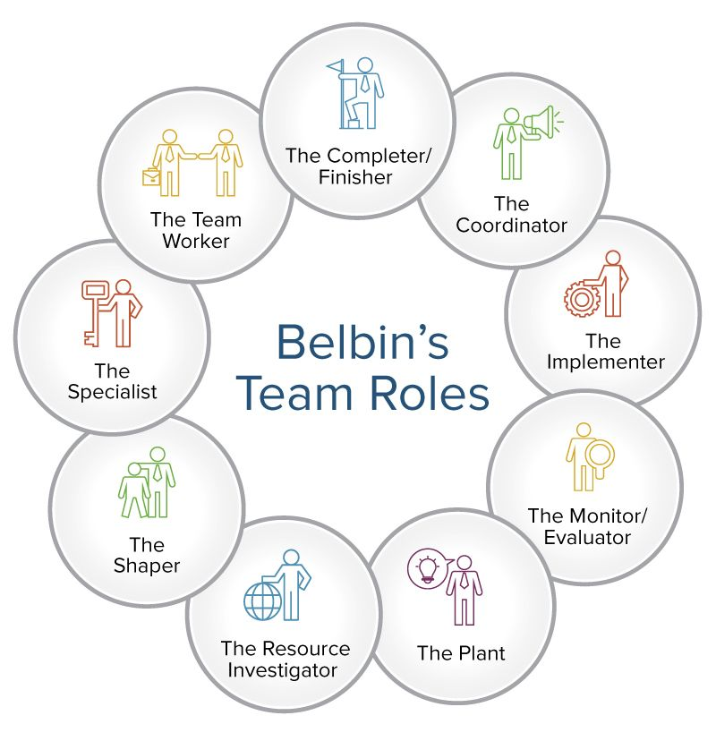
The role that most fitted my profile within the team was the ‘Implementer’ as I was always reliable and practical, and although I wasn’t nominated as the leader I would tend to turn ideas into actions and organise those ideas into real opportunities for us as a team to investigate.
As a negative, I am a bit slow to relinquish my plans as in this instance I have had a lot of experience working in the beauty industry whilst working was a high-profile company and owning my own business. I believe I had a lot to bring to the subject where as other members of team had limited knowledge of the beauty industry but bought different skills and areas of expertise.
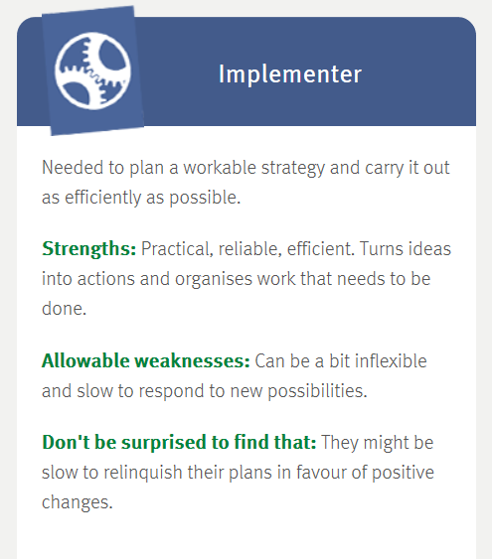
In terms of employment skills associated with the assignment I have broken it down into categories below to judge my own performance:
Communication
In terms of my approach to listening, speaking and writing, I believe I am strong in this skill set, as I do let others present their findings and opinions, but I will step to deliver mine. I believe I can accurately interpret others and organise documents and thoughts clearly. I believe this was evident in the presentation as I had to step in a couple of times to correct or assist my team mates.
Teamwork
I believe I was a strong team player throughout the assignment. I completed all my tasks on time, attended all meetings and delivered my part of the presentation. I believe I also shared my experiences and knowledge to assist other members of the team.
Problem-Solving
During the assignment there were many opportunities to solve problems, whether it be around the date of the presentation, or the change of presentation from face to face to online. At all times I put the team first for the team to succeed. I have been creative throughout the assignment and have enjoyed putting together the business plan.
Personal Management
Throughout the assignment I have personally managed my resource, time and actions on time and in advance to ensure each meeting was as effective as possible.
Interpersonal Effectiveness
I believe I have built a good relationship with my team, and I am someone they can share ideas and be honest with without judgement.
Technology Skills
Technology is an area where sometimes I can struggle but during this assignment I believe I have made personal advances and have improved. I have researched, documented and completed the presentation using different types of technology and it has not phased me where perhaps it may have done in the past.
Leadership / Management Skills
Although I was not the nominated leader, I believe I have shown strong leaderships qualities throughout the assignment, organising my own work and others, sharing knowledge, organising meetings, being professional and helping my team mates when they were struggling during the presentation. Although I don’t look for the spot light, I believe I displayed good management skills.

Presenters
- Emma Allsopp
- Tanya Smith
- Shefali Begum
- Vanessa

Aim
The aim is to deliver a positive and constructive analysis of our business presentation. presenting as a strong working team unit.

Lesson Objectives
- Deliver a 30-minute Business Plan on Scrumptious Beauty
- Create a suitable handout of our Business Plan
- Hand out evaluation sheets to get constructive feedback on our Business Plan delivery and content;
- Create a Business Plan
- The Business Plan will explore the Business viability of producing and selling 4 lip kits.
Resources
- Laptop
- Evaluation Sheet
- Handouts x 5
- Extension Lead
- Great Team Work

Conclusion

Despite my issues with certain members of the group I did enjoy the business plan. It proved to myself that I can produce my own and that I do have the knowledge to put this into place. Having faced one of my biggest fear of presenting I realised it wasn’t so bad in the end at all. This was because I had thoroughly researched my topic and felt confident in my knowledge. There has been a lot of work involved which at times felt overwhelming but Upon, reflection, I have learnt a lot as I was able to overcome any problems that we came across. Once we got together and put our minds together it was incredible how much we achieved.
Working as a team enabled me to learn so much about other areas which I felt I was strong at, such as the financial side of it. Strength is in numbers, which meant working as a team enabled us to look at many different angles from different perspectives. The topic we discussed helped me realise there are so many elements that make a successful business.
It is important to take the time to actively, at will, reflect. For example, if others are better communicators they may be more likely to get a promotion before I do. By finding a way to improve myself and come up with an action plan I will be more likely to succeed. It’s good to have a clear outlook and see everyone’s sides as everyone has knowledge and together it can become very powerful.
The understanding of good time management, delegation and interpersonal skills enables you to become comfortable, confident and consistent with staff. By further awareness of the benefits of reflection you will be able to find solutions to commons errors, whilst implementing effective processes. This process ensures that not only will you become self-aware, but you will also be mindful of that of your staff; which assist you in making SMART objectives.

References

https://www.collinsdictionary.com/dictionary/english/learning (Accessed August 2018)
GIBBS, G. (1988). Learning by Doing: A guide to Teaching and Learning Methods. Oxford: Further Education Unit. (Accessed August 2018)

https://www.belbin.com/about/belbin-team-roles/ (Accessed August 2018)

Rao.K (www.scribd.com/document/52509813/belbin-s-theory (Accessed August 2018)

ROLFE, A., (2016) Personal Development Plan Template [online]. Available from:
https://www.reed.co.uk/career-advice/personal-development-plan-template/. [Accessed August 2018]

www.opportunityjobnetwork.com (Accessed August 2018)

Appendix 1 – Personal Development Plan (PDP)

Personal Development Plan: Emma Allsopp

Main objectives…
Goal 1: To be more assertive
Goal 2: To be more confident with public speaking
Goal 3: To look at the audience more

Current strengths that will help me achieve each goal…
Goal 1: I am confident
Goal 2: I am comfortable talking to new people
Goal 3: I am a good researcher so know what I’m talking about

Key areas for development with my goals in mind…
1. Practice more and volunteer
2. Be knowledgeable about the product/subject
3. Always look at someone in the eyes when I’m talking

Skills/knowledge/qualifications I need to gain…
Goal 1: Be coached by a family member or friend
Goal 2: Research on the subject
Goal 3: Be aware of my surroundings

Date I’ll achieve each goal…
Goal 1: September 2018
Goal 2: September 2018
Goal 3: September 2018

Appendix 2 – Learning Log

Learning Log – Emma Allsopp
Date of event | What was the development activity | What was I expecting to learn? | What have I learned? | How will I apply this learning?
18/08/2018 | Complete presentation for University | How to manage my time effectively | That I need to plan my own time better and be more assertive when I am in a team to ensure the team utilises their time more appropriately and that everyone has an equal amount of time to complete the same amount of work | During this assignment I have learnt that I need to speak up more when team mates are not utilising their own time effectively. From that I have not utilised my time as effectively as possible as I have had to oversee, and correct others work so I have not been able to fully concentrate on my areas.
18/08/2018 | Complete presentation for University | How to use digital technology to make my role more efficient | That I need to learn more about software which can make my presentation work better for the team and the audience. | During this assignment we had to utilise technology at short notice to complete the presentation. I believe this was completed successfully but it did allow some team mates to hide behind technology and not participate as much as they could.

Appendix 3 – Who did what?

TASK | Emma | Tanya | Vanessa | Shefali
Executive Summary | ✔ | ✔ |  | ✔
Overview of Business Plan | ✔
Introduction business idea |  |  | ✔
Business Details |  |  | ✔
Legal Status |  | ✔
Owner Management details | ✔
Product service details | ✔
Plan for future success criteria |  |  | ✔
Markets and Competitors | ✔
Pest Analysis |  | ✔ | ✔
Legal Factors |  | ✔
Swot Analysis | ✔ | ✔ |  | ✔
Customer Target markets |  |  | ✔
Competitor analysis | ✔ |  | ✔
Sales and marketing Strategy | ✔
Marketing objectives | ✔ |  | ✔
Marketing Strategies | ✔ |  | ✔
Pricing strategy |  |  | ✔
Budget and timeline |  |  | ✔
Operations | ✔
Location premises equipment | ✔
Production and distribution process | ✔
People staff suppliers |  | ✔
Health and safety legal compliance |  | ✔
Financial information | ✔
Cash flow forecast |  |  | ✔
Sales forecast |  |  | ✔
Sources of finance |  |  | ✔
References | ✔ | ✔ | ✔ | ✔

Appendix 4 – Oral Presentation Evaluation Sheet

Module: | Managing Enterprise in the 21st Century
Topic: | Scrumptious Beauty Business plan
Presenters: | Emma Allsopp  Tanya Smith  Shefali Begum  Vanessa
Date: | 19/08/2018
What can we do better next time?

Volume quite low on recording for all Team members so probably using a headset in future would help.

Appendix 5 - Team Member Evaluation – Emma Allsopp

 | Weak | Fair | Good | Excellent
Prepared for Business Plan |  |  |  | x
Presented in an interesting way |  |  |  | x
Objectives of the presentation are clear |  |  |  | x
Used visual aids effectively |  | x
Organised the presentation logically |  |  |  | x
Made eye contact with audience |  |  |  | x
Presented without reading |  |  |  | x
Spoke loudly enough |  | x
Spoke slowly enough |  |  |  | x
Presented within appropriate time |  |  |  | x
Responded to questions accurately |  |  |  | x

