An Exemplar of Modern Architecture.
School of Architecture, Built and Natural Environment
Course: BSc Architecture

Name: Carys Ellie Davies
Student Number: 2303700
Module code: ACAA4003
Word count: 1000 +/- 10%
Date: 22nd March 2024
Introduction.
The objective of this essay is to provide a detailed description of a building, considering its historical context, spatial qualities, and aesthetic significance. The Barcelona Pavilion, designed by architect Mies van der Rohe, is one instance of modern architecture that I will discuss. I will additionally address the theories and concepts that guided the creation of this particular building, attempting to highlight recent advancements in fine art.

Historical background.
As stated by Fundació Mies van der Rohe (2024), one of the most recognised examples of the Modern Movements development, The Barcelona Pavilion, has been thoroughly examined and analysed. It has also served as an inspiration for many generations of architects. Ludwig Mies van der Rohe and Lilly Reigh designed the structure for the 1929 Barcelona International Exhibition as the German national pavilion. Constructed using glass, steel, and multiple varieties of marble, the pavilion was intended to host a stately welcome that was chaired by German authorities and the Kings of Spain, Alfonso XIII and Victoria Eugenia.
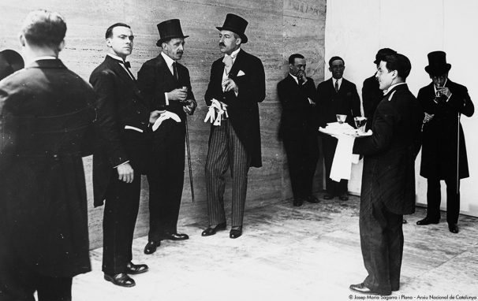
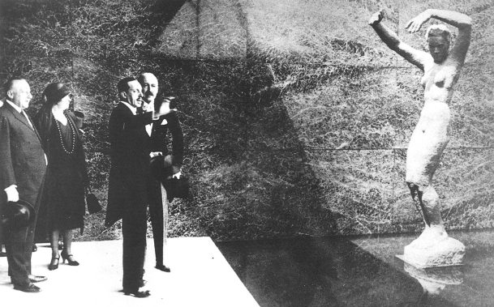
Fundació Mies van der Rohe (2024) https://miesbcn.com/the-pavilion/

In 1930, the Pavilion was taken apart following the exhibition’s discontinuation. It developed over time into a crucial point of reference for twentieth-century architecture in its entirety, as well as for Mies van der Rohe’s individual career. Consideration about the Pavilion’s potential reconstruction proved essential given its importance and notoriety.

Plan and Section.
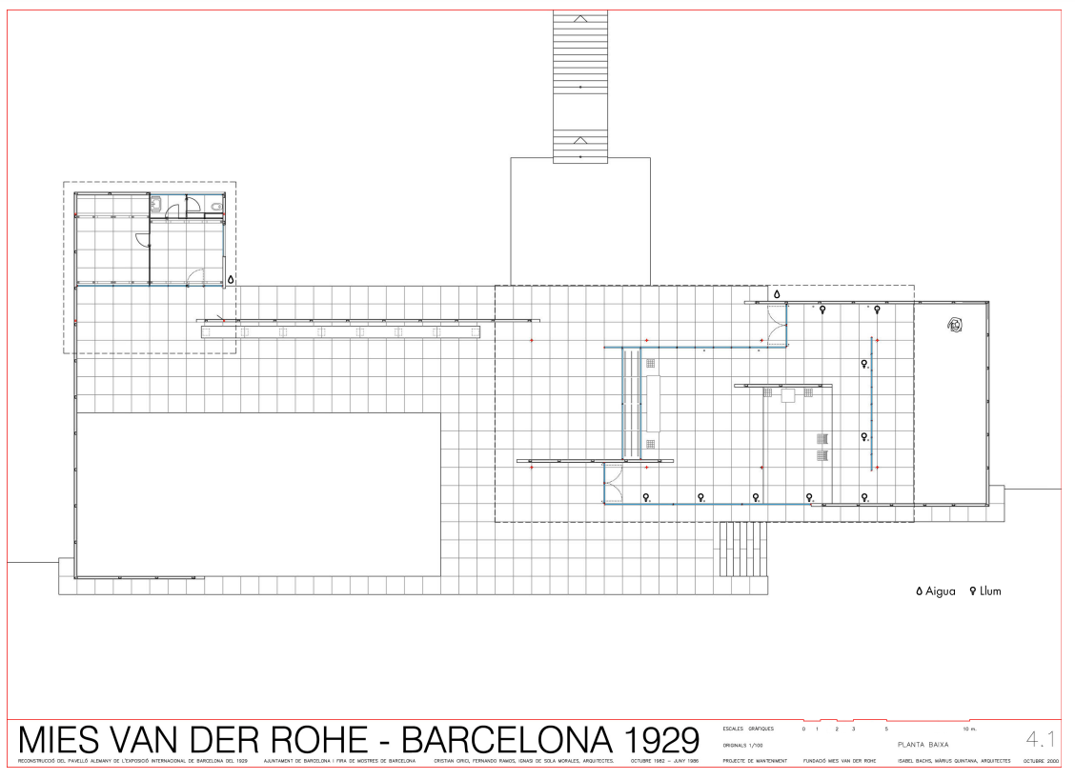
Fundació Mies van der Rohe (2024) https://miesbcn.com/the-pavilion/
The Barcelona pavilion revolves around a central axis and is composed of a number of interconnected spaces. From the plans it is evident that a linear axis passes through the middle of the pavilion which directs the occupants around the space. In order to create a sense of movement, this axis runs from the main entrance to the back terrace. A notable exhibition space with an open floor plan and extensive natural light can be found to the left of the entrance.

This area is adaptable and can be used for a variety of purposes, including holding events and exhibiting artwork. A modest reception area, which acts as a transitional space connecting the entrance hall and the additional private rooms of the pavilion, is located adjacent to the exhibition space. To add to this, there is a peaceful courtyard with glass walls towards the back of the pavilion. This quiet outdoor area is suitable for reflection and acts as an escape from the pavilion’s busier spots. A raised terrace with a reflecting pool viewpoint is located beyond the courtyard. This terrace creates the atmosphere as if you are connected to the outdoors and offers expansive views of the surrounding landscape.
The pavilions sections illustrate how Mies van der Rohe skilfully arranged the walls, columns, ands translucent partitions to convey a sense of spatial layering. The relatively straightforward floor plan gains depth and complexity as a result of this aspect. A grid of thin steel columns and beams supports the roof and enclosure elements of the pavilion, which is made prominent by the sections along with its inventive structural design. This structural system upholds the pavilions minimalist design while allowing for expansive stretches of continuous space.
Solà-Morales, Cirici, and Ramos. Mies van der Rohe: Barcelona Pavilion (2000), p 30-37.
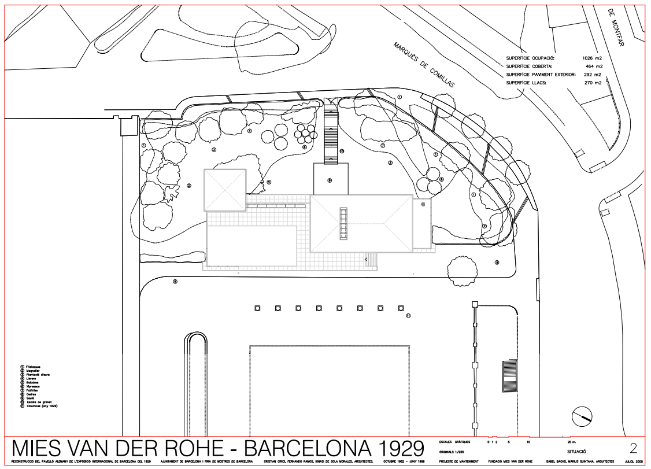
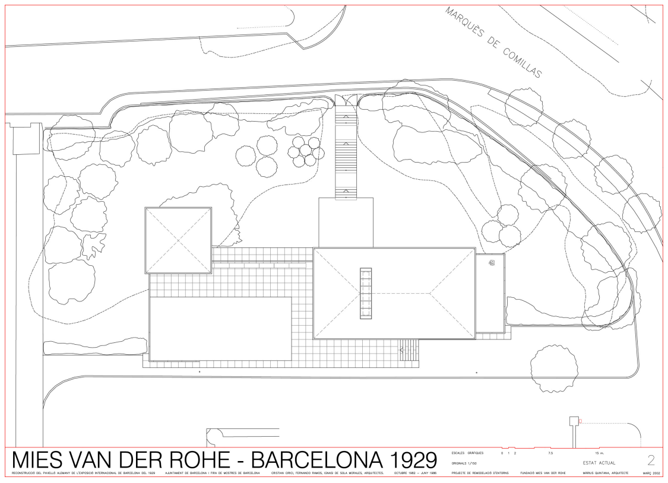
Drawing site plan and drawing roof plan:
Fundació Mies van der Rohe (2024) https://miesbcn.com/the-pavilion/
Materials and light.
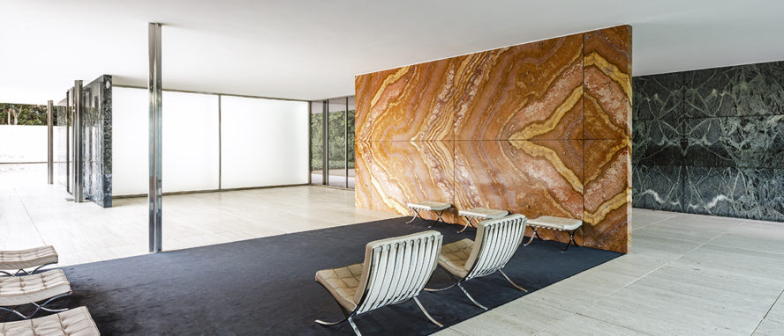
The pavilion at the International Exhibition in Barcelona, Spain, received recognition for its innovative use of materials, open layout, and minimalist style. Fundació Mies van der Rohe (2024) states that four different types of stone were utilised in the reconstruction, including roman travertine, green alpine marble, ancient green marble from Greece, and golden onyx from the Atlas Mountains. Other materials used included glass and steel. The flooring, walls, and sculptures in the pavilion are largely made of fine marble, which gives the area a sense of elegance and refinement.
Fundació Mies van der Rohe (2024) https://miesbcn.com/the-pavilion/
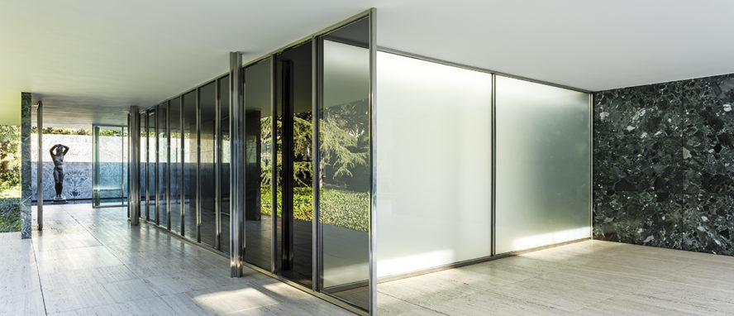
The reconstructive architects of the project, Solà-Morales, Cirici, and Ramos, examined the materials used in the design and its functionality in their book Mies van der Rohe: Barcelona Pavilion (2000), p 13-20. As steel makes up the majority of the pavilion's structure, Mies van der Rohe was able to create a design that is lighter and more open. A number of the pavilion's structural and ornamental components, including the Barcelona Chairs and Daybeds that were made especially for the area, are made of chrome-plated steel, which adds to the space's sleek and contemporary appearance.
Fundació Mies van der Rohe (2024) https://miesbcn.com/the-pavilion/
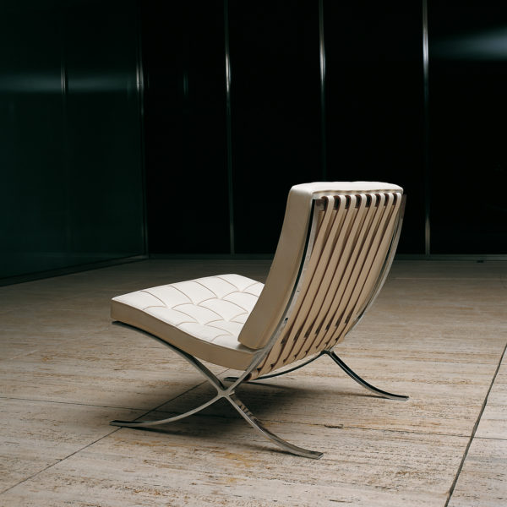
Since glass is the main material used for wall enclosures, it also has a significant impact on the design of the pavilion. The sections emphasise how the pavilion makes the most of the natural light and promotes a sense of transparency by utilising glass walls and open spaces.
The distinction between inside and outside spaces is blurred by the large floor to ceiling glass panels that create a seamless transition between them. Furthermore, concrete is used in the pavilion's foundation and certain structural components, however less so than other materials. By ensuring the building's stability and support, its use contributes to the design's structural integrity. Mies van der Rohe's materials were defined by a sense of modernity that was expressed through the geometric precision, ease of assembly, and accuracy of the individual pieces.

Fundació Mies van der Rohe (2024) https://miesbcn.com/the-pavilion/

Marble in the Barcelona Pavilion: Fundació Mies van der Rohe (2024) https://miesbcn.com/the-pavilion/

Ideas and theories underpinning the design.
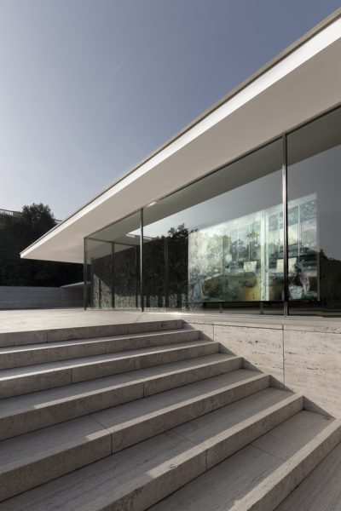
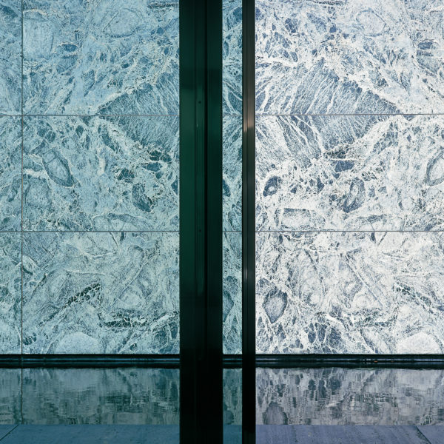
Initially, the pavilion was intended to be an architectural representation of the new Weimar Germany, one that was democratic, prosperous, and culturally forward-thinking (Callahan, 2021). Georg von Schnitzler stated that it ought to “give voice to the spirit of the new era”. The “Free Plan” and the “Floating room” were realised as a result of this idea. The design philosophy of “less is more”, which emphasises simplicity, clarity, and a lack of insignificant ornamentation, became widely recognised by Mies van der Rohe. The Barcelona Pavilions minimalist design, which is defined by open areas, simple lines, and a limited colour scheme, reflects this concept. The Pavilions simple and delicate forms respond as independent works of art, erasing the distinction between architecture and sculpture. Rohe and artist Lilly Reich worked closely together to design the pavilion, integrating handcrafted details and sculpture into the overall architectural composition (Fundació Mies van der Rohe, 2024). In an article by Re-thinking the future (no date), it highlights a fundamental component of modernist architecture which is functionalism, which emphasises the value of function over ornamentation. The Barcelona Pavilions architecture preserves its aesthetic integrity while providing a versatile venue for a range of uses, including social events and exhibitions.

Fundació Mies van der Rohe (2024) https://miesbcn.com/the-pavilion/

Fundació Mies van der Rohe (2024) https://miesbcn.com/the-pavilion/
Conclusion.
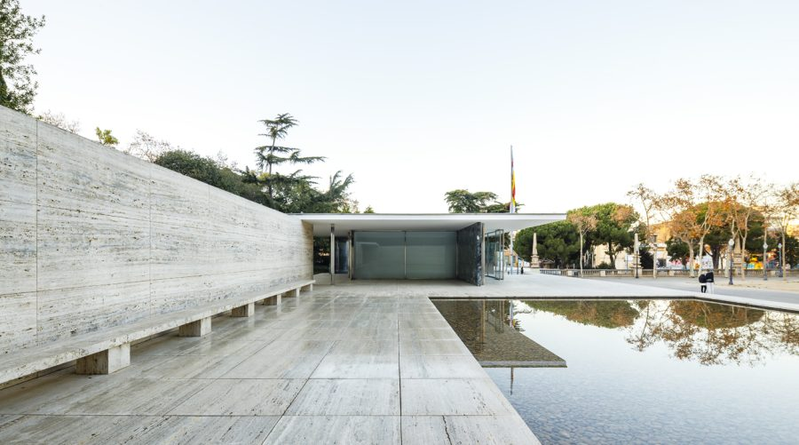
In summary the Barcelona Pavilion is an iconic representation of modernist architecture, embodying the principles of practicality, harmony with the environment, and simplicity. It reflects the eras search for progressive design solutions with its innovative material use, minimalist aesthetic, and spatial fluidity. Its significance as an exemplar of modernist ideals, continuously inspiring future generations of architects and scholars alike, is made apparent by its enduring influence on architectural debate which is still pertinent today.

Reference list:
Aleesha Callahan, Barcelona Pavilion: Barcelon, Spain. By Ludwig Mies Van Der Rohe (2021) https://architectuul.com/architecture/barcelona-pavilion#:~:text=Concept,spirit%20of%20a%20new%20era%22 [accessed 4th March 2024].
Arch Daily, Less is more: Mies van der Rohe, a Pioneer of the Modern Movement (2021) https://www.archdaily.com/350573/happy-127th-birthday-mies-van-der-rohe [accessed 4th March 2024].
Fundació Mies van der Rohe, The Pavilion, Learn: The Barcelona Pavilion was designed by Ludwig Mies van der Rohe and Lilly Reich as the German Pavilion for the Barcelona International Exhibition, held on Montjuïc (2024) https://miesbcn.com/the-pavilion/ [accessed 4th March 2024].
Rethinking The Future, Theory in architecture: Functionalism (no date) https://www.re-thinkingthefuture.com/rtf-architectural-reviews/a3348-theory-in-architecture-functionalism/ [accessed 4th March]
Solà-Morales, Ignasi D., Cirici, Cristian. and Ramos, Fernando. Mies Van Der Rohe: Barcelona Pavilion, 5th edn. (Barcelona: Editorial Gustavo Gili, 2000)

