Effective TeamWorking and Communication
BMSW4002_ETW
Raport
Lecturer: JOY BOTU
Student: Violeta Cicu 2109660

- INTRODUCTION

Communication – “a process by witch information is exchanged between individuals through a common system of symbols, signs, behavior, verbal or written message” (Merriam Websten 1828)
In my own words communication is the transference of a thought from one to another where the sender and receiver clearly understand each other.
From history, people used to communicate in different ways through (noise, birds, smoke)
Nowadays communication it`s done through technology via e-mails, messages through phones, letters, etc. The important way it`s still verbal communication .
According to Lasater (2019) “Effective communication skills are the main key to success in workplace “.
It is a necesitie to have a good balance of communication on the workplace, so the employees can have a good understanding. That will show a good organisation and will improve productivity.
This assessment will discuss the models of communication, communication skills and the advantages and disadvantages of communication.

2. MODELS OF COMMUNICATION

“Models of communication are conceptual models used to explain the human communication process”
Different models of communication can be found that work strategic through the workplace in order to improve productivity. Here are three of the very known once described below.

2.1 SHANNON AND WEAVER MODEL OF COMMUNICATION
It has been publisht in 1948 by an american mathematician – scientist as a strategic model of communication “A Mathematical Theory of communication” and it`s well known as Shannon and Weaver model or “mother of all models” being a more technological model then all other linear models.
“The purpose of this model was to design an effective communication ground between sender and the receiver.” (Kubota, 2019).
The concepts in Shannon and Weaver model are as follows:
- Sender – the person who creates the message and want to pass it on through a channel.
- Encoder – is the sender who chouse the machine and then change the message into a signal or binary data.
- Decoder - it's the receiver, the piece of device that allows you to read or hear the message received in the terminal.
- Receiver – the final destination for the message just being sent. It can be person or a place
According to the message, the receiver provides feedback.
- Noise – disturbance that can happen between the encoding and decoding the message caused by sound, crouds environment and place of work
Maria and Pedro case study:
In this case study Maria called Pedro and ask him to get a chicken on his way back home. Because their conversation has being interrupted by external noise, Pedro understood that Maria needs him home to help her in the kitchen.
As a description, here Maria was the sender, the aerial or the phone signal was the channel encoding and decoding happen in the telephone while they were talking and Pedro was the receiver. The misunderstanding and brakes happen because of background noise.
S & W model of communication can send messages in good way however the noise has created misunderstanding in the communication in the case above.



2.2 Schramm Model of Communication
This model of communication has being introduced by Wilbur Schramm in 1954. In his theory he establish that communication is a two-way process where the sender and receiver communicate in accordance with their needs. According to Schramm “in between the communication process, the presence of encoding and decoding is very much vital apart from the sender and receiver”. (Liebers and Schramm, 2019)
This model has it roots from the Shannon and Weaver model.
- Sender – the person who creates the message that needs to be send
- Encoder – the send message has being encoded into telecommunication technology and it`s on the way to the receiver
- Decoder – the device that will receive the message, binary digits.
- Interpreter – the technology use to analyse the message.
- Receiver – the person who receives the message
- Message – the data send between the sender and receiver
- Noise – the cause of misunderstanding in communication
Maria and Pedro case Study
“Telecommunication technology played the role of encoder and decoder, the interpreter has being defined by the transforming technology from message to the binary data, Pedro being the receiver.” (Mitra et all, 2020)
However the noise has being described as disturbing communications and the technology around it must be improved so the noises can be avoided in order to create a clear message for the receiver.
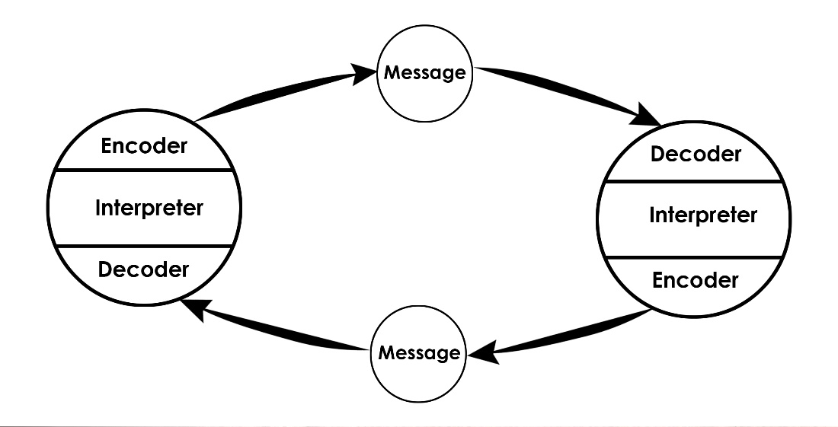
2.3 BERLO`S MODEL OF COMMUNICATION
It has being invented by the theorist David Berlo in 1964. This also has the roots in Shannon and Weaver model being a linear model and the feedback is not available. According to Kuzmar and Yager 2020 the Berlo`s model can created several misunderstandings due to the it`s complex nature. The sender or receiver can be affected by different communication skills like: language, reading, social system, speaking ability or cultural background

Professor and the village people case study
Brifely: The professor lived in the village around the ordinary people but following his attitude and communication skills “alone” in a way, into a bungalow. One day his bungalow was set on fire, hi run for help and the way hi ask for help hasn't been understood by the people. He was shouting “THE EDIFICE IS BEING CONSUMED BY GREAT CONFLAGRATION!” instead of telling in ordinary way “HELP MY BUNGALOW IS ON FIRE!”
The consequences was that his bungalow was destroyed. After his investigation he find out why people did not help him, then he concluded that villagers were unable to receive the message and to understand his complicated language.
The above incident is a consequence that the social system did not work because the professor had no intention to speak so the people could understand him. Therefore, I believe that because of cultural development they were not able to understand unfamiliar words.


3 Communication skills
Communication is the way to express the feelings and wishes. It`s the way we can or not make ourselves understood. A good listener is also a good speaker.
Communication skills are described below:
3.1 Verbal Communication: According to Radovic and Salamzadeh (2018) “a good verbal communication skills are a basic need in a sustainable workplace “ The way we chose the approach, tone of voice and the words to express our feelings plays an important role in the way we communicate and the messages we deliver.
A day with a chief case study:
Reffering to the case study I understand that even thow Mrs. Brawn was a perfect boss and shows understanding and make Mark feel comfortable he then took advantage of her nice attitude and went with the discussion in the wrong direction fallowing his interess. She did not want to speak with Mark anymore because he open a team conflict instead of showing better team bonding.
If I would happen to be in Marks shoes I would better talk the opportunity to show my skills and knowledge to Mrs. Brown instead of taking about the internal team misunderstandings.
3.2 Non-Verbal Communication:
It's when communication takes place with the body language most of the time, eye gaze, gesture, facial expressions, the tone of the voice.
According to Ali (2018) non-verbal communication skills have great impact in the workplace when a message is delivered verbally and the non-verbal have the different expressions, then the message is wrongly understood by the receiver.
A day with the chief case study:
When Mark got to California was very stressed and nervous in the same time, because of the privilege of meeting Mrs Brown and also for the toughts he had in mind regarding her sever attitude. Instead she was very polite with him so he got very relaxed, too relaxed and he changed his attitude by showing it though body language. He was loosen he's tie, cross his legs and he started talk what he thinks it goes wrong with the office in London.
And here is when body language deliver's exactly what Mark thought. This atitude did not any good to his professional visit.
3.3 Active Listening
This is the skill obtained through lots of practise. To be an active listener,must understand the verbal and non-verbal messages also to pay a good attention to the speaker without doing something else to be able to understand what the speaker said and also to respond accordingly.
According to Jonsdottir and Fridriksdottir (2020), stated that active listening skills is very necessary to enhance leadership qualities in a person.
3.4 Empathetic Listening
Is a type of structural listening, a method that involves structure of questions.
Max the multitasker case study: Max was a very busy business person, with lots of skills and also looking after his ill mother. That involves stress, huge pressure at work and tension. When he received a phone call from Tamara where she wanted to change the event date because he was busy doing more things in the same time he forgot to rearrange the party on the rescheduled time. That went to disappoint Tamara and her guests also did not look good on Max business. This shows his inefficiency.
He could just ask her to call back or hi could just call her back to make sure he got it right. On the other hand, Tamara could just give him a call back to double check the change date. Even though, Tamara was right to be upset because the arrangements has not being delivered. As for Max I'll suggest he should get at least one more employee or to make sure he takes notes of everything.
4. The Advantage and Disadvantage of technology in communication
4.1 Advantages
- People can communicate through Tele communication.
- The communication can be arranged in a very short.
- Quickest and accessible to everyone.
- Sustainable for the workplace.
- Through technology it's easy to coordinate.
- Increase capability of management.
- Promote cooperation skills.
- It does not take to much space (landline's, smart phones)
- Documents to be sent quick with a fax machine.
4.2 Disadvantages
- The expression of the message can be hiden because there is no facial expression.
- Linguistic problems.
- Disturbance of noise or weather can affect telecommunication.
- Also because of noise misunderstanding of the message can happen.
- Data security one of the most delth with problem into organisation.
- The leak of confidentiality.
Conclusion
As a conclusion communication skills are very important in monitoring a good personal relationship at work and in everyday life. It's important for sharing our thoughts, feelings, change ideas or professionally evoluate at the workplace.
Telecommunication is a must have those days in personal life and in business. Models of communication discussed in this report shows the importence of it and embrace the technology with the advantages and disadvantages in passing the message around us. Also this report talks about the non verbal communication which in more cases it's more important then any other way of communication.
Reference
Kubota, M., 2019. What is “Communication”?―Beyond the Shannon & Weaver’s Model―. International Journal, 13(1), pp.54-65. Available at: https://jaems.jp/contents/icomej/vol13/06_Kubota.pdf
Liebers, N. and Schramm, H., 2019. Parasocial interactions and relationships with media characters–An inventory of 60 years of research. Communication Research Trends, 38(2), pp.4-31. Available at: https://www.researchgate.net/profile/Nicole-Liebers-2/publication/333748971_Parasocial_Interactions_and_Relationships_with_Media_Characters_-_An_Inventory_of_60_Years_of_Research/links/5d25ae8b92851cf44074e830/Parasocial-Interactions-and-Relationships-with-Media-Characters-An-Inventory-of-60-Years-of-Research.pdf
Mitra, A., Ahmed, N., Pramanik, P. and Nandi, S., 2020. Language Studies and Communication Models. International Journal of English Learning & Teaching Skills, 3(1),
Ali, M., 2018. Communication skills 3: non-verbal communication. Nursing times, 114(2), pp.41-42.
Chistyakova, G., Bondareva, E., Demidenko, K. and Rolgayzer, A., 2021. Advantages and Disadvantages of Using Information Communication Technologies in the Process of Forming Language Competence in Global Mining Education. In E3S Web of Conferences (Vol. 278, p. 03026). EDP Sciences.
Jonsdottir, I.J. and Fridriksdottir, K., 2020. Active listening: Is it the forgotten dimension in managerial communication?. International Journal of Listening, 34(3), pp.178-188.
Jonsdottir, I.J. and Kristinsson, K., 2020. Supervisors’ active-empathetic listening as an important antecedent of work engagement. International Journal of Environmental Research and Public Health, 17(21), p.7976
Kuznar, L.A. and Yager, M., 2020. The Development of Communication Models, Quick Look. Joint Staff J39, Strategic Multi-layer Assessment Washington, DC United States.
Lasater, I., 2019. Words that work in business: A practical guide to effective communication in the workplace. PuddleDancer Press.
Radovic Markovic, M. and Salamzadeh, A., 2018. The importance of communication in business management. In Radovic Markovic, M., & Salamzadeh, A.(2018). The Importance of Communication in Business Management, The 7th International Scientific Conference on Employment, Education and Entrepreneurship, Belgrade, Serbia.

