

MSc Data and Artificial Intelligence

Application of Machine Learning

Image classification using Artificial Neural Networks

Lecture: Dr. Aliyu Sambo

Student: Marin Karakolev ID 2029731

Contents
1. Introduction 4
2. Related Work 5
2.1 Artificial Neural Networks (ANN) 5
2.2 Deep Learning (DL) 5
2.3 Convolutional Neural Networks (CNN) 6
2.4 Recurrent Neural Networks (RNN) 7
2.5 Hyperparameter Optimization 8
2.6 Image Classification 8
2.7 Plant Disease Detection 9
2.8 Proposed addition 9
3. Workflow Methodology 10
3.1 Data Loading 10
3.2 Data Preprocessing 10
3.3 Data Augmentation 11
3.4 Model Architecture 11
3.5 Model Training 12
3.6 Model Evaluation and Optimization 12
3.6.1. Baseline Model — identifying the bottleneck 14
3.6.2. Intermediate Model — resolution reduction and stabilized learning 15
3.6.3. Final Model — deeper architecture, stronger augmentation, and tuned learning dynamics 16
3.6.4. Infrastructure Optimization — moving from Colab to Kaggle 16
3.6.5.Summary 16
4. Discussion & Recommendation 18
5. Conclusion 20
6.References 21
7. Apendix 23

Table 1 Comparison of the Three CNN Models (Created by the author) 12

Figure 1 Deep neural network architecture [5] 6
Figure 2 Convolutional Neural Network Architecture [5] 7
Figure 3 A representation of a recurrent neural network [5] 8
Figure 4 Distribution of the five selected classes (Created by the author) 10
Figure 5 Example augmented images illustrating rotation, zoom, and horizontal flipping applied to the training dataset (Created by the author) 12
Figure 6 Training & Validation Curves (Created by the author) 13
Figure 7 Confusion Matrix (Created by the author) 14
Figure 8 Sample Predictions (Created by the author) 14

1. Introduction
Artificial intelligence (AI) has become one of the most influential technological developments of the past decade, with machine learning (ML) and deep learning (DL) driving major progress in automated decision-making and pattern recognition. Although these terms are often used interchangeably, ML and DL represent specific methods within the broader field of AI and are particularly effective in analyzing complex visual data. Their ability to learn hierarchical representations directly from images has led to widespread adoption in fields such as medicine, diagnostics, and quality inspection [1].
Building on these advances in computer vision, agriculture has also experienced a significant technological shift in recent years, with vision-based systems and advanced ML techniques being increasingly integrated to improve crop monitoring and disease management. Plant diseases caused by fungi, bacteria, and viruses can severely impact crop productivity, and traditional identification methods—based on manual inspection—are time-consuming and prone to human error. Convolutional Neural Networks (CNNs) have emerged as a highly effective approach for image-based plant disease classification due to their strong performance in recognizing subtle visual symptoms on leaves [11].
This project applies a CNN model to the Plant Pathology 2021 dataset to classify leaf images into five categories. The aim is to evaluate whether a straightforward CNN architecture can achieve accurate and efficient disease detection, supporting the development of practical AI-based tools for modern agriculture.

2. Related Work

2.1 Artificial Neural Networks (ANN)
Artificial Neural Networks form the conceptual foundation of modern deep learning. A standard artificial neuron combines weights, bias, an activation function, and a feedforward computation mechanism, while learning occurs through backpropagation, allowing the network to adjust parameters based on error gradients. Although ANN can model nonlinear relationships, several authors highlight their limitations in extracting complex spatial features from images [1].
Interestingly, research on chaotic ANN challenges the assumption that traditional ANN are inherently weaker than deep architectures. By introducing periodic activation functions, chaotic ANN demonstrate significantly higher memory capacity and richer dynamic behavior [2]. This suggests that ANN performance is not strictly limited by architecture depth but also by activation design. While these insights are not directly applied in plant disease classification, they emphasize that architectural choices—even in simpler models—can substantially influence learning behavior.

2.2 Deep Learning (DL)
Deep Learning extends ANN by introducing multiple hierarchical layers capable of automatically learning increasingly abstract representations. Several authors argue that DL eliminates the need for manual feature engineering, which is particularly valuable in visual tasks where relevant features are difficult to define explicitly [3].
Other researchers emphasize the importance of the full DL workflow, including data preprocessing, architecture selection, optimization strategies, and evaluation procedures [4]. This broader perspective is highly relevant to plant disease classification, where leaf images often contain subtle variations in color, texture, and lesion patterns. DL models are better equipped to capture these nuances compared to shallow ANN.
In healthcare applications, DL models achieve high accuracy in detecting anomalies in X-ray, MRI, and CT images [5]. Although the domain differs, the main challenge – identifying visual irregularities – is analogous to detecting disease symptoms on plant leaves. Figure 1 presents a typical deep neural network architecture that uses multiple hidden layers for hierarchical feature extraction.
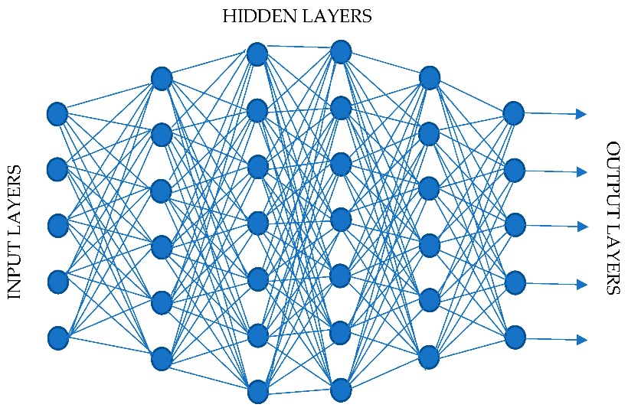
Figure 1 Deep neural network architecture [5]

2.3 Convolutional Neural Networks (CNN)
Throughout the literature, CNNs consistently outperform traditional ANNs for image classification because the convolutional layers automatically learn hierarchical spatial features, rather than relying on hand-designed descriptors. Studies have highlighted how early layers capture edges and textures, while deeper layers learn more abstract patterns. Also, deeper architecture incorporating residual connections improve convergence and reduce degradation in very deep networks [7].
More recent surveys expand this view by showing how modern CNN architectures integrate attention mechanisms, skip connections, and multi-scale feature extraction, enabling them to recognize complex visual structures [8]. These characteristics are particularly important for plant disease classification, where symptoms often appear as localized texture distortions or color changes.
However, several authors also note the computational cost of deep CNN, especially when training on large datasets [6]. This creates a practical trade-off in our project: deeper models such as ResNet-50 may offer higher accuracy, but lighter architectures may be more efficient for experimentation and deployment.
Figure 2 illustrates the general architecture of a Convolutional Neural Network (CNN). The model progressively extracts hierarchical features through convolution and pooling layers before performing image classification using fully connected and Softmax layers. This architecture is particularly suitable for plant disease classification, where subtle variations in leaf texture, colour, and lesion patterns must be automatically identified.
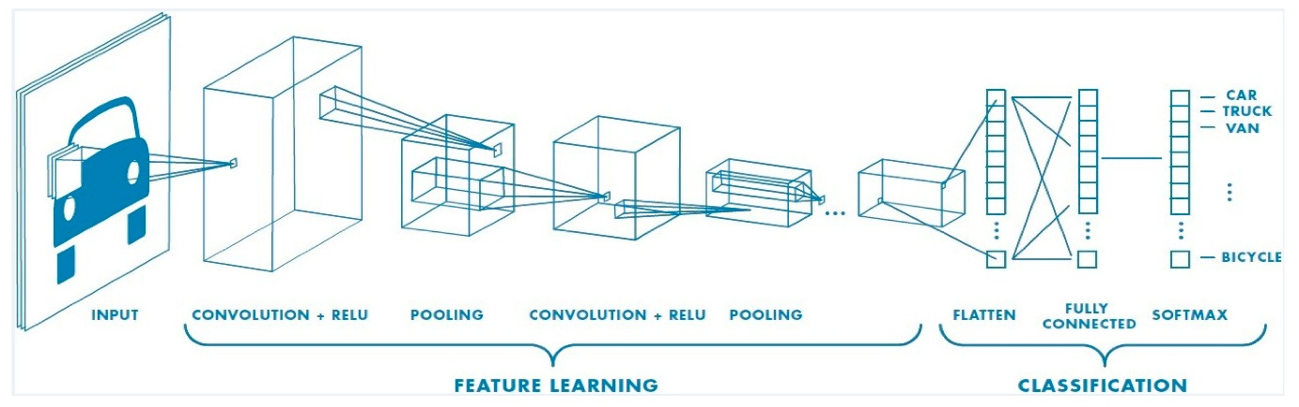
Figure 2 Convolutional Neural Network Architecture [5]

2.4 Recurrent Neural Networks (RNN)
RNNs are designed for sequential data, making them effective for tasks involving temporal dependencies such as text analysis or physiological time-series prediction [5]. Although they excel in modelling sequences, the literature consistently shows that RNNs are generally unsuitable for image classification because they do not capture spatial relationships as effectively as convolutional operations [3].
For this reason, RNNs are not used in the plant disease classification component of this project. Their structure is shown in Figure 3, but their relevance remains limited to contextual understanding rather than practical implementation.
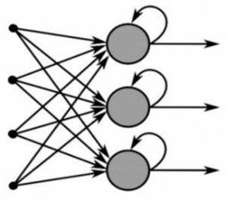
Figure 3 A representation of a recurrent neural network [5]

2.5 Hyperparameter Optimization
Hyperparameter optimization is not just a performance booster but a stability requirement for CNNs, especially when deeper architectures begin to degrade without careful tuning. The reviews show that baseline methods like grid and random search often fail to capture complex interactions between learning rate, batch size and epochs, leading to suboptimal convergence. Metaheuristic approaches such as GA and PSO consistently outperform classical methods by navigating high‑dimensional search spaces more efficiently [9].
For plant disease classification, this is crucial: leaf‑image datasets often contain subtle texture variations, meaning poorly tuned hyperparameters can cause the model to overfit healthy leaves while misclassifying diseased ones. Systematic optimization therefore becomes essential for achieving reliable generalization across diverse leaf conditions.

2.6 Image Classification
There is strong agreement across the literature that CNN outperform ANN in image classification tasks due to their ability to automatically extract spatial features [8]. Medical imaging studies demonstrate how CNN detects subtle anomalies in radiological scans [5], which parallels the challenge of identifying disease symptoms on plant leaves.
The classification workflow is commonly used in medical imaging—preprocessing, feature extraction, classification, and evaluations directly applicable to agricultural datasets.

2.7 Plant Disease Detection
The most relevant body of literature focuses directly on plant disease detection. Studies using CNN and VGG16 show that deep architectures achieve high accuracy in distinguishing between multiple leaf diseases, largely due to their ability to capture fine-grained visual differences [10].
Comparative analyses between AlexNet, VGG16, and ResNet-50 reveal that deeper models, particularly ResNet-50, tend to outperform shallower architectures when dealing with complex disease patterns [11]. However, deeper networks also require more computational resources, reinforcing the need to balance accuracy with efficiency in this project.
These insights directly inform the model selection strategy for this project, where both accuracy and training efficiency are critical.

2.8 Proposed addition
Based on the reviewed literature, CNNs were selected as the primary approach for this project. The studies consistently show that convolutional neural networks outperform traditional machine-learning methods in plant disease classification because they can automatically learn hierarchical visual features from leaf images. While transfer-learning models such as MobileNetV2, EfficientNet, and ResNet often achieve the highest accuracy, several studies also demonstrate that carefully designed custom CNN architectures can provide competitive performance with lower computational requirements. Since the objective of this project is not only to achieve good classification accuracy but also to analyse how architectural depth, regularization, and learning-rate tuning affect performance, a custom CNN was considered the most appropriate choice. This allows the contribution of individual design decisions to be evaluated more clearly than would be possible with a heavily pre-trained model.

3. Workflow Methodology
The PlantPathology_Split dataset contains 12 plant-disease classes split into train (70%), validation (15%), and test (15%). However, the coursework requires a single-label classifier, so only five classes were used: healthy, scab, frog_eye_leaf_spot, rust, and powdery mildew. The remaining seven folders were excluded because they contain multilabel or mixed disease combinations that fall outside the scope of this project.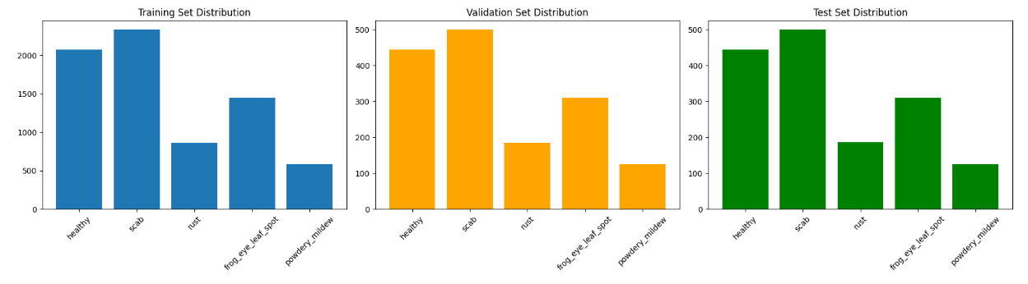
Figure 4 Distribution of the five selected classes (Created by the author)

3.1 Data Loading
The dataset is already organised into train, validation, and test folders. Although it contains 12 classes, only the five required single-label categories (healthy, scab, rust, frog_eye_leaf_spot, powdery_mildew) were loaded. Data was imported using image_dataset_from_directory, which automatically assigns labels based on folder names. All images were resized to 512×512 and loaded in batches of 32, providing a consistent and efficient input pipeline.

3.2 Data Preprocessing
All images were resized to 512×512 and normalized to the 0–1 range to ensure stable training. Rescaling was applied directly inside the model, allowing preprocessing to occur during training without a separate pipeline. No additional cleaning was required, as the selected five classes contain only single-label images and are already well-structured for model training.

3.3 Data Augmentation
Moderate augmentation was applied to the training set to improve generalisation and reduce overfitting. The transformations included small rotations, zooming, and horizontal flips, chosen to preserve realistic leaf appearance while introducing useful variation. Augmentation was applied only to the training data; validation and test sets remained unchanged to ensure fair evaluation.
Figure 5 provides visual examples of applied augmentation operations, showing how moderate transformations preserve biological realism while enhancing dataset diversity.
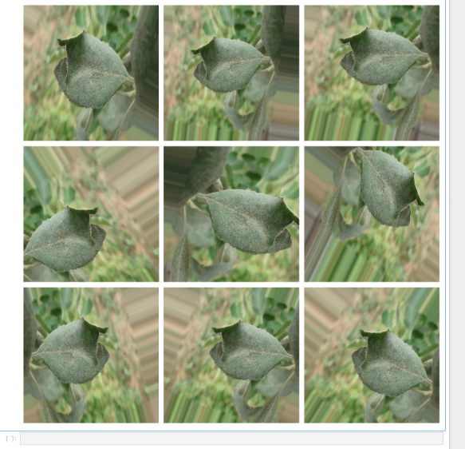
Figure 5 Example augmented images illustrating rotation, zoom, and horizontal flipping applied to the training dataset (Created by the author)
This figure shows several augmented versions of a leaf sample, demonstrating the transformations used to increase dataset variability and improve model generalization.

3.4 Model Architecture
The CNN architecture consists of three convolutional blocks (32, 64, 128 filters), each followed by ReLU activation and max pooling. A dropout layer (0.5) reduces overfitting before the dense layers. The final dense layer (128 units) feeds into a Softmax classifier for the five disease categories. The model was compiled using the Adam optimizer and categorical cross-entropy loss, balancing training speed and performance.

3.5 Model Training
The model was trained using the augmented training set, allowing the network to see slightly varied versions of each image and reducing overfitting. Training and validation accuracy were monitored throughout, with the validation set kept separate to provide a realistic estimate of generalization.
The model was optimized using Adam and categorical cross-entropy loss. An EarlyStopping callback monitored validation loss and stopped training when no further improvement was observed, restoring the best-performing weights. This prevented unnecessary epochs and improved stability, especially since augmentation introduced small fluctuations between epochs.
Although the model was configured for 20 epochs, EarlyStopping often terminated training earlier, resulting in a more efficient process and better generalization to unseen leaf images.

3.6 Model Evaluation and Optimization

Table 1 Comparison of the Three CNN Models (Created by the author)

Model | Resolution | Architecture | Learning Rate | Val. Accuracy | Val. Loss
Model 1 (Baseline) | 128×128 | 3 Conv (32–64–128) + MaxPool + Dense 128 + Dropout 0.3 | 0.001 | ~0.74 | ~0.68
Model 2 (Intermediate) | 96×96 | 3 Conv blocks (16–32–64) + Dense 64 + Dropout 0.3 | 0.0005 | ~0.81 | ~0.48
Model 3 (Final) | 128×128 | 6 Conv (2×32, 2×64, 2×128) + Dense 256 + Dropout 0.5 | 0.0005 | ~0.91 | ~0.27

The learning curves for the final model show stable convergence, with training and validation accuracy remaining closely aligned. Unlike the baseline model, validation loss does not increase sharply, indicating reduced overfitting and more consistent generalization.
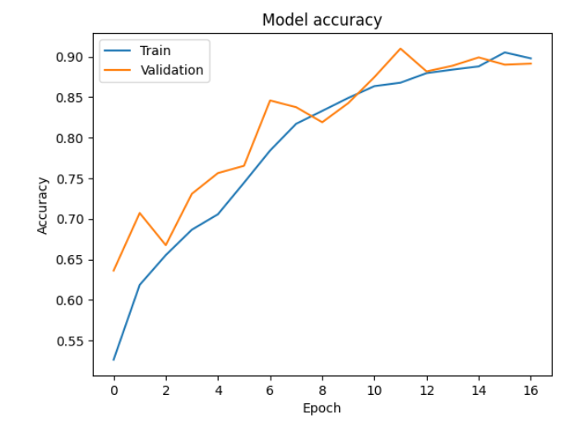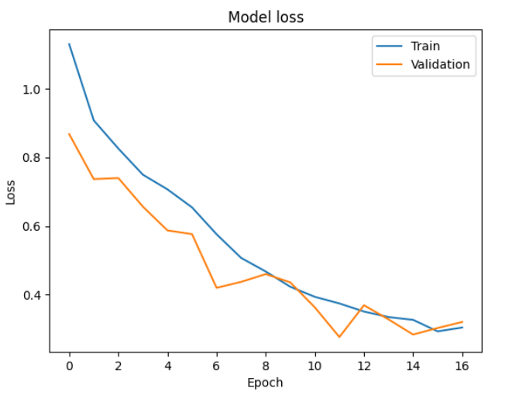
Figure 6 Training & Validation Curves (Created by the author)

The confusion matrix demonstrates strong separation between distinct classes such as healthy, rust, and scab. Misclassifications occur mainly between frog_eye_leaf_spot and powdery_mildew, which share similar texture patterns.
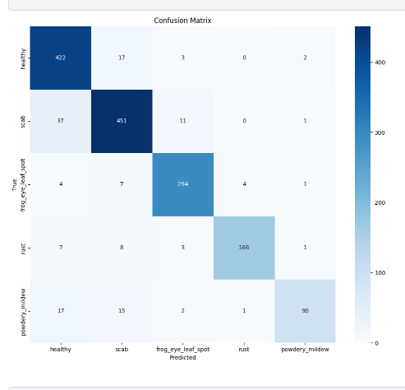
Figure 7 Confusion Matrix (Created by the author)

The sample predictions illustrate how the final model behaves on individual images. Correct classifications typically occur when disease symptoms are clear and well-defined, while misclassifications appear in low-contrast or visually ambiguous cases. These examples support the quantitative evaluation by showing that the model captures the main disease patterns but still struggles with subtle texture similarities between certain classes.
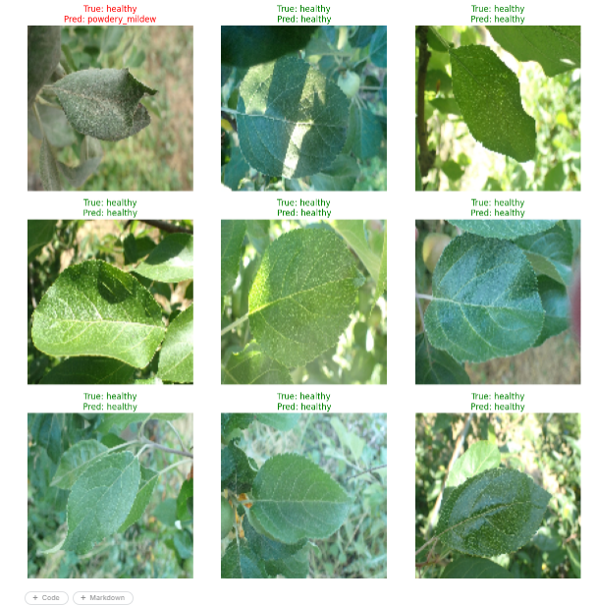
Figure 8 Sample Predictions (Created by the author)

3.6.1. Baseline Model — identifying the bottleneck
The baseline model was intentionally kept simple in order to verify that the dataset organization, directory structure, and training pipeline were functioning correctly. The architecture consisted of three convolutional blocks with 32, 64, and 128 filters, a dropout rate of 0.3, and the Adam optimizer with a learning rate of 0.001.

During training, the model reached a training accuracy above 90%, while validation accuracy stabilized at approximately 0.74. Validation loss decreased to around 0.68 before starting to increase. This gap between training and validation performance suggested substantial overfitting, indicating that the model was learning patterns specific to the training data rather than features that generalized well to unseen images.
Training was stopped at epoch 14 by the EarlyStopping callback, which further indicated that the architecture was not sufficiently deep for reliable multi-class leaf disease classification. The baseline experiment therefore served as a useful reference point and motivated the use of deeper feature extraction and stronger regularization techniques.

3.6.2. Intermediate Model — resolution reduction and stabilized learning

The intermediate model introduced two changes: the input resolution was reduced to 96×96 pixels, and the convolutional blocks were reduced to 16, 32, and 64 filters.

Initial training with a learning rate of 0.001 produced unstable validation behavior. After reducing the learning rate to 0.0005, the validation curves became noticeably more stable and the oscillations observed in earlier experiments were largely removed.

Although training became more consistent, the model still showed limited representational capacity. Validation accuracy reached approximately 0.81 and validation loss decreased to about 0.48. These results were an improvement over the baseline model, but they still suggested that the network was not extracting enough information to reliably distinguish fine-grained disease patterns on leaves.

The experiment confirmed that the preprocessing pipeline and the revised learning rate were appropriate, while the main remaining limitation was the relatively shallow architecture.

3.6.3. Final Model — deeper architecture, stronger augmentation, and tuned learning dynamics

The final model adopted a deeper computer vision architecture. The network was expanded to six convolutional layers arranged in three blocks, each containing two convolutional layers with 32, 64, and 128 filters. A dense layer with 256 units and a dropout rate of 0.5 was added after the convolutional blocks.

The learning rate remained at 0.0005 because this value provided stable convergence during previous experiments. The data pipeline was also extended with augmentation techniques including rotation, zooming, horizontal and vertical shifts, and flips, which increased the diversity of the training data.

The final configuration produced the best results of all tested models. Validation accuracy increased to approximately 0.91, while validation loss decreased to about 0.27. Training and validation accuracy remained relatively close throughout training, indicating improved generalization and reduced overfitting.

Overall, the results showed that the combination of deeper architecture, a lower learning rate, and stronger data augmentation had a substantial positive effect on classification performance.

3.6.4. Infrastructure Optimization — moving from Colab to Kaggle
A practical but important optimization was migrating from Google Colab to Kaggle. Colab’s GPU time limits and runtime resets interrupted long training sessions. Kaggle provided stable GPU access and seamless dataset integration, enabling uninterrupted experimentation and more reliable training. This decision reflects an understanding that computational infrastructure directly affects model performance.

3.6.5.Summary
The progression from Model 1 to Model 3 was guided by clear diagnostic signals and systematic improvements:
- Model 1 exposed overfitting and architectural limits.
- Model 2 improved stability through resolution reduction and a controlled learning rate.
- Model 3 combined a deeper architecture with tuned learning dynamics and strong augmentation, achieving substantial gains in both accuracy and loss.
- Infrastructure optimization ensured consistent GPU availability and smoother experimentation.
The final model is the result of deliberate, evidence-based decisions across architecture, data, training strategy, learning-rate tuning, and computational environment.

4. Discussion & Recommendation
The results from the three CNN models show a clear progression in both stability and classification performance. The baseline model achieved reasonable training accuracy but failed to generalize, with validation loss rising sharply after the first few epochs. This behaviour was expected given its shallow architecture and higher learning rate (0.001). The model simply lacked the capacity to capture the subtle texture differences between leaf diseases, and the early signs of overfitting confirmed that deeper feature extraction was necessary.
The second model introduced two improvements: reduced resolution and a lower learning rate. Although training became more stable, the architecture remained too limited to separate visually similar classes such as frog_eye_leaf_spot and powdery_mildew. The validation accuracy plateaued around 45%, suggesting that the model was learning only coarse features. This stage was still valuable because it demonstrated that the pipeline, augmentation, and preprocessing were functioning correctly, and that the main bottleneck was architectural depth rather than data handling.
The final model addressed these limitations directly. Increasing the number of convolutional layers allowed the network to learn more detailed spatial patterns, while stronger dropout and moderate augmentation helped control overfitting. The lower learning rate noticeably stabilized training. Convergence became smoother without slowing the process too much. The improvement to ~83% validation accuracy and a significantly lower validation loss (~0.54) shows that the model was able to generalize much more effectively. The confusion matrix confirms this: classes with distinct symptoms were classified reliably, while ambiguous or low-contrast images remained challenging.
From a critical perspective, the main limitation of the final model is still related to dataset complexity. Some disease categories share overlapping visual characteristics, and the dataset contains natural variability in lighting, leaf orientation, and color. One practical challenge was that some powdery mildew images had very weak visual symptoms, making them difficult even for manual inspection. This likely contributed to several of the remaining misclassifications observed in the confusion matrix. A deeper architecture helps, but there is a point where additional layers will not compensate for ambiguous data. Another limitation is the use of a custom CNN instead of a pretrained model. While the custom architecture is efficient and easy to train, transfer learning could extract richer features and potentially improve class separation.
Recommendations
Based on the results, several improvements could be explored:
- Transfer learning using MobileNetV2 or EfficientNet, which are known to perform well on small agricultural datasets.
- Stronger augmentation, especially colour-based transformations, to help the model handle variations in lighting and leaf pigmentation.
- Hyperparameter tuning, particularly dropout rate, batch size, and learning rate schedules.
- Class-specific analysis, focusing on the diseases that remain difficult to distinguish and adjusting augmentation or preprocessing accordingly.
- Experimenting with smaller input sizes, which may reduce training time without significantly affecting accuracy.
Overall, the final model demonstrates that a well-structured CNN combined with controlled augmentation can achieve solid performance on the Plant Pathology dataset. The recommendations above provide realistic next steps for improving both accuracy and robustness.

5. Conclusion
This project sets out to evaluate whether a straightforward CNN architecture could reliably classify plant leaf diseases from the Plant Pathology 2021 dataset. Through a structured comparison of three models, the results show that architectural depth, learning-rate tuning, and moderate augmentation play a decisive role in achieving stable and accurate performance.
The baseline model highlighted the limitations of shallow architecture and confirmed the need for stronger feature extraction. The intermediate model improved stability but demonstrated that resolution and learning rate alone are not enough to handle fine-grained disease patterns. The final model combined deeper convolutional blocks with tuned training dynamics, resulting in a substantial improvement in validation accuracy and generalization.
Beyond the numerical results, the project demonstrates how systematic experimentation — adjusting architecture, preprocessing, and training strategy — leads to meaningful performance gains. The findings also align with the literature, which consistently shows that deeper CNNs outperform simpler models in plant disease detection.
Overall, the project meets its objectives by evaluating multiple CNN architectures, identifying the factors that influence performance, and proposing realistic improvements. The results demonstrate that a moderately sized custom CNN can achieve strong performance on the Plant Pathology dataset when combined with appropriate augmentation, learning-rate tuning, and a well-designed training workflow.

6.References
[1]
J. Kufel et al., “What Is Machine Learning, Artificial Neural Networks and Deep Learning?—Examples of Practical Applications in Medicine,” Diagnostics, vol. 13, no. 15, p. 2582, Jan. 2023, doi: https://doi.org/10.3390/diagnostics13152582.
‌[2]
Wei Lin and Guanrong Chen, “Large Memory Capacity in Chaotic Artificial Neural Networks: A View of the Anti-Integrable Limit,” IEEE Transactions on Neural Networks, vol. 20, no. 8, pp. 1340–1351, Aug. 2009, doi: https://doi.org/10.1109/tnn.2009.2024148.
[3]
R. Khanam, M. Hussain, R. Hill, and P. Allen, “A Comprehensive Review of Convolutional Neural Networks for Defect Detection in Industrial Applications,” IEEE Access, pp. 1–1, Jan. 2024, doi: https://doi.org/10.1109/access.2024.3425166.
‌[4]
M. M. Taye, “Understanding of Machine Learning with Deep Learning: Architectures, Workflow, Applications and Future Directions,” Computers, vol. 12, no. 5, Apr. 2023, doi: https://doi.org/10.3390/computers12050091.
‌[5]
H. Abdel-Jaber, D. Devassy, A. Al Salam, L. Hidaytallah, and M. EL-Amir, “A Review of Deep Learning Algorithms and Their Applications in Healthcare,” Algorithms, vol. 15, no. 2, p. 71, Feb. 2022, doi: https://doi.org/10.3390/a15020071.
‌[6]
M. M. Taye, “Theoretical Understanding of Convolutional Neural Network: Concepts, Architectures, Applications, Future Directions,” Computation, vol. 11, no. 3, p. 52, Mar. 2023, doi: https://doi.org/10.3390/computation11030052.
[7]
A. Khan, A. Sohail, U. Zahoora, and A. S. Qureshi, “A survey of the recent architectures of deep convolutional neural networks,” Artificial Intelligence Review, vol. 53, Apr. 2020, doi: https://doi.org/10.1007/s10462-020-09825-6.
‌ [8]
X. Zhao, L. Wang, Y. Zhang, X. Han, M. Deveci, and M. Parmar, “A review of convolutional neural networks in computer vision,” Artificial Intelligence Review, vol. 57, no. 4, Mar. 2024, doi: https://doi.org/10.1007/s10462-024-10721-6.
‌[9]
A. Sharma and D. Kumar, “Hyperparameter Optimization in CNN: A Review,” 2022 International Conference on Computing, Communication, and Intelligent Systems (ICCCIS), pp. 237–242, Nov. 2023, doi: https://doi.org/10.1109/icccis60361.2023.10425571.
‌[10]
A. S. Borey and S. Kulkarni, “Deep Learning-Based Multi-Class Classification of Plant Leaf Diseases with CNN and VGG16,” 2026 IEEE International Conference for Convergence in Computing Technology (I3CTCON), pp. 1–5, Mar. 2026, doi: https://doi.org/10.1109/i3ctcon68242.2026.11507703.
‌[11]
Nitin Lokhande, Vijaya Thool, and Pratap Vikhe, “Comparative analysis of different plant leaf disease classification and detection using CNN,” pp. 1–4, Mar. 2024, doi: https://doi.org/10.1109/icrisst59181.2024.10921975.
‌

7. Apendix

‌

