Silvia Settle
Student Number: 1708386
Database Driven Website
(Security Considerations)
Databases and Application development (assignment 1)
Module ACCA5022, Gaynor Thomas

Contents
Website Analysis 2
Security issues Overview 2
Security measures 2

Database Driven Website

Website Analysis

The database and website
The purpose of the database and the associated website is to allow access to the Friends of Pontardawe Art Centre (a charitable group with the aim of supporting the Art Centre) membership details to 3 people – a chairman, a secretary, and an administrator of the group. In the future, the website may offer possibility for members to login and access their details (i.e. membership status, check payments and request new membership cards). While there is no restriction on what part of the database these 3 users can currently see and use, this may change on the future. The secretary’s main purpose is to keep track of the finances of the group, while the administrator is tasked with processing user data and keeping track of the memberships (subscriptions). The duration of the membership is one year from the date of payment. The administrator will send a reminder a month before the expiry and ensuring the status of the member is updated accordingly is a payment is made. The secretary prepares an annual statement of money coming in from membership and other sources (not subject to this database) and any spending.

Tables Design
The data is stored in a normalised database with four tables to hold the data about the members (users), their payments (payments table) and memberships (as every user may wish to renew their membership annually and hence many payments can be made to trigger the renewal, a linking table was created between payments and membership in line with the data normalisation principles. (see below). There is also a possibility for expansion to include information on membership cards and user address.
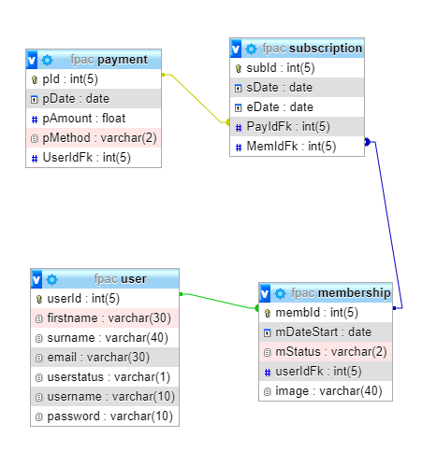

Security issues and Measures

Operation
The current design has functionality to allow the 3 main users to access the information, query the database and perform the main CRUD operations. It is not secure, however, to be used live over a network due to security vulnerabilities in most of the data transfer points: i.e. although the website grants access only to staff with correct username and password, the forms that take the data to the backend are not secure and are vulnerable to SQL injection. This can be prevented with the use of a prepared statement (example of this is enclosed within the php files). Another measure to add an extra layer of security is the username and passwords to be stored in a separate table, the information within it to be encrypted and, to have a stricter requirement for acceptable passwords. The current passwords are very weak and could be easily guessed with a brute-force password attack.
If access is gained to the website the following aspects become vulnerable: the user personal data, the users login details, financial information. To prevent this again a prepared statement could be used on every form that communicates with the back-end as each one of these offers a potential route into the database. In addition. hidden fields could be introduced on data entry points in the form of honey-pot traps that will force any net bots to complete the fields and be recognised as such and not human.
The database and the associated website are currently not fit for online use.

