

Innovating New Working Practices and Breeding an Environment Where Talent May Grow

Strategic Human Capital Report for NexSpace Health Systems

Programme: Master of Business Administration

Module: Human Capital Management

Module code: LCMB7023

Assessment: Component 1: Individual report

Lecturer: Eno Maycock (Birmingham)

Student name: Vaishali Parbatbhai Godhaniya

Student ID: 2610916

Word count: 2,652

Submission date: 15 October 2026

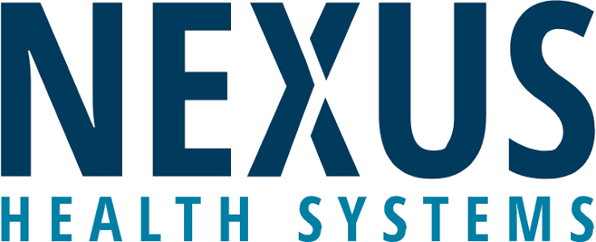

AI Use Acknowledgement
AI was used to assist with summarizing academic research papers. The final structure, analysis of material and written text are my own, and I am personally responsible for the interpretation, accuracy and integrity of the piece submitted.

Table of Contents
1 Task A: Designing Innovative Working Practices 3
NexSpace Health Systems 3
A1. Strategic diagnosis and critical evaluation 4
A2. Integrated redesign recommendations 6
A2.1. Cross-functional agile teams and employee autonomy 6
A2.2. Flexibility and international cooperation by hybrid 6
A2.3. Digital infrastructure and implementation assurance 8
2 Task B: Breeding an Environment Where Talent May Grow 8
B1. Critical foundations of a talent ecosystem 9
B2. Complete talent development plan 10
B2.1. Inclusive career architecture and skills diagnosis 10
B2.2. Coaching & mobility, learning by doing 11
B2.3. Psychological safety, wellbeing and performance 11
B2.4. International adaptation and evidence of value 12
3 Task C: Reflective Report 13
C1. AI as a strategic decision-support tool 13
C2. Three AI-use experiences and capability lessons 14
C2.1 Research support and evidence evaluation 14
C2.2 Visual communication and analytical precision 14
C2.3 Research comprehension and critical evaluation 15
C3. Personal capability development plan 15
4 References 16

Task A: Designing Innovative Working Practices

NexSpace Health Systems
NexSpace Health Systems (NHSX) is a healthcare technology company dedicated to building innovative digital solutions to create value in healthcare delivery, clinical decision making and organisational efficiencies. The company has around 600 professionals working in an international environment with teams in the UK, India and the UAE. Although NHSX is technology-oriented, it has a lot of human capital management issues such as hierarchical decision making, lack of autonomy in employees, lack of cross functional interactions and lack of career development opportunities. These challenges can jeopardise innovation, employee engagement and organizational competitiveness. Studies indicate that work design, employee empowerment, and supportive leadership are crucial to enhance performance in technology-rich settings (Parker & Grote, 2022; Bakker et al., 2023). In addition, the combination of digital transformation and strategic HRM can enhance the capabilities of the workforce and the adaptability of the organization (Chowdhury et al., 2024). This report will therefore examine innovative working practices and outline a talent development strategy to enable NHSX to sustain its growth and competitiveness.

A1. Strategic diagnosis and critical evaluation
NexSpace Health Systems (NHSX) is looking for a workplace that is clinical and innovative. Hierarchy, limited experimentation, lack of international collaboration and poor development are obstacles facing some 600 workers in the scenario. A suggested answer is bounded autonomy (decentralize product decisions, but have independent oversight of clinical safety). Sociotechnical systems thinking is a way of redesigning technology along with responsibilities and relationships (Parker & Grote, 2022). Along with technological investments, the capabilities of workers and resources of the organisation should also evolve (Chowdhury et al., 2024). Therefore, the way care is designed, the amount of work required, and the accountability for healthcare innovation should all be considered to be the joint product of NHSX's work (Bakker et al., 2023; World Health Organization [WHO], 2021).
There is some consistency of escalation, specialist supervision and clear responsibilities within traditional hierarchies. These continue to be essential when software is impacting on clinical decisions (WHO, 2021). However, sequential approvals may become a barrier between engineering and clinical know-how, and slow down problem solving. High-performance work systems (HPWS) coordinate the recruitment, development, incentives and employee participation, but their effects are dependent on the implementation and leadership. The present study of 1345 employees in Germany by Hauff et al. (2022) identified positive correlations between HPWs and wellbeing, and showed that leadership has an impact on such relationships. The emphasis of a high involvement work system is on the employee's role in making work decisions. NHSX should thus incorporate performance expectations and empowering activities while considering that autonomy without assistance can only lead to a higher demand, not better work (Parker & Grote, 2022; Bakker et al., 2023).
The benefits of agile practices are faster feedback cycles, but the use of the agile terms meetings and sprint do not necessarily make an adaptive team. Empowerment of people in agile innovation processes is of importance as Grass et al. (2020) emphasize. In the same way, hybrid work isn't about allowing people to work somewhere else, it's about carefully planning for hybrid work. (Wang et al., 2021). These changes, however, can be jeopardised by algorithmic monitoring, which can substitute managerial oversight for ongoing digital supervision (Kellogg et al., 2020). Therefore, before additional collaboration technologies are introduced, there should be clear decision rights, shared outcome and enablers of support and management within NHSX. The mechanisms presented here are combined in clinical, fairness and workload boundaries in Figure 1.
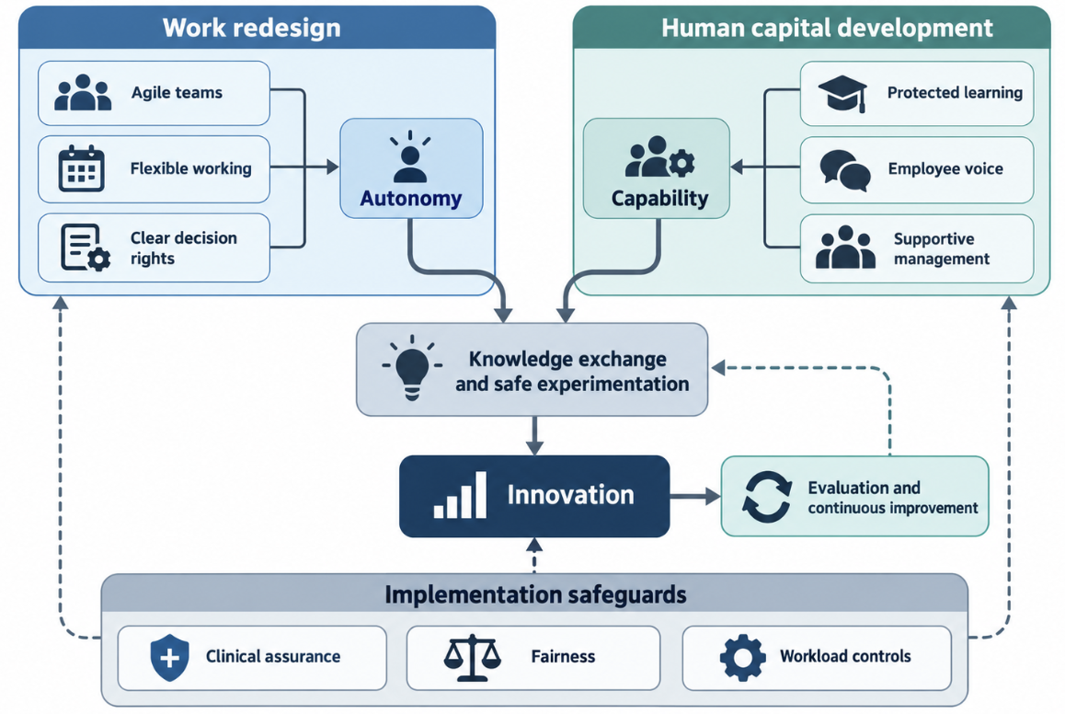
Figure 1. Integrated framework for innovative working practices
Source: Author’s own work based on Hauff et al. (2022), Parker and Grote (2022), and WHO (2021).

A2. Integrated redesign recommendations

A2.1. Cross-functional agile teams and employee autonomy
NHSX needs to test and assess three product teams with software engineering, data science, clinical assurance, design/customer implementation. Team should have a clear target (hospital or patient problem); should have a common backlog and 2 week learning cycles. Product owner would be concerned with value, security and clinical validation would be delegated to experts. The experiments were reversible interface experiments which would be conducted within agreed limits with changes impacting clinical recommendations to be subject to independent approval. This practice incorporates empowerment and adaptability (Grass et al., 2020), clear work design expectations (Parker & Grote, 2022) and the human oversight required of AI in healthcare (WHO, 2021).
Prototypes should be demonstrated to the clinical users and retrospectives should be conducted to document assumptions and failed experiments and what decisions are made. CoPs will ensure that there are no disjointed technical standards, and will connect specialists from teams. Psychological safety (Edmondson & Bransby, 2023) enables raising of uncertainties and asking for help, and collective learning should not be just a storage of documents, but an interpretation (Senge, 2006). However, an abundance of meetings and the pursuit of multiple projects simultaneously could be detrimental to agility. For managers, therefore, it is important to be wary of the speed of the sprint and to not over-commit, as well as the improvements validated. These controls include awareness of the need for extra resources, and opportunities for recovery (Bakker et al., 2023).

A2.2. Flexibility and international cooperation by hybrid
Bloom et al. (2024) performed a randomized experiment among 1,612 workers of Trip.com. The homeworking two days a week intervention led to a 2.4-percentage-point reduction in attrition (7.2% to 4.8%) without any effects on measures of performance. Conversely, Yang et al., (2022) conducted a study of a company of 61,182 Microsoft employees, and found that working 100% from home led to a more fragmented collaboration network. These studies are an assessment of different setups and should not be seen as conflicting universal guidelines. Hybrid flexibility needs to be considered for retention and NHSX should proactively encourage interconnections and collaboration between teams (Figure 2). This also suggests that work flexibility and belonging are significant factors in today's working environment, as demonstrated in the recent research which highlights the importance of belonging and flexibility on employees' attitudes towards the workplace (Sun et al., 2025).
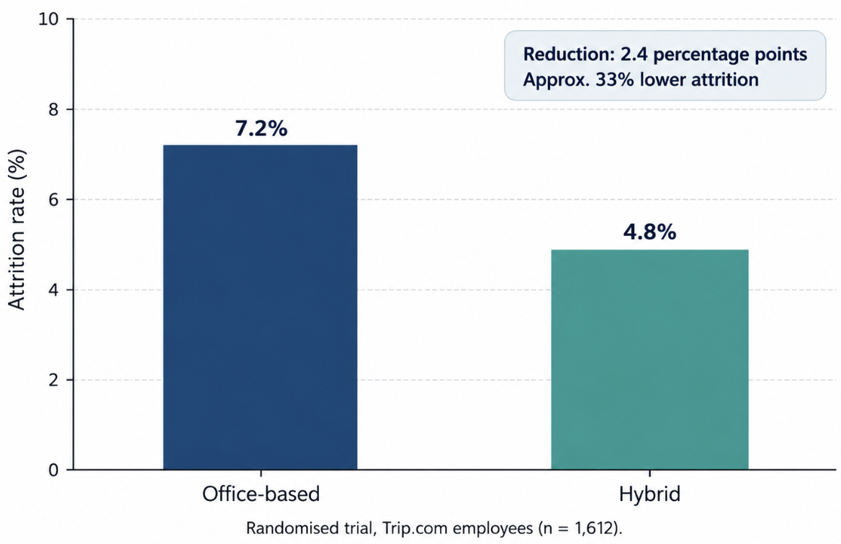
Figure 2. Attrition in a randomised hybrid working trial
Source: Author’s own graph based on Bloom et al. (2024).
Onboarding and relationship building/complex ideation should take place in office sessions, and flexible locations should be used for individual analytical work to be done by NHSX. Brucks and Levav (2022) discovered that videoconferencing limited individuals' capacity to generate creative concepts, whereas it facilitated task-oriented collaboration decisions. International teams should take turns with the not-so-convenient meeting times, have documented handovers and share decisions asynchronously. Awareness of response expectations and protected non-working hours would help resolve communication issues and work–home interference (Wang et al., 2021). However, belonging should not be assumed based on digital connectivity; accessible participation and regular interpersonal interactions should support it as well.

A2.3. Digital infrastructure and implementation assurance
Develop a knowledge space that holds approved design decisions, project documentation and learning materials and can be searched. Ownership of documents, review schedules and access restrictions should ensure reliability; there should be no patient information shared across general collaboration. Technology should be used to enhance work processes and not be the process itself (Parker & Grote, 2022). Do not use keystroke monitoring and individual collaboration scores as they can affect behavior and diminish employee agency (Kellogg et al., 2020). Table 1 offers a potential six months pilot. The implementation of AI in healthcare requires a thoughtful approach to ensure that the technology is adopted responsibly, with a focus on enhancing delivery and employee experience while maintaining the highest standards of clinical assurance, as per WHO and Chowdhury et al. (2024).
Table 1. Six-month implementation and evaluation plan
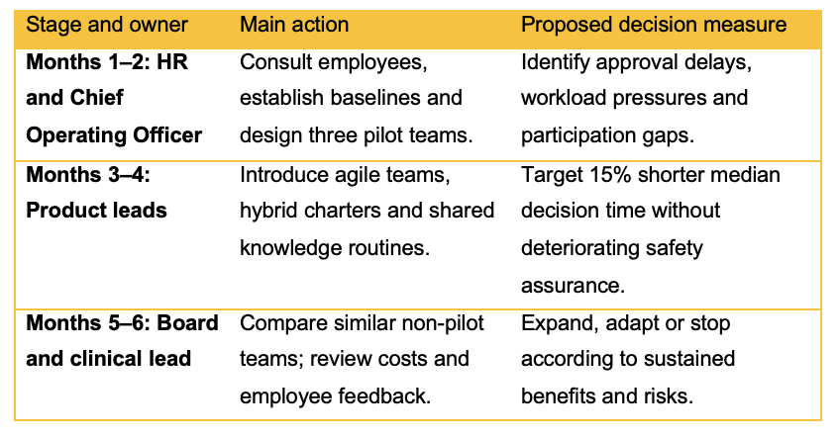

Task B: Breeding an Environment Where Talent May Grow

B1. Critical foundations of a talent ecosystem
Growth of talent needs to be given the chance to practice, feedback and progress and not courses alone. The learning organisation of Senge (2006) can be related to the four other elements of personal mastery, mental models, shared vision, team learning and systems thinking. For NHSX, this involves looking at the effect of deadlines and managerial assumptions that dis-incentivize experimentation. Sharing of mistakes and seeking out assistance is enabled by psychological safety (Edmondson & Bransby, 2023), while autonomy, competence and relatedness are seen as motivational underpinnings in self-determination theory (Ryan & Deci, 2020). New talent-management studies also indicate that there is a link between development practices and engagement and turnover intentions, which is in line with an integrated development and retention approach (Sinisterra et al., 2024).
But poor language development can mask shortage of resources. The meta-analysis of 63 growth-mindset intervention studies by Macnamara and Burgoyne (2023) resulting in 97,672 students indicates a small overall effect that is not statistically significant when adjusted for publication bias. While it is impossible to directly link education results to effectiveness in the workplace, the education results do dispute the notion that motivational messaging alone can change outcomes. The coaching research literature provides positive findings whilst recognizing a lack of consistency in reporting and limited controlled evidence (Cannon-Bowers et al., 2023). More recently, Lindebaum et al. (2026) propose that AI-generated content may lead to a lack of hands-on experience, thereby weakening the human capital development process. NHSX should therefore be able to connect learning with supervised practice, mentoring and reflection and should not make a causal connection between the latter.
High-potential opaque labels limit development access and impose management preferences. NHSX should focus on universal foundational learning and clearly identified specialist streams. Development investment should be focused on promoting engagement and organisational attachment, but it is important to note that turnover intention is not synonymous with leaving the organisation (Sinisterra et al., 2024). Job crafting can be a way to match jobs to individuals' strengths, however, individual changes can have repercussions on other employees and coordination (Tims et al., 2022). So, as seen in Figure 3, talent development is embedded in the collective capability (Ryan & Deci, 2020; Bakker et al., 2023), fairness and workload management, and connected to personal motivation and sustainable performance of the organisation.
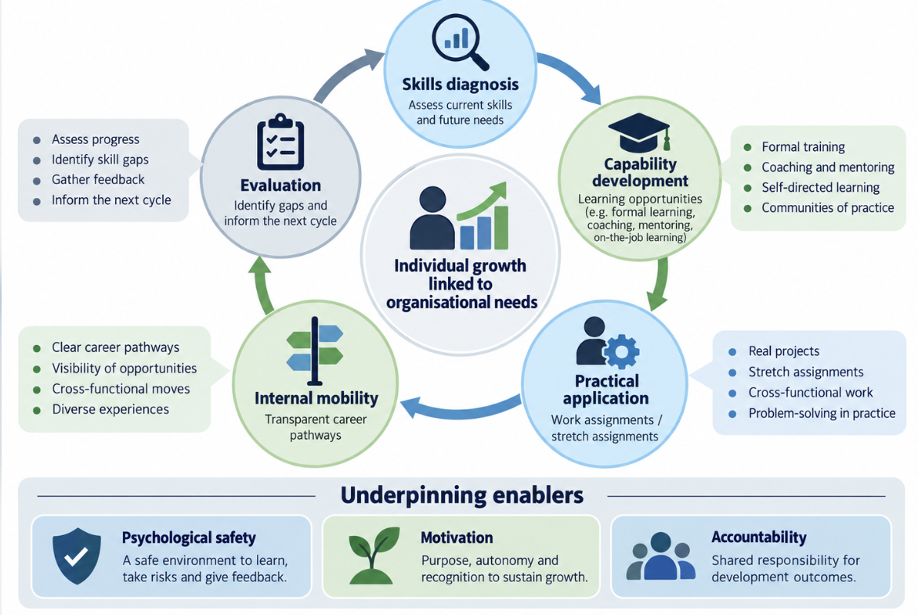
Figure 3. Strategic talent growth ecosystem
Source: Author’s own work based on Senge (2006), Ryan and Deci (2020), Tims et al. (2022), and Sinisterra et al. (2024).

B2. Complete talent development plan

B2.1. Inclusive career architecture and skills diagnosis
HR should develop a skills matrix pertaining to clinical AI assurance, cybersecurity, software quality, stakeholder communication and international collaboration. Apply a combination of self-evaluation, work samples and calibrated managerial reviews. Develop and post parallel career pathways for technical and managerial positions, quarterly career development discussion and opportunity to advertise internationally. The practices are related to development and engagement and intentions to stay (Sinisterra et al., 2024), and competence feedback to autonomous motivation (Ryan & Deci, 2020). While AI based skill matching can help in reducing the administrative burden, it must also be verified to guarantee the effectiveness and equity in candidate selection (Malik et al., 2023; Raghavan et al., 2020).

B2.2. Coaching & mobility, learning by doing
Two protected learning hours in each week, individual, learning plans and stretch assignments supervised. The Knowledge sharing would not be in one direction only, from Headquarter to UK team but there would be an inter team mentoring between the different teams based in UK, India and UAE as well. Staff need to provide evidence of learning, e.g., complete a model risk assessment. When the goals and delivery are clear, coaching can be helpful for development (Cannon-Bowers et al., 2023), and practice can help to keep knowledge alive, which cannot be substituted by explanations generated by AI (Lindebaum et al., 2026). Adding development work on top of this load can add another demand, and can also be a burden for the managers who have to adapt their delivery commitments accordingly (Bakker et al., 2023).
The organization should have a project marketplace which offers offers with a fixed time frame, definite selection conditions and agreed workload changes. Employees would be allowed to work out some aspects of their work based on their specialization while keeping the basic functions and the capacity of the colleagues (Tims et al., 2022). A developer with an interest in explainability could help with, for example, the creation of documentation of the model for clinicians, under the clinical supervision. Building competence and providing meaningful choice leads to motivation (Ryan & Deci, 2020) and healthcare applications require a specialist of accountability (WHO, 2021). It is important for managers to make timely decisions around releasing and monitor for any inequities in access to developmental assignments that may be present across locations or employee groups (Sinisterra et al., 2024).

B2.3. Psychological safety, wellbeing and performance
Managers must view challenges positively, recognise that there is uncertainty in it and respond well to challenges put forward. Psychological safety enables for candour without diminishing responsibility for clinical quality (Edmondson & Bransby, 2023). Reviews should focus on delivery and quality, knowledge sharing and development, not overtime or overtime over an extended period of time. Bakker et al., (2023) elaborate on job demands–resources theory, the need for autonomy and support and recovery in demanding jobs. Hauff et al. (2022) demonstrate that HR practices and health-oriented leadership go hand in hand, and emphasize the need to not focus on one or the other. Employee assistance needs to then be accompanied by staff changes and/or deadline changes and not be seen as a way of dealing with the organisational cause.

B2.4. International adaptation and evidence of value
Adopt the principles of good access, employee voice and clinical accountability in the local context with flexibility of scheduling and delivery of clinical work. The requirements of employees should be identified by consultation, rather than by assuming them from national stereotyping. There is a need for careful evaluation of hybrid wellbeing interventions: Simpson et al. (2024) only identified 5 eligible studies, and they found that there was a wide variation in methodology used. Therefore, the 'freshness' of the publication does not imply a strong evidence. Table 2 is a combination of capability, mobility, workload and employee-voice indicators. They recognise that there may be some level of overlap between belonging, engagement and performance but also that these are different outcomes (Sun et al., 2025; Sinisterra et al., 2024; Bakker et al., 2023).
Table 2. Talent ecosystem evaluation dashboard
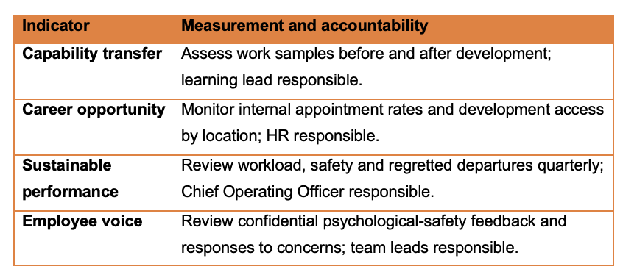
Learning cost and learning delivery cover or mentoring capacity should be taken into account by HR & Finance before expansion. A staggered rollout allows for comparison with other like teams, however, it should also be remembered that there are limitations of causal conclusions due to differences in staffing and workload. Triangulation between the quantitative results and interviews as well as quality checks, should therefore be carried out. NHSX's strategic test is: Do staff gain transferable skills and credible career opportunities and do they make safer innovation? This is more feasible with the alignment of resources, work design, and continuous learning as opposed to having isolated training or retention incentives (Chowdhury et al., 2024; Malik et al., 2023; WHO, 2021).

Task C: Reflective Report

C1. AI as a strategic decision-support tool
Being a future HR person, I think AI can be used as an additional tool for data collection, data analysis and communication. Its value as a strategic tool is dependent on the quality of information available and how that information is applied to the outputs using professional judgement. Malik et al. (2023) place AI in a broader context of HR outcomes, including those at the organisational and employee level, and Raisch and Krakowski (2021) describe the nature of the conflict between automation and human augmentation. These views indicate that the successful implementation of adoption should not be linked with a blanket dependence.
Some signs of productivity improvements reinforce the arguments for well-defined applications. As shown in Figure 4, Noy and Zhang (2023) found that 453 professionals who were performing writing tasks experienced a 40% decrease in the time they took to complete the tasks and an 18% increase in the quality of their outputs. But these results don't prove that AI is able to make reliable or equitable decisions about employment. The professional accountability must involve checking for bias, transparency and impact on employees in recruitment and performance management (Raghavan et al., 2020). My plan is thus to have AI to feed into decisions but not to take responsibility for them.
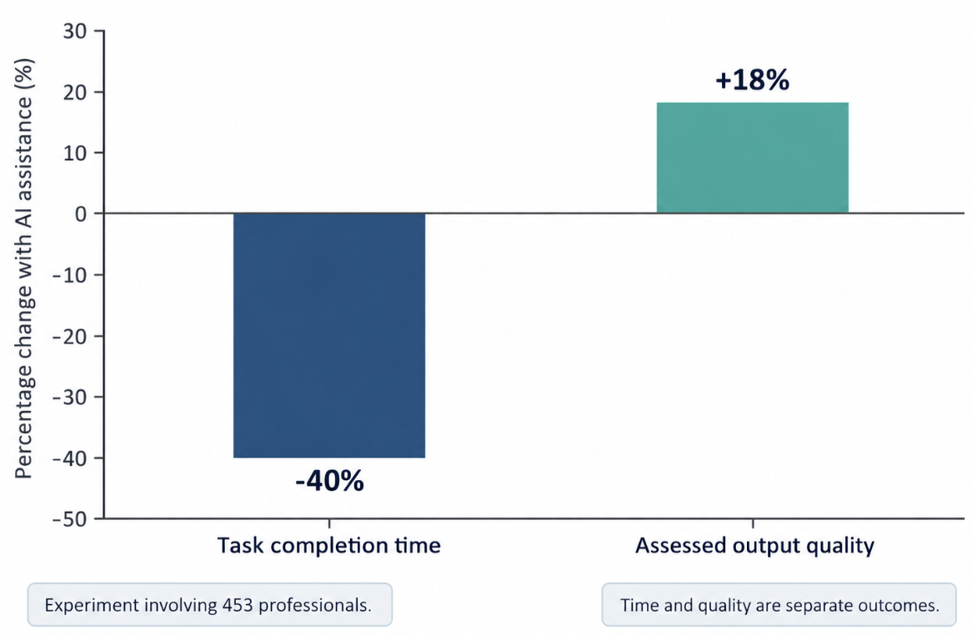
Figure 4. Generative AI effects on professional writing tasks
Source: Author’s own graph based on Noy and Zhang (2023).

C2. Three AI-use experiences and capability lessons

C2.1 Research support and evidence evaluation
The first time was when I asked for up to date academic references and statistics that could be applied to the assignment. This brought attention to the need for the evaluation of evidence and not taking something as information just because it seems authoritative. For instance, the research on hybrid work and remote work is not interchangeable in terms of different arrangements of the organisation (Bloom et al., 2024; Yang et al., 2022). The key lesson learned was that finding a potentially relevant source is just the first step in research; how, when, and where to use it, as well as its limitations, should be discussed in the context of the argument. This highlights the importance of AI-assisted HR practice being assessed independently (Malik et al., 2023).

C2.2 Visual communication and analytical precision
The second experience was to ask for figures and present the results of the statistics. This illustrated how visual communication can aid understanding, but also how it can bring with it risks of over-simplification. For example, a percentage improvement should be explained in terms of its baseline, sample and outcome measure. Results of the research also need to be different from the targets for the organisation. It was here that I recognized the need to improve my ability to accurately analyze, present and explain the relevance for practice of evidence. This is representative of the broader need to integrate the use of technology with organisational goals and the development of meaningful work (Chowdhury et al., 2024; Parker & Grote, 2022).

C2.3 Research comprehension and critical evaluation
My third experience was when I fed a research paper to the AI and asked for a summary of the key points, methods and results. The summary was very useful because it helped me pick out the main ideas, but the extent to which this was a help was dependent upon whether the qualifications were kept from the original study. This led to a consideration of whether summarization glosses over methodological constraints or presents the results of context-specific studies as general conclusions. Lindebaum et al. (2026) question the use of language-models as learning tools and Raisch and Krakowski (2021) discuss technology support and human judgment. I learnt the main thing I was able to understand with the help of the summaries and then go back over the paper for critical evaluation. The application of this approach in future HR practice would be during the review of evidence for workforce recommendations while still retaining responsibility for interpretation and application (Malik et al., 2023).

C3. Personal capability development plan
The important things I want to work on are learning to evaluate things on my own and learning to care for my digital presence as well as communicate in an empathetic way. Table 3 provides an interpretation of these priorities in terms of observable activities. Progress will be measured by work completed and feedback, not participation. The use of AI will be guided by structured risk assessment while interpersonal development will continue to be based on practice and reflection (Tabassi, 2023; Cannon-Bowers et al., 2023; Edmondson & Bransby, 2023).
Table 3. Personal employability action plan
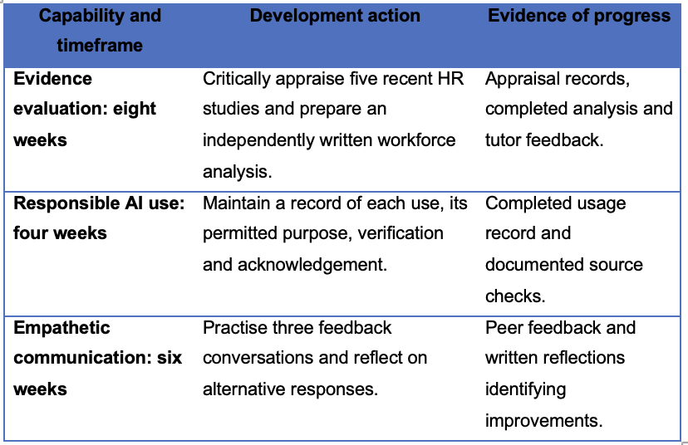

References
Bakker, A. B., Demerouti, E., & Sanz-Vergel, A. (2023). Job demands–resources theory: Ten years later. Annual Review of Organizational Psychology and Organizational Behavior, 10, 25–53. https://www.annualreviews.org/content/journals/10.1146/annurev-orgpsych-120920-053933
Bloom, N., Han, R., & Liang, J. (2024). Hybrid working from home improves retention without damaging performance. Nature, 630, 920–925. https://www.nature.com/articles/s41586-024-07500-2
Brucks, M. S., & Levav, J. (2022). Virtual communication curbs creative idea generation. Nature, 605, 108–112. https://www.nature.com/articles/s41586-022-04643-y
Brynjolfsson, E., Li, D., & Raymond, L. (2025). Generative AI at work. The Quarterly Journal of Economics, 140(2), 889–942. https://academic.oup.com/qje/article/140/2/889/7990658
Cannon-Bowers, J. A., Bowers, C. A., Carlson, C. E., Doherty, S. L., Evans, J., & Hall, J. (2023). Workplace coaching: A meta-analysis and recommendations for advancing the science of coaching. Frontiers in Psychology, 14, Article 1204166. https://www.frontiersin.org/journals/psychology/articles/10.3389/fpsyg.2023.1204166/full
Chowdhury, S., Budhwar, P., & Wood, G. (2024). Generative artificial intelligence in business: Towards a strategic human resource management framework. British Journal of Management, 35(4), 1680–1691. https://researchportal.bath.ac.uk/en/publications/generative-artificial-intelligence-in-business-towards-a-strategi/
Edmondson, A. C., & Bransby, D. P. (2023). Psychological safety comes of age: Observed themes in an established literature. Annual Review of Organizational Psychology and Organizational Behavior, 10, 55–78. https://www.annualreviews.org/content/journals/10.1146/annurev-orgpsych-120920-055217
Grass, A., Backmann, J., & Hoegl, M. (2020). From empowerment dynamics to team adaptability: Exploring and conceptualizing the continuous agile team innovation process. Journal of Product Innovation Management, 37(4), 324–351. https://onlinelibrary.wiley.com/doi/10.1111/jpim.12525
Hauff, S., Krick, A., Klebe, L., & Felfe, J. (2022). High-performance work practices and employee wellbeing—Does health-oriented leadership make a difference? Frontiers in Psychology, 13, Article 833028. https://www.frontiersin.org/journals/psychology/articles/10.3389/fpsyg.2022.833028/full
Kellogg, K. C., Valentine, M. A., & Christin, A. (2020). Algorithms at work: The new contested terrain of control. Academy of Management Annals, 14(1), 366–410. https://journals.aom.org/doi/10.5465/annals.2018.0174
Lindebaum, D., Nolan, E., & Swart, J. (2026). On the dangers of large-language model mediated learning for human capital. Human Resource Management Journal, 36(3), 430–440. https://onlinelibrary.wiley.com/doi/10.1111/1748-8583.70036
Macnamara, B. N., & Burgoyne, A. P. (2023). Do growth mindset interventions impact students’ academic achievement? A systematic review and meta-analysis with recommendations for best practices. Psychological Bulletin, 149(3–4), 133–173. https://pubmed.ncbi.nlm.nih.gov/36326645/
Malik, A., Budhwar, P., & Kazmi, B. A. (2023). Artificial intelligence (AI)-assisted HRM: Towards an extended strategic framework. Human Resource Management Review, 33(1), Article 100940. https://pure.qub.ac.uk/en/publications/artificial-intelligence-ai-assisted-hrm-towards-an-extended-strat/
Melão, N., & Reis, J. (2026). Generative artificial intelligence in HRM practice: Patterns, profiles, and theoretical insights. Administrative Sciences, 16(3), Article 113. https://www.mdpi.com/2076-3387/16/3/113
Noy, S., & Zhang, W. (2023). Experimental evidence on the productivity effects of generative artificial intelligence. Science, 381(6654), 187–192. https://www.science.org/doi/10.1126/science.adh2586
Parker, S. K., & Grote, G. (2022). Automation, algorithms, and beyond: Why work design matters more than ever in a digital world. Applied Psychology, 71(4), 1171–1204. https://iaap-journals.onlinelibrary.wiley.com/doi/10.1111/apps.12241
Raghavan, M., Barocas, S., Kleinberg, J., & Levy, K. (2020). Mitigating bias in algorithmic hiring: Evaluating claims and practices. In Proceedings of the 2020 Conference on Fairness, Accountability, and Transparency (pp. 469–481). Association for Computing Machinery. https://dl.acm.org/doi/10.1145/3351095.3372828
Raisch, S., & Krakowski, S. (2021). Artificial intelligence and management: The automation–augmentation paradox. Academy of Management Review, 46(1), 192–210. https://journals.aom.org/doi/10.5465/amr.2018.0072
Ryan, R. M., & Deci, E. L. (2020). Intrinsic and extrinsic motivation from a self-determination theory perspective: Definitions, theory, practices, and future directions. Contemporary Educational Psychology, 61, Article 101860. https://www.sciencedirect.com/science/article/pii/S0361476X20300254
Senge, P. M. (2006). The fifth discipline: The art and practice of the learning organization (Rev. and updated ed.). Doubleday/Currency. https://www.penguinrandomhouse.com/books/163984/the-fifth-discipline-by-peter-m-senge/
Simpson, E., Sutton, A., Cantrell, A., Clowes, M., Weich, S., Bentley-Hollins, K., Visintin, C., & Axtell, C. (2024). Effectiveness of interventions to improve job-related wellbeing of employees working from home: A rapid review. Discover Psychology, 4, Article 69. https://link.springer.com/article/10.1007/s44202-024-00184-9
Sinisterra, L., Peñalver, J., & Salanova, M. (2024). Connecting the organizational incomes and outcomes: A systematic review of the relationship between talent management, employee engagement, and turnover intention. Frontiers in Psychology, 15, Article 1439127. https://www.frontiersin.org/journals/psychology/articles/10.3389/fpsyg.2024.1439127/full
Sun, M., Kraus, T., Pauli, R., & Garus, C. (2025). Changing sense of place in hybrid work environments: A systematic review of place identity and employee well-being. Wellbeing, Space and Society, 8, Article 100236. https://www.sciencedirect.com/science/article/pii/S2666558125000028
Tabassi, E. (2023). Artificial intelligence risk management framework (AI RMF 1.0) (NIST AI 100-1). National Institute of Standards and Technology. https://www.nist.gov/publications/artificial-intelligence-risk-management-framework-ai-rmf-10
Tims, M., Twemlow, M., & Fong, C. Y. M. (2022). A state-of-the-art overview of job-crafting research: Current trends and future research directions. Career Development International, 27(1), 54–78. https://research.tilburguniversity.edu/en/publications/a-state-of-the-art-overview-of-job-crafting-research-current-tren/
Wang, B., Liu, Y., Qian, J., & Parker, S. K. (2021). Achieving effective remote working during the COVID-19 pandemic: A work design perspective. Applied Psychology, 70(1), 16–59. https://iaap-journals.onlinelibrary.wiley.com/doi/10.1111/apps.12290
World Health Organization. (2021). Ethics and governance of artificial intelligence for health: WHO guidance. https://www.who.int/publications/i/item/9789240029200
Yang, L., Holtz, D., Jaffe, S., Suri, S., Sinha, S., Weston, J., Joyce, C., Shah, N., Sherman, K., Hecht, B., & Teevan, J. (2022). The effects of remote work on collaboration among information workers. Nature Human Behaviour, 6, 43–54. https://www.nature.com/articles/s41562-021-01196-4

