

Assessment 1 – Reading Task Template

Upload your photo of your A3 in-class notes here:
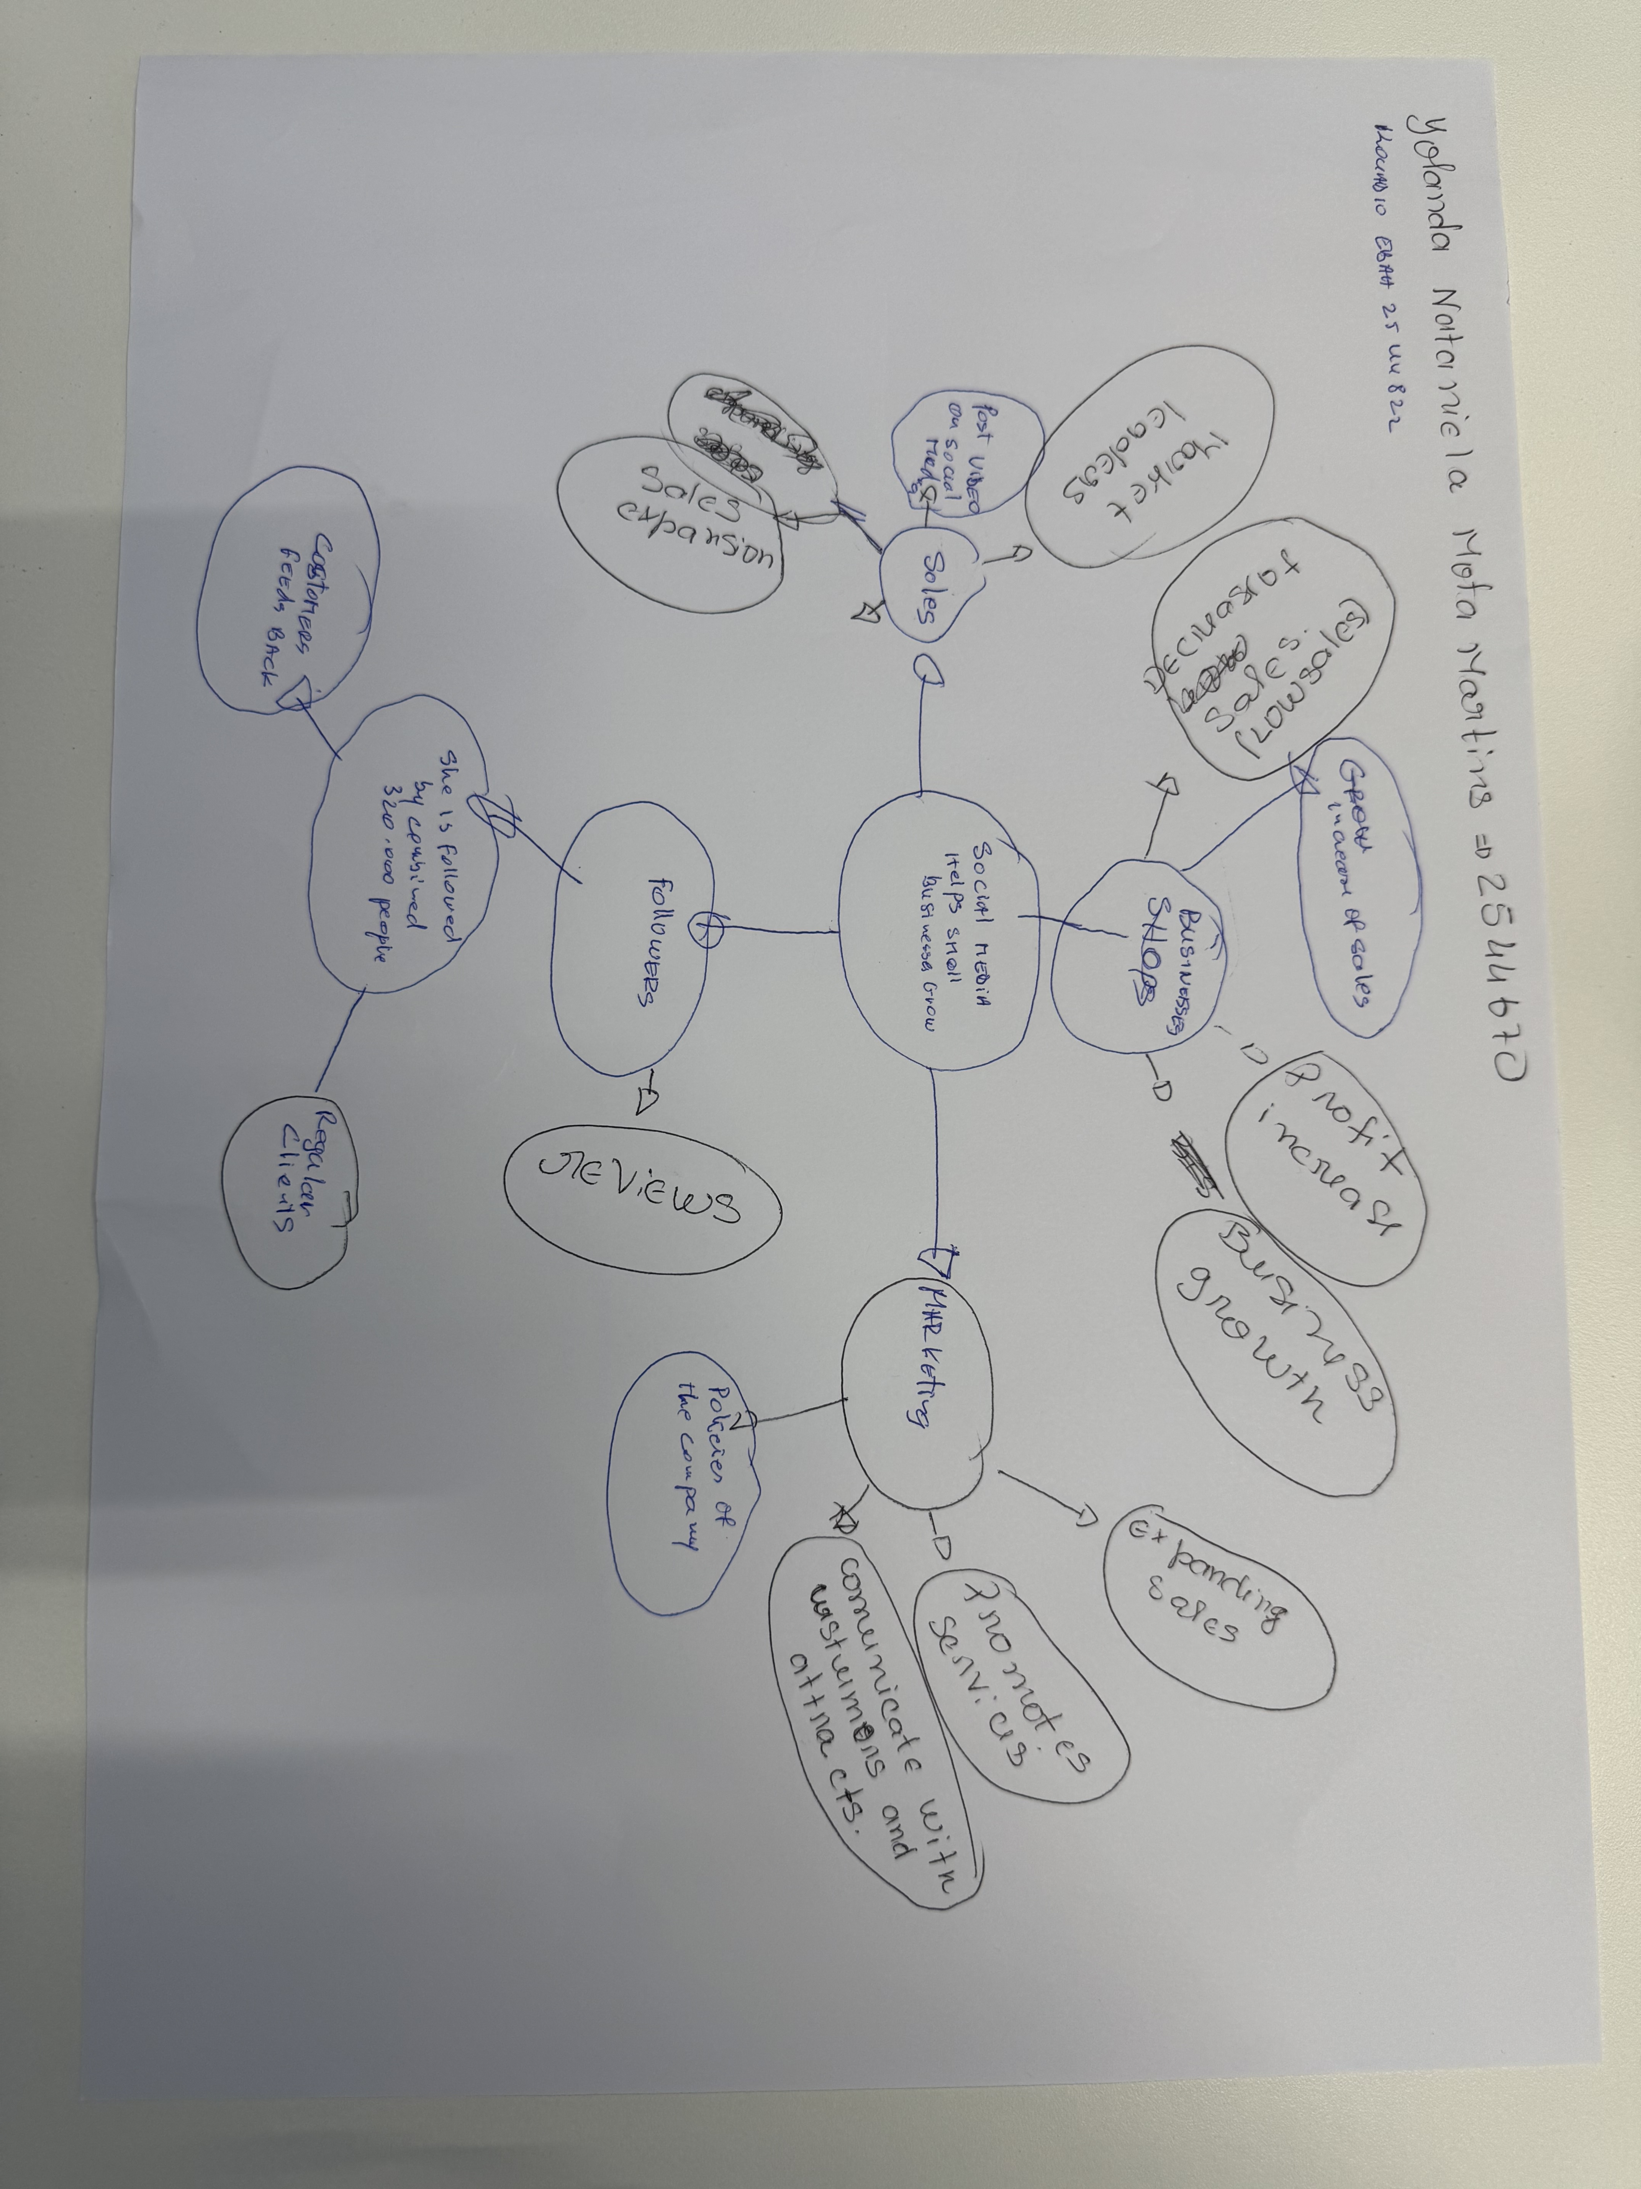

1. Answer these questions using the sentence starters below
a. What is the main idea of the text?
The main idea is that social media helps small business grow creating business expansion trough social media promothing services campaigns created by satisfid customers who have used the services promote them to the point be coming viral trends.
Small companies nowadays tend to use more social media to attract more customers due to where companies are located and popularity. Some places where this business are located, they do not have many attraction or get many people in need of their services and businesses like that need customers to survive.
b. What are two key points?
One key point is business and social media
Another key point is marketing acording to the research cited in the text it is trough marketing that small business become market leaders trough social media that more than 200 milliom companies worldwide reach customers promothing their business.

c. What part of the text did you find most important? Why?
The most important part is the response on social media has honestly changed the business’s because all these smal business already existed but after their impact of social media they went viral and experienced an increase in sales through social media like tik tok Instagram facebook social media has helped expand sales through viral videos recorded by both custmers and business owners social media is one of the most important key off expanding business smal ou big marketing on social networks helps promote services have more direct communication with customers to create a regular clients and access to reviews that help correct mistakes.
d. Was anything unclear or difficult to understand?
I was not sure about the structure and organization of the mind map which I had to get help from my group to understand how it works and how to organize the ideas using mind map. After learning it, I was able to understand and use it for my work to help me better understand the text.
About the text, I wasn’t so unsure about a technical word used on the text:
- holiday mishap;
e. How did your group help you understand the text better?
My group helped me by organizing the main map(but im stil not sure if its corretly organized)and conecting ideias according to the keys points we found in the text.
2. One sentence reflection
Question: What did you find challenging about this task?
The hardest part was finding the keys points and conecting with other points that are part of the main map leads was to understand that the goal off all antrepreneurs was to expand their small business and the way social media have adapted to expanding business in recent times makes them the central element.

