

Student Name : Ahir Jinalben Dilipbhai

Student ID : 2535262

Program : MSc cyber security and digital forensics.

Module Name : Data security, Governance and compliance

Module Code : ACCA7028

Lecturer’s Name : De Ayman El Hajjar

Word Count : 3000

DESIGNING AN INTEGRATED INFORMATION SECURITY GOVERNANCE AND COMPLIANCE FRAMEWORK FOR AEROLINK LOGISTICS: A RISK-BASED APPROACH TO SECURE CLOUD, IOT, AND AI-DRIVEN OPERATIONS

Executive Summary
The aim of this consultancy report is to review and comment on the information security governance, compliance and cybersecurity issues affecting AeroLink Logistics (ALL) and to recommend a unified governance structure to enhance the business organisation's resilience in today's increasingly digital world. The extensive adoption of cloud computing, Internet of Things (IoT) technologies, artificial intelligence (AI) and third-party service providers for the organisation has created benefits for the processes and increased their efficiency, while simultaneously creating cyber risks, regulatory non-compliance and operational disruption risks.
It thoroughly reviews various internationally recognised frameworks for information security such as ISO/IEC 27001:2022, NIST Cybersecurity Framework (CSF) 2.0, COBIT 2019, ITIL 4, and Zero Trust Architecture, and evaluates how well they align with AeroLink's governance and information security needs. Based on this assessment, a strategic governance, enterprise risk management, security controls, vendor governance, incident response and business continuity and continuous compliance monitoring framework are recommended.
In addition, the report looks at the need for ongoing governance to meet changing regulatory obligations and new types of cyber threats such as ransomware, supply-chain threats, threats based on artificial intelligence, threats in the cloud and threats in IoT. This will involve implementing an ISO/IEC 27001 Information Security Management System (ISMS), applying the NIST-CSF framework, struggling to further the implementation of Zero Trust Architecture, implementing third-party governance and creating a Security Operations Centre (SOC) with continuous compliance monitoring. All in all or used separately, these will contribute to cybersecurity resilience, long term operation sustainability of the organisation, regulatory compliance and governance effectiveness.

Table of Contents
1. Introduction 4
1.1 Background of the Study 4
1.2 Case Scenario Overview 4
1.3 Aim and Objectives of the Report 4
1.4 Report Structure 4
2. Assessment of Security, Governance and Compliance Challenges at AeroLink Logistics 4
2.1 Existing Organisational Security Issues 4
2.2 Risk Analysis 5
2.3 Compliance and Governance Gaps 5
3. Critical Evaluation of Contemporary Information Security Frameworks 6
3.1 NIST Cybersecurity Framework 2.0 6
3.2 ISO/IEC 27001:2022 Information Security Management System 6
3.3 COBIT 2019 Governance Framework 6
3.4 ITIL 4 Security Management Practices 7
3.5 Zero Trust Security Architecture 7
3.6 Comparative Analysis of Frameworks 7
4. Proposed Integrated Information Security Governance Framework for AeroLink Logistics 9
4.1 Proposed Governance Structure 9
4.2 Enterprise Risk Management Strategy 10
4.3 Security Policies and Procedures 10
4.4 Cloud, IoT and AI Security Controls 10
4.5 Vendor Governance and SLA Management 11
4.6 Incident Response and Business Continuity Planning 11
4.7 Security Implementation Roadmap 11
5. Continuous Governance, Compliance and Emerging Cybersecurity Challenges 13
5.1 Importance of Continuous Compliance 13
5.2 Emerging Technologies and Threat Landscape 13
5.3 Continuous Improvement Strategy 13
6. Strategic Recommendations 16
6.1 Priority Recommendations 16
7. Conclusion 16
References 18

1. Introduction

1.1 Background of the Study
The application of digital technologies in changing how organisations work has been a game-changer, and the role and significance of operating in the cloud, Internet of Things (IoT), artificial intelligence (AI) and remote working environments, are now a fundamental component of the business processes. These technologies offer operational advantages of effectiveness and business agility, but bring greater and greater complexities of cyber risk. Given these, organisations must have strong data security, governance and compliance policies to protect their data assets, ensure legal compliance, minimise cyber risks and maintain trust in the evolving digital landscape.

1.2 Case Scenario Overview
AeroLink Logistics is a global logistics company extensively using cloud-based infrastructure, tracking systems powered by IoTs, AI-based analytics and outsourced IT systems. The organisation has become digital, but it still suffers from significant cybersecurity issues, including regular data breaches, suboptimal governance, lack of adequate risk management procedures, businesses are not compliant with regulations, regulatory oversight of vendors is not effective, and the business continuity and incident response capabilities are not satisfactory.

1.3 Aim and Objectives of the Report
This report will aim to review current knowledge and structure recognised in the field of information security and suggest merging it with information governance with the further development of a framework suitable for the operational needs of AeroLink Logistics regarding information governance, security and compliance. Moreover, it offers strategic suggestions to enhance organizational resilience to the changing cyber threats.

1.4 Report Structure
The report discusses the organisational challenges, conducts an assessment of the security governance model, designs a tailored security governance model, discusses security compliance requirements of continuous security and finally brings forth a set of strategic suggestions to enhance the AeroLink Logistics security profile.

2. Assessment of Security, Governance and Compliance Challenges at AeroLink Logistics

2.1 Existing Organisational Security Issues
AeroLink Logistics operates in a very digitalised environment with the best available “Cloud” based infrastructure, Internet of Things (IoT) devices, Artificial Intelligence (AI) and outsourcing IT services, the necessary tools to operate globally. Such technologies help to run the business more effectively but they also increase the cyberattack surface for the organisation. The notes to the scenario indicate a lack of adequate access control and data protection, with frequent data breaches resulting from multiple instances of access to customers' information and shipment data. In addition, the organisation has many services that are hosted by Infrastructure-as-a-Service (IaaS) and Software-as-a-Service (SaaS) providers, which adds another layer of governance and visibility issues to manage, particularly regarding other security vendors and the responsibility "shift" of security. Allowing remote working methods, through unmanaged devices, only compounds this risk of unauthorised access and compromise of endpoints. Along with this, poorly developed governance systems, disjointed security operations and the lack of a unified information security strategy hampers organizational accountability, and provides a less effective avenue for processes and decisions in the field of information security.

2.2 Risk Analysis
AeroLink Logistics has certain operational models, exposing the organisation to various cyber security risks, which need to be addressed through extensive governance and risk management. Cloud-based environments can expose these risks if proper security measures are not consistently deployed, such as data leakage, insecure application programming interfaces (APIs), identity compromise, or configuration errors [36]. Likewise, the spread of IoT-based tracking devices and their resources and limited capabilities create other vulnerabilities to be monitored against, especially physical and network attack surfaces. New risks are also being introduced by this new generation of AI-driven analytics platform such as adversarial attacks, manipulation of training data, and access to datasets that are sensitive. Since supply-chain risks are vast, as noted by [4] the use of third-party vendors increases chain vulnerability levels and the vulnerability seen in the service providers can result in chain vulnerability that poses a threat to security of the organisation. While insider threats from employees, contractors, or partners who have legitimate access to the system are a constant threat, as noted by [7], there are scenarios, such as decentralised and remotely connected workplaces, that lack monitoring and control over where or when access will be granted to authorised entities.

2.3 Compliance and Governance Gaps
In the case scenario, the AeroLink Logistics' governance and regulatory framework is severely deficient. The organisation has not performed formal compliance to internationally recognised standards, like the General Data Protection Regulation (GDPR) and ISO/IEC 27001, thus impacting the likelihood of slips in the system that open up risk of regulatory penalties and reputational issues. Further, the lack of an enterprise-wide risk management process, limits an organisation's systematic risk identification, assessment, and mitigation of emerging cyber-risks [27]. Governance deficiencies can also be seen in the absence of explicit security policies and accountability frameworks, as well as ongoing compliance monitoring. Also, the lack of BC/DR planning decreases organisation resiliency when they have a potential disaster or malicious cyberactivity incident, and limits the ability of the company to keep critical logistics operations going.

3. Critical Evaluation of Contemporary Information Security Frameworks

3.1 NIST Cybersecurity Framework 2.0
The National Institute of Standards and Technology (NIST) Cybersecurity Framework (CSF) 2.0 offers a detailed and adaptable solution for managing cybersecurity risks throughout different organisations of all sizes and sectors [9]. The framework has six core functions: Govern, Identify, Protect, Detect, Respond and Recover, which facilitate organisations to augment their governance framework and to continually raise cyber resilience. NIST CSF 2.0 expands its focus on governance and leadership accountability as well as enterprise-wide cybersecurity risk management as opposed to its predecessor. It is an outcome-based framework that enables organizations to customize their security controls to meet their operational requirements, making it ideal for organizations in the midst of digital transformation [30]. Optimality, however, has to be obtained through the maturity of the organisation, skilled staff and incorporation of other governance standards for optimum effectiveness.

3.2 ISO/IEC 27001:2022 Information Security Management System
ISO/IEC 27001:2022 is an international standard that defines how to set up, operate, maintain an and continuously improve an Information Security Management System (ISMS). It takes a risk-based approach, and let organisations categorise information assets that are critical, think about how to secure them, and choose suitable technical and organisational controls [21]. In addition, ISO 27001 encourages new ongoing monitoring, internal auditing and management review, to maintain compliance with changing regulatory requirements. Certification shows that an organization is dedicated to the issue of information security and provides stakeholders with increased confidence [2]. However, for organisations with low governance maturity or low resources, to implement requires a significant investment, documentation, and organisation.

3.3 COBIT 2019 Governance Framework
COBIT 2019 offers a detailed governance and management framework to ensure IT supports the achievement of the organisational goals and the creation of value, risk optimisation, and compliance with regulations [19]. COBIT takes a different approach from other purely technical cybersecurity frameworks, by adopting governance principles, performance measurements, stakeholder requirements and enterprise goals to provide a single decision model [20]. The framework makes a clear separation between governance and operational tasks, thereby fostering accountability at various levels in the organisations. Its holistic design, however, may make it more complex to implement and typically has to be correlated with other security frameworks (such as ISO 27001 or NIST CSF) to satisfy any specific cyber security control requirements.

3.4 ITIL 4 Security Management Practices
The primary emphasis of ITIL 4 is on IT service management and also integrates security management practices along with the service lifecycle. The framework suggests that the way an organisation designs services, transitions services, conducts operation and actually implements continual improvement should incorporate information security [17]. ITIL improves incident management processes, change management, continuity of service, and operational resilience, which leads to better availability of services and customer satisfaction [24]. ITIL, however, does not offer a full cybersecurity governance framework on its own, and is best used in conjunction with other generally adopted security standards, like ISO 27001 and NIST CSF.

3.5 Zero Trust Security Architecture
The Zero Trust Security Architecture is a new cybersecurity strategy that is built on the concept of “never trust, always verify.” Instead of trust within organisational networks, Zero Trust continually requires entities to be authenticated before access to organisation resources is granted [8]. According to [34], the architecture involves implementing identity and access management, multi-factor authentication, least-privilege access, micro-segmentation, encryption and continuous monitoring to help limit lateral movement during a cyberattack. Zero Trust is especially effective in scenarios such as cloud computing, hybrid working, and very distributed digital environments [35]. However, this will require large technological costs, organisational adjustments and monitoring functions, which could lead to higher implementation expenses and to greater complexity in operation.

3.6 Comparative Analysis of Frameworks
Every information security framework brings its own set of capabilities to enhance organisation's cyber security governance. NIST CSF 2.0 describes a flexible, risk-based governance framework that can be applied to organizations that require enterprise-wide cybersecurity management. Not only does this provide internationally recognised certification, but ISO/IEC 27001:2022 also incorporates a structured framework, known as an Information Security Management System, which helps businesses meet regulatory standards and improve continuously. COBIT 2019 provides for the enhanced strategic governance through linking information technology to the organisation's goals and simplifying the accountability of the executive. While these frameworks bring specific focus to the abstract concept of cloud security, ITIL 4 enhances safe supplies management and operational resilience, and Zero Trust Architecture offers high-level technical security controls for cloud-based and remote environments established.These frameworks help flesh out the concept of cloud security at a specific level, but ITIL 4 contributes to secure IT service management and operational robustness, and Zero Trust Architecture provides highly advanced technical security controls for cloud and remote established surroundings. Nothing is ever simple for AeroLink Logistics when it comes to governance, compliance, operational and technical security. Thus, the combination of NIST CSF 2.0, ISO/IEC 27001:2022, COBIT 2019, ITIL 4, and Zero Trust Architecture becomes a total governance platform that would be able to help organizations stay in line with the regulatory requirements, ensure cyber-resilience, manage third-party risks, and promote secured digital transformation.
Framework | Advantages | Limitations | Suitability for AeroLink Logistics
NIST CSF 2.0 | Flexible, risk-based governance, strong cybersecurity lifecycle, adaptable across industries | No certification mechanism, requires organisational maturity | Excellent for enterprise-wide cyber risk governance
ISO/IEC 27001:2022 | Internationally recognised certification, structured ISMS, continuous improvement | Resource-intensive implementation and documentation | Highly suitable for regulatory compliance and information security management
COBIT 2019 | Strong governance, aligns IT with business objectives, improves accountability | Complex implementation, requires complementary technical frameworks | Suitable for executive governance and strategic decision-making
ITIL 4 | Improves IT service management, incident management, and service continuity | Limited cybersecurity governance capability when used independently | Suitable for operational security management and service delivery
Zero Trust Architecture | Strong identity protection, least-privilege access, ideal for cloud and remote work | High implementation cost and technological complexity | Highly suitable for securing cloud, IoT, AI, and remote workforce environments

Table 3.1 Comparative Analysis of Contemporary Information Security Frameworks

4. Proposed Integrated Information Security Governance Framework for AeroLink Logistics

4.1 Proposed Governance Structure
AeroLink Logistics (ALL) is recommended to set up an integrated governance system with clear accountability, decision making powers, security responsibility and other related issues within the organization to enhance the cybersecurity governance. Strategic oversight must be outlined by the Board of Directors as they determine how to ensure that cybersecurity meets organisational goals and objectives, with a Chief Information Security Officer (CISO) to lead enterprise-wide security governance [31]. An Information Security Steering Committee is required with members from IT, legal, operations, risk management and compliance groups, as noted by [23], to facilitate security efforts and track the regulatory commitments. The department managers are expected to adopt security measures within their respective boundaries of operations and all employees should be provided with periodic cybersecurity awareness training and held accountable for practice of adherence to organisational security policies (ISO 2022).
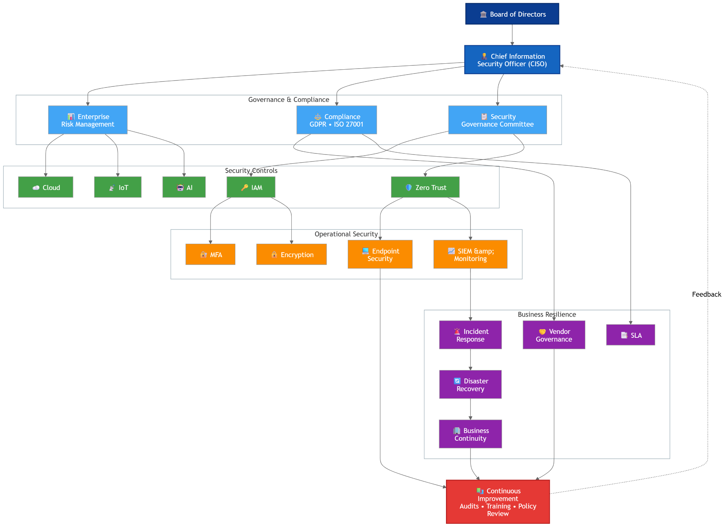
Figure 1: Integrated Information Security Governance Framework for AeroLink Logistics
(Source: Self-created)

4.2 Enterprise Risk Management Strategy
AeroLink Logistics needs to establish a comprehensive Enterprise Risk Management (ERM) system to incorporate cybersecurity elements into the organisation's decision-making process. This should start with an entity's thorough identification of risks surrounding digital assets, cloud services, the Internet of Things (IoT), Artificial Intelligence (AI), third-party suppliers to the entity, and key business processes [3]. Once a risk has been identified, it should be performed with qualitative and quantitative risk assessment, as noted by [11], to quantify the risk and assess its likelihood and impact on business. Treatment strategies for the found risks should be chosen depending on the level of risk appetite within the organisation: risk avoidance, risk mitigation, risk transfer or risk acceptance. Further, there is a need to support continuous monitoring of risk by routinely conducting vulnerability checks, penetration testing, internal auditing and executive risk reporting [12]. The ongoing nature of this improves change tracking and can help identify new forms of cyber-attacks at an opportune time, as well as keeping the risk management agenda in line with the changing business functions and regulatory needs.

4.3 Security Policies and Procedures
Security policies and procedures must put sound practices in place to build a uniform information asset protection for an organisation. AeroLink Logistics should establish an Information Security Policy that outlines objectives of governance, responsibilities of workers and regulations to be complied with. According to [15] it is necessary to implement role-based access control (RBAC) and the principle of least privilege in Access Management Policies to prevent unauthorized access. Organisations should classify information based on levels of sensitivity as part of a Data Classification Policy and assign the right protection to the right information [33]. For privileged accounts, implement strong passwords, frequently change passwords, and implement multi factor authentication (MFA). Also, there should be an Acceptable Use Policy which outlines acceptable use of systems and networks, cloud services, and mobile devices, as well as what the consequences of infractions are.

4.4 Cloud, IoT and AI Security Controls
In the context of AeroLink Logistics' use of cloud computing, Internet of Things (IoT) in logistics, and AI-based analytics, a wide range of technical security measures should be adopted. [14] say that Zero Trust Architecture should be the paradigm model because it always checks the identities of users, devices and applications before granting access to an organization's resources. Enforcement of multi-factor authentication (MFA) should be carried out for all important systems which would make verification of identity more robust and less prone to credentials being compromised [5]. Organisation and customer data needs to be secured across the entire storage, transmission and processing lifecycle, and protected by end-to-end encryption in between. According to [6], IAM solutions need to centrally control authentication, authorisation, privileged access, and user lifecycle management both on the cloud and on-premise. Endpoint Detection and Response (EDR) technologies should be able to continuously monitor any employee devices, servers and IoT endpoints to detect all malicious activities [16]. Moreover, Security Information and Event Management (SIEM) systems with continuous monitoring should help organizations to detect threats in real time, provide situational awareness through security analytics, generate timely alerts and automate their response during incidents to increase cyber-resilience.

4.5 Vendor Governance and SLA Management
Externalized IT services are key and wrapped and wrapped in a form of governance ought to be a strategic area that should be focused on. AeroLink Logistics needs to undertake proper security evaluations prior to hiring third-party providers to identify their cybersecurity skills, regulatory compliance as well as their operational resilience. The use of third-party security audits should be routinely conducted to ensure continuing compliance with contractual security commitments and internationally accepted principles [18]. It is important that Service Level Agreements (SLAs) include specific cyber security metrics, notification procedures, vulnerability management requirements, backup requirements, and regulatory obligations [29]. Additionally, any contract should mandate security provisions so as to minimise the risks of supply chain cybersecurity, such as data protection, controls over access, the ability to conduct audits, notification of any data breaches and termination provisions.

4.6 Incident Response and Business Continuity Planning
AeroLink Logistics should formalise and adopt Incident Response Plan (IRP) that conforms to recognised cyber security security practices that will enable minimal impact on operations following security incidents. The incident response lifecycle should consist of preparation, threat detection, analysis, containment, eradication, recovery, and post-incident review in order to enable organisations to learn continuously from the incident. To ensure proper, fast recovery of the system, a comprehensive Disaster Recovery Plan (DRP) should be established that includes details of the backup procedures, the recovery time objectives (RTO) and the recovery point objectives (RPO), as well as infrastructure restoration processes [37]. In addition, a Business Continuity Plan (BCP) should outline critical business functions and the alternative business operations procedures, communication plans, and other required resource allocation plans to keep necessary logistics operations running during cyber incidents, system failures, and natural disasters.

4.7 Security Implementation Roadmap
There should be a pragmatical, step-wise introduction of the implementation. Immediate priorities involve setting up of governance, risk assessment, and implementation of basic security policies. Medium-term activities should be centred around substation of Zero Trust Architecture, Identity and Access Management and continuous monitoring.
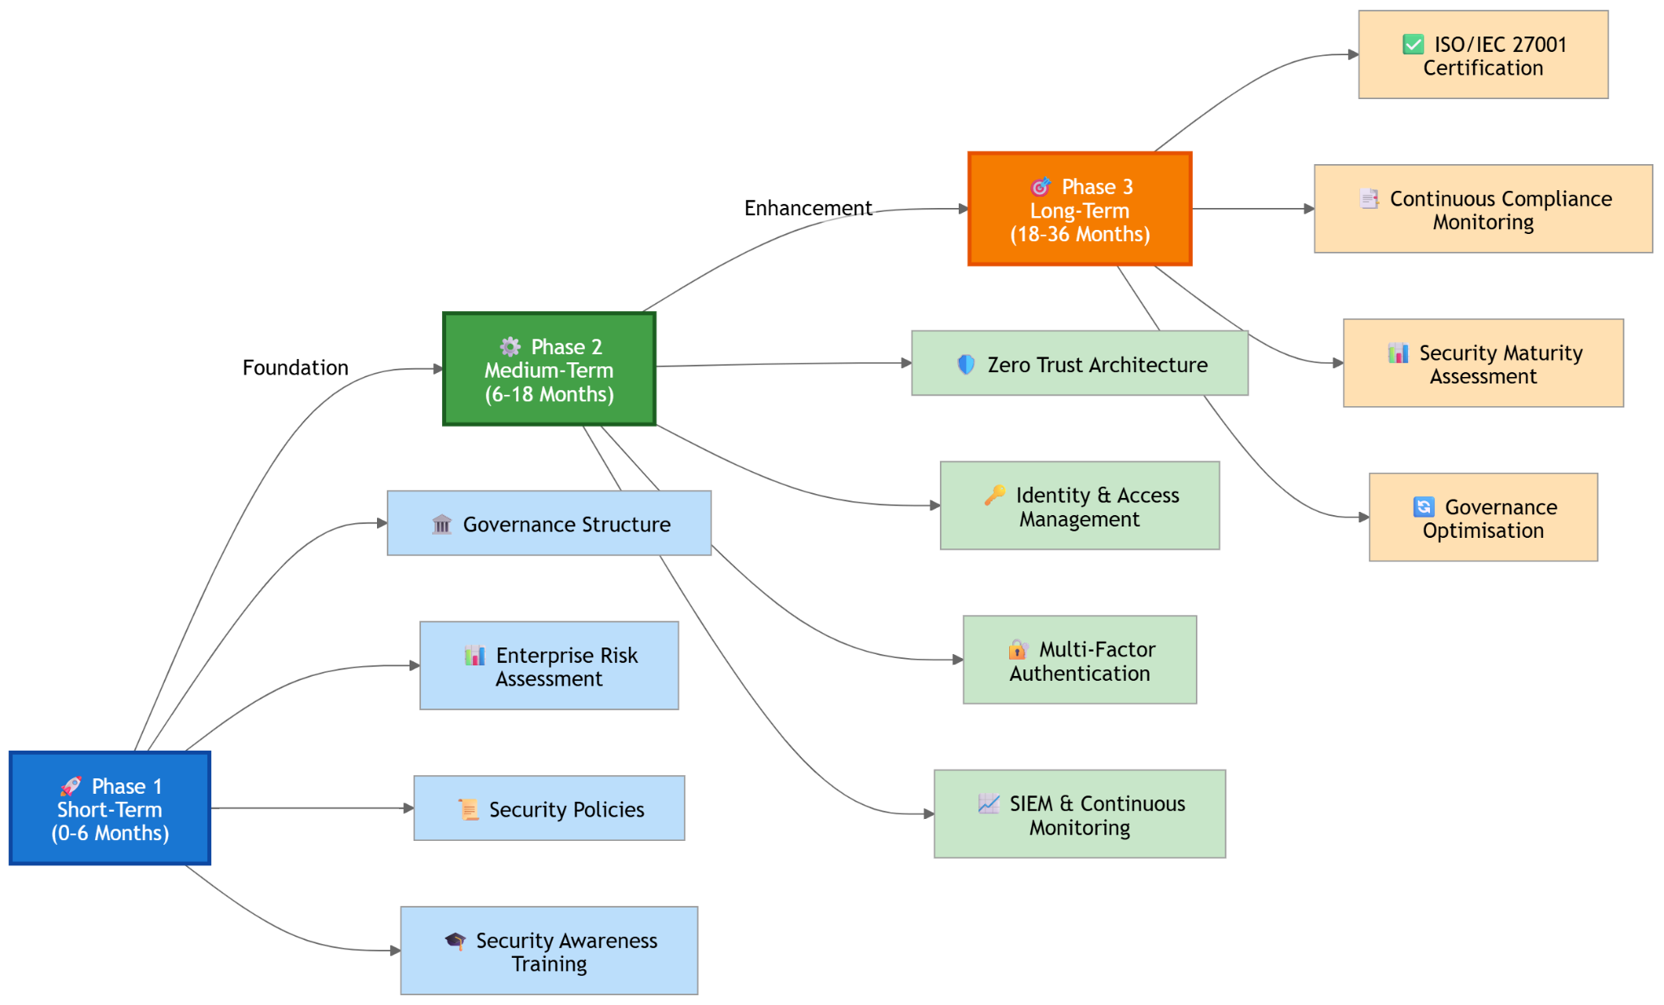
Figure 2: Security Implementation Roadmap
Long-term objectives include achieving ISO/IEC 27001 certification, continuous compliance monitoring, cybersecurity maturity assessments, and ongoing governance improvement.
Phase | Key Activities | Expected Outcome
Short-Term (0–6 Months) | Governance structure, security policies, risk assessment, awareness training | Governance foundation established
Medium-Term (6–18 Months) | Zero Trust, MFA, IAM, SIEM, EDR, vendor governance | Improved cybersecurity controls and operational resilience
Long-Term (18–36 Months) | ISO/IEC 27001 certification, continuous compliance, security maturity assessments, governance optimisation | Sustainable cybersecurity governance and continuous improvement

Table 4.1 Proposed Security Implementation Roadmap

5. Continuous Governance, Compliance and Emerging Cybersecurity Challenges

5.1 Importance of Continuous Compliance
Continuous compliance is essential for an organization to maintain its cybersecurity practices, given the ever-evolving legal and regulatory requirements and the norms established by each sector. Data protection frameworks are constantly evolving and organisations need to periodically review and update their frameworks to ensure they continue to meet data protection laws, such as GDPR, and other relevant legislation [22]. Moreover, changes of international standards like ISO/IEC 27001:2022 require companies to constantly verify the effectiveness of their Information Security Management Systems (ISMS) and make necessary adjustments where appropriate [13]. It is essential to monitor regulatory changes, compliance and minimise legal, financial and reputational risks for organisations through regulatory monitoring. For AeroLink Logistics, compliance must be made a continuous process and it needs to be integrated with its governance policy in order to ensure overall law compliance by continuous periodic internal audit, policy review, compliance check and reporting to management process that in turn builds resilience in the organisation [25].

5.2 Emerging Technologies and Threat Landscape
The world of cybersecurity is continually evolving, driven by the ever-changing landscape of technology, which offers new opportunities and security challenges for the technology team. The growth of artificial intelligence (AI), cloud computing, and Internet of Things (IoT) technologies has made organisations access points more extensive and created advanced cyber threats [1]. From Adobe's experience in the industry, as observed by [26], every organisation in the digitally transformed world faces a growing number of adversarial AI attacks, cloud misconfigurations, insecure IoT devices, and identity-based attacks all potential opportunities for success. In addition, supply chain attacks have proven to be a threat to interdependent business ecosystems and ransomware continues to grow in complexity and monetary damage [32]. Thus, organisations need to react in a cyber security manner that can deliver effective adaptation and response to the rapid evolution of threats and is built on a proactive approach to governance and continuous risk management.

5.3 Continuous Improvement Strategy
An environment of ongoing learning and security assessments provide the culture of sustainable cyber security governance. AeroLink Logistics should perform regular audits to monitor the security controls which have been put in place to check for new vulnerability and failures of the security controls [28]. Sensitisation against the changing threats through regular Cyber security Awareness programmes should enhance the awareness and understanding of staff on cyber behavioural norms.
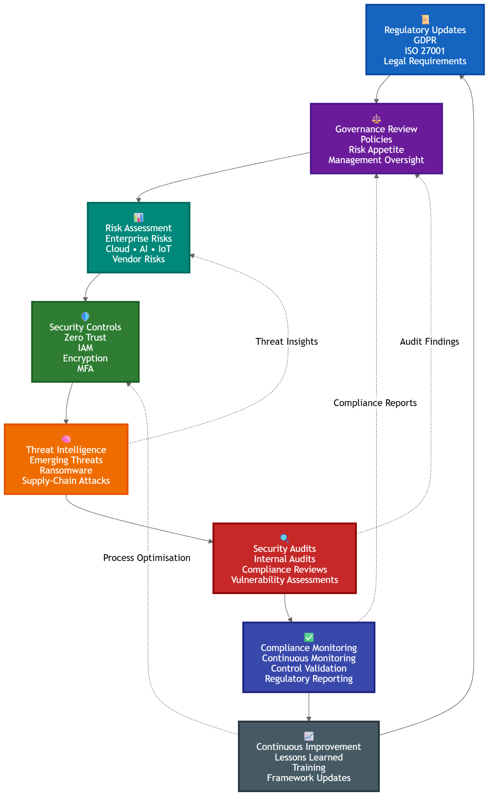
Figure 3: Continuous Governance Cycle
Furthermore, threat intelligence should be built into the framework of an organisation's risk management to facilitate proactively and timely action for responding to incidents [10]. Relevant (hazardous) evaluations of policy efficiency, compliance with the laws and rules, cybersecurity maturity and development of organizational security, including, particularly, periodic governance reviews, should ensure continuous improvement of the cybersecurity resilience.

6. Strategic Recommendations

6.1 Priority Recommendations
AeroLink Logistics should make an effort to implement an integrated information security governance framework with international standards to enhance its cybersecurity position. The organisation needs to develop an ISO/IEC 27001:2022 Information Security Management System (ISMS) to provide a formalisation of information security governance and regulatory compliance. Additionally, switching and implementing NIST Cybersecurity Framework (CSF) 2.0 would enable Cyber Risk Management (CRM) of the organization.Also, implementation of NIST Cybersecurity Framework (CSF) 2.0 would help in effective Cyber Risk Management (CRM) across the organisation. ZTA should be implemented to provide security in cloud environments, IoT devices and remote access. The organisation should also enhance vendor governance by developing comprehensive third-party risk assessments, security requirements in contracts, and/or both. Having a dedicated Security Operations Centre (SOC) would have helped in improving threat detection, incident response, and ongoing monitoring in real-time. Finally, continuous compliance monitoring needs to be built into the organisational governance procedures, guaranteeing long-term compliance and constant enhancements in cybersecurity procedures.
Recommendation | Priority | Business Impact
ISO 27001 ISMS | High | Very High
NIST CSF | High | High
Zero Trust | High | Very High
Vendor Governance | Medium | High
Security Operations Centre | High | Very High
Compliance Monitoring | High | High

Table: Priority Recommendation Matrix

7. Conclusion
This report recommended an integrated information security governance framework which is specific to the operational information security governance needs of AeroLink Logistics. The proposed approach will be expected to increase cybersecurity resilience, increase state compliance, increase the effectiveness of the governance framework and support the organisation in the long-term goal of digital transformation through a complimentary set of approaches including recognised governance frameworks, robust security controls, proper risk management and regular compliance practices.

References
[1] Abdullahi, M., Baashar, Y., Alhussian, H., Alwadain, A., Aziz, N., Capretz, L.F. and Abdulkadir, S.J., 2022. Detecting cybersecurity attacks in internet of things using artificial intelligence methods: A systematic literature review. Electronics, 11(2), p.198. https://www.mdpi.com/2079-9292/11/2/198
[2] Admass, W.S., Munaye, Y.Y. and Diro, A.A., 2024. Cyber security: State of the art, challenges and future directions. Cyber Security and Applications, 2, p.100031. https://www.sciencedirect.com/science/article/pii/S2772918423000188
[3] Ali, T., Al-Khalidi, M. and Al-Zaidi, R., 2026. Information security risk assessment methods in cloud computing: Comprehensive review. Journal of Computer Information Systems, 66(1), pp.123-150. https://www.tandfonline.com/doi/pdf/10.1080/08874417.2024.2329985
[4] Almutairi, M. and Sheldon, F.T., 2025. IoT–cloud integration security: A survey of challenges, solutions, and directions. Electronics, 14(7), p.1394. https://www.mdpi.com/2079-9292/14/7/1394
[5] Alsumayt, A., El-Haggar, N., Alshammari, M., Alghamedy, F.H. and AlFawaer, Z., 2026. Enhancing Security in Operational Technology: The Role of Multi-Factor Authentication Against Cyber Threats. Journal of Artificial Intelligence and Technology, 6, pp.64-78. https://ojs.istp-press.com/jait/article/download/881/685
[6] Chitraju, S., 2024. Cloud-Native Identity and Access Management for Financial Service Providers. Available at SSRN 5653690.https://papers.ssrn.com/sol3/Delivery.cfm?abstractid=5653690
[7] Ciceri, C., Caniato, F. and Moretto, A., 2026. Integrating artificial intelligence capabilities in supply chain cyber risk management. International Journal of Physical Distribution & Logistics Management, 56(4), pp.412-449. https://www.emerald.com/ijpdlm/article-pdf/doi/10.1108/IJPDLM-01-2025-0028/11235482/ijpdlm-01-2025-0028en.pdf
[8] CSRC (2020) NIST SP 800-207 Zero Trust Architecture Available at: https://csrc.nist.gov/pubs/sp/800/207/final [Accessed on 27th July 2026]
[9] CSRC (2024) NIST CSWP 29 The NIST Cybersecurity Framework (CSF) 2.0 Available at: https://csrc.nist.gov/pubs/cswp/29/the-nist-cybersecurity-framework-csf-20/final [Accessed on 27th July 2026]
[10] Dosunmu, A.A. and Ogundele, P.O., 2022. Threat Intelligence Integration Frameworks Supporting Proactive Enterprise Cybersecurity Decision Making. https://gisrrj.com/paper/GISRRJ225384.pdf
[11] Drissi, S., Chergui, M. and Khatar, Z., 2025. A systematic literature review on risk assessment in cloud computing: recent research advancements. IEEE Access.https://ieeexplore.ieee.org/iel8/6287639/6514899/10965667.pdf
[12] Ferreira, L.V.A., Alves, C.A.D.M., Peotta de Melo, L. and Nunes, R.R., 2025. Internal Audit Strategies for Assessing Cybersecurity Controls in the Brazilian Financial Institutions. Applied Sciences, 15(10), p.5715. https://www.mdpi.com/2076-3417/15/10/5715
[13] Folorunso, A., Mohammed, V., Wada, I. and Samuel, B., 2024. The impact of ISO security standards on enhancing cybersecurity posture in organizations. World Journal of Advanced Research and Reviews, 24(1), pp.2582-2595. https://www.researchgate.net/profile/Ifeoluwa-Wada/publication/385427490_The_impact_of_ISO_security_standards_on_enhancing_cybersecurity_posture_in_organizations/links/67a5b926461fb56424ccb620/The-impact-of-ISO-security-standards-on-enhancing-cybersecurity-posture-in-organizations.pdf
[14] Gambo, M.L. and Almulhem, A., 2025. Zero trust architecture: A systematic literature review. arXiv preprint arXiv:2503.11659. https://arxiv.org/pdf/2503.11659
[15] Ghazal, R., Malik, A.K., Raza, B., Qadeer, N., Qamar, N. and Bhatia, S., 2021. Agent-based semantic role mining for intelligent access control in multi-domain collaborative applications of smart cities. Sensors, 21(13), p.4253. https://www.mdpi.com/1424-8220/21/13/4253
[16] Gundaboina, A., 2023. Endpoint Detection and Response (EDR) in Healthcare: Mitigating Threats on Critical Devices. Artificial Intelligence, Machine Learning & Data Science, 1(2), pp.3107-3114. https://urfpublishers.com/journal/artificial-intelligence/article/view/endpoint-detection-and-response-edr-in-healthcare-mitigating-threats-on-critical-devices
[17] Hoxha, E., Mujo, A., Nikolla, S. and Pelivani, E., 2025. MECHANISMS OF INFORMATION TECHNOLOGY INFRASTRUCTURE LIBRARY (ITIL) AND ARTIFICIAL INTELLIGENCE (AI) FOR THE OPTIMIZATION OF INFORMATION SYSTEMS. International Journal of Ecosystems & Ecology Sciences, 15(2). https://www.researchgate.net/profile/Ajkuna-Mujo-2/publication/390307710_MECHANISMS_OF_INFORMATION_TECHNOLOGY_INFRASTRUCTURE_LIBRARY_ITIL_AND_ARTIFICIAL_INTELLIGENCE_AI_FOR_THE_OPTIMIZATION_OF_INFORMATION_SYSTEMS/links/67f4da0249e91c0feae9f687/MECHANISMS-OF-INFORMATION-TECHNOLOGY-INFRASTRUCTURE-LIBRARY-ITIL-AND-ARTIFICIAL-INTELLIGENCE-AI-FOR-THE-OPTIMIZATION-OF-INFORMATION-SYSTEMS.pdf
[18] Ilori, O., Nwosu, N.T. and Naiho, H.N.N., 2024. Third-party vendor risks in IT security: A comprehensive audit review and mitigation strategies. World Journal of Advanced Research and Reviews, 22(3), pp.213-224. https://www.researchgate.net/profile/Oluwatosin-Ilori-3/publication/381844798_Third-Party_Vendor_Risks_in_IT_Security_A_Comprehensive_Audit_Review_and_Mitigation_Strategies/links/669dbae88dca9f441b8edff2/Third-Party-Vendor-Risks-in-IT-Security-A-Comprehensive-Audit-Review-and-Mitigation-Strategies.pdf
[19] ISACA (2026) Celebrating Thirty Years of Empowering Enterprise IT Available at: https://www.isaca.org/resources/cobit [Accessed on 27th July 2026]
[20] ISACA (2026) ISACA Available at: https://www.isaca.org/resources/isaca-journal [Accessed on 27th July 2026]
[21] ISO (2022) ISO/IEC 27001:2022Information security, cybersecurity and privacy protection — Information security management systems — Requirements Available at: https://www.iso.org/standard/27001 [Accessed on 27th July 2026]
[22] Labadie, C. and Legner, C., 2023. Building data management capabilities to address data protection regulations: Learnings from EU-GDPR. Journal of Information Technology, 38(1), pp.16-44. https://journals.sagepub.com/doi/pdf/10.1177/02683962221141456
[23] Luis Salas-Riega, J., Riega-Virú, Y., Ninaquispe-Soto, M. and Miguel Salas-Riega, J., 2025. Cybersecurity and the NIST Framework: A Systematic Review of its Implementation and Effectiveness Against Cyber Threats. International Journal of Advanced Computer Science & Applications, 16(6). https://www.researchgate.net/profile/Yasmina-Riega/publication/393423098_Cybersecurity_and_the_NIST_Framework_A_Systematic_Review_of_its_Implementation_and_Effectiveness_Against_Cyber_Threats/links/68bb62f373c8345b7a59ea29/Cybersecurity-and-the-NIST-Framework-A-Systematic-Review-of-its-Implementation-and-Effectiveness-Against-Cyber-Threats.pdf
[24] Machaladze, O., 2025. IT infrastructure management in educational institutions using the ITIL framework. International Science Journal of Engineering & Agriculture, 4(2), pp.215-225. https://isg-journal.com/isjea/article/download/985/553
[25] Mehmood, K.T., Ashraf, Z., Iqbal, R., Rafique, A.A., Gul, H. and Ali, M., 2025. Cyber security Governance as a Pillar of Enterprise Risk Management: Designing a Compliance-Driven Framework for Operational Resilience, Policy Enforcement, and Regulatory Alignment. Annual Methodological Archive Research Review, 3(5), pp.59-77. https://www.researchgate.net/profile/Raza-Iqbal-3/publication/391448694_Cyber_security_Governance_as_a_Pillar_of_Enterprise_Risk_Management_Designing_a_Compliance-Driven_Framework_for_Operational_Resilience_Policy_Enforcement_and_Regulatory_Alignment/links/6818595bbfbe974b23c2f725/Cyber-security-Governance-as-a-Pillar-of-Enterprise-Risk-Management-Designing-a-Compliance-Driven-Framework-for-Operational-Resilience-Policy-Enforcement-and-Regulatory-Alignment.pdf
[26] Micheal, D., 2025. Resilient Cyber Defense: A Multilayer Approach to Preventing Intrusions in Distributed Environments Using Encryption and Deep Learning. https://www.researchgate.net/profile/Dave-Micheal/publication/393019373_Resilient_Cyber_Defense_A_Multilayer_Approach_to_Preventing_Intrusions_in_Distributed_Environments_Using_Encryption_and_Deep_Learning/links/685c945099d2ce32c1cb2244/Resilient-Cyber-Defense-A-Multilayer-Approach-to-Preventing-Intrusions-in-Distributed-Environments-Using-Encryption-and-Deep-Learning.pdf
[27] Mirtsch, M., Pohlisch, J. and Blind, K., 2026. Certification as a compensation mechanism for weak regulation? Exploring the diffusion of the international standard ISO/IEC 27001 for information security management. Comput. Secur., 162, p.104774. https://publica-rest.fraunhofer.de/server/api/core/bitstreams/003cdce5-5814-4d59-a119-be00b46c98d7/content
[28] Montalvo, D. and Quishpe, L., 2024. Security Auditing and Information Assurance in Information Systems: A Practical Approach to Risk Identification and Mitigation. Northern Reviews on Algorithmic Research, Theoretical Computation, and Complexity, 9(12), pp.1-22.https://northernreviews.com/index.php/NRATCC/article/download/2024-12-04/20
[29] Nicolazzo, S., Nocera, A. and Pedrycz, W., 2026. Service Level Agreement (SLA) and Security SLA (SecSLA): A Comprehensive Survey. Journal of Network and Systems Management, 34(3), p.74. https://link.springer.com/content/pdf/10.1007/s10922-026-10041-w.pdf
[30] NIST (2025) NIST Cybersecurity Framework Available at: https://www.nist.gov/cyberframework [Accessed on 27th July 2026]
[31] Pascoe, C.E., 2023. Public draft: The NIST cybersecurity framework 2.0. National Institute of Standards and Technology. https://www.authonet.com/assets/National-Institute-of-Standards-and-Technology.(NIST).Cybersecurity-Framework.CSWP.29.ipd.pdf
[32] Patsakis, C., Arroyo, D. and Casino, F., 2024. The malware as a service ecosystem. In Malware: Handbook of Prevention and Detection (pp. 371-394). Cham: Springer Nature Switzerland. https://arxiv.org/pdf/2405.04109
[33] Quinn, P. and Malgieri, G., 2021. The difficulty of defining sensitive data—The concept of sensitive data in the EU data protection framework. German Law Journal, 22(8), pp.1583-1612. https://www.cambridge.org/core/services/aop-cambridge-core/content/view/5EC5932AAC5703E31D2C90045813F6C6/S2071832221000791a.pdf/the-difficulty-of-defining-sensitive-datathe-concept-of-sensitive-data-in-the-eu-data-protection-framework.pdf
[34] Rose, S., Borchert, O., Mitchell, S. and Connelly, S., 2020. Zero trust architecture. NIST special publication, 800(207), pp.1-52. https://ab-audit.com/Nostorage/2025/07/NIST.SP_.800-207-Zero-Trust-Architecture-Francais.pdf
[35] Scalise, P., Boeding, M., Hempel, M., Sharif, H., Delloiacovo, J. and Reed, J., 2024. A systematic survey on 5G and 6G security considerations, challenges, trends, and research areas. Future Internet. 2024; 16: 67 [online]https://pdfs.semanticscholar.org/7b03/1b8d2d58b4dccd76b3294366388df8cf65fe.pdf
[36] Waqdan, M., Louafi, H. and Mouhoub, M., 2025. Security risk assessment in IoT environments: A taxonomy and survey. Computers & Security, 154, p.104456.https://www.sciencedirect.com/science/article/pii/S0167404825001452
[37] Zgureanu, A. and Andronatiev, V., 2026. Backup and Recovery Strategies in Modern Enterprise IT Systems. ASE. https://irek.ase.md/xmlui/bitstream/handle/123456789/4974/62_ZGUREANU_%20ANDRONATIEV_Proceeding_2025_08.12_pp%20502-514.pdf?sequence=1

