Stuedent Name: Sharmin Rahman
student number:1809328
Academic and Employability Skills(Health & Social)
Lecturer name: Sylvia hoffmann

Contents
Introduction………………………………………………………………2
Gibbs’ reflective cycle…………………………………………………2-3
Description………………………………………………………………3-4
Feelings……………………………………………………………………4
Evaluation………………………………………………………………….5
Analysis……………………………………………………………………5-6
Conclusion…………………………………………………………………6
Action plan…………………………………………………………………6
References...........................................................................................................7

Academic and employability skills
Introduction
Competence, capability, professionalism are the synonyms of ‘skill’. Skill is the ability to do something in a proper way. Skill is not a thing to be gifted from god. Skills needed to be earned or acquired. To be successful in life, academic and employability competency needed to be mastered. Employability skills are basic skills to get, do and keep a job. (Jacquelyn & Robinson, 2000) Definition of academic skill is a little bit different. Only reading and writing are not academic skills. Academic skill stands for critical thinking, note making, referencing time-management and many more. But both the skills are important for life. Weak study skills make student face bad experience in their student life and weak employability skills make someone frustrate about their life. Competency of both should be acquired properly and practised with hardship.
The purpose of this assignment is to demonstrate what skills I have acquired last term and draw an outline of my limitations. It will reflect my skills and limits and will be helpful to improve my skills as well.
Gibbs’ reflective cycle
Graham Gibbs’(1988) is the designer of Gibbs’ reflective cycle. It is a structure of natural psychological stages which make sense of an overall experience. There are a lot of benefits of reflection in professional carrier. Reflection is process of learning through analysing experiences, evaluate former knowledge and make a reflection in next work as well. (Jasper & Rosser, 2003) This model helps to analyse previous work and gives chance to make improvement for the next similar work. Following the framework of Gibbs’ reflection model. There are six stages of this model.
- Description-What happened
- Feelings-What were the feelings about the situation or problem
- Evaluation-What were the ‘good’ and ‘bad’ experiences
- Analysis- What sense the situation makes
- Conclusion-What can be concluded
- Action plan- What will be the steps, if the same situation happens

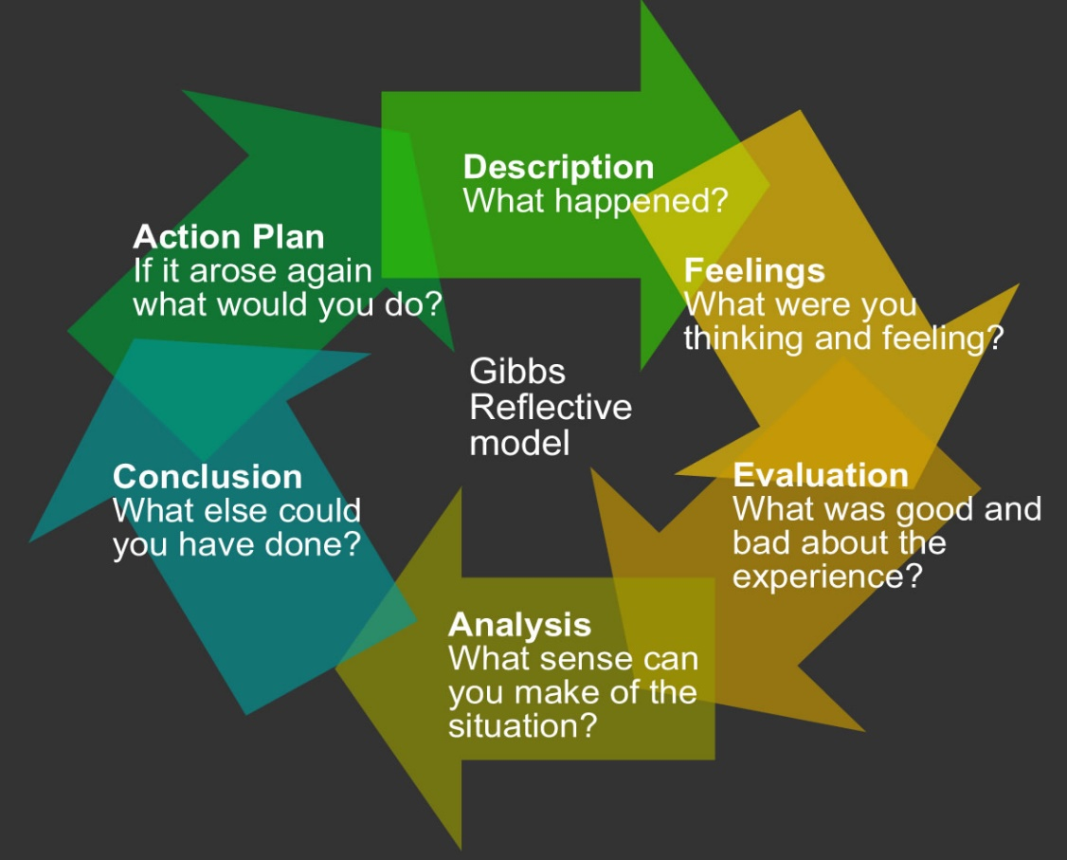
This Photo by Unknown Author is licensed under CC BY-SA-NC
Figure: Gibbs’ reflective cycle
My whole essay will be written following the structure of Gibbs’ reflective cycle. I will compare my experience of last term learning with each stages of Gibbs’ cycle. I will try to analyse my work according to the stages above. Firstly, I am going to explain the situation or the problem I was given to solve in detail. Then I am going to share my feelings about the work. Then I will inform what were the good and bad situations I faced. My next step will be analysing my whole work. To make a sense extracting my work. Then I will conclude my work. In my last step I will try to draw a plan about an upcoming work similar to the previous one. This essay will help me, think about my works and understand my weaknesses and improve my work experiences.
1.Description
As a student of ‘University of Wales Trinity Saint David’ we are given a lot of tasks to gain academic skills. Last term I had to produce an assignment of two thousand words. I was completely blank about what to write, where to find information or how to write. Then, when lecturer gave us proper instruction, the idea of the title, topic and sources of information were made clear. But it was tough for me to demonstrate a work, having zero experience in. It was my first academic writing and I was worried about the vocabulary as well. We were informed that, academic writing requires paraphrasing, summarising, referencing and a lot of research. Though we were given around ten weeks to finish it up, I decided to start the work one week later. I thought it would be better to start some research before that. I did not take much stress at first though I knew that two thousand words are not easy to write. It needed a lot of related information. Gathering information was the very first task for me from week two. Because it was very important for the information to be relevant and genuine. My tutor helped me a lot in this case. Me and some of my friends arranged several session of group studies and tried to find out our weaknesses and worked on it. Sessions of the group study boosted our confidence and cleared many misunderstandings about the essay.
2.Feelings
When I was introduced with my task first, I was completely clueless. Because each term regarding to the essay was unknown to me. While my teacher described me the task and started to tell about paraphrasing, referencing, summarising I was relaxed a little bit. Eventually I knew how to do research. At first it seemed hard to me. After trying for couple of times it got easier to me. At the beginning of the essay, it was informed that, I started to find out sources of information about my essay at very first week. That thing helped me a lot. Then in the second week when I started using Microsoft words for my assignment and started writing the information, struggled a lot with paraphrasing. I was getting upset about it. Because I was afraid of doing plagiarism unintentionally and on the other hand paraphrasing was getting harder to me. I went to my teacher to help me about this case. After getting help I survived at this stage. When someone goes through an academic process, he or she might have developed a sense of critical thinking. (Neville, 2010) That indicates the purpose of our study. If the purpose is not served well, students eventually get prone to steel other person’s ideas. That is why plagiarism is a punishable offense. At the last stage of my writing, I faced another complication about it. It was referencing. I took notes in an old school process by making notes and wrote information about the book or the journal as I did not know the process of referencing. My teacher helped me in that case. I got really confused over the name of journal and titles of the articles.
3. Evaluation
Evaluation is a process of critically examine a piece of work. Academic evaluation can be of two types-formal evaluation and informal evaluation. Formal evaluation is subjective judgement and informal evaluation talks about doubtful perspectives. (Stake, 1967) In this essay I am going to formally evaluate my previous work.
Firstly, I am going to talk about the good thing I experienced. I think my decision of starting the assignment from first week was good. It worked well with my time-management. I started my work fast and this thing helped me till the end. I got enough time to research enough to get the content for my writing. Secondly, I think, the other good work I did was note-taking. It worked as saviour. I took note from my class lecture and from the sources as well. Then used the information rephrasing them. I think, I was good in managing my overall assignment.
The bad things I had to go through were, confusion in referencing and difficulties in paraphrasing. The problem with referencing was frustrating. After getting help, it went easier. We talked about it in our group-study and found that, the correct process was not easy to anyone of us. About paraphrasing, I just can tell that this was my worse limitation in overall review. I got some tips to improve the situation. But I think it will take a lot of effort, practise and time. Another bad experience was with my digital skill. I did not know all the uses of Microsoft word tool. If I knew it before, I would make my assignment more presentable. I tried to work on my stress-management. But it did not go well. I was over-stressed at the last moment because of referencing.
4. Analysis
Higher the performance analysis, higher the performance. (Raymond K.S. Chu, 2000) For a reflective essay, analysis is very important. From my last work of essay, I got to learn many things such as- I gained some digital skills, learned the process of planning a whole essay and got to know about referencing and research as well. First of all, my time-management was good. It could be more fruitful if I knew the processes of my work. I was introduced with academic research. It will help me to improve my critical thinking process. Researching about a content is the hardest and time-consuming part of the assignment. I started from the first weak but could not finish properly in two weeks. It took more than that. Overall, I am happy that, because of my good time management, I was able to find enough time for my research.
I had some limitation or skill gap in this assignment. In my case, my first limitation was my digital skill deficiency. It was my first-time using Microsoft word. Now a days I am practising more and more and trying to know about all tools of this software. Then another restriction was paraphrasing and rephrasing. I am working on it right now. I am trying to improve my rephrasing skills by reading English articles once a week. Hopefully, I will recover my boundaries.
5.Conclusion
Last term I did my very first essay by critical thinking. Overall the quality of my work was average. I am proud that, I completed it successfully. To conclude, I want to inform that, through this assignment I learnt a lot. I worked on my critical thinking, digital skills, research, referencing, time-management, rephrasing, planning the structure and implement all of them to make a good piece of work. I doubt that, my work was excellent, but I did good as my first attempt.
I also learnt about plagiarism and being honest to my own work and got to know about the punishment of plagiarism as well. Plagiarism is unethical and deserve to be punished. I will try to reflect my experiences of this work, through my next similar work. Action plan is written at the end to demonstrate my actions for upcoming similar work.
6. Action plan
Though having some limitations, I have learnt a lot from this essay as well. I will try to implement them in my next work and will try to make it better than the previous. I have learnt about Microsoft word now. It will be easier for me to write an essay using it. I have informed about paraphrasing. Now I am learning about the different processes of paraphrasing. In this case, online learning is quick, instant and time-saving for me. They can give amazing and immediate classes. I am learning about it and I will implement it in my next assignment. I have improved my planning process and it will have a positive effect on my work. I will try to be more open up to my teachers so that they can help me more. The previous term work helped me thinking critically and helped learning some uncompromisable skills for work life and it will have a positive effect on my later life.

References

Jacquelyn, D. & Robinson, P., 2000. What Are Employability Skills?. THE WORKPLACE, 15 September, 1(3), pp. 1-3.
Jasper, M. & Rosser, M., 2003. Reflection and reflective practice. Professional development, reflection and decision-making in nursing and healthcare, pp. 41-82.
Neville, C., 2010. The complete guide to referncing and avoiding plagiarism. 2 ed. United Kingdom: Hill Education.
Raymond K.S. Chu, T. C., 2000. An importance-performance analysis of hotel selection factors. Tourism Management, Volume 21, pp. 363-377.
Stake, R. E., 1967. The countenanace of educational evaluation.

