

Employee Retention and Leadership Style During Financial Restructuring: A Case Study of the RSPCA
Independent Project

Submitted by: Beata Barbara Maciazek
Student Number: 2244700
LETURER: Dr Olusoyi Richard Ashaye
MODULE CODE: LCLM6005_LON
Table of Contents
Employee Retention and Leadership Style During Financial Restructuring: A Case Study of the RSPCA 4
CHAPTER 1: INTRODUCTION 4
1.1 Background of the Study 4
1.2 Problem Statement 5
1.3 Rationale of the Study 5
1.4 Scope and Focus of the Study 6
1.5 Research Aim and Objectives 6
1.5.1 Research Aim 6
1.5.2 Research Objectives 6
1.6 Research Questions 6
1.7 Significance of the Study 7
1.8 Overview of Dissertation 7
CHAPTER 2: LITERATURE REVIEW 8
2.0 Introduction 8
2.1 Conceptual Review 8
2.1.1 Employee Retention 8
2.1.2 Leadership Responses and Employee Retention 9
2.1.3 Human Resource Practices and Employee Retention 9
2.1.4 Financial Restructuring and Employee Morale 10
2.1.5 Service Performance 10
2.1.6 Employee Retention in the Charity Sector 10
2.2 Theoretical Framework 11
2.2.1 Social Exchange Theory 11
2.2.2 Herzberg’s Two-Factor Theory 12
2.2.3 Transformational Leadership Theory 13
2.2.4 Organisational Change Theory 14
2.3 The Influence of Leadership Responses and HR Practices on Employee Retention and Service Performance During Financial Restructuring 15
2.4 Research Gap 16
2.5 Conclusion 16
CHAPTER 3: RESEARCH METHODOLOGY 18
3.0 Introduction 18
3.1 Research Philosophy 18
3.2 Research Type 18
3.3 Research Approach 19
3.4 Research Method 19
3.5 Research Strategy 19
3.6 Data Collection Techniques 20
3.7 Sampling Method and Sample Size 20
3.8 Data Analysis Techniques 21
3.9 Ethical Considerations 21
3.10 Conclusion 21
CHAPTER 4: DATA ANALYSIS, RESULTS AND DISCUSSION 23
4.0 Introduction 23
4.1 Respondent Profile 23
4.2 Leadership During Financial Restructuring 27
4.3 HR Practices and Employee Support 29
4.4 Job Satisfaction, Morale and Retention 31
4.5 Service Performance and Organisational Impact 33
4.6 Correlation Analysis 35
4.7 Discussion of Findings in Relation to Research Questions and Literature 35
4.8 Conclusion 36
CHAPTER 5: DISCUSSION, CONCLUSION AND RECOMMENDATIONS 38
5.0 Introduction 38
5.1 Discussion of Key Findings 38
5.2 Implications for Practice 39
5.3 Limitations of the Study 39
5.4 Recommendations for Future Research 40
5.5 Conclusion 41
REFERENCES 42
APPENDIX 50

List Of Figures
Figure 4.1: Age Distribution of Respondents (n = 19) 24
Figure 4.2: Gender Distribution of Respondents (n = 19) 25
Figure 4.3: Role Type Distribution of Respondents (n = 19) 27
Figure 4.4: Employee Perceptions of Leadership During Financial Restructuring 29
Figure 4.5: Employee Perceptions of HR Practices and Employee Support 31
Figure 4.6: Job Satisfaction, Morale and Retention 33
Figure 4.7: Service Performance and Organisational Impact 34

List Of Tables
Table 4.1: Gender Distribution of Respondents (n = 19) 24
Table 4.2: Employment Status of Respondents (n = 19) 26
Table 4.3: Leadership During Financial Restructuring 28
Table 4.4: HR Practices and Employee Support 30
Table 4.5: Job Satisfaction, Morale and Retention 32
Table 4.6: Service Performance and Organisational Impact 34
Table 4.7: Correlation Matrix of Key Study Variables 35

Employee Retention and Leadership Style During Financial Restructuring: A Case Study of the RSPCA

CHAPTER 1: INTRODUCTION

1.1 Background of the Study
Employee retention has become a critical challenge for organisations across various sectors, particularly during periods of financial uncertainty and organisational restructuring. Retaining experienced employees is essential, as high staff turnover can disrupt service delivery, increase recruitment and training costs, and reduce overall organisational performance. Evidence suggests that organisations with stable and engaged workforces are more likely to maintain operational efficiency and deliver high-quality services (CIPD, 2025; Hancock et al., 2015; Hom et al., 2017).
This issue is especially significant in the charity and non-profit sector, where employees often perform emotionally demanding roles and operate under resource constraints, conditions that can intensify burnout and turnover risk where job demands are not balanced by sufficient resources (Bakker and Demerouti, 2007). In the United Kingdom, charities are currently facing increasing financial pressures due to rising operational costs, economic instability, and growing demand for services. Many organisations have experienced reduced funding, higher energy costs, and increased service demands, leading to restructuring and cost-cutting measures (Civil Society, 2024; Harle, 2024). Such changes can negatively affect employee morale, organisational commitment, and retention.
The Royal Society for the Prevention of Cruelty to Animals (RSPCA) provides a particularly relevant case for examining these challenges. As one of the largest animal welfare charities in the UK, the RSPCA plays a vital role in protecting animals and promoting welfare standards (RSPCA, 2024a). However, the organisation has recently faced significant financial pressures due to rising costs associated with animal care, veterinary services and operational activities. These challenges have led to restructuring initiatives, including voluntary severance schemes and financial management adjustments (RSPCA, 2024b; Civil Society, 2024).
Organisational restructuring often creates uncertainty among employees, which can reduce morale, increase stress and influence intentions to leave. This phenomenon is commonly referred to as the “downsizing morale effect,” where remaining employees experience reduced motivation and trust in leadership (Cameron, 1994). Organisational Change Theory further suggests that such transitions can significantly impact employee attitudes and behaviours if not managed effectively (Burnes, 2017). These outcomes can negatively affect workforce stability and organisational performance.
Maintaining a stable workforce is particularly important for the RSPCA, where frontline roles such as animal inspectors and care staff require specialised skills and emotional resilience. High turnover in these roles can negatively affect service delivery, including response times and the quality of animal care. Previous research has demonstrated a strong relationship between employee turnover and reduced organisational performance (Hancock et al., 2015; Hom et al., 2017).
In addition to financial pressures, leadership practices and human resource (HR) strategies play a key role in influencing employee retention. Transformational Leadership Theory highlights that supportive leadership, clear communication and employee engagement can improve morale and organisational commitment (Bass and Riggio, 2006; Tyagi, 2021). Leadership approaches that emphasise transparency and employee involvement can reduce the negative effects of restructuring (Armenakis and Bedeian, 1999; Burnes, 2017). Similarly, HR practices such as flexible working, career development opportunities and fair compensation are strongly associated with higher employee satisfaction and retention (CIPD, 2025).
Furthermore, Herzberg’s Two-Factor Theory suggests that both hygiene factors (such as job security and working conditions) and motivators (such as recognition and development opportunities) influence employee satisfaction and retention (Herzberg, 1959). During financial restructuring, disruptions to these factors may increase dissatisfaction and turnover intentions.
Social Exchange Theory provides an additional explanation by suggesting that employees develop relationships with their organisation based on reciprocal exchanges (Cropanzano and Mitchell, 2005). When employees perceive support from leadership and HR practices, they are more likely to respond with loyalty and commitment, which is consistent with perceived organisational support and organisational commitment research (Eisenberger et al., 1986; Meyer and Allen, 1991). Conversely, negative organisational actions, such as poor communication or job insecurity, may weaken this relationship and increase the likelihood of employee turnover (Hom et al., 2017).
Despite the importance of these factors, there remains limited research examining how leadership and HR practices jointly influence employee retention within charities undergoing financial restructuring. Much of the existing literature focuses on private sector organisations, leaving a gap in understanding within mission-driven contexts. This study therefore aims to address this gap by exploring these relationships within the RSPCA.

1.2 Problem Statement
Charities in the UK are increasingly facing financial constraints that require restructuring and cost-reduction strategies. While these measures may improve financial sustainability, they often create uncertainty, reduce employee morale, and increase staff turnover (Civil Society, 2024; Harle, 2024). For organisations such as the RSPCA, high employee turnover can negatively affect service delivery and organisational effectiveness. However, there is limited research on how leadership responses and HR practices can mitigate these effects within the charity sector.

1.3 Rationale of the Study
This study is important because it explores how organisations can maintain employee retention during periods of financial difficulty. Understanding the role of leadership and HR practices in supporting employees can help charities develop strategies that balance financial sustainability with workforce wellbeing (CIPD, 2025; Tyagi, 2021). The findings will be particularly useful for the RSPCA and similar organisations facing comparable challenges.

1.4 Scope and Focus of the Study
This research focuses specifically on the RSPCA within the United Kingdom. It examines the impact of financial restructuring on employee retention, morale, and service performance. The study considers leadership practices and HR strategies as key influencing factors. While the findings may offer insights for other charities, the research is limited to one organisation and may not be fully generalisable across all sectors (Yin, 2018).

1.5 Research Aim and Objectives
This section outlines the overall aim and specific objectives of the study. Establishing clear research aims and objectives is essential, as they guide the direction of the study, ensure coherence, and provide a framework for data collection and analysis (Saunders et al., 2019). In this research, the focus is on understanding how organisational factors influence employee outcomes during periods of financial restructuring within the charity sector.

1.5.1 Research Aim
The aim of this study is to examine how leadership responses and human resource (HR) practices influence employee retention and service performance during periods of financial restructuring at the RSPCA. The study seeks to explore how leadership communication, employee engagement, and HR strategies shape staff perceptions, morale, and commitment in a context of organisational change. By focusing on both employee retention and service outcomes, the research aims to provide a comprehensive understanding of how internal management practices can support organisational stability and effectiveness during financial uncertainty (Burnes, 2017; CIPD, 2025).

1.5.2 Research Objectives
To achieve this aim, the study will pursue the following objectives:
• To analyse the financial pressures and restructuring measures experienced by the RSPCA, including their impact on organisational operations and workforce stability.
• To examine how leadership communication, management approaches, and HR practices influence employee morale, job satisfaction, and retention during periods of change (Tyagi, 2021; CIPD, 2025).
• To investigate the relationship between staff turnover and service performance, particularly in relation to the delivery of animal welfare services (Hancock et al., 2015).
• To develop practical recommendations for improving employee retention and organisational effectiveness within the RSPCA and similar charities operating under financial constraints.

1.6 Research Questions
The study is guided by the following questions:
How have financial pressures and restructuring measures affected employee morale and retention at the RSPCA?
What is the relationship between employee turnover and service performance?
Which HR practices are most effective in supporting employee retention?
What strategies can leadership adopt to reduce staff turnover while maintaining service performance?

1.7 Significance of the Study
This study contributes to both academic knowledge and practical application. Academically, it adds to the limited research on employee retention and organisational change within the charity sector. Practically, it provides insights for leaders and HR professionals on how to improve retention and maintain service quality during financial challenges (CIPD, 2025; Hom et al., 2017).
Given the increasing financial pressures facing UK charities, developing effective workforce strategies is essential. This research aims to support organisations in enhancing employee wellbeing, improving retention and ensuring the continued delivery of essential services.

1.8 Overview of Dissertation
This dissertation is structured into five chapters, each contributing to the overall aim of examining how leadership responses and human resource practices influence employee retention and service performance during financial restructuring at the RSPCA. Chapter One introduces the research topic by outlining the background of the study, the problem statement, research rationale, aim, objectives, research questions and significance of the study. Chapter Two reviews relevant academic literature on employee retention, leadership, HR practices, organisational restructuring and the charity sector, while also discussing key theories such as Social Exchange Theory, Herzberg’s Two-Factor Theory, Transformational Leadership Theory and Organisational Change Theory. Chapter Three explains the research methodology, including the positivist philosophy, deductive approach, quantitative method, questionnaire design, sampling strategy, data analysis techniques and ethical considerations. Chapter Four presents and analyses the findings from the questionnaire survey, focusing on respondent profiles, leadership, HR practices, job satisfaction, morale, retention, service performance and correlation analysis. Finally, Chapter Five discusses the key findings in relation to the research questions and literature, before presenting practical recommendations, limitations of the study and conclusions. Overall, the dissertation provides both academic and practical insight into how charities such as the RSPCA can support employees and maintain service quality during periods of financial pressure and organisational change.

CHAPTER 2: LITERATURE REVIEW

2.0 Introduction
This chapter reviews existing literature relevant to employee retention, leadership responses, human resource (HR) practices, financial restructuring, employee morale and service performance. In response to the need to arrange the chapter more logically, the review begins by defining and discussing the key concepts that underpin the study before moving on to the theoretical framework. This structure separates the conceptual review from the theories and models that explain the relationships between the main variables.
The chapter first examines employee retention, leadership responses, HR practices, financial restructuring, service performance and employee retention in the charity sector. It then reviews the theoretical frameworks that support the study, including Social Exchange Theory, Herzberg’s Two-Factor Theory, Transformational Leadership Theory and Organisational Change Theory. These theories provide a basis for understanding how leadership and HR practices may influence employee attitudes, morale, retention and service performance during periods of organisational change. The chapter then discusses the influence of leadership responses and HR practices on employee retention and service performance during financial restructuring in organisations generally, before identifying the research gap and summarising the chapter.

2.1 Conceptual Review
A conceptual review defines and explains the main ideas that shape a study. For this research, the key concepts are employee retention, leadership responses, HR practices, financial restructuring, employee morale and service performance. Defining these concepts first provides a clearer foundation for the later discussion of theories and empirical literature.

2.1.1 Employee Retention
Employee retention refers to an organisation’s ability to retain its workforce and reduce voluntary turnover. It is an important issue because high turnover can increase recruitment costs, reduce productivity, disrupt service delivery and lead to the loss of organisational knowledge (Armstrong, 2020). Retention is especially important in service-based organisations, where employees’ experience, skills and commitment influence the consistency and quality of services delivered to users.
Research indicates that employee retention is influenced by several factors, including job satisfaction, organisational commitment, perceived organisational support, career development opportunities and working conditions (Hom et al., 2017; Meyer and Allen, 1991; Holtom et al., 2008). Evidence-based retention research also suggests that organisations should diagnose the specific causes of turnover and design targeted retention strategies rather than relying on generic solutions (Allen et al., 2010). This is particularly important during periods of uncertainty, when employees may become more likely to leave if they feel unsupported or insecure.
Employee retention is also linked to organisational performance. Studies have shown that high employee turnover can reduce performance by increasing workload pressures on remaining staff, weakening morale and reducing organisational efficiency (Hancock et al., 2015). Therefore, employee retention should not be viewed only as an HR issue, but also as a wider organisational priority connected to service quality, continuity and long-term sustainability.

2.1.2 Leadership Responses and Employee Retention
Leadership responses refer to the actions, communication and support provided by leaders during organisational events or periods of change. Leadership plays a central role in shaping employee attitudes, motivation and commitment. During organisational restructuring, employees often look to leaders for guidance, reassurance and clarity. Effective leadership responses, including clear communication, transparency, fairness and visible support, can reduce uncertainty and help maintain trust between employees and the organisation.
Research suggests that leadership has a significant influence on employee engagement and retention. Transformational leadership, in particular, has been associated with higher levels of employee motivation, organisational commitment and retention because it focuses on communication, support, inspiration and employee development (Bass and Riggio, 2006). During financial restructuring, leadership communication becomes especially important because uncertainty about job security, workload and organisational priorities can negatively affect morale.
Supportive leadership can help employees interpret organisational change more positively. When leaders communicate openly and involve employees where possible, employees may be more likely to trust the change process and remain committed to the organisation (Armenakis and Bedeian, 1999). Recent studies also suggest that leadership influences employee motivation and engagement, both of which are important drivers of retention (Siyal et al., 2021). Therefore, leadership responses are a key factor in understanding how organisations can retain employees during periods of financial pressure and restructuring.

2.1.3 Human Resource Practices and Employee Retention
Human resource practices refer to the policies, procedures and support systems used to manage and develop employees. These may include flexible working arrangements, training and development opportunities, fair reward systems, wellbeing support, communication channels and employee involvement mechanisms. HR practices are important because they shape employees’ experiences of fairness, support and value within the organisation.
Effective HR practices can improve employee satisfaction and commitment by demonstrating that the organisation values and supports its workforce. Research shows that flexible working arrangements, career development opportunities, fair compensation and employee wellbeing initiatives are associated with higher employee satisfaction and retention (CIPD, 2025; Appelbaum et al., 2000). During financial restructuring, HR practices are particularly important because employees may experience uncertainty, stress and concern about the future of their roles.
Ineffective HR support can increase dissatisfaction and turnover intentions, especially when employees feel that decisions are unfair or poorly communicated. In contrast, supportive HR practices can help employees cope with change by providing information, reassurance and practical support. Therefore, HR practices play a crucial role in maintaining morale and encouraging employees to remain with the organisation during restructuring.

2.1.4 Financial Restructuring and Employee Morale
Financial restructuring refers to organisational changes made in response to financial pressure. These changes may include cost reduction, workforce restructuring, role changes, budget adjustments or changes to service delivery. Although restructuring may be necessary to improve financial sustainability, it can have significant consequences for employees.
Organisational restructuring can create uncertainty, reduce job security and increase stress among employees. The “downsizing morale effect” describes how restructuring and workforce reductions can reduce employee motivation, weaken trust in leadership and increase anxiety among remaining employees (Cameron, 1994). Even employees who remain in the organisation may experience lower morale because of increased workloads, uncertainty about future changes and concern for colleagues who may have left.
Employee reactions to restructuring are influenced by how the change process is managed. Oreg et al. (2011) argue that employee responses to change are shaped by the change process, perceived consequences and organisational context. This means that restructuring does not automatically lead to negative outcomes; rather, the impact depends partly on how leaders and HR teams communicate, support and involve employees during the process. Clear communication, fairness and employee support can reduce the negative effects of restructuring on morale and retention.

2.1.5 Service Performance
Service performance refers to the ability of an organisation to deliver effective, consistent and high-quality services to its users. In service-based organisations, performance is closely linked to employee skills, experience, motivation and continuity. When turnover is high, service performance may be affected because experienced employees leave, remaining employees face additional workload pressures and service delivery becomes less consistent.
The relationship between employee retention and service performance is particularly important during restructuring. Financial pressures may lead organisations to reduce costs or change roles, but these actions can create staffing instability if employees feel unsupported. Research has shown that employee turnover is associated with reduced organisational performance (Hancock et al., 2015). Therefore, maintaining employee retention during periods of change is important not only for workforce stability but also for protecting service quality and organisational effectiveness.

2.1.6 Employee Retention in the Charity Sector
Employee retention is particularly important in the charity sector because many roles involve emotional labour, high workloads and limited resources. Charity employees are often motivated by a strong commitment to organisational mission, but this commitment can be weakened when financial pressures increase workload, reduce job security or limit development opportunities.
The charity sector faces specific workforce challenges, including funding uncertainty, rising demand for services and resource constraints. These pressures can contribute to burnout, stress and turnover (Harle, 2024). Sector-level data also show that the UK voluntary sector employs just under one million people and has a comparatively older workforce profile, reinforcing the importance of retention and succession planning (NCVO, 2024).
Although employees in charities may be strongly motivated by purpose and values, mission commitment alone may not be enough to retain staff during periods of financial restructuring. Supportive leadership, effective HR practices, fair treatment and clear communication remain essential. Therefore, studying employee retention in the charity sector is important because it helps explain how mission-driven organisations can maintain workforce stability while responding to financial challenges.

2.2 Theoretical Framework
The theoretical framework provides the academic foundation for explaining the relationships between leadership responses, HR practices, employee retention, morale and service performance during financial restructuring. The theories reviewed in this section are Social Exchange Theory, Herzberg’s Two-Factor Theory, Transformational Leadership Theory and Organisational Change Theory.

2.2.1 Social Exchange Theory
Social Exchange Theory (SET) is a widely used framework for understanding relationships between employees and organisations. The theory suggests that workplace relationships are based on reciprocal exchanges, where employees respond positively to supportive organisational practices (Cropanzano and Mitchell, 2005; Cropanzano and Mitchell, 2016).
In organisational contexts, when employees perceive strong leadership support and effective HR practices, they are more likely to develop trust, commitment and loyalty towards the organisation. This increases their intention to remain within the organisation. Conversely, negative experiences such as poor communication, lack of support or perceived unfairness may weaken this exchange relationship, leading to reduced morale and increased turnover intentions.
SET is relevant to this study because it explains how leadership communication and HR support during financial restructuring can influence employee morale and retention. When employees feel that the organisation supports them during change, they may respond with stronger commitment and a greater willingness to remain.
This relationship is illustrated in Figure 2.1, which demonstrates how leadership and HR support influence employee perceptions, ultimately affecting morale and retention outcomes.
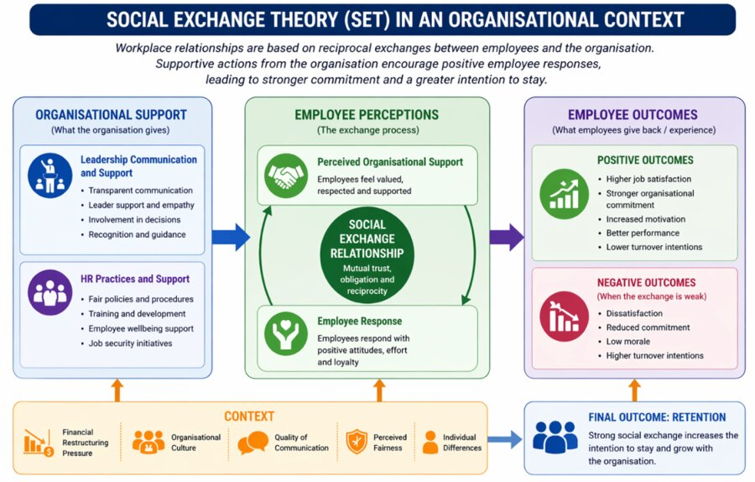
Figure 2.1: Social Exchange Theory in an Organisational Context
Source: Adapted from Cropanzano and Mitchell (2005; 2016)

2.2.2 Herzberg’s Two-Factor Theory
Herzberg’s Two-Factor Theory provides insight into employee motivation and satisfaction. The theory distinguishes between hygiene factors, such as salary, job security and working conditions, and motivators, including recognition, achievement and personal development (Herzberg, 1959).
Hygiene factors do not necessarily motivate employees, but their absence can lead to dissatisfaction. Motivators, on the other hand, can enhance job satisfaction, commitment and engagement. In the context of financial restructuring, hygiene factors such as job security, workload and working conditions may be threatened, increasing dissatisfaction and turnover intentions. At the same time, limited recognition or development opportunities may reduce motivation and commitment.
This theory complements Social Exchange Theory by explaining the internal motivational factors that influence employee retention. It is relevant to this study because restructuring can affect both hygiene factors and motivators, meaning that organisations need to maintain fair working conditions while also supporting recognition, involvement and development.
This relationship is illustrated in Figure 2.2, which highlights the distinction between hygiene factors and motivators, and their impact on employee satisfaction, morale and retention.
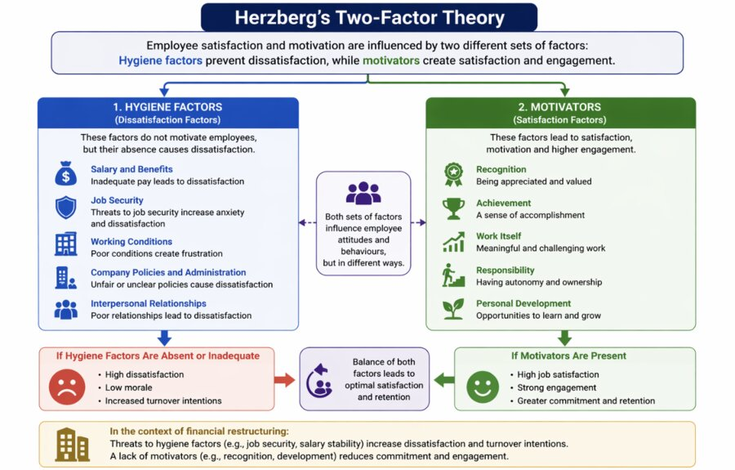
Figure 2.2: Herzberg’s Two-Factor Theory in the Context of Employee Retention
Source: Adapted from Herzberg (1959)

2.2.3 Transformational Leadership Theory
Transformational Leadership Theory emphasises the role of leaders in inspiring and motivating employees. Transformational leaders focus on communication, support, vision and employee development, which can improve employee engagement and organisational commitment (Bass and Riggio, 2006).
Research suggests that effective leadership can significantly influence employee morale and retention, particularly during periods of organisational change (Tyagi, 2021). Leaders who communicate clearly and provide emotional support can reduce uncertainty and strengthen trust among employees. This is especially important during financial restructuring, when employees may be concerned about job security, role changes and organisational stability.
In this study, transformational leadership helps explain how leadership communication and support during financial restructuring can influence employee perceptions, morale and retention. Leaders who provide reassurance, fairness and a clear sense of direction may help reduce the negative effects of restructuring on employees.
This relationship is illustrated in Figure 2.3, which demonstrates how transformational leadership behaviours, such as communication and support, influence employee engagement, trust and retention outcomes.
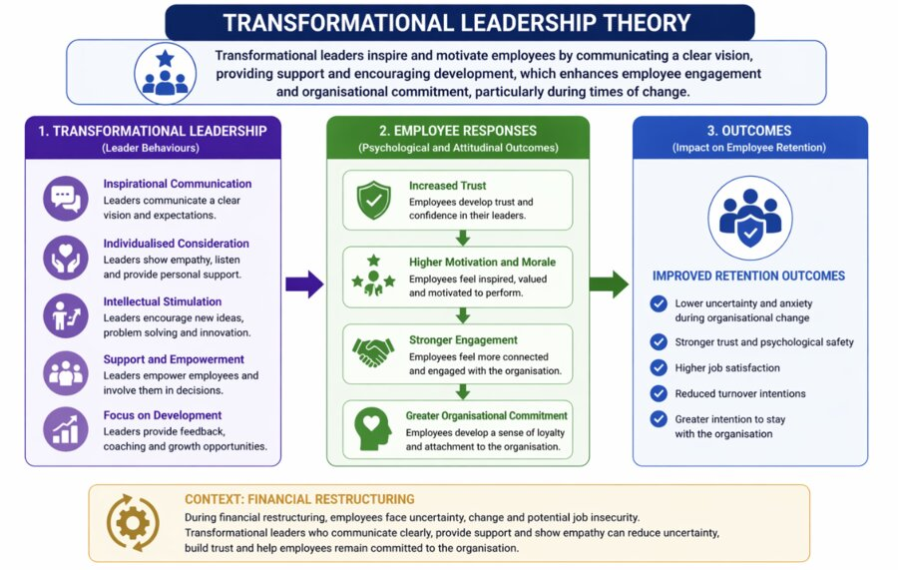
Figure 2.3: Transformational Leadership Theory in the Context of Employee Retention
Source: Adapted from Bass and Riggio (2006)

2.2.4 Organisational Change Theory
Organisational Change Theory focuses on how organisations manage transitions such as restructuring, downsizing, role changes and strategic transformation. These changes can significantly impact employee attitudes, behaviour and performance (Burnes, 2017).
Employees often experience uncertainty, stress and reduced job security during organisational change, which can negatively affect morale and increase turnover intentions. Effective change management, including clear communication, employee involvement and support, is essential in minimising these negative effects (Armenakis and Bedeian, 1999).
This theory is highly relevant to the current study because it explains how financial restructuring may influence employee retention. It also highlights the importance of managing the human side of change, rather than focusing only on financial or operational outcomes.
This process is illustrated in Figure 2.4, which demonstrates how organisational change, such as financial restructuring, influences employee attitudes and behaviour, ultimately affecting morale and retention outcomes.
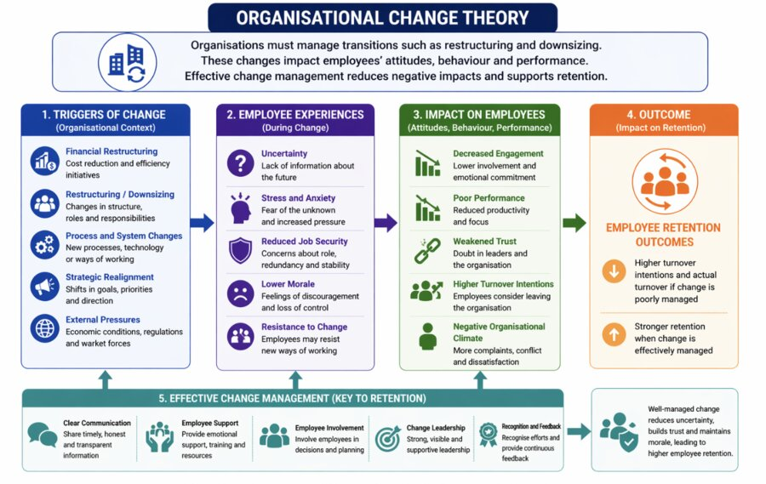
Figure 2.4: Organisational Change Theory in the Context of Employee Retention
Source: Adapted from Burnes (2017) and Armenakis and Bedeian (1999)

2.3 The Influence of Leadership Responses and HR Practices on Employee Retention and Service Performance During Financial Restructuring
Leadership responses and HR practices are important in determining how employees experience financial restructuring. During restructuring, employees may face uncertainty about job security, role changes, workload pressures and the future direction of the organisation. These concerns can negatively affect morale and increase turnover intentions. However, the literature suggests that effective leadership and supportive HR practices can reduce these negative effects by strengthening employee trust, commitment and perceived organisational support.
Leadership responses influence retention by shaping how employees interpret organisational change. Transparent communication, fairness in decision-making and visible managerial support can reduce uncertainty and help employees feel more secure. This is consistent with Social Exchange Theory, which suggests that employees are more likely to remain committed when they perceive that the organisation values and supports them. Similarly, Transformational Leadership Theory suggests that leaders who motivate, support and engage employees can improve morale and commitment during periods of change.
HR practices also influence retention during restructuring by providing practical and emotional support. Flexible working arrangements, wellbeing support, opportunities to raise concerns and clear information about role changes can help employees manage uncertainty. These practices also support Herzberg’s Two-Factor Theory by addressing hygiene factors, such as job security and working conditions, while also maintaining motivators such as recognition, involvement and development opportunities.
Employee retention is also linked to service performance. High turnover can increase workload pressure on remaining staff, reduce organisational knowledge and disrupt service delivery. This is particularly important in service-based organisations, where employee experience and continuity can directly influence service quality. Therefore, leadership and HR practices are not only important for retaining employees, but also for maintaining organisational performance during financial restructuring.
Overall, the literature suggests that the relationship between financial restructuring, employee retention and service performance is influenced by the quality of leadership responses and HR practices. Where employees perceive communication, fairness and support, they are more likely to remain committed to the organisation. Where these are absent, restructuring may lead to reduced morale, increased turnover intentions and weaker service performance.

2.4 Research Gap
Although there is extensive literature on employee retention, leadership, HR practices and organisational change, several gaps remain. Much of the existing research focuses on private sector organisations, with less attention given to the charity and non-profit sector. This is significant because charities often experience unique challenges, including funding uncertainty, emotional labour, high service demand and limited resources.
In addition, previous studies often examine leadership and HR practices separately rather than exploring their combined influence on employee retention and service performance during financial restructuring. There is also limited research examining how financial restructuring affects employee morale, retention and service quality within mission-driven organisations. This creates a gap in understanding how leadership responses and HR practices can support employee retention while maintaining service performance during periods of financial pressure.
This study addresses this gap by examining how leadership responses and HR practices influence employee retention and service performance during financial restructuring, with specific focus on the RSPCA as the case study organisation.

2.5 Conclusion
This chapter reviewed literature relating to employee retention, leadership responses, HR practices, financial restructuring and service performance. The chapter began by defining the key concepts before examining relevant theoretical frameworks, including Social Exchange Theory, Herzberg’s Two-Factor Theory, Transformational Leadership Theory and Organisational Change Theory. The review showed that employee retention is influenced by organisational support, leadership communication, HR practices, job satisfaction and morale.
The literature also suggests that financial restructuring can negatively affect employees by creating uncertainty, reducing morale and increasing turnover intentions. However, effective leadership responses and supportive HR practices can help reduce these effects by improving trust, communication, fairness and employee wellbeing. The chapter further highlighted that employee retention is linked to service performance, as high turnover can disrupt service quality and increase pressure on remaining staff.
Finally, the chapter identified a research gap concerning the combined influence of leadership responses and HR practices on employee retention and service performance during financial restructuring, particularly within the charity sector. The next chapter explains the methodology used to investigate this issue.

CHAPTER 3: RESEARCH METHODOLOGY

3.0 Introduction
This chapter outlines the research methodology adopted for this study. It explains the philosophical assumptions, research design, data collection method, sampling approach and analytical techniques used to investigate the relationship between leadership practices, human resource (HR) strategies, employee retention and service performance during financial restructuring within the RSPCA. The chapter also justifies the chosen methodological decisions and explains the ethical considerations followed throughout the research process.
The methodological choices were aligned with the study’s theoretical framework, particularly Social Exchange Theory, as the research measured relationships between perceived organisational support, leadership practices, HR support and employee retention. Since the study aimed to examine measurable relationships between variables, a quantitative research design was considered appropriate.

3.1 Research Philosophy
Research philosophy refers to the set of assumptions about how knowledge is developed, interpreted and applied within a study (Saunders et al., 2019). It influences the overall research design, data collection method and approach to analysis. The main philosophical approaches commonly used in business and management research include positivism, interpretivism and pragmatism.
This study adopted a positivist research philosophy. Positivism assumes that reality can be measured objectively through observable and quantifiable data (Bryman and Bell, 2015; Saunders et al., 2019). This philosophy was suitable because the study examined measurable variables such as leadership communication, HR practices, employee satisfaction, morale, retention intentions and service performance.
The use of a positivist approach supported the collection of structured numerical data through a questionnaire. It also allowed the researcher to analyse patterns and relationships between variables using descriptive statistics and correlation analysis. This approach enhanced objectivity, consistency and reliability, which were important for examining employee retention within an organisational context (Creswell and Creswell, 2018; Bell, Bryman and Harley, 2019).

3.2 Research Type
Research may be classified as primary or secondary depending on the source of data (Bryman and Bell, 2015). Primary research involves collecting original data directly from participants, while secondary research involves using existing literature, reports and published datasets.
This study adopted a primary research approach because original data was collected from individuals associated with the RSPCA through an online questionnaire. Primary research was appropriate because it enabled the researcher to gather current, context-specific information about employee perceptions of leadership, HR support, morale, retention and service performance during financial restructuring.
Secondary sources were also used in the literature review to provide academic and contextual grounding for the study. These included academic books, journal articles, HR reports, charity sector sources and organisational publications. Combining primary and secondary sources strengthened the study by linking empirical findings to existing theory and research (Creswell and Creswell, 2018).

3.3 Research Approach
The research approach explains the relationship between theory and data. The two main approaches are deductive and inductive reasoning (Saunders et al., 2019). A deductive approach starts with existing theory and tests whether those theoretical ideas apply in a particular context, whereas an inductive approach develops theory from observed data.
This study adopted a deductive approach. Existing theories and literature suggested that leadership practices, HR support and organisational change can influence employee morale, retention and service performance. These theoretical ideas informed the design of the questionnaire and the selection of variables measured in the study.
The deductive approach was appropriate because the research moved from established theory to empirical testing. In particular, Social Exchange Theory, Herzberg’s Two-Factor Theory, Transformational Leadership Theory and Organisational Change Theory provided a foundation for examining how employees respond to leadership and HR practices during financial restructuring. The collected data was then analysed to determine whether the findings supported these theoretical assumptions within the RSPCA context.

3.4 Research Method
This study used a quantitative research method. Quantitative research involves the collection and analysis of numerical data and is suitable for identifying patterns, trends and relationships between variables (Creswell and Creswell, 2018).
A structured online questionnaire was used as the primary data collection tool. The questionnaire consisted mainly of closed-ended questions and Likert-scale statements. These questions measured key areas such as:
- leadership communication and transparency;
- HR practices and employee support;
- job satisfaction and morale;
- employee retention intentions;
- staff turnover and service performance.
A five-point Likert scale was used to allow respondents to indicate their level of agreement with each statement. This format enabled standardised responses and supported statistical analysis. The quantitative method was therefore appropriate because it allowed the researcher to compare responses across participants and examine relationships between leadership, HR practices, retention and service performance.

3.5 Research Strategy
The research strategy provides the overall framework for conducting the study. This research adopted a case study strategy focusing on the RSPCA. A case study approach allows an in-depth investigation of a specific organisation within its real-life context (Yin, 2018).
The RSPCA was selected as the case organisation because the research focused on employee retention and service performance during financial restructuring within a charity sector context. This strategy enabled the researcher to examine how leadership responses and HR practices were perceived within a specific organisational setting.
As the questionnaire was distributed online rather than through face-to-face fieldwork, the study also involved an online data collection strategy. This online approach was suitable because it allowed participants to respond remotely and anonymously. Although a single case study limits the extent to which findings can be generalised to all organisations, it provides useful context-specific insight that may be relevant to similar charities and non-profit organisations facing financial pressures.

3.6 Data Collection Techniques
The primary data collection method was an online questionnaire survey. Online surveys were appropriate because they are efficient, accessible and cost-effective, particularly when participants may be geographically dispersed or have limited availability (Bryman and Bell, 2015).
The questionnaire included structured questions divided into sections aligned with the research objectives. These sections covered respondent profile, leadership during financial restructuring, HR practices and support, job satisfaction, morale, retention and service performance. A five-point Likert scale was used to measure respondents’ level of agreement with statements related to these themes.
The use of an online questionnaire enabled the collection of standardised data that could be analysed quantitatively. It also allowed respondents to complete the survey at a convenient time and reduced the risk of interviewer influence. The final dataset consisted of 19 valid responses, which were used for the analysis presented in Chapter 4.

3.7 Sampling Method and Sample Size
This study used a non-probability convenience sampling technique. Convenience sampling involves selecting participants based on their accessibility, availability and willingness to participate (Etikan, Musa and Alkassim, 2016). This method was appropriate because access to participants in an organisational context can be limited, particularly when the research concerns sensitive issues such as restructuring, morale and retention.
The study initially aimed to collect approximately 50 responses from current or recent individuals associated with the RSPCA. However, 19 valid responses were ultimately received and analysed. Although this sample size was smaller than initially intended, it was still suitable for a small-scale undergraduate dissertation and enabled descriptive statistical analysis and basic correlation analysis.
The sample included respondents from different demographic and organisational categories, which helped provide a range of perspectives on leadership, HR support, retention and service performance. However, the use of convenience sampling and the relatively small sample size were acknowledged as limitations because they restricted the generalisability of the findings.

3.8 Data Analysis Techniques
The collected data was analysed using quantitative statistical techniques. Descriptive statistics, including frequencies, percentages and mean scores, were used to summarise the responses and identify general patterns in the data. These techniques were particularly useful for analysing respondent profiles and levels of agreement with survey statements.
In addition to descriptive analysis, correlation analysis was used to examine relationships between key study variables, including leadership, HR practices, employee retention and service performance. This allowed the researcher to assess whether positive perceptions of leadership and HR support were associated with more favourable retention outcomes.
The analysis was conducted using spreadsheet-based statistical tools such as Microsoft Excel. The results were presented through tables, figures and summary discussion in Chapter 4. This approach enabled the findings to be clearly linked to the research objectives and research questions.

3.9 Ethical Considerations
Ethical considerations were central to the research process because the study involved human participants and explored potentially sensitive workplace experiences. The study followed ethical principles relating to informed consent, voluntary participation, confidentiality and responsible data handling, in line with guidance from the British Educational Research Association (2018).
Participation in the questionnaire was voluntary, and respondents were informed about the purpose of the study before taking part. Informed consent was obtained from participants, and they were made aware that they could choose not to answer questions or withdraw from participation where applicable.
Respondents were assured of anonymity and confidentiality. No personal identifying information was collected, and the data was used solely for academic purposes. Data was stored securely and handled in accordance with data protection principles, including the requirements of the General Data Protection Regulation (ICO, 2023). These ethical measures helped protect participants and strengthened the integrity of the study.

3.10 Conclusion
This chapter has explained the methodology used to conduct the study. A positivist philosophy and deductive approach were adopted because the research aimed to measure relationships between leadership practices, HR strategies, employee retention and service performance. A quantitative method was used through a structured online questionnaire, which enabled the collection of numerical data from respondents associated with the RSPCA.
The study used a case study strategy and convenience sampling. Although the research initially aimed to collect approximately 50 responses, 19 valid responses were ultimately analysed. The data was examined using descriptive statistics and correlation analysis, allowing the researcher to identify patterns and relationships relevant to the research questions.
The chapter also explained the ethical procedures followed during the research, including voluntary participation, informed consent, anonymity, confidentiality and secure data handling. Overall, the methodology was appropriate for a small-scale organisational study examining employee retention and service performance during financial restructuring. The next chapter presents and analyses the findings obtained from the questionnaire survey.

CHAPTER 4: DATA ANALYSIS, RESULTS AND DISCUSSION

4.0 Introduction
This chapter has presented and analysed the findings derived from the questionnaire survey, using both descriptive statistics and correlation analysis to explore key relationships between the main variables under investigation. The analysis was structured around the study’s core themes, including leadership, HR practices, employee retention, and service performance, in order to provide a comprehensive understanding of how financial restructuring has influenced both employee experiences and organisational outcomes. Overall, the results indicate that leadership and HR practices were generally perceived in a positive light, suggesting that the organisation has implemented supportive mechanisms to manage the challenges associated with restructuring. These findings highlight the importance of effective communication, fairness in decision-making, and employee-focused HR initiatives during periods of organisational change.
However, despite these positive perceptions, the findings also reveal that financial restructuring had a noticeable negative impact on employee morale. A considerable proportion of respondents reported reduced morale, suggesting that the psychological and emotional effects of organisational change remain significant. In addition, some uncertainty persisted regarding long-term employee retention, indicating that positive leadership and HR support may not be sufficient to fully mitigate the effects of restructuring on employees’ future intentions.
One of the most significant findings of this study is the strong relationship between staff turnover and service performance. Respondents consistently recognised that workforce instability increases pressure on remaining employees, disrupts workflow, and negatively affects service quality. This emphasises the operational consequences of turnover and highlights the need for organisations to prioritise retention not only as a human resource concern but also as a key factor influencing overall organisational effectiveness.
Furthermore, the results demonstrate that positive perceptions of leadership and effective HR practices are associated with more favourable retention outcomes. In particular, clear communication, transparency, fairness in decision-making, and consistent employee support appear to play a critical role in helping individuals cope with uncertainty and organisational change.
In summary, this chapter provides a detailed and integrated overview of the study’s key findings, establishing a strong empirical foundation for the subsequent discussion. The following chapter will critically evaluate these results in relation to existing literature and the theoretical framework, and will present practical recommendations aimed at improving employee retention and sustaining organisational performance during periods of financial restructuring.

4.1 Respondent Profile
This section presents the demographic characteristics of the participants included in the study. The purpose of this analysis is to provide important contextual background information and to support the interpretation of the findings by clearly outlining the composition of the sample. Understanding the demographic profile of respondents is essential, as factors such as age and career stage may influence individual perceptions of organisational change, leadership practices, and employee support during financial restructuring.
A total of 19 valid responses were collected and analysed. In terms of age distribution, the largest group of respondents fell within the 35–44 age category, accounting for 9 participants (47.4%). This was followed by the 45–54 age group with 4 respondents (21.1%). The 25–34 category included 3 respondents (15.8%), while 2 respondents (10.5%) were aged 18–24, and only 1 respondent (5.3%) was aged 55 or above. These findings indicate that the majority of participants were in mid-career stages, suggesting that they are likely to have substantial organisational experience and may be particularly sensitive to issues related to job security and organisational change. The age distribution is illustrated in Figure 4.1.

Figure 4.1: Age Distribution of Respondents (n = 19)
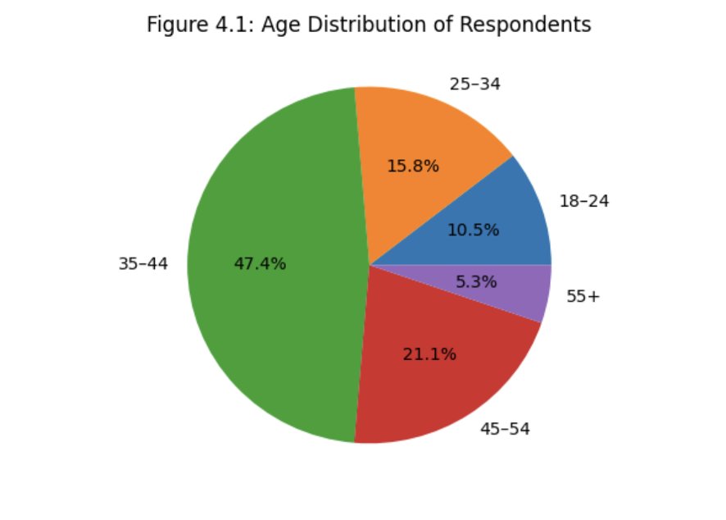
Source: Author’s survey data (2026)
In terms of gender, the sample was predominantly female, with 15 respondents (78.9%) identifying as female. Male respondents accounted for 3 participants (15.8%), while 1 respondent (5.3%) preferred not to disclose their gender. This distribution indicates a noticeable gender imbalance within the sample, which may reflect the characteristics of the organisation or sector in which the study was conducted. It is important to consider this when interpreting the findings, as gender may influence individual experiences and perceptions of organisational practices. The gender distribution is presented in Table 4.1 and Figure 4.2 for clarity and ease of reference.

Table 4.1: Gender Distribution of Respondents (n = 19)
Gender | Frequency | Percentage
Female | 15 | 78.9%
Male | 3 | 15.8%
Prefer not to say | 1 | 5.3%
Source: Author’s survey data (2026)

Figure 4.2: Gender Distribution of Respondents (n = 19)
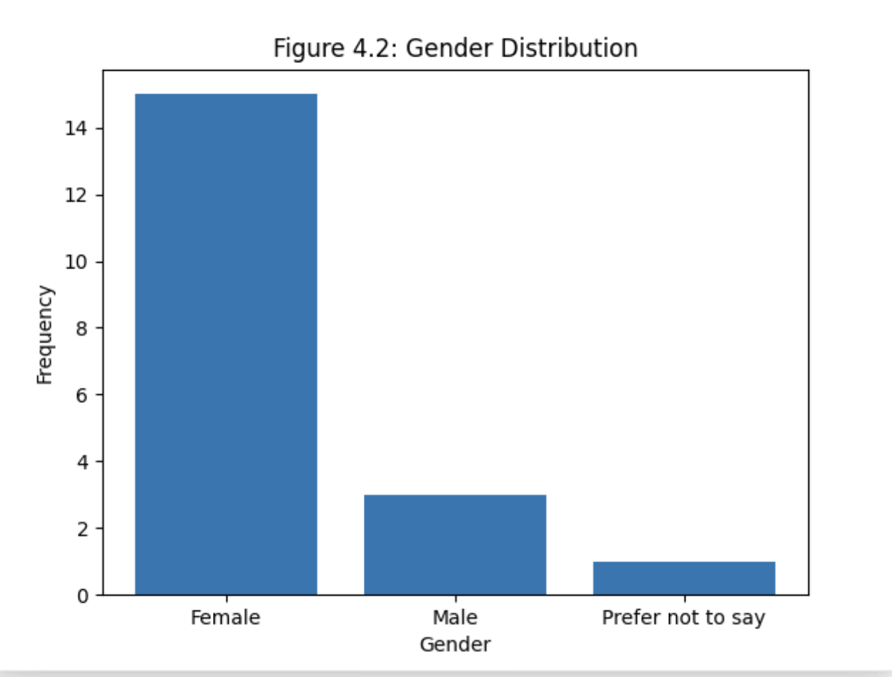
Source: Author’s survey data (2026)

Regarding employment status, the majority of respondents were current employees, accounting for 57.9% of the sample. This was followed by volunteers, who represented 15.8% of participants. A smaller proportion of respondents identified as former employees (10.5%), while 15.8% preferred not to disclose their employment status. This distribution suggests that the sample includes a variety of organisational perspectives, encompassing both current and past experiences within the organisation. Such diversity enhances the depth of the findings, as it allows for a more comprehensive understanding of how financial restructuring and organisational changes are perceived across different groups of individuals. The employment status distribution is presented in Table 4.2.

Table 4.2: Employment Status of Respondents (n = 19)
Status | Frequency | Percentage
Current employee | 11 | 57.9%
Volunteer | 3 | 15.8%
Former employee | 2 | 10.5%
Prefer not to say | 3 | 15.8%
Source: Author’s survey data (2026)
With regard to role type, the majority of respondents were employed in administration and support roles, accounting for 42.1% of the sample. This was followed by participants working in animal care roles, representing 21.1%, and those in management or leadership positions, who accounted for 15.8% of respondents. A smaller proportion of participants reported working in other roles, indicating a diverse range of responsibilities within the organisation. This distribution suggests that the data reflects perspectives from both operational and managerial levels, providing a more comprehensive view of employee experiences. The inclusion of respondents from different functional areas enhances the reliability of the findings, as it captures insights from individuals involved in both frontline service delivery and organisational decision-making processes, particularly during periods of financial restructuring. This role type distribution is illustrated in Figure 4.3.

Figure 4.3: Role Type Distribution of Respondents (n = 19)
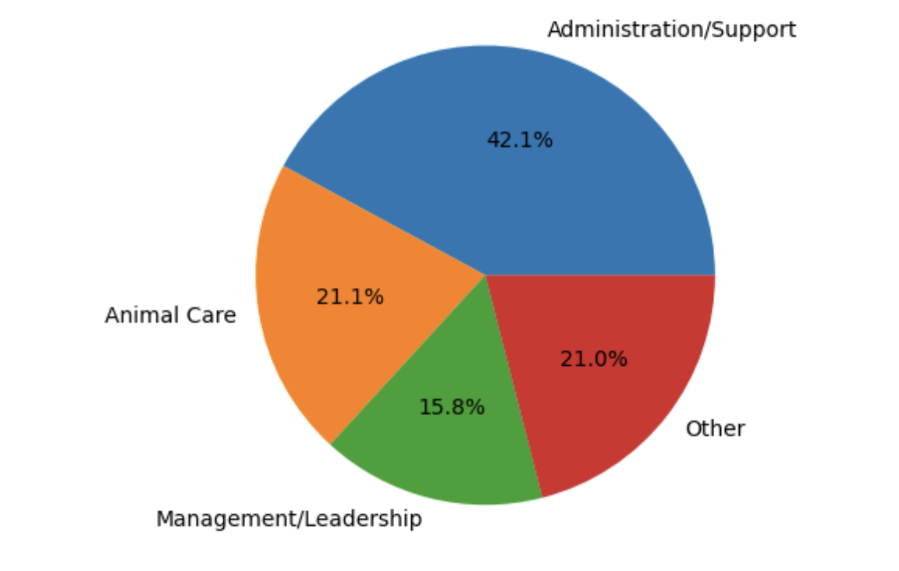
Source: Author’s survey data (2026)

In terms of length of service, the most common category among respondents was 4–6 years, representing 26.3% of the sample. The remaining participants were relatively evenly distributed across other categories, including less than 1 year, 1–3 years, 7–10 years, and more than 10 years of service. This distribution indicates a balanced mix of both less experienced and more experienced employees within the organisation. Such diversity is important, as individuals with varying levels of tenure may have different perspectives on organisational change, leadership practices, and job security. Employees with longer service may draw on extensive organisational knowledge, while newer employees may offer insights based on recent experiences.
Overall, the demographic profile demonstrates a diverse and reasonably representative sample, providing a strong and reliable foundation for analysing employee perceptions of leadership, HR practices, and retention during financial restructuring.

4.2 Leadership During Financial Restructuring
This section examines employee perceptions of leadership communication and support during a period of financial restructuring, revealing generally positive attitudes toward leadership performance. The findings suggest that employees largely felt informed and reassured by leadership throughout the process. The highest-rated statement, “Leadership communicated clearly about financial challenges,” achieved a mean score of 4.18, with all valid respondents indicating agreement or strong agreement. This highlights the effectiveness of leadership in conveying key financial issues. Similarly, “Leadership decisions during restructuring were fair” received a strong mean score of 4.06, while “I trust leadership to manage organisational change effectively” followed closely with a mean of 3.94, indicating a solid level of confidence in leadership capabilities.
However, responses were slightly lower for items relating to transparency and day-to-day managerial support. The statement “Senior management were transparent during restructuring” produced a mean score of 3.63, while “Managers provided adequate support during uncertainty” recorded a mean of 3.61. Although both scores remain above the midpoint, they suggest that some employees were less certain about the consistency and visibility of leadership support during the restructuring process.
Overall, the leadership composite mean of 3.84 indicates that employees viewed leadership in a broadly positive light during this challenging period. While communication appears to have been a particular strength, the findings also highlight areas for improvement, especially in enhancing transparency and ensuring consistent, ongoing support for employees throughout organisational change.
As shown in Table 4.3, leadership communication received the highest mean score, while transparency and managerial support scored comparatively lower. This pattern is also illustrated in Figure 4.4

Table 4.3: Leadership During Financial Restructuring
Survey Statement | Mean Score | Interpretation
Leadership communicated clearly about financial challenges | 4.18 | Very positive – strongest area
Leadership decisions during restructuring were fair | 4.06 | Positive – strong agreement
I trust leadership to manage organisational change effectively | 3.94 | Positive – good level of trust
Senior management were transparent during restructuring | 3.63 | Moderately positive – some uncertainty
Managers provided adequate support during uncertainty | 3.61 | Moderately positive – room for improvement
Overall Leadership Composite Mean | 3.84 | Generally positive perception

Figure 4.4: Employee Perceptions of Leadership During Financial Restructuring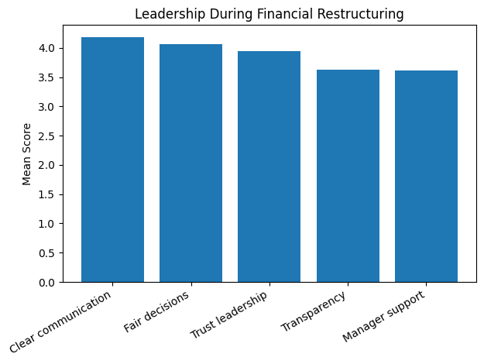
Source: Author’s survey data (2026)

4.3 HR Practices and Employee Support
This section examines employee perceptions of HR practices and organisational support during a period of financial restructuring, with findings indicating a generally positive evaluation of HR-related initiatives. Overall, respondents appeared to recognise the importance of HR policies in supporting employee wellbeing and managing organisational change effectively. The highest-rated item was flexible working arrangements, which achieved a mean score of 4.16, with 94.7% of respondents agreeing or strongly agreeing that such arrangements contributed positively to their wellbeing. This suggests that flexibility was a key strength in HR support during restructuring. Similarly, opportunities for employees to share concerns received a mean score of 4.06, indicating that communication channels were perceived as accessible and valuable. In addition, receiving sufficient information about role changes produced a mean score of 3.84, reflecting a generally positive, though slightly more moderate, perception.
Participants also responded favourably to the statement that leadership and HR support can reduce the negative impacts of employee turnover, which recorded a mean score of 4.17. This highlights a strong belief among respondents that organisational support mechanisms can mitigate the challenges associated with staffing instability during periods of change.
However, some areas received comparatively lower ratings. The statement “HR practices make employees feel valued” produced a mean score of 3.61, suggesting that not all employees felt fully recognised or appreciated. Likewise, “The organisation provided appropriate support during restructuring” recorded a mean score of 3.78, indicating some uncertainty regarding the consistency or adequacy of support provided.
The overall HR composite mean of 3.94, slightly higher than the leadership score, suggests that HR practices were viewed as an important and generally effective factor in helping employees cope with organisational change, although there remains room for improvement in fostering a stronger sense of value and support.
As shown in Table 4.4, flexible working arrangements and perceived organisational support in reducing turnover received the highest mean scores. This pattern is further illustrated in Figure 4.5, where these factors are visibly higher compared to perceptions of feeling valued and organisational support.

Table 4.4: HR Practices and Employee Support
Survey Statement | Mean Score | Interpretation
Flexible working arrangements supported wellbeing | 4.16 | Very positive – key strength
Opportunities to share concerns | 4.06 | Positive – strong communication
Received enough information about role changes | 3.84 | Moderately positive
HR & leadership reduce impact of turnover | 4.17 | Very positive – highest score
HR practices make employees feel valued | 3.61 | Lower – needs improvement
Organisation provided appropriate support during restructuring | 3.78 | Moderately positive
Overall HR Composite Mean | 3.94 | Generally positive

Figure 4.5: Employee Perceptions of HR Practices and Employee Support
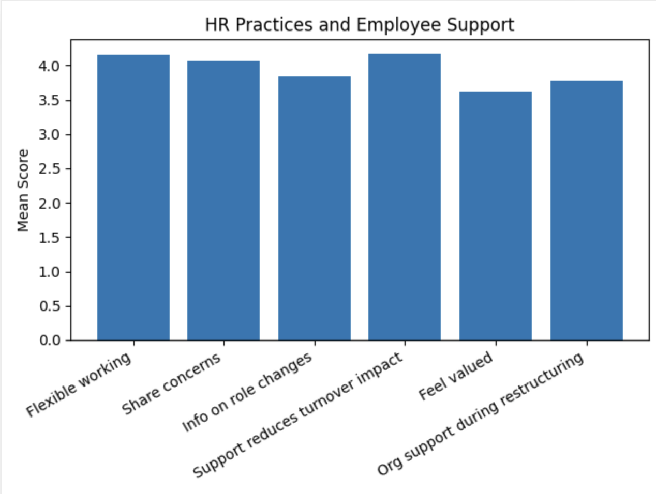

4.4 Job Satisfaction, Morale and Retention
This section examines the impact of financial restructuring on employee morale, job satisfaction, and retention intentions, revealing a combination of positive and negative perceptions. Overall, the findings suggest that while employees remain relatively satisfied with their roles, restructuring has had a noticeable effect on morale and future organisational commitment. On a positive note, respondents reported a strong sense of job security, with the statement “I feel secure in my employment” achieving a mean score of 4.05. Similarly, “I am satisfied with my current role” recorded a mean score of 3.89, while “I feel motivated to continue working for the organisation” produced a mean of 3.74. These results indicate that, despite organisational changes, many employees continue to feel stable and reasonably motivated in their positions.
However, the findings also highlight some negative impacts associated with financial restructuring. The statement “Financial restructuring has negatively affected my morale” recorded a mean score of 3.42, with 63.2% of respondents agreeing or strongly agreeing. This suggests that restructuring has had a significant adverse effect on employee morale for a considerable proportion of the workforce.
Responses relating to turnover intentions were more varied. The statement “I often think about leaving the organisation” produced a relatively low mean score of 2.78, indicating that most respondents did not frequently consider leaving. In contrast, “I intend to remain with the organisation for the next 12 months” recorded a more moderate mean score of 3.37, reflecting some uncertainty about short-term retention among certain employees.
The overall retention composite mean of 3.54, which is lower than both leadership and HR scores, suggests that although organisational support is viewed positively, financial restructuring has still contributed to reduced morale and some ambiguity regarding long-term employee retention.
As shown in Table 4.5, job security and role satisfaction received the highest mean scores, while turnover intention remained relatively low. However, Figure 4.6 illustrates that morale was negatively affected by financial restructuring, contributing to some uncertainty regarding employee retention.

Table 4.5: Job Satisfaction, Morale and Retention
Survey Statement | Mean Score | Interpretation
I feel secure in my employment | 4.05 | Positive – strong job security
I am satisfied with my current role | 3.89 | Positive
I feel motivated to continue working for the organisation | 3.74 | Moderately positive
Financial restructuring has negatively affected my morale | 3.42 | Moderate negative impact
I often think about leaving the organisation | 2.78 | Low – weak turnover intention
I intend to remain with the organisation for the next 12 months | 3.37 | Moderate – some uncertainty
Overall Retention Composite Mean | 3.54 | Mixed overall perception

Figure 4.6: Job Satisfaction, Morale and Retention
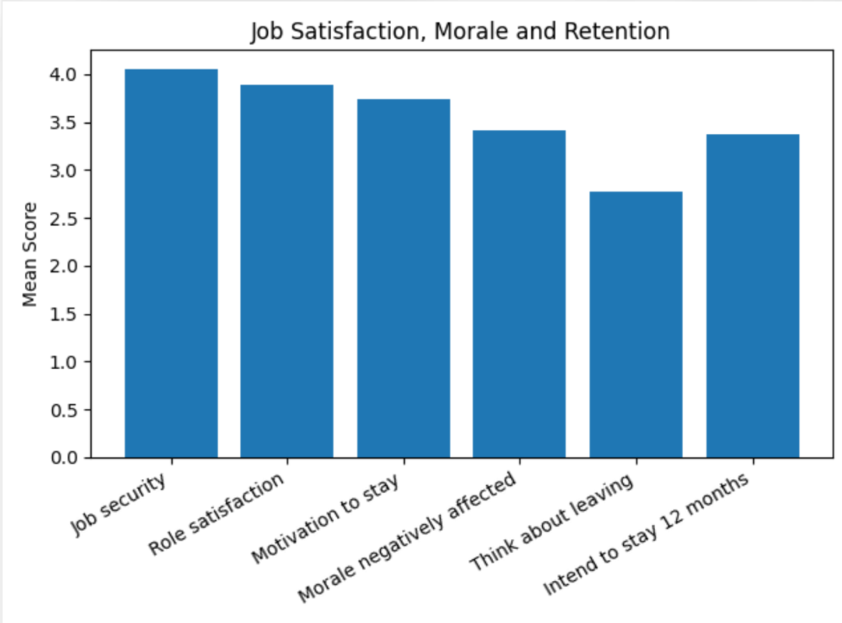

4.5 Service Performance and Organisational Impact
This section examines employee perceptions of how staff turnover and financial restructuring impact organisational performance and service delivery. The findings indicate a strong consensus among respondents regarding the importance of workforce stability for maintaining service quality and overall organisational effectiveness. The highest-rated statement in the entire survey, “Staff shortages affect service quality,” achieved a mean score of 4.44, with all respondents either agreeing or strongly agreeing. This highlights a clear recognition of the direct relationship between staffing levels and service outcomes, which aligns with evidence linking employee satisfaction, turnover and organisational effectiveness (Koys, 2001). Similarly, the statement “Employee turnover increases pressure on remaining staff” recorded a high mean score of 4.32, while “Retaining experienced employees is important for service delivery” produced a mean of 4.26, further reinforcing the importance of employee retention.
Respondents also acknowledged the broader organisational impact of financial restructuring. The statement “Financial restructuring affects organisational performance” recorded a mean score of 4.16, indicating strong agreement that such changes influence operational effectiveness. Additionally, “Leadership and HR support can reduce negative impacts of turnover” achieved a mean score of 4.32, suggesting that organisational support mechanisms are viewed as critical in mitigating the challenges associated with workforce instability.
The overall service performance composite mean of 4.29, the highest among all sections, demonstrates that respondents strongly recognise the link between employee retention and organisational performance. These findings support the view that retention is not solely an HR concern but a key operational priority, as workforce stability plays a crucial role in sustaining service quality and organisational success.
As shown in Table 4.6, staff shortages affecting service quality received the highest mean score, followed by the impact of employee turnover on remaining staff. This is further illustrated in Figure 4.7, which highlights the consistently high agreement across all service performance indicators.

Table 4.6: Service Performance and Organisational Impact
Survey Statement | Mean Score | Interpretation
Staff shortages affect service quality | 4.44 | Very high – strongest agreement
Employee turnover increases pressure on staff | 4.32 | Very high
Retaining experienced employees is important | 4.26 | Very positive
Financial restructuring affects organisational performance | 4.16 | Strong agreement
Leadership & HR reduce negative impacts of turnover | 4.32 | Very positive
Overall Service Performance Composite Mean | 4.29 | Highest across all sections

Figure 4.7: Service Performance and Organisational Impact
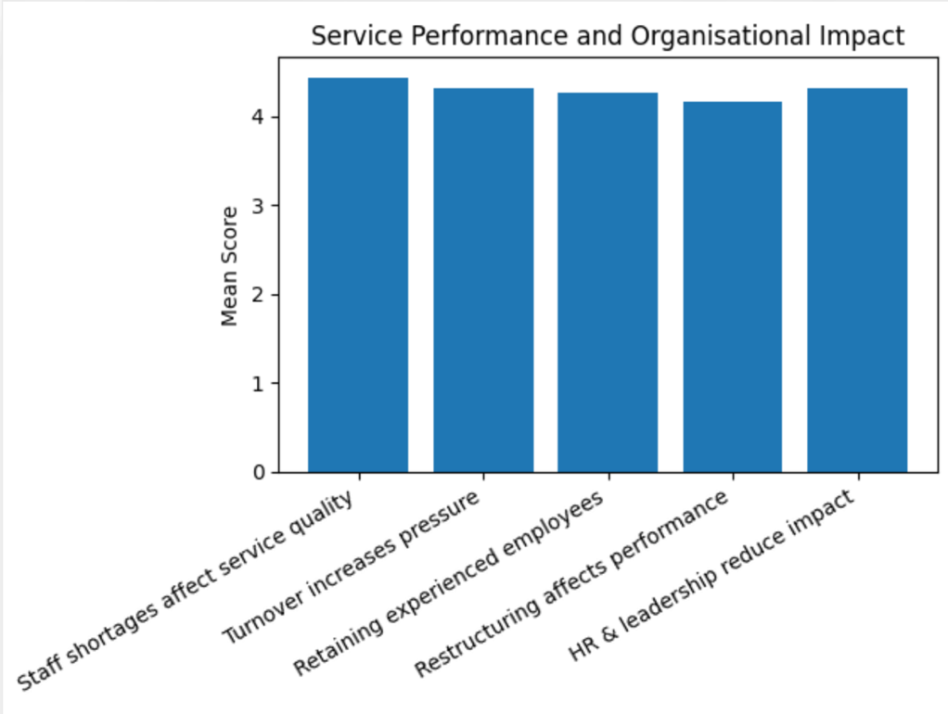

4.6 Correlation Analysis
This section examines the relationships between the key variables through correlation analysis, using composite scores for leadership, HR practices, retention, and service performance. The results reveal several meaningful associations between these variables. A strong positive correlation was identified between leadership and HR practices (r = 0.80), indicating that respondents who perceived leadership positively were also more likely to report favourable views of HR support. This suggests a close alignment between leadership effectiveness and HR practices within the organisation.
In addition, moderate positive relationships were found between leadership and retention (r = 0.54), and between HR practices and retention (r = 0.60). These findings indicate that more positive perceptions of leadership and stronger HR support are associated with improved employee retention outcomes, including higher morale, greater job satisfaction, and stronger intentions to remain with the organisation. This reinforces the importance of both leadership and HR in supporting employees during periods of organisational change.
In contrast, the relationship between service performance and the other variables was relatively weak. This may be explained by the limited variability in responses, as most participants strongly agreed that staffing issues affect service delivery. The small sample size may also have reduced the strength of observable correlations.
Overall, the results support the argument that leadership and HR practices are closely linked and play a significant role in influencing employee retention, particularly in the context of financial restructuring.
As shown in Table 4.7, there is a strong positive correlation between leadership and HR practices, alongside moderate relationships between both variables and retention. In contrast, service performance shows weak correlations with the other variables, likely due to limited variation in responses.

Table 4.7: Correlation Matrix of Key Study Variables
Variable | Leadership | HR Practices | Retention | Service Performance
Leadership | 1.00 | 0.80 | 0.54 | Weak
HR Practices | 0.80 | 1.00 | 0.60 | Weak
Retention | 0.54 | 0.60 | 1.00 | Weak
Service Performance | Weak | Weak | Weak | 1.00

4.7 Discussion of Findings in Relation to Research Questions and Literature
This section discusses the key findings in relation to the research questions, providing a clearer understanding of how financial restructuring has influenced employee experiences and organisational outcomes. The first research question explored how financial pressures and restructuring measures affected employee morale and retention. The findings indicate that restructuring had a noticeable negative impact on morale, with a majority of respondents agreeing that their morale had declined. Despite this, many employees continued to report relatively high levels of job satisfaction and a sense of employment security. However, retention intentions appeared more uncertain, suggesting that while employees may feel stable in the short term, their long-term commitment to the organisation may be affected.
The second research question examined the relationship between employee turnover and service performance. The results strongly support this relationship, as respondents overwhelmingly agreed that staff shortages reduce service quality, increase workload pressure on remaining employees, and negatively affect overall organisational performance. This highlights the operational consequences of turnover and reinforces its significance beyond HR considerations.
The third research question focused on identifying the most effective HR practices for supporting employee retention. The findings suggest that flexible working arrangements, opportunities for employees to express concerns, and the provision of clear information regarding role changes were the most positively perceived forms of support. These practices appear to play a key role in maintaining employee wellbeing and engagement during periods of change.
Finally, the fourth research question considered leadership strategies to reduce staff turnover while maintaining service performance. The results indicate that clear communication, fairness in decision-making, consistent support during uncertainty, and strong collaboration with HR are critical factors in enhancing retention and minimising the negative organisational impact of turnover.

4.8 Conclusion
This chapter has presented and analysed the findings derived from the questionnaire survey, using both descriptive statistics and correlation analysis to explore key relationships between variables. Overall, the results indicate that leadership and HR practices were generally perceived in a positive light, suggesting that the organisation has established supportive structures during a period of financial restructuring. However, despite these positive perceptions, the findings also reveal that restructuring had a noticeable negative impact on employee morale. In addition, some uncertainty remained regarding long-term employee retention, indicating that positive organisational support does not fully offset the challenges associated with change.
One of the most significant findings of this study is the strong relationship between staff turnover and service performance. Respondents consistently recognised that workforce instability increases pressure on remaining employees and negatively affects service quality. This highlights the operational importance of employee retention and suggests that turnover should be viewed not only as an HR concern but also as a critical factor influencing organisational effectiveness.
Furthermore, the results demonstrate that positive perceptions of leadership and effective HR practices are associated with more favourable retention outcomes. In particular, clear communication, fairness in decision-making, and supportive HR policies appear to play an important role in helping employees cope with organisational change.
In summary, this chapter provides a comprehensive overview of the study’s key findings and establishes a foundation for further analysis. The following chapter will critically discuss these results in relation to existing literature and the theoretical framework and will present practical recommendations to improve employee retention and organisational performance.

CHAPTER 5: DISCUSSION, CONCLUSION AND RECOMMENDATIONS

5.0 Introduction
This chapter critically discusses the findings of the study in relation to the research objectives, research questions, and existing literature. The purpose of this chapter is to move beyond the presentation of results and provide a deeper interpretation of the data, highlighting how the findings contribute to current academic understanding and practical applications. In doing so, the chapter examines how financial restructuring influences employee morale, job satisfaction, and retention, particularly within the context of the RSPCA and the wider charity sector.
The discussion draws on relevant theoretical frameworks, including Social Exchange Theory, Herzberg’s Two-Factor Theory, Transformational Leadership Theory, and Organisational Change Theory, to explain the relationships identified in Chapter 4. These theories provide a foundation for understanding how leadership practices, HR support, and organisational change processes influence employee attitudes and behaviours (Cropanzano and Mitchell, 2005; Herzberg, 1959; Bass and Riggio, 2006; Burnes, 2017). By linking the findings to these frameworks, this chapter aims to demonstrate how both external organisational factors and internal motivational drivers shape employee retention outcomes.
In addition, this chapter identifies key implications for organisational practice, particularly in managing employee retention during periods of financial uncertainty and restructuring. It also acknowledges the limitations of the study, including sample size and scope, which may affect the generalisability of the findings. Finally, recommendations are provided for both organisational practice and future research, with the aim of supporting improved employee retention strategies and enhancing organisational effectiveness in similar contexts.

5.1 Discussion of Key Findings
The findings of this study demonstrate that leadership practices, HR support, and financial restructuring play a significant role in influencing employee morale and retention. These results provide important insights into how organisational factors interact to shape employee experiences during periods of change.
Firstly, the results showed that leadership communication was generally perceived positively, particularly in relation to clarity and fairness in decision-making. This supports Transformational Leadership Theory, which emphasises the role of leaders in inspiring and motivating employees through effective communication and support (Bernard M. Bass and Ronald E. Riggio, 2006). However, slightly lower scores for transparency and day-to-day managerial support suggest that uncertainty during restructuring can still negatively affect employee perceptions. This aligns with Organisational Change Theory, which highlights that poorly managed change can lead to stress, reduced trust, and resistance among employees (Bernard Burnes, 2017).
Secondly, HR practices were found to play a crucial role in supporting employees during restructuring. Flexible working arrangements and opportunities to share concerns were particularly valued by respondents. These findings are consistent with Social Exchange Theory, which suggests that employees who perceive strong organisational support are more likely to demonstrate commitment and loyalty (Cropanzano and Mitchell, 2005). However, the finding that some employees did not fully feel valued indicates that HR practices may require further development to enhance employee engagement and satisfaction.
Thirdly, the study found that financial restructuring had a negative impact on employee morale. A considerable proportion of respondents reported reduced morale, despite relatively positive levels of job satisfaction and motivation. This finding supports Herzberg’s Two-Factor Theory, which suggests that factors such as job security and organisational stability function as hygiene factors, where their absence can lead to dissatisfaction (Frederick Herzberg, 1959).
Finally, the strongest finding in the study was the relationship between employee retention and service performance. Respondents strongly agreed that staff shortages and turnover negatively affect service quality and increase pressure on remaining employees. This supports previous research, which indicates that high employee turnover is associated with reduced organisational performance and service effectiveness (Koys, 2001; Hancock et al., 2015).

5.2 Implications for Practice
The findings of this study have several important implications for organisations such as the RSPCA and other charities facing financial pressures.
Firstly, leadership should focus on maintaining clear, transparent and consistent communication during periods of organisational change. This can help reduce uncertainty and improve employee trust.
Secondly, organisations should strengthen HR practices that support employee wellbeing, particularly flexible working arrangements and opportunities for employee feedback. These practices can improve morale and increase retention.
Thirdly, organisations should recognise the importance of employee retention for maintaining service quality. Investing in employee support and engagement strategies can help reduce turnover and improve operational performance.

5.3 Limitations of the Study
This study has several limitations that should be acknowledged when interpreting the findings. Firstly, the sample size was relatively small, with only 19 valid responses included in the analysis. While this is acceptable for a small-scale study, it limits the generalisability of the results to the wider population. Small sample sizes can reduce statistical reliability and make it more difficult to identify broader patterns or trends (Saunders et al., 2019).
Secondly, the study utilised a convenience sampling method, where participants were selected based on accessibility. This approach may introduce sampling bias, as it does not ensure that all individuals within the target population have an equal chance of being selected (Bryman, 2016). As a result, the sample may not fully represent the diversity of employees within the RSPCA.
Thirdly, due to limited access to RSPCA employees, the study included participants from the wider charity and animal welfare sector, including volunteers. Although this broadens the perspective of the study, it may reduce the specificity of the findings and limit their direct applicability to the RSPCA.
In addition, the study relied on self-reported data, which may be subject to personal bias, social desirability bias, or inaccuracies in perception (Podsakoff et al., 2003). Some responses were also incomplete or invalid and had to be excluded, further reducing the usable dataset.
Finally, the study adopted a quantitative research approach, which, while useful for identifying patterns, limits the depth of understanding of employee experiences. A qualitative approach, such as interviews or focus groups, could provide richer, more detailed insights into employee perceptions and behaviours.
An additional limitation relates to the data collection process and response rate. The survey had to remain open for a longer period than initially planned due to a low response rate in the early stages. Despite this extension, only 19 valid responses were obtained from approximately 50 potential participants. This relatively low response rate may introduce non-response bias, as the views of those who chose not to participate may differ from those who did. Consequently, the findings may not fully represent the wider population, which further limits the generalisability and reliability of the results.

5.4 Recommendations for Future Research
Future research could build on the findings of this study in several important ways to enhance understanding of employee retention within the charity sector. Firstly, future studies should aim to utilise a larger sample size in order to improve the reliability and generalisability of the findings. A broader sample would allow for more robust statistical analysis and enable researchers to identify clearer patterns across different organisational contexts (Saunders et al., 2019). In addition, collecting data from multiple charity organisations would provide a more comprehensive view of how financial restructuring impacts employees across the sector.
Secondly, future research could focus specifically on the RSPCA or similar organisations to provide more detailed, organisation-specific insights. A case study approach may be particularly valuable in understanding the unique challenges faced by animal welfare organisations, including resource constraints and emotional demands placed on employees.
Thirdly, adopting a mixed-methods approach would significantly strengthen future research. Combining quantitative surveys with qualitative methods, such as interviews or focus groups, would allow researchers to gain a deeper understanding of employee experiences and perceptions during restructuring (Creswell, 2014). This approach would provide both measurable data and rich, contextual insights.
Finally, future studies could explore additional variables that were not fully addressed in this research. Factors such as employee burnout, emotional labour, and different leadership styles may offer further explanation of employee behaviour and retention within the charity sector. These variables are particularly relevant in emotionally demanding environments and may provide a more holistic understanding of workforce dynamics.

5.5 Conclusion
This study examined the relationship between leadership practices, HR strategies, and employee retention during a period of financial restructuring, using the RSPCA as a case study. The findings provide valuable insights into how organisational practices influence employee experiences, particularly in relation to morale, job satisfaction, and retention within the charity sector.
The results indicate that both leadership and HR practices play a significant role in supporting employees during organisational change. In particular, clear communication, fairness in decision-making, and supportive HR initiatives such as flexible working arrangements were identified as key factors in maintaining employee engagement. These findings are consistent with Transformational Leadership Theory, which emphasises the importance of leadership behaviours in enhancing employee motivation and commitment (Bernard M. Bass and Ronald E. Riggio, 2006), as well as Social Exchange Theory, which suggests that employees reciprocate organisational support with increased loyalty and retention (Cropanzano and Mitchell, 2005).
However, despite these positive perceptions, financial restructuring was found to have a negative impact on employee morale. This supports Herzberg’s Two-Factor Theory, which highlights that the absence of key hygiene factors, such as job security, can lead to dissatisfaction (Frederick Herzberg, 1959). In addition, the findings align with Organisational Change Theory, which suggests that poorly managed change can increase uncertainty and reduce employee trust (Bernard Burnes, 2017).
Furthermore, the study highlights a strong relationship between employee retention and service performance. High levels of turnover were perceived to negatively affect service quality and increase pressure on remaining staff, supporting existing research that links workforce stability to organisational effectiveness (Hancock et al., 2015).
Overall, this research contributes to a deeper understanding of employee retention within the charity sector, particularly in the context of financial restructuring within the RSPCA. It demonstrates the importance of integrating effective leadership practices with supportive HR strategies to minimise the negative impact of organisational change. The findings highlight the need for organisations to prioritise employee wellbeing and stability in order to sustain both workforce commitment and service performance, particularly during periods of financial pressure.

REFERENCES
Allen, D.G., Bryant, P.C. and Vardaman, J.M. (2010) ‘Retaining talent: Replacing misconceptions with evidence-based strategies’, Academy of Management Perspectives, 24(2), pp. 48–64. doi:10.5465/amp.24.2.48.
Appelbaum, E., Bailey, T., Berg, P. and Kalleberg, A.L. (2000) Manufacturing Advantage: Why High-Performance Work Systems Pay Off. Ithaca, NY: Cornell University Press.
Armenakis, A.A. and Bedeian, A.G. (1999) ‘Organizational change: A review of theory and research in the 1990s’, Journal of Management, 25(3), pp. 293–315.
Armstrong, M. (2020) Armstrong’s Handbook of Human Resource Management Practice. 15th edn. London: Kogan Page.
Bakker, A.B. and Demerouti, E. (2007) ‘The Job Demands-Resources model: state of the art’, Journal of Managerial Psychology, 22(3), pp. 309–328. doi:10.1108/02683940710733115.
Bass, B.M. and Riggio, R.E. (2006) Transformational Leadership. 2nd edn. Mahwah, NJ: Lawrence Erlbaum Associates.
Bell, E., Bryman, A. and Harley, B. (2019) Business Research Methods. 5th edn. Oxford: Oxford University Press.
British Educational Research Association (BERA) (2018) Ethical Guidelines for Educational Research. 4th edn. London: BERA. Available at: https://www.bera.ac.uk/publication/ethical-guidelines-for-educational-research-2018-online (Accessed: 24 April 2026).
Bryman, A. (2016) Social Research Methods. 5th edn. Oxford: Oxford University Press.
Bryman, A. and Bell, E. (2015) Business Research Methods. 3rd edn. Oxford: Oxford University Press.
Burnes, B. (2017) Managing Change. 7th edn. Harlow: Pearson Education.
Cameron, K.S. (1994) ‘Strategies for successful organizational downsizing’, Human Resource Management, 33(2), pp. 189–211.
Chartered Institute of Personnel and Development (CIPD) (2025) Retention, turnover and employee engagement. Available at: https://www.cipd.co.uk (Accessed: 10 March 2026).
Civil Society (2024) Charity sector facing financial challenges and restructuring pressures. Available at: https://www.civilsociety.co.uk (Accessed: 10 March 2026).
Creswell, J.W. (2014) Research Design: Qualitative, Quantitative, and Mixed Methods Approaches. 4th edn. Thousand Oaks, CA: Sage.
Creswell, J.W. and Creswell, J.D. (2018) Research Design: Qualitative, Quantitative, and Mixed Methods Approaches. 5th edn. London: Sage.
Cropanzano, R. and Mitchell, M.S. (2005) ‘Social exchange theory: An interdisciplinary review’, Journal of Management, 31(6), pp. 874–900.
Eisenberger, R., Huntington, R., Hutchison, S. and Sowa, D. (1986) ‘Perceived organizational support’, Journal of Applied Psychology, 71(3), pp. 500–507. doi:10.1037/0021-9010.71.3.500.
Etikan, I., Musa, S.A. and Alkassim, R.S. (2016) ‘Comparison of convenience sampling and purposive sampling’, American Journal of Theoretical and Applied Statistics, 5(1), pp. 1–4.
Hancock, J.I., Allen, D.G., Bosco, F.A., McDaniel, K.R. and Pierce, C.A. (2015) ‘Meta-analytic review of employee turnover as a predictor of firm performance’, Journal of Management, 39(3), pp. 573–603.
Harle, J. (2024) Workforce challenges in the charity sector. Available at: https://www.civilsociety.co.uk (Accessed: 10 March 2026).
Herzberg, F. (1959) The Motivation to Work. New York: John Wiley & Sons.
Holtom, B.C., Mitchell, T.R., Lee, T.W. and Eberly, M.B. (2008) ‘Turnover and retention research: A glance at the past, a closer review of the present, and a venture into the future’, The Academy of Management Annals, 2(1), pp. 231–274. doi:10.1080/19416520802211552.
Hom, P.W., Lee, T.W., Shaw, J.D. and Hausknecht, J.P. (2017) ‘One hundred years of employee turnover theory and research’, Journal of Applied Psychology, 102(3), pp. 530–545.
ICO (2023) Guide to the General Data Protection Regulation (GDPR). Available at: https://ico.org.uk (Accessed: 10 March 2026).
Koys, D.J. (2001) ‘The effects of employee satisfaction, organizational citizenship behavior, and turnover on organizational effectiveness: A unit-level, longitudinal study’, Personnel Psychology, 54(1), pp. 101–114. doi:10.1111/j.1744-6570.2001.tb00087.x.
Lee, T.W. and Mitchell, T.R. (1994) ‘An alternative approach: The unfolding model of voluntary employee turnover’, Academy of Management Review, 19(1), pp. 51–89. doi:10.5465/amr.1994.9410122008.
Meyer, J.P. and Allen, N.J. (1991) ‘A three-component conceptualization of organizational commitment’, Human Resource Management Review, 1(1), pp. 61–89. doi:10.1016/1053-4822(91)90011-Z.
NCVO (2024) UK Civil Society Almanac 2024. Available at: https://www.ncvo.org.uk/news-and-insights/news-index/uk-civil-society-almanac-2024/ (Accessed: 24 April 2026).
Oreg, S., Vakola, M. and Armenakis, A. (2011) ‘Change recipients’ reactions to organizational change: A 60-year review of quantitative studies’, The Journal of Applied Behavioral Science, 47(4), pp. 461–524. doi:10.1177/0021886310396550.
Podsakoff, P.M., MacKenzie, S.B., Lee, J.Y. and Podsakoff, N.P. (2003) ‘Common method biases in behavioral research: A critical review of the literature and recommended remedies’, Journal of Applied Psychology, 88(5), pp. 879–903. doi:10.1037/0021-9010.88.5.879.
RSPCA (2024a) About the RSPCA. Available at: https://www.rspca.org.uk (Accessed: 10 March 2026).
RSPCA (2024b) Annual report and financial statements. Available at: https://www.rspca.org.uk (Accessed: 10 March 2026).
Saunders, M., Lewis, P. and Thornhill, A. (2019) Research Methods for Business Students. 8th edn. Harlow: Pearson Education.
Siyal, S., Xin, C., Umrani, W.A., Fatima, S. and Pal, D. (2021) ‘How do leaders influence innovation and creativity in employees? The mediating role of intrinsic motivation’, Administration & Society, 53(9), pp. 1337–1361.
Tyagi, N. (2021) ‘Aligning organizational culture to enhance managerial effectiveness of academic leaders’, International Journal of Educational Management, 35(7), pp. 1387–1404.
Tyagi, R. (2021) ‘The role of leadership in employee retention’, International Journal of Management Studies, 8(2), pp. 45–58.
Yin, R.K. (2018) Case Study Research and Applications: Design and Methods. 6th edn. London: Sage.

Reflective Essay Using Gibbs’ Reflective Cycle
This reflective essay uses Gibbs’ Reflective Cycle (1988) to evaluate the research process undertaken in the study, which examined the influence of leadership responses and human resource (HR) practices on employee retention and service performance during financial restructuring within the RSPCA. Gibbs’ model consists of six stages: description, feelings, evaluation, analysis, conclusion and action plan. These stages are analysed below to reflect on the research experience, identify strengths and limitations, and consider how future research practice could be improved.
Description
The aim of this research was to explore how leadership communication and human resource (HR) practices influence employee morale, retention and service performance during periods of financial restructuring within the RSPCA. Employee retention is widely recognised as a critical organisational issue because high turnover can negatively affect organisational performance, employee continuity and service delivery (Hom et al., 2017).
To address this aim, the study adopted a positivist research philosophy and a deductive approach. A quantitative method was used through an online questionnaire, which enabled structured data to be collected from participants associated with the RSPCA. The data were analysed using descriptive statistics and correlation analysis. The findings indicated that leadership and HR practices were generally perceived positively; however, financial restructuring had a negative impact on employee morale, and some uncertainty remained regarding long-term retention. These findings highlight the challenges organisations face in maintaining workforce stability during periods of organisational change (Burnes, 2017).
Feelings
At the beginning of the research process, I felt confident in selecting a topic that was both relevant and significant, particularly within the charity sector where financial pressures are increasing. I believed the topic was important because employee retention can affect both organisational stability and service quality. However, during the data collection stage, I experienced uncertainty and concern due to the low response rate, as only 19 valid responses were obtained. This made me question whether the findings would be reliable enough to support meaningful conclusions.
Despite these concerns, I felt more confident during the analysis stage because clear patterns began to emerge from the questionnaire responses. In particular, the findings showed a strong perceived relationship between employee retention, staffing pressures and service performance, which is consistent with research showing that employee turnover can negatively affect organisational performance (Hancock et al., 2015). This gave me greater confidence that the study was still able to produce useful insights, even though the sample size was smaller than initially expected.
Evaluation
A key strength of this research was the alignment between the research aim, methodology and theoretical framework. The use of established theories, including Social Exchange Theory, Herzberg’s Two-Factor Theory, Transformational Leadership Theory and Organisational Change Theory, provided a strong foundation for interpreting the findings. In addition, the quantitative approach allowed for structured data collection and supported statistical analysis, which helped improve consistency and reliability (Creswell and Creswell, 2018).
However, there were also limitations. The use of convenience sampling restricted the diversity of the sample, and the small sample size limited the generalisability of the findings (Saunders, Lewis and Thornhill, 2019). Furthermore, the reliance on quantitative data meant that deeper insights into employee experiences were not fully explored. A qualitative approach, such as interviews or focus groups, could have provided a more detailed understanding of employee perceptions during restructuring.
Analysis
The findings of this study were consistent with existing literature on employee retention and organisational change. The positive perception of leadership within the study supports Transformational Leadership Theory, which suggests that effective communication, support and motivation from leaders can enhance employee commitment and engagement (Bass and Riggio, 2006). This was reflected in the findings, where respondents generally viewed leadership communication and fairness positively.
In addition, the results reflected Social Exchange Theory, which proposes that employees who perceive strong organisational support are more likely to reciprocate with loyalty and commitment (Cropanzano and Mitchell, 2005). This was evident in the study, where positive perceptions of leadership and HR practices were associated with improved retention outcomes. HR practices such as flexible working arrangements and opportunities to share concerns appeared particularly important in supporting employees during restructuring.
However, the findings also showed that financial restructuring negatively affected employee morale. This supports Herzberg’s Two-Factor Theory, which identifies job security and working conditions as hygiene factors; when these are threatened, employee dissatisfaction can increase (Herzberg, 1959). Furthermore, Organisational Change Theory explains that restructuring can create uncertainty, stress and reduced trust among employees, even where leadership support is present (Burnes, 2017). Therefore, the analysis suggests that while leadership and HR practices are important, wider organisational and financial pressures can still significantly influence morale and retention.
Conclusion
Overall, the research process provided valuable insight into both the topic of employee retention and the practical challenges of conducting organisational research. The study achieved its main objectives by examining the relationship between leadership responses, HR practices, employee retention and service performance during financial restructuring. It also highlighted the importance of clear communication, employee support and effective HR practices during periods of organisational change.
The reflective process also helped me recognise the limitations of my research design. Although the quantitative questionnaire produced useful measurable data, the small sample size and lack of qualitative responses limited the depth of the findings. The experience emphasised the importance of planning data collection carefully, allowing sufficient time for participant recruitment and considering alternative methods where access to respondents is limited.
Action Plan
In future research, I would improve participant recruitment strategies to increase the sample size and enhance reliability. This could involve contacting participants earlier, using multiple communication channels and allowing a longer response period. I would also consider adopting a mixed-methods approach by combining quantitative surveys with qualitative interviews. This would allow statistical patterns to be supported by richer explanations of employee experiences (Creswell and Creswell, 2018).
Additionally, I would allocate more time for piloting the questionnaire, collecting responses and following up with participants. I would also seek access to a wider range of employees, including different departments and role types, to improve representativeness. These improvements would strengthen the validity, reliability and practical value of future research.

References
Bass, B.M. and Riggio, R.E. (2006) Transformational Leadership. 2nd edn. Mahwah, NJ: Lawrence Erlbaum Associates.
Burnes, B. (2017) Managing Change. 7th edn. Harlow: Pearson.
Creswell, J.W. and Creswell, J.D. (2018) Research Design: Qualitative, Quantitative, and Mixed Methods Approaches. 5th edn. Thousand Oaks, CA: Sage.
Cropanzano, R. and Mitchell, M.S. (2005) ‘Social exchange theory: An interdisciplinary review’, Journal of Management, 31(6), pp. 874-900.
Gibbs, G. (1988) Learning by Doing: A Guide to Teaching and Learning Methods. Oxford: Oxford Polytechnic.
Hancock, J.I., Allen, D.G., Bosco, F.A., McDaniel, K.R. and Pierce, C.A. (2015) ‘Meta-analytic review of employee turnover as a predictor of firm performance’, Journal of Management, 39(3), pp. 573-603.
Herzberg, F. (1959) The Motivation to Work. 2nd edn. New York: Wiley.
Hom, P.W., Lee, T.W., Shaw, J.D. and Hausknecht, J.P. (2017) ‘One hundred years of employee turnover theory and research’, Journal of Applied Psychology, 102(3), pp. 530-545.
Saunders, M., Lewis, P. and Thornhill, A. (2019) Research Methods for Business Students. 8th edn. Harlow: Pearson

APPENDIX
Ethical form
APPLICATION FOR ETHICAL APPROVAL
RESEARCH STUDENTS
This form is to be completed by the student within SIX months for full-time students and TWELVE months for part time students, after the commencement of the research degree or following progression to Part Two of your course.
Once complete, submit this form via the MyTSD Doctoral College Portal at (https://mytsd.uwtsd.ac.uk).
This document is also available in Welsh.
RESEARCH STAFF ONLY
All communications relating to this application during its processing must be in writing and emailed to pgresearch@uwtsd.ac.uk , with the title ‘Ethical Approval’ followed by your name.
STUDENTS ON UNDERGRADUATE OR TAUGHT MASTERS PROGRAMMES should submit this form
(and receive the outcome) via systems explained to you by the supervisor/module leader.
In order for research to result in benefit and minimise risk of harm, it must be conducted ethically. A researcher may not be covered by the University’s insurance if ethical approval has not been obtained prior to commencement.
The University follows the OECD Frascati manual definition of research activity: “creative work undertaken on a systematic basis in order to increase the stock of knowledge, including knowledge of man, culture and society, and the use of this stock of knowledge to devise new applications”. As such this covers activities undertaken by members of staff, postgraduate research students, and both taught postgraduate and undergraduate students working on dissertations/projects.
The individual undertaking the research activity is known as the “principal researcher”.
Ethical approval is not required for routine audits, performance reviews, quality assurance studies, testing within normal educational requirements, and literary or artistic criticism.
Please read the notes for guidance before completing ALL sections of the form.
This form must be completed and approved prior to undertaking any research activity. Please see
Checklist for details of process for different categories of application.
SECTION A: About You (Principal Researcher)
1 | Full Name: |  | Beata Barbara Maciazek
2 | Tick all boxes that apply: |  | Member of staff: | ☐ | Honorary research fellow: | ☐
 | Undergraduate Student | ☒ | Taught Postgraduate Student | ☐ | Postgraduate  Research Student | ☐
3 | Institute/Academic Discipline/Centre: |  | University of Wales Trinity Saint David
4 | Campus: |  | London
5 | E-mail address: |  | 2244700@student.uwtsd.ac.com
6 | Contact Telephone Number: |  | 07889656280
 | For students:
7 | Student Number: |  | 2244700
8 | Programme of Study: |  | BA Leadership and Management Skills for the Workplace
9 | Director of Studies/Supervisor: |  | Olusoyl Richard Ashaye
SECTION B: Approval for Research Activity
1 | Has the research activity received approval in principle? (please check the Guidance Notes as to the appropriate approval process for different levels of research by different categories of individual) |  | YES | ☐ | NO | ☒
 |  |  |  |  | Date
2 | If Yes, please indicate source of approval (and date where known): Approval in principle must be obtained from the relevant source prior to seeking ethical approval | Research Degrees Committee |  | ☐
2 |  | Institute Research Committee |  | ☐
2 |  | Other (write in) |  | ☐
SECTION C: Internal and External Ethical Guidance Materials
 | Please list the core ethical guidance documents that have been referred to during the completion of this form (including any discipline-specific codes of research ethics, location-specific codes of research ethics, and also any specific ethical guidance relating to the proposed methodology). Please tick to confirm that your research proposal adheres to these codes and guidelines. You may add rows to this table if needed.
1 | UWTSD Research Ethics & Integrity Code of Practice | ☒
2 | UWTSD Research Data Management Policy | ☒
3 | [List any other relevant documents here] | ☐
SECTION D: External Collaborative Research Activity
If there are external collaborators then you should gain consent from the contact persons to share their personal data with the university. If there are no external collaborators then leave this section blank and continue to section E.
1 | Institution
2 | Contact person name
3 | Contact person e-mail address
4 | Is your research externally funded? |  | YES | ☐ | NO | ☐
5 | Are you in receipt of a KESS scholarship? |  | YES | ☐ | NO | ☐
6 | Are you specifically employed to undertake this research in either a paid or voluntary capacity? | Voluntary | YES | ☐ | NO | ☐
7 |  | Employed | YES | ☐ | NO | ☐
8 | Is the research being undertaken within an existing UWTSD Athrofa Professional Learning Partnership (APLP)? | If YES then the  permission question below does not need to be answered. | YES | ☐ | NO | ☐
9 | Has permission to undertake the research has been provided by the partner organisation? | (If YES attach copy) If NO the application cannot continue | YES | ☐ | NO | ☒
Where research activity is carried out in collaboration with an external organisation
10 | Does this organisation have its own ethics approval system? | YES | ☐ | NO | ☒
 | If Yes, please attach a copy of any final approval (or interim approval) from the organisation (this may be a copy of an email if appropriate).
SECTION E: Details of Research Activity
1 | Indicative title: | Employee retention and leadership style during financial restructuring: A case study of the RSPCA
2 | Proposed start date: | 05/04/2026 | Proposed end date: | 12/04/2026
This research examines how leadership responses and human resource (HR) practices influence employee retention during financial restructuring, using the
Royal Society for the Prevention of Cruelty to Animals (RSPCA) as a case study. Many charities face financial pressures, increasing service demand, and workforce challenges, making employee morale and retention critical for maintaining service delivery.
The study explores how leadership communication, organisational support, and HR practices affect e mployee’s willingness to remain in their roles during organisational change.
The research question is:
1.How have financial pressures and restructuring measures at the RSPCA affected employee morale and retention?
2.What relationship exists between employee turnover and service performance within the organisation?
3.Which HR practices are perceived by employees as most effective for supporting retention?
4.What strategies can RSPCA leadership adopt to reduce staff turnover while maintaining service performance?
The aim is to investigate how leadership and HR strategies can support staff retention during financial pressure and restructuring.
The objectives of this study are to explore employee perceptions of leadership communication and organisational support during restructuring, identify HR practices such as flexible working and effective communication that support employee retention, and examine whether employee retention influences perceived frontline service performance.
Existing research shows that retention is influenced by job satisfaction, organisational commitment, leadership style, and supportive HR practices. However, limited research focuses on these issues in mission-driven charities, particularly in the animal welfare sector.
This study aims to contribute to this area and provide insights to help organisations like the RSPCA b etter support employees during financial challenges.
3 | Purpose of Research Activity

 | The purpose of this research is to examine how leadership practices and HR strategies influence employee retention and staff morale during financial restructuring at the RSPCA.
4 | Research Question  The research questions guiding this study are:  1.How have financial pressures and restructuring measures at the RSPCA affected employee morale and retention?  2.What relationship exists between employee turnover and service performance within the organisation?  3.Which HR practices are perceived by employees as most effective for supporting retention?  4.What strategies can RSPCA leadership adopt to reduce staff turnover while maintaining service performance?
5 | Aims of Research Activity  To investigate the relationship between leadership communication, HR practices and employee retention during organisational restructuring.  .
6 | Objectives of Research Activity  The objectives of this research are to analyse the impact of financial restructuring on employee morale, examine how leadership communication influences employee perceptions, explore the role of human resource practices in supporting employee retention, and identify how staff turnover affects organisational performance.
Proposed methods (maximum 600 words)
Provide a summary of all the methods that may be used in the research activity, making it clear what specific techniques may be used. If methods other than those listed in this section are deemed appropriate later, additional ethical approval for those methods will be needed. You do not need to justify the methods here but should instead describe how you intend to collect the data necessary for you to complete your project.
7 | Proposed Methods.  This research will use a quantitative approach to examine employee perceptions of leadership communication, HR practices, and retention during financial restructuring. Primary data will be collected through an online questionnaire survey, supported by secondary data from academic literature and organisational reports to provide background context.  The research will follow a case study approach focusing on the  Royal Society for the Prevention of Cruelty to Animals (RSPCA).  However, due to possible access limitations, the survey may also include employees from similar UK charity or non-profit organisations who have experienced organisational change or financial pressure.  Data will be collected using an online questionnaire distributed through platforms such as Google Forms or Microsoft Forms.  The questionnaire will mainly include closed-ended questions, such as multiplechoice and Likert scale statements,  exploring perceptions of leadership communication, organisational support, HR practices, job security, and intention to remain in the organisation.

The study aims to collect approximately 50 responses.
Participants will be recruited through voluntary participation using convenience sampling via professional networks and online platforms.
Responses will be anonymous.
The data will be analysed using descriptive statistics, such as frequencies and percentages, and presented using charts, with analysis conducted in Excel or SPSS (or similar statistical software).
Location of research activity
Identify all locations where research activity will take place.
8 |  | Online data collection via questionnaire survey, with participants based in the UK charity sector, including the RSPCA where possible
Research activity outside of the UK
If research activity will take place overseas, you are responsible for ensuring that local ethical considerations are complied with and that the relevant permissions are sought. Specify any local guidelines (e.g. from local professional associations/learned societies/universities) that exist and whether these involve any ethical stipulations beyond those usual in the UK (provide details of any licenses or permissions required). Also specify whether there are any specific ethical issues raised by the local context in which the research activity is taking place, for example, particular cultural and/or legal sensitivities or vulnerabilities of participants. If you live in the country where you will do the research then please state this.
9 |  | N/A  (this box should expand as you type)
10 | Use of documentation not in the public domain: Are any documents NOT publicly available? |  | NO |  | ☒
10 |  |  | YES |  | ☐
11 | If Yes, please provide details here of how you will gain access to specific documentation that is not in the public domain and that this is in accordance with the current data protection law of the country in question and that of England and Wales.  (this box should expand as you type)
 | Does your research relate to one or more of the seven aims of the Wellbeing of Future Generations (Wales) Act 2015? |  |  | YES |  | NO
12 | A prosperous Wales |  |  | ☐ |  | ☒
13 | A resilient Wales |  |  | ☐ |  | ☒
14 | A healthier Wales |  |  | ☐ |  | ☒
15 | A more equal Wales |  |  | ☐ |  | ☒
16 | A Wales of cohesive communities |  |  | ☐ |  | ☒
17 | A Wales of vibrant culture and thriving Welsh language |  |  | ☐ |  | ☒
18 | A globally responsible Wales |  |  | ☐ |  | ☒
19 | If YES to any of the above, please give details:
 | (this box should expand as you type)
SECTION F: Scope of Research Activity
 | Will the research activity include: | YES | NO
1 | Use of a questionnaire or similar research instrument? | ☒ | ☐
2 | Use of interviews? | ☐ | ☒
3 | Use of focus groups? | ☐ | ☒
4 | Use of participant diaries? | ☐ | ☒
5 | Use of video or audio recording? | ☐ | ☒
6 | Use of computer-generated log files? | ☐ | ☒
7 | Participant observation with their knowledge? | ☐ | ☒
8 | Participant observation without their knowledge? | ☐ | ☒
9 | Access to personal or confidential information without the participants’ specific consent? | ☐ | ☒
10 | Administration of any questions, test stimuli, presentation that may be experienced as physically, mentally or emotionally harmful / offensive? | ☐ | ☒
11 | Performance of any acts which may cause embarrassment or affect self-esteem? | ☐ | ☒
12 | Investigation of participants involved in illegal activities? | ☐ | ☒
13 | Use of procedures that involve deception? | ☐ | ☒
14 | Administration of any substance, agent or placebo? | ☐ | ☒
15 | Working with live vertebrate animals? | ☐ | ☒
16 | Procedures that may have a negative impact on the environment? | ☐ | ☒
17 | Other primary data collection methods. Please indicate the type of data collection method(s) below. | ☐ | ☒
 | Details of any other primary data collection method:  No other primary methods will be used.  Data will be collected only via the online questionnaire.  (this box should expand as you type) | ☐ | ☒
If NO to every question, then the research activity is (ethically) low risk and may be exempt from some of the following sections (please refer to Guidance Notes).
If YES to any question, then no research activity should be undertaken until full ethical approval has been obtained.
SECTION G: Intended Participants
If there are no participants then do not complete this section, but go directly to section H.

 |  | Who are the intended participants: |  |  |  | YES |  | NO
1 |  | Students or staff at the University? |  |  |  | ☐ |  | ☒
2 |  | Adults (over the age of 18 and competent to give consent)? |  |  |  | ☒ |  | ☐
3 |  | Vulnerable adults? |  |  |  | ☐ |  | ☒
4 |  | Children and Young People under the age of 18? (Consent from Parent, Carer or Guardian will be required) |  |  |  | ☐ |  | ☒
5 |  | Prisoners? |  |  |  | ☐ |  | ☒
6 |  | Young offenders? |  |  |  | ☐ |  | ☒
7 |  | Those who could be considered to have a particularly dependent relationship with the investigator or a gatekeeper? |  |  |  | ☐ |  | ☒
8 |  | People engaged in illegal activities? |  |  |  | ☐ |  | ☒
9 |  | Others. Please indicate the participants below, and specifically any group who may be unable to give consent. |  |  |  | ☐ |  | ☒
 |  | Details of any other participant groups:  (this box should expand as you type) |  |  |  |  |  | ☒
Participant numbers and source
Provide an estimate of the expected number of participants. How will you identify participants and how will they be recruited?
10 | How many participants are expected? |  | The study aims to recruit approximately 50 participants, which is sufficient to identify patterns in employee perceptions while remaining manageable for a small-scale dissertation project.
11 | Who will the participants be? |  | Participants will be current or recently employed staff at the RSPCA. If access is limited, participants may also include employees working in similar UK charity or non-profit organisations with experience in frontline, support, or management roles.
12 | How will you identify the participants? |  | Participants will be recruited using convenience sampling via personal contacts, professional networks, and online platforms. They will include employees from the RSPCA or similar UK charities with experience of organisational change. Participation will be voluntary, anonymous, and optional, with no coercion.
 |  | Information for participants: |  | YES | NO |  | N/A
13 |  | Will you describe the main research procedures to participants in advance, so that they are informed about what to expect? |  | ☒ | ☐ |  | ☐
14 |  | Will you tell participants that their participation is voluntary? |  | ☒ | ☐ |  | ☐
15 |  | Will you obtain written consent for participation? |  | ☒ | ☐ |  | ☐
16 |  | Will you explain to participants that refusal to participate in the research will not affect their treatment or education (if relevant)? |  | ☒ | ☐ |  | ☐
17 |  | If the research is observational, will you ask participants for their consent to being observed? |  | ☒ | ☐ |  | ☐
18 |  | Will you tell participants that they may withdraw from the research at any time and for any reason? |  | ☒ | ☐ |  | ☐
19 |  | With questionnaires, will you give participants the option of omitting questions they do not want to answer? |  | ☒ | ☐ |  | ☐
20 |  | Will you tell participants that their data will be treated with full confidentiality and that, if published, it will not be identifiable as theirs? |  | ☒ | ☐ |  | ☐
21 |  | Will you debrief participants at the end of their participation, in a way appropriate to the type of research undertaken? |  | ☒ | ☐ |  | ☐
22 |  | If NO to any of above questions, please give an explanation
 |  | (this box should expand as you type)
 |  | Information for participants: |  | YES | NO |  | N/A
24 |  | Will participants be paid? |  | ☐ | ☒ |  | ☐
25 |  | Is specialist electrical or other equipment to be used with participants? |  | ☐ | ☒ |  | ☐
26 |  | Are there any financial or other interests to the investigator or University arising from this study? |  | ☐ | ☒ |  | ☐
27 |  | Will the research activity involve deliberately misleading participants in any way, or the partial or full concealment of the specific study aims? |  | ☐ | ☒ |  | ☐
28 |  | If YES to any question, please provide full details
 |  | (this box should expand as you type)
SECTION H: Anticipated Risks
Outline any anticipated risks that may adversely affect any of the participants, the researchers and/or the University, and the steps that will be taken to address them.
If you have completed a full risk assessment (for example as required by a laboratory, or external research collaborator) you may append that to this form.
1 | Full risk assessment completed and appended? | Yes | ☒
1 | Full risk assessment completed and appended? | No | ☐
2 | Risks to participants  For example: sector-specific health & safety, emotional distress, financial disclosure, physical harm, transfer of personal data, sensitive organisational information

 | Risk to participants:  This research involves minimal risk.  Participants may feel slight emotional discomfort  when answering questions about job satisfaction, leadership, or morale during financial restructuring. There are no physical risks, and no sensitive financial or organisational data will be requested. All responses are anonymous, ensuring participants cannot be identified. | How you will mitigate the risk to participants:  Participation will be voluntary,  and participants can withdraw at any time.  No personal identifiers will be collected, and all responses will remain anonymous. The survey will focus only on perceptions of leadership,  HR practices, morale, and retention.  A participant information sheet will explain the study and contact details. Data will be stored securely in password-protected files and used only for academic research in line with GDPR.
3 | If research activity may include sensitive, embarrassing or upsetting topics (e.g. sexual activity, drug use) or issues likely to disclose information requiring further action (e.g. criminal activity), give details of the procedures to deal with these issues, including any support/advice  (e.g. helpline numbers) to be offered to participants. Note that where applicable, consent procedures should make it clear that if something potentially or actually illegal is discovered in the course of a project, it may need to be disclosed to the proper authorities
N/A
(this box should expand as you type)
4 | Risks to the investigator  For example: personal health & safety, physical harm, emotional distress, risk of accusation of harm/impropriety, conflict of interest
 | Risk to the investigator:  Risks are minimal, as data collection is remote via an online survey, eliminating physical or health risks. Minor emotional stress may occur when  reviewing responses about staff dissatisfaction or organisational challenges.  There is no risk of conflict of interest, and the research does not involve sensitive or in-person interactions with participants. | How you will mitigate the risk to the investigator:  All data will be collected remotely, avoiding physical contact or travel.  The survey will avoid overly sensitive questions. The investigator will follow university ethical guidance and consult the supervisor if needed.  Data will be stored securely and handled in line with GDPR and data protection requirements.
5 | University/institutional risks  For example: adverse publicity, financial loss, data protection

 | Risk to the University:  The risks to the university are minimal. The study is low-risk and involves anonymous online surveys. There is a small potential for adverse publicity if participants misunderstand the purpose of the research or if survey results are shared outside the academic context. There is also a minor risk related to data protection, as the university is ultimately responsible for the secure handling of research data. There is no financial risk associated with this project. |  | How you will mitigate the risk to the University:  Participants will be informed that the research is part of a university dissertation and responses  are anonymous and used only for academic purposes.  Data will be stored securely in line with GDPR and university policies.  Findings will be reported in aggregate, and the study will follow all university ethical guidelines under supervisor oversight.
6 | Environmental risks  For example: accidental spillage of pollutants, damage to local ecosystems
 | Risk to the environment:  The research presents no significant environmental risk, as data will be conducted entirely online without the use of physical materials or travel. |  | How you will mitigate the risk to environment:  This research will minimise environmental impact by collecting data through online surveys  And digital documents, avoiding paper use and physical travel.
 |  | Disclosure and Barring Service
 |  | If the research activity involves children or vulnerable adults, a Disclosure and Barring Service (DBS) certificate must be obtained before any contact with such participants. |  | YES | NO | N/A
7 |  | Does your research require you to hold a current DBS Certificate? |  | ☐ | ☒ | ☐
8 |  | If YES, please give the certificate number. If the certificate number is not available please write “Pending”; in this case any ethical approval will be subject to providing the appropriate certificate number.
1 | Feedback  What de-briefing and feedback will be provided to participants, how will this be done and when?
Participants will receive a summary of the research findings via email or online link after the study is completed. This will include key insights and recommendations. Feedback will be provided after data analysis, once the dissertation is finalised.
(this box should expand as you type)
2 | Informed consent  Describe the arrangements to inform potential participants, before providing consent, of what is involved in participating. Describe the arrangements for participants to provide full consent before data collection begins. If gaining consent in this way is inappropriate, explain how consent will be obtained and recorded in accordance with prevailing data protection legislation.
 | All participants will be given an information sheet explaining the purpose of the study, what participation involves, and their right to withdraw at any time. Consent will be obtained online before completing the survey by asking participants to tick a box confirming they agree to take part.
SECTION I: Feedback, Consent and Confidentiality
 | (this box should expand as you type)
3 | Confidentiality / Anonymity  Set out how anonymity of participants and confidentiality will be ensured in any outputs. If anonymity is not being offered, explain why this is the case.
All responses will be anonymous. No personally identifying information will be collected. Data will be stored securely on password-protected files and used only for academic purposes. Any results presented in the dissertation or publications will be in aggregate form, ensuring participants cannot be identified.
(this box should expand as you type)
 | Will data from the research activity (collected data, drafts of the thesis, or materials for publication) be stored in any of the following ways? | YES | NO
5 | Manual files (i.e. in paper form)? | ☐ | ☒
6 | University computers? | ☐ | ☒
SECTION J: Data Protection and Storage
 | Does the research activity involve personal data (as defined by the General Data Protection Regulation 2016 “GDPR” and the Data Protection Act 2018 “DPA”)? | YES | NO
1 | “Personal data” means any information relating to an identified or identifiable natural person (‘data subject’). An identifiable natural person is one who can be identified, directly or indirectly, in particular by reference to an identifier such as a name, an identification number, location data, an online identifier or to one or more factors specific to the physical, physiological, genetic, mental, economic, cultural or social identity of that natural person. Any video or audio recordings of participants is considered to be personal data. | x | ☐
 | If YES, provide a description of the data and explain why this data needs to be collected:
2 | The research will collect anonymous survey responses about participants perceptions of leadership, HR practices, and job satisfaction, which are needed to analyse factors influencing employee retention during financial restricting.
 | Does it involve special category data (as defined by the GDPR)? | YES | NO
3 | “Special category data” means sensitive personal data consisting of information as to the data subjects’ –  racial or ethnic origin,  political opinions,  (c ) religious beliefs or other beliefs of a similar nature,  membership of a trade union (within the meaning of the Trade Union and Labour  Relations (Consolidation) Act 1992),  physical or mental health or condition,  sexual life,  genetics,  biometric data (as used for ID purposes), | ☐ | x
 | If YES, provide a description of the special category data and explain why this data needs to be collected:
4 | (this box should expand as you type)

7 |  | Private company computers? | ☐ |  | ☒
8 |  | Home or other personal computers? | ☒ |  | ☐
9 |  | Laptop computers/ CDs/ Portable disk-drives/ memory sticks? | ☒ |  | ☐
10 |  | “Cloud” storage or websites? | ☒ |  | ☐
11 |  | Other – specify: | ☐ |  | ☒
12 |  | For all stored data, explain the measures in place to ensure the security of the data collected, data confidentiality, including details of backup procedures, password protection, encryption, anonymisation and pseudonymisation:
All collected survey data will be stored securely on a password-protected computer and backed up on a secure, encrypted cloud storage approved by the university. No personally identifiable information will be collected, ensuring anonymity. Any sensitive information will
be pseudonymised if necessary. Only the researcher and academic supervisor will have access to the data. Data will be retained for the duration required by university regulations and then securely deleted. All files will follow GDPR and university data protection policies to maintain confidentiality and prevent unauthorised access.
(this box should expand as you type)
 | Data Protection
 | Will the research activity involve any of the following activities: |  |  | YES |  | NO
13 | Electronic transfer of data in any form? |  |  | ☒ |  | ☐
14 | Sharing of data with others at the University outside of the immediate research team? |  |  | ☐ |  | ☒
15 | Sharing of data with other organisations? |  |  | ☐ |  | ☒
16 | Export of data outside the UK or importing of data from outside the UK? |  |  | ☐ |  | ☒
17 | Use of personal addresses, postcodes, faxes, emails or telephone numbers? |  |  | ☐ |  | ☒
18 | Publication of data that might allow identification of individuals? |  |  | ☐ |  | ☒
19 | Use of data management system? |  |  | ☐ |  | ☒
20 | Data archiving? |  |  | ☐ |  | ☒
21 | If YES to any question, please provide full details, explaining how this will be conducted in accordance with the GDPR and Data Protection Act (2018) (and any international equivalents, where appropriate):
Electronic Transfer of Data:
Researcher will use secure, encrypted methods for transferring data.
(this box should expand as you type)
22 | List all who will have access to the data generated by the research activity:
The researcher and the supervisor
(this box should expand as you type)
23 | List who will have control of, and act as custodian(s) for, data generated by the research activity:

The researcher
(this box should expand as you type)
24 | Give details of data storage arrangements, including security measures in place to protect the data, where data will be stored, how long for, and in what form. Will data be archived – if so how and if not why.
All survey data will be stored on a password-protected computer and backed up on secure, encrypted cloud storage approved by the university.
Data will be anonymous, retained only for the duration of the research, and securely deleted after analysis. Only the researcher and supervisor will have access.
Aggregate findings may be reported, but individual responses will remain confidential and anonymised. (this box should expand as you type)
25 | Please indicate if your data will be stored in the UWTSD Research Data Repository (see https://researchdata.uwtsd.ac.uk/ ). If so please explain. (Most relevant to academic staff)
No
(this box should expand as you type)
26 | Confirm that you have read the UWTSD guidance on data management (see https://www.uwtsd.ac.uk/library/research-data-management/) | YES | ☒
27 | Confirm that you are aware that you need to keep all data until after your research has completed or the end of your funding | YES | ☒

RESEARCH STUDENTS ONLY
Once complete, submit this form via the MyTSD Doctoral College Portal at (https://mytsd.uwtsd.ac.uk).
RESEARCH STAFF ONLY
SECTION K: Declaration
The information which I have provided is correct and complete to the best of my knowledge. I have attempted to identify any risks and issues related to the research activity and acknowledge my obligations and the rights of the participants.
In submitting this application I hereby confirm that I undertake to ensure that the above named research activity will meet the University’s Research Ethics and Integrity Code of Practice which is published on the website: https://www.uwtsd.ac.uk/research/research-ethics/
1 | Signature of applicant: |  | Date:  21/03/2026
For STUDENT Submissions:
2 | Director of  Studies/Supervisor: | Dr Olusoyi Richard Ashaye | Date:  25/03/2026
3 | Signature: | 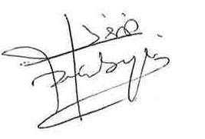
For STAFF Submissions:
4 | Academic Director/ Assistant Dean: |  | Date:
5 | Signature: |  | Date:
Checklist: Please complete the checklist below to ensure that you have completed the form according to the guidelines and attached any required documentation:
☐ | I have read the guidance notes supplied before completing the form.
☐ | I have completed ALL RELEVANT sections of the form in full.
☐ | I confirm that the research activity has received approval in principle
☐ | I have attached a copy of final/interim approval from external organisation (where appropriate)
☐ | I have attached a full risk assessment (where appropriate) ONLY TICK IF YOU HAVE ATTACHED A FULL RISK ASSESSMENT
☐ | I understand that it is my responsibility to ensure that the above named research activity will meet the University’s Research Ethics and Integrity Code of Practice.
☐ | I understand that before commencing data collection all documents aimed at respondents (including information sheets, consent forms, questionnaires, interview schedules etc.) must be confirmed by the DoS/Supervisor, module tutor or Academic Director.

All communications relating to this application during its processing must be in writing and emailed to pgresearch@uwtsd.ac.uk , with the title ‘Ethical Approval’ followed by your name.
STUDENTS ON UNDERGRADUATE OR TAUGHT MASTERS PROGRAMMES should submit this form
(and receive the outcome) via systems explained to you by the supervisor/module leader.

Collecting data – Google Form, saved in Excel

Survey Questionnaire
This questionnaire will take approximately 3–5 minutes to complete.

1.6 Research Objectives (RO)
To achieve this aim, the study will:
Analyse the financial pressures and restructuring measures experienced by the RSPCA.
Examine how leadership communication and HR practices influence employee morale and retention.
Investigate the relationship between staff turnover and service performance.
Develop recommendations to improve employee retention within the RSPCA and similar organisations.

1.7 Research Questions (RQ)
The study is guided by the following questions:
How have financial pressures and restructuring measures affected employee morale and retention at the RSPCA?
What is the relationship between employee turnover and service performance?
Which HR practices are most effective in supporting employee retention?
What strategies can leadership adopt to reduce staff turnover while maintaining service performance?

Employee Retention and Leadership Style During Financial Restructuring: A Case Study of the RSPCA
Participant Information
This questionnaire is part of an academic dissertation exploring how leadership and HR practices influence employee retention during financial restructuring. Participation is voluntary and all responses are anonymous.
Consent
Please confirm:
☐ I am 18 years or older
☐ I understand the purpose of this research
☐ I agree to participate in this questionnaire
Section A: Demographic Information
1. What is your age group?
☐ 18–24
☐ 25–34
☐ 35–44
☐ 45–54
☐ 55+
☐ Prefer not to say
2. What is your gender?
☐ Male
☐ Female
☐ Non-binary
☐ Prefer not to say
3. What is your employment status in relation to the RSPCA?
☐ Current employee ☐ Former employee ☐ Prefer not to say
4. What type of role do you work in?
☐ Animal welfare/frontline
☐ Animal care
☐ Administration/support
☐ Management
☐ Other
5. How long have you worked in the organisation?
☐ Less than 1 year
☐ 1–3 years
☐ 4–6 years
☐ 7–10 years
☐ More than 10 years
Section B: Leadership During Financial Restructuring

Please indicate your level of agreement using the following scale:
1 = Strongly Disagree | 2 = Disagree | 3 = Neutral | 4 = Agree | 5 = Strongly Agree

Leadership communicated clearly about financial challenges.

Questionnaire Mapping Matrix (Q–RQ–RO)
Q |  | RQ | RO
6 | Leadership communicated clearly about financial challenges. | RQ4 | RO2
7 | Senior management were transparent during restructuring. | RQ4 | RO2
8 | I felt leadership considered employee concerns | RQ4 | RO2
9 | Managers provided adequate support during uncertainty | RQ4 | RO2
10 | Leadership decisions during restructuring were fair | RQ4 | RO2
11 | I trust leadership to manage organisational change effectively | RQ4 | RO2
12 | HR policies helped employees cope with organisational change | RQ3 | RO2
13 | I received enough information about changes affecting my role | RQ1 | RO2
14 | Flexible working arrangements supported employee wellbeing | RQ3 | RO2
15 | The organisation provided appropriate support during restructuring | RQ1 | RO2
16 | HR practices make employees feel valued | RQ3 | RO2
17 | There were opportunities for employees to share concerns | RQ4 | RO2
18 | Financial restructuring has negatively affected my morale | RQ1 | RO2
19 | I am satisfied with my current role | RQ1 | RO2
20 | I feel motivated to continue working for the organisation | RQ1 | RO2
21 | I often think about leaving the organisation | RQ1 | RO2
22 | I intend to remain with the organisation for the next 12 months | RQ1 | RO2
23 | I feel secure in my employment | RQ1 | RO2
24 | Staff shortages affect service quality | RQ2 | RO3
25 | Employee turnover increases pressure on remaining staff | RQ2 | RO3
26 | Financial restructuring affects organisational performance | RQ2 | RO1
27 | Retaining experienced employees is important for service delivery | RQ2 | RO3
28 | Leadership and HR support can reduce negative impacts of turnover | RQ4 | RO4
29 | Would you recommend the RSPCA as a place to work | RQ1 | RO2
30 | Additional comments | All | All

6. Leadership communicated clearly about financial challenges.
7. Senior management were transparent during restructuring.
8. I felt leadership considered employee concerns.
9. Managers provided adequate support during uncertainty.
10. Leadership decisions during restructuring were fair.
11. I trust leadership to manage organisational change effectively.
Section C: HR Practices and Employee Support
12. HR policies helped employees cope with organisational change.
13. I received enough information about changes affecting my role.
14. Flexible working arrangements supported employee wellbeing.
15. The organisation provided appropriate support during restructuring.
16. HR practices make employees feel valued.
17. There were opportunities for employees to share concerns.
Section D: Job Satisfaction and Retention
18. Financial restructuring has negatively affected my morale.
19. I am satisfied with my current role.
20. I feel motivated to continue working for the organisation.
21. I often think about leaving the organisation.
22. I intend to remain with the organisation for the next 12 months.
23. I feel secure in my employment.
Section E: Service Performance and Organisational Impact
24. Staff shortages affect service quality.
25. Employee turnover increases pressure on remaining staff.
26. Financial restructuring affects organisational performance.
27. Retaining experienced employees is important for service delivery.
28. Leadership and HR support can reduce negative impacts of turnover.
Final Question
29. Would you recommend the RSPCA as a place to work to others?
☐ Yes ☐ No ☐ Not sure
30. Additional comments (optional): ______________________________

