

School of Hospitality & Tourism Management
BA International Hotel Management

BMIH5006
Sustainable Hospitality & Tourism Management

LEVEL 5

Student name: Mihaela Costache
Student ID: 2246360
Word count: 2186
Module Lead: Kathryn Roberts

Declaration
I have used Grammarly which is an AI tool to rectify any grammatical mistakes from this study. Other than this, I confirm that I have not used any AI too in the research and creation of this assignment. I confirm that I have not presented any AI generated materials as my own work. I also confirm I have copies of my draft, notes and other resources I used, which I may be asked to provide in evidence.

Executive Summary

Commercial passenger aircraft play a central role in the tourism and business segments of the hospitality business by propelling worldwide tourism and business travel. However, their environmental impact presents a growing challenge, as flights account for approximately 2.5% of global CO2 emissions, plus the emission of nitrogen oxides and water vapor at higher altitudes that enhance global warming. In addition, noise pollution, wasteful flight performance, and expansion of airport infrastructures accrue to larger-scale environmental challenges.

This paper considers the principal environmental contributions of commercial passenger air transport in the hotel industry like greenhouse gases emissions, noise pollution, ineffective business processes, and airport development. It examines green solutions like Sustainable Aviation Fuels (SAFs), noise reduction technology, fuel efficient flight plans, and effective energy-consuming airport development.

Emerging technologies, including electric and hydrogen-powered aircraft, offer promising solutions to reduce emissions. Airlines and hospitality firms are also implementing carbon offset schemes, green policies, and green initiatives to reduce their carbon footprint. While the expense of adopting green technology is still a worry, long-term benefits such as cost savings, improved brand image, and compliance with regulations make sustainability investments worthwhile.

Air transport, hotels, and policymakers all need to come together to ensure a sustainable future for the two sectors. The report concludes by proposing ways of enhancing sustainability best practices, reducing emissions, and promoting affordable green aviation initiatives.

Table of Contents
Executive Summary 2
Introduction 4
The Function of Commercial Passenger Aircraft within the Hospitality Industry 4
Environmental Damages and Commercial Passenger Aircraft in the Hospitality Industry 5
Climate Change and Greenhouse Gas Emissions 6
Damages 6
Solutions 6
Examples 7
Noise Pollution 8
Damages 8
Solutions 8
Examples 9
Environmental Impact of Flight Operations 9
Damages 9
Solutions 9
Examples 10
Environmental Impact of Airport Infrastructure 10
Damages 10
Solutions 10
Examples 11
Environmental Impact of Aircraft Design 11
Damages 11
Solutions 11
Examples 12
Cost-Effectiveness of Sustainability Measures 12
Conclusion 12
Recommendations 13
References 14

Introduction

Air transport is one of the main pillars of the modern hospitality industry, which develops international tourism and brings guests to the destinations of the world (Dileep and Kurien, 2021). However, commercial passenger aircraft, which form the backbone of the aviation industry, contribute significantly to environmental concerns. The aviation industry is estimated to be responsible for about 2.5% of the CO2 emissions globally, but its effects on global warming are worse because it emits nitrogen oxides and water vapour at high altitudes (Kim and Teter, 2023). Carbon emissions from commercial flights, noise pollution at airports, and the ecological footprint of airport infrastructure present key environmental challenges for both the airline and hospitality industries.
As more people are travelling, the hospitality industry cannot ignore its indirect environmental effects, especially through its reliance on commercial passenger aircraft. Some hotels and resorts rely on air transport for guest arrival, so sustainable air transport is important for the whole tourism sector. The consequences of such environmental impact of aviation and the possible solutions cannot be ignored in order to achieve sustainability while still preserving the economic advantages of travel and tourism.
This report aims to highlight the environmental impacts of commercial passenger aircraft in the hospitality industry, describe the main challenges, and assess the emerging sustainable solutions. It also looks at the financial aspects of implementing green technologies in commercial aviation and how this can be good for airlines, hospitality businesses, and travellers in the long run.

The Function of Commercial Passenger Aircraft within the Hospitality Industry

Commercial passenger aircraft comprise many different types of planes, including short-haul domestic flights as well as long-haul international carriers (Anwar and Asad, 2024). Major airlines like British Airways, Delta Air Lines, and Singapore Airlines fly around the world, taking tourists to hospitality companies globally. Low-cost carriers like Ryanair and Southwest Airlines have reduced air fares, facilitating more people to travel to hotels, resorts, and tourist hotspots (Bailey, 2025). The hotel industry is dependent on air transport for business travel, leisure travel, and high-end experiences, hence the need for sustainability and economic development to be balanced (Ravishankar and Christopher, 2020).

Environmental Damages and Commercial Passenger Aircraft in the Hospitality Industry

The concept of Corporate Social Responsibility (CSR) is the key in transportation for hospitality, particularly in the commercial passenger aviation sector, an industry that contributes 21.4% of the global CO₂ emissions (Tiseo, 2024a) (Fig.1). Aviation reduces its impact with SAFs, hybrid-electric aircraft, and cleaner flight, while hospitality focuses on energy efficiency, waste minimization, and sustainable transport (Farinelli, 2024). Sustainability for both sectors is key to greater environmental goals.
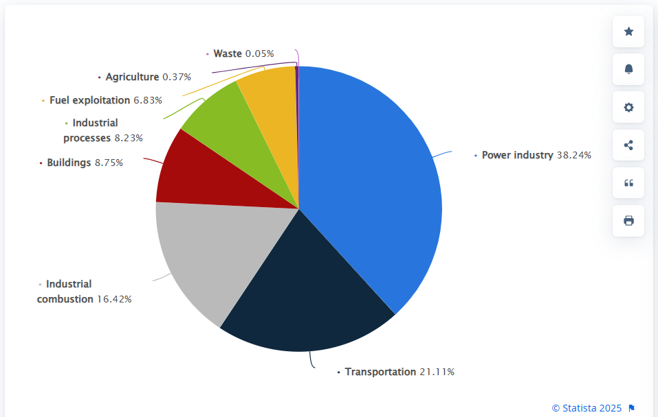
Fig. 1 - Global distribution of CO₂ emissions 2023, by sector – Source: Tiseo, (2024a).

Climate Change and Greenhouse Gas Emissions

Damages
Commercial passenger aircraft creates significant climate change impacts and emits a large share of the world’s greenhouse gas emissions. The 2023 IEA report pointed out that aviation emits 2.5% of the total CO2 emissions according to Kim and Teter, (2023). Aircraft engines do not only emit CO2 but also other gases such as water vapour, nitrogen oxides (NOx) and particulate matter that contribute to atmospheric warming (Bergero et al., 2023). Out of these, nitrogen oxides cause the formation of ozone at high altitudes which only enhances the warming effects (Vajdová et al., 2019). Although measures have been taken to reduce carbon emissions, the projections show that emission share may increase because passenger traffic is expected to grow with a CAGR of 4.3% from 2023 to 2042 and 3.6% from 2042 to 2052 (Casinader, 2024). This trend emphasises the need for immediate and effective solutions to mitigate the environmental footprint of commercial passenger aviation.

Solutions
One of the most promising solutions to commercial aviation’s environmental challenges is the adoption of SAFs (Fig.2). These fuels are produced from renewable sources such as algae, agricultural waste and municipal solid waste and can reduce CO2 emissions by up to 80% compared to conventional fossil fuels (IATA, 2024). Swedish airline SAS has also started using SAFs in its flights and has reduced carbon emissions by 20% on some flights (CAPA, 2024). The market for SAFs is expected to grow with decreasing production costs.
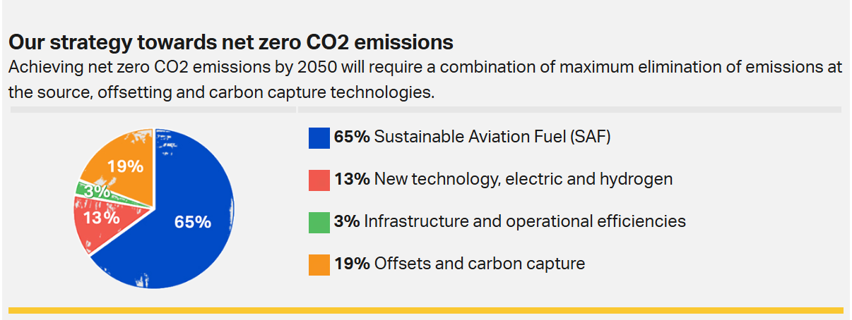
Fig.2 – Sustainable Aviation Fuel – Path to Net Zero CO2 Emissions, Source: IATA, (2024).

The hospitality industry can also help this transition by encouraging guests to fly with airlines that use sustainable aviation fuels. Eco-friendly resorts and travel agencies were sorting out the flights with sustainable fuel sources in their itineraries. Some eco-tourism agencies, including National Geographic Expeditions, now advertise travel packages that feature low-carbon flight options that are compatible with the sustainability objectives of hotels (Expeditions, 2025).

Examples
Therefore, since commercial passenger aircraft are essential for transporting guests to hotels and resorts, their environmental impact directly affects the hospitality sector. Most hotels and resorts, especially in peripheral or island destinations, depend on the air transportation of guests. Some of the big hotel chains like Marriott and Hilton have implemented carbon offset programs where guests can offset the carbon emissions of their flight when booking the accommodation (Hilton, 2025; Perkowsky, 2024). Furthermore, luxury resorts in the Maldives and Seychelles are now working with sustainable aviation programs to make passengers select flights that use SAFs (Garay, 2022; Kemp and Dłużewska, 2024).
Virgin Atlantic has pioneered SAF development, becoming the first airline to complete a transatlantic flight using 100% SAF in 2023 (Virgin Atlantic, 2025a). The airline also collaborates with hospitality businesses through its Responsible Supplier Policy, ensuring ethical sourcing and sustainability efforts (Virgin Atlantic, 2025b).

Noise Pollution

Damages
Besides emissions, commercial passenger aircraft brings noise pollution especially in the crowded areas near airports (Mohamed, Paleologos, and Howari, 2021). Aircraft noise can cause adverse health effects including hearing loss, sleep disturbance and stress, adverse effects that affect the community and the travellers. More than 20% of the population in Europe is exposed to aircraft noise and the long-term health effects remain unclear (Kurrer and Wala, 2024). Noise pollution also affects ecosystems and hence affects birds and other forms of wildlife in and around airports.

Solutions
To help limit noise pollution, airport authorities and airlines spend money on noise-reduction technology such as quiet aeroplane engines, soundproofing airports, and nighttime flight bans, while also measuring noise levels to assess and improve their impact. The next chart from EASA (2025) shows a steady decline in certified aircraft noise levels since 1990, with jet aircraft achieving greater reductions than turboprops due to advancements in engine technology, airframe design, and noise mitigation. It also highlights ICAO’s noise reduction goals for 2027 and 2037, suggesting stricter future regulations. Additionally, the European Commission is evaluating enhanced noise reduction targets under the Zero Pollution Action Plan to further curb aviation noise (EASA, 2025).
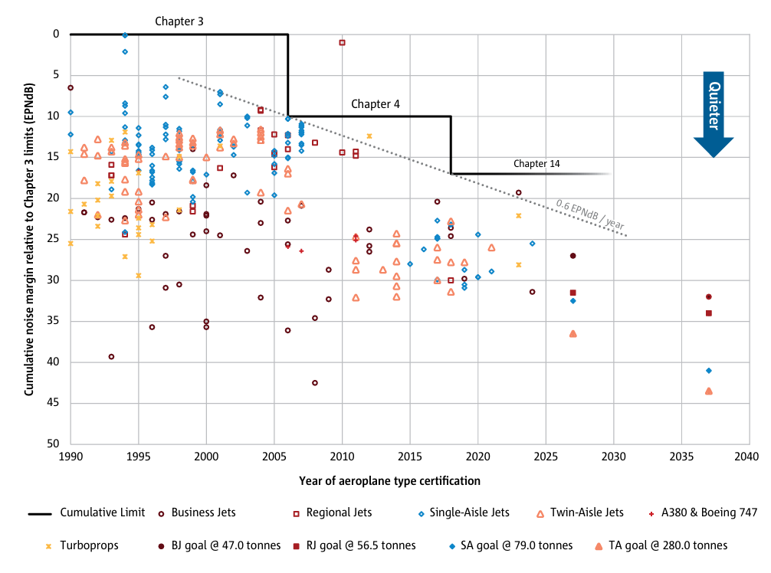
Fig.3 - Aircraft Noise Reduction Trends and Future ICAO Goals, Source: EASA, 2025

Examples
Noise-reduction architectural designs, such as soundproof windows and insulation, have been adopted by hotels at Schiphol Airport to minimise guests' discomfort (Vegter, Hoefsloot and Lieshout, 2023). Electric ground transport has also been introduced by some airports to further minimise levels of noise pollution (ESSA, 2025).

Environmental Impact of Flight Operations

Damages
Inefficient flight planning and air traffic management increase fuel consumption, leading to higher emissions from aircraft (Singh and Sharma, 2015). This is particularly concerning for tourism destinations that rely on commercial passenger aircraft, as it contributes to the overall environmental footprint of the tourism industry.

Solutions
One main approach is improving operational efficiency through optimised flight planning and air traffic management. For example, the implementation of "green routing," which utilises satellite-based navigation to minimise fuel consumption, has been shown to reduce fuel burn by approximately 10.8% compared to standard routes (Zhu, Holden and Gonder, 2017). Moreover, airports can play a vital role in reducing emissions by adopting green ground operations. This includes transitioning to electric-powered ground support vehicles and reducing energy consumption within terminal buildings (ESSA, 2025).

Examples
Heathrow Airport has implemented green ground operations, such as electric-powered ground vehicles and energy-saving measures in terminals, reducing on-ground CO₂ emissions by more than 10% compared to 2019 levels. (Heathrow Airport, 2024). Some eco-lodges are offering low-carbon private air transfers using electric or hybrid aircraft, aligning with sustainability goals and enhancing the green image of the lodges as eco-friendly tourist destinations (Laks and Doughty, 2022).

Environmental Impact of Airport Infrastructure

Damages
Energy demands for terminal operations, air traffic control, and runway maintenance, along with airport construction and expansion, contribute to significant carbon emissions (EASA, 2025). Additionally, airport growth often results in habitat loss, adversely affecting biodiversity, which is especially harmful for eco-tourism destinations that rely on natural landscapes and wildlife. A research carried out by the European Commission established that airport infrastructure development has been associated with the fragmentation of vital habitats, especially wetlands and forests (Anagnostopoulos et.al., 2022).

Solutions
Airports are increasingly adopting solar-powered terminals, electric ground transport, and habitat restoration projects to reduce their environmental footprint. These sustainable practices help mitigate the damage caused by airport expansion while supporting green tourism initiatives (Kingsland, 2019).

Examples
Amsterdam Schiphol Airport has incorporated solar-powered terminals and electric ground transportation, reducing its carbon footprint and supporting sustainable tourism practices (Schiphol, 2025).
Many airport hotels have also adopted energy-efficient lighting, eco-friendly waste disposal systems, and green transport options for guests (AIS, 2025). These efforts contribute to the green credibility of destinations, making them more attractive to eco-conscious tourists (Qiu et al., 2022).

Environmental Impact of Aircraft Design

Damages
Traditional aircraft engines and fossil fuel use are major sources of carbon emissions, with long-term implications for global warming. International aviation emissions more than doubled between 1990 and 2019, peaking at 625 MtCO₂, before totaling 492 MtCO₂ in 2023 (Tiseo, 2024b). This directly affects the sustainability of tourism by increasing the carbon cost of travel.
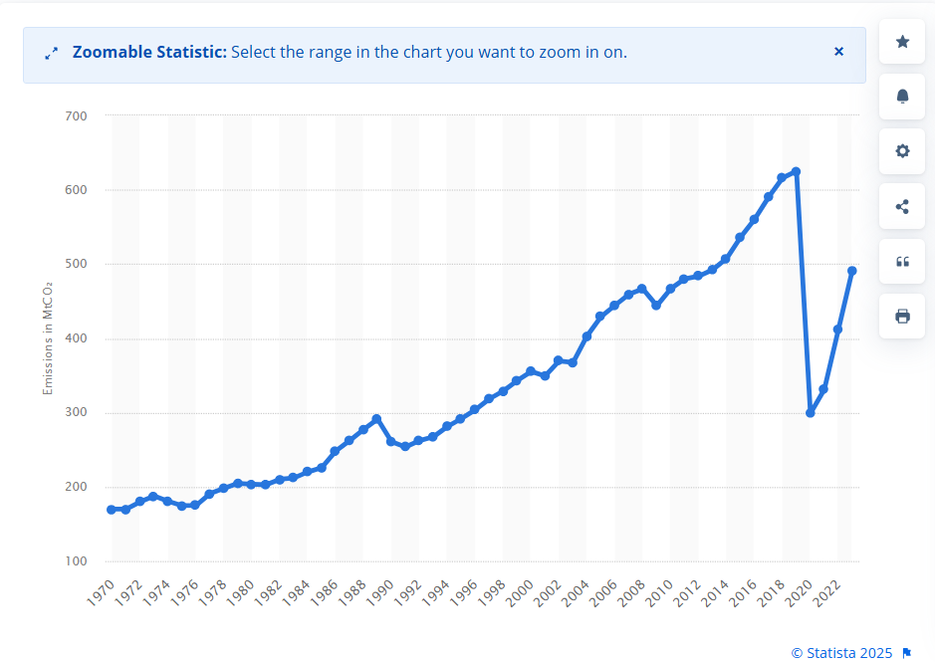
Fig. 4 – CO2 emissions from international aviation worldwide from 1970 to 2023; Source: Tiseo, (2024b).

Solutions
The development of electric, hybrid-electric, and hydrogen-powered aircraft offers significant emissions reductions, especially for short regional flights. These aircraft can play a pivotal role in making air travel more sustainable for eco-tourism destinations and remote resorts (Kuśmierek, Galiński and Stalewski, 2023).

Examples
Eviation Aircraft is developing all-electric commuter planes, offering a greener alternative for short regional flights (Eviation, 2024). This could revolutionize air travel to eco-lodges and remote destinations.
Airbus is working on hydrogen-powered aircraft that have the potential to halve direct carbon emissions from flights (Adler and Martins, 2023). These innovations could make flights to eco-tourism destinations more sustainable.

Cost-Effectiveness of Sustainability Measures

Investment in green aviation technologies, such as SAFs, hybrid-electric planes, and energy-efficient facilities, offers long-term cost advantages, especially with increased production and the reduction of prices for green fuels (Nilson, 2025). The initial investment remains a barrier, particularly for low-cost airlines. For the tourism industry, cheap aviation transport can be achieved through reduced operating expenses in airlines, which would lower air fares for travellers. Hotels and resorts can leverage this by offering such incentives as rebates to clients who opt for low-carbon flights or assisting carbon offset schemes. This will also increase brand image, and environmentally conscious travellers will find these appealing. The more regulation and customer demand for sustainability develop, the more likely hospitality firms with investments in green projects are positioned at a competitive advantage, yet increasing cost-effectiveness in transport and tourism (Reichheld, Peto, and Ritthaler, 2023). Collaboration among the air transport and tourism industries, enabled by enabling policies, will be key to maximizing cost-effective, environmentally friendly travel solutions.

Conclusion

The environmental impacts of commercial passenger aircraft are of concern to the hospitality industry, given that it depends on aviation for the transportation of visitors. Greenhouse gas emissions, noise, and unnecessary flight operations are responsible for much of the warming and pollution worldwide. However, advancements in green aviation fuels, better flight planning, noise reduction technologies, and the utilization of eco-friendly infrastructure provide sustainable solutions.
While sustainability efforts are a significant investment, they pay off in the long term in terms of economic and environmental benefits. The hospitality industry can play its part by promoting sustainable travel modes, engaging in carbon offsetting, and promoting low-emission transport. Industry cooperation, innovation, and policy favouring environmental care are essential to the future of sustainable aviation.

Recommendations

- Increased Investment in Sustainable Aviation Fuels (SAFs): Airlines and hospitality businesses should collaborate to support the adoption of SAFs by selecting flights operated by airlines that use biofuels and other sustainable fuel sources.
- Promotion of Low-Carbon Travel Options: Hotels and travel agencies should encourage customers to select airlines that have low carbon emissions through carbon offset programs and eco-tourism packages.
- Integration of Green Airport Infrastructure: Airports should further embark on the implementation of energy efficient technologies such as solar-powered terminals and electric ground transportation while hospitality businesses near airports should have their sustainability plans consistent with the above.
- Improvement in Aircraft Technology: Further research and investment in hybrid-electric and hydrogen powered aircraft should also be continued in order to guarantee long-term improvement in the environmental impact of aviation.
- Enhanced Regulations and Industry Collaboration: Governments, aviation authorities, and hospitality interests should continue to develop environmental standards for both sectors and promote the adoption of sustainable practices in both industries.

References

Adler, E.J. and Martins, J.R.R.A. (2023). Hydrogen-powered aircraft: Fundamental concepts, key technologies, and environmental impacts. Progress in Aerospace Sciences, [online] 141(141), p.100922. doi:https://doi.org/10.1016/j.paerosci.2023.100922. [Accessed 19 Feb. 2025].
AIS (2025). Green Airports: A Strategical Revolution In Aviation Space - Airport Information Systems - AIS. [online] Airport Information Systems - AIS. Available at: https://blog.airport-information-systems.com/green-revolution-in-airports/. [Accessed 18 Feb. 2025].
Anwar, S.H. and Asad, H. (2024). Passenger Preferences for Ultra Long Haul Flights vs. Connecting Flights: A Comparative Study between Asia and Europe. International Journal of Aviation Aeronautics and Aerospace, [online] 11(3). doi:https://doi.org/10.58940/2374-6793.1941. [Accessed 20 Feb. 2025].
Anagnostopoulos, A., Gabriel, N., Vanderlinder, M.S. and Avis, W. (2022). Biodiversity conservation initiatives at airport’s level. In: ICAO Environmental Report 2022. International Civil Aviation Organization (ICAO). Available at: https://www.icao.int/environmental-protection/Documents/EnvironmentalReports/2022/ENVReport2022_Art71.pdf [Accessed 19 Feb. 2025].
Bailey, J. (2025). British Airways and Ryanair named worst airlines by UK consumer group. [online] euronews. Available at: https://www.euronews.com/travel/2025/02/26/best-worst-airlines-according-to-passengers [Accessed 28 Feb. 2025].
Bergero, C., Gosnell, G., Gielen, D., Kang, S., Bazilian, M. and Davis, S.J. (2023). Pathways to net-zero Emissions from Aviation. Nature Sustainability, [online] 6(6), pp.404–414. doi:https://doi.org/10.1038/s41893-022-01046-9. [Accessed 12 Feb. 2025].
CAPA (2024). SAS ‘polar route flight’ records almost 20% CO2 reduction per passenger. [online] Centreforaviation.com. Available at: https://centreforaviation.com/news/sas-polar-route-flight-records-almost-20-co2-reduction-per-passenger-1293091 [Accessed 20 Feb. 2025].
Casinader, T., C. (2024). How Are The World’s Major Passenger Air Travel Markets Forecast To Change In The Coming Decades? [online] Simple Flying. Available at: https://simpleflying.com/major-aviation-markets-changes-forecast/. [Accessed 10 Feb. 2025].
Dileep, M., R. and Kurien, A. (2021). Air Transport and Tourism. Routledge.
EASA. (2025). European Aviation Environmental Report 2025. European Union Aviation Safety Agency (EASA) [PDF] Available at: EASA_EAER_2025_Book_v5.pdf [Accessed 19 Feb. 2025].
Eviation. (2024). About Us – Eviation. [online] Available at: https://www.eviation.com/about-us/. [Accessed 18 Feb. 2025].
Expeditions (2025) Making a Difference: Carbon Neutral. Available at: https://uk.expeditions.com/about/making-a-difference/carbon-neutral?msockid=01c6a3eaff7a63170294b1b8fe8162ea (Accessed: 23 February 2025).
Farinelli, S. (2024). Aviation Industry and Sustainability: Impact of Air Transport on Climate Change, Sustainability in Airlines and End-users Awareness and Preferences. Unive.it. [online] doi:http://hdl.handle.net/10579/27239. (Accessed 20 Feb. 2025).
Garay, E. (2022). These Maldives Resorts Are Leading the Charge on Sustainability. [online] CNN. Available at: https://edition.cnn.com/travel/article/maldives-most-sustainable-resorts/index.html. [Accessed 20 Feb. 2025].
Heathrow Airport (2024) Heathrow’s Sustainability Report 2023. Available at: https://www.heathrow.com/content/dam/heathrow/web/common/documents/company/heathrow-2-0-sustainability/reports/2023_Heathrow_Sustainability_Report.pdf [Accessed 18 Feb. 2025].
Hilton. (2025). Carbon Neutral Meetings Offer – Hilton. [online] Available at: https://www.hilton.com/en/events/offers/carbon-neutral-meetings/?msockid=01c6a3eaff7a63170294b1b8fe8162ea [Accessed 18 Feb. 2025].
IATA. (2024). Developing Sustainable Aviation Fuel (SAF). [online] Available at: https://www.iata.org/en/programs/sustainability/sustainable-aviation-fuels/#tab-1. [Accessed 18 Feb. 2025].
Kemp, M. and Dłużewska, A. (2024). Sustainable Tourism in Selected High-End Resorts in Seychelles. Seychelles Research Journal, [online] 6(1). Available at: https://seychellesresearchjournal.com/wp-content/uploads/2024/01/sustainable_tourism_in-selected_high-end_resorts_in_seychelles-michael_kemp-and-anna_dluzewska-seychelles_research_journal-6-1.pdf [Accessed 20 Feb. 2025].
Kim, H. and Teter, J. (2023). Aviation. [online] International Energy Agency. Available at: https://www.iea.org/energy-system/transport/aviation. [Accessed 15 Feb. 2025].
Kingsland, P. (2019). From making honey to restoring wetlands: ecological projects at airports. [online] Airport Technology. Available at: https://www.airport-technology.com/features/ecological-projects-at-airports/?cf-view [Accessed 23 Feb. 2025].
Kurrer, C. and Wala, Z. (2024). Air and noise pollution | Fact Sheets on the European Union | European Parliament. [online] Available at: https://www.europarl.europa.eu/factsheets/en/sheet/75/luchtvervuiling-en- [Accessed 20 Feb. 2025].
Kuśmierek, A., Galiński, C. and Stalewski, W. (2023). Review of the hybrid gas - electric aircraft propulsion systems versus alternative systems. Progress in Aerospace Sciences, [online] 141, p.100925. doi:https://doi.org/10.1016/j.paerosci.2023.100925. [Accessed 12 Feb. 2025].
Laks, Z., and Doughty, R. (2022). 16 stunning eco-hotels and resorts for 2022. Lonely Planet [online] Available at: https://www.lonelyplanet.com/articles/sustainable-travel-eco-hotels. [Accessed 16 Feb. 2025].
Mohamed, A.-M.O., Paleologos, E.K. and Howari, F.M. (2021). Chapter 19 - Noise pollution and its impact on human health and the environment. [online] ScienceDirect. Available at: https://www.sciencedirect.com/science/article/abs/pii/B9780128095829000190. [Accessed 12 Feb. 2025].
Nilson, P. (2025). A year of SAF deals: 2024 roundup. [online] Airport Technology. Available at: https://www.airport-technology.com/features/a-year-of-saf-deals-2024-roundup/?cf-view [Accessed 21 Feb. 2025].
Perkowsky, A. (2024). Marriott launches Connect Responsibly program - hotelbusiness.com. [online] hotelbusiness.com. Available at: https://hotelbusiness.com/marriott-launches-connect-responsibly-program/ [Accessed 20 Feb. 2025].
Qiu, H., Wang, X., Wu, M.-Y., Wei, W., Morrison, A.M. and Kelly, C. (2022). The effect of destination source credibility on tourist environmentally responsible behavior: an application of stimulus-organism-response theory. Journal of Sustainable Tourism, pp.1–21. doi:https://doi.org/10.1080/09669582.2022.2067167. [Accessed 02 Feb. 2025].
Ravishankar, B. and Christopher, P.B. (2020). ‘Impact of innovative services on customer satisfaction and enhancing tourism: Airline and hotel services from tourist perspective’, Journal of Critical Reviews, 7(11), Available at: Journal-of-Critical-Reviews-IMPACT-OF-INNOVATIVE-SERVICES-ON-CUSTOMER-SATISFACTION-AND-ENHANCING-TOURISM-AIRLINE-AND-HOTEL-SERVICES-FROM-TOURIST-PERSPECTIVE.pdf [Accessed 18 Feb. 2025].
Reichheld, A., Peto, J. and Ritthaler, C. (2023). Research: Consumers’ Sustainability Demands Are Rising. [online] Harvard Business Review. Available at: https://hbr.org/2023/09/research-consumers-sustainability-demands-are-rising. [Accessed 20 Feb. 2025].
Schiphol. (2025). Schiphol | At the airport. [online] Available at: https://www.schiphol.nl/en/sustainability/at-the-airport/ [Accessed 23 Feb. 2025].
Singh, V. and Sharma, S.K. (2015). Fuel consumption optimization in air transport: a review, classification, critique, simple meta-analysis, and future research implications. European Transport Research Review, [online] 7(2). doi:https://doi.org/10.1007/s12544-015-0160-x. [Accessed 16 Feb. 2025].
Tiseo, I. (2024a). Global aviation CO₂ emissions 1970-2022. [online] Available at: https://www.statista.com/statistics/1417212/international-aviation-emissions-worldwide/. [Accessed 02 Feb. 2025].
Tiseo, I. (2024b). Share of global CO2 emissions by sector 2020. [online] Statista. Available at: https://www.statista.com/statistics/1129656/global-share-of-co2-emissions-from-fossil-fuel-and-cement/. [Accessed 02 Feb. 2025].
Vajdová, I., Jenčová, E., Szabo, S., Melníková, L., Galanda, J., Dobrowolska, M. and Ploch, J. (2019). Environmental Impact of Burning Composite Materials Used in Aircraft Construction on the Air. International Journal of Environmental Research and Public Health, [online] 16(20), p.4008. doi:https://doi.org/10.3390/ijerph16204008. [Accessed 07 Feb. 2025].
Vegter, S., Hoefsloot, N. and Lieshout, R. (2023) Measuring the cost-effectiveness of noise mitigating measures for Schiphol Airport in the context of the Balanced Approach procedure: Final report, 10-3-2023. Decisio and Beelining. Available at: https://www.beelining.nl/wp-content/uploads/2024/09/Decisio_and_Beelining_Cost_effectiveness_of_noise-mitigating_measures_for_Schiphol_March_2023.pdf [Accessed 22 Feb. 2025].
Virgin Atlantic. (2025a). Fuel. [online] Available at: https://corporate.virginatlantic.com/global/en/business-for-good/planet/fuel.html. [Accessed 20 Feb. 2025].
Virgin Atlantic. (2025b). Sustainable Tourism | Responsible Tourism | Virgin Atlantic Holidays. [online] Virginatlantic.com. Available at: https://www.virginatlantic.com/holidays/responsible-tourism [Accessed 23 Feb. 2025].
Zhu, L., Holden, J.R. and Gonder, J.D. (2018). Navigation Application Programming Interface Route Fuel Saving Opportunity Assessment on Large-Scale Real-World Travel Data for Conventional Vehicles and Hybrid Electric Vehicles. Transportation Research Record: Journal of the Transportation Research Board, 2672(25), pp.139–149. doi:https://doi.org/10.1177/0361198118797805. [Accessed 20 Feb. 2025].

