Professional career development

Student name: Dalanda Diallo

Student number: 2025163

Module code: BMSW4005

Lecturer name: Rula Alousi

Assignment title: Professional career development report

Table of contents

- Cover page
- Table of contents
- Introduction, lifeline, learning style
- Career plan, recruitment, and selection, what employers want,
- Role play
- Action plan and motivation, conclusion
- Reference list
- Appendix 1 (Swot analysis)
- Appendix 2 (Smart goals)
- Appendix 3 (PDP)
- Appendix 4 (interview questions)

Professional career Development

Introduction

Individual and organisational career management are two facets of career management. On a personal basis, career management entails the deliberate and persistent implementation of someone's career vision: personal growth plans, building out specific career routes, and improving one’s personal talents. Current workers do not consider the company's aims since the priority is on distinct personal and professional requirements, behaviours, and principles (Aleksandra, P. et al. 2011).
The aim of this report is to reflect about what I have studied in this module by using Gibbs reflective cycle and provide details and my understanding of what have been taught during class. I will discuss about my lifeline, self-motivation, personal development, career plans, what employees want, my role play and by the end an action plan and a conclusion will be given. I will mention my learning styles and I will provide my SWOT analysis, smart goals as appendixes.

Lifeline

I am Dalanda I started my studies at the age of 6 I started in Guinee-Bissau where I started secondary school. However, at the age of 12 I left for Portugal. I studied there until the age of 15 I went to Switzerland. Whilst in Switzerland I studied until the age of 18 I left for London. However, coming to London was the lowest point of my life since I had a lot of trouble financially and I could not speak or understand English it was very confusing. Nevertheless, I started going to college and learning English after 6 months I could finally understand and speak English a little. Although, moving to different countries helped me learn few languages. It was challenging did for my studies since each country had their own educational system. I remember that I had to repeat the same class twice it disadvantaged me because people of my age were ahead of me. But now everything is great and with the languages I have learned I might become a translator for immigrants, and I will be able to become a lawyer in few years as I wished.

Learning style

Whilst, in class I have done some exercises to know what kind of learner I am. The exercise was simply to answer 20 questions. The results were saying that I am an auditory learner but not only that since I was 40% auditory, 25% visual and 35% tactile it was interesting to learn about that. According to F., Kayalar (2017) you understand by hearing and listening when you're an auditory learner. You comprehend and recall what you have heard. You remember relevant information on how it sounds, and you retain verbal much in than written notes. I did not think I was auditory learner before this exercise I was thinking that I was more of a tactile learner since for me to learn I usually write the word many times and at the same time I say it out loud. Furthermore, we have done another exercise about my creative type, and I learned that I am a thinker. However, is something that I knew before the test. The test provided me the creative strength, which was intellectual curiosity, skill to create and meaning. To add more the exercise provided the untapped potential and my ideal collaborator. My untapped potential is crossing over theory and practice and applying ideas in real life and finally my ideal collaborator would be the adventurer. This exercise has clearly helped me knowing my self-better.

Career plan

In this paragraph I will be discussing about my future. To start, I would like to finish this year because I realised that I would like to do another course that resemble me more. I have been very interested in being a lawyer. Because I am very passionate about law and defending what is right. I believe I can help people in need. However, being a lawyer is not my only future since I am hoping that I can open a hotel or restaurant in my country because my country is a great place to live or visit so we have been getting a lot of tourists and I am certain that I would be helping my country economically and help my family as well. In addition to my plans mentioned, I would like to have my driving licence.

Recruitment and selection

The first step in the selecting process is to market the role (Roberts, G., 1997). The procedure of finding, assessing, selecting candidates, and employing possible human resources for the objective of completing roles within businesses is known as recruiting. Hr revolves around this role. The act of hiring the appropriate individual for the right skills at the right time is considered as recruitment. Applicants' training and development needs, expertise, capabilities, and skills must all be considered during the recruitment and selection. It is the method of recruiting, identifying, and hiring qualified people to suit an organisation ’s objectives and criteria. Internally, that is, within the organisation, and externally, that is, using outside data. Internal causes also include company's structure, recruiting policies, reputation of the company, and appearance of the person. Factors, the jobs market, the jobless rate, labour regulations, legal implications, and rivals are all external influences. Recruiting efficiency boosts productivity and fosters a positive workplace environment and great relationships among employees for the appropriate positions The organisation will be able to attain its aims if the proper applicants are chosen for the correct positions. When hiring personnel, it's critical to make sure they have the credentials, capabilities, and competencies needed to do the work obligations through a good approach (Recruitment and Selection, 2016). The process of selecting or choosing the right person for the work is known as selection. It is the procedure of conducting an interview and assessing their skills that are required for a given job, after which the applicants are chosen. (Kapur, R. 2018).

What employers want

According to Wilhelm (2002) employers may find it difficult to find the ideal candidate, particularly if they are looking for a senior position with a lot of responsibilities. Many businesses have a wish list of vital talents and attributes that they hope a new hire will provide to the position.
As a possible applicant, familiarise yourself with the abilities and attributes that companies want in new employee so that you may incorporate them into your CV, and emphasize them in the interview, if chosen, to make a strong first image. Certain skills, such as those listed below, are widely valued after, and can help sustain your cover letter.

Accuracy - Each employer desires dependable employees who will put forth their best effort to accomplish in their positions. A dependable employee is prompt and takes minimal sick days. Employers are delighted by employees who work hard to complete tasks on schedule and under budget.

Organisation - The capability to manage is linked to accuracy. Companies like to recruit people with strong abilities because they can execute well at work and achieve their goals.

Enthusiasm - Throughout many businesses, a successful recruitment entails more than just finding someone who will accomplish the necessities. It is where devotion comes into play, as somebody who is enthusiastic about the company or their work within it will go above and beyond the essentials to ensure the finest possible output upon each task.

Leadership - Leading is the process that several businesses seek for in prospective employees, whether they are seeking for managers or not. Employers will see great leader as a hint that you will be a great team player. Outstanding management abilities demonstrate a positive approach and the ability to drive yourself (among others) to accomplish your maximum.

Working in team – working with a team brings a better results than working individually and employers will always look favourably on candidates that have excellent abilities. It is critical to engage responsibly and recognise the abilities of people around you when working as part of a team.

Innovation - Creativity is a key quality which could help you separate out from the crowd while applying for jobs. Individuals that are imaginative can identify issues and come up with greater creativity that others may not have considered.

Digital skills - Employers in the United Kingdom continue to be in great demand for digital abilities (Wilhelm, W.J., 2002).

Role play

The creative approach of role - playing invites players to develop behaviour patterns that represent the predicted responses of people in particular situations. Character duties are allocated, and a situation is described. The scene is typically spontaneous, though it can be written and practised. Based on impromptu interactions between characters, people in the audience can behave as observers and offer input to help with the research conclusion. Through role playing, students can use their ideas to develop situations that identify possible problems and promote teamwork (Lowenstein, A.J. and Harris, M., 2007).
According to Blatner, A. and Blatner, A., (1991) As a result of growing up in a society that largely values logical thought, several people have disregarded this talent (Blatner & Blatner, 1997). If the concept of taking on a role is viewed as an actual talent which can be taught by practise, prepping team members would become more successful. Researchers find it useful to emphasise that role-play is the recovery of an inherent ability and to remember the group that the unpredictability inspired by this activity relates to a zest for life and cognitive agility that is why it was not easy to do the role play but it was interesting role playing is a skill that we need.
Firstly, during the lessons, we have created a job application form for the job we wished to apply for then we created questions about our respective jobs. Secondly, we had to give reasons why we chose each of the five questions. I have done the role play with my partner Sanu. I had to interview her as a manager of a primary school, and she interviewed me for the position of waitress I was already familiar with the role since I have done this job before and have the experiences. Both of us had to create five questions for each other which was important to for the role to see if the applicant was informed and familiar with the job. The role play was great but a little challenging because we did never experienced interviewing before about the job that we had chosen since the questions were selected carefully and I personally chose those questions because I thought they were necessary to be asked while interviewing someone. I was feeling very stressed and anxious the day of the role play I kept wondering whether my questions were important and relevant for my partner or not. When we started the interview, I was feeling extremely stressed and anxious strangely more than when I am in an actual interview. I think these feelings were since I was being graded and I knew that. Furthermore, I remember being asked what my weaknesses where it was difficult for me to answer to that question, but I managed to answer from my heart. But in overall it helped me to practice my role play skills and see things in a manager perspective and not a interviewee point of view.

Action plan and motivation

I will make sure I study every day and as hard as I can and be more motivated in the future because my motivation is my family also because I acknowledge that I came from far, so family is my motivation.

Conclusion

Finally, this report has covered about my lifeline, learning style, my career recruitment and selection, what employers expect, role play and to finalise I discussed my action plan what motivates me. To add more this report has discussed about my strengths and weaknesses and this module helped to develop new skills and be sure about my career and plans. This report will include my PDP, SWOT analysis, and smart goals as appendices. It will be appendix 1,2,3 and 4.

- References

Aleksandra, P. et al. (2011) Career and professional development – challenges for employees and modern organizations, ResearchGate, Available at:
- https://www.researchgate.net/publication/237092444_Career_and_professional_development_-_challenges_for_employees_and_modern_organizations Accessed: 12 June
- Bright, J. and Earl, J., 2008. Brilliant CV: What employers want to see and how to say it. Pearson Education.
- Blatner, A. and Blatner, A., 1991. Imaginative interviews: A psychodramatic warm-up for developing role-playing skills. Journal of group psychotherapy, psychodrama & sociometry, 44(3), pp.115-120.
- https://www.piette.me/adam/pdntbk/talksho.htm
- Kayalar, F. (2017). (PDF) The effects of Auditory Learning Strategy on Learning Skills of Language Learners (Students’ Views). [online] ResearchGate. Available at: https://www.researchgate.net/publication/320880247_The_effects_of_Auditory_Learning_Strategy_on_Learning_Skills_of_Language_Learners_Students%27_Views Accessed: 12 June

- Kapur, R. (2018). Recruitment and Selection. [online] ResearchGate. Available at: https://www.researchgate.net/publication/323829919_Recruitment_and_Selection Accessed: 12 June
- Lowenstein, A.J. and Harris, M., 2007. Role play. Innovative teaching strategies in nursing and related health professions, pp.173-181.
- Roberts, G., 1997. Recruitment and selection. CIPD publishing.
- Wilhelm, W.J., 2002. Research on workplace skills employers want. In Meeting the demand: Teaching “soft” skills (pp. 12-33). Little Rock, AR: Delta Pi Epsilon Society. https://files.eric.ed.gov/fulltext/ED477252.pdf#page=21

Appendix 1
Swot Analysis

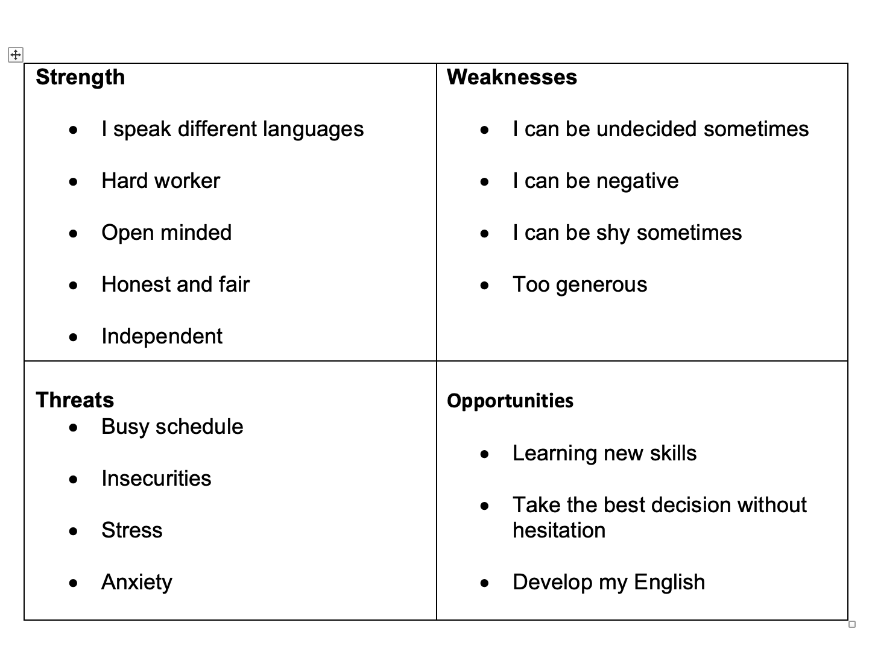

Appendix 2

Smart goals

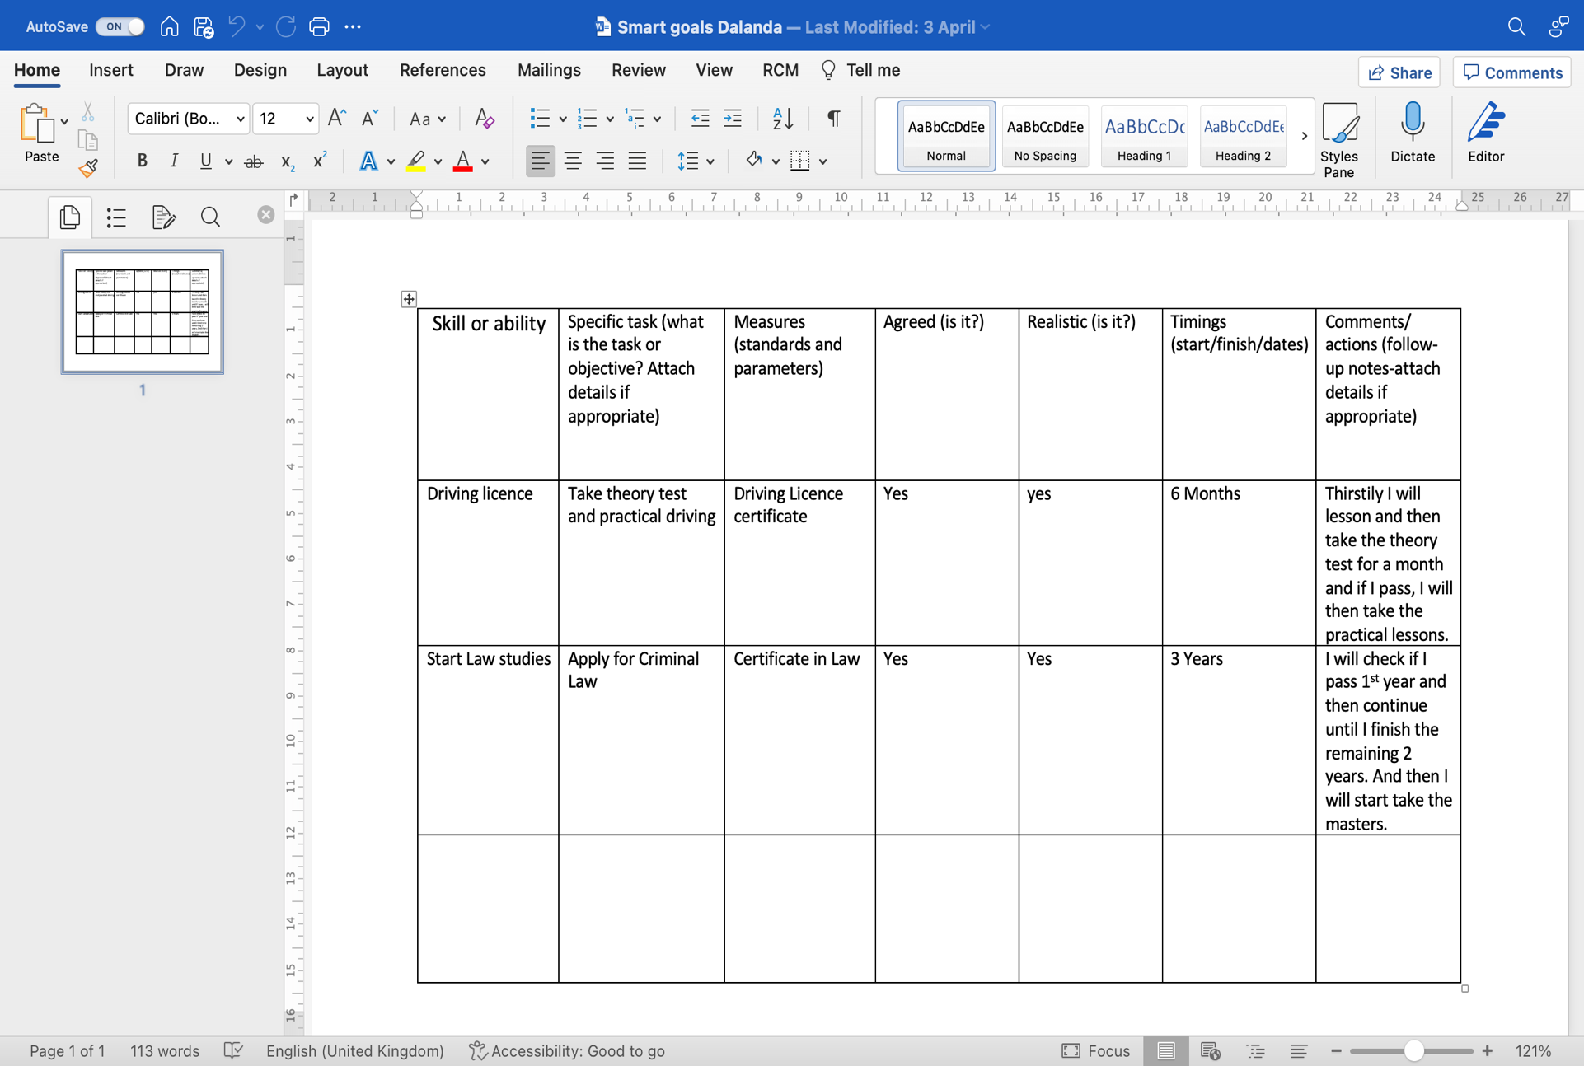

Appendix 3

PDP

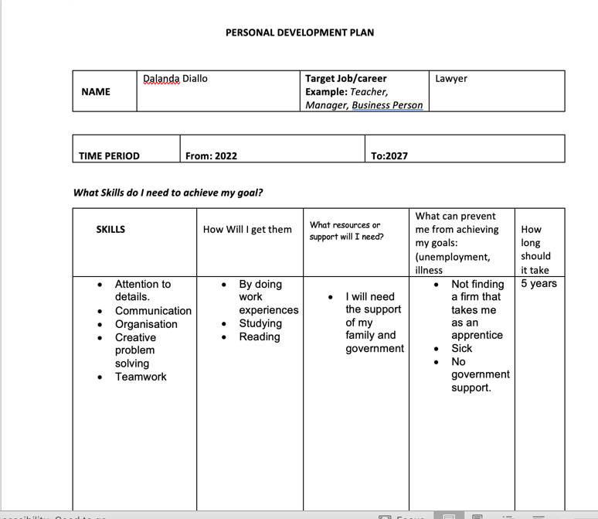

Appendix 4

Interview Questions



