2022
The Decline of the High Street

Student Name: Andrei Stafi
Student ID number: 2114799
Date submitted: 25.03.2022

Contents
1. Introduction 2
2. Main findings 3
a. Defining the problem [nature, scope, impact] 3
b. SWOT 3
c. PESTLE 5
3. Conclusion 8
4. Recommendations 9
5. Action plan 11
6. Appendices 12
a. SWOT Analysis 12
b. PESTLE Analysis 13
c. Decision-Making Matrix 14
References 15

Introduction

Problem-free service and development are essential for every multinational organisation with a global reach to remain competitive. In today's highly competitive global business environment, top-tier organisations are always battling to stay on top. There is a decline in the number of high streets and independent and chain retailers in Britain due to the ongoing economic crisis (Abrick and Twose, 2021). It is not only retailers and suppliers who have been impacted by the shift in retail location from the centre of town to the outskirts of town. In this study, a SWOT analysis of the high street was conducted. The identified problem was then subjected to a PESTLE study to determine the impact of the external environment on it. Problem-solving and decision-making skills are critical to a company's long-term success.

Main findings

This report will be looking to define the problem that the high street is facing at the moment and apply a SWOT and PESTLE analysis:

Defining the problem [nature, scope, impact]

The root cause of the problem that leads to the decline of the high street is the development of out of town retail stores.
Nature – The main reason is the number of shops in a city centre limited by space, and many moved out of town to shopping malls and designer outlet stores. Also, as a general rule, rents and wages are cheaper outside of the city (Hubbard, 2017).
Scope - Due to the chain of stores outside the city, the shops on the main street are affected, as customers prefer to go shopping outside the city where they can easily find parking spaces, which is why this affects the high street because they have limited space. Therefore, those affected may be Employees, Landlords, Retailers, Suppliers, Local Council.
Impact - They were financially affected by this problem due to the lack of customers, so they had to reduce their expenses, and employees got fired.

SWOT

Analysing strengths, weaknesses, threats, and opportunities may help a company determine how well it can compete with its current resources (Allen and Buck, 2020).
SWOT study of the main thoroughfare:
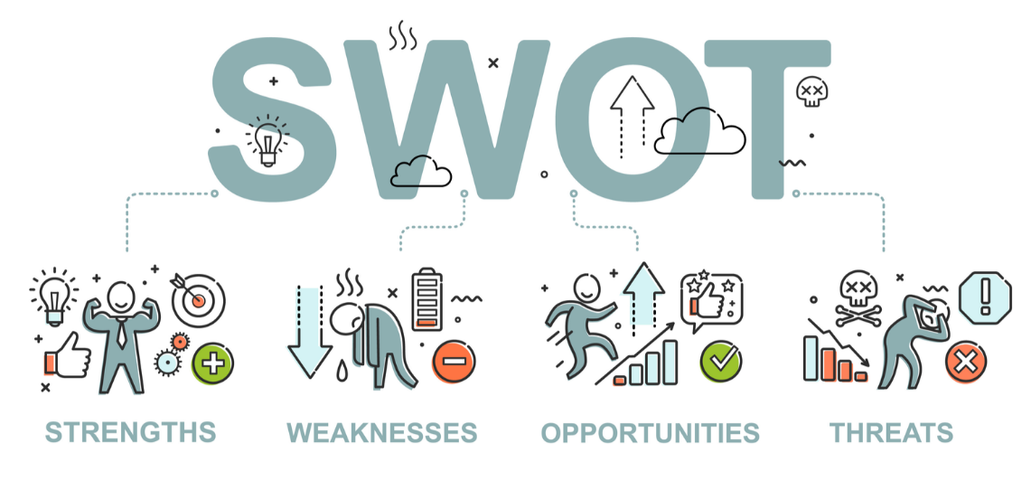
Figure 1: SWOT analysis (Allen and Buck, 2020)
Opportunities
- To take advantage of the expanding use of e-commerce, high street shops should have an Omnichannel presence.
- Physical stores will always be required.
- Creating a sense of community.
- Promoting during Christmas and Black Friday, and other events.

Threats
- Out-of-town shopping has become a threat to the high street due to the relocation of businesses off the main drag.
- Incredible technological advances have supported the development of internet business.
- It is a two-pronged attack: Inflation and rising interest rates (Jung Sung-Hoon, 2020).
- Adapting to new circumstances.
- People are afraid of crime because high streets have been depicted as dangerous criminal hotspots in the media, which has slowed down their recent growth.

Strengths
- Customers may find everything they need to complete their purchases in one spot.
- If public transportation is accessible, those unable or unwilling to drive will have easier access to downtown areas (Parker et al., 2017).
- There is a certain authenticity about little shops on main streets that they lack in shopping malls full of big-name companies.
- Many historic sites may be found along the city's main thoroughfare.

Weaknesses
- A dearth of reasonably priced, nearby parking spaces has made acquiring a spot a lottery, but the high demand for these locations has further driven up their prices.
- A lack of infrastructure is causing problems in the community.
- As the internet retail business evolves, many small high-street shops lose ground to their bigger competitors because they lack an online presence (Parker et al., 2017).
- It is hard to find something just in one place.
- Loss of uniqueness and character of the local environment.

PESTLE

According to PESTLE research, out-of-town retail is causing the high street to deteriorate:
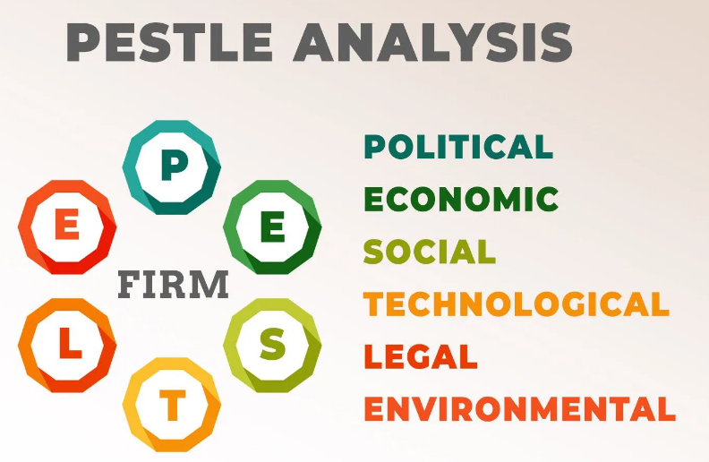
Figure 2: PESTLE analysis (Ackerman, 2021)
Political factors
In the retail industry, government regulations have a major impact on sales and profitability. In terms of the economy, consumer spending patterns, and trade agreements, these limits exert an impact (Akman, 2020). It has had a tremendous influence on retailers, such as the recent lockdown policy in the United Kingdom. Since then, the number of high-end retailers that have had to close their doors has increased as a result of the effect.
Economic factors
Low and high consumer spending, unemployment, interest rates, and the general cost of living all have an impact on high street retailers. For example, offline purchases were at an all-time low during the closure. Due to their reliance on offline consumers, high-street shops have seen their sales fall (Tongue, Otieno, and Diane Cassidy, 2018). In addition, recent inflation has affected small business owners on the high street.
Social factors
Societal trends impact people's buying patterns, attitudes, and behaviours, which may alter and vary over time (HudsonDavies, Parker, and Byrom, 2021). Due to the present outbreak, people have been forced to stay at home, and e-commerce businesses have taken advantage of this opportunity. Unfortunately, it has made matters worse for businesses who depend on foot traffic on the main street.
Technological factors
In the UK retail business, online merchants possess 22% of the market share, according to KPMG's head of retail (Ziaullah, Feng, and Akhter, 2021). If a retailer wants to succeed in the online market, they need to have the correct online offerings containing a value, convenience, or both. Out-of-town merchants have already overtaken them.
Legal factors
Local labour laws, taxes, and other commercial constraints apply to high street businesses in the UK (Akman, 2020). Minimum pay, working time directive, and average living wage all significantly influence high-volume merchants. A recent increase in the minimum wage and living wage laws, for example, has affected retail businesses. When wages grow, retailers will have to pay more to their employees because many high-street businesses are owned and operated by small, independent business owners. New regulations considerably affect their operations, driving up operating costs for all businesses involved. As a result, many businesses choose to conduct their operations elsewhere.
Environmental factors
The highest rate of air pollution is in city centres due to the large number of cars. Automobile emissions pollute the environment and contribute to climate change (Akman, 2020). There is a possibility that they may be limited in access on the high street and favour non-polluting ones, such as electric cars. If the number of cars decreases this will influence the income of those on the high street. A solution for that could be to install as many electric car charging stations as possible and mount plants, even in pots, to improve air.

Conclusion

High-street shops may boost customer conversion by using several strategies. Businesses on Main Street may be able to keep customers despite their inability to manage everything.
- If there is no product available, there must be another that shops may sell. In addition, customers are increasingly being offered beverages and the possibility of eating in a restaurant to increase their amount of time on the high street.
- The sight of a lengthy line in a shop may frighten even the most patient of customers. So, for example, stores may situate their pay registers near the changing rooms towards the shop's back.
- Customers may be enticed to buy from a store if they show that previous customers have been satisfied. It is a lot like a review on social media. High-street stores may be able to print those favourable reviews that may be hung on the store's wall. (Jamalovna, 2020).
- According to revenue rather than visitor counts, many merchants schedule their staff based on the number of customers (Lawhead, 2020). Therefore, by increasing the number of staff on duty, a firm may better serve all of its customers, likely leading to increased sales.

Recommendations

- For some time, it has been widely acknowledged that out-of-town retail shopping has played a significant role in the collapse of the United Kingdom's high streets (Resnick, Foster, and Woodall, 2020). Without relinquishing its free-market views, the Government may assist existing retailers and other high-street staples by adjusting corporation taxes to reflect the new economic realities brought about by e-commerce. When business rates and rent are expensive, it is difficult for excessive street vendors to remain alive.
- The rise of internet shopping, without question, represents the biggest threat to the profitability of our traditional retail businesses in the United States (Allport, 2021). Out-of-town retail and office shows serve to drive people and money away from local shopping centres and downtown businesses. Residents and companies have always congregated in town centres to do business. By boosting foot circulation, the high street may be able to recover its former splendour (Allport, 2021).
- Much can be done to offset the negative consequences of out-of-town shopping via the use of planning restrictions and the ability to issue licenses to businesses. Changes in legislation may be undertaken to entice individuals to work in the town centre. The improvement of the general public sphere should be a top priority. There should also be enough amenities, such as gyms, childcare centres, food places, and, most importantly, enough parking space to accommodate all visitors (Guo and Schloeter, 2021).
The best response was chosen using a decision-making matrix (Appendices, c) based on the options mentioned above. To compare the different approaches, a set of standards was devised.
This matrix shows that initiatives to revitalise the high street will be the best choice. High-street retailers will provide their support, but they will face tougher obstacles and a larger budget. The policymaking and applications of emerging technology processes include the construction of more parking spaces, gyms, children's amusement centres, drink shops, and the revitalization of roads.

Action plan

Monitoring, Reviewing and Communicating a Decision

Decision implemented: The local governments have to communicate with various stakeholders such as retailers, customers, suppliers, and the local community (Fletcher et al., 2021) and notify them of what strategy they will implement to improve sales.

Monitoring the decision:
Resources: The local Government will monitor and evaluate the real-time implementation, following the criteria mentioned above. As soon as the authority detects any problems, they will notify the principal project leader. The Government has selected a project leader responsible for making the necessary modifications (Guy, 2021).

Key Indicators: Monitoring, Communication, Research, Sales, Traffic, Investment

Targets: Increase high street sales by 15% in 12 months.

Data Sources: Compare and improve sales from the last year.

Reviewing the decision:
It is expected that the body responsible for monitoring will issue a report summarising their findings when they examine the project. The research findings will guide the decision on whether or not to demo the newly reconstructed high street. It will be judged a success if everything goes according to plan (Guy, 2021).

Communicating the Decision:
Internal Stakeholders  Shops via Microsoft Teams meetings – regular meetings (Yang and Ho, 2020). Once every two weeks. | External Stakeholders  Local Government via website page updated – Once per month.

Appendices

SWOT Analysis

Strengths  - Customers may find everything they need to complete their purchases in one spot.  - If public transportation is accessible, those who are unable or unwilling to drive will have easier access to downtown areas (Parker et al.,2017).  - There is a certain cachet about little shops on main streets that they lack in shopping malls full of big-name companies.  - Many historic sites may be found along the city's main thoroughfare.  - The term "high street fashion" is used in the United Kingdom to describe customers' clothing choices that are similar to those found at mass-market merchants. However, despite non-exclusive and mass-produced clothing, many generally see it as superior quality. | Weaknesses  - A dearth of reasonably priced, nearby parking spaces has made acquiring a spot a lottery, but the high demand for these locations has further driven up their prices.  - A lack of infrastructure is causing problems in the community.  - As the internet retail business evolves, many small high-street shops are losing ground to their bigger competitors because they lack an online presence (Parker et al.,2017).  - It is impossible to find whatever you are looking for in just one place.  - Loss of uniqueness and character of the local environment.
Opportunities  - To take advantage of the expanding use of e-commerce, high street shops should have an Omnichannel presence.  - Physical stores will always be required.  - Creating a sense of community.  - Promoting during charismas and Black Friday and other events. | Threats  - Out-of-town shopping has become a threat to the high street due to the relocation of businesses off the main drag.  - Incredible technological advances have supported the development of internet business.  - It is a two-pronged attack: Inflation and rising interest rates (Jung Sung-Hoon, 2020).  - Adapting to new circumstances and circumstances  - People are afraid of crime because high streets have been depicted as dangerous criminal hotspots in the media. This has slowed down their recent growth.

PESTLE Analysis

Element | Factor | Business Impact
Political | Government regulations have a major impact on sales and profitability. | It has had a tremendous influence on retailers, such as the recent lockdown policy in the United Kingdom. Since then, the number of high-end retailers that have had to close their doors has increased as a result of the effect.
Economic | Low and high consumer spending, unemployment, interest rates, and the general cost of living all have an impact on high street retailers. | For example, offline purchases were at an all-time low during the closure. In addition, due to their reliance on offline consumers, high-street shops have seen their sales fall (Tongue, Otieno, and Diane Cassidy, 2018).
Sociological | Societal and societal trends impact people's buying patterns, attitudes, and behaviours, which may alter and vary over time (HudsonDavies, Parker, and Byrom, 2021). | Due to the present outbreak, people have been forced to stay at home, and e-commerce businesses have taken advantage of this opportunity. However, unfortunately, it has made matters worse for businesses who depend on foot traffic on the main street.
Technological | In the UK retail business, online merchants possess 22% of the market share, according to KPMG's head of retail (Ziaullah, Feng, and Akhter, 2021). | If a retailer wants to succeed in the online market, they need to have the correct online offerings containing a value, convenience, or both. Out-of-town merchants have already overtaken them.
Legal | Minimum pay, working time directive, and average living wage all significantly influence high-volume merchants. A recent increase in the minimum wage and living wage laws, for example, has affected retail businesses. | Because so many high-street businesses are owned and operated by small, independent business owners, new regulations considerably affect their operations, driving up operating costs for all businesses involved. As a result, many businesses choose to conduct their operations elsewhere.
Environmental | Due to environmental considerations, there has been a rise in traffic and congestion in large retail parks. | By offering enough parking, out-of-town stores have been able to attract customers. There is a downside to Greenfield's out-of-town shops, however.

Decision-Making Matrix

Ideas | Cost  (5) | Time  (5) | Profitability  (5) | Efforts  (5) | Total
Corporate tax amendment | 4 | 3 | 4 | 4 | 15
Applications of emerging technologies | 4 | 4 | 3 | 3 | 14
High street restorations | 3 | 4 | 4 | 4 | 15

References

Abrick, J. and Twose, R., 2021. Balanced SWOT: Revisiting SWOT Analysis through Failure Management and Success Management. SSRN Electronic Journal, 1(2), pp.5-7.
Ackerman, A., 2021. Road Management and PESTLE Analysis. Ante Portas - Studia nad bezpieczeństwem, 1(14)/2020(1(14)/2020), pp.93-102.
Akman, M., 2020. Defense Management and PESTLE Analysis. Ante Portas - Studia nad bezpieczeństwem, 1(14)/2020(1(14)/2020), pp.93-102.
Allen, A. and Buck, D., 2020. Decision-making, problem-solving and organizational learning. Omega, 11(4), pp.321-328.
Allport, D., 2021. The UK high street: Current issues and their implications. Journal of Retail & Leisure Property, 5(1), pp.2-16.
Fletcher, G., Greenhill, A., Griffiths, M., Holmes, K., and McLean, R., 2021. Creatively prototyping the future high street. Production Planning & Control, 27(6), pp.477-489.
Griffiths, S., Vaughan, L., Haklay, M. and Emma Jones, C., 2017. The Sustainable Suburban High Street: A Review of Themes and Approaches. Geography Compass, 2(4), pp.1155-1188.
Guo, Z. and Schloeter, L., 2021. Street Standards as Parking Policy. Journal of Planning Education and Research, 33(4), pp.456-470.
Guy, C., 2021. 'High street' retailing in off-center retail parks: a review of the effectiveness of land use planning policies. Town Planning Review, 69(3), p.291.
Hubbard, P., 2017. The battle for the high street: Retail gentrification, class and disgust. Springer.
Hudson‐Davies, R., Parker, C. and Byrom, J., 2021. Towards a healthy high street: developing mentoring schemes for smaller retailers. Industrial and Commercial Training, 34(7), pp.248-255.
Jamalovna, J., 2020. Ways to Effectively Use Marketing Strategies to Increase the Customer Satisfaction of Physical Education and Sports Services. International Journal of Psychosocial Rehabilitation, 24(5), pp.2930-2938.
Jung Sung-Hoon, 2020. The Portas High Street -A Pathway to the Revitalization of the High Street in the United Kingdom-. Journal of the Association of Korean Photo-Geographers, 24(4), pp.223-230.
Parker, C., Ntounis, N., Quin, S. and Grime, I., 2017. High Street research agenda: identifying High Street research priorities. Journal of Place Management and Development, 7(2), pp.176-184.
Resnick, S., Foster, C. and Woodall, T., 2020. Exploring the UK high street retail experience: Is the service encounter still valued? International Journal of Retail & Distribution Management, 42(9), pp.839-859.
Tongue, M., Otieno, R. and Diane Cassidy, T., 2018. Evaluation of sizing provision among high street retailers and consumer buying practices of children's clothing in the UK. Journal of Fashion Marketing and Management: An International Journal, 14(3), pp.429-450.
Yang, P. and Ho, M., 2020. The Studying on Design Communication and Conveyance in Project Plan. Applied Mechanics and Materials, 311, pp.286-292.
Ziaullah, M., Feng, Y. and Akhter, S., 2021. How does justice matter in online retailers’ reputation and purchase intentions: an empirical study of China. Behaviour & Information Technology, pp.1-10.

